Use of Population Exposure Frequency Distributions to simulate effects of policy interventions on NO2 exposure

C. DIMITROULOPOULOU1, M.R.ASHMORE2*, A.C TERRY2

1: Environmental Change Department, Centre for Radiation, Chemical and Environmental Hazards, Public Health England, Chilton, OX11 0RQ

2. Stockholm Environment Institute, Environment Building, Wentworth Way, University of York, York YO10 5NG, UK

*corresponding author: e-mail:mike.ashmore@york.ac.uk;

tel: 00-44-1904-324744

## Abstract

Health effects of air pollution on individuals depend on their personal exposure, but few modelling tools are available which can predict how the distribution of personal exposures within a city will change in response to policies to reduce emissions both indoors and outdoors. We describe a new probabilistic modelling framework (INDAIR-2/EXPAIR), which provides predictions of the personal exposure frequency distribution (PEFD) across a city to assess the effects of both reduced emissions from home sources and reduced roadside concentrations on population exposure. The model uses a national time activity database, which gives the percentage of each population group in different residential and non-residential micro-environments, and links this, for the home, to predictions of concentrations from a three-compartment model, and for non-residential microenvironments to empirical indoor/outdoor ratios. This paper presents modelled PEFDs for NO2 in the city of Leicester, for children, the elderly, and office workers, comparing results in different seasons and on different days of the week. While the mean NO2 population exposure was close to, or below the urban background concentration, the 95%ile of the PEFD was well above the urban background concentration. The relationship between both mean and 95%ile PEFD and urban background concentrations was strongly influenced by air exchange rate. The 24h mean PEFD showed relative small differences between the population groups, with both removal of home sources and reductions of roadside concentrations on roads with a high traffic density having similar effects in reducing mean exposure. In contrast, the 1h maximum of the PEFD was significantly higher for children and the elderly than for office workers, and showed a much greater response to reduced home emissions in these groups. The results demonstrate the importance of understanding the dynamics of NO2 exposure at a population level within different groups, if the benefits of policy interventions are to be accurately assessed.

**Key words**: personal exposure, indoor air pollution, modelling; nitrogen dioxide

**Highlights**

* A new model predicts personal exposure frequency distributions (PEFD) across a city
* It links a microenvironmental model of the home to time-activity patterns
* We applied the model to simulate PEFDs for nitrogen dioxide in the city of Leicester
* The mean of the PEFD was similar to, or below, urban background concentrations
* The 95%ile PEFD was more strongly influenced by indoor and outdoor emission peaks

**1. Introduction**

Over the past two decades, the short-term and long-term adverse effects on human health of exposure to relatively small concentrations of particulates have been established and quantified (e.g. COMEAP 2010; Atkinson et al., 2014a;b), but there is now increasing evidence of the effects of nitrogen dioxide (NO2), both in the home (e.g. Logue et al., 2011) and outside (e.g. Faustini et al., 2014; Mills et al., 2015). Indoor and outdoor exposure to NO2 can affect the health of children and the elderly in particular (e.g. Breysse et al., 2010; Favarato et al., 2014; USEPA, 2016; RCP, 2016). A recent meta-analysis (Lin et al., 2013) confirmed that both gas cooking and elevated indoor NO2 concentrations were associated with a higher prevalence of childhood asthma and wheeze; furthermore, there is evidence that the threshold for increased symptoms in asthmatic children, as a result of long-term exposure, lies below 10ppb i.e. below current annual air quality guidelines (Belanger et al., 2013). In adults, increased bronchial responsiveness has been associated with gas cooking for individuals without a gene which increases oxidant stress detoxification (Amaral et al., 2014).

The evidence associating NO2 exposure with health effects has strengthened substantially in recent years (COMEAP, 2015). Three authoritative reviews on the health effects from exposure to NO2 have been carried out: a statement on the quantification of the effects of long-term exposure to NO2 on respiratory morbidity in children by COMEAP (2009), the updated Integrated Science Assessment by US EPA (2013, 2016), and the Review of Evidence on Health Aspects of Air Pollution-REVIHAAP by WHO (2013). In addition, recent studies, including the ESCAPE study (Beelen et al., 2014), the DUELS study (Fischer et al., 2015), a study following the RoLS cohort in Rome (Cesaroni et al., 2013) and a meta-analysis of long-term studies on NO2 (Faustini et al, 2014), show associations between long-term exposure to NO2 and all-cause, respiratory and cardiovascular mortality, children’s respiratory symptoms and lung function. Furthermore, there are positive associations between short-term exposure to NO2 and hospital admissions and emergency room visits for cardiovascular and/or cardiac diagnoses. Positive and statistically significant associations of short-term ambient concentrations of NO2 with all-cause and cause-specific mortality have also been reported. Although the evidence for short-term effects is stronger, whether these associations reflect adverse health effects of long-term exposure to NO2 or other pollutants emitted by the same sources, such as traffic, has been a matter of debate (COMEAP, 2015).

Although some epidemiological studies of the effects of indoor NO2 exposure use direct measurements in the home, most outdoor studies have either assumed that exposure of the study populations can be represented by measurements made at fixed central monitoring sites, or have used appropriate predictive models to estimate the outdoor concentrations at the place of residence. However, health outcomes are most directly related to the personal exposure of individuals, and there is evidence that day-to-day variation in symptoms is more closely related to measured personal exposure than to data from fixed-site monitors (e.g. Spira-Cohen et al., 2011; Brook et al., 2011). Several studies of NO2 exposure assessment have examined factors that affect the reliability of NO2 ambient monitors to act as a surrogate for personal NO2 exposures in epidemiological studies, given that the strength of the association between ambient NO2 and personal NO2 exposure contributes to exposure error (e.g. Vardoulakis et al., 2011; Brown et al., 2009; Delfino et al., 2008; Kim et al., 2006). In some cases, data from fixed monitoring stations explain only a fraction of variation in personal NO2 exposures, which are more strongly associated with the NO2 indoor residential and workplace concentrations (e.g. Kousa et al., 2001; Alm et al., 1998). Meng et al. (2012), in a meta-analysis of studies carried out over the previous 30 years, concluded that the strength of the associations between personal NO2 exposure and outdoor concentrations, although positive overall, varied among studies, with differences related to study design and exposure factors.

Furthermore, for a given outdoor pollutant concentration field across a city, there will be a wide range of individual personal exposures within the population, due to the effects of exposure in different indoor micro-environments, and variations in people’s activity, added to spatial variation in outdoor concentrations. Personal exposures can be determined directly by measurement, or indirectly using computer models. When the aim is to assess the effect of different policy interventions on population exposure, models offer significant advantages over direct measurement methods, as they allow the relative contributions of different indoor and outdoor sources to population exposure to be assessed, and the benefits of different policy measures to be compared (Dimitroulopoulou et al., 2001). Furthermore, when the distribution of exposures within a population is of interest, a very large number of exposure measurements are required. The upper percentile of these exposure distributions is of particular interest, as they may experience the greatest effects on health. Furthermore, policies that aim to reduce mean population exposure may not necessarily address the specific exposure sources that affect this upper percentile group (Edwards et al., 2005; Edwards and Jantunen, 2009). Hence, analysis of what we term the Population Exposure Frequency Distribution (PEFD) is central to understanding the variable patterns of exposure in different locations, and within different population groups, and the impact of different policy interventions.

In order to assess the benefits of policy interventions both indoors and outdoors in terms of the PEFD, a modelling approach is needed that integrates personal activity profiles with models of indoor concentrations, and specifically those within the home environment, as well as data on outdoor concentrations in different locations (e.g. Wu et al., 2005; Physick et al., 2011). In most western societies, people typically spend over 90% of their time indoors, much of it at home, and therefore understanding of the processes controlling indoor concentrations, and their relationship to outdoor concentrations, is essential if personal exposures are to be predicted with any degree of certainty. Various indoor exposure modelling techniques are available, ranging from simple statistical regression and mass balance approaches, to more complex multi-zone and computational fluid dynamics tools (e.g. Fabian et al., 2012; Milner et al., 2011).

Over the past two decades, several probabilistic micro-environmental models of population exposure across a city have been developed, including the probabilistic SHEDS-PM model, which estimated population distributions of PM2.5 exposures in Philadelphia (Burke et al., 2001), the models derived from the European EXPOLIS study (e.g. Kruize et al., 2003; Hanninen et al., 2003), and a recent probabilistic exposure model that predicts distributions of children and elderly PAH exposures in Rome (Gariazzo et al., 2015). However, these models generally use an empirical approach to modelling indoor concentrations, and do not explicitly simulate the effects of specific indoor sources. For example, Borrego et al. (2009) predicted spatial patterns of human exposure to ozone, NO2 and PM across Portugal using a single indoor-outdoor ratio to predict indoor concentrations; such an approach cannot account for the wide variation in indoor concentrations depending on differing building characteristics, time of day, and indoor emission sources. More recently, probabilistic models of residential concentrations of NO2 and other pollutants across a city have been described (e.g. Logue et al., 2014), which typically treat the home as a single micro-environment using a mass balance approach; however, NO2 concentrations in kitchens, bedrooms and living rooms vary significantly, as does the time spent in each room by different population groups.

The aim of our study was to develop and apply a novel population exposure model (EXPAIR) to simulate the population exposure frequency distribution (PEFD) to NO2, and its variation with time; unlike other models, we aimed specifically to simulate the effect of indoor sources in different rooms within the home and on population groups with contrasting time-activity profiles. We also aimed to assess the effect of policy interventions both outdoors (i.e. reductions in outdoor NO2 concentrations within air quality management areas) and indoors (i.e. reduced indoor emissions from gas cooking) on modelled distributions of population exposures, using data from the UK city of Leicester.

**2. Methods**

**2.1 Overview of exposure model (EXPAIR)**

The probabilistic population exposure model EXPAIR combines the outputs from the probabilistic micro-environmental model INDAIR-2 with the time-activity-location profiles of population groups within a city. Thus the inputs to EXPAIR are:-

* Air pollutant concentrations in the MEs in which this particular group is located, throughout the day, as generated by the microenvironmental INDAIR-2 model, divided by day of the week (weekdays/weekends) and season (summer/winter). See below, and Section 3.1 for the specific methods for generating these profiles.
* Time-activity-location patterns over the course of a day for each population group, divided by day of the week (weekdays /weekends), and season (winter and summer), for the selected micro-environments (MEs) (see Section 2.2).

Both location of the population groups, and outdoor air pollutant concentrations, which are used as input to INDAIR-2 simulations, are defined for different zones within a city, depending on land use and traffic density; for the application described in this paper, four different zones were differentiated (see Section 3 for details).

For the simulations reported in this paper, the simulation period was 24 hours and the time-step was 15 minutes. Model simulations follow the following stages.

1. A library of ME concentrations is generated by the new micro-environmental probabilistic INDAIR-2 model (see Section 2.3 for details). INDAIR-2 simulates residential MEs (assuming either no sources, or cooking and smoking activity) and non-residential MEs, simultaneously. In these runs, the pollutant concentrations in each ME are simulated at each time step from outdoor concentrations and indoor activity, using regression coefficients which are defined as a frequency distribution. Outdoor concentrations at each step are also defined as a frequency distribution for the relevant season and day of the week. Using a large number of iterations (1000, to stabilise the results), the INDAIR-2 model randomly generates values from these distributions to predict the pollutant concentrations in each ME. Based on these results, a library with the daily profiles of the air pollutant in each ME is constructed, expressed as a frequency distribution (mean, s.d.), at each 15-min interval. These daily air pollutant profiles are then used as inputs into the EXPAIR personal exposure model.

For a city specific application, the INDAIR-2/EXPAIR modelling framework allows the different outdoor concentrations, in different zones across the city, and the mobility of the population across zones during the day, to be accounted for. In the application described in this paper, we used an analysis of traffic density and fleet composition on the urban road network to distinguish four distinct zones with different outdoor NO2 levels (see Section 3.1), but other methods of defining zones could be employed. We used outdoor measurement data for one particular year, although multi-year data or modelling predictions could also be used as input to INDAIR-2/EXPAIR. Within each zone, outdoor concentrations, for each day of the week and each season, were defined for each hour as the frequency distributions of all the relevant days with measurement in that year**.**

2. EXPAIR is then run for the time-activity-location profiles (see Section 2.2) of the relevant population group, season and day of the week, to produce frequency distributions of exposure (PEFDs) across the population at each time-step. At each time-step, EXPAIR randomly selects 1000 pollutant concentrations from the INDAIR-2 concentration frequency distributions. The number of times that EXPAIR is linked to each ME depends on the time-activity-location profiles, which give the percentage of the simulated population group occupying this ME, at a particular time-step. For example, if at midnight (00:00h), for the population group of children, 95% were in the bedroom, 1% were in the kitchen and 4% in the lounge, then for a simulation of 1000 iterations, the EXPAIR model links 950 times to the concentration frequency distribution of the bedroom, 10 times to the concentration frequency distribution of the kitchen and 40 times to the concentration frequency distribution of the lounge. Thus, at each 15-min time-step, PEFDs are generated for each population group.

3. The procedure above is modified to consider city specific time-activity-location profiles, which take account the zonal variation in outdoor pollutant concentrations, and in the location of the MEs that are used by the population group, to quantify the city-wide PEFD. The outdoor concentration profiles that are defined separately for each zone are used to generate separate INDAIR ME libraries for each zone, while the percentage of each ME within the zone is also quantified (as described in Section 3.2 for the specific application). The selection of MEs by EXPAIR is then modified accordingly. For example, if in the above example, 50% of homes were in zone 1, 50% of homes in zone 2, and none in zones 3 or 4, EXPAIR at each time-step would link 475 times to the bedroom ME profile for zone 1, 475 times to the bedroom profile in zone 2, and would not select any values from the bedroom profile in zones 3 and 4.

# **2.2 Time-activity-location profiles**

The general time-activity profiles of three population groups (children aged 4-15, office workers, and adults aged 65+) were derived from the BBC Survey for Daily Life (Telmar, 1998), a comprehensive database of activity for the UK population, in which activities and locations were recorded in the previous 24 hours, in half-hourly segments (quarter hours between morning and evening peak times). This allowed us to define six non-residential MEs (outdoor, transport, school, office, shops and large buildings, bars and restaurants) and three residential MEs (kitchen, lounge, bedroom). Since this survey was conducted for different purposes, assumptions had to be made in constructing the model location categories from location and activity data within the survey. In particular, the proportions of population in the 'home' location of the BBC survey were split into the residential microenvironments (kitchen, living room, bedroom) using combinations of appropriate BBC survey activity categories (e.g. asleep, childcare, housework, watching TV, preparing food). The derived time-activity profiles for the three population groups for winter weekdays are illustrated on Figure 1.

The city specific time-activity-location profiles were created from the general activity profiles based on land use and traffic density. The distribution of homes, and the five indoor non-home MEs, between the different zones, as distinguished above for the outdoor NO2 concentrations, can be defined in a number of ways, depending on the availability of GIS data, location information, and transport use statistics. In this specific application, we used a mix of methods, as described in Section 3.2.

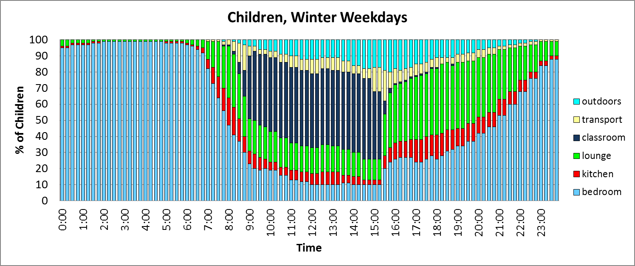

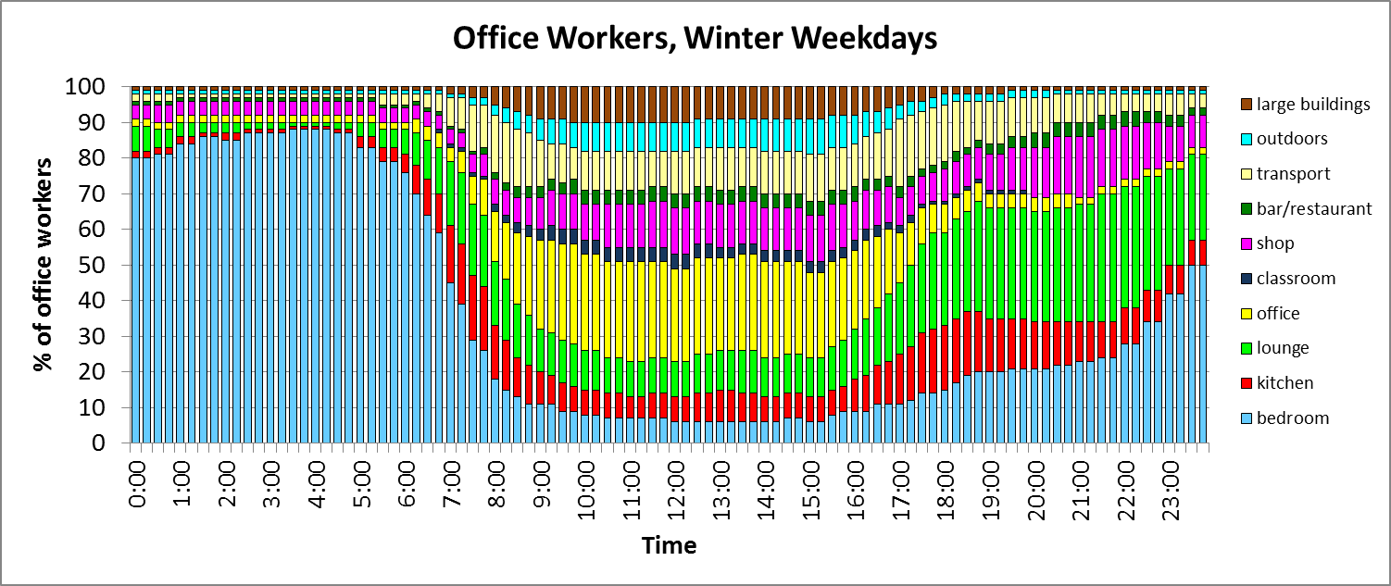

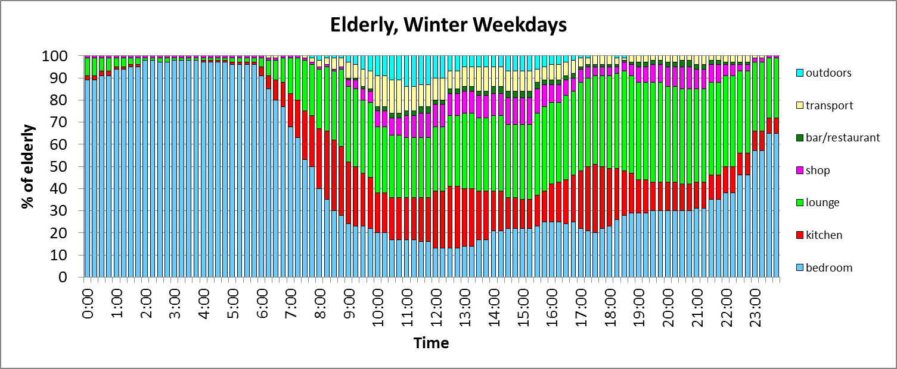

**Figure 1.** General time-activity profiles of school-going children, office workers and the elderly in winter weekdays.

**2.3 Microenvironmental model (INDAIR-2)**

*2.3.1 Overview*

The original INDAIR model is a probabilistic micro-environmental model, which simulates analytically the frequency distributions of indoor air pollutant concentrations in the three major home microenvironments (MEs), kitchen, lounge and bedroom (Dimitroulopoulou et al., 2006). INDAIR uses an assumed fixed activity pattern for smoking and cooking, and so cannot capture the range of activities in different homes over the course of the day. INDAIR also incorporates only one outdoor concentration profile, and cannot simulate exposure over the range of outdoor concentrations across an urban population. The INDAIR-2 model is more flexible, including variation in cooking and smoking activity across the population, over the course of a day and has been expanded to include up to 20 no-source and source MEs. INDAIR-2 also simulates indoor concentrations as a function of different outdoor concentration profiles (Section 2.3.2), according to the location of the microenvironments.

INDAIR-2 predicts the concentrations in indoor given ME (Cin) from the outdoor concentration (Cout) using four regression coefficients:

log.Cin = b0 + b1 + b2 + b3*log.Cout Eq 1

In the absence of indoor sources, the coefficients b0 and b3 define the relationship between indoor and outdoor concentrations, with b1 and b2 set to zero. In the presence of sources, the coefficients b1 and b2 describe the incremental effect of different activities (e.g. cooking and smoking) on the modelled concentrations, assuming this effect is independent of that of outdoor air penetration. Each coefficient is defined as a probability function and can be varied over the day, to reflect different levels of activity. The original INDAIR model was used to derive these regression coefficients for three generic home MEs (kitchen, living room and bedroom). In addition the model was parameterised using published data for the MEs transport, school, office, shops and large buildings, and bars and restaurants.

### 2.3.2 Regression Coefficients – Parameterisation for residential MEs

*No sources.* Results from the original INDAIR model (Dimitroulopoulou et al., 2006), using the original probability distributions of room size, air exchange rate, and deposition velocity, were used to derive the home regression coefficients for INDAIR-2; for details of these parameter values, refer to Dimitroulopoulou et al. (2006). Initially, the probabilistic indoor/outdoor relationships for no indoor source scenarios were defined. Since the outdoor concentrations were log-normally distributed, values of Cin and Cout were expressed on a logarithmic basis; in this case, b3 in Equation 1 takes a value of 1, and b0 expresses the log-transformed indoor/outdoor ratio. The results showed a linear relationship between log-transformed outdoor and indoor concentrations, with high values of R2 (typically explaining 98% or more of the variation).

Table 1 gives the fitted value of bo and its standard deviation (sd) for NO2, for different home MEs, in summer and winter. The more negative values in winter reflect the lower air exchange rate, which leads to a lower indoor/outdoor ratio. The more negative value for the bedroom reflect the smaller room size, greater surface area/volume ratio, and hence greater loss through deposition, leading to a lower indoor/outdoor ratio.

**Table 1.** Intercepts (with standard deviations) between log values of NO2 indoor and outdoor concentrations for three rooms in the residential ME (winter/summer). The values were generated by running the INDAIR model with a no source scenario.

|  |  |  |  |  |  |  |
| --- | --- | --- | --- | --- | --- | --- |
|  | **Summer** | | | **Winter** | | |
|  | **lounge** | **kitchen** | **bedroom** | **lounge** | **kitchen** | **bedroom** |
| bo | -0.4727 | -0.4695 | -0.5215 | -0.6647 | -0.6249 | -0.7215 |
| Sd | 0.1420 | 0.1715 | 0.2033 | 0.1885 | 0.2230 | 0.2598 |

*Cooking sources.* For each time-step of the model, the frequency distributions of additional concentrations that result from the cooking activity were constructed from the original INDAIR model, using the emission rates described by Dimitroulopoulou et al. (2006). The results showed that concentrations due to cooking activity, expressed as the difference from the no-source simulations, are effectively independent of both time of day and outdoor concentrations. The duration and timing of cooking activity for each season and day-of the-week was derived from the BBC Survey for Daily Life (see Section 2.2), based on when each group was in the kitchen preparing food. In the case of children, the time-activity data for housewives (data not shown) was used; this group spent significantly more time in the kitchen than the children themselves.

*c. Smoking sources.* Using the same approach, geometric means and SD of the regression coefficients for pollutants from smoking were calculated (data not shown), using the emission rates per cigarette described by Dimitroulopoulou et al. (2006). The assumptions made about smoking activity at home were based on the Living in Britain General Household Survey 2001 (ONS, 2001), which indicates that 27% of both men and women smoke on average 15 cigarettes per day.

*2.3.3 Parameterisation for non-residential MEs*

The original INDAIR model parameterisation did not allow explicit simulations for non-residential MEs. Therefore, these parameters were derived from an analysis of measurement data from published sources mainly from the UK and northern Europe. Unpublished sources were also used, after appropriate quality evaluation of measurement method and sample size. ME/outdoor ratios derived from UK studies and used in model parameterisation were 0.75 (sd 0.12) for schools, offices, and shops and large buildings, 1.0 (s.d. 0.25) for bars and restaurants, and 1.25 (s.d 0.12) for transport (e.g. Field et al., 1992; Hoskins, et al., 1993; Ekberg, 1995; Colbeck, 1998; Drakou et al., 1998; Kukadia and Palmer,1998; Lee and Chang, 1999; Janssen et al., 2001; Harrison et al., 2002; Dimitroulopoulou, 2003; Lai et al., 2004; Sorensen et al., 2005; Van Roosbroeck, et al., 2007; Kornartit et al., 2010; Challoner and Gill, 2014).

**3. Application of EXPAIR model in Leicester**

As described above, the only specific data parameterisation needed to apply the INDAIR-2/EXPAIR model to the city of Leicester was to define the outdoor NO2 concentrations and ME locations for different zones within the city. The division into zones was based on a detailed traffic flow model for the city, using the TRIPS (Transport Improvement Planning System) model; traffic data from TRIPS were used to divide the road network (53,000 links) into four types, based on detailed data on traffic characteristics and fleet composition, as described in Chen et al. (2008). These were used to define four zones, as follows:

* Road type 1: urban background/town roads with only car traffic;
* Road type 2: Urban roads with low HGV(Heavy Goods Vehicles) flows;
* Road type 3: Urban roads with medium HGV flows;
* Road type 4: Urban roads with high HGV flows.

*3.1 Assignment of outdoor concentrations to zones*

Log-normal frequency distributions were then derived for NO2 concentrations, for summer and winter, and weekdays and weekend, from appropriate monitoring sites. For road type 1, data from only one site was available - the Leicester urban background site in the UK Automatic Urban and Rural Monitoring Network (AURN). For the other three road types, data from 10 roadside pollution monitors were used, with all the data from monitors within a given road type being combined to define the frequency distribution of concentrations at each time step. The summary statistics for the NO2 concentrations are given in Table 2, which shows the increasing concentrations with increasing traffic flows, and higher concentrations in winter compared with summer, and weekdays compared to weekends. All data fitted a log-normal distribution, and are summarised as values of geometric mean and standard deviation in Table 2.

**Table 2.** Summary statistics for NO2 concentrations (ppb), for four road types in Leicester shown as geometric mean ( geometric standard deviation).) [Type 1 – urban background; Type 2 – low HGV content; Type 3 – medium HGV content; Type 4 – high HGV content]

|  |  |  |  |  |
| --- | --- | --- | --- | --- |
| Road Type | 1 | 2 | 3 | 4 |
| Winter/weekday | 19.97 (1.65) | 22.41 (1.53) | 28.11 (1.40) | 33.11 (1.42) |
| Winter/weekend | 16.61 (1.72) | 19.49 (1.56) | 26.15 (1.40) | 27.52 (1.33) |
| Summer/weekday | 14.44 (1.65) | 17.68 (1.75) | 25.24 (1.85) | 34.48 (1.47) |
| Summer/weekend | 10.62 (1.75) | 14.03 (1.84) | 22.01 (1.93) | 29.73 (1.54) |

*3.2 Assignment of MEs to zones*

As explained in Section 2.2, each ME within the INDAIR/EXPAIR model then needs to be divided between these four zones, as defined by dominant road types, using mapped data showing the assignment of road links to road type. Table 3 summarises the division of Leicester between the four zones, for each ME.

For schools and bars, the number of premises on each road type was counted individually, while for offices and shops, zones within the Leicester land-use map were used; this showed that both types of premise tend to be found at similar locations. Homes within the TRIPS network were apportioned according to the number of TRIP links; we also assigned the roads across Leicester which lie outside the TRIPS network to road type 1, assuming all were residential. In the case of buses, the total length of bus routes with the four road types was calculated from bus route maps while for cars, traffic flow data from the AQMA database was used to distribute vehicles across the four road types. A much higher proportion of bus and car MEs are on road types with higher concentrations of NO2. This mix of method means that assignation of some MEs to zone (e.g. transport, schools and bars) is more precise than others (e.g. offices, shops), which are based on broad land-use maps.

**Table 3.** Distribution of microenvironments (proportion of MEs) across the four different road types[Type 1 – urban background; Type 2 – low HGV content; Type 3 – medium HGV content; Type 4 – high HGV content]

|  |  |  |  |  |  |
| --- | --- | --- | --- | --- | --- |
| **ME** | **Method of road type distribution** | **Road type** | | | |
| **1** | **2** | **3** | **4** |
| Schools | TRIPS links | 0.43 | 0.31 | 0.14 | 0.12 |
| Shops | TRIPS links | 0.41 | 0.34 | 0.06 | 0.19 |
| Bars | TRIPS links | 0.25 | 0.43 | 0.09 | 0.23 |
| Offices | TRIPS links | 0.41 | 0.34 | 0.06 | 0.19 |
| Homes | Total road length in Leicester/TRIPS links | 0.48 | 0.22 | 0.18 | 0.12 |
| Buses | Length bus routes | 0.02 | 0.46 | 0.17 | 0.35 |
| Cars | AQMS traffic flow | 0.07 | 0.29 | 0.16 | 0.48 |

*3.4 Simulated changes in emissions*

There are a wide range of potential policy interventions that could be considered using the INDAIR-2/EXPAIR modelling framework. Here, we illustrate two hypothetical policy interventions, in order to compare the effects of reduced indoor and outdoor concentrations in the two population groups:-

1. The removal of all home sources of NO2 in the INDAIR-2 model, specifically gas cooking and smoking.
2. Reduction of all roadside concentrations to ensure that, on average, they meet current air quality objectives within the UK National Air Quality Strategy. Rather than create a detailed probabilistic analysis, we identified that annual mean concentrations on road type 2 were approximately equal to proposed air quality guidelines, while mean concentrations at the two road categories with medium and high HGV were above these guidelines. Therefore, for this assessment, the frequency distributions of the outdoor concentrations for road types 3 and 4 were changed to those of road type 2.

**4. Results from EXPAIR modelling**

*4.1 Comparison of population group exposures*

Figure 2 shows a comparison of the temporal variation in mean personal exposure for the three population groups, for winter weekdays. Concentrations at the urban background monitoring site, which was used to define road type 1, are included for comparison.

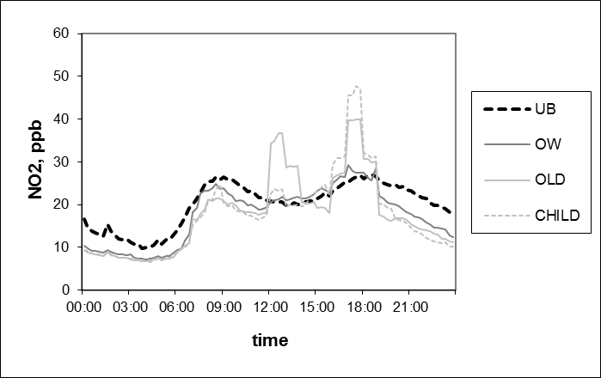

##### **Figure 2.** Diurnal variation (arithmetic means) of personal exposure to NO2 for office workers (OW), elderly (OLD) and children (CHILD) on winter weekdays. Urban background (UB) concentrations are shown for comparison; these are taken from the Leicester AURN monitoring site and represent outdoor concentrations for road type 1.

In the early morning and late evening, when a large proportion of all the population groups are at home, their mean exposures are very similar, and tend to track the urban background concentrations, with mean exposure being generally less than the urban background concentration. During the daytime, the exposure patterns reflect a more complex set of phenomena. At this level of resolution, the dominant factors influencing differences between the three groups are time-activity patterns and source activity in the home. Mean NO2 exposures remain lower than urban background concentrations, apart from periods with the greatest cooking activity; mean exposures of office workers during these periods are lower than for the other groups, as a smaller proportion of individuals are at home.

Within the EXPAIR model, the PEFD is simulated at each time step. Figure 3 presents snapshots of NO2 cumulative frequency distributions at selected times on winter weekdays, contrasting PEFDs produced using INDAIR simulations with and without sources of NO2 in the home. The results are compared for a group (the elderly) who spend most of their time at home and a group (office workers) who are away from the home for most of the day.

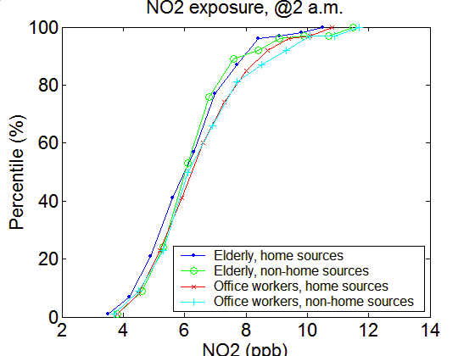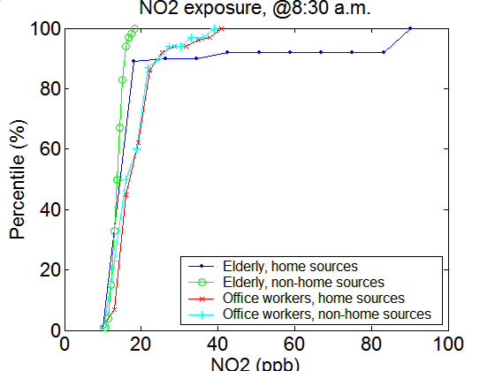

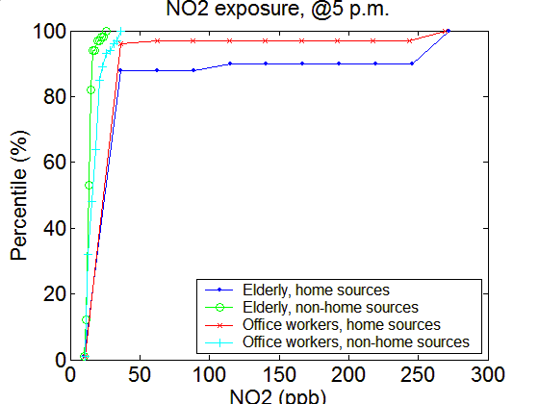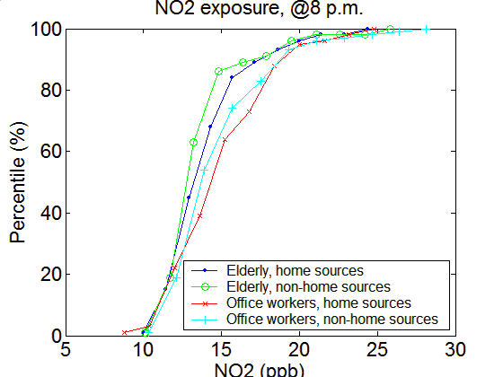

Figure 3. Cumulative frequency distributions of exposures to NO2, for elderly and office workers (urban background, winter weekdays), at selected times of day. Note that the scale of the x axis varies between the different diagrams

Early in the morning, the cumulative frequency distributions of exposures of both groups were similar and low. With no home sources at other times of day, exposures of office workers were generally higher; this was particularly marked at 08.30, due to the high numbers of office workers who are commuting. With home sources active during the day, in contrast, there is a much greater proportion of the elderly exposed to the highest NO2 concentrations, reflecting the much greater proportion of this population group who remain in the home during the day. Note that a small proportion of office workers do experience high NO2 concentrations during the day; this can be attributed to home exposure, because our time-activity profiles are not based on a generic working day, but include the fact that a small proportion of those with office jobs may be at home on a particular day.

*4.2 Effect of interventions: comparison of mean and 95%ile values of PEFDs*

The diurnal time course of the simulated PEFDs is shown in Figure 4, in terms of both mean concentrations and the 95%ile of the PEFD. Results are shown for children and the elderly, the groups thought to be at high risk from health impacts of air pollution, using winter weekday concentrations as an example. The PEFD values are also compared with the urban background concentrations, and the effects of removing indoor sources and reducing outdoor concentrations are also illustrated.

Figures 4a and 4b show that the mean values of the PEFD are below the urban background concentrations at all times, except when cooking and commuting activity is high. In contrast, the 95%ile of the PEFD is similar to the urban background concentration during the night, and significantly above it during the day. The effect of cooking activity on the midday and early evening peaks for the elderly is particularly marked, while the children also show a sharp early morning peak associated with travel to school. The large variation in the impacts of indoor source activity within the two population groups during the day leads to a difference between the mean population exposure and the 95%ile population exposure that is much greater than during the night, when most individuals of both groups are at home with no source activity

Figure 4c and 4d show the effect of reducing outdoor concentrations on road types 3 and 4. Mean and 95%ile exposures for both groups appear visually to be only reduced slightly compared to the baseline scenario, because the reduction in outdoor concentrations on both mean and 95%ile PEFD values is masked by the effects of indoor sources. However, there is a small but clear reduction in mean exposure compared to urban background concentrations when there is little home source activity.

With no home source activity, as shown in Figures 4e and 4f, both mean and 95%ile exposures are substantially reduced for both groups (note the different y axis scale used in these figures). Removal of home sources also reveals the impact on exposure to NO2 of temporal variation in roadside concentrations, with peaks, especially in 95%ile exposures, occurring at the two main rush hour times. The much greater difference in outdoor concentrations, and the greater variety of locations and activities among the children, led to much greater values of the 95%ile values compared to the means at these times of day.

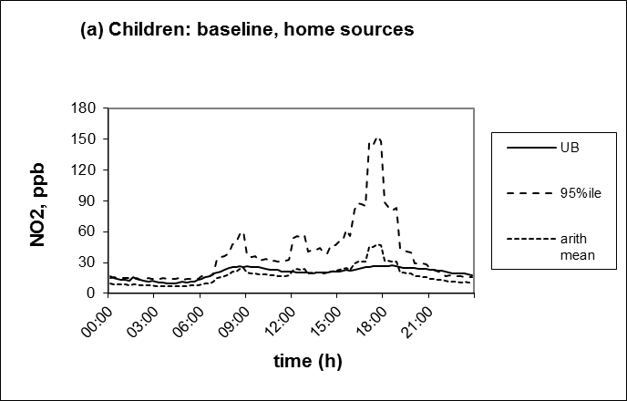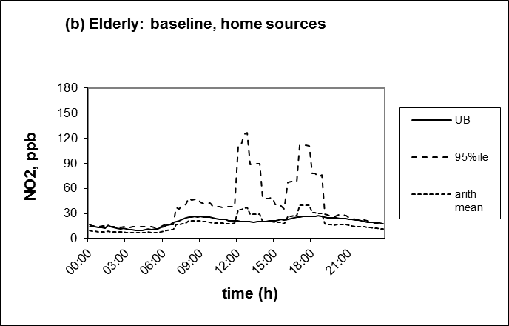

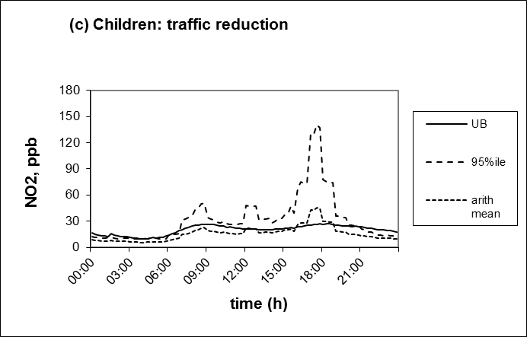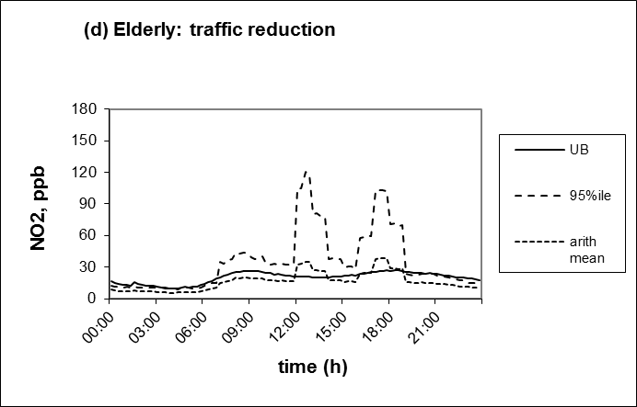

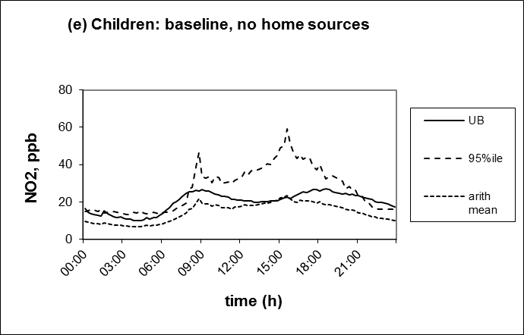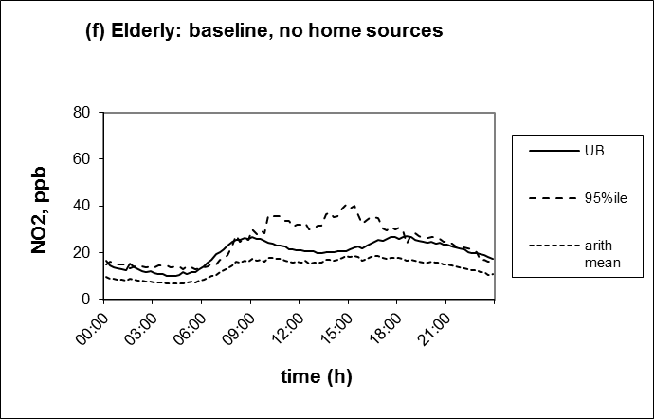

**Figure 4.** Simulated exposure profiles to NO2 for children and the elderly in winter weekdays, showing the arithmetic mean exposures, and the 95%ile of the population exposure at each time. The values at the urban background location are shown for comparison. (a) values for children under baseline conditions; (c) values for children with roadside concentrations reduced to meet air quality guidelines; (e) values for children with no home source emissions; (b) values for elderly under baseline conditions; (d) values for elderly with roadside concentrations reduced to meet air quality guidelines; (f) values for elderly with no home source emissions. Note that the scale of the y axis is different in (e) and (f) compared to (a), (b), (c), (d).

*4.3 Effect of interventions on seasonal mean population exposures*

Table 4 provides a comparison of the effects of the two policy interventions on the seasonal mean value of the PEFD for the three population groups, comparing summer/winter and weekday/weekend. The values are compared with the mean urban background concentrations for the same season and day of the week, to provide PE/UB (personal exposure/urban background) ratios for comparison. Values are not provided for the 95%ile PEFD value, because the INDAIR/EXPAIR model is designed to simulate time-activity profiles across a population, and not for specific individuals; the personal exposure of any individual within the population may lie at different percentiles at different times of day. Hence the 95%ile of the mean of all the individual 24h mean personal exposures within the population is likely to be different from (lower than) the mean of the population 95%ile values at each 15 min interval, because the same individuals would not be in the upper 5%ile of NO2 exposure at each 15min interval. In contrast, at each 15min interval, we capture the PEFD of the whole population, and averaging all these values give an unbiased estimate of the mean value of the PEFD over the day.

**Table 4.** Seasonal mean NO2 personal exposures (PE) of the elderly, children and office workers and their ratios to urban background (UB) concentrations (PE/UB), under baseline conditions, and with no home sources (NHS) and reduced road concentrations (RR)

|  |  |  |  |  |  |  |  |  |
| --- | --- | --- | --- | --- | --- | --- | --- | --- |
|  | Winter weekday | | Winter weekend | | Summer weekday | | Summer weekend | |
| **mean** | **PE/UB** | **mean** | **PE/UB** | **mean** | **PE/UB** | **mean** | PE/UB |
| *Office workers*  Baseline  NHS  RR | 14.6  14.2  13.2 | 0.73  0.71  0.66 | 12.6  12.5  11.6 | 0.76  0.75  0.70 | 13.7  13.4  12.3 | 0.95  0.93  0.85 | 10.8  10.6  9.5 | 1.02  1.00  0.90 |
| *Children*  Baseline  NHS  RR | 13.3  12.6  12.2 | 0.67  0.63  0.61 | 15.8  11.0  9.9 | 0.95  0.66  0.60 | 15.2  11.9  10.1 | 1.05  0.83  0.70 | 12.6  9.4  8.6 | 1.19  0.89  0.81 |
| *Elderly*  Baseline  NHS  RR | 13.4  12.1  11.0 | 0.67  0.61  0.55 | 12.0  10.5  9.5 | 0.72  0.63  0.57 | 12.7  11.7  10.0 | 0.88  0.81  0.69 | 10.1  9.1  7.6 | 0.95  0.86  0.72 |
| UB | 19.9 |  | 16.6 |  | 14.4 |  | 10.6 |  |

For both office workers and the elderly, and children in summer, weekend mean exposures were lower than weekday exposures, reflecting the lower ambient concentrations, especially on the heavily trafficked roads (Table 2). However, for children with home sources in winter, weekend seasonal mean exposures were higher, reflecting the greater time spent at home, rather than at school. The PE/UB ratios were consistently higher in summer than in winter, reflecting the higher air exchange rates that are assumed in the INDAIR model in summer than winter, leading to higher NO2 infiltration into the home, where all three groups spend the majority of their time. Despite the higher exposure of the elderly at times when home sources are on, higher 24h mean exposures to NO2 were calculated for office workers, both in the presence and absence of home sources. This reflects the time that office workers spend in MEs with higher pollutant levels than occur in the home during the long periods of time when there are no active source of NO2.

Table 4 shows that the effect of removing home sources on seasonal mean NO2 exposure was small for the office workers (0.1-0.4 ppb, depending on season/day), compared with children (0.7-4.8 depending on season/day) and the elderly (1.0-1.5 ppb, depending on the season/day), reflecting the much lower time spent exposed to home emissions. The greater variability in the exposure benefit for children compared to the elderly is likely to reflect the greater variability in their time-activity patterns between seasons and days of the week, compared to the elderly.

In every case, the reduced concentrations on road types 3 and 4 had a greater effect on 24h mean NO2 exposure than did the removal of home sources (Table 4). The reduction was lower for office workers (1.0-1.1ppb, depending on season/day) that for children (1.1-5.9 ppb, depending on season/day), and the elderly (2.4-2.7ppb, depending on season/day). The greater variability for children compared with both office workers and the elderly again is likely to be due to the greater variation in their activity patterns.

*4.4 Effect of interventions on maximum 1h population mean exposures*

Table 5 shows a similar summary as for Table 4 for the maximum hourly value of the mean PEFD over the course of the day. PE/UB values were not calculated in this case, as the peaks of personal exposure and urban background may not occur at the same time. On winter weekdays, in the baseline scenario, the value for children was about 48ppb, compared with 40ppb for the elderly, while that of office workers was only about 27ppb; these are the values that are shown in Figure 2.

**Table 5** Values of the highest 1h mean of the PEFD NO2 exposure (ppb) over the course of a day for the elderly, children and office workers for summer and winter, and weekend and weekdays, for baseline conditions and with no home sources (NHS) and reduced road concentrations (RR)

|  |  |  |  |  |
| --- | --- | --- | --- | --- |
|  | Winter  weekday | Winter  weekend | Summer weekday | Summer weekend |
| *Office workers*  Baseline  NHS  RR | 27.4  23.4  24.5 | 21.8  19.1  20.1 | 24.5  21.9  22.1 | 19.2  18.0  18.5 |
| *Children*  Baseline  NHS  RR | 47.7  22.8  45.1 | 113.0  19.5  111.0 | 88.2  22.6  85.8 | 64.2  16.9  63.1 |
| *Elderly*  Baseline  NHS  RR | 39.9  18.6  38.1 | 39.7  15.8  38.1 | 33.8  18.4  32.1 | 29.6  14.1  28.2 |

Reduced outdoor concentration on road types 3 and 4 had very little effect on the maximum hourly mean exposure for any of three population groups on winter weekdays; the reductions ranged from 0.7ppb to 2.9ppb. The reductions tended to be lower at weekends than weekdays, because of the lower baseline concentrations on these road types at weekends (Table 2).

In contrast, the removal of home sources had very different effects on the three population groups. The effect on the maximum hourly mean NO2 exposure of office workers was relatively small, reducing it by values between 1.2ppb and 4ppb. The benefit of this intervention for office workers was only between 0.2ppb and 1ppb greater than that of reducing road concentrations. This mainly reflects the lower amount of time, compared to other groups, spent at home by office workers, including during cooking activity.

In contrast, for elderly and children, the effect of removal of home sources was much greater than that of reducing road concentrations. Without home sources, the mean 1h NO2 exposures for children were comparable to those of office workers, with rather lower values for the elderly, who largely remained at home, where the exposure peaks due to outdoor NO2 were buffered. The size of the reductions with no home sources for these two groups in different seasons and on different days of the week largely reflected the magnitude of the predicted baseline exposures.

For the elderly, the maximum 1h mean NO2 exposures were comparable at winter weekends and weekdays, but were a little lower in summer, reflecting the lower duration or frequency of cooking and the increased air exchange rate. For children, the maximum 1h mean NO2 exposure showed a much larger variation, with values that were consistently greater than those of the elderly, reflecting the greater cooking activity assumed in family homes than in those occupied by the elderly. The highest value for children (113 ppb) was on winter weekends, when children spend more of their time in the home, air exchange rates are low, and the duration of cooking to prepare family meals is high.

*4.5 Relationship between urban background concentrations and population exposure*

The population exposure simulations described above were based on the frequency distributions of measured NO2 concentrations at roadside monitors over a season. In order to assess how day-to-day variation in population exposure is related to day-to-day variation in outdoor concentrations, we simulated PEFDs for days on which the 24h mean concentration was at the 50%ile, 95%ile and 99%ile of the seasonal frequency distributions. We applied the same percentiles for all four road categories, and assumed that the diurnal variation of NO2 concentration on these days followed that of the seasonal mean.

The relationships derived are shown in Figure 5 for the elderly, who were selected as being of greatest concern in terms of health impacts. The mean of the PEFD and the 95 percentile of the PEFD are presented on the left-hand side (a, c, e) and right-hand side (b, d, f) respectively. As noted above, the individuals in the 95%ile of the PEFD at each time interval may be different, whereas the simulated values in Figure 5 assume that they are; hence they can be considered as the highest possible 95%ile exposures.



**Figure 5**. Daily mean NO2 population exposures for the elderly over a range of urban background (UB) concentrations during winter and summer weekdays (♦/■) and weekends (▲/x). Mean exposures (a, c, e) and the respective 95 percentiles (b, d, f) of the population exposure frequency distributions are shown with home cooking and smoking sources for the baseline scenario (a,b), home sources and NAQS traffic policy intervention (c,d), and with no home sources for the baseline scenario (e,f). Regression lines are fitted for winter and summer exposure values.

All the relationships between urban background concentrations and PEFD parameters were linear with a high value of R2 (Figure 5). The fitted lines were similar for weekend and weekday for the elderly, reflecting the fact that there are no large differences in their activity patterns; this would not necessarily apply to population groups in routine weekly work or education. There were large seasonal differences in the fitted lines; for outdoor concentrations above the 50%ile, population exposure was higher in summer than in winter, primarily due to the higher air exchange rates assumed in homes allowing increased infiltration of road traffic pollution. Although activity profiles lead to a greater proportion of time outdoors in the summer months, this is likely to be a relatively small factor in comparison.

### The positive intercepts on the y axis are greatest with home sources present, in winter, and for the 95%ile exposure, reflecting the greater influence of home sources on peak exposure and in winter.

### In a few cases, a small negative intercept was found, but this was non-significant and due to combining data for weekends and weekdays. With home sources present, the fitted lines imply that NO2 exposures in winter are somewhat higher than in summer at outdoor concentrations below 50%ile; this reflects the lower air exchange rates in winter leading to higher indoor concentrations, and hence higher mean and 95%ile exposure, due to indoor sources. In contrast, with no home sources, and exposure dominated by outdoor sources, summer exposure is greater than that in winter across the whole range of ambient concentrations, reflecting the greater indoor penetration. The effects of the AQM and no home source scenarios are comparable in summer, but the no home source scenario has a greater effect in winter. This reflects the greater air exchange rate and greater time spent outdoors in summer, which mean that policies to reduce outdoor concentrations have a much greater effect on exposure in summer.

**5. Discussion**

*5.1 Model evaluation*

This paper has described the development and application of a novel modelling framework that allows the effects of different policy interventions to be assessed in terms of the frequency distribution of exposures within a population. The modelling framework has a relatively simple empirical approach which can readily be adapted to different applications and different locations. We first consider the validity, limitations and the advantages of this modelling approach, before discussing the health and policy implications of our findings.

A formal validation of the results of the various simulations presented in this paper would require a very detailed personal monitoring campaign using a population-based sample. One independent validation of the INDAIR/EXPAIR modelling framework for NO2 has been carried out (Molter et al., 2012). This study compared measured personal exposures in a sample of 46 schoolchildren in Manchester with home exposures modelled from INDAIR using home questionnaire data, and a GIS-based estimate of outdoor concentrations at home, at school and during travel between them for each child. The results showed excellent agreement in geometric 48h mean concentration between the EXPAIR model predictions and measurements using a personal sampler, with a significant positive rank correlation between model predictions and measured exposure, although there were differences between modelled and measured exposures for individual children. These results provide confidence in the modelled mean exposures at a population level, at least for children. Furthermore, the ratios of personal exposure to urban background concentrations for NO2 for office workers predicted by our study (approximately 0.7 in winter and 0.9 in winter) are very similar to measured values for UK office workers reported by Kornartit et al. (2010). They are also similar to values reported for UK office workers by Crump et al. (1998), although Lai et al. (2004) reported a slightly higher value of 1.05 on an annual basis.

No UK studies to our knowledge have reported 1h peak personal exposures to NO2 in a large population, and hence it is not possible to assess the validity of the high peak exposures that are predicted inside the home. Delgado-Saborit (2012) reported personal exposures to NO2 in a limited monitoring campaign in Birmingham, and reported that instantaneous peaks during cooking reached a peak of 800ppb; however, these were exposures experienced by individuals in the process of cooking, whereas we simulated the mean concentration in the kitchen. Franklin et al. (2006) reported a peak to average ratio in Australian kitchens with gas cooking of 7.8 (range 2.8-13.0), a value consistent with our INDAIR simulations. Logue et al. (2014) used a mass balance model to simulate the influence of gas cooking on indoor NO2 concentrations in Californian homes, and found the highest daily 1h mean concentrations averaged between 80 and 180ppb; our highest 1h mean concentrations simulated in INDAIR are within this range. Overall, therefore, while we cannot validate our peak exposure estimates in the home, they are consistent with the range of values that have been reported in other measurement and modelling studies.

The indoor concentration simulations in INDAIR/EXPAIR use simple regression equations to predict the impact of different levels of cooking activity and different levels of air exchange rate; this approach allows us to quickly assess the effect of different interventions etc. on PEFDs without the need to apply the detailed INDAIR model. A similar flexible approach underpinned by a detailed mechanistic model was adopted by Fabian et al (2012) who used the CONTAM model parameterised for a complex multi-family apartment building to explicitly simulate indoor PM2.5 and NO2 concentrations, and then derived simple regression equations from the output to allow the effects of different interventions and assumptions to be rapidly assessed. Other models which incorporate a mass balance approach (e.g. Physick et al 2008; Fabian et al., 2012; Logue et al., 2014) estimate an indoor-outdoor ratio for the whole home, and then apply this to estimate daily mean concentrations. Such an approach does not allow differences in human and source activity within the home, or short-term variations in exposure, to be simulated. The EXPAIR model allows us to simulate not only 24h mean personal exposures, but also simulate the PEFDs over averaging times of an hour or less, and the INDAIR/EXPAIR framework therefore provides one of the most advanced modelling tools available internationally to assess the contribution of different sources and microenvironments to exposure on a population basis.

Nevertheless, the model has a number of limitations that derive (a) from model assumptions and structure, and (b) from limitations of the input data. The most important of the former is that the activity database does not describe the precise geographical location of activities, and consequently the model is run using outdoor concentrations from measurement sites which are representative of a wider area of the urban road network. With more geographically explicit information, rather than the limited number of generic zones in our application, it would be possible to make the micro-environmental library produced by INDAIR more location-specific, and hence to produce improved estimates of exposure. The second important limitation is the method of probabilistic sampling of microenvironments. The EXPAIR model is not designed simulate the time-activity patterns of specific individuals, and, for this reason, while the model can provide PEFDs for a particular point in time, it cannot provide the 24h mean PEFD for individuals within the whole population.

The validity of the PEFDs depends on the validity of the frequency distributions of microenvironmental concentrations. For the home, these largely relate to assumptions in the INDAIR model, which are discussed by Dimitroulopoulou et al. (2006). However, for non-home locations, there are very few data for the UK to define the appropriate probability density functions, creating a significant source of uncertainty. For mean exposures, uncertainties related to modelled concentrations for the home, and for work and school, will be most important because of the time spent in these locations. However, for peak exposures, other locations such as transport may be more important. The PEFDs also depend on the validity of the time-activity profiles for each population group. The BBC survey, which we have used, is the most comprehensive dataset which is available for the UK population, but is designed for information on viewing and listening habits, making assumptions necessary to adapt it for pollution modelling. Some aspects of time-activity may also have changed since this survey was conducted, but these are unlikely to alter the broad exposure patterns that we describe.

Given these limitations, and the fact that the model is only parameterised for one UK city, it would be inappropriate to make categorical and quantitative statements about the effects of specific policy measures on population exposure from the results of this study. However, there are important general features of our findings that we believe are likely to be relevant to other cities of a similar size to Leicester, which has a population of about 300,000. In contrast, for megacities, such as London in the case of the UK, with a population almost 10 million within its administrative boundaries and a further several million in its immediate vicinity, the size of the population and the road network would add significant additional complexity to the exercise, meaning that some features of our findings may not be directly transferable. It should also be noted our model parameterisation is only for people who both live and work within the city’s administrative boundaries; for some population groups, a more flexible approach considering commuting across the boundary, might be needed. Detailed spatio-temporal models of outdoor pollutant exposure have been developed in London, that can be linked to human time-activity data (Beevers et al, 2013), but these, unlike the INDAIR/EXPAIR framework, are not yet linked to indoor exposure.

*5.2 Health and policy implications*

Our modelling approach allowed us to assess the impact of home sources on the mean exposures of three population groups. Although significantly elevated concentrations of NO2 were modelled by INDAIR-2 during cooking activity, the effect of removing home sources on the mean exposure of the office workers was very small – typically decreasing mean exposure by less than 5%. Even for the elderly, who spend the majority of their time in the home, the effect was relatively small, between 8% and 15%. For children, there was a wider variability; on weekdays, when their activity pattern was comparable to office workers, the effect was as low as 5%, but on winter weekends, when most of their time was spent in the home, and cooking activity was high, the effect reached 30%

However, these relatively small effects on mean population exposure disguise very large effects of home sources on the short-term exposure of the upper percentiles of the frequency distribution when sources are active and the majority of the population group are in the home. There is some evidence of the health effects of short-term variations in outdoor pollutant concentrations within a day. For example, McCreanor et al. (2007) found that 2h of walking along a busy street in central London caused a significant decrease in lung function in adults with moderate asthma compared with 2h of walking in a local park. For PM2.5, short-term increases in PM2.5 exposure in the course of a day’s normal activity can be associated with changes in cardiovascular function (He et al., 2010; Brook et al, 2011). If these effects are of clinical significance, there will be an increasing need for models such as EXPAIR that can simulate these shorter-term variations in population exposure over the course of a day.

We did not simulate the effect of specific measures to reduce NO2 home concentrations from indoor combustion sources, but some recent intervention studies could provide data to allow this to be done in the future. For example, Paulin et al. (2104) reported that installation of high efficiency filters in the room, and replacement of unvented gas cookers by electric cookers, significantly reduced kitchen and bedroom median NO2 concentration by about 50% and 20% respectively; however, installation of ventilation hoods over the cooker had no significant effect. Most studies of the health effects of gas cooking have only measured long-term NO2 exposure, but Smith et al (2000) showed a significant association for asthmatic children between variation in daily personal exposure in the home and the likelihood of symptoms. This suggests that effects of variations in time-activity on children’s exposure to short-term NO2 peaks due to gas cooking that are demonstrated in our simulations may be of health significance, at least for those with pre-existing respiratory disease. There is also evidence that controlled experimental studies that repeated exposure to the short-term peaks at NO2 concentrations within the range predicted by INDAIR/EXPAIR can have adverse effects, e.g. on sensitising the airways of asthmatics to inflammation caused by allergens (Barck et al., 2005) or on airway inflammation (Ezratty et al., 2014).

Two of the population groups for whom the model has been parameterised (children and the elderly) are identified as being at higher risk of adverse effects of ambient air pollution. However, the model has not specifically been parameterised for subjects with pre-existing respiratory or cardiovascular disease, in particular elderly subjects who may have quite different activity patterns. Furthermore, individuals with chronic cardiovascular or pulmonary disease who are susceptible to air pollution may modify their behaviour or take measures both to reduce outdoor infiltration and indoor sources, especially on days when high concentrations are predicted (Laumbach et al., 2015). More detailed assessment of this issue, based on time-activity data as well as measured exposure, would be useful to assess whether model parameterisation is appropriate for those with pre-existing disease.

The rate of penetration of roadside air pollution into indoor micro-environments, and in particular the home, has a strong influence on modelled population exposures, and many of the differences between seasons are due to differences in air exchange rate (Taylor et al., 2014). It is important to emphasise that, within the INDAIR model, there is a large variation in home air exchange rates, which reflected the real variation in the U.K. building stock when the INDAIR model was parameterised 15 years ago. Housing stock and building design is changing, and a trend towards low energy-efficient homes, with reduced air exchange rates and use of ventilation systems, may significantly reduce population exposure to traffic pollutants, but increase the impact of indoor sources, especially if people are not aware of how to use the ventilation systems (Shrubsole et al., 2012). More analysis is therefore needed of how are modelled PEFDs will change with changes in the UK housing stock.

In summary, there are many models which simulate the effects of policy interventions to reduce traffic emissions and transport policy on outdoor residential concentrations, and thus to quantify the health benefits. Although the importance of relating individual health outcomes to individual personal exposures, rather than outside pollutant concentrations measured at fixed monitoring stations, is widely recognised, the challenge of modelling the effect of policy interventions on the distribution of personal exposures within a population has received much less attention. We demonstrate here, for NO2, the subtle interactions between time-activity-location profiles of the three population and the frequency distributions of their exposure, and we expect similar effects for other pollutants. This paper has considered simple, hypothetical and illustrative interventions to demonstrate key features of the response of PEFDs across a city, but the concept of the PEFD, which is operationalized in the INDAIR/EXPAIR framework, has considerable potential for the evaluation of the effects of specific emission control policies, changes in life-style, alterations in building stock.

**Acknowledgements**

This work was supported by UK Department of Health. We also acknowledge the contribution of the Engineering and Physical Sciences Research Council (EPSRC) to the infrastructure of the Instrumented City Facility, which provided traffic and air pollution data, and Leicester City Council for providing input data for our analysis. We gratefully acknowledge the assistance of Matt Hill, and of two MSc students, at the University of Bradford, in developing the model parameterisation for Leicester.

**References**

Alm, S., Mukala, K., Pasanen, P., Tiittanen, P., Ruuskanen, J., Tuomisto, J., Jantunen M.J., 1998. Personal NO2 exposures of pre-school children in Helsinki. Journal of Exposure Analysis and Environmental Epidemiology, 8, 79-100.

Amaral, A.F.S., Ramasamy, A., Castro-Giner, F., Minelli, C., Accordini, S., Sørheim, I-C., Pin, I., Kogevinas, M., Jõgi, R., Balding, D.J., Norbäck, D., Verlato, G., Olivieri, M., Probst-Hensch, N., Janson, C., Zock, J-P, Heinrich, J., Jarvis D.L., 2014. Interaction between gas cooking and GSTM1 null genotype in bronchial responsiveness: results from the European Community Respiratory Survey. Thorax, 69, 558-564.

Atkinson, R.W., Kang, S., Anderson, H.R., Mills, I.C., Walton, H.A., 2014a. [Epidemiological time series studies of PM2.5 and daily mortality and hospital admissions: a systematic review and meta-analysis.](http://www.ncbi.nlm.nih.gov/pubmed/24706041) Thorax, 69, 660-665.

Atkinson, R.W., Mills, I.C., Walton, H.A., Anderson, H.R., 2014b. [Fine particle components and health-a systematic review and meta-analysis of epidemiological time series studies of daily mortality and hospital admissions.](http://www.ncbi.nlm.nih.gov/pubmed/25227730) Journal of Air and Waste Management Association, 25, 208-214.

Barck, C., Lundahl, J., Hallden, G., Bylin, G., 2005. Brief exposures to NO2 augment the allergic inflammation in asthmatics. Environment Research, 97, 58-66.

Beelen, R., Raaschou-Nielsen, O., Stafoggia, M., Andersen, Z.J., Weinmayr, G., Hoffmann, B., Wolf, K.,Samoli, E., Fischer, P., Nieuwenhuijsen, M., Vineis, P., Xun, W.W., Katsouyanni, K., Dimakopoulou, K., Oudin, A., Forsberg, B., Modig, L., Havulinna, A.S., Lanki, T., Turunen, A., Oftedal, B., Nystad, W., Nafstad, P., De Faire, U., Pedersen, N.L., Östenson, C.G., Fratiglioni, L., Penell, J., Korek, M., Pershagen, G., Eriksen, K.T., Overvad K., Ellermann, T., Eeftens, M., Peeters, P.H., Meliefste, K., Wang, M., Bueno-de-Mesquita, B., Sugiri, D., Krämer, U., Heinrich, J., de Hoogh, K., Key, T., Peters, A., Hampel, R., Concin, H., Nagel, G., Ineichen, A., Schaffner E., Probst-Hensch, N., Künzli, N., Schindler, C., Schikowski, T., Adam, M., Phuleria, H., Vilier, A., Clavel-Chapelon, F., Declercq, C., Grioni, S., Krogh, V., Tsai, M.Y., Ricceri, F., Sacerdote, C., Galassi, C., Migliore, E., Ranzi, A., Cesaroni, G., Badaloni, C., Forastiere, F., Tamayo, I., Amiano, P., Dorronsoro, M., Katsoulis, M., Trichopoulou, A., Brunekreef, B., Hoek, G., 2014. Effects of long-term exposure to air pollution on natural-cause mortality: An analysis of 22 European cohorts within the multicentre ESCAPE project. Lancet; 383, 785-795.

Beevers, S.D., Kiwiroon, N., Williams, M.L., Kelly, F.J., Anderson, H.R., Carslaw, D.C., 2013. Air pollution dispersion models for human exposure predictions in London. Journal of Exposure Analysis and Environmental Epidemiology, 23, 647-653

Belanger, K., Holford, T.R., Gent, J.F., Hill, M.E., Kezik, J.M., Leaderer, B.P., 2013. Household levels of nitrogen dioxide and pediatric asthma severity. Epidemiology, 24, 320-30.

Borrego, C., Sa΄, E., Monteiro, A., Ferreira, J., Miranda, A.I., 2009. Forecasting human exposure to atmospheric pollutants in Portugal – a modelling approach. Atmospheric Environment 43, 5796–5806.

Breysse, P.N., Diette, G.B., Matsui, E.C., Butz, A.M., Hansel, N.N., McCormack, M.C., 2010. Indoor air pollution and asthma in children. Proceedings of American Thoracic Society, 7, 102–106.

Brook, R.D., Bard, R.L., Burnett, R.T., Shin, H.H., Vette, A., Croghan, C., Phillips, M., Rodes, C., Thornburg, J., Williams, R., 2011. Differences in blood pressure and vascular responses associated with ambient fine particulate matter exposures measured at the personal versus community level. Occupational and Environmental Medicine, 68, 224-230.

Brown, K.W., Sarnat, J.A., Suh, H.H., Coull, B.A., Koutrakis, P., 2009. Factors influencing relationships between personal and ambient concentrations of gaseous and particulate pollutants. Science of the Total Environment 407, 3754-3765.

Burke J.M., Zufall, M.J., Ozkaynak, H., 2001. A population exposure model for particulate matter: case study results for PM2.5 in Philadelphia, PA. Journal of Exposure Analysis and Environmental Epidemiology, 11, 470-489.

Cesaroni, G., Badaloni, C., Gariazzo, C., Stafoggia, M., Sozzi, R. Davoli, M., Forastiere, F., 2013. Long-Term Exposure to Urban Air Pollution and Mortality in a Cohort of More than a Million Adults in Rome. Environ Health Perspect 121, 324-331, http:// dx.doi.org/10.1289/ehp.1205862

Challoner, A., Gill, L., 2014. Indoor/outdoor air pollution relationships in ten commercial buildings: PM2.5 and NO2. Building and Environment, 80, 159-173.

Chen, H., Namdeo, A., Bell, M., 2008. Classification of road traffic and roadside pollution concentrations for assessment of personal exposure. Journal of Environmental Modelling and Software 23, 282-287.

Colbeck, I.,1998. Nitrogen dioxide in the workplace environment. Environmental Monitoring and Assessment, 52, 123-130.

COMEAP, 2009 Committee on the Medical Effects of Air Pollutants. Statement on Quantification of the effects of long-term exposure to nitrogen dioxide on respiratory morbidity in children, Committee on the Medical Effects of Air Pollutants.

http://webarchive.nationalarchives.gov.uk/20140505104658/http://www.comeap.org.

uk/documents/statements

COMEAP, 2010 Committee on the Medical Effects of Air Pollutants. Mortality effects of long-term exposure to particulate air pollution in the UK. Available at: <https://www.gov.uk/government/publications/comeap-mortality-effects-of-long-term-exposure-to-particulate-air-pollution-in-the-uk>

COMEAP, 2015 Committee on the Medical Effects of Air Pollutants. Statement: The evidence for the effects of nitrogen dioxide on health, Available at: <https://www.gov.uk/government/publications/nitrogen-dioxide-health-effects-of-exposure>

Crump, D.R., Bland, B.H., Mann, H.S., Brown, V.M., 1998. Personal exposure to air pollutants in Hertfordshire. BRE Report No: CR 263/98.

Delfino, R.J., Staimer, N., Tjoa, T., Gillen, D., Kleinman, M.T., Sioutas, C., Cooper, D., 2008. Personal and ambient air pollution exposures and lung function decrements in children with asthma. Environmental Health Perspectives, 116, 550-558.

Delgado-Saborit, J.M., 2012. Use of real-time monitors to characterise human exposures to combustion related pollutants. Journal of Environmental Monitoring, 14, 1824-1837.

Dimitroulopoulou, C., Ashmore, M.R. Byrne, M. and Kinnersley, R., 2001. Modelling of indoor exposure to nitrogen dioxide in the UK. Atmospheric Environment, 35, 269-279.

Dimitroulopoulou, C., 2003. Private communication, BRE Client reports.

Dimitroulopoulou, C., Ashmore, M.R., Hill, M.T.R., Byrne, M., Kinnersley, R., 2006. INDAIR: a probabilistic model of indoor air pollution in the U.K. Atmospheric Environment 40, 6362–6379.

Drakou, G., Zerefos, C., Ziomas, I., Voyatzaki, M., 1998. Measurement and numerical simulations of indoor O3 and NOx in two different cases. Atmospheric Environment, 32, 595-610.

Edwards, R.D., Schweizer, C., Jantunen, M., Lai, H.K., Bayer-Oglesby, L., Katsouyanni, K., Nieuwenhuijsen, M., Saarela, K., Sram, R., Kunzli, N., 2005. Personal exposures to VOC at the upper end of the distribution – relationships to indoor outdoor and workplace concentrations. Atmospheric Environment 39, 2299-2307.

Edwards, R., Jantunen, M., 2009. Subgroups exposed to systematically different elemental compositions of PM2.5. Atmospheric Environment, 43, 3571-3578.

Ekberg, L.E., 1995. Concentrations of NO2 and other traffic related contaminants in office buildings located in urban environments. Building and Environment, 30, 293-298.

Ezratty, V., Guillossou, Neukirch, C., Dehoux, M., Koscielny, S., Bonay, M., Cabanes, P.-A., Samet, J.M., Mure, P., Ropert, L., Tokarek, S., Lambrozo, J., Aubier, M., 2014. Repeated nitrogen dioxide exposures and eosinophilic airway inflammation in asthmatics: a randomised crossover study. Environmental Health Perspectives, 122, 850-855.

Fabian, P., Adamkiewicz, G., Levy, J.I., 2012. Simulating indoor concentrations of NO2 and PM2.5 in multi-family housing for use in health-based intervention modelling. Indoor Air, 22, 12-23.

Faustini, A., Rapp, R., Forastiere, F., 2014. Nitrogen dioxide and mortality: review and meta-analysis of long-term studies. European Respiratory Journal, 44, 744-753.

Favarato, G., Anderson, H.R., Atkinson, R., Fuller, F., Mills, I., Walton, H., 2014. Traffic-related pollution and asthma prevalence in children. Quantification of associations with nitrogen dioxide. Air Quality and Atmospheric Health, 7, 459-466.

Field, R.A., Phillips, J.L., Goldstone, M.E., Lester, J.N., Perry, R., 1992. Indoor/outdoor interactions during an air pollution event in Central London. Environmental Technology, 13, 391-408.

Fischer, P. H., M. Marra, C. B. Ameling, G. Hoek, R. Beelen, K. de Hoogh, O. Breugelmans, H. Kruize, N. A. Janssen and D. Houthuijs, 2015. Air Pollution and mortality in seven million adults: The Dutch Environmental Longitudinal Study (DUELS). Environmental Health Perspectives, 123, 697-704.

Franklin, P., Runnion, T., Farrar, D., Dingle, P., 2006. Comparison of peak and average nitrogen dioxide concentrations inside homes. Atmospheric Environment, 40, 7449-7454.

Gariazzo, C., Lamberti, M., Hanninen, O., Silibello, C., Pelliccioni, A., Porta, D., Cecinato, A., Gherardi, M., Forastiere, F., 2015. Assessment of population exposure to Polycyclic Aromatic Hydrocarbons (PAHs) using integrated models and evaluation of uncertainties. Atmospheric Environment, 101, 235-245.

Gong, H., Linn, W.S., Clark, K.W., Anderson, K.R., Geller, M.D., Sioutas, C., 2005. Respiratory responses to exposures with fine particulates and nitrogen dioxide in the elderly with and without COPD. Inhalation Toxicology, 17, 123-132.

Hanninen, O., Kruize, H., Lebret, E., Jantunen, M., 2003. EXPOLIS simulation model: PM2.5 application and comparison to measurements. Journal of Exposure Analysis and Environmental Epidemiology 13, 75–85.

Harrison, R.M., Thornton, C.A., Lawrence, R.G., Mark, D., Kinnersley, R.P., Ayres, J.G., 2002. Personal exposure monitoring of particulate matter, nitrogen dioxide, and carbon monoxide, including susceptible groups. Occupational and Environmental Medicine, 59, 671–679.

He, W.R.F., Shaffer, M.L., Li, X., Rodriguez-Colon, S., Wolbrette, D.L., Williams, R., Cascio, W.E., Liao, D., 2010. Individual-level PM2.5 exposure and the time-course of impaired heart rate variability, the AFCAR study. Journal of Exposure Science and Environmental Epidemiology, 21, 65-73.

Hoskins, J.A., Brown R.C., Levy L.S., 1993. Current Levels of air contaminants in Europe: a review of real situations. Indoor Environment, 2, 246-256.

Janssen, N.A.H., van Vliet, P.H.N., Aarts, F., Harssema, H., Brunekreef, B., 2001. Assessment of exposure to traffic related air pollution of children attending schools near motorways. Atmospheric Environment, 35, 3875-3884.

Kim, D., Sass-Kortsak, A., Purdham, J.T., Dales, R.E., Brook, J.R., 2006. Associations between personal exposures and fixed-site ambient measurements of fine particulate matter, nitrogen dioxide, and carbon monoxide in Toronto, Canada. Journal of Exposure Science and Environmental Epidemiology 16, 172-183.

Kornatit, C., Sokhi, R.S., Burton, M.A., Ravindra, K., 2010. Activity pattern and personal exposure to nitrogen dioxide in indoor and outdoor microenvironments. Environment International, 36, 36-45.

Kousa, A., Monn, C., Rotko, T., Alm, S., Jantunen, M.J., 2001. Personal exposures to NO2 in the EXPOLIS study: relation to residential indoor, outdoor and workplace concentrations in Basel, Helsinki and Prague. Atmospheric Environment 35, 3405 – 3412.

Kruize, H., Hanninen, O., Breugelmans, O., Lebret, E., Jantunen, M., 2003. Description and demonstration of the EXPOLIS simulation model: two examples of modelling population exposure to particulate matter. Journal of Exposure Analysis and Environmental Epidemiology 13, 87–99.

Kukadia, V., Palmer, J., 1998. The effect of external atmospheric pollution on indoor air quality: a pilot study. Energy and Buildings, 27, 223-230.

Lai, H.K., Kendall, M., Ferrier, H., Lindup, I., Alm, S., Hanninen, O., Jantunen, M., Mathys, P., Colvile, M.R., Ashmore, M.R., Cullinan, P., Nieuwenhuijsen, M.J., 2004. Personal exposures and microenvironment concentrations of PM2.5, VOC, NO2 and CO in Oxford, UK. Atmospheric Environment 38, 6399-6410.

Laumback, R., Meng, Q., Kipen, H., 2015. What can individuals do to reduce personal xposure risks from air pollution? Journal of Thoracic Disease, 7, 96-107.

Lee, S.C., Chang, M., 1999. Indoor air quality investigations at five classrooms. Indoor Air, 9, 134-138.

Lin, W., Brunekreef, B., Gehring, U., 2013. Meta-analysis of the effects of indoor nitrogen dioxide and gas cooking on asthma and wheeze in children. International Journal of Epidemiology, 42, 1724-1737.

Logue, J.M., McKone, T.E., Sherman, M.H., Singer, B.C., 2011. Hazard assessment of chemical air contaminants measured in residences. Indoor Air, 21, 92-109.

Logue, J.M., Klepels, N.E., Lobsheid, A.B., Singer, B.C., 2014. Pollutant exposures from natural gas cooking burners: a simulation-based assessment for Southern California. Environmental Health Perspectives, 122, 43-50.

McCreanor, J., Cullinan, P., Nieuwenhuijsen, M.J., Stewart-Evans, J., Mallarou, E., Jarup, L., Harrington, R., Svartengren, M., Han, I.K., Ohman-Strickland, P., Chung, K.F., Zhang, J.., 2007. Respiratory effects of exposure to diesel traffic in persons with asthma. New England Journal of Medicine, 357, 2348-2358.

Meng, Q.Y., Svendsgaard, D., Kotchmar, D.J., Pinto, J.P., 2012. Associations between personal exposures and ambient concentrations of nitrogen dioxide: a quantitative research synthesis. Atmospheric Environment 57, 322–329.

Mills, I.C., Atkinson, R.W., Kang, S., Walton, H., Anderson, H.R., 2015. Quantitative systematic review of the associations between short-term exposure to nitrogen dioxide and mortality and hospital admissions. BMJ Open 2015; 5:e006946.

Milner J., Vardoulakis S., Chalabi Z., Wilkinson P., 2011. Modelling inhalation exposure to combustion-related air pollutants in residential buildings: application to health impact assessment. Environment International 37: 268–279.

Molter, A., Lindley, S., de Vocht, F., Agius, R., Kerry, G., Johnson, K., Ashmore, M., Terry, A., Dimitroulopoulou, C., Simpson, A., 2013. Performance of a microenvironmental model for estimating personal NO2 exposure in children. Atmospheric Environment, 51, 225-233.

Office for National Statistics, 2001. *Living in Britain*. Results from the 2001 General Household survey, Chapter 8: Smoking, 115-138. TSO: London.

Paulin, L.M., Diette, G.B., Scott, M., McCormack, M.C., Matsui, E.C., Curtin-Brosnan, J., Williams, D.L., Kidd-Taylor, A., Shea, M., Breysse, P.N., Hansel, N.N., 2014. Home interventions are effective at decreasing indoor nitrogen dioxide concentrations. Indoor Air, 24, 416-424.

Physick, W., Powell, J., Cope, M., Bloast, K., Lee, S., 2011. Measurement of personal exposure to NO2 and modelling using ambient concentrations and activity data. Atmospheric Environment, 45, 2095-2102.

RCP, 2016 Royal College of Physicians. Every breath we take: the lifelong impact of air pollution. Report of a working party. London, ISBN 978-1-86016-567-2, eISBN 978-1-86016-568-9.

Sorensen, M., Loft, S., Andersen, H.V., Raaschou-Nielsen, O., Skovgaard, L.T., Knudsen, L.E., **Nielsen, I.V., Hertel, O.,** 2005. Personal exposure to PM2.5, black smoke and NO2 in Copenhagen: relationship to bedroom and outdoor concentrations covering seasonal variation. Journal of Exposure Analysis and Environmental Epidemiology, 15, 413–422.

Shrubsole, C., Ridley, I., Biddulph, P., Milner, J., Vardoulakis, S., Ucci, M., Wilkinson, P., Chalabi, Z., Davies, M., 2012. Indoor PM2.5 exposure in London’s domestic housing stock. Modelling current and future exposures following energy efficient refurbishment. Atmospheric Environment, 62, 336-343.

Smith, B.J., Nitschke, M., Pilotto, L.S., Ruffin, R.E., Pisaniello, D.L., Wilson, K.J., 2000. Health effects of daily indoor nitrogen dioxide exposure in people with asthma. European Respiratory Journal, 16, 879-885.

Spira-Cohen, A., Chen, L.C., Kendall, M., Lall, R., Thurston, G.D., 2011. Personal exposures to traffic related air pollution and acute respiratory health among Bronx schoolchildren with asthma. Environmental Health Perspectives, 119, 559-565.

Taylor, J., Shrubsole C., Hamilton, I., Davies, M., Vardoulakis, S., Dasa, P., Mavrogianni, A., Jones, B., Oikonomou, E., 2014. The modifying effect of the building envelope on population exposure to PM2.5. Indoor Air 24, 639-651.

Telmar Communications Limited, 1998. A User's guide to "Daily Life in the 1990s" Telmar Communications Limited, London.

US EPA, 2013 Integrated Science Assessment for Oxides of Nitrogen – Health Criteria (First External Review Draft) United States Environmental Protection Agency.

http://cfpub.epa.gov/ncea/isa/recordisplay.cfm?deid=259167 [Accessed February2015]

US EPA, 2016 Integrated Science Assessment for Oxides of Nitrogen – Health Criteria (2016 Final Report). U.S. Environmental Protection Agency, Washington, DC, EPA/600/R-15/068. <http://cfpub.epa.gov/ncea/isa/recordisplay.cfm?deid=310879> [Accessed February 2016]

Vardoulakis, S., Solazzo, E., Lumbreras, J., 2011. Intra-urban and street scale variability of BTEX, NO2 and O3 in Birmingham, UK: Implications for exposure assessment. Atmospheric Environment 45, 5069-5078.

Van Roosbroeck, S., Jacobs, J., Janssen, N.A.H., Oldenwening, M., Hoek, G., Brunekreef, B., 2007. Longterm personal exposure to PM2.5, soot and NOx in children attending schools located near busy roads, a validation study. Atmospheric Environment, 41, 3381–3394.

WHO, 2013 Review of evidence on health aspects of air pollution-REVIHAAP

project: final technical report. World Health Organziation Regional Office for Europe.

http://www.euro.who.int/en/health-topics/environment-and-health/airquality/

publications/2013/review-of-evidence-on-health-aspects-of-air-pollutionrevihaap-

project-final-technical-report

Wu, J., Lurmann, F., Winer, A., Lu, R., Turco, R., Funk, T., 2005. Development of an individual exposure model for application to the Southern California children’s health study, Atmospheric Environment, 39, 259-273.