Assistive Technology product innovation through undergraduate projects
Anthony Ward1, Ian Grout2 , Laura Grindei3 and Dan Mândru 4
¹ Department of Electronics, University of York, York, England
² Faculty of Science and Engineering, University of Limerick, Limerick, Ireland
³ Faculty of Electrical Engineering, Technical University of Cluj-Napoca, Cluj-Napoca, Romania
³ Faculty of Mechanics, Technical University of Cluj-Napoca, Cluj-Napoca, Romania

Abstract— The final year or capstone individual project undertaken by students in Electrical and Information Engineering programmes is the opportunity students have to demonstrate their ability to integrate all their academic learning and use it appropriately to undertake a significant engineering project in a professional manner. The project not only allows them to demonstrate their proficiency in technical skills but also in a range of generic skills whilst offering potential bonus benefits. This paper proposes that projects that focus on Assistive Technology (AT) solutions to real disability related issues make both excellent project topics from a technical and generic skills perspective but also serve to raise the general awareness of problems individuals with a disability face in their general living and working lives. Such projects also, potentially lead to innovative new commercial product ideas. This paper starts with an introduction to the supply side academic objectives of the student first employment transition in the form of programme learning outcomes and graduate attributes and then describes three AT projects undertaken by students in SALEIE Project partner institutions. It shows that these projects are effective in all the above stated respects and that they provide an excellent topic for student projects. A signpost to a freely available source of disability related project ideas is given at the end of the paper.
Keywords— disabilities; product innovation; assistive technologies; final year projects; equality in higher education.

Introduction
At the time when students graduate and start work for an employer, the “first employment transition” [1] it is important that the graduate has the required graduate attributes for their prospective employer. This alignment is one of the critical parts of the student gaining successful employment in a field professionally related to their academic programme. This paper starts with a review of the supply side expression of the graduate from the three authors’ institutions, the University of York, England; the University of Limerick, Ireland; and the TechnicalUniversity of Cluj-Napoca, Romania.
The University of York expresses these attributes in terms of generic programme learning outcomes:
- Subject Knowledge – Assess electronic engineering designs by applying detailed knowledge of algorithms, devices and systems and by consulting relevant documentation and research.
- Eningeering Analysis – Analyse system & component performance through computational methods and modelling.
- Engineering Design – Create designs to address real-world problems by synthesising ideas into engineering specifications.
- Practical Skills – Solve technical problems through employing skills in programming, CAD, construction and measurement and by using safe laboratory techniques.
- Technical Communication – Clearly communicate and explain electronic engineering issues and practice in a technically accurate manner to a variety of audiences, verbally, in writing and using multimedia.
- Management and Personal Development – Coordinate and execute complex projects in electronics, computing and related disciplines, with effective time management, team working, and ethical decision-making.
The University of Limerick is committed to “creating and sustaining an outstanding and distinctive learning environment for all of its students”. It’s six Graduate Attributes [2], Knowledgeable, Proactive, Creative, Responsible, Collaborative and Articulate form a shared value system across the whole university.
In the Technical University of Cluj-Napoca the skills developed in students are those that help define an engineer. The skills are primarily technical but generic skills such as communication, ethics, working in teams, etc. are also developed. The graduate attributes recognized as being important include:
- A knowledge base for engineering appropriate to the studied program.
- Ability to effectively apply theories into real practical problem solving
- Ability to conduct investigations of complex problems by methods that include appropriate experiments, analysis, interpretation and validation of data
- Computer skills and ability to use engineering tools for designing new systems, components or processes that meet specified needs with required attention for safety risks and standards
- Team working as an ability to work effectively as a member and leader in multi-disciplinary teams
- Creativity, innovation aspiration and self motivation
- Good communication skills for oral presentation and dissemination of complex engineering concepts within the profession and with society at large.
- Desire for improving knowledge through training and courses
- Ability to apply professional ethics, accountability, and equity
- Foreign language skills

As would be expected there is a high degree of similarity in overall learning objectives between the three institutions. The generic skills included within the graduate attribute statements obviously align with the National and International definitions of graduate programmes [3], [4].
According to the 2015 Skills and Demand in Industry Survey report [5] “employers still expect “enthusiasm and willingness to learn”, but naturally there is a sense that ‘higher’ technical and interpersonal skills will be presented. “Good level of subject knowledge”, “specific industry awareness”, “practical experience”, “the ability to work in a team and absorb quickly,” “confident communications”, “problem-solving skills”, and ultimately “the ability to hit the ground running” are all on employer checklists. “Commercial awareness”, in terms of understanding the importance of their own contribution to the success of the business, was also picked out.”
Industry surveys such as this together with other sources of intelligence such as job advertisements [6] and research studies [7] all provide windows into the needs of graduates to help them successfully cross the first employment transition.
Within the academic curricula the final year project is an excellent opportunity for students to show what they are able to do and, if the project is specified carefully, this demonstration can include a number of generic skills, see Section III.
The project is also an opportunity to raise awareness of the issues of general living with a disabiltiy and the specific issues of engineers with disabilities have in the general work and laboratory environments. This last idea came from the SALEIE Project, which is introduced next.

The saleie project
The “Strategic Alignment of Electrical and Information Engineering in European Higher Education Institutions”, SALEIE, Project [8] was a European Union funded project involving 45 project partners and a budget of just over €1m. The financial eligibility period was October 2012 to December 2015. 44 of the project partners came from 26 different European countries, the other partner was from Russia.
The aims of this project were to investigate and explore the challenges HE across Europe is facing, specifically in the EIE discipline areas and to:
- “Build a shared understanding of the skills and competence needs of graduates to help European Companies respond to the current global technical challenges.”
- “Enhance current understanding of academic programmes and modules in terms of technical content and level of learner achievement as a means of improving clarity of learner skills and competence for mobility, academic progression and employment.”
- “Build a common understanding of current practices and issues associated with marketing programmes and the support of students from unconventional backgrounds and those with special needs. In this context special need are taken to include, but not be limited to students with: physical mobility problems; dyslexia and dyspraxia; visual and audio impairments; Asperger’s, autism, depression, anxiety.” [9]
Workpackage 4, Widening Participation and Dissabilities, created a significant online resource for the support of students with disabilities, the resource is targeted at three key stakeholder groups, Students, Academic Supervisors and Administrative staff.
All the resources are freely available on the project website and range from International and National Policy and legal statements through summaries of country interpretations; student support models; information on National and Institutional support; mobility; finance; Assistive Technologies for a range of disabilities to advice on making learning materials; and laboratories fully accessible. In addition there are pages with links to other disability related EU and Global projects and a database of “SALEIE Projects”.
The “SALEIE Projects” are final year projects that are suitable for final year students in that they will allow a student to demonstrate they have met the required learning outcomes of a final year project whilst also serving to raise awareness of disabilities. Each project has a set of data to a common date set template, comprising:
- Project Supervisor – the original proposer of the project and
- Project Supervisor’s Academic Institution – this is provided soley for the purpose of making contact for additional informaton and discussion.
- Project Title
- Project Duration at the proposer’s institution (this can, of course be varied to suit specific needs)
- Project Level (academic level such as Bachelor level of Integrated Masters level)
- Course suitability (this is included as an indicator of academic pre-requisites)
- Project descritpion (the detailed description of the project).
Viewers are free to use the projects as described or as the basis for variations to suit specific local needs.
This paper reports on projects undertaken during the academic year 2015-2016 by undergraduate students from three universities which were involved in the SALEIE project, University of York, UK, University of Limerick, Ireland and Technical University of Cluj-Napoca, Romania. All projects reported on focused on the area of assistive technology. In total 4 undergraduate students from the Deprtment of Electronics, University of York, 2 from the Computer Science Faculty, University of Limerick and 5 from the Department of Electrotechnics and Measurements, Technical University of Cluj-Napoca undertook disability related projects.
This paper gives a description of one project from each University and includes the objective of it and the results achieved. In some cases comments from the students are included. Section III covers the project from the University of York, Section IV the project from the University of Limerick and Section V the project from the Technical University of Cluj-Napoca.

Project 1: Emergency ALerting Bracelet
This project was undertaken by a student at the University of York. The ‘brief’ for this project was: “The project is aimed at students who cannot hear, and in particular cannot hear the sound of an emergency alarm. The objective of the project is to design an alerting bracelet that vibrates when an alarm is sounding. The circuitry can be sophisticated in that it can be ‘tuned’ to listen for specific alarm sounds as opposed to just noise above a threshold sound level. This project links into the active EU Lifelong Learning Programme "SALEIE" (Strategic ALignment of Electrical and Information Engineering in European Higher Education Institutions) and the work will be aligned to the area of assistive technologies to support students with disabilities.”
The project is challenging in that it requires a solution that listens constantly, detects when a fire alarm is sounding and then alerting the user through haptic feedback. The solution challenges the student to undertake research work into alarm signal characteristics, appropriate types of microphones and their required signal conditioning, sampling frequency and resolution, digital signal processing, the concepts of false positive and false negative alerts, vibrating alerting technologies as well as the more general issues of battery powering such a device with a decent battery life and making it small enough to fit into a wearable bracelet.
The three students that undertook this project during the last academic year approached it in quite different ways. One started with a survey of potential users to try to refine the specification. All obviously explored the nature of fire alarm signal characteristic and how they differ from other alarm and general high-level noise signals, such as road construction tools.
Solutions ranged from use of a basic microcontroller chip to a Adafruit Flora (ATmega32U4) programmable board. One solution also embedded an automatic phone messaging system that would, immediately after triggering the bracelet vibrating alert to the wearer, would also send a text message to a preprogrammed ICE (In Case of Emergency) number. In all projects battery power was a concern and, with the best type of battery currently available being lithium polymer, the students were introduced to a new set of genuine Health and Safety engineering considerations, those of charging and storage safety.
Casing design requires the students to learn a suitable 3D design package and them, if they got that far, produce the case using the Department’s 3D printing facilities. Fig. 1 Alerting bracelet case design (left) and completed prototype (right)1 (left) shows the design of one of the cases that were actually created this year and Fig. 1 Alerting bracelet case design (left) and completed prototype (right)1(right) a completed prototype.

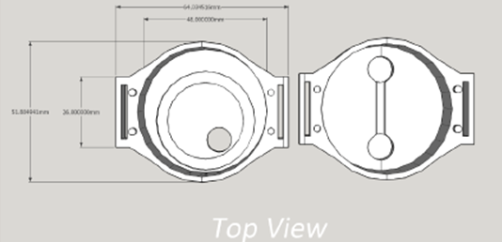 |  | 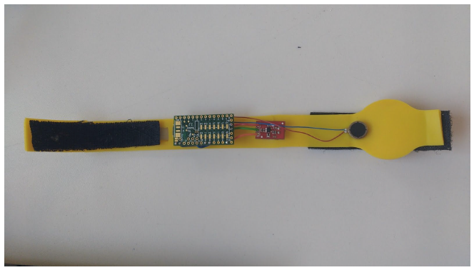
Fig. 1 Alerting bracelet case design (left) and completed prototype (right)

The objective of this project is primarily to provide a ‘vehicle’ by which the student can demonstrate they have undertaken a significant individual project in a professional manner. This includes the creation of a formal specification for their project, undertaking an appropriate literature review of aspects of the project’s scope, undertaking a system design, developing detailed sections of the overall system, designing, building and testing these sections and integrating them all together as a whole system.
Secondly, the project provides a vehicle through which the student can demonstrate proficiency in a number of generic skills including what we require of students in the Department of Electronics and the University of York:
- Communications – students produce an initial and final written report on their work, the initial being a statement of their project, a literature review, formal specification and initial project plan. We have, in the past also required them to produce an advertising Poster of their project and for them to give a Public Presentation on their project. All components carry marks including for structure and layout of their formal reports. They are also required to defend their project after they have submitted their report for 60 minutes against questioning from two academics – this allows us to verify their understanding is truly their own but also to test their active listening and oral communication skills.
- Project Management – students produce an initial project plan and are expected to manage their time and activities to this plan, they are required to include a short section in their final report which discusses the success or otherwise of their management of the project. Included in this is a Risk Register with each risk score on probability and severity and with each having a brief narrative on the recognition the risk is happening and their remedial/corrective actions.
- Personal Organisation and Management – being self disciplined and working to plan in an organized way, maintaining good records of work done and results achieved can be very visible and provides evidence to support ability in this skill. Students are required to maintain a day log of work they do.
- Problem Solving – students can face problems of a technical, organizational, personal and access to resources nature. How they face up to these problems and solve them or work around them is a good overall indicator of their problem solving ability. Oversight of this is through regular progress meetings between the academic supervisor and the student and weekly emailed progress reports sent through the Department’s electronic management system to both academic supervisors and the project administrator who will send reminders if the student does not submit a report and if the academic supervisor does not respond each week.
- System thinking – by requiring evidence of a system design the approach taken and the depth of analysis by the student there is assessable evidence of ability in this skill
- Literature Review – again the depth and breadth of the review, the items reviewed, the criticality of discussion and the approach taken to undertaking the review and they way in which it is reported are all indicators of this skill
- Reflective Practice – students are required to include a short reflective section in their final report on their experience of the whole project.
All of the above skills are assessed or inform the marks as part of the overall project marking. Marking is through a formal rubric including word picture descriptors for each category which helps remove differences between markers and the need for wide result marks variation moderation.
Finally, projects such as this one, which are disability related also serve to raise the awareness of the issues of individuals with disabilities face in general living or, as in the case of other projects, such as a soldering aid for one handed individuals, issues engineers with disabilities face in their working life.
A potential side effect of this aspect of the project is that a novel new product idea could easily emerge from the student project.
By way of illustration of the effect the project can have on the student, one of the students who undertook a project to design a talking electronic component identifier said after they had completed the project: “Undertaking this project has given me a much greater appreciation for both the needs of those with visual impairment and their capabilities. Before the project, I would have considered it impossible for a blind person to work in the electronics industry, particularly with the prevalence of small components with visual markings - even for a colour-blind person, this can cause difficulty. However with the aid of a simple tool such as the talking component identifier, I now believe that a blind person can overcome these difficulties and work effectively. There are already examples of blind people working in the industry, and if a device like this were to become available it would make the industry far more accessible to those with visual impairment - perhaps even helping to address the severe shortage of people in the electronics industry in the UK.”

Project 2: Assistive technology for individuals with limited movements in their hands and fine motor skill impairments
The project was undertaken by a student at the University of Limerick. In this project, the ADXL346 3-axis accelerometer was considered to interface to an Arduino UNO microcontroller system and personal computer (PC) in order for head motion to be read by the PC when the accelerometer is attached to a human head. In this arrangement, the sensor would be worn by a student who will control the operation of the PC using head motion and the system would be worn by an individual with a physical disability that would limit their ability to use a keyboard and mouse arrangement.
The purpose of this sensor system would be to act as an assistive technology for individuals with limited movements in their hands and fine motor skill impairments. Hence, an experiment can be run by the individual without touching the equipment or experiment.
Suitable movement of the head would enable the head motion to be measured and sent to the computer. This motion would then be interpreted by the computer application in order to send suitable commands to the equipment used in the experiment. Hence, the head movement would form a non-verbal language.
The student who undertook this project produced a prototype, which partially functioned. More time and a deeper understanding of embedded system design concepts would have been needed to produce a more polished end result.
In part this example helps to demonstrate that the project is a suitable vehicle for discriminating between students of differing ability but also that expecting a fully working prototype for a novel idea or product is beyond the ability of some students.
The student, irrespective of their final result, does however learn from the experience – it is their opportunity to pull together the knowledge and skills they have learned from the entire academic programme and apply them appropriately to their project.

Project 3: Hybrid FES – Hand Orthosis System
This project was undertaken by a student from the Faculty of Electrical Engineering at the Technical University of Cluj-Napoca. At the University it is recognised that community orientated real-world projects, professionally relevant to the student study programme make good project topics. Student interest and involvement is higher in projects of this nature.
By way of background to this project the grasping function is provided by the bio-mechanism formed by the metacarpal bones, the finger bones and their joints, where the flexion-extension and the laterality movements of the last four fingers are realized as well as the flexion-extension, abduction-adduction and the opposition of the thumb.
Patients with traumatic brain injury, stroke or cerebral palsy lose the ability to control the thumb, with a consequential negative impact on precision grasping and manipulation. This project proposes a hybrid solution to restore the opposable thumb function.
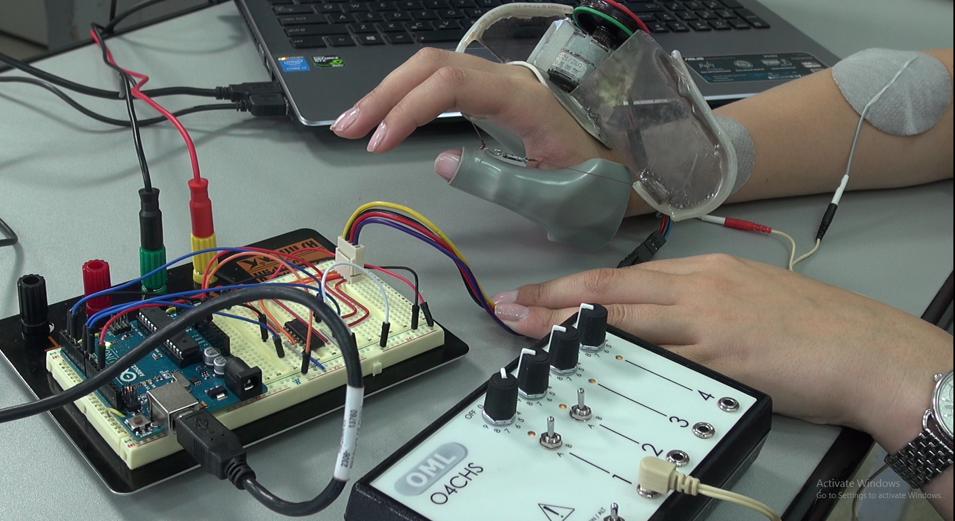
Fig. 2 The hybrid FES - hand orthosis system
It is based both on a functional electrical stimulation (FES) module and an active orthotic device to restore the thumb opposition Error: Reference source not found2.
FES produces contractions in paralysed muscles by the application of small pulses of electrical stimulation to their nerves. The Odstock Four Channel Stimulator was the core of the FES module (Conclusions3 left). The proper position of the electrodes was experimentally determined. The output can be ramped at the beginning and end of each cycle to give a comfortable sensation and prevent stretch induced spasticity.
The stimulation is controlled in such a way that the thumb is moved toward the index and middle finger.
The thumb orthotic device (3 right) includes a stepper actuator, a pulley and tendon driven mechanism that provides the opposition of the thumb. Based on the anthropometric data, the hardware module was designed and manufactured.
A control system of the orthosis, developed on an Arduino Uno board was proposed. An interface that allows the control of the motor speed and stroke (number of steps) was investigated. The balanced control among FES muscle activation and lightweight active orthosis leads to a better restoration of the grasping ability.

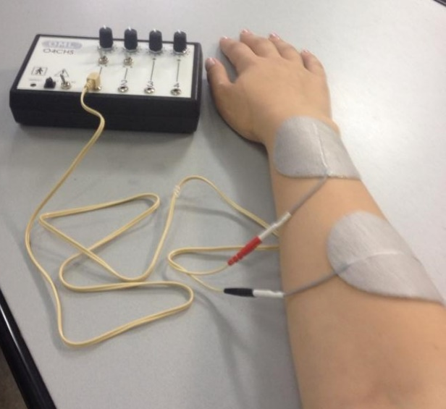 |  | 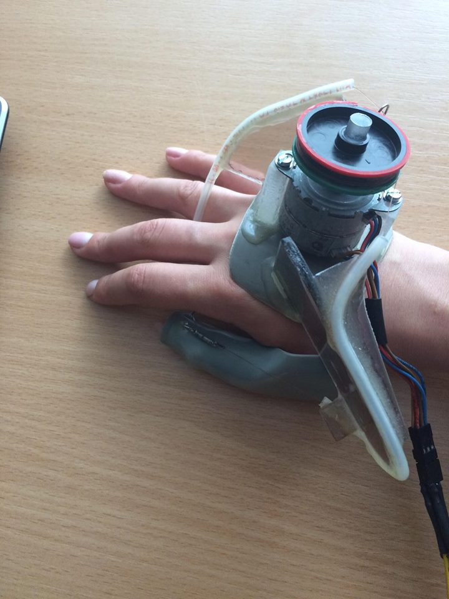
Fig. 3 Odstock Four Channel Stimulator (left), thumb orthotic device (right)
The student that developed this project was very pleased to realise and present the hand orthosis system as a simple engineering solution by using only an Arduino board, a driver and a computer.
For patients that loose certain abilities to control their thumbs for instance , implementation of technical solutions for solving this problem is very important also concerning accuracy of movements and esthetical aspects .
The student who undertook this project produced a functional prototype only based on basic knowledge and skills accumulated during 4 years of studies, and of course with the advice of his project coordinator. Further developments could involve medical specialists and more efforts and tests to realize a more portable hand orthosis system .

discussion
Individual final year (or capstone) projects typically follow a generic model irrespective of technical topic or institution. The student is given a statement of the project in the form of a ‘brief’. This ‘brief’ is a high level outline of the project broadly defining why it is important and what the ideal deliverable should be. The brief is a good opportunity to define the project in the form of a problem statement which gives the student freedom to be innovative with the ultimate in this being a solution that is truly novel and potentially commercially exploitable. Being able to demonstrate innovation is another valued generic skill by some employers. Broadly it can be measured on a scale from “truly new and novel solution to the problem” through to “only minor incremental developments over existing or obvious solutions”. This scale is far from scientific but is indicative of the students’ innovative ability.
This ‘brief’ forms the starting point for a discussion with the academic supervisor(s) and work undertaken by the student. In these early stages there is an excellent opportunity for the demonstration of professionalism through the development of an engineering specification for the project (requirements capture and specification writing) and a project plan (work breakdown structure, project planning, Gantt or PERT Chart). These are skills that students are somewhat weaker in and specifications are sometimes presented incomplete or without tolerances. Project plans often lack detail and do not focus on all the project deliverables.
The normal project would commence with an overall system design, breaking the system down into component parts that can then be designed in detail. Each system component would then be modeled, simulated, prototyped, tested, built in a more substantial, if not final form, and then retested. Here again, testing is an important generic skill for engineers and gives them the opportunity to understand the role of equipment calibration, measurement accuracy, the effect of the test method on the item being tested, noise and interference.
The overall process mirrors that in industry even to the point, for better students, of understanding tolerance analysis, design for manufacture concepts and the principles of quality assurance.
Once all the components have been designed and tested system integration commences and the build and test cycle repeats. At all stages documentation is vital so the good habits (hopefully) students have been trained in for laboratory record keeping during their earlier study years really have meaning in the final project.
Having the students present their project formally or informally verbally to technical or non-technical audiences is good for the presentation skill section of communication skill. The format report on the project is a test of their written communication skill (at least in terms of a formal report is concerned).
More generically the project exposes the students’ ability to solve problems; act on their own initiative; often negotiation skills for resources and help they may need; information searching and management; work ethic; personal time management and organization; and more.
All of these generic skills can be assessed (albeit it usually very qualitatively) in the final assessment. What is perhaps more important is that the student’s academic supervisor has visibility of the overall performance of the student in these respects and can use the information to help inform references they may be asked to write for the student. Maintaining oversight of the overall performance of the student therefore has many advantages. The formal, meaningful assessment of generic skills is, however, still at its infancy with many firmly of the view that meaningful measurement is not practical or even possible. However, advances in the assessment of public speaking, as an example, through the use of word picture descriptor rubrics is improving the reliability of assessments and it is hoped, in the future, may lead to statements of student ability that are truly meaningful to employers [10].

Conclusions
The individual final year (or capstone) project is the opportunity each student has to demonstrate their overall ability to undertake a significant piece of work in a professional engineering manner. The expectations of a student in all three Institutions, as described in section III above, is the same and this applies irrespective of the nature of the project.
Final year projects are usually very closely professionally aligned to the academic programme and hence could be of an analogue electronics, digital electronics, embedded system, music or media technology, computing, medical, control and even engineering management nature. Projects in any sub-discipline of Electrical and Information Engineering fit into the overall generic model described herein.
The addition of projects that raise the awareness of real disability issues is an added bonus for the student, the academic department, individuals with the associated disability and potentially the wider community. Finally, by focusing final year student projects on real world problems the opportunity exists to be innovative and potentially create new products.
There is the issue of who owns the intellectual property in the case of undergraduate student as this is, in some institutions, not as clearly defined as it is for postgraduate students and staff, but this could be addressed through a ‘contract’. The bio-medical and BioTech sector could usefully engage with Universities in such developments to either take them forward to real products or as a source of ideas for projects to be undertaken by students.
The projects described in this paper are three from a pool of potential disability related projects freely accessible in the SALEIE “Student Project” page. New projects can be added to this page by submitting a description, using the same data fields as in the description template, to the project webmaster.
We recomment academic staff from technical faculties should encourage students to work on projects in the assistive technology area trying to obtain not only good functional prototypes but also innovation in products, technologies and systems that enable disabled people equal access to life's opportunities and education. The benefits are a challenging and interesting project for the student; a vehicle to truly allow the student to demonstrate and the academic supervisor to see a good range of generic skills; and the potential for a commercially exploitable end result.

Acknowledgment
The authors of this project thank the European Union for the funding to enable this project to be undertaken and to the partners of the SALEIE Project for their contribution of projects to the initial database. We also thank the students who undertook these projects this year for their permission to use quotes from them and photographs of their project work.

Conflict of Interest
The authors declare that they have no conflict of interest.

REFERENCES
- T. Ward, “Electrical and Information Engineering Employability Skills: A UK University Perspective,” Submitted for publication, pp. 1–9, Feb. 2015.
- “University of Limerick,” 03-Jul-2012. [Online]. Available: http://www3.ul.ie/ctl/sites/default/files/GraduateAttributes_03July2012%20(3).pdf. [Accessed: 19-Aug-2016].
- “The Washington Accord,” washingtonaccord.org. [Online]. Available: http://www.washingtonaccord.org/Washington-Accord/. [Accessed: 27-Feb-2014].
- A. Kumar, N. Randerson, and L. Kiwana, “Engineering UK 2013,” Engineering UK, Sep. 2013.
- “2015 IET skills survey,” 20-Oct-2015. [Online]. Available: http://www.theiet.org/factfiles/education/skills2015-page.cfm. [Accessed: 16-Aug-2016].
- A. E. Ward, A. Gbadebo, and B. Baruah, “Using job advertisements to inform curricula design for the key global technical challenges,” 2015, pp. 1–6.
- A. E. Ward, “The Alignment of Generic, Specific and Language Skills within the Electrical and Information Engineering Discipline,” EIE-Surveyor Project, York, Dec. 2008.
- http://www.saleie.co.uk/SSSH/text/html/Student_Projects.php, Accessed 27th July 2016
- http://www.saleie.co.uk, Accessed 27th July 2016
- N.R. Jackson, A.E. Ward, “Assessing Public Speaking, A trial rubric to speed up and standardise feedback”, 13th International Conference on Information Technology based Higher Education and Training (ITHET), York, England, 2014.

