## Urban networks and Arctic outlands

## Craft specialists and reindeer antler in Viking towns

Steven P. Ashby, Ashley Coutu, and Søren M. Sindbæk

This paper uses a recently developedminimally destructive? biomolecular technique to explore the resource networks behind one of the first specialized urban crafts in early medieval Northern Europe: the manufacture of composite combs of deer antler. The research incorporates the largest application of species identification by mass spectrometrypeptide mass fingerprinting (ZooMS) to a medieval artefactual assemblage. It documents the early use of reindeer antler, from the 780s AD, presenting the earliest unambiguous evidence for exchange-links between the Scandinavian Peninsula and urban markets in the southern North Sea region. The results demonstrate that the common conceptual distinction between urban hinterlands and long-distance trade conceals a vital continuity. Long-range networks were vital to urban activities from the first appearance of towns in this part of the world, preceding the historically documented maritime expansion of the Viking Age. We suggest that urbanism is more appropriately defined and researched in terms of network dynamics than as a function of circumscribed catchment areas or hinterlands.

**Beyond hinterlands**

Deer antler was an important product in pre-modern craft and industry. In the early medieval period, this raw material was used to produce a range of valued items including hair combs. As a result, it began to be exploited on a previously unprecedented scale. Rich assemblages of antler combs and waste from the workshops that made them have been excavated in Viking-age towns and trading-places around the coasts of northern Europe (Riddler (ed.), 2003; Ashby, 2011). However, the organisation of this craft – and, in particular, the means by which the antlers from local or exotic animals were collected and traded – remains unclear. It is widely assumed that the majority of this material was procured from the surrounding countryside as part of the exchange cycles which constituted urban hinterlands. As yet, however, this issue has not been studied in any depth.

A close interrelationship with a regional hinterland is a component in most definitions of urbanism. (e.g. Childe, 1950; Yoffee, 2005; Renfrew, 2008; Trigger, 2008, 55; M.E. Smith, 2010). Communication with external regions, on the other hand, is often seen as a derived dynamic. Urban centres are correlated with spatially circumscribed territories, to the extent that it can be argued that “All settlements have catchment areas, but only cities have hinterlands” (Cowgill, 2004, 527). For some centres, such as the early medieval emporia of Northern Europe, the weak definition of regional interaction has led researchers to question their identification as ‘urban’ (cf. Verhulst, 1994, 370; Theuws, 2004, 134). Despite the “profligate debris associated with trade and in many cases, crafts, which makes these places remarkable” (Hodges, 2012, 93), the argument is made that “their general lack of territorial hinterlands further explains why so many of them failed as economic centres” (Wickham, 2005, 685f).

The assumption that exchange must be locally structured in order to sustain true urbanism dismisses a considerable number of pre-modern urban-type settlements, for which non-local exchange was a vital concern (e.g. Miksic, 2000; Ekblom and Wood, 2012; Mattingly and Sterry, 2013). It also assumes a clear distinction between long-distance exchange, often believed to concern prestige goods or luxuries for elite consumption, and local exchange of bulk products, supposedly reflecting regional production and economic intensification.

The limitations of this distinction are highlighted by the issue of specialized crafts. The geographer James Morris Blaut has pointed out that the conceptual distinction between regional hinterland interactions and long-distance ‘trade’ ignores the ‘productive’ nature of the latter. Long-distance movement and exchange were integral to many forms of pre-modern production: “activities involved in moving commodities over long distances were not, ontologically, ‘exchange’; they were spatial transport. They produced use-value at the destination from commodities that had none, or less, at the point of departure” (Blaut, 1993, 169).

Recent research has begun to analyse urbanism as a dynamic of communication and social networks (Sindbæk, 2007; 2013; Knappett *et al*., 2008; Taylor, 2012; Müller, 2013). Pre-modern urban craftspeople were dependent on wider regions for their raw-materials, and as markets for their products. What mattered to a craftsworker, however, was not if people and things were located in a spatially contiguous hinterland, but if theycould be reached through available means of communication. In settlements such as the North European early medieval emporia, which were linked into wide-ranging marine traffic, the ‘hinterland’ of a craftsperson did not necessarily equate to the surrounding countryside.

**Combmakers as urban craftspeople**

Previous archaeological approaches to urban networks have been constrained by the fact that only a limited range of find materials can be assigned a specific provenance (Sindbæk, 2013). The problem is particularly acute for a number of staple commodities and raw-materials, like pottery, stone products or textiles, while rare materials or highly refined items (e.g. glass or metal ornaments) can more often be assigned a specific origin. This situation has contributed to the production of a received wisdom: an association between long-distance trade and ‘luxuries’. However, currently emerging applications of elemental, isotopic and biomolecular methods are transforming archaeology’s ability to source materials (e.g. Henderson et al. 2005; Hull et al.2008; Barrett *et al*., 2011; Stewart *et al*., 2012; Ling *et al*., 2013), and the growing capacity to specify the composition of organic and inorganic raw materials holds unprecedented potential to make urban resource networks traceable.

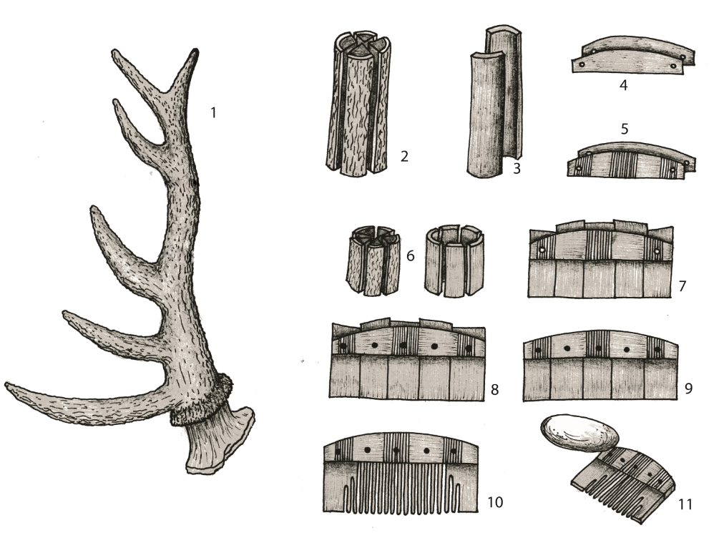

**Fig. 1. Schematic representation of the manufacture of Viking-age antler combs. The process of carefully fitting tooth-plates, connecting plates and iron or copper alloy rivets demanded a high degree of skill and training, and was mainly pursued in urban workshops. Illustration by Hayley Saul, previously published in Ashby 2013).**

A case of special importance for the early middle ages concerns bone- and antler-working. The composite combs used in the Viking period were complex objects which required a considerable level of skill and training to produce (Galloway, 1990; Ashby, 2013a, 2014a). They were manufactured using carefully fitted tooth-plates and connecting-plates, riveted together with iron or copper-alloy rivets (**fig. 1**). Johan Callmer notes how the “production of these combs is extraordinarily meticulous, with a considerable number of components, the dimensions of which have to be thoroughly adjusted to each other... A number of special tools must be used, such as precision saws, files, rasps and emery cloth and other abrasives.” (Callmer, 2003, 350). While evidence for production is occasionally encountered at rural and aristocratic sites, workshop material is concentrated at urban sites, where large quantities of manufacturing debris may be encountered: for example, 16.956 units at Ribe, Denmark, 28.136 units at Åhus, South Sweden, and 340.000 units at Hedeby, North Germany (Ulbricht, 1978; Callmer, 2002, 135; Feveile (ed.), 2006, pl. 1).

The most convincing explanation as to why so much antler craft took place in towns would seem to hinge on the issue of specialisation. A well-made comb was an essential hygienic and aesthetic amenity (Ashby, 2014b), and finds in graves suggest that a considerable proportion of the Scandinavian population were in possession of this form of manufactured product. Even so, demand would be too limited to sustain continuous production within households or local communities. In order to acquire and maintain the skills needed for quality production, a craftsworker would need to produce for greater numbers of consumers, which could be reached either through itinerancy, at periodic assemblies or, when they existed, at urban markets. Antler combs would thus appear to present an example of the interdependence invoked by Gordon Childe and others as a causative mechanism for urban development: a specialized industry made viable by the accumulated demand of an urban market (Childe, 1950, 15).

Specialized production, however, would have to be reliant on raw material procured through trade or redistribution. As such, it would be valuable to have an understanding of the degree to which comb-making was dependent for its materials on a local hinterland, or on wider supply networks. It has been suggested that comb-makers in Viking towns were predominantly supplied with raw materials from the local hinterland (Ambrosiani, 1981: 52; see also Mainman and Rogers, 1999: 1905-6), or possibly from controlled collection at elite estates and deer parks (Callmer, 2003, 352). Discussing the extensive workshop assemblages from ninth- to eleventh century Hedeby, Ingrid Ulbricht takes the great predominance of red deer antler as evidence that craftworkers in Hedeby were supplied by “people in the surroundings” who collected antler as a side-occupation and “perhaps used the opportunity upon their next visit to Hedeby to trade these on the market…” (Ulbricht, 1978, 127, our translation). This mode of procurement would constitute a model case of hinterland interaction.

However, Ulbricht also notes a minor occurrence of elk and reindeer antler as imported raw materials in the Hedeby workshops . She suggests that these represented a trade in raw materials, which presumably emerged when demand outstripped local resources (Ulbricht, 1978, 17f, 128). The apparent paradox of sourcing reindeer antler through long-distance transport into a deer-rich region might be justified by an accident of ecology. Reindeer form very large herds and shed their antler in open tundra landscapes, where they are more easily retrieved in quantity than in the densely forested environment which other deer species inhabit.

Any inference about raw material procurement must rest on the provenancing of antler, which is best achieved via biogeographical means: through the identification of antler products to species level. A number of authors (Ashby, 2009, 2013b; Stephan, 1994; Smirnova, 2002; Weber, 1995; Lie, 1993; Ballin Smith, 1995) have attempted to differentiate ‘local’ species from imported material using macroscopic zoological methods, but these approaches had limited success for highly worked or fragmentary material. Bioarchaeology offers the potential to provide unqualified, definite species identifications at the molecular level.

**Zooarchaeology by Mass Spectrometry**

Using the innovative biomolecular approach of Zooarchaeology by Mass Spectrometry (ZooMS), it is now possible to testwe tested a range of antler objects in order to identify the species of deer from which the raw material was taken. Genetics may be used for this, but the success rate of DNA extraction and replication in curated archaeological material is rather unpredictable (Shapiro and Hofreiter (eds.), 2012; Hofreiter, Collins and Stewart, 2012). Proteomic techniques offer a less destructive method, and one that is more consistent in yielding the kind of results we need. ZooMS allows the rapid analysis of a large quantity of antler combs at relatively little expense and with little destruction of the artefact, as only 5- 10 milligrams of the sample is necessary for analysis. The method relies on the extraction of a very small sample of material, and thus facilitates the identification of archaeological material that would not otherwise be amenable to such analysis (by traditional zooarchaeological methods, for instance). The method will thus functions equally well on tiny fragments of craft debris and highly worked finished objects, the materials of both of which would not be easily identified using macroscopic techniques. Building upon similar work undertaken in early medieval England and Scotland (von Holstein *et al*., 2014), we have exploited this technology technique in order to identify the species of antler used in the production of combs found at Viking-age sites across Denmark.

A detailed description of the ZooMS protocol used in order to analyse these samples is provided in the Supplementary Material . Briefly, small samples (5-10 milligrams) of powder or chipped antler are soaked in a 50mM ammonium bicarbonate buffer to remove surface contaminants. The samples are heated to 65°C for 1 hour to solubilize a small fraction of the collagen in the sample for analysis. This soluble fraction is trypsinated overnight at 37°C to break the protein into peptide fragments, and eluted using a BioVyon C18 Porvair cartridge. ZooMS works by extracting the protenacious collagen fraction from the antler, breaking down the collagen into peptide fragments (Buckley *et al., 20*10; Buckley and Collins, 2011; von Holstein *et al.,* 2014). Samples were soaked overnight in a 50mM ammonium bicarbonate buffer, as described in van Doorn *et al.* (2011), in order to remove any surface contaminants. A fresh aliquot of the buffer was then added to the samples and heated to 65°C for 1 hour, in order to gelatinize the collagen. The collagen was then trypsinated overnight at 37°C, and eluted using a BioVyon C18 Porvair cartridge. Samples were then analysed using a calibrated Ultraflex III (Bruker Dalonics) MALDI-TOF MS instrument in reflector mode. By extracting and analyzing the peptides, a mass spectrum, or peptide mass fingerprint (PMF) is produced for each sample, such as that shown in **fig. 2**. The presence and combination of certain masses is unique to family groups, while the presence of others allows identification to species level. Thus, by comparing the spectrum producedsample peptide mass fingerprint against to a reference library of known spectra (Kirby *et al., 20*13; Buckley *et al.,* 2009; Buckley *et al.* 2010; Buckley and Collins 2011; Kirby *et al.* 2013; von Holstein *et al.* 2014), an archaeological sample may be identified at various levels of precision. The collagen sequences of deer species are very similar. Thus, only roe deer and reindeer have peptide differences that can distinguish them from red/elk/fallow deer (Buckley *et al.* 2009; Buckley and Collins 2011; Kirby *et al.* 2013). We can therefore identify if antler material is made from reindeer or roe deer, but cannot distinguish between red deer, elk, and fallow deer. For the purposes of this paper, as mentioned above, we have excluded the possibility of fallow deer on biogeographical grounds, so the categories for species identification using ZooMS are reindeer, roe, and red/elk. Such a result (red/elk) is nonetheless useful in the context of our research question, as it excludes the possibility of reindeer antler. 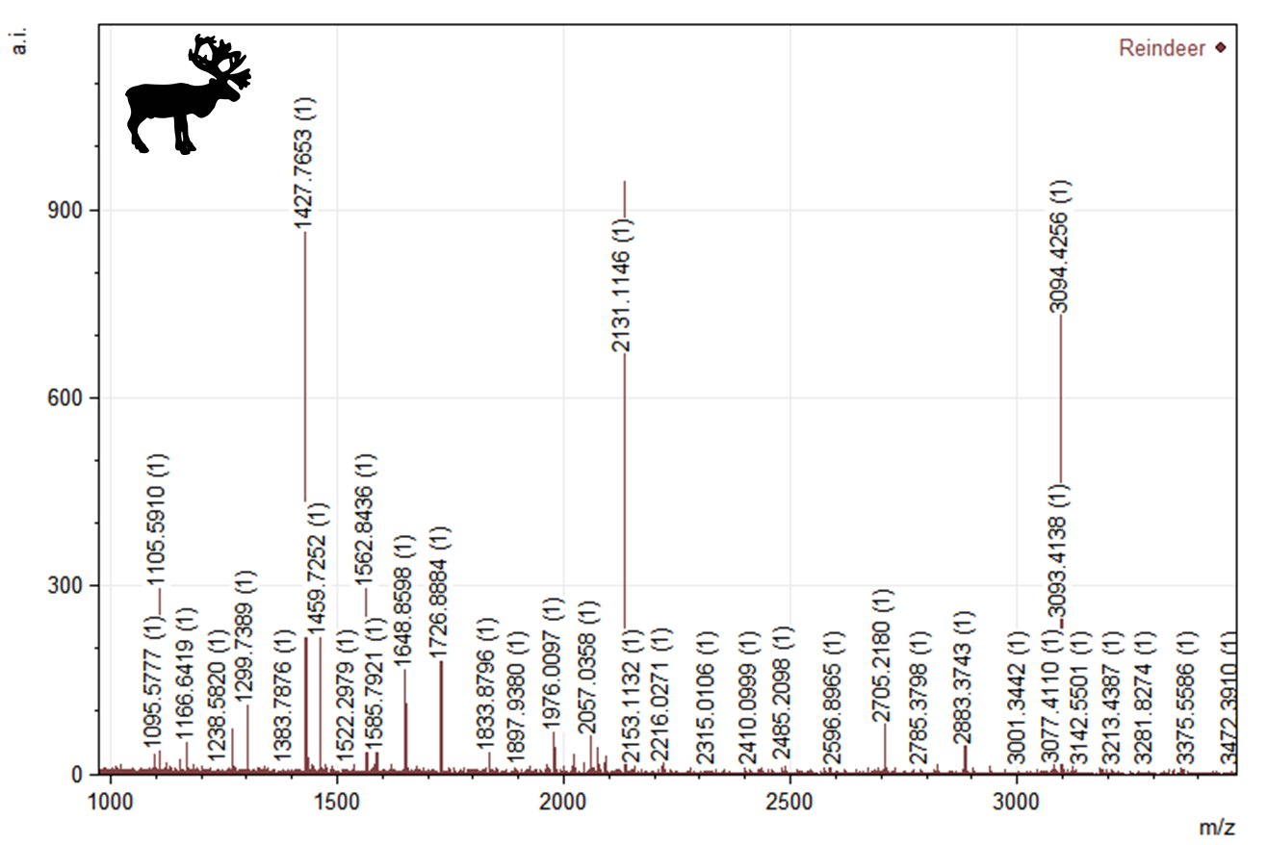

**Fig. 2. Peptide mass spectrum of an antler comb sample from Aarhus identified as reindeer. The peptide markers at m/z 1166, 1580, and 3093 identify this sample as reindeer from roe deer (m/z 3043, 3059) and red/elk (m/z 1550, 3033), following reference spectra established by Buckley *et al.* 2009, Buckley and Collins 2011, and Kirby *et al.* 2013.**

Samples were taken from three localities: Ribe, Aarhus, and Aggersborg, all in Jutland, Denmark (**fig. 3**). Finished antler combs (both entire and fragmentary) and production waste were sampled at all three sites, in order to characterize the range of materials being used. Selection criteria were determined by (1) availability of objects for destructive analysis, and (2) availability of contextual information. Samples were routinely taken from intact comb connecting-plates, as previous studies (von Holstein *et al.*, 2014) have demonstrated that sampling from the comb itself is preferable to using detached teeth, whose provenance or associations can rarely be established with certainty. Where possible, two samples were taken: one from the connecting plate, and another from a tooth-plate. This allowed determination of possible material heterogeneity of an individual comb.

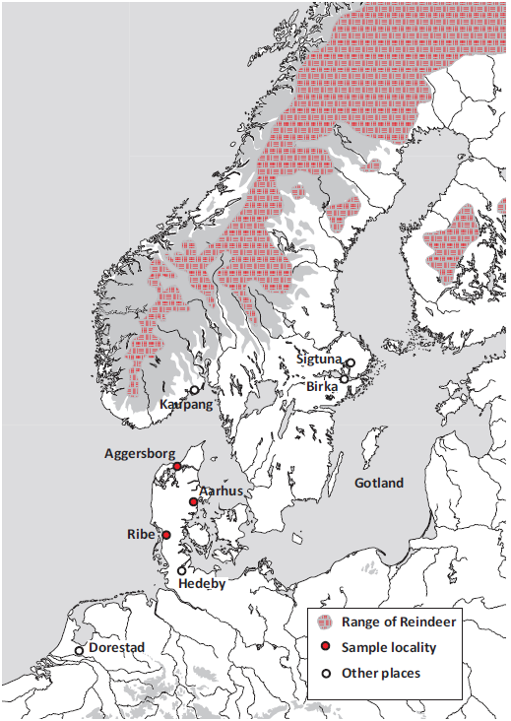

**Fig. 3 Map of Scandinavia with sample localities and other places mentioned in the text. Hatching indicates the approximate natural occurrence of reindeer according to nineteenth-century data in Ulbricht, 1978. Elk was found over much of the Scandinavian peninsula, while red deer and Roe deer were common across the North European lowland, including Denmark.**

**Ribe**

Ribe is one of Scandinavia’s earliest towns (Hodges, 1982; Clarke and Ambrosiani, 1991) and extensive remains of a settlement dating to between the eighth and ninth centuries have been excavated. It is characterized by a pattern of regular plots facing a main street, dense occupation layers and considerable evidence for craft and trade (Bencard and Jørgensen*,* 1990; Feveile (ed.), 2006). While it is still being debated whether the earliest phases of the site represent a permanent settlement or a seasonal market, the range and intensity of documented activities express the economy of an urban-type centre, equivalent with the emporia or *wics* of England and the western European continent (Näsman, 2000, 54-56; Wickham, 2005, 683; Skre, 2007, 454; Feveile, 2012, 114; Hodges, 2012, 108). One of the key crafts testified throughout the history of the site is antler working, and particularly the manufacture of combs.

The sampled artefacts were selected from a collection of 13,056 antler pieces excavated 1990-91 at the site ASR 9 ‘Posthuset’, located centrally at Ribe’s so-called ‘Market Place Area’ (Feveile and Jensen, 2006). The settlement deposits in this area were clearly stratified, and could be divided into a series of 20-30-year long phases, covering the period *c*. AD 705-850. Sampling focused on material from trenches M1+M2, which were consistently excavated and recorded as single contexts and had a well-understood stratigraphy with which to date the finds.

Material was selected from each of six phases: B, C, D, E, F, and I; these represented the phases with the largest quantities of material, and were hence more likely to represent workshops. Phase D, which was poor in antler finds, was included specifically because it dates to the period AD 760-780, which is relevant to questions about maritime long-distance connectivity before and after the historically documented beginning of Viking raids *c.* AD 790. For each phase, a few pieces from each main category of waste (antler tips, off-cuts, blanks, etc.) were sampled. More samples were taken from the more highly worked or well finished pieces, as many large pieces of shed or cut antler could be visually identified as red deer. A target was set of including a minimum of 25 samples per phase, though some phases had multiple workshops and thus a much larger proportion of antler material compared to the other phases. In these phases with multiple workshops, the aim was to collect 10 samples per workshop. Except where otherwise noted, the selection was based on random sampling, without consideration of visual appearance.”

The material from ASR 9 comprised very few finished combs. In order to compare the pattern of raw-material use in waste material with that of finished objects, a number of comb fragments were selected for sampling from four other excavation sites in Ribe: ASR 7 Sankt Nikolajgade, ASR 8 Rosenallé, ASR 2360 Sankt Nikolajgade and 5M 74 X D06592 Dommerhaven (Bencard and Jørgensen 1990; Feveile (ed.), 2006; Jensen, 2013).

In total 273 samples taken from finished bone and antler combs, and from antler production waste were investigated. A table with the breakdown of the identifications is given below (**Fig. 4**). 19 samples were identified as red deer. Another 109 samples were identified as elk/red deer/roe deer, and while the markers were indistinguishable, it is likely that the great majority of these samples comprised red deer on grounds of biogeography and functional utility. This shows that large deer antler was the standard material used in comb-making throughout all phases. This result corroborates the impression gained from the large pieces of cast or cut antler that could be visually identified (Feveile and Jensen, 2006, 171).

|  |  |  |  |  |  |  |  |  |
| --- | --- | --- | --- | --- | --- | --- | --- | --- |
| http://campusarch.msu.edu/wp-content/uploads/2010/02/stratigraphy1.jpg | https://encrypted-tbn3.gstatic.com/images?q=tbn:ANd9GcQEyenPkI98AnLEEh1bFWFeGQM4ljKOcXsjtsCGuMd9TZ3uGrFqGw |  |  |  |  |  |  |  |
| **Phase** | **Date AD** | **Antler finds** | **Samples** | **Animal bone** | **Roe deer** | **Red deer** | **Red/Roe/Elk** | **Reindeer** |
| Ribe AA-A | < *c.* 705 | 1 | 0 | 0 | 1 | 0 | 0 | 0 |
| Ribe B | 705-25 | 1079 | 34 | 1 | 4 | 0 | 12 | 1 (+1(1)) |
| Ribe C | 725-60 | 3262 | 59 | 6 | 3 | 2 | 20 | 0 |
| Ribe D | 760-80 | 178 | 26 (+8 (2)) | 2 | 1? (3) | 3 (+1 (4)) | 15 (+5 (5)) | 0 |
| Ribe E | 780-90 | 3024 | 50 | 4 | 0 | 3 | 23 | 7 (+1(6)) |
| Ribe F | 790-800 | 4507 | 56 (+1(7)) | 2 | 1 | 3 | 23 | 7 (8) |
| Ribe G-I | 800-850 | 998 | 26 | 0 | 0 | 7 | 9 | 0 |
| Ribe, unstr. | 700-850 | >1 | 1 | 0 | 0 | 0 | 0 | 1 |
| Ribe, total | 700-850 | 13050 | 261 | 15 | 9 (10?) | 19 | 97 | 18 |
| Aggersborg | 800-1000 | 53 | 53 | 0 | 0 | 15 | 14 | 10 |
| Aarhus | 850-1050 | >500 | 106 | 11 | 3 | 19 | 43 | 12 |

In addition: one reindeer antler comb fragment from an unstratified context in Ribe.

(1) One sample from corresponding layers in 5M 74 Dommerhaven.

(2) Eight samples assigned to either phase D or E.

(3) One sample assigned to ASR 7 X 928, horizon 5. This horizon corresponds to phases D-F.

(4) One sample assigned to either phase D or E.

(5) Five samples assigned to either phase D or E.

(6) One piece assigned to either phase D or E.

(7) One piece assigned to either phase E or F.

(8) Includes 3 pieces from one comb. One further fragment (not counted) assigned to phases E/F had possible reindeer markers, but could not be confirmed.

**Fig. 4. Breakdown of the species identification for material sampled from Ribe, Aggersborg and Aarhus by phase. Dates and numbers of antler finds after Feveile and Jensen, 2006, Skov, 2009, and Madsen and Sindbæk, 2014.**

Six samples were identified as cattle bone rather than deer antler. They include four clearly identifiable comb fragments or tooth plates. The visual analysis of ambiguously determined pieces identified a further four pieces of production waste and five comb fragments as animal bone, including one goat rib. This evidence clusters in early phases B to E. Similarly, the ten pieces identified as roe deer antler belong to the early period, phases A to C. The samples identified as cattle bone or roe deer antler include pieces of production waste, demonstrating that both materials were worked on site. The use of animal bone and of the relatively small roe deer antler in an urban comb-making workshop is unexpected (though see Riddler, 2003). It could indicate that craftspeople at this time were sometimes unable to source adequate supplies of large deer antler.

With 18 samples identified as reindeer antler, this material constitutes an unexpectedly large group (**fig. 5**). This number includes three pieces of one fragmented comb, and three large pieces which were specifically targeted because they had previously been visually identified as elk or reindeer antler. In addition to the unambiguously identified samples, five other samples that were indeterminate to species did have markers consistent with reindeer.

The chronological distribution of the finds shows a clear pattern. From phases A to D (*c.* 705-780) only two pieces are identified as reindeer antler, both from finished combs. One was a tooth fragment found in phase B layers (fig. 5 l). The second was a large fragment of decorated connecting plate, found in a well in excavations at Dommerhaven (fig 5 o). The construction of the well is dated by dendrochronology to *c.* 704-10, and it was sealed by a characteristic organic layer, which corresponds to phase C at ASR 9 Posthuset (Bencard and Jørgensen, 1990, 58-62). The comb fragment must therefore be assigned a date corresponding to phase B. These pieces probably come from finished combs carried by visitors from northern regions, and indicate that there were links with central or northern Scandinavia from a very early stage after Ribe’s foundation in the early eighth century.

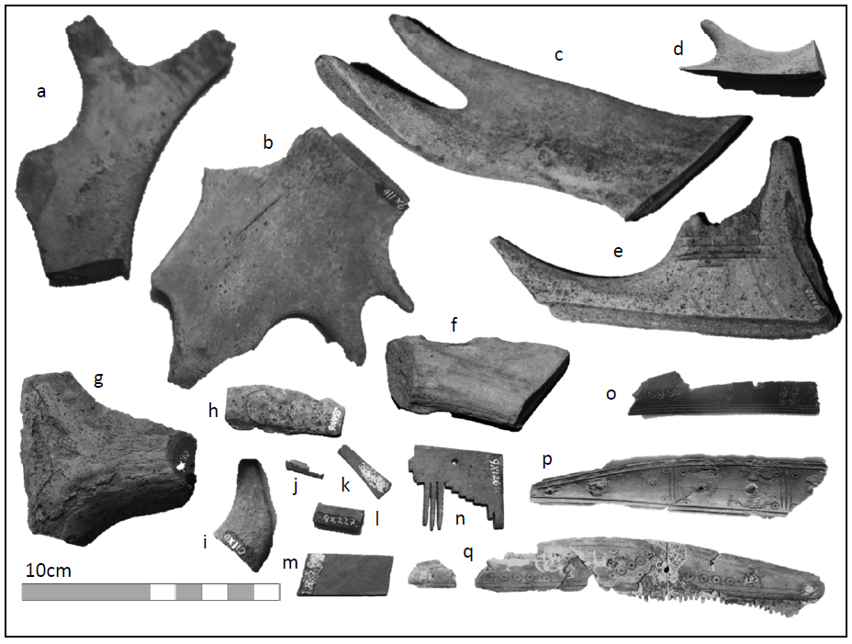

**Fig. 5. Workshop waste and fragments of finished combs of reindeer antler found in Ribe: a-i antler waste; j-m semi-finished fragments; n-q fragments of finished combs. Photos: Ashley Coutu.**

The pattern changes strikingly in phases E and F (*c.* 780-800), from which 14 pieces are identified, in addition to one piece that may derive from either phase D or E. The reindeer antler from phases E and F comprises ten pieces of production waste, clearly pointing to the use of reindeer antler as a raw material. These pieces come from ten distinct contexts, making it unlikely that they express a single or small number of episodes of use. The finds include tine tips (6 examples) and burrs (1 example, fig. 5 f), as well as part-worked blanks and unexploited chunks of antler, demonstrating that reindeer antler was brought to Ribe as complete antlers for working. The coincidence of this pattern with the diminishing use of animal bone and roe deer antler in phases E and F is suggestive of a move toward differently organized supply networks, focused on more deliberate sourcing.

From the later phases G-I (dated *c.* AD 800-850), identified samples comprise only red deer (7 pieces) and material identified as elk/red deer/roe deer, but more likely to be red deer (9 pieces). While the material from these phases is somewhat limited due to inferior preservation relative to lower layers, this result may point to a new sourcing pattern. Regardless, the results imply that in the late eighth century, reindeer antler was a significant raw material in Ribe workshops.

**Aarhus**

After Ribe, Aarhus in eastern Jutland was one of the first places in present Denmark to attain an urban character. From the ninth century onwards, the site – located at a river mouth facing a sheltered bay – featured a dense concentration of buildings and thick occupation deposits. These included remains from a range of specialized crafts, including metal working and bone and antler working. From the mid-tenth century at the latest, the settlement was enclosed by a substantial rampart (Andersen *et al*. 1971; Skov, 2005; Jantzen, 2013). It has previously been suggested, based on a broad survey of archaeological imports, that Viking-age Aarhus was a regional centre and less of a nodal point for international exchange than was Ribe (Skov, 1999, 603). While the evidence for craft-working and market activities in Ribe appears to dwindle in the late ninth century, however, Aarhus has a rich material from the tenth century, which offers an opportunity to extend chronologically the comparison of the use of different raw materials for combs.

Material was selected from excavations in the town centre undertaken in 1994 at Store Torv, next to the Cathedral (FHM 3880 – 62 samples, see Skov, 1998;, 2006, 655 and fig. 10), and in, 2009 at Bispetorvet (FHM 5124 – 19 samples). The material from FHM 3880 came from a substantial deposit of antler waste found in the fill of a sunken-featured building, probably dating from the tenth century. This material appears to represent waste from a comb-making workshop. From this context a few pieces from each category of waste were sampled. In order to compare the pattern of raw-material use in waste with that of finished objects, a number of comb fragments were selected for sampling from other sites in the town. In particular, samples were taken from 15 finished combs excavated at Aarhus Søndervold (FHM 1393, Andersen *et al*., 1971). In seven of these, both connecting-plates and tooth plates were sampled.

106 samples of bone and antler combs and of antler production waste were examined (**fig. 4**). Of those that could be positively identified to a specific species, 19 were red deer and 3 roe deer. 43 samples were identified as elk/red deer/roe deer, and, as was the case for the Ribe material, most of these samples probably were from red deer. 12 samples were identified as reindeer, all from finished combs (**fig. 6**). 2 samples were found to be of cattle bone, and there are examples of the use of bones of horse and sheep/goat. The spectra of the remaining 22 samples could not be determined more closely than as deer or ruminant.

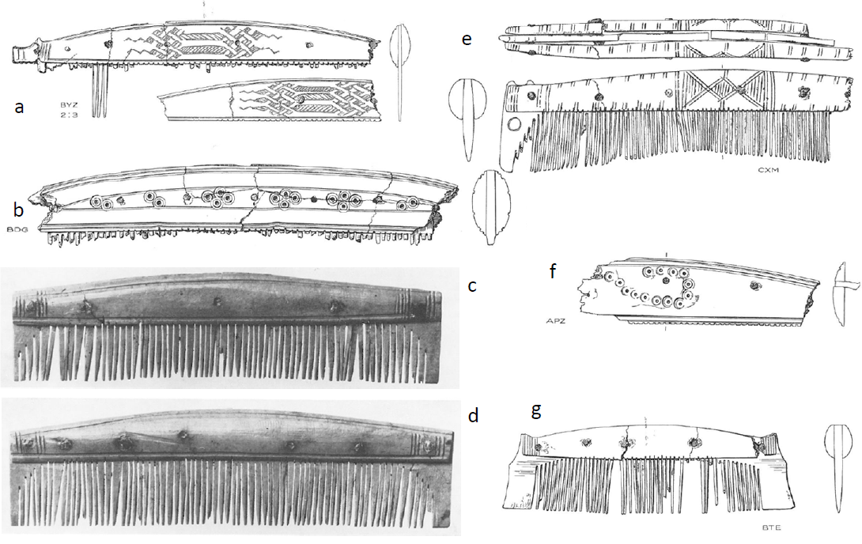

**Fig. 6. Finished combs and comb fragments of reindeer antler found in Aarhus. After Andersen *et al*. 1971.**

The results confirm that large deer antler was the standard material used in comb-making in the workshop targeted for this investigation. The very limited inclusion of other types of raw material, such as cattle bone or roe deer antler, points to a selective use of material and to the existence of a well-established resource network as a means of sourcing preferred materials in adequate quantities. This indicates a level of craft specialisation and exchange networks consistent with an urban economy. No examples of obvious non-native species were identified amongst the workshop waste. In this respect the results mark a contrast with the evidence from Ribe. Among the finished combs, however, reindeer antler is the most common material by a significant margin. The sampled combs comprise a variety of types ranging from the ninth to the eleventh centuries, suggesting that what we see was a long-term pattern in Aarhus. In light of the lack of evidence for the use of reindeer antler in the workshop material, the presence of a considerable number of finished combs of this material suggests a substantial presence of non-local people, or a long-distance trade in finished combs. This result diverges from the previous assessment of Viking-age Aarhus as a largely regionally-oriented centre, and adds to the impression of an urban network in which long-range communication formed an important component.

**Aggersborg**

The site of Aggersborg, North Jutland, comprises extensive remains of a settlement dating to the ninth and tenth centuries, replaced by a late tenth-century circular fortress, both excavated by the National Museum of Denmark between 1945 and 1970 (Roesdahl *et al*. (eds.), 2014). Albeit a large and centrally located site, Aggersborg cannot be considered an urban-type settlement (Sindbæk, 2014, 134). The finds comprise one of the most extensive collections of finished antler combs from Denmark, along with occasional waste from antler working. The collection offers the opportunity to compare evidence for consumption patterns with the results from the urban workshop, while the two contexts of the fortress and the pre-fortress rural settlement provide chronologically – and socially – distinct contexts for the material.

53 sampled were analyzed, including all preserved antler combs and most of the few finds fragments of antler production waste. 15 samples were identified as red deer and 10 as reindeer antler. A further 14 samples could be identified as elk/red deer/roe deer. The spectra of the remaining 14 samples were indeterminate. In two cases, tooth- and connecting-plates from the same comb were identified as reindeer antler. A total of eight objects of reindeer antler were thus identified.

One comb fragment (**fig. 7.a**) was found in a sunken-featured building which was partly covered by the fortress rampart, and thus certainly pre-dates the construction of the fortress around AD 975. Five other comb fragments (**fig. 7.b-f**) were found in settlement features or layers to the east of the fortress and are thus almost certainly related to the pre-fortress settlement. Two pieces, however, (**fig. 7.g-h**) were found within the fortress area and in features which may well relate to one of the fortress buildings. The date indicated by the typology of one of these (**fig. 7.h**), the late tenth or eleventh century, supports its association with the fortress.

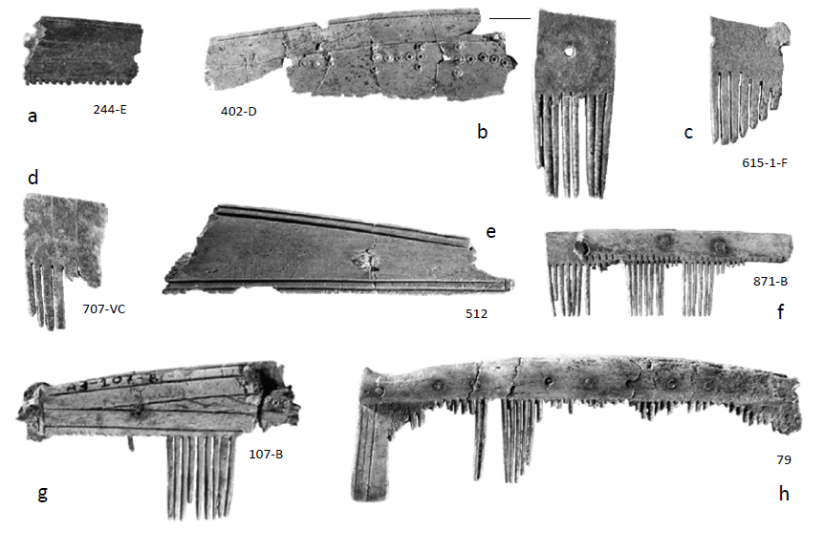**Fig. 7. Finished combs and comb fragments of reindeer antler found at Aggersborg. Photo: Moesgaard Photo lab.**

The Aggersborg collection is thus characterized by the occurrence of finished combs, some manufactured in non-local materials, and very limited workshop material, comprising material made of local species. Most of the non-local combs almost certainly relate to the pre-fortress phase, emphasizing the general observation that a fair number of finds from this settlement phase are non-local (and in particular from the Scandinavian Peninsula). A few combs are most likely from the fortress, and one of these is also of reindeer, demonstrating continued links to central or northern Scandinavia. The association of reindeer antler combs with both the rural settlement and the fortress indicate that their occurrence is a persistent pattern at the site: as many as one in five combs used and discarded at Aggersborg were positively made of antler from a non-local species.

**Urban emergence**

This study has demonstrated that deer antler consumed in urban workshops is a sensitive indicator of patterns of communication and resource networks in the Viking Age. Chronological patterns are important, but the distribution also relates to differences in site character and connectivity. It has previously been suggested that Ribe originated as a market site which “served a defined region of central Jutland” (Hodges, 2012, 109). Its highly visible imports of Frankish pottery, glass and metals is often seen as an articulation between a peripheral region and the ‘core’ of North West Europe (cf. critique in Wickham, 2005, 822).

The biomolecular characterisation of raw material and finished products at Ribe reveals an early phase characterized by bricolage: an admixture of resources apparently acquired through ad hoc supply, according to local availability. Even so, from the early eighth century the identification of a number of typologically and stratigraphically early combs of reindeer antler clearly bears witness to the presence of individuals who had travelled to the town from the north. Previously, Ribe’s earliest identified evidence for contact with central or northern Scandinavia was the presence of steatite vessels, occurring shortly after *c.* AD 800; other Norwegian products, such as whetstones of Eidsborg schist or walrus ivory appear only after the ninth century (Feveile and Jensen, 2006, 140). A Norwegian origin is indicated by the metallurgy of some ironobjects, including an anchor, possibly dated *c.* AD 750-80 (Buchwald, 2006; cf. Rieck, 2006 and chronology in Feveile and Jensen, 2006). Eighth-century Norwegian graves and settlements contain types of pottery, beads and ornaments which are similar to items produced or exchanged in Ribe, but it is not clear whether they represent direct interaction (Näsman and Roesdahl, 2003; Sindbæk, 2011, 58-9).

It is notable that the reindeer-antler combs precede the arrival of these classes of material, pushing Ribe’s history of contact with areas to the north back to the first half of the eighth century. Ribe was, from an early date, not merely a regional market, but an entrepôt for commodity flows and, by implication, for long-distance travellers converging from the north and south.The results allow us to question the assumption that long-distance connectivity was always secondary to developments within regional hinterlands as a component of urbanism. Our ability to trace connections to other parts of Scandinavia is indicative of more complex dynamics.

**The beginning of the Viking Age**

Exotic fauna makes its entrance as a raw material in Ribe in thelast quarter of the eighth century. At this point some urban craftworkers began to receive a significant proportion of their materials via a long-distance maritime supply network. This potentially substantial appearance of reindeer antler comes at a time when other exchange patterns in Ribe shift dramatically. Changes are noted in the appearance of glass beads which had been mass-produced in Middle Eastern factories. These became available in such substantial numbers that they out-competed local bead-making workshops (Callmer, 1995, 53-57). It is also reflected in Frankish products: most particularly in transport vessels (Badorf ware, Reliefband-amphora), which, although they do occur in earlier layers, appear in much more substantial numbers in strata from the 780s onwards (H. J. Madsen, 2004, 255; Feveile and Jensen, 2006, 134-138). Not least, it is noted in the introduction of characteristic new technologies and ornamental styles on non-ferrous metal jewellery, which subsequently come to characterize large parts of Scandinavia (H. Brinch Madsen, 1984; Feveile, 2002).

These changes coincide with a remarkable increase in the intensity of coin use at the Frankish emporium of Dorestad, which was almost certainly a key site in Ribe’s network; this has been explained by Simon Coupland as indicating “a boom in trade between Franks and Scandinavians” (Coupland, 2010: 101; 2011: 119). More broadly, they align with the Viking Age’s “florescence of piracy, trade, migration, conquest and exploration across much of Europe”, as marked by the first Viking raids recorded in the Anglo-Saxon Chronicle, and by references in the Royal Frankish Annals to an intensification of Carolingian-Danish contacts (Barrett, 2010: 289).

While urban trade has been suggested as a trigger or context for Viking-age maritime expansion, it has been rightly pointed out that an important group of actors in this expansion must have come from western Norway, where no urban sites existed in the eighth century (Barrett, 2008; 2010: 293f). In this context the introduction, at the beginning of the Viking Age, of considerable quantities of reindeer antler to Ribe is significant. It proves that at this point, part of central Scandinavia was sufficiently closely linked into the exchange of an urban network to respond to changing economic flows. Other materials may have been involved in these flows, including iron and furs, but their chronology awaits further investigation. Given the evidence for even earlier northerly contacts in the form of finished combs, it is clear that the changes we see in the late eighth century relate not to the emergence of a network *per se*, but rather constitute an event within the life of an already extant network. Thus, for the first time, urban trade can now be proven as an economic and cultural factor in Central Scandinavia before *c.* AD 800, and could well have been part of the equation that explains the early stages in the Viking-age expansion.

**Arctic expansion**

Another pattern that may be discerned and must be explained is the apparent drop-off in the use of reindeer antler in later phases at Ribe. Preservation is poor in ninth-century and later levels, but before discounting the pattern as a result of taphonomy or site formation processes, we should consider the possibility that this reflects a historical reality. Does the tail-off suggest that the use of reindeer antler, and by inference the extension of Ribe’s network to the north and west, was confined to a rather limited chronological horizon in the eighth century? Evidence from beyond Ribe suggests otherwise. Previous investigations have conclusively demonstrated the use of reindeer antler in Scandinavian-made combs used by Viking-age (i.e. post AD 850) and medieval settlers in Atlantic Scotland; indeed, the appearance of such combs constitutes a distinctive marker of the Viking Age in the region (Ashby, 2009; von Holstein *et al*, 2014). This persistence is equally perceptible in other products; Ribe itself was clearly still flourishing in the first half of the ninth century, given the quantity of its metalworking output that found its way to Norway (Brinch Madsen, 1984 distribution maps), and it is precisely during this phase that Norwegian stone products first appear at the site.

In more general terms, reindeer antler has been recorded by means of traditional visual means in ninth- and tenth-century contexts at Hedeby, where a total of 1300 finds of reindeer antler was identified (Ulbricht, 1978, 17). Despite the impressive number, this amounts to only *c.* 0.5% of the total assemblage of antler finds from the settlement, a figure which has led some to rule out a role for trade in non-local antler in Hedeby (Ambrosiani, 1981, 52). However, in some contexts reindeer antler constitutes as much as 7% of the material found, suggesting that its use was not random (Ulbricht, 1978, 107). Ulbricht warns that “reindeer antler could not always be unambiguously identified as such. This was only possible for large pieces of waste and pieces with few traces of working, while heavily worked pieces… do not allow for an identification of the animal species.” (Ulbricht, 1978, 107, our translation). The extent to which ZooMS analysis of the many otherwise unidentifiable fragments at Ribe has boosted the number of known reindeer antler pieces suggests that their relative occurrence in Hedeby may, if anything, be underestimated. Ulbricht notes a concentration of reindeer antler in upper layers, and sees this as evidence that reindeer antler was introduced only at an advanced point in the history of the settlement (Ulbricht, 1978, 128). The new evidence for a much earlier arrival of reindeer antler at Ribe raises the possibility that this material was also used throughout the history of Hedeby.

In particular, the broad pattern indicated by our analyses of finished combs from Aarhus and Aggersborg suggests an increasing reliance on non-local products or materials that persisted into the tenth century (**fig.** **8**). As much as one comb in four from Aarhus and Aggersborg were made of reindeer antler. The evidence for use of reindeer antler in combs in Scandinavia and in Northern Britain is matched by evidence for increased reindeer hunting and other outland use in Norway (Mikkelsen, 1994; Nesje *et al*., 2012). Moreover, the use of non-local material may not be confined to non-local species. Using strontium isotopic analysis, Becker and Grupe (2012) have recently shown that many red deer antlers from Hedeby were imported. According to the cut-off 87Sr/86Sr values determined by measuring the local geological bedrock range, 87% of 31 sampled antlers could not have come from the regional hinterland of Hedeby. Most of the imports have elevated 87Sr/86Sr isotopic ratios, indicating a north-to-south trade. We have not, to date, attempted to distinguish between local and imported sources of *Cervus elaphus* or *Alces alces*, but this may be a task for the future. Schyman (2012) has demonstrated the potential of isotopic approaches to antler, by noting statistically significant differences in strontium ratios in red deer and elk material from Sigtuna, Uppland, Sweden, and Fröjel, Gotland. It is of particular interest that he suggests that material may have been imported to Sigtuna in periods of characterized by depleted local supply.

**Fig. 8. The proportion of reindeer antler, roe deer antler and other materials used in finished combs and comb fragments from Ribe AD *c*. 705-780 (n=27) and AD *c*. 780-860 (n=59), Aggersborg (n=45) and Aarhus (n=34). The results suggest a general trend towards an increasing use of non-local material, and a diminishing use of sub-standard local material. Graphics: Steven P. Ashby.**

In all, the disappearance of reindeer antler in the late phases at Ribe is clearly a context-specific development, and a component of a broader pattern. In this regard, one may note the near-contemporary foundation of Kaupang as an entrepôt in Norway (Skre, 2007), as well as the development of Hedeby as an additional nodal point in southern Scandinavia (Kalmring, 2010: 29). The appearance of these hubs transformed the communication networks of the Baltic and North Sea areas, their particular impact being that henceforth a certain component of maritime traffic that had previously frequented Ribe, now bypassed it. In this context, we suggest that our findings indicate a growing integration of Arctic and subarctic outlands into North European maritime networks during the Viking Age, but as a gradual process which had begun before 800, and reached a substantial scale by the end of the period.

Archaeological studies have shown that the exploitation of special resources from outland regions were an essential element in Viking-age expansion in the northern parts of Scandinavia, and reaching into the islands of the North Atlantic (Øye, 2003; Mahler,, 2007: 16). Reindeer antler was one of a number of coveted products identified in this context, including furs (Wigh, 2001: 120-124). According to a late ninth-century text, the ‘Old English Orosius’, King Alfred received at his court in Wessex a Norwegian visitor called Ohthere. Ohthere not only came from the far north, but also claimed to own six hundred reindeer, and to know the sailing route to Hedeby. The products of the Artic outland, which could be supplied by travellers like Ohthere, were equally coveted in southern exchange. Ohthere brought walrus tusks as an exotic gift for the king of Wessex. This ivory from the Arctic was a highly desirable commodity, which a hundred years later was worked by artists and craftsmen at many sites around Europe. Ultimately the Norse voyages and settlements in Greenland and America have been suggested to be at least partly spurred by the demand for products from the Arctic outland (Arneborg, 1998; Roesdahl, 2003; Keller, 2010).

The fact that products such as reindeer antler were infiltrating the urban networks of the North Sea and the Baltic speaks to an articulation between the towns of southern Scandinavia, and the outland areas of the north (**fig. 9**). That tells us about something more profound than simply the geography of north vs south, but about the relationship between these nodes of travel and trade, and what might be seen as much more marginal, frontier-like areas. Or at least, it allows us to consider in tandem two different types of frontier.

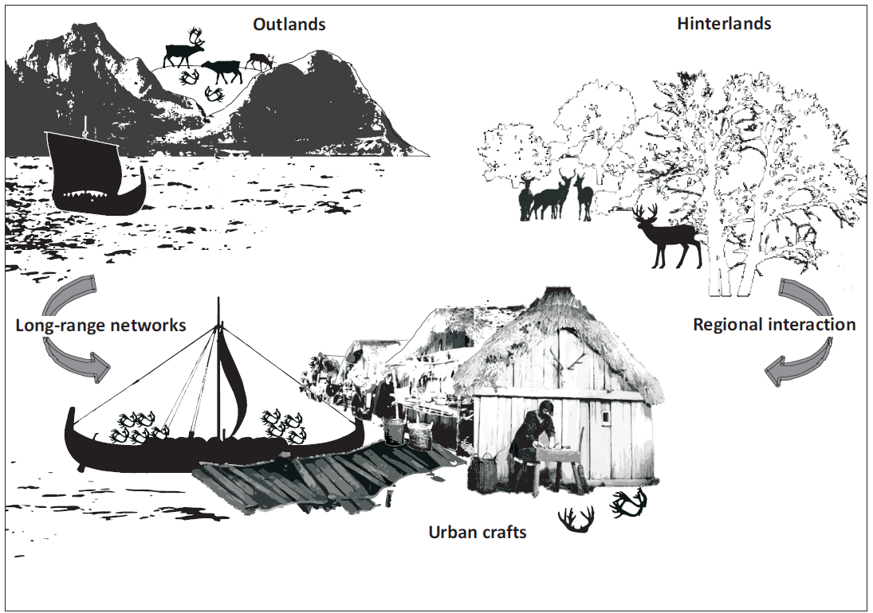**Fig. 9. Model representation of supply networks behind comb-making in Viking-age towns. Long-distance maritime networks extracted use-value from outland products as an alternative to sourcing from local hinterlands. In the pattern of practices and networks that supported urban comb-makers, a distinction between local production and long-distance trade is not a necessary analytical dimension. Graphics by Søren M. Sindbæk**

**Conclusion**

Around the time we recognize as the beginning of the Viking Age, people living in the Scandinavian Peninsula would have taken to outland areas to hunt reindeer, or to collect their shed antlers. They would do so in order to ship the material to craft specialists at sites many days sailing to the south. Some craftspeople maintained a scale of production that made this means of sourcing raw material economically viable, acting as a supplement to material available from the great woodlands in the surrounding countryside. The rationale for this chain of activities sprung from the maritime network and the urban centres on which it focused. Those involved in foraging expeditions in the Scandinavian outlands were thus engaged in a quintessentially urban activity.

What is *urban* about early urban networks is not confined to one site or region, but rather is dispersed in resource and production networks that might involve both extended sea journeys and the exploration of marginal terrestrial landscapes. Some of the activities that gave Ribe its distinctively urban character occurred in the bustling marketplace; others took place on a Norwegian mountainside. This revelation highlights an issue in the study of urbanism that has been somewhat neglected in favour of a focus on settlement hierarchies and built structures. While these are of course significant considerations, urbanism needs also to be considered as a pattern of practices and networks. Its effects were not necessarily confined to circumscribed catchment areas or hinterlands, but may be more appropriately defined and researched as dynamics of mobility focused on certain sites, which catalysed transitions to material and social complexity.

**Acknowledgements**

We wish to thanks to Prof. M. Collins and CodeX Technician Keri Roswell, both of the University of York, and Dr Mike Buckley, The University of Manchester, for assistance and consultation on the application of ZooMS. Prof. T. O’Connor, the University of York, generously assisted in visual confirmation of antler and bone. We would also like to thank Moesgaard Museum, the National Museum of Denmark, and the Museum of South West Jutland for permission to sample objects from their collections, and curators Morten Søvsø and Lars Krants Larsen for generous assistance in this work. The research for this paper form a component of the research project “ENTREPOT - Maritime Network Urbanism in Global Medieval Archaeology” funded by the Danish Council for Independent Research (DFF) research career programme Sapere Aude, based at the University of Aarhus, see: <http://projekter.au.dk/en/entrepot/>

**References**

Ambrosiani, K. 1981. *Viking Age Combs, Comb Making and Comb Makers in the Light of Finds from Birka and Ribe*. Stockholm Studies in Archaeology 2, Stockholm, Almqvist and Wiksell.

Andersen, H.H., P.J. Crabb and H.J. Madsen 1971. *Århus Søndervold. En byarkæologisk undersøgelse*. København : Gyldendalske boghandel.

Arneborg, J. 1998. The high arctic ‘utmark’ of the Norse Greenlanders, in: H. Andersson H. Andersson, L. Ersgard and E. Svensson (eds.) *Outland use in preindustrial Europe*, 156-126. Lund: Institute of Archaeology, Lund University.

Ashby, S. P. 2009. Combs, contact, and chronology: reconsidering hair combs in Early-historic and Viking-age Atlantic Scotland. *Medieval Archaeology*, 53: 1-33.

Ashby, S. P. 2013a. Making a Good Comb: Mercantile Identity in 9th to 11th-century England. *In:* Ten-Harkel, L. and Hadley, D. M. (eds) *Everyday Life in Viking Towns: Social Approaches to Towns in England and Ireland c. 800-1100.* Oxford: Oxbow, pp.193-208.

Ashby, S. P. 2013b. Some Comments on the Identification of Cervid Species in Worked Antler. In: S. O'connor, S. and Choyke, A. M. (eds) *From These Bare Bones: Raw materials and the study of worked osseous materials*. Oxford: Oxbow, pp.208-222

Ashby, S. P. 2014a. *A Viking Way of Life. Combs and Communities in Britain and Scandinavia, c. AD 800-1100,* Stroud: Amberley.

Ashby, S. P. 2014b. Technologies of Appearance: hair behaviour in Early-Medieval Britain and Europe. *Archaeological Journal***,** 171: 153-186.

Ashby, S. P. in press. ‘With staff in hand, and dog at heel’? What did it mean to be an ‘itinerant’ artisan? In: G. Hansen, Ashby, S. P. and Baug, I. (eds) *Everyday Products in the Middle Ages. Crafts, Consumption and the Individual in Northern Europe c. AD 1000-1600*. Oxford: Oxbow.

Barrett, J. H. 2008. What caused the Viking Age? *Antiquity*, 82: 671-685.

Barrett, J. H. 2010: Rounding Up the Usual Suspects: Causation and the Viking Age Diaspora. In: A. Anderson, J.H. Barrett, K.V. Boyle (eds.) *The Global Origins and Development of Seafaring*. Cambridge: McDonald Institute for Archaeological Research, pp.289-302

Barrett, J. H., D. Orton, C. Johnstone, J. Harland, W. Van Neer, A. Ervynck, C. Roberts, A. Locker, C. Amundsen, I. Bødker Enghoff, S. Hamilton-Dyer, D. Heinrich, A. K. Hufthammer, A. K.G. Jones, L. Jonsson, D. Makowiecki, P. Pope, T. C. O’Connell, T. de Roo, M. Richards 2011. Interpreting the expansion of sea fishing in medieval Europe using stable isotope analysis of archaeological cod bones. *Journal of Archaeological Science* 38: 1516-1524.

Becker, C. and Grupe, G. 2012. Archaeometry meets archaeozoology: Viking Haithabu and medieval Schleswig reconsidered. *Archaeological and Anthropological Sciences* 4: 241–262.

Bencard, M. and Jørgensen, L. Bender 1990. Excavations and Stratigraphy. In: M. Bencard, Bender Jørgensen, L. and Brinch Madsen, H. (eds) *Ribe excavations 1970-76* vol. 4. Esbjerg (Sydjysk Universitetsforlag), pp.15-168.

Buckley, M., Collins, M., Thomas-Oates, J. and Wilson, J. C. 2009. Species identification by analysis of bone collagen using matrix-assisted laser desorption/ionisation time-of-flight mass spectrometry *Rapid Communications in Mass Spectrometry*, 23: 3843-3854.

Buckley, M., Whitcher Kansa, S., Howard, S., Campbell, S., Thomas-Oates, J., Collins, M., 2010. Distinguishing between archaeological sheep and goat bones using a single collagen peptide. *Journal of Archaeological Science* 37, 13-20.

Buckley, Mike, and Matthew James Collins. 2011. Collagen Survival and Its Use for Species Identification in Holocene-Lower Pleistocene Bone Fragments from British Archaeological and Paleontological Sites. *Antiqua* 1 (1): e1. doi:10.4081/antiqua.2011.e1.

Buchwald, V.F. 2006: A note concerning three ancient anchors from Nydam, Ladby and Ribe. In M. Bencard, Kann Rasmussen, A. and Brinch Madsen, H. (eds.) *Ribe Excavations 1970-76 vol 5*. Højbjerg: Jutland Archaeological Society, pp. 183-186.

Callmer, J. 1995b: The influx of oriental beads into Europe during the 8th century. In: M. Rasmussen *et al*. (eds): *Glass beads - Cultural History, Technology, Experiment and Analogy. Proceedings of the Nordic Glass Bead Seminar 16th-18th October 1992.* Studies in Technology and Culture 2. Lejre: Historical-Archaeological Experimental Centre, pp. 49-54.

Clarke, H.B. and Ambrosiani, B. 1991. *Towns in the Viking Age.* London: Leicester University Press.

Coupland, S. 2010: Boom and bust at 9th-century Dorestad. In A. Willemsen and Kik, H. (eds) *Dorestad in an international framework*. Turnhout: Brepols, 95-104.

Van Doorn, N. L., Hollund, H. and Collins, M. J. 2011. A novel and non-destructive approach for ZooMS analysis: ammonium bicarbonate buffer extraction. *Archaeological and Anthropological Sciences*, 3 (3): 281-9

Feveile, C. (ed.) 2006. *Det ældste Ribe. Udgravninger på nordsiden af Ribe Å 1984-2000.* Ribe Studier vol. 1.1 and 1.2. Aarhus: Jysk Arkæologisk Selskab.

Feveile, C. 2002. Støbning af ovale skålspænder i Ribe – type- og teknikvariation. In: M. B. Henriksen (ed.) *Metalhåndværk og håndværkspladser fra yngre germansk jernalder, vikingetid og tidlig middelalder.* Rapport fra et seminar på Hollufgård den 22. oktober 2001. Skrifter fra Odense Bys Museer vol. 9. Odense: Odense Bys Museer, 17-26.

Feveile, C. 2006. Ribe on the north side of the river, 8th-12th century. In: C. Feveile (ed.) *Det ældste Ribe. Udgravninger på nordsiden af Ribe Å 1984-2000.* Ribe Studier vol. 1.2. Aarhus: Jysk Arkæologisk Selskab, pp. 65-92.

Feveile, C. 2012. Ribe - emporia and town in the 8th and 9th century. In: S. Gelichi and R. Hodges (eds) *From one sea to another: Trading places in the European and Mediterranean Early Middle Ages.* Turnhout: Brepols, pp.111-122.

Feveile, C. and Jensen, S. 2006. ASR 9 Posthuset. In: C. Feveile (ed.), *Det ældste Ribe. Udgravninger på nordsiden af Ribe Å 1984-2000.* Ribe Studier vol. 1.2. Aarhus: Jysk Arkæologisk Selskab, pp.119-191.

Galloway, P. 1990. Toilet Equipment: Combs of Bone, Antler, and Ivory. In: M. Biddle (ed.) *Object and Economy in Medieval Winchester.* Winchester Studies volume 7.ii.ii. Oxford: Clarendon Press, pp.665-678

Jantzen, C. 2013. *Middelalderbyen Aarhus.* Aarhus: Den Gamle By.

Henderson, J., J.A. Evans, H.J. Sloane, M.J. Leng, and C. Doherty. 2005. The Use of Oxygen, Strontium and Lead Isotopes to Provenance Ancient Glasses in the Middle East. *Journal of Archaeological Science* 32 (5): 665–73.

Hodges, R. 1982. *Dark Age Economics: The Origins of Towns and Trade A.D. 600-1000.* London: Duckworth.

Hodges, R. 2012. *Dark Age Economics: A new audit.* London: Bristol Classics Press.

Hofreiter, M. Collins, M. and Stewart, J. 2012. Ancient Biomolecules in Quaternary palaeoecology. *Quaternary Science Reviews* 33: 1-13.

von Holstein, I. C., Ashby, S. P., Van Doorn, N. L., Sachs, S. M., Buckley, M., Meirai, M., Barnes, I., Brundle, A. and Collins, M. J. 2014. Searching for Scandinavians in pre-Viking Scotland: molecular fingerprinting of Early Medieval combs. *Journal of Archaeological Science*, 41: 1-6.

Hull, Sharon, Mostafa Fayek, Frances Joan Mathien, Phillip Shelley, and Kathy Roler Durand. 2008. A New Approach to Determining the Geological Provenance of Turquoise Artifacts Using Hydrogen and Copper Stable Isotopes. *Journal of Archaeological Science* 35 (5): 1355–69.

Keller, C. 2010: Furs, Fish, and Ivory: Medieval Norsemen at the Arctic Fringe. *Journal of the North Atlantic*, 3: 1–23.

Kirby, Daniel P, Michael Buckley, Ellen Promise, Sunia a Trauger, and T Rose Holdcraft. 2013. Identification of Collagen-Based Materials in Cultural Heritage. *The Analyst* 138 (17): 4849–58.

Ling, J., Hjärthner-Holdar, E., Grandin, L., Billström, K., Persson, P.-O. 2013. Moving metals or indigenous mining? Provenancing Scandinavian Bronze Age artefacts by lead isotopes and trace elements. *Journal of Archaeological Science*, 40: 291-304.

Madsen, H. Brinch 1984. Metal-Casting, Techniques, Production and Workshops. In: M. Bencard (ed.) *Ribe Excavations 1970-1976.* vol. 2, Esbjerg: Sydjysk Universitetsforlag.

Madsen, H.J. 2004: Pottery from the 8th – 9th Centuries. In M. Bencard, Kann Rasmussen, A. and Brinch Madsen, H. (eds) *Ribe Excavations 1970-76 vol 5*. Højbjerg: Jutland Archaeological Society, pp.223-270.

Madsen, H.J. and Sindbæk, S.M. 2014. Combs. In E. Roesdahl, S. M. Sindbæk, A. Pedersen and D. M. Wilson (eds) *Aggersborg: The Viking-Age settlement and fortress*. Højbjerg : Jysk Arkæologisk Selskab, pp.269-272.

Mahler, D. L. 2007. *Sæteren ved Argisbrekka. Økonomiske forandringer på Færøerne i vikingetid og tidlig middelalder.* Copenhagen/Torshavn: Faroe Universtity Press.

Mainman, A. J. and Rogers, N. S. H. 1999. Craft and Industry: The Range of the Evidence. In: Macgregor, A., A. J. Mainman, A. J. and N. S. H. Rogers, N. S. H. (eds) *Bone, Antler, Ivory and Horn from Anglo-Scandinavian and Medieval York*. The Archaeology of York 17/2: Craft, Industry and Everyday Life*.* York: Council for British Archaeology, pp.1903-1916.

Näsman, U. 2000. Exchange and politics: the eighth-early ninth century in Denmark. In: C. Wickham and Lyse Hansen, I. (eds) *The long eighth century. Production, distribution and demand.* The transformation of the Roman World 11. Leiden: Brill, pp.35-68.

Näsman, U. and E. Roesdahl 2003. Scandinavian and European perspectives on Borg I:1. In G.S. Munch, Johansen, O. S. and Roesdahl, E. (eds) *Borg in Lofoten. A chieftain’s farm in North Norway*. Trondheim: Tapir Academic Press, pp.283-300.

O' Connor, S. 1987. *The Identification of Osseous and Keratinaceous Materials at York. Archaeological Bone, Antler and Ivory*. UKICHAW Occasional Papers No. 5. London: The United Kingdom Institute for Conservation of Historic and Artistic Works, pp.9-21.

Øye, I. 2003. ‘Outfields as part of the medieval farm – four archaeological case studies from Western Norway’, in J. Bergstøl (ed.), *Scandinavian Archaeological Practice – in Theory.* Proceedings from the Sixth Nordic TAG, Oslo 2001. Oslo: Institutt for Arkeologi, pp.400–411.

Penniman, T. K. 1952. Pictures of Ivory and Other Animal Teeth, Bone and Antler, Occasional Papers on Technology 5, Oxford, Pitt-Rivers Museum.

Nesje, A., Pilø, L.H. Finstad, E., Solli, B., Wangen, V., Ødegård, R. Strand, Isaksen, K., Støren, E. N., Bakke, D.I., Andreassen, L.M. 2012: The climatic significance of artefacts related to prehistoric reindeer hunting exposed at melting ice patches in southern Norway. *The Holocene* 22:4, 485-496.

Riddler, I. D. 2003. A Lesser Material: the Working of Roe Deer Antler in Anglo-Saxon England. *In:* Riddler, I. D. (ed.) *Materials of Manufacture: the Choice of Materials in the Working of Bone and Antler in Northern and Central Europe during the First Millennium AD.* Oxford: British Archaeological Reports International Series 1193. pp.41-48)

Rieck, F. 2006: The Anchor from Sct. Nicolaigade in Ribe. In M. Bencard, A.Kann Rasmussen and H. Brinch Madsen (eds.) Ribe Excavations 1970-76 vol 5. Højbjerg: Jutland Archaeological Society. 173-182.

Roesdahl, E. 2003: Walrus ivory and other northern luxuries: their importance for Norse voyages and settlements in Greenland and America, in S. Lewis-Simpson (ed.), Vínland Revisited: the Norse World at the Turn of the First Millennium. Selected Papers from the Viking Millennium International Symposium, 15–24 September 2000, Newfoundland and Labrador, 145–152. St. John’s, NFL.

Roesdahl, E., S. M. Sindbæk, A. Pedersen and D. M. Wilson (eds) 2014: *Aggersborg: The Viking-Age settlement and fortress*. Højbjerg : Jysk Arkæologisk Selskab.

Schyman, J. 2012. *Proveniensbestämning av vikingatida hornmaterial – en studie utifrån stabila isotoper.* Unpublished Masters thesis, Arkeologiska Forskningslaboratoriet, Stockholms universitet.

Shapiro, B. and Hofreiter, M. 2012. *Ancient DNA: Methods and Protocols*. Methods in Molecular Biology, vol. 840. New York: Springer

Sindbæk, S. M. 2011a. Silver Economies and Social Ties: Long-Distance Interaction, Long-Term Investments - and why the Viking Age happened. In: J. Graham-Campbell, Sindbæk, S. M. and Williams, G. (eds) *Silver Economies, Monetisation and Society in Scandinavia AD 800-1100.* Moesgård: Aarhus University Press, pp.41-66

Sindbæk, S. 2011b. Urban Crafts and Oval Brooches. Style, Innovation and Social Networks in Viking Age Towns. In: S. Sigmundsson (ed.) *Viking Settlements and Viking Society. Papers from the Proceedings of the Sixteenth Viking Congress*. Reykjavik: University of Iceland Press, pp.407-421

Sindbæk, S.M. 2014.The Viking-Age settlement. In E. Roesdahl, Sindbæk, S. M. Pedersen, A. and. Wilson, D. M. (eds) *Aggersborg: The Viking-Age settlement and fortress*. Højbjerg : Jysk Arkæologisk Selskab, pp.81-138.

Skov, H. 1998. Udgravningerne i Århus midtby 1994-97. *Kuml*,1997-98: 227-294.

Skov, H. 1999. Archaeological evidence of trade in Århus, Denmark, from the 10th to the 17 th centuries. *Lübecker Kolloquium zur Stadtarchäologie im Hanseraum* 2: 603-611.

Skov, H. 2005: Aros 700-1100. In C. Damm (ed.) *Viking Aros.* Aarhus: Moesgaard Museum, pp.15-39.

Skov, H. 2006. Evidence of Craft in Ärhus between 800 and 1600 AD. *Lübecker Kolloquium zur Stadtarchäologie im Hanseraum* 5: 651-668.

Skre, D. 2007: Towns and Markets, Kings and Central Places in South-western Scandinavia. In D. Skre (ed.) *Kaupang in Skiringssal, Kaupang Excavation Project Publications Series 1*, 445-469. Oslo: Aarhus University Press.

Smirnova, L. 2002. *Comb-making in Medieval Novgorod (950-1450): An Industry in Transition*. Ph.D Thesis, University of Bournemouth.

Stephan, E. 1994. Die Materialsbestimmung der "Bein" schnallen aus Bopfingen, Pfullingen und Gruibingen. *In:* Quast, D. (ed.) Merowingerzeitliche Funde aus der Martinskirche in Pfullingen, Kreis Reutlingen*.* *Fundberichte aus Baden-Wurtttemberg*, 19: 653-660.

Stewart, J.R.M., Allen, R.B., Jones, A.K.G., Penkman, K. and Collins, M. 2012. ZooMS: Making eggshell visible in the archaeological record. *Journal of Archaeological Science*, 40 (4): 1797-1804.

Ulbricht, I. 1978. *Die Geweihverarbeitung in Haithabu.* Die Ausgrabungen in Haithabu 7. Neumünster: Wachholtz.

Ulbricht, I. 1984. *Die Verarbeitung von Knochen, Geweih und Horn im mittelalterlichen Schleswig.* Neumünster: Wachholtz.

Weber, B. 1995. The identification of raw material in combs. *Universitetets Oldsaksamlings Årbok*, 1993/1994: 197-205.

Wigh, B. 2001. *Animal Husbandry in the Viking Age Town of Birka and its Hinterland,* Stockholm: The Birka Project, Riksantikvarieämbetet, pp. 120-123.

Lie, R. 1993. Appendix. In: Weber, B., Norwegian reindeer antler export to Orkney, *Universitetets Oldsaksamlings Årbok*, 1991/1992: 161-174.

Ballin Smith, B. 1995. Reindeer antler combs at Howe: contact between late Iron Age Orkney and Norway. *Universitetets Oldsaksamlings Årbok*, 1993/94: 207-211.

Wickham, C. 2005. *Framing the early Middle Ages: Europe and the Mediterranean 400-800*. Oxford: Oxford University Press.

**Illustrations**

1. Schematic representation of the manufacture Viking-age antler combs. The process of carefully fitting tooth-plates, connecting plates and iron or copper alloy rivets demanded a high degree of skill and training, and was mainly pursued in urban workshops. After Callmer 2003.
2. Two examples of spectra produced after analysing the collagen peptides within a sample. The mass spectrometer analysis produces a spectrum with lines indicating the intensity and signal of each mass. In the top graph, the masses indicated with pink lines are masses which together are unique to reindeer. The lower graph is a spectra reproduced from Buckley *et al*. 2011 (276) highlighting the masses unique to roe deer.
3. Map of Scandinavia with sample localities and other places mentioned in the text. Hatching indicates the natural occurrence of reindeer according to Ulbricht 1978.
4. Breakdown of the species identification for material sampled from Ribe, Aggersborg and Aarhus by phase. Dates and numbers of finds after Feveile and Jensen 2006, Roesdahl *et al*. 2014 and Skov 2009.
5. A selection of workshorkshop refuse and fragments of finished combs of reindeer antler found in Ribe. Photos: Ashley Coutu.
6. Finished combs and comb fragments of reindeer antler found in Aarhus.
7. Finished combs and comb fragments of reindeer antler found in Aggersborg[text to be included in figure: A) 244-E, B) 402-D, C) 615-1-F, D) 707-VC, E) 512, F) 871-B, G) 107-B, H) 79].
8. The proportion of reindeer antler, roe deer antler and other materials used in finished combs and comb fragments from Ribe, Aggersborg and Aarhus. The results suggest a general trend towards an increasing use of non-local material, and a diminishing use of sub-standard local material. Graphics: Steven P. Ashby.
9. Model representation of supply networks behind combmaking in Viking-age towns. Long-distance maritime networks produced use-value from arctic outlands products as an alternative to sourcing from local hinterlands. In the pattern of practices and networks which supported urban combmakers, a distinction between local production and long-distance trade is irrelevant.