The Archaeology of Postwar Childhood in Rose Macaulay’s The World My Wilderness

Beryl Pong
University of Toronto

The World My Wilderness (1950) is a painful meditation on the social and material ruins of the Second World War. The novel’s chronotope of ruins creates a palimpsest of physical, psychic, and textual dereliction. During the Blitz, air raids uncovered ancient ruins while creating new ones out of present-day buildings and infrastructure. This peculiar archaeological environment resonates with what philosophers have theorized as a ruin’s multidirectional, suspended temporality. Like several other books of “ruin-mapping” in the immediate postwar period, Macaulay’s novel renders this dislocated setting through a cartographic treatment of Blitzed London. Ultimately, the novel complicates conventional ways of reading both the metropolis and the Bildungsroman by emphasizing war’s creation of surrogate habitats, and the residual, destructive effects on youth and maturation.

Keywords: Rose Macaulay / ruins / Blitz / archaeology / Bildungsroman

From the first day of the Blitz on 7 September 1940, London’s landscape altered irrevocably. Three hundred German planes descended upon “Target G,” the London docks that lay in a bight of the Thames. The events led to a trail of rubble whose imagery would continue to dominate the media’s representations of the Blitz thereafter. Everywhere in the city there were “stories of roads blocked, streets in ruins, named places that I knew,” recalls one shop keeper, “and it was almost unbelievable to hear someone say, you know this place or that place, well, it’s been bombed” (Gardiner 23). The photographer Bert Hardy, visiting the East End two days later on September 9, dramatically described the scene as “like the end of the world…. Whole streets down and gone” (30). It was a process of urban unmapping.
The material and psychological scars of the Blitz, both personal and national, form the backdrop and fabric of Rose Macaulay’s postwar novel, The World My Wilderness (1950). Set in 1946 in the immediate aftermath of the war, the text highlights society’s efforts to tame—or as Macaulay writes, “civilise”—the seventeen-year-old protagonist Barbary. In doing so, the novel emphasizes war’s lasting, destructive effects on children’s maturation, fashioning together a postwar Bildungsroman that departs from its generic blueprint. As Franco Moretti writes in The Way of the World (1987), the figure of youth “achieves its symbolic centrality” as modernity’s “essence,” since adolescent characters growing into adulthood represent “the sign of a world that seeks its meaning in the future rather than in the past” (5). In The World My Wilderness, the meaning of that future is uncertain and desolate, and the text is a distorted take on the traditional novel of formation that casts individual development as a symbol of societal development.
Female experiences of development require further attention, and it is arguable whether different appropriations of the nineteenth- and early twentieth-century Bildungsroman share the same discourses about identity and nationhood, or whether they represent the “fusion” or “a new unity” between individual and society “with a force of conviction and optimistic clarity that will never be equaled again,” as Moretti argues (16). Recent revisionist studies of the Bildungsroman form expand upon, as well as reconsider, some of Moretti’s thinking. For the purposes of this essay, his discussion is useful in localized ways, particularly in his focus on the interrelations between national and personal chronologies in literary narrative. His argument is of special interest with regards to Macaulay’s novel.
Moretti writes that the European novel of formation emerges from a period of “crisis and genesis,” and that it is about sloughing off, and moving on from, the ruins of the old world (10). The link between individual and society has important implications for The World My Wilderness, which features a delinquent teenager among the material and psychological rubble of the Second World War—another, albeit different, moment of crisis and genesis. There is a very real and pressing context behind this image: the rise of juvenile delinquency during the wartime and immediate postwar periods. Between 1939 and 1941, reported incidents of vandalism and petty stealing by those under seventeen years old climbed dramatically (Calder 225), and the number of sentences of corporal punishment applied to boys under fourteen increased by over six hundred percent (Titmuss 340). As if in response to these concerns, child psychologist Cyril Burt’s The Young Delinquent (1925) was reissued in both 1940 and 1944, despite the context of increasing publishing restrictions and paper rationing. By 1950, a landmark journal, The British Journal of Delinquency, was established. Macaulay’s novel mines the symbolic import of this sociological context: if juvenile delinquency is about deviating from social norms, about growing up astray, then it is a suggestive metaphor for the attempt to re-establish normality and continuity in postwar life.
Situating The World My Wilderness within the historical and socio-political crossroads at which Macaulay wrote, this essay contextualizes the physical landscape of rubble and ruin in Blitzed London. Here, modern war’s truism of being “bombed back into the stone ages” would find its ironic corollary with bombing’s uncovering of older archaeological ruins. In response to this dislocated environment, Macaulay’s writing makes an attempt at temporal suture through the use of ruin as a Bakhtinian chronotope. But Macaulay refuses to fully restore material, psychological, and social dereliction in her depiction of ruins as surrogate yet unhomely homes for postwar youth. If, as Walter Benjamin writes, “Through its street names, the city is a linguistic cosmos,” then Macaulay’s cartography of Blitzed London inscribes ruination in both character and landscape through its own textual cosmos, its own grammar of ruin (qtd. in Gilloch 181).

The temporality of ruins

Macaulay’s novel is about the spaces and temporalities of ruination, and it engages the contexts of visible spatial and temporal dislocation. Before elucidating the implications of that claim, one might turn to some philosophical thinking about the ontology of ruins in order to understand the way the Blitzscape resonated and manifested such ideas. For while ruination can be examined in terms of its spatial properties, it also involves disrupted notions of time. “[I]n the ruin history has physically merged into the setting,” Benjamin writes (Origin 177). Similarly, Andreas Huyssen has defined the ruin as “the spatialization of history” and “the temporalization of space” (26). For both critics, ruins are where vertices of space and time intersect. In addition to the conjunction between space and time, ruins are also characterized by a vexed temporality or chronology. In part defined by its pre-destroyed past, a ruin is always a remnant of something else. However, a ruin is inescapably present in its state of irreversible decrepitude; a ruin is a ruin precisely because it is not what it was. Ruins are by definition referents to, and revenants of, another place and another time.
This complicated ontology lies at the heart of several critical and philosophical examinations of ruins over the course of the past century. In his essay “The Ruin” (1911), Georg Simmel observes, “sinking from
life,” ruins “still strike us as settings of a life” (261); the “contour” of a ruined environment is “defined by the building-up and the breaking-down” (264). All ruins engage with, and are constituted by, the dynamics between destruction and survival. Comparable arguments concerning a ruin’s death-in-life and life-in-death, its simultaneous pastness and presentness, inform contemporary analyses. In Robert Ginsberg’s The Aesthetics of Ruins (2004), the ruin’s “birthmark” involves “proclaiming that it has come into being by a passing away” (57). In Dylan Trigg’s The Aesthetics of Decay (2006), modern ruins are seen as embodiments of the decline of rational progress in modernity, and Trigg also addresses the ruin’s peculiar temporal make-up, what he calls its “warped timescale” (133). “Having fallen from (active) time, the ruin becomes disjoined from time,” he writes. “The untimeliness is evident in how past, present, and future conspire to converge in the ruin. Having outlived its functional existence, the ruin’s persistence in time disproves outright extinction, so compels an unexpected return” (131). Casting the ontology of ruins within Freud’s concept of the uncanny, Trigg’s study is about the way the past comes into the present, but, “framed by resemblances,” it remains “distant from its origin” (131). Ruins are both ghosts and physical traces of what-has-been; they are part of what was, as well as, inevitably, its imitations.
For these thinkers, the dialectical relationship between past and present, living and dying, survival and extinction, and ending and return defines all ruins in general. They encompass temporal suspension and fissure: “untimeliness” or “dynamic stasis” (Trigg 131, 133; original emphases). However, the devastations of war aggravate the temporality of ruins in specific ways. The idea of temporal rupture, for instance, is not as pronounced in “natural” ruins, those which are products of attrition, decay, and environmental phenomena created over long periods of time. The ruins of war, by contrast, are human-made and often produced instantaneously. In mid-century Britain the force of their appearance exemplifies a sense of temporal abortion that spoke to fears about the nation’s extinction in another global war. As Kitty Hauser demonstrates in Shadow Sites (2007), the impression of national temporal continuity on the verge of instant destruction formed the cultural phenomenology of the interwar and wartime periods. The impression manifested itself, most notably, in the visual media of the day, which often focused on ruins or bomb damage of historic sites and long-standing symbols of national heritage.
More germane to Blitzed London, the specific circumstances of war resonated with the multidirectional, suspended temporality of ruins in visible and marked ways. The “dynamic stasis” of ruin-time inscribed itself spectacularly onto the landscape, not least with the destruction of historical monuments. As the headline in the American magazine Time declared, “The past bombed out of our lives” (qtd. in Brittain 214). During the air raids, many of London’s oldest buildings were destroyed, with hundreds of years of history and tradition reduced to rubble and charred debris. The Blitzscape was one of “History Under Fire,” to quote from the title of Cecil Beaton’s wartime book of photography. Such events invoked comparison with the Great Fire of 1666, and among those writers who made that connection was Virginia Woolf. In her diary on 1 January 1941, she writes about the Blitz through Samuel Pepys’s account of the Great Fire: “On Sunday night, I was reading about the Great Fire, in a very accurate detailed book. London was burning. 8 of my city churches destroyed, & the Guildhall” (Woolf, Diary 351). The feeling of disrupted cultural and historical continuity accompanied the sensation of being bombed back into the past.
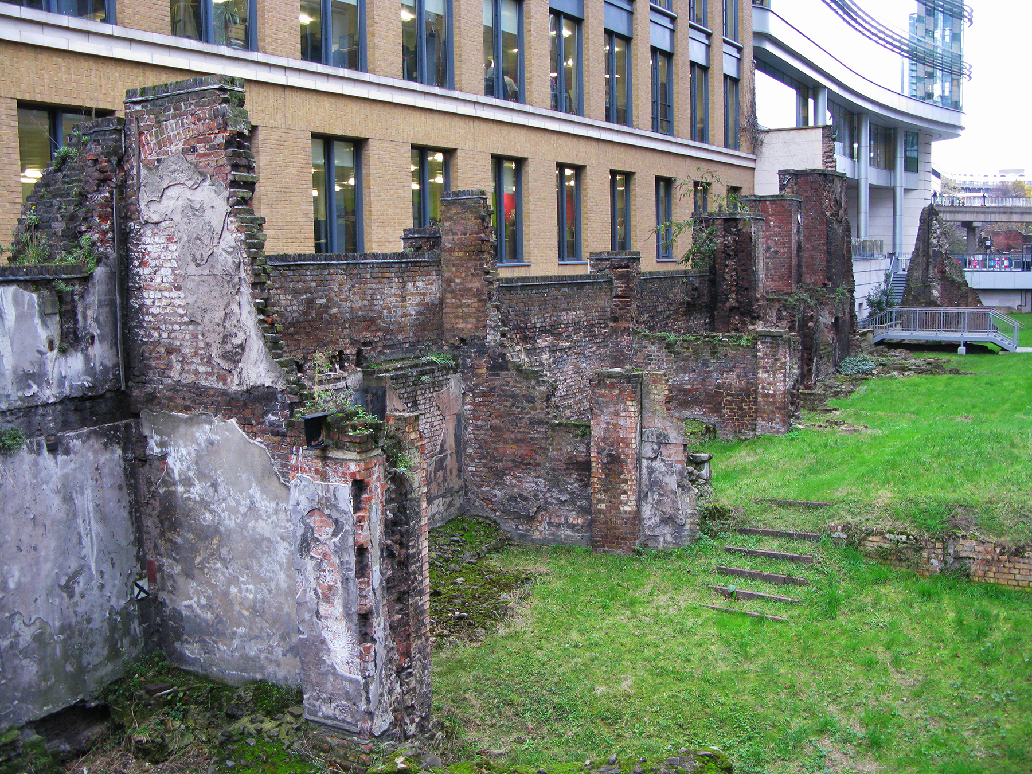
Figure 1: Contemporary picture of parts of the ancient Roman London wall which were uncovered by Blitz bombing on Noble Street. Photograph by the author.

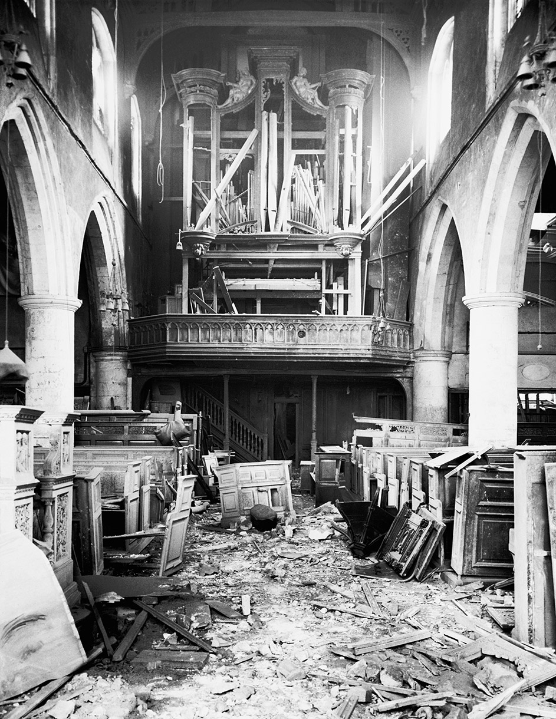
Concomitant to this sense of temporal reversion was the astonishing way in which the Blitz blasted the past into the present, materially. On the night to which Woolf refers, 29 December 1940, twenty-eight bombs fell around the Cripplegate area, revealing parts of the centuries-old Roman London Wall for the first time in two hundred years [Figure 1] (Gardiner 240; “London Wall”). Other architectural wonders discovered as a result of the bombings included: an underground chamber paved with tiles, conjectured to be part of a baptistry, below the altar of St Mary Le Bow Church on Cheapside; a Gothic blocked-up doorway in the south wall of St. Vedast’s Church, on Foster Lane; and a seventh-century Romanesque arch behind the organ of All Hallows Barking Church in Byward Street, west of the Tower of London, which had been previously concealed by paneling [Figure 2] (Kent 59, 62, 95). Between 1940 and 1945, one-third of the City of London was destroyed, which continually opened up London’s landscape for archaeologists to investigate (Hauser 244). Regarding these archaeological revelations, The Times wrote in 1944: “The centuries fall away as the war approaches its climax, or its end, and disclose new views of old London.... [they] yield a rich harvest of interest. The long past as well as the present and future are here, and we may look back and forward as no man has done since 1660” (qtd. in Hauser 244; “Old London”).
Figure 2: Bomb damage at All Hallows Church, December 1940. An arch formed of Roman tiles without a keystone, dating from the latter part of the seventh century, was found behind the organ. © Museum of London/By Kind Permission of The Commissioner of the City of London Police.

With time “fall[ing] away,” and past, present, and future telescoping in London’s cityscape, a collective enthusiasm for ancient history emerged. “The clearing away of the damaged buildings and the digging down to their foundations have given up glimpses of an unknown London,” Norman Brett-James enthused (Kent x). The wealth of “new” old ruins led to a section dedicated to such findings in the first National Buildings Record exhibition in June 1944, held at the National Gallery. And what the Luftwaffe began, the British finished. The interest in London’s material past persisted into the early postwar years, leading to several large-scale excavations. The Roman and Medieval London Excavation Council (RMLEC) was formally inaugurated in 1946 to capitalize on the bomb-discovery of ruins.
In several instances, ecological phenomena also paralleled the explosion of archaeological past into wartime present. This took place through the invasion of Blitz ruins by opportunistic flora, which Londoners often remarked upon for its suggestions of nature’s revenge, or of new growth. The most famous of those plants was rosebay willowherb or Epilobium Angustifolium, commonly known as fireweed. Fireweed thrives on soil that has been subjected to heat, “which enables it to get a firm hold before its competitors” (Fitter 231), making it “the emblematic flower of the bombsites” (Mellor 9) [Figure 3].
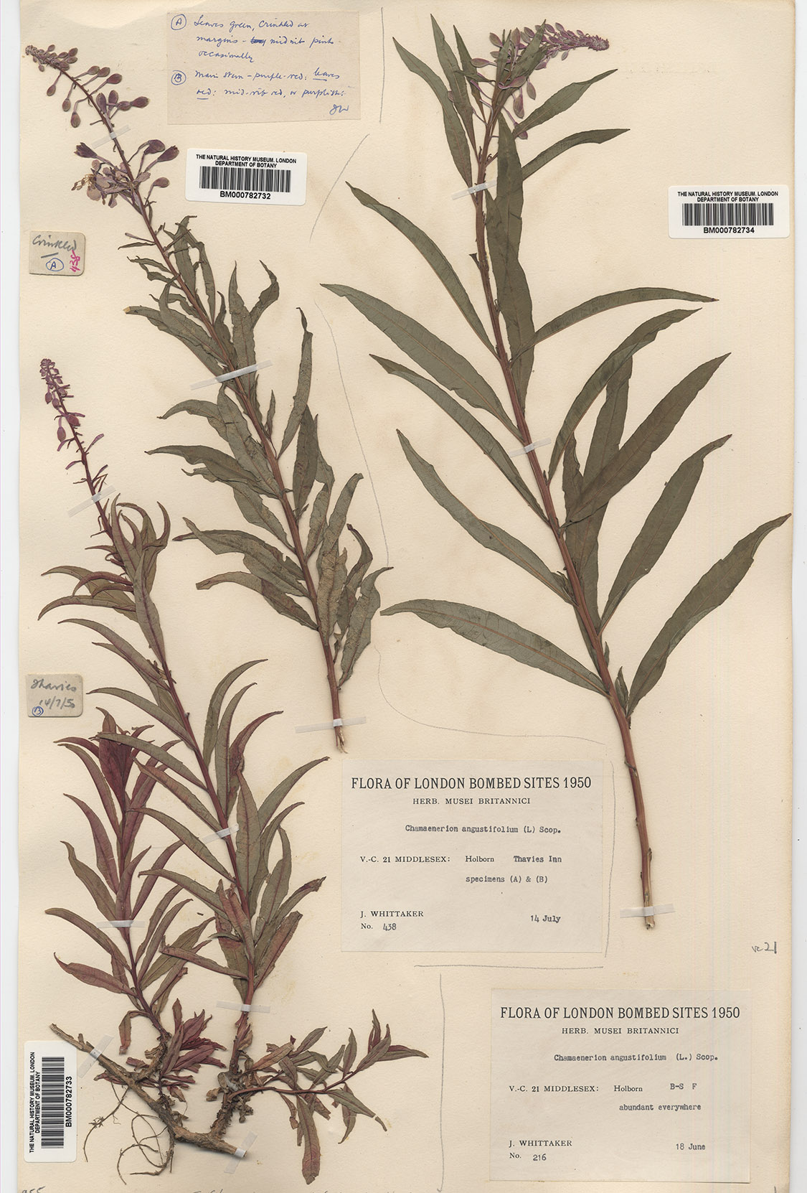
There were also occurrences of ecological resurrection. In September 1940, the herbarium at the Natural History Museum was badly hit and lost ten percent of its species. The air damage in turn created conditions that induced certain seeds to grow again. The Listener from 4 April 1946 reported: “As a result of air-raid damage to the herbarium of the museum in 1940, the seeds of some plants got damp, including a type of mimosa that had been brought over from China in 1793. In spite of their long sleep of a hundred and forty-seven years in the herbarium the seeds germinated” (“Seeds”). Encouraged by this revival, the Keeper of Botany experimented with the same treatment by soaking Nelumbium seeds from prehistoric South Manchuria. “All germinated within two days—an unwitting contribution by Hitler to the Museum’s research,” he declared (qtd. in Ziegler 123). In this way, too, the Blitz bombed the past back into existence, as plants elided a lengthy period of slumber and death.
Figure 3: Specimens of rosebay willowherb (Epilobium Augustifolium) retrieved from London in 1950, housed at the Natural History Museum. © Natural History Museum, London.
In The World My Wilderness, Macaulay would make use of this spatio-temporally dislocated setting in both plot and theme. The novel is well-known for its evocative descriptions of the vegetation that overtook London’s bombsites; it includes taxonomic catalogues of the plant life that filled the craters of ruins. It also refers to the Great Fire multiple times in descriptions of Blitzed London, and it foregrounds the environment of archaeological discovery. As Barbary’s brother Richie observes, while walking through the bombsites, excavators were uncovering “the Middle Ages, The Dark Ages, Londinium, Rome...” (252). In the novel, ruin-time’s inter-animating relationship between past, present, and future has important implications for issues of space and time in literary narrative. But while rendering the “dynamic stasis” of the temporality of ruins, Macaulay would also work against it in an attempt at temporal suture. This takes place, jointly, through the appearance of ghosts, and through writing as mapping: spectral cartography.

Street haunting

“How beautiful a London street is... with its islands of light, and its long groves of darkness, and on one side of it perhaps some tree-sprinkled, grass-grown space...” Virginia Woolf wrote in “Street Haunting” (1930) (22). Such elation in London’s peaceful streets would become ironic memories by the Second World War. The London night no longer signaled peace, but the black-out; the topography was one of demolished houses and uprooted streets; quaint plots of “tree-sprinkled, grass-grown” spaces were either appropriated as gardens for cultivating food, or overgrown by plants and flora. For Macaulay, to haunt Blitz London’s streets was to haunt an altogether different cityscape.
Macaulay was fascinated by ruins. Penelope Fitzgerald recalls “the alarming experience of scrambling after her” following air raids as the latter “shinned undaunted down a crater, or leaned, waving, through the smashed glass of some perilous window.... She was studying obliteration” (Macaulay, Wilderness xii). But the Blitz also brought personal tragedy. On 10 May 1941, Macaulay’s flat was bombed, and she lost almost all of her possessions, including her books, manuscripts, and personal correspondences. Tangible objects attesting to her life and history were incinerated in a resulting fire. “I now have nothing,” she lamented to a friend. “I came up last night to find Lux[borough] House no more—bombed and burned out of existence, and nothing saved. I am bookless, homeless, sans everything but my eyes to weep with.... No nothing...” (qtd. in Smith 157). In a November 1941 piece for the Spectator, Macaulay recounted how she haunted her own demolished flat in search of lost objects (Crawford 128).
This experience informs Macaulay’s only short story written during the war, “Miss Anstruther’s Letters” (1942). Like her author, the eponymous character loses her possessions during a raid, including letters from her deceased lover. Macaulay’s own lover of over twenty years, Gerald O’Donovan, had died in 1942—an autobiographical fact that haunts the story. Ironically and painfully, the only bit of writing that Miss Anstruther recovers is a bitter and accusatory fragment from her beloved, and this surviving ruin of their correspondence distorts her memory of the relationship. Left with an incomplete version of her love affair, Miss Anstruther “now felt herself a ghost,” and as with Macaulay, “like a revenant,” she haunts her ruins (58, 60).
In The World My Wilderness, haunting and ghostliness conjoin on the site of Blitzed London as a phantasmagoria of urban ruin and unfettered, natural plant growth. The novel takes place within an environment of simultaneous dereliction and uncultivated fecundity that weaves together detailed descriptions of London’s urban and ecological topography:

The maze of little streets threading through the wilderness… their dense forests of bracken and bramble, golden ragwort and coltsfoot… the wrecked guild halls that had belonged to saddlers, merchant tailors… St. Giles Cripplegate, its tower high above the rest, the ghosts of churches burnt in an earlier fire… all this scarred and haunted green and stone and brambled wilderness received the returned traveler… with a wrecked, indifferent calm. (128-9)

Breathlessly lush with geographical, historical, and ecological detail, Macaulay’s writing simulates, and seems to feed, the very growth of unnatural nature it limns. Like vines twining up against rubble, her writing weaves together human and natural worlds, with the growth of the wild embedded within a recognizable urban landscape.
The passage above showcases concerns and qualities central to Macaulay’s novel. It demonstrates the author’s general interest in rubble’s reclamation by weeds, which in turn suggests urban regeneration and renewal. Like many parts of the book, it is also painstakingly detailed in topography. According to Jane Emery, The World My Wilderness is so exact in its geography of war-torn London that a successful charge of libel was brought against Macaulay and her publisher “for an adjective she used implying the questionable business methods of one firm, although she did not name it” (285). Furthermore, the passage is one of several in which Macaulay evocatively populates the urban wilderness with figurative as well as actual ghosts. The prime focus is the area south of where the Barbican stands today, where her protagonists feel most at home. The children run through Monkwell Street, where we are told the Abbot of Clarendon’s monks had once lived, and they play on the Cripplegate Wall, where Macaulay evokes the ghosts of previous generations, particularly those residents of houses destroyed in the Great Fire (70-1).
The intertwining of ghosts with topography creates a haunted streetscape that puts the city of ghosts in The Waste Land in a new and actualized light. As several critics have noted, the poem is a key intertext for Macaulay, and the novel is haunted by the fragments of other literary works. What I am interested in, though, is how the conjunction between spectrality and topography allows for a kind of narrative that layers time upon space, history upon geography. In Macaulay’s spectral cartography, post-World War II London is not only a place damaged by the German Luftwaffe, but a city merged with the London of centuries past. In addition to a visual map of London’s material spaces, Macaulay provides a historical timeline of people who lived on such sites throughout hundreds of years. Underlying her metaphysical crowd of past Londoners is an awareness and compression of the deep continuum of time.
Infusing the present with the imprint of the past, Macaulay’s narrative interlocks space and time in an exemplification of Mikhail Bakhtin’s formulation of the chronotope. A term borrowed from Einstein’s Theory of Relativity, and meaning “time space” in Greek, chronotope refers to “the intrinsic connectedness of temporal and spatial relationships that are artistically expressed in literature” (15). Analyzing literature and narrative as sites in which space and time are inseparable, Bakhtin writes: “Time, as it were, thickens, takes on flesh, becomes artistically visible; likewise, space becomes charged and responsive to the movements of time, plot, and history” (15). If categories of space and time are intertwined in the ontology of ruins, then Macaulay’s rendering of space and time in postwar London, through the space and time of literary narrative, embodies what one might call a chronotopic “ruin-narrative.” In both content and form, Macaulay’s Blitzscape is a palimpsestic topos where history is spatialized and space is temporalized.
Others who have considered Macaulay’s aesthetics of cartography have described it in terms of preservation. In the novel’s “geographic” narrative K.L. Anderson writes, “there is a sense of preservation in such long lists, a need for a known geography to be remembered as once known and, just as importantly, used” (n. pag.). She compares The World My Wilderness to Ulysses (1922), noting that Macaulay’s novel is akin to Joyce’s in its “A-to-Z tabulating of London’s bomb victims and survivors” (Anderson). I agree, though I think that the term “preservation” requires qualification, as with the comparison of Macaulay’s novel with Joyce’s. If Joyce was recording Dublin, he was doing so with an eye to preserving it against the potentialities of future conflict and total war. For the interwar modernists, the cartographic tabulation of the metropolis came from an urge of documentation in anticipation of destruction. By contrast, the topography under scrutiny in The World My Wilderness is the postwar capital already marked by craters and bombsites, already overtaken by flowers and weeds.
Because this is literary cartography of ruination after the fact, what Macaulay’s novel engages with, instead, is a desire for postwar recovery and salvage. This line of interpretation has been put forth by Leo Mellor and Deborah Longworth, the latter of whom sees Barbary as a late, female variant of the Baudelairean “wandering urban rag-picker.” Longworth writes that Macaulay, like her protagonist, collects fragments because she is “concerned with the refuse objects of everyday life, forming a connective relationship with the city in which the urban landscape is regarded as a palimpsest of layered time” (qtd. in Parsons 34). She collects objects to form a new present. In the temporally dislocated environment of Blitzed London, Macaulay’s spatialization of history and temporalization of space share ontological affinities with ruin-time, but she re-instills continuity by transforming this setting into a historically-conscious, spatio-temporal whole.
Ultimately, literary cartography in The World My Wilderness is part of a wider milieu of textual ruin-mapping as salvage that took place in the immediate postwar period. For comparison, one might look at street haunting in another, though considerably less intricate work of fiction, George Walter Stonier’s The Memoirs of a Ghost (1947). The novella opens with a direct air raid on the narrator, who wonders, “What next? Death, death no doubt came quickly, crashing, crushing in an instant” (3). He loses his memory, and both he and the reader are left to wonder whether he is alive or dead. Like The World My Wilderness, the text involves topographical descriptions of Blitzed London, and Stonier makes an explicit correlation between the mapping of place and the mapping of identity. With the help of the Baedeker guidebook, the narrator haunts the Blitzscape, and he spends whole days walking and imaginatively reconstructing the city to reconstruct the gaping holes of his past life. So laborious and absorbing is the cartographic process that “I could not tell whether I was map-making or wandering about the area in question,” he explains (56). At one point, he draws a “picture rather than a map” of London, and a line drawing of the River Thames is interpolated into the text (55, 56). The distinction between reconstruction, deconstruction, and construction itself is very fine, as the narrator concocts “counterfeit memories” to hide his psychological state from others. “One result of these counterfeit memories was that at moments a real memory... would present itself. It was rarely more than a flash, a fragment...” (54). In The Memoirs of a Ghost, the haunting of streets is both a symptom of war’s traumas as well as a palliative form of recovering oneself and the past.
Textual reconstruction is also at work in the extraordinary publishing history of a non-fiction book of reverse “ruin-mapping,” Arthur Mee’s London: Heart of the Empire and Wonder of the World (1937). Originally printed in 1937 to coincide with the Coronation of King George VI, the encyclopedic tome—“964 pages, 200 pictures, 29 cities and towns,” its cover declares—presents images and maps of London’s various districts along with their histories. Conceived in the uncertain period before the Second World War, the book is an exemplary instance of pre-emptive salvage. But after the war, it was conspicuously reprinted in a second edition in 1946 by Hodder and Stoughton, where the only edits made to the text involve the addition of a Preface called “Eternal City.” “This is the book of a city which will not be destroyed, the London of ages and ages yet to come,” it says. “It is a record of London as it was before the Blitzkrieg and the V weapons scattered death and ruin and fire about its streets” (xvii-xviii). The book effectively presents the case for selective amnesia: its textual reconstruction asks the reader to overlook the Second World War to pay tribute to a previous era. The back cover makes this relationship between forgetting and reconstruction clear: “The publishers have decided to retain the original text, notwithstanding the destruction during the war of many of the treasures which Mr. Mee has described. [...] Here, then, is the Capital City of the world complete with all its churches and buildings as they stood before bombardment from the air removed so much and revealed so much.” Reconstruction, again, is predicated on constructive acts of the imagination, as the reader unmaps the Blitzscape to map a pre-war geography.
The most important analogue to Macaulay’s and Stonier’s works is William Kent’s The Lost Treasures of London (1947). The “lost treasures” are both the artifacts and buildings damaged by bombing, as well as the archaeological discoveries made as a direct result of the Blitz. One of several cartographical records of the city produced in the mid- to late forties, it is organized as a series of seven walks, roughly two hours each in duration. Kent takes the reader-walker on tours of ruins around central London, with a focus on each site’s pre-war history. Because “it is assumed that many readers will like to carry the book on their pilgrimages through the City,” the text incorporates illustrated maps (5). Indeed, one can carry the book on the mental pilgrimage through Macaulay’s novel, since Kent provides plenty of detail for the streets that Barbary and Raoul would have frequented.

In Monkwell Street, which turns north from Silver Street, was the
BARBERS’ HALL. The Barbers first erected a Hall on this site in 1381. In 1540, by statute, they were incorporated with the Surgeons... In 1636 Inigo Jones built a court room which later became the hall....
The hall and the other apartments have been entirely destroyed. (65)

Wood Street crosses the junction of Silver Street and Addle Street and, by way of the northern half of the first-named thoroughfare the reader can reach the Church of
ST. GILES, CRIPPLEGATE. This church was rebuilt after a fire in 1545. It was a good specimen of the Perpendicular style…. It was 146 ft. 3 in. in length....
The church was subjected three times to attacks from the air. It was the first church to be hit—on 24th August 1940. It is now nothing but a ruin. (66)

Most of Kent’s book is written in this way, beginning with an address to the reader-walker followed by cartographic directions, by detailed facts about the site in question, and ending with a description of the site’s fate after the Blitz. As with Macaulay’s novel, Kent goes to great lengths to fill the hollow of ruins with prior histories and physical forms. Layering the events of centuries on top of present-day ruins, his mapping of London is a spatio-temporal palimpsest that means to recover the “lost treasures.”
At times, reading and walking Kent’s maps resemble uncomfortable acts of ruin-tourism, since the mourning of ruins seems to border on marveling at their spectacle. The reader-walker is encouraged to look directly for bomb damage, and to compare the buildings’ ruined forms with their prior states, as photographic plates provide before-and-after comparisons. The potential discomfort is sidelined by Kent, whose focus on ruins intimates that history and memory can restore, or at the very least temper, the ruined, disjunctive present. For him, the reader is the Benjaminian rag-picker. As Graeme Gilloch writes in his discussion of Benjamin: “It is ultimately the task of the reader to rescue the fragments of the text, to redeem and refunction them in the struggles of the present... Reading is the salvation of the text, which complements rag-picking as the redemption of the thing” (183).

Unhomely ruins

Bakhtin had the Bildungsroman in mind while he developed his essay on the chronotope, writing the latter while working on a study of Goethe and the novel of formation between 1936 and 1938. Although only a fragment of the Goethe study survived, Bakhtin often uses in it the term chronotope without explanation, which suggests that the Goethe fragment is a component of the chronotope essay (Morson and Emerson 405). In The World My Wilderness Macaulay conjoins Bildungsroman and chronotope by mapping London’s sites and ruins while simultaneously countering the map with her protagonist’s private geography, a more traumatic chronotope of the mind. The past is blasted into the present through the unveiling of archaeological sites; but the wartime past is also blasted into the postwar present with more unsettling effects on Barbary’s psyche—effects that amount to a questioning of society’s “formation” or “development” of its youth. Hence, two kinds of mnemonic terrain appear in the novel: one in which the reader imaginatively “walks” London’s historic heritage sites, and another in which one treads through Barbary’s psychological landscape of ruin.
Cripplegate, Barbary and Raoul’s main haunt, is an evocative place for postwar youth to feel at home. It is where old and new ruins intersect, where the ancient Roman London wall re-materialized, where the iconic St. Paul’s Cathedral is located, and where the flowering of plant life reclaimed rubble. This redemptive symbolism is undercut by the children’s interactions with the Blitzscape. After growing up in occupied France, the characters are unable to feel at home in a place that is not marked by ruination. They are drawn to London’s ruinscape because it resembles the war-torn landscape of Collioure, and material dereliction chimes with psychological dereliction: London’s ruins “made a lunatic sense, as the unshattered streets and squares did not” (52, 61). It is only with ruin and rubble that they identify themselves, physically and spiritually; the demolished church in which they play becomes their home (57). The rest of the city appears unreal and “less natural” (74). The repetition of the word “natural” to describe ruins is, of course, doubly ironic, since it refers to both the “natural” overgrowth of plant life, and to Barbary and Raoul’s unnatural naturalization of a landscape charred by violence.
The children’s sense of alienation in an ordered world is directly attributed to war’s effects on their growth and maturation. At every turn Macaulay points to Vichy France as having disrupted their normal childhood and twisted their conscience and morals. Barbary was raised in an environment characterized by black-market lawlessness, political and familial betrayal, and general dishonesty and violence. Her mother aligns her delinquent turn with the outbreak of war in 1939 (26). Richie similarly explains that wartime distorted Barbary’s growth, because “[t]he way you were reared… explains why you are as we see you to-day... I have grown up a civilised being, and you, so far, have not” (33).
In London during the Blitz and immediately after, as families became homeless and children were orphaned or abandoned, youth spent more time in bombsites (Bell 130-1). This context informs Macaulay’s novel, whose characters find their familial homes inadequate, and who are compelled to create alternate, surrogate homes among the ruins. Indeed, as Anderson observes, the Adelphi Terraces where Barbary and her father Gulliver live are described as genteel abodes of Edwardian propriety, when, historically speaking, they should have been entirely torn down in 1936. An art deco building was subsequently erected in 1938 that would not resemble anything described in the novel. Macaulay reconstructs in fiction a house that would not have existed during the war, and the characters inhabit “either a reliquary shard or a ghostly shell” of London’s past, their home anachronistic and false (Anderson, n. pag.).
Barbary’s search for a place to call home leads her on a quest to discover, and recover, different versions of the “maquis”: places of ruin that she recognizes as similar to Collioure and Vichy France. The principal meaning of the maquis is geographical, as it is a landscape found in Corsica but also in southern France, a wasteland characterized by shrubbery and acidic soil. The term “maquis” is central to describing Barbary’s experience of occupied France, since it also refers to the French Resistance of which she was a part, and which hid in those wastelands. As the novel progresses, the maquis takes on physical manifestations for Barbary that include the desolate farmlands of Arshaig and the rubble around Blitzed London. Ultimately, the city is an imaginative topos, a chronotope tethered to material and psychological ruination. When Gulliver asks her about Collioure, Barbary recoils; she wants to tell him about the “squalor of the enfants du maquis years” but does not think he would believe her (84). The maquis is not so much the actual place of the French Resistance as it is the haunting spatio-temporal dimension of Barbary’s experience of France.
Barbary actively looks for the maquis because it speaks to her as a place she recognizes, but it is also a chronotope that surfaces whether or not she wills it (61). In the middle of the novel, Barbary and Raoul are discovered in a ruin by Father Roger, who became psychologically unstable after he was trapped in the wreckage of his bombed church for two days. He gives a tortured, impromptu sermon about hell, and the children looked “unto the dark pits of the past…. Like Father Roger, they knew all about hell” (167, 169). Even though Barbary can be seen as a wandering rag-picker who collects fragments “to create art from rubble,” in another sense, her role as rag-picker can also be seen as one that is thrust upon her by a broken psyche (Parsons 188). Barbary’s condition exposes the darker side of flânerie. Benjamin has described the flâneur as a streetwalker who indulges in urban stimuli, but who simultaneously experiences flashes of memories while doing so. The flâneur proceeds along two axes, one of “sensory data taking shape before his eyes,” the other of “far-off times and places [that] interpenetrate the landscape and the present moment” (Benjamin, Arcades 2, 4; qtd. in Fisher 471). If the city is a “mnemonic for the lonely walker” (Benjamin, “Return” 262), then Blitzed London has the capacity to recall Barbary’s difficult past in Collioure as well.
Barbary’s search for a place to call the maquis, and the way the maquis in turn seems to follow her, demonstrates how the anguish of that place and time remain in her head, waiting to erupt. While the narrative at large can omnisciently catalogue London’s ecological and urban terrain, Barbary’s own map is spatially and temporally fixated on wartime France. The text hinges on the tension between this attitude of salvage towards London, and the failure of the city to be completely home-like or “knowable” to its young characters. This unreconciled opposition raises the question of just how redemptive Macaulay’s novel is; or at the very least, it asks us to consider how the project of salvage might succeed with some but not with others. Barbary, after all, “knew nothing” of the pre-ruin world (181). All she does know is the maquis—and hell.
“Maquis” is used multifariously by the narrator and by Macaulay’s characters, forming a hermeneutics of ruin that proliferates through the book like the weeds that creep over London. The maquis is a physical place: “How like… London was to Collioure, the maquis of the city to the maquis of the Forêt de Sorède” (210). It is also a metaphoric place: “this is the maquis that lies about the margins of the wrecked world” (129). It is a group of people: “they ran around with the maquis” (92). It is a game of role playing: “she... liked playing at houses; and playing at the maquis” (213). It is an adjective and attitude: Barbary has “maquis manners” (107). Finally, it is an internal habitat, an aspect of human nature: “the maquis is within us, we take our wilderness where we go” (210). As a spatio-temporal, psychic-physical ruin-habitat, the maquis is both past and present, memory and projection, nightmare and nostalgia, prison and home.
Barbary’s father wonders whether she would “eventually qualify as salvage” (139) or remain as wreckage. It is not clear that Barbary would ever be salvaged. In the climax of The World My Wilderness, the children are chased by the police, whom Barbary compares to the Gestapo. The scene ends with Barbary’s near-death when she falls into the pit of an archaeological site, its medieval treasures uncovered by bombing. Not only are the police unsympathetic to the children throughout the book, this scene brings together the phantoms and ghosts of London’s past, and they rally vindictively in support of the children’s capture:

The ghosts of Noble Street and Addle Street crowded to their vanished windows to watch the chase…. all gazed respectfully down at the fleeing criminal, the pursuing police, lending the law the silent support of some eight centuries of property and substance… .
The ghosts drew back... sighing that all was over with the world and the British Way of Life if criminals could get so easily away... (193)

Macaulay re-employs the salvage ethics of cartography though the perspective of ghosts, but here, it is in favour of the past against the future. History is not on the side of the young, and it nearly swallows Barbary whole. Even when the policeman gives up his chase, indifferent, the ghosts want blood. For them, this generation is not part of the “British Way of Life.” It represents a delinquent and unwanted future. What one finds, alongside the temporal salvage of Macaulay’s literary cartography, is history’s bitterness towards the future, its desire for revenge.
The World My Wilderness purports, in part, to be a Bildungsroman, a text about attempts to educate and “civilise” youth astray in their trajectories towards adulthood. The original Bildungsroman came from a desire to reconcile the “conflict between the ideal of self-determination and the equally imperious demands of socialization,” Moretti writes (15). That goal of maturation, that reconciliation, is depicted here as morally problematic. At the end of the novel, when Raoul decides to grow up in the conventional sense of the phrase, he associates the path with that of the collaborators against whom he struggled all along. When Barbary asks him about his future plans, he replies: “I shall collaborate. That is to say, I shall observe the laws, go daily to school, obey my uncle and aunt…” (236). Growing up in the postwar world is akin to giving up on one’s values, beliefs, and integrity. If the Bildungsroman is about the coming-of-age of youth, then Macaulay shows that adulthood is not exonerated from the moral wilderness from which her youth are supposed to emerge. Ruination persists. The characters are unable to escape the painful inheritances of the previous generation, to create a future unfettered from the shackles of the wartime past. As Macaulay ventriloquises the Blitzscape: “Here… is your home; here you belong; you cannot get away, you do not wish to get away” (129).

Notes

For more on female development and the Bildungsroman, see Abel, Hirsch, and Langland.
For a cogent overview of recent criticism on the Bildungsroman, see Boes.
Later, in the excavation of the area in 1947, archaeologists discovered a Roman fort which became “perhaps the outstanding event in the twentieth century archaeological study of London,” said W.F. Grimes, who presided over the Roman and Medieval London Excavation Council (RMLEC) (Grimes 38, qtd. in Hauser 244).
William Kent’s The Lost Treasures of London (1947) details these discoveries; I will discuss this text later in the essay. Thus far, the best critical discussion of the Blitz’s peculiar archaeologies is found in Hauser’s book.
One particular panel illustrated “cases where war damage has revealed details or characteristics of archaeological and technical interest,” with examples ranging from “a bastion of London’s medieval wall to the archaic iron frame of a Victorian warehouse” (National Gallery 14).
The examination of a number of Blitz sites in the postwar years would also result in the discovery of the Temple of Mithras and the first full excavation of a medieval church of St. Bride’s at Fleet Street. For more information on postwar excavations of London’s bomb damage sites, see Shepherd.
For more on fireweed, see Fitter 228-39. Fireweed, in fact, breeds on multiple grounds. The secretary of the Royal Horticultural society asserted that the weed grew anywhere, whether or not there had been a fire (Ziegler 317). For more on fireweed in The World My Wilderness, see Mellor 179-83.
This echoes an article Macaulay wrote for The Spectator earlier, in 1949, when she noted: “Excavators are at work, uncovering foundations and bastions, seeking lost centuries, seeking Londinium, seeking Rome” (“In the Ruins”).
See also LeFanu 251-2.
See Mellor 192-95.
See Saint-Amour. As he writes, the “ravenously inclusive, even encyclopaedic projects” of Joyce, Woolf, and Alfred Döblin are imbued with an “all-encompassing cartographic gaze” that gives “a sense of the urban object’s radical vulnerability” (156).
I am indebted to Peter Lowe for drawing my attention to this book.
It should also be noted that The Lost Treasures of London, like many cartographic records of the forties, is partial to central London. It problematically omits or neglects many areas that were severely damaged but that lie in the periphery. Heavily bombed neighborhoods like Bethnal Green, Hackney, and Wapping are largely dismissed, and they are mentioned in a couple of sentences in a kind of postscript chapter (without maps) at the end of the book.
The Goethe essay is now typically known to us as “The Bildungsroman and Its Significance in the History of Realism (Toward a Historical Typology of the Novel),” collected in Speech Genres and Other Late Essays (1986).
See the Ealing Studios comedy Hue and Cry (1947), directed by Charles Crichton, for a filmic treatment of this environment. Works cited Abel, Elizabeth, Marianne Hirsch and Elizabeth Langland, eds. The Voyage In: Fictions of Female Development. Hanover, NH: UP of New England, 1983. Print. Anderson, K.L. “A Horrid, Malicious, Bloody Flame: Elegy, Irony and Rose Macaulay’s Blitzed London.” Literary London Journal (September 2007): n. pag. Web. 28 Jan. 2012. <http://www.literarylondon.org/london-journal/september2007/anderson.html>. Bakhtin, Mikhail. “Forms of Time and of the Chronotope in the Novel: Notes toward a Historical Poetics.” Narrative Dynamics: Essays on Time, Plot, Closure, and Frames. Ed. Brian Richardson. Columbus: Ohio State UP, 2002. 15-24. Print. ---. Speech Genres and Other Late Essays. Ed. Caryl Emerson and Michael Holquist. Trans. Vern M. McGee. Austin: U of Texas P, 1986. Print. Beaton, Cecil. History Under Fire: 52 Photographs of Air Raid Damage to London Buildings, 1940-41. Text by James Pope-Hennessy. London: B.T. Batsford Ltd., 1941. Print. Bell, Amy Helen. London Was Ours: Diaries and Memoirs of the London Blitz. London: I.B. Tauris, 2008. Print. Boes, Tobias. “Modernist Studies and the Bildungsroman: A Historical Survey of Critical Trends.” Literature Compass 3.2 (2006): 230-43. Web. 1 Oct. 2012. Brittain, Vera. England’s Hour: An Autobiography 1939-1941. Basingstoke: Macmillan, 1941. Print. Benjamin, Walter. The Arcades Project. Cambridge: Belknap, 1999. Print. ---. The Origin of German Tragic Drama. New York and London: Verso, 1977. Print. ---. “The Return of the Flâneur.” Selected Writings, Volume 2, 1927-1934. Ed. Michael Jennings and Gary Smith. Cambridge: Belknap, 1999. 262-68. Print. Calder, Angus. The People’s War: Britain 1939-45. [1969]. London: Jonathan Cape, 1986. Print. Crawford, Alice. Paradise Pursued: The Novels of Rose Macaulay. Cranbury, NJ: Associated UP, 1995. Print. Emery, Jane. Rose Macaulay: A Writer’s Life. London: John Murray, 1991. Print. Fisher, Jaimey. “Wandering in/to the Rubble-Film: Filmic Flânerie and the Exploded Panorama after 1945.” The German Quarterly 78.4 (Fall 2005): 461-80. Print. Fitter, R.S.R. The Natural History of London. London: William Collins, 1945. Print. Gardiner, Juliet. Blitz: The British Under Attack. London: Harper Press, 2010. Print. Gilloch, Graeme. Myth and Metropolis: Walter Benjamin and the City. Cambridge: Polity Press, 1996. Print. Ginsberg, Robert. The Aesthetics of Ruins. Amsterdam: Rodopi, 2004. Print. Grimes, W. F. The Excavation of Roman and Medieval London. London: Routledge and K. Paul, 1968. Print. Hauser, Kitty. Shadow Sites: Photography, Archaeology, and the British Landscape 1927-1955. Oxford: Oxford UP, 2007. Print. Hue and Cry. Dir. Charles Crichton. Ealing Studios, 1947. Film. Huyssen, Andreas. “Authentic Ruins: Products of Modernity.” Ruins of Modernity. Eds. Julia Hell and Andreas Schönle. Durham, NC: Duke UP, 2010. 17-28. Print. Kent, William. The Lost Treasures of London. Intro. by Norman Brett-James. London: Phoenix House, 1947. Print. LeFanu, Sarah. Rose Macaulay. London: Virago, 2003. Print. “London Wall: Plans to Preserve Relics Revealed by Bombing.” The Times (26 July 1952): 5. Print. Macaulay, Rose. “In the Ruins.” The Spectator (18 Nov. 1949): 661. Print. ---. “Miss Anstruther’s Letters.” 1942. Wave Me Goodbye/Hearts Undefeated Omnibus. Eds. Anne Boston and Jenny Hartley. London: Virago Press, 2003. 58-65. Print. ---. The World My Wilderness. 1950. Introduction by Penelope Fitzgerald. London: Virago Press, 1983. Print. Mee, Arthur. London: Heart of the Empire and Wonder of the World. 1937. 2nd ed. London: Hodder & Stoughton, 1946. Print. Mellor, Leo. Reading the Ruins: Modernism, Bombsites and British Culture. Cambridge: Cambridge UP, 2011. Print. Moretti, Franco. The Way of the World: The Bildungsroman in European Culture. London: Verso, 1987. Print. Morson, Gary Saul and Caryl Emerson. Mikhail Bakhtin: Creation of a Prosaic. Stanford: Stanford UP, 1990. Print. National Gallery, London. National Buildings Record: Exhibition of Photographs and Drawings of English Architecture. Oxford: Oxford UP, 1944. Print. “Old London: New Vistas of the Past.” The Times (31 Aug. 1944): 2. Print. Parsons, Deborah L. Streetwalking the Metropolis: Women, the City and Modernity. Oxford: Oxford UP, 2000. Print. Saint-Amour, Paul. “Air War Prophecy and Interwar Modernism.” Comparative Literature Studies 42.2 (2005): 130-61. Web. 28 Jan. 2013. “Seeds from Pharaoh’s Tomb.” The Listener (4 April 1946): 425. Print. Shepherd, John, ed. Post-war Archaeology in the City of London, 1946-68: A Guide to Records of Excavations by Professor W.F. Grimes held by the Museum of London. The Archaeological Gazetteer Series, vol 3. London: Museum of London, 1998. Print. Simmel, Georg. “The Ruin.” 1911. Georg Simmel, 1858-1918. Ed. K.H. Wolff. Columbus: Ohio State UP, 1959. 259-66. Print. Smith, Constance Babington. Rose Macaulay: A Biography. London: Collins, 1972. Print. Stonier, George Walter. The Memoirs of a Ghost. London: Grey Walls Press, 1947. Print. Titmuss, Richard M. Problems of Social Policy. 1950. History of the Second World War, United Kingdom Civil Series. Ed. W.K. Hancock. London: Her Majesty’s Stationery Office and Kraus Reprint, 1976. Print. Trigg, Dylan. The Aesthetics of Decay. London: Peter Lang, 2006. Print. Woolf, Virginia. The Diary of Virginia Woolf. Vol 5. New York: Harvest Books, 1985. Print. ---. “Street Haunting: A London Adventure.” The Death of the Moth and Other Essays. 1942. San Diego, New York, London: Harcourt Brace & Company, 1970. 20-36. Print. Ziegler, Philip. London at War, 1939-1945. London: Pimlico, 2002. Print.

