**UNIVERSITY OF YORK**

**Social Policy Research Unit**

**WATER POVERTY IN ENGLAND AND WALES: AN UPDATE**

Jonathan Bradshaw[1] and Gill Main[2]

We published an article on this subject based on an analysis of 2009/10 data from the Family Resources Survey[3].

This note updates that analysis but does not reproduce all the policy discussion in the article because these arguments really have not changed.

Water charges have continued to rise - faster than general inflation (CPI and RPI) and faster than average net equivalent disposable incomes. See Figure 1.

**Figure 1: Trends in prices, earnings and water prices. 2005=100.**

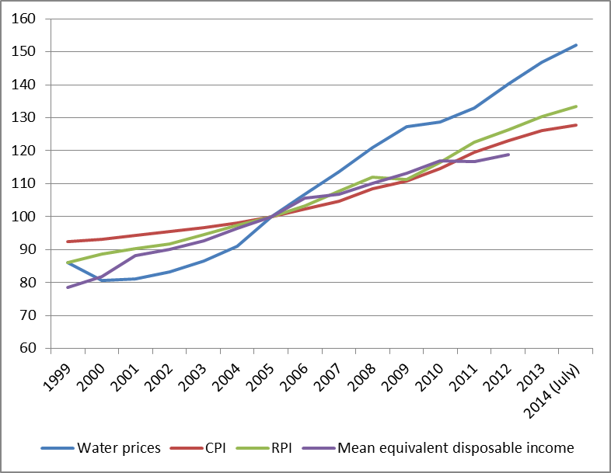

OFWAT is negotiating with the water companies to achieve a real terms reduction in water prices of 5% 2015-2020. To achieve this would be a huge break in their past achievements. But a real terms reduction in prices does not mean a reduction in water poverty. Since 2010 incomes have been falling behind prices and behind water prices and we don’t know when that pattern is going to end.

Water poverty has been conventionally defined as households spending more than 3% or 5% on water and sewerage. These thresholds are arbitrary and it would be a good idea for the government and the regulators to invest in the kind of exercise that has led to the redefinition of fuel poverty as a result of the Sir John Hills report[4].

Table 1 is the result of analysis of the Family Resources Surveys from 2009/10 to 2011/12 the most recent available. Water poverty rates using the 3% threshold have increased over the whole period. The water poverty gap (the average reduction in water charges needed per week by those in water poverty if they are to be lifted out of water poverty) has fallen slightly.

**Table 1: Water poverty rates and gaps 2009/10-2011/12**

|  |  |  |  |  |
| --- | --- | --- | --- | --- |
|  | Water poverty rate >3% | Water poverty rate >5% | Water poverty gap 3% £ per week | Water poverty gap 5% £ per week |
| 2009/10[5] | 22.3 | 9.8 | 3.48 | 3.63 |
| 2010/11 | 22.4 | 9.2 | 3.18 | 3.33 |
| 2011/12 | 23.5 | 10.0 | 3.43 | 3.49 |

Source: Own analysis of the Family Resources Surveys

There is no easy solution to water poverty.

The Water Sure scheme is not being taken up and touches the edge of the problem. The South West subsidy is ill directed. There is also a huge and growing water debt problem.

The water companies don’t know enough about consumers to target relief successfully and really they don’t want to try.

The best solutions are

1. Fiercer regulation of prices by OFWAT.
2. Faster introduction of water meters.
3. Then tilting tariffs so consumers who wash their cars or fill their ponds/swimming pools with drinking water pay a premium.
4. But meanwhile, and anyway, the key is really an increase in cash benefits and low wages so that they exceed water price increases.
5. More research on this subject is also needed - by OFWAT, CCWater and/or the water companies.

No one funded this analysis!

September 2014.

1. Professor of Social Policy, University of York and University of Durham
2. Research Fellow, Social Policy Research Unit, University of York.
3. Bradshaw, J. and Huby, M. (2013) Water poverty in England and Wales, *Journal of Poverty and Social Justice*, 21, 2, 137-148
4. https://www.gov.uk/government/publications/final-report-of-the-fuel-poverty-review
5. These numbers are slightly different than given in Bradshaw and Huby for 2009/10 (for reasons that we cannot fathom) but they are a consistent basis for each year.