The Impact of Cracks on the Performance of Photovoltaic Modules

Mahmoud Dhimish, Violeta Holmes, Mark Dales, Peter Mather, Martin Sibley
Dept. Computing and Engineering
University of Huddersfield
Huddersfield, United Kingdom
Benjamin Chong, Li Zhang
School of Electronic and Electrical Engineering
Leeds University
Leeds, United Kingdom

Abstract—This paper presents a statistical approach for identifying the significant impact of cracks on the output power performance of photovoltaic (PV) modules. Since there are a few statistical analysis of data for investigating the impact of cracks in PV modules in real-time long-term data measurements. Therefore, this paper will demonstrate a statistical approach which uses two statistical techniques: T-test and F-test. Electroluminescence (EL) method is used to scan possible cracks in the examined PV modules. Moreover, virtual instrumentation (VI) LabVIEW software is used to predict the theoretical output power performance of the examined PV modules based on the analysis of I-V and P-V curves. The statistical analysis approach has been validated using 45 polycrystalline PV modules at the University of Huddersfield, UK.
Index Terms—Photovoltaic (PV) cracks; Electroluminescence (EL) method, Statistical approach; Virtual Instrumentation (VI) LabVIEW software.

Introduction
Photovoltaic modules (PV) are expected to have a lifetime of more than 20 years under various environmental conditions like temperature changes, wind load, snow and many other factors. Such loads induce mechanical stresses into the components of the PV module, especially into the crystalline solar cell [1]. The resulting cracks in silicon solar cells reduce the power output of the PV modules [2]. The amount of this degradation is usually relatively small, if measured directly after the crack initiation. A subsequent artificial aging of PV modules, however, shows that PV modules with cracked cells indicate a much higher degradation than undamaged PV modules [3].
The PV industry has reacted to the in-line non-destructive PV cracks by developing new techniques of crack detection such as resonance ultrasonic vibration (RUV) for scanning PV cells with pre-existing cracks [4]. This helped to reduce cracking due to defective wafers, but, it does not mitigate the cracks generated during the manufacturing process.
There are several types of cracks that might occur in PV modules: diagonal cracks, parallel to busbars crack, perpendicular to busbars crack and multiple directions crack. Diagonal cracks and multiple directions cracks always show a significant reduction in the PV output power [5].
Collecting the data from damaged PV modules using installed systems is a challenging task. Electroluminescence (EL) imaging method is used to scan the surface of the PV modules, the light output increases with the local voltage so that regions with poor contact show up as dark spots [6]. The thermography technique is simpler to implement, but the accuracy of the image is lower than with the EL technique, and does not allow the estimation of the area (in mm²) that is broken in the solar cells [7]. Therefore, the image technique used in this work is based on EL imaging method which also is illustrated and discussed briefly in the work of Berardone et al [8] and Spataru et al [9].
As proposed in [10 & 11] the performance of PV systems can be monitored using proprietary software such as LabVIEW. Also MATLAB software allows users to create tools to model, monitor and estimate the performance of photovoltaic systems [12]. Simulation tools are important to compare the real-time long-term output measured data from the cracked PV modules with the theoretical output power performance.
There are a few statistical analysis tools that have been deployed in PV applications. The commonly used tool is the normal standard deviation limits (± 1 SD or ± 3 SD) technique [13]. However, Kajari-Schröder et al [5] used a statistical local distribution analysis in identifying the type of cracks in a PV modules. To the best of our knowledge none of the reviewed articles have used a real-time long-term statistical analysis approach for PV cracked modules under real-time operational process. Therefore, the main contribution of this work is the development of a novel statistical analysis approach that can be used to identify the significant effect of cracks on the output power performance for PV modules under various environmental field data measurements.
Four different types of cracks are examined: diagonal, parallel to busbars, perpendicular to busbars and multiple cracks direction. Fig. 1 illustrates the overall system architecture of the statistical analysis approach.
This Work is sponsored by the Computing and Engineering Department, University of Huddersfield, United Kingdom.
The first layer is used to simulate the PV module performance curves: I-V and P-V curves. Two layers of statistical analysis techniques are used: T-test and F-test layer. T-test layer is used to compare the measured data with theoretical simulation. And the F-test layer is used to compare the data of possible cracked cell with a PV module that has no cracks. The main purpose of the F-test layer is to confirm the significance of the crack on the PV power performance. Statistical layers one and two are presented by 2 and 3 on Fig. 1 respectively.
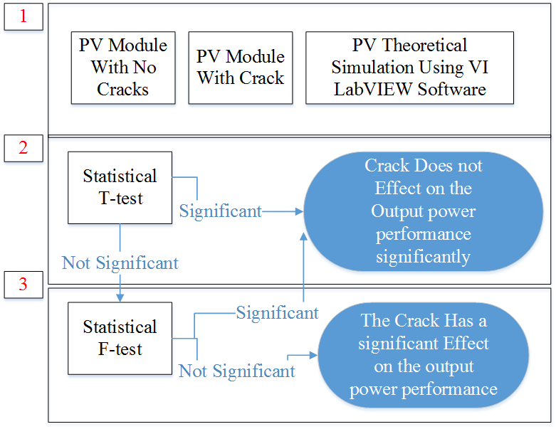
Figure. 1. Overall crack approach architecture, three layers used to identify the significant impact of the crack

Methodology

Experimental Setup
A static mechanical load tester meeting the requirement of IEC 61215 10.16 is used for the mechanical load test, which is applied to all examined PV modules. The tested modules are evaluated with respect to crack type with the electroluminescence (EL) method. Broken cells are sorted according to the type of crack which are classified as the following:
- Diagonal (+45⁰)
- Diagonal (-45⁰)
- Parallel to busbars
- Perpendicular to busbars
- Multiple directions
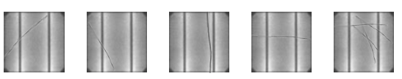
(A) (B) (C) (D) (E)
Figure. 3. Examined crack types. (A) Diagonal crack (+45⁰); (B) Diagonal crack (-45⁰); (C) Parallel to busbars crack; (D) Perpendicular to busbars crack; (E) Multiple directions crack

In order to speed up the crack detection and make it more reliable an EL image is taken both and after the mechanical load test. The comparison of the two images greatly improves the visibility of cracks in solar cells as shown in Fig. 2. This test technique was firstly proposed by Sara et al [5].

Crack Orientation
Orientations of cracks can have very different impact on the power output of PV modules. In particular, a single crack that leads to an electrical separation of a relevant part of the cell can significantly reduce the power output of a PV modules [14]. In order to assess the criticality of the cracks we classify them according to the orientation of the crack. Fig. 3 illustrates the crack orientations which have been analyzed and examined using the EL method.
In order to test the impact of each crack orientation which has been examined in the PV solar cells, real-time long-term data analysis is carried out. The cracked PV modules has been tested at the installation in the University of Huddersfield, United Kingdom.
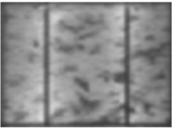
(A)
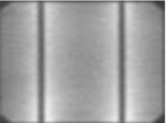
(B)
Figure. 2. EL image of PV solar cell. (A) After a mechanical load test; (B) Difference between EL image before and after the mechanical load test

Data Acquision
In this work, statistical analysis study of various PV modules showing different crack orientations has been tested. Forty five Different polycrystalline PV modules have been examined as shown in Fig. 4. To establish the connection for each PV module separately, a controlling unit allows the user to connect any PV module to a FLEXmax 80 MPPT.
In order to facilitate a real-time monitoring for each PV module, a Vantage Pro monitoring unit is used to receive the Global solar irradiance measured by a Davis weather station which includes a pyranometer. Hub 4 communication manager is used to facilitate acquisition of modules temperature using Davis external temperature sensor, and the electrical data for each photovoltaic module. LabVIEW software is used to implement data logging and monitoring functions of the examined PV modules.
Fig. 4 shows the system data acquisition design where the peak power for each PV module is equal to 220Wp. And the age of the PV installations is 5 years. The PV systems tilt angel and azimuth angel is equal to 42 degrees and 185 degree respectively.

VI LabVIEW Software PV Theoretical Ouput Power Simulation
In order to predict the output power of the examined PV modules, the DC side of all examined PV modules is modelled using 5-parameters model. The voltage and the current characteristics of the PV module can be obtained using the single diode model [14] as the following:
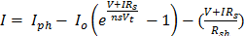 (1)
Where I_{ph} is the photo-generated current at STC , I_{o} is the dark saturation current at STC, R_{s} is the module series resistance, R_{sh} is the panel parallel resistance, ns is the number of series cells in the PV module and V_{t} is the thermal voltage and it can be defined based on:

TABLE I
Statistical T-Test Confidence Interval [16]
Value of t for Confidence Interval of Critical Value |t| for P Values of Number of Degrees of Freedom | 90 %  (P=0.1) | 95%  (P=0.05) | 99%  (P=0.01)
1 | 6.31 | 12.71 | 63.66
20 | 1.72 | 2.09 | 2.85
50 | 1.68 | 2.01 | 2.68
∞ | 1.64 | 1.96 | 2.58

(2)
Where a the diode ideality factor, K is Boltzmann’s constant and q is the charge of the electron.

Statistical Analysis Approach
In order to examine the significant impact of the crack on the generated output power of the examined PV modules, two statistical techniques are used: T-test and F-test as shown in Fig. 5. The first method (T-test) is used to compare the simulated theoretical power with the measured PV output power. T-test can be evaluated using (3) where is the mean of the measured samples, µ is the population mean of the theoretical simulated power, n is the sample size and SD is the standard deviation of the entire data.
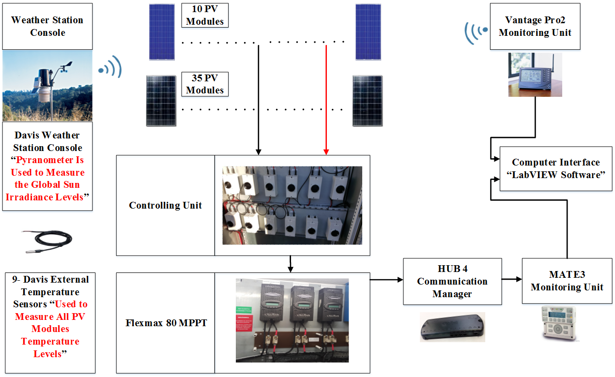
Figure. 4. 45 photovoltaic modules installed at Huddersfield University, United Kingdom
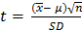 (3)

The confidence interval for all measured samples are estimated at 99%. Statistically speaking, the crack does not have a significant impact on the output power performance of the examined PV module if the t-test value is less than or equal to 2.58, as shown in Table I.
If the t-test value is not significant (t-test > 2.48) as shown in Fig. 5, another statistical method/layer is used to compare the output measured power from the cracked PV module with a PV module that has 0% of cracks. This layer is used to confirm that the output generated power of the cracked PV module has a significant impact (real damage) on the total generated output power performance of the examined photovoltaic module. From the results section, most of the inspected results indicates that if the T-test value is significant, F-test value is also significant. The overall statistical approach can be explained in Fig. 5 and F-test can be evaluated using (4). Where the explained variance is calculated mean square value between groups, the unexplained variance is calculated using mean square value within groups [15 and 16].
In this work, a infinite number of samples have been taken during the measurements (total measured samples > 120) in order to determine whether the F-test value is significant (F ≤ 6.635) or not significant (F > 6.635).
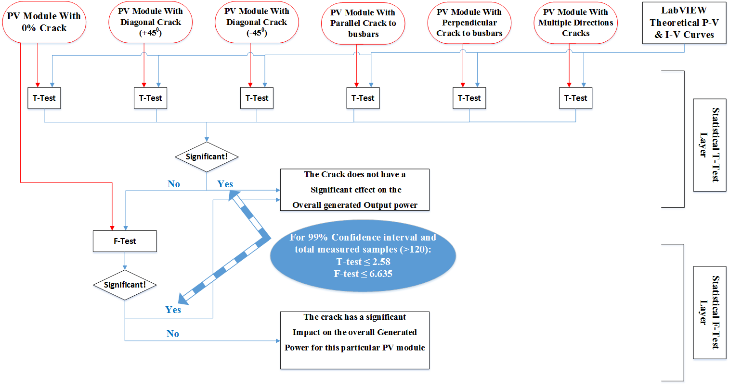
Figure. 5. Statistical approach used to identify whether the crack type has a significant impact on the output power performance of a photovoltaic module

According to the statistical approach explained in Fig. 5, T-test and F-test methods are significant based on a threshold values. Therefore, crack types are divided into two categories: Short: crack effects one solar cell in a PV module; Long: crack effects two or more solar cells in a PV module.

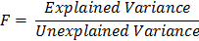 (4)

Results
This section describes the main results of the proposed statistical analysis approach. Two case studies are carried out to verify the effectiveness of the proposed approach.

Case Study 1 : Diagonal Crack
TABLE II
Diagonal Crack Performance Indicators
Number of Affected Solar Cells | Approximate Area Broken (mm) | T-test Value | Significant/Not Significant Effect on the PV Power Performance
1 | 1 mm² – 83 mm² | 0.40 - 0.66 | Not Significant,  Since t < 2.56
2 | 85.85 mm² – 169.7 mm² | 1.22 - 1.86 | Not Significant
3 | 172.7 mm² - 256.6 mm² | 2.51 - 2.71 | Significant
4 | 257. 5 mm² - 344.4 mm² | 2.65 - 2.70 | Significant
5 | 345.1 mm² – 424.3 mm² | 3.12 - 3.35 | Significant

Diagonal cracks can be classified into two different categories: +45⁰ and -45⁰ as explained previously in Fig. 3. The measured data which has been carried out from both diagonal crack categories indicate that the value of the measured output power performance for all examined PV modules are comparable. Therefore, both categories can be classified as one type of crack. This result is different from the results explained in [7, 8] because all the measured data in our experiments were taken from a real-time long-term environmental measurements instead of laboratory under controlled climate conditions.
Based on the proposed statistical approach, the T-test values for all examined diagonal crack PV modules (12 PV modules) are shown in Table II. Since the T-test value for a diagonal crack which affects 1 or 2 solar cells is less than 99% of the confidence interval threshold (2.58), the output power performance for the PV module is statistically not significant: there is no evidence for a real damage in the PV module. The F-test for a diagonal crack which affects 1 or 2 solar cells is equal to 4.55 and 5.67 respectively.
A real-time measured data obtained over 24 hours period is carried out to estimate the output performance for a diagonal crack which affects 1 and 5 solar cells are presented in Fig. 6(A). The theoretical simulated output power which is calculated using LabVIEW software has a standard deviation equal to 61.5 which is very close to the standard deviation for a diagonal crack which affects 1 solar cell (SD=61.4). However, a diagonal crack which affects 5 solar cells has a significant reduction in the output power performance of the PV module where the standard deviation is equal to 61.
Fig. 7(A) shows the output power efficiency for the examined diagonal cracks which affect 1, 2, 3, 4 and 5 solar cells. From 0.35 - 0.44% reduction of power estimated for a diagonal crack which affects 1 solar cell. However, the estimated reduction of power for a diagonal crack which affects 5 solar cells is between 2.97 - 5.37%.

Case Study 2 : Parallel to Busbars Cracks
Parallel to the busbars cracks have a percentage of occurrence 20% in the total examined PV modules (9 PV modules out of 45 examined PV modules) and this type of crack can be listed as the following:
- 9% (4 PV modules): Short crack affect
- 11% (5 PV modules): Long crack affect
Not all parallel to busbars cracks have a significant impact/reduction on the output power performance of the PV module. As shown in Table III, parallel to busbars cracks which affect 1 solar cell statistically indicates that there is no real damage in the PV module. The result is confirmed by the T-test value which is less than the threshold value 2.58. Moreover, when a parallel to busbars crack affects 2 solar cells with approximate broken area less than 82mm² have no significant effect on the amount of power generated by the PV module.
Fig. 6(B) presents real-time measured data for a parallel to busbars crack which affects 1 and 4 solar cells. The standard deviation for the theoretical simulated power is 62 which is very close to the standard deviation for a parallel to busbars crack affects 1 solar cell (61.8). However, parallel to busbars crack affects 5 solar cells has a significant reduction in the output power performance of the PV module while the standard deviation is equal to 61.1.
Fig. 7(B) describes the output power efficiency for the examined parallel to busbars cracks that which affects 1, 2, 3 and 4 solar cells. The reduction of power estimated for a parallel to busbars crack affects 1 solar cell is between 0.75% ~ 0.97%. However, the estimated reduction of power for a parallel to busbars crack which affects 3 and 4 solar cells is between 2.39% ~ 3.0% and 3.67% ~ 4.55% respectively.

Conclusion
In this paper, we have proposed a new statistical analysis approach to identify the significant impact of cracks on the output power performance of the PV modules. The approach uses a Virtual Instrumentation (VI) LabVIEW software in order to predict the theoretical output power of the examined PV module. Forty-five polycrystalline PV modules were examined. Additionally, various crack type are demonstrated by the statistical analysis approach such as diagonal, parallel to busbars, perpendicular to busbars and multiple directions crack. In order to capture the crack type which exists in the PV modules, electroluminescence (EL) imaging method is used to scan the surface of the PV modules.

TABLE III
Parallel to Busbars Crack Performance Indicators
Number of Affected Solar Cells | Approximate Area Broken (mm²) | T-test Value | Significant/Not Significant Effect on the PV Power Performance
1 | 1 ~59.2 | 0.78 ~1.13 | Not Significant
2 | 63 ~ 81 | 1.42 ~ 1.87 | Not Significant
2 | 82 ~121 | 2.62 ~ 2.74 | Significant
3 | 122 ~ 177 | 4.04 ~ 4.81 | Significant
4 | 177.3 ~ 239.7 | 4.39 ~ 5.66 | Significant

The proposed approach can be applied to PV systems with limited advanced monitoring systems while the electrical measurements are still available.

References
- Ndiaye, A., Charki, A., Kobi, A., Kébé, C. M., Ndiaye, P. A., & Sambou, V. (2013). Degradations of silicon photovoltaic modules: A literature review.Solar Energy, 96, 140-151.
- Pichler, K., Lughofer, E., Pichler, M., Buchegger, T., Klement, E. P., & Huschenbett, M. (2015). Detecting cracks in reciprocating compressor valves using pattern recognition in the pV diagram. Pattern Analysis and Applications, 18(2), 461-472.
- Köntges, M., Kunze, I., Kajari-Schröder, S., Breitenmoser, X., & Bjørneklett, B. (2011). The risk of power loss in crystalline silicon based photovoltaic modules due to micro-cracks. Solar Energy Materials and Solar Cells, 95(4), 1131-1137.
- Abdelhamid, M., Singh, R., & Omar, M. (2014). Review of microcrack detection techniques for silicon solar cells. IEEE Journal of Photovoltaics,4(1), 514-524.
- Kajari-Schröder, S., Kunze, I., Eitner, U., & Köntges, M. (2011). Spatial and orientational distribution of cracks in crystalline photovoltaic modules generated by mechanical load tests. Solar Energy Materials and Solar Cells,95(11), 3054-3059.
- van Mölken, J. I., Yusufoğlu, U. A., Safiei, A., Windgassen, H., Khandelwal, R., Pletzer, T. M., & Kurz, H. (2012). Impact of micro-cracks on the degradation of solar cell performance based on two-diode model parameters.Energy Procedia, 27, 167-172.
- Gerber, A., Huhn, V., Tran, T. M. H., Siegloch, M., Augarten, Y., Pieters, B. E., & Rau, U. (2015). Advanced large area characterization of thin-film solar modules by electroluminescence and thermography imaging techniques.Solar Energy Materials and Solar Cells, 135, 35-42.
- Berardone, I., Corrado, M., & Paggi, M. (2014). A generalized electric model for mono and polycrystalline silicon in the presence of cracks and random defects. Energy Procedia, 55, 22-29
- Spataru, S., Hacke, P., Sera, D., Glick, S., Kerekes, T., & Teodorescu, R. (2015, June). Quantifying solar cell cracks in photovoltaic modules by electroluminescence imaging. In Photovoltaic Specialist Conference (PVSC), 2015 IEEE 42nd (pp. 1-6). IEEE.
- Dhimish, M., & Holmes, V. (2016). Fault detection algorithm for grid-connected photovoltaic plants. Solar Energy, 137, 236-245.
- M. Dhimish, V. Holmes and B. Mehrdadi, "Grid-connected PV monitoring system (GCPV-MS)," 2016 4th International Symposium on Environmental Friendly Energies and Applications (EFEA), Belgrade, Serbia, 2016, pp. 1-6.doi: 10.1109/EFEA.2016.7748772.
- Chong, B. V. P., & Zhang, L. (2013). Controller design for integrated PV–converter modules under partial shading conditions. Solar Energy, 92, 123-138.
- Dhimish, M., Holmes, V., & Dales, M. (2016, November). Grid-connected PV virtual instrument system (GCPV-VIS) for detecting photovoltaic failure. In Environment Friendly Energies and Applications (EFEA), 2016 4th International Symposium on (pp. 1-6). IEEE.
- Köntges, M., Kunze, I., Kajari-Schröder, S., Breitenmoser, X., & Bjørneklett, B. (2011). The risk of power loss in crystalline silicon based photovoltaic modules due to micro-cracks. Solar Energy Materials and Solar Cells, 95(4), 1131-1137.
- McEvoy, A., Castaner, L., Markvart, T., 2012. Solar Cells: Materials, Manufacture and Operation. Academic Press.
- Miller, J. N., & Miller, J. C. (2005). Statistics and chemometrics for analytical chemistry. Pearson Education.
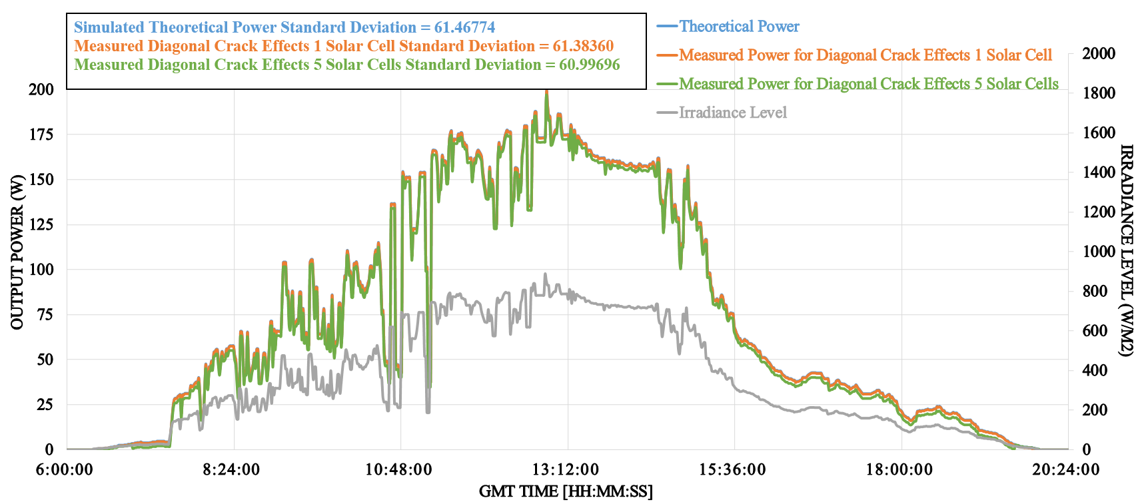
(A)
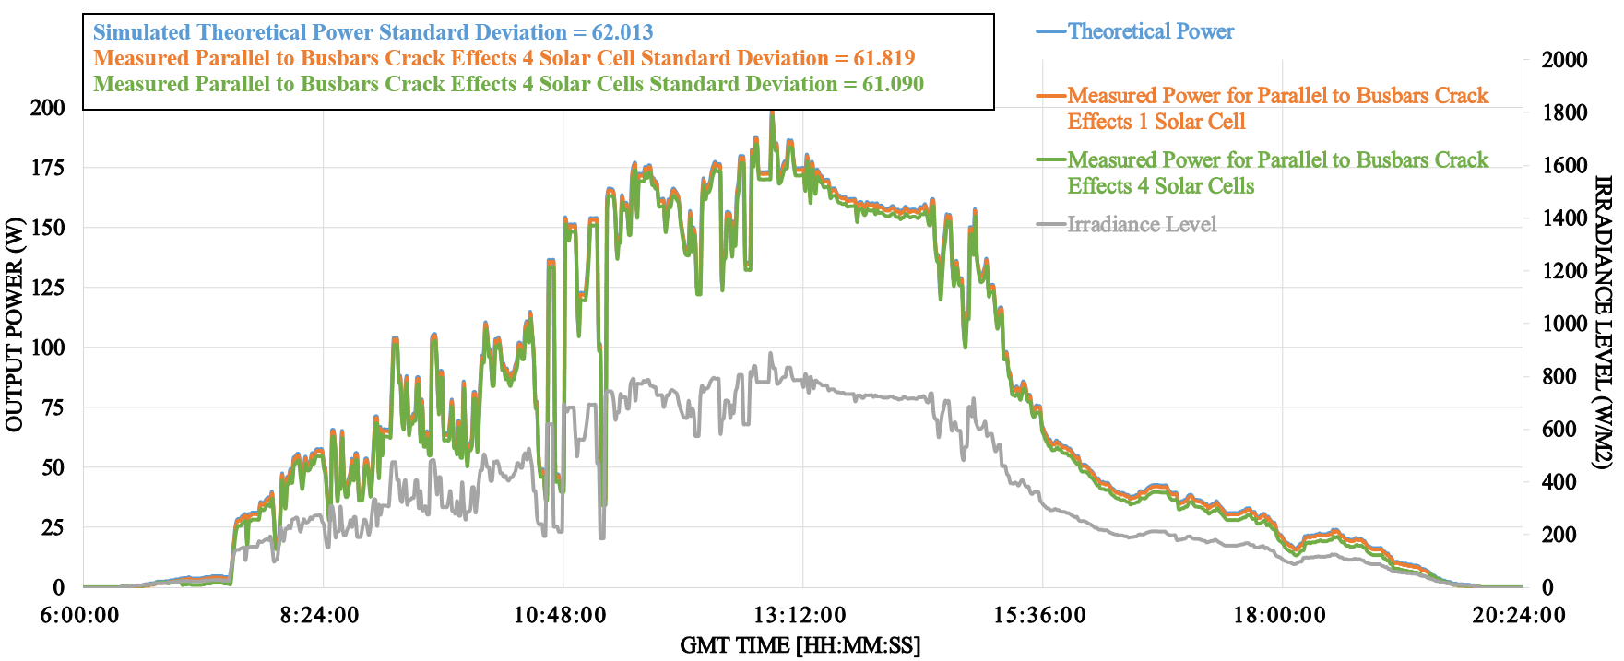
(B)
Figure. 6. (A) Real-time measured data for a diagonal crack which affects 1 and 5 solar cells; (B) Real-time measured data for a parallel to busbars crack which affects 1 and 4 solar cells

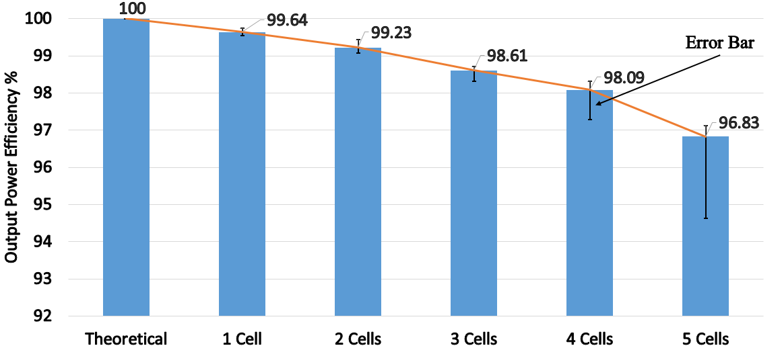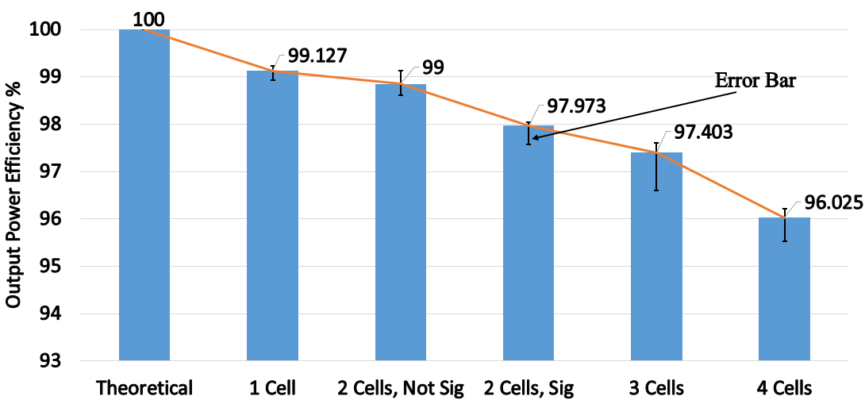
- (B)
Figure. 7. (A) Output power efficiency for a diagonal cracks which affects 1, 2, 3, 4 and 5 PV solar cells; (B) Output power efficiency for parallel to busbars crack which affects 1, 2, 3 and 4 PV solar cells

