Effects of winter wheat and endogeic earthworms on soil physical and hydraulic properties
Jamal Hallam ^{a, b}, Joseph Holden^{c}, David A. Robinson^{d}, Mark E. Hodsonª
ª University of York, Department of Environment and Geography, Wentworth Way, Heslington, York, YO10 5NG, UK (jamal.hallam@inra.ma / mark.hodson@york.ac.uk).
^{b} National Institute of Agricultural Research of Morocco. Avenue des FAR. B.P. 124 Inezgane - Agadir Morocco (jamal.hallam@inra.ma / jamal.hallam@gmail.com).
^{c} water@leeds, School of Geography, University of Leeds, Leeds, LS2 9JT, UK (j.holden@leeds.ac.uk).
^{d} UK Centre for Ecology & Hydrology, Deiniol Road, Bangor, UK LL57 2UW (davi2@ceh.ac.uk).

Corresponding author: Jamal Hallam; E-mail: jamal.hallam@gmail.com; Telephone: 00447823451298 / 00212664734460; ORCID: https://orcid.org/0000-0002-4515-7568

Abstract
Earthworms directly and indirectly affect soil physico-hydraulic properties. We studied interactions between winter wheat and the common European earthworm Allolobophora chlorotica, testing for impacts upon soil physico-hydraulic properties. Column experiments with three different soil textures and field-relevant earthworm densities were conducted. Saturated hydraulic conductivity (K_{s}) increased over time in earthworm treatments, with the increase occurring most rapidly in the plant plus earthworm treatment. After 16 weeks K_{s} had increased in the treatment comprising both plants and earthworms by factors of 12, 34 and 39 in the loam, silt-loam and sandy-loam soils respectively relative to controls. The presence of earthworms resulted in an 88.5% increase in the contribution of pores >3mm diameter to water flow. In the majority of treatments, soil water-holding capacity and percentage water-stable aggregates of the 5 cm topsoil in both the plant and the earthworm treatments increased significantly compared to controls with the plant plus earthworm treatment showing the greatest increase. Plant growth was greater in the presence than absence of earthworms. Our study shows synergistic and additive effects on soil physical properties in the presence of both earthworms and plants compared to when only earthworms or plants are present. It shows that it is not just vertical-burrowing anecic earthworms that can have a significant effect on soil hydraulic properties but that field-relevant densities of endogeic earthworms such as A. chlorotica can also contribute to soil water flow regulation.
Keywords: Soil unsaturated hydraulic conductivity, partitioning flow, pore classes, , soil water release curves, earthworm-plant interaction.

Introduction
It is well known that earthworms directly and indirectly affect soil physical and hydrological processes by regulating the surrounding physical environment through their burrowing behaviour (Blouin et al., 2013; Hallam et al., 2020). Burrows created by earthworms can conduct water and affect other hydrological proprieties of the bulk soil with specific impacts depending on the earthworms’ ecological group (Shipitalo and Le Bayon, 2004). Different earthworm species create burrows of different diameters, lengths, densities, and directions and at different rates (Bouché 1977; Ehlers 1975; Ruiz et al. 2015; Shipitalo and Butt 1999). Allolobophora chlorotica for example has a mean burrow diameter of 3 mm (Capowiez et al., 2011) and is reported to burrow at a rate of 22 cm week⁻¹ (Capowiez et al., 2014b). The hydrological effectiveness of burrows depends not only on their length and diameter but also on their continuity, connectivity to the soil surface and other macropores, the rate of flow of water to the soil matrix through the burrow walls and the antecedent soil moisture conditions (Capowiez et al., 2015, 2014b; Smettem, 1992).
In field conditions it is only the burrows of some deep burrowing anecic earthworm species that are commonly connected to the drainage systems of poorly drained soils such as tile drains (Shipitalo et al., 2004). Perhaps because of this, and their commercial availability, the majority of laboratory studies that consider earthworms and hydrology focus on anecic earthworms, usually Lumbricus terrestris (Bastardie et al., 2005; Thorpe et al., 1996; Yu et al., 2019). For deep burrows that connect to field drains, when it rains and the burrows fill with water, a constant flux of water flows through the burrows at a rate related to their radius as described by Poiseuilles’ equation. Typically, laboratory experiments investigating the impacts of earthworms on soil hydrology mimic this situation and are designed to avoid water logging of the soil by having a free-draining highly porous layer at the base of a column of soil to which the earthworm burrows connect (e.g. Capowiez et al. 2015; Edwards et al. 1989; Shipitalo et al. 1994). Endogeic earthworms are far more common in arable systems than anecic earthworms (Capowiez et al., 2009; Spurgeon et al., 2013). The non-vertical burrows of endogeic earthworms are less likely to connect to free draining macropores or tile drains so that once they are filled with water, constant flow is not necessarily maintained; the water will flow through the burrow wall and into the soil matrix with the flux of water depending on factors such as the permeability of the soil matrix, burrow length and radius and the wetness of the surrounding soil matrix.
Unlike anecic earthworms (Andriuzzi et al., 2015; Shipitalo and Edwards, 1996), significant effects on soil water infiltration have not been widely reported for endogeic earthworms (Ela et al., 1992; Spurgeon et al., 2013). However, endogeic species impact a number of soil properties that influence soil-water relations (e.g. Blouin et al., 2013). Hallam and Hodson (2020), showed that the endogeic species A. chlorotica increases the percentage of water-stable aggregates (%WSA) and water holding capacity (WHC) of soil whereas the anecic Lumbricus terrestris only increased %WSA. Of the few other existing studies that consider the impact of earthworms on soil water retention and storage, most report an increase in water retention in the presence of endogeic (mainly A. caliginosa) (Blanchart et al., 1999; McDaniel et al., 2015) and epigeic (Ernst et al. 2009; Smagin and Prusak 2008) species or when endogeics are associated with anecic or epigeic species (Boyle et al., 1997; Hallam et al., 2020). The effect of endogeics on soil water retention could be due to their burrowing behaviour with greater bioturbation of the soil and aggregate formation resulting in a tortuous and complex burrow system that helps to hold water and ensure more flow into the surrounding soil matrix (Pérès et al., 1998; Weiler and Naef, 2003). However, more research is needed to understand their effect on soil hydraulic proprieties, particularly when associated with plants.
In the field, earthworms generally live in vegetated areas and endogeics live in the upper mineral soil where they interact with plant roots (Springett and Gray, 1997; Wu et al., 2017). Therefore, the impact of earthworms on soil hydrology will usually be within the context of the presence of plant roots. However, most laboratory-based studies on the impacts of earthworms on soil hydrology are carried out in the absence of plants (Bastardie et al. 2003; Capowiez et al. 2015; Ernst et al. 2009; McDaniel et al. 2015). Plant roots penetrate the soil more slowly (at a rate of up to 0.025 m day⁻¹) than earthworms (typical burrowing rates of 0.1 to 0.2 m day⁻¹ Ruiz et al. 2015). Like earthworms, as roots penetrate the soil they create biopores and modify soil physical properties including hydrological ones (Whalley and Dexter, 1994). Therefore, understanding the interactions between endogeic earthworms and plants is crucial to fully understand how earthworms impact on soil hydrology.
In this study we investigated the interactive effects of the endogeic earthworm A. chlorotica and winter wheat (Skyfall variety) on soil hydrology and soil aggregation. A. chlorotica is of special interest as it is the most frequently occurring earthworm species in England, representing 34% of identified specimens (Natural England Commissioned Report NECR145, 2014). A. chlorotica is found throughout Europe and is present as an invasive species in North and South America, North Africa and New Zealand; earthworms that occupy the same ecological niche are present across the world (Dupont et al., 2011). We carried out a column experiment using earthworm densities typical of those found at our soil and earthworm sampling sites. Treatments with and without winter wheat and in the presence and absence of earthworms plus a combination of both wheat and earthworms were established for three differently textured soils. We studied changes over time in soil hydraulic conductivity and the contribution of different pore sizes to the flow of water through the soil. At the end of the 16 week experimental period we measured soil water release curves, soil water holding capacity, aggregate stability, and plant biomass. The main hypothesis that we tested was that the combined effect of A chlorotica and winter wheat will synergistically increase soil hydraulic conductivity and soil water retention, i.e. increases in the presence of the earthworms and plants together will be greater than the sum of the increases in the presence of each alone. Subsequent hypotheses were that: i) compared to other treatments, the increase in saturated hydraulic conductivity (K_{s}) over time will be faster when both A. chlorotica and winter wheat are present and ii) the level of synergism between earthworms and plants on soil properties will be a function of soil texture and organic matter content with increases in water flow and retention being greatest in soils with a coarser texture and higher organic matter content.

Materials and methods

Experiment design
    - Soil columns
PVC columns (16 cm diameter x 30 cm high, Fig. A.1) were repacked with Cambisols (IUSS Working Group WRB, 2015) of different textures sampled from a depth of 0-20 cm from the University of Leeds commercial farm (53° 51’ 44” N, 1° 20’ 35’’W). The physical and chemical properties of the soils are presented in Table 1. The soils were air-dried and sieved to < 2mm. The columns were filled gradually with c. 1163 g of soil at a time to give a dry bulk density of 1.3 g cm⁻³. Between soil additions the columns were raised and dropped to ensure spatial homogeneity in the pore structure of the soil and to avoid compacted layers to reduce the tendency of the plant roots to concentrate along the column wall (Burr-Hersey et al. 2017; Valentine et al. 2012). The soils were wetted with deionized water to approximately 30% gravimetric water content to sustain earthworm activity (Butt and Lowe, 2011). In common with many column-based experiments a layer of melted petroleum jelly was smeared over the inner surface of the columns before adding the soil to maintain a good contact between the soil and the column wall in order to avoid preferential flow of water down the sides of the columns (Dawes and Goonetilleke, 2006; Monaghan et al., 1989). Further, earthworm burrowing along column walls as the path of least resistance is a typical bias in mesocosm experiments (Ernst et al., 2009) and the petroleum jelly will have discouraged this behavior. Recovery of earthworms at the end of the experiment indicated no toxic effect of the jelly. The upper and lower surface of the basal 3 cm of soil in the columns was covered with c. 0.5 mm diameter nylon mesh to prevent earthworm escape from the column and connection of their burrows to the base of the columns. Fifteen cm high paper barriers held in place with rubber bands to prevent earthworm escape were placed at the top of the columns. The columns were weighed, covered with plastic film to prevent water loss and stored at 15 °C until planting of winter wheat and addition of earthworms.

Table 1 Physical and chemical properties of the soils used in the experiment. Values are given for replicate subsamples.
Land use | pH¹ | Organic matter² (%) | Field dry bulk density³ (g cm⁻³) | Clay (%)⁴ | Silt (%)⁴ | Sand (%)⁴ | Textural class
 |  |  |  | < 2 μm | 2-50 μm | 50-2000 μm | Textural class
Arable | 7.73  7.79  7.62 | 3.63  3.31  3.30 | 1.56  1.54 | 8.93  8.08  8.29 | 45.93  42.09  42.93 | 45.14  49.82  48.78 | Loam (L)
Arable | 7.48  7.71  7.73 | 3.86  3.46  3.50 | 1.38  1.51 | 4.28  4.46  4.21 | 51.24  53.83  51.28 | 44.47  41.70  44.50 | Silt loam (SiL)
Pasture | 7.26  7.33  7.23 | 9.61  9.57  9.58 | 1.22  1.14 | 3.54  2.48  3.21 | 45.11  34.55  41.56 | 51.33  62.96  51.76 | Sandy loam (SaL)
¹ Measured at soil : water ratio of 1:2.5 (Ministry of Agriculture Fisheries and Food, 1986), ² by loss on ignition at 350 °C (Ayub and Boyd, 1994; CEAE, 2003), ³ using soil density rings of 95 cm³, ⁴ using a MasterSizer2000 laser particle size analyzer (Malvern Instruments, UK ).
    - Crop growth and earthworm addition
Winter wheat seeds (Triticum aestivum, Skyfall variety) were germinated on Petri dishes. Individual seedlings were transplanted to each column when radicles were ≈ 2 cm long. Plants were grown under natural light for five days and then A. chlorotica were added. The columns were then placed in a 15 ± 1°C and 60 ± 7 % rh controlled temperature chamber with a photoperiod of 16 h under 50 W LED lights (Fig. A.2) (Massa et al., 2008). To ensure optimum photosynthesis and better distribution of radiation the position of the lights was regularly adjusted during the growing period to maintain a measured Photosynthetically Active Radiation (PAR) (Bugbee and Salisbury, 1988) at the top of each column (Fig. A.3). The plants were watered every week with deionized water. Green morphs of A. chlorotica (Satchell, 1967) were collected from the same site as the test soils by hand sorting of the soil. In the laboratory, active adult earthworms were selected, washed with deionized water and acclimatized to laboratory conditions in containers of the same soil as that used in the experiment. After three days at 15 °C in darkness, active earthworms were rinsed, dried with tissue paper and weighed. Eight earthworms of approximately the same total mass (2.32 ± 0.18 g, n = 24) were added to each earthworm treated column giving an abundance equivalent to 400 ind m⁻². Although this seems high it is comparable to abundances found in the fields where the soils were collected. Earthworm abundances in the fields were 757.5 ± 426.2 ind m⁻² in pasture, 673.6 ± 326.9 ind m⁻² in field margins and 325.5 ± 254.7 ind m⁻² in the arable soils with up to 68.8% of the total adult abundance comprising endogeic earthworms, of which A. chlorotica was the dominant species (Holden et al., 2019). A surface application of 10 g adult⁻¹ month⁻¹ milled (< 1 mm) and rewetted oven dried horse manure was added to each column as an additional food source (Butt and Lowe, 2011). The columns were established in four replicates for each soil in an orthogonal design with the presence and absence of A. chlorotica and winter wheat plants as the treatments giving Wheat (W), Earthworm (E) and Wheat + Earthworm (WE) treatments together with a bare soil control (C).

Measurements
    - Earthworm and winter wheat biomass
Winter wheat shoots were cut at 0.5 cm above the soil surface at the end of the experiment and oven dried at 70 °C to constant weight. A. chlorotica were recovered, rinsed in deionized water, dried with tissue paper and weighed.
    - Unsaturated and saturated hydraulic conductivity
Water infiltration rates were measured using a Decagon Mini Disk Portable Tension Infiltrometer (Decagon Devices Inc, 2016) until steady-state flow was reached. Measurements were made at supply tensions of – 6 cm, -3 cm and -1 cm which according to capillary theory are equivalent to water flow through pore diameters of < 0.5 mm, < 1 mm and < 3 mm respectively. The disc infiltrometer was placed on a layer of fine moist sand applied to the soil surface to improve the hydraulic contact between the disc and the soil (Reynolds and Elrick, 1991) and measurement was started at the lower tension to avoid hysteresis effects (Baird, 1997). Boundary effects due to the extension of the saturation front below the infiltrometer will have been minimal given the relative diameters of the mini disk infiltrometer and the soil columns together with the relatively small volume of water used in the infiltrometer (Bordoloi et al., 2019). Unsaturated hydraulic conductivity (K) at different tensions was derived from cumulative infiltration measurements following the Van-Genuchten Zhang transient method as proposed by Zhang (1997). The saturated hydraulic conductivity (K_{s}) was calculated using the Reynolds and Elrick (1991) method that requires cumulative water flow measurements under two or more applied tensions.
Hydraulic conductivities were measured after 3, 9 and 16 weeks of the experiment. The measurements during the experiment (weeks 3 and 9) were made in a controlled temperature room at 15 °C whilst those at the end of the experiment (week 16) were made in the laboratory at 20 °C. All the estimated hydraulic conductivities from the controlled temperature room were adjusted to a standard temperature of 20 °C to account for viscosity differences (Levy et al., 1989).
    - Partitioning flow between different pore classes
The proportion of water flow through different pore size classes and the percent of soil volume accounting for that proportion were calculated based on Watson and Luxmoore (1986). Soil pore classes are not uniformly defined in the literature (Luxmoore, 1981), but here we define macropores as pores > 1 mm (Germann and Beven, 1981; Holden, 2008; Luxmoore, 1981). Therefore, we defined smaller and larger macropores as pores of 1 – 3 mm and > 3 mm diameter respectively. Micropores and mesopores were defined as pores < 0.5 mm and in the range 0.5 - 1 mm diameter respectively.
    - Soil water release curves (SWRC)
SWRC determinations are extremely time consuming, therefore measurements were restricted to the loam soil, since earthworms are typically more active in this soil texture (Jongmans et al., 2003). One soil core of 250 cm³ (5 cm height x 8 cm diameter) was collected from the surface of each column and analyzed up to pF = 3 using a HYPROP device (UMS, Munchen, Germany) based on the simplified evaporation method (Peters et al., 2015; Schindler et al., 2010). For the very dry end of the SWRC, we measured the relative humidity of a soil sample at equilibrium with potassium carbonate at a matric potential (ψ_{m}) of -115 331 KPa. Using HYPROP-FIT software, the HYPROP measurement campaigns were modeled and adjusted using the measured K_{s} and K at different tensions. The SWRC were then fitted to our data and hydraulic function parameters were generated using the Van Genuchten (1980) model.
    - Water holding capacity (WHC) and percentage water stable aggregates (%WSA)
WHC was measured following the ISO 11268-2:1998 method on 5 cm high x 8 cm diameter cores collected from the surface of the columns. The samples were saturated for 24 hours, drained for 48 hours and then the water content was measured by drying the samples at 105°C overnight. Four grams of 1-2 mm air-dried soils were added into 250 µm sieves to measure the %WSA using bespoke wet sieving equipment (Eijkelkamp, Agrisearch Equipment). The aggregates were pre-moistened for 10 minutes and wet sieved by raising and lowering into the underlaying water at a rate of 34 times per minute for 3 minutes. The remaining stable aggregates in the sieves were then broken up using sodium hexametaphosphate in order to correct the %WSA for the mass of sand >250 µm. The %WSA was calculated as the weight of water stable aggregates divided by the sum of the weights of the unstable and water stable aggregates (Kodešová et al., 2009).

Statistical analysis
The change in hydraulic conductivity with time was tested using two-way mixed ANOVA. This was applied to each soil in turn with time and treatment as factors. Data were log-transformed to achieve homogeneity of variance when required. Repeated factor (measurement at different time points) effects were tested for their sphericity and the Bonferroni method was chosen for pairwise comparisons. Tukey's honestly significant difference (HSD) procedure was used for pairwise comparisons between factors. At the end of the experiment ordinary two-way ANOVA was used to analyze the interaction effect between soil textures and treatments for hydraulic conductivities and the other measured parameters. SPSS (IBM Corp. Released 2016, version 24) software was used to estimate the statistical significance of mean differences between treatments. P values of < 0.05 were used as the threshold for significance. In this paper median, minimum and maximum values are presented for directly measured parameters as we make the assumption that the number of replicates (n = 4) are insufficient to describe the variation of the data about a mean.

Results

Earthworms biomass
All A. chlorotica from the columns were recovered at the end of the experiment except for one missing earthworm in one replicate of the E treatment of the L soil and two missing earthworms in one replicate of the E treatment of the SiL soil. Within other replicates of the same treatment and soil, additional juvenile earthworms were found; one in the L soil and four in the SiL soil. Earthworms were distributed throughout the columns (from 5 cm deep to the bottom of the column) and their casting behavior made the soil surface rough; the roughness was more pronounced in the absence of plants. Earthworm biomass decreased between the start and the end of the experiment in L and SiL soil (Table 2). In the SaL soil, the A. chlorotica weight increased significantly with time in both the E and WE treatments. Unlike anecic earthworms that feed at the surface on decaying organic matter A. chlorotica is an endogeic earthworm and feeds by consuming soil. Although horse manure was added to the soil surface to feed A. chlorotica, the earthworms still lost weight over the duration of the experiment except in the sandy loam (SaL) soil which has the highest organic matter content and therefore presumably more available food.

Table 2 A. chlorotica total weight in g at the start and end of the experiment for the different soil textures and treatments. WE = Soil with winter wheat and A. chlorotica, E = Soil with A. chlorotica (n = 4). L = Loam soil, SiL = Silty loam, SaL = Sandy loam (values in the same row of the same treatment bearing the same letter were not significantly different at the 5% significance level).
Soil texture | Treatments | Initial earthworm weight (g) |  |  | Final earthworm weight (g)
Soil texture | Treatments | Median | Min | Max | Median | Min | Max
L | WE | 2.42ª | 2.12 | 2.86 | 2.24ª | 2.18 | 2.73
L | E | 2.21ª | 2.11 | 2.48 | 2.08ª | 1.81 | 2.18
SiL | WE | 2.35 ª | 2.15 | 2.60 | 2.39ª | 2.25 | 2.55
SiL | E | 2.30ª | 2.11 | 2.39 | 1.98ª | 1.85 | 2.43
SaL | WE | 2.33ª | 2.14 | 2.56 | 2.75^{b} | 2.49 | 2.88
SaL | E | 2.25ª | 2.16 | 2.35 | 2.51^{b} | 2.31 | 2.68

Wheat Biomass
No signs of stress were observed on the shoots during the growth of the plant or on the roots at the end of the experiment. Plant dry matter biomass was greater in the WE than W treatments (p < 0.001, Fig. 1) whilst the highest values were obtained for the SaL soil. The dry biomass was lowest in the SiL soils (p < 0.001) of both the W and WE treatments but was not significantly different between the L and SaL soils. There was no significant interaction between treatments and soil textures.
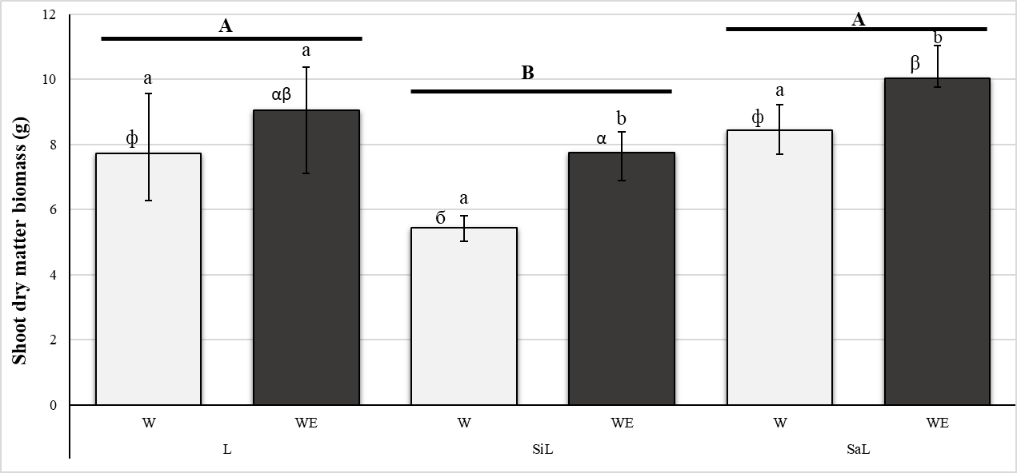
Fig. 1. Median winter wheat shoot dry matter biomass for the wheat (W) and wheat and A. chlorotica (WE) treatments for the loam (L), the silt loam (SiL) and the sandy loam (SaL) soils (n = 4, error bars = max and min values). Capital letters in bold over columns (A, B) refer to statistical differences between soils. Cyrillic symbols (ф, б) refer to statistical differences for the W treatments between soils. Greek symbols (α, β) refer to statistical differences for the WE treatments between soils. Lowercase letters on columns (a, b) refer to statistical differences between treatments (W and WE) for each soil type. Columns with the same letter or symbols over them are not significantly different.

Percentage water stable aggregates
The %WSA varied significantly between soil textures and treatments (p < 0.001) (Fig. 2). The SaL soil samples had significantly higher %WSA than the other two soil textures (p < 0.001). Between treatments, soil from the planted columns (W and WE treatments) had a higher %WSA than unplanted (C and E) treatments with the %WSA being lowest in the controls and greatest in the WE treatments (Fig.2). There was a synergistic interaction in the SaL soil (increases in WE were greater than the sum of increases in the W and E treatments) and additive effects in the L and SiL soil (increases in WE were equal to the sum of increases in the W and E treatments) compared to the W or the E treatments alone (Table A.1). Within unplanted columns of the SiL soil, A. chlorotica addition resulted in higher %WSA compared to the control. In L and SaL soils, the %WSA was not significantly different between control and the E treatment.
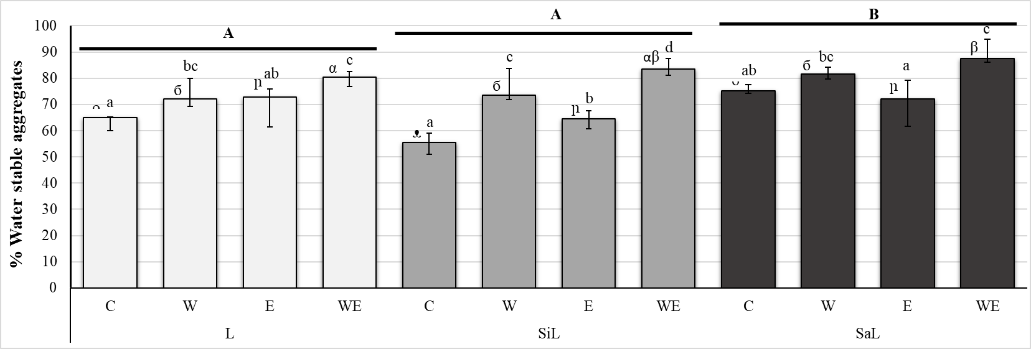
Fig. 2. Median percentage water stable aggregates by tested treatments and for the L (loam), the SiL (silt loam) and the SaL (sandy loam) soils. Letters refer to the four treatments, C (control), W (Soil + Wheat), E (Soil + Earthworms), WE (Soil + Wheat + Earthworms). (n = 4, error bars = max and min values). Capital letters in bold over columns (A, B) refer to statistical differences between soils. Phonetic symbols (ᴖ, ᴥ, ᴗ) refer to statistical differences for the Control treatments between soils. Cyrillic symbols (б) refer to statistical differences for the W treatments between soils. Hebrew symbols (ր) refer to statistical differences for the E treatments between soils. Greek symbols (α, β) refer to statistical differences for the WE treatments between soils. Lowercase letters on columns (a, b, c, d) refer to statistical differences between treatments (C, W, E and WE) for each soil type. Columns with the same letter or symbols over them are not significantly different.

Soil water flow

Changes in K_{s} over time
K_{s} varied with soil texture, treatment and time (Fig. 3). For each soil texture, and taking all treatments into account, there was a significant increase in K_{s} with time (p < 0.05); K_{s} was lowest at 3 weeks, intermediate at 9 weeks and highest at 16 weeks. These increases were largely driven by increases in the E and WE treatments. K_{s} between treatments was significantly different (with controls being always the lowest, the WE treatments the greatest and the W and E treatments being intermediate) (p < 0.001); the changes in K_{s} over time varied between treatments (p < 0.001). Increases in K_{s} were highest in the WE treatments and were greater than the sum of the increases in the W and E treatments by week 16 (Table 3). For the L soil, by week 3, K_{s} in the E and WE treatments was greater than that of the controls (p < 0.05) (Fig. 3). By 9 weeks, the K_{s} in the WE treatments for all the soils was much higher than that in all the other treatments. By the end of the experiment all the treatments showed significantly higher K_{s} than the controls (p < 0.05); the K_{s} in the E and WE treatments were significantly higher than in the W treatments (p < 0.01) and had the greatest increase (p < 0.01), with the WE values being greater than the E values. There was no significant change in K_{s} for the controls of each soil type over time (Fig. 3). SaL soils had the highest, and SiL the lowest, value of K_{s} (p < 0.01).
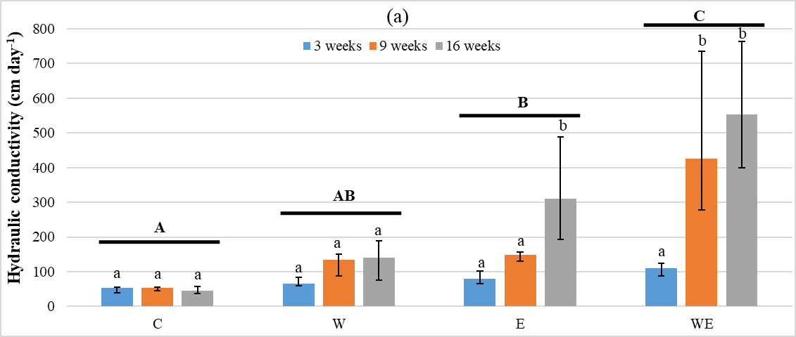
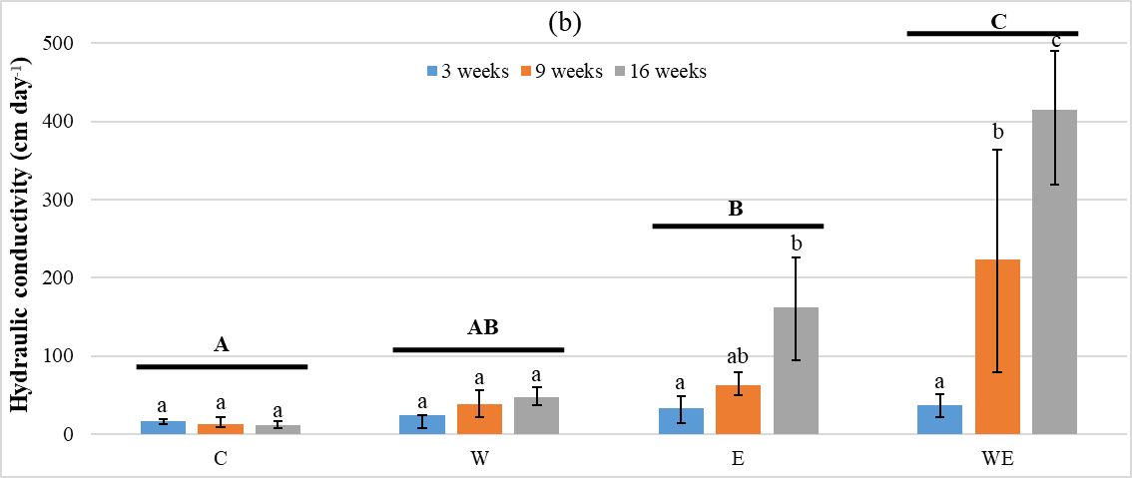
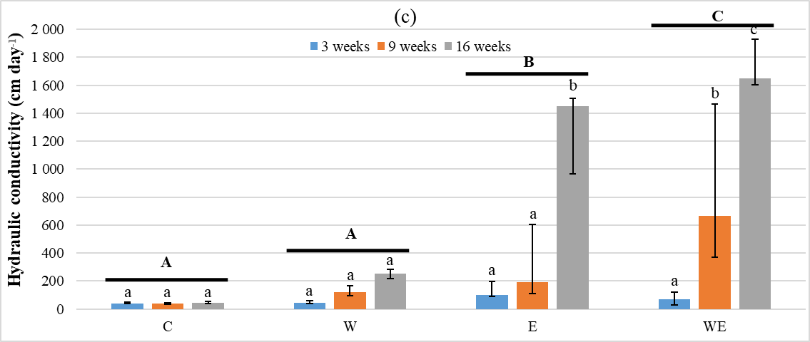
Fig. 3. Median hydraulic conductivity, K_{s}, over time at saturated conditions in (a) the L soil (loam), (b) the SiL soil (silt loam) and (c) the SaL (sandy loam) soil. Letters refer to the four treatments, C (control), W (Soil + Wheat), E (Soil + Earthworms), WE (Soil + Wheat + Earthworms). (n = 4, error bars = max and min values). Capital letters in bold over columns (A, B, C) refer to statistical differences across time between treatments. Lowercase letters on columns (a, b, c) refer to statistical differences overtime (3, 9, and 16 weeks) for each treatment. Columns with the same letter over them are not significantly different.

Table 3. Mean hydraulic conductivity, K_{s} (cm day⁻¹), at saturated conditions at the end of the experiment for the L soil, SiL and the SaL soils. The values for the Control treatments are those reported in Fig. 3. The values for the W, E and the WE treatments are calculated as the values reported in Fig. 3 but with the Control values subtracted; the Control treatments were subtracted to determine the value of K_{s} due to the effect of earthworms or plants and whether earthworms or plants have synergistic or additive effects on soil K_{s} . WE – (W + E) > 0 indicates a synergistic effect.
Soil textures | Treatments |  |  |  | Sum of separate effect of W and E | Synergistic/additive effect
Soil textures | C | W | E | WE | W + E | WE – (W + E)
L | 46.23 | 90.24 | 279.66 | 520.31 | 369.90 | 150.41
SiL | 11.92 | 35.82 | 149.06 | 397.70 | 184.88 | 212.83
SaL | 43.89 | 206.86 | 1299.04 | 1663.14 | 1505.91 | 157.24

Changes in K over time
For each soil the K at -1 cm water tension (K₋₁) increased significantly across time (p < 0.05) and varied significantly between treatments (p < 0.001) ( Fig. 4). There was also a significant interaction between treatments and time for each soil (p < 0.001). K₋₁ showed no significant change with time in the control treatments. By the end of the experiment a significantly greater amount of water flowed through the < 3 mm diameter pores for each treatment compared to the control for each of the soils (Fig. 4). Flow rates were highest (p < 0.01) in the WE treatments (81.6, 30.2 and 210.3 cm day⁻¹ in L, SiL and SaL soils respectively). K₋₁ was also significantly greater in the E and W treatments than in the controls, except for the W treatment in the L soil. The results of water flow for each soil at -3 and -6 cm water tension (K_{-3,} K₋₆) are reported in the supporting information section (Fig. A.6, Fig. A.7). These results indicate that water flow through pores < 1 mm and < 0.5 mm diameter was variable depending on the treatment and the soil texture.
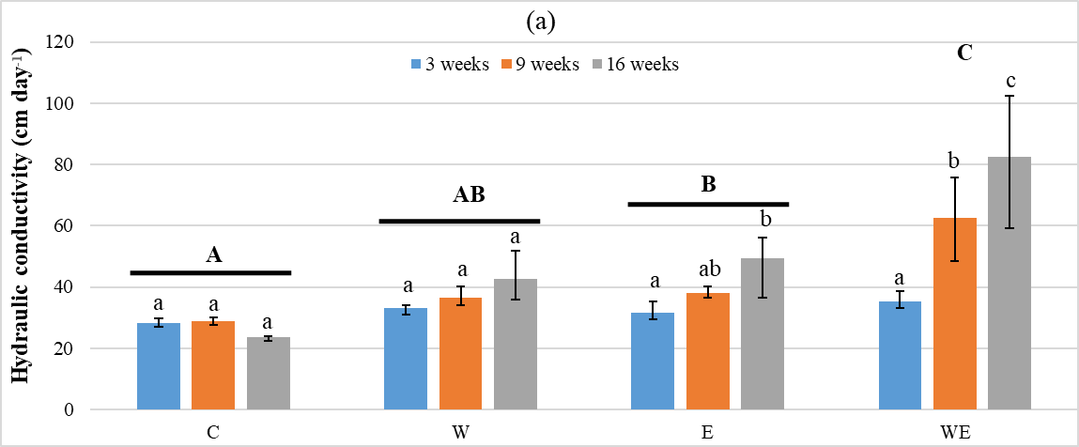
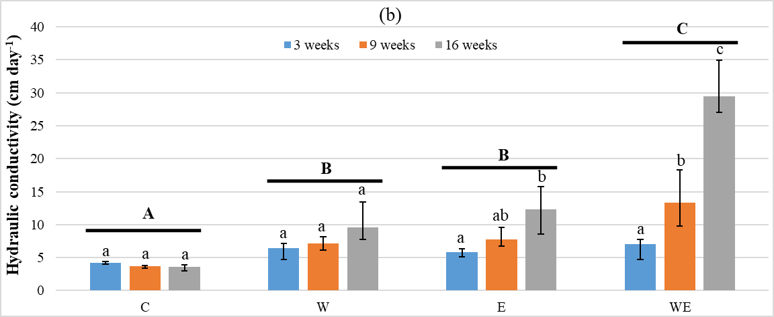
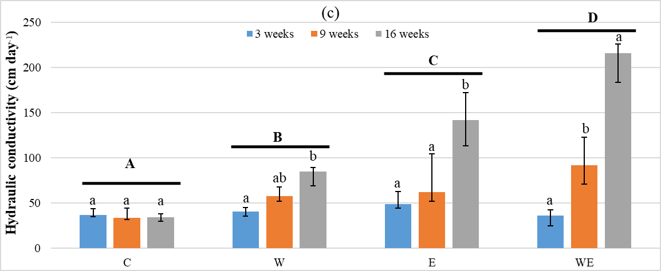
Fig. 4 Median hydraulic conductivity over time at a water tension of – 1 cm in (a) the L soil, (b) the SiL soil and (c) the SaL soil. Letters refer to the four treatments, C (control), W (Soil + Wheat), E (Soil + Earthworms), WE (Soil + Wheat + Earthworms). (n = 4, error bars = max and min values). Capital letters in bold over columns (A, B, C, D) refer to statistical differences across time between treatments. Lowercase letters on columns (a, b, c) refer to statistical differences overtime (3, 9, and 16 weeks) for each treatment. Columns with the same letter over them are not significantly different.

Pore size class contribution to water flow
The percentage of flow occurring in larger macropores (> 3mm diameter) increased gradually with time in all soil textures and treatments (p < 0.05) (Fig. 5, Fig. A.8). However, pairwise comparisons showed that between week 3 and week 16 the increase in percentage flow through these pores was only significant in the E and WE treatments for the L and SaL soils. The dominance of flow through the larger macropores was reached earlier in the experiment (by week 9) in the WE treatments, though percentage flow through these pores had not increased further by the end of the experiment (data reported in the Supporting Information section, Fig. A.8). In the control treatments, there were no significant changes across time in the proportion of water flow through the different pore size classes.
The proportion of water flowing through the different pore size classes was also significantly different between treatments (p < 0.01) for each soil except for smaller macropores (1 – 3 mm diameter) in the SaL soils. A higher proportion of flow through larger macropores occurred in the WE and E treatments (88.51 ± 3 % and 88.56 ± 4 % respectively; Fig. 5) than in the W and C treatments (70.41 ± 9.9 % and 46.24 ± 21.8 respectively %) (p < 0.05). In all treatments, pores < 1 mm diameter contributed less to water flow compared to wider pores except for in the controls (Fig. 5).
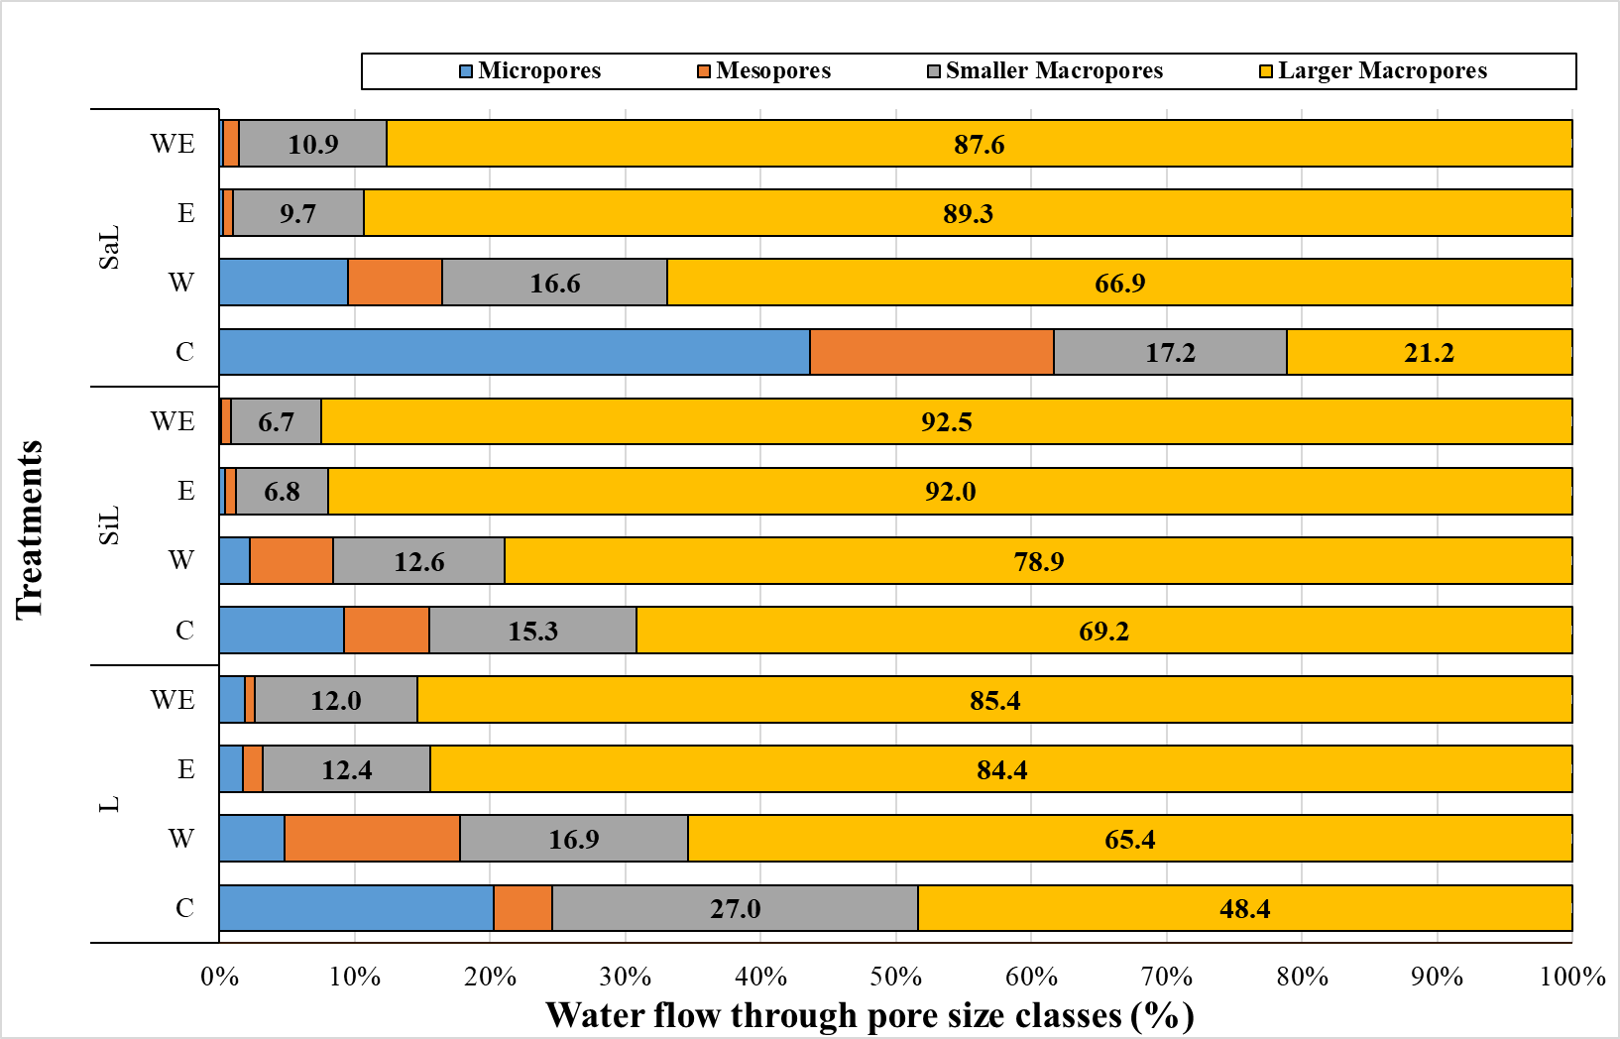
Fig. 5. Pore size class contribution to water flow at the end of the experiment (16 weeks burrowing) for the four treatments, C (control), W (Soil + Wheat), E (Soil + Earthworms), WE (Soil + Wheat + Earthworms) and three soils (L = loam, SiL = silt loam and SaL =sandy loam). Pore size class contribution to water flow at weeks 3 and 9 are reported in Fig. A.8.

Soil water release curves (SWRC)
The volumetric water content of the L soil averaged across different treatments was significantly different at different applied water potentials (pF) (Fig. 6). Pairwise comparison shows that at saturation the water content was significantly higher in the W, E and WE treatments compared to the control. The highest water content was in the E treatment (p < 0.001). Water content at field capacity was measured at potentials of 1.8 and 2.5 corresponding to shallow (< 1 m) and deep (> 1 m) water tables (Kirkham, 2005; Pertassek et al., 2015). Under these conditions only the E treatment showed a significantly higher water content than the control at both potentials (p < 0.01). The WE treatment only had a significantly higher water content at pF 1.8 (p = 0.05 for pF 1.8 and p = 0.07 at pF 2.5). There were no significant differences between treatments in plant available water (p = 0.081) but this could well reflect the lower accuracy of Hyprop measurements in the dry area of the curve where results are modelled extrapolations from the wet area of the curve.
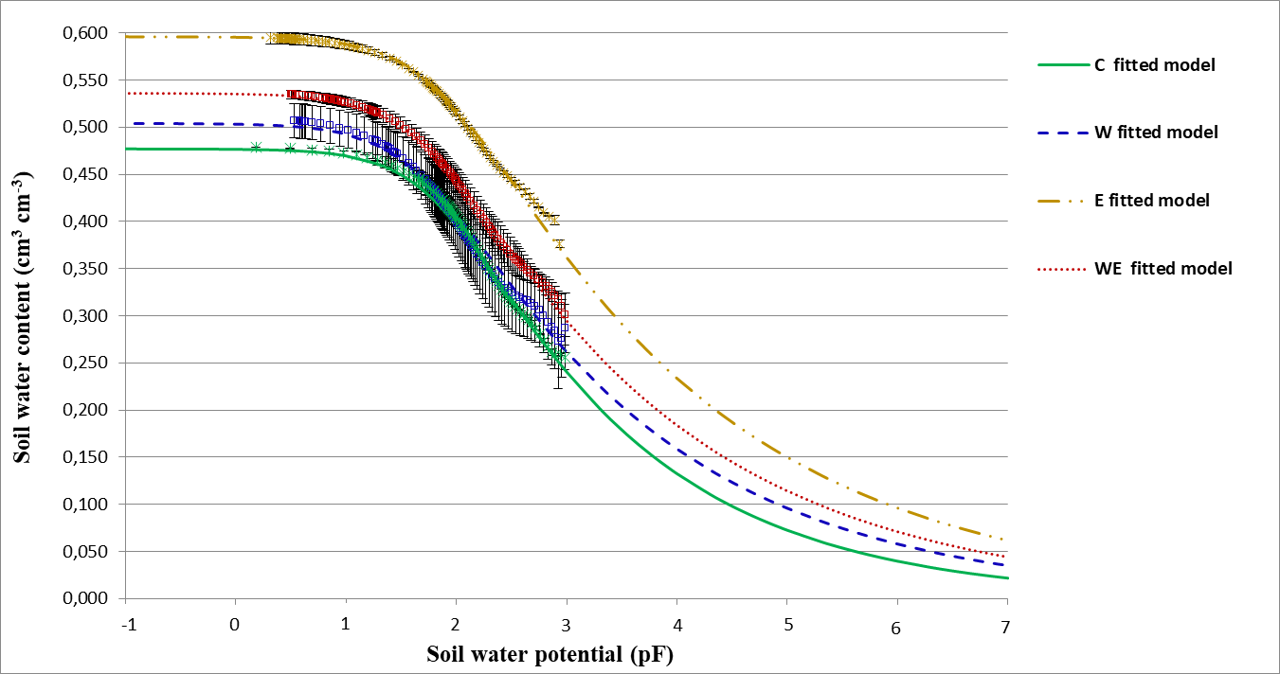
Fig. 6. Water release curves fitted to the measured data using the Van Genuchten (1980) model. The curves represent the four treatments, C (control), W (Soil + Wheat), E (Soil + Earthworms), WE (Soil + Wheat + Earthworms), for the L (loam) soil. Three replicates were combined for each treatment using Hyprop-Fit models. Standard deviation bars are shown.

Water holding capacity
The WHC was significantly different between treatments and soil textures (p < 0.001) but the treatment effects were similar across the soil textures. Plant roots and A. chlorotica activity both had a significant impact on soil WHC of the 0-5 cm topsoil. The W and WE treatments had higher WHC than the controls. The highest values were obtained for the WE, relative to C, W and E treatments, but were only significantly higher for the SiL and SaL soils (Fig. 7). The increases in WHC in the WE treatments were additive relative to the increases in both the W and the E treatments for each soil texture (Table A.3). Pairwise comparisons indicate that the SaL soils had the greatest WHCs (p < 0.001).
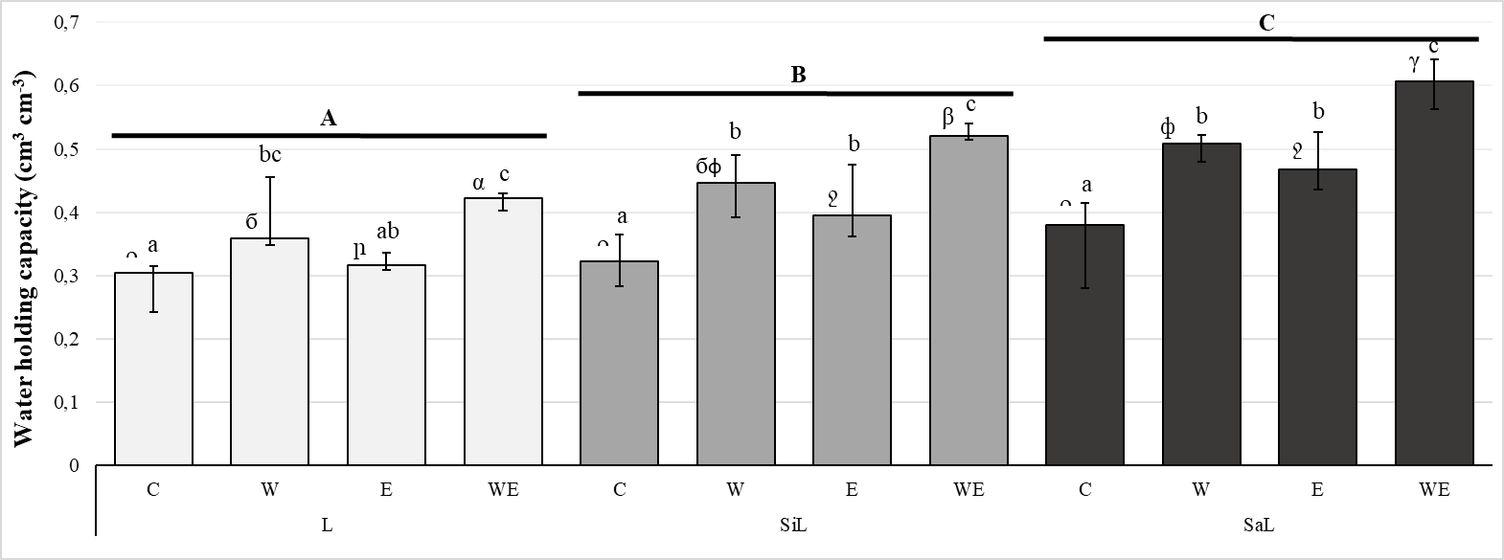
Fig. 7. Median water holding capacity for the L (loam), the SiL (silt loam) and the SaL (sandy loam) soils and the four treatments, C (control), W (Soil + Wheat), E (Soil + Earthworms), WE (Soil + Wheat + Earthworms). (n = 4, error bars = max and min values). Capital letters in bold on columns (A, B, C) refer to statistical differences between soils. Phonetic symbols (ᴖ) refer to statistical differences for the Control treatments between soils. Cyrillic symbols (б, ф) refer to statistical differences for the W treatments between soils. Hebrew symbols (ր, ջ) refer to statistical differences for the E treatments between soils. Greek symbols (α, β, γ) refer to statistical differences for the WE treatments between soils. Lowercase letters on columns (a, b, c) refer to statistical differences between treatments (W and WE) for each soil type. Columns with the same letter or symbols over them are not significantly different.

Discussion

Wheat shoot biomass
As has been observed in many studies (Bertrand et al., 2015; Hallam et al., 2020; Laossi et al., 2010), the presence of A. chlorotica increased plant shoot biomass significantly across all soil textures (p < 0.001, Fig. 1). Increases in plant biomass in the presence of earthworms are attributed to increasing N mineralization, K availability in soils and soil microbial activity (Andriuzzi et al., 2015; van Groenigen et al., 2014). However, the increases may also be due to abiotic properties (van Groenigen et al., 2014), at least in part as our findings show, to the increase in WHC in the E and WE treatments compared to earthworm-absent treatments (Fig. 7) (Hallam et al., 2020) as increases in WHC can lead to increased plant growth (Farrell et al., 2012).

Soil water flow
Both earthworms and plant roots affect soil structure and macroporosity and shape soil hydraulic properties (Fischer et al., 2014; Hallam et al., 2020). The K_{s} of the E treatments was greater than that of the W treatments and the K_{s} of the WE treatments after 16 weeks were factors of 4, 9 and 7 greater than those in the W treatments for L, SiL and SaL respectively. These increases in K_{s} (which incorporates flow through all pores) (Fig. 3) and in flow through < 3 mm diameter pores (-1 cm water tension) (Fig. 4) in the E and WE treatments for all the soils suggests that the A. chlorotica earthworms play a key role in water flow through their effect on soil structure. The change in structure is reflected in the increased %WSA due to earthworm activity (Fig. 2). Similar trends in K_{s} and flow through < 3mm diameter pores are reported in the literature both for earthworms in general (Becher and Kainz, 1983; Edwards and Bohlen, 1996; Hopp and Slater, 1948) and specifically for endogeic earthworms (Ela et al., 1992; Ernst et al., 2009; Joschko et al., 1992). Whilst differences in experimental design prevent direct comparison with the studies cited above, our orthogonal design shows that the increases in Ks in the WE treatments relative to the W and E treatments resulted from a synergistic interaction and were higher than the increases seen in previous studies of similar duration and comparable earthworm densities when response to the presence of only plants or earthworms relative to a control were considered (Ernst et al., 2009; Fischer et al., 2014).
Although the flow through the < 3mm pores increased in the W and WE treatments (Fig.4), the actual % of total flow through these pores decreased, with more of the flow being concentrated through the > 3mm diameter pores (Fig. 5) despite them occupying only 0.0028% of the total soil volume (Fig. 5). Such low volumes are typical of both agricultural (e.g. Azevedo et al., 1998) and forest (e.g. Watson and Luxmoore, 1986) soils. The reduced percentage of total flow through the smaller diameter pores is most likely because water will flow preferentially through the coarser pores created by the earthworms (their burrows) and plant roots (biopores). However, it may also be the case that the forces involved in creating these coarser pores led to loss of smaller pores as soil particles are pushed together during earthworm burrowing (Becher, 1994; Bodner et al., 2014). This in itself may explain the slightly higher percentage contribution to water flow through smaller pores in the W treatments relative to the E and WE treatments. However, this may also be due to an increase in smaller pores in this treatment around plant roots and rootlets. The proportion of flow through the > 3mm pores was similar between the E and WE treatments (and greater than in the W treatments) despite the K_{s} at the end of the experiment being greater for the WE treatments (Fig. 3). This shows both the significant role of larger macropores in the flow of water through soil, and the relative importance of earthworms and plants in the development of such pores.
Typically, flow rates are low for unstructured soils (Kodešová et al., 2009). Our study showed similar outcomes and therefore, the high values of K_{s} for the E and WE treatments relative to the control may, in part, be due to the comparison between worked soil treatments and a control with an unstructured soil sieved to < 2 mm at the beginning of the experiment. This is consistent with the extreme findings of Hoogerkamp et al. (1983) who recorded an 118 to 136 times increase in water infiltration in the presence of earthworms in Dutch polders when compared to unstructured soil reclaimed from the sea. While some of the hydraulic conductivity values we have found may appear very high (e.g. > 1000 cm day⁻¹ in the E and WE treatments of SaL soil at the end of the experiment), they are still orders of magnitude lower than typical rates of overland flow (Bouma, 1982). However, since heavy rainstorms in the UK rarely exceed 35 mm day⁻¹ with the rainfall being concentrated in a shorter time period (Friederike et al., 2018), the high hydraulic conductivities (Fig. 3) in the earthworm-present treatments (> 95 cm day⁻¹) at the end of the experiments relative to bare soils (mean of 34 ± 17 cm day⁻¹) suggest that earthworms could substantially reduce infiltration-excess overland flow. However, this requires further investigation as the extrapolation of results obtained from the impacts of earthworm activity in a restricted volume of soil over a 16 week period to the field scale is not straight forward.

Soil water content
The earthworm-present treatments (E and WE) showed a high volumetric water content compared to earthworm-absent (W and C) treatments at saturation (Fig. 6) reflecting the increase in pore volume due to earthworm burrowing activity and the relatively lower impact of plant root growth on soil porosity. Endogeic earthworms produce burrows that are more sinuous than those produced by other ecotypes (Ernst et al., 2009). Sinuous burrows will create more pore volume for water storage than straight burrows that traverse the same soil volume. Surface casting was more pronounced in the E treatment than when plants were present. This is most likely related to the availability of food; in this experiment food in the form of manure was added to the soil surface but, in the WE treatments, A. chlorotica may have been able to feed in the root zone where conditions are more favorable (see A. chlorotica biomass gain in Table 2). The casts may help hold water through the creation of porous aggregates or by the high swelling hygroscopic manure remains in the egested casts (Smagin and Prusak, 2008) and therefore increase the water content at saturation.
At field capacity, the soil in the E and WE treatments had a higher water content than that in the earthworm-absent treatments whereas measured water holding capacity was greater in the WE and W treatments than the control. The lack of a significant difference between the C and E treatment water holding capacity was due to the L soil where the E treatment had only a slightly higher water holding capacity than the C treatment; for the other soils E treatments had significantly higher values than the controls. Both field capacity and water holding capacity are measures of water held in soil against gravity due to capillary and adsorption forces and as such the variation between the field capacity and water holding capacity trends was unexpected. Whilst the variation may reflect differences in pore size distributions, and hence the forces holding water in those pores, associated with the E and W treatments, differences are most likely down to the different methods used to measure the field capacity and water holding capacity. The growth of plant roots will produce pores and also enhance soil aggregation by the excretion of exudates (Doussan et al., 2015); similarly, earthworm burrowing will increase porosity; their casting enhances soil aggregation and the compressive forces that occur whilst they burrow push the soil particles together creating micropores that hold water (Kuan Teng et al., 2012; Larink et al., 2001). All of these factors will result in increased water retention by the soil.

Variation between soil types
In addition to the variation between treatments, there were variations between the three soils which appear to have been related to differences in their texture and organic matter content. In the WE treatments (but not in the W treatments), shoot dry biomass was highest in the SaL soil. The SaL soil contains more organic matter than the other soils (Table 1) and accelerated breakdown of this due to earthworm processing (Lavelle et al., 1998) may have led to a greater availability of nutrients. The higher organic matter content of the SaL soil is also most likely responsible for its generally higher WHC than the other soils due to a combination of the presence of micropores in the organic matter, increased aggregation associated with higher organic matter contents and ingestion and mixing of the organic component of the soil by earthworms leading to the formation of more hydrophilic coatings on inorganic soil components (Dal Ferro et al., 2012; Tang et al., 2016). The higher water flow through the SaL soil compared to the L and SiL soils is explained by the higher %WSA of the SaL soil (Fig. 2) (itself a function of its higher organic matter content) and also its coarser texture which will have also contributed to a higher soil porosity.

Research limitations
A valid practical concern, common to all column studies with horizontally burrowing earthworms, is that our chosen column diameter limits the horizontal range available for earthworm movement. For a reported A. chlorotica burrowing rate of 22 cm week⁻¹ (Capowiez et al., 2014b), and assuming a single direction of travel, columns should have a diameter > 22 cm per week of experiment to avoid this constraint. In reality this is not practical and as with all laboratory experiments our design is a compromise between practicalities and realism, designed to test specific hypothesis to help inform our understanding of field systems. We have used similar column diameters to other insightful studies (e.g. Capowiez et al. 2014a, 2015; McDaniel et al. 2015), some of which, have run for similar lengths of time but with higher earthworm densities. Further, the level of replication in our experiments (four) is greater than that found in many experiments from which ecologically relevant information has been derived (e.g. Capowiez et al. 2014b; Ernst et al. 2009; Scholl et al. 2014). A. chlorotica feeds within the soil but, recognizing the long duration of our experiment we felt it appropriate to supply additional food to the earthworms (Butt and Lowe, 2011). The manure was not mixed into the soil as this would have impacted on the soil properties we wished to study. By the end of the experiment surface casting was visible in our earthworm-present treatments (Fig. A.4). This may be a consequence of food limitations in the column driving unusual behaviour in the A. chlorotica and / or a function of earthworm abundance. Nonetheless, despite these caveats, we argue that our experiment provides useful insights into the impacts of the interactions between lateral burrowing earthworms, plants and soil hydrologic properties.

Conclusion
Our results support previous findings (e.g. van Groenigen et al., 2014) that the presence of earthworms increases plant growth. The increase in growth can in part be explained by earthworm-induced increases in %WSA and WHC leading to increased water storage. Thus, our study shows that there would be advantages both in terms of water retention in the topsoil and plant growth if land management practices that increase earthworm numbers, such as minimum till, are adopted (Chan, 2001; Spurgeon et al., 2013).
Plants alone also increase %WSA and WHC but we observed a positive feedback in which the increased plant growth in the presence of earthworms resulted in a synergistic increase in soil properties such as soil hydraulic conductivity. However, soil texture and its organic matter content moderated the magnitude of these effects. The high organic matter content in SaL soil contributed to its higher %WSA and WHC relative to the L and SiL soils. In turn, the high %WSA together with the coarser texture of SaL resulted in higher rates of water flow compared to the other soil textures.
When investigating the effects of soil organisms, plant or animal, on soil hydrology, it is important to consider their combined effect, together with soil properties such as texture and organic matter content in order to ensure that results are field relevant. Further experiments, ideally using manipulated, field based mesocosms, are now required to determine the full impact of earthworm-plant synergisms in the field.

Acknowledgements
We gratefully acknowledge the support of the Islamic Development Bank and National Institute of Agricultural Research of Morocco. Thanks go to Dr. Inma Lebron from the Centre for Ecology & Hydrology of Bangor, Dr. Miranda Prendergast-Miller, Mrs. Tamsyn Kiss and Mr. Matt Pickering from the University of York for their assistance.

References
Andriuzzi, W.S., Pulleman, M.M., Schmidt, O., Faber, J.H., Brussaard, L., 2015. Anecic earthworms (Lumbricus terrestris) alleviate negative effects of extreme rainfall events on soil and plants in field mesocosms. Plant Soil 397, 103–113. https://doi.org/10.1007/s11104-015-2604-4
Ayub, M., Boyd, C.E., 1994. Comparison of different methods for measuring organic carbon concentrations in pond bottom soils. J. World Aquac. Soc. 25, 322–325. https://doi.org/10.1111/j.1749-7345.1994.tb00198.x
Azevedo, A.S., Kanwar, R.S., Horton, R., 1998. Effect of cultivation on hydraulic properties of an IOWA soil using tension infiltrometer. Soil Sci. 163, 22–29.
Baird, A.J., 1997. Field estimation of macropore functioning and surface hydraulic conductivity in a fen peat. Hydrol. Process. 11, 287–295. https://doi.org/10.1002/(sici)1099-1085(19970315)11:3<287::aid-hyp443>3.0.co;2-l
Bastardie, F., Capowiez, Y., de Dreuzy, J.R., Cluzeau, D., 2003. X-ray tomographic and hydraulic characterization of burrowing by three earthworm species in repacked soil cores. Appl. Soil Ecol. 24, 3–16. https://doi.org/10.1016/S0929-1393(03)00071-4
Bastardie, F., Ruy, S., Cluzeau, D., 2005. Assessment of earthworm contribution to soil hydrology: a laboratory method to measure water diffusion through burrow walls. Biol. Fertil. Soils 41, 124–128. https://doi.org/10.1007/s00374-004-0817-4
Becher, H.H., 1994. Soil compaction around a small penetrating cylindrical body and its consequences. Soil Technol. 7, 83–91. https://doi.org/https://doi.org/10.1016/0933-3630(94)90009-4
Becher, H.H., Kainz, M., 1983. Effect of long-term manuring on soil structure. Zeitschrift Fur Acker Und Pflanzenbau-Journal Agron. Crop Sci. 152, 152–158.
Bertrand, M., Barot, S., Blouin, M., Whalen, J., de Oliveira, T., Roger-Estrade, J., 2015. Earthworm services for cropping systems. A review. Agron. Sustain. Dev. 35, 553–567. https://doi.org/10.1007/s13593-014-0269-7
Blanchart, E., Alegre, J., Duboisset, A., Lavelle, Patrick, Brussaard, Lijbert, 1999. Effects of earthworms on soil structure and physical properties, in: Lavelle, P, Brussaard, L, Hendrix, P. (Eds.), Earthworm Management in Tropical Agroecosystems. CAB International, Wallingford, UK., pp. 149–171.
Blouin, M., Hodson, M.E., Delgado, E.A., Baker, G., Brussaard, L., Butt, K.R., Dai, J., Dendooven, L., Peres, G., Tondoh, J.E., Cluzeau, D., Brun, J.J., 2013. A review of earthworm impact on soil function and ecosystem services. Eur. J. Soil Sci. 64, 161–182. https://doi.org/10.1111/ejss.12025
Bodner, G., Leitner, D., Kaul, H.-P., 2014. Coarse and fine root plants affect pore size distributions differently. Plant Soil 380, 133–151. https://doi.org/10.1007/s11104-014-2079-8
Bordoloi, S., Yamsani, S., Garg, A., Sekharan, S., 2019. Critical assessment of infiltration measurements for soils with varying fine content using a Mini Disk Infiltrometer. J. Test. Eval. 47, 868–888. https://doi.org/10.1520/JTE20170328
Bouché, M.B., 1977. Strategies lombriciennes, in: Lohm, U., Persson, T. (Eds.), Soil Organisms as Components of Ecosystems. Ecol. Bul, Stockholm, Sweden, pp. 122–133.
Bouma, J., 1982. Measuring the hydraulic conductivity of soil horizons with continuous macropores. Soil Sci. Soc. Am. J. 46, 438–441. https://doi.org/10.2136/sssaj1982.03615995004600020047x
Boyle, K.E., Curry, J.P., Farrell, E.P., 1997. Influence of earthworms on soil properties and grass production in reclaimed cutover peat. Biol. Fertil. Soils 25, 20–26. https://doi.org/DOI 10.1007/s003740050274
Bugbee, B.G., Salisbury, F.B., 1988. Exploring the limits of crop productivity: I. photosynthetic efficiency of wheat in high irradiance environments. Plant Physiol. 88, 869–878. https://doi.org/10.1104/pp.88.3.869
Burr-Hersey, J.E., Mooney, S.J., Bengough, A.G., Mairhofer, S., Ritz, K., 2017. Developmental morphology of cover crop species exhibit contrasting behaviour to changes in soil bulk density, revealed by X-ray computed tomography. PLoS One 12, e0181872. https://doi.org/10.1371/journal.pone.0181872
Butt, K.R., Lowe, C.N., 2011. Controlled Cultivation of Endogeic and Anecic Earthworms, in: Karaca, A. (Ed.), Biology of Earthworms. Springer Berlin Heidelberg, Berlin, pp. 107–121. https://doi.org/10.1007/978-3-642-14636-7_7
Capowiez, Y., Bottinelli, N., Jouquet, P., 2014a. Quantitative estimates of burrow construction and destruction, by anecic and endogeic earthworms in repacked soil cores. Appl. Soil Ecol. 74, 46–50. https://doi.org/10.1016/j.apsoil.2013.09.009
Capowiez, Y., Bottinelli, N., Sammartino, S., Michel, E., Jouquet, P., 2015. Morphological and functional characterisation of the burrow systems of six earthworm species (Lumbricidae). Biol. Fertil. Soils 51, 869–877. https://doi.org/10.1007/s00374-015-1036-x
Capowiez, Y., Cadoux, S., Bouchant, P., Ruy, S., Roger-Estrade, J., Richard, G., Boizard, H., 2009. The effect of tillage type and cropping system on earthworm communities, macroporosity and water infiltration. Soil Tillage Res. 105, 209–216. https://doi.org/10.1016/j.still.2009.09.002
Capowiez, Y., Sammartino, S., Michel, E., 2014b. Burrow systems of endogeic earthworms: Effects of earthworm abundance and consequences for soil water infiltration. Pedobiologia (Jena). 57, 303–309. https://doi.org/10.1016/j.pedobi.2014.04.001
Capowiez, Y., Sammartino, S., Michel, E., 2011. Using X-ray tomography to quantify earthworm bioturbation non-destructively in repacked soil cores. Geoderma 162, 124–131. https://doi.org/https://doi.org/10.1016/j.geoderma.2011.01.011
CEAE, 2003. Determination de la matiere organique par incineration: Methode de perte de feu (PAF). Centre d’expertise en analyse environnementale du Québec, Quebec, Canada.
Chan, K.Y., 2001. An overview of some tillage impacts on earthworm population abundance and diversity - implications for functioning in soils. Soil Tillage Res. 57, 179–191. https://doi.org/Doi 10.1016/S0167-1987(00)00173-2
Dal Ferro, N., Berti, A., Francioso, O., Ferrari, E., Matthews, G.P., Morari, F., 2012. Investigating the effects of wettability and pore size distribution on aggregate stability: the role of soil organic matter and the humic fraction. Eur. J. Soil Sci. 63, 152–164. https://doi.org/10.1111/j.1365-2389.2012.01427.x
Dawes, L., Goonetilleke, A., 2006. Using undisturbed columns to predict long term behaviour of effluent irrigated soils under field conditions. Soil Res. 44, 661–676. https://doi.org/https://doi.org/10.1071/SR06030
Decagon Devices Inc, 2016. Decagon biophysical instruments: Minidisk infiltrometers.
Doussan, C., Cousin, I., Berard, A., Chabbi, A., Legendre, L., Czarnes, S., Toussaint, B., Ruy, S., 2015. Crop systems and plant roots can modify the soil water holding capacity. Present. EGU 2015, Eur. Geosci. Union Gen. Assem. Vienne, AUT (2015-04-12 - 2015-07-17).
Dupont, L., Lazrek, F., Porco, D., King, R.A., Rougerie, R., Symondson, W.O.C., Livet, A., Richard, B., Decaëns, T., Butt, K.R., Mathieu, J., 2011. New insight into the genetic structure of the Allolobophora chlorotica aggregate in Europe using microsatellite and mitochondrial data. Pedobiologia (Jena). 54, 217–224. https://doi.org/https://doi.org/10.1016/j.pedobi.2011.03.004
Edwards, C.A., Bohlen, P.J., 1996. Biology and Ecology of Earthworms, 3rd ed. Chapman and Hall, London, UK.
Edwards, W.M., Shipitalo, M.J., Owens, L.B., Norton, L.D., 1989. Water and nitrate movement in earthworm burrows within long-term no-till cornfields. J. Soil Water Conserv. 44, 240–243.
Ehlers, W., 1975. Observations on earthworm channels and infiltration on tilled and untilled loess soil. Soil Sci. 119, 242–249. https://doi.org/Doi 10.1097/00010694-197503000-00010
Ela, S.D., Gupta, S.C., Rawls, W.J., 1992. Macropore and surface seal interactions affecting water infiltration into soil. Soil Sci. Soc. Am. J. 56, 714–721. https://doi.org/10.2136/sssaj1992.03615995005600030007x
Ernst, G., Felten, D., Vohland, M., Emmerling, C., 2009. Impact of ecologically different earthworm species on soil water characteristics. Eur. J. Soil Biol. 45, 207–213. https://doi.org/10.1016/j.ejsobi.2009.01.001
Farrell, C., Mitchell, R.E., Szota, C., Rayner, J.P., Williams, N.S.G., 2012. Green roofs for hot and dry climates: Interacting effects of plant water use, succulence and substrate. Ecol. Eng. 49, 270–276. https://doi.org/https://doi.org/10.1016/j.ecoleng.2012.08.036
Fischer, C., Roscher, C., Jensen, B., Eisenhauer, N., Baade, J., Attinger, S., Scheu, S., Weisser, W.W., Schumacher, J., Hildebrandt, A., 2014. How do earthworms, soil texture and plant composition affect infiltration along an experimental plant diversity gradient in grassland? PLoS One 9. https://doi.org/ARTN e9898710.1371/journal.pone.0098987
Friederike, E.L.O., Karin van der, W., Geert Jan van, O., Sjoukje, P., Sarah, F.K., Peter, U., Heidi, C., 2018. Climate change increases the probability of heavy rains in Northern England/Southern Scotland like those of storm Desmond—a real-time event attribution revisited. Environ. Res. Lett. 13, 24006.
Germann, P., Beven, K., 1981. Water flow in soil macropores I. An experimental approach. J. Soil Sci. 32, 1–13. https://doi.org/10.1111/j.1365-2389.1981.tb01681.x
Hallam, J., Berdeni, D., Grayson, R., Guest, E.J., Holden, J., Lappage, M.G., Prendergast-Miller, M.T., Robinson, D.A., Turner, A., Leake, J.R., Hodson, M.E., 2020. Effect of earthworms on soil physico-hydraulic and chemical properties, herbage production, and wheat growth on arable land converted to ley. Sci. Total Environ. 713, 136491. https://doi.org/10.1016/j.scitotenv.2019.136491
Hallam, J., Hodson, M.E., 2020. Impact of different earthworm ecotypes on water stable aggregates and soil water holding capacity. Biol. Fertil. Soils 56, 607–617. https://doi.org/10.1007/s00374-020-01432-5
Holden, J., 2008. Flow through macropores of different size classes in blanket peat. J. Hydrol. 364, 342–348. https://doi.org/http://dx.doi.org/10.1016/j.jhydrol.2008.11.010
Holden, J., Grayson, R.P., Berdeni, D., Bird, S., Chapman, P.J., Edmondson, J.L., Firbank, L.G., Helgason, T., Hodson, M.E., Hunt, S.F.P., Jones, D.T., Lappage, M.G., Marshall-Harries, E., Nelson, M., Prendergast-Miller, M., Shaw, H., Wade, R.N., Leake, J.R., 2019. The role of hedgerows in soil functioning within agricultural landscapes. Agric. Ecosyst. Environ. 273, 1–12. https://doi.org/https://doi.org/10.1016/j.agee.2018.11.027
Hoogerkamp, M., Rogaar, H., Eijsackers, H.J.P., 1983. Effect of earthworms on grassland on recently reclaimed polder soils in the Netherlands, in: Satchell, J.E. (Ed.), Earth Worm Ecology. Springer, Dordrecht, pp. 85–105.
Hopp, H., Slater, C.S., 1948. Influence of earthworms on soil productivity. Soil Sci. 66, 421–428.
IUSS Working Group WRB, 2015. World Reference Base for Soil Resources 2014, update 2015 International soil classification system for naming soils and creating legends for soil maps. Rome. https://doi.org/ISBN 978-92-5-108369-7
Jongmans, A.G., Pulleman, M.M., Balabane, M., van Oort, F., Marinissen, J.C.Y., 2003. Soil structure and characteristics of organic matter in two orchards differing in earthworm activity. Appl. Soil Ecol. 24, 219–232. https://doi.org/http://dx.doi.org/10.1016/S0929-1393(03)00072-6
Joschko, M., Sochtig, W., Larink, O., 1992. Functional-relationship between earthworm burrows and soil-water movement in column experiments. Soil Biol. Biochem. 24, 1545–1547. https://doi.org/Doi 10.1016/0038-0717(92)90148-Q
Kirkham, M.B., 2005. 8 - Field capacity, wilting point, available water, and the non-limiting water range, in: Kirkham, M.B. (Ed.), Principles of Soil and Plant Water Relations. Academic Press, Burlington, pp. 101–115. https://doi.org/https://doi.org/10.1016/B978-012409751-3/50008-6
Kodešová, R., Vignozzi, N., Rohošková, M., Hájková, T., Kočárek, M., Pagliai, M., Kozák, J., Šimůnek, J., 2009. Impact of varying soil structure on transport processes in different diagnostic horizons of three soil types. J. Contam. Hydrol. 104, 107–125. https://doi.org/https://doi.org/10.1016/j.jconhyd.2008.10.008
Kuan Teng, S., Aziz, N.A., Mustafa, M., Aziz, S.A., Yan, Y.W., 2012. Evaluation on physical, chemical and biological properties of casts of geophagous earthworm Metaphire tschiliensis tschiliensis. Scientific Research and Essays. https://doi.org/10.5897/SRE11.2233
Laossi, K.-R., Decaens, T., Jouquet, P., Barot, S., 2010. Can we predict how earthworm effects on plant growth vary with soil properties? Appl. Environ. Soil Sci. 2010, 6. https://doi.org/10.1155/2010/784342
Larink, O., Werner, D., Langmaack, M., Schrader, S., 2001. Regeneration of compacted soil aggregates by earthworm activity. Biol. Fertil. Soils 33, 395–401.
Lavelle, P., Pashanasi, B., Charpentier, F., Gilot, C., Rossi, J.-P., Derouard, L., André, J., Ponge, J.-F., Bernier, N., 1998. Large-scale effects of earthworms on soil organic matter and nutrient dynamics, in: Edwards, C.A. (Ed.), Earthworm Ecology. St. Lucie Press, pp. 103–122.
Levy, G.J., Smith, H.J.C., Agassi, M., 1989. Water temperature effect on hydraulic conductivity and infiltration rate of soils. South African J. Plant Soil 6, 240–244. https://doi.org/10.1080/02571862.1989.10634520
Luxmoore, R.J., 1981. Micro-, meso-, and macroporosity of soil. Soil Sci. Soc. Am. J. 45, 671–672. https://doi.org/10.2136/sssaj1981.03615995004500030051x
Massa, G.D., Kim, H.-H., Wheeler, R.M., Mitchell, C.A., 2008. Plant productivity in response to LED lighting. HortScience 43, 1951–1956.
McDaniel, J.P., Butters, G., Barbarick, K.A., Stromberger, M.E., 2015. Effects of Aporrectodea caliginosa on soil hydraulic properties and solute dispersivity. Soil Sci. Soc. Am. J. 79, 838–847. https://doi.org/10.2136/sssaj2014.07.0290
Ministry of Agriculture Fisheries and Food, 1986. The analysis of agricultural materials. H.M.S.O, London.
Monaghan, R.M., Cameron, K.C., McLay, C.D.A., 1989. Leaching losses of nitrogen from sheep urine patches. New Zeal. J. Agric. Res. 32, 237–244. https://doi.org/10.1080/00288233.1989.10423459
Natural England Commissioned Report NECR145, 2014. Earthworms in England: distribution, abundance and habitats. England. https://doi.org/ISBN 978-1-78354-099-0
Pérès, G., Cluzeau, D., Curmi, P., Hallaire, V., 1998. Earthworm activity and soil structure changes due to organic enrichments in vineyard systems. Biol. Fertil. Soils 27, 417–424. https://doi.org/10.1007/s003740050452
Pertassek, T., Peters, A., Durner, W., 2015. HYPROP-FIT software user’s manual, V.3.0, UMS GmbH, Gmunder Str. 37, 81379.
Peters, A., Iden, S.C., Durner, W., 2015. Revisiting the simplified evaporation method: Identification of hydraulic functions considering vapor, film and corner flow. J. Hydrol. 527, 531–542. https://doi.org/http://dx.doi.org/10.1016/j.jhydrol.2015.05.020
Reynolds, W.D., Elrick, D.E., 1991. Determination of hydraulic conductivity using a tension infiltrometer. Soil Sci. Soc. Am. J. 55, 633–639.
Ruiz, S., Or, D., Schymanski, S.J., 2015. Soil penetration by earthworms and plant roots—mechanical energetics of bioturbation of compacted soils. PLoS One 10, e0128914. https://doi.org/10.1371/journal.pone.0128914
Satchell, J.E., 1967. Colour Dimorphism in Allolobophora chlorotica Sav. (Lumbricidae). J. Anim. Ecol. 36, 623–630. https://doi.org/10.2307/2817
Schindler, U., Durner, W., von Unold, G., Mueller, L., Wieland, R., 2010. The evaporation method: Extending the measurement range of soil hydraulic properties using the air-entry pressure of the ceramic cup. J. Plant Nutr. Soil Sci. 173, 563–572. https://doi.org/10.1002/jpln.200900201
Scholl, P., Leitner, D., Kammerer, G., Loiskandl, W., Kaul, H.P., Bodner, G., 2014. Root induced changes of effective 1D hydraulic properties in a soil column. Plant Soil 381, 193–213. https://doi.org/10.1007/s11104-014-2121-x
Shipitalo, M.J., Butt, K.R., 1999. Occupancy and geometrical properties of Lumbricus terrestris L-burrows affecting infiltration. Pedobiologia (Jena). 43, 782–794.
Shipitalo, M.J., Edwards, W.M., 1996. Effects of initial water content on macropore/matrix flow and transport of surface-applied chemicals. J. Environ. Qual. 25, 662–670.
Shipitalo, M.J., Edwards, W.M., Redmond, C.E., 1994. Comparison of water movement and quality in earthworm burrows and pan lysimeters. J. Environ. Qual. 23, 1345–1351. https://doi.org/10.2134/jeq1994.00472425002300060031x
Shipitalo, M.J., Le Bayon, R.-C., 2004. Quantifying the effects of earthworms on soil aggregation and porosity, in: Edwards, C.A. (Ed.), Earthworm Ecology. CRC Press, Bosa Roca, FL, pp. 183–200. https://doi.org/doi:10.1201/9781420039719.pt5 10.1201/9781420039719.pt5
Shipitalo, M.J., Nuutinen, V., Butt, K.R., 2004. Interaction of earthworm burrows and cracks in a clayey, subsurface-drained, soil. Appl. Soil Ecol. 26, 209–217. https://doi.org/10.1016/j.apsoil.2004.01.004
Smagin, A. V, Prusak, A. V, 2008. The effect of earthworm coprolites on the soil water retention curve. Eurasian Soil Sci. 41, 618–622. https://doi.org/10.1134/S1064229308060069
Smettem, K.R.J., 1992. The relation of earthworms to soil hydraulic properties. Soil Biol. Biochem. 24, 1539–1543. https://doi.org/https://doi.org/10.1016/0038-0717(92)90147-P
Springett, J., Gray, R., 1997. The interaction between plant roots and earthworm burrows in pasture. Soil Biol. Biochem. 29, 621–625. https://doi.org/http://dx.doi.org/10.1016/S0038-0717(96)00235-0
Spurgeon, D.J., Keith, A.M., Schmidt, O., Lammertsma, D.R., Faber, J.H., 2013. Land-use and land-management change: relationships with earthworm and fungi communities and soil structural properties. BMC Ecol. 13, 46. https://doi.org/10.1186/1472-6785-13-46
Tang, X., Jiang, Z., Jiang, S., Wang, P., Xiang, C., 2016. Effect of organic matter and maturity on pore size distribution and gas storage capacity in high-mature to post-mature shales. Energy & Fuels 30, 8985–8996. https://doi.org/10.1021/acs.energyfuels.6b01499
Thorpe, I.S., Killham, K., Prosser, J.I., Glover, L.A., 1996. The role of the earthworm Lumbricus terrestris in the transport of bacterial inocula through soil. Biol. Fertil. Soils 23, 132–139. https://doi.org/10.1007/BF00336053
Valentine, T.A., Hallett, P.D., Binnie, K., Young, M.W., Squire, G.R., Hawes, C., Bengough, A.G., 2012. Soil strength and macropore volume limit root elongation rates in many UK agricultural soils. Ann. Bot. 110, 259–270. https://doi.org/10.1093/aob/mcs118
Van Genuchten, M.T., 1980. A closed-form equation for predicting the hydraulic conductivity of unsaturated soils. Soil Sci. Soc. Am. J. 44, 892–898.
van Groenigen, J.W., Lubbers, I.M., Vos, H.M.J., Brown, G.G., De Deyn, G.B., van Groenigen, K.J., 2014. Earthworms increase plant production: a meta-analysis. Sci. Rep. 4, 6365. https://doi.org/10.1038/srep06365
Watson, K.W., Luxmoore, R.J., 1986. Estimating macroporosity in a forest watershed by use of a tension infiltrometer1. Soil Sci. Soc. Am. J. 50, 578–582. https://doi.org/10.2136/sssaj1986.03615995005000030007x
Weiler, M., Naef, F., 2003. An experimental tracer study of the role of macropores in infiltration in grassland soils. Hydrol. Process. 17, 477–493. https://doi.org/10.1002/hyp.1136
Whalley, W.R., Dexter, A.R., 1994. Root development and earthworm movement in relation to soil strength and structure. Arch. Agron. Soil Sci. 38, 1–40. https://doi.org/10.1080/03650349409365834
Wu, J., Zhang, W., Shao, Y., Fu, S., 2017. Plant-facilitated effects of exotic earthworm Pontoscolex corethrurus on the soil carbon and nitrogen dynamics and soil microbial community in a subtropical field ecosystem. Ecol. Evol. https://doi.org/10.1002/ece3.3399
Yu, M., van der Ploeg, M., Lwanga, E.H., Yang, X., Zhang, S., Ma, X., Ritsema, C.J., Geissen, V., 2019. Leaching of microplastics by preferential flow in earthworm (Lumbricus terrestris) burrows. Environ. Chem. 16, 31–40.
Zhang, R., 1997. Determination of soil sorptivity and hydraulic conductivity from the disk infiltrometer. Soil Sci. Soc. Am. J. 61, 1024–1030. https://doi.org/10.2136/sssaj1997.03615995006100040005x

