# Optimized synthesis of granular fuel and granular activated carbon from sawdust hydrochar without binder

Fengbo Yu a, Xiangdong Zhu a, b, Wenjie Jin a, c,*, Jiajun Fan d, James H. Clark a, d, Shicheng Zhang a, b, *

a Shanghai Key Laboratory of Atmospheric Particle Pollution and Prevention (LAP3), Department of Environmental Science and Engineering, Fudan University, Shanghai 200433, China.

b Shanghai Institute of Pollution Control and Ecological Security, Shanghai 200092, China.

c Department of Environmental Engineering, College of Chemical Engineering and Technology, University of Science and Technology Liaoning, Anshan 114051, China.

d Green Chemistry Centre of Excellence, Department of Chemistry, University of York, York, YO10 5DD, UK.

*Corresponding author**:**

Wenjie Jin**:** Email**:** jinwenxianzi1994@sina.com**;** Tex.**:** +86-412-5928572

Shicheng Zhang**:** Email**:** [zhangsc@fudan.edu.cn](mailto:zhangsc@fudan.edu.cn); Tex.**:** +86-21-31242297**Abstract**

In this study, a facile and eco-friendly method for synthesis of granular fuel and granular activated carbon was developed. The approach needs not to add a harmful binder due to inherent characteristics of sawdust hydrochar and has not been previously reported. Granular fuel was prepared from densification of sawdusthydrochar acquired from hydrothermal carbonization. Sawdusthydrochar was also pelletized and activated with FeCl3 and ZnCl2 to obtain granular activated carbon. The effects of the temperature used for the hydrothermal carbonization process on the characteristics of granular fuel and granular activated carbon were investigated. The results showed that at the optimal temperature of 230 °C, the high heat value, energy density, and equilibrium moisture content of granular fuel were 23.53 MJ/kg, 35.87 GJ/m3, and 0.73 %. Equilibrium moisture content was improved about 7 times compared to sawdust. In addition, the hydrothermal carbonization temperature was negatively correlated with the Brunauer-Emmett-Teller surface area and the iodine adsorption value of granular activated carbon. The compression strength of granular activated carbon was excellent (up to 8.8 MPa), which was high enough to use in adsorption bed. For optimal granular fuel and granular activated carbon properties, the best temperature was found to be 230 °C, and the Brunauer-Emmett-Teller surface area and the iodine adsorption value of granular activated carbon were 641 m2/g and 626 mg/g. As the environmental problems acquire increasingly attentions, the granular fuel and granular activated carbon could be promising and eco-friendly materials for future applications.

Keywords: Granular fuel, Granular activated carbon, Sawdust, Hydrothermal carbonization, densification.Symbolic abbreviations and interpretations

|  |  |  |  |
| --- | --- | --- | --- |
| Symbol | Full name | Symbol | Full name |
| SDP | Sawdust pellet | HCP | Hydrochar pellet |
| GF | Granular fuel | GAC | Granular activated carbon |
| HTC | Hydrothermal carbonization | HHV | High heat value |

**1. Introduction**

Due to fossil fuel depletion, low investment in petroleum and environmental concerns, alternatives sources of carbon have been gaining an increasing amount of attention. Biomass, as a recyclable and plentiful resource (Bajwa et al., 2018), has great potential to replace carbon sources including fuels that have more negative environmental impacts. For example, rapeseed husk was used for preparation of solid fuel (Elaigwu and Greenway, 2016) and biochar was acquired by the pyrolysis of biomass (Wang et al., 2017). According to forecasts from the European Commission, about 45 % of heat and power production will be from biomass in 2020 (Bajwa et al., 2018). Sawdust wasteis one of the major sources of biomass coming from forests in China. Sawdust is also widely used for the preparation of granular fuel (GF) and granular activated carbon (GAC). Liu et al. (2014) reported the characterization of fuel pellets from woody biomass has been improved by hydrothermal carbonization (HTC) process. In addition, sawdust waste is low-cost and the most extensive lignocellulosic biomass. It is meaningful and good for controlling the cost in the study of preparing materials from sawdust (Zhu et al., 2014b).

The major markets for GF are for usage in electricity generation, industrial heat, and residential heat (Bajwa et al., 2018). At present, lots of GF is prepared directly from biomass to provide energy. Palm oil kernel shell as solid fuel for replacing diesel was studied (Heredia Salgado et al., 2019). The utilization of non-debarked maritime pine wood as solid fuel for industrial boilers indicated a high probability of slagging and fouling (Nunes et al., 2019). GF prepared from sawdust without pretreatment technology usually has low energy density and high moisture which make it a poor material for applications (Gan et al., 2019). GAC is usually used for environmental remediation including the adsorption of heavy (Yue et al., 2009), dyes (Cai et al., 2020), and volatile organic compounds (González García, 2018). GAC has many advantages over powdered activated carbon, such as less dust pollution, recyclability, and convenience of transport. Conventional method for preparation of GAC is that a mixture of powdered activated carbon with binders is compressed and carbonized. The powdered activated carbon is prepared from biomass or coal using activation technology. The method for GAC preparation from biomass requires the addition of expensive and harmful binders, some of which are found to block pores and have more negative environmental impacts, such as tar pitch and petroleum bitumen binder (Zhang et al., 2018) because of the volatile toxic organic which is harmful to the environment. Li et al. (2011) also reported that cells exposed to coal tar pitch showed a dose dependent cytotoxicity with a half lethal concentration (LC50) of 8.64 mg/L. Smith et al. (2012) studied six binders for preparing GAC and Saeidi and Lotfollahi (2015) reported inorganic and organic binders for GAC. To overcome these problems, pretreatment technology for biomass is especially important.

Hydrothermal carbonization is a pretreatment technology that can be used to treat sawdust for producing GF and GAC. It has gained widespread interest because of its efficiency and convenience. HTC is a degradative process that uses organic materials in subcritical water at a temperature range of 150-350 °C to produce hydrochar (solid product) (Jain et al., 2016). Hydrochar has better properties such as higher carbon content, lower oxygen content, and lower moisture (Kim et al., 2016) than the original biomass, like rapeseed husk (Elaigwu and Greenway, 2016). In addition, hydrochar has good coherence, allowing it to self-bind, enhancing its strength. Reza et al. (2014) found that torrefied biochar pellets had higher strength when they used hydrochar as a binder. Hoekman et al. (2015) reported the excellent strength of hydrochar because of the resins produced in the HTC process. The properties of hydrochar significantly depend on HTC conditions, including HTC temperature, HTC time, and reaction pressure. The excellent properties of hydrochar would be benefit for properties of GF and strength of GAC. It is possible to find numerous research papers about the effects of different HTC conditions on hydrochar properties. However, there are few studies on the relationship between HTC temperature and GAC properties, especially when no binder is used in the hydrochar. After the HTC process is applied to sawdust, the sawdust hydrochar needs to be densified to produce GF, and then further activated with activating agents at a high temperature to achieve the production of GAC having high surface area and pore volume. There are many activating agents like KOH (Charola et al., 2019), ZnCl2 (Prauchner et al., 2016), H3PO4 (Sun et al., 2016), and FeCl3 (Oliveira et al., 2009), which were used to prepare activated carbon. In this study, ZnCl2 and FeCl3 were selected as activating agents for preparing GAC. FeCl3 and ZnCl2 have a good hole-making capability and are resourceful in the world which contributes to industrial production. Activated mechanism of FeCl3 is that during heating, the transformation of Fe-species is governed by the following procedures. Fe3+ ions are hydrolyzed to the amorphous Fe-species and are converted to Fe2O3 and Fe3O4. Then Fe2O3 and Fe3O4 are further reduced by amorphous carbon and CO gas. Gas such as CO or CO2 which are produced in the activation process would produce pore structure. In addition, after washing GAC with HCl, porosity is appeared due to removing Fe, Fe2O3 or Fe3O4 (Zhu et al., 2016). ZnCl2 is also widely used for producing activated carbon. ZnCl2 acts as a dehydrating agent and ZnCl2 activation cause the chemical dehydration and condensation reaction by selectively stripping out the H and O from sawdust hydrochar in form of H2 and H2O that leads to high pore volume and high surface area of the GAC (Chang et al., 2014). In high temperature, a phase transition of ZnCl2 occurs to form a molten state and fill surface defects which would form the pore after washed with acid solution.

To reduce negative environmental impacts from binders and improve the properties of GF and GAC, this study evaluated the effects of various HTC temperatures on the characteristics of GF and GAC. This included evaluating the relationship between HTC temperature and the hydrophobicity of the GF, as well as the surface area, iodine adsorption, and compression strength of the GAC. The optimal HTC temperature was identified, which may be beneficial to the future applications of GF and GAC from sawdust.

**2.** **Experimental Section**

## 2.1. Materials

The sawdust used in the HTC process was mainly collected from pinus sylvestris var in Suzhou, China. Zinc chloride (ZnCl2, 98 %) and ferric chloride (FeCl3, CP), which were used as activating agents, as well as potassium iodide (KI, AR), sodium hyposulfite (Na2S2O3, AR), and iodine (I2, AR), were purchased from Sinopharm (Shanghai) Chemical Reagent Co., Ltd., China. The other chemical reagents used were of analytical grade and obtained from commercial suppliers. In addition, the water used in this experiment was distilled water from a water purifier.

## 2.2. Preparation of Sawdust Hydrochar

Before the HTC process, sawdust was dried at 80 °C for 2 hours and pulverized by a grinder. The particle size of dried sawdust was less than 1 mm. After pulverized by a grinder, the dried sawdust was mainly sieved through a 60-mesh sieve for better decomposition in HTC process. Then, 150 g sawdust and 900 mL of distilled water were loaded into a 3 L autoclave. The autoclave was heated to the target temperature (170, 200, 230, 260, or 290 °C as HTC temperature). When the target temperature was reached, the autoclave temperature was maintained for 0.5 hour at a stirring speed of 350 rpm/min. After the reaction stopped, the mixed products (hydrochar and hydrothermal solution) were separated by filtration to acquire the sawdust hydrochar. The sawdust hydrochar was then dried at 80 °C for 24–48 hours and sieved through a 60-mesh sieve.

## 2.3. Preparation of Granular Fuel

GF was prepared by densification of sawdust hydrochar. The sawdust hydrochar was densified at 140 °C and 115 MPa for 30 s by a bead machine (769YP-15A, Tianjin Keyi High and New Technology Co., Ltd., China) (Reza et al., 2014). GF with a diameter of 13 mm and a length of 3–6 mm was obtained. The products of GF were denoted as HCP-X, where X represents the HTC temperature.

## 2.4. Preparation of Granular Activated Carbon

Sawdust hydrochar needs to be pelletized and further activated with an activating agent at high temperature to obtain GAC. The wet granulation was used in the preparation of granular hydrochar at the step of preparation of GAC. In the densifying process, the gage pressure and temperature were zero and room temperature. The diameter of GAC has an effect on pore distribution of GAC. If the diameter is so big, the inside of GAC would not be wholly activated leading to the forming of micropore. In addition, the particle diameter of GAC is closely related to its application. In the use process, sewage treatment will mostly choose larger particles, because it is easy to be loaded into handling facilities as GAC. Most of the small particles (Less than 1 mm) will be used for air purification treatment. According to commercial GAC for sewage treatment (about 1.5-8 mm) and literature (Rizhikovs et al., 2012), the diameter of 6 mm was moderate and common. These quantities for both ZnCl2 (Zhu et al., 2014a) and FeCl3 (Zhu et al., 2016) were selected according to previous research findings. The activation conditions of 700 °C (Zhu et al., 2014b) and 1.5 h were suitable for preparation of carbon materials due to better Brunauer-Emmett-Teller (BET) surface area and product yield of GAC (Luo et al., 2019). If activation temperature and time were too low, BET surface area of GAC would not be developed absolutely due to reduction in volatilization of organics. If activation temperature and time were too high, micropores may be collapsed into mesopores and even large pores which lead to lower BET surface area and the product yield of GAC is also decreased. The steps were as follows: 10 g sawdust hydrochar, 20 g of ZnCl2, and 100 mL of 0.8 M FeCl3 were mixed in a 120 mL bottle, then put into an oscillating box with a speed of 150 rpm/min at 25 °C for 24 hours. After shaking, solids were collected by filtration and dried at 80 °C for 12 hours. The solids were then pelletized with 10 mL distilled water on a 6 mm die to acquire granular hydrochar. The granular hydrochar was collected after being dried. In order to develop a pore structure, the granular hydrochar was loaded into the tube furnace and heated to the final temperature of 700 °C at a rate of 5 °C/min, then soaked for 1.5 hours. Lastly, the products were washed with 0.1 M HCl and distilled water to bring them to a neutral pH, and then dried at 80 °C. The products were denoted as GAC-X, with X representing the HTC temperature.

## 2.5. Characterization and Analysis

The whole experimental process for producing GAC can be broken down into three main steps: HTC, pelleting, and activation. The mass of sawdustwas defined as mo (g) and hydrochar obtained from HTC was defined as m1 (g). GAC obtained by activation was defined as m2 (g). The overall process yield can be divided into two types: hydrochar yield (%) and activation yield (%), which were calculated by Eq. (1), and Eq. (2):

$hydrochar yield=m_{1}/m_{0}*100$% (1)

$activation yield=m_{2}/m_{1}*100$% (2)

Higher heating value (HHV) was calculated by Eq. (3) (Channiwala and Parikh, 2002).

*HHV =* 0.3517*C +* 1.1626*H +* 0.1047*S -* 0.111*O* MJ/kg (3)

Where C, H, S, and O are mass fraction of GF, C, H, S, and O are abbreviation of carbon, hydrogen, sulfur, and oxygen element. The mass fraction of C, H, S, and O were measured by an elemental analyzer (Vario ELIII, Germany Elemental Instrument Co., Ltd).

The energy density (GJ/m3) was calculated by multiplying the mass density (kg/m3) times the HHV of GF. The hydrophobicity of the GF mainly included the factors of moisture absorption rate, equilibrium moisture content, and length expansion. Prior to analysis, all samples were dried in an oven at 80 °C for 10 hours. The moisture absorption rate was determined according to the literature (Liu et al., 2014). For determination of the equilibrium moisture content and length expansion, the steps were as follows: The GF was put into a constant temperature (25 °C) and humidity (60 %) incubator. When the water content of GF became constant, that amount was defined as the equilibrium moisture content. Meanwhile, the growth rate of GF along its length was regarded as length expansion.

The elemental (C, H, and N) compositions were analyzed with an elemental analyzer (Vario ELIII, Germany Elemental Instrument Co., Ltd). Oxygen was calculated by the difference, and details have been reported previously. The ash measure method was referred to in the literature (Shang et al., 2018). The measurement procedure of cellulose, hemicellulose, and lignin levels were described in Yan et al. (2015). 13C nuclear magnetic resonance (13C NMR) was acquired by using the instrument Bruker DSX 300 13C NMR. Thermogravimetric analysis was conducted on a DTG-60H thermal analyzer. The nitrogen adsorption–desorption isotherms were measured by BET analyzer (Quadrasorb SI, America). The specific surface area was obtained through the BET method. Pore volume and surface area percentage of GAC were acquired by the t-plot method. When the GAC was destroyed for the first time by a particle strength tester (YHKC-2A), this pressure was defined as compression strength (Saeidi and Lotfollahi, 2015). The iodine adsorption experiments on the GAC were carried out in a batch system and it was measured according to GBT 12496.8-2015. Iodine adsorption procedure was described as follows.

GAC was ground to sieve a 200 mesh sieve (71 um) and dried at 150 °C. After dried, 0.5000 g pretrated GAC was putted into 250 mL conical bottle. Then, 10 mL HCl (5wt %) was added into into 250 mL conical bottle above for wetting the specimen. The bottle was heated until boiling for 30 seconds and cooled to ambient temperature. 50 mL of 0.1000 mol/L I2 solution was added into the bottle and shaken for 15 minutes. After shaken, the solution was filtered rapidly for gathering filter liquor.

10 mL filter liquor and 100 mL deionized water were mixed in 250 mL reagent bottle. The mixed solution was titrated by 0.1 mol/L Na2S2O3 solution. When the mixed solution was light yellow, the mixed solution was added into 2 mL indicator of starch solution and was continued to titrate until the solution was colorless. Finally, the volume of Na2S2O3 solution was recorded. Iodine adsorption value of GAC was calculated by Eq. (3).

$A=\frac{5*（10C1-1.2C2*V）*126.93}{m}*D$ (3) $A=\frac{5*（10C1-1.2C2*V2）*126.93}{m}*D$

*A* was iodine adsorption value of GAC, mg/g. *C1* and *C2* were the concentration of I2 solution and Na2S2O3 solution, mol/L. *V* was the volume of Na2S2O3 solution used, L. *m* was the mass of GAC. *D* was the correction factor which could be found GBT 12496.8-2015.

**3. Re****sults and Discussion**

## 3.1. Properties of Sawdust Hydrochar

**Figure. 1a** shows that the hydrochar yield decreased as the temperature increased, primarily due to the thermal decomposition of lignocellulose (Phanphanich and Mani, 2011). Lignocellulose includes hemicellulose, cellulose, and lignin, which decompose at temperatures of 180, 220, and 250 °C, indicating that hydrochar would be more stability with increasing temperature (Kim et al., 2016). 13C NMR results (**Figure. 1b** and **Table S2**) show that aromatic C and aromatic C-O content increased from 15.13 to 46.06 % and from 2.39 to 6.84 %, which means that the degree of hydrochar aromatization increased with increasing HTC temperature. **Figure. 1b** also shows the increase in relative intensity of the peak at 150 ppm, which is known to relate to -O-C=C- (Falco et al., 2011). To further prove the increase of aromatization, thermogravimetric analysis of the hydrochar (HC-170, HC-230, HC-290) are tested in a nitrogen atmosphere with a nitrogen flux of 100 mL/min. The heating rate is 5 °C/min and the temperature range is from 25 to 750 °C. **Figures. 1c** **and** **1d** show the thermal gravimetric (TG) and differential thermal gravimetric (DTG) profiles. It is clear that hydrochar has a higher residual mass when the HTC temperature increased. The proportion of the residue changes from 15.4 % to 50.9 %, which indicates that hydrochar produced at higher HTC temperatures is more difficult to decompose and stabile (Titirici et al., 2012).

## 3.2. Properties of Granular Fuel

**Figure. 2a** shows the change of moisture content results from different exposure times, at 25 °C and 60 % humidity, indicating that moisture content increased rapidly with an exposure time of 0-120 min, then increased slowly from 120 to 500 min, and was nearly constant after 500 min. The moisture content of sawdust pellet (SDP) is the highest, as compared with other HCPs. Similarly, **Table 1** shows that SDP had the lowest hydrophobicity and the variations are similar to those shown in **Figure. 2a**. The hydrophobicity of HCPs initially increased and then decreased slightly, as the HTC temperature rose. The hydrophobicity of HCP-230 is optimal. Its equilibrium moisture content of HCP-230 is 0.73 % and is improved dramatically, by about 7 times compared to that of SDP. There are two factors that affect moisture adsorption: (1) pore volume or surface area, and (2) the presence of specific sorption sites, such as hydrogen bonds (Kambo and Dutta, 2014). It is shown that hydrophobicity increased dramatically at temperatures up to 230 °C and decreased above 230 °C in **Table 1**. The increases of hydrophobicity can be attributed to the absence of specific sorption sites in GF (**Figure. 2b**). **Figure. 2b** illustrates that a dehydration process led to the decrease in hydrogen bonds as the HTC temperatures increased (Nizamuddin et al., 2017). Above 230 °C, the main reason is that surface area increased rapidly (**Figure. S1a**).

The results of elemental analysis are shown in **Table 2**. With increased HTC temperatures, the carbon content of GFs increased from 50.08 to 72.24 %, while the oxygen and hydrogen content decreased from 42.67 to 21.36 % and from 6.54 to 5.42 %. The changes in content of C, O, and H result in a decrease of the atomic ratios of H/C and O/C. In the HTC process, elements are transformed because of deoxygenation, dehydration, and decarboxylation reactions of lignocellulose (Elaigwu and Greenway, 2016). These reactions result in a decrease in mass of hydrochar because some oxygenated or hydrogen compounds are transformed into liquid (Kambo and Dutta, 2014). According to the formula for calculating HHV, carbon, oxygen, and hydrogen content have a large influence on HHV and energy density of GFs. **Table 1** shows that HHV increased as the HTC temperature increased, as did the carbon content (**Table 2**). The energy density and mass density were increased at temperatures up to 230 °C. This will improve transport performance and decrease transport cost (Sahoo et al., 2019). To evaluate the combustion characteristics of GFs, TG and TGA are performed in air with an air flux of 150 mL/min, a heating rate of 20 °C/min, and a temperature range from room temperature to 850 °C. The results are presented in **Figures. S1b and S1c**. According to the results, the combustion characteristics are summarized in **Table S3**. Initial combustion temperature and final combustion temperature are obtained from the literature (Zhao et al., 2013). **Table S3** shows that final combustion temperature increased and temperature at the maximum weight-loss rate for HCP-230 decreased compared to SDP, which means that combustion of HCP-230 was more moderate (Liu et al., 2014).

According to these results, 230 °C is best for achieving the desired characteristics of GF. HHV, energy density, and equilibrium moisture content of HCP-230 are 27.34 MJ/kg, 35.87 GJ/m3 and 0.73 %, which are much better than the values reported in the literatures (**Table S4**). There are also very good improvements in the properties of sawdustafter HTC pretreatment, implying a promising alternative for biomass application.

## 3.3. Properties of Granular Activated Carbon

**Figure. 3a** shows that as the HTC temperature increased, the activation yields gradually increased, while iodine adsorption values decreased. Sawdust hydrochar produced at higher HTC temperatures was more stable (this conclusion was obtained from **Figure. 1**), which led to lower amounts of organic materials for degradation in pyrolysis. Some organic materials were volatilized, and this process produced carbon dioxide, methane, hydrogen and bio-oil (Rizhikovs et al., 2012), which brought about more pore volume in pyrolysis. **Table 3** and **Figure. S2** show the pore structure distribution of GAC produced at various HTC temperatures. BET surface area decreased from 961 to 588 m2/g with increasing HTC temperatures from 170 to 290 °C, which was similar with the decreases of iodine adsorption values from 961 to 633 mg/g. In Table 3, according to the BET surface area and the microporous ratio, the pore characteristics of GAC from sawdust were comparative and even superior, which was facilitating for the applications of materials. The relativity was 0.97 between the iodine adsorption value and the BET surface area of GAC (Figure. 3b). It may be inferred that the adsorption mechanism of iodine is due to high surface area belonging to pore filling (physical adsorption) (Nieto Delgado et al., 2019). In addition, the average pore size increased from 1.67 to 3.34 nm. Surface area and percentage of micropores decreased from 919 to 517 m2/g and from 95.63 to 87.93 %, which will not favor iodine adsorption (the iodine molecule is about 0.335 nm in size). Isotherms of N2 adsorption-desorption and pore size distribution of GAC are presented in **Figure. S2**. Profiles of GAC-170, GAC-200 and GAC-230 prove to be mainly microporous, while the others are microporous and mesoporous. N2 adsorption-desorption values decreased sharply from 170 °C to 200 °C, and GAC micropores are mostly smaller than 1.2 nm.

In the HTC process, lignocellulose from sawdustexperienced hydrolysis, dehydration, decarboxylation, condensation polymerization, and aromatization. Hemicellulose is generally hydrolyzed to produce pentose sugars and continue to hydrolyze to small molecules such as furans. The cellulose is hydrolyzed into hexoses. Carbon-carbon bonds are then broken down to form short-chain compounds, such as organic acids. Lignin is hydrolyzed into phenols and other substances (Liu et al., 2013). Among these compounds, some could have remained in the GAC as binders, such as sugars (Johns et al., 1998), resins (Hoekman et al., 2015), which could increase the strength of the GAC. **Figure. 3c** shows that the compressive strength increased with increasing temperature up to 230 °C, with a sudden drop as the temperature increased above 230 °C. It is possible that the organic matter which act as a binder was further degraded at temperatures above 230 °C. In addition, the residual iron oxide was existed in inside of the GAC which may act as a skeleton to increase the strength. At 230 °C, the maximum compression strength was 8.8 MPa, which is good for insuring that GAC does not collapse during application and is better than the others shown in **Table S5**.

From these results, it can be concluded that the preparation of GAC without a binder, using the HTC process, is feasible and environmentally friendly. At 230 °C, its BET surface area, iodine adsorption value, and compression strength are 641 m2/g, 626 mg/g, and 8.8 MPa, which meets the requirements for industrial application. In addition, ZnCl2 is widely used as activated agent in industry. Although there was a ZnCl2 contamination in the preparation process of GAC, the contamination was treated by the technology of precipitation and zinc was recovered.

# 4. Conclusions

In this study, it has been shown that HTC temperature has a strong effect on the characteristics of granular fuel and granular activated carbon and that the optimum HTC temperature is 230 oC. The higher heating value, energy density, and equilibrium moisture content of HCP-230 are 23.53 MJ/kg, 35.87 GJ/m3, and 0.73 %. Especially, equilibrium moisture content was improved about 7 times compared to sawdust, which is a dramatic improvement over sawdust treated by the HTC process. In addition, the BET surface area, iodine adsorption value, and compression strength of GAC-230 are 641 m2/g, 626 mg/g, and 8.8 MPa, which indicates that preparation of a high performance granular activated carbon without a binder, using the HTC process, is facile and eco-friendly.

# Acknowledgements

This study was supported by The National Key Research and Development Program of China (No. 2017YFC0212205), the National Natural Science Foundation of China (No. 21876030), the International Cooperation Project of Shanghai Municipal Science and Technology Commission (No. 18230710700), and the Royal Society International Exchanges 2016 Round 2 - IE160441.

**References**

Arami Niya, A., Daud, W.M.A.W., Mjalli, F.S., 2010. Using granular activated carbon prepared from oil palm shell by ZnCl2 and physical activation for methane adsorption. Journal of Analytical and Applied Pyrolysis 89(2), 197-203. https://doi.org/10.1016/j.jaap.2010.08.006.

Bajwa, D.S., Peterson, T., Sharma, N., Shojaeiarani, J., Bajwa, S.G., 2018. A review of densified solid biomass for energy production. Renewable and Sustainable Energy Reviews 96, 296-305. https://doi.org/10.1016/j.rser.2018.07.040.

Cai, Z., Deng, X., Wang, Q., Lai, J., Xie, H., Chen, Y., Huang, B., Lin, G., 2020. Core-shell granular activated carbon and its adsorption of trypan blue. Journal of Cleaner Production 242, 118496. https://doi.org/10.1016/j.jclepro.2019.118496.

Chang, B., Wang, Y., Pei, K., Yang, S., Dong, X., 2014. ZnCl2-activated porous carbon spheres with high surface area and superior mesoporous structure as an efficient supercapacitor electrode. RSC Advances 4(76), 40546-40552. https://doi.org/10.1039/C4RA06418F.

Channiwala, S.A., Parikh, P.P., 2002. A unified correlation for estimating HHV of solid,liquid and gaseous fuels. Fuel 81, 1051-1063. https://doi.org/10.1016/S0016-2361(01)00131-4.

Charola, S., Patel, H., Chandna, S., Maiti, S., 2019. Optimization to prepare porous carbon from mustard husk using response surface methodology adopted with central composite design. Journal of Cleaner Production 223, 969-979. https://doi.org/10.1016/j.jclepro.2019.03.169.

Dong, M., Zhou, H., Liu, W., He, C., 2020. Activated carbon prepared from semi-coke as an effective adsorbent for dyes. Polish Journal of Environmental Studies 29(2), 1137-1142. https://doi.org/10.15244/pjoes/101616.

Elaigwu, S.E., Greenway, G.M., 2016. Microwave-assisted hydrothermal carbonization of rapeseed husk: A strategy for improving its solid fuel properties. Fuel Processing Technology 149, 305-312. https://doi.org/10.1016/j.fuproc.2016.04.030.

Falco, C., Baccile, N., Titirici, M.M., 2011. Morphological and structural differences between glucose, cellulose and lignocellulosic biomass derived hydrothermal carbons. Green Chemistry 13(11), 3273-3281. https://doi.org/10.1039/C1GC15742F.

Fiuza Jr, R.A., De Jesus, R.M., Correia, L.B., Carvalho Andrade, H.M., 2015. Preparation of granular activated carbons from yellow mombin fruit stones for CO2 adsorption. Journal of Eenvironmental Management 161, 198-205. https://doi.org/10.1016/j.jenvman.2015.06.053.

Gan, Y.Y., Ong, H.C., Ling, T.C., Chen, W.H., Chong, C.T., 2019. Torrefaction of de-oiled Jatropha seed kernel biomass for solid fuel production. Energy 170, 367-374. https://doi.org/10.1016/j.energy.2018.12.026.

González García, P., 2018. Activated carbon from lignocellulosics precursors: A review of the synthesis methods, characterization techniques and applications. Renewable and Sustainable Energy Reviews 82, 1393-1414. https://doi.org/10.1016/j.rser.2017.04.117.

Heredia Salgado, M.A., Tarelho, L.A.C., Matos, M.A.A., Rivadeneira, D., Narváez C, R.A., 2019. Palm oil kernel shell as solid fuel for the commercial and industrial sector in Ecuador: tax incentive impact and performance of a prototype burner. Journal of Cleaner Production 213, 104-113. https://doi.org/10.1016/j.jclepro.2018.12.133.

Hoekman, S.K., Broch, A., Warren, A., Felix, L., Irvin, J., 2015. Laboratory pelletization of hydrochar from woody biomass. Biofuels 5(6), 651-666. https://doi.org/10.1080/17597269.2015.1012693.

Jain, A., Balasubramanian, R., Srinivasan, M.P., 2016. Hydrothermal conversion of biomass waste to activated carbon with high porosity: A review. Chemical Engineering Journal 283, 789-805. https://doi.org/10.1016/j.cej.2015.08.014.

Johns, M.M., Marshall, W.E., Toles, C.A., 1998. Agricultural by-products as granular activated carbons for adsorbing dissolved metals and organics. Journal of Chemical Technology & Biotechnology 71(2), 131-140. https://doi.org/10.1002/(SICI)1097-4660(199802)71:2<131::AID-JCTB821>3.0.CO;2-K.

Kambo, H.S., Dutta, A., 2014. Strength, storage, and combustion characteristics of densified lignocellulosic biomass produced via torrefaction and hydrothermal carbonization. Applied Energy 135, 182-191. https://doi.org/10.1016/j.apenergy.2014.08.094.

Kim, D., Lee, K., Park, K.Y., 2016. Upgrading the characteristics of biochar from cellulose, lignin, and xylan for solid biofuel production from biomass by hydrothermal carbonization. Journal of Industrial and Engineering Chemistry 42, 95-100. https://doi.org/10.1016/j.jiec.2016.07.037.

Li, Z., Wu, Y., Zhao, Y., Wang, L., Zhu, H., Qin, L., Feng, F., Wang, W., Wu, Y., 2011. Analysis of coal tar pitch and smoke extract components and their cytotoxicity on human bronchial epithelial cells. Journal of Hazardous Materials 186(2), 1277-1282. https://doi.org/10.1016/j.jhazmat.2010.11.123.

Liu, Z., Quek, A., Balasubramanian, R., 2014. Preparation and characterization of fuel pellets from woody biomass, agro-residues and their corresponding hydrochars. Applied Energy 113, 1315-1322. https://doi.org/10.1016/j.apenergy.2013.08.087.

Liu, Z., Quek, A., Kent Hoekman, S., Balasubramanian, R., 2013. Production of solid biochar fuel from waste biomass by hydrothermal carbonization. Fuel 103, 943-949. https://doi.org/10.1016/j.fuel.2012.07.069.

Luo, J., Jia, C., Shen, M., Zhang, S., Zhu, X., 2019. Enhancement of adsorption and energy storage capacity of biomass-based N-doped porous carbon via cyclic carbothermal reduction triggered by nitrogen dopants. Carbon 155, 403-409. https://doi.org/10.1016/j.carbon.2019.08.075.

Mazarji, M., Aminzadeh, B., Baghdadi, M., Bhatnagar, A., 2017. Removal of nitrate from aqueous solution using modified granular activated carbon. Journal of Molecular Liquids 233, 139-148. https://doi.org/10.1016/j.molliq.2017.03.004.

Nieto Delgado, C., Partida Gutierrez, D., Rangel Mendez, J.R., 2019. Preparation of activated carbon cloths from renewable natural fabrics and their performance during the adsorption of model organic and inorganic pollutants in water. Journal of Cleaner Production 213, 650-658. https://doi.org/10.1016/j.jclepro.2018.12.184.

Nizamuddin, S., Baloch, H.A., Griffin, G.J., Mubarak, N.M., Bhutto, A.W., Abro, R., Mazari, S.A., Ali, B.S., 2017. An overview of effect of process parameters on hydrothermal carbonization of biomass. Renewable and Sustainable Energy Reviews 73, 1289-1299. https://doi.org/10.1016/j.rser.2016.12.122.

Nunes, L.J.R., Godina, R., Matias, J.C.O., Catalão, J.P.S., 2019. Evaluation of the utilization of woodchips as fuel for industrial boilers. Journal of Cleaner Production 223, 270-277. https://doi.org/10.1016/j.jclepro.2019.03.165.

Oliveira, L.C., Pereira, E., Guimaraes, I.R., Vallone, A., Pereira, M., Mesquita, J.P., Sapag, K., 2009. Preparation of activated carbons from coffee husks utilizing FeCl3 and ZnCl2 as activating agents. Journal of Hazardous Materials 165(1), 87-94. https://doi.org/10.1016/j.jhazmat.2008.09.064.

Phanphanich, M., Mani, S., 2011. Impact of torrefaction on the grindability and fuel characteristics of forest biomass. Bioresource Technology 102(2), 1246-1253. https://doi.org/10.1016/j.biortech.2010.08.028.

Prauchner, M.J., Sapag, K., Rodríguez Reinoso, F., 2016. Tailoring biomass-based activated carbon for CH4 storage by combining chemical activation with H3PO4 or ZnCl2 and physical activation with CO2. Carbon 110, 138-147. https://doi.org/10.1016/j.carbon.2016.08.092.

Reza, M.T., Uddin, M.H., Lynam, J.G., Coronella, C.J., 2014. Engineered pellets from dry torrefied and HTC biochar blends. Biomass and Bioenergy 63, 229-238. https://doi.org/10.1016/j.biombioe.2014.01.038.

Rizhikovs, J., Zandersons, J., Spince, B., Dobele, G., Jakab, E., 2012. Preparation of granular activated carbon from hydrothermally treated and pelletized deciduous wood. Journal of Analytical and Applied Pyrolysis 93, 68-76. https://doi.org/10.1016/j.jaap.2011.09.009.

Saeidi, N., Lotfollahi, M.N., 2015. A procedure to form powder activated carbon into activated carbon monolith. The International Journal of Advanced Manufacturing Technology 81(5), 1281-1288. https://doi.org/10.1007/s00170-015-7311-z.

Sahoo, K., Bilek, E., Bergman, R., Mani, S., 2019. Techno-economic analysis of producing solid biofuels and biochar from forest residues using portable systems. Applied Energy 235, 578-590. https://doi.org/10.1016/j.apenergy.2018.10.076.

Shang, H., Zhu, X., Shen, M., Luo, J., Zhou, S., Li, L., Shi, Q., Zhou, D., Zhang, S., Chen, J., Ren, Z.J., 2018. Decarbonylation reaction of saturated and oxidized tar from pyrolysis of low aromaticity biomass boost reduction of hexavalent chromium. Chemical Engineering Journal 360, 1042-1050. https://doi.org/10.1016/j.cej.2018.10.168.

Smith, K.M., Fowler, G.D., Pullket, S., Graham, N.J.D., 2012. The production of attrition resistant, sewage–sludge derived, granular activated carbon. Separation and Purification Technology 98, 240-248. https://doi.org/10.1016/j.seppur.2012.07.026.

Sun, Y., Li, H., Li, G., Gao, B., Yue, Q., Li, X., 2016. Characterization and ciprofloxacin adsorption properties of activated carbons prepared from biomass wastes by H3PO4 activation. Bioresource Technology 217, 239-244. https://doi.org/10.1016/j.biortech.2016.03.047.

Titirici, M.M., White, R.J., Falco, C., Sevilla, M., 2012. Black perspectives for a green future: hydrothermal carbons for environment protection and energy storage. Energy & Environmental Science 5(5), 6796-6822. https://doi.org/10.1039/C2EE21166A.

Wang, Q., Han, K., Gao, J., Li, H., Lu, C., 2017. The pyrolysis of biomass briquettes: Effect of pyrolysis temperature and phosphorus additives on the quality and combustion of bio-char briquettes. Fuel 199, 488-496. https://doi.org/10.1016/j.fuel.2017.03.011.

Wazir, A.H., Wazir, I.U., Wazir, A.M., 2020. Preparation and characterization of rice husk based physical activated carbon. Energy Sources, Part A: Recovery, Utilization, and Environmental Effects, 1-11. https://doi.org/10.1080/15567036.2020.1715512.

Yan, Z., Song, Z., Li, D., Yuan, Y., Liu, X., Zheng, T., 2015. The effects of initial substrate concentration, C/N ratio, and temperature on solid-state anaerobic digestion from composting rice straw. Bioresource Technology 177, 266-273. https://doi.org/10.1016/j.biortech.2014.11.089.

Yue, Z., Bender, S.E., Wang, J., Economy, J., 2009. Removal of chromium Cr(VI) by low-cost chemically activated carbon materials from water. Journal of Hazardous Materials 166(1), 74-78. https://doi.org/10.1016/j.jhazmat.2008.10.125.

Zhang, G., Sun, Y., Xu, Y., 2018. Review of briquette binders and briquetting mechanism. Renewable and Sustainable Energy Reviews 82, 477-487. https://doi.org/10.1016/j.rser.2017.09.072.

Zhao, P., Ge, S., Yoshikawa, K., 2013. An orthogonal experimental study on solid fuel production from sewage sludge by employing steam explosion. Applied Energy 112, 1213-1221. https://doi.org/10.1016/j.apenergy.2013.02.026.

Zhu, X., Liu, Y., Luo, G., Qian, F., Zhang, S., Chen, J., 2014a. Facile fabrication of magnetic carbon composites from hydrochar via simultaneous activation and magnetization for triclosan adsorption. Environmental Science & Technology 48(10), 5840-5848. https://doi.org/10.1021/es500531c.

Zhu, X., Liu, Y., Zhou, C., Luo, G., Zhang, S., Chen, J., 2014b. A novel porous carbon derived from hydrothermal carbon for efficient adsorption of tetracycline. Carbon 77, 627-636. https://doi.org/10.1016/j.carbon.2014.05.067.

Zhu, X., Qian, F., Liu, Y., Matera, D., Wu, G., Zhang, S., Chen, J., 2016. Controllable synthesis of magnetic carbon composites with high porosity and strong acid resistance from hydrochar for efficient removal of organic pollutants: An overlooked influence. Carbon 99, 338-347. https://doi.org/10.1016/j.carbon.2015.12.044.

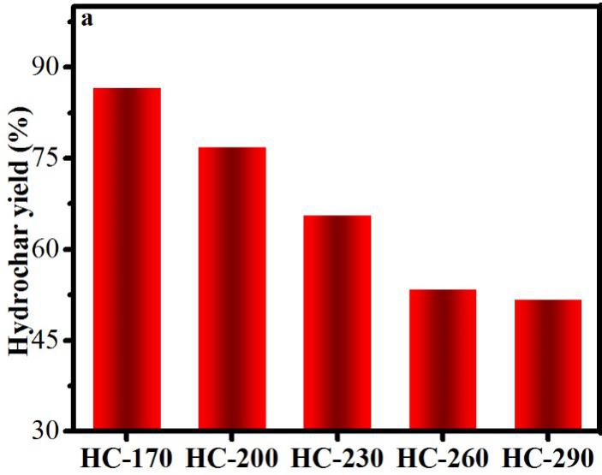

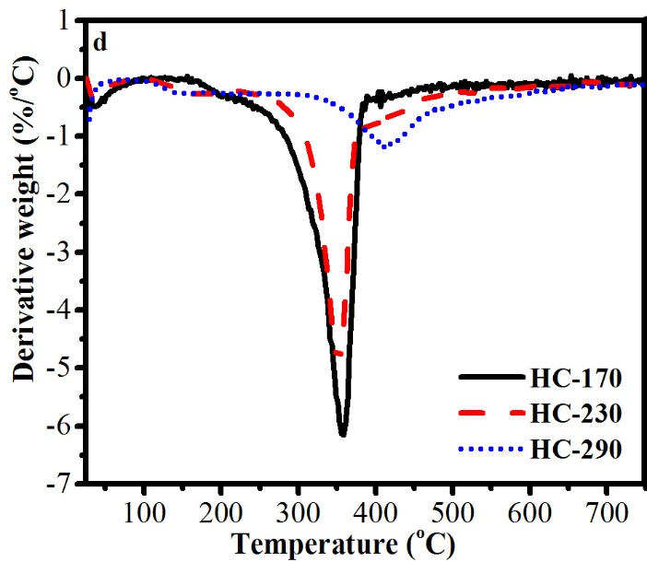

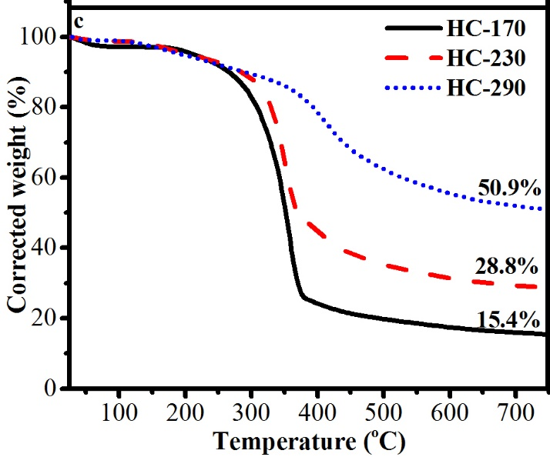

**Fig. 1.** (a) Hydrochar yield acquired at different HTC temperatures. (b) 13C NMR results for HC-170, HC-230 and HC-290, (c) TG, and (d) DTG spectra of HC-170, HC-230 and HC-290, which are hydrochar produced at 170, 230, and 290 °C.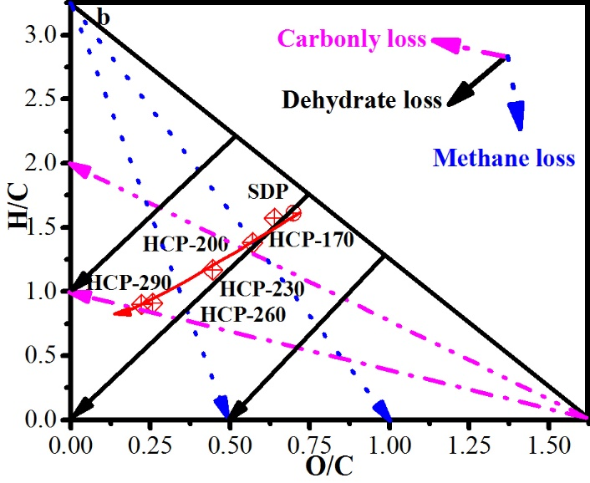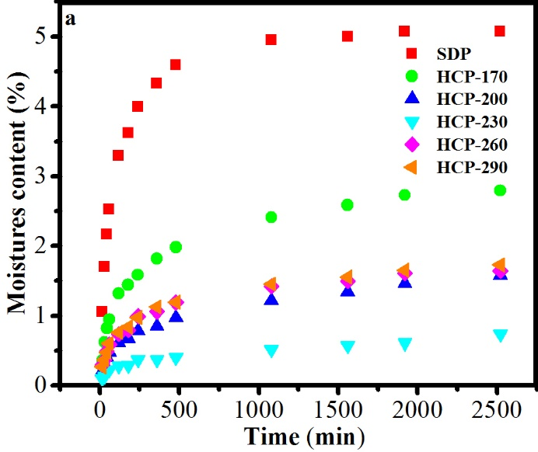

**Fig. 2.** (a) Moisture content compared to exposure time at 25 °C and 60 % humidity. (b) Van Krevelen Diagram of SDP, HCP-170, HCP-200, HCP-230, HCP-260, and HCP-290. SDP was granular fuel produced without the HTC process. HCP-170, HCP-200, HCP-230, HCP-260, and HCP-290 were granular fuels produced at 170, 200, 230, 260, and 290 °C.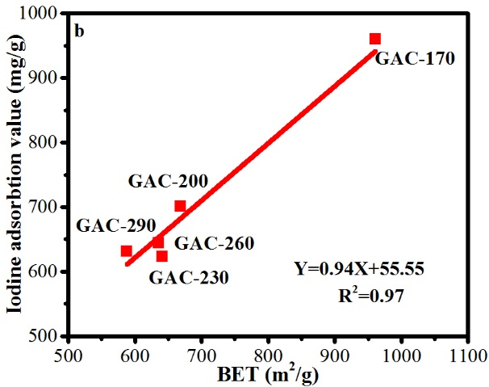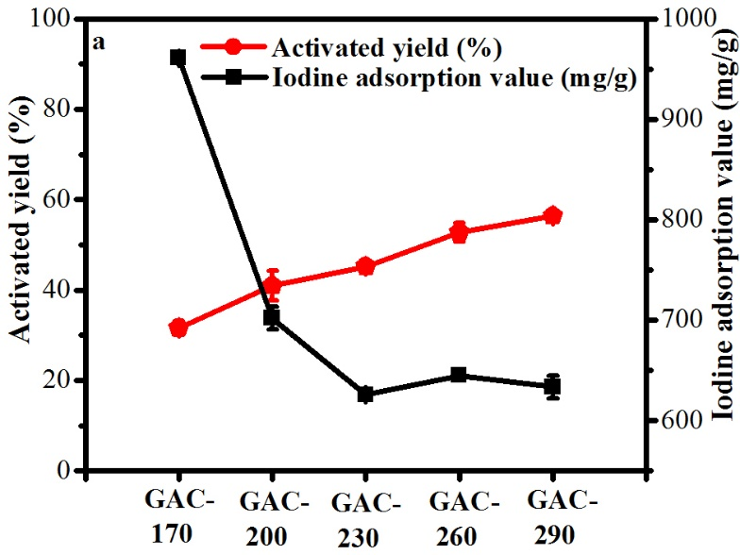

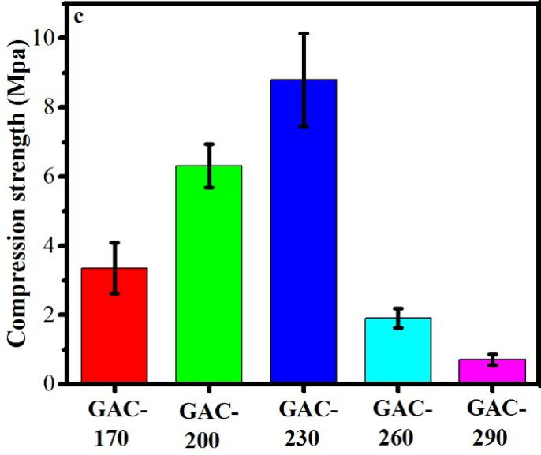

**Fig. 3.** (a) Activated yield and iodine adsorption value diagram, (b) Correlation curves between BET surface area and iodine adsorption value, and (c) Compression strength. GAC-170, GAC-200, GAC-230, GAC-260, and GAC-290 which were produced at 170, 200, 230, 260, and 290 °C in HTC process, and then were activated at 700 °C for 90 min.

**Table 1**

Characteristics of granular fuel prepared from sawdust by HTC process.

|  |  |  |  |  |  |  |
| --- | --- | --- | --- | --- | --- | --- |
| Sample a | Equilibrium moisture content (%) | Moisture uptake rate (min-1*10-3) | Length expansion  (%) | HHV  (MJ/kg) | Energy density (GJ/m3) | Mass density (kg/m3) |
| SDP | 5.07 | 4.36 | 8.13 | 24.31 | 25.82 | 1062 |
| HCP-170 | 2.79 | 2.23 | 3.30 | 25.12 | 32.19 | 1281 |
| HCP-200 | 1.58 | 1.65 | 2.18 | 25.60 | 33.29 | 1300 |
| HCP-230 | 0.73 | 1.32 | 0.67 | 27.34 | 35.87 | 1312 |
| HCP-260 | 1.64 | 2.27 | 1.28 | 30.75 | 32.78 | 1066 |
| HCP-290 | 1.73 | 2.15 | 0.96 | 31.68 | 34.36 | 1084 |

aSDP prepared without the HTC process. HCP-170, HCP-200, HCP-230, HCP-260, and HCP-290 are granular fuels produced at 170, 200, 230, 260, and 290 °C.

**Table 2**

Elemental analysis of granular fuel produced at different HTC temperatures.

|  |  |  |  |  |  |  |  |
| --- | --- | --- | --- | --- | --- | --- | --- |
| Sample a | Ash (%) b | C % c | H % c | N % c | O % d | H/C | O/C |
| SDP | 0.31 | 48.09 | 6.45 | 0.29 | 44.84 | 1.61 | 0.70 |
| HCP-170 | 0.39 | 50.08 | 6.54 | 0.29 | 42.67 | 1.57 | 0.64 |
| HCP-200 | 0.22 | 52.97 | 6.07 | 0.48 | 40.25 | 1.38 | 0.57 |
| HCP-230 | 0.10 | 58.87 | 5.76 | 0.32 | 34.92 | 1.17 | 0.44 |
| HCP-260 | 0.24 | 70.03 | 5.29 | 0.47 | 23.95 | 0.91 | 0.26 |
| HCP-290 | 0.43 | 72.24 | 5.42 | 0.53 | 21.36 | 0.90 | 0.22 |

a SDP prepared without the HTC process. HCP-170, HCP-200, HCP-230, HCP-260, and HCP-290 were granular fuel produced at 170, 200, 230, 260, and 290 °C. b Ash content on water-free basis. c Elemental composition and atomic ratios on a water-free basis. H/C: atomic ratio of hydrogen to carbon, O/C: atomic ratio of oxygen to carbon. d O elemental content acquired by difference.

**Table 3**

Pore structure analysis of GAC produced at different HTC temperatures.

|  |  |  |  |  |  |  |
| --- | --- | --- | --- | --- | --- | --- |
| Sample a | SBET b  （m2/g） | Smic c  （m2/g） | Smic/SBT  (%) | Vt b  (cm3/g) | Pore size  (d. nm) | References |
| GAC-170 | 961 | 919 | 95.63 | 0.4011 | 1.670 | This study |
| GAC-200 | 669 | 641 | 95.81 | 0.2984 | 1.780 | This study |
| GAC-230 | 641 | 593 | 92.51 | 0.2950 | 1.840 | This study |
| GAC-260 | 636 | 584 | 91.82 | 0.4172 | 2.630 | This study |
| GAC-290 | 588 | 517 | 87.93 | 0.4905 | 3.340 | This study |
| CZ0.25 | 736 | -- | -- | 0.3600 | -- | (Arami Niya et al., 2010) |
| YMH3PO4 | 510 | 309 | 60.59 | 0.3210 | -- | (Fiuza Jr et al., 2015) |
| AC1 | 901 | -- | -- | 0.4900 | -- | (Mazarji et al., 2017) |
| PAC900 | 502 | -- | -- | 0.1280 | 1.501 | (Wazir et al., 2020) |
| SAC | 724 | 458 | 63.26 | 0.7475 | -- | (Dong et al., 2020) |

a GAC-170, GAC-200, GAC-230, GAC-260, and GAC-290 were produced at 170, 200, 230, 260, and 290 °C in HTC process, and then activated at 700 °C for 90 min. b SBET and Vt obtained by the Brunauer-Emmett-Teller method. cSmic obtained by the t-plot method.