Organic amendments increase crop yields by improving microbe-mediated soil functioning of agroecosystems: a meta-analysis
Gongwen Luo ^{a,1}, Ling Li ^{a,1}, Ville-Petri Friman ^{b}, Junjie Guo ª, Shiwei Guo ª, Qirong Shen ^{a, *}, Ning Ling ª
1, These two authors contribute equally to this paper

Affiliations:
a, Jiangsu Provincial Key Lab for Organic Solid Waste Utilization, Nanjing Agricultural University, Nanjing, 210095, China
b, Department of Biology, University of York, Wentworth Way, York, YO10 5DD, UK

*Corresponding author:
*Qirong Shen: E-mail: shenqirong@njau.edu.cn
Abstract
Although numerous studies suggest that organic amendments are better at maintaining soil fertility and crop production than mineral-only fertilization, it is unclear if this holds across different agricultural systems on a global scale. Here we report a comprehensive meta-analysis of 690 independent experiments comparing the performance of organic amendments and mineral-only fertilization on crop-yields, contents of soil organic carbon (SOC) and total nitrogen (TN) and soil nutrient dynamics and biological properties. Our analysis shows that organic amendments increased crop-yields on average of 26.77% than mineral-only fertilization. Farmyard manure (FYM) had the highest effect (49.03% increase) and this was especially clear in wheat croplands (40.49% increase). Organic amendment increased the amount of SOC (37.91%), TN (20.22%), microbial biomass carbon (MBC; 51.11%) and microbial biomass nitrogen (MBN; 23.90%) than mineral-only fertilization. Organic amendments also increased the soil microbiome enzyme activity in terms of soil hydrolytic C acquisition (C-acq; 39.29%), N acquisition (N-acq; 22.11%), P acquisition (P-acq; 47.80%) and oxidative decomposition (OX; 57.85%). Increased nutrient acquisition and oxidative decomposition could be a driving factor in the positive effects of organic amendment on crop yields. Crucially, observed patterns were consistent with most types of crops and organic materials across different experimental conditions. Together our analysis suggests that organic amendments can improve microbe-mediated soil ecosystem functioning, long-term soil fertility and crop productivity over mineral fertilization on a global scale.

Keywords: Organic amendment; Crop-yields; Soil extracellular enzymes; Microbial biomass pools; Meta-analysis

1. Introduction
Optimal management strategies are essential for maintaining good soil quality and the long-term sustainability of agricultural production (Li et al., 2015; Deng et al., 2006; Ramesh et al., 2009). Over the past decade, intensive agriculture has caused a clear decrease in soil fertility, which is a major concern for the long-term agricultural productivity and stability (Sarma et al., 2017; Agegnehu et al., 2014). Despite playing a critical role in feeding the global population (Jensen et al., 2011), excessive use of mineral fertilizers is one of the main drivers behind the loss in soil fertility (Chen et al., 2014; Zhang et al., 2016). Organic materials, such as farmyard manure, straw or mixture of manure and compost, have been proposed as alternatives for mineral fertilization (Bodirsky et al., 2014; Gu et al., 2015). However, it remains largely unknown if organic amendments can provide equally comprehensive and continuous nutrition for plant growth and functioning of agroecosystems across different farming systems (Thangarajan et al., 2013; Ling et al., 2016). Here we address this problem by utilizing a meta-analysis approach that combines data from 690 previously conducted independent experiments around the world.
Numerous previous studies have demonstrated that organic amendments can provide various benefits over mineral fertilization such as improved soil structure (Thangarajan et al., 2013), enhanced soil fertility (Chaparro et al., 2012), long-term maintenance of soil health (Xie et al., 2014), and particularly, similar or even higher crop-yields in certain cases (Lin et al., 2009; Seufert et al., 2012). These benefits have primarily been associated with responses in soil biological and biochemical properties (Hueso et al., 2011; Ling et al., 2016). Common responses include increased soil extracellular enzyme activity (EEAs) (Thangarajan et al., 2013) and microbial biomass (MB) (Kallenbach and Grandy, 2011), which are important factors behind the soil carbon (C), nitrogen (N) and phosphorus (P) turnover and dynamics (Agegnehu et al., 2016; Xia et al., 2017). Soil MB also facilitates key ecosystem functions and services such as microbial community-mediated nitrogen-use efficiency (NUE) and carbon-use efficiency (CUE) (Mooshammer et al., 2014; Kallenbach and Grandy, 2011). Fertilizer-mediated microbial activity can further lead to changes in C and N dynamics (Mooshammer et al., 2014; Brilli et al., 2017), which can regulate the balance between NUE and CUE (Zhong et al., 2015). Microorganisms have the ability to adjust their CUE and NUE according to soil nutritional conditions and it has been shown that high environmental N can lead to low NUE and high CUE (Mooshammer et al., 2014). High CUE has been found to promote microbial growth and stabilization of C in soils, while low CUE has been found to favor respiration (Manzoni et al., 2012). Microbial growth will not only affect the number of cells but also their metabolism and the concentration of EEAs (Burns et al., 2013; Joergensen and Wichern, 2018). Moreover, changes in EEAs and MB are more dynamic and faster than changes in soil physiochemical properties providing immediate information on the activity of agriculturally important microbial processes (Dick and Tabatabai, 1993; Ros et al., 2003). It remains unclear, however, if these patterns hold across different agricultural systems and geographic locations.
In general, EEAs have been widely used as indicators of soil quality (Loeppmann et al., 2016), ecosystem functioning (Bastida et al., 2016) and productivity (Zhao et al. 2009). A wide range of EEAs has been associated with soil organic C, N and P decomposition and oxidation and these are largely dependent on soil C and N availability (Burns et al., 2013; Chen et al., 2016; Sinsabaugh et al., 2008). For example, the cellulases, including β-1,4-xylosidase (BX), β-1,4-glucosidase (BG) and β-D-cellobiosidase (CBH), are a group of hydrolytic enzymes produced by soil microbes that are used to decompose polysaccharides (Deng and Tabatabai, 1994). Key enzymes associated with microbial N acquisition include β-1,4-N-acetyl-glucosaminidase (NAG), leucine aminopeptidase (LAP) and urease (UREA) that target chitin, protein, and urea, respectively (Tabatabai and Bremner, 1972). The enzymes associated with P acquisition cleave PO₄³⁻ from P-containing organic compounds and include acidic (ACP) and alkaline (ALP) phosphatases (Eivazi and Tabatabai, 1977). Phenol oxidase (PhOx) and peroxidase (PEO) are the two most frequently assayed oxidases responsible for decomposing insoluble materials such as lignin and aromatic compounds (Sinsabaugh, 2010; Wang et al., 2012). Thus far, soil extracellular enzyme activities have been reported to both decrease and increase in response to organic amendments with varying magnitude (Burns et al., 2013; Henry, 2013; Geisseler and Scow, 2014; Sinsabaugh et al., 2014). Generally, the responses of EEAs to fertilization management are affected by the types of crops and organic amendments, soil pH and texture, as well as climate conditions (Jian et al., 2016; Ramesh et al., 2009). Analyzing these patterns on a global scale, therefore, is important for identifying key abiotic and biotic drivers that have positive effects on soil EEAs and crop-yields.
Here we performed a comprehensive meta-analysis where we compared the effects of organic amendments versus mineral fertilizers on crop-yields, soil organic carbon (SOC), soil total nitrogen (TN) and soil biological properties using 690 independent studies published in >100 journals between 2000-2016. We hypothesized that: (i) Organic amendments could support similar or higher crop-yields than mineral-only fertilization on average but that this effect is likely to depend on the particular crop type, abiotic environment or other factors. Moreover, we expected that (ii) when organic amendments are observed to have a more positive effect on crop-yields than mineral fertilizers, this could correlate positively with the soil EEAs and MB pools having positive effect on the functioning of agroecosystems.

- Materials and methods

2.1. Data extraction and compilation

We collected a total of 106 peer-reviewed papers published between 2000 and 2016 listed in the ISI Web of Science (www.isiknowledge.com) and Google Scholar (scholar.google.com). Through this search, we found 690 individual records (Fig. 1) that included at least two of our targeted search terms: “soil extracellular enzyme”, “exoenzyme”, “crop yields” and either “farmyard manure (FYM)”, “manure”, “compost”, “waste”, “straw” or “solid waste”. Data were extracted and compiled according to three following criteria: (1) If the data of interest were only shown in graphs or figures, both the standard deviation (SD) and the means were extracted by using ImageJ 1.50i and the standard errors (SE) converted to SD using following equation: SD = SE×$\sqrt{n}$(n, replicate numbers) (Jian et al., 2016); (2) If one paper reported various independent experiments (e.g., two experiments at separate locations), each of them was considered as an individual study and incorporated as an independent observation into our dataset (García-Palacios et al., 2015). (3) If one paper contained results from various sampling dates and soil depths, we used the data from the latest sampling time-point and from the sample collected from the uppermost layer of soil. The complete dataset is included as supplementary material and contains 24 parameters linked with crop-yields, soil EEAs, SOC, TN and MB pools. The effects of other management factors were considered when selecting the literature for our meta-analysis by choosing only studies that focused on comparing the impacts of organic amendments and mineral-only fertilization under otherwise similar management practices such as pest management and irrigation. The organic amendments also included two classes: organic-only amendments and organic amendments that were supplemented with other fertilizers. In this study, both these classes were combined as ‘organic amendment’ treatment to allow straightforward comparison with mineral-only fertilization treatment.
In total, 17 individual extracellular enzymes were included in this study (Table S1). The enzyme activity units were unified in the process of extracting and analyzing data. Moreover, as we used the response ratio of enzyme activity as our response variable, we could eliminate the differences in different enzyme analysis methods between studies. We also used averaged mean EEAs as proxies of specific substrate or nutrient acquisition (Li et al., 2012, 2013; Jian et al., 2016) including carbon (C-acq), nitrogen (N-acq), phosphorus (P-acq) acquisition and oxidative decomposition (OX) (Table S1). The mean EEAs were calculated as follows：
C-acq = (AG+BG+CBH+BX+XY+INV)/6 (1)
N-acq = (NAG+LAP+UREA+BAA)/4 (2)
P-acq = (DEs+ALP+ACP)/3 (3)
OX = (PEO+DHH++CAT+PhOx)/4 (4)
where AG, BG, CBH, BX, XY, INV, NAG, LAP, UREA, BAA, ALP, ACP, PEO, DHH, DEs, CAT and PhOx represent the activities of α-1,4-glucosidase, β-1,4-glucosidase, β-D-cellobiosidase, β-1,4-xylosidase, xylanase, invertase, β-1,4-N-Acetyl-glucosaminidase, leucine aminopeptidase, urease, protease, alkaline phosphatase, acid phosphatase, peroxidase, dehydrogenase, diesterase, catalase and phenol oxidase, respectively (see Table S1). We also collected data of the amount of soil organic carbon (SOC), total nitrogen (TN), microbial biomass carbon (MBC), microbial biomass nitrogen (MBN) and crop-yields for the studies that also reported data on soil EEAs.
The geographic, edaphic, climatic and experimental data was collected for each site as follows. Geographical parameters included latitude and longitude and edaphic properties such as soil pH and soil type and texture. When pH-CaCl₂ was used in a publication instead of pH-H₂O, an estimated value of the latter was calculated as follows: pH-H₂O = 0.86×pH-CaCl₂+1.65 (Augusto et al., 2008). If soil type and texture was not reported in the original publication, it was determined based on soil characteristics reported in the China soil taxonomy (Zhang et al., 2014). Climatic properties such as mean annual temperature (MAT) and mean annual precipitation (MAP) were also recorded, and if not reported in the original studies, climate data was collected from a NASA Surface meteorology and Solar Energy-Location site (https://eosweb.larc.nasa.gov) based on the latitude and longitude os study sites. Extracted experimental properties included soil depth, crop type, the type of organic amendment, the type of experiment, the duration of the experiment, the quantity of N in a given fertilizer and the amount of N contained by organic amendment than mineral-only fertilizer.
Organic amendments were divided into five categories: farmyard manure (FYM), compost, green manure, solid waste and straw. FYM is a natural organic material without industrial processing. The main ingredient of FYM is human or/and animal waste and it also contains plant material (often straw), which has been used as bedding for animals. Compost is the decomposed remnants of organic materials. It is usually of plant origin but often includes some animal dung or bedding. Green manure is from crops that are plowed in to increase soil fertility through the incorporation of nutrients and organic matter into the soil. Solid waste is an organic material derived from the solid waste material (such as urban sludge and garbage) that has gone through biological treatment (decomposition by microorganisms) before applying as a fertilizer. Straw, the dry stalks of cereal plants, is an agricultural by-product after the grain and chaff have been removed from crops. Generally, compost manure (CM) and solid waste (SW) had relatively high protein, protein-like product, carbohydrate and nutrient contents than other amendments. FYM had the highest pH, energy, organic carbon and C:N ratio, while the compost had the second highest values in all categories except for organic carbon content that was the second highest for the straw.
All continuous variables were divided into groups based on the results of meta-regression analysis (Borenstein et al., 2009) under random model effects, which could assess the the effect size (LnR; dependent variable) of each independent variable and decides where to split them. We also chose categories that makes sense scientifically and that are commonly used in soil biology research reflecting well different agricultural practices. Latitude variable was divided to five (≤20 °N, 20-30 °N, 30-40 °N, 40-50 °N and >50 °N) and altitude to three categories (≤100 m, 100-500 m and >500 m). MAT was divided to four (≤5 °C, 5-10 °C, 10-20 °C and >20 °C) and MAP to three categories (≤500 mm, 500-1000 mm and >1000 mm). The duration of experiments was categorized to five (≤3 years, 3-10 years, 10-20 years, 20-30 years and >30 years), the soil depth to four (≤10 cm, 10-15 cm, 15-20 cm and >20 cm) and the soil pH to four (≤6, 6-7, 7-8 and >8) categories. The type of the experiment was classified into three categories: “field” “greenhouse” or “lab” experiments. The ‘field’ category includes experiments conducted on paddy fields and dry land; the ‘greenhouse’ category includes pot experiments and experiments conducted in agricultural facilities; the ‘lab’ category includes incubation experiments and microcosm experiments conducted in the in the laboratory. In this study, the amount of N means that the total input of N that includes both mineral N and organic N. While mineral-only fertilizer contained only mineral N, ‘organic amendments’ contained both mineral and organic N in most cases (organic-only and organic-mineral fertilizer treatments were grouped together). Terms ‘Higher’, ‘Equal’ and ‘Lower’ were used to denote if the amount of N was statistically higher, equal or lower in organic amendment compared than mineral-only fertilizer treatments, respectively.

2.2. Meta-data analysis
We used response ratio (RR) as a metric to compare the effect sizes of different response variables (crop-yields, soil EEAs, soil MB pools, the contents of SOC and TN) between mineral-only and organic amendments in the meta-analysis (Jian et al., 2016). The RR was calculated as the natural log of the ratio between mean of organic amendment (X_{t}) and mineral-only (X_{c}) fertilization groups:
RR = ln(x_{t}/x_{c}) = ln(x_{t}) - ln(x_{c}) (5)
The variance of the effect size (v) was calculated by using the inverse of the pooled variance as described below (Hedges et al., 1999):
v = s_{t}²/n_{t}x_{t}² + s_{c}²/n_{c}x_{c}² (6)
where n_{t} and n_{c} represent the replicate numbers of organic amendment and mineral-only fertilizer groups, respectively; the s_{t} and s_{c} standard deviations for all comparisons in the organic and mineral-only fertilizer groups, respectively.
Considering studies where neither the SD nor the SE were available in the original papers, two weighting functions were used as follows: (i) each individual observation was weighted by the reciprocal of the pooled variance as often done in meta-analysis (Curtis and Wang, 1998), or (ii) all the data were weighted by the following replication-based function:
weight= (n_{t} × n_{c})/(n_{t} + n_{c}) (7)
where n_{t} and n_{c} represent the number of replicates for the organic amendment and mineral-only fertilizer groups, respectively (Adams et al., 1997). As most of the categorical variables violated the normality assumption (Table S2) a bootstrapping procedure (Jian et al., 2016) was used to fulfil the requirement of normal distribution. In categorical group analysis, the total heterogeneity of effect sizes between studies (Q_{T}) was partitioned into within-group (Q_{E}) and between-group (Q_{M}) heterogeneity and examined relative to all response variables (Bai et al., 2013; Treseder, 2008). The significance level of the heterogeneity of the random-effect models (Q_{M}), that is the variation in the effect sizes that is explained by this model, was tested against a chi-square (χ²) distribution which is equivalent to calculating the significance level of the slope against a normal distribution. From this, a significant Q_{M} means that the independent variable explains a significant amount of the variability in effect sizes by this model (Rosenberg et al., 2000; Bai et al., 2013; Treseder, 2008; Mji and Schmidt, 2017) (see Table S3). To test the effects of publication bias (because journals might publish certain type of studies or studies with statistically significant results), we used the fail-safe N technique (Rothstein et al., 2007; Rosenthal and Rosnow, 2008). The robustness of the findings of the meta-analysis is directly correlated with the size of the fail-safe number (N_{fs}) that represents the number of studies required to refute significant meta-analytic means. All the data was corrected with the results of both Rosenthal’s (a = 0.05) and Orwin’s method (negligible effect = 0.2) (Rosenberg et al., 2000; Liu et al., 2016) (see Table S4). The impact of organic amendment was considered evident if the 95% CI did not overlap with the RR of 0. Means of categorical variables were considered significantly different if their 95% CIs did not overlap with each other.

2.3. Statistical analyses
The mean effect sizes and 95% CI were generated by building random-effect models with restricted maximum likelihood estimation in OpenMEE (Brown University, Providence, RI, USA) (Wallace et al., 2017). The RR and CI of treatments were back-transformed from lnRR values and all figures showing the weighted RR values were plotted in SIGMAPLOT (version12.5; Systat Software Inc., San Jose, CA, USA). Specifically, the RR results are shown as percentage changes ((e^{RR}-1)×100%) based on the comparison between organic amendment and mineral-only fertilization. We employed ordinary least squares (OLS) regression analysis to compare significant correlations between response ratios (crop-yields and biological and chemical parameters) by using the R package ‘splines’. Aggregated boosted tree (ABT) analysis (De’ath, 2007) was carried out by using the “gbmplus” package (with 500 trees used for the boosting, 0.02-fold shrinkage rate and three-way interactions) to quantitatively and visually evaluate the relative effect of environmental variables (climate, soil physicochemical properties, MB pools and the ratio of microbial carbon-use efficiency (CUE) to nitrogen-use efficiency (NUE) (CUE:NUE)) on soil enzyme activity (C-acq, N-acq, P-acq and OX)). The CUE:NUE was calculated according to the following equation :
CUE:NUE = B_{C:N} : R_{C:N} (8)
where B_{C:N} is the C:N ratio of the microbial biomass and R_{C:N} is the C:N ratio of the soil.
Structural equation modeling (SEM) was used to disentangle indirect and direct effects of climate (MAT and MAP), soil physicochemical properties, the ratio of C and N and soil enzyme activities on crop-yields (Eisenhauer et al., 2015) by using AMOS software (IBM SPSS AMOS 20.0.0). Before modeling, all data were normalized (making sure the data is in a standard normal distribution with a mean value of 0 and standard deviation of 1) and an a priori model was established based on the known effects and relationships among the drivers that have had a significant effect on crop-yields in our previous analyses (Grace, 2006). SEM was employed instead of multiple regressions because directions can be assigned to several relationships, which results in multiple explanatory as well as multiple response variables in one model (Grace, 2006). Furthermore, the structure of such a model can reveal whether a significant bivariate relationship occurs due to a significant relationship between two given variables and a third variable. The following criteria were used to evaluate the fit of the models: The root mean squared error of approximation (RMSEA; the model has a good fit when RMSEA is low (<0.05)), chi-square value (χ²; the model has a good fit when χ² is low), Fisher’s P statistic (the model has a good fit when 0.05 < P ≤ 1.00) and the Akaike information criterion (AIC; the model has a good fit when AIC is low) (Schermellehengel et al., 2003).

3. Results
3.1. Comparing the effect of organic amendments and mineral-only fertilization on crop-yields
On average, organic amendments increased crop-yields by 26.77% than mineral-only fertilization. Forest plots and the mean weighted RR with 95% confidence intervals (CI) for all the investigated variables are shown in Figure 2. Of all included crop types, wheat showed the highest increase in the yield (40.49%), followed by maize (35.94%), millet (29.47%) and rice (7.70%) (Fig. 2). Moreover, the type of organic amendment had a large effect on the magnitude and direction of yield response. For example, farmyard manure (FYM) had the most positive effect on crop-yields (49.03%), followed by compost (16.82%) and straw (7.67%). Yield responses to organic amendments were significantly positive in clay (28.85%), clay loam (11.55%) and sandy loam soils (10.43%) (Fig. 2). Organic amendment had also generally positive effects on crop-yields regardless of the soil pH and the highest increase was observed when pH values were higher than 8 (35.60%). Increases in the crop-yields were more notable when organically amended soils received relatively higher quantities of N than mineral-only fertilized soils (51.16%) (Fig. 2). Response ratios were generally positive regardless of mean annual precipitation (MAP) having highest values when the MAP varied between 500 mm and 1000 mm (34.42%). The duration of the experiment had a positive effect on crop-yields up until 30 years after which effects became more similar to mineral-only fertilizer treatments (Fig. 2). Response ratios were generally positive regardless of mean annual precipitation (MAP) and soil types (Fig. 2; Fig. S1). Together these results suggest that organic amendments had a more positive effect on crop-yields than mineral-only fertilizers and that this effect depended on the crop and manure types and the amount of N input.

3.2. Comparing the effect of organic amendments and mineral-only fertilization on soil enzyme activity
In general, organic amendments significantly increased the activity of α-1,4-glucosidase, β-1,4-glucosidas, β-D-cellobiosidase, β-1,4-xylosidase, xylanase, invertase, protease, urease, leucine aminopeptidase, diesterase, alkaline phosphatase, acid phosphatase, catalase, dehydrogenase, β-1,4-N-Acetyl-glucosaminidase, peroxidase and phenol oxidase (by 49.16%, 35.22%, 22.36%, 88.18%, 14.15%, 39.27%, 51.16%, 16.48%, 93.35%, 118.35%, 61.37%, 28.08%, 73.44%, 58.45%, 45.52%, 12.94% and 22.32%, respectively; Fig. S2). Moreover, the carbon (C-acq), nitrogen (N-acq), phosphorus (P-acq) and oxidative decomposition (OX) related enzyme activities increased by 22.27%, 47.80%, 57.85% and 39.29%, respectively, in response to organic amendments than mineral-only fertilization. On average, C-acq, N-acq, P-acq and OX activities had the highest and consistent responses to solid waste (79.99%, 42.27%, 155.69% and 147.37%, respectively) and compost (45.41%, 29.50%, 41.84% and 57.15%, respectively). C-acq and P-acq responded more positively to the organic amendments at higher pH (>8), and N-acq and OX when the pH value varied between 7-8 (59.05%) and 6-7 (62.51%), respectively (Fig. 3). Increases in the OX, C-acq, N-acq and P-acq activities were larger when organically amended soils received relatively higher N input (72.45%, 63.40%, 34.11% and 64.25%, respectively, Fig. 3). Response ratios were generally positive regardless of the MAP or edaphic, climate and experimental conditions (Fig. 3; Fig. S3). Similar to crop-yields, C-acq and OX activities showed increasingly positive responses with the length of the experiment up until 30 years (Fig. 3). Together these results suggest that soil enzyme activity was generally higher under organically amended than mineral-only fertilized soils.

3.3. Comparing the effects of organic amendments and mineral-only fertilization on soil organic carban, total nitrogen and microbial biomass (MB) pools
The SOC, TN, MBC and MBN of organically amended soils showed 37.91%, 22.41%, 51.11% and 23.90% higher values than mineral-only fertilized soils, respectively (Fig. 4; Fig. S4). Moreover, SOC, TN, MBC and MBN showed consistently positive responses with wheat (Fig. 4). Soil MBC (246.55%), MBN (64.44%) and SOC (136.63%) had the highest responses to solid-waste manure, while soil TN (29.91%) had the highest response to compost (Fig. 4). On average, MBC (51.11%), SOC (37.91%) and TN (22.41%) had the highest responses to organic amendments when the soil pH values were >8 (Fig. 4). When the N-input was equal between organic and mineral-only fertilizers, the MBN still had a higher response ratio to organic amendments (40.57%). When N-input was relatively higher in the organic than mineral-only fertilizers, we also observed an increase in TN (30.65%), SOC (60.06%) and MBC (75.18%) (Fig. 4). Responses to MAP were generally positive and especially high for MBC and SOC when MAP was <500 mm (Fig. 4). The responses of soil MBC, MBN, SOC and TN to organic amendments varied only slightly with the duration of experiment: response ratios were positive for MBC and TN when the duration of experiments exceeded 3 years and varied slightly between 10 and 20 years (Fig. 4). Together these results suggest that SOC, TN and microbial biomass had more positive responses to organic amendments than mineral-only fertilization.

3.4 Measuring correlations between soil microbial activity and crop-yields
CUE:NUE correlated positively with increase in C-acq and N-acq enzyme activities (R²=0.637; p<0.01 and R²=0.278; p<0.05, respectively, Fig. 5A-B). However, non-linear relationships were found between CUE:NUE and P-acq and OX (Fig. 5C-D). We also conducted OLS regression analysis using standardized means of all study sites to explore associations between mean soil enzyme activities and crop-yields (Fig. 5E-H). We found that crop-yields correlated positively with C-acq (R²=0.189; p<0.001), N-acq (R²=0.246; p<0.001), P-acq (R²=0.215; p<0.001) and OX (R²=0.148; p<0.001). Further analysis showed that crop-yields were positively correlated with most individual EEAs, including BG, BX, BAA, UREA, ALP, ACP and DHH (Table S5). Together these results suggest that soil enzyme activities were positively correlated with crop-yields across the whole dataset.

3.5. Determining key major environmental drivers behind increased soil enzyme activity
To compare the relative importance of soil and climatic (MAP and MAT) properties on the mean soil enzyme activity, we conducted aggregated-boosted tree (ABT) analysis. Overall, 84.03%-96.17% of the variance in C-acq, N-acq, P-acq and OX related enzyme activity could be explained by the first five factors that were different for each mean enzyme activity group. Specifically, CUE:NUE, SOC and MBC were important in explaining the variation of C-acq, N-acq, P-acq and OX (Fig. 6A-D; Table S6). Moreover, the MAP, CUE:NUE, MBC and MAT were the key factors explaining the variation of C-acq, N-acq, P-acq and OX, accounting for approximately 28.32%, 35.23%, 30.39% and 38.25% of the total variation, respectively. Additionally, MAT, TN and MAP were important for C-acq (20.62%), N-acq (11.20%) and P-acq (14.72%), respectively. C:N had a significant influence on N-acq (18.83%) and P-acq (12.69%) (Fig. 6). Together these results suggest that MAP, CUE:NUE, MBC and MAT were the major drivers of soil enzyme activity.

3.6. Disentangling the direct and indirect effects of climate, biological and chemical factors on the yield of organically amended soils
We employed structural equation modeling (SEM) to analyze how different explanatory variables and their interactions affected the yield of organically amended crops. The final SEM model explained 67% of the total variation of crop-yields (χ²= 13.21; Fisher’s C statistic P=0.74, AIC=114.41, RMSEA=0.008, Fig. 7). Of all the included variables, soil SOC, MBC and MBN were the most important factors having positive effects on crop-yields directly or via other model variables. In general, soil SOC had a positive effect on soil MBC (path coefficient=0.54) and MBN (path coefficient=0.48). Soil MBC had direct (path coefficient=0.41) and indirect positive effects on crop-yields via soil N-acq (MBC to N-acq path coefficient=0.24; N-acq to crop-yield path coefficient=0.43). Soil MBN had only an indirect positive effect via C-acq (MBN to C-acq path coefficients=0.32; C-acq to crop-yield path coefficients=0.36). As a result, soil SOC played an important indirect role in driving the positive effect on crop-yields via MBC, MBN, N-acq and C-acq (Fig. 7). In contrast, MAP (path coefficient= -0.44), MAT (path coefficient= -0.55), MBN (path coefficient= -0.34) and TN (path coefficient= -0.26) had direct negative effects on crop-yields (Fig. 7). Moreover, mean enzyme activities correlated positively with each other and thus potentially interactively impacted crop-yields. Together these results confirm that microbe-mediated enzyme activities improve crop-yields under organic amendment.

4. Discussion
4.1. Organic amendments improve crop-yields than mineral-only fertilization
On average, organic amendments increased crop-yields by 26.77% than mineral-only fertilization (Fig. 2). Noticeably, performance of crop-yields varied substantially depending on crop species, organic amendment type, edaphic properties, and climatic conditions (Fig. 2). For example, while wheat had the highest yield increment (40.49%) followed by maize (35.94%) and millet (29.47%), barley yields did not show a statistically significant response to organic amendments (Fig. 2). One explanation for this could be that wheat, maize and millet can better synchronize their nutrient demands with the slow release of nutrients from organic amendments (Seufert et al., 2012; Crews and Peoples, 2005). Additionally, organic amendments could have improved the disease resistance of crops by providing an adequate amount of nutrients (Dordas, 2008). On average, crop-yields increased most in response to farmyard manure (49.03%), followed by compost (16.82%) and straw (7.67%) (Fig. 2). Crop responses to organic amendments is dependent on the C:N ratio (Mohanty et al., 2011) and lignin and cellulose contents (Blanchet et al., 2016). As a result, it is not a surprise that crops responded best to manure that has high N content and low C:N ratio (Cordovil et al., 2005; Seneviratne, 2000; Masunga et al., 2016). Similarly, crops responded more positively to organic amendments when the input of N was relatively high (Fig. 2; Seufert et al., 2012). This suggests that organic amendments with high N content and low C:N ratios can mineralize sufficient N to satisfy growth demands of plants (Seneviratne, 2000; Cordovil et al., 2005). We also found that the crop-yield responses were quite small during the first 3 years of fertilization after which they gradually increased (Fig. 2). This could be explained by the fact that the mineralization and the release of nutrients from organic amendments is relatively slow and could take longer to have a visible effect (Berry et al., 2002; Pang and Letey, 2000). Surprisingly, crop-yield improvements declined in the long term and no positive effect of organic amendment than mineral-only fertilizers was observed after 30 years of the beginning of the fertilization (Fig. 2). Many factors could explain this. For example, soil-nutrient levels could saturate during long-term application of organic amendments potentially inhibiting or slowing down the enzyme activity of soils (Fig. 3; Marcote et al., 2001; Han et al., 2016). In support of this, we found similar decreases in soil C-acq and OX activities after 30 years of fertilization (Fig. 3). Moreover, the N input may limit crop-yield responses under long-term application when a single type of organic amendment is used (Ramesh et al., 2009). Thus, the combined application of different types of organic amendments could help to improve crop-yields in the long-term. Moreover, crops responded better to organic amendments when soil pH ranged from weak-acidic to weak-alkaline soils (Fig. 2). This suggests that organic amendments may modify soil pH making the soil more suitable for microbes and plants via positive impacts on soil C and N availability (Fischer and Glaser, 2012; Courtney and Mullen, 2008; Agegnehu et al., 2016). Together these results suggest that crop-yields have a generally positive response to organic amendments across different environmental conditions and agricultural systems.

4.2. Organic amendments can improve the functioning of soil ecosystem
Organic amendments significantly increased soil C and N dynamics by improving soil enzyme activity (Diacono and Montemurro, 2010; Maltas et al., 2013; Xia et al., 2017; Guo et al., 2017). In agreement with previously published studies (Moeskops et al., 2010; García-Ruiz et al., 2008; Luo et al., 2017a, b), organic amendments increased specifically the soil EEAs associated with C hydrolysis (39.29%), N (22.27%) and P (47.80%) decomposition and oxidation (57.85%) (Fig. 3). Soil microbial communities are particularly sensitive to the dynamics and availability of C and N (Allison et al., 2007). Hence, increases in C and N enzyme activities could have been driven by microbial growth, changes in microbial community composition or the stimulation of microbial activity in response to organic amendments (Fig. 5 and S5; Table S6) (Zhao et al., 2009). In general, the performance of organic amendments on soil enzyme activity was probably due to a combined effect of a higher degree of stabilization of enzymes to humic substances and an increase in microbial biomass with increased soil C concentration (Martens et al., 1992; Goyal et al., 1993; Zhao et al., 2009).
Generally, soil pH and SOC and MB pools are the main factors regulating the synthesis and activity of soil enzymes (Jian et al., 2016; Sinsabaugh et al., 2008; Luo et al., 2017a, b). Soil enzyme activity is further shaped by different experimental conditions (Zhao et al., 2009; Kallenbach and Grandy, 2011). We found that organic amendments had a more positive impact on soil microbial biomass than mineral-only fertilization as indicated by the substantial increase in the MBC and MBN concentrations (Fig. 4; Wang, 2007; Kallenbach and Grandy, 2011). This could have resulted from the addition of microbial biomass along the organic materials (e.g. manure). Alternatively, addition of labile organic matter could have promoted the growth of microbes already present in the soil (Smukler et al., 2008; Kallenbach and Grandy, 2011) (Li et al., 2015). Moreover, the activity of specific enzymes varied depending on the type of organic amendment and soil characteristics (Fig. 3; Sinsabaugh et al., 2008; Stursová and Baldrian, 2011), and for example, solid waste organic amendment had the greatest impact on MB pools (Fig. 4) probably due to its low C:N ratio and high N concentration (Cornwell et al., 2008). Together these results suggest that both EEA and MB pools could be used as appropriate indicators of soil quality and functioning in response to fertilization. Determining such indicators is crucial for the sustainable management of agricultural systems (Ge et al., 2009) and could help to ensure high crop-yields and plant nutrient availability in the future (Liang et al., 2003, 2005; Tu et al., 2006).

4.3. Linking crop-yields with underlying drivers of soil ecosystem functioning
We found that soil EEAs correlated significantly with both CUE:NUE and crop-yields (Fig. 5). In the case of CUE:NUE, N-acq and C-acq showed a positive linear relationship, P-acq a quadratic relationship and OX a negative relationship. In contrast, all soil enzyme activities correlated positively with crop-yields. Together these results suggest that CUE:NUE is linked with crop productivity via N-acq and C-acq but less clearly via P-acq and OX. In general, EEA mediates the acquisition of nutrients from the soil environment for both plants and microbes and this process is largely dependent on soil C and N availability (Sinsabaugh et al., 2008; Moorhead and Sinsabaugh, 2006). Notably, C- and N-cycle-related enzyme activities are expected to mediate increases in plant nutrient demands (Buchkowski et al., 2015; Chen et al., 2016; Sinsabaugh et al., 2008). As microbes can rapidly adjust their CUE and NUE according to soil nutritional conditions (Manzoni et al., 2012; Six et al., 2006), CUE:NUE ratio could potentially be used as an indicator of soil microbial activity and functionality (Zhong et al., 2015). To study how the effects of organic amendment were ‘transferred’ into improved crop-yields we constructed SEM pathway analysis. Our final model showed that soil MB pools (MBC and MBN), EEAs (C-acq and N-acq), as well as the climate (MAP and MAT) had significant effects on crop-yields (Fig. 7). SOC was an important underlying factor indirectly affecting crop-yields by boosting both microbial biomass and soil enzyme activities (Fig. 7). The increase in microbial densities could have then impacted the temporal availability of soil N for the plants (Sabahi et al., 2010). Moreover, microbes can prolong N immobilization (Manzoni and Porporato, 2009; Xia et al., 2017), potentially providing energy for plants and a favorable environment for the accumulation of soil enzymes (Martens et al., 1992; Zhao et al., 2009). Both MAP and MAT had negative effects on crop-yields, which suggests that geographical location has a big influence on the potential positive effects of organic amendments. Climate change poses a serious and continuing threat to development of agroecosystems (Challinor et al., 2014). For example, in Africa, the crop-yields may decrease by 10-20% to 2050 result from the increasing warming and drought (Jones and Thornton, 2003). Although the negative effects of climate on crop-yields are unpredictable and difficult to control, it is unclear to what extent organic amendments could counteract this by having a positive effect on soil biological properties (e.g. EEAs and MB) (Fig. 7; Agegnehu et al., 2016; Blanchet et al., 2016). Currently, many developing countries are considered highly vulnerable to changes in temperature and precipitation (Slingo et al., 2005) partly because their agroecosystems have a poor resilience to environmental changes.

4.4. Future perspectives regarding organic amendments and crop production
Our comprehensive meta-analysis suggests that organic amendments could play a key role in improving crop production by increasing SOC and TN and biological soil enzymatic activity than mineral-only fertilization across different crop systems. The C, N content and C:N of organic materials may influence the performance of organic amendments on microbe-mediated soil functioning. However, most literature included in our meta-analysis did not report these parameters, and as a result, it was not possible to comprehensibly analyze their effects on soil functioning and crop yields . Including this information to the future studies would help to evaluate the relative contribution of C and N content and ratio on productivity of agroecosystems. Additionally, future work should concentrate on more comprehensive and holistic analysis using a wider selection of variables and direct experimentation to test the causal links between organic amendments and crop-yields. Our study suggests that organic amendments could support similar or higher crop-yields than mineral-only fertilization on a global scale and that improvement of soil biological activity by organic amendment is an important approach to improving food production.

ACKNOWLEDGMENTS
This work was financially supported by National Key Research and Development Program of China (2017YFD0200805), China Postdoctoral Science Foundation (2015M570460 and 2016T90473) and Special Fund for Agro-scientific Research in the Public Interest (20150312205). Ville-Petri Friman is supported by Royal Society Research Grant and by the Well come Trust [ref: 105624] through the Centre for Chronic Diseases and Disorders (C2D2) at the University of York.

References
Adams, D.C., Gurevitch, J., Rosenberg, M.S., 1997. Resampling tests for meta-analysis of ecological data. Ecology 78, 1277-1283.
Agegnehu, G., Lakew, B., Nelson, P.N., 2014. Cropping sequence and nitrogen fertilizer effects on the productivity and quality of malting barley and soil fertility in the Ethiopian highlands. Archives of Agronomy and Soil Science 60, 1261-1275.
Agegnehu, G., Nelson, P.N., Bird, M.I., 2016. Crop yield, plant nutrient uptake and soil physicochemical properties under organic soil amendments and nitrogen fertilization on nitisols. Soil and Tillage Research 160, 1-13.
Allison, S.D., Gartner, T., Holland, K., Weintraub, M., Sinsabaugh, R.L., 2007. Soil enzymes: linking proteomics and ecological process. American Society of Microbiology, 704-711.
Augusto, L., Bakker, M.R., Meredieu, C., 2008. Wood ash applications to temperate forest ecosystems-potential benefits and drawbacks. Plant and Soil 306, 181-198.
Bai, E., Li, S., Xu, W., Li, W., Dai, W., Jiang, P., 2013. A meta-analysis of experimental warming effects on terrestrial nitrogen pools and dynamics. New Phytologist 199, 441-451.
Bastida, F., Torres, I.F., Moreno, J.L., Baldrian, P., Ondoño, S., Ruiz-Navarro, A., 2016. The active microbial diversity drives ecosystem multifunctionality and is physiologically related to carbon availability in mediterranean semi-arid soils. Molecular Ecology 25, 4660-4673.
Berry, P.M., Sylvester-Bradley, R., Philipps, L., Hatch, D.J., Cuttle, S.P., Rayns, F.W., 2002 Is the productivity of organic farms restricted by the supply of available nitrogen? Soil Use and Management 18, 248-255.
Blanchet, G., Gavazov, K., Bragazza, L., Sinaj, S., 2016. Responses of soil properties and crop yields to different inorganic and organic amendments in a swiss conventional farming system. Agriculture Ecosystems and Environment 230, 116-126.
Bodirsky, B.L., Popp, A, Lotzecampen, H, Dietrich, JP, Rolinski, S, Weindl, I., 2014. Reactive nitrogen requirements to feed the world in 2050 and potential to mitigate nitrogen pollution. Nature Communications 5, 3858.
Borenstein, M., Hedges, L.V., Higgins, J.P.T., Rothstein, H.R., 2009. Introduction to meta-analysis (Chapter 20 Meta-Regression). Chichester, UK: John Wiley and Sons, Ltd. https://doi.org/10.1002/ 9780470743386.ch20
Brilli, L., Bechini, L., Bindi, M., Carozzi, M., Cavalli, D., & Conant, R., 2017. Review and analysis of strengths and weaknesses of agro-ecosystem models for simulating C and N fluxes. Science of the Total Environment 598, 445-470.
Buchkowski, R.W., Schmitz, O.J., Bradford, M.A., 2015. Microbial stoichiometry overrides biomass as a regulator of soil carbon and nitrogen cycling. Ecology 96, 1139-1149.
Burns, R.G., DeForest, J.L., Marxsen, J., Sinsabaugh, R.L., Stromberger, M.E., Wallenstein, M.D., Weintraub, M.N., Zoppini, A., 2013. Soil enzymes in a changing environment: current knowledge and future directions. Soil Biology and Biochemistry 58, 216-234.
Chaparro, J., Sheflin, A., Manter, D., Vivanco, J., 2012. Manipulating the soil microbiome to increase soil health and plant fertility. Biology and Fertility of Soils 48, 489-499.
Challinor, A.J., Watson, J., Lobell, D.B., Howden, S.M., Smith, D.R., Chhetri, N., 2014. A meta-analysis of crop yield under climate change and adaptation. Nature Climate Change 4, 287-291.
Chen, Z., Ding, W., Luo, Y., Yu, H., Xu, Y., Müller, C., Xu, X., Zhu, T., 2014. Nitrous oxide emissions from cultivated black soil: A case study in Northeast China and global estimates using empirical model. Global Biogeochemical Cycles 28, 1311-1326.
Chen, J., Luo, Y., Li, J., Zhou, X., Cao, J., Wang, R., Wang, Y., Shelton, S., Jin, V., Walker, L., Feng, Z., Niu, S., Feng, W., Jian, S., Zhou, L., 2016. Costimulation of soil glycosidase activity and soil respiration by nitrogen addition. Global Change Biology 23, 1328-1337.
Cordovil, C.D.S., Coutinho, J., Goss, M., Cabral, F., 2005. Potentially mineralizable nitrogen from organic materials applied to a sandy soil: fitting the one-pool exponential model. Soil Use and Management 21, 65-72.
Cornwell, W.K., Cornelissen, J.H., Amatangelo, K., Dorrepaal, E., Eviner, V.T., Godoy, O., 2008. Plant species traits are the predominant control on litter decomposition rates within biomes worldwide. Ecology Letters 11, 1065-1071.
Courtney, R.G., Mullen, G.J., 2008. Soil quality and barley growth as influenced by the land application of two compost types. Bioresource Technology 99, 2913-2918.
Crews, T.E., Peoples, M.B., 2005. Can the synchrony of nitrogen supply and crop demand be improved in legume and fertilizer-based agroecosystems? A review. Nutrient Cycling in Agroecosystems 72, 101-120.
Curtis, P.S., Wang, X., 1998. A meta-analysis of elevated CO₂ effects on woody plant mass, form, and physiology. Oecologia 113, 299-313.
De’ath, G., 2007. Boosted trees for ecological modeling and prediction. Ecology 88, 243-251.
Deng, X.P., Shan, L., Zhang, H., Turner, N.C., 2006. Improving agricultural water use efficiency in arid and semiarid areas of China. Agricultural Water Management 80, 23-40.
Deng, S.P., Tabatabai, M.A., 1994. Cellulase activity of soils. Soil Biology and Biochemistry 26, 1347-1354.
Diacono, M., Montemurro, F., 2010. Long-term effects of organic amendments on soil fertility. A review. Agronomy for Sustainable Development 30, 401-422.
Dick, W.A., Tabatabai, M.A., 1993. Significance and potential uses of soil enzymes. Soil microbial ecology: application in agricultural and environmental management. Marcel Dekker, New York, 95-125.
Dordas, C., 2008. Role of nutrients in controlling plant diseases in sustainable agriculture. A review. Agronomy for Sustainable Development 28, 33-46.
Eisenhauer, N., Bowker, M.A., Grace, J.B., Powell, J.R., 2015. From patterns to causal understanding: structural equation modeling (SEM) in soil ecology. Pedobiologia-Journal of Soil Ecology 58, 65-72.
Eivazi, F., Tabatabai, M.A., 1977. Phosphatases in soils. Soil Biology and Biochemistry 9, 167-172.
Fischer, D., Glaser, B., 2012. Synergisms between compost and biochar for sustainable soil amelioration. In: Management of Organic Waste. (eds Sunil K, Bharti A), ISBN 978-953-307-925-7, Chapter 10, pp. 167-198.
García-Palacios, P., Vandegehuchte, M.L., Shaw, E.A., Dam, M., Post, K.H., Ramirez, K.S., 2015. Are there links between responses of soil microbes and ecosystem functioning to elevated CO₂, N deposition and warming? A global perspective. Global Change Biology 21, 1590-1600.
García-Ruiz, R., Ochoa, V., Hinojosa, M.B., Carreira, J.A., 2008. Suitability of enzyme activities for the monitoring of soil quality improvement in organic agricultural systems. Soil Biology and Biochemistry 40, 2137-2145.
Joergensen, R. G., Wichern, F., 2018. Alive and kicking: why dormant soil microorganisms matter. Soil Biology and Biochemistry 116, 419-430.
Goyal, S., Mishra, M.M., Dhankar, S.S., Kapoor, K.K., Batra, R., 1993. Microbial biomass turnover and enzyme activities following the application of farmyard manure to field soils with and without previous long-term applications. Biology and Fertility of Soils 15, 60-64.
Ge, G.F., Li, Z.J., Zhang, J., Wang, L.G., Xu, M.G., Zhang, J.B., 2009. Geographical and climatic differences in long-term effect of organic and inorganic amendments on soil enzymatic activities and respiration in field experimental stations of china. Ecological Complexity 6, 421-431.
Geisseler, D., Scow, KM., 2014. Long-term effects of mineral fertilizers on soil microorganisms-a review. Soil Biology and Biochemistry 75, 54-63.
Grace, J.B., 2006. Structural equation modeling natural systems. Fish and Fisheries 8, 368-369.
Gu, B., Ju, X., Chang, J., Ge, Y., Vitousek, P.M., 2015. Integrated reactive nitrogen budgets and future trends in china. Proceedings of the National Academy of Sciences of the United States of America 112, 8792.
Guo, J., Liu, W., Zhu, C., Luo, G., Kong, Y., and Ling, N., et al., 2017. Bacterial rather than fungal community composition is associated with microbial activities and nutrient-use efficiencies in a paddy soil with short-term organic amendments. Plant and Soil, 1-15.
Han, P., Zhang, W., Wang, G., Sun, W., Huang, Y., 2016. Changes in soil organic carbon in croplands subjected to fertilizer management: a global meta-analysis. Scientific Reports 6, 27199.
Hedges, L.V., Gurevitch, J., Curtis, P.S., 1999. The meta-analysis of response ratios in experimental ecology. Ecology 80, 1150-1156.
Henry, H.A., 2013. Reprint of “ Soil extracellular enzyme dynamics in a changing climate”. Soil Biology and Biochemistry 56, 53-59.
Hueso, S., Hernández, T., García, C., 2011. Resistance and resilience of the soil microbial biomass to severe drought in semiarid soils: the importance of organic amendments. Applied Soil Ecology 50, 27-36.
Jensen, L.S., Schjørring, J.K., van Der Hoek, K.W., Poulsen, H.D., Zevenbergen, J.F., Pallière, C., 2011. Benefits of nitrogen for food, fibre and industrial production. Social Epistemology.
Jian, S., Li, J., Chen, J., Wang, G., Mayes, M.A., Dzantor, K.E., 2016. Soil extracellular enzyme activities, soil carbon and nitrogen storage under nitrogen fertilization: a meta-analysis. Soil Biology and Biochemistry 101, 32-43.
Jones, P.G., Thornton, P.K., 2003. The potential impacts of climate change in tropical agriculture: the case of maize in Africa and Latin America in 2055. Global Environmental Change 13, 51-59.
Kallenbach, C., Grandy, A.S., 2011. Controls over soil microbial biomass responses to carbon amendments in agricultural systems: a meta-analysis. Agriculture Ecosystems and Environment 144, 241-252.
Li, J., Ziegler, S., Lane, C.S., Billings, S.A., 2012. Warming-enhanced preferential microbial mineralization of humified boreal forest soil organic matter: Interpretation of soil profiles along a climate transect using laboratory incubations. Journal of Geophysical Research: Biogeosciences 117, 502-504.
Li, J., Ziegler, S.E., Lane, C.S., Billings, S.A., 2013. Legacies of native climate regime govern responses of boreal soil microbes to litter stoichiometry and temperature. Soil Biology and Biochemistry 66, 204-213.
Li, P., Liang, H., Lin, W.T., Feng, F., Luo, L., 2015. Microbiota dynamics associated with environmental conditions and potential roles of cellulolytic communities in traditional chinese cereal starter solid-state fermentation. Applied and Environmental Microbiology 81, 5144.
Liang, Y.C., Yang, Y.F., Yang, C.G., Shen, Q.R., Zhou, J.M., Yang, L.Z., 2003. Soil enzymatic activity and growth of rice and barley as influenced by organic manure in an anthropogenic soil. Geoderma 115, 149-160.
Liang, Y.C., Si, J., Nikolic, M., Peng, Y., Chen, W., Jiang, Y., 2005. Organic manure stimulates biological activity and barley growth in soil subject to secondary salinization. Soil Biology and Biochemistry 37, 1185-1195.
Lin, Z.A., Zhao, B.Q., Yuan, L.A., Bingso, H., 2009. Effects of organic manure and fertilizers long-term located application on soil fertility and crop yield. Scientia Agricultura Sinica 42, 2809-2819.
Ling, N., Zhu, C., Xue, C., Chen, H., Duan, Y., Peng, C., 2016. Insight into how organic amendments can shape the soil microbiome in long-term field experiments as revealed by network analysis. Soil Biology and Biochemistry 99, 137-149.
Liu, S., Zhang, Y.,, Zong, Y., Hu, Z., Wu, S., Zhou, J., 2016. Response of soil carbon dioxide fluxes, soil organic carbon and microbial biomass carbon to biochar amendment: a meta-analysis. Global Change Biology Bioenergy 8, 392-406.
Loeppmann, S., Blagodatskaya, E., Pausch, J., Kuzyakov, Y., 2016. Substrate quality affects kinetics and catalytic efficiency of exo-enzymes in rhizosphere and detritusphere. Soil Biology and Biochemistry 92, 111-118.
Luo, G., Ling, N., Nannipieri, P., Chen, H., Raza, W., et al., 2017a. Long-term fertilisation regimes affect the composition of the alkaline phosphomonoesterase encoding microbial community of a vertisol and its derivative soil fractions. Biology and Fertility of Soils 53, 375-388.
Luo, G., Rensing, C., Chen, H., Liu, M., Wang, et al., 2017b. Deciphering the associations between soil microbial diversity and ecosystem multifunctionality driven by long-term fertilization management. Functional Ecology. DOI: 10.1111/1365-2435.13039
Maltas, A., Charles, R., Jeangros, B., Sinaj, S., 2013. Effect of organic fertilizers and reduced-tillage on soil properties, crop nitrogen response and crop yield: results of a 12-year experiment in Changins, switzerland. Soil and Tillage Research 126, 11-18.
Manzoni, S., Porporato, A., 2009. Soil carbon and nitrogen mineralization: theory and models across scales. Soil Biology and Biochemistry 41, 1355-1379.
Manzoni, S., Taylor, P., Richter, A., Porporato, A., Agren, G.I., 2012. Environmental and stoichiometric controls on microbial carbon-use efficiency in soils. New Phytologist 196, 79-91.
Marcote, I., Hernández, T., Garcı’a, C., Polo, A., 2001. Influence of one or two successive annual applications of organic fertilisers on the enzyme activity of a soil under barley cultivation. Bioresource Technology 79, 147-154.
Masunga, R.H., Uzokwe, V.N., Mlay, P.D., Odeh, I., Singh, A., Buchan, D., 2016. Nitrogen mineralization dynamics of different valuable organic amendments commonly used in agriculture. Applied Soil Ecology 101, 185-193.
Martens, D.A., Johanson, J.B., Frankenberger, J.W.T., 1992. Production and persistence of soil enzymes with repeated addition of organic residues. Soil Science 153, 53-61.
Mji, B., Schmidt, O., 2017. Conventional tillage decreases the abundance and biomass of earthworms and alters their community structure in a global meta-analysis. Global Change Biology 23, 4396-4419.
Moeskops, B., Buchan, D., Sleutel, S. Herawaty, L., Husen, E., Saraswati, R., 2010. Soil microbial communities and activities under organic and conventional vegetable farming in west Java, Indonesia. Applied Soil Ecology 45, 112-120.
Mohanty, M., Reddy, K.S., Probert, M.E., Dalal, R.C., Rao, A.S., Menzies, N.W., 2011. Modelling N mineralization from green manure and farmyard manure from a laboratory incubation study. Ecological Modelling 222, 719-726.
Mooshammer, M., Wanek, W., Hämmerle, I., Fuchslueger, L., Hofhansl, F., Knoltsch, A., 2014. Adjustment of microbial nitrogen use efficiency to carbon: nitrogen imbalances regulates soil nitrogen cycling. Nature Communications 5, 3694.
Moorhead, D.L., Sinsabaugh, R.L., 2006. A theoretical model of litter decay and microbial interaction. Ecological Monographs 76, 151-174.
Pang, X.P., Letey, J., 2000. Organic farming challenge of timing nitrogen availability to crop nitrogen requirements. Soil Science Society of America Journal 64, 247-253.
Ramesh, P., Raten Panwar, N., Bahadur Singh, A., Ramana, S., Subba Rao, A., 2009. Impact of organic-manure combinations on the productivity and soil quality in different cropping systems in central India. Journal of Plant Nutrition and Soil Science 172, 577-585.
Ros, M., Hernandez, M.T., Garc, C., 2003. Soil microbial activity after restoration of a semiarid soil by organic amendments. Soil Biology and Biochemistry 35, 463-469.
Rothstein, H.R., Sutton, A.J., Borenstein, M., 2007. Publication bias in meta-analysis: prevention, assessment and adjustments. Psychometrika 72, 269.
Rosenberg, M.S., Adams, D.C., Gurevitch, J., 2000. MetaWin: statistical software for meta-analysis with resampling tests. Quarterly Review of Biology 73, Vol. 73, No. 1 (Mar., 1998), pp. 126-128.
Rosenthal, R., Rosnow, R., 2008. Essentials of behavioral research: methods and data analysis. Contributions to Plasma Physics 51, 863-876.
Sabahi, H., Veisi, H., Soufizadeh, S., Asilan, K.S., 2010. Effect of fertilization systems on soil microbial biomass and mineral nitrogen during Canola (Brassica napus L.) development stages. Communications in Soil Science and Plant Analysis 41, 1665-1673.
Sarma, B., Borkotoki, B., Narzari, R., Kataki, R., Gogoi, N., 2017. Organic amendments: effect on carbon mineralization and crop productivity in acidic soil. Journal of Cleaner Production 152, 157-166.
Schermellehengel, K., Moosbrugger, H., Müller, H., 2003. Evaluating the fit of structural equation models: tests of significance and descriptive goodness-of-fit measures. MPR-online 8, 23-74.
Seneviratne, G., 2000. Litter quality and nitrogen release in tropical agriculture: a synthesis. Biology and Fertility of Soils 31, 60-64.
Seufert, V., Ramankutty, N., Foley, J.A., 2012. Comparing the yields of organic and conventional agriculture. Nature 485, 229-232.
Sinsabaugh, R.L., Lauber, C.L., Weintraub, M.N., Ahmed, B., Allison, S.D., Crenshaw, C., 2008. Stoichiometry of soil enzyme activity at global scale. Ecology Letters 11, 1252-1264.
Sinsabaugh, R.L., 2010. Phenol oxidase, peroxidase and organic matter dynamics of soil. Soil Biology and Biochemistry 42, 391-404.
Sinsabaugh, R.L., Belnap, J., Findlay, S.G., Shah, J.J.F., Hill, B.H., Kuehn, K.A., 2014. Extracellular enzyme kinetics scale with resource availability. Biogeochemistry 121, 287-304.
Six, J., Frey, S.D., Thiet, R.K., Batten, K.M., 2006. Bacterial and fungal contributions to carbon sequestration in agroecosystems. Soil Science Society of America Journal 70, 555-569.
Smukler, S.M., Jackson, L.E., Murphree, L., Yokota, R., Koike, S.T., Smith, R.F., 2008. Transition to large-scale organic vegetable production in the salinas valley, california. Agriculture Ecosystems and Environment 126, 168-188.
Slingo, J.M., Challinor, A.J., Hiskins, B.J., Wheeler, T.R., 2005. Introduction: food crops in a changing climate. Philosophical Transactions of the Royal Society, Series B 360, 1983-1989.
Stursová, M., Baldrian, P., 2011. Effects of soil properties and management on the activity of soil organic matter transforming enzymes and the quantification of soil-bound and free activity. Plant and Soil 132, 630-641.
Tabatabai, M.A., Bremner, J.M., 1972. Assay of urease activity in soils. Soil Biology and Biochemistry 4, 479-487.
Thangarajan, R., Bolan, N.S., Tian, G., Naidu, R., Kunhikrishnan, A., 2013. Role of organic amendment application on greenhouse gas emission from soil. Science of the Total Environment 465, 72.
Treseder, K.K., 2008. Nitrogen additions and microbial biomass: A meta-analysis of ecosystem studies. Ecology Letters 11, 1111-1120.
Tu, C., Jean, B., Ristaino, Hu, S.J., 2006. Soil microbial biomass and activity in organic tomato farming systems: effects of organic inputs and straw mulching. Soil Biology and Biochemistry 38, 247-255.
Wallace, B.C., Lajeunesse, M.J., Dietz, G., Dahabreh, I.J., Trikalinos, T. A., Schmid, C. H., 2017. Openmee: intuitive, open-source software for meta-analysis in ecology and evolutionary biology. Methods in Ecology & Evolution 8, 941-947.
Wang, X., 2007. Effects of species richness and elevated carbon dioxide on biomass accumulation: a synthesis using meta-analysis. Oecologia 152, 595-605.
Wang, G., Post, W.M., Mayes, M.A., Frerichs, J.T., Sindhu, J., 2012. Parameter estimation for models of ligninolytic and cellulolytic enzyme kinetics. Soil Biology and Biochemistry 48, 28-38.
Xia, L., Lam, S.K., Yan, X., Chen, D., 2017. How does recycling of livestock manure in agroecosystems affect crop productivity, reactive nitrogen losses and soil carbon balance? Environmental Science and Technology 51, 7450.
Xie, H., Li, J., Zhu, P., Peng, C., Wang, J., He, H., Zhang, X., 2014. Long-term manure amendments enhance neutral sugar accumulation in bulk soil and particulate organic matter in a mollisol. Soil Biology and Biochemistry 78, 45-53.
Zhao, Y., Wang, P., Li, J., Chen, Y., Ying, X., Liu, S., 2009. The effects of two organic manures on soil properties and crop yields on a temperate calcareous soil under a wheat-maize cropping system. European Journal of Agronomy 31, 36-42.
Zhang, Y., Li, C., Wang, Y., Hu, Y., Christie, P., Zhang, J., Li, X., 2016. Maize yield and soil fertility with combined use of compost and inorganic fertilizers on a calcareous soil on the North China Plain. Soil and Tillage Research 155, 85-94.
Zhang, W.L., Xu, A.G., Zhang, R.L., Ji, H.L., Wu, S.X., 2014. Review of soil classification and revision of China soil classification system. Scientia Agricultura Sinica 47, 3214-3230.
Zhong, Y., Yan, W., Shangguan, Z., 2015. Impact of long-term n additions upon coupling between soil microbial community structure and activity, and nutrient-use efficiencies. Soil Biology and Biochemistry 91, 151-159.

Figure legends
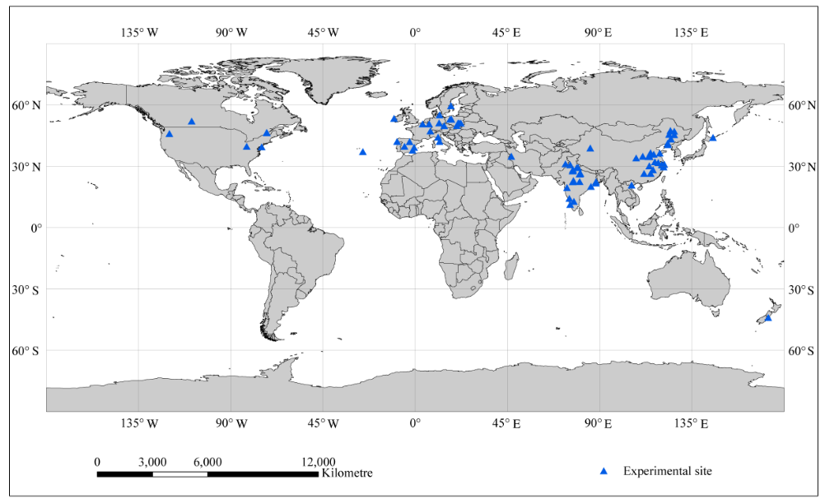

Fig. 1. World map showing the sites included in 106 studies (covering 690 experiments) that were used in meta-analysis.

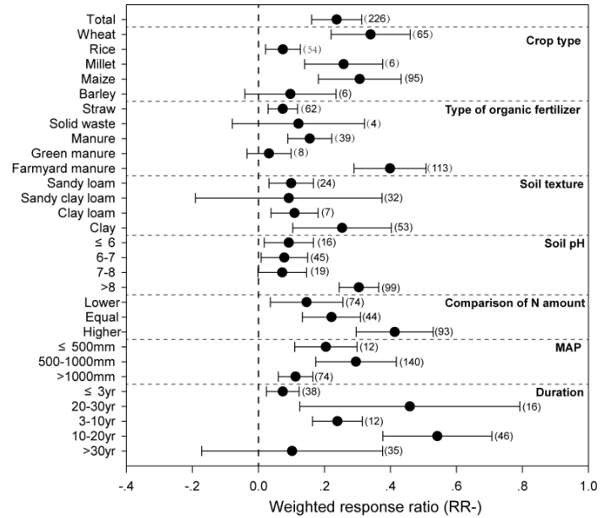
Fig. 2. The effect of organic amendments and mineral-only fertilization on the crop-yield response ratio. The mean bar values larger than zero denote a larger effect of organic than mineral-only fertilization on the crop-yields. All plots represent the mean response ratio of different variables with 95% confidence intervals (CIs). The sample size of each variable is displayed beside each bar in parentheses. The MAP denotes for mean annual precipitation and the ‘Lower’, ‘Equal’ and ‘Higher’ denote the amount of N in organic relative to mineral-only fertilization.
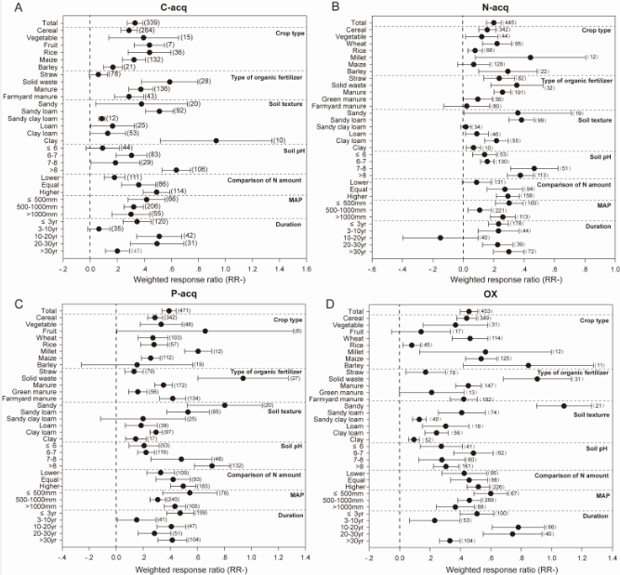
Fig. 3. The effect of organic amendments and mineral-only fertilization on soil hydrolytic C acquisition (C-acq; A), N acquisition (N-acq; B), P acquisition (P-acq; C) and oxidative decomposition (OX; D). The mean bar values larger than zero denote a larger effect of organic amdnements than mineral-only fertilization on the crop-yields. All plots represent the mean response ratio of different variables with 95% confidence intervals (CIs). The sample size of each variable is displayed beside each bar in parentheses. The MAP denotes for mean annual precipitation and the ‘Lower’, ‘Equal’ and ‘Higher’ denote the amount of N in organic relative to mineral-only fertilization.
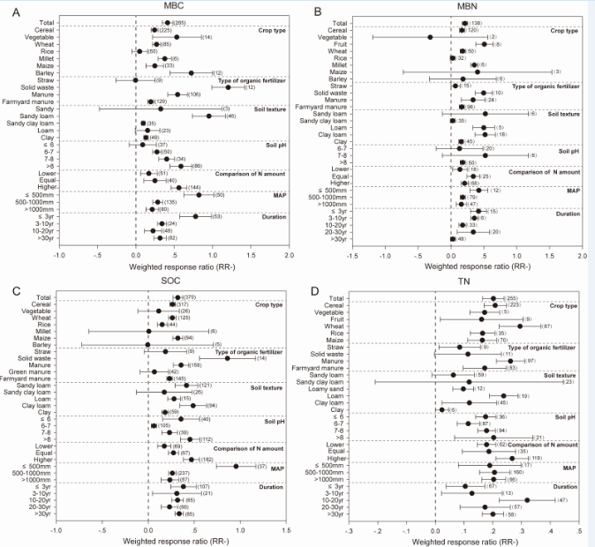
Fig. 4. The effect of organic amendments and mineral-only fertilization on microbial biomass carbon (MBC; A), microbial biomass nitrogen (MBN; B), soil organic carbon (SOC, C) and soil total nitrogen (TN, D). The mean bar values larger than zero denote a larger effect of organic amendments than mineral-only fertilization on the crop-yields. All plots represent the mean response ratio of different variables with 95% confidence intervals (CIs). The sample size of each variable is displayed beside each bar in parentheses. The MAP denotes for mean annual precipitation and the ‘Lower’, ‘Equal’ and ‘Higher’ denote the amount of N in organic relative to mineral-only fertilization.
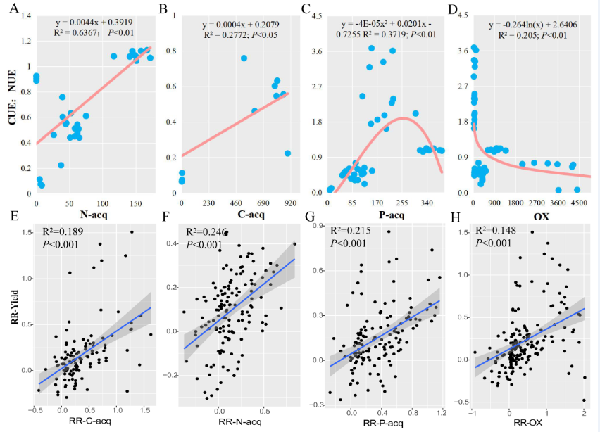
Fig. 5. Correlations between the ratio of microbial carbon-use efficiency to nitrogen-use efficiency (CUE:NUE) and soil enzyme activity (A-D) and between crop-yield and soil enzyme activity (E-H). Figure abbreviations denote for C acquisition (C-acq; A, E), N acquisition (N-acq; B, F), P acquisition (P-acq; C, G) and oxidative decomposition (OX;D, H). The red and blue fitted lines show correlations and OLS regression, respectively, and shaded areas in panels E-H show 95% confidence intervals of the fitted regression model.
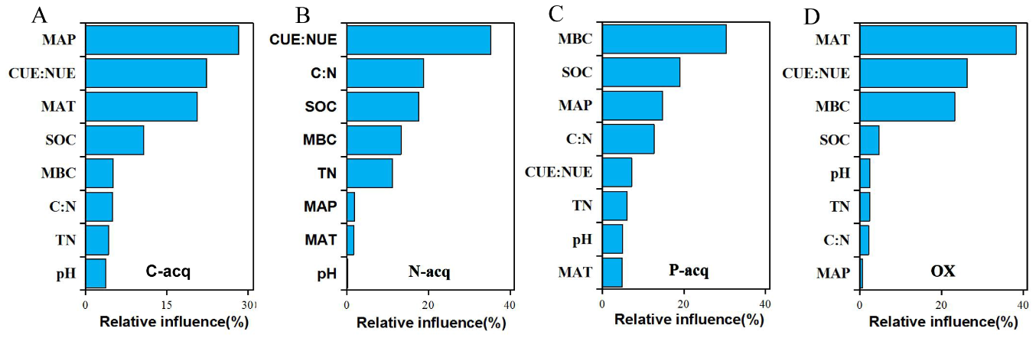
Fig. 6. The relative influence (%) of climatic (MAT and MAP), microbial activity (CUE:NUE) and physicochemical factors on soil enzyme activity (including C-acq, A; N-acq, B; P-acq, C and OX, D)based on aggregated boosted tree (ABT) model analysis. Figure abbreviations denote for: soil organic carbon (SOC), soil total nitrogen (TN), C-acquisition enzyme activity (C-acq), N-acquisition enzyme activity (N-acq), (P-acquisition enzyme activity (P-acq), oxidative enzyme activity (OX), mean annual temperature (MAT), mean annual precipitation (MAP), microbial biomass carbon (MBC), microbial biomass nitrogen (MBN), carbon-nitrogen ratio (C:N) and carbon-use to nitrogen-use efficiency (CUE:NUE).
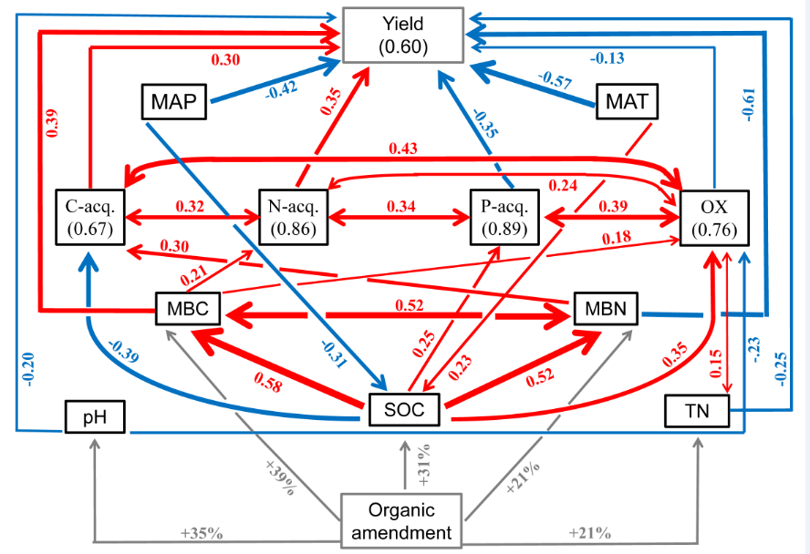
Fig. 7. Structural equation model (SEM) showing the direct and indirect effects of climatic (MAP and MAT), soil physicochemical factors (SOC, TN and pH), microbial biomass (MB) pools and soil enzyme activities on crop-yields under organic amendments. The red and blue arrows represent significantly positive (p<0.05) and negative (p<0.05) relationships, respectively. The grey arrows show the effects of organic amendment on soil physiochemical properties and MB pools (TN, SOC, pH, MBC and MBN) - the percentage next to grey arrows denote the relative effect of organic to mineral-only fertilization on a given variable. Numbers next tored and blue arrows denote for path coefficients between different variables and the thickness of the arrows represent the magnitude of these effects. Figure abbreviations denote for: soil organic carbon (SOC), soil total nitrogen (TN), C-acquisition enzyme activity (C-acq), N-acquisition enzyme activity (N-acq), mean annual temperature (MAT), mean annual precipitation (MAP), microbial biomass carbon (MBC) and microbial biomass nitrogen (MBN).

