Paper accepted for publication in JEP: General.
Date of acceptance: 08.02.16.
DOI: http://dx.doi.org/10.1037/xge0000160
The manuscript has an APA copyright. This version may not exactly replicate the authoritative document published in the APA journal. It is not the copy of record.

Functional architecture of visual emotion recognition ability: A latent variable approach
G.J. Lewis^{1,2}*, C.E. Lefevre^{3,4}, & A.W. Young²

1. Department of Psychology, Royal Holloway, University of London, Egham TW20 0EX, UK
2. Department of Psychology, University of York, Heslington, York YO10 5DD, UK
3. Centre for Decision Research, Leeds University Business School, Leeds LS2 9JT, United Kingdom
4. Centre for Behaviour Change, Department of Clinical, Educational and Health Psychology, University College London, 1-19 Torrington Place, University College London, London, WC1E 7HB, UK

*Corresponding author: gary.lewis@rhul.ac.uk; Royal Holloway, University of London, Egham TW20 0EX, UK

Abstract
Emotion recognition has been a focus of considerable attention for several decades. However, despite this interest, the underlying structure of individual differences in emotion recognition ability has been largely overlooked and thus is poorly understood. For example, limited knowledge exists concerning whether recognition ability for one emotion (e.g. disgust) generalizes to other emotions (e.g. anger, fear). Furthermore, it is unclear whether emotion recognition ability generalizes across modalities, such that those who are good at recognizing emotions from (for example) the face are also good at identifying emotions from non-facial cues (such as cues conveyed via the body). The primary goal of the current set of studies was to address these questions through establishing the structure of individual differences in visual emotion recognition ability. In three independent samples (Study 1: n=640; Study 2: n=389; Study 3: n=303) we observed that the ability to recognise visually-presented emotions is based on different sources of variation: a supra-modal emotion-general factor, supra-modal emotion-specific factors, and face- and within-modality emotion-specific factors. In addition, we found evidence that general intelligence and alexithymia were associated with supra-modal emotion recognition ability. Autism-like traits, empathic concern, and alexithymia were independently associated with face-specific emotion recognition ability. These results 1) provide a platform for further individual differences research on emotion recognition ability, 2) indicate that differentiating levels within the architecture of emotion recognition ability is of high importance, and 3) show that the capacity to understand expressions of emotion in others is linked to broader affective and cognitive processes.
Keywords: latent variable; emotion recognition; empathy; autism; alexithymia
Introduction
The ability to recognise the emotions of others represents a critical component of human socio-cognitive capacities (Bruce & Young, 2012). Unsurprisingly, then, the processes underpinning emotion recognition have been of enduring scientific interest (e.g. Darwin, 1872), with a considerable body of research having addressed this issue using a variety of approaches. The primary focus of much of this research has been on facial expressions of emotion, with inspiration for such work often stemming from Darwin's (1872) suggestion that a core set of what are now called basic emotions have an evolutionary origin, and that in consequence their facial expressions will be universally recognised (Ekman & Friesen, 1971). This emphasis on facial expressions has in turn been incorporated into the dominant model of the neural processes involved in emotion recognition (Haxby & Gobbini, 2011).
Two assumptions underpin these approaches, but both are known to have limitations. First, it is often presumed that facial expression recognition is both the primary source of perceptual evidence and that it is relatively independent of recognition of emotion from other cues such as the voice or body. However, behavioral (De Gelder, 2006), neuropsychological (Calder et al., 2001; Calder & Young, 2005), and functional neuroimaging studies (Peelen et al., 2010) have shown that cues from different modalities are often closely integrated in the perception of emotion. Second, the universality claim is often taken to imply that people can recognise all facial expressions more or less equally well; however, notable individual differences have been reported across many studies (e.g. Matsumoto et al., 2000; Rozin et al., 2005; Scherer & Scherer, 2011; Schlegel et al., 2012, Suzuki et al., 2010).
Acknowledging that emotion recognition ability contains significant individual differences, both within and across modalities, gives rise to important questions regarding the architecture of individual differences in emotion recognition ability that have yet to be comprehensively understood. To address questions of this kind, individual differences methods – which include statistical tools such as structural equation modelling – are of considerable value, as exampled in related fields, including general intelligence (Carroll, 1993), executive functions (Miyake et al., 2000), and developmental psychopathology (Ronald et al., 2006). Here we used this modelling approach to shed light on the key theoretical question of whether emotion recognition involves mechanisms that are emotion-specific (for example, with specialist systems devoted to the recognition of fear, or to the recognition of disgust) or emotion-general (that is, with a common system for recognising all emotions). Moreover, we also address whether these processes are modality-specific (for example, specific to emotion conveyed by the face or body) or supra-modal (with a common mechanism for dealing with cues to emotion from several modalities).
Surprisingly little previous work has addressed the organization of individual differences in emotion recognition ability (cf. Scherer & Scherer, 2011; but see Matsumoto et al., 2000; Rozin et al., 2005; Schlegel et al., 2012, Suzuki et al., 2010), and no previous studies have sought to establish the functional architecture of emotion recognition using latent variable modelling both within and across communicative modalities. To address this gap in knowledge we used data from three independent participant samples to test a series of competing latent variable models in order to establish the factor structure of recognition of basic emotions from the face, the body, and at the supra-modal level. Specifically, we tested three latent variable models (see Figure 1), each reflecting a different theoretical perspective in the emotion recognition literature: Model 1 specified distinct face and body latent factors, in line with the pervasive assumption (captured in the widespread use of concepts such as 'facial expression recognition') that distinct mechanisms underlie these aspects of emotion recognition; Model 2 also specified distinct face and body latent factors, but allowed an additional supra-modal latent factor, in line with research demonstrating that processes underlying emotion recognition are closely integrated across communicative modalities (Calder & Young; 2005; De Gelder, 2006; Peelen et al., 2010). Model 3 included the core architecture of Model 2, but also included supra-modal latent factors for each emotion. This additional level in the factor architecture was included in line with work emphasising that supra-modal emotion recognition processes may operate within emotion as well as across emotion (Calder et al., 2001; Park et al., 2010).
To assess emotion recognition ability we used five basic emotions: anger, disgust, fear, happiness, and sadness. We left aside the other putative basic emotion (surprise) for two reasons. First, the status of surprise as a basic emotion has been questioned; you can be pleasantly or unpleasantly surprised (Oatley & Johnson-Laird, 1987). Second, because surprise is already known to be linked to an individual difference (in terms of confusion with fear), we did not want to ‘stack the odds’ in favor of finding such differences. In our initial studies (Studies 1 & 2), each of the five selected basic emotions was represented by stimuli showing morphed versions of static expressions taken from the FEEST (Young et al., 2002) set of Ekman and Friesen (1971) images, or by short clips of body movements using point-light walkers taken from Atkinson et al.'s (2004) well-validated set of body expressions. In this way, we ensured that the different communicative domains (face vs. body) also involved as different cues as possible (static apex expressions vs. patterns of movement), which would provide strong evidence for generality if evidence for a supra-modal factor was to be observed. We also sought through pilot work to ensure that recognition performance showed no floor or ceiling effects and that the variances were adequate for individual differences research. In addition, in Study 3 we used stimuli sets involving static bodies (DeGelder & Van den Stock, 2011) and dynamic faces (taken from Lau et al., 2009) to ensure differences between modalities were not driven by differences in presentation mode.

Study 1
Methods
Participants
663 participants were recruited from Amazon’s MTurk service. As expected with an online presentation we encountered a number of participants who experienced technical failures (e.g. stimuli not displaying properly). Accordingly, we only included participants in our analyses who completed at least 90% (≥18 of 20) of trial blocks for each emotion and modality. We also excluded participants for whom responses indicated low attention (e.g. using the same response key repeatedly). This led to the omission of 23 participants and a final sample size of 640. Mean age was 35.8 years (SD = 12.2), with 447 female and 191 male participants (2 undisclosed). A range of ethnicities were reported: White (n=488), Hispanic (n=33), Asian (n=32), Black (n=19), Native American (n=10), with 42 participants of other ethnicities and 16 who did not report an ethnicity. These demographics are typical for MTurk samples (Paolacci, Chandler, & Ipeirotis, 2010).

Stimuli
Face stimuli: To capture individual differences in facial expression recognition abilities we used static image stimuli taken from the FEEST set (Young et al., 2002). In brief, a total of 10 identities each posing five emotions (anger, disgust, fear, happiness, and sadness) were selected from the Ekman and Friesen series of Pictures of Facial Affect (Ekman & Friesen, 1976). In order to avoid floor/ceiling effects, we piloted examples of each emotional expression morphed relative to the neutral expression of the same identity using Psychomorph (Tiddeman et al., 2001). This procedure is known to lead to changes in the perceived intensity of emotion (Calder et al., 1997). Here it was used to create five intensities (25%, 50%, 75%, 100%, and 125%) of each prototype (100%) expression (total n=250 images). In a pilot experiment (n=12 participants) we tested recognition accuracy for each of these stimuli in a five-alternative forced choice paradigm with a 1000ms exposure time. This step is of considerable importance as the limited scope of individual differences research on emotion recognition ability has meant that suitable stimuli – i.e. free of ceiling effects and with adequate variance for individual differences research – have usually been unavailable. We then selected sets of 10 stimuli for each emotion (i.e. total n=50) that showed adequate means and variances based on these pilot data. These stimuli are presented in Figure 1.
Body Stimuli: To capture emotion recognition ability from body expressions we used patch-light walker stimuli previously described by Atkinson et al. (2004). In short, 10 actors were recorded performing each of five emotions at three levels of intensity (typical, exaggerated, very exaggerated). Actors wore suits with 13 reflective patches. Subsequent rendering removed all information other than the patches from each video. Video clips lasted between 4.2 and 8 seconds. As with the face stimuli, we chose 10 stimuli for each emotion (i.e. total n=50) that showed adequate means and variances following a pilot experiment (n=6 participants).

Procedure
Stimuli were blocked according to modality. Face and body blocks were each presented twice to the participants in a fixed order (i.e. face-body-face-body). In a five-alternative forced choice paradigm, participants had to select the emotion they thought was displayed by each stimulus using radio buttons on screen. Each face stimulus was presented for 1000ms. Body stimuli were presented for the duration of each video clip. Participants could provide their response at any point following the onset of the stimulus presentation. The within-block presentation order was fully randomized. Participants were given the opportunity to rest following completion of each block.

----- Insert Figures 1 and 2 here -----

Analysis
The theoretical models tested are detailed in Figure 2. As described above, Model 1 posited only face-specific and body-specific emotion recognition factors (see Figure 2a), which were distinct and thus uncorrelated. We also tested a version of this model which allowed the face- and body-specific factors to be correlated (Model 1a). Model 2 mirrored Model 1 by including latent factors for face-specific and body-specific emotion recognition, but also included an emotion-general supra-modal factor (see Figure 2b). This model is typically referred to as a bi-factor model and in the current framework posits direct influences on emotion recognition ability from the face, the body, and the supra-modal factors. We also tested nested variations of this model; specifically: 1) removing the face-specific factor (Model 2a); 2) removing the body-specific factor (Model 2b); 3) simultaneously removing the face- and body-specific factors (Model 2c). Model 3 was similar to Model 2 but also included an additional set of latent variables addressing supra-modal variance within each emotion (see Figure 2c). This model is typically referred to as a higher order, or hierarchical, model. In this model emotion recognition ability is directly influenced by face and body factors, and by emotion-specific supra-modal factors. Influences of the emotion-general supra-modal factor are conceived as indirect: i.e. via the five emotion-specific supra-modal factors. Again, we tested nested variations of this model: 1) removing the face-specific factor (Model 3a); 2) removing the body-specific factor (Model 3b); 3) removing both the face and the body-specific factor (Model 3c). These nested models allowed us to formally examine whether the exclusion of specific components (e.g. the face-specific latent factor) of the model led to a decrement in fit.
In order to better handle measurement error, we modelled scores from emotion recognition for both test block 1 and test block 2 with each set of stimuli (rather than an aggregated score) in each of our models. Accordingly, because emotion recognition ability is likely to reflect emotion/modality specific variance and thus we did not expect common factor variance to explain all variance in our emotion recognition measures, we allowed the residual variance on measures across blocks (e.g. the face-happiness score for block 1 and for block 2) to co-vary.
Absolute model fit was evaluated using the comparative fit index (CFI) and root mean square error of approximation (RMSEA): ≥ .95 and ≤ .06, respectively, correspond to good absolute fit (Hu & Bentler, 1999). Relative fit was evaluated using the Akaike information criterion (AIC: Akaike 1973). The AIC considers the fit of a model to the observed data while at the same time penalizing for complexity and thus rewarding parsimony. Lower values indicate greater support for a particular model.

Results
Descriptive statistics and correlations for study variables are shown in Table 1. In summary, the majority of variables were approximately normally distributed with no evidence of ceiling or floor effects; of the 42 possible correlations all were positively signed and 38 were significant at the 5% level.

----- Insert Tables 1 & 2 here -----

Confirmatory Factor Analyses
We next moved to tests of our competing models (see descriptions above). Model outputs for all analyses are detailed in Table 2. Model 3 was superior as adjudicated by goodness of fit indices and provided an excellent absolute fit to the data; hence it was retained as our final model (see Figure 3). Several important features of this model are noteworthy. First, the emotion-general supra-modal factor loaded significantly and substantially on each of the emotion-specific supra-model factors. We also saw a coherent face-specific factor, with the majority of loadings showing significant influences. The body-specific factor, in contrast, did not show a coherent pattern of loadings; rather, here we saw no clear evidence for a common ability factor acting at the level of the body, although several path loadings were significant indicating why a model including this factor fitted better than a reduced model omitting this factor. Finally, general ability factors were not sufficient to fully explain variation in emotion recognition ability: we also observed significant overlaps between block 1 and block 2 scores (i.e. the correlated residuals), indicating that some mechanisms underlying emotion recognition ability operate at the level of specific emotions within a given modality (e.g. recognising anger from the face).

----- Insert Figure 3 here -----

Discussion
The results of Study 1 provide powerful evidence that individual differences in emotion recognition ability operate at multiple levels: specifically, 1) at an emotion-general supra-modal level, 2) at an emotion-specific supra-modal level; 3) at a face-specific level, and 4) and at the level of specific emotions within a given modality. These findings provide convergent evidence with observations from lesion patients (Adolphs et al., 1994; Calder, Lawrence, & Young, 2001; Calder & Young, 2005) and cognitive neuroscience (Park et al., 2010; Peelen et al., 2010) that suggest emotion recognition reflects both distinct and overlapping processes operating at different levels of abstraction.
The observation of distinguishable general ability factors underlying emotion recognition ability raises important questions regarding how broader affective and cognitive variables relate to these common ability emotion recognition factors. While traits such as alexithymia (Cook, Brewer, Shah, & Bird, 2013; Lane et al., 1996; Parker, Taylor, & Bagby, 1993), autism (Ashwin, Chapman, Colle, & Baron-Cohen, 2006; Baron-Cohen, Jolliffe, Mortimore, & Robertson, 1997; Corden, Chilvers, & Skuse, 2008; Hobson, 1986), and empathy (Mayer & Geher, 1996) have all been associated with emotion recognition ability, such work has near-exclusively used face tasks (but see Philip et al., 2010) to assess emotion recognition ability. This kind of approach thus largely overlooks the observations apparent here; namely, that emotion recognition ability reflects multiple sources of variation.
With these issues in mind we recruited an independent participant sample for Study 2 in order probe affective characteristics of the face-specific factor and the emotion-general supra-modal factor. We used the same face and body emotion stimuli as in Study 1, but also measured a range of empathy-relevant traits. Specifically, we assessed alexithymia, empathy, and autism-like traits using well-established measures in the literature: the Toronto Alexithymia Scale (Bagby, Parker, & Taylor, 1994), the Interpersonal Reactivity Index (Davis, 1983), the Autism Spectrum Quotient for Adults (short version: Allison, Auyeung, & Baron-Cohen, 2012),
We were also interested to examine whether general intelligence was associated with our supra-modal factor. General intelligence is widely understood to associate with virtually all cognitive abilities (Hunt, 2010); as such, determining the size of the relationship between supra-modal emotional recognition and general intelligence will be of clear value in understanding the nature of this supra-modal factor. To this end, we measured general intelligence using the Alice Heim AH4 group test of general intelligence (Part 1: Heim, 1970).

- Study 2
Methods
Participants
An independent sample of 400 participants was recruited from Amazon’s MTurk service. We again encountered a modest number of participants who experienced technical failures (e.g. stimuli not displaying properly) or who were noted to be using the same response key repeatedly. Accordingly, as in Study 1 we only included participants in our analyses who completed at least 90% (≥18 of 20) of the trial blocks for each emotion and modality and showed no evidence of false responding. This led to the omission of 11 participants and a final sample size of 389. Mean age was 37 years (SD = 11.7), with 253 females, 131 males (5 undisclosed). A range of ethnicities were reported: White (n=290), Hispanic (n=14), Asian (n=22), Black (n=11), Native American (n=2), with 32 participants of “other” ethnicities and 18 participants who did not report an ethnicity.

Stimuli and Measures
Emotion Recognition: To measure emotion recognition ability in the face and body – across the emotions of anger, disgust, fear, happiness, and sadness – we used the identical stimuli and procedure as detailed in Study 1.
Autism Spectrum Quotient for Adults (short version; AQ-10): The AQ-10 (Allison, Auyeung, & Baron-Cohen, 2012) is a measure of autism-like traits and was developed from the original 50-item version (Baron-Cohen, Wheelwright, Skinner, Martin, & Clubley, 2001) as a screening tool for clinicians. Participants make responses on a four-point scale: definitely disagree, slightly disagree, slightly agree, and definitely agree. Items include: “I find it easy to ‘read between the lines’ when someone is talking to me” (reverse-scored); “I like to collect information about categories of things (e.g. types of car, types of bird, types of train, types of plant etc)”. We summed responses to form a continuous score of autistic traits, with a higher score corresponding to a greater degree of autistic traits. Internal consistency was α = .51.
Interpersonal Reactivity Index (IRI): The IRI is a widely used multi-dimensional self-report measure of trait empathy and consists of four subscales: perspective taking (PT), personal distress (PD), empathic concern (EC), and fantasy (F) (Davis, 1983). Items include: “I believe that there are two sides to every question and try to look at them both” (PT); “Being in a tense emotional situation scares me” (PD); “I often have tender, concerned feelings for people less fortunate than me” (EC); “Becoming extremely involved in a good book or movie is somewhat rare for me” (reverse-scored) (F). Each sub-scale contains seven items. They were measured on a five point Likert scale anchored at 1-“does not describe me well” to 5-“describes me very well”. We summed responses to create a total scale score and sub-scale scores. Higher scores indicate greater interpersonal reactivity. Internal consistency for the total scale was α = .86.
Toronto Alexithymia Scale (TAS-20): The TAS-20 (Bagby, Parker, & Taylor, 1994) is a 20 item measure of alexithymia with three sub-scales: difficulty identifying feelings (DIF), difficulty describing feelings (DDF), and externally oriented thinking (EOT). Items include: “I am often confused about what emotion I am feeling” (DIF); “It is difficult for me to find the right words for my feelings” (DDF); “I prefer talking to people about their daily activities rather than their feelings” (EOT). Higher scores on the total scale or any of the sub-scales indicate greater levels of alexithymia. Internal consistency for the total scale was α = .89.
General Intelligence: To assess general intelligence we used the Alice Heim AH4 group test of general intelligence Part 1, which includes 65 items (tapping logical reasoning, and language and arithmetical ability) to be completed within 10 minutes. Six practice items were also administered prior to the start of the test. This test has been shown to load highly on the general factor of intelligence and to have high test-retest reliability (r=.92 across a one month period; Heim, 1970). Participant performance on this test was approximately normally distributed.

Procedure
The study procedure was identical to that described in Study 2 with the exception that participants additionally completed a questionnaire/test battery (in the order as detailed above) following the emotion recognition tasks.

Results
Descriptive statistics and correlations for the emotion recognition variables are shown in Table 3. In summary, all variables were approximately normally distributed; of the 42 possible correlations all were positively signed and 35 were significant at the 5% level.

----- Insert Tables 4 & 5 here -----

Confirmatory Factor Analyses
We first examined the theoretical models tested in Study 1 to assess goodness of fit. Model output for all analyses is detailed in Table 4. As in Study 1, several models provided a good absolute fit to the data, although Model 1 was again notably inferior. Our favored model in Study 1 – Model 3 – was empirically under-identified in the current sample: this model produced a small number of theoretically implausible parameters estimates (i.e. negative error variances) that did not appear to be the simple result of sampling variability. The source of empirical under-identification can be hard to isolate; however, a reasonable assumption here was that the parameter estimates associated with the body latent factor were relevant, as these were noted to be of limited value in Study 1 and models without this factor successfully converged (e.g. Models 2b and 3b). As such, we built a slightly-modified version of this model that closely approximated the key features of the final model in Study 1. Specifically, we removed the two paths from the body latent factor to disgust, as these were non-significant in Study 1. This model converged without issue and also showed excellent absolute and comparative fit (see Table 4), in line with the findings of Study 1. We thus took this model (see Figure 4) forward for subsequent analyses with our affective and cognitive variables.

----- Insert Table 5 here -----
----- Insert Figure 4 here -----

We next examined the associations between the emotion-general supra-modal factor and the face-specific factor and our measures of affective and cognitive traits; specifically, alexithymia, autism-like traits, empathy, and general intelligence. To this end, we extended Model 3 by including either our measure of alexithymia, autism-like traits, empathy, or general intelligence and allowing this variable to simultaneously correlate with the supra-modal and the face-specific latent factor. This approach allowed us to establish the independent links between our affective and cognitive variables and both supra-modal and face-specific emotion recognition ability. Full results are detailed in Table 5. In summary, supra-modal emotion recognition ability was most strongly associated with greater general intelligence, but was also significantly associated with lower levels of and alexithymia autism-like traits. Face-specific emotion recognition ability was most notably associated with lower levels of autism-like traits, but was also related to greater empathy and lower alexithymia, and marginally related to greater general intelligence. In order to establish the independence of these effects we next included autism-like traits, alexithymia, empathy, and intelligence in the model simultaneously. While the results of this analysis were broadly similar, the association between supra-modal emotion recognition and autism-like traits was no longer significant. The association between face-specific emotion recognition and intelligence also now fell short of nominal significance, although the parameter estimate remained largely unchanged (from .15 to .13).

Discussion
The results of Study 2 confirm the architecture of emotion recognition identified in Study 1; namely, we found evidence for supra-modal emotion recognition factors and a face-specific factor, but no evidence for a meaningful body-specific factor. Of importance, we found evidence that broader affective and cognitive processes – tapped by measures of alexithymia, autism-like traits, empathy, and general intelligence – were significantly related to both the face-specific and the emotion-general supra-modal factor; however, these correlates were notably differentiated across these levels of analysis. Specifically, the emotion-general supra-modal factor was primarily linked to general intelligence and alexithymia, whereas the face-specific factor was linked to alexithymia, autism-like traits, and empathy.
Although these observations serve to replicate and extend the findings of Study 1, one outstanding issue yet to be addressed concerns the generalizability of the identified architecture. Accordingly, in order to establish whether our results reflect emotion recognition processing more broadly, or are dependent upon the specific stimulus sets used in the two previous studies, we repeated the broad modelling approach as performed in Studies 1 and 2 but included a dynamic emotional face expression stimulus set and a static emotional body expression stimulus set (see Study 3 Methods for more details). The inclusion of these additional stimulus sets allowed us to more carefully probe: 1) whether the supra-modal emotion recognition factor generalizes across a broad base of visual emotion expressions performed by a variety of actors, and 2) whether the lack of a body-specific factor is due to nature of the point-light walker stimuli or reflects a more general characteristic about body emotion expression recognition ability.

Study 3
Methods
Participants
An independent sample of 384 participants was recruited from Amazon’s MTurk service. As for Studies 1 and 2, we only included participants in our analyses who completed at least 90% (≥17 of 19) of the trial blocks for each emotion and modality and showed no evidence of false responding. This led to the omission of 81 participants and a final sample size of 303. Mean age was 34.8 years (SD = 11.3), with 166 females, 137 males. A range of ethnicities were reported: White (n=232), Hispanic (n=16), Asian (n=16), Black (n=10), Native American (n=1), with 15 participants of “other” ethnicities and 13 participants who did not report an ethnicity.

Stimuli
Emotion Recognition: To measure emotion recognition ability in the face and body – across the emotions of anger, disgust, fear, happiness, and sadness – we used the identical stimuli and procedure as detailed in Studies 1 and 2, alongside an additional set of face and body stimuli detailed next.
Dynamic face stimuli: We used a sub-set of dynamic stimuli previously used for emotion recognition work (Lau et al., 2009). In brief, these stimuli were created by morphing one male and one female image from a neutral expression to one of the five basic emotions (anger, disgust, fear, happiness, and sadness). Stimuli dynamically changed from the neutral expression to one of four levels of intensity (25%, 50%, 75%, 100%). For happy, due to the ceiling effects often observed, intensity levels were lower: 10%, 25%, 50%, and 75%. We only used stimuli where actors directly faced the camera, with either direct or averted gaze. This led to a total of 80 stimuli that we piloted as before, in order to avoid floor/ceiling effects (n=47 participants) before selecting sets of 10 stimuli for each emotion (i.e. total n=50) that showed adequate means and variance based on these pilot data. Each video clip was approximately 1.5 seconds in length.
Static body stimuli: To test emotion recognition from static bodies we employed the BEAST stimuli set (de Gelder & Van den Stock, 2011). In brief, these stimuli comprise black and white whole body photographs of actors with faces obscured depicting one of four emotions (anger, fear, happiness, and sadness). Disgust is not included in this stimuli set due to it being difficult to represent in the body alone (de Gelder & Van den Stock, 2011). The original image set contains 254 images. We again undertook piloting (n=14 participants) to identify 10 stimuli per emotion (i.e. total n=40) suitable for an individual differences task, for which we then validated mean and SD in a second pilot study using MTurk participants (n=50). As with the static facial images, we presented each image for 1000ms.

Procedure
Procedures were identical to Studies 1 and 2 with the exception that all participants completed the task in the same order of static bodies, static faces, moving bodies, and moving faces.

Results
Descriptive statistics and correlations for the emotion recognition variables are shown in Table 6 and Tables 7-9, respectively. In summary, almost all variables were approximately normally distributed; of the 171 possible correlations 162 were positively signed and 133 were significant at the 5% level.

----- Insert Tables 6-9 here -----

Confirmatory Factor Analyses
Model output for all analyses is detailed in Table 10. The key observation from these analyses is that Model 3b, reflecting a high-order supra-modal latent factor alongside a face-specific factor, but without a body-specific factor, provided the best fit to the data. This model thus replicates the key features of the architecture identified in Studies 1 and 2. Models that included body-specific factors failed to converge (see Table 10), and the nature of these failures to converge indicated model misspecification (i.e. a large number of non-positive definite matrices). Nonetheless, in order to further probe whether a body-specific factor was present we explored whether alternative path loadings would reveal insights into the underlying structure. However, no evidence for a body-specific factor presented itself, whether as a single global body-specific factor, correlated or uncorrelated factors for dynamic and static body expression stimuli, respectively, or subsets of these configurations. As such, we retained Model 3b as our final model (see Figure 5).

----- Insert Table 10 here -----
----- Insert Figure 5 here -----

General Discussion
The ability to recognise the expressions of emotion displayed by others is a core social skill; however, remarkably little research to date has addressed the architecture of individual differences in this domain. The current studies sought to address this gap in knowledge using a structural equation modelling approach in three large samples of individuals assessed on emotion recognition ability in the face and body (Studies 1 - 3), as well as on broader affective and cognitive traits (Study 2) and with a novel stimulus set (Study 3). This work has provided a number of important findings. Firstly, these results provide strong evidence that emotion recognition ability is underpinned by a complex architecture operating at multiple levels. Within modality, we found support for the existence of a face-specific ability factor; of interest, however, no equivalent body-specific factor was observed. We also saw consistent evidence for an emotion-general supra-modal ability factor, as well as emotion-specific supra-modal factors for each of the basic emotions. Finally, we found evidence for influences acting at the emotion-specific level within modality (e.g. angry faces), in line with the residuals correlating across blocks 1 and 2. These results make it clear that a full characterisation of emotion recognition ability requires a more holistic approach than typically reported in the literature.
We found that these emotion recognition ability factors were linked to a set of broad-based affective and cognitive traits in both common and distinct ways: specifically, the emotion-general supra-modal factor showed a strong association with general intelligence and modest-to-moderate associations with alexithymia, whereas the face-specific factor was primarily linked with alexithymia, autism-like traits, and empathy, and showed only marginal links to general intelligence. While these results indicate that different affective and cognitive traits relate to specific components of emotion recognition more strongly than to other components, they also highlight that a full understanding of the social deficits underlying traits such as alexithymia will need to consider both face-specific and supra-modal emotion recognition ability. The equivalent recommendation is, of course, applicable to other psychological traits and disorders that show links to emotion recognition deficits, such as depression (Dalili, Penton-Voak, Harmer, & Munafò, 2015).
The observation that our measure of general intelligence was moderately associated with supra-modal emotion recognition warrants further discussion. This finding indicates that emotion recognition ability, at least at the supra-modal level of abstraction, reflects broad-based cognitive processes. This is in contrast to what we observed for the face-specific factor, and to what has been reported for face recognition ability (Wilmer et al., 2010). As such, this result gives rise to interesting questions about the nature of this relationship. One possibility is that discerning the emotion expression in a particular face or body is, at least for some people and some of the time, akin to puzzle-solving, which in turn is a hallmark characteristic of general intelligence (Gottfredson, 1997). A second possibility is as follows: supra-modal emotion recognition processes reflect the integration of information from multiple modalities and expression cues across a number of cortical and sub-cortical regions. Performance is thus likely to be heavily dependent on the neural capability to effectively transfer information (i.e. processing speed), which in turn is a known hall-mark of general intelligence (Penke et al., 2010).
Our main findings concerning the functional architecture of emotion recognition were remarkably consistent across the three studies reported, The replicability of the main findings and their generalization to different stimuli (as shown in Study 3) raises the critical theoretical question as to why the brain uses this overall organization? One key driver that has been suggested is that supra-modal mechanisms are an efficient solution when responses are required to rapidly changing inputs, which is of course very much the case for emotion recognition and interpersonal interaction more generally (Calder & Young, 2005; Young & Bruce, 2011; Bruce & Young, 2012; Young, 2016). More specifically, though, our data raise questions such as what individual differences in facial or body recognition represent once you have accounted for more general supra-modal differences? One possibility is that domain-specific mechanisms are still needed because the cues from faces and bodies (or voices) are themselves quite different in nature. The ability to raise and address such theoretical questions is an important consequence of the individual differences approach.
Other, more specific recommendations for future work are also warranted. Firstly, a more accurate test of the architecture underlying supra-modal emotion recognition ability will ultimately need to include measures of emotion recognition from the voice and perhaps multimodal expressions as well. A challenge in this respect has been the availability of suitable stimuli for individual differences research, where it is important to create tasks without ceiling or floor effects. The current findings, however, further advocate the need for the development and use of such tools. Secondly, while we show that specific components of emotion recognition ability associate with normal variation in clinically-relevant characteristics, such as alexithymia and autism-like traits, establishing whether these associations hold in clinical samples will be of value for characterising the full nature of the socio-cognitive impairment in these disorders. Thirdly, our brief measure of autism-like traits, while effectively capturing a broad autism-like phenotype, was not suitable for examining the sub-components – social impairment, communication difficulties, and rigid and repetitive behaviors – thought to underpin autism and autism-like traits (Happé, Ronald, & Plomin, 2006). Future work seeking to further probe the nature of supra-modal emotion recognition ability is recommended to use more fine-grained assessments that tap both broad-based (e.g. emotional intelligence) and more focused affect- and empathy-related constructs. Fourthly, the current results were obtained using data from US-based participants and so generalizations beyond this demographic may be unwise and we recommend the application of such latent variable approaches in broader, non-Western populations. Finally, while we argue that the selection of models tested here reflect valid operationalizations of major theoretical positions concerning emotion recognition ability, future work may wish to refine and/or expand on this selection. Testing further models will of course be entirely consistent with our approach of using individual differences to refine understanding of the functional architecture of emotion recognition.
In summary, we have used latent variable modelling to provide a novel approach in characterizing the functional architecture of emotion recognition ability. Our findings demonstrate that individual differences in emotion recognition ability reflect a combination of different cognitive levels, including face-specific and supra-modal components. Importantly, these components show differential associations with broader cognitive and affective processes, with face-specific ability being most strongly associated with alexithymia, autism-like traits, and empathy, whereas emotion-general supra-modal ability was more strongly associated with general intelligence. These findings provide a powerful insight into the structure of the processes underlying person perception abilities, indicating the importance of taking a holistic approach to delineating the architecture of this ability.

References
Adolphs, R., Tranel, D., Damasio, H., & Damasio, A. (1994). Impaired recognition of emotion in facial expressions following bilateral damage to the human amygdala. Nature, 372, 669-672.
Akaike, H. (1973). Information theory and an extension of the maximum likelihood principle. In: International Symposium on Information Theory (Eds. B. N. Petran & F. Csaki), pp. 267–281. Budapest: Akademiai Kiadi.
Allison, C., Auyeung, B., & Baron-Cohen, S. (2012). Toward brief “red flags” for autism screening: the short autism spectrum quotient and the short quantitative checklist in 1,000 cases and 3,000 controls. Journal of the American Academy of Child & Adolescent Psychiatry, 51, 202-212.
Ashwin, C., Chapman, E., Colle, L., & Baron-Cohen, S. (2006). Impaired recognition of negative basic emotions in autism: A test of the amygdala theory. Social Neuroscience, 1, 349-363.
Atkinson, A. P., Dittrich, W. H., Gemmell, A. J., & Young, A. W. (2004). Emotion perception from dynamic and static body expressions in point-light and full-light displays. Perception, 33, 717-746.
Bänziger, T., Grandjean, D., & Scherer, K. R. (2009). Emotion recognition from expressions in face, voice, and body: the Multimodal Emotion Recognition Test (MERT). Emotion, 9, 691-704.
Bagby, R. M., Parker, J. D., & Taylor, G. J. (1994). The twenty-item Toronto Alexithymia Scale—I. Item selection and cross-validation of the factor structure. Journal of Psychosomatic Research, 38, 23-32.
Baron‐Cohen, S., Jolliffe, T., Mortimore, C., & Robertson, M. (1997). Another advanced test of theory of mind: Evidence from very high functioning adults with autism or Asperger syndrome. Journal of Child Psychology and Psychiatry, 38, 813-822.
Baron-Cohen, S., Wheelwright, S., Skinner, R., Martin, J., & Clubley, E. (2001). The autism-spectrum quotient (AQ): Evidence from asperger syndrome/high-functioning autism, malesand females, scientists and mathematicians. Journal of Autism and Developmental Disorders, 31, 5-17.
Broks, P., Young, A. W., Maratos, E. J., Coffey, P. J., Calder, A. J., Isaac, C. L., ... & Hadley, D. (1998). Face processing impairments after encephalitis: amygdala damage and recognition of fear. Neuropsychologia, 36, 59-70.
Bruce, V. & Young, A.W. (2012) Face perception. Psychology Press: London.
Calder, A. J., Lawrence, A. D., & Young, A. W. (2001). Neuropsychology of fear and loathing. Nature Reviews Neuroscience, 2, 352-363.
Calder, A. J., & Young, A. W. (2005). Understanding the recognition of facial identity and facial expression. Nature Reviews: Neuroscience, 6, 641-651.
Calder, A. J., Young, A.W. Rowland, D., Perrett, D.I., Hodges, J.R. & Etcoff, N.L. (1996). Facial emotion recognition after bilateral amygdala damage: Differentially severe impairment of fear. Cognitive Neuropsychology, 13, 699-745.
Calder, A.J., Young, A.W., Rowland, D., & Perrett, D.I. (1997). Computer-enhanced emotion in facial expressions. Proceedings of the Royal Society: Biological Sciences B, 264, 919-925.
- Calder, A. J., Keane, J., Manes, F., Antoun, N. & Young, A.W. (2000). Impaired recognition and experience of disgust following brain injury. Nature Neuroscience, 3, 1077-1078.
Cook, R., Brewer, R., Shah, P., & Bird, G. (2013). Alexithymia, not autism, predicts poor recognition of emotional facial expressions. Psychological Science, 24, 723-732.
Corden, B., Chilvers, R., & Skuse, D. (2008). Avoidance of emotionally arousing stimuli predicts social–perceptual impairment in Asperger's syndrome. Neuropsychologia, 46, 137-147.
Dalili, M. N., Penton-Voak, I. S., Harmer, C. J., & Munafò, M. R. (2015). Meta-analysis of emotion recognition deficits in major depressive disorder. Psychological Medicine, 45, 1135-1144.
Darwin, C. (1872/1965). The expressions of the emotions in man and animals. Oxford University Press, New York.
Davis, M. H. (1983). Measuring individual differences in empathy: Evidence for a multidimensional approach. Journal of Personality and Social Psychology, 44, 113-126.
de Gelder, B. (2006). Towards the neurobiology of emotional body language. Nature Reviews Neuroscience, 7, 242-249.
de Gelder, B. & Van den Stock, J. (2011). The Bodily Expressive Action Stimulus Test (BEAST). Construction and validation of a stimulus basis for measuring perception of whole body expression of emotions. Frontiers in Psychology, 2, 181. doi:10.3389/fpsyg.2011.0018.
Ekman, P., & Friesen, W. V. (1971). Constants across cultures in the face and emotion. Journal of Personality and Social Psychology, 17, 124-129.
Ekman, P., & Friesen, W. V. (1975). Pictures of facial affect. Consulting Psychologists Press.
Gottfredson, L. S. (1997). Mainstream science on intelligence: An editorial with 52 signatories, history, and bibliography. Intelligence, 24, 13-23.
Happé, F., Ronald, A., & Plomin, R. (2006). Time to give up on a single explanation for autism. Nature neuroscience, 9, 1218-1220.
Haxby, J. & Gobbini, M.(2011).Distributed neural systems for face perception. In A. Calder, G. Rhodes, M. Johnson, & J. Haxby (Eds.), The Oxford Handbook of Face Perception (pp. 93–110). Oxford: Oxford University Press.
Heim, A. W. (1970). AH 4 group test of general intelligence manual. NFER Publishing Company Limited.
Hobson, R. P. (1986). The autistic child's appraisal of expressions of emotion. Journal of Child Psychology and Psychiatry, 27, 321-342.
Hu, L. T., & Bentler, P. M. (1999). Cutoff criteria for fit indexes in covariance structure analysis: Conventional criteria versus new alternatives. Structural Equation Modeling, 6, 1-55.
Hunt, E. (2010). Human intelligence. Cambridge University Press.
Lane, R. D., Lee, S., Reidel, R., Weldon, V., Kaszniak, A., & Schwartz, G. E. (1996). Impaired verbal and nonverbal emotion recognition in alexithymia. Psychosomatic Medicine, 58, 203-210.
Lau, J. Y., Burt, M., Leibenluft, E., Pine, D. S., Rijsdijk, F., Shiffrin, N., & Eley, T. C. (2009). Individual differences in children's facial expression recognition ability: the role of nature and nurture. Developmental Neuropsychology, 34, 37-51.
Matsumoto, D., LeRoux, J., Wilson-Cohn, C., Raroque, J., Kooken, K., Ekman, P., ... & Goh, A. (2000). A new test to measure emotion recognition ability: Matsumoto and Ekman's Japanese and Caucasian Brief Affect Recognition Test (JACBART). Journal of Nonverbal Behavior, 24, 179-209.
Mayer, J. D., & Geher, G. (1996). Emotional intelligence and the identification of emotion. Intelligence, 22, 89-113.
Oatley, K., & Johnson-Laird, P. N. (1987). Towards a cognitive theory of emotions. Cognition and Emotion, 1, 29-50.
Paolacci, G., Chandler, J., & Ipeirotis, P. G. (2010). Running experiments on amazon mechanical turk. Judgment and Decision making, 5, 411-419.
Park, J. Y., Gu, B. M., Kang, D. H., Shin, Y. W., Choi, C. H., Lee, J. M., & Kwon, J. S. (2010). Integration of cross-modal emotional information in the human brain: An fMRI study. Cortex, 46, 161-169.
Parker, J. D., Taylor, G. J., & Bagby, R. M. (1993). Alexithymia and the recognition of facial expressions of emotion. Psychotherapy and Psychosomatics, 59, 197-202.
Peelen, M. V., Atkinson, A. P., & Vuilleumier, P. (2010). Supramodal representations of perceived emotions in the human brain. Journal of Neuroscience, 30, 10127-10134.
Penke, L., Maniega, S. M., Murray, C., Gow, A. J., Hernández, M. C. V., Clayden, J. D., ... & Deary, I. J. (2010). A general factor of brain white matter integrity predicts information processing speed in healthy older people. Journal of Neuroscience, 30, 7569-7574.
Philip, R. C. M., Whalley, H. C., Stanfield, A. C., Sprengelmeyer, R., Santos, I. M., Young, A. W. … & Hall, J. (2010). Deficits in facial, body movement and vocal emotional processing in autism spectrum disorders. Psychological Medicine, 40, 1919-1929.
Rozin, P., Taylor, C., Ross, L., Bennett, G., & Hejmadi, A. (2005). General and specific abilities to recognise negative emotions, especially disgust, as portrayed in the face and the body. Cognition and Emotion, 19, 397-412.
Scherer, K. R., & Scherer, U. (2011). Assessing the ability to recognize facial and vocal expressions of emotion: construction and validation of the Emotion Recognition Index. Journal of Nonverbal Behavior, 35, 305-326.
Schlegel, K., Grandjean, D., & Scherer, K. R. (2012). Emotion recognition: Unidimensional ability or a set of modality-and emotion-specific skills? Personality and Individual Differences, 53, 16-21.
Suzuki, A., Hoshino, T., & Shigemasu, K. (2010). Happiness is unique: A latent structure of emotion recognition traits revealed by statistical model comparison. Personality and Individual Differences, 48, 196-201.
Wilmer, J. B., Germine, L., Chabris, C. F., Chatterjee, G., Williams, M., Loken, E., ... & Duchaine, B. (2010). Human face recognition ability is specific and highly heritable. Proceedings of the National Academy of Sciences, 107, 5238-5241.
Young, A.W. (2016). Finding the clues. British Journal of Psychology, 107, 23-25.
Young, A.W., & Bruce, V. (2011). Understanding person perception. British Journal of Psychology, 102, 959-974.
- Young, A.W., Rowland, D., Calder, A.J., Etcoff, N.L., Seth, A., & Perrett, D.I. (1997). Facial expression megamix: tests of dimensional and category accounts of emotion recognition. Cognition, 63, 271-313.
- Young, A., Perrett, D., Calder, A., Sprengelmeyer, R., & Ekman, P. (2002). Facial expressions of emotion – stimuli and tests (FEEST). Thames Valley Test Company, Bury St Edmunds, England.

Figure 1. Static face expression stimuli.
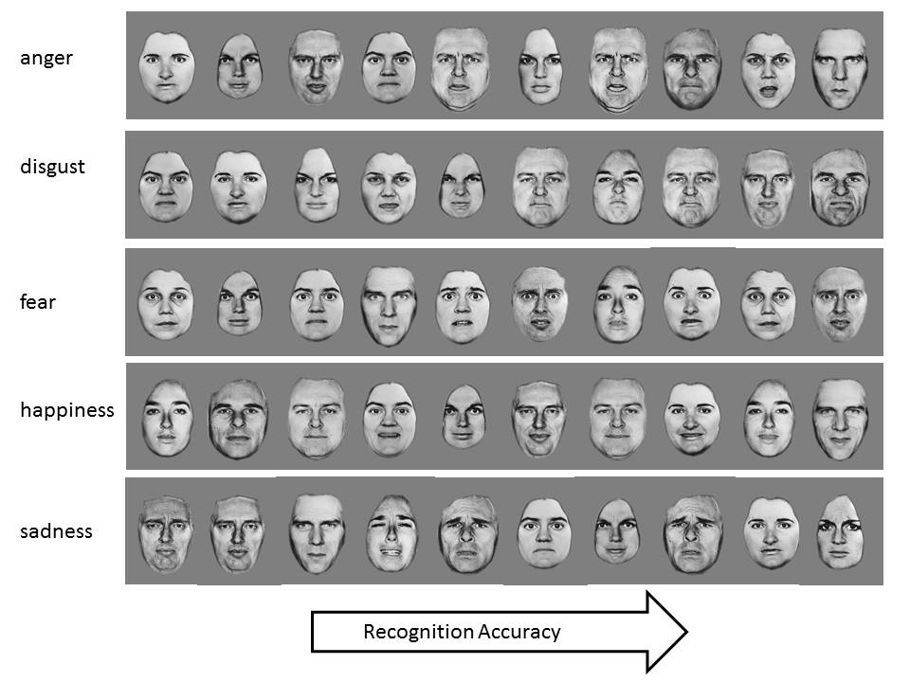
Figure 2. Schematic of theoretical models. Model 1 contains distinct face-specific and body-specific factors; Model 2 contains distinct face-specific and body-specific factors alongside a supra-modal factor; Model 3 contains distinct face-specific and body-specific factors alongside a supra-modal factor that influences emotion-specific supra-modal factors
a) Model 1

b) Model 2
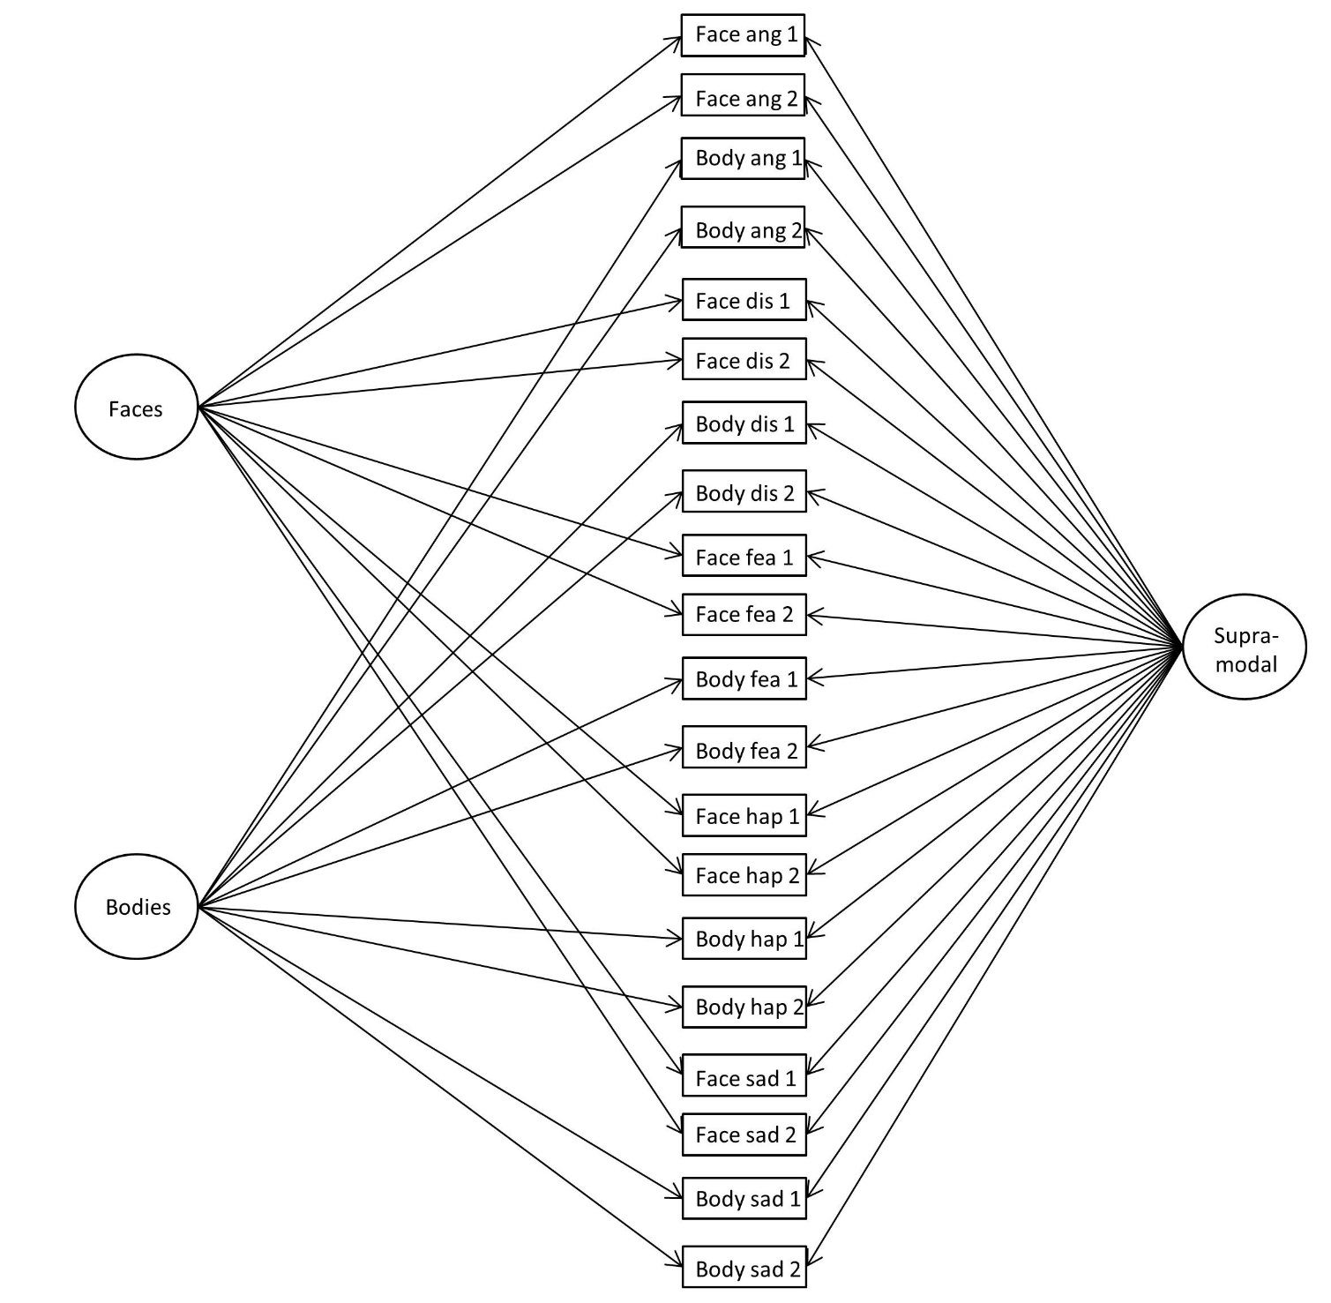

c) Model 3
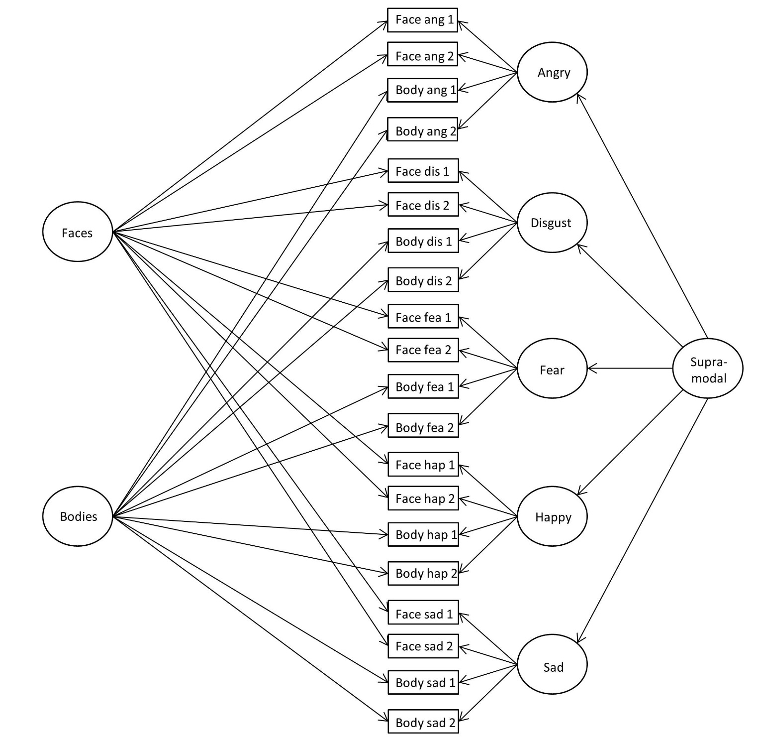

Note. ang = anger; dis = disgust; fea = fear; hap = happiness; sad = sadness; 1/2 = block 1/2.

Figure 3. Final Model for Study 1.
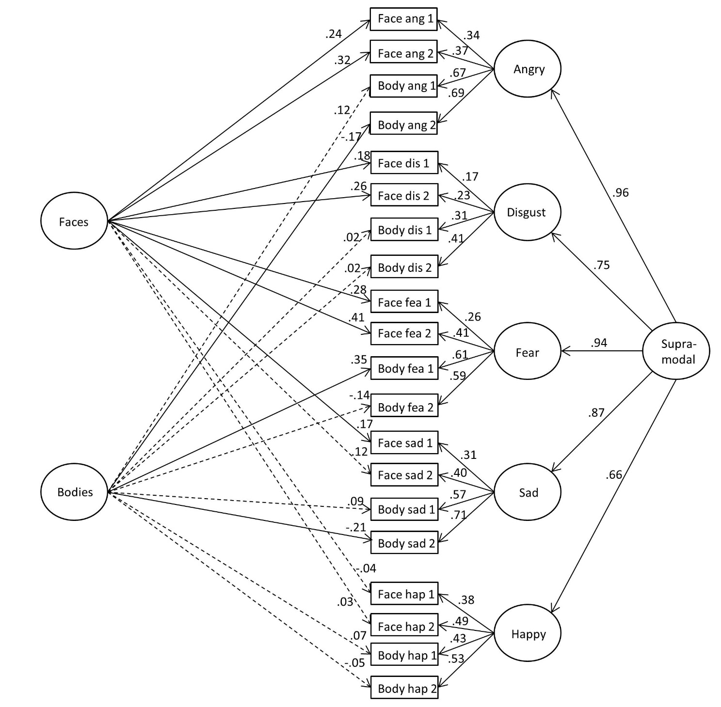
Note. Unbroken lines = p < .05; Error variances across blocks/within modality were allowed to correlate (although are not shown here in the interests of clarity), and were all significant at p < .001 and ranged in magnitude from .36 to .62; ang = anger; dis = disgust; fea = fear; hap = happiness; sad = sadness; 1/2 = block 1/2.
Figure 4. Final Model for Study 2.
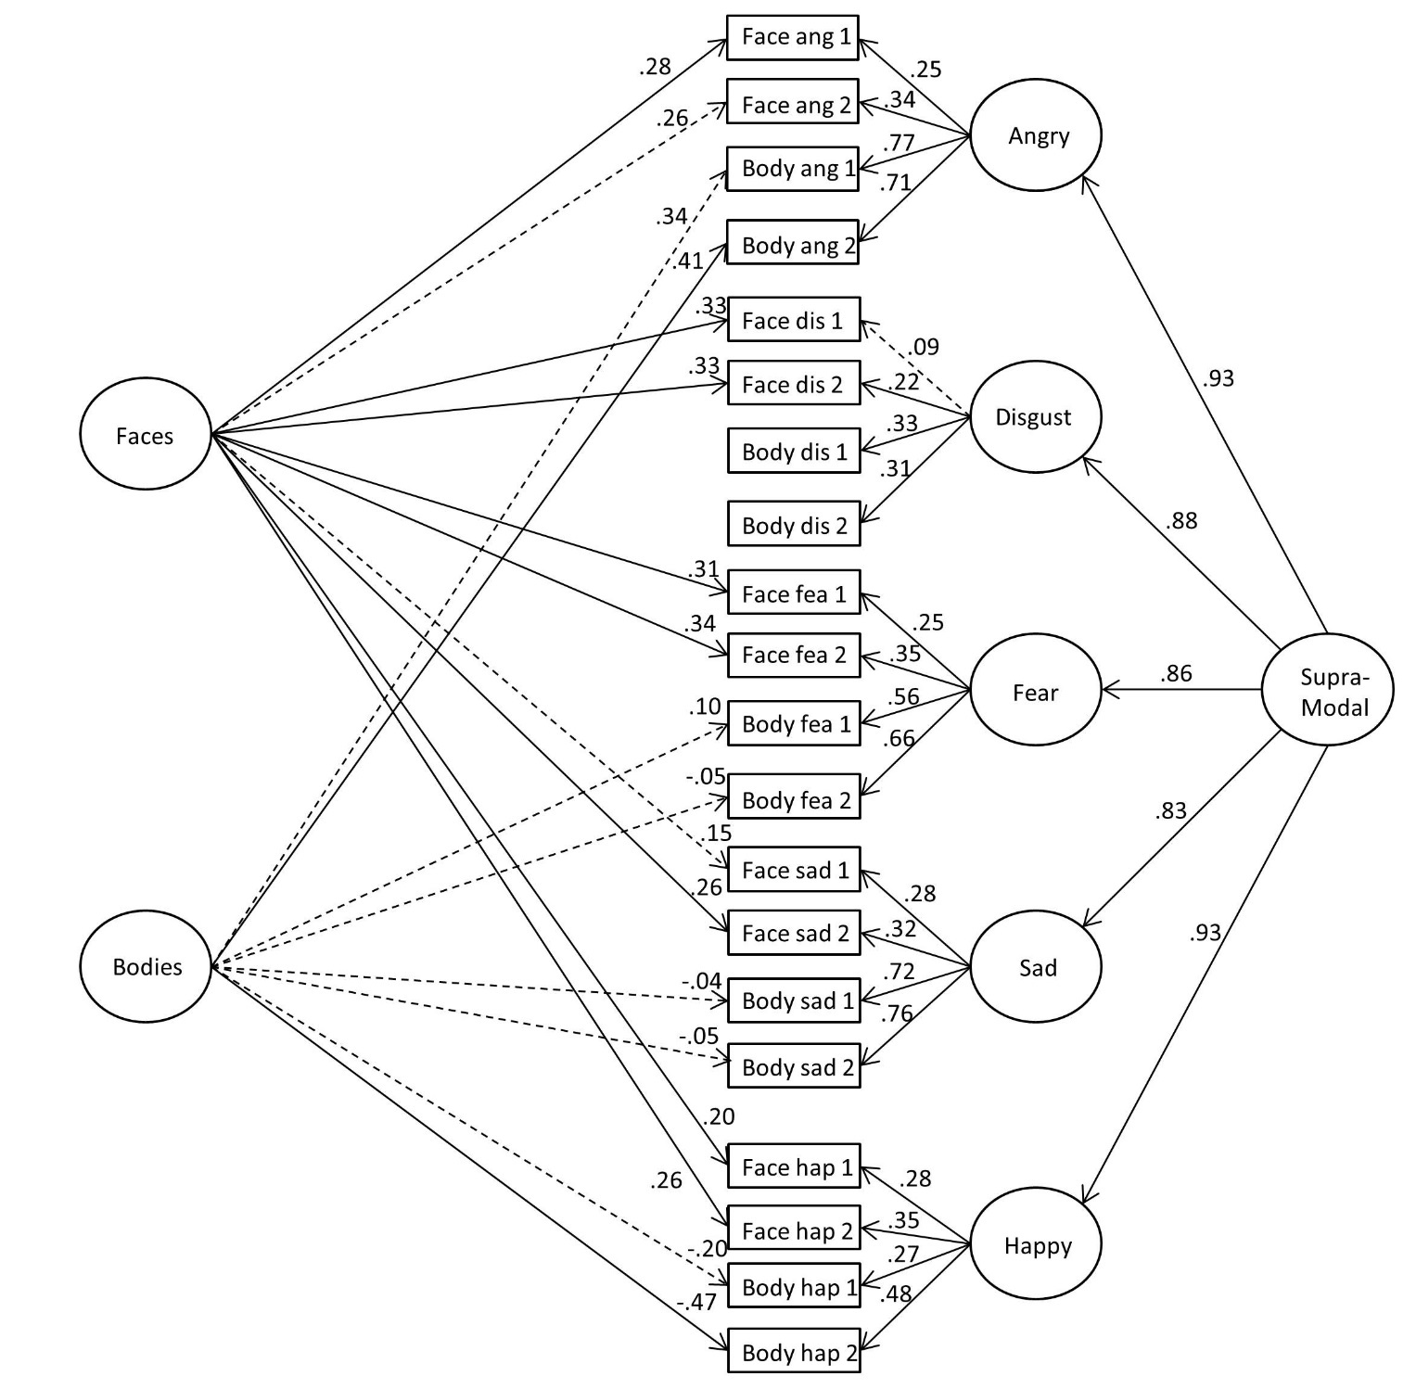

Note. Unbroken lines = p < .05; Error variances across blocks/within modality were allowed to correlate (although are not shown here in the interests of clarity), and with the exception of body sadness and anger blocks 1 and 2 (p > .05) were all significant at p < .01 and ranged in magnitude from .37 to .64; ang = anger; dis = disgust; fea = fear; hap = happiness; sad = sadness; 1/2 = block 1/2.
Figure 5. Final model for Study 3.
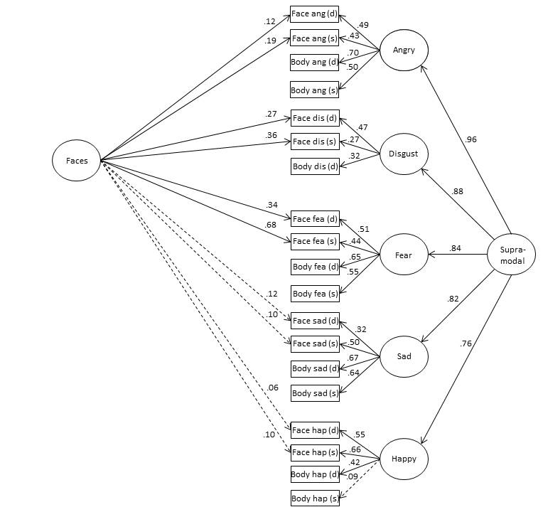

Note. Unbroken lines = p < .05; Error variances across blocks/within modality were allowed to correlate (although are not shown here in the interests of clarity); all static-dynamic face residuals, with the exception of fear (r = -.08, p = .79), were significantly correlated (rs from .26 to .32, all ps <. 05); the residuals for static-dynamic body angry and static-dynamic body sad were significant at p < .05, although were negatively correlated (-.19 & .-.24, respectively); no other static-dynamic body residual correlations were significant at p < .05; ang = anger; dis = disgust; fea = fear; hap = happiness; sad = sadness.
Tables
Table 1. Descriptive statistics and zero-order correlations between emotions across modalities in Study 1.
 | Mean | SD | 1.1 | 1.2 | 1.3 | 1.4 | 1.5 | 2.1 | 2.2 | 2.3 | 2.4
Faces
1.1 Anger | .54 | .17 | .57***
1.2 Disgust | .57 | .19 | .13*** | .64***
1.3 Fear | .66 | .16 | .27*** | .21*** | .49***
1.4 Happiness | .84 | .14 | .13*** | .16*** | .08* | .56***
1.5 Sadness | .47 | .18 | .21*** | .08* | .18*** | .02 | .56***
Bodies
2.1 Anger | .69 | .17 | .32*** | .12** | .27*** | .18*** | .25*** | .65***
2.2 Disgust | .32 | .18 | .10* | .11** | .15*** | .07 | .13** | .25*** | .66***
2.3 Fear | .66 | .18 | .27*** | .07 | .28*** | .21*** | .23*** | .26*** | .12** | .57***
2.4 Happiness | .52 | .18 | .18*** | .06 | .16*** | .29*** | .10* | .16*** | .27*** | .26*** | .65***
2.5 Sadness | .70 | .18 | .22*** | .08 | .18*** | .25*** | .29*** | .45*** | .17*** | .38*** | .23*** | .58***
Note. * p < .05; ** p < .01; *** p < .001. n = 603-620; block 1-block 2 correlations are on the diagonal; skew ranged from -1.17 to 0.47; kurtosis ranged from -0.45 to 1.53.

Table 2. Model output for confirmatory factor analyses in Study 1.
Model | χ² (df) | RMSEA [CI90%] | CFI | AIC
1 | 538.62 (160) | .06 [.06, .07] | .90 | 678.62
1a | 337.25 (159) | .04 [.04, .05] | .95 | 479.25
2 | - | - | - | -
2a | 287.65 (150) | .04 [.03, .04] | .96 | 447.65
2b | - | - | - | -
2c | 343.36 (160) | .04 [.04, .05] | .95 | 483.36
3 | 236.70 (135) | .03 [.03, .04] | .97 | 426.70
3a | 267.28 (146) | .04 [.03, .04] | .97 | 435.28
3b | 292.44 (145) | .04 [.03, .05] | .96 | 462.44
3c | 323.22 (156) | .04 [.04, .05] | .96 | 471.22
Note. RMSEA = root mean square error of approximation; CFI = Comparative Fit Index; AIC = Akaike Information Criterion; df = degrees of freedom; final model is bolded; all chi-square values were statistically significant at p < .001; fit indices are only reported for identified models.

Table 3. Descriptive statistics and zero-order correlations between emotions across modalities in Study 2.
 | Mean | SD | 1.1 | 1.2 | 1.3 | 1.4 | 1.5 | 2.1 | 2.2 | 2.3 | 2.4 | 2.5
Faces
1.1 Anger | .54 | .17 | .59***
1.2 Disgust | .57 | .19 | .14** | .59***
1.3 Fear | .66 | .16 | .19*** | .17** | .49***
1.4 Happiness | .85 | .13 | .14** | .19*** | .15** | .61***
1.5 Sadness | .47 | .18 | .19*** | .10* | .23*** | .17*** | .53***
Bodies
2.1 Anger | .69 | .19 | .27*** | .12* | .20*** | .22*** | .24*** | .70***
2.2 Disgust | .34 | .19 | .20*** | .03 | .09 | .01 | .11* | .27*** | .67***
2.3 Fear | .68 | .18 | .14* | .08 | .22*** | .27*** | .20*** | .45*** | .10 | .60***
2.4 Happiness | .53 | .18 | .10 | .04 | .11* | .19*** | .11* | .30*** | .30*** | .17** | .67***
2.5 Sadness | .72 | .19 | .25*** | .17** | .25*** | .28*** | .30*** | .14* | .14* | .41*** | .25*** | .61***
Note. * p < .05; ** p < .01; *** p < .001. n = 353-368; block 1-block 2 correlations are on the diagonal; Skew ranged from -1.15 to 0.45; kurtosis ranged from -0.59 to 1.69.
.

Table 4. Model output for confirmatory factor analyses in Study 2
Model | χ² (df) | RMSEA [CI90%] | CFI | AIC
1 | 339.40 (160) | .05 [.05, .06] | .92 | 479.40
1a | 238.85 (159) | .04 [.03, .05] | .97 | 380.85
2 | - | - | - | -
2a | - | - | - | -
2b | 228.92 (150) | .04 [.03, .05] | .97 | 388.92
2c | 252.22 (160) | .04 [.03, .05] | .96 | 392.22
3 | - | - | - | -
3 (mod.) | 196.35 (138) | .03 [.02, .04] | .97 | 380.35
3a | - | - | - | -
3b | 223.92 (146) | .04 [.03, .05] | .97 | 391.92
3c | 250.84 (156) | .04 [.03, .05] | .96 | 398.84
Note. RMSEA = root mean square error of approximation; CFI = Comparative Fit Index; AIC = Akaike Information Criterion; df = degrees of freedom; 3 (mod.) = bodyL with only paths to anger, fear, happiness, and sadness (not to disgust); final model is bolded; all chi-square values were statistically significant at p ≤ .001; fit indices are only reported for identified models.
Table 5. Associations between the face-specific/supra-modal emotion-general recognition factors and autism-like traits, alexithymia, empathy, and general intelligence in Study 2.
 | Supra-modal |  | Face-specific
Variable | r | P | r | P
AQ-10 | .12 (.00) | .04 (.95) | .36 (.27) | < .001 (< .01)
IRI | .07 (.05) | .24 (.38) | .24 (.22) | < .01 (< .01)
IRI-EC | .10 | .07 | .30 | < .001
IRI-PT | .07 | .22 | .26 | .002
IRI-PD | -.10 | .07 | -.06 | .46
IRI-FS | .11 | .05 | .13 | .12
TAS-20 | -.21 (-.16) | < .001 (<. 01) | -.32 (-.16) | < .001 ( .05)
TAS-Describe | -.12 | .04 | -.24 | .004
TAS-Identify | -.19 | < .001 | -.21 | .01
TAS-External | -.21 | < .001 | -.36 | < .001
Intelligence | .43 (.42) | < .001 (< .001) | .15 (.13) | .06 (.12)
Note. AQ-10 = autism-spectrum quotient (10-items); IRI = Interpersonal reactivity index; EC = empathic concern; PT = perspective taking; PD = personal distress; FS = fantasy seeking; TAS = Toronto alexithymia scale; values in parentheses reflect correlations/p values when AQ-10, IRI, TAS-20, and intelligence were modeled simultaneously: Model fit χ² (df) = 378.97 (216), CFI = .93, RMSEA = .04 [CI90%: .04 - .05], AIC = 594.97.

Table 6. Descriptive statistics for each emotion across modalities in Study 3.
 | Static Faces |  | Dynamic Faces |  | Static Bodies |  | Dynamic Bodies
 | Mean | SD | Mean | SD | Mean | SD | Mean | SD
Anger | .54 | .19 | .56 | .24 | .50 | .23 | .71 | .18
Disgust | .57 | .21 | .75 | .18 | - | - | .36 | .20
Fear | .65 | .19 | .68 | .24 | .66 | .20 | .71 | .20
Happiness | .82 | .16 | .76 | .16 | .45 | .23 | .54 | .19
Sadness | .47 | .22 | .43 | .26 | .79 | .21 | .73 | .20
Note. Skew ranged from -1.41 to 0.26; kurtosis ranged from -0.91 to 2.49

Tables 7. Zero-order correlations between emotions for static and dynamic faces in Study 3.
 | 1.1 | 1.2 | 1.3 | 1.4 | 1.5 | 2.1 | 2.2 | 2.3 | 2.4
Static Faces
1.1 Anger
1.2 Disgust | .20***
1.3 Fear | .28*** | .33***
1.4 Happiness | .26*** | .20*** | .24***
1.5 Sadness | .26*** | .12* | .26*** | .15*
Dynamic Faces
2.1 Anger | .44*** | .15** | .26*** | .28*** | .19**
2.2 Disgust | .22*** | .46*** | .34*** | .29*** | .14* | .16**
2.3 Fear | .21*** | .25*** | .42*** | .19** | .16** | .29*** | .29***
2.4 Happiness | .18** | .08 | .20*** | .53*** | .16** | .25*** | .27*** | .15*
2.5 Sadness | .14* | .05 | .19** | .09 | .42*** | .22*** | .09 | .15** | .21***
Note. * p < .05; ** p < .01; *** p < .001. n = 300-303.

Table 8. Zero-order correlations between emotions for static and dynamic bodies in Study 3.
 | 1.1 | 1.2 | 1.3 | 1.4 | 1.5 | 2.1 | 2.2 | 2.3 | 2.4
Static Bodies
1.1 Anger
1.2 Disgust | -
1.3 Fear | .34*** | -
1.4 Happiness | .10 | - | -.13*
1.5 Sadness | .26*** | - | .32*** | .11
Dynamic Bodies
2.1 Anger | .23*** | - | .25*** | .00 | .34***
2.2 Disgust | .11 | - | .09 | .05 | .14* | .27***
2.3 Fear | .25*** | - | .39*** | -.03 | .30*** | .39*** | .10
2.4 Happiness | .21*** | - | .11 | .08 | .18** | .22*** | .18** | .20***
2.5 Sadness | .16** | - | .25*** | .06 | .29*** | .38*** | .13* | .32*** | .13*
Note. * p < .05; ** p < .01; *** p < .001. n = 301-303.

Table 9. Zero-order correlations between emotions across face and body stimuli in Study 3.
 | Static Faces |  |  |  |  | Dynamic Faces
 | 1.1 | 1.2 | 1.3 | 1.4 | 1.5 | 2.1 | 2.2 | 2.3 | 2.4 | 2.5
Static Bodies
1.1 Anger | .18** | .05 | .14* | .26*** | .25*** | .23*** | .16** | .20*** | .25*** | .08
1.2 Disgust | - | - | - | - | - | - | - | - | - | -
1.3 Fear | .17** | .04 | .20*** | .19** | .19*** | .22*** | .11 | .32*** | .17** | .12*
1.4 Happiness | -.01 | -.02 | -.08 | .10 | -.05 | .02 | .07 | -.05 | .00 | -.08
1.5 Sadness | .20*** | .23*** | .13* | .21*** | .33*** | .24*** | .21*** | .20** | .19** | .22***
Dynamic Bodies
2.1 Anger | .28*** | .12* | .30*** | .34*** | .32*** | .35*** | .33*** | .30*** | .22*** | .12*
2.2 Disgust | .08 | -.03 | .02 | .10 | .00 | .13* | .09 | .24*** | .04 | .01
2.3 Fear | .25*** | .18** | .31*** | .24*** | .25*** | .27*** | .24*** | .31*** | .24*** | .15*
2.4 Happiness | .11* | .11 | .12* | .28*** | .18** | .13* | .12* | .08 | .22*** | .13*
2.5 Sadness | .32*** | .24*** | .31*** | .33*** | .31*** | .27*** | .29*** | .26*** | .33*** | .24***
Note. * p < .05; ** p < .01; *** p < .001. n = 300-303.
Table 10. Model output for confirmatory factor analyses in Study 3.
Model | χ² (df) | RMSEA [CI90%] | CFI | AIC
1 | 428.49 (143) | .08 [.07, .09] | .74 | 560.49
1a | 258.80 (142) | .05 [.04, .06] | .89 | 392.80
2 | - | - | - | -
2a | - | - | - | -
2b | 233.74 (133) | .05 [.04, .06] | .91 | 385.74
2c | 260.13 (143) | .05 [.04, .06] | .89 | 392.13
3 | - | - | - | -
3a | - | - | - | -
3b | 212.36 (130) | .05 [.03, .06] | .93 | 370.36
3c | 246.37 (140) | .05 [.04, .06] | .90 | 384.37
Note. RMSEA = root mean square error of approximation; CFI = Comparative Fit Index; AIC = Akaike Information Criterion; df = degrees of freedom; final model is bolded; all chi-square values were statistically significant at p < .001; fit indices are only reported for identified models.

