How to invest in getting cost-effective technologies into practice? A framework for value of implementation analysis applied to novel oral anticoagulants

Running title: Value of implementation: framework and application.

Authors:
Rita Faria, MSc¹, Simon Walker, MSc¹, Sophie Whyte, PhD², Simon Dixon, PhD², Stephen Palmer, MSc¹, Mark Sculpher, PhD¹
- Centre for Health Economics, University of York
- The School of Health and Related Research, University of Sheffield

Correspondence to:
Rita Faria
Centre for Health Economics
University of York
Heslington, York
YO10 5DD
E-mail: rita.nevesdefaria@york.ac.uk

Source of funding
Financial support for this study was provided UK Department of Health Policy Research Programme under the Policy Research Unit in Economic Evaluation of Health and Care Interventions (EEPRU). The funding agreement ensured the authors’ independence in designing the study, interpreting the data, writing, and publishing the report.
The views expressed in this report are those of the authors and not those of the UK Department of Health. Any errors are the responsibility of the authors.

Meetings at which this work was presented
This work was presented at the Health Economics Study Group meeting in Leeds on the 7th-9th January 2015 and at the 17th Annual European Congress of the International Society for PharmacoEconomics and Outcomes Research in Amsterdam on the 8th-12th November 2014. We are grateful for all comments and suggestions received at those meetings.

Word count: 5,020 (max 5,000 words).

ABSTRACT (244 words; max 275 words)
Cost-effective interventions are often implemented slowly and sub-optimally in clinical practice. In such situations, a range of implementation activities may be considered to increase uptake. A framework is proposed to use cost-effectiveness analysis to inform decisions on how best to invest in implementation activities. This framework addresses two key issues: (1) how to account for changes in utilisation in the future in the absence of implementation activities; and (2) how to prioritise implementation efforts between subgroups. A case study demonstrates the framework’s application: novel oral anticoagulants (NOACs) for the prevention of stroke in the National Health Service (NHS) in England and Wales. The results suggest that there is value in additional implementation activities to improve uptake of NOACs, particularly in targeting patients with average or poor warfarin control. At a cost-effectiveness threshold of £20,000 per quality-adjusted life-year (QALY) gained, additional investment in an educational activity that increases the utilisation of NOACs by 5% in all patients currently on warfarin generates an additional 254 QALYs, compared with 973 QALYs in the subgroup with average to poor warfarin control. However, greater value could be achieved with higher uptake of anticoagulation more generally: switching 5% of patients potentially eligible for anticoagulation but currently on no treatment or using aspirin would generate an additional 4,990 QALYs. This work can help health services make decisions on investment at different points of the care pathway or across disease areas in a manner consistent with the value assessment of new interventions.

INTRODUCTION
The utilisation of interventions which have been recommended by health systems is variable (1, 2). Therefore, patients and systems in general do not attain the full value that these interventions offer. In the UK National Health Service (NHS), for example, implementation of guidance for prescription pharmaceuticals from the National Institute of Health and Care Excellence (NICE) can be limited, despite the requirement of mandatory funding and inclusion in hospital formularies (1, 3, 4). Implementation of cost-effective interventions can be encouraged with activities that address the barriers to uptake and promote their utilisation. These activities can include audits and feedback, education and training, decision support systems and outreach activities (5). Implementation activities are complex interventions in that they attempt to affect behaviours and different groups of individuals, including health organisations, clinicians and patients (6). Despite their complex nature, however, implementation activities should be evaluated in a consistent manner to other health care interventions, given that they are competing for resources from the same budget. In other words, the benefits of implementation activities should be compared to their opportunity costs, which are the benefits that could be achieved from using these resources for other purposes.

A framework is outlined which extends existing approaches reported in the literature (7, 8) to assess of the value of implementation. The framework is then applied to a case study of novel oral anticoagulants (NOACs) for the prevention of stroke and systemic embolism in people with nonvalvular atrial fibrillation. NOACs are an example of an intervention that has been recommended by NICE through their Technology Appraisal (TA) process, but for which subsequent uptake is variable and remains lower than anticipated (9). The framework and accompanying analyses aim to determine the value of additional implementation activities to increase utilisation of NOACs beyond that which might emerge without intervention, and to identify subgroups of patients for which additional investment might be most efficiently targeted.

METHODS

Existing literature on value of implementation
The proposed framework builds on existing literature on the value of implementation (2, 7, 8, 10-17), specifically Fenwick’s et al seminal study integrating value of information and value of implementation (7). Fenwick et al (7) examined the cost-effectiveness of implementation together with value of information analysis given that, in a budget-constrained health care system, implementation activities, research and health care interventions compete for investment. They proposed the concepts of expected value of perfect implementation (EVPIM) and expected value of specific implementation (EVSIM). EVPIM gives a measure of the maximum return to implementation activities and is a necessary condition to assess whether implementation activities are potentially worthwhile. EVSIM represents the return associated with the change in utilisation achieved by specific implementation activities, the employment of which is worthwhile if EVSIM exceeds their cost. Hoomans et al (8, 12, 15) applied the concept of incremental net benefit (INB) (18), typically used to assess the value of an intervention, to implementation. They defined the INB of an implementation activity, i.e. the added benefits of an implementation activity net of its costs, as difference between the value of improving utilisation (EVSIM) and the costs of the implementation activity.
Table 1 summarises the different assessments involved in value of implementation analysis on which the extensions proposed here are built. The framework presented here extends the assessments of EVPIM and EVSIM by comparing the value of the implementation activities across different patient subgroups and explicitly accounting for changes in future utilisation that could arise in the absence of additional implementation activities. The value of the implementation activity (VI) is equivalent to Hoomans et al’s total net benefit of the implementation activity (8). The value of the implementation activity is larger the lower the costs and the higher the increase in utilisation it generates.

Framework extensions
Table 1 also shows the extensions proposed here accounting for: (i) multiple subgroup populations; and (ii) changes in future utilisation.

Extension 1: Multiple subgroups
Subgroup analysis aims to evaluate whether there is differential value in increasing utilisation in specific subsets of patients, given that there may be systematic variation in the cost-effectiveness of the intervention and the subgroup size, as well as in the costs and effects of the implementation activity itself. The EVPIM for subgroup j (${EVPIM}_{j}$) corresponds to the number of patients in that subgroup ($n_{j}$) who are not using the cost-effective intervention ($\left(1-ρ_{j}\right)$, multiplied by the INB of the cost-effective intervention in that subgroup (${INB}_{j}$). The increase in utilisation ($σ_{j}-ρ_{j}$) may be specific to the subgroup and the cost of the implementation activity ($I_{j}$) can also be specific for the subgroup. There may be leakage across subgroups in that, although an implementation activity may aim to increase utilisation of an intervention specifically in one subgroup, other, less valuable subgroups, may also receive the intervention. This is not an issue as long as the intervention is cost-effective in these other subgroups (i.e. positive INB). The value of implementation activity will decrease if leakage occurs to subgroups in which the intervention is not cost-effective.

Extension 2: Changes in future utilisation
The second key extension relates to how utilisation is likely to change in the future in the absence of implementation activities, given that some change may be expected over time without intervention. This is important because the scope for investment in implementation activities reduces as utilisation increases. Ultimately, an implementation activity will not be worthwhile if utilisation can be expected to increase rapidly for all indicated patients.
Table 1 shows how future changes in utilisation can be incorporated into value of implementation analysis:
- The EVPIM is the sum of two terms: the EVPIM for the prevalent population, that is the patients with the condition at the time zero, expressed as ($n^{P}∙\sum_{t=1}^{T}{∆ρ_{t}∙{INB}^{t}}$); and the EVPIM in the incident patients, that is the patients who will develop the condition in the future, expressed as $\sum_{t=1}^{T}{\frac{n_{t}^{I}}{{(1+r)}^{t}}∙}∆ρ_{t}{∙INB}^{t}$.
- The EVPIM for the prevalent population corresponds to the number of individuals forming the prevalent population ($n^{P}$) multiplied by the lifetime INB per patient of switching to the new intervention currently (at time zero) or at some time in the future (${INB}^{t}$). $∆ρ_{t}$ is the proportion of the prevalent population switching medication at time t.
- The EVPIM in the incident population is calculated in a similar manner. Incident patients can be given the new intervention, or start in the old intervention and switch to the new intervention at time t (${INB}^{t}$). As with the prevalent population, $∆ρ_{t}$ represents the proportion of incident patients started or switched to the new medication at time t. The term $\frac{n_{t}^{I}}{{\left(1+r\right)}^{t}}$ is the number of incident patients at time t, discounted to time zero. This is the only term requiring discounting because the incremental net benefit already accounts for discounting of future costs and benefits.
The calculation of EVSIM and value of implementation is similar but accounting for specific changes in utilisation ($∆ρ_{t}-∆σ_{t}$) and for a cost of implementation over time t ($\sum_{t=1}^{T}{\frac{I_{t}}{{(1+r)}^{t}}}$).

Application of the framework to a case study
The framework is used to evaluate the value of implementation activities in increasing the utilisation of NOACs by the NHS in England and Wales. The NOACs (dabigatran (Pradaxa ®), rivaroxaban (Xarelto ®) and apixaban (Eliquis ®)) received positive recommendation by NICE as alternatives to warfarin for the prevention of stroke and systemic embolism in patients with non-valvular atrial fibrillation with one or more risk factors (19-21). The NOACs are an example of a class of prescription drugs recommended by NICE in its single technology appraisal (STA) process with variable and generally lower than expected uptake (1, 22).
The base-case evaluates the value of implementation activities that increase the number of patients switching to NOACs. Table 2 summarises the assumptions made and their rationale. Results are presented for a cost-effectiveness threshold of £20,000 per QALY for the NHS in England and Wales (23). In accordance with the NICE reference case, the analysis takes the perspective of the NHS and personal social services, and future costs and health benefits are discounted at 3.5% per annum(19-21, 23).

Parameter inputs
Table 3 presents the parameter inputs used in the analysis. The INB of NOACs compared to warfarin is calculated based on the additional costs and quality-adjusted life years (QALYs) of dabigatran as agreed on the NICE TA249 on dabigatran (20). At the time of the analysis, NICE had reported the most plausible ICER only for dabigatran and did not compare each NOAC incrementally. Therefore, for the purposes of the case-study, subsequent estimates of the value of implementation are assumed to be generalisable to this anticoagulant class.
Estimates of the population size are obtained from an audit tool used in general practice: the Guidance on Risk Assessment and Stroke Prevention for Atrial Fibrillation (GRASP-AF) (24). GRASP-AF identifies patients with a diagnosis of atrial fibrillation and calculates their stroke risk based on their CHADS₂ score. The CHADS₂ score is a clinical prediction rule for estimating the risk of stroke in patients with nonvalvular atrial fibrillation (25). GRASP-AF also highlights patients at high risk of stroke (CHADS₂ ≥2) not receiving anticoagulation and captures this information into a national database.
The eligible population for the base-case corresponds to those patients currently on anticoagulation (alone or in combination with antiplatelet; n=560,617 in England and Wales). Estimates of current utilisation of NOACs are derived from data on the number of anticoagulant units dispensed in the community in England extrapolated to England and Wales until June 2013 (26). Overall, 3.79% of patients on anticoagulation are estimated to have received a NOAC in June 2013.
The effectiveness of implementation initiatives is obtained from a review of systematic reviews examining the effectiveness of activities to improve the implementation of guidelines (4), of which five studies are considered applicable to the uptake of NOACs given their focus on the improved uptake of recommended medications (27-31). The median absolute increase in uptake varied from 1.3% to 10.6%. The heterogeneity of the studies, both in terms on the type of intervention evaluated and outcomes, precluded quantitative synthesis. Therefore, the base-case analysis assumes that the absolute improvement in the uptake of NOACs is 5%. This corresponds to the effect of education outreach activities reported in O’Brien et al (29), and in a cost-effectiveness analysis evaluating an educational activity to promote changes in prescribing practice for angiotensin-converter enzyme inhibitors and antidepressants (10). The cost of an implementation initiative is obtained from the same cost-effectiveness study, at £284 per GP practice (1999 prices) (10)These costs are inflated to a 2013 price year and extrapolated to cover all GP practices in England and Wales (n=8,729), resulting in an overall cost estimate of approximately £3.66 million.

Subgroup analysis
The analyses conducted for the NICE TA249 on dabigatran suggested that the cost-effectiveness of NOACs may depend on the severity of the disease and on the level of warfarin control (32). Therefore, two subgroup analyses are presented: subgroups defined by baseline risk of stroke, as measured by CHADS₂ score, which was the risk used in the NICE appraisal, and subgroups defined by level of warfarin control (good versus poor to average control). Table 3 shows the parameter inputs for the subgroup analysis and their sources. Details are presented in the Appendix. The subgroup analysis assumes that the current utilisation of NOACs, the increase in utilisation generated by the implementation activities and the cost of those activities in these subgroups are the same as in the base-case. Since the implementation activity is aimed at GPs rather than individual patients, its cost depends on the number of GPs contacted and should remain the same regardless of how many patients are affected. The impact of these assumptions is explored in the threshold analysis.

The impact of an increase in utilisation in the future
Even without explicit implementation activities, the utilisation of NOACs is likely to increase over time as clinicians become more knowledgeable about these drugs, more evidence on their effectiveness and safety emerges and increasing awareness by patients. The impact of an increase in future utilisation on the scope for investment in implementation is shown using a time horizon for the implementation activity of five years.
Future utilisation between 2014-2018 is predicted using two regression models fitted to the proportion of patients on NOACs between June 2011 (dabigatran market entry) and June 2013 (time of data collection): (i) a model in which utilisation changes linearly with time; and (ii) a quadratic model where utilisation changes linearly with time and with the square of time (see Appendix for details). Both models fitted the observed data well and predicted that utilisation would increase over time. The predicted rate of change is greater for the polynomial model, which predicts that utilisation reaches 80% by 2018, whilst the linear model predicts an utilisation at 14% by that date. As such, these alternative models lead to two analyses with wide ranging estimates of future uptake.
As discussed earlier, calculating the value of implementation over time involves data not only on future utilisation, but also on the lifetime INB accounting for delays in treatment switch from warfarin to NOACs. Although it was not possible to access or rebuild the cost-effectiveness model used in the NICE TA249 on dabigatran, the impact of a delay in treatment switch on the INB can be approximated by assuming that the INB is accrued linearly over time; i.e. by dividing the INB over remaining life expectancy of the patient cohort. However, in long-term treatments for chronic diseases, the annual INB is likely take a parabolic shape: negative as treatment costs outweigh the benefits, positive as the treatment prevents adverse health outcomes, and negative again as the mortality risk from other causes increases. Despite this limitation, it demonstrates the impact of future utilisation on the current value of NOACs for the NHS and on the scope for investment in implementation.

Threshold analysis
The cost and increase in utilisation achieved by the implementation activity may differ depending if the entire population or specific subgroups are targeted. Therefore, a threshold sensitivity analysis is presented showing the combination of the maximum cost of the implementation activity and specific increases in utilisation that are consistent with that activity being cost-effective. This is applied to the entire population, the subgroup with CHADS₂=5&6 and the subgroup with poor to average warfarin control.

Scenario analysis
The scenario analysis explores the impact of alternative warfarin monitoring costs (Scenario 1) and of increasing anticoagulation with warfarin or NOACs in patients potentially eligible but currently on aspirin or no treatment (Scenario 2). Table 3 also shows the parameter inputs for the scenario analysis and their sources. Details are presented in the Appendix. The rationale for Scenario 1 is that warfarin monitoring costs may vary widely across different localities. Therefore, at a local level, there may be more or less scope for investment in activities to increase utilisation depending on the costs of warfarin monitoring. This uncertainty was recognised in NICE TA249 on dabigatran (20), and the NICE costing template tested the impact of varying costs by 20% (from the base-case of £242 per patient per year to £193 or £290) (33, 34). Scenario 2 addresses the issue that more than half a million patients with atrial fibrillation in the UK are not treated consistently with clinical guidelines in that they are not using anticoagulation (24). Although some patients may be contra-indicated or refuse treatment, most would stand to benefit from anticoagulation (35).

RESULTS

Base-case: value of implementation in patients currently on warfarin
The EVPIM, at £97.63 million or 4,882 QALYs, represents the maximum amount that the NHS could invest in implementation activities whilst still accruing some value from the intervention itself (NOACs). This represents the potential value of NOACs in the eligible population currently not using these drugs and who, instead, still currently receive warfarin for anticoagulation. The EVSIM, at £5.08 million or 254 QALYs, represents the maximum amount that the NHS should invest for an increase in utilisation of 5% (from 3.79% to 8.79%). The value of the implementation activity represents its additional value given its expected cost. An implementation activity increasing utilisation by 5% (base-case) and costing an average of £419 per GP practice adds additional value to the NHS of £1.42 million or 71 QALYs for England and Wales.

Subgroup analysis
Figure 1 shows the value of implementation for the entire (base-case) and subgroup populations. In the subgroups defined by CHADS₂ score, EVPIM ranged between £17.4 million and £26.1 million and EVSIM between £0.9 million and £1.4 million (compared with £97.6 million and £5.1 million in the entire population). Therefore, if the costs of the implementation activity for each subgroup are in the same order of magnitude (i.e. £3.66 million) as for the entire patient population, then additional implementation activity would not be worthwhile if restricted to specific CHADS₂ scores. In contrast, the value of implementation is much increased in the subgroup with average or poor warfarin control. This is the result of the combined effect of the greater value of NOACs in the subgroups (INB £925 vs £181) and the large proportion of the population standing to benefit (n=420,463), which is greater than the number of patients in the most severe CHADS₂ subgroup (CHADS₂ score 5&6 n=22,993). Therefore, by targeting implementation efforts in the subgroup population with average or poor warfarin control, the NHS would stand to gain more value than in trying to increase utilisation equally across the entire population.

The impact of an increase in utilisation in the future
Figure 2 shows the impact of the two different extrapolation scenarios regarding growth in baseline utilisation over time and in the value of NOACs to the NHS. The lines represent baseline utilisation over time as predicted by the linear and polynomial models. The bars in grey represent the INB to the NHS for future utilisation at a threshold of £20,000 per QALY. INB increases as utilisation increases. The current value of NOACs to the NHS is £4.8 million. As more patients are switched from warfarin to NOACs, the current value increases. Over five years, the current value is £10.5 million using the linear model and £49.0 million using the polynomial model. The bars in white represent the EVPIM over time. The EVPIM decreases: over a five year time horizon from £97.6 million in the base-case to £91.0 million using the linear model and to £52.5 million using the polynomial model.

Threshold analysis
Figure 3 shows the combination of the maximum cost of the implementation activity and specific increases in utilisation that are consistent with that activity being cost-effective. The investment increases linearly with the increase in utilisation. In the base-case population, 1% increase in utilisation warrants up to £1 million investment across England and Wales. In the subgroup with CHADS₂=5&6, the investment per 1% increase in utilisation is much smaller, at approximately £270,000. Unless cost of the implementation activity is substantially smaller than in the base-case, its deployment is not worthwhile if it targets solely this subgroup. Conversely, 1% increase in utilisation in the subgroup with poor to average warfarin control warrants up to £3.9 million in investment.

Scenario analysis
Figure 4 shows the results of the scenario analysis and the base-case for comparison. In Scenario 1, at higher warfarin monitoring costs, the INB increases and so does the value of implementation. The EVSIM for an increase of 5% in uptake is £14 million (704 QALYs) for a warfarin monitoring cost of £290 per patient per year; hence the NHS could invest up to £14 million in implementation activities and still accrue some value from NOACs.
Scenario 2 takes the population with atrial fibrillation and a CHADS₂≥2 who are using antiplatelets or no intervention for the prevention of stroke and systemic embolism who are not contraindicated for or who did not refuse anticoagulation (n=242,336). The value of implementation is much greater for switching these patients to an anticoagulant than for switching from warfarin to NOACs. For example, the EVPIM is £1,135 million for the comparison of warfarin versus aspirin compared with £97.6 million in the base-case. The EVSIM, which shows the maximum the NHS can invest in switching patients to the cost-effective intervention, is £99.8 million for an activity that increases utilisation by 5%. This suggests that there is greater scope to invest in implementation activities for patients on antiplatelet or no treatment than for switching patients between anticoagulants.

DISCUSSION

Principal findings
This study presents a conceptual framework to estimate the potential and actual value of implementation activities to improve the utilisation of recommended interventions. It also considers whether to target those activities on the entire patient population or specific subgroups, the impact of the anticipated rate of baseline utilisation and how to incorporate local variation in parameter inputs. The case study shows the potential of value of implementation analysis to inform policy and indicates the issues and challenges in applying this framework in practice.
This case study suggests that there is value in additional implementation efforts directed towards encouraging the utilisation of NOACs. This additional value can be represented both in terms of net health and monetary benefits to the NHS. At a cost-effectiveness threshold of £20,000 per QALY gained, an additional £3.66 million in investment in an activity that increases utilisation by 5% would generate an additional 71 QALYs (£1.42 million in terms of monetary equivalent) across England and Wales compared to the use of these resources in other (health generating) NHS activities. The value of implementation appears highest in targeting efforts to increase the utilisation of NOACs in patients with average to poor warfarin control. In contrast, there appears to be no value in investing in increasing utilisation in more severe CHADS₂ subgroups. Although NOACs had a more favourable cost-effectiveness profile per patient in the more severe subgroups, the smaller size of this subgroup means that the benefits of treatment are outweighed by the cost of an implementation activity. However, this assumes that the cost of the implementation activity is unrelated to the size of the patient population but instead depends on the number of health care professionals involved. This is plausible for the type of education activity assumed here, but may not be the case for all types of intervention. In addition, the investment in implementation activities may depend on local constraints (e.g. warfarin monitoring costs) or other factors that can have an impact on the cost-effectiveness of the intervention. This may also raise ethical concerns in that investment in the implementation of an intervention for a larger subgroup may generate greater gains in population health despite a change in utilisation generating less gains in outcomes per patient than in a smaller subgroup. Importantly, greater value to the NHS would potentially be achieved with higher uptake of anticoagulation more generally (i.e. including warfarin) given the high proportion of individuals with atrial fibrillation who are currently receiving no treatment or antiplatelet therapy only.

Strengths and limitations
This study extends the value of implementation framework to account for multiple subgroups and for changes in utilisation in the future. The framework and its application directly informs decisions that health care managers have to take on how appropriately to invest in implementation activities associated with NICE’s recommended technologies in general and NOACs in particular. It shows that there is scope to invest in the implementation of NOACs, but the investment offers better returns if targeted to patients with poor to average warfarin control and eligible patients on aspirin or no treatment. The estimates were obtained from data publically available information and published literature and NICE recommendations. The lack of access to cost-effectiveness estimates for subgroups and scenarios was addressed through innovative derivation of INB from the available data. Although estimated INB for delays in treatment initiation were not available, the impact of changes in future utilisation on the value of implementation is presented through an illustration.
There are, however, limitations to the analysis. The NICE appraisals did not report cost-effectiveness results for rivaroxaban and apixaban, nor for subgroups and scenarios under the committee’s preferred assumptions. Furthermore, the cost-effectiveness model was not available in order to obtain the lifetime INB for delays in the switch between treatments. Therefore, the INBs required were derived from the available inputs and may not accurately represent the cost-effectiveness of each NOAC for each subgroup and scenario. There was also limited evidence on the effectiveness of alternative implementation activities to this specific case study. Consequently, it has not been possible to provide a comprehensive analysis comparing the cost-effectiveness of alternative implementation activities. Nonetheless, the threshold analysis shows the level of uptake that would be required per £ spent by the NHS or other health care systems in order for an implementation activity to be cost-effective, which can be applied to a broader range of potential implementation activities.

Uncertainties and future research
The key uncertainty remaining relates to future utilisation with and without implementation activities. This involves predicting future utilisation in the absence of implementation activities on the basis of historical data and extrapolating the increase in utilisation from specific implementation activities. Despite the extensive literature on implementation activities (4), little is known on their generalisability of other situations and how best to tackle the different barriers to implementation. In this case study, anecdotal reports suggest that the barriers to implementation may be more related to concerns around the budget impact in primary care while potential savings are in secondary care rather than the clinicians’ lack of experience in the use of NOACS. These may require other types of activities in addition to the educational outreach activity used in the case study, such as budget transfers between sectors.
More research is also required on the impact of uncertainty on the scope for investment in implementation and its interaction with the value of information. Fenwick et al showed how imperfect implementation affects the value of future research. A recent study extended this further by accounting for different degrees of implementation (36). Uncertainty may affect implementation in that the investment in implementation activities should reflect the cost of uncertainty around the decision. Therefore, and all things equal, investment in interventions highly likely to be cost-effective should be greater than in more uncertain interventions.

Implications for policy
This study presents a framework to evaluate the value of implementation activities following the cost-effectiveness assessment of the intervention. Although, in principle, the two could be conducted simultaneously, this separation avoids conflating two separate concepts: (i) the value of the intervention itself, and potential population net benefit assuming perfect implementation and (ii) the value of any specific implementation activities, and the achievable net benefits. It allows for the evaluation of implementation activities that respond to specific challenges in getting the interventions into practice, which became apparent only ex post. The framework helps to highlight the potential magnitude of population net benefit that could be realised (in a perfect world) and the magnitude of acceptable investment on specific implementation activities.
This case study shows that value of implementation is most useful in policy for wider definitions of the decision problem. While in cost-effectiveness analysis, the new intervention should be compared against all other potential cost-effective options, value of implementation should include interventions that are known not to be cost-effective but which are still used in current practice. Including aspirin and no treatment shows that the benefits of investing in activities that promote switching patients from aspirin or no treatment to anticoagulation are much greater than switching between anticoagulants. The focus on the comparison of NOACs versus warfarin risks ignoring the value of increasing anticoagulation more generally. It can reinforce the ‘adoption’ mentality by which new drugs that are more beneficial but also more expensive are given priority for implementation investments (37). There is, however, a wider policy question in the diagnosis and management of patients with atrial fibrillation. Again, value of implementation can be used to inform the question of where to prioritise efforts to improve implementation of existing evidence-based guidelines across the full care pathway or across populations in different disease areas. More generally, value of implementation can help health services compare the costs and benefits of investing resources in improving the utilisation of cost-effective technologies, consistent with the value assessment of new interventions.

REFERENCES
1. Prescribing and Primary Care team. Use of NICE appraised medicines in the NHS in England - 2012, experimental statistics. Health & Social Care Information Centre, 2014.
2. Gandjour A, Lauterbach KW. When is it worth introducing a quality improvement program? A mathematical model. Medical decision making. 2003;23(6):518-25.
3. National Institute for Health and Care Excellence. NICE and the NHS 2013 [17/02/2014]. Available from: http://www.nice.org.uk/aboutnice/whatwedo/niceandthenhs/nice_and_the_nhs.jsp.
4. Essat M, Faria R, Gomersall T, Grimm S, Keetharuth A, Walker S, et al. Getting cost-effective technologies into practice: the value of implementation. Report on initial scoping review. York: University of York & University of Sheffield, 2014.
5. Grimshaw J, Thomas RE, MacLennan G, al e. Effectiveness and efficiency of guideline dissemination and implementation strategies. Health Technology Assessment. 2004;8(6).
6. Craig P, Dieppe P, Macintyre S, Michie S, Nazareth I, Petticrew M. Developing and evaluating complex interventions: the new Medical Research Council guidance. Bmj. 2008;337.
7. Fenwick E, Claxton K, Sculpher M. The value of implementation and the value of information: combined and uneven development. Medical Decision Making. 2008;28(1):21-32.
8. Hoomans T, Ament AJHA, Evers SMAA, Severens JL. Implementing guidelines into clinical practice: what is the value? Journal of evaluation in clinical practice. 2011;17(4):606-14.
9. Torjesen I. Access to some NICE approved drugs varies hugely across England. BMJ: British Medical Journal. 2014;348.
10. Mason J, Freemantle N, Nazareth I, Eccles M, Haines A, Drummond M. When is it cost-effective to change the behavior of health professionals? Jama. 2001;286(23):2988-92.
11. Sculpher M. Evaluating the cost-effectiveness of interventions designed to increase the utilization of evidence-based guidelines. Family practice. 2000;17:S26-31.
12. Hoomans T, Fenwick EA, Palmer S, Claxton K. Value of Information and Value of Implementation: Application of an Analytic Framework to Inform Resource Allocation Decisions in Metastatic Hormone‐Refractory Prostate Cancer. Value in Health. 2009;12(2):315-24.
13. Johannesson M, Weinstein MC. On the decision rules of cost-effectiveness analysis. Journal of health economics. 1993;12(4):459-67.
14. Gandjour A, Lauterbach KW. How much does it cost to change the behavior of health professionals? A mathematical model and an application to academic detailing. Medical decision making. 2005;25(3):341-7.
15. Hoomans T, Abrams KR, Ament AJHA, Evers SMAA, Severens JL. Modeling the value for money of changing clinical practice change: a stochastic application in diabetes care. Medical care. 2009;47(10):1053-61.
16. Gandjour A. A model to predict the cost‐effectiveness of disease management programs. Health economics. 2010;19(6):697-715.
17. Gandjour A. Investment in quality improvement: how to maximize the return. Health economics. 2010;19(1):31-42.
18. Stinnett AA, Mullahy J. Net health benefits a new framework for the analysis of uncertainty in cost-effectiveness analysis. Medical Decision Making. 1998;18(2):S68-S80.
19. National Institute for Health and Care Excellence. Apixaban for preventing stroke and systemic embolism in people with nonvalvular atrial fibrillation. NICE technology appraisal guidance 275. London: National Institute for Health and Care Excellence, 2013.
20. National Institute for Health and Care Excellence. Dabigatran etexilate for the prevention of stroke and systemic embolism in atrial fibrillation. NICE technology appraisal guidance 249. London: National Institute for Health and Care Excellence, 2012.
21. National Institute for Health and Care Excellence. Rivaroxaban for the prevention of stroke and systemic embolism in people with atrial fibrillation. NICE technology appraisal guidance 256. London: National Institute for Health and Care Excellence, 2012.
22. Office for National Statistics. Statistical bulletin: Annual Mid-year Population Estimates for Clinical Commissioning Groups, 2011 2013 [17/02/2014]. Available from: http://www.ons.gov.uk/ons/rel/sape/clinical-commissioning-group-population-estimates/mid-2011--census-based-/stb---clinical-commissioning-groups---mid-2011.html?format=print.
23. National Institute for Health and Care Excellence. Guide to the methods of technology appraisal 2013. London: National Institute for Health and Care Excellence, 2013.
24. PRIMIS. GRASP-AF quick guide 2013 [17/02/2014]. Available from: http://www.nottingham.ac.uk/primis/documents/information/grasp-af-quickguide.pdf.
25. Gage BF, Waterman AD, Shannon W, Boechler M, Rich MW, Radford MJ. Validation of clinical classification schemes for predicting stroke: results from the National Registry of Atrial Fibrillation. Jama. 2001;285(22):2864-70.
26. NHS Prescription Services. Prescription Cost Analysis (PCA) Data 2013 [17/02/2014]. Available from: http://www.nhsbsa.nhs.uk/PrescriptionServices/3494.aspx.
27. Giguère A, Légaré F, Grimshaw J, Turcotte S, Fiander M, Grudniewicz A, et al. Printed educational materials: effects on professional practice and healthcare outcomes. Cochrane Database Syst Rev. 2012;10.
28. Ivers N, Jamtvedt G, Flottorp S, Young JM, Odgaard-Jensen J, French SD, et al. Audit and feedback: effects on professional practice and healthcare outcomes. Cochrane Database Syst Rev. 2012;6.
29. O’brien M, Rogers S, Jamtvedt G, Oxman A, Odgaard-Jensen J, Kristoffersen D, et al. Educational outreach visits: effects on professional practice and health care outcomes. Cochrane database syst rev. 2007;4(4).
30. Shojania KG, Jennings A, Mayhew A, Ramsay CR, Eccles MP, Grimshaw J. The effects of on-screen, point of care computer reminders on processes and outcomes of care. Cochrane Database Syst Rev. 2009;3.
31. Steinman MA, Ranji SR, Shojania KG, Gonzales R. Improving antibiotic selection: a systematic review and quantitative analysis of quality improvement strategies. Medical care. 2006;44(7):617-28.
32. Spackman E, Burch J, Faria R, Corbacho B, Fox D, Woolacott N. Dabigatran etexilate for the prevention of stroke and systemic embolism in atrial fibrillation: Evidence Review Group Report Centre for Reviews and Disseminations & Centre for Health Economics., 2011.
33. Boehringer Ingelheim Ltd. Atrial fibrillation - dabigatran etexilate: manufacturer submission. 2009.
34. National Institute for Health and Care Excellence. TA249 Atrial fibrillation - dabigatran etexilate: costing template 2012 [17/02/2014]. Available from: http://guidance.nice.org.uk/TA249/CostingTemplate/xls/English.
35. Petersen P, Godtfredsen J, Boysen G, Andersen E, Andersen Br. Placebo-controlled, randomised trial of warfarin and aspirin for prevention of thromboembolic complications in chronic atrial fibrillation: the Copenhagen AFASAK study. The Lancet. 1989;333(8631):175-9.
36. Andronis L, Barton P. Adjusting Estimates of the Expected Value of Information for Implementation Theoretical Framework and Practical Application. Medical Decision Making. 2015:0272989X15614814.
37. Bryan S, Scotland G. ‘In with the old, out with the new’ – In search of ways to help health economists break their addiction to technology adoption. Invited lecture at the Centre for Health Economics, University of York2014.
38. Chaillet N, Dubé E, Dugas M, Audibert F, Tourigny C, Fraser WD, et al. Evidence-based strategies for implementing guidelines in obstetrics: a systematic review. Obstetrics & Gynecology. 2006;108(5):1234-45.
39. Davis RC, Hobbs FR, Kenkre JE, Roalfe AK, Iles R, Lip GY, et al. Prevalence of atrial fibrillation in the general population and in high-risk groups: the ECHOES study. Europace. 2012;14(11):1553-9.
40. Curtis L. Unit Costs of Health and Social Care 2013. Personal Social Services Research Unit, University of Kent, 2013.
41. Curtis L. Unit Costs of Health and Social Care 2004. Personal Social Services Research Unit, University of Kent, 2004.
42. Evidence Review Group. Dabigatran – Comments to the new information provided by manufacturer. National Institute of Health and Care Excellence, 2011.

Table 1 Assessments involved in value of implementation analysis

Assessment |  | Evidence | Equation
Existing literature on value of implementation
Net monetary benefit (INMB) and net health benefit (INHB) | Is the technology cost-effective given the cost-effectiveness threshold? | Difference in costs vs comparator ( $∆C$)  Difference in benefits vs comparator ($∆H$)  Cost-effectiveness threshold (k) | $$INHB= k∙∆H-∆C$$  $$INHB= ∆H-∆C/k$$
Expected value of perfect implementation  (EVPIM) | What is the value of increasing utilisation from current to optimal? | Size of the eligible population ($n$)  Current utilisation ($ρ$) | $EVPIM=n∙\left(1-ρ\right)∙INB$⁽¹⁾
Expected value of specific implementation  (EVSIM) | What is the value of increasing utilisation from current to the achievable with an implementation activity? | Utilisation following implementation activity (σ). | $EVSIM=n∙(σ-ρ)∙INB$⁽¹⁾
Value of the implementation activity (VI) | What is the value of a particular implementation activity given its costs? | Costs of implementation activity (I) | $$VI=EVSIM-I$$
Framework extensions
Extension 1: Multiple subgroups | What is the value of implementation across subgroups? | Incremental net benefit for subgroup $j$ (${INB}_{j})$  Size of the subgroup $j$ ($n_{j}$)  Current utilisation in subgroup $j$ ($ρ_{j}$)  Utilisation following implementation activity in subgroup $j$ ($σ_{j}$)  Costs of implementation activity in subgroup $j$ ($I_{j}$) | $${EVPIM}_{j}=n_{j}∙\left(1-ρ_{j}\right)∙{INB}_{j}$$  $${EVSIM}_{j}=n_{j}∙\left(σ_{j}-ρ_{j}\right)∙{INB}_{j}$$  $${VI}_{j}={EVSIM}_{j}-I_{j}$$
Extension 2: Changes in future utilisation | What is the value of implementation if utilisation changes in the future? | Incremental net benefit from baseline to lifetime accounting for the switch at time $t$ (${INB}^{t}$)  Size of prevalent population ($n^{P})$  Size of incident population at each year ($n_{t}^{I}$)  Annual change in utilisation without activity ($∆ρ_{t})$  Annual change in utilisation with activity ($∆σ_{t}$)  Discount rate ($r$)  Costs of implementation activity at each time point ($I_{t}$) | $$EVPIM=n^{P}∙\sum_{t=1}^{T}{∆ρ_{t}∙{INB}^{t}+\sum_{t=1}^{T}{\frac{n_{t}^{I}}{{\left(1+r\right)}^{t}}∙}}∆ρ_{t}{∙INB}^{t}$$  $EVSIM=n^{P}∙\sum_{t=1}^{T}{(∆ρ_{t}-∆σ_{t})∙{INB}^{t}+\sum_{t=1}^{T}{\frac{n_{t}^{I}}{{\left(1+r\right)}^{t}}∙}}(∆ρ_{t}-∆σ_{t})∙{INB}^{t}$  $$VI=EVSIM-\sum_{t=1}^{T}{\frac{I_{t}}{{(1+r)}^{t}}}$$
- Incremental net monetary benefit used throughout for simplicity.
- If calculating in terms of health benefits, the cost of the implementation activity should be converted in its health benefit equivalent by dividing by the threshold ($I/k)$

Table 2 Assumptions employed in the analysis
Assumptions | Rationale and/or sensitivity analysis
Adherence to clinical guidelines is optimal: all patients indicated for anticoagulation are treated as such. | The scenario tests the impact of expanding the population to all patients with CHADS₂≥2 not currently treated with anticoagulation.
Patients switch from warfarin to NOACs immediately following the introduction of the implementation activity and do not switch back to warfarin. | Follows the cost-effectiveness assessment conducted for the NICE appraisal of dabigatran.
The implementation activity is an education outreach activity targeted at GPs, which increases utilisation by 5% and costs £419 per GP practice. | Based on the literature (27-31, 38) and tested in the threshold analysis.
The INB of NOACs vs warfarin for subgroups and scenarios under the NICE committee’s assumptions can be derived from the estimates under the manufacturer’s assumptions. | The impact of the different set of assumptions affects the entire population and subgroups in equal manner.
The GP practices registered for GRASP-AF are representative of all GP practices in England and Wales. There are 1.1 million patients with atrial fibrillation, half a million of which on anticoagulation. | Assumption required in light of the lack of data on the prevalence of atrial fibrillation and utilisation of anticoagulation. This estimate is consistent with a recent study on the prevalence of anticoagulation (39).
GP: General practitioner. INB: incremental net benefit. NICE: National Institute for Health and Care Excellence. NOACs: novel oral anticoagulants.

Table 3 Parameter inputs
Parameter | Input | Source
Base-case
Difference in costs (difference in QALYs) per patient of dabigatran vs warfarin | £3,007 (0.159 QALY) | NICE TA249 (20)
Net monetary benefit (net health benefit) | £181 (0.009 QALY) | Calculated (see Table 1)
Eligible population in England and Wales | 560,617 | Patients with atrial fibrillation using anticoagulation (September 2013) in GRASP-AF database (24)
Current utilisation  Number of patients prescribed NOACs in England in June 2013 | 20,011 | Prescription cost analysis database (June 2013) (26)
Effectiveness of the implementation activity: absolute increase in update | 5% | Average effect of education outreach visits (29)
Costs of implementation activity (2012) for England & Wales | £3,657,125 | Cost of educational outreach activity at 1999 inflated to 2012 (40, 41) (10)
Subgroup analysis by warfarin control
Net monetary benefit (net health benefit)  Good warfarin control  Average to poor warfarin control | -£2,050 (-0.103 QALY)  £925 (0.046 QALY) | Estimates for good warfarin control obtained from assessment group’s additional analysis (42).  Estimates for poor to average control are derived (see Appendix).
Eligible population in England and Wales  Good warfarin control  Average to poor warfarin control | 140,154  420,463 | 25% of total population.  75% of total population.
Subgroup analysis by baseline risk of stroke (as defined by CHADS₂ score)
Net monetary benefit (net health benefit)  Subgroup with CHADS₂ score = 1  Subgroup with CHADS₂ score = 2  Subgroup with CHADS₂ score = 3&4  Subgroup with CHADS₂ score = 5&6 | £130 (0.006 QALY)  £138 (0.007 QALY)  £155 (0.008 QALY) £1,179 (0.059 QALY) | Derived (see Appendix).
Eligible population in England and Wales  Subgroup with CHADS₂ score = 1  Subgroup with CHADS₂ score = 2  Subgroup with CHADS₂ score = 3&4  Subgroup with CHADS₂ score = 5&6 | 139,470 (24.88%)  184,375 (32.89%)  154,467 (27.55%)  22,993 (4.10%) | Derived assuming that the CHADS₂ scores in the entire population with atrial fibrillation is representative of the distribution in the population in England and Wales.
Scenario analysis 1: alternative costs of warfarin monitoring
Net monetary benefit (net health benefit)  £193 per patient per year⁽¹⁾  £290 per patient per year⁽¹⁾ | -£140 (-0.007 QALY)  £502 (0.025 QALY) | Derived from the assessment group’s additional analyses (42).
Scenario analysis 2: Patients potentially eligible for anticoagulation but currently on aspirin or no treatment
Net monetary benefit (net health benefit)  Warfarin vs Aspirin  NOACs vs Aspirin | £4,685 (0.234 QALY)  £4,866 (0.243 QALY) | INB warfarin vs aspirin obtained from assessment group report for TA249 (32). INB for NOACs vs aspirin = INB warfarin vs aspirin + INB NOAC vs warfarin.
Eligible population in England and Wales | 274,476 | GRASP-AF database: patients on antiplatelet or no treatment with CHADS₂ ≥ 2 who do not have a reason recorded for not being on anticoagulation (24).
NOACs – novel oral anticoagulants; QALY – quality-adjusted life year; GRASP-AF - Guidance on Risk Assessment and Stroke Prevention for Atrial Fibrillation; INB – incremental net benefit.

FIGURES

Figure 1 Value of implementation in the entire population and subgroups
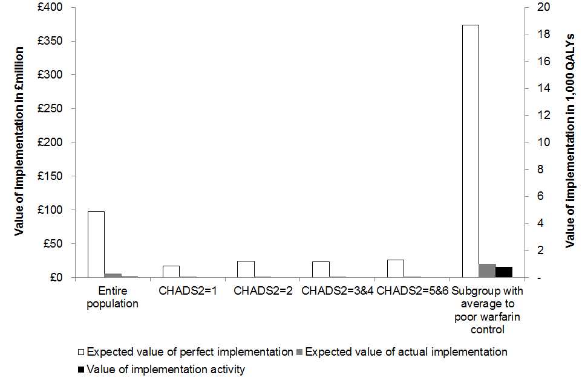

Figure 2 The effect of natural diffusion in the value of implementation
Figure 2A Prediction of future utilisation with linear regression model
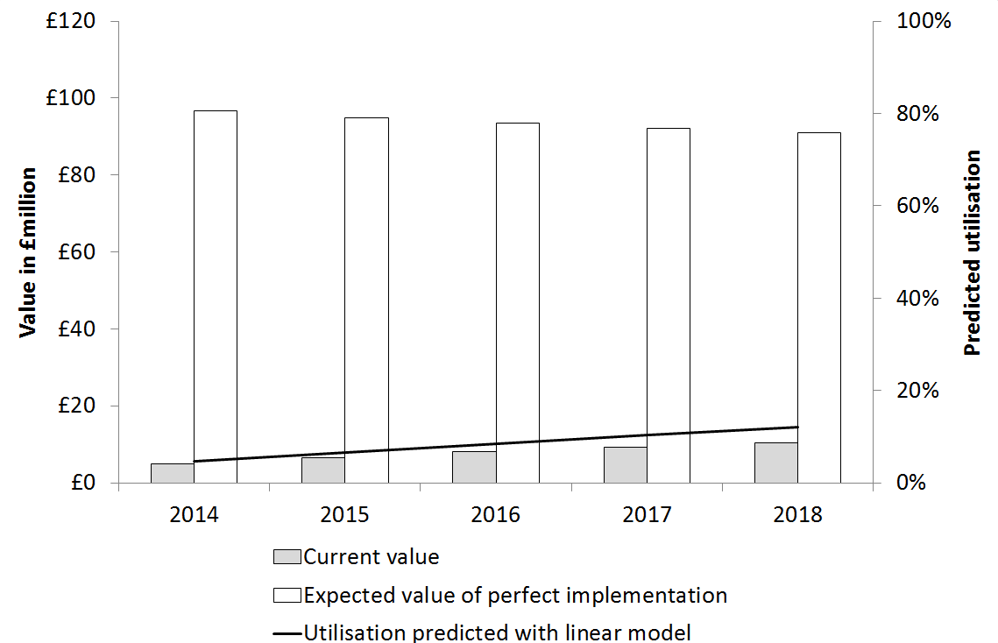
Figure 2B Prediction of future utilisation with quadratic regression model
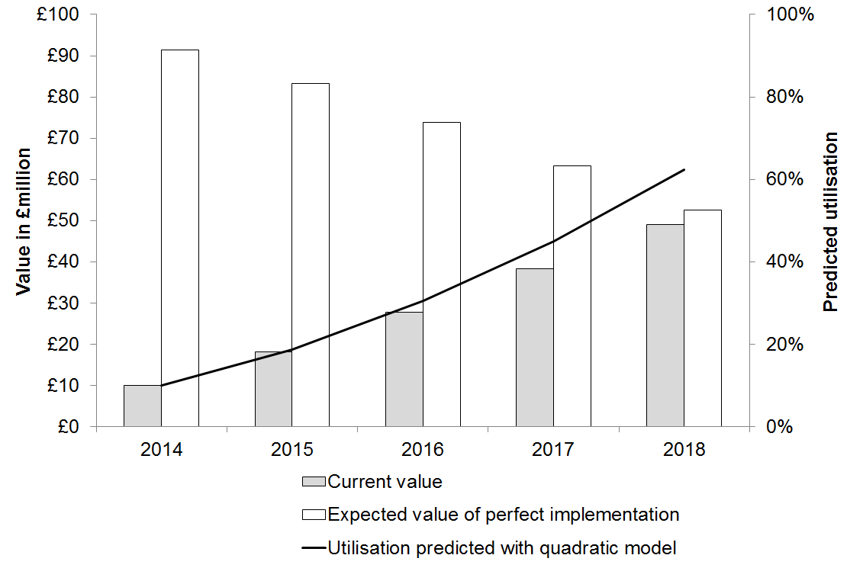
Figure 3 Threshold analysis on the cost of the implementation activity
The marks in bold show the increase in utilisation assumed for the base-case, at 5%.
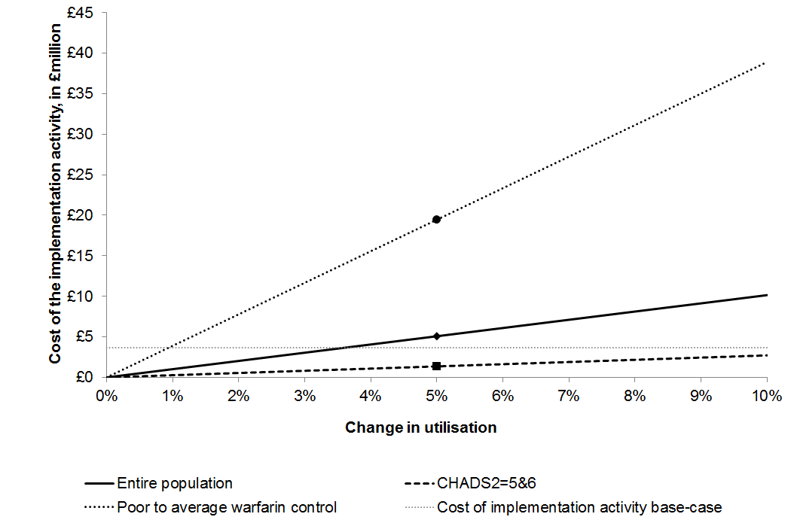
Figure 4 Scenario analysis
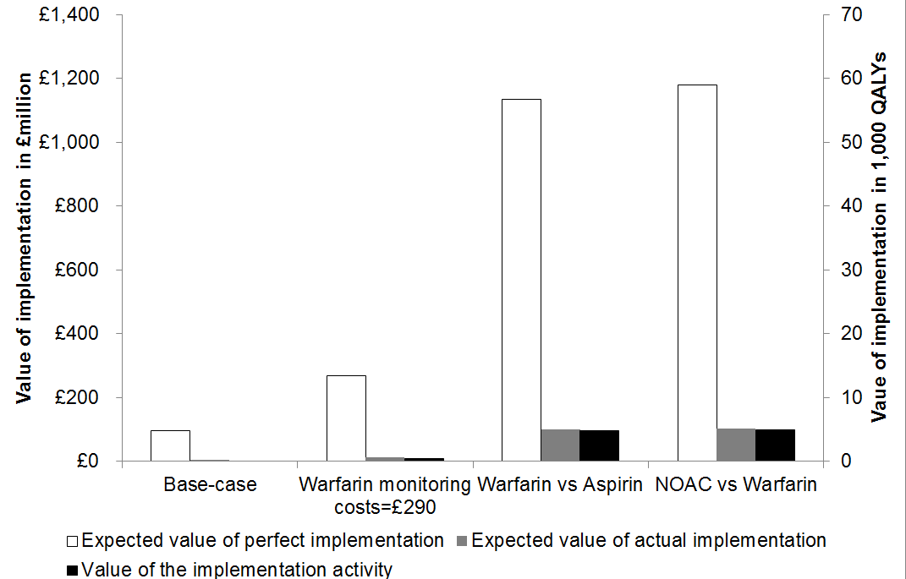

Appendix

- Current and future utilisation of NOACs

Table 1 presents the number of patients on anticoagulants obtained from GRASP-AF database. At the time of the analysis, the GRASP-AF database held information on X general practices (GP) in England. This number was extrapolated to all GP practices in England and Wales, assuming that those included in the GASP-AF database are representative of the entire population.

Table 1 Patients on anticoagulation in England and Wales⁽¹⁾
Treatment | England and Wales | Percentage
Anticoagulation only | 479,442 | 43.43%
Anticoagulation with antiplatelet | 81,174 | 7.35%
Antiplatelet | 378,811 | 34.32%
No treatment | 164,411 | 14.89%
Any treatment (overall population) | 1,103,838 | 100.00%
Personal communication from Ian Robson, NHS Improving Quality.

Table 2 presents the number of patients that are estimated as being prescribed NOACs for the prevention of stroke and systemic embolism at a monthly basis. By June 2013, there were an estimated 20,011 patients in England on NOACs.
The proportion of patients on novel anticoagulants was calculated as the ratio of the number of patients on NOACs and the patient population with atrial fibrillation on anticoagulants in England (528,569), derived from GRASP-AF.

Table 2 Patients estimated to be prescribed NOACs at each month in England
Month - year | Dabigatran | Rivaroxaban | Apixaban | All NOACs | % on NOACS/any anticoagulant⁽¹⁾
Jun-11 | 65 | 0 | 0 | 65 | 0.01%
Jul-11 | 70 | 0 | 0 | 70 | 0.01%
Aug-11 | 74 | 0 | 0 | 74 | 0.01%
Sep-11 | 180 | 0 | 0 | 180 | 0.03%
Oct-11 | 272 | 0 | 0 | 272 | 0.05%
Nov-11 | 387 | 0 | 0 | 387 | 0.07%
Dec-11 | 608 | 0 | 0 | 608 | 0.12%
Jan-12 | 740 | 2 | 0 | 742 | 0.14%
Feb-12 | 819 | 14 | 0 | 833 | 0.16%
Mar-12 | 1193 | 38 | 0 | 1231 | 0.23%
Apr-12 | 1377 | 46 | 0 | 1423 | 0.27%
May-12 | 2151 | 113 | 0 | 2264 | 0.43%
Jun-12 | 2616 | 199 | 0 | 2815 | 0.53%
Jul-12 | 3352 | 439 | 0 | 3791 | 0.72%
Aug-12 | 4420 | 664 | 3 | 5087 | 0.96%
Sep-12 | 4638 | 878 | 1 | 5517 | 1.04%
Oct-12 | 5746 | 1230 | 1 | 6977 | 1.32%
Nov-12 | 6578 | 1753 | 6 | 8337 | 1.58%
Dec-12 | 7393 | 2262 | 9 | 9664 | 1.83%
Jan-13 | 8255 | 2909 | 24 | 11188 | 2.12%
Feb-13 | 8413 | 3390 | 54 | 11857 | 2.24%
Mar-13 | 9887 | 4485 | 107 | 14479 | 2.74%
Apr-13 | 10850 | 5383 | 204 | 16437 | 3.11%
May-13 | 12235 | 6942 | 355 | 19532 | 3.70%
Jun-13 | 12065 | 7462 | 484 | 20011 | 3.79%
- The proportion of patients on NOACs was calculated dividing the number of patients on NOACs at each month by the total number of estimated individuals in England on anticoagulants according to the GRASP-AF database.

These data were used to extrapolate future utilisation. Utilisation of NOACs, as the proportion of patients on NOACs from all patients with atrial fibrillation on anticoagulation, was regressed on the number of months since product license, both in a linear model and in a quadratic model. Table 3 presents the model statistics and goodness of fit. These regression models were used to predict the future utilisation of NOACs.

Table 3 Model statistics and goodness of fit for utilisation over time
Model | Coefficient on month | Coefficient on month squared | Constant | Adjusted R-squared
Linear model | 0.0015  (0.0013 to 0.0018) | - | -0.0090  (-0.0131 to -0.0049) | 0.845
Quadratic model | -0.0010  (-0.0012 to -0.0008) | 0.0001  (0.0001 to 0.0001) | 0.0001  (0.0001 to 0.0001) | 0.995

- Extrapolation of incremental net benefit for population subgroups
There are no estimates of incremental net benefit (INB) for subgroups under the set of assumptions preferred by the NICE committee nor was access to the original decision model made possible. Therefore, estimates of INB for subgroups are derived from the estimates presented in the manufacturer’s submission and the evidence review group (ERG) report for the NICE technology appraisal of dabigatran.
  - Subgroups defined according to warfarin control
The ERG presented estimates of incremental costs and quality-adjusted life years (QALYs) for dabigatran versus warfarin in the best controlled patients ⁴. The best controlled patients were defined as the quartile (25%) of the patient population with greater time with therapeutic range in an observational study set in Wales ⁵. In these patients, and under the set of assumptions preferred by the NICE committee, dabigatran was more costly by £3,568 per patient and more effective by 0.0759 QALYs (incremental cost-effectiveness ratio (ICER) = £46,989) ⁴.

The INB for the subgroup with better warfarin control (${INB}_{best controlled quartile}^{Committee}$), together with the INB in the entire population (${INB}_{population}^{Committee}$), are used to derive the value for the remaining 75% of patients whose time in therapeutic range is below 84% (average to poor warfarin control; ${INB}_{average or poor controlled }^{Committee}$). This assumes that the INB in the entire population is the weighted average of the INB in each subgroup (Equation 1).

Equation 1 Relationship between net benefit in the overall population and subgroups

$${INB}_{average or poor controlled }^{Committee}=({INB}_{population}^{Committee}-0.25*{INB}_{best controlled quartile}^{Committee})/0.75$$

Table 4 presents the INB of dabigatran for the entire population and subgroups defined by warfarin control.

Table 4 Net benefit of dabigatran for the entire population and subgroups defined by warfarin control
Population subgroup | Threshold of £20,000/QALY gained
 | Net monetary benefit | Net health  benefit
Overall population | £181 | 0.009 QALYs
Good control (25% patients) | -£2,050 | -0.103 QALYs
Average or poor control (remaining 75%) | £925 | 0.046 QALYs

  - Subgroups defined according to CHADS₂ score
The objective is to obtain estimates of INB of NOACs versus warfarin for subgroup populations defined by CHADS₂ score: CHADS₂=1, CHADS₂=2, CHADS₂=3 or 4 and CHADS₂=5 or 6. These subgroups are consistent with the manufacturer’s original submission ². The INB is derived assuming that the ratio between the INB in the entire population and subgroups is the same across assumptions (Equation 2). This assumes that the different set of assumptions affect the INB across subgroups in equal fashion. $I{NB}_{Committee}^{population}$ and ${INB}_{Manufacturer}^{population}$represent the INB for the entire population under the NICE committee’s ¹ and the manufacturer’s preferred set of assumptions ². $I{NB}_{Committee}^{subgroup}$ and $I{NB}_{Manufacturer}^{subgroup}$ represent the INB for the subgroups under the NICE committee’s and the manufacturer’s preferred set of assumptions ⁴.

Equation 2 Relationship between the net monetary benefit of subgroups and population under the manufacturer’s and the Committee’s preferred set of assumptions
$${INB}_{Committee}^{subgroup}=\frac{{INB}_{Committee}^{population}}{{INB}_{Manufacturer}^{population}}*{INB}_{manufacturer}^{subgroup}$$

Table 5 presents the derived INB for subgroups defined by CHADS₂ score according to the set of assumptions preferred by the NICE committee.

Table 5 Derived INB for subgroup populations defined by CHADS₂ score under the Committee’s set of preferred assumptions
Population | At a threshold of £20,000/QALY gained
 | In monetary units | In QALYs
Base-case population | £181 | 0.009
CHADS2=1 | £130 | 0.006
CHADS2=2 | £138 | 0.007
CHADS=3 or 4 | £155 | 0.008
CHADS2=5 or 6 | £1,179 | 0.059

The size of each subgroup population is obtained from the GRASP-AF database, extrapolated to England and Wales (Table 6).

Table 6 Size of subgroup populations defined by CHADS₂ score
Population | Number | Proportion
Base-case population | 560,617 | 100%
CHADS₂=1 | 139,470 | 25%
CHADS₂=2 | 184,375 | 33%
CHADS₂=3 or 4 | 154,467 | 28%
CHADS₂=5 or 6 | 22,993 | 4%
- Extrapolation of incremental net benefit for scenarios
  - Scenario 1: Alternative estimates of warfarin monitoring costs
The ERG presented an exploratory analysis of the incremental costs of dabigatran versus warfarin under the NICE committee’s set of preferred assumptions but using a lower warfarin monitoring cost (£115 vs. £242 preferred by the committee) ⁴. This is used to derive the INB under the committee’s set of preferred assumptions with alternative warfarin monitoring costs. This assumes that the difference in incremental costs is proportional to the difference in monitoring costs (Equation 3).

Equation 3 Relationship between incremental costs and monitoring costs
$${{Cost}_{monitoring}^{New}-{Cost}_{monitoring}^{base-case}}/{{Incremental costs}^{New}-{Incremental costs}^{base-case}}=constant$$

${Incremental costs}^{New}=\left({Cost}_{monitoring}^{New}-{Cost}_{monitoring}^{base-case}\right)*constant+{Incremental costs}^{base-case}$

Table 7 presents the derived incremental costs for alternative monitoring costs. The monitoring cost of £115 per patient per year, presented by the ERG in their additional analyses ⁴, is used to obtain the ratio between the difference in monitoring costs and the difference in incremental costs. This ratio is then applied to the difference in monitoring costs to obtain derived estimates of the incremental costs under the alternative estimates of monitoring costs. The INB is estimated using the incremental health benefits in the entire population (0.1594 QALYs) ¹.

Table 7 Derived incremental costs for alternative monitoring costs
Costs of monitoring | $${Cost}_{monitoring}^{New}-{Cost}_{monitoring}^{base-case}$$ | $${Incremental costs}^{New}$$
Base-case population (£242 per person per year) | Not applicable | 3007
Committee’s scenario £115 per person per year* | -£127 | £3,845*
Costing tool scenario £193 per person per year | -£49 | £3,328
Costing tool scenario £290 per person per year | £48 | £2,686
*Used to obtained the ratio between the cost differences which is then applied to the other estimates of monitoring costs to obtain the new incremental costs.

  - Scenario 2: Patients potentially eligible for anticoagulation but currently on antiplatelets or no treatment
Estimates of INB for anticoagulation (with warfarin or NOACs) compared with aspirin under the Committee’s set of preferred assumptions are obtained from the estimates presented by the ERG in their exploratory analyses ³. Table 8 presents value estimates for patients treated with aspirin or warfarin for warfarin monitoring costs of £242. This is taken as the only assumption, of the Committee’s set of preferred assumptions, which could affect the costs and health outcomes with warfarin or aspirin treatment.

Table 8 Estimates of INB for warfarin vs aspirin
Parameter | Aspirin | Warfarin
Average costs per patient | £15,080 | £14,415
Average QALYs per patient | 7.082 | 7.283
Difference in costs | -£665
Difference in QALYs | 0.201
Net benefit at £20,000/QALY | £4,685 (0.234 QALYs)
Average costs and QALYs per patient for each treatment obtained from Table 51 page 116 of ERG report ³

Table 9 shows the derived INB.

Table 9 INB of NOACs versus aspirin
Comparison | At a threshold of £20,000/QALY gained
 | In monetary units | In QALYs
NOACs vs warfarin | £181 | 0.009
Warfarin vs aspirin | £4,685 | 0.234
NOACs vs aspirin | £4,866 | 0.243

Note that ${INB}^{t}$ accounts for the patients who switched at time $t$ and for the patients who died before the switch. This assumes that the change in utilisation between $t$ and $t-1$ in the living patients is generalisable to those who died before the switch. In other words, patients who died are assumed to have the same likelihood of switching to the new treatment as the patients who are alive

