Enrichment planting to improve habitat quality and conservation value of tropical rainforest fragments.

Yeong Kok Loong1, 2, Glen Reynolds2, Jane K. Hill3

Addresses & contact details

1 International Tropical Forestry Programme, Faculty of Science and Natural Resources, Universiti Malaysia Sabah, Jalan UMS, 88400 Kota Kinabalu, Sabah, Malaysia

2 South East Asia Rainforest Research Partnership, Danum Valley Field Centre, PO Box 60282, 91112 Lahad Datu, Sabah, Malaysia

3 Department of Biology, Wentworth Way, University of York, York YO10 5DD, UK

Corresponding author:

Dr Yeong Kok Loong, School of Geography, University of Nottingham Malaysia Campus, Jalan Broga, 43500 Semenyih, Selangor, Malaysia.

Email; [yeong83@gmail.com](mailto:yeong83@gmail.com)

ORCID ID; 0000-001-8193-2130

**Abstract** Many areas of tropical rainforest have been fragmented and the habitat quality of fragments is often poor. For example, on Borneo, many forest fragments are highly degraded by repeated logging of Dipterocarpaceae trees prior to fragmentation, and we examined the viability of enrichment planting as a potential management tool to enhance the conservation value of these forest fragments. We planted seedlings of three dipterocarp species with contrasting light demands and tolerances (*Parashorea malaanonan* (light demander), *Dryobalanops lanceolata* (intermediate), *Hopea nervosa* (shade tolerant)) in eight forest fragment sites (3 to 3,529 ha), and compared seedling performance with four sites in continuous forest. Eighteen months after planting, survival rates of seedlings were equally high in fragment sites (mean survival = 63%), and in continuous forest sites (mean survival = 68%). By contrast, seedling growth and herbivory rates were considerably higher in fragments (by 60% for growth and 45% for herbivory) associated with higher light environments in degraded forest fragments compared with continuous forest sites. Among the three study species, *H. nervosa* seedlings had the highest survival rates overall, and *P. malaanonan* seedlings generally grew fastest andsuffered highest herbivory rates. There were no interactions between species performance and the effects of fragment site area, forest structure or soil characteristics of sites suggesting that the three species responded similarly to fragmentation effects. High survival of planted seedlings implies that enrichment planting would be a successful forest management strategy to improve forest quality, and hence conservation value, of fragments.

**Keywords** forest fragmentation . regeneration . Danum Valley . Sabah . Malaysia. oil palm.

**Introduction**

Previously extensive areas of rainforest now persist as isolated fragments within agricultural and urban landscapes (Hill et al. 2011; Laurance et al. 2011). Forest fragmentation alters habitat quality as a consequence of increased edge effects, changes in vegetation structure (smaller fragments are often highly degraded and disturbed) and an altered microclimate (Ferreira and Laurance, 1997; Didham and Lawton, 1999). For example, fragmentation increases edge effects, which alter local microclimates and increase disturbance (e.g. windthrow of trees), and these effects are greater in smaller fragments (which have greater perimeter:area relationships). Fragmentation is also associated withreduced species richness of forest communities within fragments (e.g. Benitez-Malvido and Martinez-Ramos, 2003; Lucey et al. 2014), thereby disrupting ecosystem processes such as nutrient cycling, forest regeneration and carbon storage within the fragments (Laurance et al. 2011; Magnago et al. 2015; Yeong et al. 2016). Small, low quality fragments typically have higher air temperatures, reduced humidity and drier soils (Ewers and Banks-Leite, 2013) due to changes in canopy cover, light environments and edge effects (Didham and Lawton, 1999). In this study we use the term ‘quality’ to refer to forest that has a structure characteristic of primary undisturbed forest, and the biotic and abiotic changes that occur following fragmentation reduce the habitat quality of fragments and number of species they support (e.g. Tawatao et al. 2014). Thus, the conservation value of forest fragments is associated with their size, as well as their habitat quality, which is determined primarily by the structure and composition of the tree species that they contain (Harrison and Bruna, 1999, Dantas de Paula et al. 2015). Dipterocarp species are especially important in this context because they are key components of the forest canopy and essential in maintaining local conditions and habitats suitable for supporting forest-dependent animal and plant species and for improving the regeneration capacity of fragmented and disturbed sites. This, improving the habitat quality of fragments may help to maintain ecosystem functioning within fragments, thereby ensuring the long-term viability of forest fragments and enhancing their conservation value.

Rainforests on Borneo are dominated by trees from the Dipterocarpaceae family of trees (Bawa, 1998; Ashton 2004), which are important timber trees as well as being important components of forest community and structural composition. This region is also, especially in low-lying areas, highly vulnerable to land-use change and extensive areas of rainforest have been heavily logged and subsequently converted to oil palm *Elaeis guineensis* plantations (Koh and Wilcove, 2008). Many remaining areas of forest are highly degraded and fragmented (Reynolds et al. 2011), with natural forest remnants remaining as small patches scattered across plantation landscapes (Foster et al. 2011). Forest fragments in these landscapes may be retained if they contain ‘High Conservation Values’ (HCVs; Senior et al. 2014) or occur in areas that are unsuitable for agriculture, e.g. too steep or flood prone to plant with oil palms (Foster et al. 2011). These forest patches have, in most cases, been repeatedly logged prior to fragmentation and large dipterocarps are present at much lower densities than in continuous forest, or even entirely absent (Yeong et al. 2016). There is potential to improve the vegetation structure of these fragmented sites through enrichment planting of dipterocarp seedlings, especially where natural recruitment of seedlings is inhibited by a lack of dipterocarps of fruiting size. The faunal species richness of highly-disturbed forest fragments is much lower than that of less-disturbed fragments, which are more similar to continuous forest (e.g. for ants, Tawatao et al. 2014). This implies that actions to accelerate forest regeneration and improve vegetation structure through enrichment planting of dipterocarp seedlings will increase species richness. This supports other studies highlighting the importance of habitat management for improving the effectiveness of Protected Areas (e.g. for vertebrates in Africa; Costelloe et al. 2015). Enrichment planting of dipterocarp seedlings has been used to restore continuous degraded tropical forests (Lamb et al. 2005; Stanturf et al. 2014), but the potential for its use in the rehabilitation of fragmented forest sites is not known.

Enrichment planting of dipterocarps has been commonly used in the rehabilitation of selectively-logged production forests in Southeast Asia (Ådjers et al. 1995; Hector et al. 2011), but has not previously been considered in rainforest fragments. Enrichment planting involves planting nursery-raised dipterocarp seedlings in degraded forests where natural regeneration of dipterocarps is limited due to low abundance, or absence, of mature reproductive trees (Wyatt-Smith, 1963; Ådjers et al. 1995). Low natural seed production in degraded sites may also increase predation pressure on those few seeds that are produced, further reducing the occurrence of natural seedlings and natural forest regeneration. Previous studies have shown high growth and survival rates of dipterocarp seedlings planted in selectively-logged forests (Ådjers et al. 1995; Bebber et al. 2002a), due to increased light in more open-canopy logged forests (Tuomela et al. 1996). However, herbivory rates would also be expected to be higher in higher light environments due to increasing photosynthetic rates that increase plant nutrient content for insects (Strauss & Agrawal, 1999), and increased insect abundance (Coley and Barone, 1996; Basset et al. 2001), potentially affecting seedling survival (Eichhorn et al. 2010). Moreover, soil compaction at selectively logged sites may affect seedling establishment with compacted soils disrupting root development (Nussbaum et al. 1995; Pinard et al. 2000). Dipterocarps are classified according to their light requirements for growth, which correlates well with wood density (King et al. 2006; Gustafsson et al. 2016). Species with less dense wood are generally fast growers compared with medium and high density species (King et al. 2006). Most of the *Shorea* species (*Mutica* section) and *Parashorea* species are light-demanders which have lower wood density, while *Dryobalanops* species and *Dipterocarpus* species are intermediate (medium density), and the other *Shorea* species (*Shorea* section), *Hopea* species and *Vatica* species are shade-tolerant species (high density) (Newman et al. 1996, 1998; Brown et al. 1999; Ashton, 2004). By studying species along a spectrum of light requirements we were able examine whether variation in canopy openness and hence light levels affected seedling growth and hence the suitability of these species for enrichment planting in fragments.

The main aim of this study was to investigate survival, growth and herbivory rates of experimentally-planted dipterocarp seedlings in rainforest fragments. We compared species with contrasting light requirements for growth; *Parashorea* *malaanonan* are light demanding, while *Dryobalanops* lanceolata are intermediate species, and *Hopea* nervosa are shade-tolerant species (Newman et al. 1996, 1998), which are commonly found across the study sites (Ashton, 2004). These three species were selected for study because we would expect seedling growth and survival of these species to differ in relation to the different light environments in forest fragments (Newman et al. 1996, 1998). We compared the performance of seedlings in forest fragment sites with performance in continuous forest sites to assess the effectiveness of enrichment planting in fragments. We tested the hypothesis that survival, growth and herbivory rates of experimentally-planted dipterocarp seedlings varied in relation to fragment area and forest habitat quality (as determined from measures of forest structure and soil characteristics at study sites).

**Method**

**Study sites**

The study was carried out in the Malaysian state of Sabah (Borneo; Fig. 1; Table 1). Sabah has a climate typical of the aseasonal tropics with mean annual temperatures of 27°C and annual rainfall of 2,800 mm (Walsh and Newbery, 1999). A total of 12 sites were studied comprising eight forest fragment sites (3 ha to 3,529 ha) and four sites within a large tract of continuous forest (Yayasan Sabah Forest Management Area (~800,000 ha). The continuous forest sites were in undisturbed primary forest in the Danum Valley Conservation Area (two sites), and the Malua Forest Reserve that had been selectively logged twice in the mid-1980s and 2005/6 (two sites; Reynolds et al. 2011; Hector et al. 2011). All study sites comprised lowland dipterocarp forest below 300 m elevation (Reynolds et al. 2011). Soils in the region are sandy to clay-loam soils, derived from basic and intermediate igneous rocks, mudstone and sandstone (Marsh and Greer, 1992). All study fragments were surrounded by mature fruiting oil palm plantations at the time of the study and forest fragments were probably formed in the 1990s during the rapid expansion of the oil palm industry in Sabah (Reynolds et al. 2011). Study fragments were formed from heavily-degraded forest that had been repeatedly logged prior to conversion to plantations (N = 4 sites), as well as from previously undisturbed forest (‘Virgin Jungle Reserves’; Tawatao et al. 2014; N = 4 sites) and thus study sites spanned a gradient of forest habitat quality typical in the region, as well as a wide range of fragment sizes (from 3 ha to 3,529ha; Table 1). At each of the 12 study sites, stations were established along a line transect at 500 m intervals (1- 3 stations per transect depending on site area; total of 32 stations). All stations in fragments were located at least 100 m from edges to avoid major edge effects.

**Measuring survival, growth and herbivory of planted seedlings**

Seedlings from three dipterocarp species (*Parashorea malaanonan,* *Dryobalanops lanceolata,* *Hopea nervosa*) were acquired from nurseries of the Sabah Biodiversity Experiment (SBE, Hector et al. 2011) and the Innoprise-FACE (Forest Absorbing Carbon Emissions Foundation) Rainforest Rehabilitation Project (INFAPRO) within the Ulu-Segama Forest Reserve of the Yayasan Sabah Forest Management Area (Reynolds et al. 2011). All seedlings had been germinated from seeds collected locally and were about 1-year old at the time of planting. A total of 40 seedlings per species per station were planted within a 36 m x 30 m zone located at the centre of each station (grand total of 3,840 seedlings planted across the 12 study sites, 32 stations and three dipterocarp species; Online Resource 1). Seedlings were planted 3m apart on a grid design without fertilizer or watering, using similar techniques described in Hector et al. (2011). All the seedlings were planted between October and December 2010 when rainfall was typically high for the region (>250 mm per month, Online Resource 2). Seedlings were tagged with aluminium tags stamped with a unique code. Any seedlings that died within 2 months of being planted were replaced between January and February 2011 (to avoid over-estimating mortality as a direct result of planting), which is standard practice in other enrichment planting projects (Hector et al. 2011). We measured seedling survival, growth rates (seedling height; in mm, measured from the ground to the apical meristem) and herbivory rates (area of leaf damaged). In order to be able to measure leaf area damage over time, the top four leaves of each seedling (excluding flushing leaves that were not fully expanded) were marked on the underside of the leaf near the petiole with a paint marker (1 dot for the top leaf, 2 dots for the second leaves etc., following the method of Bagchi et al. 2010). Leaf area damage of these marked leaves was estimated by eye, to the nearest 5%.

Survival of planted seedlings was assessed 18 months after planting during August to October 2012. We recorded the number of seedlings that had survived, seedling height and leaf area damage. Relative growth rates were estimated for each seedling based on height measurements, and were calculated as: growth rate per year = [(lnG2 - lnG1)/(t2 - t1)] x 12, where G1 and G2 is seedling height (in mm year-1) at time t1 (planting date) and t2 (re-measurement date 18 months later). We also measured seedling growth rates based on stem diameter measurements, which are reported in supplementary online resource documents (Online Resources 3 to 7). Herbivory was estimated as: leaf area damage (%) = LA1 - LA2 where LA1 and LA2 are the % of leaf area present at the first and second measurement 18 months later, and the difference computed per seedling as the mean of four leaves. Leaf area damage was recorded as 100% if marked leaves were missing from the stem.

**Assessing forest habitat quality at study sites**

In order to quantify forest habitat quality at sites, we measured 15 variables related to vegetation, soil and environmental variables at each of the 32 study stations. These measurements and analyses have been described in detail elsewhere (Yeong et al. 2016) and so we will only briefly describe them here. We carried out two Principal Components Analyses (PCAs), and variables were incorporated either into a PCA quantifying forest structure (9 variables) or a PCA quantifying soil characteristics (6 variables; Online Resource 8). To quantify forest structure we measured: distance and girth (diameter at breast height; DBH) of two saplings (5-30 cm DBH) and two large trees (>30 cm DBH) nearest to the centre of the station in each of four quadrants (positioned along the main compass bearings) up to a distance of 30 m from the centre of the station (maximum 8 trees and 8 saplings per station), ground cover (estimated by eye within 10 m radius), canopy cover (densiometer measures), and temperature (Hobo® logger placed 1.8 m from the ground on a tree stem for 10 days during April to July 2011). We also measured dipterocarp tree density and richness (>30 cm DBH), leaf litter depth (using a steel ruler), and light intensity (photosynthetic active radiation (PAR), using a Skye Light Meter for Growers Limited). To quantify soil characteristics at each station we measured the following (from 25 cores per station, cores measuring 4 cm by 10 cm); soil moisture (% gravimetric soil moisture), soil pH (pH-meter in slurry of water and soil), soil nitrogen (N), carbon (C) and C:N ratio (using dry combustion C/N analyser), and soluble phosphorus (P, using wet digestion methods with hydrogen peroxide, lithium sulphate and sulphuric acid). Thus, data on dipterocarp and non-dipterocarp tree density, dipterocarp tree species richness, non-dipterocarp sapling density, canopy and ground cover, leaf litter depth, and PAR were incorporated into a PCA quantifying forest structure (PCF scores), and data on soil moisture, soil pH, total soil nitrogen and carbon, soluble phosphorus and C:N ratio were incorporated into another PCA quantifying soil characteristics (PCS scores; Online Resource 8; Yeong et al. 2016). All variables were normalised where necessary and standardised by subtracting the mean value and dividing by twice the standard deviation prior to incorporations into the PCAs (Grueber et al. 2011). The first PCF score (PCF1) for forest structure accounted for 42 % of the variation in the vegetation dataset and increased with (in order of importance) increasing dipterocarp tree density and richness, canopy cover, leaf litter depth, and decreasing PAR (Online Resource 8). The first PCS score (PCS1) for soil characteristics accounted for 34 % of the variation in the soil dataset and increased with (in order of importance) increasing soil moisture, soluble P, total C and decreasing soil pH. PCF1 and PCS1 scores were highest in continuous undisturbed forest sites and lowest in small fragments that had been repeatedly logged (Yeong et al. 2016) and thus we used PCF1 and PCS1 scores as our measures of forest habitat quality at sites.

**Statistical analysis**

We carried out two types of Generalized Linear Mixed Models (GLMMs) to examine seedling performance among sites. In all analyses, the three response variables we examined were the same and were; individual seedling measures of survival (i.e. seedling dead or alive), growth (seedling height), and herbivory. The first GLMMs (3 models) quantified the effect of fragmentation *per se*, and we included survival, growth and herbivory of seedlings at each station as dependent variables, forest type (continuous forest or fragment) and species identity (*P. malaanonan,* *D. lanceolata* or *H. nervosa*) as fixed factors, and ‘station nested within site’ as a random factor. To examine the effects of site area and forest habitat quality on seedlings, the second GLMMs (3 models) included survival, growth and herbivory of seedlings at each station as dependent variables, with site area, habitat quality (PCF1 and PCS1 scores) and species identity(*P. malaanonan,* *D. lanceolata* or *H. nervosa*) as fixed factors, and ‘station nested within site’ included as a random factor. To allow all sites to be analysed in these second GLMMs, we assumed that the four continuous study sites were from an area of forest of 800,000 ha (the area of the Yayasan Sabah Forest Management Area). We used the ‘glmer’ function with a binomial error distribution for analyses of seedling survival, and the ‘lmer’ function with gaussian error distribution for measures of herbivory and growth using the lme4 package for R 3.2.0 (R Core Team, 2013). All models were checked for homogeneity of variances and normality of residuals (Faraway 2006; Warton and Hui 2011). Transformations were performed to correct non-normal residuals and non-homogenous variances as follows: log10 (leaf area damaged/1-leaf area damaged) and cube root transformation (growth). To allow direct comparison of the relative importance of each predictor variable for explaining changes in seedling survival, growth and herbivory, predictor variables were standardised by subtracting the mean value and dividing by twice the standard deviation (Grueber et al. 2011). Best-fitting models were identified using Akaike Information Criteria (AICc; Burnham and Anderson, 2002) and model-averaging procedures were used if multiple models were equally good (i.e. ΔAICc < 2).

**Results**

Compared with continuous forest sites, forest fragments generally had lower habitat quality (i.e. lower PCF1 and PCS1scores), corresponding to ~50% reduction in the density of large dipterocarp trees and ~13% higher light levels (PAR; Table 1). Sites with high PCF1 and PCS1 scores were generally in undisturbed continuous forest, and were characterized by having a high density and richness of dipterocarp trees, a closed canopy, deep leaf litter layer, cooler temperatures, lower light levels, higher soil moisture, lower soil pH and a higher concentrations of soil C and soluble P (Online Resource 8).

**Survival rates of planted seedlings**

Survival rates of planted seedlings were generally high across all study sites(mean survival of all species at all 12 sites = 66.5%; range = 18.0 - 90.5%; Table 2). Seedling survival rates in fragments (mean = 62.8% ± 4.8) were not significantly different from survival rates in continuous forest (mean = 67.8% ±1.9; E = -0.17, CIs = -0.83 to 0.49; Fig. 2), even though very low survival rates were recorded in the smallest fragment (3 ha; mean survival of all three species = 31.3% ± 5.0; Fig. 3). Survival rates of seedlings were not affected by site area (mean effect size = -0.054, CIs = -0.043 to 0.323, although this was close to significance; Fig. 3A), forest structure (PCF1 score; mean effect size = -0.177, CIs = -0.493 to 0.140; Fig. 3B) or soil characteristics (PCS1 score; mean effect size = -0.037, CIs = -0.377 to 0.302; Fig. 3C, Fig. 4). Thus, seedling survival rates were generally high amongst all study sites and were relatively insensitive to fragmentation and habitat degradation.

**Growth and herbivory rates of planted seedlings**

Seedling growth and herbivory rates were higher in fragments compared with continuous forest sites (growth rate effect size = -0.15, CIs = -0.23 to -0.05; herbivory effect size = -0.81, CIs = -1.21 to -0.41; Fig. 2). Herbivory rates were negatively related to site area (mean effect size = -0.29, CIs = -0.47 to -0.11; Fig 3) and an interaction between forest structure and soil characteristics (mean effect size = -0.188, CIs = -0.368 to -0.009) suggested that herbivory rates were particularly high in small sites with the poorest quality forest structure and soils. However, seedling growth rates were not related to site area (mean effect size = -0.213, CIs = -0.432 to 0.005), nor to forest structure (mean effect size = -0.08, CIs = -0.255 to 0.099) or soil characteristics (mean effect size = -0.179, CIs = -0.38 to 0.02; Fig. 3, Fig. 4). These results were qualitatively similar if the smallest site (site 12; 3ha) was excluded from analyses (Online Resource 9, Fig. 4), showing that this very small site did not have a disproportionate effect on findings. Measures of seedling growth rates according to stem diameter measures showed similar trends to fragmentation as the measures of seedling height, but effects were often not significant (Online Resources 3 to 7).

**Differences among species**

Among the three study species, *H. nervosa* (shade-tolerant) seedlings had highest survival rates (mean = 70.6% ±5.7), compared with *D. lanceolata* (intermediate, 66.1% ±5.0) and *P. malaanonan* (light demander, 50.5% ±5.4; Fig. 3). Growth and herbivory rates of *P. malaanonan* (mean growth rate = 2.13mm year-1 ±0.44, mean herbivory = 65.42% ±4.21) were higher than *D. lanceolata* (growth = 1.46mm year-1 ±0.24, herbivory = 38.41% ±5.20) and *H. nervosa* (growth = 1.71mm year-1 ±0.27, herbivory = 30.26% ±4.78; Fig. 3). There was no interaction between species identity and site area, forest structure or soil characteristics suggesting that all three seedling species responded to fragmentation and habitat degradation in a similar way.

**Discussion**

**Survival and growth of dipterocarp seedlings**

Survival rates of planted dipterocarp seedlings were generally high in all sites (overall mean survival = 65%), and were not sensitive to fragmentation effects or related to forest habitat quality (as measured by forest structure and soil characteristics). Survival rates were comparable to other studies on Borneo by Ådjers et al. (1995) and Romell et al. (2008). The exception was the smallest (3 ha) site which had much lower seedling survival (31% compared with 70% in fully protected continuous forest sites), primarily because of a large number of trees and branches falling onto seedlings due to high wind turbulence from edge effects (YKL pers. obs.). Similar effects of physical damage from litter fall have been reported in Brazilian forest fragments (Scariot 2000; Portela and Santos 2009). Rainfall during the period of planting (October to December 2010) was typically high and so seedlings were unlikely to have experienced drought conditions during planting, which can increase mortality (Bebber et al. 2002b), and reduced soil moisture in fragments was not sufficient to affect seedling survival. Severe droughts in the study region are associated with ENSO events (Walsh and Newbery 1999), which can lead to increased dipterocarp mortality (Woods, 1989) and increased insect herbivore damage (Bebber et al. 2002b, McDowell et al. 2008). The importance of avoiding enrichment planting during droughts has been recognized (Hector et al. 2011).

In our study, forest fragments had lower canopy cover than continuous forest sites due to ~50% reduction in the density of mature dipterocarp trees (Table 1). In association with this reduction in canopy cover, the understorey in forest fragments experienced higher light environments and our ground-based measure of PAR increased by ~13% compared with continuous forest sites (Table 1). However, these changes in the light environment were not related to seedling survival. Previous studies have also shown high survival of planted dipterocarp seedlings in highly degraded sites (Sakai et al. 2014) although other studies have shown that high light availability reduces survival of dipterocarp seedlings (Brown and Whitmore, 1992; Ashton, 1995). Our results also contrast with other fragmentation studies showing reduced survival of tree seedlings in forest fragments due to increased temperature and reduced humidity (Benitez-Malvido, 1998). Given that our study sites spanned a wide range of sizes and levels of habitat quality, we conclude that seedling survival was relatively robust to these habitat changes, at least up to 18 months after planting. Further surveys are required to examine if seedling survival rates remain similarly high among sites over time.

**Growth and herbivory of dipterocarp seedlings**

Dipterocarp seedlings grew about 60% faster in forest fragments than in continuous forest sites and growth rates were negatively related to site area. These findings were robust to any potential biases from the outlying smallest (3 ha) site, because results were qualitatively the same if this site was removed from the analyses. Forest fragments tended to have higher photosynthetic active radiation (PAR) levels due to fewer mature trees in fragments and hence reduced canopy cover (Laurance et al. 2011), which would be expected to result in increased plant photosynthetic rates and hence faster growth (Brown and Whitmore, 1992; Zipperlen and Press, 1996; Philipson et al. 2014), as seen in our study. Other studies on dipterocarp species have also shown that seedling growth increased with increasing canopy openness (Tuomela et al. 1996; Philipson et al. 2014), and light demanding species often outperform shade-tolerant species in high light environments (Gustafsson et al. 2016). The availability of soil nutrients is also important for the growth of seedlings in tropical rainforests (Nussbaum et al. 1995; Palmiotto et al. 2004), but soil nutrients (particularly C and P) were higher in undisturbed continuous forest and so we conclude that light was the primary factor enhancing seedling growth rates in fragments.

Herbivory rates of seedlings were lowest in continuous forest sites (Fig. 2) and increased with decreasing site area (Fig. 4), such that herbivory rates in fragments were approximately twice that of continuous forest sites. As with our measures of seedling growth, we assume that increased herbivory rates were probably related to higher light environments in forest fragments. Higher rates of photosynthesis are expected to increase plant nutrient content and reduce defensive phenolic compounds and tannins, and hence result in more palatable plant tissues for herbivores in high light environments (Coley and Barone, 1996; Eichhorn et al. 2007). In addition, higher herbivory rates could be due to increased insect abundance in higher light environments (Coley and Barone, 1996; Basset et al. 2001), and/or decreased abundance of herbivore predators in fragments (e.g. Rao et al. 2001; Terborgh et al. 2001).

High growth rates of seedlings were associated with high herbivory rates (Table 1), an observation that is consistent with the compensatory continuum hypothesis and limiting resource model whereby plants increase growth to compensate for herbivory damage in resource-rich (i.e. high light) environments (Wise and Abrahamson, 2005). In addition, a common response to herbivory is for plants to increase photosynthesis and growth rates (Strauss and Agrawal, 1999). Thus high rates of herbivory in high light environments might be expected to result in increased plant growth rates in forest fragments. This contrasts with other studies that have found that herbivory reduced dipterocarp seedling growth, although these effects were most evident in deeply-shaded sites (Paine et al. 2012).

Fragmentation reduced the density and diversity of naturally-occurring dipterocarps, potentially altering the effects of herbivory among seedlings (Janzen-Connell effect; Bagchi et al. 2011). For example, Massey et al. (2006) found that the rate of herbivory damage was higher in single-species versus mixed stands of dipterocarp seedlings. Even though in this study, the diversity and density of planted seedlings was the same among sites, local differences in natural seedling and dipterocarp tree diversity may affect the local distribution of herbivores, contributing to differences in the herbivory rates we observed.

**Species differences in survival, growth and herbivory**

There were differences in growth, survival and herbivory among the three study species that were related to species-specific light requirements for growth, but all three species responded in a similar way to forest fragmentation, without any interaction effects. Thus, herbivory rates of *P. malaanonan* (light-demanding species) seedlings were highest at all sites, most likely due to higher leaf nitrogen content, lower leaf defences, reduced leaf toughness and low lignin in light-demanding species (Coley and Barone, 1996; Eichhorn et al. 2007). A light-demanding species such as *P. malaanonan* would be expected to have higher growth rates, as noted in Zipperlen and Press (1996), due to higher rates of photosynthesis in light-demanding species. Our results also support findings of other studies showing high survival of shade-tolerant species (i.e. *Hopea nervosa*; Whitmore and Brown 1996).

**Rehabilitation of degraded forest fragments**

We conclude that high survival of seedlings planted in forest fragments implies that restoration of these fragments by enrichment planting to improve the conservation value of fragments would be a feasible proposition. There were some differences among the three study species in their survival rates, but rehabilitation planting to increase tree diversity (and thus the animal species dependent on high plant diversity; Novotny et al. 2002), will require a range of species to be planted. Our findings provide evidence that enrichment planting is a viable option in degraded rainforest sites, and we suggest that enrichment planting should be a feature of forest and plantation management plans if the conservation value of these areas is to be maintained. If replanting is associated with concomitant enhancement of conservation values and ecosystem services (e.g. above ground carbon stocks), this provides further support for replanting programmes to be incorporated into plantation and forest management plans (Magnago et al. 2015).

**Acknowledgements** This study was part of a PhD project funded by the Earthwatch Institute, supported by Shell PLC, and supervised by JKH, GR and Dr. John Tay (Universiti Malaysia Sabah). We thank the SE Asia Rainforest Research Partnership (SEARRP), Yayasan Sabah, Sabah Forestry Department, the Danum Valley Management Committee and Wilmar International Limited for permission to access research sites and facilities. We also thank Adrian Karolus, Phillip Ulok, Remmy Murus, Mohd. Edri, Mohd. Azlin, Amat Ahmad, Mohd. Herdam and Udin Jaga for assistance in the field. We thank Dr. Jennifer Lucey and Sarah Scriven for their comments on the paper.

**Author contribution** All authors conceived and designed the experiments and wrote the manuscript. YKL performed the experiments, carried out the fieldwork, and analyzed the data.

**Conflicts of interest**  All authors declare that they have no conflicts of interests

**References**

Ådjers G, Hadengganan S, Kuusipalo J, Nuryanto K, Vesa L (1995) Enrichment planting of dipterocarps in logged-over secondary forests: effect of width, direction and maintenance method of planting line on selected *Shorea* species. For Ecol Manag, 73(1), 259-270.

Ashton MS (1995) Seedling growth of co-occurring *Shorea* species in the simulated light environments of a rain forest. Forest Ecol Manag 72:1-12

Ashton PS (2004) Dipterocarpaceae. In: Soepadmo E, Saw LG and Chung RCK (eds) Tree flora of Sabah and Sarawak Vol 5. Sabah Forestry Department, Sandakan, pp 63–388

Basset Y, Charles E, Hammond DS, Brown VK (2001) Short-term effects of canopy openness on insect herbivores in a rain forest in Guyana. J Appl Ecol 38:1045-1058

Bagchi R, Press MC, Scholes JD (2010) Evolutionary history and distance dependence control survival of dipterocarp seedlings. Ecol Lett 13:51-59

Bagchi R, Philipson CD, Slade EM, Hector A, Phillips S, Villanueva JF, Lewis OT, Lyal CHC, Nilus, R, Madran A, Scholes JD, Press MC (2011) Impacts of logging on density-dependent predation of dipterocarp seeds in a South East Asian rainforest. Philos T R Soc B 366:3246-3255

Bawa KS (1998) Conservation of genetic resources in the Dipterocarpaceae. In: Appanah S, Turnbull JM (eds) A review of Dipterocarps: Taxonomy ecology and silviculture. CIFOR, Bogor, Indonesia

Bebber D, Brown N, Speight M, Moura-Costa P, Wai YS (2002a) Spatial structure of light and dipterocarp seedling growth in a tropical secondary forest. Forest Ecol Manag 157:65-75

Bebber D, Brown N, Speight M (2002b) Drought and root herbivory in understorey Parashorea Kurz (Dipterocarpaceae) seedlings in Borneo. J Trop Ecol 18:795-804

Benitez-Malvido J (1998) Impact of Forest Fragmentation on Seedling Abundance in a Tropical Rain Forest. Conserv Biol 12:380-389

Benitez-Malvido J, Martinez-Ramos M (2003) Impact of forest fragmentation on understory plant species richness in Amazonia. Conserv Biol 17:389-400

Brown ND, Whitmore TC (1992) Do dipterocarp seedlings really partition tropical rain-forest gaps. Philos T Roy Soc B 335:369-378

Brown N, Press M, Bebber D (1999) Growth and survivorship of dipterocarp seedlings: differences in shade persistence create a special case of dispersal limitation. Philos T R Soc B 354:1847-1855

Burnham KP, Anderson D.R (2002) Multimodel selection and multimodel inferences: A practical information theoretic approach, 2nd edn. Springer-Verlag, New York.

Costelloe B, Collen B, Milner‐Gulland EJ, Craigie ID, McRae L, Rondinini C, Nicholson E (2015) Global biodiversity indicators reflect the modeled impacts of protected area policy change. Conserv Lett 9:14-20

Coley PD, Barone JA (1996) Herbivory and plant defences in tropical forests. Annu Rev Ecol Syst 27:305-335

Dantas de Paula M, Groeneveld J, Huth A (2015) Tropical forest degradation and recovery in fragmented landscapes — Simulating changes in tree community, forest hydrology and carbon balance. Global Ecology and Conservation 3:664-677

Didham RK, Lawton J.H (1999) Edge structure determines the magnitude of changes in microclimate and vegetation structure in tropical forest fragments. Biotropica 31:17-30

Eichhorn MP, Fagan KC, Compton SG, Dent DH, Hartley SE (2007) Explaining leaf herbivory rates on tree seedlings in a Malaysian rain forest. Biotropica 39:416-421

Eichhorn MP, Nilus R, Compton SG, Hartley SE, Burslem DFRP (2010) Herbivory of tropical rain forest tree seedlings correlates with future mortality. Ecology 91:1092-1101

Ewers RM, Banks-Leite C (2013) Fragmentation Impairs the Microclimate Buffering Effect of Tropical Forests. Plos One 8

Faraway JJ (2006) Extending the linear model with R. CRC Press, Boca Raton

Ferreira LV, Laurance WF (1997) Effects of forest fragmentation on mortality and damage of selected trees in central Amazonia. Conserv Biol 11:797-801

Foster WA, Snaddon JL, Turner EC, Fayle TM, Cockerill TD, Ellwood MDF, Broad GR, Chung AYC, Eggleton P, Khen CV, Yusah KM (2011) Establishing the evidence base for maintaining biodiversity and ecosystem function in the oil palm landscapes of South East Asia. Philos T R Soc B 366:3277-3291

Grueber CE, Nakagawa S, Laws RJ, Jamieson IG (2011) Multimodel inference in ecology and evolution: challenges and solutions. J Evolution Biol 24:1627-1627

Gustafsson M, Gustafsson L, Alloysius D, Falck J, Yap SW, Karlsson A, Ilstedt U (2016) Life history traits predict the response to increased light among 33 tropical rainforest tree species. Forest Ecol and Manag 362:20-28

Harrison S, Bruna E (1999) Habitat fragmentation and large-scale conservation: what do we know for sure? Ecography 22:225-232

Hector A, Philipson C, Saner P, Chamagne J, Dzulkifli D, O'Brien M, Snaddon JL, Ulok P, Weilenmann M, Reynolds G, Godfray HCJ (2011). The Sabah Biodiversity Experiment: a long-term test of the role of tree diversity in restoring tropical forest structure and functioning. Philos T R Soc B 366:3303-3315

Hill JK, Gray MA, Khen CV, Benedick S, Tawatao N, Hamer KC, 2011. Ecological impacts of tropical forest fragmentation: how consistent are patterns in species richness and nestedness? Philos T R Soc B 366:3265-3276

King DA, Davies SJ, Tan S, Noor NSM (2006) The role of wood density and stem support costs in the growth and mortality of tropical trees. J. Ecol 94:670–680

Koh LP, Wilcove DS (2008) Is oil palm agriculture really destroying tropical biodiversity? Conservation Letters 1:60-64

Lamb D, Erskine PD, Parrotta JA (2005) Restoration of degraded tropical forest landscapes. Science 310:1628-1632

Laurance WF, Camargo JLC, Luizao RCC, Laurance SG, Pimm SL, Bruna EM, Stouffer PC, Williamson GB, Benitez-Malvido J, Vasconcelos HL, Van Houtan KS, Zartman CE, Boyle SA, Didham RK, Andrade A, Lovejoy TE (2011) The fate of Amazonian forest fragments: A 32-year investigation. Biol Conserv 144:56-67

Lucey JM, Tawatao N, Senior MJM, Khen CV, Benedick S, Hamer KC, Woodcock P, Newton RJ, Bottrell SH, Hill JK (2014) Tropical forest fragments contribute to species richness in adjacent oil palm plantations. Biol Conserv 169:268-276

Magnago LFS, Magrach A, Laurance WF, Martins SV, Meira-Neto JAA, Simonelli M, Edwards DP (2015). Would protecting tropical forest fragments provide carbon and biodiversity co-benefits under REDD+? Global Change Biology. doi: 10.1111/gcb.12937

Marsh CW, Greer AG (1992) Forest land-use in Sabah, Malaysia: an introduction to Danum Valley. Philos T R Soc B 335:331-339

Massey FP, Massey K, Press MC, Hartley SE (2006) Neighbourhood composition determines growth, architecture and herbivory in tropical rain forest tree seedlings. J Ecol 94:646-655

McDowell N, Pockman WT, Allen CD, Breshears DD, Cobb N, Kolb T, Plaut J, Sperry J, West A, Williams DG, Yepez EA (2008) Mechanisms of plant survival and mortality during drought: why do some plants survive while others succumb to drought? New Phytol 178:719-739

Newman MF, Burgess PF, Whitmore TC (1996) Manuals of Dipterocarps for foresters: Borneo island light hardwoods. CIFOR and Royal Botanical Garden Eidinburgh, United Kingdom

Newman MF, Burgess PF, Whitmore TC (1998) Manuals of Dipterocarps for foresters: Borneo island medium and heavy Hardwoods. CIFOR and Royal Botanical Garden Eidinburgh, United Kingdom

Novotny V, Basset Y, Miller SE, Weiblen GD, Bremer B, Cizek L, Drozd P (2002) Low host specificity of herbivorous insects in a tropical forest. Nature 416:841-844

Nussbaum R, Anderson J, Spencer T (1995) Factors limiting the growth of indigenous tree seedlings planted on degraded rainforest soils in Sabah, Malaysia. Forest Ecol Manag 74:149-159

Paine CE, Stenflo M, Philipson CD, Saner P, Bagchi R, Ong RC, Hector A (2012) Differential growth responses in seedlings of ten species of Dipterocarpaceae to experimental shading and defoliation. J Trop Ecol 28:377-384

Palmiotto PA, Davies SJ, Vogt KA, Ashton MS, Vogt DJ, Ashton PS (2004) Soil-related habitat specialization in dipterocarp rain forest tree species in Borneo. J Ecol 92:609-623

Philipson CD, Dent DH, O’Brien MJ, Chamagne J, Dzulkifli D, Nilus R, Philips S, Reynolds G, Saner P, Hector A (2014) A trait-based trade-off between growth and mortality: evidence from 15 tropical tree species using size-specific relative growth rates. Ecol Evol 4:3675-3688

Pinard MA, Barker MG, Tay J (2000) Soil disturbance and post-logging forest recovery on bulldozer paths in Sabah, Malaysia. Forest Ecol Manag 130:213-225

Portela RDQ, Santos FAM (2009) Mortality and mechanical damage of seedlings in different size fragments of the Brazilian Atlantic Forest. J Trop Ecol 50:267-275

R Core Team (2013) R: A language and environment for statistical computing. R Foundation for Statistical Computing, Vienna, Austria. http://www.R-project.org. Accessed 30 November 2015.

Rao M, Terborgh J, Nunez P (2001) Increased herbivory in forest isolates: Implications for plant community structure and composition. Conserv Biol 15:624-633

Reynolds G, Payne J, Sinun W, Mosigil G, Walsh RPD (2011) Changes in forest land use and management in Sabah, Malaysian Borneo, 1990-2010, with a focus on the Danum Valley region. Philos T R Soc B 366:3168-3176

Romell E, Hallsby G, Karlsson A, Garcia C (2008) Artificial canopy gaps in a Macaranga spp. dominated secondary tropical rain forest—Effects on survival and above ground increment of four under-planted dipterocarp species. Forest Ecol Manag 255:1452-1460

Sakai A, Visaratana T, Vacharangkura T, Thai-Ngam R, Nakamura S (2014) Growth performance of four dipterocarp species planted in a Leucaena leucocephala plantation and in an open site on degraded land under a tropical monsoon climate. Jarq-Jpn Agr Res Q 48:95-104

Scariot A (2000) Seedling mortality by litterfall in Amazonian forest fragments. Biotropica 32:662-669

Senior MJM, Brown E, Villalpando P, Hill JK (2014) Increasing the scientific evidence base in the “High Conservation Value” (HCV) approach for biodiversity conservation in managed tropical landscapes. Conservation Letters. doi: 10.1111/conl.12148

Strauss SY, Agrawal AA (1999) The ecology and evolution of plant tolerance to herbivory. Trends Ecol & Evol 14:179-185

Stanturf JA, Palik BJ, Dumroese RK (2014) Contemporary forest restoration: A review emphasizing function. Forest Ecol Manag 331:292-323

Tawatao N, Lucey JM, Senior M, Benedick S, Khen CV, Hill JK, Hamer KC (2014) Biodiversity of leaf-litter ants in fragmented tropical rainforests of Borneo: the value of publically and privately managed forest fragments. Biodivers Conserv 23:3113-3126

Terborgh J, Lopez L, Nunez P, Rao M, Shahabuddin G, Orihuela G, Riveros M, Ascanio R, Adler GH, Lambert TD, Balbas L (2001) Ecological meltdown in predator-free forest fragments. Science 294:1923-1926

Tuomela K, Kuusipalo J, Vesa L, Nuryanto K, Sagala APS, Adjers G (1996) Growth of dipterocarp seedlings in artificial gaps: An experiment in a logged-over rainforest in South Kalimantan, Indonesia. Forest Ecol Manag 81:95-100

Walsh RPD, Newbery DM (1999) The ecoclimatology of Danum, Sabah, in the context of the world's rainforest regions, with particular reference to dry periods and their impact. Philos T R Soc B 354: 1869-1883.

Warton DI, Hui FKC (2011) The arcsine is asinine: the analysis of proportions in ecology. Ecology 92: 3-10

Whitmore TC, Brown ND (1996) Dipterocarp seedling growth in rain forest canopy gaps during six and a half years. Philos T Roy Soc B 351:1195-1203

Wise MJ, Abrahamson WG (2005) Beyond the compensatory continuum: environmental resource levels and plant tolerance of herbivory. Oikos 109:417-428

Woods P (1989) Effects of logging, drought, and fire on structure and composition of tropical forests in Sabah, Malaysia. Biotropica 21:290-298

Wyatt-Smith J (1963) Manual of Malayan silviculture for inland forests vol. 1. Forest Research Institute Malaysia, Kuala Lumpur.

Yeong KL, Reynolds G, Hill JK. 2016. Leaf litter decomposition rates in degraded and fragmented tropical rainforests of Borneo. Biotropica. doi: 10.1111/btp.12319.

Zipperlen SW, Press MC (1996) Photosynthesis in relation to growth and seedling ecology of two dipterocarp rain forest tree species. J Ecol 84:863-876

Table 1. Summary data for survival, growth and herbivory rates of planted seedlings of three dipterocarp species *(Parashorea malaanonan; Dryobalanops lanceolata; Hopea nervosa;* 40 seedlings planted per species per station,1-3 stations per site depending on site area). Data are also presented for site area, habitat quality (PCF1 (forest structure) and PCS1 (soil characteristics)), dipterocarp tree density and richness (>30 cm DBH), photosynthetic active radiation (PAR).* = selectively-logged sites. Data are mean values (±SEs) per station. ‘cont.’ refers to four continuous forest study sites in the 800,000 ha Yayasan Sabah Forest Management Area (Reynolds et al. 2011).

|  |  |  |  |  |  |  |  |  |  |  |  |  |  |  |  |  |  |  |
| --- | --- | --- | --- | --- | --- | --- | --- | --- | --- | --- | --- | --- | --- | --- | --- | --- | --- | --- |
| Site | Area (ha) | #of stations | Survival  (%) | | Growth  (mm year-1) | | Herbivory  (%) | | Forest quality | | | | Dipterocarp tree density (ha-1) | | Dipterocarp tree richness (ha-1) | | PAR  (μmolm-2s-1) | |
| PCF1 score | | PCS1 score | |
|  |  |  | $$\overline{x}$$ | SE | $$\overline{x}$$ | SE | $$\overline{x}$$ | SE | $$\overline{x}$$ | SE | $$\overline{x}$$ | SE | $$\overline{x}$$ | SE | $$\overline{x}$$ | SE | $$\overline{x}$$ | SE |
|  |  |  |  |  |  |  |  |  |  |  |  |  |  |  |  |  |  |  |
| 1 | cont. | 3 | 73.1 | 5.1 | 0.57 | 0.03 | 25.9 | 12.2 | 1.03 | 0.30 | 1.54 | 0.15 | 33.3 | 6.7 | 23.3 | 6.7 | 6.4 | 0.9 |
| 2 | cont. | 3 | 67.7 | 9.2 | 0.68 | 0.02 | 25.1 | 9.1 | 0.47 | 0.12 | 0.49 | 0.53 | 56.7 | 12.0 | 36.7 | 3.3 | 8.5 | 1.5 |
| 3* | cont. | 3 | 65.0 | 10.3 | 1.35 | 0.04 | 36.5 | 13.5 | 0.42 | 0.52 | 0.90 | 0.33 | 46.7 | 8.8 | 36.7 | 8.8 | 20.2 | 5.9 |
| 4* | cont. | 3 | 65.4 | 9.0 | 1.01 | 0.15 | 29.9 | 9.8 | 0.56 | 0.36 | 0.44 | 0.16 | 30.0 | 15.3 | 20.0 | 10.0 | 13.0 | 4.2 |
| 5 | 3,529 | 3 | 71.5 | 3.1 | 1.36 | 0.17 | 40.4 | 13.0 | 1.03 | 0.15 | -0.27 | 0.28 | 43.3 | 3.3 | 30.0 | 5.8 | 8.3 | 2.0 |
| 6 | 500 | 3 | 66.6 | 9.6 | 0.96 | 0.08 | 49.9 | 13.7 | 0.17 | 0.18 | 0.56 | 0.22 | 60.0 | 5.8 | 16.7 | 6.7 | 24.2 | 5.6 |
| 7 | 250 | 3 | 59.6 | 9.3 | 2.32 | 0.41 | 52.4 | 11.6 | -1.10 | 0.09 | -0.88 | 0.21 | 6.7 | 3.3 | 6.7 | 3.3 | 31.5 | 14.4 |
| 8* | 120 | 3 | 69.7 | 4.7 | 3.13 | 0.46 | 38.4 | 11.1 | -1.09 | 0.27 | -1.10 | 0.35 | 10.0 | 5.8 | 10.0 | 5.8 | 42.5 | 11.9 |
| 9* | 85 | 3 | 69.7 | 6.8 | 2.63 | 0.45 | 65.2 | 6.4 | -0.63 | 0.65 | -0.51 | 0.37 | 20.0 | 20.0 | 10.0 | 10.0 | 66.5 | 25.1 |
| 10 | 45 | 2 | 72.7 | 6.7 | 0.82 | 0.08 | 42.3 | 12.1 | 0.39 | 0.12 | 0.18 | 0.76 | 40.0 | 0.1 | 35.0 | 5.0 | 14.5 | 3.3 |
| 11* | 12 | 2 | 61.4 | 4.0 | 3.62 | 0.83 | 54.5 | 7.0 | -0.49 | 0.81 | -0.99 | 0.48 | 30.0 | 30.0 | 20.0 | 20.0 | 44.9 | 16.7 |
| 12* | 3 | 1 | 31.3 | 5.0 | 2.76 | 0.24 | 75.9 | 12.0 | -2.35 | - | -1.85 | - | 0.0 | - | 0.0 | - | 128.8 | - |
|  |  |  |  |  |  |  |  |  |  |  |  |  |  |  |  |  |  |  |

Table 2: Summary data comparing seedling survival, growth and herbivory rates (mean values ±SEs) of three dipterocarp species in continuous forest (N = 4 sites) and forest fragment sites (N = 8 sites). Data combining all three species are plotted in Fig. 2. PM = *Parashorea malaanonan* light demander; DL = *Dryobalanops lanceolata* intermediate; HN = *Hopea nervosa* shade tolerant species. Survival, growth or herbivory rates that differed significantly between continuous sites and fragment sites (i.e. 95% CIs exclude zero values) are in bold. These findings were similar when the outlier small study site (site 12; 3ha) was excluded.

|  |  |  |  |  |  |  |
| --- | --- | --- | --- | --- | --- | --- |
| Variables | Continuous forest | | | Forest fragments | | |
|  | $$\overline{x}$$ | SE | $$\overline{x}$$ | | SE |
|  |  |  |  | |  |
| *Survival (%)* |  |  |  | |  |
| PM | 52.80 | 3.92 | 50.45 | | 5.37 |
| DL | 69.19 | 1.95 | 66.08 | | 4.96 |
| HN | 81.36 | 1.49 | 70.63 | | 5.66 |
|  |  |  |  | |  |
| *Growth (mm year-1)* |  |  |  | |  |
| PM | 2.434 | 0.516 | 7.827 | | 1.488 |
| DL | 2.522 | 0.501 | 4.958 | | 0.865 |
| HN | 2.720 | 0.557 | 5.915 | | 0.927 |
|  |  |  |  | |  |
| *Herbivory (% damage)* |  |  |  | |  |
| PM | 51.47 | 4.33 | 72.39 | | 4.12 |
| DL | 19.89 | 1.21 | 47.68 | | 5.15 |
| HN | 16.65 | 3.05 | 37.19 | | 5.72 |
|  |  |  |  | |  |

Figure legend

Fig. 1. Locations of study sites in Sabah, Malaysian Borneo. In the main panel, grey shading represents forest cover (undisturbed protected forest and selectively-logged production forest) and black circles show the locations of 12 study sites listed in Table 1. White shading represents non-forested areas, which are primarily oil palm plantations. Right-hand panel shows the experimental design for planting dipterocarp seedlings. One to three stations per site (depending on the area of the site) were placed 500 m apart along a transect and 100 m from forest edges. A total of 120 seedlings (40 seedlings per species) from three dipterocarp species (*Parashorea malaanonan, Dryobalanops lanceolata, Hopea nervosa*) were planted 3 m apart on a grid design at each station (species planted randomly; represented by circles, triangles and squares).

Fig. 2. Differences in seedling (A) survival, (B) growth and (C) herbivory rates between continuous forest sites (CF, N = 4 sites, black bars) and forest fragment sites (FF, N = 8 sites, white bars). Data are measurements from seedlings 18 months after planting. Mean values (±SE) are plotted (combining data for the three dipterocarp species), and bars with * are significantly different at the 5% level.

Fig. 3. Relationships between dipterocarp seedling survival (A-C), growth (D-F) and herbivory rates (G-I) of *Parashorea malaanonan* (red), *Dryobalanops lanceolata* (blue) and *Hopea nervosa* (black) seedlings 18 months after planting in relation to study site area (ln ha), forest structure (PCF1 score) and soil characteristics (PCS1 score). Data are mean survival, growth and herbivory rates (±SEs) in forest fragments (circles) and ‘continuous’ 800,000 ha forest sites (squares) that were unlogged (solid symbols) or selectively logged (hollow symbols). Solid lines are plotted for significant relationships.

Fig. 4. Effect sizes of predictor variables based on model averaging of best-fitting models from GLMMs analysing the effects of study site area, forest structure and soil characteristics (N = 12 study sites) on (A) survival, (B) growth and (C) herbivory rates of dipterocarp seedlings 18 months after planting. Error bars show model-averaged 95 % confidence intervals (CIs). A = site area, F = forest structure (from PCF1 score), S = soil characteristics (from PCS1 score), * indicates an interaction effect, HN = *Hopea nervosa* , PM = *Parashorea malaanonan,* DL = *Dryobalanops lanceolata.* Grey bars are analyses of all 12 study sites, white bars are equivalent analyses excluding the outlier smallest site 12 (3 ha).



Fig. 1.

A

B

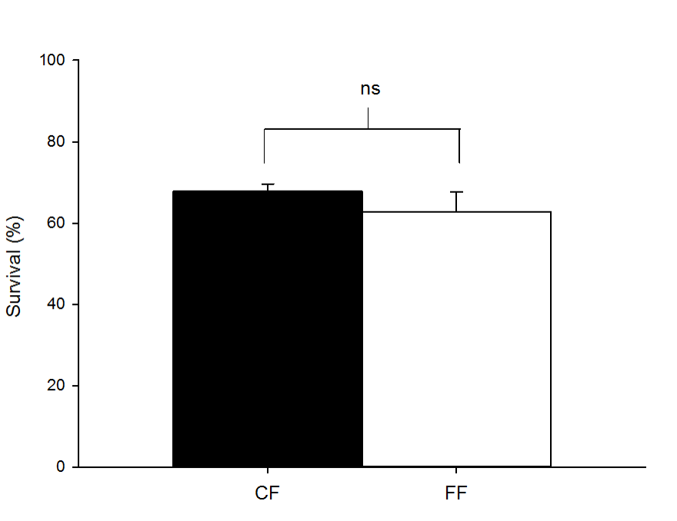

C

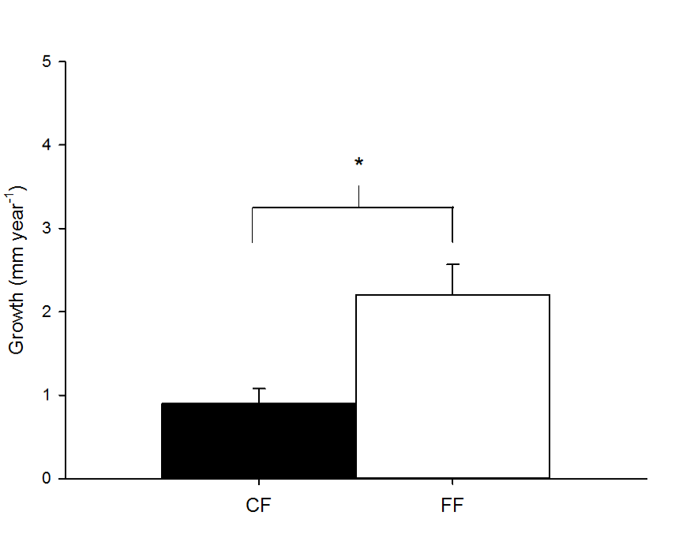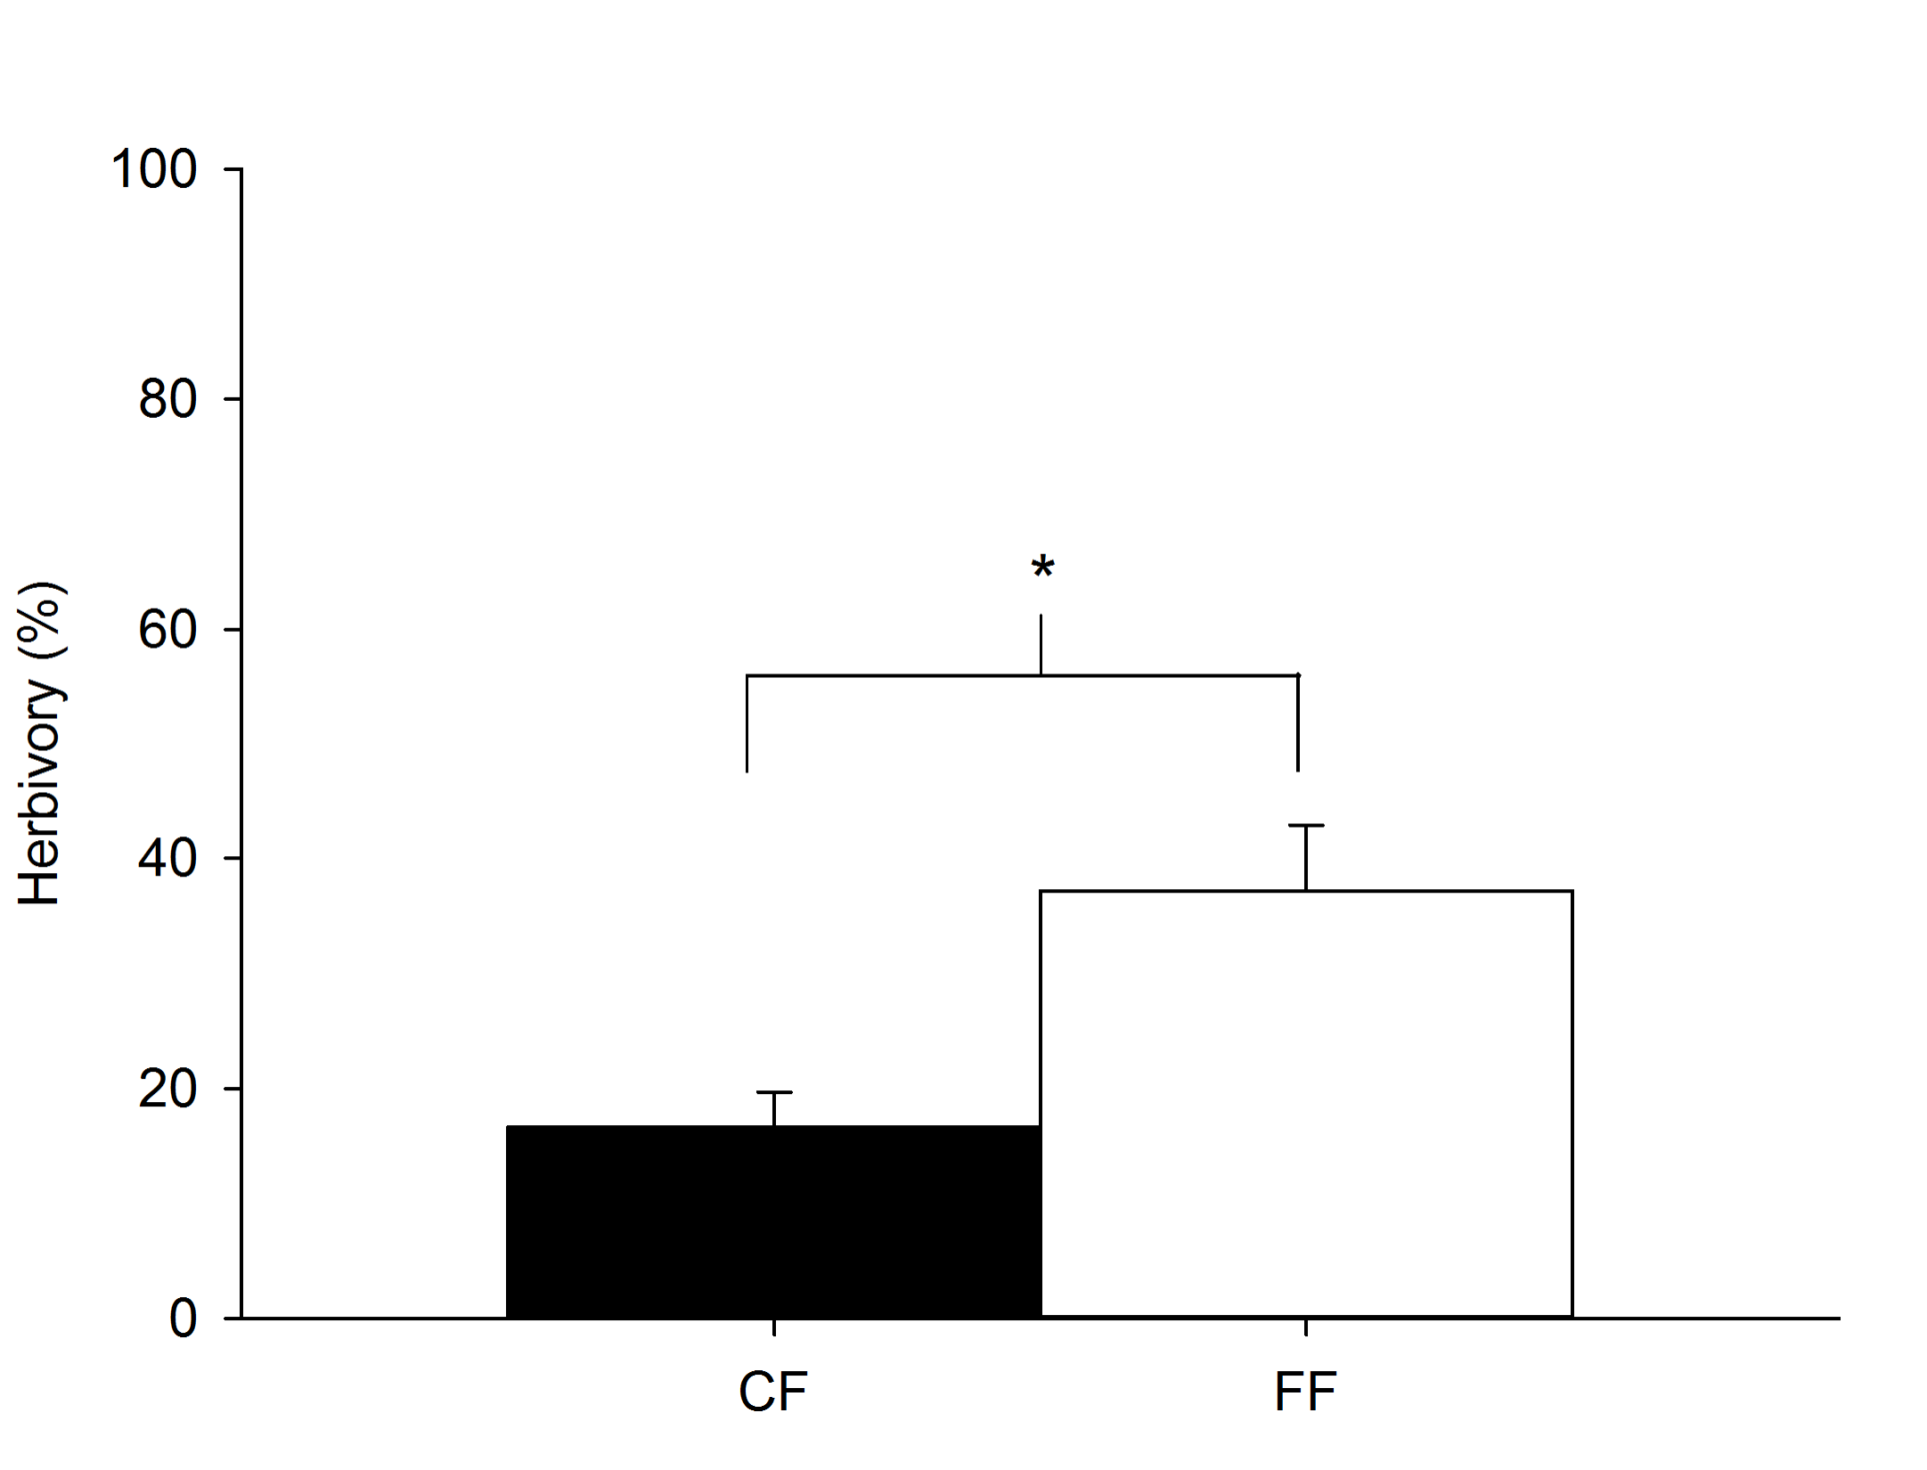

Fig. 2.

B

C

D

E

G

A

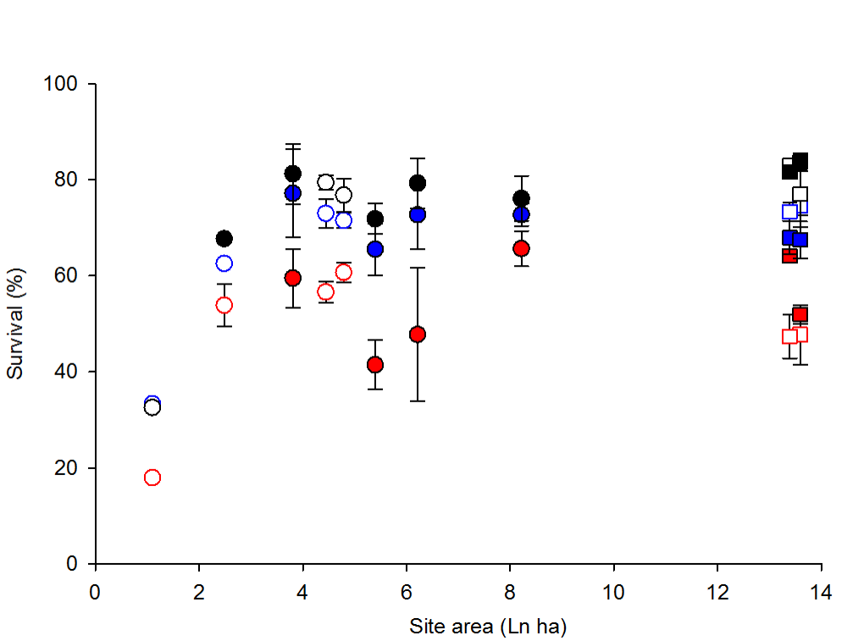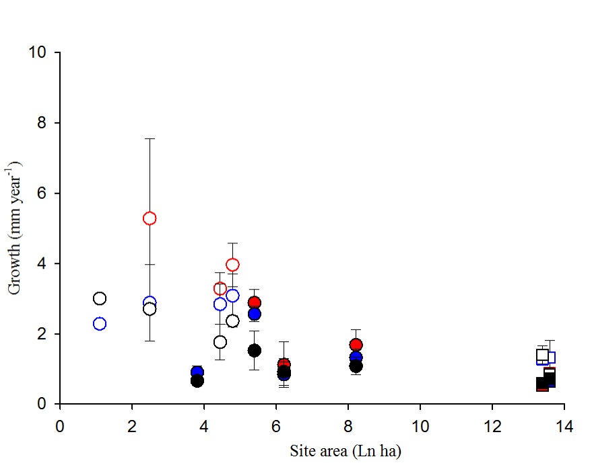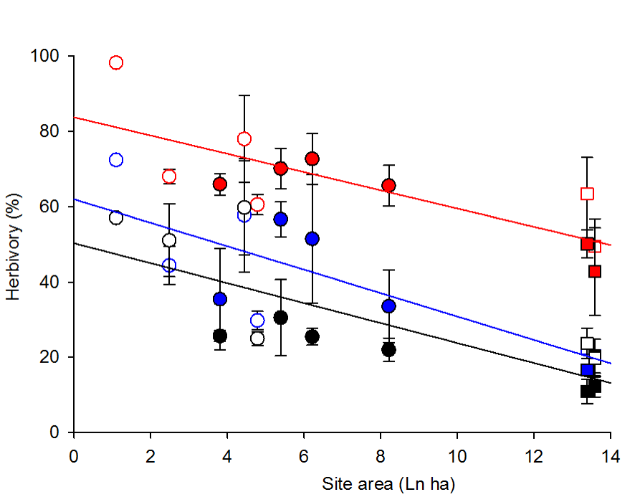

F

H

I

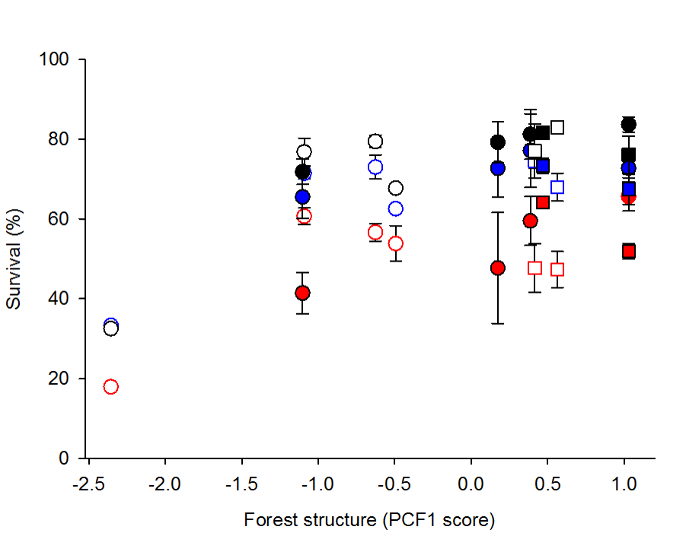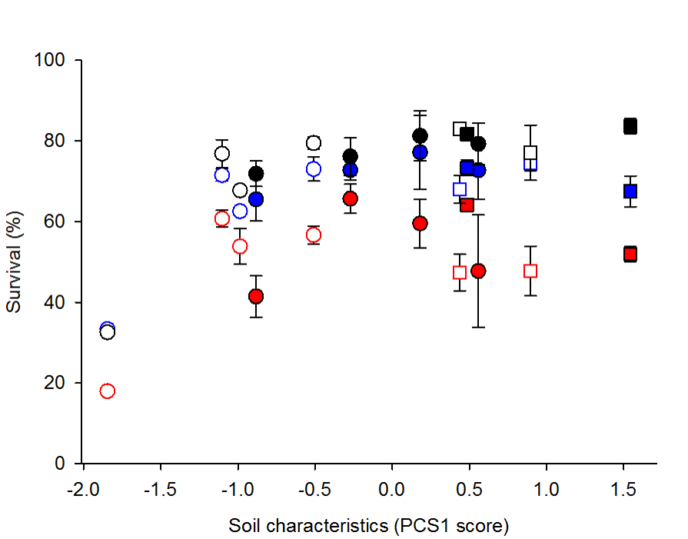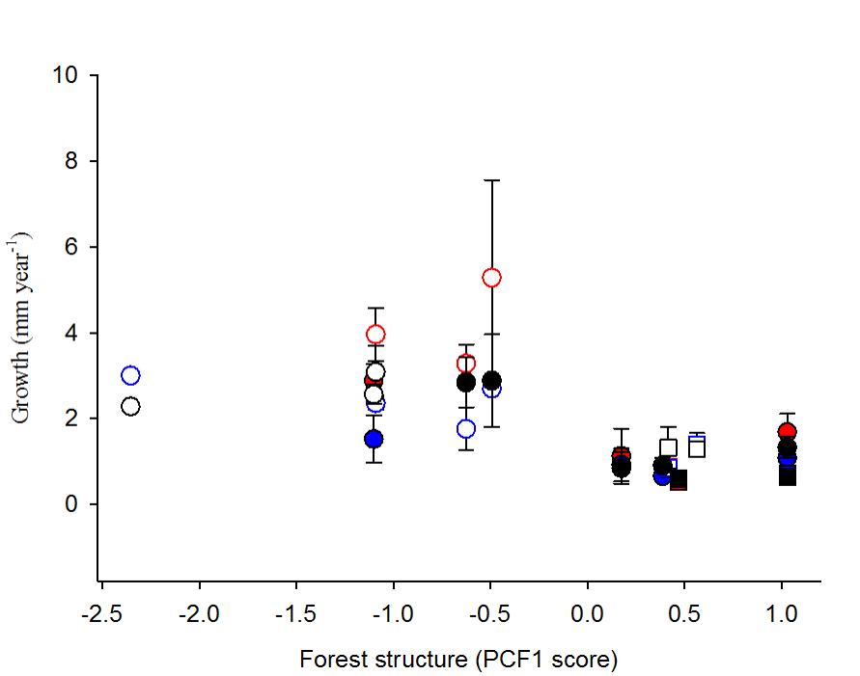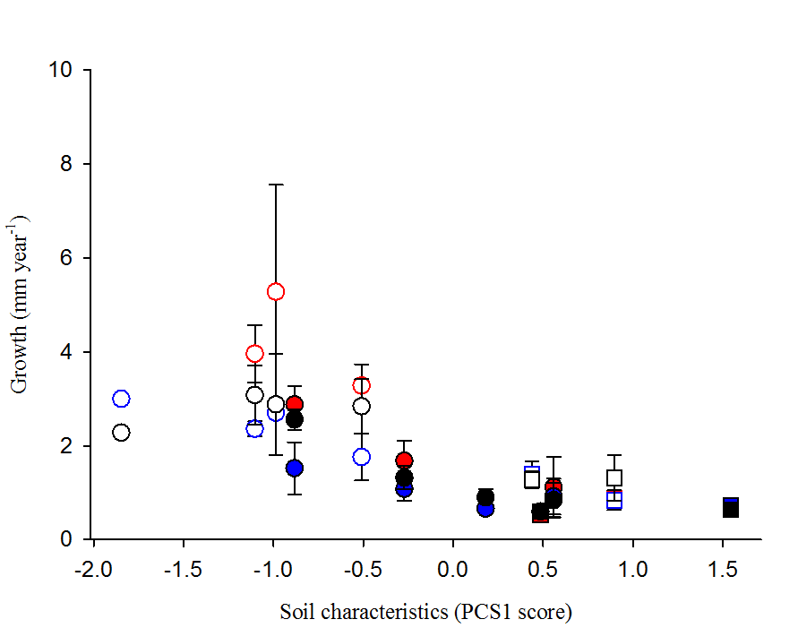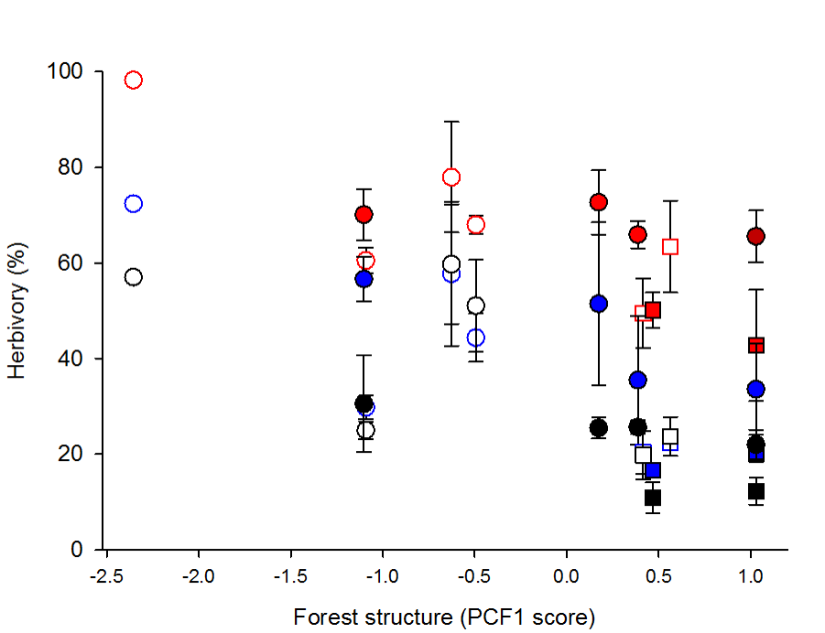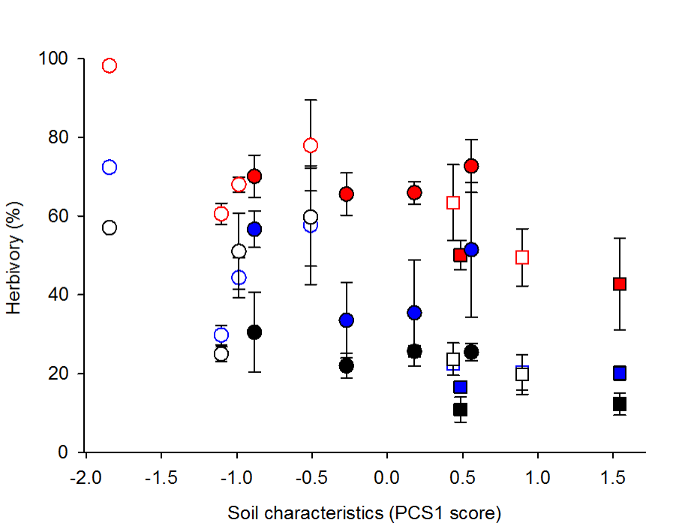

A



F

E

D

Fig. 3

A

B

C



Fig. 4