How Entrainers Enhance Solubility in Supercritical Carbon Dioxide
Seishi Shimizu^{1*} and Steven Abbott^{2,3}
¹York Structural Biology Laboratory, Department of Chemistry, University of York, Heslington, York YO10 5DD, United Kingdom.
²Steven Abbott TCNF Ltd., 7 Elsmere Road, Ipswich, Suffolk IP1 3SZ, United Kingdom.
³School of Mechanical Engineering, University of Leeds, Leeds LS2 9JT, United Kingdom.
Corresponding Author:
Seishi Shimizu
York Structural Biology Laboratory, Department of Chemistry, University of York, Heslington, York YO10 5DD, United Kingdom
Tel: +44 1904 328281, Fax: +44 1904 328281, Email: seishi.shimizu@york.ac.uk
ABBREVIATIONS: KB, Kirkwood-Buff; CO₂, carbon dioxide; scCO₂, supercritical carbon dioxide; EoS, Equation of State; NRTL, Non-Random Two Liquid activity coefficient theory

ABSTRACT

Supercritical carbon dioxide (scCO₂) on its own can be a relatively poor solvent. Yet the addition at relatively modest concentration of “entrainers”, simple solvent molecules such as ethanol or acetone, can provide a significant boost in solubility, thereby enabling its industrial use. However, how entrainers work is still under debate; without an unambiguous explanation it is hard to optimize entrainers for any specific solute. This paper demonstrates that a fundamental, assumption-free statistical thermodynamic theory, the Kirkwood-Buff (KB) theory, can provide an unambiguous explanation of the entrainer effect through an analysis of published experimental data. The KB theory shows that a strong solute-entrainer interaction accounts for the solubility enhancement, while CO₂ density increase and/or CO₂-entrainer interactions, which have been assumed widely in the literature, do not account for solubilization. This conclusion, despite the limited completeness of available data, is demonstrably robust; this can be shown by an order-of-magnitude analysis based upon the theory, and can be demonstrated directly through a public-domain “app”, which has been developed to implement the theory.

1. Introduction

Chemical extraction using supercritical carbon dioxide (scCO₂) is an important industrial process, enabled by overcoming the poor solvent nature of CO₂ through the addition of entrainers. ¹⁻⁵ Entrainers are usually small and simple organic molecules, which can cause dramatic solubility enhancements when added to scCO₂. Despite their widespread use, how entrainers really work is still a much-debated question with different hypotheses, summarized below, which have been proposed as answers to this question:

Hypothesis (i): Preferential entrainer-solute interaction compared to CO₂-solute interaction. Because of the favourable entrainer-solute interaction, the more entrainer in the solution, the more soluble the solute.⁷⁻¹¹

Hypothesis (ii): Heterogeneity of bulk scCO₂ caused either by (a) self-aggregation of entrainers^{12,13} or (b) aggregation of CO₂ around the entrainer.¹⁴⁻¹⁷ Either way, it is the heterogeneity and microstructure of bulk scCO₂ that enhances the interaction between the solute and the CO₂ aggregate, through which solubility increases.

Hypothesis (iii): Because higher scCO₂ density from higher pressure leads to higher solubility, it is plausible that the fluid density increase induced by entrainers would similarly increase solubility.^{18,19} By hypothesis, interaction between carbon dioxide molecules is enhanced through the involvement of entrainers in between, which thus causes local increases in the density of scCO₂ and therefore higher solubility.

The logical consequence of the hypotheses (ii) and (iii) is that the entrainer effect should be identical for all solutes, because no contribution from the properties of solute or solute-solvent interaction have been considered. The immediate counter-example to these hypotheses is ethanol as entrainer, whose solubilisation power depends on whether it can form hydrogen bonds with the solute.²⁰ In addition, a careful simulation study found that the augmentation of local density (hypothesis (iii)) has been shown to play a negligible role.²¹ Such considerations make one wonder if the mechanisms proposed in each hypotheses really make a significant quantitative contribution to solubilisation. To evaluate these hypotheses quantitatively, a clear theoretical guideline is indispensable.

The assumption-free, rigorous Kirkwood-Buff (KB) theory should, in principle, be able to resolve the issues.²²⁻³⁴ Note that the KB theory is chiefly an interpretative tool, which provides a molecular-level understanding starting from thermodynamic data, which has successfully been used on problems as varied as protein folding, small molecule hydrotropy and food and beverage science.²²⁻³⁴ In each case the KB analysis could clearly tell a correct mechanism from hypotheses such as water structure and hydrotrope self-association and show unambiguously the key mechanisms at work.²²⁻³⁴

Previous work³⁵⁻³⁸ applying KB theory to entrainer and co-solvent effects in scCO₂ provided interesting insights but did not lead to a clear and usable explanation of the mechanism. The aim of this paper (and the associated, freely available, open source, on-line “app”) is to show that the relatively simple calculations based upon the KB theory, using datasets taken from the scCO₂ literature, can clearly resolve the mechanism of solubility enhancement.

2. The essence of the Kirkwood-Buff theory

Throughout this paper, we follow the following indexing scheme of Shimizu and Matubayasi:^{24,28} $i=1$ for CO₂, $i=2$ for entrainer, and $i=u$ for solute.

2.1 Solute-entrainer interaction versus entrainer self-association
The central question is how the addition of entrainers into scCO₂ increases the solubility of the solutes. Since solubility is governed by the solute’s pseudochemical potential,$μ_{u}^{*}$ (chemical potential of a solute molecule with fixed centre of gravity),²²⁻³² the key is its dependence on entrainer molar concentration, $c_{2}$, namely, ${\left(\frac{∂μ_{u}^{*}}{∂c_{2}}\right)}_{T,P,c_{u}→0}$, while, as in experiments, $T$ (temperature) and $P$ (pressure) are kept constant.²²⁻²⁴ The quantity ${\left(\frac{∂μ_{u}^{*}}{∂c_{2}}\right)}_{T,P,c_{u}→0}$ can be linked, through KB theory, to the distribution of CO₂ and entrainer molecules around the solute as follows:²²⁻²⁴
$-\frac{1}{kT}{\left(\frac{∂μ_{u}^{*}}{∂c_{2}}\right)}_{T,P,c_{u}→0}=\frac{\left(G_{u2}-G_{u1}\right)}{1+c_{2}\left(G_{22}-G_{21}\right)}$ (1)
where $R$ is the gas constant, and $G_{ij}$ is referred to as the KB integral between the species i and j, defined in terms of radial distribution function $g_{ij}\left(r\right)$ as:
$G_{ij}=4π\int_{0}^{∞}{\left[g_{ij}\left(r\right)-1\right]}r^{2}dr$ (2)
where r is the distance between the centres of the molecular species i and j.²²⁻³⁴ Throughout this paper, the l.h.s. of Eq. (1), $-\frac{1}{RT}{\left(\frac{∂μ_{u}^{*}}{∂c_{2}}\right)}_{T,P,c_{u}→0}$, is referred to as the solubilization gradient. The larger the solubility, the more negative $μ_{u}^{*}$ becomes. Hence the more positive the solubilization gradient, the more effective the entrainer in solubilising the given solute.

The KB integral $G_{ij}$, simply speaking, describes how much each species i is surrounded by other species, j, relative to the bulk density.²²⁻³⁴ (Note that $G_{ii}$ can be interpreted in a similar manner). A large positive integral means that there is increased concentration from the bulk value. ²⁰⁻³² (Note that the KB integrals are defined in the grandcanonical ensemble; thermodynamic relations have been exploited to bridge the $μ$VT ensemble in which the KB theory is constructed and the NPT ensemble in which solubility measurements are carried out.²²⁻³³)

We can immediately translate the precise thermodynamics into chemical intuition: a large solubilization gradient induced by the entrainer occurs when:
- the value of the numerator is high, i.e. relative to their respective bulk densities, there is a lot of entrainer around the solute compared to CO₂ around it ($G_{u2}$ is large compared to $G_{u1}$).²²⁻²⁴
- and/or the denominator is low, i.e. when the entrainer has little self-association compared to association with the CO₂ ($G_{22}$ is comparable to $G_{21}$).²²⁻²⁴ The entrainer concentration $c_{2}$ contributes also to lowering the denominator.

Because the self-association (and therefore density) of the CO₂, $G_{11}$, does not appear in this equation, we can see that assumption-free thermodynamics tells us that CO₂-CO₂ interactions do not directly contribute to solubilisation. But one must bear in mind that CO₂-CO₂ interactions may indirectly affect solubilisation because the entrainer self-association and entrainer-solute interaction are essentially the potential of mean force.²²⁻²⁴ Instead, it is clear that a good entrainer will enhance solubility by having a strong interaction with the solute (large $G_{u2}$) and by having a small self-association (small $G_{22}$). Note that Eq. (1) is concerned with the change of solubility induced by the entrainer.

So we no longer have the question of how an entrainer enhances solubility. Instead we have the question of why a given molecule will show a smaller or larger entrainment effect. In other words we have to know the magnitude of $G_{u2}$ which enhances solubility, and the magnitude of $G_{22}$ which reduces solubility. Although we can hope in the longer term that these values can be calculated from first principles, at present we can use them only in retrospect, calculating them from a few basic values readily obtained in scCO₂ experiments. The app used in this paper (Appendix A) makes it especially easy to generate the key numbers precisely (if extra data are available) or to “good enough” accuracy in the majority of cases. Indeed, the robustness of “good enough” accuracy in inferring the mechanism of entrainer action will be theoretically formulated in Section 4.1; a simple order-of-magnitude comparison of experimental data can identify the cause of the entrainer action.

2.2 From experiments to KB integrals

It turns out that calculations of the KB integrals require just three sets of data: solubilities (converted to pseudo chemical potential³⁴) at the given T and across a range of P; densities (converted to partial molar volumes) of the CO₂+entrainer again across a range of P values; and entrainers’ activity coefficients. The solubility data are available in the literature.³⁹⁻⁴⁵ The density data are not hard to measure but unfortunately sufficient data are not always reported in the literature; so it is generally impossible to derive $V_{1}$ and $V_{2}$ which are the partial molar volumes of CO₂ and entrainer. We instead approximate $V_{1}$ as the pure scCO₂ value which can easily be calculated from the density data⁴⁴, and $V_{2}$ as the infinite dilution values available in the literature.⁴⁷⁻⁵¹ It is hoped that measuring densities of CO₂+solute, CO₂+entrainer and CO₂+entrainer+solute will become standard practice for future publications as these values will generate more accurate values for use within the app. The activity coefficient data can be taken from models such as the non-random two liquid (NRTL) model.⁵² Whilst the calculation of the KB integrals from experimental data is conceptually straightforward, the practice involves a chain of reasoning that can be cumbersome.

A brief summary of the individual steps (presented below) is followed by a more detailed explanation (in Section 3). All equations are either well-known in rigorous KB theory or are derived in the Appendix B.²²⁻³⁴ The pragmatic use of the low-concentration limit approximations is assumed for the solute.²²⁻³³ The steps are as follows:
- Calculate the pseudochemical potential change of the solute between the entrained and non-entrained solubility cases.
- Calculate the gradient of pseudo chemical potential change with respect to entrainer concentration to create a numerical rather than analytical derivative (Eq. (1), l.h.s). If a richer dataset is available, data can be fitted to a polynomial and an analytical derivative can be used.
- Calculate the denominator term, $1+c_{2}\left(G_{22}-G_{21}\right)$ from activity coefficient data for CO₂/entrainer using any activity coefficient model, such as NRTL.⁵²
- Calculate the preferential solute-entrainer interaction, $G_{u2}-G_{u1}$ from the chemical potential change (Eq. (1)) and the denominator term.
- To find both $G_{u2}$ and $G_{u1}$ we need a second equation.^{25,26} This comes from their relationship to the partial molar volume of the solute, $V_{u}$, which, in turn, is derived from density data. (See Section 3.1. for further details).
- Ideally $G_{22}$, $G_{21}$ and $G_{11}$ can be individually calculated from well-known KB relationships²²⁻³³ from activity coefficients and partial molar volumes. Since density data of CO₂/entrainer at the relevant pressures, temperatures and compositions are unavailable, we reluctantly accept that $G_{22}$ and $G_{21}$ cannot be separated using the datasets typically found in the literature.
- By comparing the effects of different entrainers, a broader understanding of their efficacy can be developed, hopefully leading to a more rational design of entrainer systems.

3. Calculation of the Kirkwood-Buff integrals from experimental data

In this section the step-by-step outline in Section 2.2 is described in more detail, and the specific calculations of KB integrals for one entrainer system (the default system in the accompanying app) at one T and P are carried out. Figure 1 shows the interface of the accompanying app, which demonstrates that specifying the inputs is not at all hard and that the outputs are easy to decipher.

The specific (=app default) system chosen in this section for demonstration is benzoic acid at 308 K, 120 bar with and without 3.5 mole % methanol.⁴⁰ The quoted solubilities (in the 120 bar row) as mole fractions are respectively 0.131% and 0. 731%,⁴⁰ i.e. we need to explain why the entrainer has increased solubility by a factor of ~5.5.

3.1. Solubilization gradient and its driving forces

The pseudochemical potential, $μ_{u}^{*}$, can be calculated from the experimental solubility data, relative to the value in the pure CO₂, $μ_{u}^{*0}$. This can be done using the molarity-scale solubility of solutes in pure CO₂ ($c_{u}^{0}$) and in CO₂-entrainer mixture ($c_{u}$).^{22-24,33} Because scCO₂ solubility data are usually quoted in mole fractions ($x_{u}^{0}$ and $x_{u}$) the conversion to molarity requires the trivial conversion via density and molecular weight. The pseudochemical potential change can thus be calculated from the following well-known formula:^{22-24,33}
$μ_{u}^{*}-μ_{u}^{*0}= -RT\ln\left(\frac{c_{u}}{c_{u}^{0}}\right)$ (3)
(Note here that the absolute values of $μ_{u}^{*}$ and $μ_{u}^{*0}$, which would require the free energy of solute sublimation, is unnecessary for the application of Eq. (1); the change of pseudochemical potential, i.e., $μ_{u}^{*}-μ_{u}^{*0}$ is sufficient for the execution of partial differentiation on the right hand side.) The pressure dependent solubility data have been fitted to a 3rd degree polynomial.

The chemical potential change immediately gives us the multi-termed expression in Eq. (1) via the simple approximation that the derivative is obtained by dividing the chemical potential change by the change in entrainer concentration, $c_{2}$. If more data were available at multiple entrainer concentrations then they could be fitted to a polynomial and a more accurate derivative could be calculated. According to Eq. (1), multiplying $-\frac{1}{RT}$ to the derivative gives us the solubilization gradient, $\frac{\left(G_{u2}-G_{u1}\right)}{1+c_{2}\left(G_{22}-G_{21}\right)}$. The task now is to obtain as many individual $G_{ij}$ values as the data allow.

Solubility gradient’s numerator, $G_{u2}-G_{u1}$can be calculated via the standard KB equation containing the partial molar volumes of the three components, $V_{1}$, $V_{2}$ and $V_{u}$:²²⁻³³
$V_{u}= -c_{1}V_{1}G_{u1}-c_{2}V_{2}G_{u2}+RT κ_{T}$ (4)
where $κ_{T}$ is the isothermal compressibility. The term $RTκ_{T}$ can be shown to be negligible by at least two orders of magnitude in the app, through the use of the Span and Wagner equation of state.⁴⁶

To determine $V_{1}$ and $V_{2}$ directly, a careful set of density versus pressure measurements at relevant concentrations of the entrainer is necessary.²²⁻³³ In the absence of such data, we have chosen $V_{1}$ and $V_{2}$ in the following manner. The molar volume of pure CO₂ at the given temperature and pressure has been used as $V_{1}$, because the entrainers are dilute. In the app this value is provided as MWt/density, with the density at the given temperature and pressure calculated from the Span and Wagner equation of state.⁴⁶ Where possible, the infinite dilution $V_{2}$ reported in the literature for various entrainers have been used for $V_{2}$,⁴⁷⁻⁵¹ considering again the diluteness of the entrainers. Note that $V_{2}$ takes large negative values (i.e. the entrainer makes the system more compact) near the critical temperature, and plateaus to a modest level (generally not far from the conventional molar volume) at higher pressures. ⁴⁷⁻⁵¹ However, such a variation of $V_{2}$ does not pose any difficulties, because (1) solubilization is generally carried out at pressures above the critical point^{6,39-45} and (2) any “reasonable” value of $V_{2}$ can be entered by the user who can verify that it makes little difference to the final result (Appendix A). This robustness with regards to $V_{2}$ will be rationalized theoretically in Section 4.

$V_{u}$ can be measured directly from the data typically obtained in any solubility experiment with entrainers: $V_{u}={\left(\frac{∂μ_{u}^{*}}{∂P}\right)}_{T,N_{1},N_{2}}+RTκ_{T}$, i.e. the change of Gibbs free energy with pressure, which in turn comes from the change of chemical potential (derived as above) with pressure.²²⁻³³ The app provides a polynomial fit (line) to the solubility data (points) with and without entrainer and the required derivative at a chosen pressure is trivially calculated. (The contribution from the isothermal compressibility is again negligibly small, which can also be demonstrated in the output of the app.)

What remains to be done for the calculation of $G_{u2}$ and $G_{u1}$ is the calculation of the denominator of Eq. (1), i.e., $1+c_{2}\left(G_{22}-G_{12}\right)$.

Solubility gradient’s denominator, can be calculated from experimental data through the use of the following rigorous KB relationship derived in Appendix B:
$1+c_{2}\left(G_{22}-G_{21}\right) =\frac{RT}{{c_{2}\left(\frac{∂μ_{2}}{∂c_{2}}\right)}_{T,P}}=-\frac{RT}{c_{1}{\left(\frac{∂μ_{1}}{∂c_{2}}\right)}_{T,P}}$ (5)

The derivatives can be calculated using activity coefficients obtained via any convenient methodology. Because it is readily available, we employed the NRTL model;⁵² the app uses the $τ_{12}$ and $τ_{21}$ values along with a $σ$ value usually assumed to be 0.3.⁵² Again due to the sparseness of data reported in the literature, it is hard to track down reliable values for these parameters at the specific pressures and temperatures. We hope that more extensive thermodynamic data collection will be undertaken. Our intention, in the meantime, is to establish the method of analysis based upon the KB theory, implemented by the app, which facilitate the examination of the robustness of our conclusion. Once again, the user can verify that modest changes to NRTL values do not significantly alter the dominance of the $G_{u2}$ term for solubilization.

3.2. Calculating the KB integrals from limited experimental data

We have 3 equations with 4 unknowns, so we can extract only 3 values, $G_{u2}$, $G_{u1}$ and $G_{22}-G_{21}$.^{25,28} From the pseudo chemical potential (solubility difference) with entrainer we have the value for the full solubilization gradient. Independently we have $1+c_{2}\left(G_{22}-G_{21}\right)$ so combining them we can calculate the numerator $G_{u2}-G_{u1}$. Via the solubility versus pressure curves we have $V_{u}$ and from Eq. (4) and with our “reasonable” estimates of $V_{1}$ and $V_{2}$ we can solve the simultaneous equations involving $G_{u2}$ and $G_{u1}$.

With the specific example shown, it is clear that by far the dominant term in terms of solubilizing benzoic acid is $G_{u2}$ (~3000 cm³/mol), which is greater than $G_{u1}$ (~700 cm³/mol). Although we do not know $G_{22}$ and $G_{21}$ independently, we can see that their balance is only ~100 cm³/mol and in any event, because of the small value of $c_{2}$ (0.6 M methanol compared to 17 M CO₂), the net effect is a value of 1.08 for the $1+c_{2}\left(G_{22}-G_{21}\right)$ term which means that any self-clustering of methanol compared to methanol-CO₂ interactions, is reducing the solubilization effect by 8%. Self-clustering, far from being a driving force for solubilization,^{12,13} provides a modest, but unwelcome, reduction in solubility.

All the KB integrals, $G_{22}$, $G_{21}$ and $G_{11}$, can in principle be calculated by a combination of activity and volumetric data through a well-established KB-inversion procedure, which has been applied to a number of fluid mixtures.²²⁻³³ In scCO₂, however, there is the unfortunate lack of systematic thermodynamic data suitable for the analysis by the KB theory. Hence our aim in this paper is to establish a robust method of analysis, which can extract reliable estimates of the KB integrals, at least in terms of the better-than order-of-magnitudes, based upon limited experimental data available; $V_{1}$ is approximated as the value of pure scCO₂, and the infinite dilution value of $V_{2}$ have been used.⁴⁷⁻⁵¹ The robustness of such an approach is guaranteed by the theory (see Section 4.1), and can be demonstrated interactively by the app.

The entrainers work via solute-entrainer interaction $G_{u2}$. This important conclusion, which has been demonstrated using one entrainer (methanol) on one solute (benzoic acid) at one temperature and pressure,⁴⁰ is general, as demonstrated in Table 1, together with the input data summarized in Table 2. Despite the unfortunate lack of exact $V_{1}$ and $V_{2}$ data, plus the difficulties of finding reliable NRTL parameters,⁵² the robustness of this conclusion will be shown theoretically in Section 4.1, and can be demonstrate by the app.

The solute-entrainer interaction $G_{u2}$ becomes closer to the solubilization gradient as the pressure goes up and away from the critical pressure. This can be seen from Figure 2 (solubilization of benzoic acid using methanol and hexane as entrainers), Figure 3 (solubilization of cholesterol using acetone as entrainer) and Figure 4 (solubilization of naproxen using isopropanol). These results have been obtained from the app, using a polynomial fitting of solubility and density data with respect to the pressure. Since solubilization is carried out in practice at much higher pressures than the critical, Figures 2-4 suggest that $G_{u2}$ is indeed the dominant factor determining entrainer-induced solubilization.

4. A statistical thermodynamic examination of the classical hypotheses on how entrainers work

A general picture emerged in Section 3 through a systematic, app-assisted calculation of KB integrals, that solute-entrainer interaction is the dominant driving force of solubilization. This conclusion is shown here to be robust and general. To this end, a simple theoretical analysis, assisted by an order-of-magnitude analysis of experimental data, is sufficient, as will be shown below. Such an approach can also be used to examine the validity of the classical hypotheses on the origin of the entrainer effect as summarized in the Introduction.

4.1. Solute-entrainer interaction (hypothesis (i)).

A strong solute-entrainer interaction, $G_{u2}$ is the major driving force of the entrainer effect.⁷⁻¹¹ This conclusion is general and robust, as can be shown by the following simple order-of-magnitude analysis suggested by the theory.

Eq. (1), (4) and (5) can be solved to yield
$-\frac{1}{RT}{\left(\frac{∂μ_{u}^{*}}{∂c_{2}}\right)}_{T,P,c_{u}→0}=\frac{1}{1+c_{2}\left(G_{22}-G_{21}\right)}\left[\left(1+\frac{c_{2}V_{2}}{c_{1}V_{1}}\right)G_{u2}+\frac{V_{u}}{c_{1}V_{1}}\right]$ (6)
where the negligibly small $RTκ_{T}$ has been ignored. According to Eq. (6), the solute-entrainer interaction, $G_{u2}$, is the dominant contributor to $-\frac{1}{RT}{\left(\frac{∂μ_{u}^{*}}{∂c_{2}}\right)}_{T,P,c_{u}→0}$, namely
$-\frac{1}{RT}{\left(\frac{∂μ_{u}^{*}}{∂c_{2}}\right)}_{T,P,c_{u}→0}≃G_{u2}$ (7)
when the following conditions are met:
- $\left|\frac{V_{u}}{c_{1}V_{1}}\right|≪\left|\frac{1}{RT}{\left(\frac{∂μ_{u}^{*}}{∂c_{2}}\right)}_{T,P,c_{u}→0}\right|$
- $\left|c_{2}\left(G_{22}-G_{21}\right)\right|≪1$
- $\left|\frac{c_{2}V_{2}}{c_{1}V_{1}}\right|≃\left|\frac{c_{2}G_{21}}{c_{1}V_{1}}\right|≪1$

The order-of-magnitude analysis summarized by Table 3 and carried out by the app shows that the conditions 1-3 are met accurately by the experimental data used in this paper. Indeed, it is easy to see in Table 3 that the conditions 2 and 3 hold true from the values of $c_{2}\left(G_{22}-G_{21}\right)$ and $c_{2}V_{2}/c_{1}V_{1}$, both of which are much smaller than 1 for all the examples. To examine whether the condition 1 is satisfied, a comparison between $G_{u2}$ and $V_{u}/c_{1}V_{1}$will be sufficient, since we have established that $G_{u2}-G_{u1}$ is dominated by $G_{u2}$. For all the examples in Table 3, we observe $G_{u2}≫V_{u}/c_{1}V_{1}$, showing that the condition 1 is also satisfied. Thus solubilization can be attributed almost entirely to the preferential solute-entrainer interaction; the contribution from entrainer self-association is very small. This conclusion, based upon a rigorous theory and an order-of-magnitude of the data, is considered to be robust.

4.2. Entrainer-entrainer interaction (hypothesis ii(a)).

Entrainer self-association^{12,13} cannot be unambiguously determined from the data without high-quality density/pressure data for a range of relevant entrainer concentrations. However, in all the examples in the table $G_{22}-G_{21}$ is of modest size and the contribution from $1+c_{2}\left(G_{22}-G_{21}\right)$ is a modest reduction (a few percent) in the solubilization gradient. As it is unlikely that G₂₁ is especially large it is reasonable to assume that both $G_{22}$ and $G_{21}$ are modest, giving a modest overall value to their difference. Thus, in opposition to the assertion that entrainer self-association is the cause of enhanced solubility,^{12,13} the self-association reduces solubility. This captures the intuition that any entrainers which are self-associating are incapable of associating with, and enhancing the solubility of, the solute. The analogy with small-molecule hydrotropy is valid: despite the decades-old assumption that hydrotrope self-association was a necessary precursor to solubilization, it is clear from KB theory that the self-association reduces the overall efficacy of the hydrotrope.²²⁻²⁵

4.3. Entrainer-induced density increase and CO₂ clustering around the entrainer (hypotheses (ii-b) and (iii)).

The fact that the entrainer increases the density of the system is not in doubt. To say that solubility is increased “because of the increased density” does not constitute an explanation. For example, using our default dataset, in the presence of 3.5 % methanol, a slight density increase from 0.77 to 0.789 g cm⁻³ accompanies a 5.5 times increase of solubility,⁴⁰ whereas in pure CO₂, the solubility increase of 43 % is accomplished by a density increase from 0.77 at 120 bar to 0.811 g cm⁻³ at 150 bar.⁴⁰ Such a quick inspection of density data is sufficient to cast doubts on the density-increase hypothesis.

Encouraged by the above observation, let us examine the density hypothesis. Before doing so, we show first that the fluid density hypothesis (iii)^{18,19} and the CO₂ clustering hypothesis (ii-b)¹⁴⁻¹⁷ are equivalent, when the entrainer concentration is sufficiently low. Note, first of all, that CO₂ density can be expressed either in terms of the molar concentration $c_{1}$, or mass per volume $M_{1}c_{1}$, where $M_{1}$ is the molar mass of CO₂; they are different only by the factor $M_{1}$, hence we focus on the molar concentration. Now let us translate the fluid density hypothesis (iii)^{18,19} into the language of statistical thermodynamics. The entrainer-induced increase in the CO₂ density can be expressed as ${\left(\frac{∂c_{1}}{∂c_{2}}\right)}_{T,P}$ under constant $P$ and $T$, which can be linked to the KB integrals as
${\left(\frac{∂c_{1}}{∂c_{2}}\right)}_{T,P}=-\frac{1+c_{1}(G_{11}-G_{12})}{1+c_{2}\left(G_{22}-G_{12}\right)}$ (8)
See Appendix C for derivation. At dilute entrainer concentration limit, Eq. (8) becomes:
${\left(\frac{∂c_{1}}{∂c_{2}}\right)}_{T,P;c_{2}→0}=c_{1}^{0}G_{12}^{0}=-\frac{V_{2}^{0}}{V_{1}^{0}}$ (9)
when we ignore the negligible terms relating to the isothermal compressibility of CO₂ (Appendix C), and the superscript $0$ denotes the dilute limit of $c_{2}$. Eq. (9) shows that the entrainer-induced density increase (l.h.s. of Eq (9), i.e., hypothesis (iii)) is equivalent to the CO₂-entrainer KB parameter $G_{21}^{0}$, which represents the increased concentration of CO₂ around the entrainer (hypothesis (ii-b)). Hypotheses (ii-b) and (iii) are thus equivalent.

Hypotheses (ii-b)+(iii) can now be evaluated. If this hypothesis were true, there would be a correlation between ${\left(\frac{∂c_{1}}{∂c_{2}}\right)}_{T,P;c_{2}→0}$ and the solubilization gradient. Here we examine this using the solubility data of benzoic acid in the presence of methanol and hexane as entrainers (a more extensive analysis of experimental data has not been possible due to the lack of data).

Within each entrainer, we observe that ${\left(\frac{∂c_{1}}{∂c_{2}}\right)}_{T,P}$ indeed correlates with the solubilization gradient (Figure 5). However, two entrainers (hexane and methanol) show completely different correlation with the solubilization gradient, which shows clearly that entrainer-induced fluid density increase (hypothesis (iii))¹⁴⁻¹⁷ and CO₂ clustering around entrainers (hypothesis (ii-b))^{18,19} cannot be a universal driving force which explains the effect of all entrainers.

5. Conclusion

How do entrainers improve the solubility of solutes in scCO₂? To answer this question at a molecular basis, we have employed the Kirkwood-Buff (KB) theory of solutions, which is an exact theory of statistical thermodynamics.²²⁻³⁷ The theory probes the driving force of solubilization in terms of preferential interactions, using basic experimental thermodynamic data.²²⁻³⁷

Based upon the KB theory, we have identified the driving force of entrainer-induced solubilization which is preferential entrainer-solute interaction.⁷⁻¹¹ In addition there is a small effect that reduces solubilization via self-aggregation of the entrainers, in stark contrast to the classical hypothesis that self-aggregation is the driving force for solubilization.^{12,13,22-24}

KB theory, furthermore, has shown that the other two classical hypotheses, CO₂ clustering around the entrainer (hypothesis (ii)(b) in Introduction)¹⁴⁻¹⁷ and entrainer-induced CO₂ density increase (hypothesis (iii) in Introduction),^{18,19} are merely one factor: the entrainer-CO₂ interaction represented by the entrainer-CO₂ KB integral, which is shown to make a negligibly small contribution to the solubilization.

The advantage of our analysis is in the rigorous nature of the KB theory,²²⁻³⁷ which enables an examination of the hypotheses on the entrainer action from first-principles. This is in stark contrast to all other thermodynamic models that involve various degrees of approximations and assumptions and historically have provided no resolution to the debate on entrainer effects.

These conclusions are reached despite the absence, for practical reasons, of some of the detailed numbers (such as $V_{1}$ and $V_{2}$ and the NRTL $τ_{12}$ and $τ_{21}$ values⁵²) required for calculation of all KB integrals. Yet our overall conclusion is expected to be robust: $G_{u2}$ is dominant in every example shown in Table 1, underscoring the universality of the dominance of solute-entrainer interaction.²²⁻²⁸ The validity of our conclusion, however, can be evaluated for different solute-entrainer pairs, as well as the different sets of thermodynamic data and parameters, using the app and datasets accompanying this paper or via loading new datasets into the app. We also hope that such an app will inspire a systematic approach to thermodynamic measurements, which will rectify the unfortunate shortage of data analysable by the KB theory.

Throughout this paper, we have employed the infinite dilution approximation for the solutes, following earlier applications of KB theory to solubilisation in aqueous solutions. This approach may not yield a good approximation, when there is a strong tendency for a solute to self-associate even in very dilute solutions in scCO₂.⁵³ This solute self-association may be the source of severe difficulties in the simulation-based prediction of the entrainer effect, and may pose difficulties in applying infinite dilution approximation in the case of carboxylic acids.²¹ Extending the KB theory to incorporate solute-solute interaction is possible,³⁵⁻³⁷ yet the resulting formulae are cumbersome. Therefore a tractable theory of the entrainer effect which account for solute self-association is a necessary task.

With this clarification of the driving force, and with the advent of more (and higher quality) KB integrals it is hoped that the scCO₂ community can discuss not what the mechanism is, but rather why one entrainer has a larger enhancement than another. We might then be able to move to a regime of predicting the optimum entrainer, which is a hard problem but one that is made easier by better understanding of which problem has to be solved.

Appendix A: The “app” accompanying this paper.

The accompanying app, named scCO2, can be run from http://www.stevenabbott.co.uk/Practical-Solubility/scCO2.php. The screen shot, showing the input-output interface, is found in Figure 1. This appendix serves as a brief users’ manual.

Users can load any of the 16 datasets taken from the literature or can easily create their own datasets and load those.

The solubility and density versus pressure data (with and without entrainer) are the most important input for the calculation of the solubilization gradient (l.h.s. of Eq. (1)). All the data that have been analysed in this paper, are loadable within the app for each system, so that users are encouraged to form their own judgement about the values and their interpretation. More importantly, the app can calculate the KB integrals as soon as the new solubility and density data have been added. The separation of the solubilization gradient into the numerator and denominator of the r.h.s. of Eq. (1) is carried out using NRTL parameters from the literature.⁵⁰

Decomposing the solubilization gradient into $G_{u1}$ and $G_{u2}$ requires the partial molar volume of CO₂ ($V_{1}$) and entrainer ($V_{2}$). While the former is calculated from EOS,⁴⁶ $V_{2}$ should be inputted by the user, based upon literature⁴⁷⁻⁵¹ or experimental measurements. Whilst it is always preferable to have accurate values, and whilst it would be nice if someone else did the work to obtain them for all relevant entrainers, the pragmatic approach of putting in a “reasonable” value gives satisfactory overall results. The robustness of our conclusion over a reasonable variation of $V_{2}$ can be explored interactively by adjusting $V_{2}$ over any reasonable range; the users can see for themselves that the overall conclusions are not significantly altered.

The main conclusion from our paper is that the solute-entrainer KB integral, $G_{u2}$, is the dominant contribution to the solubilization gradient. We have shown that the accuracy of this conclusion is subject to the three conditions given in Section 4.1, whose validity can be examined live on the app.

For those seeking a hands-on guide to KB theory, the same website offers a step-by-step guide to the key ideas, along with a rather similar app which shows that the effects of small molecule hydrotropes such as urea or nicotinamide can be analysed in an analogous manner and that G_{u2} again dominates the mechanism of solubility enhancement.

Appendix B: KB theory of solubilization gradient

Here we derive Eqs. (1) and (4) from first principles based upon inhomogeneous solution theory.²⁴ The advantage of this novel approach is in its simplicity while being rigorous.

Statistical thermodynamic foundation: Consider a mixture of carbon dioxide ($i=1$) and entrainer ($i=2$) molecules. The grand potential $J$can be expressed in terms of grand partition function $Ξ$ in the following manner:²⁴
$J=-kT\ln{Ξ(V,μ_{1},μ_{2})}$ (B1)
in which the temperature $T$, which is kept constant throughout the discussion, is omitted. (Note that k is the Boltzmann constant, which is used throughout this appendix, together with $c_{i}$ as number density and $V_{i}$ expressed as volume per molecule, which have been necessitated by statistical thermodynamics. Conversion to molar quantities, as have been used in the main text, is straightforward). Here we consider two systems: with and without the solute ($i=u$) molecule fixed at the origin. When the fixed solute molecule is present, it acts as the source for an external field for CO₂ and entrainers. Such a solution is inhomogeneous.²⁴ When the fixed solute molecule is absent, the system consists only of CO₂ and entrainers, and is homogeneous.²⁴ The chemical potential of the fixed solute molecule $μ_{u}^{*}$ can be expressed in terms of the grand partition functions of the homogeneous $Ξ_{0}$ and inhomogeneous systems $Ξ_{u}$in the following manner:²⁴
$μ_{u}^{*}=J_{u}-J_{0}=-kT\ln{\frac{Ξ_{u}(V_{u},μ_{1},μ_{2})}{Ξ_{0}(V_{0},μ_{1},μ_{2})}}$ (B2)
From Eq. (B2), we have the following fundamental relationship:
$-dμ_{u}^{*}=kT\sum_{i}{\left[\frac{1}{Ξ_{u}} \frac{∂Ξ_{u}}{{∂μ}_{i}}-\frac{1}{Ξ_{0}}\frac{∂Ξ_{0}}{∂μ_{i}}\right]dμ_{i}}=\sum_{i}{\left[{〈N_{i}〉}_{u}-{〈N_{i}〉}_{0}\right]dμ_{i}}$ (B3)
where 〈 〉 refers to ensemble average. Note that effect of the fixed CO₂ molecule is localized; this is satisfied when $V_{u}-V_{0}=o(1)$. Consequently, in the following, we put $V_{1}=V_{0}≡V$.²⁴

Our next goal is to simplify Eq. (B3) using another relationship between $μ_{1}$ and $μ_{2}$. This can be executed by considering the pressure $P$ of the system, which can be obtained from the grand partition function as
$P=\frac{kT}{V}\ln{Ξ\left(V,μ_{1},μ_{2}\right)+o(1)}$ (B4)
which is valid both for inhomogeneous and homogeneous systems (hence has been presented without the subscript 0 or 1).²⁴ From Eq. (B4), it easily follows that
$dP=\sum_{i}{\frac{kT}{V}\frac{1}{Ξ}\frac{∂Ξ}{∂μ_{i}} dμ_{i}}+o\left(1\right)=\sum_{i}{\frac{〈N_{i}〉}{V}}dμ_{i}+o(1)$ (B5)
which is the Gibbs-Duhem equation. Combining Eqs. (B3) and (B5) under constant pressure ($dP=0$), we obtain:
$-dμ_{u}^{*}=\left\{\left[{〈N_{2}〉}_{u}-{〈N_{2}〉}_{0}\right]-\frac{\frac{{〈N_{2}〉}_{0}}{V}}{\frac{{〈N_{1}〉}_{0}}{V}}\left[{〈N_{1}〉}_{u}-{〈N_{1}〉}_{0}\right]\right\}dμ_{2}$ (B6)
Now we introduce the following KB integrals, defined as,
$G_{ui}=V\frac{{〈N_{i}〉}_{u}-{〈N_{i}〉}_{0}}{{〈N_{i}〉}_{0}}$ (B7)
The equivalence between Eqs. (2) and (B7) is well established, which should be referred to Refs 24, 33 and 34. By the help of Eq. (B7), Eq. (B6) can be rewritten into the following form:
$-dμ_{u}^{*}=c_{2}\left(G_{u2}-G_{u1}\right)dμ_{2}$ (B8)
This is the fundamental equation.²⁴

Derivation of Eq. (1): To derive Eq. (1), let us differentiate Eq. (B8) with respect to $c_{2}$
$-{\left(\frac{∂μ_{u}^{*}}{∂c_{2}}\right)}_{T,P,n_{u}→0}=c_{2}\left(G_{u2}-G_{u1}\right){\left(\frac{∂μ_{2}}{∂c_{2}}\right)}_{T,P,c_{u}→0}$ (B9)
Now we must evaluate ${\left(\frac{∂μ_{2}}{∂c_{2}}\right)}_{T,P,c_{u}→0}$. To do so, let us repeat the same argument as before, taking an entrainer molecule ($i=2$), whose centre of mass is fixed in the solution, as the solute. We consider again the two systems: an inhomogeneous system with a fixed entrainer molecule as the source of external field, as well as a homogeneous system without the fixed entrainer molecule. This is effectively to repeat the same argument as Eqs. (B1) to (B8); the only difference this time is equating $u=2$, which leads to
$-{\left(\frac{∂μ_{2}^{*}}{∂c_{2}}\right)}_{T,P}=c_{2}\left(G_{22}-G_{21}\right){\left(\frac{∂μ_{2}}{∂c_{2}}\right)}_{T,P}$ (B10)
Now the chemical potential of the fixed entrainer molecule $μ_{2}^{*}$ should be related back to $μ_{2}$ through the following well-known formula:
$dμ_{2}^{*}=dμ_{2}-kTd\ln{\frac{{〈N_{2}〉}_{0}}{V}}$ (B11)
Combining Eqs. (B10) and (B11), we obtain the following:
${\left(\frac{∂μ_{2}}{∂c_{2} }\right)}_{T,P}=\frac{kT}{c_{2}\left[1+c_{2}\left(G_{22}-G_{21}\right)\right]}$ (B12)
which is equivalent to Eq. (5). The remaining part of Eq. (5) can be derived through $c_{2}{\left(\frac{∂μ_{2}}{∂c_{2} }\right)}_{T,P}=-c_{1}{\left(\frac{∂μ_{1}}{∂c_{2} }\right)}_{T,P}$, which can be derived straightforwardly from the Gibbs-Duhem equation for CO₂-entrainer mixture. From here, Eq. (1) can be derived straightforwardly by combining Eqs. (B9) and (B12).

Derivation of Eq. (4): From Eqs. (B3) and (B7), we have
$-{\left(\frac{∂μ_{u}^{*}}{∂P}\right)}_{T,P,N_{1},N_{2},N_{u}→0}=c_{1}V_{1}G_{u1}+c_{2}V_{2}G_{u2}$ (B13)
Using the definition of the pseudochemical potential, ${dμ}_{u}^{*}={dμ}_{u}-RTd\ln{c_{u}}$, Eq. (B13) can be rewritten as
$-{\left(\frac{∂μ_{u}}{∂P}\right)}_{T,P,N_{1},N_{2},N_{u}→0}-\frac{RT}{V}{\left(\frac{∂V}{∂P}\right)}_{T,P,N_{1},N_{2},N_{u}→0}=c_{1}V_{1}G_{u1}+c_{2}V_{2}G_{u2}$ (B14)
Using the definition of the isothermal compressibility $κ_{T}=-\frac{1}{V}{\left(\frac{∂V}{∂P}\right)}_{T,P,N_{1},N_{2},N_{u}→0}$, we obtain Eq. (4).

Appendix C: KB theory of entrainer-induced CO₂ density change

Derivation of Eq. (8). Exchanging the indexes $1$ and $2$ in Eq. (B12) yields²³⁻²⁵
${\left(\frac{∂μ_{1}}{∂c_{1} }\right)}_{T,P}=\frac{RT}{c_{1}\left[1+c_{1}\left(G_{11}-G_{21}\right)\right]}$ (C1)
Combining Eq. (C1) with the Gibbs-Duhem equation (Eq. (B5) with $dP=0$), we obtain
${\left(\frac{∂μ_{2}}{∂c_{1} }\right)}_{T,P}=-\frac{RT}{c_{2}\left[1+c_{1}\left(G_{11}-G_{21}\right)\right]}$ (C2)
Combining Eqs. (C2) and (B12), we obtain:
${\left(\frac{∂c_{1}}{∂c_{2}}\right)}_{T,P}=\frac{{\left(\frac{∂μ_{2}}{∂c_{2} }\right)}_{T,P}}{{\left(\frac{∂μ_{2}}{∂c_{1} }\right)}_{T,P}}=-\frac{1+c_{1}\left(G_{11}-G_{21}\right)}{1+c_{2}\left(G_{22}-G_{21}\right)}$ (C3) which is Eq. (8).

Derivation of Eq. (9). The first key to derivation is
$G_{11}^{0}=-\frac{1}{c_{1}^{0}}+RTκ_{T}$ (C4)
which, in combination to Eq. (3) at $c_{2}→0$, yields Eq. (9); $RTκ_{T}$, as before, is negligibly small. Eq. (C4) can be derived by differentiating Eq. (B3) with respect to $P$, in combination with Eq. (B6) under the condition that $u=1$ and there is no component $2$ in the solution. We obtain
$-{\left(\frac{∂μ_{1}^{*}}{∂P}\right)}_{T,N_{1}}=c_{1}^{0}G_{11}^{0}V_{1}^{0}=G_{11}^{0}$ (C5)
where $V_{1}^{0}={\left(\frac{∂μ_{1}}{∂P}\right)}_{T,N_{1};N_{2}→0}$ is the partial molar volume of CO₂, which, in pure solvent, $V_{1}^{0}=\frac{1}{c_{1}^{0}}$ . ${\left(\frac{∂μ_{1}^{*}}{∂P}\right)}_{T,N_{1};N_{2}→0}$, by the use of its definition, can be shown to be
${\left(\frac{∂μ_{1}^{*}}{∂P}\right)}_{T,N_{1};N_{2}→0}={\left(\frac{∂μ_{1}}{∂P}\right)}_{T,N_{1};N_{2}→0}+RT\frac{1}{V}{\left(\frac{∂V}{∂P}\right)}_{T,N_{1};N_{2}→0}=V_{1}^{0}-RTκ_{T}$ (C6)
where $κ_{T}$ is the isothermal compressibility. Combination of Eqs. (C5) and (C6) yields Eq. (C1). The second key to derivation is
$V_{2}^{0}=-G_{21}^{0}+RTκ_{T}$ (C7)
which can be derived straightforwardly from Eq. (4) at $c_{2}→0$ and $u=2$. Combining Eqs. (C4) and (C7) with Eq. (C3) at $c_{2}→0$ yields Eq. (9). Note that Eq. (9) has been known valid beyond the $c_{2}→0$ limit.³³

Acknowledgments

We are grateful to Andy Hunt for stimulating discussions, and to Edward Matthews for his assistance in the preliminary calculations.

References
- Eckert, C.A.; Knutson, B. I.; Debenedetti, P. G. Supercritical Fluids as Solvents for Chemical and Materials Processing. Nature, 1996, 383, 313–318.
- Reverchon, E. Supercritical Fluid Extraction and Fractionation of Essential Oils and Related Products. J. Supercrit. Fluids, 1997, 10, 1–37.
- Chiavlo, A. A.; Cummings, P. T. Solute-Induced Effects on the Structure and Thermodynamics of Infinitely Dilute Mixtures. AIChE J., 1994, 40, 1558–1573.
- Gopalan, A. S.; Wai, C. M.; Jacobs, H. K. Supercritical Carbon Dioxide. ACS Symposium Series 860, 2003.
- Herrero, M.; Cifuentes, A.; Ibañez, E. Sub-and Supercritical Fluid Extraction of Functional Ingredients from Different Natural Sources: Plants, Food-by-products, Algae and Microalgae: A Review. Food Chem., 2006, 98, 136–148.
- Hunt, A. J.; Sin, E. H. K.; Marriott, R.; Clark, J.H. Generation, Capture, and Utilization of Industrial Carbon Dioxide. ChemSusChem, 2010, 3, 306–322.
- Reddy, S. N.; Madras, G. Modeling of Ternary Solubilities of Solids in Supercritical Carbon Dioxide in the Presence of Cosolvents or Cosolutes. J. Supercrit. Fluids, 2012, 63, 105–114.
- Gurina, D. L.; Antipova, M. L.; Petrenko, V. E. Structural Features of Binary Mixtures of Supercritical CO2 with Polar Entrainers by Molecular Dynamics Simulation. Russ. J. Phys. Chem. A, 2013, 87, 1662–1667.
- Van Alsten, J. G.; Eckert, C. A. Effect of Entrainers and of Solute Size and Polarity in Supercritical Fluid Solutions J. Chem. Eng. Data, 1993, 38, 605–610.
- Anderson, K. E.; Siepmann, J. I. Solubility in Supercritical Carbon Dioxide: Importance of the Poynting Correction and Entrainer Effects. J. Phys. Chem. B., 2008, 112, 11374–11380.
- Yamamoto, M.; Iwai, Y.; Nakajima, T.; Arai, Y. Fourier Transform Infrared Study on Hydrogen Bonding Species of Carboxylic Acids in Supercritical Carbon Dioxide with Ethanol. J. Phys. Chem. A, 1999, 103, 3525–3529.
- Chatzis, G.; Samios, G. Binary Mixtures of Supercritical Carbon Dioxide with Methanol. A Molecular Dynamics Simulation Study. Chem. Phys. Lett., 2003, 374, 187–193.
- Stubbs, J. M.; Siepmann, J. I. Binary Phase Behavior and Aggregation of Dilute Methanol in Supercritical Carbon Dioxide: A Monte Carlo Simulation Study. J. Chem. Phys., 2004, 121, 1525–1534.
- Tucker, S. C. Solvent Density Inhomogeneities in Supercritical Fluids. Chem. Rev., 1999, 99, 391–418.
- Yamamoto, T.; Matsumoto, M. Solute Effects on Supercritical Fluid. Mol. Simul., 2011, 37, 1091–1096.
- Eckert, C. A.; Ziger, D. H.; Johnson, K. P.; Kim, S. Solute Partial Molal Volumes in Supercritical Fluids J. Phys. Chem., 1986, 90, 2738–2746.
- Debenedetti, P. G. Clustering in Dilute, Binary Supercritical Mixtures: A Fluctuation Analysis. Chem. Eng. Sci., 1987, 42, 2203–2212.
- Sato,T.; Sugiyama, M.; Misawa, M.; Hamada, K.; Itoh, K.; Mori, K.; Fukunaga, T. Structural Investigation on Supercritical Carbon Dioxide and Its Mixture with Alcohol. J. Mol. Liq., 2009, 147, 102–106.
- Wu, R.-S.; Lee, L. L.; Cochran, H. D. Structure of Dilute Supercritical Solutions: Clustering of Solvent and Solute Molecules and the Thermodynamic Effects. Ind. Eng. Chem. Res., 1990, 29, 977–988.
- Frolov, A. I.; Kiselev, M. G. Prediction of Cosolvent Effect on Solvation Free Energies and Solubilities of Organic Compounds in Supercritical Carbon Dioxide Based on Fully Atomistic Molecular Simulations. J. Phys. Chem. B, 2014, 118, 11769-11780.
- Su, Z.; Maroncelli, M. Simulations of Solvation Free Energies and Solubilities in Supercritical Solvents. J. Chem. Phys., 2006, 124, 164506/1-164506/15.
- Booth, J.J.; Abbott, S.; Shimizu, S. Mechanism of Hydrophobic Drug Solubilization by Small Molecule Hydrotropes. J. Phys. Chem. B. 2012, 116, 14915-14921.
- Shimizu, S.; Booth, J.J.; Abbott, S. Hydrotropy: Binding Models vs. Statistical Thermodynamics. Phys. Chem. Chem. Phys. 2013, 15, 20625-20632
- Shimizu, S.; Matubayasi, N. Hydrotropy: Monomer-Micelle Equilibrium and Minimum Hydrotrope Concentration. J. Phys. Chem. B. 2014, 118, 10515–10524.
- Shimizu, S. Estimating Hydration Changes upon Biomolecular Reactions from Osmotic Stress, High Pressure, and Preferential Hydration Experiments. Proc. Natl. Acad. Sci. U.S.A. 2004, 101, 1195-1199.
- Shimizu, S.; Boon, C.L. The Kirkwood–Buff Theory and the Effect of Cosolvents on Biochemical Reactions. J. Chem. Phys. 2004, 121, 9147-55.
- Shimizu, S.; McLaren, W.M.; Matubayasi, N. The Hofmeister Series and Protein-Salt Interactions. J. Chem. Phys. 2006, 124, 234905/1-234905/5.
- Shimizu, S.; Matubayasi, N. Preferential Solvation: Dividing Surface vs Excess Numbers. J. Phys. Chem. B 2014, 118, 3922-3930.
- Smith, P.E. Cosolvent Interactions with Biomolecules: Relating Computer Simulation Data to Experimental Thermodynamic Data. J. Phys. Chem. B 2004, 108, 18716-18724.
- Smith, P.E. Equilibrium Dialysis Data and the Relationships between Preferential Interaction Parameters in Biological Systems in terms of Kirkwood-Buff Integrals. J. Phys. Chem. B 2006, 110, 2862-2868.
- Shulgin, I.L.; Ruckenstein, E. The Kirkwood−Buff Theory of Solutions and the Local Composition of Liquid Mixtures. J. Phys. Chem. B 2006, 110, 12707–12713.
- Ruckenstein, E.; Shulgin, I.L. Effect of Salts and Organic Additives on the Solubility of Proteins in Aqueous Solutions. Adv. Coll. Interf. Sci. 2006, 123-126, 97–103.
- Ben-Naim, A. Molecular Theory of Solutions. New York: Oxford University Press, 2006.
- Kirkwood, J.G.; Buff, F.P. The Statistical Mechanical Theory of Solutions. I. J. Chem. Phys. 1951, 19, 774-777.
- Shulgin, I.; Ruckenstein, E. Fluctuations in Dilute Binary Supercritical Mixtures. J. Mol. Liq., 2002, 95, 205-226.
- Ruckenstein, E.; Shulgin, I. Entrainer Effect in Supercritical Mixtures. Fluid Phase Equilib., 2001, 180, 345-359.
- Ruckenstein, E.; Shulgin, I. The Solubility of Solids in Mixtures Composed of a Supercritical Fluid and an Entrainer. Fluid Phase Equilib., 2002, 200, 53-67.
- Chialvo, A. A. Solute-Solute and Solute-Solvent Correlations in Dilute Near-Critical Ternary Mixtures: Mixed-Solute and Entrainer Effects. J. Phys. Chem., 1993, 97, 2740-2744.
- Gupta, R. B.; Shim, J.-J. Solubility in Supercritical Carbon Dioxide. Boca Raton, FL: CRC Press, 2006.
- Dobbs, J. M.; Wong, J. M.; Lahiere, R. J.; Johnston, K. P. Modification of Supercritical Fluid Phase Behavior Using Polar Cosolvents. Ind. Eng. Chem. Res., 1987, 26, 56-65.
- Mendez-Santiago, J.; Teja, A. S. Solubility of Benzoic Acid in Mixtures of CO2 + Hexane. J. Chem. Eng. Data, 2012, 57, 3438−3442.
- Kopcak, U.; Mohamed, R. S. Caffeine Solubility in Supercritical Carbon Dioxide/Co-solvent Mixtures. J. Supercrit. Fluids, 2005, 34, 209–214.
- Foster, N. R.; Singh, H.; Yun, S. L. J.; Tomasko, D. L.; Macnaughton, S. J. Polar and Nonpolar Cosolvent Effects on the Solubility of Cholesterol in Supercritical Fluids. Ind. Eng. Chem. Res., 1993, 32, 2849-2853.
- Ting, S. S. T.; Tomasko, D. L.; Foster, N. R.; Macnaughton, S. J. Solubility of Naproxen in Supercritical Carbon Dioxide with and without Cosolvents. Ind. Eng. Chem. Res., 1993, 32, 1471–1481.
- Ke, J.; Mao, C.; Zhong, M.; Han, B.; Yan, H. Solubilities of Salicylic Acid in Supercritical Carbon Dioxide with Ethanol Cosolvent. J. Supercrit. Fluids, 1996, 9, 82–87.
- Span, R.; Wagner, W. A New Equation of State for Carbon Dioxide Covering the Fluid Region from the Triple‐Point Temperature to 1100 K at Pressures up to 800 MPa. J. Phys. Chem. Ref. Data, 1996, 25, 1509–1596.
- Coutsikos, P.; Magoulas, K.; Tassios, D.; Cortesi, A.; Kikic, I. Correlation and Prediction of Infinite-Dilution Partial Molar Volumes of Organic Solutes in SC CO2 Using the Peng-Robinson and PHCT Equations of State and the LCVM EOS/GE model J. Supercrit. Fluids, 1997, 11, 21–35.
- Cortesi, A.; Kikic, I.; Spicka, B.; Magoulas, K.; Tassios, D. Determination of Partial Molar Volumes at Infinite Dilution of Alcohols and Terpenes in Supercritical Carbon Dioxide. J. Supercrit. Fluids, 1996, 9, 141–145.
- Spicka, B.; Cortesi, A.; Fermeglia, M.; Kikic, I. Determination of Partial Molar Volumes at Infinite Dilution Using SFC Technique. J. Supercrit. Fluids, 1994, 7, 171–176.
- Kumar, S. K.; Johnson, K. P. Modelling the Solubility of Solids in Supercritical Fluids with Density as the Independent Variable. J. Supercrit. Fluids, 1988, 1, 15–22.
- Takeshima, S.; Ekimori, S.; Sato, Y.; Matsuoka, M. Partial Molar Volumes of Alcohols in Supercritical Carbon Dioxide. Proceedings of the Asian Pacific Confederation of Chemical Engineers, 3P-03-035, 2004. http://doi.org/10.11491/apcche.2004.0.840.0
- Kwak, C.; Sandler, S.I.; Byun, H.-S. Correlation of Vapor-Liquid Equilibria for Binary Mixtures with Free Energy-Based Equation of State Mixing Rules: Carbon Dioxide with Alcohols, Hydrocarbons, and Several Other Compounds. Korean J. Chem. Eng., 2006, 23, 1016-1022.
- Bell, P. W.; Thorte, A. J.; Park, Y.; Gupta, R. B.; Roberts, C. B. Strong Lewis Acid−Lewis Base Interactions between Supercritical Carbon Dioxide and Carboxylic Acids: Effects on Self-association. Ind. Eng. Chem. Res., 2003, 42, 6280−6289.

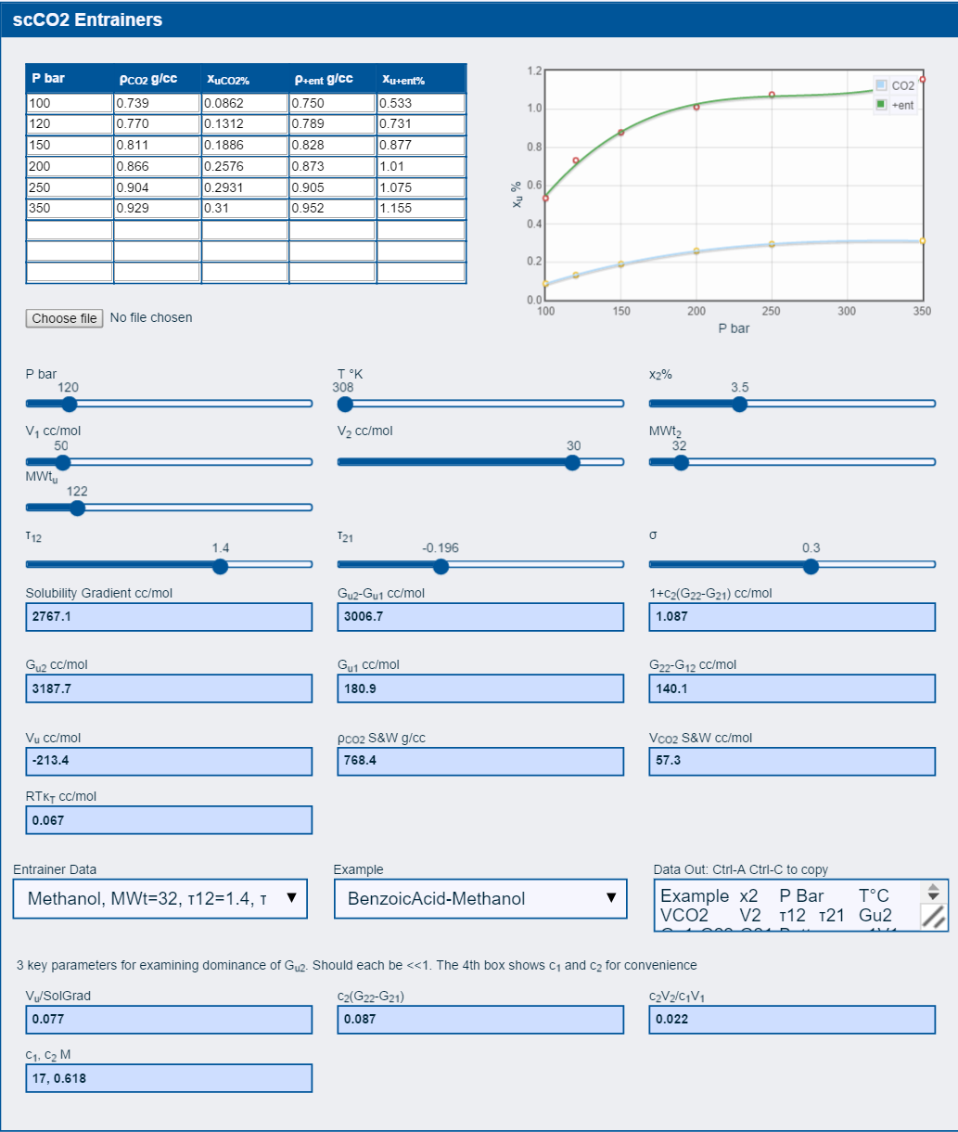

Figure 1. Screen-shot of the “app”, which has been developed to implement the theory presented in this paper, and to facilitate the analysis of experimental data in an interactive manner. The consequences of changing input parameters can be explored immediately through the change of output, i.e., the KB integrals.

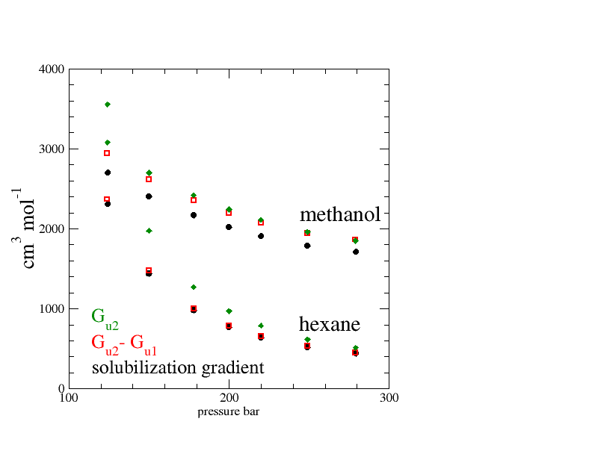
Figure 2. Solubilization of benzoic acid using methanol and hexane as entrainers. The pressure-dependence of the solubilization gradient (Eq. (1), black circle) is compared with $G_{u2}-G_{u1}$ (red square) and $G_{u2}$ (green diamond). The solubility data have been taken from Ref. 40 and 41.

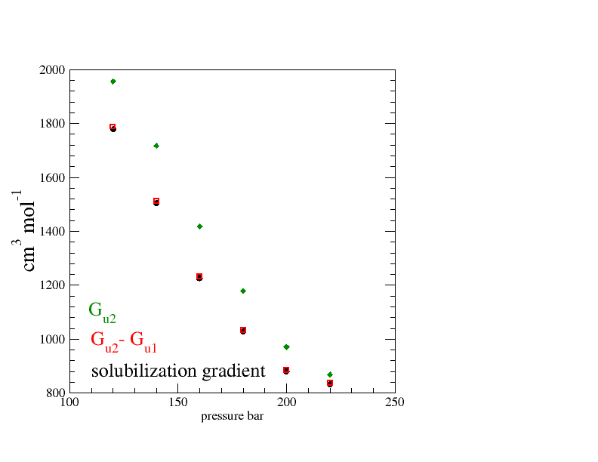
Figure 3. Solubilization of cholesterol using acetone as an entrainer. The pressure-dependence of the solubilization gradient (Eq. (1), black circle) is compared with $G_{u2}-G_{u1}$ (red square) and $G_{u2}$ (green diamond). The solubility data have been taken from Ref. 43.

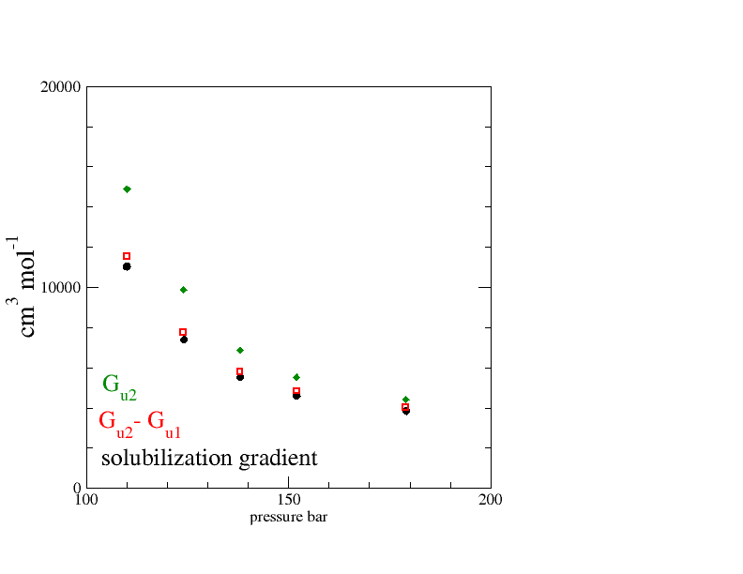
Figure 4. Solubilization of naproxen using isopropanol as an entrainer. The pressure-dependence of the solubilization gradient (Eq. (1), black circle) is compared with $G_{u2}-G_{u1}$ (red square) and $G_{u2}$ (green diamond). The solubility data have been taken from Ref. 44.

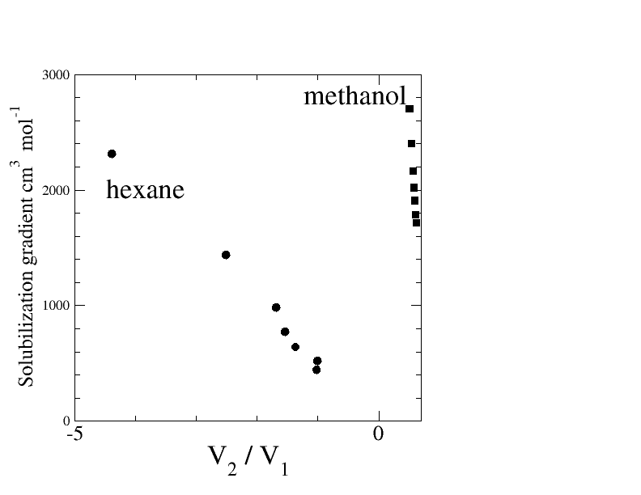
Figure 5. The correlation between the solubilization gradient (Eq. (1)) and $V_{2}/V_{1}$ at infinite entrainer dilution limit, in order to examine the validity of the fluid density hypothesis and the CO₂ clustering hypothesis through Eq. (9). No correlation common to both entrainers (methanol and hexane) in the solubilization of benzoic acid (data from Refs. 40 and 41) has been observed, in contradiction to these hypotheses.

Table 1. Summary of KB integral calculation results, showing that solute-entrainer KB integral $G_{u2}$ is the dominant contribution to solubilization, and that the entrainer self-association ($1+c_{2}\left(G_{22}-G_{21}\right)$), whose deviation from 1 is small, contributes negligibly to solubilization. See Eq. (1). Note that the pressures have been chosen to span a large range for illustrative purposes. The input data used for calculation are summarized in Table 2.
Solute-Entrainer | % | P  Bar | T  K | $G_{u2}$ª | $G_{u1}$ª | G₂₂-G₂₁ª | 1+c₂(G₂₂-G₂₁)
BenzoicAcid-Methanol | 3.5 | 120 | 308 | 3188 | 181 | 140 | 1.087
2-AminoBenzoicAcid-Acetone | 3.5 | 120 | 308 | 1945 | 119 | 9 | 1.005
2-AminoBenzoicAcid-Methanol | 3.5 | 149 | 308 | 3319 | -47 | 133 | 1.087
2-Napthol-Methanol | 3.5 | 199 | 308 | 2492 | 13 | 125 | 1.087
Acridine-Acetone | 3.5 | 202 | 308 | 1359 | 88 | 8 | 1.005
Acridine-Methanol | 3.5 | 250 | 308 | 1816 | 101 | 119 | 1.087
BenzoicAcid-Acetone | 3.5 | 100 | 308 | 3142 | 733 | 9 | 1.005
BenzoicAcid-Hexane | 3.1 | 253 | 318 | 600 | 82 | 41 | 1.024
BenzoicAcid-Hexane | 7 | 253 | 318 | 628 | 134 | 43 | 1.055
BenzoicAcid-Octane | 3.5 | 150 | 308 | 1633 | 363 | -9 | 0.994
Caffeine-Ethanol^{b} | 5 | 178 | 313 | 2207 | -61 | 161 | 1.149
Cholesterol-Acetone | 3.5 | 161 | 328 | 1500 | 239 | 9 | 1.005
Cholesterol-Hexane | 3.5 | 150 | 328 | 2432 | 690 | 50 | 1.027
Naproxen-i-Propanol | 5.3 | 124 | 333 | 12253 | 4485 | 86 | 1.048
Naproxen-Methanol | 5.25 | 124 | 333 | 7978 | 1055 | 232 | 1.133
SalicylicAcid-Ethanol | 4 | 139 | 318 | 5558 | 187 | 187 | 1.119

ªin cm³ mol⁻¹; ^{b}Based upon approximate experimental values.

Table 2. Summary of input data required for the calculation of KB integrals, together with the source of experimental data and NRTL parameters. Note that the pressures have been chosen to span a large range for illustrative purposes.

Solute-Entrainer | % | P  Bar | T  K | V₁ª  cm³mol⁻¹ | V₂  cm³mol⁻¹ | $τ_{12}$^{b} | $τ_{21}$^{b}
BenzoicAcid-Methanol^{c} | 3.5 | 120 | 308 | 57.3 | 30^{i} | 1.4 | -0.196
2-AminoBenzoicAcid-Acetone^{d} | 3.5 | 120 | 308 | 57.3 | 0^{j} | -0.51 | 0.075
2-AminoBenzoicAcid-Methanol^{d} | 3.5 | 149 | 308 | 54 | 30^{i} | 1.4 | -0.196
2-Napthol-Methanol^{d} | 3.5 | 199 | 308 | 50.8 | 30^{i} | 1.4 | -0.196
Acridine-Acetone^{d} | 3.5 | 202 | 308 | 50.7 | 0^{j} | -0.51 | 0.075
Acridine-Methanol^{d} | 3.5 | 250 | 308 | 48.8 | 30^{i} | 1.4 | -0.196
BenzoicAcid-Acetone^{d} | 3.5 | 100 | 308 | 61.6 | 0^{j} | -0.51 | 0.075
BenzoicAcid-Hexane^{e} | 3.1 | 253 | 318 | 51.2 | -50^{j} | 0.193 | 0.053
BenzoicAcid-Hexane^{e} | 7 | 253 | 318 | 51.2 | -50^{j} | 0.193 | 0.053
BenzoicAcid-Octane^{d} | 3.5 | 150 | 308 | 53.9 | -150^{j} | 0.5 | -0.8
Caffeine-Ethanol^{f} | 5 | 178 | 313 | 53.8 | 40 ^{j} | 1.95 | -0.7
Cholesterol-Acetone^{g} | 3.5 | 161 | 328 | 64.2 | 0 ^{j} | -0.51 | 0.075
Cholesterol-Hexane^{g} | 3.5 | 150 | 328 | 67.2 | -140 ^{j} | 0.193 | 0.053
Naproxen-i-Propanol^{h} | 5.3 | 124 | 333 | 94.4 | -100 ^{k} | 0.33 | 0.013
Naproxen-Methanol^{h} | 5.25 | 124 | 333 | 94.4 | 30^{i} | 1.4 | -0.196
SalicylicAcid-Ethanol^{i} | 4 | 139 | 318 | 61.2 | 40 ^{j} | 1.95 | -0.7

ªCalculated using Ref 46 using infinite entrainer dilution approximation; ^{b}Parameters for the NRTL model⁵²; ^{c}Solubility data taken from Ref 40; ^{d}Ref 41; ^{e}Ref 42; ^{f}Ref 43; ^{g}Ref 44; ^{h}Ref 45;^{i}Infinite dilution $V_{2}$ data taken from Ref 51; ^{j}Ref 48; ^{k}Ref 47.

Table 3. Confirmation of the key conditions or the order-of-magnitude estimates. The data are from the calculations used to create Table 1.
Solute-Entrainer | % | P  bar | T  K | G_{u2}  cm³mol⁻¹ | c₂ (G₂₂-G₂₁) | $V_{u}/(c_{1}V_{1} )$  cm³ mol⁻¹ | $c_{2}V_{2}/c_{1}V_{1}$
Benzoic acid-Methanol | 3.5 | 120 | 308 | 3188 | 0.087 | 0.077 | 0.0223
2-AminoBenzoicAcid-Acetone | 3.5 | 120 | 308 | 1945 | 0.005 | 0.055 | 0
2-AminoBenzoicAcid-Methanol | 3.5 | 149 | 308 | 3319 | 0.087 | 0.006 | 0.0204
2-Napthol-Methanol | 3.5 | 199 | 308 | 2492 | 0.087 | 0.028 | 0.0217
Acridine-Acetone | 3.5 | 202 | 308 | 1359 | 0.005 | 0.066 | 0
Acridine-Methanol | 3.5 | 250 | 308 | 1816 | 0.087 | 0.088 | 0.0224
BenzoicAcid-Acetone | 3.5 | 100 | 308 | 3142 | 0.005 | 0.245 | 0
BenzoicAcid-Hexane | 3.1 | 253 | 318 | 600 | 0.024 | 0.114 | -0.0315
BenzoicAcid-Hexane | 7 | 253 | 318 | 628 | 0.055 | 0.159 | -0.0739
BenzoicAcid-Octane | 3.5 | 150 | 308 | 1633 | -0.01 | 0.115 | -0.115
Caffeine-Ethanolª | 5 | 178 | 313 | 2207 | 0.149 | 0.011 | 0.03805
Cholesterol-Acetone | 3.5 | 161 | 328 | 1500 | 0.005 | 0.152 | 0
Cholesterol-Hexane | 3.5 | 150 | 328 | 2432 | 0.027 | 0.195 | -0.1036
Naproxen-i-Propanol | 5.3 | 124 | 333 | 12253 | 0.048 | 0.209 | -0.1111
Naproxen-Methanol | 5.25 | 124 | 333 | 7978 | 0.133 | 0.19 | 0.01753
SalicylicAcid-Ethanol | 4 | 139 | 318 | 5558 | 0.119 | 0.065 | 0.02674

ª Approximate values.

Table of Contents Graphics

