Understanding the Dynamics of Regional Growth and Shrinkage in 21st Century Japan: Towards the Achievement of an Asia-Pacific ‘Depopulation Dividend’

Peter Matanle (University of Sheffield)

Introduction
Japan is shrinking. Under present trends government projections indicate that the country’s population may decrease in number by up to one third, from nearly 128 million people in 2008 to around 87 million by 2060 (NIPSSR 2012), due to a sustained fall in rates of human reproduction in the postwar era. In combination with steadily increasing life expectancy Japan is therefore one of the most rapidly ageing countries in the world. With 25 per cent of the population now aged 65 or over, Japan is now a ‘hyper-aged society’ and the consequences of ageing and depopulation are already appearing across the entire Japanese archipelago and throughout all areas of activity (Coulmas 2007: 5; MIC 2015).
Population reduction is potentially good news, providing opportunities for reconfiguring living conditions and alleviating human-environmental pressures. Nevertheless, ageing and depopulation have outcomes that require adjustment for affected regions and sectors. One of these is spatial inequalities, on a national scale between provincial and metropolitan regions, and regionally between rural and urban locales. This gap between rural and urban Japan has been present since at least the early 20th century, but has accelerated and become more acute since the 1990s, when the onset of economic stagnation coincided with the unwinding of the demographic tempo effects of the postwar baby boom and the long period of below replacement fertility. For example, the proportion of the population of working age has been declining since reaching its peak of 70% in 1990. By 2010 it had fallen to 64%, and will reach an anticipated 51% in 2060 (MIC 2015), presenting challenges for the government in achieving fiscal stability and maintaining adequate care of older people. This is a pressing concern for rural regions especially, whose economic development and capital accumulation have lagged urban areas, but where the proportion of older residents requiring interventions is larger. These and other issues exemplify a fissure developing between rural and urban regions, which looks set to deepen and widen in the future.
What is significant about Japan’s situation is how adaptive responses there might inform about future prospects for other Asia-Pacific countries as they experience similar post-growth trajectories. Just as Japan’s 20th century developmental leadership in Asia has long been acknowledged (Akamatsu 1962; Chang 2006), in the 21st century Japan might be seen as the pioneer ageing and shrinking society for trends that are becoming increasingly prevalent on an Asia-Pacific and even global scale (Jackson 2014; Kaneko and Sato 2013; Matanle 2014; Matsutani 2006), with rural-urban imbalances and inequalities being key indicators of national stability.
This chapter follows on from Lützeler’s numerical analysis of regional social inequality in Japan, and Elis’s on the discourse of rural-urban dynamics (chapters 12 and 13 in this volume) to present an overview of rural-urban dynamics in post-growth Japan via a qualitative analysis of the means by which some rural residents are exercising their agency in responding to their emerging circumstances. Overall, the chapter is intended as a call to understand the broader geographical significance of Japan’s current situation by suggesting that agency within Japan’s rural regions can deliver positive spill-over effects, with the rural Japanese experience being potentially useful both in assisting Japan’s urban areas in their transition to shrinkage, and in contributing to an emerging post-growth and post-developmental relationship between Japan and its Asia-Pacific neighbours. Hence, the next section begins by setting Japan within the world demographic context. I will then describe some of the impacts of ageing and depopulation in Japan’s rural regions and use a case study of Sado Island in Niigata Prefecture to illustrate residents’ responses. In conclusion I will suggest that there is potential for benefitting from demographic shrinkage – what I term a ‘depopulation dividend’, in homage to Bloom, Canning and Sevilla’s ‘demographic dividend’ (2003) – and for Japan to lead its neighbours into a more sustainable post-growth steady-state economy (Daly 1996). I define the depopulation dividend as the achievement from depopulation of positive gains that contribute to socio-cultural, political-economic, and environmentally sustainable living.

Japan in the World Demographic Context
In the 21st century a historic turnaround in world demographic trends is under way (Lutz, Sanderson and Scherbov 2001; Rostow 1998). Demographic transition theory shows a convergence on below replacement fertility (Wilson 2011) whereby developed regions (17% of current world population) will undergo depopulation, and developing countries with intermediate fertility levels (70% of world population) will stabilise and may experience shrinkage on reaching developed status. The remaining 13% from least developed countries will either continue with high fertility or develop into intermediate or lower fertility regions (UNPD 2015).
In East Asia, South Korea and China are at the tail end of experiencing their ‘demographic dividend’ (see, Bloom et al. 2003), whereby rapid demographic change and economic expansion have gone hand in hand to deliver significant improvements in material well-being. Other countries in East and Southeast Asia are experiencing similar developmental pathways. Indeed, the successful economic development of Asia undoubtedly has been one of the seminal events in human history, and Japan’s spearhead contribution in helping to galvanise other countries’ developmental regimes should not be underestimated. However, East Asia is ageing too, and about to begin shrinking. Once more Japan is leading the way. Viewed negatively, this might be considered a ‘demographic burden’, creating a complex series of systemic crises across the area. Alongside the potential for long-term economic contraction and the need to reform unsustainable fiscal structures, these might include higher levels of socio-economic inequality between growing and shrinking regions, whereby the winners from responses to changing population structures draw further away from the ‘losers’. In these circumstances it is also worth considering how these phenomena affect collective notions of social, cultural and political solidarity within nations that, even today, consider themselves to be relatively homogeneous and cohesive. Issues of rural-urban inequality are, therefore, deeply interwoven with socio-economic development and, moreover, resonate with people’s overall sense of identity and connectedness.

Figure 1. Actual & Projected Population Change in East Asia 1950-2100 (millions. Japan and South Korea left hand scale, China right hand scale) | Fig. 2. Actual and projected child and old age dependency ratio in East Asia (per cent)
<FIGURE 1> | <FIGURE 2>
Source: UNPD (2015). Note: Medium variant projections and variable fertility. | Source: UNPD (2015).

Figure 1 uses UN Population Division data to display actual and projected demographic change in Japan, China and South Korea. Japan grew by 82% in the 75 year period up to its population peak in 2010, and is projected to shrink 26% by 2085. The graph forecasts similar paths for South Korea and China. South Korea is projected to grow and shrink 110% and 27% in the 75 and 65 year periods either side of its expected peak in 2035, and China by 100% and 29% in the 75 and 70 year periods either side of its peak in around 2030.
In all three countries, projections for the dependency ratio between working and non-working people (see Figure 2) point to challenging consequences for long-term fiscal stability, for the continuation of growth-oriented economic regimes, and for maintaining community stability and resilience in affected regions. Figures 1 and 2 also show that 1990 is a significant turning point for Japan, as it marks the end of the country’s demographic dividend, when the proportion of working age people in the population reached its peak and, coincidentally, it was also the year that the economy tilted into its long stagnation. Thereafter the proportion of the population dependent on working people has risen steadily and is expected to reach about one worker per dependent in 2055. China and South Korea are both expected to reach their most advantageous ratios in 2015-20, whereupon both will follow Japan and experience greater pressures in maintaining the ratio of contributions from working people to overall socio-economic well-being.
Together with changes in the age structure of Japan’s population has occurred a dramatic shift in its spatial distribution, due to the familiar processes of agricultural transformation, industrialization, and urbanization that accompany modern economic development (England 2005; Egglestone and Tuljapurkar 2011). Whereas in 1960 41% of Japan’s population lived in urban regions, by 2010 this had increased to 67%. Simultaneously the total population expanded by 73% over the same period. While slower economic growth since the 1990s has reduced the rate of urbanisation from rural-urban migration, the unwinding of demographic tempo effects produced by very long-term low fertility has meant, first, that urban populations have followed rural regions into an era of rapid population ageing and, second, the rate of population loss in rural areas has continued, even accelerated in many areas since the 1990s, as an increasing proportion of the rural population passes away. The result has been both a flattening of urbanisation rates as the growth in the national population slowed, as well as a deepening spiral of community ageing and depopulation in rural regions (Matanle and Sato 2010). Consequently, while urban areas experienced enormous pressures in accommodating demand for housing, infrastructure, goods and services in the early post-war decades, ageing has now become a more pressing concern, and urban questions continue to be the focus of human geographers interested in contemporary Japanese spatial patterns. Less remarked in the academic and mainstream discourses, perhaps because it is less noticeable, has been the stresses that population ageing and loss have placed on rural regions.
Similar demographic patterns are evident in China, South Korea, as well as other Asia-Pacific countries such as New Zealand (Jackson 2014), producing some dramatic outcomes. First has been the appearance of extreme differences in rural-urban population size and density. Huge urban metropolises have emerged, supplied with sophisticated high cost infrastructure to enable complex economies and diverse societies to function. These cities consequently generate an enormous gravitational pull, drawing in people and resources from their suburban, periurban, and rural surroundings, which accumulates into a widening gap between dynamic and prosperous metropolitan centres and a declining and disconnected periphery. In Japan the Kanto region can ‘boast’ that it is the world’s largest urban area by population. China possesses at least six megacities of more than ten million persons, and seven of the world’s ten largest urban areas are located along the western arc of the Pacific Ocean – in order of magnitude: Tokyo, Jakarta, Manila, Seoul, Shanghai, Beijing, and Guangzhou (Demographia, 2015: 20). And at 1.4 million people Auckland has 31% of New Zealand’s population within its environs.
Second, until the 1990s, urbanization in Japan was taking place against the backdrop of an expanding national population and economy. Metropolitan centres and prefectural capitals in particular grew rapidly, to some extent at the expense of rural shrinkage, but mainly because the whole country was growing. However, in the 1990s and 2000s population growth ground to a halt. With the onset of national-scale depopulation in 2008 nearly all settlements are now shrinking, including most provincial core cities. This has produced a gradual awakening in Japan since the 1990s that depopulation can no longer be dismissed as simply an unfortunate rural expression of successful national economic development, as it all too often used to be, but as a significant problem confronting nearly all except the very largest settlements (AS 06.01.2014; Matanle and Rausch et al. 2011). Other Asia-Pacific countries are themselves also approaching the time when they have to face the consequences of national-scale depopulation.

Ageing and Depopulation in Rural Japan: Employment and Overcapacity
In circumstances of national-scale depopulation it is axiomatic that population growth in one settlement is balanced by proportionately greater shrinkage in another. Hence, as Tokyo continues to grow, drawing in people and resources from elsewhere, nearly every other settlement in Japan is now shrinking. In these circumstances, the capital region’s strong unipolar concentration has even produced demographic destabilising effects in the Keihanshin urban region of Kyoto-Osaka-Kobe (Buhnik 2014). And in peripheral rural areas some communities are collapsing and others have been abandoned by their residents, leaving ghost towns and villages behind (see, Grist, 2014). This is what Japanese social scientists mean when they describe ‘genkai shūraku’, or ‘communities on the edge’ (Ono 2005), where more than 50% of residents are over 65 and the community is unable to reproduce itself. In these places there is little economic activity, few children are being born, much of the built environment lies empty and deteriorating, and agricultural land is left for scrub. Forests encroach on residences, leaving villagers with less light and giving cover for pests such as monkeys, bears, deer, and boar to approach and raid allotments and orchards, ransack houses, and confront elderly residents (Knight 2003). According to the Rural Development Planning Commission, in 2005 there were 1,403 communities in imminent danger of collapse in Honshu, Shikoku and Kyushu (NKKI 2006: 33), while in 2011 the Ministry of Internal Affairs described 10,091 of Japan’s 64,954 settlements as having a population with an average age of 65 and over, with the proportion being identified as such doubling from 7.5 to 15.5% of settlements between 2001 and 2011; 205 of which had 100% of their population over the age of 75 (MIC 2011: 7-8).
What are some of the conditions of living and working in Japan’s rural regions and what have been some of the responses to community decline, in particular since the post-growth era began in the 1990s? Below I present description and analysis distilled from 25 years of personal experience of and research into rural depopulation and decline in Japan, focusing on issues of employment and over-capacity in Niigata Prefecture and Sado Island (see, Matanle 2006; Matanle and Sato 2010).
Beginning with stable employment, which is the basic foundation for a durable and resilient community, well-paid secure full-time jobs are in short supply in rural Japan. Traditional routes into employment for eldest sons and daughters wishing to remain in the family holding and care for ageing parents, such as family enterprises, municipal administration, school teaching, and construction are disappearing where economic functions are in decline, services in reorganization and retreat, and government redistribution measures being cut back. For example, over-capacity in educational infrastructure due to a drop of approximately 50% nationwide in the number of school age children means that prefectural and municipal authorities are merging and closing schools, leading to fewer teaching opportunities; with increasing numbers of empty school buildings dotting the landscape, reminding residents of once thriving communities noisy with children’s play (see Figure 3).
Where a low-fertility culture means that most couples have one or perhaps two children, the lack of rural employment can have long-term impacts on community reproduction and sustainability. Ordinarily, in multi-children households in the past the eldest son, or another of the children, would remain near to the family holding and take stable employment in public services or teaching, for example, to look after the family business, farm or property as his (or her) parents aged and this would allow younger siblings to migrate to urban locales safe in the knowledge of household and community continuity. As economic opportunities have contracted, particularly since the 1990s, and single-children households have become the norm, younger people who have felt the need to move away to seek educational, employment and social opportunities in provincial cities or metropolitan regions, leave their parents alone and deprive the community of its reproductive potential. Few return.

Figure 3. Two abandoned schools in Sado City, Niigata Prefecture; an elementary school in Sotokaifu (top left), and a junior high school in Hatano (top right) presently being used as storage for construction materials; and two abandoned hotels, in Aikawa, Sado City, Niigata Prefecture (left), and Tōyō Town, Kochi Prefecture (right). (Photos © Peter Matanle).
<FIGURE 3>

In these cases family businesses are inevitably abandoned and disappear, and leave residents – predominantly older people - dependent on a depleted community base. These households are often small-scale crafts manufacturers, niche food and beverage producers, small-scale local retailers, restaurants, guest houses and small hotels (see Figure 3), and their closure causes secondary damage to economic potential, just as municipal authorities are seeking to boost the locale’s attractiveness to outsiders to strengthen economic sustainability. Following is a statement by a teacher with responsibility for career education at a senior high school (ages 15-17), describing the employment situation there and younger people’s aptitudes:

When they graduate most [students] leave and the number that return is small. Even if graduates want to return [to Sado], there are few places that can employ them because their skills and knowledge are not suited to the work here .... There are no big companies and manufacturing has almost disappeared, construction is scaling down, agriculture is more difficult ... managers tend to be from outside, while temps and part-timers are usually locals.
Senior High School teacher and careers advisor, Niibo, Sado City, Niigata Prefecture.

Similarly, as a result of central government measures aimed ostensibly at providing local autonomy through decentralization and rationalization, and partly with the intention of providing the tools to respond specifically to ageing and depopulation in rural regions, a wave of municipal mergers took place through the early 2000s which saw the number of municipalities decrease by 45%, from 3,229 to 1,788 between 1999 and 2008 (Rausch 2012: 187; Yokomichi 2007: 6-7). Niigata Prefecture saw the greatest proportion of mergers in Japan, with the number of municipalities dropping 69%, from 112 to 35 (Yokomichi 2007: 20). In 2004 Sado Island, which had lost nearly 50% of its 1950 population, went from ten municipalities to a single Sado City.
In Sado, as well as many other rural places in Japan, the merger has driven a reorganization and centralization of essential services, resulting in the closure of public facilities and buildings in peripheral areas. Consequently, as of December 2013 Japan’s local governments had plans to demolish 12,251 redundant municipal buildings nationwide at a projected cost of JPY404 billion, with none being scheduled for renovation or rebuilding, and only 40% of which are currently in use (NKS 03.12.2013). Moreover, as services have become more distant from users, and public transport cut back, residents feel forced into cars, which disproportionately affects older people, who often have mobility restrictions, but who may not drive. Hence, younger and middle-aged people then spend resources and time helping and caring for elderly relatives and neighbours in compensation for reduced formal service provision. Although such kindness is admirable, it reduces the opportunity that able citizens have for economic sustenance activity. Furthermore, as organizations close facilities, remove duplication, and slim workforces through retiree attrition, businesses located nearby such as restaurants and cafes lose customers, as indicated by the following quotation:

The municipal merger has meant that there are fewer public officials working here, as jobs have been closed down or moved to the new city office. So, the bulk of our lunchtime business has now gone ... My husband's bar also gets fewer customers in the evening as public officials do their evening eating and drinking in the new restaurants in Sawata, which is closer to the city office.
Café and restaurant owner, Aikawa, Sado City, Niigata Prefecture.

Finally, the growing preference among urban Japanese for travel and tourism overseas means that tourism related work is declining in many domestic rural destinations, particularly for women seeking part-time or seasonal employment to supplement family incomes and enable informal care roles. Although international tourism to Japan is increasing, foreign visitors rarely venture beyond the most popular sites in Tokyo and Kyoto. Sadly, in response to the decline in their populations and economies through the post-war period, many regional municipalities had attempted to revitalize their declining economies through the development of tourism facilities, which have since failed, leaving towns saddled with huge debts and a declining tax base. Yūbari City in Hokkaido is a well-documented example, where the collapse of the coal-mining industry led to a severe decline in the city’s fortunes and an attempt to reverse this through a misguided and ultimately catastrophic over-investment in tourism development (Culter 1999: Seaton 2010).

Figure 4: Abandoned and empty buildings are now a common sight in provincial regions. Clockwise from top left: A farmhouse in Ryōtsu, Sado City, Niigata Prefecture; a farmhouse with a tree growing outwards from the inside in Tōyō Town, Kochi Prefecture; an office building and shops in Ueda City, Nagano Prefecture; rows of abandoned houses in Horonai, Mikasa, Hokkaido; a restaurant and shop in Aikawa, Sado City; and a row of empty shops in Shibata City, Niigata Prefecture.
<FIGURE 4>

Alongside securing stable employment, dealing with overcapacity has become a serious concern in non-metropolitan regions, as communities shrink, leaving excess housing stock, an underused built environment, and underworked land. Provincial real estate markets are failing as houses remain empty and occupancy rates in apartment blocks reach alarmingly low levels. Property reinvestment is falling and the built environment looking shabby and derelict, further depressing the atmosphere, reducing land values and encouraging out-migration by those who can – leaving behind those who can’t!. The prefectures with the most rapid depopulation also, not unexpectedly, have the lowest land prices; Tokyo (JPY309,700/m2) is more than 20 times as expensive as Akita (JPY15,300/m2) (MLIT 2014). Empty houses, or akiya, are becoming unsellable due to colonization by fauna and flora, and thousands of shops and businesses lie empty and deteriorating or are underused (see Figure 4). Data from the government’s 2008 Housing and Land Survey show 7.6 million vacant dwellings in Japan, up from 3.9 million in 1988, 2.7 million of which (1.3 million in 1988) were categorized as being left unattended or whose owners had died (MIC 2008).
It is difficult to imagine that one could derive benefits and opportunities from such circumstances. In the next section, however, I will show that some people are attempting to do so, as a result of a gradually emerging change in personal orientation away from 20th century values that prioritize economic growth and demographic expansion, towards 21st century values that emphasize the achievement of personal and community wellbeing. Here’s how.

Community Responses Under National-Scale Depopulation: (Re)Valuing Localism, Environment, and Lifestyle Aesthetics
Outside Japan’s metropolitan centres the prospect of community growth is now impossible for the majority of settlements. Indeed, ageing and shrinkage are already occurring in more than nine out of ten of Japan’s municipalities, including many urban and suburban locales (AS 06.01.2014). How are rural residents adjusting to the new dynamic of national-scale depopulation? In particular, can the emergence of a ‘depopulation dividend’ be observed; one that might provide some lessons for other Asia-Pacific countries encountering similar dynamics? In this section I focus on community and individual responses to rural depopulation and link these to changes in value orientations; for it is universally agreed that values inform human motivation, which in turn feeds behaviour, and which together constitute part of a complex series of psychological and emotional dimensions that constitute ‘agency’ (Dahlgaard and Dahlgaard 2003; Giddens 1991).
Throughout the postwar era government interventions into the rural-urban divide in Japan have been dominated by a complex system of financial transfers to boost investment in rural infrastructure. To a great extent these measures have failed, principally because they were as much rooted in nefarious political and financial relationships – the ‘iron-triangle’ of the bureaucracy, business and politics and the ‘construction state’ (Feldhoff 2002; McCormack 2001) – as they were intended to resolve regional imbalances. Indeed, these so-called ‘spatial equalization measures’ may have made the situation worse, for example by incentivizing villages to exhibit the characteristics of a collapsing community in order to continue to receive state ‘kaso’ (depopulation) subsidies (Mizohata 2010).
Furthermore, it is generally acknowledged that Japan’s centrally managed postwar development has wreaked havoc on the country’s natural environment (Kerr 2002; Matanle and Rausch et al. 2011; McCormack 2001). The felling of original growth mixed-leaf forests and replacement by cedar monoculture, the concreting of virtually all of Japan’s major rivers for flood control, the construction of 102 commercial airports, 3,076 dams, and 1.2 million km of roads, and the presence of ‘bridges to nowhere’, ‘tunnels without exits’, and ‘ports without ships’ must be familiar to anyone with a knowledge of Japan’s 20th century regional development (ICOLD 2014; Kerr 2002; McCormack 2001; MIC 2015; World Airport Database 2015). Yet, despite these decades of lavish spending, Japan’s regional communities continue resolutely to shrink and deteriorate.
Where official policies continue to promote the notion of revitalization as a synonym for growth, some residents of rural areas express frustration because they recognise that in circumstances of national-scale shrinkage these are unattainable goals for their communities. The response among some residents is to conflate socio-economic, cultural, and environmental decline, to ascribe these to Japan’s top-down and urban-centred modernization, and to work towards the establishment of a more balanced relationship with their surroundings. Consequently, some are beginning to include or even prioritize other values in their decision-making; their rationale being that, where growth is unattainable, and in order to maintain a positive and hopeful outlook, it makes sense to place greater importance on values that can be realized. Of these, three orientations have been expressed, and these represent a turn towards the local or regional, environmental conservation, and lifestyle aesthetics.
Hence, a new localism has been emerging in Japan’s provincial regions since the 1990s. This is expressed via endogenous small-scale activities for the purposes of rejuvenating community sustainability through, for example, cultural and social development, creating a comfortable and functional built environment, promotion of health and well-being, care and compassion for more vulnerable citizens, micro-energy generation, clean agriculture, bio-diversity conservation, and the development of a regional and local politics. Recently this movement was given powerful extra impetus after the 11 March 2011 tsunami and nuclear crisis in Tōhoku/Fukushima, because the central government’s regional policies were associated with contributing to the severity of the unfolding disasters (Feldhoff 2013; Matanle 2011). These movements are specific to local contexts and are usually neither anti-Tokyo nor anti-growth, though a deep scepticism is present among some as to whether the political, bureaucratic and business elites in Tokyo understand, and are therefore able to respond to, local concerns. Consequently, for example, on 5 June 2013 50 municipalities representing 4.3 million people signed up to the newly established ‘Association of Municipalities for Improving Residents' Sense of Well-Being’ (nicknamed the ‘Happiness League’), for the purposes of developing small scale local projects that promote personal well-being, sharing information between municipalities, and by-passing the central government in Tokyo (ISHES 2013).
Together with those who are raising social, political, and environmental concerns, there are an increasing number of people in Japan who are preferring lifestyle aesthetics. This can be seen most readily in the increasing number of lovingly restored houses and other buildings using locally sourced materials, and craftspeople using traditional methods. In some cases initiators have been long-term foreign residents who are disappointed with the aesthetics in post-war planning and architecture, or are seeking to contribute to community sustainability, and have begun with restoration of their own properties, which then galvanises others nearby to do the same. Many properties serve as businesses and have become focal points for local cultural and socio-economic revitalization efforts. While these businesses can be profitable, the owners’ focus has been primarily personal, social, and cultural, rather than economic (for example, Kerr 2013).
In Sado Island in Niigata Prefecture, where much of my own research has taken place, examples of the above change in value orientations, and their manifestation in behaviour are numerous. They are to a great extent responses to what residents view are the geographical, or regional, gaps (chiiki kakusa) that have been widening, particularly since the 1990s when Japan went into its long-term economic slowdown and the 2000s, when the central government adopted a more stringent approach to supporting rural areas, such as with the Trinity Reforms enacted by Prime Minister Koizumi (see, chapter 11 in this volume by Elis). What is interesting about these developments is how they are concerned with community restoration and cohesion, and not growth per se; though they are not anti-growth. They are anchored in local particularities and show concern for the past as well as the present and future. They acknowledge that growth is no longer possible and instead represent a turn towards local community well-being. They are as much a consequence of the impacts of depopulation as they are about taking the opportunities that depopulation presents. It is important also to acknowledge that they are also derived from wider concerns, such as for climate change and biodiversity, and enable the people of Sado to reach out beyond traditional networks and structures to appeal to a global audience.
- Under Mayor Takano (2004-2012), Sado City launched a series of town hall hearing sessions to learn of local people’s concerns more directly, and to engage in direct dialogue with citizens. The results have translated into the mayor’s goal of making Sado into a ‘sumiyasui tokoro’, or comfortable living space, for local people.
- Part of the development of a sumiyasui tokoro has been a campaign to establish Sado as an ‘eco-island’ and an example for people elsewhere to live in greater harmony with their natural surroundings. This includes various initiatives, such as eco-tourism to the original growth temperate rain forest in northeastern Sado, and has centred around the conservation of the symbolic toki, or Japanese crested ibis (Nipponia nippon), which is Japan’s national bird and whose only remaining habitat in Japan is Sado. For some the survival of the island’s society and culture is associated with the continued residence of crested ibis such that, rather like the ravens at the Tower of London, the disappearance of the toki from Sado would presage the end of Sado as a human community.
- The desire to nurture the toki and return it to sustainability in its habitat, after a long period of the systematic promotion of conventional modern industrial agricultural techniques, is contributing to a revival of traditional food production and consumption practices in Sado (FAO 2010). This is manifested in, for example, the conservation of the satoyama landscape and agricultural system, which is unique to Japan, but which has valuable lessons for Asia in preserving bio-diversity at the human-forest interface under wet rice agriculture. This led to the award to Sado in 2011, in conjunction with the Noto Peninsula in Ishikawa Prefecture, of Globally Important Agricultural Heritage Status (GIAHS) by the Food and Agriculture Organization of the UN (FAO 2011). The award was especially notable because it was the first time any region in a developed country had been recognized for the importance of its agricultural heritage and the efforts of local people in conserving the natural environment for sustainable food production. Interestingly, the project joined multiple actors unused to working together in a coordinated effort going beyond traditional bureaucratic channels, including local, national and international organizations, academic and non-governmental institutions, and corporations (FAO 2010).
- Sado City government is also participating with a regional private education provider to develop vocational education relevant to local needs and sensibilities. NSG is the first post-secondary institution to be located in Sado, which delivers courses in Environmental Management, Care and Welfare for the Elderly, and Traditional Crafts (including architectural restoration and ‘Mumyoi’ pottery, which is unique to Sado). Students come from Sado as well as other parts of Japan to study in one of Japan’s richest natural and cultural environments. Opened in April 2008 on the site of a former girls senior high school, and with a JPY200 million loan from the municipality, NSG now teaches six courses in related subjects and accepts up to 200 students per year group. For graduating students there are opportunities to remain in Sado working to care for the elderly population, as well as work in the restoration of temples and shrines, and in redeveloping the island’s arts and crafts heritage. In an era when more than 75% of each youth cohort now experiences post-secondary education this is a significant step for socio-cultural sustainability in Sado because, for the first time, younger people do not have to leave the island if they wish to continue their studies beyond upper secondary school.
- Further examples of the municipal government and citizens of Sado reaching out beyond traditional networks to develop local social, environmental, and cultural resources, as well as contribute to those elsewhere, are (see Figure 5):
  - The Small Island Study Association held its Fifth International Conference on Small Island Cultures in Sado in 2009. Sado municipal government’s intention in inviting the conference to the island was to bolster efforts to redevelop the island’s cultural and environmental resources, as well as to share Sado’s experiences and knowledge with people living in small islands across the world.
  - Sado is the base for the world famous Kodo taiko drumming group, who tour internationally and host a summer percussion festival in Ogi Town, which draws thousands of visitors to Sado. Year-round the group contributes to music education and performance in Sado through its purpose-built centre in Ogi, southwestern Sado.
  - Sado hosts an international triathlon in September each year. Celebrating its 16th year in 2015, it attracts more than 1,200 athletes and sponsors from Japan and internationally. It is one of only two long-distance triathlons in Japan, comparable in distance and difficulty to the Iron Man event in Hawaii. From 2016 it will be the representative event for Japan in the International Triathlon Union’s global schedule for elite athletes. As the centrepiece event of the municipal Sado City Sports Association, it is part of an island-wide effort to promote health and well-being among citizens, to attract visitors and contribute positively to the island’s image.
  - With the largest concentration of micro-breweries of any prefecture, Niigata’s rural areas are famous internationally for sake production. Due to declining domestic markets for traditional sake, two of Sado’s remaining six producers are responding to rising international demand, with one winning prizes in international competitions, such as the International Wine Challenge in London and the US National Sake Appraisal, as well as supplying the First Class cabin of Air France, and another supplying the worldwide ‘Nobu’ chain of restaurants part-owned by Hollywood film star Robert de Niro. A third brewer is producing organic sake by purchasing rice directly from employees, by-passing conventional distribution systems, thereby providing a second income for them and strengthening local economic and environmental resilience simultaneously.
  - Due to its history as a haven for political, religious, and intellectual exiles, Sado has the highest concentration of traditional Noh theatres outside of Kyoto. Approximately one third of all Japan’s Noh stages are located there, many as parts of village Shrine buildings. Restoration of shrines as Noh sites is ongoing and developing a following among aficionados of Noh theatre in Japan, and intended as a part of the island’s gradual restoration of its place as a centre for Japan’s arts and crafts heritage.

Figure 5. Clockwise from top left: A hand-painted sign on a roadside in Sado. The caption reads ‘Towards the Toki flying once more’; the satoyama agricultural landscape in Aikawa, western Sado; The Kodo taiko drum group’s base in Ogi Town, southwestern Sado; Saké produced exclusively by Hokusetsu of Hamochi in Sado for the Nobu international restaurant chain; original growth temperate rain forest in northeastern Sado; and Sado City gymnasium and base for the Sado City Sports Promotion Association. (All photos © Peter Matanle.)
<FIGURE 5>

Conclusion and Implications: Towards an Asia-Pacific ‘Depopulation Dividend’
Since the 1990s Japan has been facing the prospect of an end to its modern expansion and the emergence of a post-growth society and economy. While the future is always uncertain, China and South Korea will also face some of the outcomes of ageing and depopulation currently being experienced by Japan, due to their similar patterns of demographic and economic change. Later in the century other Asia-Pacific countries, such as Thailand, Malaysia, and New Zealand may follow.
The Asia-Pacific area will remain economically dynamic. However, a deep cleavage is appearing there, between large, vibrant, energetic and relatively young metropolitan centres, such as Tokyo, Shanghai, Seoul, and Jakarta, and Auckland, and an ageing, shrinking, depressed and struggling regional periphery. How this tension between urban dynamism and rural decay will unfold is contestable. Nevertheless, the potential for disruption is present and, I suggest, increasing. Not only is the number and size of marginal regional communities rising, their exposure to risks is expanding. Whereas in previous decades in Japan only the most peripheral hamlets were under threat, in the 21st century even provincial core cities are shrinking and losing their vitality. For example, the 11 March 2011 tsunami in northeastern Japan revealed just how vulnerable marginal communities can be to external shocks. Climate change theory predicts extreme weather events of increasing frequency and intensity, and the Western zone of the Pacific Ring of Fire appears to be experiencing an increase in seismic activity (Lay, 2015), with large earthquakes occurring near Sumatra in 2004, New Zealand in 2010, and Japan in 2011. As countries develop their economies there is an increasing risk of extreme disturbances destabilising industrial facilities such as power stations and chemical plants. Hence, large-scale techno-environmental shocks such as occurred in Tōhoku and the Fukushima Daiichi nuclear power plant may in future strike ageing and shrinking regions elsewhere in the Asia-Pacific.
Careful study of how economic and demographic change interact in present-day Japan will provide essential knowledge for responding to similar circumstances in the rest of Asia and beyond in the decades to come. In particular, how Japan responds to the intersection between the long-run endogenous ‘disaster’ of rural decline and the sudden exogenous ‘disaster’ of the 11 March 2011 tsunami and nuclear crisis will be especially instructive for other regions in Asia as they traverse their own paths through ageing, shrinkage, and post-industrial development and seek a ‘depopulation dividend’.
Illustrations
Figure 1. Actual & Projected Population Change in East Asia 1950-2100 (millions. Japan and South Korea left hand scale, China right hand scale) | Fig. 2. Actual and projected child and old age dependency ratio in East Asia (per cent), 1950-2100.
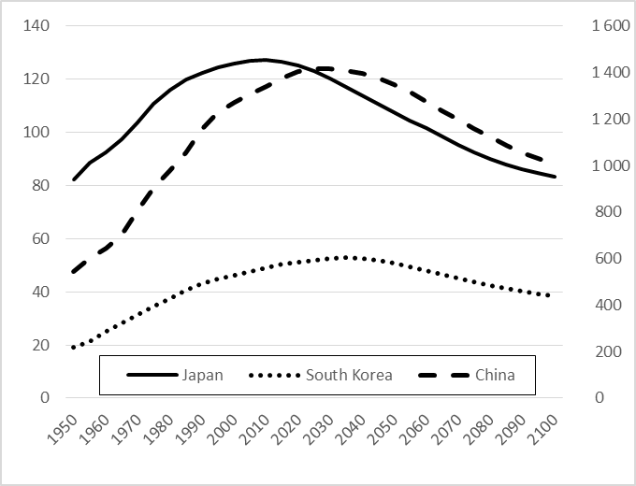 | 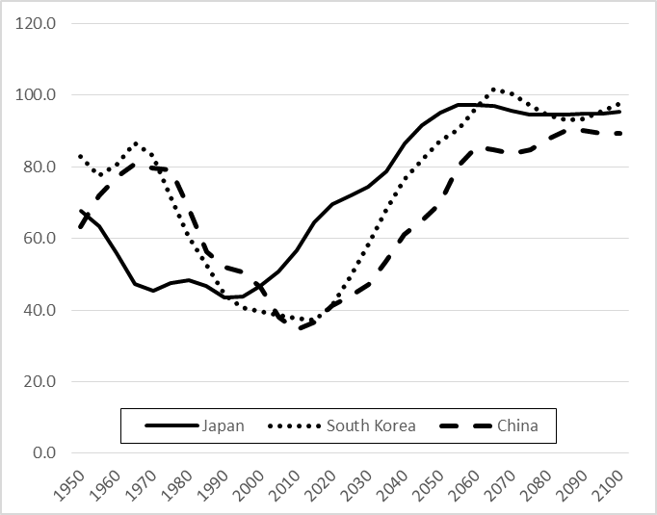
Note: Medium variant projections and variable fertility.  Source: UNPD (2015). | Source: UNPD (2015).
Note: The data for China do not include Hong Kong and Macao, Special Administrative Regions (SAR) of China, and Taiwan Province of China.

Figure 3: Two abandoned schools in Sado City, Niigata Prefecture; an elementary school in Sotokaifu (top left), and a junior high school in Hatano (top right) presently being used as storage for construction materials; and two abandoned hotels, in Aikawa, Sado City, Niigata Prefecture (left), and Tōyō Town, Kochi Prefecture (right). (Photos © Peter Matanle).
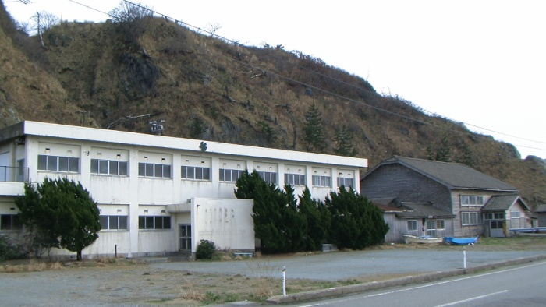 | 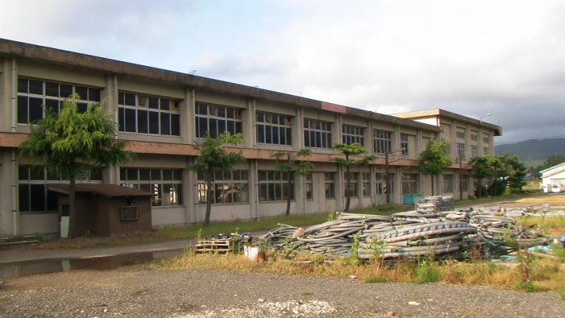
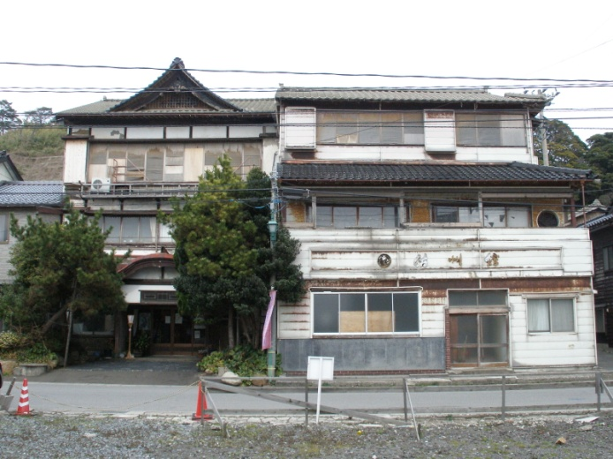 | 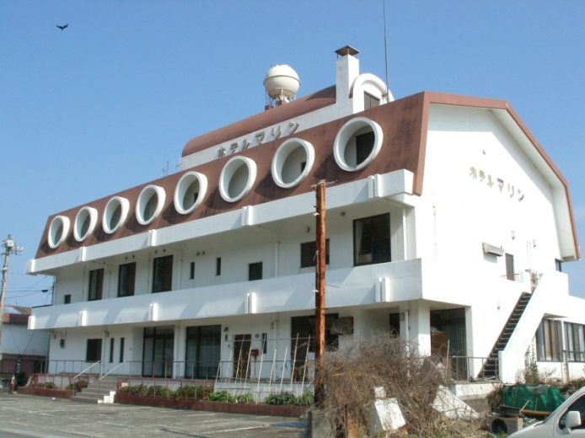

Figure 4: Abandoned and empty buildings are now a common sight in provincial regions. Clockwise from top left: A farmhouse in Ryōtsu, Sado City, Niigata Prefecture; a farmhouse with a tree growing outwards from the inside in Tōyō Town, Kochi Prefecture; an office building and shops in Ueda City, Nagano Prefecture; rows of abandoned houses in Horonai, Mikasa, Hokkaido; a restaurant and shop in Aikawa, Sado City; and a row of empty shops in Shibata City, Niigata Prefecture.
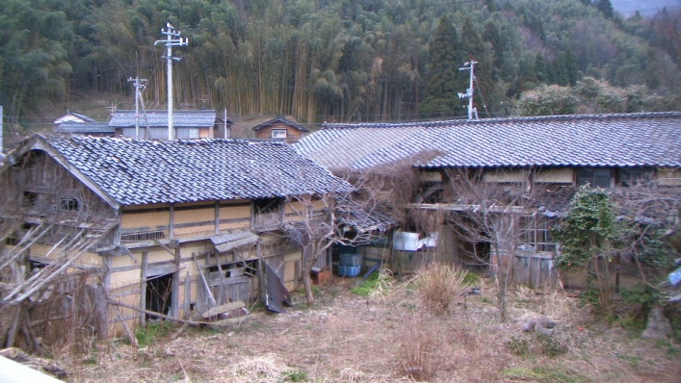 | 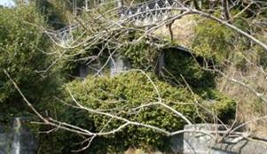
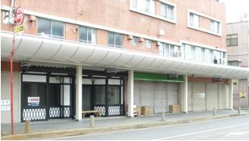 | 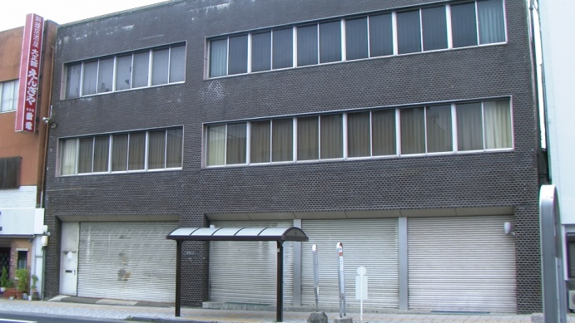
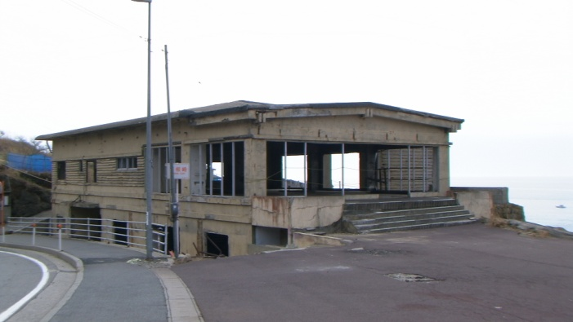 | 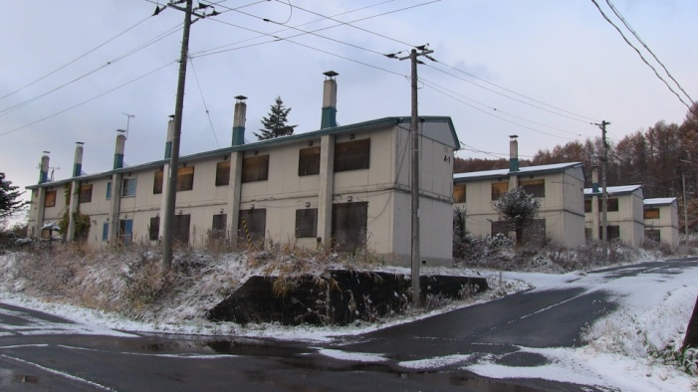

Figure 5. Clockwise from top left: A hand-painted sign on a roadside in Sado. The caption reads ‘Towards the Toki flying once more’; the satoyama agricultural landscape in Aikawa, western Sado; The Kodo taiko drum group’s base in Ogi Town, southwestern Sado; Saké produced exclusively by Hokusetsu of Hamochi in Sado for the Nobu international restaurant chain; original growth temperate rain forest in northeastern Sado; and Sado City gymnasium and base for the Sado City Sports Promotion Association. (All photos © Peter Matanle.)
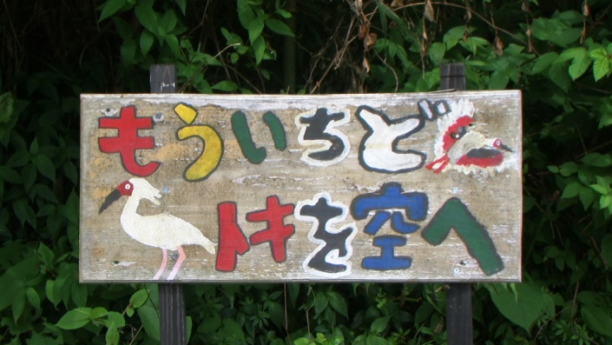 | 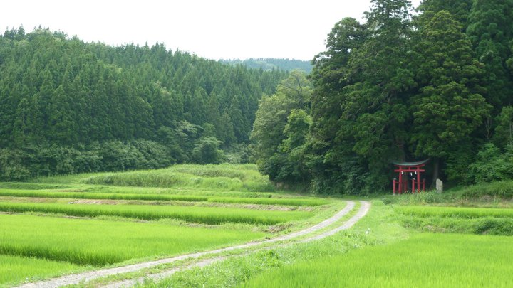
 | 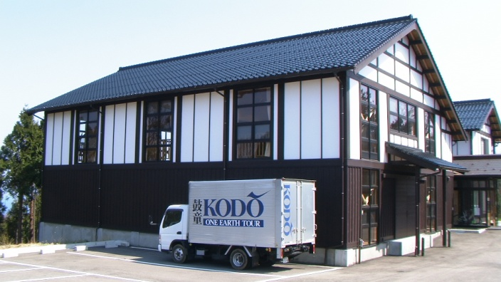

References
Akamatsu, Kaname. 1962. “A Historical Pattern of Economic Growth in Developing Countries.” The Developing Economies, 1 (1): 3-25.
AS (Asahi Shinbun). 06.01.2014. “Editorial: Japan Must Tackle Demographic Challenges Facing Large Cities.” http://ajw.asahi.com/article/views/AJ201401060039 (05.11.15).
Bloom, David E.; Canning, David; Sevilla, Jaypee. 2003. The Demographic Dividend: A New Perspective on the Economic Consequences of Population Change. Santa Monica: Rand Corporation.
Buhnik, Sophie. 2014. “The Uneven Impacts of Demographic Decline in a Japanese Metropolis: A Three-Scale Approach to Urban Shrinkage Patterns in the Osaka Metropolitan Area.” Globalization and New Intra-Urban Dynamics in Asian Cities, Natacha Aveline-Dubach; Sue-Ching Jou; Hsin-Huan Michael Hsiao (eds.). Taipei: National Taiwan University Press, pp. 199-230.
Coulmas, Florian. 2007. Population Decline and Ageing in Japan: The Social Consequences. London: Routledge.
Culter, Suzanne. 1999. Managing Decline: Japan’s Coal Industry Restructuring and Community Response. Honolulu: University of Hawaii Press.
Dahlgaard, Su Mi Park; Dahlgaard, Jens J. 2003. “Towards a Holistic Understanding of Human Motivation: Core Values - The Entrance to People’s Commitment?” AI and Society, 17 (2): 150-180.
Demographia. 2015. Demographia World Urban Areas: 11th Annual Edition: 2015: 01. http://www.demographia.com/db-worldua.pdf (09.11.15).
Daly, Herman E. 1996. Beyond Growth: The Economics of Sustainable Development. Boston: Beacon Press.
Egglestone, Karen; Tuljapurkar, Shripad. 2011. Aging Asia: The Economic and Social Implications of Rapid Demographic Change in China, Japan, and South Korea. Washington: Brookings Institution.
England, Robert S. 2005. Aging China: The Demographic Challenge to China's Economic Prospects. Westport: Praeger Publishers.
FAO (Food and Agriculture Organization of the United Nations). 2010. “Template for GIAHS Proposal.” http://www.fao.org/fileadmin/templates/giahs_assets/Sites_annexes/Sado_Proposal.pdf (05.11.15).
——. 2011. “Sado’s Satoyama in Harmony with Japan’s Crested Ibis.” http://www.fao.org/fileadmin/templates/giahs_assets/case_study_annexes/Sado-satoyama-in-harmony-with-crested-ibis-Japan-GIAHS-poster.JPG.pdf (05.11.15).
Feldhoff, Thomas. 2005. Bau-Lobbyismus in Japan: Institutionelle Grundlagen – Akteursnetzwerke – Raumwirksamkeit. Dortmund: Dortmunder Vertrieb für Bau- und Planungsliteratur.
——. 2013. “New Challenges after Fukushima: Nuclear Energy, Critical Junctures and Regional Development Policies in Japan.” Electronic Journal of Contemporary Japanese Studies, 13 (1). http://japanesestudies.org.uk/ejcjs/vol13/iss1/feldhoff.html (05.11.15).
Giddens, Anthony. 1991. Modernity and Self-Identity: Self and Society in the Late Modern Age. Stanford: Stanford University Press.
Grist, Michael J. 2014. Into the Ruins: Adventures in Abandoned Japan. Kindle Edition: Self-Published. (23.01.14).
Ha-Joon, Chang. 2006. The East Asian Development Experience: The Miracle, the Crisis, and the Future. Penang: Third World Network and Zed Books.
ICOLD (International Commission on Large Dams). 2014. Number of Dams by Country Members. http://www.icold-cigb.net/GB/World_register/general_synthesis.asp?IDA=206 (05.11.15).
ISHES (Institute for Studies in Happiness, Economy and Society). 28.10.2013. Municipalities Across Japan Establish “Happiness League”. http://ishes.org/en/happy_news/2013/hpy_id001115.html (05.11.15).
Jackson, Natalie. 2014. “Sub-National Depopulation in Search of a Theory: Towards a Diagnostic Framework.” New Zealand Population Review, 40: 3-39.
Kaneko, Ryuichi; Sato, Ryuzaburo. 2013. Entering the Post-Demographic Transition Phase in Japan: Dynamic Social Changes Toward New Population Regime. International Union for the Scientific Study of Population XXVII International Population Conference, Busan, 31 August.
Kerr, Alex. 2002. Dogs and Demons: The Fall of Modern Japan. London: Penguin.
——. 2013. “New Life for Old Towns through Sustainable Tourism.” TED.com. http://www.youtube.com/watch?v=kLRanIhp2jg (05.11.15).
Knight, John. 2003. Waiting for Wolves in Japan: An Anthropological Study of People-Wildlife Relations. Oxford: Oxford University Press.
Lay, Thorne. 2015. “The Surge of Great Earthquakes from 2004 to 2011.” Earth and Planetary Science Letters, 409: 133-146.
Lutz, Wolfgang; Sanderson, Warren C.; Scherbov, Sergei. 2004. The End of World Population Growth in the 21st Century: New Challenges for Human Capital Formation and Sustainable Development. London: Earthscan.
Matanle, Peter. 2006. “Organic Sources for the Tevitalization of Rural Japan: The Craft Potters of Sado.” Japanstudien, 18: 149-180.
——. 2011. “The Great East Japan Earthquake, Tsunami and Nuclear Meltdown: Towards the (Re)Construction of a Safe, Sustainable and Compassionate Society in Japan's Shrinking Regions.” Local Environment, 16 (9): 823-847.
——. 2014. “Ageing and Depopulation in Japan Understanding the Consequences for East and Southeast Asia in the 21st Century.” East Asia in 2013: A Region in Transition. Hugo Dobson (ed.). Sheffield: WREAC, pp. 30-35.
——; Sato, Yasuyuki. 2010. “Coming Soon to a City Near You! Learning to Live ‘Beyond Growth’ in Japan’s Shrinking Regions.” Social Science Japan Journal, 13 (2): 187-210.
——; Rausch, Anthony S. 2011. Japan’s Shrinking Regions in the 21st Century: Contemporary Responses to Depopulation and Socioeconomic Decline. Amherst: Cambria Press.
Matsutani, Akihiko. 2006. Shrinking Population Economics: Lessons from Japan. Tokyo: International House of Japan.
McCormack, Gavan. 2001. The Emptiness of Japanese Affluence. New York: M.E. Sharpe.
MIC (Ministry of Internal Affairs and Communications). 2008. Housing and Land Survey. http://www.stat.go.jp/english/data/jyutaku/index.htm (05.11.15).
——. 2011. Kaso Chiiki nado ni okeru Shūraku no Jōkyō ni kan suru Genjō Haaku Chōsa Kekka no Gaiyō. http://www.soumu.go.jp/main_content/000112719.pdf (05.11.15).
——. 2015. Japan Statistical Yearbook 2015. http://www.stat.go.jp/english/data/nenkan/index.htm (05.11.15).
Mizohata, Sachié. 2010. Le Vieillissement Rural Revisité: L´Approche par les Capabilités en Action. PhD Dissertation, Paris: Paris Descartes University.
MLIT (Ministry of Land, Infrastructure and Transport). 2014. Heisei 25 Todōfuken Chika Chōsa. http://tochi.mlit.go.jp/chika/chousa/2013/index.html (05.11.15).
NIPSSR (National Institute for Population and Social Security Research). 2012. Nihon no Shōrai Suikei Jinkō (Heisei 24nen 1gatsu Suikei). http://www.ipss.go.jp/syoushika/tohkei/newest04/sh2401.asp (09.11.15).
NKS (Nihon Keizai Shinbun). 03.12.2013. “Jichitai Kōkyō Shisetsu, 12000 Mune no Kaitai Kentō Hiyō 4000 oku En.” http://www.nikkei.com/article/DGXNASDG0304C_T01C13A2CR8000/ (05.11.15).
NKKI (Nōson Kaihatsu Kikaku Iinkai). 2006. Genkai Shūraku ni okeru Shūraku Kinō no Jittaitō ni kan suru Chōsa. http://www.maff.go.jp/j/nousin/noukei/communit/pdf/17report.pdf (05.11.15).
Ono, Akira. 2005. Sanson Kankyō Shakaigaku Josetsu: Gendai Sanson no Genkai Shūraku ka to Ryūiki Kyōdō Kanri. Tōkyō: Nōsan Gyoson Bunka Kyōkai.
Rausch, Anthony S. 2012. “A Framework for Japan’s New Municipal Reality: Assessing the Heisei Gappei Mergers.” Japan Forum, 24 (2): 185-204.
Rostow, Walt W. 1998. The Great Population Spike and After: Reflections on the 21st Century. New York: Oxford University Press.
Seaton, Philip. 2010. “Depopulation and Financial Collapse in Yūbari: Market Forces, Administrative Folly, or a Warning to Others?” Social Science Japan Journal, 13 (2): 227-240.
UNPD (United Nations Population Division). 2015. World Population Prospects: The 2015 Revision. http://esa.un.org/unpd/wpp/ (26.01.16).
Wilson, Chris. 2011. “Understanding Global Demographic Convergence since 1950.” Population and Development Review, 37 (2): 375-388.
World Airport Database. 2015. World Airport Database: Airports in Japan. http://www.airport-data.com/world-airports/countries/JP-Japan-Airports.html (05.11.15).
Yokomichi, Kiyotaka. 2007. The Development of Municipal Mergers in Japan. http://www.clair.or.jp/j/forum/honyaku/hikaku/pdf/up-to-date_en1.pdf (05.11.15).

NIPSSR projections presented here are medium variant and based on constant rates of fertility. UN Population Division projections assume a fertility bounce back and therefore anticipate slower population shrinkage for Japan than NIPSSR data.
The ‘demographic dividend’ refers to a period in a country’s development when child mortality decreases, causing women to have fewer children, and life-expectancy increases, producing a temporarily larger working age population. Accompanied by sound public health and economic policies, this set of circumstances can assist in propelling a country into an advanced state of development. The term was first coined by Bloom, Canning and Sevilla (2003) in their book of the same title.
UNPD data is used to provide clearer international comparison. UN projections for Japan are more conservative than the Japanese government’s, assuming a fertility bounce-back.
Estimates for the population of the Kanto region range around 30-47 million people, or approximately 30% of the population of Japan.
Interviews conducted by Peter Matanle in 2008 and 2009.
‘Growth’ is often used ambiguously, without a clear separation between its constituent elements, and where demographic and economic expansion in the modern era have become conflated to mean one and the same thing.
See the NSG Sado website at: http://www.sado-nsg.com/.
See the conference website at: http://island-festa.com/sicri/index.html.
See the Kodo website at: http://island-festa.com/.
See the Sado Triathlon website at: http://www.scsf.jp/triathlon/.
See the Sado City Sports Association website at: http://www.scsf.jp/.
See the Nobu restaurant chain website at: http://www.noburestaurants.com/.
See the Obata Shuzo (http://www.obata-shuzo.com/) and Hokusetsu (http://sake-hokusetsu.com/) saké brewery websites.

