Factory Modelling: The impact of Data granularity on Manufacturing and Building Asset Simulation Results Quality

|  |  |  |
| --- | --- | --- |
|  | | |
|  |  |
|  |  |
|  |  |
|  |  |
|  |  |
|  |  |
|  |  |
|  |  |
|  |  |

Structured ABSTRACT

**Purpose –** This paper reports on the experimentation of an integrated manufacturing and building model to improve energy efficiency. Traditionally, manufacturing and building-facilities engineers work independently, with their own performance objectives, methods and software support. However, as progress is made in resource reduction, advances become more challenging. Further opportunities for energy efficiency require an expansion of scope across functional boundaries to encompass manufacturing, utilities and building assets.

**Design/methodology/approach –** The impact of modelling methods providing guidance on modelling at factory level is inductive. The literature review outlines available techniques in simulation modelling at factory-level for energy effieicney of manufacturing and building assets. It demonstrates that detailed guidance for such a task is sparse. Therefore, five experiments are undertaken in the combined manufacturing and building simulation software IES <VE> to evaluate the impact of time interval granularity on the modelling of a paint shop process.

**Findings –** Experimentation demonstrates that time-step granularity can have a significant impact on simulation model results quality. :Linear deterioration in results can be assumed from time intervals of 10 minutes and beyond. Time interval settings in data capture must be carefully selected in line with the capabilities of the simulation software.

**Practical implications –** This work supports progress towards sustainable manufacturing by understanding the impact of time-step granularity used for analysis, on the quality of simulation results. Better understanding of this impact will guide engineers to use an appropriate level of data and understand the impact of the choices they are making.

**Originality/value –** This paper reports on the use of simulation modelling tool that links the areas of manufacturing and and buildings, enabling their joint analysis in order to reduce factory resource consumption. Currently, there are few available tools to link these areas together, hence, there is little or no understanding of how such combined factory analysis should be conducted to assess and reduce factory resource consumption.

# Background

Global energy use has risen by 70% since 1971 and is set to continue its steady 2% increase over the coming decades, fuelled by economic expansion and global development (Clarke and Trinnaman, 2007). Along with increasing energy use comes consequent emissions of greenhouse gases and the depletion of finite reserves of natural resources (Sorrell et al. 2010). Finite resources formed by the Earth over millions of years are being exhausted by a rising global population, and associated increases in manufacturing to cater for our growing dependence on energy and resource-intensive products (Al-Shemmeri, 2011 pp.13).

Moves toward sustainable manufacturing are driving resource reductions in order to mitigate environmental impacts (Seliger et al, 2007). Early interventions and practice adoption seek to prevent and reduce resource use of primary-materials, energy, water, and other consumables in localised areas, such as production lines. Point-solutions found through analysis methods such as lean value stream mapping are well documented within literature (Antony, 2011). However, as progress is made in resource reduction, advances become more challenging. Further opportunities for energy efficiency require an expansion of scope across functional boundaries to encompass manufacturing, utilities and building assets.

**1.1 Problem Statement:**

Typically work on factory energy reduction is undertaken independently within manufacturing, utility and building assets (Ball et al, 2009), with each achieving goals based upon their own performance measures. Firstly, this is because individual asset assessment is a traditional practice for achieving specified efficiency targets. Secondly there is an absence of methodologies and tools to support collaborative analysis across factory assets.

Currently, there is little consideration on the impacts of combining manufacturing, utility and building assets to measure and improve factory-level energy consumption. Decisions made in isolation could be sub-optimal and inappropriate, e.g. facilities may replace inefficient equipment without giving prior attention to reductions in manufacturing energy consumption, resulting in oversized equipment. Additionally, due to the complexities associated with factory-level energy analysis,representative modelling methods and supporting simulation outputs are required to understand the behaviour, feasibility and impact of potential solutions.

**1.2 Objectives:**

Modelling of process flows in manufacturing is well established and used in industry and research through tools like Witness, Arena, Simul8. Similarly, modelling of energy in buildings is well established through tools such as Ecotect, Trimble and IES <VE>. However, there are no commercially available tools and methods to link these areas together. Hence, as yet there is little or no understanding of how such modelling can help reduce factory energy consumption. Therefore, the objectives of this work are:

* Develop a factory model that combines manufacturing, utility and building assets
* Use novel simulation tool (IES <VE> THERM) to analyse the impact of time-step granularity
* Provide guidance on the quality of simulation results generated from different time-steps.

Currently, there is a lack of knowledge on combined modelling of manufacturing and buildings assets. Addtionally there is little understanding on how time-step granularities may impact the quality of simulation results within either disciplines of manufacturing buildings design and operation. What knowledge is available is generalised, based on experience and lacks empirical evidence. This work aims to address this gap by presenting a combined manufacturing and building asset model, inputs at varying time-step ganulairites, with a focus on the simulation result quality. The case data was drawn from a UK manufacturing firm to show how accurately the model emulates its ‘real world’ counterpart.

# Literature review

Energy consumption within the industrial sector equates to approximately one third of global energy use (Saygin et al., 2010). In factories, resource reduction activities have previously focused on point-solutions for discrete processes within manufacturing and building assets independently. Such solutions have often been through operational product and process focused improvement methods such as Lean and Six sigma. Increasingly, more attention is being sought at a factory-level, encompassing energy, material and waste flows across manufacturing, utilities and building architecture domains.

There are many recognised conceptual approaches that address industrial sustainability at factory-level. Examples include industrial ecology (Graedel and Allenby, 1995), eco-efficiency strategies of reduce, reuse and recycle (Sarkis and Rasheed 1995) and green-supply chain management (Beamon, 2008). The calculation of energy and material resource efficiency at factory level is complex and difficult to evaluate using conceptual approaches alone (Oates et al., 2011a). The paucity of literature on implementing the conceptual approaches is due to their abstract nature and in turn improvement opportunities are limited at factory level due to a lack of analytical tools and methods.

Contrary to the industrial sustainability literature, existing operations management literature provides detailed improvement methods and tools for product and process optimisation as Six Sigma DMAIC (Coronado and Anthony, 2002) and Lean VSM (Bicheno and Holweg, 2011). These methods detail behaviours and approaches for eliminating waste, measuring production variables and standardizing product improvement efforts (Schiele and McCue, 2010). However, they address production efficiency of which environmental improvement is a beneficial side-effect rather than a primary focus of improvement.

Within the field of environmental performance improvement there methods such as Material Flow Analysis (Yacoob and Friessner, 2006) which have structure but are problematic in considering all parts of a factory beyond product flow. Cases reported in practice (e.g. by Zero Waste Network, IEMA and ESKTN) have yielded point-solutions focused on specific manufacturing cells, processes and products. Although beneficial, they lack documentation of analysis techniques for energy, materials and waste flows across factory domains (Weinert, et al, 2011). Despite widespread dissemination of improvement initiatives and several reported studies exemplifying economic, environmental and social benefits, their implementation barriers continue (Lopes Silva et al., 2012). The literature suggests a lack of systematic rigour and repeatability in the application of current analysis methods for factory-level improvement.

The gaps in current knowledge on tools for factory analysis are particularly evident for modelling and analysis. Beyond Lean and Six Sigma there is little guidance to support resource efficiency improvement opportunities across the factory. Some researchers have presented studies on enabling opportunities to increase energy efficiency (Herrmann & Thiede, 2009), reduce material usage (Abdul Rashid et al., 2008) and minimise waste output (Chuang & Yang, 2013). In turn these positively affect financial performance (Yang et al., 2011). These few studies capture, through modelling, energy and material resources across production, utilities and building architecture assets.

Focusing on the resource efficiency of production domains alone is insufﬁcient to capture most energy consumption within factory environments. Utilities (electricity, gas, water) and building assets (lighting, air conditioning and ventilation) consume up to 40% of total factory energy (DECC, 2012). Thus there is significant potential for resource efficiency improvement by integrating the analysis of these assets and viewing the factory as an ecosystem (Despeisse et al., 2013). Furthermore, combining energy focused production analysis with utility and building assets allows consideration of interdependencies and synergies across the factory (Wischhusen et al., 2003). Different modelling and simulation analysis approaches can been applied to determine resource efficiency opportunities. These include: thermodynamic frameworks detailing process work, heat from machinery and material flows into the production environment (Bakshi et al., 2011), the coupling of building utility and production domain simulation tools (Hesselbach et al. 2005) and automated life cycle assessment (Thiede et al. 2011).

Simulation models are widely used within the disciplines of building and production domains engineering. Building fabric and assets are modelled to measure and improve day-lighting lux levels and embodied carbon. However, associated methods focus on energy efficiency during the design and construction phases of the building lifecycle and not on the management and maintenance of building assets throughout operations. Manufacturing on the other hand, focuses on in-use environmental performance to measure and improve lead-times, processing costs, and work-in-progress levels. In turn, results, although effective, are confined by their scope. Any improvement is therefore confined to functional area assets and not the whole factory. Although previous studies do provide bespoke solutions for individual assets and/or isolated areas (i.e. product, process or building), currently there is no modelling method for the whole factory, and so factory level opportunities could be missed. Additionally, the increasing number of simulation tools and analysis methods (DOE, 2011) being utilised across both fields makes it difficult for managers to choose a suitable tool for achieving energy reduction targets (Oates, 2013).

The complexity of modelling energy and material flow across factory assets has made simulation control logic a ‘state of the art’ technology, helping analyse and test existing environmental performance and potential improvement scenarios (figure 9). Control logic; defined as the part of a simulation that defines how a reactive system responds to events or conditional changes (Hamon & Rushby, 2004), is linked with model granularity level to identify required resource data for simulation. Simulation results could be used to determine improvement opportunities based on the application of best practices (Smith & Ball, 2011). Models that incorporate evaluation of energy and material consumptions (European Commission, 2007), environmental impacts and technical performance improve control of factory assets (Herrmann et al., 2011). Allowing energy efficiency measures, beyond single machine improvement, to be identified (Patterson, 1996).

Combining factory assets from manufacturing, utilities and buildings into a single model poses challenges depending on the functionality being modelled (Sarjoughian, 2006). Complex system models (Pidd, 2004), must account for all quantitative energy flows, asset levels, measurement time-steps and magnitudes (e.g. low volume of highly volatile non-organic compound). The composition of these attributes and there associated data-sets captures when and where resource flows occur, and outline available modelling granularities. Identifying improvement opportunities across factory production, utility and building assets therefore requires particular attention to data granularity and composability (Davé and Ball, 2013). This is particularly relevant in the experimentation stage (figures 4-8) of simulation when data input time-step granularity, will have a direct effect on the ability to manipulate the model and provide valid outputs (figures 9-13).

It is during model building phases that consideration of granularity factors and composability is required. Composability; defined as the capability to select and assemble simulation components (assets) in various combinations to satisfy user requirements (Petty and Weisel, 2003) is directly linked with granularity level, time-step and magnitude characteristics. Data granularity dictates the analysis capability of the simulation, directly effecting model fidelity and resultant output quality. Granularity can be defined with three main characteristics. The level relates to the subdivision of assets being modelled, time-step relates to the data recording interval of measurement taken from selected subdivisions, and magnitude relates to the type resource data being modelled. Simulation results are shown to change substantially over a range of data time steps from 1 minute to 30 minutes. Therefore, understanding the relationship between what time-step is available and what is results are achievable from that data, is important prior to running simulations. Methodologies to support composability have been designed (Pratt et al., 1999). However, guidance is needed on the level and time-step of detail data (granularity) to acquire and cleanse prior to simulation. For example, CNC machines (computer numerical control) and HVAC (heating, ventilation and air conditioning) could be represented at the same or different levels. Finally, once modelling level is established, time-steps must be considered, e.g. whether the time-step for those assets is seconds, minutes or hours.

The impacts of “big-data” gathered from supervisory control and data acquisition (SCADA) systems, Energy Management Systems (EMS), and manual data loggers challenge the granularity of models. Either the granularity is too high resulting in potentially time consuming and unnecessary activity for the simulation output required or granularity is too low due to absence of loggers in certain areas questioning whether a model is representative The usefulness of results is highly dependent not only on the available data but the decisions made to simplify it. Choosing the appropriate granularity is considered one of the most difficult aspects of the modelling process (Law, 1991). Concerning the availability of data, typical sources are incomplete or inappropriate for use without manipulation. The modelling method and tool IES <VE> THERM described in this paper seeks to fulfil the current gap in this area by tackling the challenge of granularity empirically.

# MethoDology

The case study presented is motivated by the challenges experienced in factory-level modelling, and the lack of information and guidance on data granularity characteristics. An inductive approach is used to understand the impact of simulation result quality based upon time-stepped granularity inputs. Research and case study data sets are acquired and analysed using the following method:

* A structured literature review is undertaken to gain modelling and data granularity insights.
* The selected case study is an industrial paint-shop that the research group had access to
* Case features a broad scope of factory assets and encounters granularity and modelling challenges
* Asset data was collated through direct contact with process engineers and SCADA systems
* Data cleansed by addressing and verifying reasons for missing or unclear data points
* Time-step granularities were defined based upon the tool (IES<VE>) requirements
* VE software (IES <VE>, 2013) used to build a model of the paint-shop environment and assets
* Model build presented to the company to verify the correct interpretation of data
* Simulation experimentation undertaken to understand the effect of data granularity on results quality.

Experimentation runs covered a range time-steps granularities between one to thirty minutes. The choice of time step was dictated by the functionality of the software. Validation of the base results was through discussion with company staff. Addtionally, comparison runs were face validated by the research team. Analysis of simulation results was done through numerical and visual procedures described later in this paper.

# CASE description

The industrial paint-shop is composed of three major assets: gas burner, biscuit de-humidifier, a closed loop steam re-heat, situated within an Air Supply House (ASH) unit. The ASH process conditions external air by passing it through a sequence of assets (Figure 1). These assets process the air to achieve temperature and humidity conditions within a psychrometric control window, before supply it to the desired destination (Figure 2). The data collected and model build (Figure 3) has been simplified for the purpose of experiments. steam injection and closed loop cooling coil assets do not feature in the created model. This is because these assets are only active during periods of high temperature and moisture content of the external air. This weather scenario is rare in temperate countries such as the UK.

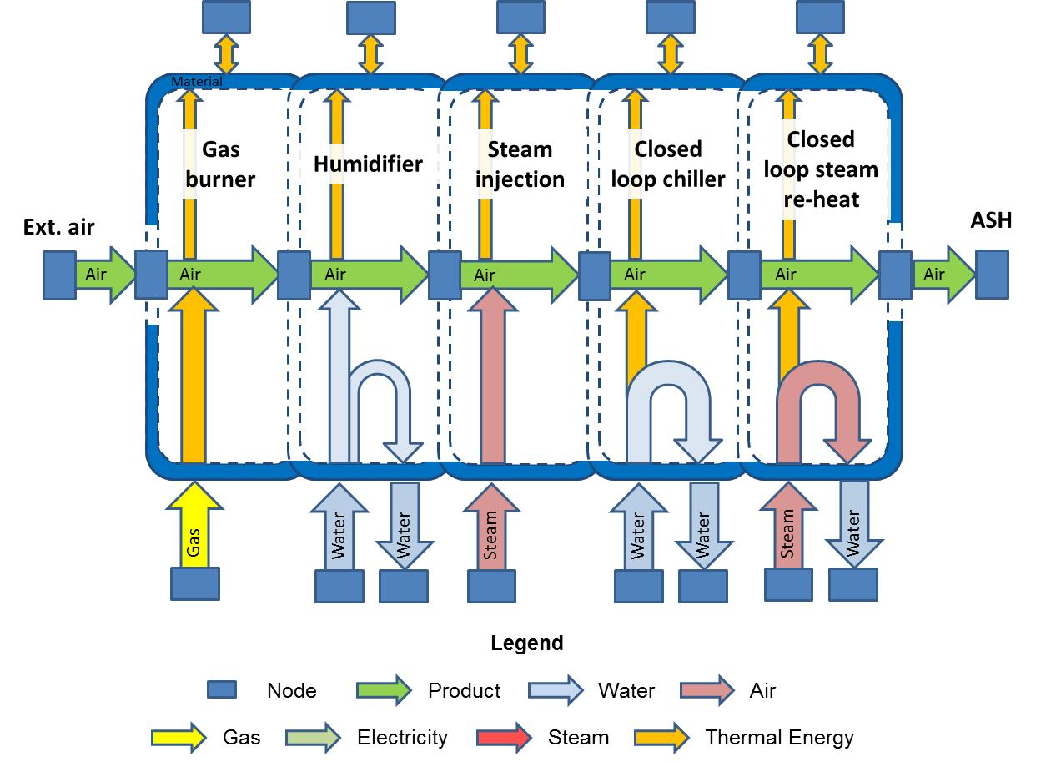

Figure 1. Graphical representation of the ASH (Oates, 2013)

Figure 2 illustrates the psychrometric behaviour and sequence of processes in the ASH house. This chart details the gas burner (1 -2), biscuit humidifier (2-3) and closed loop steam reheat (3-4). The first circle (1) represents the cold/dry (lower left) inlet condition of the external air. The parallelogram (4) shows the control window that the air must be in prior to delivery. Depending on the condition of the external air not all of the sequence is required.

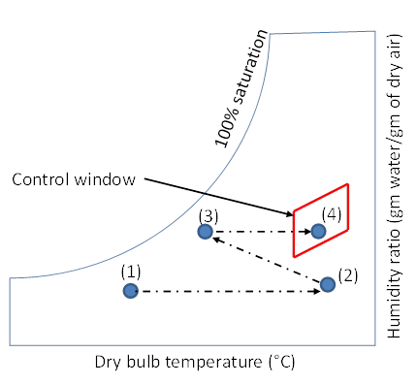

Figure 2. Psychrometric chart with control window (Oates, 2013)

Figure 3 shows the sequence modelled in IES <VE> using ApacheHVAC module. recorded data has been collated from site (Table 1). It is possible to emulate the control strategy of the ASH process using the ApacheHVAC module toolkit. Once built, model simulation can ascertain energy consumption for each of the three process assets.



Measurement Nodes

(1) = Inlet

(2) = after gas burner

(3) = after biscuits

(4) = after re-heat

(4)

(3)

(2)

(1)

Figure 3. The paint shop case study model in IES <VE> ApacheHVAC module (Turner et al., 2012)

Recorded data streams from the manufacture’s SCADA system were collated. Table 1 shows acquired data, providing detail on wet bulb temperature (Tw), dry bulb temperature (Td) and relative humidity (RH). The SCADA system records data point at time-steps of approximately 10seconds. However, the simulation tool required a breakdown of these into larger time-steps of a minute and larger. Therefore time-step granularity was calculated by analysis data points on a per-minute basis across the time-length of the recording. To create an accurate model initial temperature settings (Relative Humidity (RH), in the case of the biscuit de-humidifier) for each of the assets were required, along with gas consumption data from the gas burner. All data was collected from the site and composed within the model. Once defined, the composed model and data granularity intervals were verified by process engineers, experts in their field who understand the detailed data associated with the modelled assets.

Table 1. Logged data from assets available in the SCADA system

# Experimentation

## Design

The simulation model utilises the recorded data, outlined in section 4 of this paper. Recordings were taken from a seven day period of running in the case study paint shop. The data has been cleansed and defined into five time-step granularities. The first set contains data points at per-minute intervals, the second set every two, the third every six, the fourth every ten and the fifth every thrity minutes. The five data point intervals were decided upon after experimentation with data points between 1 and 30 minutes (with data intervals above ten minutes showing a marked deterioration in quality). By varying the time-step granularity and therefore data point frequency the impact on simulation result quality can be assessed. This experimentation can therefore guide other researchers and practitioners in how they understand the accuracy of their simulation results. This is especially important when using simulation support descion making in order to minimise risk and test all scenarios before deployment.

## Results

Five temperature profile sets have been generated from the simulation model (one for each data set), showing the temperature profile (as measured at each of the four nodes shown in Figure 3) over a one day period are shown in Figure 4 to Figure 8. The data shows distinct shift patterns when manufacturing is running (assumed to be constant) or stopped. Air temperature node data relates to outside temperature at the inlet node (shown in Figure 3 as (1)) and air temperature at ‘after gas burner’, ‘after Biscuits’ and ‘after re-heat’ nodes (shown as nodes (2) and (3) and (4) in Figure 3). The changes in air temperature throughout the paint shop process is discussed in section 4.

It can be seen in a comparison of the profiles that the two minute profile (shown in Figure 5) shows little or no deterioration over the 1 minute profile (shown in Figure 4). This is also true of the 6 minute (Figure 6) and 10 minute (Figure 7) profiles where a some normalisation can be seen in relation to that of the 1minute profile (Figure 4). It is only in the 30 minute profile (Figure 8) that significant smoothing and loss of deailed energy data (peaks and troughs) in the simulated data can be noticed. For a more detailed assessment of the effects of data point interval choice it is necessary to compare the simulation results with the metered data.

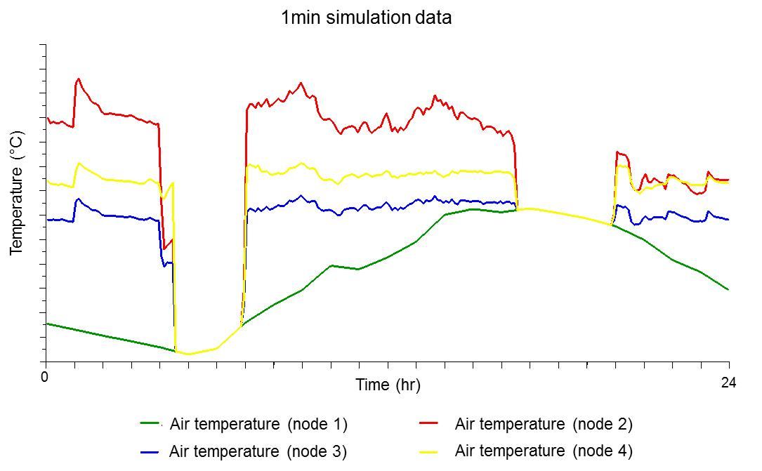

Figure 4. Temperature profiles (relating to Figure 3 flows) - 1min interval data

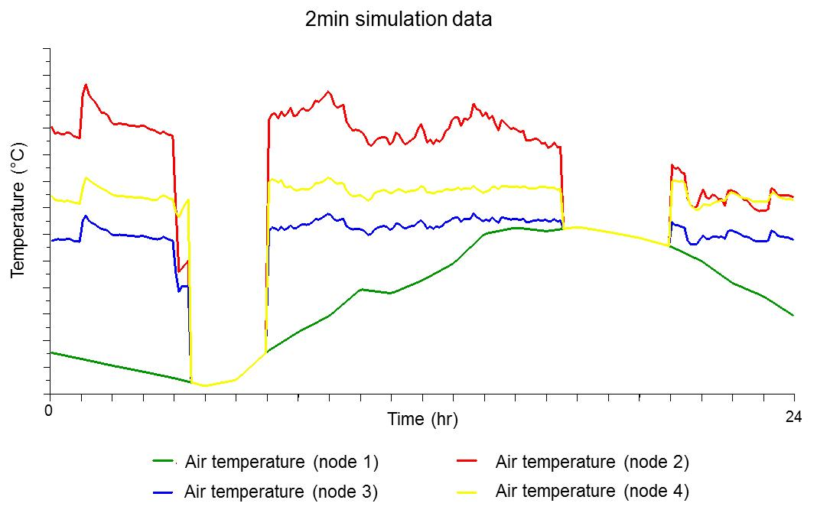

Figure 5. Temperature profiles (relating to Figure 3 flows) - 2min interval data

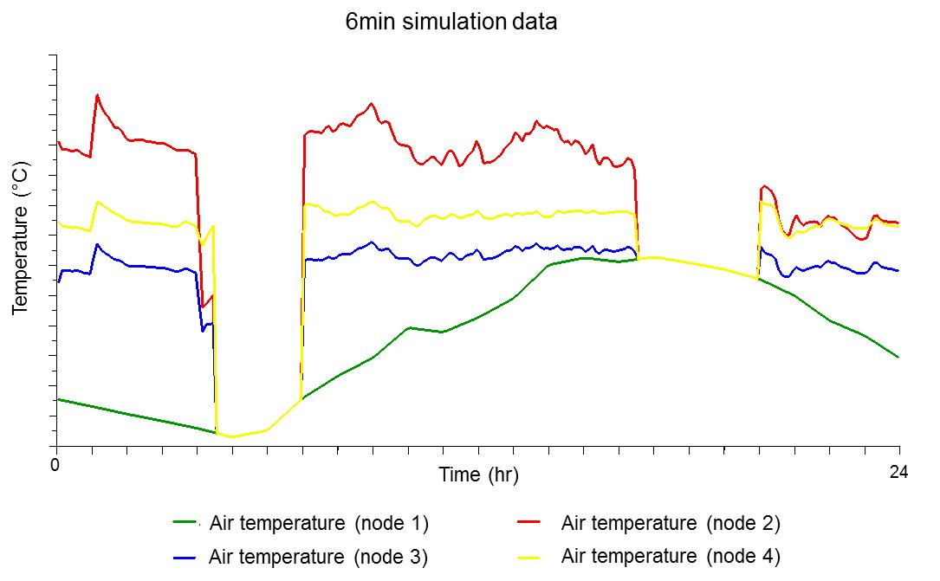

Figure 6. Temperature profiles (relating to Figure 3 flows) - 6min interval data

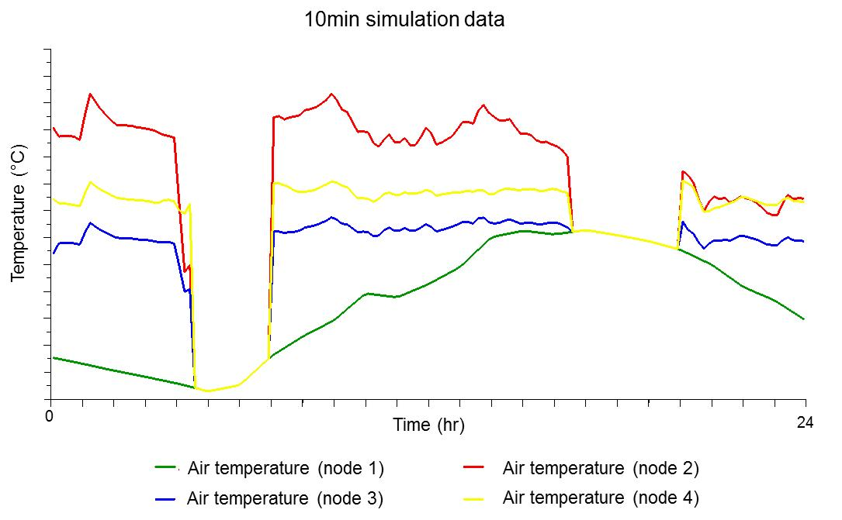

Figure 7. Temperature profiles (relating to Figure 3 flows) - 10min interval data

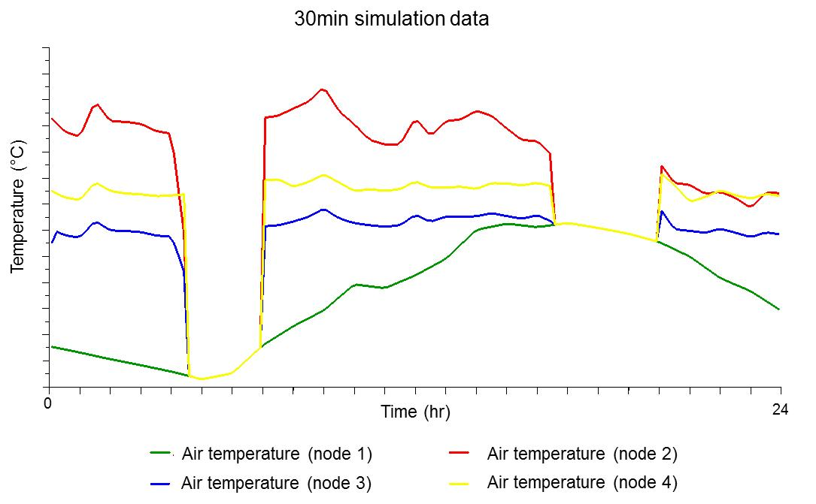

Figure 8. Temperature profiles (relating to Figure 3 flows) - 30min interval data

Five energy consumption profiles for the gas burner asset are shown in Figure 9 - Figure 13. Data presented is over a one day period with a graphing for time-step granularity The figures show the experiments in result quality by comparing simulated results against metered data. The red profile shows the simulated energy consumption profile and the blue shows recorded data from the SCADA system. Figure 9 features the 1 minute interval data set. It can be seen in Figure 9 that there are small deviations in peak values between the 1 minute time-step granularity and the recorded data values.

Overall the simulated results slightly underperform that of the metered data, however the 1 minute data is a comparable emulation as shown in the figures. One explanation for result underperformance could be due to the fact that the simulation does not account for moisture transfer from the gas burner to the passing air. The gas burner asset is modelled as a heater battery which assumes the air will increase in dry bulb air temperature at a constant humidity ratio. In reality moisture from the burning of gas will transfer to the passing air. This in turn increases the air temperature and the humidity ratio of the air condition post gas burner, resulting in a greater enthalpy difference between the inlet and post gas burner air condition than that of the simulation model. The resulting quality of the simulation still requires some refinement if being used to support any decision making. Moisture from the gas burner and inlet assets require further detailing to replicate the increase in moisture throughout the process. One method for achieve this is to insert a steam injection asset after the heater battery (i.e. currently representing the gas burner), injecting moisture into the passing air at a constant dry bulb temperature.

Minor discrepancies between energy consumption patterns at the start and end of manufacturing shifts between simulated and metered data have been noted. Future work will look to minimise this difference via improved process controls. Figure 10 demonstrates a very similar picture for the 2 minute data. Figure 11 and Figure 12 show that 6 minute and 10 minute (respectively) intervals largely follow the peaks and troughs of the metered data, though some normalising of the simulation profile is more noticeable in the 10 minute interval (Figure 12). The 30 minute interval shows high levels of normalisation and a greater degree of smoothing in the profile to the metered data (Figure 13), as is the case of the temperature profile (Figure 8) when compared against lesser time-step intervals.



Figure 9. Gas burner energy consumption profiles actual -vs- simulated - 1min interval data



Figure 10. Gas burner energy consumption profiles actual -vs- simulated - 2min interval data



Figure 11. Gas burner energy consumption profiles actual -vs- simulated - 6min interval data



Figure 12. Gas burner energy consumption profiles actual -vs- simulated - 10min interval data



Figure 13. Gas burner energy consumption profiles actual -vs- simulated - 30min interval data

From the simulated temperature profiles (Figure 4 to Figure 8) and simulated versus metered gas consumption data (Figure 9 - Figure 13) it is fair to surmise that the 1 minute data profile provides the smallest deviance in time-step granulation and closest simulation result, in regard to emulation of the recorded data. Though use of the 2, 6 and even 10 minute data intervals will still enable the generation of profiles that show the variation required to generate results from the simulation model. The 30 minute profile is more appropriate for the identification of broad trends in the data.

Figure 14 illustrates 1 minute consumption profile for the gas burner over a seven day period. The figure compares simulated data against metered data, with the red profile showing the simulated energy consumption profile and the blue the metered data. No manufacturing occurred during days 3 and 4. Though it is more difficult to compare the simulated and metered results in relation over this time period, the pattern of the two results are correlated with one another. This shows that 1 min data (being the highest value accepted by the simulation tool) is the most appropriate granularity time-step for building this type of simulation model.



Figure 14. Gas burner energy consumption profiles actual -vs- simulated - 1min interval data (7days)

Table 2 provides an overview of the simulated results for 1,2,6,10 and 30 time step intervals against metered data over 1 and 7 days in two ways, percentage difference and root mean square error (RMSE). The table indicates that over 1 and 7 days’ period of analysis, the 30 minute data has a lower percentage difference than the 1,2,6 and 10 minute data sets. The smoothing of the metered and simulated data reduces the percentage difference between the two results. This is not a true reflection of what is happening on site, and can be seen when comparing the metered data of the 1 minute (Figure 9) and that of the 30 minute (Figure 13) data sets. The percentage differences for the time step intervals of 1,2,6 and 10 minutes are similar, providing solace in the summary of the graphed data in Figure 9 to Figure 13. Similarities to the percentage difference shown in Table 2 are also displayed for the RMSE across the datasets.

Table 2. Gas burner energy consumption metered data compared against simulated results

# Discussion and Conclusions

This work has sought to support the progress towards sustainable manufacturing by understanding the impact of data granularity and data quality used for analysis on the accuracy of the analysis. With better understanding of the impact rules and guidance can be developed for engineers to seek to use an appropriate level of data and understand the impact of the choices they are making. The experimentation featured in this paper demonstrates that the granularity of time intervals will have a significant impact of the quality of results obtained from the simulation model. A gradual linear deterioration in results, can be assumed from time intervals of 10 minutes and beyond. Therefore, to use of a simulation model to support decision making means time-step granularity must emulate process assets feasibly to minimise uncertainty and risks.

Time-step granularity is a pre-requisite task that requires justification during data analysis and model model building phase. Most simulation tools will dictate the maximum time-step capability manageable by the software. Modelling methods such as numerical analysis must be used to measure the simulation result quality against recorded data. Comparing results to understand their accuracy as in the case of the gas burner asset. Future work includes research to better understand granularity characterics and how they impact the simulation results. Additionally, work is being carried out on data cleansing such as minimising the presence of noise/outliners in composed data. Further work is also required in the detailing of assets and their connection with resource data in modelling tools. This includes assets such as the gas burner, in order to better replicate required data so as to build confidence in the model and its simulated results.

# ACKNOWLEDGMENTS

The authors would like to thank the funders and partners for their support of this work: UK Technology Strategy Board (TSB) funded THrough-life Energy and Resource Modelling (THERM) project and the UK’s EPSRC Centre for Innovative Manufacturing in Industrial Sustainability (EP/1033351/1).

# references

Abdul Rashid, S. H., Evans, S. and Longhurst, P. (2008), “A comparison of four sustainable manufacturing strategies”. *International Journal of Sustainable Engineering*, Vol. 1 No.3, pp. 214-229.

Al-Shemmeri, T. (2011), “*Energy audits: a workbook for energy management in buildings*”, Chichester, Wiley.

Antony, J. (2011), “Six sigma vs lean: Some perspectives from leading academics and practitioners”, *International Journal of Productivity and Performance Management*, Vol. 60 No. 2, pp.185-190.

ApacheHVAC. (2013), “ApacheHVAC”, available at: <http://www.iesve.com/software/ve-pro/analysis-tools/hvac/apachehvac> (accessed 22 April 2013).

Bakshi, B. R., Gutowski, T. G. and Sekulic, D. P. (2011), “*Thermodynamics and the destruction of resources*”. Cambridge, Cambridge University Press.

Ball, P.D., Evans, S., Levers, A. and Ellison. D. (2009), “Zero carbon manufacturing facility: towards integrating material, energy and waste process flows”, *Journal of Engineering Manufacture*, Vol. 223 No. B9, pp. 1085-1096.

Ball, P.D., Despeisse, M., Evans, S., Greenough, R.M., Hope, S.B., Kerrigan, R., Levers, A., Lunt, P., Oates, M.R., Quincey, R., Shao, L., Waltniel, T., Wheatley, C., and Wright, A.J., (2011), “Modelling energy flows across buildings, facilities and manufacturing operations”, 28th International Manufacturing Conference, Dublin, Ireland.

Beamon, B. M. (2008). “Sustainability and the future of supply chain management”, *Operations and Supply Chain Management*, Vol. 1 No.1, pp. 4-18.

Bicheno, J. and Holweg, M. (2011), *The Lean Toolbox*, Picsie, Buckingham.

Brooks, R. J. (2010), *Complexity, Level of Detail, and Model Performance,* excerpt from *Conceptual Modeling for Discrete-Event Simulation*. 1st ed., London, CRC Press, Taylor & Francis Group.

Brown, T., Gambhir, A., Florin, N., and Fennel, P. (2012), “*Reducing CO2 emissions from heavy industry: a review of technologies and considerations for policy makers: Briefing paper 7”*, London, Grantham Institute for Climate Change.

Cesarotti, V., Di Silvio, B., and Introna, V. (2009), “Energy budgeting and control: A new approach for an industrial plant”, *International Journal of Energy Sector Management*, Vol. 3 No. 2, pp. 131-156.

Clarke, A. W. and Trinnaman, J. A. (2007), *Survey of Energy Resources*, London, WEC Reports.

Coronado, R. B. and Antony, J. (2002), “Critical success factors for the successful implementation of six sigma projects in organisations”. *The TQM magazine*, Vol. 14 No. 2, pp. 92-99.

Chuang, S. P., and Yang, C. L. (2013), “Key success factors when implementing a green-manufacturing system”, *Production Planning & Control*, (ahead-of-print), Vol. 1 No. 15.

Davé, A., and Ball, P.D. (2013), “Factory modelling: data guidance for analysing manufacturing, utility and building architecture systems”. *Proceedings of 11th international conference on Manufacturing Research,* pp. 115-121.

DECC, (2012), “*Consultation on simplifying the Climate Change Agreements Scheme*”, London, Department of Energy and Climate Change.

Despeisse, M., Oates, M. R. and Ball, P. D. (2013), “Sustainable manufacturing tactics and cross-functional factory modeling”, *Journal of Cleaner Production*, (ahead-of-print).

Despeisse, M., Ball, P. D. and Evans. S. (2011), “Modelling and Tactics for Sustainable Manufacturing: An Improvement Methodology”, *9th Global Conference Sustainable Manufacturing,* 28-30 September, Saint Petersburg, Russia

DOE, (2011) “US DOE building energy software tools directory”, available at:

http:// apps1.eere.energy.gov/buildings/tools_directory/alpha_list.cfm (accessed April 22, 2013).

European Commission, (2007), “DG Competition Report on Energy Sector Inquiry”, European Commission, Brussels.

Graedel, T.E., and Allenby, B.A. (1995), *Industrial Ecology*, New Jersey, Prentice Hall.

Hesselbach, J., Junge, M., Herrmann, C., Dettmer, T. (2005), “Production focused life cycle simulation”, in Floriano´ polis and Brasilien (Ed.), *Proceedings of the 38th CIRP International Seminar on Manufacturing systems*.

Herrmann, C., Thiede, S., Kara, S. and Hesselbach, J. (2011), “Energy oriented simulation of manufacturing systems—concept and application”, *CIRP Annals-Manufacturing Technology*, Vol. 60 No.1, pp. 45-48.

Herrmann, C., and Thiede S. (2009), “Process Chain Simulation to Foster Energy Efficiency in Manufacturing”. *CIRP Journal of Manufacturing Science and Technology*, Vol. 1 No. 4, pp. 221-229.

IEA (2013), “Tracking Industrial Energy Efficiency and CO2 Emissions”, available at:

http://www.iea.org/publications/freepublications/publication/tracking_emissions.pdf (accessed April 22, 2013).

IES <VE> (2013), “VE-Pro”, available at: http://www.iesve.com/ software/ve-pro (accessed 22 April 2013).

Jelinski, L., Graedel, T.E., Laudise, R.A., McCall, D.W. and Patel, C.K.N. (1992), “Industrial Ecology: Concepts and Approaches”, Colloquium Paper, *Proceedings of the National Academy of Science of USA*, Vol. 89 No. 3, pp. 793-797.

Law, A. M. (1991), “Simulation model’s level of detail determines effectiveness”, *Industrial Engineering* Vol. 23 No.10, pp. 16-18.

Law, A. M., and Kelton, W. D. (2000), *Simulation Modelling and Analysis*. 3rd ed. NY, McGraw Hill.

Lopes Silva, D. A., Delai, I., Soares de Castro, M. A., and Ometto, A. R. (2012), “Quality Tools Applied To Cleaner Production Programs: A First Approach Towards A New Methodology”, *Journal of Cleaner Production*, Vol. 47, pp. 174–187.

Oates, M., A. (2013). “*A new approach to modelling process and building energy flows in manufacturing industry”*, PhD Thesis, De Montfort University, Leicester.

Oates, M., Wright, A., Greenough, R., and Shao, L. (2011a), “Understanding resource flows in a factory environment: A graphical approach”, *In Proceedings of the 2011 1st International Conference On Sustainable Intelligent Manufacturing*, Portugal, Institute of Energy and Sustainable Development.

Oates, M., Wright, A., Greenough, R., and Shao, L. (2011b), “A new modelling approach which combines energy flows in manufacturing with those in a factory building.” *Proceedings of the 12th  Conference of International Building Performance Simulation Association*, Sydney, Australia, Institute of Building Simulation.

O’Brien, C. (1999), “Sustainable Production: A new paradigm for a new millennium”, *International Journal Production Economics*, Vol. 60, pp. 1-7.

Patterson M.G., (1996), “What is energy efficiency?: Concepts indicators and methodological issues”, *Journal of Energy Policy*, Vol. 24 No. 5, pp. 377–390.

Pauli, G. A., (2010), *The blue economy: 10 years, 100 innovations, 100 million jobs.* Taos, Paradigm.

Petty, M. D., and Weisel, E. W. (2003), “A composability *lexicon”, in Proceedings of the 2003 Spring Simulation Interoperability Workshop IEEE*, pp.181-187.

Pidd, M. (2004), *Computer Simulation in Management Science*, 5th edition. Chichester, Wiley.

Pratt, D. R., Ragusa, L. C., & von der Lippe, S. (1999), “Composability as an architecture driver”, *In The Interservice/Industry Training, Simulation & Education Conference (I/ITSEC)*, National Training s Association, Vol. 1999 No. 1.

Robinson, S. (2004), *Simulation – The Practice of Model Development and Use*. NJ, John Wiley & Sons.

Sarjoughian, H. S., (2006), “Model composability”, *38th Winter Simulation Conference, IEEE*, pp.149-158.

Sarkis, J., & Rasheed, A. (1995). “Greening the manufacturing function”, *Business Horizons-Bloomington*, Vol. 38, pp. 17.

Saygin, D., Patel, M. K. and Gielen, D. J. (2010), “Global industrial energy efficiency benchmark: An energy policy tool”, New York, United Nations Industrial Development Organization (UNIDO).

Seliger, G., H.J. Kim, S. Kernbaum, M. Zettl, (2008), “Approaches to sustainable manufacturing”, *International Journal of Sustainable Manufacturing*. Vol. 1 No. 2, pp. 58-77.

Schiele, J. J., and McCue, C. P. (2010). “A framework for the adoption of lean thinking within public procurement”, *International Journal of Procurement Management*, Vol. 3 No. 4, pp. 379-396.

Smith, L., and Ball, P.D. (2012), “Steps towards sustainable manufacturing through modelling material, energy and waste flows”, *International Journal of Production Economics*, Vol. 140 No. 1, pp. 227-238.

Sorrell, S., Speirs, J., Bentley, R., Brandt, A. and Miller, R. (2010), “Global oil depletion: A review of the evidence”, *Journal of Energy Policy*, Vol. 38 No. 9, pp. 5290-5295.

THERM. (2012), THrough-life Energy and Resource Modeling (THERM), available at: http://www.iesve.com/research/current-projects/therm (accessed 22 April 2013).

Turner, C., Davé, A., Oates, M., Murray, V. and Ball, P. (2012), “Modelling energy in buildings and production systems: The impact of model granularity and quality on output”, *Proceedings of the 10th International Conference on Manufacturing Research ICMR 2012*, Aston, Birmingham.

Thiede, S., Herrmann, C., and Kara, S. (2011), “State of Research and an innovative Approach for simulating Energy Flows of Manufacturing s”. In Hesselbach, Jürgen, Herrmann, Christoph (Ed.), Glocalized Solutions for Sustainability in Manufacturing, Heidelberg, Springer, pp. 335-340.

Weinert, N., Chiotellis, S. and Seliger, G. (2011). “Methodology for planning and operating energy-efficient manufacturing systems”, *CIRP Annals-Manufacturing Technology*, Vol. 60 No. 1, pp. 41-44.

Wischhusen, S., Ludemann, B., Schmitz, G. (2003), “Economical Analysis of Complex Heating and Cooling s with the Simulation Tool HKSim”, *In Proceedings of the 3rd International International Modelica Conference*, Linkoping, Sweden, pp. 259-268.

Wright, A. J., Oates, M. R., and Greenough, R. (2013), “Concepts for dynamic modelling of energy-related flows in manufacturing”, *Applied Energy*, (ahead-of-print).

Yacoob, A., and Friessner, J. (2006), *Half is Enough - An Introduction to CP*, Beirut, Lebanon, LCPC Press.

Yang, M. G. M., Hong, P., and Modi, S. B. (2011), “Impact of lean manufacturing and environmental management on business performance: an empirical study of manufacturing firms”, *International Journal of Prouction Economics*, Vol. 129 No. 2, pp. 251-261.