Playful and Multi-Sensory Fieldwork: Seeing, Hearing and Touching New York

Abstract
Geographical fieldwork is being reinvigorated through a series of pedagogical and methodological innovations. Yet, while there are many good ideas in circulation, there is less evidence of where these ideas are taking us: what students are getting out of them, and what significance they may have for the discipline. These questions are explored through a series of case studies involving playful and multi-sensory fieldwork, conducted by British university students in New York. Projects described here involve: collecting sounds; urban climbing; finding ‘accidental art’; and getting lost. These ‘lively’ geographies matter for a number of reasons: students enjoy them, and in turn are inspired to learn actively and creatively; they foster the acquisition of new skills, which students may find helpful in their search for and transition to employment or simply in their personal development; they provide new answers to the questions of what a ‘geography of curiosity’ might entail and where it might lead; and they explore the possibilities for a less narrowly visual – and more multi-sensory – geography. So this fieldwork can be instructive, inspiring and enchanting too.

Key words: Fieldwork, Sensory, Visual, Tactile, Sound, Art, Enchantment, Psychogeography
Introduction
Geographical fieldwork in schools and universities is being reinvigorated through creative and energetic innovations in teaching and learning (Cook, 2011; Phillips and Johns, 2012). These developments are driven by the renewal of geographical traditions, ranging from the experiments in outdoor learning that were pioneered in Victorian Britain to the urban expeditions convened by radical geographers in the 1970s (Bordessa and Bunge, 1975), and also by experiments with new forms of exploration and fieldwork, for example through the revival of cultural geography (Burgess and Jackson, 1992). These developments are influenced, in turn, by constructivist and co-constructivist theories of learning (Sprake, 2012) and Problem Based Learning (PBL) (Pawson et al, 2006). In its simplest form, originally and eloquently put forward by Jean Jacques Rousseau in Émile: or, Concerning Education, this curiosity-driven learning begins with experience, which can be sparked by stepping outside the classroom. Seeing and touching something as simple as a stone, a young person may become curious, framing questions about the world, then refining and attempting to answer those questions (Rousseau, 1762, quoted by Phillips, 2014: 500). These simple principles provide a rationale for field-based learning.

But, while there are now many good fieldwork ideas in circulation, there is less evidence of where these ideas are taking us, what students are getting out of them, and whether and how they are significant for students and for the discipline of Geography. To answer these questions, it is necessary to shift some attention from teaching to learning and from pedagogy to practice, asking how students are helping shape the new fieldwork and what they are getting out of it. This paper focusses upon student experiences of fieldwork, examining upon some particularly innovative, playful and adventurous fieldwork, which involves multi-sensory explorations of and in the field.

Playful and Multi-Sensory Fieldwork
Some of the most exciting contemporary geographical fieldwork ideas, revolving around multi-sensory exploration of places and landscapes, are being developed and communicated through an exchange between educators and a range of geographers outside the academy. The ‘Geography Collective’ – ‘a bunch of Guerrilla Geographers’ including ‘explorers, doctors, artists, teachers, activists, adventurers’ who ‘think it’s really fun and important to get exploring and questioning the world’ (Geography Collective 2010, p. 196) – have published one of a series of manuals for playful and adventurous fieldwork. The first of these, entitled Mission:Explore (2010), encourages the reader to ‘Become a guerrilla explorer and extreme missioner with missions that defy gravity, see the invisible and test your mental agility’ (Geography Collective, 2010, back cover, emphasis added). Missions involve seeing differently, engaging the other senses, and exploring places playfully. For example: ‘Play hide in shop. Go to a shopping centre and play hide-and-seek. Which are the best three shops to hide in?’ (Geography Collective, 2010, p. 145). Other, similar books include How to be an Explorer of the World (2008) by Keri Smith, which comprises a series of exercises and begins by advising the reader to be adventurous: ‘Start with whatever makes you feel a twinge of excitement’ (Smith, 2008, p. 2). This means ‘observ[ing] the world around you as if you’ve never seen it before’ (Smith 2008: 1). It means exploring differently-visual and more-than-visual geographies (Aitken and Craine, 2005). Specific exercises suggest how to engage all the senses, for example by mapping sounds (figure 1) or wearing a blindfold to explore otherwise-familiar places in new ways (figure 2).

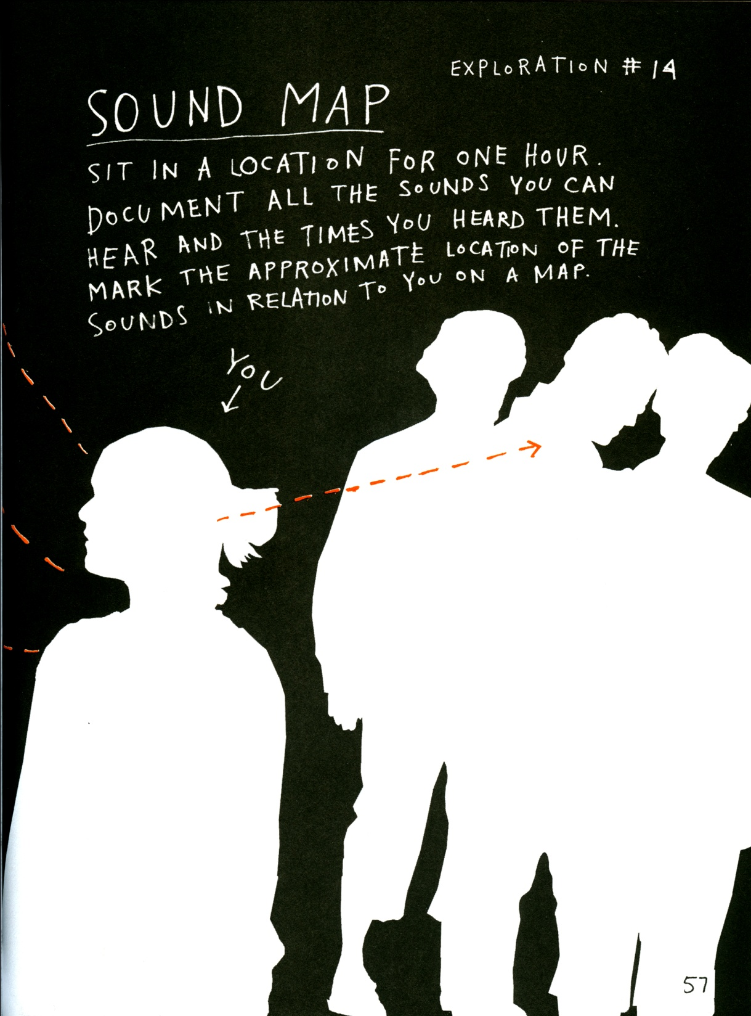
Figure 1 Extract from How to be an Explorer, by Keri Smith (2008)

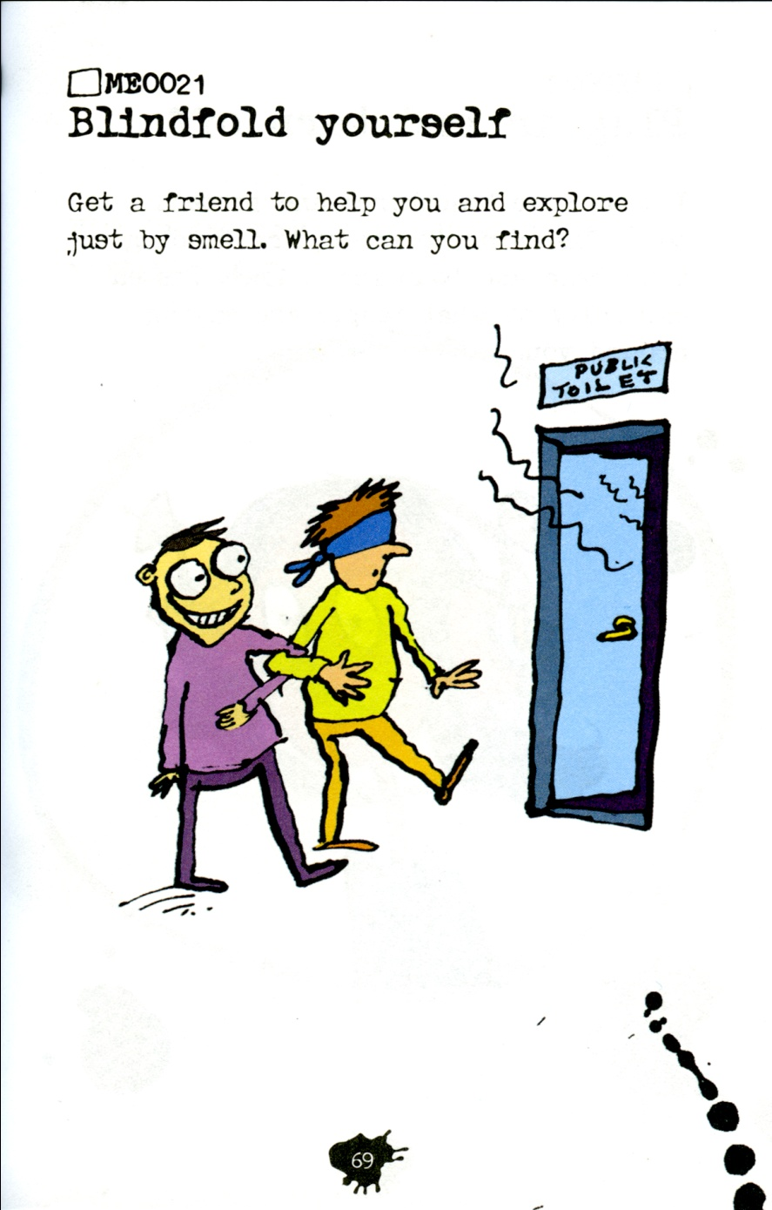
Figure 2 Extract from Mission:Explore. Source: Geography Collective (2010, p. 69)

These ideas are both borrowing from and influencing developments in more formal educational settings. The team behind Mission:Explore – including Daniel Raven-Ellison, a former school teacher who now encourages geographical learning and exploration through a range of less formal means – are working with the National Geographic Society in the United States and advising schools there and in the UK on creative learning strategies, and their ideas are also circulating and being discussed by geographers in higher education (Phillips and Johns, 2012). They are borrowing from geographical traditions in teaching and research, ranging from the expeditions, coordinated William (Bill) Bunge in the 1970s, which employed and experimented with smell and soundscapes, emotional and mental mappings, to more recent research into geographies of smell (Henshaw, 2013), sound, noise and music (Law, 2013), and sensuality more generally (Rodaway, 1994).

These methods are applicable to a range of settings. Ideally, they do not require travel, since they offer new ways of seeing or otherwise encountering familiar places. A typical exercise in the Lonely Planet Guide to Experimental Travel suggests visiting an airport, not to catch a plane, but to experience this place of comings-and-goings afresh. This metaphorical rather than material separation from one’s usual environment is designed to de-familiarise ordinary places. That said, it can be easier to look with fresh eyes – or engage the other senses – when one is far from home, as for example on an international field trip, and especially in a place such as New York, where there is so much to see, hear, smell, taste and touch. In the field, it is possible to ‘embrace the full range of sensory possibilities’ (Phillips, 2014, p. 508) and, as Rousseau predicted, to be stimulated to learn.

Pedagogical philosopher Mark Zuss elaborates on the relationships between sensory stimulation and curiosity, which he describes as ‘thought’s freedom’ (Zuss, 2012, p. 91). He argues that thought’s freedom can and ideally should be free-ranging, adventurous, playful and transgressive, within a particular spirit, which revolves around questioning rather than subversion for its own sake. ‘How is it,’ he asks, ‘that, like small flames, questions arise from the filaments of our senses?’ (Zuss, 2012: 122). He traces questions to sensory experiences – the ‘immersion of bodies in the world’ (Zuss, 2012: 128) – through the ‘activity of the sensible’ (Zuss, 2012: 146). This presents a powerful vision for fieldwork: the immersion of bodies in the world, where sensory stimulation is strong, heightened by unfamiliarity and by the particular sounds, smells, tastes and textures of particular field sites, and where stimulation provokes questions and inquiries (Phillips, forthcoming 2015). The intense experience of non-local fieldwork, where sensory stimulation prompts enquiry, can be helpful in developing skills that can ultimately be applied nearer home, to familiar settings that can be more challenging to see with fresh eyes.

Multi-sensory fieldwork is not only innovative in its methods, but also its ideas and politics. Conceptually, it contributes to a broader critique of the dominance of the visual, both within Geography (Rose, 2003) and more generally (Bull and Back, 2003). This does not mean abandoning the visual, but instead deepening and extending visual research (Zuss, 2012), while also exploring a range of other sensory possibilities including touch, taste and sound. Thus, while some researchers within a multi-sensory approach may continue to work entirely within the realm of the visual, or one other sense, the geographies they collectively define with be richer and broader from a sensory point of view. This is linked to a politics, and often a radical politics. William Bunge conceived the urban expeditions, which he led in Detroit and Toronto, as a form of radical geography (Merrifield, 1995). The Lonely Planet Guide to Experimental Travel (2005) portrays its missions as disruptions, unsettling the pathways defined by the travel industry. Situationist principles and practices have also been adapted for fieldwork by psychogeographers including the travel writers and urban essayists, Iain Sinclair and Will Self (Sinclair, 1997), as well as by academic geographers including Keith Bassett (2004) and Alastair Bonnett (1989). As these different approaches indicate, the politics of sensory geographies are open, and constantly changing. Though ‘psychogeographers’ such as Sinclair and Bonnett reassert the politics of their Situationist mentors, I am more persuaded by Bassett’s (2004) observation that it would be unrealistic to expect students to follow precisely in these footsteps, and it would be more in the spirit of the Situationist enterprise to see where students want to take their own fieldwork, methodologically, creatively and politically. This raises questions about where such fieldwork can take students. Do they value it? Are they interested in its politics? What do they do with it? The only real way to answer these questions is by asking students themselves, or watching what they do. A systematic and representative sample of student fieldwork in this context is not feasible or realistic, within the scope of a single paper such as this, but it will nevertheless be possible and insightful to explore a series of student projects, which experiment with more-than-visual, differently-visual and adventurous fieldwork methods.

The following paragraphs explore fieldwork through the experiences of undergraduates, conducting fieldwork in a distant city: British students in New York. This city is one of the most popular destinations for UK university human geography fieldwork, though different departments and fieldwork leaders cite different reasons for their interest in New York. My reasons, introduced above, relate both to the city’s relevance to historical and theoretical modules in urban geography, which many of the students also take alongside their fieldwork, and also to the way I and my colleagues Jessica Dubow and Eric Olund teach this module. Students, who take this module in the final year of their degrees, are required to design and conduct an independent research project. New York, diverse as it is, allows for a wide range of possibilities in this respect. Students are encouraged but not of course required to be creative and playful in the way they approach these projects, and are specifically invited to experiment with methods they may not have used in their dissertations, the major research projects they have submitted shortly before. Many UK geography students are methodologically conservative in their dissertations, opting for depth interviews, whether because they expect these to be straightforward, or because they are reluctant to take risks in these heavily-weighted pieces of work, or because they are influenced by the precedents set by their peers and previous year groups (Phillips and Johns, 2012). In the light of this, post-dissertation fieldwork provides an opportunity for students to spread their wings, methodologically and creatively, and in my experience many willingly accept this challenge. Here, again, New York proves a fertile destination, since it is a powerfully stimulating place.

Guidelines, provided to students, are open ended: ‘the most important thing about the independent research project is that it reflects your intellectual curiosity and enthusiasm, followed through with rigorous fieldwork’. These guidelines offer students a license to be playful and creative, should they wish to be, but it is still necessary to help them understand what this could mean. To this end, each student is given a sealed envelope, randomly chosen from a stack, each containing a personal mission. Missions, such as those shown in figures 1 and 2, were drawn from those included in Mission:Explore (Geography Collective, 2010) and How to be an Explorer of the World (Smith, 2008).

Students are typically given a week to complete their missions and then report verbally in class. The aim of this is to encourage them to begin to explore playful and multi-sensory methods, to experiment with ways of describing and recording these, and to begin to reflect on their possible significance, all in a supportive environment. Once they have completed initial exercises, and begun to reflect on them, students are invited to read a chapter than can help put them into context: ‘How to be an Explorer: Rediscovering your Curiosity’ (Phillips and Johns, 2012: chapter 9).

With the exception of the initial exercise and reading, none of this is forced. The course handbook states that ‘Creativity is encouraged!’ but students were not forced into creative projects. Their enthusiasm for this fieldwork depended in the first instance upon their freedom to choose this over other, more structured or conventional methods, and those that chose the latter were simply encouraged in that alternative pathway.

In the remainder of this paper, I discuss projects by four students who opted for more experimental, playful and multi-sensory field projects. All the projects described here were conducted during a field class that took place in March, 2014. These brief case studies include my own summaries of the student work, supplemented with extracts from their projects. Reflecting on these projects, I then go on to suggest that their deep, sensory engagements with place can be a source of what Jane Bennett (2001, p. 5) calls ‘enchantment’. For Bennett, this means ‘ having one’s nerves or circulation or concentration powers turned up or recharged’ (Bennett, 2001, p. 5). The enchantment of fieldwork, evident in projects on sound, touch and sight, is explored more directly in another: an experiment in getting lost.

Touching the City: Henry
Mike Crang once argued that human geographers, though sometimes caricatured as ‘touchy-feely’, have been very light on either touching or feeling, neglecting the tactile (Crang, 2003). Henry took up the challenge, inherent in this critique, by exploring New York through his hands and feet: climbing. Doing so, he identified with a series of communities and individuals who touch the city in particular, active, playful and sometimes skilled ways: children playing in parks and on buildings; urban explorers infiltrating forbidden spaces and defying health and safety restrictions to scale tall structures (Garrett, 2014); and those who skateboard or practice parkour (Chiu, 2009). These are not the only ones to know the city through touch – others brush against objects and make accidental contact with things and with each other (Rodaway, 1994) – though their active touch arguably brings the city to life in a particularly profound way, as a ‘textured part of an overall body experience’ (Degen, 2008, p42). Henry, who learned to climb on small but challenging rock surfaces in the Peak District, in Northern England, was drawn to the schist boulders of Central Park. He explains:
By going climbing in New York, I was able to personally experience the tactile city, not having to rely on descriptions from others, but instead being able to compare these to my own sensory findings. Other climbers have suggested that this activity allows them to detach themselves from the sensory overload ordinarily experienced in cities such as New York.

The specific form of climbing practiced by Henry – bouldering – allows close intimate contact between body and rock: an ‘increased awareness of the sense of touch’ (Foster, 2007, p1), which can be entirely absorbing.
I was on a boulder problem next to a children’s play area, so there were many aural and visual distractions happening around me; however, as soon as I started climbing I was concentrating so hard on my sense of touch, assessing whether I could maintain my grip on the holds and completing each move on the problem, that I completely zoned out to all of the noise and movement happening around me, effectively switching my brain off to any distractions.

Climbing is accessible not only to skilled boulderers, but also to others. Henry ‘noticed that many children were trying to scramble up the rock next to [him]’. Interpreting this observation in the light of claims that a ‘child both explores and evaluates the environment with touch’ (Rodaway, 1994, p.51), he concluded that adults can learn not only from skilled climbers but also from playful children. Doing so, they can begin to know another city, challenging the cliché of the city as visual spectacle, and that this can cultivate new relationships between people and the city (Lewis, 2000).

Listening to the City: Ben
Another student set out to explore the soundscapes of New York, looking for accidental music within the otherwise noisy city. To find and describe urban music, Ben conducted sound walks, searching for ‘harmonious, orderly and regular’ sounds and distinguishing these from the ‘discordant, disorderly and irregular’ backdrop of noise (Butler, 2006 p.7; Hetherington, 2013).

Like Henry, who brought climbing skills from the Peak District to New York, Ben found that his training as a geographer – by then, in the final year of his degree – had provided him with few of the skills needed to describe acoustic landscapes. This is not surprising, since human geographers are typically trained in visual data collection and analysis, but – despite some inspiring work in this area (Smith, 1994; Revill, 2013) – students have relatively few opportunities to develop the vocabularies or skills needed to describe or interpret sounds. Ben was conscious of this.
One of the challenges I faced in this research was the difficulty of finding the right vocabulary to describe a musical sound and which truly reflected my experience. I overcame this hurdle by talking to other students and exchanging vocabularies.
Ben was able to draw upon knowledge and skills he had gained outside the classroom, in his case from an interest in and exposure to music, and also his conversations with other students about sound and music. He may be overstating the case to say that he had ‘overcome’ this hurdle, since his soundscapes remain somewhat preliminary, still searching for a vocabulary equal to the sounds of the city and to his experiences of them. Ben compares the sounds of the city to elements of music, which he knows: a woman’s ‘rhythmic walk reminded [him] of a walking bass,’ and he compares the sounds of the New York Subway with another kind of music:
The train generates a high pitched and long drawn out musical sound that gets higher and higher before fading off into the distance as the train gathers momentum. After a number of repetitions of this note, I realised that it reminded me of the opening bars of George Gershwin’s Rhapsody in Blue, which combines elements of classical music with jazz-influenced effects. The opening sound used in the piece is a clarinet glissando and startlingly mimics the sound of the train.

Ben’s description of subway music was inspired by his reading of Walter Benjamin, who argued that ‘the peculiar sounds of transit are the signature tunes of modern cities’ (Benjamin, 1985, p.53), and who pioneered the method of collecting sounds. It borrows from Luigi Russolo, who sought to evoke the industrial music emanating from automobile engines and trams in his musical compositions (Russolo and Pratella, 1967). And Ben’s premise – that musical sounds, encountered by chance, can enhance, enrich and enliven spaces – is also informed by Doreen Massey (2005, p. 109)’s argument that ‘surprise’ and ‘encounter with the unforeseen’ can open up moments of possibility. Notwithstanding this theoretical engagement, Ben’s fieldwork stands out for the risk it takes in venturing beyond the canon of geographical skills training, and for its willingness to do something playful and creative, improvising where necessary.

Looking (differently) at the City: Rosa
Another student, also searching for unexpected and accidental beauty within the city, by paying attention to that which had previously been neglected, turned to the visual. For Rosa, this meant looking, but looking differently: at a city that is closely associated with the visual, or rather with a particular set of visual clichés and conventions (Balshaw and Kennedy, 2000). Again, this project allowed and perhaps pressed the student to draw upon skills that she had acquired outside her Geography degree, and that she had previously seen as irrelevant to it. Again, it prompted her to approach geographical fieldwork playfully and creatively.

Rosa took inspiration from ‘CounterTourism’, a playful form of travel suggested by Antony and Henry’s Lonely Planet Guide to Experimental Travel (2005, p.101), which instructs the reader to ‘do the opposite of what you think a traveller should do’ and remain largely outside the more familiar boundaries of classic tourism. To this end, she visited many of New York’s popular tourist sites but sought to go against the grain of the city as spectacle (Antony & Henry, 2005), destablising the tourist gaze, which is typically constructed in opposition to the everyday and the ordinary (Urry, 1990). Rosa tried to divert her attention away from the spectacular and instead towards its opposite: the very small (in a city of big things: the colourful (in a city famous for its concrete and asphalt), and the texture of things seen up close (in a city usually admired from a distance). There is space here for just one example of how she did this: through attention to small things.

Marketed as the Big Apple, New York is of course famous for all things large, so one strategy for the counter-tourist is to focus on the small. This resonates with a broader fascination, in the history of human curiosity, with the tiny. As art curator and critic Ralph Rugoff (1997, p. 14) has argued, tiny objects can ‘force us to draw closer in order to scrutinize them’: ‘The act of paying attention is itself a kind of magnifying glass, as the philosopher Gaston Bachelard has observed, and the focussed attention we give tiny art is almost voyeuristic in intensity.’ Similarly, as scientists have found, by finding ways to look at ever smaller objects, it has been possible to open up new worlds of perception, to open up new fields of curiosity (Ball, 2012). A close-up, cropped photograph of part of a door, shown in figure 3, is decontextualized and abstracted: defamiliarised.

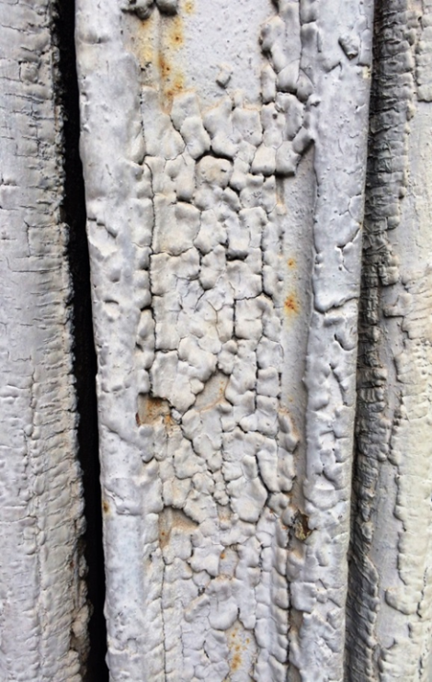
Figure 3: Small things: detail of door, photograph by Rosa

Some of Rosa’s other photographs explore colour in a cityscape, the most iconic images of which appear in black and white. One shows light falling through a stained glass window onto a wet sidewalk (figure 4, online version only), throwing a splash of colour on the ground; another depicts a rusty waste bin. These decontextualized images present abstract patterns, traces of accidental and fleeting displays of light, and find colour and beauty in unlikely places. Reflecting on these, Rosa concluded that her photographs challenged the visual conventions through which New York is typically imagined and experienced. What I conclude from her work is that, by taking risks, by drawing upon and experimenting with observational and descriptive practices, and by embracing the challenge to be more creative (see Hawkins, 2010, 2014), geography students find it possible to bring fieldwork to life, and to make real discoveries.
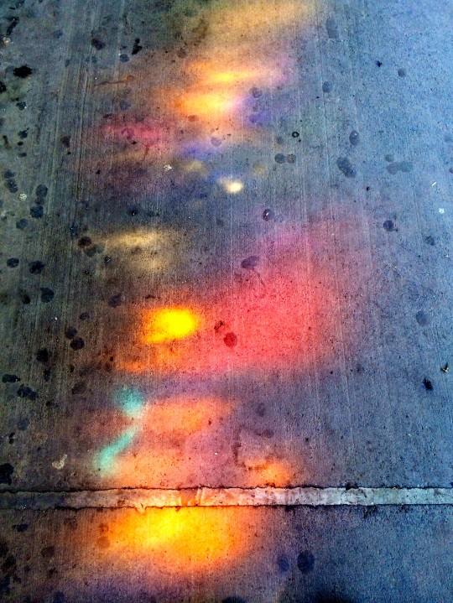
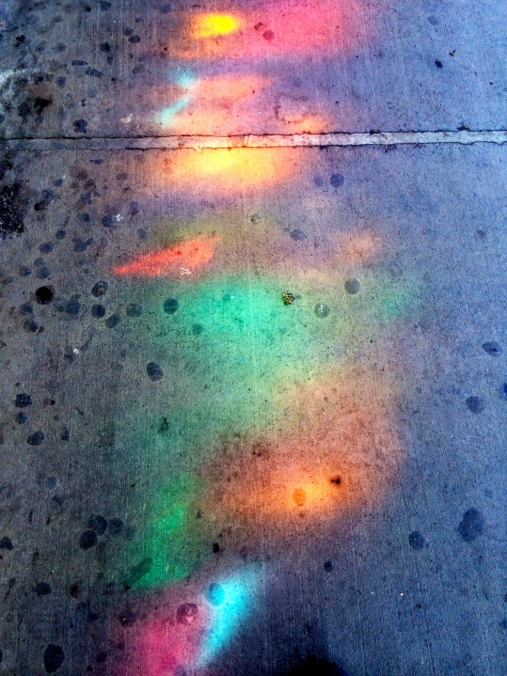
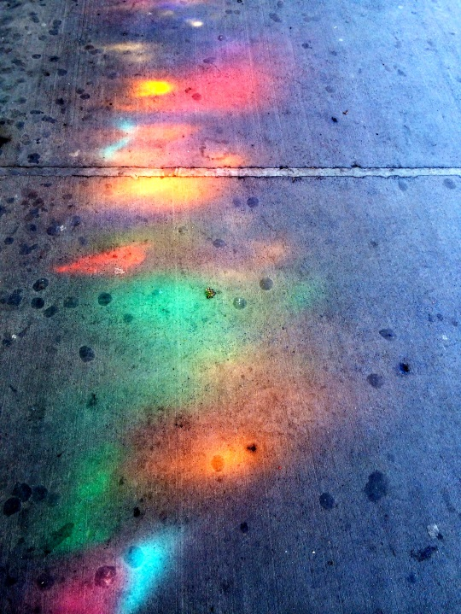
Figure 4 (online version only): Light from a stained glass window on the sidewalk, Williamsburg Subway station, photography by Rosa

Enchantment: Iain gets Lost
Each of the projects by Henry, Ben and Rosa heightened a particular sensory engagement with the city and, though these students took cues from within and without the geographical literature, each brought their own skills and experiences to their projects and also took risks, introducing elements of originality. Though they situated their work within theoretical and methodological literatures, as they were required to do, each also communicated something less formulaic and conventional: some combination of creativity awakened, curiosity unbound, intense experience, and a sense of discovery: enchantment. In this state, Jane Bennett (2001, p. 5) argues, ‘you notice new colours, discern details previously ignored, hear extraordinary sounds, as familiar landscapes of sense sharpen and intensify’. One final project presents a concentrated illustration of enchantment in the field. Iain set out to get lost.

Though geographers are best known for making maps and for knowing where they are, there is an alternative geographical tradition, which revolves around ‘unmapping’ (Phillips, 1997). David Pinder argues that maps ‘shut out the city’s noise and confusion, its energy and incessant movement, concluding that ‘going off the map’ can be enlightening (Pinder, 1996, p. 407). Off the map, it may be possible to recover the open-ness and sense of possibility that cartographic boundaries and coordinates close down. Rebecca Solnit argues that getting lost can prompt unexpected discoveries, both about the self and about the surrounding environment (Solnit, 2005). If it doesn’t happen accidentally, getting lost is not as easy as it sounds, and this is why urban explorers have actively pursued ways of achieving this (Saper, 1990). Ways of getting lost, explained in books and manuals such as Mission:Explore and the Lonely Planet Guide to Experimental Travel, as well as in some academic literature (Bonnett, 1989), borrow from the Situationists, who tried ‘using the map of one city to navigate another’ (Bassett, 2004; Debord, 1994), adding some new ideas and suggestions such as flipping a coin at each intersection to decide whether to go left or right (Antony and Henry, 2005). Iain adapted these techniques to New York’s grid system and subway and also experimented with methods of his own, one of which involved asking strangers for directions to these favourite places, and following these until he was lost. His field diary illustrates where this took him:
A man tentatively placed his hand upon my shoulder. I, in somewhat of a daydream, turned to see a tall, slightly plump man. He had several sweat droplets pouring from his forehead, whilst his top button and tie were slightly off centre; he was evidently hot and bothered. “Do you know where Lexington is?” he asked. “I’m sorry I don’t”, I replied, “I’m a bit lost myself!” He chuckled and continued on without as much as a pleasantry. I continued at the control of the coin, and I wandered along another city avenue. I came across a Ukraine memorial site, in the middle of a fairly derelict residential city block. I did not know where I was. I found myself travelling along another street with tall and brown residential buildings…. I noticed a man who looked somewhat familiar. Walking towards me, in his baggy black suit, dark gloves and off centre tie was the man who asked me for directions 15 minutes ago. We shared a moment of acknowledgment – his smile was friendly and warm, it was a humorous situation which we both enjoyed. His hands were full with 2 large white Macy’s bags – had he found Lexington? (Field Diary: Somewhere in Manhattan)
This vignette illustrates how being lost can recover spontaneity and playfulness, qualities that have sometimes been squeezed out of modern cities. Lost, Ian finds a moment of connection with a dishevelled man in a suit, and this culminates in amused, wordless recognition. Iain’s ‘lostness’ is also a catalyst for a heightened attention to the details of place. Here, he loses himself in a memorial he might otherwise have rushed past.

While some of his observations are incidental, others are directed at way finding. Paradoxically, though he works hard at getting lost, when he achieves this, he spends much of the time trying to reorient himself, and this involves paying close attention to signs, directions and other clues in the landscape. Some of Iain’s other diary extracts illustrate how getting lost is not always a good feeling. ‘One moment I was appreciating works of graffiti on a voyage of discovery, whilst the next, possibly when that unmapped voyage goes on for too long, I was experiencing undesirable sensations of being lost.’ But even these more challenging experiences recover an intensity of experience, which brings the city to life in new and unexpected ways, and heightens experiences of it.

Conclusion
I began by asking whether some intriguing activities for fieldwork, proposed in manuals and books of missions, as well as in more formal pedagogical literature, are just frivolous (not necessarily a bad thing, in its place) or whether they have more serious and sustained significance for learners and indeed for the discipline. The answers to these questions, I have suggested, must come partly from students: from the risks they are prepared to take, the creativity they venture, and the skills and experiences (including those from outside their formal geographical training) they bring.

The projects described in this paper illustrate how students can enjoy and value multi-sensory fieldwork, but not always for the same reasons that some of the inventors and proponents of such methods have done. As explained above, multi-sensory fieldwork is a broad term, which encompasses a range of different approaches, not excluding visual research, but also including a range of other sensory explorations, some of which may focus upon one sense, while others engage more than one. This is true of the projects described here, which range from Rosa’s creative way of seeing New York to Ian and Henry’s experiments with listening and touching the city.

Another thing all four projects do have in common, though, is their playfulness, which reaches as far as is likely, given the reality of the constraints that most students feel in relation to assessed work. It might be argued that they are not so much playful as wanting to appear as such, in order to anticipate the tastes and interests of the instructor: myself. But this would be a dour assessment, and and I would confidently hope that, at least some of the time, this playful spirit is more genuine. In other words, I trust that the student work described in this project illustrates how students are learning from the spirit of similar work, and renewing it as they go. Students have more to learn from the creative and disruptive spirit of the Situationists rather than the detail of the methods (Bassett, 2004), and the same may be true of the methods described here. Learning from the spirit of this work rather than mechanicallyreplicating its practices, they can bring new life to this fieldwork tradition. For example, one way in which I have seen students taking ownership of this fieldwork tradition, and taking it in their own direction, in through a fresh approach to its politics. In contrast with the radical humanism of Bill Bunge, the ostensibly subversive, Situationist politics of Alastair Bonnett, and the rants of popular psychogeographers such as Iain Sinclair and Will Self, undergraduates I have known tend to start with a more modest sense of their own political significance, adopting a less pretentious style, which can bring a new honesty and creativity to this work.

The lively fieldwork, illustrated through the four student projects that have been discussed in this paper, matters for a number of reasons: students appear or claim to enjoy working in this way, and this inspires these students to learn actively with enthusiasm and a sense of discovery; they open up new possibilities for and dimensions of geographical exploration and enquiry; they facilitate the acquisition of new skills, which students may find helpful in their search for and transition to employment (Phillips and Johns, 2012); they provide new answers to the question of what a ‘geography of curiosity’ might entail and where it might lead, including students in this answer (Phillips, 2010); and they indicate some things that a less narrowly visual – and more multi-sensory – geography might entail, and what it might find. In addition to all this, playful and multi-sensory fieldwork can matter for another reason, which is harder to pin down, but which was illustrated through fleeting, sometimes enchanting moments in the field, such as when Iain recognised a stranger in Manhattan, or when Rosa noticed a play of colours on the ground, when Henry lost himself in the touch of a rock, or when Ben found a kind of music in the city. Moments such as these can be enchanting, inspiring, and instructive too.
References
Aitken, S. C. & Craine, J. (2005). Visual methodologies: what you see is not always what you get. In: Flowerdew, R. & Martin, D. (Eds) Methods in Human Geography: a guide for students doing a research project (2nd edition). Harlow: Pearson. pp. 239-256.
Antony, R. & Henry, J. (2005). The Lonely Planet Guide to Experimental Travel. London: Lonely Planet.
Ball, P. (2012). Curiosity: How Science Became Interested in Everything. London: Random House
Balshaw, M. & Kennedy, L. (2000). Urban Space and Representation. London: Pluto.
Bassett, K. (2004). Walking as an aesthetic practice and a critical tool: some psychogeographic experiments. Journal of Geography in Higher Education, 28, pp.397-410.
Bennett, J. (2001) The Enchantment of Modern Life: Attachments, Crossings and Ethics. Princeton: Princeton University Press.
Benjamin, W. (1985). One Way Street and Other Writings. London: Verso
Bonnett, A. (1989). "Situationism, geography, and poststructuralism." Environment and Planning D: Society and Space, 1, pp. 131-146
Bordessa, R. & Bunge, W. (eds) (1975). The Canadian Alternative: Survival, Expeditions and Urban Change. Toronto: York University Geographical Monographs No. 2
Bull, M. & Back, L. (2003). The Auditory Culture Reader. New York: Berg.
Burgess, J. & Jackson, P. (1992). Streetwork: an encounter with place. Journal of Geography in Higher Education, 16, pp. 151-157
Butler, T, (2006). A walk of art: the potential of the sound walk as practice in cultural geography. Social and Cultural Geography, 7, pp. 889-908.
Chiu, C. (2009). Contestation and Conformity Street and Park Skateboarding in New York City Public Space. Space and culture, 12(1), 25-42.
Cook, V. A. (2011). The origins and development of geography fieldwork in schools. Geography, 96, pp 69-74
Crang, M. (2003) ‘Qualitative methods: touchy, feely, look-see?’ Progress in Human Geography 27,4 (2003) pp. 494–504
Debord, G. (1994 [1967]) The Society of the Spectacle. New York: Zone
Degen, M. M. (2008). Sensing cities: regenerating public life in Barcelona and Manchester. Abingdon: Routlege.
Garrett, B.L. (2014). Undertaking recreational trespass: urban exploration and infiltration. Transactions of the Institute of British Geographers, 39, pp. 1-13.
Geography Collective (2010) Mission:Explore. London: Can of Worms Kids Press
Hawkins, H. (2014). For Creative Geographies: Geography, visual arts and the making of worlds. New York: Routledge.
Hawkins, H. (2010). Turn your trash into…Rubbish, art and politics. Richard Wentworth’s geographical imagination. Social and Cultural Geography, 11, pp.805-827.
Henshaw, V. (2013) Urban Smellscapes: Understanding and Designing City Smell Environments. London: Routledge.
Hetherington, K. (2013), Rhythm and noise: the city, memory and the archive. The Sociological Review, 61, pp. 17–33. doi: 10.1111/1467-954X.12051
Law, L. (2013). Urban senses. In: Cloke, P., Crang, P. & Goodwin, M. (Eds) Introducing Human Geographies. Abingdon: Routledge. pp. 706-719.
Lewis, N. (2000). The climbing body, nature and the experience of modernity. Body & society, 6, pp. 58-80.
Merrifield, A. (1995). Situated knowledge through exploration: reflections on Bunge’s geographical expeditions, Antipode, 27, pp. 49-70
Pawson, E., Fournier, E., Haigh, M., Muniz, O., Traffords, J. & Vajoczki, S. (2006). Problem-based Learning in Geography. Journal of Geography in Higher Education, 30, pp. 103–116.
Phillips, R. (2012). Curiosity and Fieldwork. Geography, 97, pp. 75-85
Phillips, R. (2014). Space for Curiosity. Progress in Human Geography , 38(4), pp. 493–512
Phillips, R, (forthcoming 2015). Curiosity: Care, Virtue and Pleasure in Uncovering the New. Theory Culture and Society
Phillips, R. & Johns, J. (2012). Fieldwork for Human Geography. London: Sage.
Pinder, D. (1996) “Subverting cartography: the situationists and maps of the city.” Environment and Planning A, 28, pp. 405 – 427
Revill, G. (2013). Points of departure: listening to rhythm in the sonoric spaces of the railway station. Sociological Review, 61, pp. 51–68. doi: 10.1111/1467-954X.1205
Rodaway, P. (1994). Sensuous Geographies: Body, Sense and Place. London: Routledge.
Rose, G. (2003). On The Need To Ask How, Exactly, Is Geography ‘Visual’? Antipode, 35, pp.212-221.
Rugoff, R. (1997) At the threshold of the visible : miniscule and small-scale art, 1964-1996, New York: Independent Curators
Saper, C. J. (1990). Learning From Being Lost: Invention-Tourism in Barthes’ Empire of Signs. Journal of Urban and Cultural Studies, 1, pp. 67-86.
Sinclair, I. (1997). Lights Out for the Territory. London: Granta
Smith, K. (2008). How to Be An Explorer of the World. New York: Penguin.
Smith, S. J. (1994). Soundscape. Area, 26, pp.232-40.
Solnit, R. (2005) A Field Guide to Getting Lost. Canongate, Edinburgh.
Sprake, J. (2012) Learning-Through-Touring: Mobilising Learners and Touring Technologies to Creatively Explore the Built Environment. Rotterdam: Sense Publishers
Urry, J. (1990). The Tourist Gaze: Leisure and Travel in Contemporary Societies. London: Sage
Zuss, M. (2012) The Practice of Theoretical Curiosity. New York: Springer

