Sustainable manufacturing tactics and cross-functional factory modelling

Mélanie Despeisse1,a, Michael R. Oates2,b, Peter D. Ball1,c*

*1 Manufacturing and Materials Department, Cranfield University, Cranfield, MK43 0AL, UK*

*2 Institute of Energy and Sustainable Development, De Montfort University, Leicester, LE1 9BH, UK*

a m.despeisse@cranfield.ac.uk, b moates@dmu.ac.uk, c* Corresponding author: p.d.ball@cranfield.ac.uk

|  |  |
| --- | --- |
|  | ABSTRACT |
| *Manuscript submitted on the 15TH of June 2012 as a Research Article*  *Keywords:*  Sustainable manufacturing tactics;  Industrial sustainability;  Factory modelling;  Resource flows. | Manufacturers are under increasing pressure from stakeholders and stricter regulations to reduce the environmental impact of their activities. The research on sustainability in general and on sustainable manufacturing in particular is rapidly developing and crossing disciplinary boundaries. There are numerous well-developed concepts for industrial sustainability which can contribute to sustainable manufacturing, but there is a gap in knowledge on how to achieve the desired conceptual aims at operational level. There also is a growing volume of industrial cases on sustainable manufacturing practices, but little is known on how these improvements were conceived. Additionally, the means by which improvement options can be reproduced and modelled is lacking. This paper presents a tactics library to provide a connection between those generic sustainability concepts and more specific examples of operational practices for resource efficiency in factories. Then a factory modelling approach is introduced to support the use of tactics by combining the analysis of building energy and manufacturing process resource flows. Finally a step-by-step guide in the form of a workflow for factory modelling and resource flow analysis is presented and tested via a prototype tool. The aim was to provide guidelines for manufacturers to undertake the sustainability journey by guiding them through the steps of factory modelling, resource flow analysis and improvement opportunities identification. The paper has implications for researchers and practitioners as it demonstrates how factories can sustainably be improved in a structured, systematic and cross-functional way. This contributes to the need for expanding the scope of analysis beyond functional boundaries to apply sustainability at factory level. |
|  |  |

# Introduction

Industry has typically been associated with a negative impact on the environment: over the last decades, the natural environment degradation due to population growth and its associated increase in resource consumption (Holdren and Ehrlich, 1974), economic growth and the associated intensification of industrial activities (Meadows and Club of Rome, 1974) have become an undeniable global issue (World Commission on Environment and Development, 1987). With the need for sustainability now widely recognised as a great challenge for society, industrial companies have become part of the solution to change the way society operates (Erkman, 1997; Jovane et al., 2008).

There are many well-established concepts and approaches which address environmental issues at a systems level, such as industrial ecology (Graedel, 1994), green supply-chain management (Beamon, 2008), and the ‘Rs’ strategies of *Reduce-Reuse-Recycle* (Sarkis and Rasheed, 1995). Additionally, sustainable strategies and policies (Kerr, 2006) as well as supporting metrics (Figge et al., 2002; Labuschagne et al., 2005) to assess performance and quantify the contribution to the triple bottom line—people, planet and profit (Elkington, 1997)—are well-developed.

This research takes particular interest in sustainability in manufacturing as it has a major role to play in moving society towards more resource-efficient industrial systems. There are concepts for sustainability applicable to manufacturing (Robèrt et al., 1997; Lovins et al., 1999) and numerous examples of sustainable manufacturing practices such as waste minimisation (Clelland et al., 2000), energy efficiency (Bunse et al., 2011) through monitoring (Ameling et al., 2010) or through technology substitution (Compressed Air Challenge, 2011). However there is a lack of information on how to move from these high-level sustainability concepts to the selection of appropriate practices. The numerous examples of successful sustainable manufacturing practices in various industrial sectors demonstrate that there are benefits in implementing sustainability improvements (Rusinko, 2007; Menzel et al., 2010). However, the adoption of sustainability practices is not systematic (Madsen and Ulhøi, 2003). The literature and the case studies fail to provide the means by which improvements can be identified for more sustainable manufacturing operations and resource flows from a manufacturer’s perspective. Examples of good practice are largely context specific and relate to specific problem situations. Thus it is difficult to understand how such improvements can be reproduced by others.

Critical elements for sustainable manufacturing are the production system as well as the buildings and facilities which are servicing manufacturing operations and provide heating, ventilation, air-conditioning (HVAC), lighting, power, water, and waste removal. Driven by increasingly tighter building energy regulations and voluntary green rating systems, methodologies have been developed to guide design and reduce resource use, including modelling and simulation tools. However, buildings and manufacturing facilities are typically managed separately and use different performance metrics. Historically, buildings in many industrial situations have lifetime values that are low compared to the production process; as a result little emphasis has been placed on buildings. Statistical energy consumption data for 25 industrial sectors in the UK highlighted that for some manufacturing industries (e.g. manufacture of motor vehicles, electrical machinery, radios, medical equipment), building related energy (i.e. space heating and lighting) contributes to approximately 40% to 60% of the overall energy consumed (DECC, 2012). Thus there is significant potential for resource efficiency improvement by integrating these disciplines and viewing the factory as an ecosystem (Despeisse et al., 2012a).

Additionally the need for resource efficiency in manufacturing is driven by cost, regulations and stakeholders’ pressures. Sustainable manufacturing research area spans multiple disciplines and the move towards sustainability can only take place through wide changes, from behavioural to technological, and through holistic perspective as well as local solutions. Sustainable building design has been evolving with a practical approach and measures for over two decades (BRE Group, 2012). In sustainable manufacturing the issue is magnified by the greater resolution and complexity of activities involved and the wider diversity between facilities. Some manufacturers have considered integrating buildings and process, but there is a lack of tools to support such integration and thus manual analysis is limited in complexity and completeness.

To tackle the magnified problem, powerful IT tools have been developed to enable the analysis of ever more interconnected and complex systems. Various modelling and energy analysis tools have shown tangible benefits towards sustainable manufacturing (Heilala et al., 2008; Gutowski et al., 2009; Herrmann and Thiede, 2009; Michaloski et al., 2011). However, while these tools are helpful to support improvements, they do not provide a practical approach and overall structural framework for the users across functions to identify inefficiencies or improvement options for resource efficiency. Therefore, guidance is required on how to achieve sustainable improvement in manufacturing.

This paper examines work carried out in the research field of sustainable manufacturing and presents a novel approach to systematise the identification of improvement opportunities in factories. It introduces a library of tactics providing the generic rules for resource efficiency in manufacturing. It also presents a cross-functional factory modelling tool and its associated workflow for mapping and modelling manufacturing systems in order to support improvement activities. The work uses cross-functional factory modelling to integrate material, energy, water and waste (MEW) flows at factory level by combining buildings, facilities and manufacturing operations analysis. The research method used entailed bringing together discipline experts to undertake literature review, tool conceptual design, software development, and prototype testing.

# Research Programme

The work presented in this paper is part of a wider project called THrough-life Energy and Resource Modelling (THERM Project, 2011) which aims at supporting sustainable manufacturing improvement (Ball et al., 2011). The research is collaborative as it brings together universities, manufacturing industries and software development to create a modelling, simulation and analysis tool which integrates sustainable building design and process MEW flow analysis. In other words, the tool will support sustainable manufacturing plant design and improvement. In this paper, a workflow is introduced to identify improvement opportunities in a methodical way using modelling of MEW resource flows through a factory and a tactics library.

The work is exploratory and inductive. It starts with the development of a tactics library rationalised and structured according to an improvement hierarchy derived from waste/energy hierarchies and sets of sustainability principles, concepts and strategies. The tactics aims at bridging the gap between high-level concepts and observed industrial practices for sustainable manufacturing. These tactics can guide manufacturers through the steps of translating sustainability concepts into tangible actions while the improvement hierarchy can support decision-making as prioritisation is needed to select appropriate improvements. A workflow is then proposed to embed the elements of the tactics library into a practical application framework; in the case of THERM this takes the form of a *Navigator* (Quincey and McLean, 2011). It is a step-by-step approach based on factory modelling integrating the structured library of tactics to improve the resource flow by viewing the factory as an ecosystem. A factory modelling prototype tool integrating buildings, facilities and manufacturing operations is presented to test the integrated methodology.

# Improvement Hierarchy and Tactics for Sustainable Manufacturing

This section presents research findings in the form of a tactics library for sustainable manufacturing. The tactics library is structured using the improvement hierarchy which prioritises options. Sustainable manufacturing tactics were formulated based on the mechanisms of change observed in practices collected and analysed in a previous study (Despeisse et al., 2012b). In this work, tactics form the link between the high-level sustainability concepts mentioned previously and the specific operational practices which manufacturers can employ to improve their industrial systems. They are verb–noun formulations to specify the type of change (remove, replace, add, optimise, etc.) and the focus of the change (resource flow or technology). Tactics are thus both generic enough to be applicable in multiple environments, but are also specific enough to be actionable in those environments and disciplines leading to specific process-level improvements.

## Prioritisation of improvement options

The energy and waste hierarchies (Sarkis and Rasheed, 1995; Lund, 2007; Dovì et al., 2009; Blackstone, 2011) can help to prioritise tactics by identifying at which stage an improvement should be implemented. The material waste hierarchy is well-established and is typically represented by a pyramid with disposal at the bottom rising up though recovery, recycling, reuse, reduction (or the so-called ‘Rs’ strategies) and finally prevention at the top. Prevention is the preferred option with disposal the least favoured.

Analogous energy and low-carbon hierarchies also exist to prioritise improvements in energy use avoidance at the top, going down through the levels of technology for energy efficiency and shift to renewable energy sources, and finally at the bottom of the hierarchy, offsetting techniques and carbon sequestration considered as the last resort (London Energy Partnership, 2004; Hope, 2008).

It is therefore appropriate to structure the library of tactics based on a similar improvement hierarchy for resource efficiency (Table 1). It incorporates existing sets of principles and strategies for industrial sustainability (Lovins et al., 1999; Allwood, 2005; Abdul Rashid et al., 2008) in addition to the waste/energy hierarchies mentioned earlier.

The development of the improvement hierarchy was strongly influenced by the *Toyota 6 attitudes* which is an industrial approach to energy reduction developed by Toyota (Hope, 2011). This approach has allowed the company to achieve significant reduction in energy consumption over the past two decades (Evans et al., 2009) and is now being used elsewhere (Lunt and Levers, 2011). The major steps Toyota is taking to reduce the CO2 emissions from the manufacturing processes include the careful consolidation of production processes to match production level fluctuations, improved process management, facility size reductions, and operating rate improvements. These steps are bundled in 6 attitudes that represent the different actions taken according to the specific situation in which energy minimization is aimed for (greenfield or operational improvement project).

These 6 attitudes are: *Stop* (“Just because it’s operating doesn’t mean it’s working.”), *Eliminate* (“Why is this equipment needed?”), *Repair* (“Are we losing energy as a result of the breakdown?”), *Reduce* (“Why do we need so much?”), *Pick-up* (“Don’t throw it away. Can’t you use it somewhere?”) and *Change* (“Is there any cheaper source of energy?”). Within an operational context, the energy minimization activities can be split in 3 stages. At stage 1, the focus is to reduce energy consumption during non-production periods. In this stage Toyota applies the *Stop* and *Eliminate* attitudes. At stage 2, the *Repair* and *Reduce* attitudes are used, focusing on reducing the fixed energy in the processes. Only when stages 1 and 2 are completed by going through the required amount of C-PDCA (check–plan–do–check–act) loops (Shewhart, 1939), Toyota is moving to Stage 3. In this stage the focus is on energy savings through advanced equipment improvement and efficient machine installation using the *Pick-up* and *Change* attitudes. All these steps are already implemented in Toyota’s manufacturing operations through the development of Toyota’s internal Energy Service Company (ESCO) which promotes energy savings and conservation activities as well as conducts energy audits that are according the above mentioned steps.

Following the hierarchies and attitudes to identify improvement is an iterative process: *Pick-up* attitude / recovery strategy (e.g. waste-to-energy) and *Change* attitude / substitution strategy (e.g. renewable energy sources) join with *Stop* and *Eliminate* attitudes / prevention strategy (e.g. eliminate the significant item by deletion or substitution). The prioritisation of preferred options can be based on practical considerations (i.e. the “easy” things first) or based on philosophical ideas (i.e. the “right” things first).

Additionally, which attitude or strategy is chosen first depends on whether a new process is being designed or existing equipment is being improved or refurbished. In the case of new process design or refurbishment of an old process, there is no current investment and the best environmental option can be considered, e.g. installation of high efficiency equipment, corresponding to *Change* attitude / substitution strategy. However, if improvement activities are conducted on an existing process, the capital investment is already made and therefore the prioritisation starts at prevention and then proceeds around the loop to finish with substitution strategy. Also, by conducting improvements at the top of the hierarchies (prevention) on existing processes, some of the improvements lower down cease to be necessary, e.g. if resource use of a particular process is fully prevented, then there is no need to reduce input or substitute the process.

Each level of this improvement hierarchy can be further detailed into tactics as proposed in the next section and provides actionable steps to improve resource efficiency in manufacturing operations.

## Sustainable manufacturing tactics for resource efficiency

Table 1 describes the sequence in which improvements should be implemented – however it is not usually the sequence in which improvements are identified. Additionally, it is often more difficult to identify an improvement than it is to implement it. In some cases more data is required to identify “low-hanging fruits” (e.g. switch off and repair equipment) whereas replacing elements of the system at high cost can be identified quickly (e.g. replace fossil fuels by renewable energy sources or old inefficient equipment by best available technology). Keeping this challenge in mind, this section presents a library of tactics following the prioritisation order of the improvement hierarchy rather than the first potential improvement identified. The tactics listed in Table 2 provide the missing link to move from sustainability concepts to concrete actions for sustainable manufacturing operations.

To access the **prevention** tactics, it is important to note that the two first tactics (“remove”) can be difficult to identify as they require expert knowledge to recognise the unnecessary process which can be removed. The two following prevention tactics are comparing patterns between resource usage or process controls and production schedule (or product profile) to identify when equipment can be stopped or put in stand-by mode. The data collected in this instance comes from multiple sources requiring close collaboration of multiple functions. For example, the production schedule data will come from Planning or from Manufacturing Operations, whereas the resource consumption data may come from Facilities Management. Data may also be automatically connected (or there may arise a requirement to automatically collect data) which would involve IT functions.

The **waste reduction** tactics focus on waste outputs to reduce waste and losses or to maintain the value of the output through adequate treatment and management. These improvements are considered as relatively easy since they allow quick savings in resource and cost compared to the efforts invested. But manufacturers’ knowledge about their waste is often limited and thorough data collection must be conducted to identify waste patterns. Such improvement would preferably target the largest or specific (e.g. based on toxicity, scarcity or cost) resource consumers and waste generators.

The **resource use reduction** tactics focus on the inputs to increase process efficiency. The most difficult improvements can be to challenge the set points or alter production schedules as these can only be done with deep knowledge of the processes and production system. This knowledge will involve yet more functions in the analysis. Manufacturing Engineering or Industrial Maintenance may have an in-depth understanding of the process and the equipment, and any changes to the process must involve appropriate Quality functions. This type of improvement compares patterns in demand and supply profiles both in a static (logic tests) and dynamic (simulation) way. The logic tests are comparing the magnitude of supply to the minimum requirements to better match the demand-side. Typical examples include compressed air pressure and cooling water temperature. Simulation is also used to optimise the timing of the resource flow which can result in overall efficiency improvements (avoid peak consumption or reach the optimum demand level to match equipment high efficiency point of use). The simulations require a large amount of data, thus those improvements can be identified only based on advanced analysis of the system.

The **reuse** tactics focus primarily on the waste flows and look for opportunities to reuse waste output as a resource input. The use of a simulation tool is an important asset to allow systematic search for compatible waste and demand in the system taking into account the complexity of the system modelled, the timing of the flows and the spatial dimension. These improvements must be done after the prevention and reduction improvement are exhausted as wastes must be eliminated or minimised before looking for reuse opportunities. Reuse improvements are the hardest of all to implement; in industrial processes the sheer extent and grades of material, energy and water make this aspect a significant and iterative challenge.

The **substitution** tactics can be identified at early stage of the modelling by recognising inefficient components (based on equipment information such as capacity, efficiency and age) or black-listed resource inputs (e.g. toxic, non-renewable, non-reusable). This type of improvement is the most commonly found in industrial practice: replacing a piece of equipment or a process by a more efficient one or a less environmentally damaging one is a quick way to increase the sustainability performance but likely at high cost. It involves large scale changes by improving the source of supply and using high efficiency technology. Similarly to reuse tactics, the prioritisation of these substitution improvements must be done after other types of improvement are exhausted to avoid replacing a technology when a process can be stopped or to avoid oversizing equipment when the demand can be reduced.

The improvement hierarchy and tactics can help manufacturers to find out about what to do. However, it does not tell the user how to identify improvements and it does not provide the quantitative assessment required. Such quantitative analysis can be achieved with modelling as discussed in the next section.

# Need for Quantitative Analysis

Quantitative analysis is needed to assess the environmental impact of manufacturing activities as well as the benefits of potential improvements. The analysis can be applied at different resolution levels to derive opportunities incrementally as effort is increased.

Existing modelling tools provide energy analysis in building modelling (Clarke, 2001; Pérez-Lombard et al., 2009), product flows and timing of process flows in manufacturing (Pandya, 1995), but none covers all aspects to account for all resource flows, intermittency of processes and spatial dimensions. They also do not provide the means to find opportunities directly, many of which involve complex data manipulation and visualisation. The inclusion of buildings and facilities in manufacturing process analysis has been considered by manufacturers such as Toyota (Hope, 2008). However, the analysis is largely manual and limited in complexity and completeness due to the lack of supporting tools. Therefore buildings and manufacturing facilities are still typically considered separately (Oates et al., 2011b).

As with lean/green approaches and manufacturing modelling tools, new methodologies and techniques require incremental development to be refined and to include all elements needed to support the design and analysis of sustainable manufacturing systems (Jahangirian et al., 2010). Tools supporting sustainable manufacturing must capture the interactions not only within the manufacturing system, but also with its physical environment, i.e. the manufacturing processes, their supporting facility, the surrounding buildings as well as some influential external factors (weather conditions and neighbouring industries and infrastructures). The analysis has to account for location and time in a manner that is not supported by either manufacturing process simulation tools or building energy tools. There are currently no tools commercially available for manufacturers to assess environmental performance, identify improvement areas and help suggesting specific actions across the breadth of the application area just described. There are examples of manufacturing research (Hesselbach et al., 2008; Heilala et al., 2008; Herrmann and Thiede, 2009; Michaloski et al., 2011; Ball et al., 2009) to bring these domains together. Such work presents conceptual design and narrow simulation but does not offer as much benefit as the combination of improvement methodologies and integrated buildings, facilities and production system modelling.

The next section presents the workflow and prototype tool showing the use of the workflow to guide the analysis to methodically identify improvements.

# Prototype Tool

In this section, an integrated modelling approach and associated workflow are proposed to adopt an integrated systems view of a factory. It combines various techniques to form a modelling tool which can support the design and analysis of sustainable manufacturing systems.

## Factory modelling and process data

The conceptual manufacturing ecosystem model (Despeisse et al., 2012a) used in this research identifies three sub-systems: manufacturing operations, supporting facilities and surrounding buildings. All three sub-systems are linked by resource MEW flows. The MEW flows within and between these sub-systems are crossing functional boundaries and therefore promote an ecosystem view of the factory. The aim is to reduce the overall input associated with resource depletion and undesirable waste and pollutants outputs of the complete system rather than the efficiency of individual components of the system. There is potential to extend beyond the factory gate to suppliers, neighbouring industries and other economic sectors. The inherent difficulty with factory modelling is the complex nature of MEW flows. These difficulties are exemplified when MEW flows cross functional boundaries. The systematic approach presented here aids in identifying functional boundaries and collection of data.

Prior to data collection discussed below, a factory model that brings together research disciplines is required. An integrated factory approach consists of inputting model data from the three sub-systems and combines modelling functionalities from both building and manufacturing disciplines:

* Manufacturing operations: manufacturing process systems (boundaries and connections), associated equipment (links to process systems), material flows (added value product, non-value added waste, and process system flow paths);
* Supporting facilities: facility equipment, inputs to manufacturing operations (e.g. compressed air, steam, cooling water), outputs (e.g. returned mediums, exhaust fumes, waste heat);
* Surrounding buildings: building geometry, construction data, weather data, HVAC systems and internal gains.

To create the factory model and represent the three sub-systems and links introduced above, process data must be defined. The elements modelled are the buildings, the equipment and process technology components placed in and near the buildings, and the resource flows linking all elements of the model. These resource flows can be energy and material inputs or product and waste outputs. All elements of the system are characterised by process data. The right-hand column of Table 3 shows the list of model process data and the corresponding information collected by the user.

These sub-systems and links can be graphically represented (Oates et al., 2011a). Figure 1 illustrates energy flows that occur within a factory environment. The figure seeks to couple traditional building energy flow paths with those generated in a factory environment. Within the factory environment the manufacturing process system is split into two categories: thermal and electrical. Other forms of energy can be created by processes that create friction, impact, laser cutting, etc. These are to be represented as internal gains. Dependent upon the medium inside, a thermal process may resemble air-based processes such as ovens and furnaces, or liquid-based processes such as tanks and vats. Material flowing through a factory environment from process to process will absorb or release thermal energy to its surrounding environment. For example, thermal energy will be transferred when a component leaves a furnace or a refrigerator within an enclosed manufacturing process system, factory or external environment. The amount of energy absorbed or released is dependent upon temperature, geometry and material properties of emissivity, absorption, specific heat capacity, and thermal mass.

The improvement identification must follow a sequence that links the tactics to the process data used to model the manufacturing system. The next section presents the workflow with an industrial case application to illustrate this sequence.

## Workflow and case application

The tool is developed in the context of the THERM project and is based on an existing modelling and simulation software: IES Virtual Environment (VE). The VE is specialised in building design and energy analysis. The THERM project aims at extending the software capabilities to include manufacturing processes into the building model and to perform a combined analysis of MEW resource flows through the buildings, manufacturing facilities and operations (Oates et al., 2012).

The workflow (Figure 2) has been developed to support a structured, systematic and cross-functional identification of sustainable manufacturing improvements (using tactics) and combines factory modelling and improvement hierarchy. It requires involvement of multiple actors to collect the data, and to validate and implement the output. Thus although it is possible to perform the workflow computationally with a single user, the overall process is a highly collaborative one.

The five tactic groups from Table 2 are all applied to some extent at all stages of resolution through an analysis as evidenced in the workflow shown in Figure 2. As encoded in the workflow, it is possible to find quantitative improvements as the data resolution builds up – at each stage resolution is increased to find more opportunities. This is a key outcome because it shows a stepwise approach with increasing investment of effort; it also shows that some easy wins are possible with minimal invested effort.

The following sub-sections describe the process of developing, testing and validating the workflow, based on data obtained from the industrial partners of the THERM project. Data from a drying tank process has been used for the development of a prototype (Lunt and Levers, 2011). The testing highlights the collaborative nature of the work as it brings together manufacturing and facility engineers, shop-floor technicians, and energy managers:

### Getting started & settings

The first step of the workflow is *Getting started & settings* to define the scope of the analysis by setting system boundaries and targets. A factory “walkthrough” and detailed description of the processes by a specialist are conducted at this stage to gain deeper understanding of the processes selected for the analysis. Typical system boundary definition is delimited by specific processes with multiple equipment or machines and physical areas of the factory such as buildings.

A formulated team of industrial operations and facility engineers working in collaboration with the industrial, academic and software developer defined the focus of the study. Figure 3 summarises the possible options for the analysis in the THERM software. Although the analysis can support the design of new factories, the case application focused on the analysis of an existing one. The assessment was carried out at the factory gate level first and then progressed into static process analysis noting that subsequent dynamic simulation capability was not used. The focus and measurement was energy reduction as water, materials, carbon and cost were considered to be the consequences of improvements in this particular case.

Help files are available at each phase within the workflow to provide generic advice based on the principles and approach of the workflow, a glossary to overcome the integration of two disciplines, and the collection of information and data, i.e. building and process data.

### Factory gate analysis

For the *Factory gate analysis* the system would ideally correspond to the complete factory and the flow map would stop at the factory gate. This is achieved by taking a top-down approach with details being added by “zooming” on the processes of interest and through iteration where subsystems are put together until a complete model of the factory is obtained.

Early stage analysis focuses on the collection and examination of utility metered data to focus the analysis on specific resource flows or specific processes such as large energy consumers (Figure 4). This data usually consist of half hourly and hourly meter readings, logged by utility suppliers for billing purposes, e.g. electricity and gas. During early stage analysis there is no need for building geometry, process mapping or high resolution data. Sustainable manufacturing tactics and *help prompts* identify the drying tank as a large energy consumer in the focal area.

### Building geometry

In the third step of the workflow, the building is modelled by creating *building geometry* and assigning construction data. Due to the nature of the integrated approach covering building design and manufacturing process simulation tools, the building is included as a representative boundary surrounding the drying tank and supplementary equipment as illustrated in the building model in Figure 5.

### Process mapping

In the fourth step, the qualitative process model is created by *mapping processes*, i.e. placing technology components in the building model as illustrated with the yellow components in Figure 5. The resource flows are also added to link all elements of the model. The inputs include energy, material, water and chemicals whilst the outputs included products and wastes in the form of physical waste accumulating in bins and energy waste. The elements within the system boundaries previously defined are mapped against the factory layout to integrate spatial aspects into the model. The list of processes and equipment as well as their sequence for various flows are also defined: the most common way of defining the process sequence is to follow the product flow, but other sequences must be defined to follow the utility flows such as compressed air, steam and cooling water. Inputs and outputs are documented so that each flow clearly links to the processes it goes to or comes from. It is important to consider the resource flows as individual entities in themselves, not simply as being assigned to equipment and processes as an input value with no origin and an output value with no destination. Doing so will bring into focus the links and interactions between processes across functional boundaries and enable the user to adopt an ecosystem view of the manufacturing system studied.

In this case application, the drying tank consists of material flow, tank, supplementary equipment such as fan, heat exchanger (HX) and air re-circulation ductwork. Air is drawn into the fan from the factory environment represented by the perimeter blue box in the graphical representation of the process in Figure 6. The air temperature increases due to the transfer of thermal energy from the heat exchanger and the input of work from the fan prior to entering the drying tank. A proportion of the air is re-circulated, and mixed with air drawn from the factory environment. The HX is a closed-loop water circuit connected to a combined heat and power (CHP) source. Material in a wet state enters the process, is dried and moved back into the factory environment. The process is repeated for each batch that passes through the drying tank. The connections and links between the technology components and the resource flows are illustrated in Figure 6.

### Design & measured analysis

The *design & measured analysis* is an iterative, non-simulation phase of the workflow. The quantitative model is created by adding process data and creating profiles, i.e. metered data and characteristics of resource flows and technology components. All elements of the system must be characterised by process data. This stage can be repeated to add more data as they become available and increase the level of detail of the model. The list of model process data and the corresponding sources was introduced in the previous section (Table 3). To enable the *design & measured analysis* and identification of improvement opportunities, some process data are defined as constraints, mainly production schedule and set points. These constraints determine the minimum input requirements for the manufacturing processes to achieve the correct product quantity and quality. Additional variables characterise the technology components: capacity or equipment rating, running load (including the minimum demand or base load, and maximum demand or peak load), the performance or efficiency curve which define the ratio output/input as function of running load. Optional information can be added to increase the quality of the analysis, such as equipment depreciation and operating cost.

**At this** stage operational profiles are derived from sub-metered data. and assigned to the fan, HX and drying tank process components discussed in step 4. Material flow profiles are derived from production schedules and assigned to the material component. The assignment of quantitative process data enables the workflow to iterate through the manufacturing sustainable tactics. At this non-simulated stage of the workflow, all of the tactics (Table 2) are activated with exception to reuse. A first pass of the tactics identified potential improvements. The prevention tactic was flagged due to a mismatch between the operational and production profiles. For example, the energy consumption profile of the equipment can be compared to the material flow through the process as highlighted in Figure 7. The prevention tactic advises to switch off the fan when there is no product being processed. Reduction tactics were also identified based on material drying times, tank temperature set points, equipment flow rates and ratings. The alteration of equipment set points and reduction in material drying times to conform to minimal design condition need to be investigated in the future.

### Building mapping and simulated analysis

In the seventh step, the process data is used to simulate the system’s performance. When parts of the model are complete, simulation can be used to analyse a selection of process data locally. This stage of the analysis identifies local improvement opportunities to prevent and reduce the use of resources, increase efficiency and reduce waste. With the example given in Figure 7, the operational profiles of the fan and HX were modified in conjunction with the prevention tactic. There are potential energy savings when there is no product being dried within the process, illustrated in the figure by the filled areas: fan (green) and HX (blue). Simulated results predict a 74% energy savings from one week of data. Further potential savings could be achieved by restricting the drying time of the material to the minimal design condition and reducing set points. Due to the varied production flow of material that occurs on-site as a consequence of a batch process, the industrial partner has reduced the operation usage of the drying tank in line with shift hours and turned the process off outside these hours (e.g. weekends). Future work is to be carried out in line with the reduction recommendations, following consultations with operations and facility engineers. Outcomes from this prototype are also to be cascaded across other similar processes, resulting in further energy saving opportunities.

When the system model is completed, the analysis identifies system-wide improvement opportunities with reduction in resource use by following a chain of constraints from process to process or potential reuse of waste output from one process elsewhere in the system. This phase of the work requires a fully functional simulation model, being developed as part of the THERM project. The building mapping requires that the user assigns HVAC data to factory thermal zones, and construction properties, weather data, room temperature set points, internal gains from lighting and room occupancy to the building. The simulated aspect of the works activates all of the sustainable manufacturing tactics. Following the same principle outlined in the non-simulation approach, the workflow cycles through the tactics identifying potential improvements. Further work will include enhanced functionalities to identify reuse opportunities such as highlighting processes in operation as illustrated in Figure 8 and highlighting based on thermal gradient, energy type, etc.

# Discussion and Conclusion

This paper addresses the challenge of sustainability from a manufacturer’s point of view. The literature on the topic is growing fast and there are numerous concepts for sustainability applicable to manufacturing as well as examples of sustainable manufacturing practices to demonstrate the benefits of sustainability improvements. However there is a lack of information on how to move from these high-level concepts to the selection of appropriate practices. Various modelling and analysis tools have been developed and proved helpful to support improvements (Heilala et al., 2008; Gutowski et al., 2009; Herrmann and Thiede, 2009; Michaloski et al., 2011), but they do not provide guidance for identifying inefficiencies and improvement opportunities for resource efficient manufacturing. Therefore, guidance is required on how to achieve sustainable improvement in manufacturing. Additionally, sustainable manufacturing requires the combined analysis of buildings and facilities supporting the manufacturing operations, but these disciplines are typically managed separately resulting in missed opportunities to improve these areas in an integrated way. Sustainability by its very nature involves the collaboration of all parts of the ecosystem, and thus it is essential that this guidance combines disciplines.

This collaborative research has brought together universities, manufacturing industries and software developer to build a cross-functional modelling and simulation tool which demonstrates that the conceptual design is valid: the prototype tool and workflow show that the sustainable manufacturing tactics (Despeisse et al., 2011) and factory modelling approach (Despeisse et al., 2012a) can be combined to apply sustainability concepts across disciplines in factories and guide the analysis through methodical improvement opportunities identification. The workflow takes the user through the steps of modelling, analysing and improving manufacturing systems. The approach adopted helps to jointly analyse manufacturing processes, facilities and buildings, and guide the various parts of a manufacturing organisation step by step towards sustainability. The improvement hierarchy synthesises and prioritises existing strategies for sustainability in industry and applies them to a single manufacturing unit. Each level in the improvement hierarchy is further detailed into tactics, i.e. generic rules for sustainable manufacturing which can be widely applied independently of the system’s specificity, and bridges high-level concepts for industrial sustainability and specific actions for sustainable manufacturing. The tactics were formulated to cover a wide range of sustainable manufacturing practices and dictate the rules for identifying improvement opportunities in the resource flows following the improvement hierarchy. The workflow provides tangible guidelines for manufacturers to approach sustainability at an operational level. In turn broader and more informed decisions could be made on improving overall resource flows, regardless of ownership and functional boundaries, by reducing inputs and wastes and by closing the flow of resource through reuse of waste.

The analysis focuses on what happens within the ecosystem of a factory (gate-to-gate). The authors recognise the need for a more holistic perspective on industrial systems and on the whole society if sustainability is to be achieved. However, the boundaries have been drawn around the elements on which the manufacturing organisation has full control. Additionally the resources considered in the analysis are energy, material, water, chemicals and not capital, employees, etc. The analysis accounts for location and time as well as manufacturing process in a manner that is not supported by the independent disciplines of either manufacturing process simulation or building energy analysis tools. The work showed that it is possible to identify sustainable manufacturing improvement opportunities in a structured and systematic way using modelling of manufacturing system across disciplines.

Future work includes reposition the research activity as a result of the tool development for integrated modelling of resource flows to identify sustainable manufacturing improvement opportunities through combined analysis of manufacturing operations, supporting facility systems and production buildings, and integration of best practices available from manufacturers.

# Acknowledgements

The authors wish to acknowledge the UK’s Technology Strategy Board (TSB) who funded the THrough-life Energy and Resource Modelling (THERM) project, and all individuals who contributed to the THERM project for their valuable inputs in the development of this work, including Peter Lunt, Steve Hope, Steve Evans, Richard Greenough, Ruth Kerrigan, Andy Levers, Vincent Murray, Richard Quincey, Li Shao, Timothy Waltniel, Andrew Wright.

# References

Abdul Rashid, S. H., Evans, S., Longhurst, P., 2008. A comparison of four sustainable manufacturing strategies. *International Journal of Sustainable Engineering* 1(3), 214-229.

Allwood, J. M., 2005. What is Sustainable Manufacturing? *Sustainable Manufacturing Seminar Series,* 16th February 2005, Cambridge University,Cambridge (UK), pp. 1-32.

Ameling, M., Wuensch, D., Nietzold, F., 2010. Energy management in manufacturing based on plant integration. *APMS 2010 International Conference on Advances in Production Management Systems,* 11–13 October 2010, Como (Italy), pp. 1-9.

Ball, P. D., Despeisse, M., Evans, S., Greenough, R. M., Hope, S. B., Kerrigan, R., Levers, A., Lunt, P., Oates, M. R., Quincey, R., Shao, L., Waltniel, T., Wheatley, C., Wright, A. J., 2011. Modelling energy flows across buildings, facilities and manufacturing operations. *Proceedings of the 28th International Manufacturing Conference (IMC28),* 30 August–1 September 2011, Dublin (Ireland), pp. 290-297.

Ball, P. D., Evans, S., Levers, A., Ellison, D., 2009. Zero carbon manufacturing facility – towards integrating material, energy, and waste process flows. *Proceedings of the Institution of Mechanical Engineers, Part B: Journal of Engineering Manufacture* 223(9), 1085-1096.

Beamon, B. M., 2008. Sustainability and the Future of Supply Chain Management. *Operations and Supply Chain Management* 1(1), 4-18.

Blackstone, 2011. *Institution of Mechanical Engineers - Energy, Environment and Sustainability, How do we achieve a sustainable lifestyle?*, available at: www.imeche.org/knowledge/industries/energy-environment-and-sustainability/news/Sustainable-Lifestyles (accessed 24 September 2012).

BRE Group, 2012. *What is BREEAM?*, available at: www.breeam.org (accessed 18 April 2012).

Bunse, K., Vodicka, M., Schönsleben, P., Brülhart, M., Ernst, F. O., 2011. Integrating energy efficiency performance in production management - gap analysis between industrial needs and scientific literature. *Journal of Cleaner Production* 19(6–7), 667-679.

Clarke, J. A., 2001. *Energy Simulation in Building Design,* 2nd ed, Butterworth-Heinemann, Oxford (UK).

Clelland, I. J., Dean, T. J., Douglas, T. J., 2000. Stepping towards sustainable business: An evaluation of waste minimization practices in US manufacturing. *Interfaces* 30(3), 107-124.

Compressed Air Challenge, 2011. *Case Studies Library*, available at: www.compressedairchallenge.org/library/#Case_Studies (accessed 24 September 2012).

DECC, 2012. *Energy consumption in the United Kingdom*, available at: www.decc.gov.uk/en/content/cms/statistics/publications/ecuk/ecuk.aspx (accessed 4 January 2012).

Despeisse, M., Ball, P. D., Evans, S., Levers, A., 2012a. Industrial ecology at factory level – a conceptual model. *Journal of Cleaner Production* 31(3-4), 30-39.

Despeisse, M., Ball, P. D., Evans, S., 2012b. Modelling and Tactics for Sustainable Manufacturing: an Improvement Methodology. Günther, S. (ed.), in: *Sustainable Manufacturing – Shaping Global Value Creation,* Springer Berlin Heidelberg, Berlin (Germany), 9-16.

Despeisse, M., Ball, P. D., Evans, S., 2011. Identifying improvement opportunities towards sustainable manufacturing. *Proceedings of the 28th International Manufacturing Conference (IMC28),* 30 August–1 September 2011, Dublin (Ireland), pp. 195-202.

Dovì, V. G., Friedler, F., Huisingh, D., Klemeš, J. J., 2009. Cleaner energy for sustainable future. *Journal of Cleaner Production* 17(10), 889-895.

Elkington, J., 1997. *Cannibals with Forks: The Triple Bottom Line of 21st Century Business,* Capstone Publishing, Oxford (UK).

Erkman, S., 1997. Industrial ecology: An historical view. *Journal of Cleaner Production* 5(1-2), 1-10.

Evans, S., Norell Bergendahl, M., Gregory, M., Ryan, C., 2009. *Towards a sustainable industrial system,* University of Cambridge Institute for Manufacturing, Cambridge (UK).

Figge, F., Hahn, T., Schaltegger, S., Wagner, M., 2002. The sustainability balanced scorecard - Linking sustainability management to business strategy. *Business Strategy and the Environment* 11(5), 269-284.

Graedel, T. E., 1994. Industrial Ecology: Definition and Implementation. in: Socolow, R., Andrews, C., Berkhout, F. et al. (eds.) *Industrial Ecology and Global Change,* Cambridge University Press, Cambridge (UK), pp. 23-41.

Gutowski, T. G., Branham, M. S., Dahmus, J. B., Jones, A. J., Thiriez, A., Sekulic, D. P., 2009. Thermodynamic analysis of resources used in manufacturing processes. *Environmental Science and Technology* 43(5), 1584-1590.

Heilala, J., Vatanen, S., Tonteri, H., Montonen, J., Lind, S., Johansson, B., Stahre, J., 2008. Simulation-based sustainable manufacturing system design. *Winter Simulation Conference Proceedings (WSC'08),* 7–10 December 2008, Miami, FL (United States), pp. 1922-1930.

Herrmann, C., Thiede, S., 2009. Process chain simulation to foster energy efficiency in manufacturing. *CIRP Journal of Manufacturing Science and Technology* 1(4), 221-229.

Hesselbach, J., Herrman, C., Detzer, R., Martin, L., Thiede, S., Lüdemann, B., 2008. Energy efficiency through optimized coordination of production and technical building services. *Proceedings of the 15th CIRP International Conference on Life Cycle Engineering (LCE2008),* 17–19 March 2008, Sydney (Australia), pp. 624.

Holdren, J. P., Ehrlich, P. R., 1974. Human population and the global environment. *American Scientist* 62(3), 282-292.

Hope, S., 2011. Sustainability in Manufacturing - towards zero emissions. *IET Manufacturing Network – Sustainable Manufacturing Symposium,* 10 November 2011, Leicester (UK), available at: http://tv.theiet.org/technology/manu/12068.cfm# (accessed 5 November 2012)

Hope, S., 2008. Case study: Towards zero emissions manufacturing. *Green Power Conferences – Sustainable Manufacturing Summit Europe,* 19–20 November 2008, Brussels (Belgium).

Jahangirian, M., Eldabi, T., Naseer, A., Stergioulas, L. K., Young, T., 2010. Simulation in manufacturing and business: A review. *European Journal of Operational Research* 203(1), 1-13.

Jovane, F., Yoshikawa, H., Alting, L., Boër, C. R., Westkämper, E., Williams, D., Tseng, M., Seliger, G., Paci, A. M., 2008. The incoming global technological and industrial revolution towards competitive sustainable manufacturing. *CIRP Annals - Manufacturing Technology* 57(2), 641-659.

Kerr, I. R., 2006. Leadership strategies for sustainable SME operation. *Business Strategy and the Environment* 15(1), 30-39.

Labuschagne, C., Brent, A. C., van Erck, R. P. G., 2005. Assessing the sustainability performances of industries. *Journal of Cleaner Production* 13(4), 373-385.

London Energy Partnership, 2004. *Integrating energy into new developments: Toolkit for planners, developers and consultants,* Greater London Authority, London (UK).

Lovins, A. B., Lovins, L. H., Hawken, P., 1999. A road map for natural capitalism. *Harvard Business Review* 77(3), 145-158.

Lund, H., 2007. Renewable energy strategies for sustainable development. *Energy* 32(6), 912-919.

Lunt, P., Levers, A., 2011. *Reducing Energy Use in Aircraft Component Manufacture - Applying Best Practice in Sustainable Manufacturing,* SAE Technical Paper 2011-01-2739.

Madsen, H., Ulhøi, J. P., 2003. Have trends in corporate environmental management influenced companies' competitiveness? *Greener Management International* (44), 75-88.

Meadows, D. H., Club of Rome, 1974. *The Limits to growth : a report for the Club of Rome's project on the predicament of mankind,* Pan Books, London (UK).

Menzel, V., Smagin, J., David, F., 2010. Can companies profit from greener manufacturing? *Measuring Business Excellence* 14(2), 22-31.

Michaloski, J. L., Shao, G., Arinez, J., Lyons, K., Leong, S., Riddick, F., 2011. Analysis of Sustainable Manufacturing Using Simulation for Integration of Production and Building Service. *Symposium on Simulation for Architecture and Urban Design (SimAUD 2011),* 4–6 April 2011, Boston, MA (United States), pp. 1-9.

Oates, M. R., Despeisse, M., Ball, P. D., Evans, S., Greenough, R. M., Hope, S. B., Levers, A., Lunt, P., Quincey, R., Shao, L., Waltniel, T., Wheatley, C., Wright, A. J., 2012. Design of Sustainable Industrial Systems by Integrated Modelling of Factory Building and Manufacturing Processes. *Proceedings of the 10th CIRP Global Conference on Sustainable Manufacturing - Towards Implementing Sustainable Manufacturing,* 31 October–2 November 2012, Istanbul (Turkey), pp. 1-8.

Oates, M. R., Wright, A. J., Greenough, R. M., Shao, L., 2011a. Understanding Resource Flows in a Factory Environment - A Graphical Approach. Bártolo, H. e. a. (ed.), in: *Proceedings of SIM2011 conference,* 29 June–1 July 2011, IST Press, Lisboa (Portugal), pp. 53-60.

Oates, M. R., Wright, A. J., Greenough, R. M., Shao, L., 2011b. A new modelling approach which combines energy flows in manufacturing with those in a factory building. *Proceedings of Building Simulation 2011: 12th Conference of International Building Performance Simulation Association,* 14–16 November 2011, Sydney (Australia), pp. 223-230.

Pandya, K. V., 1995. Review of modelling techniques and tools for decision making in manufacturing management. *IEE Proceedings: Science, Measurement and Technology* 142(5), 371-377.

Pérez-Lombard, L., Ortiz, J., González, R., Maestre, I. R., 2009. A review of benchmarking, rating and labelling concepts within the framework of building energy certification schemes. *Energy and Buildings* 41(3), 272-278.

Quincey,R. J. and McLean,D. J., 2011. *Method and system for modeling energy efficient buildings using a plurality of synchronized workflows.* Integrated Environmental Solutions Ltd. Patent no. US 7,912,807 B2. Available at: www.uspto.gov (accessed 18 April 2012).

Robèrt, K. H., Daly, H., Hawken, P., Holmberg, J., 1997. A compass for sustainable development. *International Journal of Sustainable Development & World Ecology* 4(2), 79-92.

Rusinko, A., 2007. Green Manufacturing: An Evaluation of Environmentally Sustainable Manufacturing Practices and Their Impact on Competitive Outcomes. *IEEE Transactions on Engineering Management* 54(3), 445-454.

Sarkis, J., Rasheed, A., 1995. Greening the Manufacturing Function. *Business Horizons* 38(5), 17-27.

Shewhart, W. A., 1939. *Statistical Method from the Viewpoint of Quality Control,* Washington, DC.

THERM Project, 2011. *THrough-life Energy and Resource Modelling (THERM)*, available at: www.therm-project.org (accessed 24 September 2012).

World Commission on Environment and Development, 1987. *Our common future,* Oxford University Press, Oxford.

Table 1: Improvement hierarchy for resource efficiency (Despeisse et al., 2012a)

|  |  |
| --- | --- |
| 1 | **Prevention by avoiding resource use:** eliminate unnecessary elements to avoid usage at the source, stop or stand-by equipment when not in use. |
| 2 | **Reduction of waste generation:** good housekeeping practice, repair and maintain equipment. |
| 3 | **Reduction of resource use by improving efficiency:** optimise production schedule and start-up procedures, match demand and supply level to reach best efficiency point of use of equipment or improve overall efficiency of the system. |
| 4 | **Reuse of waste as resource:** look for compatible waste output and demand, understand where and when waste are generated and whether it can be used as resource input elsewhere considering the complexity of the system. |
| 5 | **Substitution by changing supply or process:** renewable and non-toxic inputs, replace technology and resource for less polluting or more efficient ones, change the way the function is achieved to allow larger scale improvements. |

Table 2: Library of sustainable manufacturing tactics (Despeisse et al., 2012b)

|  |
| --- |
| **1 Prevention (avoid usage)**   * Remove unnecessary resource usage * Remove unnecessary technology * Align resource input profile with production schedule * Switch off/standby mode when not in use |
| **2 Waste reduction**   * Waste collection, sorting, recovery and treatment * Repair and maintain |
| **3 Resource use reduction**   * Optimise production schedule to improve efficiency * Optimise resource input profile to improve efficiency * Change set points/running load * Monitor performance * Control performance * Change resource flow layout * Change technology layout |
| **4 Reuse (waste as a resource)**   * Synchronise waste generation and resource demand to allow reuse * Reuse waste output as resource input |
| **5 Substitution (new resource or technology)**   * Replace resource input for better one * Replace technology for better one * Add high efficiency resource * Add high efficiency technology * Change the way the function is accomplished |

Table 3: List of process data for modelling and the corresponding data sources

|  |  |
| --- | --- |
| **Model process data** | **Data source** |
| **Building model**: Drawing the infrastructure | |
| Building geometry / thermal zones | Factory layout (technical drawings) |
| Construction data | Building construction materials |
| **Qualitative process model**: Mapping manufacturing operations & facilities | |
| Technology (process/equipment) geometry | Equipment technical drawings |
| Technology layout | Factory layout (technical drawings) |
| Technology attributes/characteristics | Process/equipment specifications |
| Resource layout | Energy & material path/network layout/ routing specification |
| Resource characteristics | Energy & material characteristics |
| List of processes (qualitative product flow) | Manufacturing routings |
| **Quantitative process model**: Modelling manufacturing operations & facilities | |
| Production profile (factory-wide), equipment/process operations profile (local), product profile (quantitative product flow) | Production schedules & actual planning schedule |
| Technology set point / demand profiles | Equipment and process set points, demand, running load |
| Technology control profiles | Controls (controllers, valves, etc.) |
| Resource usage profiles | Facility equipment &manuf. process consumption (metered data) |
| Resource supply profiles | Facility equipment generation (metered data) |
| Waste profiles | Facility equipment &manuf. process waste generation |
| Total inputs to the system (check model completeness) | Total inputs to the system (energy/water bills and BOM) |
| Energy and mass balance (for missing data) | Thermodynamics for resource transformation process |
| HVAC systems | Building Service System documentation |
| Link technology to HVAC system | Thermal transfer to space / building |
| Link technology to bins (waste profile, energy and mass balance) | Waste data (if available) |
| **Optimised process model**: Improvements implementation | |
| Controller functions (for simulation purpose)  Bins / recycling repositories  Modification to technology (process/equipment)  Modification to resource flow | Control strategy |



Figure 1: Schematic of the overall energy flow paths of a factory environment (Oates et al., 2011b)



Figure 2: Workflow for factory modelling and resource efficiency

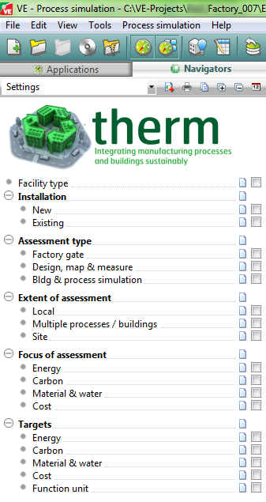

Figure : Options in the setting for the analysis



Figure : Processes ranked by annual power consumption

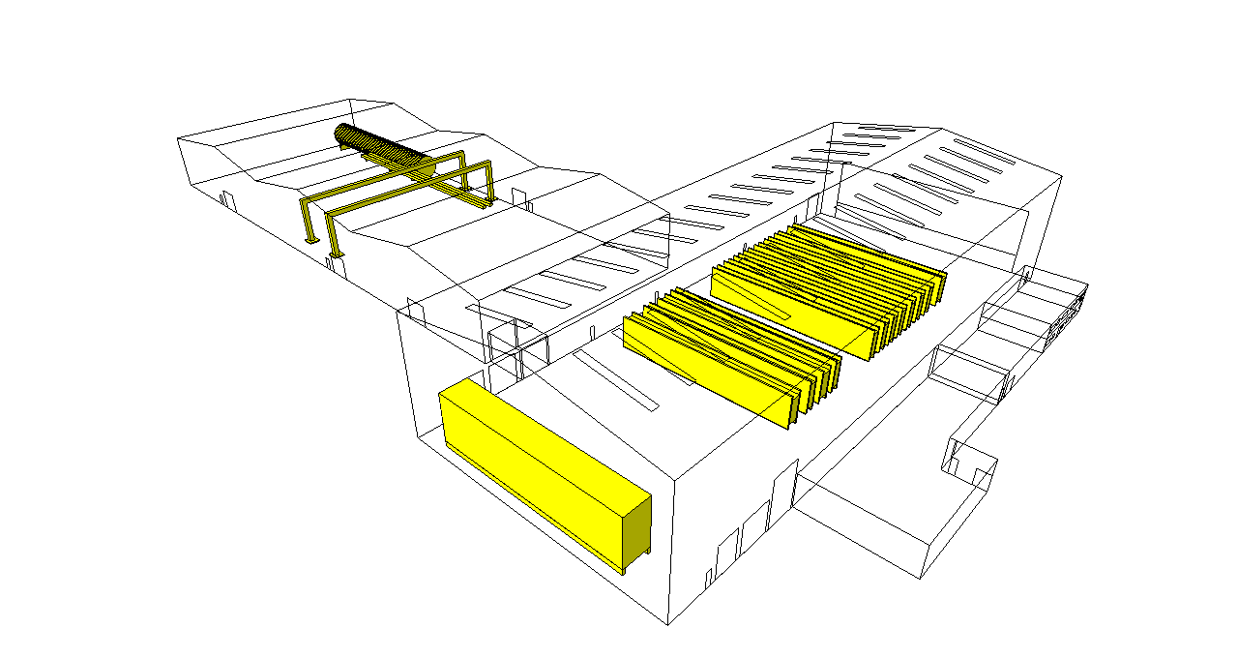

Figure : Building geometry (wired frame) and technology components (yellow elements)

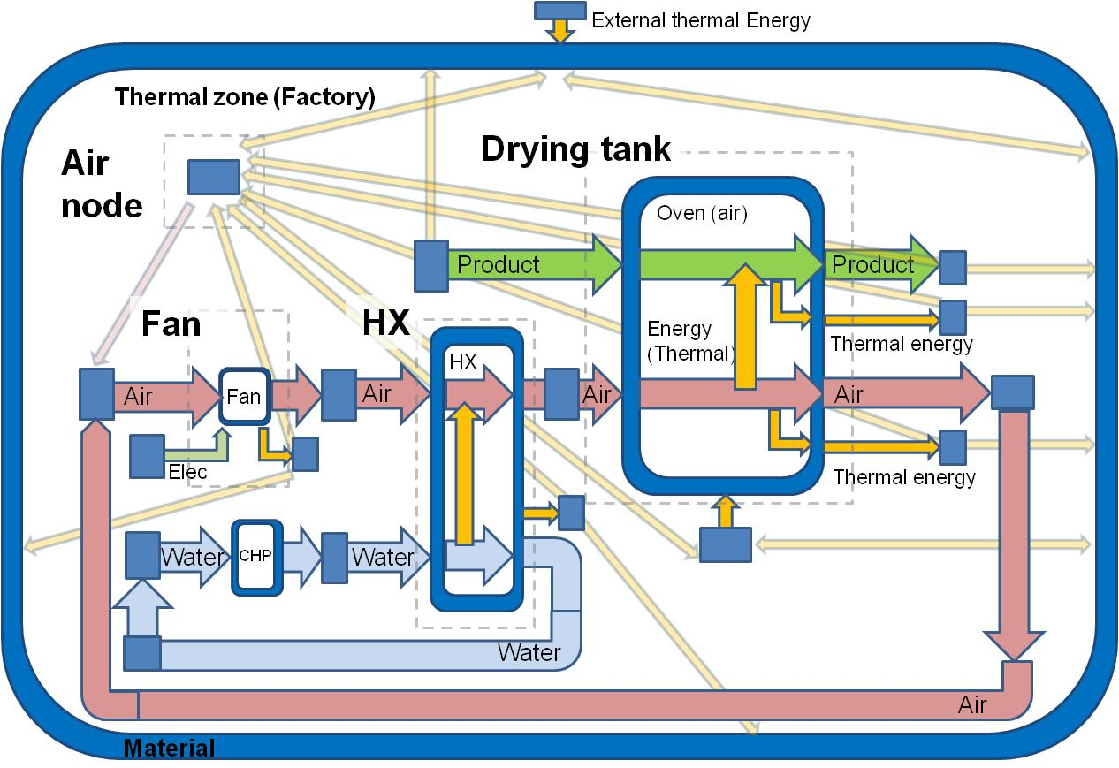

Figure 6: Graphical representation of a drying tank and its subsequent equipment coupled to its location (factory environment) (Oates et al., 2011a)



Figure : Fan and HX energy savings using prevention tactic ‘Switch off when not in use’

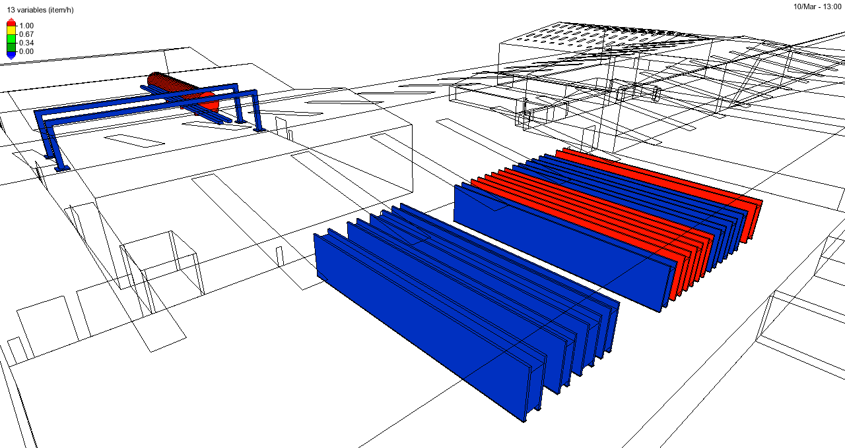

Figure : Simulated analysis with red highlight for operating processes and blue for non-operating processes to identify opportunities for reuse of waste between processes