Interaction of DLC and B₄C coatings with fully formulated oils in boundary lubrication conditions

Y. Tamura^{a, b}*, H. Zhaoª, C. Wangª, A. Morinaª, A. Nevilleª
ª Institute of Functional Surfaces, School of Mechanical Engineering, University of Leeds, Leeds LS2 9JT, United Kingdom
^{b} Materials Technical Center, Research Division, Komatsu Ltd., 1200, Manda, Hiratsuka, Kanagawa 254-8567, Japan
*Corresponding author for yukio.yt.tamura@gmail.com (Y. Tamura), TEL.:+81 463 35 9206
Abstract
Diamond-like carbon (DLC) and Boron Carbide (B₄C) coatings are promising candidates for sliding-rolling contact parts, especially gears to increase scuffing load capacity and prolong lifetime. Generally, commercially available fully formulated oils are compatible with ferrous surfaces, but normally have not been optimised for coatings. In this study, the tribological properties of tungsten carbide containing DLC (WC-DLC), hydrogenated DLC (H-DLC) and B₄C coatings against steel ball with two fully formulated oils in boundary lubrication conditions have been evaluated. They were compared with that of a Steel/Steel tribocouple. Interactions between lubricants and sliding surfaces were also investigated using surface characterisation techniques such as XPS and Raman Spectroscopy. It was found that Steel/H-DLC system provided the lowest friction coefficient for both two oils.
Keywords: DLC, B₄C, fully formulated oil, tribochemistry

- Introduction
In recent years improvement of tribological performance of heavy duty parts such as gears, roller element bearings and cam/followers have been essential in order to achieve further reduction in size and increase in performance. These parts normally work in mixed-boundary lubrication where the interaction between contact surfaces and lubricants has an important role in the tribological performance and prevention of failures, i.e., pitting, scuffing and wear. To protect contact surfaces from those failures and improve the power density, various coatings have been studied. Amorphous Diamond-Like Carbon (DLC) and boron carbide (B₄C) coatings are promising candidates especially for gears in order to improve tribological performance leading to an increase in scuffing load capacity and improvement of life time [1-5]. Currently some of these coatings have been successfully adopted in transmission components in mainly automobile application [6]. Especially tribological properties of W or WC containing DLC coatings, which are also known as W-DLC, WC-DLC or WC/C, actively have been evaluated in order to apply them to gears [1-3]. Joachim et al. [1] reported that gears with the WC/C coating showed the increase in scuffing load capacity and macro-pitting capacity compared to uncoated steel gears under lubrication conditions with a fully formulated oil. Kalin et al. [2] investigated the tribological performance of W-DLC-coated gears in biodegradable oil and revealed that the combination of W-DLC-coated pinion and wheels reduced the frictional heating compared to steel-steel gear pairs. WC/C films on steel substrates, which micro shot peening is applied to, had a longer lifetime than conventional case-carburized steel in gear tests under a loss-of-lubrication [3]. On the other hand, B₄C coated gears lubricated with a fully formulated oil had better scuffing and macro-pitting resistance than steel gears [1]. In terms of other types of DLC, the surface fatigue resistance of hydrogenated DLC prepared using the Plasma Enhanced Chemical Vapour Deposition method had 100 times longer life than that of carburised-quenched-tempered steel in roller-pitting tests with automatic transmission fluids (ATF) [5]. However, it is still not fully understood how the interactions between coated surfaces and lubricant additives can affect the tribological properties in boundary lubrication with fully formulated oils and higher performance of gear systems. As well as actual gear tests with promising coatings, fundamental tribological research of studies have been carried out by using benchtop tribometer tests in model oils, which are base oil(s) blended with certain one or two additive(s), rather than fully formulated oils.

  - Interaction between WC-DLC coatings and lubricant additives

Several studies reported the interaction between WC-DLC and lubricant additives [7-14]. Some papers reported that no interaction of WC-DLC with lubricant additives was found. WC-DLC was evaluated in poly-alpha-olefin (PAO) oil with and without sulphur-based Extreme Pressure (EP) additives or ZDDP-based anti-wear (AW) additive as well as fully formulated gearbox oil (API GL-4) [7]. Addition of either EP or AW additive in PAO lowered the friction coefficient (20-25%) compared to uncoated steel, but the API GL-4 gave only a minor friction reduction. They found that tribofilms consisting of transferred coating material and reaction products from the additives were formed on steel surfaces, both the initially uncoated and those exposed by wear, although no such film was detected on remaining parts of coating material in all lubricants. Further studies reported that tungsten in the transferred layer reacted with sulphur derived from S-based EP additive in PAO oil, forming lamellar WS₂ tribofilms on steel counter-face or the steel substrate exposed by wear while no tribofilms were on the top surface of DLC coatings. On the other hand, WC-DLC with P-containing AW additives showed high friction [8-11]. In contrast, some research has shown the interaction of WC-DLC with lubricant additives. WC-DLC reacting with certain additives (nitrogen sulphur with and without either sulfurized isobutylene, amine phosphate or phosphate ester) in synthetic base oil provided lower wear than steel due to the formation of tribofilms containing WS₂ compound with other reaction film on the coating surface [12]. Interaction between WC-DLC and additives which contain ZDDP (anti-wear additive) and thiadiazole (corrosion inhibitor additive) in synthetic base oil led to the formation of reaction compounds, i.e. zinc sulphide, tungsten sulphide, tungsten oxide, tungsten carbide, zinc tungstate and an organic film on the coating surface, as well as carbon-based transfer film around the edge of the wear scar on counter-DLC ball [13]. Those compounds gave a lower friction coefficient and wear. A recent paper investigated interaction of W-containing DLC with fully formulated engine oils. This study showed the formation of tribofilm containing C, Ca, O, P and S elements on the coating surface [14].

  - Interaction between hydrogenated DLC coatings and lubricant additives

Hydrogenated amorphous DLC (a-C:H) has dangling bonds passivated by the hydrogen atoms within the coating and thus the hydrogen-carbon combination provides a non-polar inert surface having low surface energy which further causes poor wettability and probably little or no adsorption of oil additives on the rubbing surface [15]. Indeed, hydrogenated DLC lubricated in PAO oil with and without EP (sulphurized olefin) or AW (a mixture of diamine monohexyl phosphate and amine dihexyl phosphate) additive showed stable friction coefficient of around 0.28, and no reaction products or tribofilm formation on the DLC coated surfaces were observed while a carbon transfer layer was found on steel counter-surfaces [10, 11]. In contrast, tribofilm formation on the wear scar of hydrogenated DLC in PAO oil with additives such as Zinc dialkyldithiophosphate (ZDDP) and Molybdenum dithiocarbamate (MoDTC) was observed and according to XPS analysis the main components of tribofilm were metal sulphide (molybdenum sulphide and/or zinc sulphide) while no P element from ZDDP additive [16]. Haque et al. [17] reported that hydrogenated DLC in PAO oil with ZDDP and Mo containing friction modifier additives presented lower friction coefficient than uncoated steel, resulting from the formation of MoS₂ and MoO₃ tribofilm on the DLC coating and a transfer carbon layer on the steel counter-surface. On the other hand, no ZDDP derived antiwear tribofilm was found on the DLC surface. In contrast, it was reported that ZDDP and MoDTC in API group II base oil reacted to form very thin, friction-reducing films on the DLC surfaces though the presence of those films was claimed using atomic force microscopy (AFM) and accurate elements included in the films were not reported [18]. Equey et al. [19] reported that the formation of ZDDP derived tribofilm was observed on the DLC coatings using SEM and the thickness of it was around 100 nm according to AFM analysis. Recently XPS analysis showed the formation of ZnS, ZnO and Zn-phosphates on the coating surface lubricated with fully formulated oils containing ZDDP [20]. This study also reported the presence of Ca and N elements, which are derived from detergent and dispersant in the oil respectively, on the coated contact surface. As mentioned above, therefore, the interaction between hydrogenated DLC and lubricants additives seems to be strongly dominated by the kind of additives and the combination of several additives.

  - B₄C tribological performance in different environments

Tribological studies of B₄C coatings or bulk materials mainly have been carried out in dry or humid conditions at room temperature [21-26]. Larsson et al. [21] found that B₄C bulk materials formed tribofilms of oxides that contributed to the decreasing of wear rates and the smoothing of tribo-surfaces as the sliding distance increased. XPS analysis indicated the presence of boron oxide or boric acid on the wear scar of B₄C coatings [22]. Erdemir et al. [23] reported that annealed B₄C bulk materials in contact with zirconia presented lower friction coefficient: 0.03-0.05 in dry condition, but as-received B₄C showed higher friction around 0.3. Raman observations revealed the presence of an H₃BO₃ film at the sliding interface, resulting in the low friction character of both the annealed B₄C bulk materials and coatings [23, 24]. Boric acid formed on B₄C gave quite lower wear of counter face pin, but the pin sliding against the as-received B₄C suffered significant wear [25]. On the other hand, transfer film from the annealed B₄C was found on the contact surface of counter body material [24]. In-situ Raman analysis revealed the formation of boric acid and carbon at the sliding interface of annealed B₄C and sapphire and evolution of carbon amount lead to higher friction [26]. In terms of the tribological properties of lubricated B₄C, Siniawski et al. [27] reported that B₄C coatings lubricated with mineral oil in boundary lubrication condition showed low friction coefficient: around 0.12 compared with unlubricated B₄C. However, the interaction between B₄C contact surface and lubricant additives is not fully understood.
As reviewed here, there are many papers which studied the interaction between coating surfaces and mainly model lubricants with specific additives. However, how the coating surfaces react with additives in formulated oils in the boundary lubrication regime relevant to gear systems has received less attention. Commercially-available fully formulated oils are in general compatible with ferrous surfaces. They have not specifically been optimised for coatings such as DLC and B₄C. Understanding of the role of additives on tribology of coated surfaces will enable expansion in parts coated with functional coatings.
The aim of the present work was to investigate the tribological performance of tungsten carbide containing DLC (WC-DLC), non-doped hydrogenated DLC (H-DLC) and B₄C coatings in boundary lubrication conditions lubricated with two kinds of formulated oil. Tribochemical interactions between the above coatings and lubricant additives have been further analysed using surface characterisation techniques.

- Experimental details

  - Materials and lubricants

In this study, a ball-on-disc tribometer running in pure sliding condition was chosen to evaluate friction and wear performance. The material of 6.35 mm diameter ball used was high chromium steel (AISI52100). Three kinds of hard coatings, hydrogenated tungsten carbide containing DLC (WC-DLC), non-doped hydrogenated DLC (H-DLC) and B₄C coatings, and high chromium steel (AISI52100) as a reference were used for the disc. The disc dimensions were 42 mm in outer diameter, 25 mm in inner diameter and 3 mm thickness. Each coating of disc was deposited on the AISI52100 steel. WC-DLC and B₄C coatings were deposited by a reactive sputtering process at Oerlikon Balzers Coating (UK) and Teer coatings Ltd. (UK), respectively. On the other hand, H-DLC was prepared by Microwave excited Plasma Enhanced CVD (MW-PECVD) at the University of Leeds. Physical properties (reduced Young’s modulus and hardness) of the steel substrate, coatings and counterbody steel ball measured using Nano-indenter are presented in Table 1. Surface roughness was measured by Bruker white light interferometer. The lubricants used in the present work were two types of fully formulated oils which are used in actual gear systems. One was API group I mineral oil containing ZDDP anti-wear additive, Ca detergent, succinimide dispersant and anti-oxidant, which is used for transmission (denoted as Oil A). The other was API GL-5 mineral oil containing sulphur-based extreme pressure additive, anti-oxidant and corrosion inhibitor applicable to heavy duty gear system in final drive (denoted as Oil B). Zn in Oil B is actually impurity contained in lubricant and its concentration is quite low compared to other elements’ concentrations. Lubricant properties are presented in Table 2.

  - Tribological tests

Tests were carried out using the ball-on-disc tribometer under boundary lubrication conditions. The disc was rotated against the stationary ball. The test conditions are described in Table 3. For each material couple the test was carried out more than three times to check the repeatability. Before testing, the test samples were cleaned with acetone in ultrasonic bath for 10 min. The friction data were measured by transducer (capacitance type) and data acquisition was conducted every one second. Initial maximum contact pressure was calculated using equation for Hertzian point contact for elastic deformation and initial film thickness ratio, Lambda ratio λ, was calculated using the following equation [28]:
$λ=\frac{h_{min}}{\sqrt{R_{q1}^{2}+R_{q2}^{2}}}$ (1)
$\frac{h_{min}}{R'}=3.63{\left(\frac{Uη_{0}}{E'R'}\right)}^{0.68}{\left(αE'\right)}^{0.49}{\left(\frac{W}{E'{R'}^{2}}\right)}^{-0.073}\left(1-e^{-0.68k}\right)$ (2)
where h_{min} minimum film thickness, R_{q1} the average rms roughness of ball, R_{q2} the average rms roughness of disc, U the entraining surface velocity, η₀ the dynamic viscosity, E’ the reduced Young’s modulus, R’ the reduced radius of curvature, α the viscosity-pressure coefficient, W the normal load, k the elliptical parameter which is equal to 1 for point contact. The calculated λ ratio is under 0.50 using Oil B viscosity that means lubrication regime considered is the boundary lubrication regime.

  - Surface analysis

Wear scar diameters on ball sample were measured using optical microscope and then the material volume loss (V) on the balls was calculated. Finally, the specific wear rates (k) have been calculated using the following equation:
$k=\frac{V}{WS}$ (3)
where W the normal load, S the sliding distance. Wear on the disc was too small to measure using white light interferometer due to high overlap ratio (ratio of initial wear track on disc to initial contact radius of the ball) and higher initial roughness of disc [13]. This made it difficult to distinguish the wear scar from the intact surface.
Chemical characterisation was carried out using energy dispersive X-ray technique (EDX) attached on a Zeiss EVO MA15 SEM. EDX was used to assess the elemental constituents present inside the wear scar on the balls and on the wear track for the discs as well as give an indication of wear level from test to test. Before analysis, the samples were rinsed with n-heptane. The accelerate voltage of EDX was 10 keV, corresponding to the penetration depth about 1 µm. This means that acquired data have the information on the chemical elements of top contact surfaces (tribofilm) and coating or steel substrate. The EDX data were taken from an area of 150 µm $×$ 110 µm at three different positions inside wear scar. Assuming that the volume of material analysed by EDX is the same for each sample, the concentration of elements which are in the substrate can give qualitative information on the coating in removal. In terms of the evaluation of the coating wear on the wear track, Haque et al. [29] reported the method using the EDX. In this study, the same method was applied.
Furthermore, X-ray Photoelectron Spectroscopy (XPS) analysis was performed on tribofilms to reveal their chemical composition and study the possible tribochemical reactions that lead to tribofilm formation. An area of 200 µm $×$ 400 µm in the wear scar of both balls and discs has been analysed using a monochromatized Al Kα source in the XPS. The XPS peaks obtained from region scans were fitted using the CasaXPS software [30]. The position of C 1s peak (285 eV) was considered as the reference for charge correction. The peak area ratio, difference between binding energies of the doublets, and Full-Width at Half-Maximum (FWHM) were constrained to provide the most appropriate chemical meaning [20]. A Shirley background approximation was used to process the data in this study. A handbook of XPS was used to find the chemical species at particular binding energies [31]. Basically the analysis was carried out for the top surface of wear track. When only the small amounts of P and S elements from additives at the top surface were detected from the XPS data, argon etching was conducted for 30s. The etching was performed using argon ion gun set at beam energy of 4 keV and emission current of 10 mA in an area of 1 mm $×$ 2 mm on the wear scar.
Raman spectroscopy was carried out to investigate the presence of transfer material, which would come from the counterpart coated discs, on the wear scars of the steel balls as well as structural changes of coated discs during the tribological test. The excitation wave length of the laser used was 488 nm. The scan range from 1000 cm⁻¹ to 1900 cm⁻¹ was applied to observe the carbon D peak and G peak. The D peak around 1350 cm⁻¹ represents the breathing modes of sp² atoms in aromatic or benzene clusters in hydrogenated carbon films [32, 33]. On the other hand, the G peak around 1580 cm⁻¹ is derived from the in-plane bond-stretching motion of pairs of carbon sp² atoms [32]. In the case of worn WC-DLC coated discs the Raman spectra could not be fitted by two Gaussian peaks. Schwan et al. [33] reported that some DLC coatings can be better fitted using four curves. Raman spectrum of transfer layer on the counterbody from DLC coatings had weak additional contribution from graphite as well as two main peaks (D and G peaks) from DLC [34]. In this study, four curves, where each curve is comprised of the mixture of Gaussian and Lorentzian, were used to fit the all Raman spectra. Full-width at Half-Maximum (FWHM) was constrained to obtain the meaningful results of DLC and transfer layer structures from the curve fitted spectra.
In order to investigate the morphology and phase distribution of tribofilms, AFM analysis was conducted in air and at room temperature using a commercial Atomic Force Microscope (Dimension Icon from Bruker). Scanning was carried out in peak force quantitative nanomechanical mapping (QNM) mode with silicon tip on nitride lever. The Si tip height was 5 µm, tip radius was 2 nm and its spring constant was 0.4 N/m.

- Results

  - Friction, wear and coating durability

Representative friction coefficients as a function of time and tribocouple for Oil A and Oil B are shown in Fig. 1(a) and (b), respectively. Friction values of all tribocouples reach steady-state levels after 1h testing. As a whole, friction behaviour for all tribocouples can be distinguished into two groups. One contains Steel/Steel, Steel/B₄C and Steel/WC-DLC where the friction coefficients gradually decrease with rubbing and reach steady-state after about 60 min for both Oils A and B. The other is Steel/H-DLC where the friction coefficients in both Oil A and Oil B show significant reductions in the first 5 to 10 min, then gradually go up and finally have steady-state values. Fig. 2 presents the average of friction coefficients for the last 1h testing. For both oils the Steel/H-DLC system offers low friction. Friction values of Steel/B₄C and Steel/WC-DLC systems, however, show the dependence on oils. In comparison with Steel/Steel systems, the Steel/B₄C system gives similar friction performance, whereas the Steel/WC-DLC couple provides lower friction with Oil B. For any disc materials there is the difference in the initial surface roughness as shown in Table 1. It may affect the lowering of friction coefficient. However, the authors believe that interaction of additives with coating surfaces and the formation of carbon transfer layer are more effective for friction reduction. The details are discussed at section 4.2.
Specific wear rates of ball samples are shown in Fig. 3. Oil A gives the same level (10⁻¹⁷-10⁻¹⁶m³/Nm) of the wear rates between Steel/steel system and Steel/Coating systems compared to Oil B. The level of specific wear rates is categorized in the severe wear condition or the transition regime between mild and severe wear conditions under boundary lubrication regime. Calculated lambda ratios of all material couples using the viscosities of Oil A and Oil B were within 0.10 and 0.50 in this study, indicating that all the tests were performed in severe or moderate boundary lubrication when considered the severity definition of boundary lubrication by Roshan et al. [35]. For Oil A the wear rate of the ball rubbing against WC-DLC is higher than that of steel disc. This result is in agreement with previous report by Podgornik et al. [10]. On the other hand, the wear rate of the ball in contact with H-DLC decreases. For in contact with B₄C the wear rate of the ball is nearly the same as that of the Steel/Steel system. In the case of Oil B, steel/steel couple gives a significant lower wear rate than Steel/Coating couples. In Steel/Coating systems, H-DLC has the lowest wear rate, followed by WC-DLC. As shown in Fig. 4, transfer layers from coated discs are clearly observed around the edge of the ball wear scars rubbing against WC-DLC and H-DLC in Oil B.
The tribometer condition in this study was considered in order to prevent the wear depth from exceeding the coating depth on discs. The accurate wear depth or width on the post-test coating disc was not able to be measured using conventional profilometry which has high resolution of nm order. This is due to low wear and higher surface roughness of disc samples. As an alternative method, the extent of disc wear was qualitatively obtained from EDX analysis results as well as the wear track images taken by the optical microscope. EDX detects the signal from not only the top surface of the coating but also the intermediate layer and iron containing substrate. WC-DLC and H-DLC have Cr and WC/Cr layer, respectively, although B₄C have no intermediate layer. This means that higher wear of the coating provides higher concentration of elements which are constituents of the intermediate layers and steel. Fig. 5 shows the wear track images of the discs acquired using the optical microscope. Table 4 (a) and (b) represents the EDX quantification acquired from inside and outside wear track of discs for Oil A and Oil B, respectively. In the case of Steel/Steel system, the wear track is not clear for Oil A but it is more visible for Oil B as shown in Fig. 5. In the case of WC-DLC lubricated with Oil A, the amount of iron and tungsten elements inside wear track slightly increases and the amount of carbon decreases compared to those outside wear scar. According to depth analysis of the coating using XPS, tungsten content increases with the depth (not presented in this paper). These results indicate that most of the WC-DLC coating lubricated with Oil A is still present inside the wear track after test. In WC-DLC lubricated with Oil B no change of iron and carbon elements in EDX analysis is observed, deducing that no significant wear of the coating has occurred when testing with this oil. This result is consistent in the wear track image of WC-DLC with Oil B which shows no clear boundary between inside and outside wear track (Fig. 5). For H-DLC no surface changes on the wear tracks for both oils are observed (Fig. 5). Moreover, EDX analysis indicates that the amount of iron and tungsten elements inside wear track is quite similar to that outside wear track for both oils. These results prove the excellent wear resistance and durability of H-DLC coatings when tested with oils A and B. EDX analysis of B₄C wear scars show that the amount of iron inside wear track is still suppressed for both oils compared with outside wear track. This indicates that not much of the B₄C coating has been worn out. The above results indicate that no or less wear on rubbed surfaces of the coated discs occurs within the coating depth, corresponding to the survival of coatings after the tests.

  - Surface analyses

Tribofilm formation was investigated using EDX and XPS. Table 4 and Table 5 show the EDX elemental quantifications of the rubbing area for disc and ball samples, respectively. It is difficult to separate oxygen peak from chromium peak precisely on the EDX because of very close energy position between O Kα and Cr Lα peaks. Thus the sums of oxygen and chromium elements as well as oxygen contents for all tribocouples are presented in Table 4 and Table 5. In all material couples except for B₄C coated disc in Oil A, lubricant additives derived elements are observed on the rubbing area according to EDX data (Table 4 and Table 5). This indicates that tribofilms are formed on most of the wear scars of balls and discs. In terms of Steel/H-DLC systems, higher carbon concentration was detected. Fig. 6 showed the SEM image and EDX elemental distribution of carbon, zinc and phosphorus on the wear scar of the steel ball against H-DLC in Oil A. It indicates that presence of carbon transfer film and ZDDP derived tribofilm on the wear scar of the ball. Fig. 7 shows the wear track on the B₄C coated disc rubbing against steel ball in Oil B. SEM image shows that the rubbing surface consists of roughly two areas: bright and dark colour areas. EDX spectra present that higher amounts of O P, S and C and a lower amount of B are detected in the dark colour areas (point II) whereas no additives derived elements are detected in the bright colour areas where a higher amount of B is observed instead of lower C content (point I). It should be mentioned that the elemental quantification data acquired using EDX have the information from top-surface to at least 1 µm depth. This means that the amount of tribofilm related elements could be underestimated. Therefore, XPS analysis, which provides the elemental information from top-surface to several nm, was performed in order to investigate the top layer of tribofilms.

    - Tribochemical interaction of materials with Oil A

Table 6 shows XPS quantification of tribofilms formed on steel balls and steel/coated discs when testing with Oil A. In all material couples lubricant additives derived elements such as P, S, Zn and Ca are observed on the rubbing area.
In terms of the ball surface when tested against steel disc as shown in Table 6 (a), large amounts of P, Zn and Ca are observed on the wear scar at the top surface. On the other hand, no or less additive derived elements were detected on the wear scars of the steel balls when tested against coated discs (Table 6 (a)). Thus, the argon etching for 30 s was carried out for all coated discs. After etching, the additive derived elements such as P, S, Zn and Ca had higher concentrations than those at the top surface. Interestingly, the amount of iron and sulphur was high on the steel ball surfaces against B₄C and WC-DLC discs, but low on the steel ball surface against H-DLC disc. Furthermore, the ball surface when tested against WC-DLC coated disc had high P, Zn and Ca concentrations. In terms of nitrogen, its concentration was high for the balls tested against the coated discs although no nitrogen was detected for the coated discs. Interestingly, boron was detected after the etching, indicating the boron transfer from the coated disc to the steel counterbody. On the other hand, less or no tungsten was detected on the ball wear scar in Steel/WC-DLC system.
In terms of steel disc as shown in Table 6 (b), large amounts of P, S and Zn elements are detected. This indicates that ZDDP derived tribofilm is formed on the wear track of the disc. On the other hand, evolution of Ca content was observed for the coated discs instead of P, S and Zn. No iron was detected on the wear scar of any coated disc. It means that little or no iron transfer from counterbody material as well as no exposure of iron containing substrate beneath the coating. Among the coatings, H-DLC had the lowest Ca concentration, indicating that the coating surface is the least tribochemically active.

    - Tribochemical interaction of materials with Oil B

Table 7 presents XPS quantification of tribofilms formed on the wear scars of steel balls and steel or coated discs when testing in Oil B. As observed in the case of Oil A, lubricant additives derived elements are present on the wear scars for all material couples.
As shown in Table 7 (a), relative concentrations of P and S are low at the top surfaces of all the wear scars of steel balls in Oil B compared with those in Oil A. Thus, the etching was performed for all the steel balls in Oil B. In comparison of elemental quantification results after the etching, steel ball surfaces against steel and H-DLC discs have high P concentration whereas steel ball surfaces against B₄C and WC-DLC discs have high S and Fe concentrations. In terms of nitrogen, its concentration is high on the wear scars of the balls when tested against the coated discs. This behaviour is similar to the Oil A results. Boron transfer from the coated disc to the steel ball was also observed.
Table 7 (b) shows XPS quantification of tribofilms formed on the wear scars of steel disc or coated discs when tested in Oil B. High P concentration with Fe was detected on the wear scar of the steel disc. For all the coated discs, phosphorus was observed on the wear scars. However, H-DLC had the lowest P concentration among the discs although relative concentrations of other elements such as S and N are similar to those in other discs. It indicates that H-DLC surface is the least active with P in Oil B. Interestingly S and N concentrations are high on the wear scar of the WC-DLC as well as P concentration. This indicates that WC-DLC easily reacts with several additives in Oil B. It should be mentioned that all coatings tested survived the tribological tests because of the absence of iron in XPS results.
    - Chemical species in tribofilms

Table 8 shows binding energies, concentrations of XPS peaks and corresponding chemical species in tribofilms on the wear scar in Oil A. The binding energies of P 2p, Zn 2p and Ca 2p suggested the formation of Zn/Ca phosphate on all the wear scars of both balls and discs. CaCO₃ was observed only for the steel ball surfaces. Interestingly, additional component (348.7 eV) in Ca peak on the wear scar of the steel ball in Steel/B₄C system was found. This binding energy is similar to Ca borate (348.3-348.4 eV) [36]. In Steel/Steel system sulphide and sulphate were observed. For Steel/Coating systems, sulphate was observed only on the coated disc surfaces, indicating the formation of Zn/Ca sulphate. On the other hand, sulphide was detected on both the balls and discs in Steel/Coating systems. N 1s peak was found only on the steel ball surfaces against the coated discs, corresponding to N-C bond of succinimide group [37].
Table 9 presents binding energies, concentrations of XPS peaks and corresponding chemical species in tribofilms on the wear scar in Oil B. According to the binding energy of P 2p, S 2p and N 1s, phosphate, sulphide and N species were mainly present on the wear scars of both balls and discs in all the material couples with Oil B.
As mentioned in the introduction section, WC-DLC and B₄C have possibility of the formation of reaction layer with additive: WS₂ and boron oxide and/or boric acid, respectively, under rubbing conditions. Therefore, XPS high resolution peaks of W 4f, S 2p and B 1s were analysed to investigate if the reaction product was formed. As shown in Fig. 8, XPS high resolution peaks of W 4f and S 2p peaks acquired from the WC-DLC coated disc in Oil A revealed the absence of WS₂ tribofilm. On the other hand, Fig. 9 shows the formation of WS₂ and W-O compounds was observed on the wear scar of the WC-DLC coated disc in Oil B. In the case of Steel/B₄C systems, B 1s peak decomposed into two components which were B₄C and B-O compounds on the coated disc in Oil B as shown in Fig. 10 (a). On the other hand, Fig. 10 (b) suggested that the steel ball surface against the B₄C coated disc had only the B-O compounds.

  - Raman analyses

Raman analyses were carried out for the ball samples rubbing against the coated discs in order to investigate the presence of transfer layer as well as the structural change of coatings. Fig. 11 (a) presents the spectra of WC-DLC discs and counterpart steel balls. For pre-test WC-DLC coated disc, G peak was present with a small D peak shoulder. When Oil A was used, spectrum from the wear track of the coated disc was the same as that from the pre-test coated disc. Although no clear transfer layer was found on the wear scar of steel ball in optical microscope observation (Fig. 4), Raman analysis revealed that some transfer layers were present on the wear scar of the ball. This transfer layer had slightly a narrow band of G peak (FWHM_{G} 100.6 cm⁻¹) compared to the worn coated disc (FWHM_{G} 102.8 cm⁻¹), but the position of D peak of the transfer layer was equal to that of the worn coated disc. On the other hand, evolutions of the intensities of the D peaks were visible on the wear track of the coated disc and wear scar of the steel ball in Oil B. Frequency shift to higher wave number and decrease in the width of G peaks were also observed on the worn surfaces of the ball and disc in Oil B. Decrease of width and frequency shift upward on G peaks and increase in the height of D peaks are attributed to increase of ordered sixfold rings in the sp² amorphous carbon network during a trajectory from amorphous carbon to nanocrystalline graphite [32]. These results indicate that the lubricant type can strongly affect the structural change of WC-DLC and the extent of the amount of transfer layers.
Fig. 11 (b) presents Raman spectra acquired from H-DLC coated discs and counterbodies (steel balls). In the case of Oil B, transfer layer on the ball wear scar showed clear D peak evolution and narrowing of G peak width, indicating that the layer had more graphite nature although the wear track of the coated disc in Oil B had no clear change in spectrum compared with a reference spectrum acquired from pre-test coated disc. On the other hand, spectra from transfer layer on the wear scar of the ball and wear track of the coated disc in Oil A was similar to the reference spectrum.
Fig. 11 (c) presents Raman spectra of B₄C coated discs and counterbodies (steel balls). Obviously, the transfer layer in any oil has D and G peaks. This indicates that B₄C was decomposed into C-based compounds as well as B-based compounds mentioned earlier. Evolution of D and G peaks after test agrees with the results reported by Dvorak et al. [26].

  - AFM analyses

AFM analyses were carried out only for steel disc and B₄C disc. Steel/Steel and Steel/B₄C couples had nearly the same friction coefficients for both Oil A and Oil B although wear rate of the steel ball was quite different between the two couples. Therefore, in order to understand tribological performance in those systems surface topography and tribofilm distribution should be observed as well as elemental quantification of tribofilm using XPS. Fig. 12 presents AFM images of wear scars for steel and B₄C disc with both Oil A and Oil B. In the case of Oil A, steel disc has some patched-like structures which are typical morphology in contact surface reacted with ZDDP additive. On the other hand, B₄C had a very smooth surface with some large patchy regions. In terms of Oil B, the steel disc had smooth surface with some protuberances. This feature was also observed on the wear scar of the B₄C disc. It should be mentioned that elongated groove observed on the left side of AFM image obtained B₄C disc with Oil B (Fig. 12(d)) is the structure itself formed during the coating deposition process.

- Discussion

  - Tribochemistry and tribological performance
    - Steel/DLC tribocouples with Oil A

In general, ZDDP tribofilm has a pad-like structure consisting of Fe/Zn glass phosphates, organic sulphides, Zn polyphosphate and ZnS/FeS [38], protecting rubbing surfaces from wear. However, ZDDP tribofilm is more complex when fully formulated oils containing other additives are used. Especially, Ca detergent in Oil A could play a significant role in the formation of glass phosphates as observed in this study where high Ca concentrations with a small amount of Zn was detected on the wear scars of both the steel balls and DLC coated discs. Similar behaviour was observed in Steel/Steel system reported by Nicholls et al [39]. They suggested that the film formed from ZDDP and Ca detergent on the steel surface is primarily a shorter-chain calcium polyphosphate glass intermixed with some zinc phosphate, leading to decrease in anti-wear property of ZDDP tribofilm itself. Moreover, in the case of Steel/WC-DLC system, high iron and sulphur concentrations were detected on the wear scar of the steel ball compared to Steel/H-DLC system. This indicates that a large amount of iron sulphide is present in the Steel/WC-DLC system. Martin et al. [40] suggested that in severe running conditions the ZDDP film comprises the mixed short-chain pyrophosphate corresponded to Fe₂O₃, ZnO and 2P₂O₅ and iron sulphide whereas in mild wear conditions the wear debris, which represents the piece of ZDDP film, is made of a zinc polyphosphate glassy material. Based on the above results, the Steel/WC-DLC interface was placed in severe running conditions compared to Steel/H-DLC interface, resulting in higher wear of materials in the Steel/WC-DLC system (Fig. 3 and Fig. 5). In terms of Steel/H-DLC system, H-DLC surface is the least tribochemically active due to small amounts of additive elements detected on the wear scar. Moreover, it could be said that the least additives derived tribofilm formation promotes the occurrence of carbon transfer to the counterbody. They could lead to the lower wear of the steel ball rubbing against H-DLC coated disc. The Steel/WC-DLC system gave a slightly higher friction coefficient than Steel/Steel system. This result agrees with previous reports regarding DLC lubricated with fully formulated oil containing ZDDP additive [20]. In Steel/WC-DLC system, large amounts of additive elements were detected on the wear scar of both the steel ball and coated disc, which could suppress the formation of the graphitic transfer film which provides a low friction [20]. Furthermore, XPS high resolution analyses revealed the absence of WS₂ tribofilm which has low shear strength, leading to low friction on the wear scar of the coated disc (Fig. 8). They could be the reason why this system gave a slightly higher friction coefficient.

    - Steel/DLC tribocouples with Oil B

The Steel/WC-DLC tribocouple gave a slightly lower friction coefficient than Steel/Steel tribocouple. In this system, two components which are WS₂ tribofilm and graphite-like transfer film mainly gave the lower friction. This result is in agreement with previous reports mainly using PAO base oil containing a single or two sulphur-based additive(s) [7-11].
Steel/H-DLC system in Oil B provided the lowest friction among all the tribocouples for any oil used in this study. As well as WC-DLC coating, carbon transfer layer was formed on the wear scar of steel countersurface rubbing against the coated disc (Fig. 4). Furthermore, Raman spectrum revealed that this layer has a graphite-like nature (Fig. 11). On the other hand, less additive derived S and P elements were present on the disc wear scar. Similar result was observed in Oil A. In general, hydrogenated DLC (a-C:H) has poor wettability and little or no adsorption of oil additives on the sliding surface [15], probably leading to the evolution of graphitization/structural change of DLC and the carbon material transfer from the coated disc to the counterbody. In comparison with Oil A, Oil B has a trend to provide more graphitic transfer layer for both WC-DLC and H-DLC (Fig. 11). It could be because a large amount of oxygen (mainly oxides) on the wear scar of the balls in Oil B plays a role as a third body, inducing graphitization of the DLCs compared to those in Oil A.

    - Steel/B₄C tribocouples with Oil A and B

Steel/B₄C system provided nearly the same tribological properties as Steel/Steel system except for the wear of the ball in Oil B. However, the compounds presented at the sliding interfaces are different between two systems. XPS analysis revealed the transfer film consisting of B-O bond on the wear scars of the balls in both Oil A and Oil B. It partially agrees with previous papers which reported that the formation of boric acid, which was a reaction product of B-O compound (B₂O₃) and H₂O on the wear scar and the presence of transfer layer on the counterbody in dry conditions [26]. This study was carried out in lubricated conditions and thus B₄C reacts with oxygen dissolved in the oil and lubricant additives. Surface analyses showed formation of B-O compounds and carbon in the tribofilm. On the other hand, Raman spectroscopy analyses of the tribofilm did not show any boric acid formed on the wear scar. Although the absence of boric acid prevents further friction reduction in this system, B-O compounds could provide low friction coefficient (around 0.11) in boundary lubrication conditions. The above results are in agreement with the previous report by Siniawski et al. [27] which suggested that an evolution of the surface oxidation of the B₄C coating primarily lead to the reduction in friction coefficient.
In terms of wear performance of the Steel/B₄C system, a large amount of phosphorus which generally plays a significant role as an anti-wear agent at the rubbing surface was detected on the wear scar of the ball in Oil B compared to that in Oil A. Furthermore, higher boron concentration on the rubbed ball surface in Oil B could protect the rubbed surface from wear. On the other hand, Oil A provided higher N concentration which was probably constituent of adsorptive succinimide on the top surface because its concentration drastically decreased with etching on XPS analysis. These results agree with the previous report by Martin et al. [37]. Moreover, Ca detergent could promote the formation of phosphate with short-chain length, resulting in lower wear protection [38]. They result in lower wear rate of the steel ball tested with Oil B than Oil A.

  - Comparison of Steel/Steel system and Steel/Coating systems on tribochemical reactions

Based on this study, the type of coating strongly affects the tribochemical reactions with lubricant additives. In general, additives react with the ferrous surface easily in Steel/Steel system, providing low friction and anti-wear resistance because many commercial additive packages are usually tuned up for ferrous materials. However, Steel/Coating systems seem to change not only the reaction of the coating surface with additive but also the reaction of the ferrous counter-surface with additives. This suggests that lubricant selection based on the combination of steel and coating rather than just the kind of coating should be conducted carefully. In the case of Steel/Steel system, phosphate was a main component of the tribofilm on the wear scar for both Oil A and Oil B. Higher P concentration on the wear scar in Oil B provided lower wear rate of the steel ball than Oil A. EP agent like sulphur containing additive also might play a great role in wear protection [41]. However, for the testing conditions in this study, the authors believe that phosphorus compounds are more relevant for wear protection of steel ball against steel disc than sulphur compounds. This is based on XPS analyses (Table 7), sulphur concentration on the worn surface of steel ball against steel disc is lower than that of steel ball against coating. This indicates that sulphur compound has a minor role in wear reduction of the steel ball compared to phosphorus compound in Oil B. In the case of Steel/Coating systems, phosphorus concentration on the wear scars of the steel balls decrease compared with Steel/Steel system except for Steel/WC-DLC in Oil A and Steel/H-DLC in Oil B. However, only this finding does not directly indicate the extent of wear rate of the ball. It should be considered how much DLCs (WC-DLC and H-DLC) and B₄C which generally provide transfer films leading to low friction and/or wear reduction in the systems [13, 20, 26] react with additives. As mentioned earlier, H-DLC is the least tribochemically active, promoting the formation of transfer films on the wear scars. Thus, this system provided low friction and wear compared to other coatings. Other coatings such as WC-DLC and B₄C are more tribochemically active, promoting the formation of large amounts of adsorptive and reaction layers on the wear scar. The diversity of the adsorptive and reaction layers gave better tribological properties in some system.
It should be mentioned here that the initial surface roughness is less effective for friction reduction than the interaction of additives with coated surfaces and the formation of carbon transfer layer in this study. Among Steel, WC-DLC and B₄C their friction coefficients in Oil A are nearly the same although there is the difference in the initial surface roughness (Steel 0.1-0.2 µm in Rq, WC-DLC 0.3-0.5 µm in Rq and B₄C 0.5-0.7 µm in Rq). Only WC-DLC with Oil B showed the friction reduction due to the interaction of the rubbed surface with additives and the formation of transfer layer. In terms of Steel and H-DLC which have the same initial surface roughness 0.1-0.2 µm in Rq, the friction value of Steel/Steel is the nearly same as that of Steel/H-DLC when the wear test is carried out using a base oil which is of the same as that of Oil A except oil viscosity (This result is not presented in this paper). However, the base oil with the same additive package as that included in Oil A provided friction reduction by 25% for Steel/H-DLC, but no friction reduction for Steel/Steel. As a result, the correlation of surface roughness with the friction cannot be established for all tribocouples in this study, indicating that lubricant additives and their interaction with rubbed surfaces affect the friction coefficient significantly.
On the other hand, tribofilm morphology could be dependent on not only additive type but also the nature of steel/coating material itself according to AFM results of steel and B₄C coated discs. The additives in Oil A provided patched-like structures on the rubbed surfaces for steel and B₄C discs. The formation of large patchy region observed on the B₄C disc may be derived from the formation of B-O compounds and/or phosphate/sulphate which contains a large amount of Ca. On the other hand, both surfaces of steel and B₄C coated discs in Oil B have smoother surfaces than those in Oil A. Furthermore, XPS analysis revealed the formation of N species on the disc surfaces tested in Oil B although N element was not detected on the disc surfaces in Oil A. It indicates that the tribofilm containing not only phosphate and sulphide but also N species has a link with the formation of smoother surfaces in Oil B. Further study is needed to reveal the detail of the complicated interaction of coating with commercially used additives.

- Conclusions
The tribological performance of Steel/Coating (WC-DLC, H-DLC and B₄C) couples was investigated and the results were compared with Steel/Steel system as a reference. Tribofilms on the coated surfaces and transfer layers on the counterbodies were analysed using surface characterisation techniques such as EDX, XPS, Raman spectroscopy and AFM. Main findings in this study are as follows:
- H-DLC coating gave the lowest friction and wear for both Oil A and Oil B compared to other tribocouples.
- Oil B showed the lowest wear rate for the ball in Steel/Steel couple. A large amount of phosphate in tribofilm gave an excellent wear resistance for this system.
- For all coated surfaces, tribofilms were observed on the wear scars. However, H-DLC surface had only traces of tribofilm elements, indicating that this coating is the least tribochemically active for lubricant additives used in this study.
- Transfer films on ball wear scars were observed for all Steel/Coating couples. In the case of WC-DLC and H-DLC, the films in Oil B had graphite-like nature whereas DLC-like transfer films were observed for WC-DLC and H-DLC in Oil A.
- For B₄C coatings, the formation of B-O compounds in the coated discs could induce the build-up of the transfer film on the ball surfaces.
- Interaction of WC-DLC with lubricant additives provided WS₂ triobofilm for Oil B, resulting in low friction, but mainly oxides for Oil A, leading to high friction. This indicates the importance of the choice of lubricants in this system.
Acknowledgement
Authors would like to thank Komatsu Ltd. (Japan) for funding this project and the University of Leeds for offering facilities to implement the project.
References
[1] Joachim F, Kurz N, Glatthaar B. Influnece of coatings and surface improvements on the lifetime of gears. Gear Technology. 2004;July/August:50- 6.
[2] Kalin M, Vizintin J. The tribological performance of DLC-coated gears lubricated with biodegradable oil in various pinion/gear material combinations. Wear. 2005;259:1270-80.
[3] Murakawa M, Komori T, Takeuchi S, Miyoshi K. Performance of a rotating gear pair coated with an amorphous carbon film under a loss-of-lubrication condition. Surf Coat Tech. 1999;120:646-52.
[4] Fujii M, Kumar MA, Yoshida A. Influence of DLC coating thickness on tribological characteristics under sliding rolling contact condition. Tribology International. 2011;44:1289-95.
[5] Yakabe F, Jinbo Y, Kumagai M, Horiuchi T, Kuwahara H, Ochiai S. Excellent durability of DLC film on carburized steel (JIS-SCr420) under a stress of 3.0 GPa. J Phys Conf Ser. 2008;100.
[6] Stott WR. Myths and Miracles of Gear Coatings. Gear Technology. 1999;July/August:35-44.
[7] Podgornik B, Jacobson S, Hogmark S. DLC coating of boundary lubricated components - advantages of coating one of the contact surfaces rather than both or none. Tribology International. 2003;36:843-9.
[8] Podgornik B, Jacobson S, Hogmark S. Influence of EP additive concentration on the tribological behaviour of DLC-coated steel surfaces. Surf Coat Tech. 2005;191:357-66.
[9] Podgornik B, Hren D, Vizintin J, Jacobson S, Stavlid N, Hogmark S. Combination of DLC coatings and EP additives for improved tribological behavioiur of boundary lubricated surfaces. Wear. 2006;261:32-40.
[10] Podgornik B, Vizintin J. Tribological reactions between oil additives and DLC coatings for automotive applications. Surf Coat Tech. 2005;200:1982-9.
[11] Podgornik B, Hren D, Vizintin J. Low-friction behaviour of boundary-lubricated diamond-like carbon coating's containing tungsten. Thin Solid Films. 2005;476:92-100.
[12] Mistry KK, Morina A, Erdemir A, Neville A. Extreme Pressure Lubricant Additives Interacting on the Surface of Steel- and Tungsten Carbide-Doped Diamond-Like Carbon. Tribology Transactions. 2013;56:623-9.
[13] Mistry KK, Morina A, Neville A. A tribochemical evaluation of a WC-DLC coating in EP lubrication conditions. Wear. 2011;271:1739-44.
[14] Gangopadhyay A, Zdrodowski RJ, Simko SJ. Interactions of Diamond-Like Carbon Coatings with Fully Formulated Engine Oils. Tribology Transactions. 2014;57:503-14.
[15] Neville A, Morina A, Haque T, Voong Q. Compatibility between tribological surfaces and lubricant additives - How friction and wear reduction can be controlled by surface/lube synergies. Tribology International. 2007;40:1680-95.
[16] de Barros'Bouchet MI, Martin JM, Le-Mogne T, Vacher B. Boundary lubrication mechanisms of carbon coatings by MoDTC and ZDDP additives. Tribology International. 2005;38:257-64.
[17] Haque T, Morina A, Neville A, Kapadia R, Arrowsmith S. Non-ferrous coating/lubricant interactions in tribological contacts: Assessment of tribofilms. Tribology International. 2007;40:1603-12.
[18] Topolovec-Miklozic K, Lockwood F, Spikes H. Behaviour of boundary lubricating additives on DLC coatings. Wear. 2008;265:1893-901.
[19] Equey S, Roos S, Mueller U, Hauert R, Spencer ND, Crockett R. Tribofilm formation from ZnDTP on diamond-like carbon. Wear. 2008;264:316-21.
[20] Kosarieh S, Morina A, Laine E, Flemming J, Neville A. Tribological performance and tribochemical processes in a DLC/steel system when lubricated in a fully formulated oil and base oil. Surf Coat Tech. 2013;217:1-12.
[21] Larsson P, Axen N, Hogmark S. Tribofilm formation on boron carbide in sliding wear. Wear. 1999;236:73-80.
[22] Harris SJ, Krauss GG, Simko SJ, Baird RJ, Gebremariam SA, Doll G. Abrasion and chemical-mechanical polishing between steel and a sputtered boron carbide coating. Wear. 2002;252:161-9.
[23] Erdemir A, Bindal C, Zuiker C, Savrun E. Tribology of naturally occurring boric acid films on boron carbide. Surf Coat Tech. 1996;86-7:507-10.
[24] Erdemir A, Eryilmaz OL, Fenske GR. Self-replenishing solid lubricant films on boron carbide. Surface Eng. 1999;15:291-5.
[25] Erdemir A. Review of engineered tribological interfaces for improved boundary lubrication. Tribology International. 2005;38:249-56.
[26] Dvorak SD, Wahl KJ, Singer IL. Friction Behavior of boric acid and annealed boron carbide coatings studied by in situ Raman tribometry. Tribology Transactions. 2002;45:354-62.
[27] Siniawski MT, Martini A, Harris SJ, Wang Q. Effects of lubrication and humidity on the abrasiveness of a thin boron carbide coating. Tribol Lett. 2005;18:185-95.
[28] Stachowiak GW, Batchelor AW. Elastohydrodynamic Lubrication. Engineering Tribology, 3rd Edition. 2005:287-362.
[29] Haque T, Morina A, Neville A. Effect of Friction Modifiers and Antiwear Additives on the Tribological Performance of a Hydrogenated DLC Coating. J Tribol-T Asme. 2010;132.
[30] Fairly N. CasaXPS Version 2.3.16.
[31] Moulder JF, Stickle WF, Sobol PE, Bomben KD. Handbook of X-Ray Photoelectron Spectroscopy. 1992.
[32] Ferrari AC, Robertson J. Interpretation of Raman spectra of disordered and amorphous carbon. Physical review B. 2000;61:14095-107.
[33] J. Schwan SU, V. Batori, H. Ehrhardt and S. R. P. Silva. Raman spectroscopy on amorphous carbon films. J Appl Phys. 1996;80:440-7.
[34] Hauert R. An overview on the tribological behavior of diamond-like carbon in technical and medical applications. Tribology International. 2004;37:991-1003.
[35] Roshan R, Priest M, Neville A, Morina A, Xia X, Warrens CP and Payne MJ. Subscale tribofilm tribological modelling in boundary lubrication using multivariate analysis, Proc. IMechE Part J: J. Engineering Tribology, 2010;225:58-71.
[36] Varlot K, Martin JM, Grossiord C, Vargiolu R, Vacher B, Inoue K. A dual-analysis approach in tribochemistry: application to ZDDP/calcium borate additive interactions. Tribol Lett. 1999;6:181-9.
[37] Martin JM, Grossiord C, Le Mogne T, Igarashi J. Role of nitrogen in tribochemical interaction between Zndtp and succinimide in boundary lubrication. Tribology International. 2000;33:453-9.
[38] Spikes H. The history and mechanisms of ZDDP. Tribol Lett. 2004;17:469-89.
[39] Nicholls MA, Bancroft GM, Norton PR, Kasrai M, De Stasio G, Frazer BH, et al. Chemomechanical properties of antiwear films using X-ray absorption microscopy and nanoindentation techniques. Tribol Lett. 2004;17:245-59.
[40] Martin JM. Antiwear mechanisms of zinc dithiophosphate: a chemical hardness approach. Tribol Lett. 1999;6:1-8.
[41] Komvopoulos K, Do V, Yamaguchi ES, Yeh SW, Ryason PR. X-ray photpelectron spectroscopy analysis of antiwear tribofilms produced on boundary-lubricated steel surfaces from sulfur- and phosphorus-containing additives and metal deactivator additive. Tribology Transactions. 2004;47:321-7.

Table 1
Physical properties of the disc and ball material.
 | Steel ball/disc | B₄C coated disc | WC-DLC coated disc | H-DLC coated disc
Substrate material | AISI52100 | AISI52100 | AISI52100 | AISI52100
Thickness of coating | - | 1-2 µm | 2-3 µm | 1-2 µm
Hardness | 8.9±2.7 GPa | 14.6±6.3 GPa | 9.9±2.7 GPa | 10.1±2.5 GPa
Reduced Young’s modulus | 194±37 GPa | 158±52 GPa | 103±20 GPa | 121±32 GPa
Roughness, R_{q} | 0.1-0.2 µm for disc | 0.5-0.7 µm | 0.3-0.5 µm | 0.1-0.2 µm
 | ≈0.13 µm for ball
Interlayer | - | - | Cr | Cr, WC

Table 2
Lubricant properties.
Lubricant | Reference  Name | Base stock | Additives | Kinematic viscosity at 100°C (mm²/s) | Concentration (wt %)
 |  |  |  |  | Zn | P | S | Ca | N
Fully formulated oils | Oil A | Group I | ZDDP  Ca detergent  Succinimide dispersant  Antioxidant | 11.0 | 0.09 | 0.08 | 0.85 | 0.39 | 0.01
 | Oil B | Group I | Sulphur-based EP  Antioxidant  Corrosion inhibiter | 15.3 | 0.003 | 0.12 | 2.62 | - | 0.08

Table 3
Tribological test conditions.
 | Conditions
Load | 14 N
Sliding velocity | 1.0 m/s
Initial hertzian contact pressure | 1.1-1.5 GPa
Lubricant temperature | 80 ± 5 °C
Test duration/Sliding distance | 2h / 7.2km

Table 4
EDX quantification acquired from inside and outside wear track of the discs lubricated with (a) Oil A and (b) Oil B.
(a)
Disc material | Measuring area | EDX (at %)
 |  | C | O | O+Cr | P | S | Zn | Fe | Ca | B | W
Steel | Inside wear area | 15.5 | 4.2 | 5.6 | 0.4 | 0.3 | 0.7 | 75.9 | 0.5 | - | -
 | Outside wear area | 24.7 | 3.5 | 4.8 | 0.1 | 0.1 | 0.1 | 68.9 | 0.2 | - | -
B₄C | Inside wear area | 34.4 | 1.1 | 1.1 | 0.0 | 0.0 | 0.0 | 0.2 | 0.0 | 58.4 | -
 | Outside wear area | 26.7 | 1.1 | 1.1 | 0.0 | 0.0 | 0.0 | 0.2 | 0.0 | 66.3 | -
WC-DLC | Inside wear area | 75.5 | 1.1 | 1.4 | 0.3 | 0.1 | 0.0 | 1.0 | 0.1 | - | 14.8
 | Outside wear area | 80.5 | 1.3 | 1.6 | 0.4 | 0.0 | 0.0 | 0.6 | 0.1 | - | 11.7
H-DLC | Inside wear area | 95.6 | 0.6 | 0.6 | 0.0 | 0.2 | 0.0 | 0.1 | 0.1 | - | 2.6
 | Outside wear area | 96.6 | 0.1 | 0.1 | 0.1 | 0.0 | 0.0 | 0.0 | 0.0 | - | 2.2

(b)
Disc material | Measuring area | EDX (at %)
 |  | C | O | O+Cr | P | S | Fe | B | W
Steel | Inside wear area | 17.3 | 6.6 | 8.4 | 1.3 | 0.1 | 71.0 | - | -
 | Outside wear area | 19.3 | 1.9 | 3.8 | 0.0 | 0.1 | 76.4 | - | -
B₄C | Inside wear area | 34.6 | 2.0 | 2.0 | 0.1 | 0.2 | 0.4 | 58.1 | -
 | Outside wear area | 21.9 | 1.5 | 1.5 | 0.0 | 0.0 | 0.2 | 72.1 | -
WC-DLC | Inside wear area | 81.5 | 3.0 | 3.2 | 0.7 | 0.8 | 0.6 | - | 10.0
 | Outside wear area | 81.4 | 2.0 | 2.3 | 0.3 | 0.1 | 0.6 | - | 11.2
H-DLC | Inside wear area | 96.2 | 0.3 | 0.3 | 0.1 | 0.0 | 0.0 | - | 2.4
 | Outside wear area | 96.5 | 0.2 | 0.2 | 0.1 | 0.0 | 0.0 | - | 2.3

Table 5
EDX quantification acquired from inside wear scar of the steel balls lubricated with (a) Oil A and (b) Oil B.
(a)
Disc material | EDX (at %)
 | C | O | O+Cr | P | S | Zn | Fe | Ca | B | W
Steel | 14.8 | 9.7 | 10.8 | 1.7 | 0.9 | 1.5 | 67.3 | 2.1 | - | -
B₄C | 10.4 | 9.4 | 10.6 | 2.0 | 1.2 | 1.3 | 71.6 | 2.6 | 0.0 | -
WC-DLC | 14.1 | 14.2 | 15.2 | 3.3 | 2.2 | 3.9 | 58.2 | 2.7 | - | 0.0
H-DLC | 30.4 | 9.9 | 10.8 | 2.0 | 2.4 | 3.2 | 48.1 | 2.4 | - | 0.0

(b)
Disc  material | EDX (at %)
 | C | O | O+Cr | P | S | Zn | Fe | Ca | B | W
Steel | 15.0 | 4.9 | 6.2 | 0.9 | 0.2 | 0.0 | 76.4 | 0.8 | - | -
B₄C | 20.5 | 0.9 | 2.0 | 0.1 | 0.2 | 0.0 | 76.7 | 0.0 | 0.0 | -
WC-DLC | 13.3 | 1.2 | 2.5 | 0.2 | 0.1 | 0.0 | 83.4 | 0.1 | - | 0.0
H-DLC | 15.5 | 1.1 | 2.4 | 0.2 | 0.1 | 0.0 | 81.3 | 0.0 | - | 0.0

Table 6
XPS quantification of tribofilms for (a) steel balls and (b) steel or coated discs in Oil A
(a)
Disc material | Etching time (s) | C  1s | O  1s | P  2p | S  2p | Zn  2p3/2 | Fe  2p3/2 | Ca  2p | N  1s | B  1s | W  4f
Steel | 0 | 43.5 | 33.6 | 10.5 | 1.7 | 0.9 | 0.8 | 9.0 | 0.0 | - | -
 | 30 | Not measured
B₄C | 0 | 72.4 | 17.8 | 0.0 | 0.0 | 0.0 | 0.0 | 0.0 | 9.9 | 0.0 | -
 | 30 | 57.0 | 20.7 | 1.6 | 4.3 | 0.4 | 3.3 | 6.2 | 3.0 | 3.6 | -
WC-DLC | 0 | 49.9 | 19.5 | 0.8 | 0.8 | 0.3 | 0.6 | 2.0 | 26.2 | - | 0.0
 | 30 | 26.0 | 38.7 | 7.3 | 6.9 | 1.8 | 5.0 | 12.3 | 1.9 | - | 0.0
H-DLC | 0 | 77.4 | 14.7 | 0.0 | 0.0 | 0.0 | 0.0 | 0.0 | 7.9 | - | -
 | 30 | 58.5 | 20.4 | 4.9 | 2.4 | 0.5 | 0.7 | 9.7 | 3.0 | - | -

(b)
Disc material | C  1s | O  1s | P  2p | S  2p | Zn  2p3/2 | Fe  2p3/2 | Ca  2p | N  1s | B  1s | W  4f
Steel | 64.1 | 26.2 | 3.6 | 2.4 | 2.6 | 0.2 | 1.0 | 0.0 | - | -
B₄C | 40.0 | 15.8 | 1.4 | 1.8 | 0.2 | 0.0 | 4.2 | 0.0 | 36.7 | -
WC-DLC | 68.5 | 19.2 | 1.3 | 0.6 | 0.1 | 0.0 | 4.8 | 0.0 | - | 5.5
H-DLC | 87.3 | 9.4 | 0.5 | 1.0 | 0.2 | 0.0 | 1.7 | 0.0 | - | 0.0

Table 7
XPS quantification of tribofilms for (a) steel balls and (b) steel or coated discs in Oil B
(a)
Disc material | Etching time (s) | C  1s | O  1s | P  2p | S  2p | Fe  2p3/2 | N  1s | B  1s | W  4f
Steel | 0 | 69.2 | 16.2 | 0.5 | 0.0 | 0.0 | 14.0 | - | -
 | 30 | 48.7 | 33.8 | 9.5 | 2.1 | 5.5 | 0.5 | - | -
B₄C | 0 | 62.6 | 19.6 | 2.9 | 0.0 | 0.9 | 5.4 | 8.6 | -
 | 30 | 30.7 | 34.8 | 5.9 | 4.3 | 7.7 | 2.6 | 14.0 | -
WC-DLC | 0 | 75.5 | 16.7 | 1.6 | 0.0 | 0.5 | 5.7 | - | 0.0
 | 30 | 28.7 | 43.3 | 6.2 | 8.1 | 11.2 | 2.4 | - | 0.1
H-DLC | 0 | 73.4 | 17.3 | 0.0 | 0.0 | 0.0 | 9.3 | - | -
 | 30 | 50.9 | 28.3 | 11.8 | 2.5 | 3.3 | 3.2 | - | -

(b)
Disc material | C  1s | O  1s | P  2p | S  2p | Fe  2p3/2 | N  1s | B  1s | W  4f
Steel | 66.6 | 21.3 | 7.3 | 1.9 | 0.9 | 2.0 | - | -
B₄C | 36.4 | 10.9 | 2.1 | 1.3 | 0.0 | 1.9 | 47.5 | -
WC-DLC | 70.5 | 14.0 | 4.5 | 4.3 | 0.0 | 4.3 | - | 2.5
H-DLC | 89.4 | 5.9 | 0.7 | 1.6 | 0.0 | 2.4 | - | 0.0

Table 8
Binding energies, concentrations of XPS peaks and corresponding chemical species in tribofilms on the wear scars in Oil A. All data processing of the balls and discs was conducted using the high resolution peaks acquired after 30 s etching and 0 s etching, respectively, except for the ball (0 s etching) in Steel/Steel system.
Systems |  | Binding energies (eV), concentrations and corresponding chemical species
Ball/Disc |  | P 2p | Zn 2p | Ca 2p | S 2p | N 1s
Steel/  Steel | Ball | 133.0 (100%)  Phosphate | 1022.4 (100%)  ZnS, ZnO, Zn phosphate,  Zn sulphate | 347.2 (63.9%)  CaCO₃ | 161.4 (54.6%)  Sulphide | -
 |  |  |  | 347.9 (36.1%)  Ca phosphate,  Ca sulphate | 163.4 (18.0%)  Sulphide
168.7 (27.4%)
Sulphate
 | Disc | 133.4 (100%)  Phosphate | 1022.5 (100%)  ZnS, ZnO, Zn phosphate,  Zn sulphate | 347.8 (100%)  Ca phosphate,  Ca sulphate | 161.6 (24.3%)  Sulphide | -
163.8 (27.6%)
Sulphite
168.8 (48.1%)
Sulphate
Steel/  B₄C | Ball | 133.7 (100%)  Phosphate | 1022.8 (100%)  ZnS, ZnO, Zn phosphate | 347.2 (16.2%)  CaCO₃ | 161.9 (71.7%)  Sulphide | 399.8 (100%)  N-C bond
 |  |  |  | 347.9 (60.5%)  Ca phosphate | 163.3 (28.3%)  Sulphide
348.7 (23.3%)
Ca borate
 | Disc | 133.5 (100%)  Phosphate | 1022.3 (100%)  ZnS, ZnO, Zn phosphate,  Zn sulphate | 347.9 (100%)  Ca phosphate,  Ca sulphate | 162.3 (52.7%)  Sulphide | -
168.6 (47.3%)
Sulphate
Steel/  WC-DLC | Ball | 133.6 (100%)  Phosphate | 1022.1 (100%)  ZnS, ZnO, Zn phosphate | 346.7 (7.8%)  CaCO₃ | 161.9 (79.4%)  Sulphide | 399.7 (100%)  N-C bond
 |  |  |  | 347.9 (92.2%)  Ca phosphate | 163.2 (20.6%)  Sulphide
 | Disc | 133.3 (100%)  Phosphate | 1022.6 (100%)  ZnS, ZnO, Zn phosphate,  Zn sulphate | 347.8 (100%)  Ca phosphate,  Ca sulphate | 168.7 (100%)  Sulphate | -
Steel/  H-DLC | Ball | 133.3 (100%)  Phosphate | 1022.5 (100%)  ZnS, ZnO, Zn phosphate | 347.6 (44.3%)  CaCO₃ | 161.7 (62.7%)  Sulphide | 399.3 (100%)  N-C bond
 |  |  |  | 348.1 (55.7%)  Ca phosphate | 163.1 (37.3%)  Sulphide
 | Disc | 133.6 (100%)  Phosphate | 1022.6 (100%)  ZnS, ZnO, Zn phosphate  Zn sulphate | 347.9 (100%)  Ca phosphate,  Ca sulphate | 161.9 (32.1%)  Sulphide | -
163.8 (37.6%)
Sulphide
168.6 (30.3%)
Sulphate

Table 9
Binding energies, concentrations of XPS peaks and corresponding chemical species in tribofilms on the wear scars in Oil B, All data processing of the balls and discs was conducted using the high resolution peaks acquired after 30 s etching and 0 s etching, respectively.
Systems |  | Binding energies (eV), concentrations and corresponding chemical species
Ball/Disc |  | P 2p | S 2p | N 1s
Steel/Steel | Ball | 134.0 (100%) Phosphate | 162.3 (22.0%) Sulphide | 400.1 (100%) N-C/N-H bond
 |  |  | 164.5 (78.0%) Sulphide
 | Disc | 133.6 (100%) Phosphate | 163.2 (55.5%) Sulphide | 399.6 (30.8%) N-C/N-H bond
 |  |  | 165.3 (44.5%) Organic sulphur | 402.0 (69.2%) N-H bond
Steel/B₄C | Ball | 133.5 (100%) Phosphate | 161.6 (75.5%) Sulphide | 399.6 (100%) N-C/N-H bond
 |  |  | 162.9 (24.5%) Sulphide
 | Disc | 133.4 (100%) Phosphate | 162.3 (37.9%) Sulphide | 400.0 (57.1%) N-C/N-H bond
 |  |  | 164.0 (62.1%) Sulphide | 401.9 (42.9%) N-H bond
Steel/WC-DLC | Ball | 133.4 (100%) Phosphate | 161.6 (66.0%) Sulphide | 399.6 (100%) N-C/N-H bond
 |  |  | 163.0 (23.4%) Sulphide
 |  |  | 165.2 (10.6%) Organic sulphur
 | Disc | 133.3 (100%) Phosphate | 162.4 (29.8%) Sulphide | 400.2 (71.2%) N-C/N-H bond
 |  |  | 164.0 (70.2%) Sulphide | 402.2 (28.8%) N-H bond
Steel/H-DLC | Ball | 130.6 (8.7%) Organic phosphorus | 161.9 (82.4%) Sulphide | 399.2 (100%) N-C bond
 |  | 133.5 (91.3%) Phosphate | 163.8 (17.6%) Sulphide
 | Disc | 133.9 (100%) Phosphate | 162.4 (24.6%) Sulphide | 400.5 (100%) N-C/N-H bond
 |  |  | 164.1 (75.4%) Sulphide

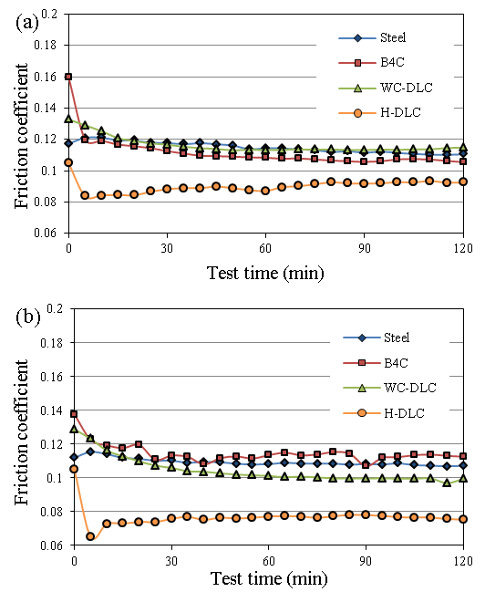
Fig. 1. Friction coefficients of Steel/Steel and Steel/Coating systems as a function of time when testing with (a) Oil A and (b) Oil B.
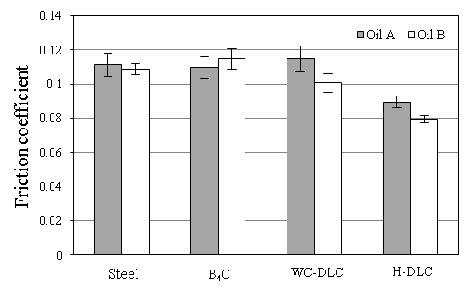
Fig. 2. Comparison of friction coefficients of the coatings lubricated with two fully formulated oils.
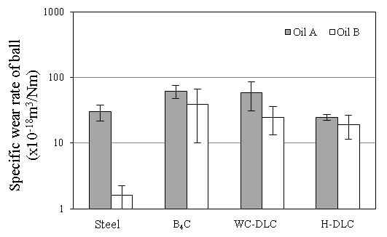
Fig. 3. Comparison of specific wear rates of steel balls rubbing against steel or coated discs.
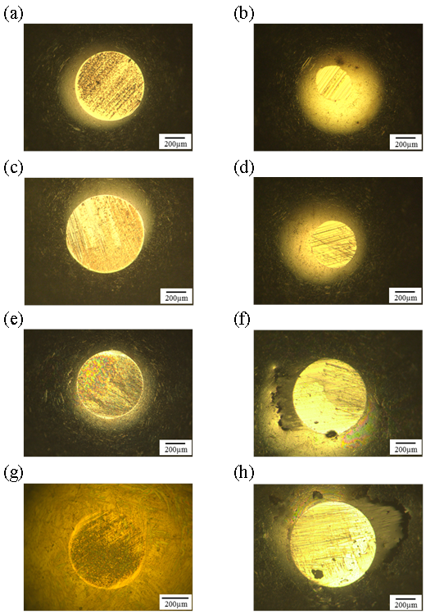

Fig. 4. Wear scar images of the balls rubbing against: (a) steel disc with Oil A, (b) steel disc with Oil B, (c) B₄C coated disc with Oil A, (d) B₄C coated disc with Oil B, (e) WC-DLC coated disc with Oil A, (f) WC-DLC coated disc with Oil B, (g) H-DLC coated disc with Oil A and (h) H-DLC coated disc with Oil B.
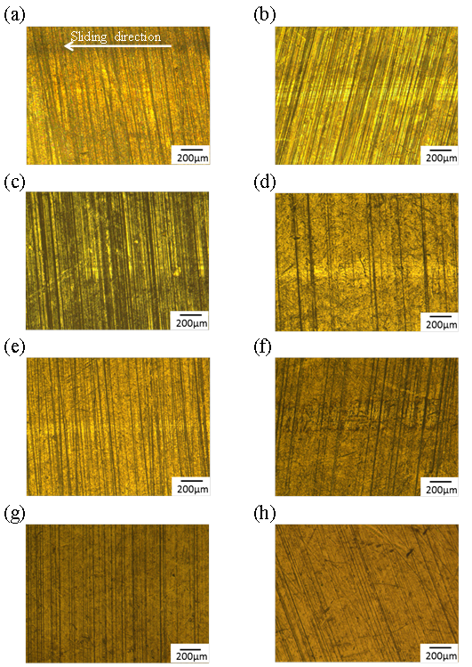
Fig. 5. Wear track images of the discs: (a) steel disc with Oil A, (b) steel disc with Oil B, (c) B₄C coated disc with Oil A, (d) B₄C coated disc with Oil B, (e) WC-DLC coated disc with Oil A, (f) WC-DLC coated disc with Oil B, (g) H-DLC coated disc with Oil A and (h) H-DLC coated disc with Oil B. The arrow in (a) shows representative sliding direction in all the discs of (a) - (h).
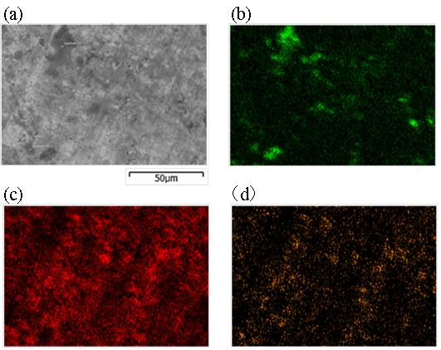
Fig. 6 (a) SEM image and EDX elemental distribution of (b) carbon, (c) zinc and (d) phosphorus from the wear scar of the steel ball rubbing against H-DLC coated disc in Oil A
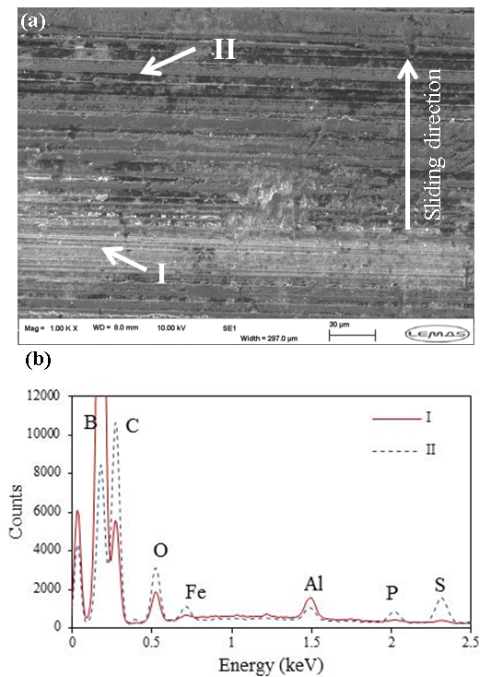
Fig. 7. (a) SEM image of wear track on B₄C coated disc rubbing against steel ball in Oil B and (b) EDX spectrum from the points I and II in the SEM image.
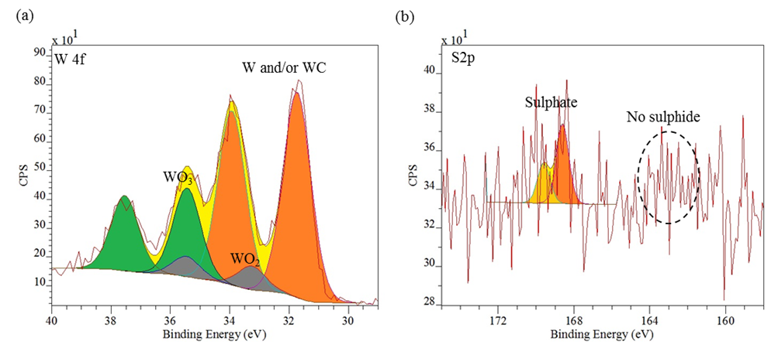
Fig. 8 XPS high resolution peaks of (a) W 4f (b) S 2p on the wear scar of the WC-DLC coated disc in Oil A.
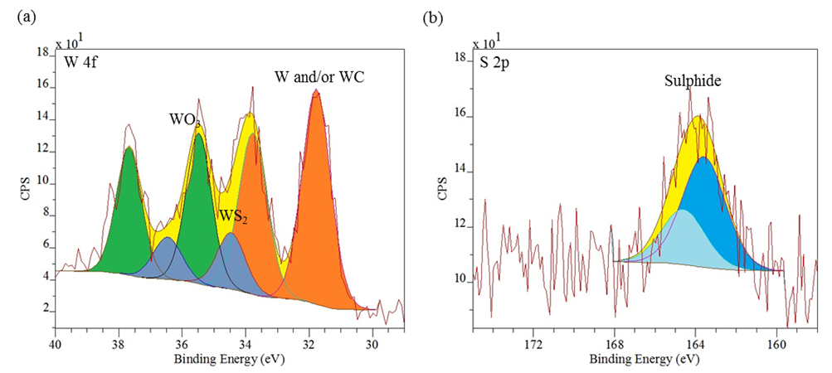

Fig. 9 XPS high resolution peaks of (a) W 4f and (b) S 2p on the wear scar of the WC-DLC coated disc in Oil B.
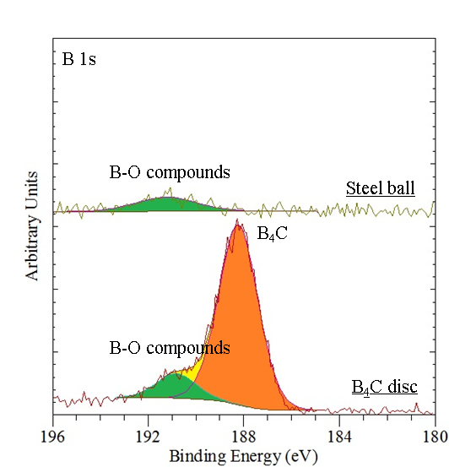
Fig. 10 XPS high resolution peaks of B 1s on the wear scars of B₄C coated disc and steel ball in Oil B.
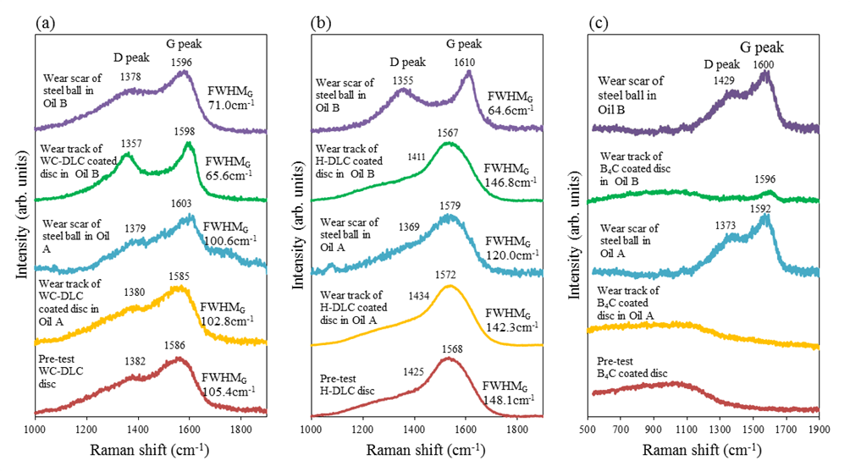
Fig. 11. Raman spectra of (a) Steel/WC-DLC tribocouples, (b) Steel/H-DLC tribocouples and (c) Steel/B₄C tribocouples.
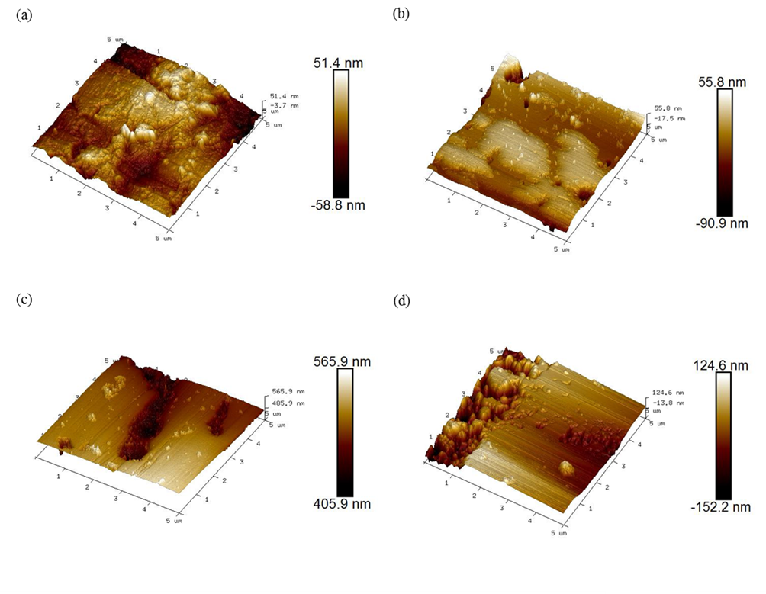
Fig. 12 AFM images of the wear scars for (a) steel disc in Oil A, (b) B₄C disc in Oil A, (c) steel disc in Oil B and (d) B₄C disc in Oil B.

