Concurrent Parent-child Relationship Quality is Associated with an Imprinting-like Effect in Children’s Facial Preferences

Running head:
Parent–child relationships and facial imprinting

J. Vukovic¹, L. G. Boothroyd*, E. Meins², & D.M. Burt
Department of Psychology, Durham University, South Road, Durham, DH1 3LE, UK
*author for correspondence: l.g.boothroyd@dur.ac.uk +44 191 334 3289
- Current affiliation: West Texas A&M University
- Current affiliation: University of York

Acknowledgements
This work was supported by an Economic and Social Research Council grant to LB and EM (ES/H034773/1). The authors wish to thank the families of the Tees Valley Baby Study, the postgraduate lab assistants, and Ben Jones and Lisa DeBruine for helpful comments. Underlying data will be made available through the UK Data Archive on completion of longitudinal research with the sample (http://discover.ukdataservice.ac.uk/).

Abstract
Humans have been shown to display phenomena resembling sexual imprinting, whereby adults are attracted to features in potential mates which resemble their opposite sex parent. In humans this may be particularly so when the parent–child relationship is positive, but there are currently limited data elucidating the causes of these patterns. Here we investigate whether such preferences can be documented in children on the cusp of puberty, for whom prospective data exist on parent–child relationships. Sixty 9-year-olds and their parents were recruited from a British longitudinal sample who have been studied since infancy. Parents were photographed and children were then presented with stimuli in which a computer generated face was manipulated to appear more or less like the parent. Children also reported on their current relationship with each parent. Although attachment at 15 months did not predict imprinting at 9 years of age, children reporting a more accepting current relationship with their parents preferred parental features significantly more than those who reported a more rejecting relationship with their parents. These data support the suggestion that imprinting-like phenomena in humans may arise through associative learning.

Keywords
Imprinting; facial attraction; homogamy; kin recognition; attachment

1. Introduction
Sexual imprinting, the phenomenon whereby individuals’ mate choice is influenced at an early stage by the features of their parents (or foster parents), has been well documented in non-human species (for a review see Rantala & Marcinkowska, 2011). In certain mate-choice relevant contexts, there is also evidence that human adults prefer individuals with features that resemble their parents. For example, Little, Penton-Voak, Burt, and Perrett (2003) found that participants reported their romantic partners possessed similar hair and eye colors to those of their opposite-sex parents. Similarly, Jedlicka (1980) found that men were likely to marry women of the same ethnic origins as their mothers, whereas women tended to marry men of the same ethnic origins as their fathers. More recently, Rantala, Pölkki, and Rantala (2010) found that the reported hairiness of women’s fathers was correlated with women’s reports of the hairiness of their romantic partners, as well as their preferences for the presence or absence of body hair in images of male torsos. Parental age relative to oneself (Perrett et al., 2002) as well as parental personality characteristics (Gyuris, Jarai, & Bereczkei, 2010) have also been shown to be associated with adults’ preferences for similar characteristics in potential and actual partners, respectively. Collectively, these studies present evidence for an association between parental traits and both actual and potential romantic partner characteristics.
The mechanism via which such preferences arise is unclear. Some authors have suggested that during the course of development to sexual maturity, individuals learn about parental characteristics, and these experiences with parents shape mate-choice relevant decisions later in life (Bereczkei, Gyuris, & Weisfeld, 2004; Little et al., 2003; also see Mateo & Johnston, 2004). Alternatively, preferences for parental features in opposite-sex partners could come about as a result of the heritability of such preferences or via a mechanism that allows individuals to recognize others that resemble self or kin (see Mateo & Johnston, 2004; see Rantala & Marcinkowska, 2010). To exclude issues of heritability, Bereczkei et al. (2004) recruited a sample of adopted female participants and found that women’s fathers resembled their husbands, with retrospectively reported closeness of relationship to father moderating this effect. The importance of family relationships (at least as retrospectively reported by participants) has also been seen in other studies. Bereczkei et al. (2002) found a similar effect between genetically related mothers and sons (although Marcinkowska & Rantala, 2012, failed to replicate), while Wiszewska, Pawlowski, and Boothroyd (2007) reported that the facial proportions of women’s fathers correlated positively with the proportions of male faces they found attractive, but only if daughters reported a positive relationship with their father in childhood. Similarly, Watkins et al. (2010) found that women who reported being emotionally close to their fathers had stronger preferences for opposite-sex faces resembling themselves. Since it is unlikely that self or kin phenotypes are preferentially learned from opposite-sex parents, the opposite-sex specificity shown in these studies (Wiszewska et al., 2007; Watkins et al., 2010) is evidence against the argument that preferences for parental features arise simply via a self- or kin-recognition mechanism.
The question thus arises: why would reported parental relationship quality moderate individuals’ tendency to be attracted to people who resemble their parents? There are a number of possible answers to this question. First, parent–child relationship quality may index the amount of exposure to the parent. Because simple visual exposure to faces has been found experimentally to influence face preferences in both adults (Rhodes, Jeffery, Watson, Clifford, & Nakayama, 2003; Webster & MacLeod, 2011) and children (Anzures, Mondloch, & Lackner, 2009), it could be that parents with better relationships with their children spend more time with those children, resulting in a more parent-biased facial prototype in the child and thus a tendency to prefer parental features in potential partners. Second, simple associative learning may account for a greater preference for parental features in individuals who reported close parental relationships. Children with better relationships may have exposure to the parent’s face that is accompanied by more positively valenced experiences that then lead to preferences for parental facial features. Preferences for arbitrary facial features can be induced experimentally by pairing certain features with pleasant or aversive auditory stimuli (Jones, DeBruine, Little, & Feinberg, 2007), but it is not known whether this learning holds for real life emotional experiences and naturalistic exposure to faces.
These explanations both assume that individuals’ early experiences with parents play a role in the ontogeny of preferences for parent-like facial characteristics, but previous research has not assessed early relationships directly, relying only on adults’ retrospective report. In particular, no study has yet investigated the relation between the quality of parental relationships and preferences for parent-like characteristics both concurrently, and prospectively in childhood. Addressing these issues was the aim of the study reported here. Given that many facets of adult facial attraction have been documented in middle to late childhood (Boothroyd et al., 2014), and that, as discussed above, recent visual experience can affect preferences in children (Anzures et al., 2009; Cooper, Geldart, Mondloch & Maurer, 2006), it is reasonable to suppose that the preference for parent-like features which underlies sexual imprinting in adults may also emerge around this time.
The present study explored how the quality of children’s attachment relationships in infancy predicted their preferences for parental facial characteristics at age 9. Children’s attachment security was assessed at age 15 months using the strange situation procedure (Ainsworth, Blehar, Waters, & Wall, 1978; Main & Solomon, 1986, 1990) which places infants into one of four categories on the basis of their response to brief separation from the caregiver and subsequent reunion: secure, insecure-avoidant, insecure-resistant, insecure-disorganized. Attachment security in infancy is known to predict a number of factors that are likely to be relevant to understanding individual differences in preferences for parent-like faces. For example, insecure-avoidant attachment in infancy is associated with children turning more to social partners other than the mother for interaction or information. Meins et al. (2011) reported that, compared with their peers in the other attachment categories, avoidant infants were more likely to initiate social interaction with an experimenter. Insecure-avoidant attachment was also associated with a tendency not to initiate joint attention with the mother.
Similarly, attachment in infancy has been found to predict children’s engagement with social partners other than the mother in the preschool years. Sroufe, Fox, and Pancake’s (1983) findings showed that children classified as insecure-avoidant in infancy were more likely than their secure and insecure-resistant counterparts to seek help from their teachers when they began school. Corriveau et al. (2009) reported that insecure-avoidant attachment in infancy was associated with a tendency at ages 4 and 5 not to trust information provided by the mother, with avoidant-group children preferring to rely on an experimenter’s or their own judgements. Taken together, these studies suggest that early insecure attachment, and avoidant attachment in particular, may be associated with lower levels of preference for parent-like facial characteristics. Given that attachment may be an important evolved process with established long term correlates in terms of sexual strategies (for discussion see e.g. Del Giudice, 2009), identifying attachment-related differences in facial preferences could shed further light on the reasons for the observed effects of early attachment.
A final alternative, consistent with an associative learning account, is that the quality of the current parent–child relationship (i.e., the most recent ‘conditioning experiences’) may be more critical than distal relationship quality in predicting preferences for parent-like facial characteristics. Moreover, several studies suggest that attachment security is not stable from infancy to childhood or late adolescence (Bar-Haim, Sutton, Fox, & Marvin, 2000; Booth-LaForce & Roisman, 2014; NICHD, 2001; Pinquart, Feußner, & Ahnert, 2013; Trapolini, Ungerer, & McMahon, 2007), highlighting the need to consider the quality of both early and concurrent parent–child relationships. Consequently, the study reported here included an assessment of current relationship quality.
In summary, the present study explored relations between children’s preferences for parent-like facial features at age 9 and (a) attachment security in infancy, (b) the quality of the current parent–child relationship, and (c) amount of exposure to parents, to explore the comparative contributions of early and concurrent parent–child relationships to children’s facial preferences.

2. Method

2.1. Participants
Participants were 62 families (62 mothers, 45 fathers, 62 children of whom 29 were girls) who had been participating in a longitudinal study since the first year of life. Infant attachment data were collected at age 15 months (M = 15.5, SD = 0.60, range 13.7–17.3). Facial preferences and parental relationship quality data were collected at a follow-up when children were age 9. Although both parents were invited to participate, 16 fathers were not able schedule a convenient testing session, and one father was no longer in contact with the child. One of the fathers included in the study was not the child’s biological father, but all other parents were biologically related to the child. Of the participating mother–father pairs, one pair was separated and the rest were still living together. Parents gave informed consent at both testing phases and children themselves gave verbal assent to participate at age 9.
2.2 Materials and Methods
Testing sessions at Phase 1 (15 months) and Phase 2 (9 years) were conducted in the University’s developmental laboratories. The attachment assessment at Phase 1 was conducted at the end of a one-hour session. At Phase 2, parents were photographed, after which the parents and the child completed their questionnaires in separate inter-connecting rooms. After a short break, the child completed the face preference test. Each child received £5 and a sticker at the end of the session.
2.2.1 Attachment Security
Infant–mother attachment security was assessed using the strange situation procedure (Ainsworth et al., 1978; Main & Solomon, 1986, 1990). All of the strange situations were classified by a trained and reliable researcher who was blind to all other measures. A second blind, reliable researcher coded a randomly selected 25% of strange situations. Inter-rater reliability using the four-way classification system was κ = 0.82. Attachment data were available for 60 children (two strange situations were terminated due to extreme infant distress) and the distribution across the categories was as follows: 41 secure, 13 insecure-avoidant, and 6 insecure-resistant.

2.2.2 Facial Stimuli
Images of 10 males and 10 females were chosen from the CAL/PAL database (Minear & Park, 2004) to act as ‘base faces’ onto which parental-resemblance transforms were applied. All the images used were of White individuals, since the sample of families was White. Separately to this, four prototype templates of the ‘average’ male and female were produced by combining 6 White individuals ranging in age from 20 to 50 to produce: a female with mean age 35, a female with mean age 45, a male with mean age 35, and a male with mean age 45 (two different ‘age’ prototypes were produced per sex due to variation in age of children’s parents). All individuals used to create these prototypes were photographed in the laboratory under identical conditions to the parents.
Facial photographs of the parents were taken with a 12-megapixel Canon DSLR camera in a room with consistent artificial lighting. These photographs of the parents were delineated in the computer program Psychomorph using 179 landmarks to define face shape. Each parent’s face image was then matched with the average prototype of the appropriate sex and age, and the vector differences in face shape between the individual parent and the average prototype were calculated. The 10 CAL/PAL images corresponding to that parent’s sex were then transformed by +/- 50% of this (shape only) difference between the target parent and their same-sex, same-age prototype (see Rowland & Perrett, 1995, for details of shape transforms). This resulted in two manipulated images for each of the 10 CAL/PAL faces (one more parent-like, one less parent-like). All the images were masked in order to minimize the manipulation artefacts of the software. Figure 1 illustrates the methods used to create the stimuli.

2.2.3 Face preference task
Each pair of faces (i.e., the more-parent-like and less-parent-like versions of each face) was presented side by side on a computer screen underneath the question: “Which person is more attractive?” The child was asked to choose which face s/he found more attractive, and then to rate the amount by which they preferred their chosen face: a little bit more, a bit more, more, a lot more. Once the child had selected an option for that pair of images, the next pair was automatically presented. The order of trials and the side on which more-parent-like and less-parent-like face images were presented were fully randomized. None of the children had problems with using the computer equipment, and all but 3 of the children understood the task on their own by reading the computer screen or having the text read out to them. Those children who needed further explanation of the question at the top of the screen were instructed by the experimenter to choose the face they liked better.

2.2.4 Coding of face preferences
To ensure that children’s preferences were not simply preferences for the more attractive manipulations rather than preferences for parental features, we recruited 5 control groups of 12 to 16 adult participants (aged 20 to 60) who also rated all the manipulations (1070 trials) using the same preference task as the children. The trials were split into 5 blocks (2 blocks of 200 trials, 2 blocks of 210, and 1 block of 250 trials). Some control participants participated in multiple blocks of trials. Participants were not told about the purpose of the study until they finished their participation.
Children’s and control participants’ preferences for more parent-like faces were coded on a scale from 0 (particularly strong preference for mother/father-like faces) to 7 (particularly weak preference for mother/father-like faces) and averaged across all trials for that parent. The children’s final scores were calculated by running a regression of children’s preferences against the average of the control group’s separately for mother- and father-like faces (standardized β=.16, for mother-like, standardized β=.35 for father-like). The residuals from these regressions indicated the degree to which each child preferred a face resembling their mother or father, given how much the control group preferred that face. These standardized residuals thus control for adults’ perceptions of the attractiveness of the preferred faces and were used in all subsequent analyses.

2.2.5 Parental exposure questionnaire

Mothers completed a questionnaire on a laptop assessing the child’s exposure to parental features. This questionnaire was inspired by previous research assessing children’s exposure to faces (Cooper et al., 2006) and required mothers to estimate the number of hours each parent spent with the child in an average week, the number of hours spent playing face-to-face/board games, the number of paternal and maternal relatives (of each sex) living in the household and visiting the house, and the number of photographs of each parent around the house. Answers for each question were standardized and then averaged to create two variables named Exposure to Mother and Exposure to Father.
2.2.6 Parental Acceptance and Rejection Questionnaire (PARQ)
Children completed a computerized version of the short 24-item version of the PARQ (Rhoner, 1990) in which they were required to respond to statements such as: My mother: says nice things about me or seems to dislike me. Children reported whether these statements were: almost always true, sometimes true, rarely true, never true and scores for each question were recorded from 1 to 4 where higher scores indicate more rejecting, less accepting, parents. Final scores were summed across all questions.
Each child completed the PARQ for Mother (PARQ-M) before the PARQ for Father (PARQ-F). On the very rare occasions where a child required further explanation, the experimenter verbally clarified the question; four children did not fully complete the PARQ-M, and 12 of those children whose fathers were not at the session did not complete the PARQ-F. The child whose non-biological father attended the session was instructed to complete the PARQ-F with her stepfather in mind. The children’s PARQ-M (M=.7, n=58, SEM=1.23) and PARQ-F (M=35.5, n=50, SEM=1.61) scores were then split by mean so that participants belonged to either the Low PARQ group (i.e., feeling more accepted by parent) or the High PARQ group (i.e., less accepting relationship with parent).

3. Results

3.1 Preliminary Analyses
Of those with both parents at the testing session, children who preferred mother-like faces also tended to prefer father-like faces, r(45) = .53, p <.001.
A paired samples t test revealed that the mothers reported the children were more exposed to themselves than to the fathers, t(60) = 9.35, p <.001. The two variables were correlated so that children who were more exposed to their mother were also more exposed to their father, r(60) = .66, p <.001.
A paired sample Wilcoxon test revealed no difference between children’s scores on the PARQ-M and the PARQ-F, Z(49) = .82, p =.410. Children who reported more accepting relationships with mother also tended to report more accepting relationships with father, r_{s}(50) = .80, p <.001.
Infant attachment security was unrelated to PARQ-M, χ²(2) = 0.97, p =.615 (secure infants: 17 high PARQ, 25 low PARQ; resistant infants: 1 high PARQ, 4 low PARQ; avoidant infants: 5 high PARQ, 6 low PARQ), and PARQ-F, χ²(2) = 0.32, p =.854 (secure infants: 14 high PARQ, 22 low PARQ; resistant infants: 1 high PARQ, 3 low PARQ; avoidant infants: 4 high PARQ, 6 low PARQ). There was likewise no relation between infant attachment and PARQ categories when attachment was coded dichotomously (secure/insecure), both χ²(1) = 0.43, both p = .84.
Independent sample t tests comparing exposure to each parent between high and low PARQ groups revealed no difference between the groups for either parent, t(55) = 0.13, p = .894, for mother; t(47) = 1.26, p = .215, for father. Likewise, infant attachment (assessed in three categories or dichotomously) was unrelated to later exposure to either parent, 3-categories: Fs < .2, ps > .8; dichomously: ts < .6, ps > .5.
There was no difference between high and low PARQ groups in terms of how attractive the control participants rated the mother vs. non-mother faces, t(56) = 0.27, p = .791, or the father vs. non-father faces, t(56) = 1.24, p = .224.
3.2 Relations between Infant Attachment and Age 9 Facial Preferences
ANCOVAs [between-subject factors: infant attachment category, child gender; covariate: Exposure to Mother/Father], revealed no significant main effects or interactions for preferences for mother-like or father-like faces, both for 3-category and dichotomous attachment classifications (all Fs < .57, all ps > .5).
3.3 Relations between Concurrent Parental Acceptance and Age 9 Facial Preferences
For the relation between maternal acceptance and preference for mother-like faces, ANCOVA [between-subject factors: PARQ-M group (high or low), child gender; covariate: Exposure to Mother], revealed a significant main effect of PARQ-M group, F(1,56) = 4.54, p =.038, Figure 2a), whereby children with low PARQ-M scores (i.e., more accepting relationship with their mother) reported stronger preferences for mother-like faces than did children with high PARQ-M scores. There were no other main effects or significant interactions (all Fs < .12, all ps > .728).
For the relation between paternal acceptance and preference for father-like faces, ANCOVA [between-subject factors: PARQ-F group (high or low), child gender: covariate: Exposure to Father], also revealed a main effect of PARQ-F group, F(1,41) = 7.42, p = .010; Figure 2b), whereby children with low PARQ-F scores (i.e., more accepting relationship with their father) reported stronger preferences for father-like faces than did children with high PARQ-F scores. There were no other main effects; however there was a marginally significant interaction between PARQ-F group and child gender, F(1,41) =3.42, p=.073. Further investigation revealed that, while there was a main effect of PARQ-F group on preferences for father-like faces in girls, F(1,15) =7.01, p = .0185, this effect did not exist in boys, F(1,21) = 0.36, p =.555. In contrast, boys showed a significant association between exposure to father and preference for father-like faces, F(1,21) = 8.44, p = .008, but girls did not, F(1,15) = 0.06, p =.806.
Excluding the non-biological father and the separated couple from all the ANCOVA analyses did not change the pattern of significant results.

4. Discussion

The results of the present study showed that children’s preferences for faces that resemble their parents were modulated by the quality of the current parent–child relationship. In general, children who reported currently experiencing more accepting relationships with their parents preferred parent-like faces more than did children who reported less accepting relationships with their parents. The results regarding current parent–child relationships are consistent with previous findings that adults prefer faces resembling their fathers (Wiszewska et al., 2007; Bereczkei et al., 2004) or themselves (Watkins et al., 2010) only if they reported having a close relationship with their fathers in childhood. In this respect, our data support the hypothesis that imprinting-like phenomena in human facial attraction may be built on associative experiences which affect preferences from childhood onwards. In contrast, 9-year-olds’ preferences for parent-like faces were unrelated to attachment security in infancy, both when attachment was treated as a three-category (secure/avoidant/resistant) and dichotomous (secure/insecure) variable.

The lack of any association between infant attachment and preference for parental features 8 years later may suggest that current experience overrides previous experience. Alternatively, the role of emotional experience in forming ideal facial prototypes may only commence from childhood onwards. To explore these alternatives, future research could investigate children’s preferences for parent-like faces and the quality of the parent–child relationship longitudinally. It may be that infant attachment security relates to children’s tendency to prefer parent-like faces early in development, but that this effect wanes over time. Preferential looking paradigms could be used to explore how early attachment relates to children’s face preferences in infancy. Longitudinal research would also enable one to investigate whether changes in the parent–child relationship (e.g., from secure to insecure or insecure to secure) relate to variation in preferences for parent-like faces. The PARQ is a self-report measure that primarily assesses acceptance/rejection; it would thus be interesting to explore how more in-depth measures of childhood attachment relate to children’s preferences for parent-like faces. For example, the Child Attachment Interview (Shmueli-Goetz, Target, Fonagy, & Datta, 2008) assesses the child’s internal working model of attachment relationships, and future research could explore whether these mental representations of attachment relationships relate to children’s tendency to prefer parent-like faces.
In our study, we did not observe an overall sex difference in the strength of children’s preferences for parental features in opposite sex faces. For instance, girls did not show a stronger preference for father-like features than did boys, or vice versa for maternal features. There was, however, evidence that only girls showed a moderating effect of parent–child relationship on preferences for paternal features. In contrast, only boys showed an effect of exposure on their preferences for paternal features. As adults do not show sex-specific effects for pro-social judgments when responding to cues of kinship (DeBruine et al., 2011), it is possible that both boys and girls were treating the female faces in a pro-social context (i.e., how much did they like or trust these individuals), but that this was not the case for male faces. This may not be surprising given that British 9-year-olds typically spend most of their day in the care of adult women (i.e., primary school teachers who are predominantly female) rather than men.
Alternatively, our results may reflect a lack of sex-of-face differentiation by girls, while boys may have already started to treat male and female faces separately. Although full puberty is typically earlier in girls than boys, adrenarche (the earliest stage of puberty up to about 10 years where sexual attraction may begin) shows no general sex difference (De Perretti & Forest, 1978). As we did not assess whether the children had started experiencing sexual attraction, we were unable to test whether this was the mediating factor for the sex difference in our data. Importantly, whether or not the children were starting to view facial stimuli as potential mates, previous findings show that 9-year-olds are already exhibiting other elements of adult-like face preferences (e.g., significant preferences for averageness, symmetry, and healthiness in faces), albeit to a weaker degree than adults (Boothroyd et al., 2014). Future research on how hormonal markers of the various stages of puberty relate to boys’ and girls’ facial preferences would help shed further light on these issues.
In interpreting the present study’s findings, a number of potential limitations should be taken into account. First, the participants who rated the faces to provide a control for facial attractiveness were adults. Ideally, these participants would have been age-matched children in order to control most accurately for characteristics that may be attractive specifically to children. Second, the children judged the attractiveness of faces manipulated to resemble either their parent or a composite image meant to represent the average face within the parent’s age range. It was judged that six images were sufficient to make up this composite template, given that Little and Hancock (2002) had previously found that composite images made up of 6 versus 12 faces did not differ significantly in ratings of attractiveness. Little and Hancock (2002) also found that distinctiveness ratings were not significantly different for the 6- and 12- face composites. However, since we used the minimum number of faces required to make up a good composite template, it is possible that our composite images did not represent the average face adequately. For this reason, we recommend that future studies use more faces in the preparation of their composite images.
Third, the variables Exposure to Mother and Exposure to Father may have been biased by mothers’ perceptions of the amount of exposure the child had to each parent. Future research should obtain measures of exposure from both mothers and fathers, or employ observational tracking devices to collect accurate data on the type of activity and the amount of time each parent spends with the child. However, it is well established that recent, rather than average/typical, exposure to faces drives visual adaptation effects in both adults (Buckingham et al., 2006) and children (Anzures et al., 2009). Therefore, it is possible that our null results for the exposure variable in girls judging paternal faces, and all children judging maternal faces, may be due to our contact measures failing to tap into the critical time frame of visual experience. The present study did not precisely control the amount of time children were exposed to their parents before they did the face preference task, and future research could explore whether the amount of exposure immediately before the task relates to children’s preferences for parent-like faces.

In conclusion, our study shows that children’s views on the quality of their current relationships with parents relate to their tendency to prefer parent-like faces. In this respect, our data support the hypothesis that imprinting-like phenomena in human facial attraction may be built on associative experiences. However, the finding that the quality of concurrent—but not early—parent–child relationships relates to preferences for parent-like faces suggests that these experiences are influential somewhat later in childhood. This pattern of preferences may function to strengthen the relationship between the child and parent and facilitate survival. Alternatively, a preference for parent-like faces in children who perceive their parents to be accepting may arise as a by-product of generalized facial prototyping and associative learning abilities without serving any adaptive function. In line with this suggestion, evidence for fitness benefits of imprinting-like phenomena is currently weak (Rantala & Marcinkowska, 2011). Finally, although our results suggest a role of associative learning in the shaping of preferences for parental features, since our sample contained biological parents and children, we cannot rule out genetic mediation. Further research involving parents and non-biological children is needed to shed light on this issue.

References
Ainsworth, M. D. S.; Blehar, M. C.; Waters, E.; &Wall, S. (1978) Patterns of attachment: a psychological study of the strange situation. Hillsdale, N.J.: Erlbaum
Anzures, G., Mondloch, C. J., & Lackner, C. (2009). Face Adaptation and Attractiveness Aftereffects in 8-Year-Olds and Adults. Child Development, 80, 178-191.
Bar-Haim, Y., Sutton, D. B., Fox, N. A., & Marvin, R. S. (2000). Stability and change of attachment at 14, 24, and 58 months of age: Behavior, representation, and life events. Journal of Child Psychology and Psychiatry, 41, 381-388.
Bereczkei, T., Gyuris, P., Koves, P., & Bernath, L. (2002). Homogamy, genetic similarity, and imprinting; parental influence on mate choice preferences. Personality and Individual Differences, 33, 677-690.
Bereczkei, T., Gyuris, P., & Weisfeld, G. E. (2004). Sexual imprinting in human mate choice. Proceedings of the Royal Society of London Series B-Biological Sciences, 271, 1129-1134.
Bestelmeyer P.E.G., Jones B.C., DeBruine L.M., Little A.C., Perrett D.I., et al. (2008). Sex-contingent face aftereffects depend on perceptual category rather than structural encoding. Cognition 107, 353-365
Booth-LaForce, C., & Roisman, G. I. (2014). The Adult Attachment Interview: Psychometrics, stability, and change from infancy, and developmental origins. Monographs of the Society for Research in Child Development, 79 (Issue 1).
Boothroyd, L. G., Meins, E., Vukovic, J., & Burt, D. M. (2014). Developmental changes in children's facial preferences. Evolution and Human Behavior, 35, 376-383
Buckingham, G., DeBruine, L. M., Little, A. C., Welling, L. L. M., Conway, C. A., Tiddeman, B. P., & Jones, B. C. (2006). Visual adaptation to masculine and feminine faces influences generalized preferences and perceptions of trustworthiness. Evolution and Human Behavior, 27, 381-389.
Cooper, P. A., Geldart, S. S., Mondloch, C. J., & Maurer, D. (2006). Developmental changes in perceptions of attractiveness: a role of experience? Developmental Science, 9, 530-543.
Corriveau, K. H., Harris, P. L., Meins, E., Fernyhough, C., Arnott, B., Elliott, L., et al. (2009). Young Children's Trust in Their Mother's Claims: Longitudinal Links With Attachment Security in Infancy. Child Development, 80, 750-761.
DeBruine, L. M., Jones, B. C., Watkins, C. D., Roberts, S. C., Little, A. C., Smith, F. G., & Quist, M. C. (2011). Opposite-sex siblings decrease attraction, but not prosocial attributions, to self-resembling opposite-sex faces. Proceedings of the National Academy of Sciences of the United States of America, 108, 11710-11714.
Del Giudice, M. (2009). Sex, attachment, and the development of reproductive strategies. Behavioral and Brain Sciences, 32, 1-21.
Gerlach, G., & Lysiak, N. (2006). Kin recognition and inbreeding avoidance in zebrafish, Danio rerio, is based on phenotype matching. Animal Behaviour, 71, 1371-1377.
Gyuris, P., Jarai, R., & Bereczkei, T. (2010). The effect of childhood experiences on mate choice in personality traits: Homogamy and sexual imprinting. Personality and Individual Differences, 49, 467-472.
Jedlicka, D. (1980). A test of the psychoanalytic theory of mate selection. Journal of Social Psychology, 112, 295-299.
Jones, B.C., DeBruine, L.M., Little, A.C., & Feinberg, D. R. (2007). The valence of experience with faces influences generalized preferences. Journal of Evolutionary Psychology, 5, 119-129.
Little, A. C., Penton-Voak, I. S., Burt, D. M., & Perrett, D. I. (2003). Investigating an imprinting-like phenomenon in humans: Partners and opposite-sex parents have similar hair and eye colour. Evolution and Human Behavior, 24, 43-51.
Main, M., & Solomon, J. (1986). Discovery of an insecure-disorganized/disoriented attachment pattern. In T. B. Brazelton, & M. W. Yogman (Eds.), Affective development in infancy (pp. 95-124). Westport, CT: Ablex.
Main, M., & Solomon, J. (1990). Procedures for identifying infants as disorganized/ disoriented during the Ainsworth strange situation. In M. T. Greenberg, D. Cicchetti, & E. M. Cummings (Eds.), Attachment in the preschool years: Theory, research, and intervention (pp. 121-160). Chicago: University of Chicago Press.
Marcinkowska, U. M., & Rantala, M. J. (2012). Sexual Imprinting on Facial Traits of Opposite-Sex Parents in Humans. Evolutionary Psychology, 10, 621-630.
Mateo, J. M., & Johnston, R. E. (2003). Kin recognition by self-referent phenotype matching: Weighing the evidence. Animal Cognition, 6, 73–76.
Meins, E., Fernyhough, C., Arnott, B., Vittorini, L., Turner, M., Leekam, S. R. & Parkinson, K. (2011). Individual differences in infants' joint attention behaviors with mother and a new social partner. Infancy, 16, 587-610.
NICHD Early Child Care Research Network (2001). Child-care and family predictors of preschool attachment and stability from infancy. Developmental Psychology, 37, 847-862.
Perrett, D. I., Penton-Voak, I. S., Little, A. C., Tiddeman, B. P., Burt, D. M., Schmidt, N., et al. (2002). Facial attractiveness judgements reflect learning of parental age characteristics. Proceedings of the Royal Society of London Series B-Biological Sciences, 269, 873-880.
Pinquart, M., Feußner, C., & Ahnert, L. (2013). Meta-analytic evidence for stability in attachments from infancy to early adulthood. Attachment and Human Development, 15, 189-218.
Rantala, M. J., & Marcinkowska, U. M. (2011). The role of sexual imprinting and the Westermarck effect in mate choice in humans. Behavioral Ecology and Sociobiology, 65, 859-873.
Rantala M.J., Pölkki M. & Rantala L.M. (2010). Preference for human male body hair changes across the menstrual cycle and menopause. Behavioral Ecology, 21, 419–423
Rhodes, G., Jeffery, L., Watson, T. L., Clifford, C. W. G., & Nakayama, K. (2003). Fitting the mind to the world: Face adaptation and attractiveness aftereffects. Psychological Science, 14, 558-566.
Rohner, R. P. (1990). Handbook for the study of parental acceptance and rejection. Storrs, CT: Rohner Research.
Rowland, D. A., & Perrett, D. I. (1995). Manipulating Facial Appearance through Shape and Color. IEEE Computer Graphics and Applications, 15, 70-76.
Shmueli-Goetz, Y., Target, M., Fonagy, P., & Datta, A. (2008). The Child Attachment Interview: a psychometric study of reliability and discriminant validity. Developmental psychology, 44, 939.
Sroufe, L. A., Fox, N. E., & Pancake, V. R. (1983). Attachment and Dependency in Developmental Perspective. Child Development, 54, 1615-1627.
Trapolini, T., Ungerer, J. A., & McMahon, C. A. (2007). Maternal depression and children’s attachment representations during the preschool years. British Journal of Developmental Psychology, 25, 247-261.
Watkins, C. D., DeBruine, L. M., Smith, F. G., Jones, B. C., Vukovic, J., & Fraccaro, P. (2011). Like father, like self: emotional closeness to father predicts women's preferences for self-resemblance in opposite-sex faces. Evolution and Human Behavior, 32, 70-75.
Webster, M. A. & MacLeod, D. I. A. (2011). Visual adaptation and face perception. Philosophical Transactions of the Royal Society of London Series B-Biological Sciences, 366, 1702-1725.
Wiszewska, A., Pawlowski, B., & Boothroyd, L. G. (2007). Father-daughter relationship as a moderator of sexual imprinting: a facialmetric study. Evolution and Human Behavior, 28, 248-252.

Figures
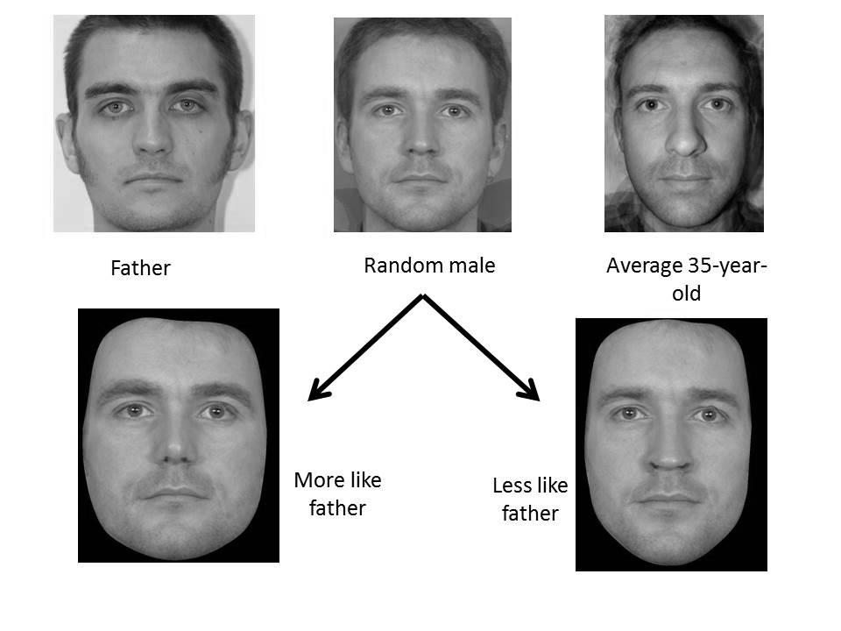
Figure 1. Example of stimulus construction

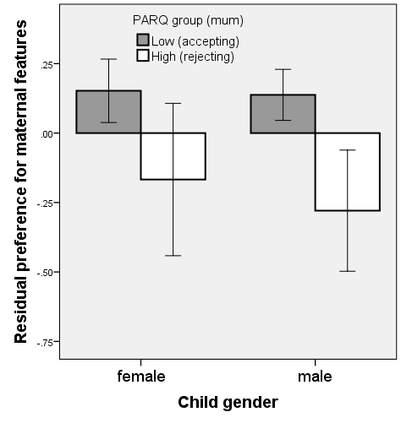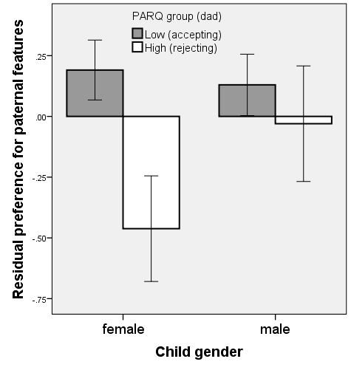
a)
b)

Figure 2. Standardised residuals of preference for parental-type features corrected for control group preferences (where high scores indicate a preference for the parent-like faces) by PARQ group (where high scores indicate more rejecting parents) for a. mother and b. father, split by child gender. Error bars show 1 S.E.

