Manuscript title: Implementing REDD+ at the local level: assessing the key enablers for credible mitigation and sustainable livelihood outcomes

Authors: Joanes O. Atela^{1, 2*}, Peter A. Minang ² , Claire H. Quinn¹ and Lalisa A. Duguma²
¹ Sustainability Research Institute, School of Earth and Environment, University of Leeds, LS2 9JT, Leeds, UK
²ASB- Partnerships for the Tropical Forest Margins, World Agroforestry Centre, PO Box 30677-00100, Nairobi, Kenya

*Corresponding author addresses
Email: eejoa@leeds.ac.uk or JAtela@cgiar.org
Phone: + 254 721 761 869

Abstract
Achieving cost-effective mitigation and sustainable livelihoods through reducing emissions from deforestation and forest degradation (REDD+) depends heavily on the local context within which REDD+ projects are implemented. Studies have focused on how REDD+ can benefit or harm local people, with little attention paid to how people, their assets and institutions can promote or impede REDD+. This paper examines the key local assets necessary for REDD+ to protect forests and support local livelihoods based on evidence from a globally-linked REDD+ project in Kenya. Household interviews (n=100), focus group discussions (n=6) and in-depth interviews with government (n=8) and project stakeholders (n=14) were undertaken to rank and explain how local assets interact with the project’s efforts to protect forests, and the role of State institutions in shaping project-asset interactions. Locally, pro-poor assets such as land tenure and water access had most influence on the project’s ability to protect forests. Inclusion of communal forests as part of the REDD+ project entitled local poor peasant farmers to participate in and benefit from the project and so dissuaded them from using protected forests for charcoal production. Water access determined agricultural productivity and intensity of forest use for livelihoods and coping. Even though carbon revenues were distributed equally between social groups and support direc6ted to pro-poor livelihood initiatives, efforts were impeded by State decisions on land that interfered with communal approaches to forest conservation, by strict carbon standards that limited trade-offs between livelihoods and forest protection and by fluctuating carbon prices and by buyers that limited funds needed for project operations and local livelihoods. Equitable and pro-poor benefit sharing is necessary but not sufficient for effective REDD+ implementation unless national institutions are reformed and global carbon prices harmonized with local livelihood needs.

Key words: enablers, forest protection, livelihoods, pro-poor, REDD+

Introduction
Reducing emissions from avoided deforestation and forest degradation (REDD+) has gained both institutional legitimacy and critique on its ability to link carbon management to human development in practice (Brown et al., 2011; UN-REDD, 2010). Negotiations at the United Nations Framework Convention on Climate Change (UNFCCC; decision 2/COP13; decision 4/COP15; decision 1/COP16), have formalized REDD+ as a cost-effective mechanism for protecting forests in developing countries that could achieve a mitigation potential of 20–30% of all carbon-dioxide (CO₂₎ emissions annually, as well as supporting livelihoods (UN-REDD, 2010). The global REDD+ design rules recognize emissions reductions and livelihoods as key outcomes expected from implementing REDD+ (appendix 1/CP. 16).
Studies on implementing REDD+ (Corbera at al., 2009; Luttrell et al., 2012; Maraseni et al., 2014; Pokorny et al. 2013) acknowledge that global REDD+ design rules, when put to practice, are likely to face new challenges that test their feasibility in the local context. These settings may contribute to fostering support and/or creating barriers to the implementation of REDD+(Lin et al., 2014; Mattsson et al., 2012; Mustalahti et al., 2012; Sills et al., 2009). Understanding of the local livelihood assets required to achieve REDD+ implementation outcomes is necessary to inform both national REDD+ policies and the literature on REDD+ implementation.
Local livelihood assets are diverse. The sustainable livelihoods framework (Scoones, 1998) defines them as tangible and intangible goods and services owned and used by households or communities for living. They are sorted into five broad categories: natural, financial, human, social and physical (Scoones, 1998). Emissions reductions under REDD+ build directly on natural assets, such as land and forests. Forests are vital for REDD+ projects to meet their emission reduction targets (Lin et al., 2014). Areas or countries endowed with forest resources retain more carbon (Gibbs et al., 2007) and so support REDD+ implementation (Atela et al., 2014; Lin et al., 2014). These forest resources, especially in tropical areas, also face high deforestation rates that REDD+ projects can help to tackle and cost-effectively reduce emissions (Stern, 2006).
Financial assets, including income, savings and fixed assets (Vincent, 2007), are equally useful for REDD+. These assets allow households or communities to pursue various livelihood strategies including farming and business, and in so doing, influence REDD+ implementation by shaping the drivers of deforestation (Boyd et al., 2007). Human assets include capabilities, skills, education and employment (Vincent, 2007). These aid the successful pursuit of different livelihood strategies and even help local people to understand the content and objectives of REDD+ projects (Romijn et al., 2012). Social assets include household/community networks, social claims, land tenure systems, affiliations and associations (Vincent, 2007)that help households or communities to coordinate their livelihood strategies (Scoones, 1998; Vincent, 2007) and in their engagement in REDD+ projects (Maraseni et al., 2014).
The flow of livelihood assets between households and communities and into REDD+ activities is mediated by institutions. Institutions, such as State legislated tenure regimes, structure land access and utility thereby creating opportunities and barriers for local REDD+ activities (Chhatre et al., 2012). As such, the State plays a key role in REDD+ implementation and as such has been mandated by the UNFCCC to coordinate and support REDD+ within national jurisdictions (decision 2/CP 17).
Based on the influence local livelihood assets and the State may have, projects are expected to adapt the global REDD+ design to both national and local settings (appendix 1/CP, 16; Corbera et al. 2009). This may involve new community engagement and benefit sharing mechanisms that go beyond global standards to suit the local context (appendix 1/COP16). In doing so, projects may reshuffle assets in a manner that either benefits or harms local communities (Peskett and Brockhaus, 2008, Skutsch and McCall, 2010). Projects might support local people with alternative livelihood activities to compensate for the loss of forest-based livelihoods when forests are protected for emission targets (Boyd et al., 2007; May and May, 2004; Asquith et al., 2002). But projects may also harm local people by excluding them from project activities and benefits resulting in a net loss for local livelihoods (Pokorny et al., 2013; Dzangirai 2014).
This paper aims to identify and discuss the set of local livelihood assets necessary for effective implementation of REDD+ at the local level drawing on evidence from the ongoing implementation of the Kasigau REDD+ project in Kenya. The specific objectives of the study are: (1) to evaluate how a globally linked REDD+ project engages the local community in its activities; (2) to identify the livelihood assets that significantly influence the project’s ability to protect forests;(3) to analyse project impacts on livelihood assets and forest conservation; (4) to analyse the role of the State in the project’s implementation. The next section unpacks policy implementation as this study’s conceptual framework. Research methods, results and discussion then follow subsequently.
- Unpacking policy implementation
This paper applies the concept of policy implementation (Leventon and Antypas (2012) to analyse REDD+ implementation. Policy implementation refers to translating documented policy decisions into practice through on-the-ground activities (Leventon and Antypas, 2012). In the context of REDD+ this would mean translating the negotiated decisions on forest protection into practice and coordinating activities to deliver on sustainable development outcomes such as sustainable forest management and livelihood benefits (appendix 1/CP. 16). Policy implementation however remains a key challenge in environmental governance with most policy decisions characterised by implementation deficits (Leventon and Antypas, 2012). Implementation deficits occur when the original goals of a policy are not met either because the policy itself is not translated into action or the policy is translated into action but fails to sufficiently achieve the desired implementation outcomes (Jordan, 1999). In the context of REDD+, this would mean failure by a globally designed REDD+ project to sustainably conserve forests/reduce emissions and alleviate poverty/support livelihoods in practice (appendix 1/CP 16). This paper analyses REDD+ implementation focusing on how local livelihood assets and the State influence the achievement of the expected implementation outcomes.

Research design and methods
  - Research design
Kenya, alongside 16 African countries, is currently preparing national REDD+ policies through the World Bank’s Forest Carbon Partnership Facility (FCPF) and thus requires policy lessons to be generated from ongoing REDD+ demonstrations. An initial mapping of REDD+ projects in Kenya (Atela et al., 2013) guided the case project selection process. The Kasigau Corridor REDD+ project in the Kenya’s Coastal region was selected as a case study (Figure 1). The project is the world’s first globally-linked REDD+ project to sell verified carbon credits in the voluntary carbon market (Peters-Stanley et al., 2014). Lessons from this project are therefore of interest to project developers implementing or intending to implement REDD+ projects in other contexts (Caplow et al., 2011).
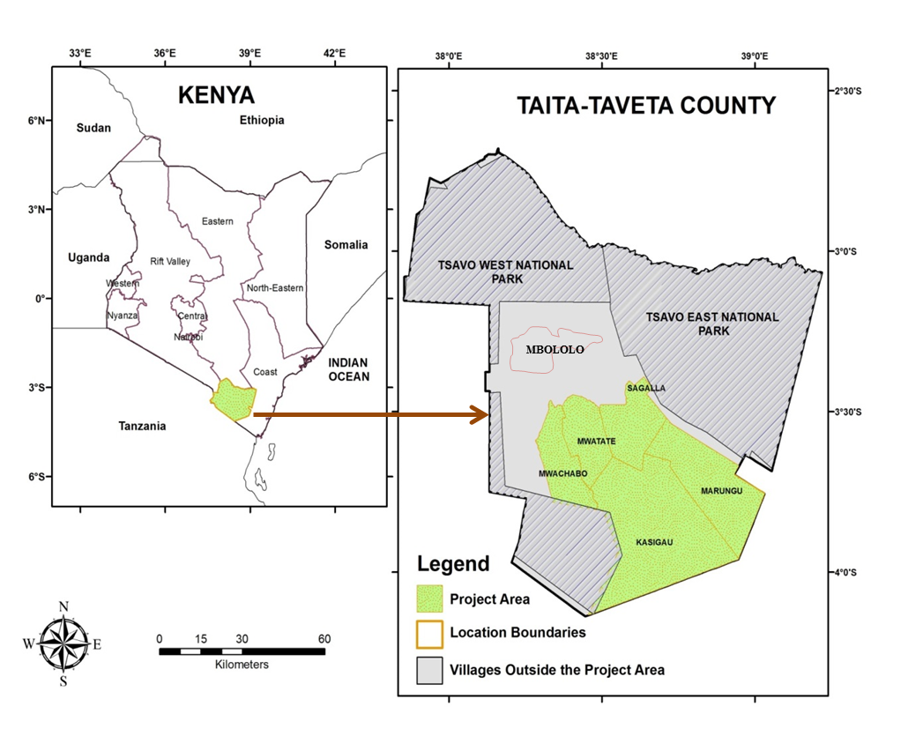
Figure 1: Kasigau Corridor project location within Kenya and the specific data collection sites

To validate data on project-livelihood interactions and particularly the project’s impacts on livelihood assets, data collected from project sites (intervention) were compared with the opinions of households in non-project sites (control) (Jagger et al., 2010). Specific study sites were selected through a rapid rural appraisal process bringing together project extension staff and community informants (Chambers, 1981). Marungu and Mbololo villages were selected as representative of intervention and control sites respectively (Table 1).

Table 1 (about here)

  - Data collection
    - Document analysis
Content analysis of project documents and consultation with project staff were first undertaken to evaluate the project’s activities in the context of key REDD+ implementation outcomes, e.g. forest protection for carbon, community participation and benefit sharing/poverty alleviation (appendix 1/CP 16). Participation in this case refers to community contribution to project decisions and activities (Angelsen et al., 2009). Benefit sharing focused on sharing of carbon revenues between the project and community, and associated livelihood impacts (Mwakalobo et al., 2011). The documents were analysed through a combination of exploratory analysis to identify project activities and actors (Thai et al., 2008) and in-depth iterative content analysis to establish the linkages between actors and activities (Marsh and White, 2006; Kohlbacher, 2006).

    - Household questionnaires
Questionnaires were used to collect data from a total of 100 households on how local livelihood assets influence project activities (asset-impact) and the corresponding project response/impact on these local assets (project-impact). Stratified random sampling was used to select households equally from the intervention and control sites. The sampling frame at the intervention site was a Community Based Organization (CBO) ‘The Marungu Hills Conservancy’. The CBO provides the link through which the REDD+ project engages community members and disseminates benefits. The CBO includes all community groups in Marungu administrative location and as a result of their direct engagement with project activities respondents were able to give a realistic account of project-asset interactions. Control households were randomly sampled from Mraru and Tausa ranch groups, which work closely with conservation projects in their areas.
The intervention and control samples represented 20.1 % (50 of 280 registered households) and 19.4 % (50 of 285 registered households) of the sampling frame respectively. This sample size enabled time to be spent to explain questions and retrieve quality information from households, considering the low level of understanding of carbon issues among individual households. Village elders who had lived in each location for many years and had a good knowledge of their community assisted in categorizing all households in the target groups (CBO and ranch groups) into low, middle and high wealth status. Village elders mediate resource allocation and conflicts among households and thus possess a deeper knowledge of important assets (Bolin and Tassa, 2012). Household land holdings, crop yields, livestock numbers and educational capabilities were used to define the wealth categories. Of the 100 households, 48 low-wealth, 32 middle-wealth and 20 high-wealth households were interviewed.
The questionnaires comprised both open and closed questions. Questions for the intervention and control households were matched. The first three parts of the questionnaire detailed respondents’ livelihood assets. The assets were categorized into the five asset capitals of the sustainable livelihood framework (Scoones, 1998) and each category represented by specific indicators developed from a scoping study (Atela et al. 2014; Atela 2013) (Table 2). Respondents stated and explained the positive and/or negative impact of each asset indicator on forest protection (asset-impact). In a similar way, the respondents detailed the impacts of forest protection procedures on the asset indicators (project-impact). While considerable overlap between the asset-impact and project-impact was noted, structuring enquiries in this way improved objectivity and clarity in describing project-asset interactions.

Table 2 (about here)
In assessing the asset-impact and project-impact for each of the asset indicators, an impact measure of +1 was assigned to any positive impact and -1 to any adverse impact. If positive and negative impacts on a particular asset indicator were of equal value to a respondent, an impact factor of 0 (no overall effect) was assigned. The asset-impact scores show the impacts of household assets on the project but do not reveal the relative strengths of the assets in influencing the project’s activities. As such, respondents were additionally asked to rank and explain the three top assets with mostinfluence on forest proection. The highest ranked asset was assigned 3 points, the middle ranked asset 2 point, and the lowest ranked asset 1 point. Focus group discussions and in-depth interviews were used to triangulate household interviews.
    - Focus group discussions (FGDs)
The household questionnaire data was triangulated with six FGDs, three each in the intervention and control sites. The FGD participants were purposefully selected (Bedford and Burgess, 2001) and included village elders (n=12), land owners (n=11) and representatives from women, men and youth groups in the community (n=15). Draft cumulative asset rankings gathered from household interviews were presented to representatives of community groups who then verified, discussed and voted on the asset rankings. Village elders and community resource persons constructed community livelihood calendars overlaid with key livelihood assets as well as project activities. Information from household questionnaires indicated that land tenure was a major factor for the REDD+ project and so land owners drawn from ranch shareholders, individual owners and community land trustees discussed the project’s work in the context of diverse land ownership. The discussions and debates about asset ranking were particularly useful in explaining why certain assets are more crucial for the project than others (Sithole, 2002). These discussions were complemented with non-participant observations in several community meetings and group activities on engagement in and benefit sharing from the project.
    - In-depth Interviews
Semi-structured interviews were undertaken with stakeholders drawn from the Kenya Forest Service (n=5), which hosts the REDD+ National Coordination Office, and the National REDD+ taskforce (n=3) tasked with formulating national REDD+ strategies. These State level stakeholders discussed national level implementation and the role of the State in the Kasigau REDD+ project (see Atela and Quinn, 2014). Project stakeholders (staff and CBO leaders) (n=14) were also interviewed about the project’s interactions with local assets, links to the State level, national policy, practical challenges and project experiences. The interviewees were identified using a snowball technique (Atkinson & Flint, 2001).

  - Data analysis
The impact factor scores were averaged for each asset indicator and for each wealth category, with qualitative responses used to understand and explain the scores. Household data from the control site were only used in the project-impact analysis where site comparisons were quantitatively possible, but were excluded from the asset-impact analysis because the control respondents had no experience with the project and could not give an account of the influence of their assets on a REDD+ project. In comparing project-impact between intervention and control sites, the quantitative project-impact score for the control group was pre-assigned on a null basis or ‘no-effect’ scale (0) to remove the confounding effect of livelihood changes driven by the State or other projects. Chi-squared and spearman rank correlation coefficient were applied to test for significant differences in the impact scores between wealth categories and between sites (Green and Salkind, 2010). Qualitative data drawn from FGDs and in-depth interviews were coded to draw out themes and illustrative quotes (Hopkins, 2007).

Results

Project design and community participation
Project activities, institutions involved and community participation are illustrated in Figure 2. The project has been designed under global standards: the Voluntary Carbon Standard (VCS) and the Climate Community and Biodiversity Standard (CCBS). The VCS emphasizes emissions reductions and provides procedures upon which carbon credits are verified for payment. By contrast, the CCBS emphasizes participation and robust benefits to the local community in line with REDD+ safeguards (appendix 1/CP16) but does not ideally influence payments. Guided by these standards, the project protects a dryland forest constituting private ranches (50–2,500 members per ranch) and community land altogether covering 500,000 acres. This is expected to reduce emissionsby49, 300,000 tons of carbon over a 30 year project period (2006-2036).
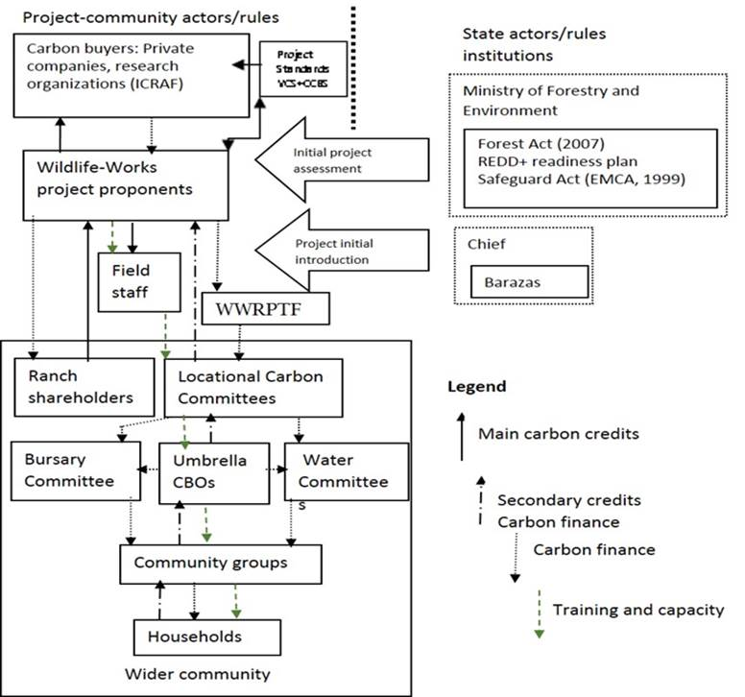
Figure 2: Flow of activities between the project, State and local communities

Group ranches registered as private companies are the primary source of carbon sequestration, generating 75% of all carbon credits. However, most shareholders of the ranching companies/groups reside outside the local community with only about 5% of the shares held by locals. Most local community members nonetheless participate in the project via CBOs through which the community commits communal land to the project, participates in capacity building and forest protection activities, and bargains for benefits. Within the CBOs, community members have elected Locational Carbon Committees (LCCs) that directly represent community interests in the project. By committing their lands to the project and granting conservation rights to the project, the local community and ranch shareholders transferred carbon rights to the project proponents in accordance with free prior and informed consent procedures outlined in the project standards and global safeguards. A key feature of the easement agreement is the flexibility involved, i.e. the community and ranch shareholders can change their commitments to the project at any time. While this could threaten the project’s sustainability, the threat is minimal because both ranches and communal lands have regulations that require collective land use decisions rather than individualized ones.
Other than transfer of carbon rights, committing land to the project also means that the local community is restricted from accessing and using forests for livelihoods e.g. livestock grazing, charcoal burning or firewood collection. These forest uses were common before the project but their restriction allows for replenishment of payable carbon. In collaboration with project extension services, the CBOs and their respective LCCs coordinate training needed for the community to implement forest protection activities initiated by the project, e.g. eco-charcoal factories, tree nurseries and recruitment of community forest wardens. These activities employ members of the local community thereby providing an alternative income to charcoal burning in the protected forest lands.
In return, the local community is entitled to all the carbon revenue resulting from communal forests and additionally, benefits from a one third share of carbon revenue from the ranches. The one third community share is part of a benefit sharing mechanism in which the other two thirds are equally divided between ranching companies and project operations. The community share of carbon revenue is invested in a host of livelihood projects through an established trust fund ‘Wildlife Works REDD+ Project Trust Fund’ (WWRPTF). While the community makes decisions on which livelihood projects are to be supported through the WWRPTF, their decisions have to be supported by various institutions including the LCC and its sub-committees on water or bursaries, approved by the project proponents and assessed by relevant State agencies e.g. the water board (Figure 2).Local institutional structures coordinate community participation in the project but also exclude the opinions of some community members, especially those who are not part of any group or CBO. Even though non-group members may be excluded, the project’s ability to conserve forests depends on all community members whose livelihood assets are linked to forests.

Impacts of household assets on forest protection (asset-impact)
Household assets influenced project activities in different ways and depending on wealth categories (Figure 3). Low-wealth households generally perceived that most of their asset levels negatively impacted on forest protection. This low-wealth group identified water access as a key asset supporting project objectives yet their own poor access to water raised pressure on protected forests, especially during drought-driven crop failures (Table 3). On the contrary, asset levels for most middle and high-wealth respondents, e.g. land sizes and economic activities, had positive impacts on forest protection. Middle-wealth households felt that pursuing farming as an economic activity within their relatively large land holdings enabled them to undertake agroforestry practices that reduced pressure on protected forests (Table 3).Most high-wealth households received carbon revenues from their shares in the ranches and were motivated to commit part of their larger landholdings to on-farm forests for carbon. Despite the fact that asset levels of relatively richer households positively supported forest protection, spearman rank correlation coefficient showed that the low-wealth household assets had the most weight in influencing forest protection at 0.85 (p<0.01) compared to the middle- and high-wealth households with coefficients of 0.69 (p<0.01) and 0.44 (p<0.05) respectively.
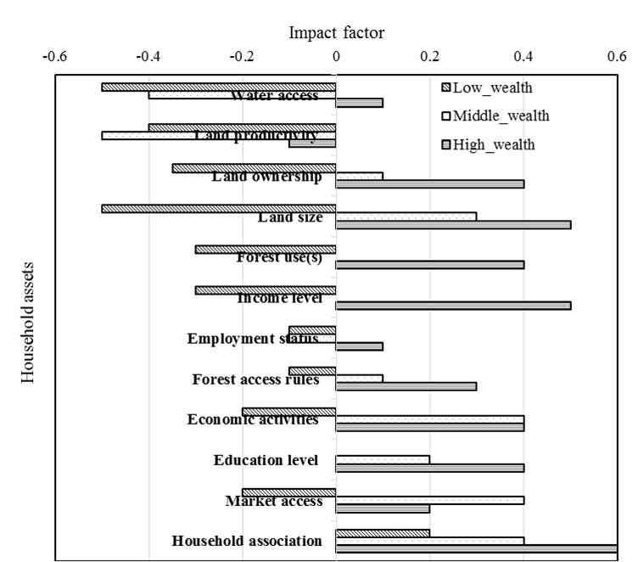
Figure 3: Impact factor of assets on the project differentiated by household wealth status

The importance of low-wealth household assets for forest protection also manifests in the ranking of relative influence of assets on forest protection. Assets that were identified by the poor (low-wealth households) to negatively impact forest protection, e.g. water access, land ownership, economic activities and land productivity, received higher overall ranking (Figure 4). These asset indicators are interlinked, form part of the community livelihood calendar and influence dependence on forests.

Table 3 (about here)

When the asset ranks were discussed during in-depth interviews and FGDs, water access and land ownership emerged as principle asset indicators that influence the other high ranked asset indicators. Most poor households practice rain-fed agriculture both for food and income. However, their poor water access affects land productivity and the harvest available to cover their food and income needs and this leads to illegal charcoal production and firewood collection within protected forests. Communal forests provide crucial complementary livelihood goods and services, e.g. charcoal/firewood, to the poor whose small land sizes have limited capacity to provide these goods.

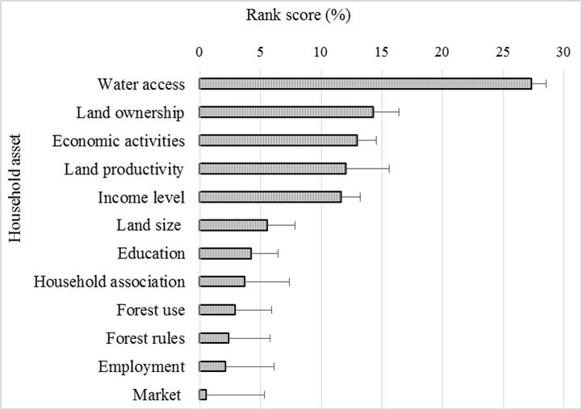

Figure 4: Ranking of household assets in terms of their influence on the project’s activities (1.5-column fitting image)

Project impacts on household assets (project-impact)
The project-impact scores for asset indicators in the intervention site compared to the control site are presented in Table 4 and explained in Table 5. Low-wealth respondents perceived that the carbon revenue allocated to communal livelihood projects, e.g. water projects and pro-poor education bursaries, positively improved their asset indicators compared to middle- and high-wealth respondents (Table 5). Low-wealth respondents further perceived that incorporating communal land into the project improved their bargaining power for benefits, which they would otherwise forego because of their smaller land sizes (Table 5). This contradicts the perception of some high-wealth respondents, who felt that the project’s emphasis on and recognition of collective/communal ownership hinders the sub-division of land into individual parcels or ranch shares. Even though all wealth groups experienced increased economic opportunities as a result of the project, most of low-wealth households have not utilised these opportunities to increase their incomes compared to the middle and high-wealth households who were able to increase their business clientele and claim direct carbon payments.
Overall, the project impact on livelihoods was significant in the intervention site (p<0.05). Control households mainly hoped that a REDD+ project would support a range of livelihood initiatives including water and education, as witnessed in the project area (Table 4). Most importantly, the control community hoped that a REDD+ project in their area would facilitate the handover of State forests and associated benefits to the community.
They claimed that the forested hills currently benefit only a few State officers and businesspeople involved in corruption and illegal logging. The control households, especially the middle-wealth ones, however expressed fears that a REDD+ project might restrict livestock grazing areas, thereby affecting their livelihood opportunities.
Despite the significant project impact on livelihoods, discussions revealed that the livelihood benefits have not adequately matched community expectations or the opportunity costs of restricting forest use. The local community still expects the project to support more alternative livelihood initiatives such as irrigated horticulture and poultry projects, among others. According to project staff, expectations of dramatic livelihood improvement remain a challenge for the project. This is exacerbated by fluctuating carbon prices and buyers. The project mainly sells credits in international carbon markets to buyers including private companies such as Puma (EU and USA) and Alliance Panapa Bank. Buyers offer varied prices, from as low as US$ 4 to a high of US$ 10 per ton of CO_{2.} By the time of this study, the project had sold credits generated up to 2011 but was still sourcing buyers to purchase credits generated from 2012 onwards. Pressurized by livelihood expectations, the project sometimes allowed community members to draw firewood from and graze animals in protected forests, especially during dry seasons. This is recognized by project staff as a major source of loss of carbon credits.

Table 5 (about here)

  - The role of the State in the project
The engagement of the State in the Kasigau project is minimal because national REDD+ policies are still under preparation by the forestry sector. Even though the State, through the National Environment Management Authority (NEMA), initially assessed the project’s potential environmental and social impacts, this could not be adequately performed because there is little capacity in the government to understand the global standards upon which the project operates. Further, Kenya’s NEMA is not fully conversant with issues of REDD+ given their poor representation in the national REDD+ taskforce. The taskforce is responsible for implementing REDD+ strategies for Kenya but is mainstreamed within the forestry sector with little representation from key sectors such as lands, environment, agriculture or energy even though these sectors are closely linked to deforestation in Kenya and are legal custodians of some REDD+ enablers, e.g. land tenure.
The exclusion of key sectors in national REDD+ reduces the legitimacy of REDD+ within the excluded sectors. Certain decisions made in these excluded sectors, e.g. lands, do not support key REDD+ enablers. For instance, the Kasigau project partly draws its success from collective tenure systems (communal and group ranches) which have enabled inclusive participation and benefit sharing as well as simplified negotiations with the local community to commit their lands to the project. However, the lands authority plans to issue individual title deeds to ranch shareholders meaning a single ranch could be subdivided into 50-2,500 individually owned parcels of land. This means that the REDD+ project may have to convince over 2,500 individuals to commit their parcels of land to the project, a situation that would be complex and costly and perhaps a recipe for emission reversals in the context of diverse individual interests in land use.
Ideally, State institutions are expected to support and enforce enablers of REDD+. However, project staff and community members have blamed bureaucracy within State institutions e.g. the water board and lands registrar, for delays in assessing and approving livelihood projects funded by carbon revenues. There was, however, a perception among State stakeholders that the Kasigau project is a private entity operating with its own funds and the State wouldn’t want to interfere. Discussions however revealed lack of support for local enablers of REDD+ projects within State institutions, caused by a historic process of centralisation of resources. Benefits from and management decisions about the area’s wildlife resources have historically been channeled to the central government with no share for the local community. This centralization of benefits was apparent in the control community (Mbololo) who thought that a REDD+ project could help to re-distribute benefits from the State owned Mbololo forest in their favour. The opinion of the area’s forestry staff, however, contradicted this expectation. The staff asserted that REDD+ funds linked to the hills would be channeled to central government through the Kenya Forest Service (KFS) as outlined in the Kenya’s REDD+ readiness proposal.

Discussion

  - Enabling local assets
This study aimed to identify and discuss the enabling assets for REDD+ to achieve mitigation and build local livelihoods in practice. The study context comprised a diversity of wealth-structured livelihoods that revolve around water access, land ownership, land productivity and economic opportunities, but from which the project protects a dryland forest for carbon credits and livelihoods. From this diversity of assets, water access and land ownership were identified as the most strategic assets for the project due to their role in agricultural livelihoods and economic opportunities for the poor, who pose a greater threat to protected forests.
The above finding corroborates other studies that indicate that water scarcity linked to drought is the greatest form of vulnerability for forest ecosystems, especially those in arid and semi-arid areas, as poor community members invade forests to cope with agricultural failures (FAO 2010; Nkem et al., 2012). Various lands, including private/group ranches and communal lands, host the forests targeted for carbon. At the same time, these lands provide crucial livelihood resources for different groups within the project area. Recognizing the diverse claims to lands enhanced inclusion of various groups into the project’s activities and widened the pool of beneficiaries. This promoted collective commitment to REDD+ and reduced pressure on forests hosted by these lands. The Kasigau project experience with diverse and collective land tenure contrasts with other studies that have viewed the enabling tenure system for REDD+ mainly in terms of titled private/individualized ownership (Chhatre et al., 2012).
Supporting water access and diverse land tenure in REDD+ promotes pro-poor and equitable participation and benefit sharing in REDD+. Equity and pro-poor approaches have been emphasized as crucial for effective REDD+ implementation (Boyd 2007; Smith and Scherr, 2003). Achieving these may require that the global design procedures be reshuffled in particular ways to fit the local setting. For instance, global design standards, e.g. the VCS, mainly emphasise carbon delivery yet the Kasigau experience reveals that local livelihood needs are critical for delivering carbon. As such, benefit sharing with regards to livelihoods represents a key area where global REDD+ design interplays with local assets to influence implementation. Even though most carbon results from ranches owned by relatively smaller number of richer land owners, redistributing carbon revenue equally with the poor is a crucial part of the project’s implementation success. This benefit redistribution is not explicit in REDD+ global designs but the Kasigau experience reveals that this kind of benefit redistribution significantly reduces pressure on dryland forests and minimizes leakage by providing more support for poorer livelihoods so that they need to rely less on protected forests.
From a broader perspective, benefit redistribution is crucial considering that the State and other private groups control most tropical forests (Lyster, 2011). Local communities own only 18-25% of tropical forests (Bluffstone et al., 2013). As a result, payments based on ownership alone will generate relatively few benefits for the poor. Payments based on property rights could also create spaces for powerful actors to acquire communal land and further marginalize the poor (Lemaitre, 2011). For instance, some rich households in the Kasigau area view the project as an impediment to the subdivision of communal ranch land into purchasable individual pieces which they could use their wealth to acquire. Pro-poor approaches and equitable benefit redistribution are, however, conditioned by other national and global factors.

  - Global and national factors controlling the local project enablers
Results presented here revealed that State institutions and global carbon conditions are key to REDD+ implementation locally. The case of Kasigau specifically reveals that gaps within these broader policy settings remain important impediments to effective implementation. The State is the legitimate representative of a country in the global REDD+ process and is expected to support REDD+ activities in line with their climate commitments. However, this study reveals that bureaucracy and sectoral fragmentation within State agencies and poor links to the private sector currently threaten the project’s work. The shortcomings of the State are attributable to national institutional gaps, especially path dependencies where REDD+ decisions have been monopolized by the forestry sector to the exclusion of other relevant sectors (Atela and Quinn, 2014). This limits the legitimacy of the REDD+ agenda across sectors. As such, the water sector, which is not represented in the national REDD+ taskforce, may not appreciate the need for water in a REDD+ project. Similarly, the lands sector, where authorities do not understand what REDD+ is about, may not think they are harming a REDD+ project by making decisions on land subdivision and privatization.
Sectoral fragmentation is an impediment to successful forest protection in many developing countries (Brockhaus et al., 2013, Minang et al., 2014). However for any meaningful emissions reductions to be achieved under REDD+, restructuring of national institutions to embrace sectoral integration is required. This is crucial because findings here indicate that certain enablers of REDD+, such as tenure regimes and livelihood projects, depend on State institutions and are beyond the institutional scope of sub-national private projects. While these private projects dominate the current and future REDD+ portfolio and have the resources to support local implementation, their potential to do so requires political goodwill and support from the State.
Global institutions mainly constrain project implementation via strict carbon standards and conditions. Equitable and pro-poor strategies in the Kasigau project implementation are constrained by strict carbon requirements that limit trade-offs between forest livelihoods and forest protection. Tension between carbon and livelihoods has been a concern in many studies, e.g. Leach & Scoones (2013) and Pokorny et al. (2013), but in this study this tension manifests as the key source of negative impacts community members associate with the project. Such perceived negative impacts include the restriction of forest-based livelihoods as a means to secure carbon. While the project has attempted to provide alternative pro-poor livelihood support funded by a share of the carbon funds, this ‘equitable’ share had not met community expectations because of the opportunity costs imposed by restricted forest access and use. This is further exacerbated by fluctuating carbon prices and a diminishing pool of carbon buyers in the global carbon market. As such, while a plethora of literature (Jindal, 2010; Corbera et al., 2007; Asquith et al., 2002; Luttrell et al., 2012) and REDD+ safeguards support equitable benefit sharing and pro-poor approaches as key REDD+ enablers, this study shows that even when projects do these things, broader factors such as national institutional gaps and global carbon-based conditions, e.g. prices and buyers, can still create implementation deficits.
In the context of policy implementation, the constraints emanating from national and global REDD+ processes support the assertion byLeventon and Antypas (2012) that multilevel policy implementation deficits often result from higher levels of governance. This justifies why emerging debates on REDD+ implementation should seek to unpack the multilevel design and implementation of REDD+ to holistically identify sources of implementation deficits.

Conclusion
This study aimed to identify and discuss the enabling assets for REDD+ implementation at the local level. The study shows that while enabling assets align with the livelihood interests of various wealth groups, especially the poor, these assets are conditioned by processes outside the local context. Locally, water access and integrated land tenure are key assets for REDD+ implementation due to their close links with livelihoods and their knock-on effects on other assets that are equally crucial for a REDD+ project. The water-land ownership nexus constitutes an important part of the landscape for REDD+ projects, driving pro-poor livelihoods and economic opportunities and thereby influencing the direction of deforestation. Communal approaches to engagement and the redistribution of carbon revenue to favour poor livelihoods are key strategies that apparently improve local participation as well as collective commitment to and acceptance of REDD+ projects. Achieving these enabling conditions however depends on the State institutions that legitimize actions and global carbon conditions that influence the funds available to support pro-poor livelihood activities and project operations. Therefore, equitable benefit redistribution and pro-poor livelihood support are necessary conditions for local REDD+ implementation but are not sufficient unless national institutions are reformed and global carbon conditions and pricing harmonized with local forest-based livelihoods.

Acknowledgement
This research was funded by a University of Leeds International Research Scholarship and the ASB-Partnership for the Tropical Forest Margin of the World Agroforestry Centre. The scoping study for this work was funded through fieldwork bursaries from the University of Leeds’ Sustainability Research Institute.

References

Agrawal, A., Angelsen, A., 2009. Using community forest management to achieve REDD+ goals, in: Angelsen, A., Brockhaus, M., Kanninen, M., Sills, E., Sunderlin, W. D., Wertz-Kanounnikoff, S. (Eds.), Realising REDD+: National strategy and policy options, pp. 201-212.
Angelsen, A., Larsen, H., Lund, J., Smith-Hall, C., Wunder, S., 2011.Measuring livelihoods and environmental dependence: methods for research field work, London, UK: Earthscan.
Angelsen, A., Brockhaus, M., Kanninen, M., Sills, E., Sunderlin, W. D., Wertz-Kanounnikoff, S., (Eds.) 2009. Realizing REDD+: National strategy and policy options, CIFOR, Bogor, pp. 330.
Asquith, N.M., Vargas Ríos, M.T., Smith, J., 2002.Can Forest-Protection Carbon Projects Improve Rural Livelihoods? Analysis of the Noel Kempff Mercado Climate Action Project, Bolivia. Mitigation and Adaptation Strategies for Global Change 7:323-337.
Atela J.O., Quinn, C.H, 2014. Exploring the agency of Africa in designing REDD+ and the associated implications for national level implementation. Centre for Climate Change Economics and Policy Working Paper No. 198, UK. [online] URL: http://www.see.leeds.ac.uk/fileadmin/Documents/research/sri/workingpapers/SRIPs-75_.pdf
Atela, J., 2013. Governing REDD+: global framings versus practical evidence from the Kasigau Corridor REDD+ Project, Kenya. STEPS Working Paper No. 49, [online]URL: http://steps-centre.org/wp-content/uploads/Governing-REDD+.pdf
Atela, J., Quinn, C., Minang, P., 2014. Are REDD+ projects pro-poor in their spatial targeting? Evidence from Kenya. Applied Geography 52: 14–24.
Bedford, T., Burgess, J., 2001. The Focus-Group Experience, in: Limb, M. and Dwyer, C. (Eds), Qualitative Methodologies for Geographers, London, UK: Arnold.
Bernard, F., Minang, P., Adkins, B.F.,2014. REDD+ projects and national-level readiness processes: A case study from Kenya. Climate Policy 2014:1-13.
Bluffstone, R., Robinson, E., Guthiga, P., 2013. REDD+ and community-controlled forests in low-income countries: any hope for a linkage? Ecological Economics 87:43-52.
Bolin, A., Tassa, D. T., 2012. Exploring climate justice for forest communities engaging in REDD+: experiences from tanzania. Forum for Development Studies 39:5-29.
Boyd, E., May, P., Chang, M.,Veiga, F.C., 2007. Exploring socioeconomic impacts of forest based mitigation projects: lessons from Brazil and Bolivia. Environmental Science & Policy 10:419-433.
Brooks, N., Adger, W., Kelly, P., 2005.The determinants of vulnerability and adaptive capacity at the national level and the implications for adaptation. Global Environmental Change 15:151-163.
Brown, H.C.P., Smit, B., Sonwa, D.J., Somorin, O.A., Nkem, J., 2011. Institutional perceptions of opportunities and challenges of REDD+ in the Congo Basin. The Journal of Environment & Development 20:381-404.
Caplow, S., Jagger, P., Lawlor, K. and Sills, E., 2011.Evaluating land use and livelihood impacts of early forest carbon projects: lessons for learning about REDD+. Environmental Science & Policy14:152-167.
Chambers, R. 1981. Rapid Rural Appraisal: rationale and repertoire. Public Administration and Development 1:95-106.
Chhatre, A., Lakhanpal, S., Larson, A.M., Nelson, F., Ojha, H. and Rao, J., 2012. Social safeguards and co-benefits in REDD+: a review of the adjacent possible. Current Opinion in Environmental Sustainability 4:654-660.
Corbera, E., Brown, K., Adger, W. N., 2007. The equity and legitimacy of markets for ecosystem services. Development and Change 38:587-613.
Corbera, E., Soberanis, C. G., Brown, K.., 2009. Institutional dimensions of Payments for Ecosystem Services: An analysis of Mexico's carbon forestry programme. Ecological Economics 68: 743-761.
Dzingirai, V., (In Press). Rural disenfranchisement through carbon: The case of Kariba REDD, Zimbabwe, in: Scoones, I. & Leach, M. (Eds.), carbon conflicts and forest landscapes in Africa. Routledge, London, pp. 54-63.
FAO,2010. Forest resources assessment: key findings, Rome, Italy: Food and Agriculture Organization.
Gibbs, H., Brown, S., Niles, J., Foley, J., 2007.Monitoring and estimating tropical forest carbon stocks: making REDD a reality. Environ. Res. Lett. 2:13.
Government of Kenya, 2010.Revised REDD+ Readiness Preparation Proposal, Nairobi, Kenya: Government Printer [online] URL: https://www.forestcarbonpartnership.org/sites/forestcarbonpartnership.org/files/Documents/PDF/Oct2010/Revised%20RPP%20for%20Kenya.pdf
Green, S. B., Salkind, N. J., 2010. Using SPSS for Windows and Macintosh: analyzing and understanding data, Hall Press, Prentice.
Hopkins, P. E. 2007. Thinking critically and creatively about focus groups. Area 39:528-535.
IPCC, 2007.Impacts, adaptation and vulnerability: contribution of Working Group II to the Fourth Assessment Report of the Intergovernmental Panel on Climate Change, Cambridge, UK: Cambridge University Press.
Jagger, P., Sills, E.O., Lawlor, K. and Sunderlin, W.D., 2010.A guide to learning about livelihood impacts of REDD+ projects. Center for International Forestry Research Occasional Paper No. 56.
Jindal, R., 2010. Livelihood impacts of payments for forest carbon services: field evidence from Mozambique, in Tacconi, L., Mahanty, S. and Suich, H. (Eds), Payments for Environmental Services, Forest Conservation and Climate Change: Livelihoods in the REDD+? Edward Elgar Publishing, UK, pp. 185-211.
Jordan, A. 1999. The implementation of EU environmental policy: a policy problem without a political solution? Environment and Planning C : Government and Policy 17: 69-90.
Kohlbacher, F., 2006. The use of qualitative content analysis in case study research. Forum Qualitative Sozialforschung/Forum: Qualitative Social Research, 2006.
Leach, M., Scoones, I., 2013. Carbon forestry in West Africa: the politics of models, measures and verification processes. Global Environmental Change 23:957-967.
Lemaitre, S. 2011. Indigenous peoples' land rights and REDD: a case study. Review of European Community & International Environmental Law, 20:150-162.
Leventon, J., Antypas, A., 2012. Multi-level governance, multi-level deficits: the case of drinking water management in Hungary. Environmental Policy and Governance 22:253-267.
Lin, L., Sills, E., Cheshire, H., 2014. Targeting areas for Reducing Emissions from Deforestation and forest Degradation (REDD+) projects in Tanzania. Global Environmental Change 24:277-286.
Luttrell, C., Loft, L., Gebara, M. & Kweka, D. 2012. Who should benefit and why? Discourses on REDD+ benefit sharing, in: Angelsen, A., Brockhaus, M., Sunderlin, W. D. & Verchot, L. (Eds.), Analysing REDD: challenges and choices. CIFOR, Bogor, pp. 129-152.
Lyster, R., 2011. REDD+, transparency, participation and resource rights: the role of law. Environmental Science & Policy, 14:118-126.
Maraseni, T.N., Neupane, P.R., Lopez-Casero, F., Cadman, T., 2014.An assessment of the Impacts of the REDD+ Pilot Project on Community Forests User Groups (CFUGs) and their Community Forests in Nepal. Journal of Environmental Management 136:37-46.
Marsh, E., White, M. D., 2006. Content analysis: a flexible methodology. Library Trends, 55:22-45.
Mattsson, E., Persson, M., Ostwald, M., S.P. Nissanka, S.P., 2012. REDD+ readiness implications for Sri Lanka in terms of reducing deforestation. Journal of Environmental Management 15: 29–40.
Minang, P.A., Van Noordwijk, M., A., D. L., Alemagi, D., Do, T.H., Agung, P., Bernard, F., Robiglio, V., Alemagi, D., Catacutan, D., Suyanto, C., Armas, A., Silva, B., Feudjio, M., Galudra, G., Retno, M., White, D., Kahurani, E.,Widayati, A., Namirembe, S., Leimona, B., 2014. REDD+ Readiness Progress Across Countries: time for reconsideration. Climate Policy 2014:1-24.
Mustalahti, I., Bolin, A., Boyd, E. and Paavola, J. 2012. Can REDD+ reconcile local priorities and needs with global mitigation benefits? Lessons from Angai forest, Tanzania. Ecology and Society 17:14-125.
Mwakalobo, A., Kajembe, G., Silayo, S., Nzunda, E., Zahabu, E., Maliondo, S. & Kimaro, D., 2011. REDD and sustainable development – perspective from Tanzania IIED Working Papers, London. Available online at: http://pubs.iied.org/pdfs/G03068.pdf
Nkem, J., Somorin, O., Jum, C., Idinoba, M., Bele, Y., Sonwa, D., 2012.Profiling climate change vulnerability of forest indigenous communities in the Congo Basin. Mitigation and Adaptation Strategies for Global Change 18:513-533.
Peskett, L., Brockhaus, M., 2008.When REDD+ goes national: a review of realities, opportunities and challenges, in Angelsen, A. (Ed), Moving Ahead with REDD+: issues, options and implications, CIFOR, Bogor, pp. 25-44.
Peters-Stanley, M. & Gonzalez, G. 2014. Sharing the stage: State of the voluntary carbon markets 2014, Executive Sumary. Washington: Forest Trends Association. Available online at: http://www.forest-trends.org/documents/files/doc_4501.pdf
Pokorny, B., Scholz, I. & DE Jong, W., 2013. REDD+ for the poor or the poor for REDD+? About the limitations of environmental policies in the Amazon and the potential of achieving environmental goals through pro-poor policies. Ecology and Society, 18: 3.
Romijn, E., Herold, M., Kooistra, L., Murdiyarso, D., Verchot, L., 2012. Assessing capacities of non-Annex I countries for national forest monitoring in the context of REDD+. Environmental Science & Policy20: 33-48.
Scoones, I., 1998. Sustainable rural livelihoods: a framework for analysis. Institute of Development Studies Working Paper No. 72, UK. [online] URL: http://www.ids.ac.uk/files/dmfile/Wp72.pdf
Sills, E., Madeira, E., Sunderlin, W. and Wertz-Kanounnikoff, S. 2009.The evolving landscape of REDD+ Projects, in Angelsen, A. (Ed), Realizing REDD+ national strategy and policy options, CIFOR, Bogor, pp. 265-279.
Sithole, B. 2002. Where the power lies: multiple stakeholder politics over natural resources: a participatory methods guide. CIFOR Manuals, Bogor, [online] URL: http://www.cifor.org/livesinforests/publications/pdf_files/BSithole0301.pdf
Skutsch, M., McCall, M., 2010. Reassessing REDD+: governance, markets and the hype cycle. Climatic Change 100:395-402.
Smith, J., Scherr, S. 2003. Capturing the value of forest carbon for local livelihoods. World Development 31:2143-2160.
Stern, N., 2006. The economics of climate change: the Stern review, Cambridge Press, UK.
Thai, V., Handschuh, S., Decker, S., 2008. IVEA: An information visualization tool for personalized exploratory document collection analysis. Lecture Notes in Computer Science 5021:139-153.
UNFCCC, 2009. The Copenhagen Accord: Report of the Conference of the Parties on its fifteenth session held in Copenhagen, 7 - 18 December 2009. FCCC/CP/2009/L.7, UNFCCC, Bonn.
UNFCCC, 2010.Report of the Conference of the Parties on its sixteenth session, 29 November –10 December 2010 in Cancun. FCCC/CP/2010/7, UNFCC, Bonn.
UNFCCC, 2011.Report ofthe Conference ofthe Parties on its seventeenth session, held in Durban from 28 November - 11 December 2011.FCCC/CP/2011/9/Add.1, UNFCC, Bonn.
UN-REDD, 2010. UNPD mission to reducing emissions from deforestation and forest degradation in Suriname, [online] URL: http://undpsuriname.org.
Vincent, K., 2007. Uncertainty in adaptive capacity and the importance of scale. Global Environmental Change 17:12-24.
Wildlife-Works, 2011. The Kasigau Corridor REDD+ Project Design Document [online] URL: http://www.carbomark.org/gb0_files/u4/Progetto_REDD_Kasigau.pdf

Table 1: Characteristics of the study sites
Attribute | Maungu (intervention) | Mbololo (control)
Geographical location | 3° 33' S / 38° 45' E | 3° 16' S / 38° 28' E
Distance from the project | 0.5km | 26km
Ethnic composition | Taitas, Kambas, Durumas | Taitas and Durumas
Agro ecological condition | Semi-arid | Semi-arid
Main livelihood activities | Farming | Farming
Existing forest resources | Ranches, communal forest | Ranches, trust and communal forest
Forest management | Private, communal and trust | Private, communal and trust
Vulnerability index¹ | 0.917 | 1.014
Land ownership | Private and communal | Private and communal
¹Atela et al. (2014)

Table 2: Asset indicators used in assessing the project-livelihood interactions
Asset Category | Asset indicator
Social | Forest access rules
 | Household associations
 | Land ownership
Natural | Land size
 | Land productivity
 | Forest use(s)
Financial | Economic activities
 | Income level
Human | Education level
 | Employment status
Physical | Water access
 | Market access

Table 3: Qualitative impacts of high ranked assets on the project [Negative impact (-) No impact (0) Positive impact (+1)]
Asset (impact score) | Main impacts of asset indicators on the project
 | Low-wealth | Middle-wealth | High-wealth
Water access (-0.5*) | (-)Unreliable rainfall/water scarcity; reduced land productivity and increased pressure on forest/tree resources | (-) More time spent searching for water instead of tree planting | (-)Unreliable rainfall/water sources; carbon related trees drying up  (+) Water scarcity enables sale of water at higher prices as alternative income source to forest uses.
Land ownership (-0.28*) | (+) Communal land benefits all  (-) No title deed; fear of project and rich people acquiring communal land | (-) Competitive land market with sales of the land to a higher bidder | (+) Have land title deeds thus commitment to plant trees for carbon credits  (-) Availability of title deed can lead to conversion of land to non-carbon land uses
Land productivity (-0.3) | (-) Decline in productivity; pressure on forest/tree resources to fill the production gap | (-) Decline in productivity; more time in non-farm activities instead of farm/land carbon related activities | (-) Decline in productivity; reduced residue volume for livestock resulting in forest based grazing
Economic opportunities (0.04) | (+) Declining economic activities increase the household willingness to be part of the project  (-) Charcoal/firewood gathering as economic activities increase deforestation | (+) Farming as an economic activity enhances on-farm conservation activities for carbon | (+) Households with stable/diversified economic activities reduces charcoal production within the protected forest
*significance between wealth categories at p=0.05

Table 4: Wilcoxon matched pairs signed test for differences between project impacts (intervention) and expected (control)
Household asset | Low-wealth | Middle-wealth | High-wealth | Overall (Mean ± SE)
Water access | 0.42** | 0.08 | 0.14 | 0.18**±0.07
Land ownership | 0.08 | -0.08 | -0.29 | -0.05±0.10
Economic opportunities | 0.21* | 0.23 | 0.57* | 0.25*±0.10
Land productivity | 0.17* | 0.40** | 0.00 | 0.09* ±0.08
Income level | -0.08 | 0.30** | 0.43** | 0.11±0.11
Land size | -0.04 | -0.08 | 0.00 | -0.05±0.03
Education | 0.42** | 0.69** | 0.21* | 0.55**±0.08
Local associations | 0.38* | 0.15 | 0.57** | 0.34** ±0.09
Forest use | -0.04* | -0.15 | 0.29 | 0.05±0.11
Forest access rules | -0.13 | 0.23* | 0.00 | 0.18* ±0.10
On-farm forest/tree cover | -0.08 | 0.00 | 0.29* | 0.00*±0.09
Employment status | 0.54** | 0.23 | 0.43 | 0.43**±0.08
Market access | 0.17 | 0.38** | 0.57** | 0.30* ±0.08
Overall significance in relation to control | 0.756** | 0.686** | 0.538* | 0.690**
*0.05 , **0.01 Significance in relation to the control (paired t-test)

Table 5: Main impacts of the project on local assets. Assets listed in the table include those that were highly ranked as significant to the project
Asset | Main perceived and actual impacts at the intervention site (Marungu) |  |  |  | Main expected impacts at the control site (Mbololo)
 | Low-wealth | Middle-wealth | High-wealth | Actual impact | Low-wealth | Middle-wealth | High-wealth
Water access | (+)Expected construction of water projects | (+)Expected construction of water projects | (+) Protected water sources | Ksh 3,331,551 (US$39,195) committed to community water projects | (+) Project to fund water projects and protect forest for rains | (+) Project to fund water projects | (+) Project to fund water projects and protect current catchment
Land ownership | (+) Strengthens communal land ownership and benefits | (0)No effect | (-)Hinders sub-division of communal land to individual households | Communal land recognized | (+) Change of ownership of State land to communal land | (+) Strengthen communal land ownership and benefits | No effect
Land productivity | (+)Expect rains to increase and increased yields  (-) Increased number of elephants destroying crops |  | (+) Expect access to irrigation from the project funded water projects | 25,000 seedlings planted in farmers’ fields | (+) increase in rainfall and water access for better yields  (-) protection against elephants destroying crops |  | (+) Increased yield from project-initiated irrigation facilities
Economic opportunities | (+)Diversified economic activities from project staff and visitors | (+)Diversified economic activities from project staff and visitors  (-) Restricted grazing in ranches | (+)Diversified economic activities from project staff and visitors | Business and employment opportunities increased (Not quantified)  Grazing in 400,000 acres ranches prohibited | (+) Diversified economic opportunities  (-) Restricted charcoaling | (-) Restricted grazing in ranches  (+) Sale of tree seedlings and carbon credits | (+)Sale of carbon credits from on-farm trees  (+) Business opportunities from project staff
 | (-)Restricted charcoal production/firewood collection for sale
Education | (+)Educational bursaries and school construction | (+)Educational bursaries | (0)No effect – it only targets poor families | Ksh 5,174,244 (US$60,873) committed to educate 271 secondary school students and55 college and university students and construct two schools | (+) Bursaries and school facilities |  | (+)Bursaries and school facilities  (-) Children dropping out of school for project jobs
Employment | (+) Community members employed by the project | (+) Community members employed by the project | (+) Community members employed by the project | 13 staff at the local CBO, 200 casual employees and 100 permanent employees within project activities | (+) Project to offer jobs | (+) Project to offer jobs | (+) Project to offer self-employment opportunities such as businesses
Household associations | (+) Marungu Hills Conservancy and associated groups supported with administrative and activity funds |  |  |  | (+) Increased activity for local groups
Forest cover | (+)25,000 seedlings supplied to households | (+)25,000 seedlings supplied to households | (+)25,000 seedlings supplied to households | 2,500 acres of communal hills and over 400,000 acres of dry-land forest conserved | (+) increased forest protected area | (+) Increased on-farm forest cover | (+) Increased on-farm forest cover

For example ‘How does water availabilityfor your family affect how you use the forest?
Atela and Quinn, (2014). Also see Kenya REDD Readiness Proposal (Government of Kenya, 2010)

