Figure 1 Schema: the mediation of the confrontation between atheism and Christianity
Discursive Form of Newspaper Item
Slant Atheism Christianity Both Atheism Christianity Both Atheism Christianity Both
Tone Positive Negative Neutral

Descriptive Form of Newspaper Item
Slant Atheism Christianity Both Atheism Christianity Both Atheism Christianity Both
Tone Positive Negative Neutral

Tendentious Form of Newspaper Item
Slant Atheism Christianity Both Atheism Christianity Both
Tone Positive Negative

Figure 2: Slant, Tone and Form of Broadsheet, Middle Market Tabloid and Tabloid Newspaper Items
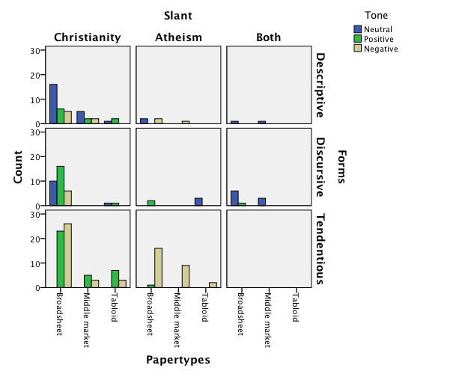

Figure 3: news form of each newspaper item
Newspaper Items | Discursive News Form | Descriptive News Form | Tendentious News Form | Total
News Story | 21 | 36 | 22 | 79
Editorial | 4 | - | 11 | 15
Opinion Piece | 15 | 3 | 32 | 50
Letter | 9 | 1 | 26 | 36
NIBS | - | 4 | 3 | 7
Other | - | 2 | 1 | 3
TOTAL | 49 | 46 | 95 | 190

Figure 4: the tendentious news form of newspaper items in the broadsheets, middle market tabloid and tabloid Newspapers
 | CHRISTIANITY SLANT AND  POSITIVE TONE | CHRISTIANITY SLANT AND NEGATIVE TONE | ATHIESM SLANT AND POSITIVE TONE | ATHEISM SLANT AND NEGATIVE TONE
BROADSHEET | 23 (24.2%) | 26 (27.3%) | 1 (1.1%) | 16 (16.8%)
MIDDLE MARKET TABLOID | 5 (5.3%) | 3 (3.2%) | - | 9 (9.5%)
TABLOID | 7 (7.4%) | 3 (3.2%) | - | 2 (2.1%)
TOTAL | 35 (36.8%) | 32 (33.7%) | 1 (1.1%) | 27 (28.4%)

Figure 5: the news forms, slant and tone of readers’ letters
 | NEWS FORM | SLANT | TONE | TOTAL
Independent | Discursive (N=1)  Tendentious (N=8) | Atheism (N=1)  Christian (N=8) | Negative (N=9) | 9
Daily  Telegraph | Discursive (N=2)  Tendentious (N=7) | Christian (N=4)  Atheism (N=5) | Positive (N=4)  Negative (N=5) | 9
Guardian | Discursive (N=3)  Tendentious (N=5) | Atheism (N=1)  Both (N=2)  Christian (N=5) | Neutral (N=1)  Positive (N=4)  Negative (N=3) | 8
The Times | Tendentious (N=3) | Atheism (N=3) | Negative (N=3) | 3
Express | Discursive (N=2)  Descriptive (N=1) | Both (N=2)  Atheism (N=1) | Neutral (N=2)  Negative (N=1) | 3
Sunday Telegraph | Discursive (N=1)  Tendentious (N=1) | Christianity (N=2) | Positive (N=1)  Negative (N=1) | 2
Daily Mail | Tendentious (N=1) | Atheism (N=1) | Negative (N=1) | 1
The Sun | Tendentious (N=1) | Christianity (N=1) | Negative (N=1) | 1
TOTAL | 36 | 36 | 36 | 36

Appendix 1: Tone of each type of Newspaper Item
 | Neutral Christian | +ve  Christian | -ve  Christian | Neutral  Atheist | +ve Atheist | -ve  Atheist | Neutral Both | +ve Both | -ve Both
News Story | 25 | 25 | 16 | 3 | - | 7 | 3 | - | -
Editorial | 1 | 6 | 1 | - | - | 5 | 2 | - | -
Opinion Piece | 3 | 23 | 12 | 2 | 1 | 6 | 3 | - | -
Letter | 3 | 6 | 14 | - | 2 | 10 |  | 1 | -
NIBS | - | - | 2 | - | - | 2 | 3 | - | -
Other | 1 | 1 | - | - | - | 1 | - | - | -
TOTAL | 33 | 62 | 45 | 5 | 3 | 30 | 11 | 1 | -

Where a newspaper is coded as tendentious then by definition it cannot be neutral. Also see Figure 2.

