Involving children in research, audit and service evaluation

F. Gilchrist, H. D. Rodd, C. Deery, Z. Marshman.

Fiona Gilchrist, BDS, MClin Dent, MPaed Dent, FDS (Paed)

Helen D Rodd, BDS (Hons), FDS (Paed), PhD

Chris Deery, BDS, MSc, FDS(Paed Dent), RCS Ed, PhD

Zoe Marshman, BDS, MPH, DDPH, FDS (DPH), PhD

School of Clinical Dentistry, University of Sheffield, Claremont Crescent, Sheffield, S10 2TA

Abstract
UK health and social policy advocates active involvement of children in service development and decision making and this is increasingly seen worldwide. The purpose of this paper is to give an overview of the ethical considerations and methods which can be employed in child-centred research, audit and service evaluation.

Introduction
Children are important users of health services, accounting for up to a quarter of general medical practice consultations and 30% of accident and emergency admissions.¹ In 2011/12 children accounted for 26% of all courses of treatment provided by General Dental Practitioners in England.² However, childrens’ perspectives on healthcare have not always been sought, rather parents, carers and healthcare professionals have been traditionally used as proxies.^{3, 4} Over the last two decades, there has been a shift in conceptualisation of childhood. Social researchers have changed the focus from seeing children as immature and incomplete, to an appreciation that children are not incomplete adults but competent social actors who are actively involved in shaping their own social worlds. Furthermore, there has been a growing appreciation of children’s rights, especially with regard to decision making, following the publication of the United Nations Conventions on the Rights of the Child 1989; Children Act 1989, the Children (Scotland) Act 1995 and the Children (Northern Ireland) Order 1995.⁵⁻⁸

Recent UK health and social care policies have reflected these changes and advise inclusion of children’s views in research, audit and service development. The publication of the National Service Framework for Children in 2004, aimed to achieve a change in the way health services were developed and promoted a move away from a disease-centred to a child-centred approach, creating a healthcare system designed around children’s needs.⁹ Quality criteria were suggested for children’s services and the need for shared decision making with children and families was advocated. Following this, the Department of Health further promoted the involvement of children in all aspects of their medical care in the publication of “Achieving Equity and Excellence for Children” and “You’re Welcome”.^{10, 11} These documents encourage healthcare providers to listen to children and young people’s opinions regarding their treatment. Recommendations are made for young-people friendly services including the development of age appropriate materials, to enable children and young people to make informed choices regarding their care. The NHS Confederation, in conjunction with the Royal College of Paediatrics and Child Health and the Office for Public Management, reiterated these points in their publication, stating that such engagement with children should be embedded within the culture and be part of day-to-day activity of health professionals.¹²

In addition to seeking children’s views of dental services, engaging children and young people in dental research should be encouraged wherever possible. The benefits of involving children in research can be seen within four main areas: 1. benefits to the research itself; 2. to its dissemination and evaluation; 3.to the young participants; 4. for adult researchers.¹³
Involving children in the development of the research project can aid prioritisation of topic areas, ensure age-appropriate materials are developed and may help with recruitment strategies.¹³ Dissemination of the research can be enhanced by the involvement of young co-researchers, ensuring future publications (e.g. patient information leaflets, research reports for participants, etc.) are in a format most likely to be accessed by other young people and that they are user-friendly. Being actively involved in research can help development of reasoning and debating skills and decision making skills for the young people involved.¹⁴ In addition, there are benefits to the adult researchers, such as gaining a greater understanding of children and young people’s perspectives, learning new skills to facilitate communication and gaining from the enthusiasm young people bring.¹³

Despite these recommendations and acknowledged benefits, a systematic review of the pre-2005 oral health literature revealed that only 13% of studies included children as active research participants.¹⁵ Active involvement can be defined as: where children are seen, listened to and heard and where priority is given to establishing children’s own perspectives.15 More recently, however, several good examples have been published in the medical and dental literature of projects which have actively involved children in this way.¹⁶⁻¹⁸

The aim of this paper is to discuss methods for actively involving children in research, audit and service development (Table 1) and to consider the ethical issues which may be encountered when conducting such studies.

Ethical issues
Ethical issues to be considered when carrying out research or service evaluation with children may include: power relationships, consent issues, confidentiality and dissemination of results. These considerations are not unique to research with children, although some aspects require specific attention when involving this population.

Power relationships
In general, our society is adult-centred, and thus there is potential for power that adults have over children in everyday life to be carried over into research practice. ¹⁹⁻²¹ In particular, there are concerns that children may find it difficult to withdraw from a project once it has started. They may also be less able to explain if they feel uncomfortable with a particular question or may feel pressured to give the answer they think the researcher wants rather than offering their own opinion.⁴ These issues exist within research with any population and it is the responsibility of the research team that strategies are in place to ensure that participants are comfortable and are reassured that there are no right or wrong answers. Various approaches have been adopted with children, for example, giving them a yellow card to hold up if they feel uncomfortable with a particular question and a red card if they wish to stop completely.²² It should also be made clear to participants that they can withdraw at any time and that no one will be cross with them and that they don’t have to explain why.²³ Additionally investigators should be aware of body language which may indicate that a participant is unhappy with the research process. ⁴

Consent/assent
Gaining informed consent from participants is mandatory in all research projects. However, this may not be possible with younger children, who may lack the capacity to give this level of consent. Therefore, consent is usually obtained from the adult “gatekeeper” and agreement to participate is gained from the child. This is termed “assent” and is defined as “an expression by the child of their desire to participate in the research”.²² Age appropriate materials must be developed to enable the child to make an informed decision; for example pictures and speech bubbles can be used.²⁴ It should be noted that this process is ongoing and the child’s willingness to participate should be checked at regular intervals. The Royal College of Paediatrics and Child Health has produced written guidelines which cover the aspects mentioned above, but also include recommendations for ensuring valid consent, such as: checking families know who to contact if they have questions, that refusal to participate will not prejudice the child’s future treatment and whether the child will directly benefit from the research.²⁵

Confidentiality
This can be a complex area when conducting research with children, due to the potential for disclosure of information which may indicate that they or another child are “at risk”. For example, where a child reveals information which leads the researcher to suspect there is a child protection issue, confidentiality will have to be broken in order to follow safeguarding protocols. The best interests of the child should always be paramount. It is proposed that the limitations of confidentiality should be discussed with the participant at the outset to ensure that they understand what type of information may be passed on and what will remain private.²⁶⁻²⁸

Dissemination of results
Wherever possible, an age-appropriate summary of the key findings should be provided to participants.26 Consideration should be given to whether participants should contribute to data interpretation or provide additional information.^{23, 29} It is important to ensure that all published data are anonymised.

Methods used for involving children
A variety of methods, both qualitative and quantitative, can be used to engage children in research, audit or service evaluation. In 2003, Sloper and Lightfoot ³⁰ performed a postal survey of health authorities and NHS Trusts to ascertain how children with disabilities and chronic diseases were being involved in service development. Of the 244 Trusts and health authorities who replied, only 77 reported involving children in this way. Those who did seek children’s views used many different methods such as written (suggestion boxes, graffiti walls or creative writing); verbal (discussion groups, individual interviews and children being active participants in steering groups) and visual (drawing, photography, videos, role play and designing display cabinets). It was reported that engaging children in these ways had been a positive experience for both children and staff. Children had expressed views which had not been anticipated by staff and it was felt that the confidence of the children involved had increased through participation.³⁰

A selection of these methods will now be discussed, with examples of how they have been used.

Interviews and focus groups
Interviews and focus groups can be used to collect detailed information from children of different ages. Participatory activities such as drawing and creative writing can be incorporated, acting as ice-breakers or to enrich the data. These techniques can be used in large scale national projects or in smaller local projects to inform service development or to aid in the development of age-appropriate patient/participant information materials.

“Better Together”, a health improvement initiative in Scotland used focus groups to explore areas of healthcare services which were important to children.³¹ Focus groups were conducted with children aged 6-16 years. Additional activities were incorporated such a brainstorming, a question lottery (where a child would pull a question from a bag and read it out to the group) and drawings. The children were willing participants and their views focused on six key areas (Table 2).

Of particular relevance to dentistry were comments regarding waiting rooms. In common with other studies, children and young people mentioned décor and lack of age-appropriate materials for them to read or play with.^{32, 33} Some children drew pictures of their ideal waiting room with specific areas for children of different ages. They also discussed how sounds, sights and posters with “scary” pictures may heighten anxiety while they waited. Children who discussed dentistry mentioned the good relationship they had with their dentist. Some reported that they felt comfortable as they had known their dentist for a long time and others commented that their dentist treated them like an adult and that treatments were always explained to them. Two children discussed an arrangement they had with their dentist whereby the dentist would stop if they raised their hand, giving them a sense of control over the procedure. Not surprisingly the aspects they liked least were injections and the smell of the dentist’s gloves. These findings give an interesting insight into children’s perspectives of dental care which would be otherwise difficult to gain without such open discussions.

In depth interviews can be used to inform the development of age-appropriate materials for research projects. Marshman and colleagues ³⁴ conducted interviews with participants in a pilot trial, funded by the National Institute for Health Research, to inform the main randomised controlled trial investigating the management of caries in primary teeth. Parents, children and the participating practitioners were interviewed as part of the feasibility study. Some of the older children were aware that they had been enrolled in the study but others had no memory or understanding of the trial. Children who remembered being asked to sign an assent form, enjoyed this involvement. The findings of this pilot study are now being incorporated into the main trial with an increased focus being placed on providing information to parents and children, as well as the development of a storybook to engage these young participants.

The Royal College of Nursing developed a national audit tool to assess the effectiveness of pain management in children.³⁵ This was developed with children who made suggestions as to which forms of data collection would be most useful. In total, four tools were developed which included activities such as: drawing, writing, a questionnaire and an interactive game. The tool has detailed instructions for those using it to enable interpretation of the various items.

Interviews can be performed on a much smaller scale to aid the development of questionnaires or audit tools for use in specific studies.^{36, 37} This important step allows the questionnaire to be tailored to the target population and ensures that the wording is age-appropriate. Eiser and colleagues³⁶ used interviews to construct a questionnaire to seek patients’ perceptions of the rationale for ongoing follow up appointments for survivors of childhood cancer. The results revealed the information needs of this population and allowed the investigators to develop more sensitive follow up regimens according to the presence of diseases associated with the late effects of cancer treatment.

Bell and co-workers³⁷ used semi-structured interviews with 10 children and their parents to develop a questionnaire to assess young patient’s views on preformed metal crowns. The study demonstrated that the majority of children viewed their crown as something special, and in contrast to their parents, had little concern about its appearance.

Diaries
Written or video diaries can be used to explore day-to-day activities or specific events in a child’s life. They can be used to gain contemporaneous insights into participants disease and treatment experiences, negating the effects of inaccurate recall.^{38, 39}

Video diaries
Video diaries have been used successfully in health-related research with children of varying ages. Rich and colleagues⁴⁰ used video diaries to further understanding of how chronic illness affects young people. Participants were given a camcorder and were asked to document their day-to-day lives for a period of 4-8 weeks. Clinical interviews were held with participants prior to the start of the study. Participants were asked to include a number of specific topics in their videos including: tours of their homes, daily activities, self-care and medical management and contacts with healthcare professionals. The findings gave a valuable insight into living conditions and medication habits. For example, a participant whose home had been declared “asthma safe” following interviews with the family was shown to be overcrowded, dusty and with forced air heating. Others demonstrated ineffective inhaler techniques and unauthorised discontinuation of medication. The video diaries new information about asthma management, which had not been discovered during the clinical interview, thus allowing participants and clinicians to make changes to improve care. This technique has also been used in children with spina bifida, obesity and diabetes mellitus.^{41, 42} More recently, video diaries have been used for the first time with young dental patients to gain their perspective of dental treatment under general anaesthetic.⁴³

Written diaries
These can be used to allow children to express their thoughts through written accounts or drawings (Figure 1). Written diaries have been used to explore the experiences of children with oral conditions during their transition to secondary school.⁴⁴ A two-week diary was developed with children and incorporated both open and closed questions with space to include drawings. The children recruited had a variety of oral conditions including: dental caries, cleft lip and/or palate, hypodontia and traumatised incisors. Participants discussed a variety of aspects about the transition to secondary school related to the change in environment, changes in social interactions and concerns about their appearance. Some children discussed their oral conditions such as cleft lip and how they dealt with questions from peers about it, whilst others reported having sought treatment to improve the appearance of enamel opacities prior to starting secondary school (Figure 2). Appearance related concerns were not limited to oral conditions as some children stated that they had tried to lose weight, have their hair cut or not wear glasses prior to the transition. This enquiry gave dental professionals a clearer understanding of young people’s dental concerns prior to educational transition, and highlighted the need for more timely interventions where appropriate.

Questionnaires
Questionnaires can be used for a variety of purposes: to evaluate new or existing services, to assess patient satisfaction or determine treatment outcomes. On completion, they could be posted anonymously in a box placed in the clinic reception area (Figure 3).

Validated patient satisfaction questionnaires are available; however, it may be that none are available in the proposed area of enquiry. ^{45, 46}
As mentioned previously, where there is no existing questionnaire, it is possible to use interviews to develop your own, provided that they are designed carefully and evaluated thoroughly. It is also possible to use open-ended questionnaires to generate items. Rodd and co-workers⁴⁷ initially sought the views of patients who had received treatment for enamel defects. Patients were sent an open-ended questionnaire to ascertain how having visible enamel opacities had affected them and what improved following treatment. From the responses, a simple 10 item visual analogue scale was developed with an additional free text box for patients to write further comments. The information provided by patients was very positive about the care received and staff in the department but revealed some unmet treatment expectations. Some reported disappointment that their teeth “weren’t perfect” following the treatment. This is important for clinicians to know, so that these expectations can be managed at the outset of treatment. Allowing children to state their views anonymously in this way, allows those who feel too shy to openly state their disappointment in the dental surgery, an opportunity to have their say, therefore ensuring that expectations can be managed appropriately for others in the future.

Measures of oral health related quality of life can be used to assess the impact of oral conditions in children. Several measures have been designed for use in children.⁴⁸⁻⁵⁴ The most frequently used of these are from the Child Oral Health Quality of Life battery of questionnaires including the Parental Perceptions Questionnaire (PPQ) and the age specific Child Perceptions Questionnaire (CPQ) 11-14 years or 8-10 years. ^{48, 49, 51, 55} Both the CPQ and the Child Oral Health Impact Profile (Child OHIP) were developed for use in clinical populations ^{48, 49, 52}, while the Child Oral Impacts on Daily Performances (Child OIDP) questionnaire was developed for epidemiological purposes.⁵⁰ However, the involvement of children in the development of these measures was limited and therefore they may not cover all areas of concern to children.⁵⁶ In addition, these measures have not been validated longitudinally and therefore cannot be used to evaluate different treatment outcomes in clinical trials without further testing.

Opportunities for future research
Within dentistry, there are a number of topic areas which may benefit from the involvement of children in research, audit or service evaluation. To date little is known about children’s experiences of different treatment modalities and therefore which are effective from the child’s perspective. This could be investigated using qualitative methods such as interviews, video diaries, questionnaires developed using child-centred methods or even using innovative methods such as children interviewing their families and each other.

Involving children in decision making has been identified as a priority area for development in UK policy.¹⁰⁻¹² Decision aids have been used in medicine to enable patients to make decisions about their own healthcare.^{57, 58} A large number of decision aids have been developed, however, very few are related to children’s healthcare.⁵⁹ It would be beneficial to develop aids to enable children to participate in decision-making regarding treatment under general anaesthetic, conscious sedation or in making choices about aesthetic treatments such as orthodontics.

Establishing panels of child experts to advise on projects and service development has been successfully used in a number of areas.^{60; 61; 62} These panels can allow children to be part of the project from the outset, including the development of ideas which are important to children, ensuring that data collection methods are appropriate and influencing services which they use.

Children are generally willing participants, but collaboration with individuals with experience in this area, can aid the development of appropriate resources and provide training in the various aspects associated with research, audit or service evaluation in this age group.

Conclusion
Actively involving children in projects can be fulfilling for both investigators and participants and should be considered good practice. Not all studies lend themselves to active participation, however, consideration should be given to incorporating children’s perspectives wherever possible.

References

1. Hart C, Chesson R. Children as consumers. BMJ. 1998;316:1600-1603.
2. Health and Social Care Information Centre PPC. NHS Dental Statistics for England: 2011/12. London: Health and Social Care Information Centre, 2012.https://catalogue.ic.nhs.uk/publications/primary-care/dentistry/nhs-dent-stat-eng-2011-2012/nhs-dent-stat-eng-2011-2012-rep.pdf 26th March 2013.
3. Eiser C, Morse R. Can parents rate their child's health-related quality of life? Results of a systematic review. Qual Life Res. 2001;10:347-357.
4. Kirk S. Methodological and ethical issues in conducting qualitative research with children and young people: a literature review. Int J Nurs Stud. 2007;44:1250-1260.
5. United Nations. United Nations Convention on the Rights of the Child. Geneva: 1989.
6. Children Act. London: HMSO, 1989.http://www.legislation.gov.uk/ukpga/1989/41 9th January 2013.
7. Children (Scotland) Act. London: HMSO, 1995.http://www.legislation.gov.uk/ukpga/1995/36 9th January 2013.
8. Children (Nothern Ireland) Order. London: Office of Public Sector Information, 1995.http://www.legislation.gov.uk/nisi/1995/755/made 9th January 2013.
9. Department of Health. National Service Framework for Children, Young People and Maternity Services: Key Issues for Primary Care. London: 2004.
10. Department of Health. You're Welcome quality criteria: making health services young people friendly. London: Department of Health, 2007.http://www.dh.gov.uk/en/Publicationsandstatistics/Publications/PublicationsPolicyAndGuidance/DH_073586 9th January 2013.
11. Department of Health. Achieving Equity and Excellence for Children. London: Department of Health, 2010.http://www.dh.gov.uk/en/Publicationsandstatistics/Publications/PublicationsPolicyAndGuidance/DH_119449 9th January 2013.
12. The NHS Confederation, Office for Public Management, The Royal College of Paediatrics and Child Health. Involving children and young people in health services. London: NHS Confederation, 2011.http://www.nhsconfed.org/Publications/reports/Pages/children-health-services.aspx 9th January 2013.
13. McLaughlin H. Involving Young Service Users as Co-Researchers: Possibilities, benefits and Costs. British Journal of Social Work. 2006;36:1395-1410.
14. Sinclair R, Franklin A. Young People’s Participation. Quality Protects Research Briefings, no 3. London: Department of Health, 2000.
15. Marshman Z, Gibson BJ, Owens J, Rodd HD, Mazey H, Baker SR, et al. Seen but not heard: a systematic review of the place of the child in 21st-century dental research. Int J Paediatr Dent. 2007;17:320-327.
16. Morris C, Liabo K, Wright P, Fitzpatrick R. Development of the Oxford ankle foot questionnaire: finding out how children are affected by foot and ankle problems. Child Care Health Dev. 2007;33:559-568.
17. Freeman R, Whelton H, Gibson B. Toothbrushing rules: power dynamics and toothbrushing in children. Social Science and Dentistry. 2010;1:37-47.
18. Stinson JN, Sung L, Gupta A, White ME, Jibb LA, Dettmer E, et al. Disease self-management needs of adolescents with cancer: perspectives of adolescents with cancer and their parents and healthcare providers. J Cancer Surviv. 2012;6:278-286.
19. Harden J, Scott S, Beckett-Milburn K, Jackson S. Can't talk, won't talk: methodological issues in researching children. Sociological Research Online. 2000; 5. Available from: http://www.socresonline.org.uk/5/2/harden.html 8th January 2013.
20. Morrow V, Richards M. The ethics of social research with children: an overview. Children and Society. 1996;10:90-105.
21. Punch S. Research with children-the same or different from research with adults? Childhood. 2002;9:321-341.
22. Helseth S, Slettebo A. Research involving children: some ethical issues. Nurs Ethics. 2004;11:298-308.
23. Westcott H, Davies G. Sexually abused children's and young people's perspectives on investigative interviews. British Journal of Social Work. 1996;26:451-474.
24. FiCTION Trial. NIHR HTA FiCTION Trial - Filling Children's Teeth: Indicated or Not? Website. Newcastle University2012; cited 8th January 2013; Available from: http://research.ncl.ac.uk/fictiontrial/forparentschildren/informationforchildren/
25. Royal College of Paediatrics and Child Health: Ethics Advisory Committee. Guidelines for the ethical conduct of medical research involving children. Arch Dis Child. 2000;82:177-182.
26. Alderson P. Listening to Children: Children and Social Research Ethics. London: Barnardos, 1995.
27. Beresford B. Personal Accounts: Involving Disabled Children in Research. New York: Social Policy Research Unit, 1997.
28. Davis J. Understanding the meanings of children: a reflexive process. Children and Society. 1998;12:325-335.
29. Glasgow Centre for the Child and Society. Code of Practice on Research Ethics: Responsibilities to Research Participants. Glasgow: Glasgow Centre for the Child and Society.http://www.strath.ac.uk/humanities/socialwork/glasgowcentreforthechildandsociety/publications/ 26th March 2013.
30. Sloper P, Lightfoot J. Involving disabled and chronically ill children and young people in health service development. Child Care Health Dev. 2003;29:15-20.
31. The Scottish Government. Better Together: Scotland's Patient Experience Programme: Building on Children and Young People's Experiences. Edinburgh: The Scottish Government, 2009.http://www.scotland.gov.uk/Publications/2009/06/12150703/0 8th January 2013.
32. The Stationary Office. Improving the Patient Experience: Friendly Healthcare Environments For Children and Young People. London: The Stationary Office, 2004.http://www.swpho.nhs.uk/resource/item.aspx?RID=67821 26th March 2013.
33. Curtis P. Space to care: children's perceptions of spatial aspects of hospitals: Full Research Report. ESRC End of Award Report. Swindon: ESRC, 2007. RES-000-23-0765.http://www.esrc.ac.uk/my-esrc/grants/RES-000-23-0765/outputs/read/e65206b6-b6e5-44aa-b941-e29d44dee77e 26th March 2013.
34. Marshman Z, Innes N, Deery C, Hall M, Speed C, Douglas G, et al. The management of dental caries in primary teeth - involving service providers and users in the design of a trial. Trials. 2012;13:143.
35. The Royal College of Nursing. Clinical Practice Guidelines: The recognition and assessment of acute pain in children. London: The Royal College of Nursing, 2002.http://www.rcn.org.uk/development/practice/clinicalguidelines/pain 26th March 2013.
36. Eiser C, Levitt G, Leiper A, Havermans T, Donovan C. Clinic audit for long-term survivors of childhood cancer. Arch Dis Child. 1996;75:405-409.
37. Bell SJ, Morgan AG, Marshman Z, Rodd HD. Child and parental acceptance of preformed metal crowns. Eur Arch Paediatr Dent. 2010;11:218-224.
38. Verbrugge LM. Health diaries. Med Care. 1980;18:73-95.
39. Butz A. Use of health diaries in pediatric research. J Pediatr Health Care. 2004;18:262-263.
40. Rich M, Lamola S, Amory C, Schneider L. Asthma in life context: Video Intervention/Prevention Assessment (VIA). Pediatrics. 2000;105:469-477.
41. Buchbinder MH, Detzer MJ, Welsch RL, Christiano AS, Patashnick JL, Rich M. Assessing adolescents with insulin-dependent diabetes mellitus: a multiple perspective pilot study using visual illness narratives and interviews. J Adolesc Health. 2005;36:71 e79-13.
42. Rich M, Polvinen J, Patashnick J. Visual narratives of the pediatric illness experience: children communicating with clinicians through video. Child Adolesc Psychiatr Clin N Am. 2005;14:571-587, x-xi.
43. Rodd H, Hall M, Deery C, Gilchrist F, Gibson B, Marshman Z. Video diaries to capture children’s participation in the dental GA pathway. Submitted to European Archives of Paediatric Dentistry. 2012.
44. Rodd HD, Marshman Z, Porritt J, Bradbury J, Baker SR. Oral health-related quality of life of children in relation to dental appearance and educational transition. Br Dent J. 2011;211:E4.
45. Rifkin L, Wolf MH, Lewis CC, Pantell RH. Children's perceptions of physicians and medical care: two measures. J Pediatr Psychol. 1988;13:247-254.
46. Simonian SJ, Tarnowski KJ, Park A, Bekeny P. Child, parent, and physician perceived satisfaction with pediatric outpatient visits. J Dev Behav Pediatr. 1993;14:8-12.
47. Rodd HD, Abdul-Karim A, Yesudian G, O'Mahony J, Marshman Z. Seeking children's perspectives in the management of visible enamel defects. Int J Paediatr Dent. 2011;21:89-95.
48. Jokovic A, Locker D, Stephens M, Kenny D, Tompson B, Guyatt G. Validity and reliability of a questionnaire for measuring child oral-health-related quality of life. J Dent Res. 2002;81:459-463.
49. Jokovic A, Locker D, Tompson B, Guyatt G. Questionnaire for measuring oral health-related quality of life in eight- to ten-year-old children. Pediatr Dent. 2004;26:512-518.
50. Gherunpong S, Tsakos G, Sheiham A. Developing and evaluating an oral health-related quality of life index for children; the CHILD-OIDP. Community Dent Health. 2004;21:161-169.
51. Jokovic A, Locker D, Guyatt G. Short forms of the Child Perceptions Questionnaire for 11-14-year-old children (CPQ11-14): development and initial evaluation. Health Qual Life Outcomes. 2006;4:4.
52. Broder HL, McGrath C, Cisneros GJ. Questionnaire development: face validity and item impact testing of the Child Oral Health Impact Profile. Community Dent Oral Epidemiol. 2007;35 Suppl 1:8-19.
53. Broder HL, Wilson-Genderson M. Reliability and convergent and discriminant validity of the Child Oral Health Impact Profile (COHIP Child's version). Community Dent Oral Epidemiol. 2007;35 Suppl 1:20-31.
54. Dunlow N, Phillips C, Broder HL. Concurrent validity of the COHIP. Community Dent Oral Epidemiol. 2007;35 Suppl 1:41-49.
55. Jokovic A, Locker D, Stephens M, Kenny D, Tompson B, Guyatt G. Measuring parental perceptions of child oral health-related quality of life. J Public Health Dent. 2003;63:67-72.
56. Marshman Z, Gibson BJ, Benson PE. Is the short-form Child Perceptions Questionnaire meaningful and relevant to children with malocclusion in the UK? J Orthod. 2010;37:29-36.
57. Hofmann S, Vetter J, Wachter C, Henne-Bruns D, Porzsolt F, Kornmann M. Visual AIDS for multimodal treatment options to support decision making of patients with colorectal cancer. BMC Med Inform Decis Mak. 2012;12:118.
58. Jayadev C, Khan T, Coulter A, Beard DJ, Price AJ. Patient decision aids in knee replacement surgery. Knee. 2012;19:746-750.
59. Ottawa Hospital Research Institute. Decision Aid Library Inventory (DALI). 2012; cited 8th January 2013; Available from: http://decisionaid.ohri.ca/cochinvent.php
60. Central Manchester University Hospitals NHS Foundation Trust. Join the Youth Forum. 2012; cited; Available from: http://www.cmft.nhs.uk/young-person-zone/get-involved/join-the-youth-forum.aspx
61. Healthcare Improvement Scotland. Borders Youth Health Forum. 2012; cited; Available from: http://www.scottishhealthcouncil.org/case_studies/borders_youth_health_forum.aspx
62. Youth4U & The Welsh Government. Youth4U. 2013; cited 8th January 2013; Available from: http://www.youth4u.co.uk

Research | Attempts to determine generalisable new knowledge
Audit | Measures whether services comply with a gold standard
Service evaluation | Seeks to evaluate current services from patient and/or staff perspective
Table 1: Definition of research, audit and service evaluation.

Access and waiting
Better information about health and healthcare
Environmental needs in health care settings
Building relationships and trusting professionals
Emotional impact of accessing healthcare
Involvement in decisions and control over choices

Table 2: Key areas of healthcare which were important to children and young people.³¹

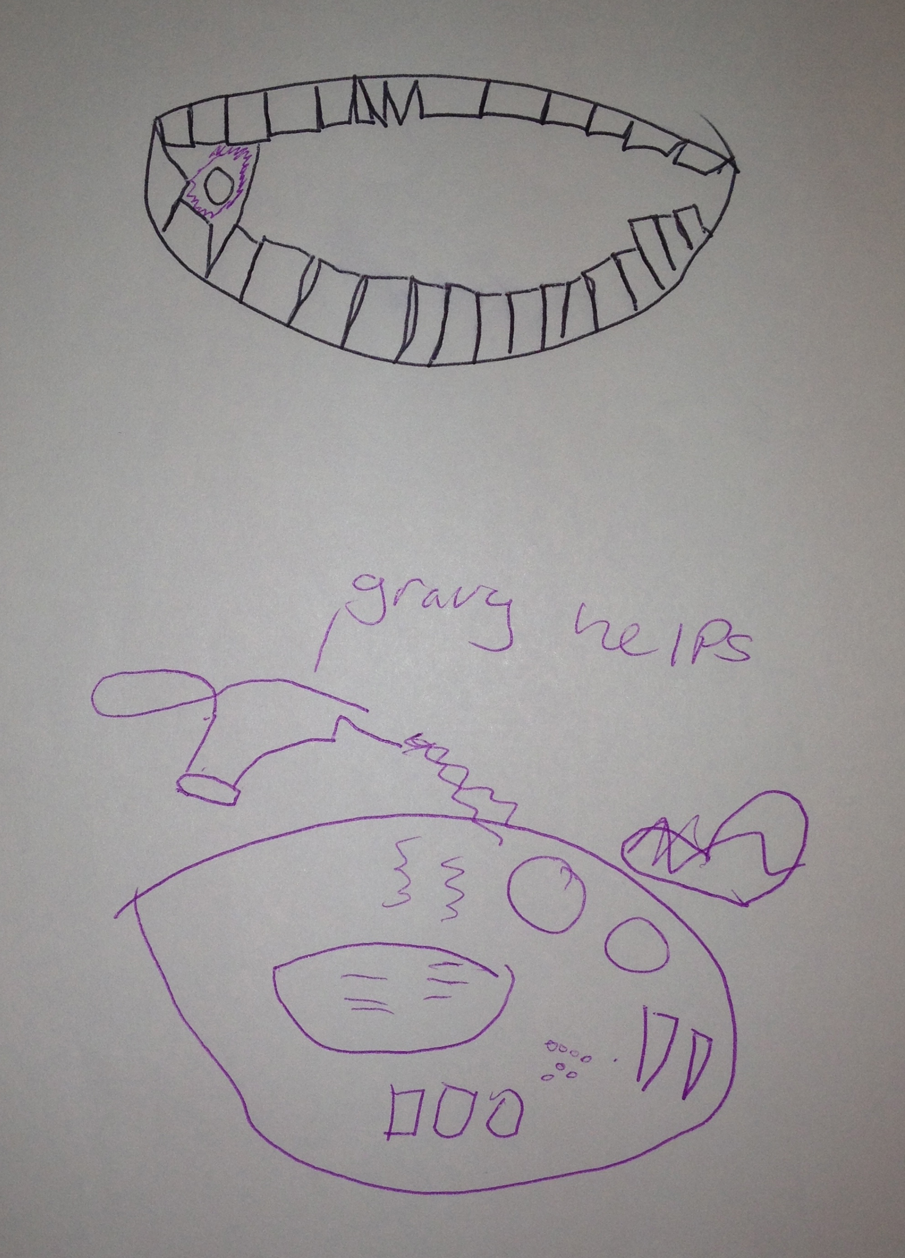
Fig 2. Drawing from a diary recording children’s perceptions of care they received for apthous ulceration, showing a drawing of the ulcer and what helps to make it better.

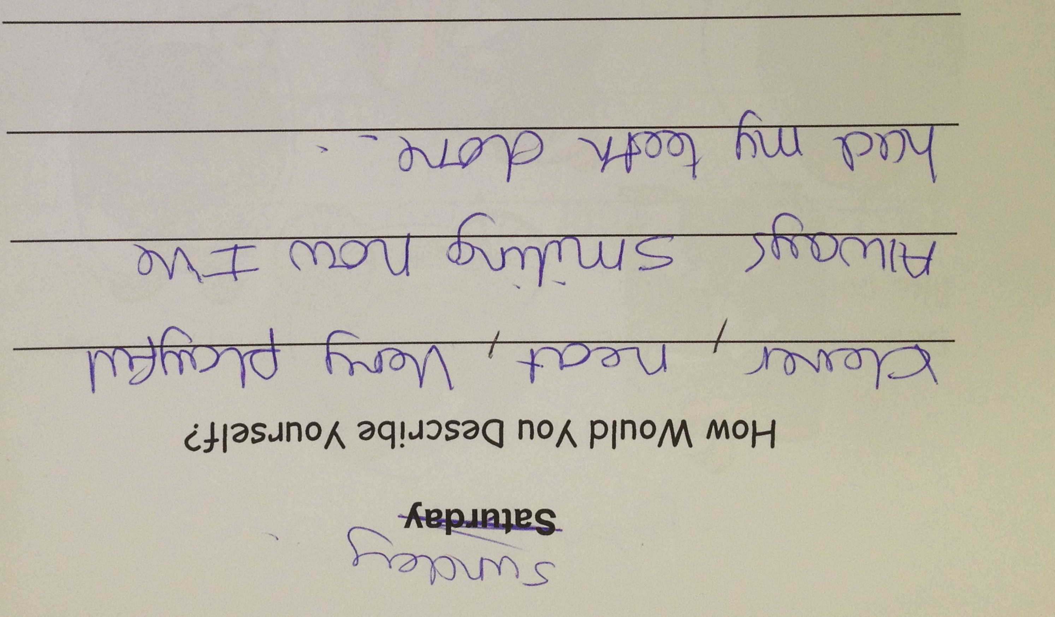

Fig 2. Excerpt from a diary completed by a 12-year-old girl.

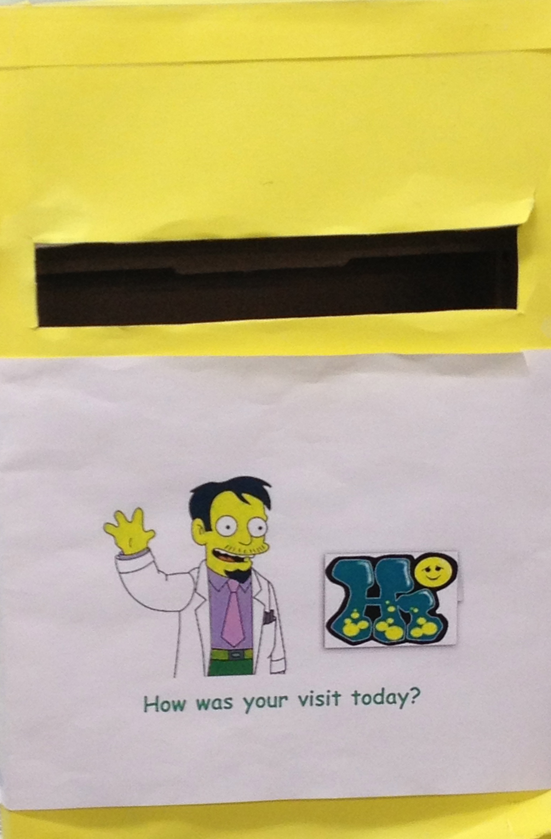

Fig 3. Post box placed at clinic reception for questionnaires.

