Thatcher’s Grandchildren: The Long Road to Inequality Margaret Thatcher changed British politics – but did her policies change our political attitudes? In a groundbreaking new study Emily Gray, Stephen Farrall, Colin Hay, Danny Dorling and Will Jennings find that the ‘Iron Lady’ left a lasting impact on British social attitudes that is still being felt today.

Political attitudes are important. How the electorate feel about politics and policies can have a short and long term influence on voting behaviour. The public’s political predilections can affect support for particular policies or alliances and more broadly influence an individual’s relationship with society and its members. Over time, attitudinal shifts in the general population may have consequences for the perceptions that political parties feel they can legitimately uphold – or feel obliged to uphold, in order to maintain support. An increasing tolerance of the (widening) gap between rich and poor, for example, may result in subsequent policies that oppose ‘rewarding’ recipients of welfare or which emphasise personal ‘responsibility’.
In this vein, political scientists have focused increasingly on the extent to which the governments of Margaret Thatcher, and later John Major (and to an extent Tony Blair) influenced public attitudes in the UK. This has led to an examination of political attitudes that might be considered ‘Thatcherite’. In this piece we consider what Thatcherism might mean in terms of political values and the long-term process of attitudinal change. In so doing, we present some of the headline findings, arising from an analysis of the survey data on public attitudes towards income and justice inequality in Britain since the early 1980s.
‘Thatcherite’ values
What are ‘Thatcherite’ values? How might we conceptualise them? The tenets of the New Right (of which Thatcherism is one variant) highlighted minimal state intervention, the supremacy of ‘the market’ and the importance of personal responsibility. In practice this meant that Thatcher pursued economic policies that aimed to control inflation (rather than unemployment) and reduce taxation and the role of the state. She achieved these ambitions via the privatisation of key public services set up during the postwar political consensus, such as selling off the social housing stock via the ‘right to buy’ scheme. Meanwhile, at the social level, she actively supported punitive approaches to law and order and celebrated ‘Christian values’: she argued against sexual ‘permissiveness’ and hoped to place the nuclear family at the centre of society’s moral compass. It is now widely accepted that Thatcher’s premiership was a time of immense social and economic change, which resulted in high levels of unemployment and a sharp decline in manufacturing. At the same time, there were changes in the nature of home-ownership, whilst family formations shifted and crime rose steadily.
We might expect attitudes post-1979 to align with the aims of Thatcherite social and economic policies. However, this was not borne out by studies which took place during and immediately after her terms in office. One of the earliest surveys of public attitudes towards Thatcherism, conducted between 1980 and 1984, found little support for ’Thatcherite’ social and political attitudes. Rather, the results suggested that respondents wanted increases in spending and taxation (not decreases) with an attendant drop in support for spending on the armed forces. Local government was also considered essential, although support was identified for the curbing of trade union power at the time. Notably, later studies in this vein (Johnston and Pattie, 1990; Heath and Park, 1997) – which, by this point benefited from examining data over a longerterm period – concluded that by the time Thatcher left office in 1990, she had had little impact on public attitudes. These collective studies indicated instead that the electorate remained resolutely unimpressed by much of Thatcher’s approach to the challenges that the country faced, and in many respects had started to move away from her policies.
Trickle down: an evolutionary process of attitudinal change
How quickly and significantly do public attitudes change? On reflection, rapid shifts might not be expected for a number of reasons. Some of the views which Thatcher articulated can be traced back to the 1950s and 1960s and were already held by a reasonably large proportion of the electorate (so Thatcherism could be seen as the result of attitudinal change, rather than as a cause of it). Additionally, studies of political socialisation (the long-term process by which people form their political values) often stress that the configuration of political attitudes takes place early in an individual’s life. The processes of inter-generational replacement may mean that considerable periods of time pass before attitudinal shifts start to show up in cross-sectional surveys. Thus, attitudinal changes may prove difficult to detect, either because Thatcherism was in fact a response to shifts in public feelings which took place prior to her election, or because her message and some of the values it contained took time to become embedded in wider social and political cultures.
With the refinement of research methods and the benefits afforded by a combination of repeated longitudinal survey measures, and a longer time period (covering around three decades) we are now better placed to reject the initial claim that the Thatcher governments had no enduring impact on British social attitudes. In earlier research, Farrall and Jennings (2012) demonstrated empirically that increased rates of unemployment and inequality led directly to increases in crime rates, which in turn led to mounting public concern with crime. More recently, access to around 30 years of data via the British Social Attitudes Survey and the Crime Survey for England and Wales (formerly the British Crime Survey) indicates that Thatcherism had a varying impact on the attitudes of successive generations of people. Specifically, the work we are currently conducting suggests that the former prime minister’s impact on political values is most noticeable amongst those born in the 1960s through to the late 1970s – those who grew up in what was often referred to as ‘Thatcher’s Britain’, as well as people born during the 1980s and 1990s – a generation who might be referred to as ‘Thatcher’s grandchildren’.
Inequality: who cares?
The following analysis uses a simple statistical method called ‘conditional formatting’ which visually enhances top-line findings from two questions in the British Social Attitudes (BSA) Survey on (i) income and (ii) justice inequality in Britain from 1983 to 2012. Certainly, inequality is a pertinent topic in relation to Thatcherite values, since Britain witnessed a dramatic growth in income inequality in the 1980s and the level of inequality has, if anything, increased further since then, albeit at a slower rate.
The table is divided by age of respondent and year of interview, which allows us to examine the relative influence of age on a respondent’s attitudes over the historical period. The first question asked: ‘Thinking of income levels generally in Britain today would you say that the gap between those with high incomes and those with low incomes is…’ The response options were ‘too large’ (3); ‘about right’ (2); ‘too small’ (1). The question was asked in the BSA from 1983 to 2012, with the exception of 1996, 2005 and 2011 (see figure 1). Visually, the cells reflect mean scores whereby higher values denote greater concern about the gap between rich and poor – these values are in red and the lowest values are purple.
Figure 1: Is the gap between the rich and poor too large (high values agree) Britain 1983-2012, by age
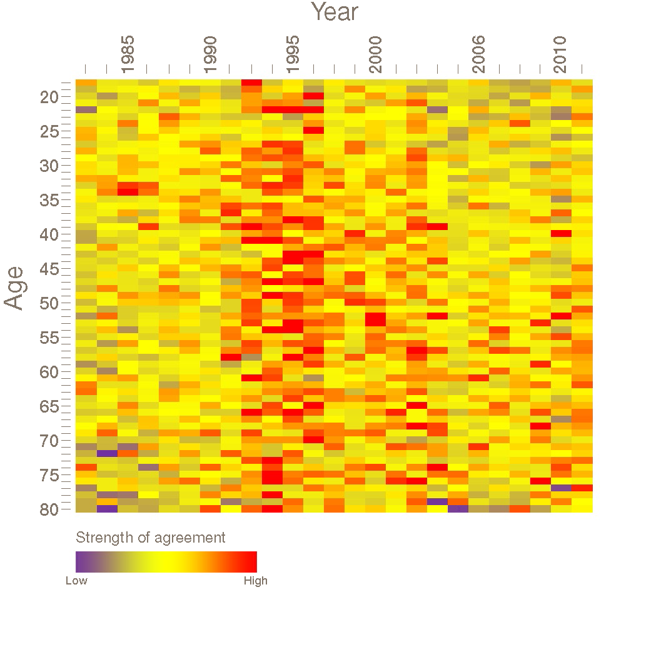
Source: The British Social Attitudes Survey, 1983-2012
Eyeballing the data we can quickly detect that from the early 1990s, respondents of almost all ages expressed significant concern about income inequality. This was a period of recession when inflation was in double figures and interest rates were as high as 15 per cent. During this time, respondents of almost all ages expressed significant concern about income inequality. In fact, in many instances respondents from particular birth years were unanimously agreed that the gap was ‘too large’ (as indicated by bright red cells). A downwards diagonal pattern of red and orange cells suggests that those who were aged around 27-40 in 1995, continued to be concerned about this issue through the turn of the century and up to 2012, although we can detect a lifting off of tension around the time of Labour’s landslide victory in 1997. Comparatively, from 2003 onwards, it is also possible to see that younger people of this era revert to being less worried – or more accepting of the still-prevalent gap between rich and poor. In 2012 there was a huge increase in interest in inequality, as compared to 2010 for all age groups. Unfortunately this question was not asked in the survey in 2011.
We also looked at a second question from the British Social Attitudes Survey that asked ‘How much do you agree or disagree that there is one law for the rich and one for the poor’ (figure 2). The item was coded ‘agree strongly’ (5); ‘agree’ (4); ‘neither’ (3); ‘disagree’ (2); ‘disagree strongly’ (1). The item was asked every year for 26 years, between 1986 and 2012. Again, the colour of the cells reflect mean scores; the highest scores are depicted in red, and the lowest scores are in purple.
Figure 2: Is there one law for the rich and one for the poor (high values agree), Britain 1983-2012, by age
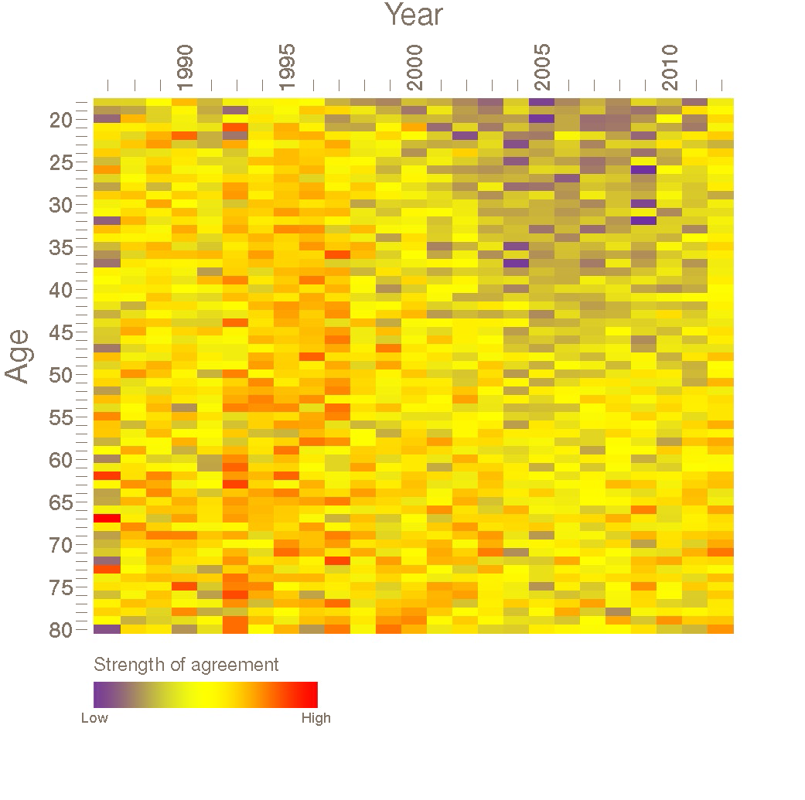
Source: The British Social Attitudes Survey, 1983-2012
Here we notice a recurrence of the pattern for income inequality. The mid- 1990s data was marked by strong feelings (red) in relation to an apparent justice gap between rich and poor; middle-aged and older people were most worried about this issue at this time. By the noughties, for people aged under-45 the view that the poor were treated differently than the rich by the law was not widely held; and in some ways it had become quite an old fashioned sentiment. However, in both 2011 and 2012 more people in all age groups again began to agree with the statement.
Looking carefully at figure 2 it is also possible to imagine a cohort of voters, born around 1965, aged 21 in 1986 and 47 in 2012, who held onto the view that there was one law for the rich more strongly than those younger than them. Many of their children will make up the youngest, most recent age groups, whose views are shown in the few yellow cells in the top right hand corner of figure 2: people aged 18 in 2011, born in 1993, often to parents aged about 28 when they became parents, who were themselves born around 1965.
Shaping political values
These results indicate that a more detailed exploration and more thorough statistical analysis is required, but what is already clear is that they offer evidential support to the claim that patterns of social and economic division infused the public consciousness during the 1990s and became a key concern in public attitudes. Income inequality was negatively viewed by all participants, but was most strongly expressed by those in their middle and older age. Meanwhile younger generations, who came of age during the governments of New Labour, became less worried about structural income differences after 2003. As such, these results indicate that tolerance of inequality may now be more prevalent amongst younger people. This underlines the contention that the political culture into which one is born, has a lasting effect on an individual’s political values. It is possible, though, that the recent economic crisis will change this again – only time will tell.
The political and social attitudes of subsequent generations of young people were shaped by Thatcherite values, far more so than those of the generation of voters who had been socialised prior to her arrival in office. These findings underline the slow learning-process through which political values are transmitted from one generation to the other. But, while the speed of the process has been much slower, it is no less important or consequential. Indeed, the ripples of Thatcher’s legacy have been, and will very likely continue to cascade through the political attitudes of young people growing up long after she left office and beyond her death in 2013.
References:
Edgell, S. and Duke, V. (1991) A Measure of Thatcherism, Harper Collins: London.
Farrall, S. and Jennings, W. (2012) ‘Policy Feedback and the Criminal Justice Agenda: an analysis of the economy, crime rates, politics and public opinion in post-war Britain’, Journal of Contemporary British History, 26(4): 467–88.
Heath, A. and Park, A. (1997) Thatcher’s Children? British Social Attitudes: The End of Conservative Values?, Ashgate: Aldershot.
Johnston, R. J. and Pattie, C. (1990) ‘The Regional Impact of Thatcherism’, Regional Studies, 24(6): 479-493.
The Project, ‘Long-term Trajectories of Crime in the UK’, is funded by the ESRC (award number ES/K006398/1). Those interested are encouraged to visit the project website: http://www.sheffield.ac.uk/ law/research/projects/crimetrajectories. The vast dataset that we have collated covers 30 years of survey data on victimisation, fear of crime, social and political attitudes with national socioeconomic indicators for England and Wales. Those wishing to get in contact can do so to s.farrall@sheffield.ac.uk or via Twitter (@thatcher_legacy).

