Fretting corrosion of fully cemented polished collarless tapered stems: The influence of PMMA bone cement

M. Bryantª*, R. Farrar^{b}, K. Brummitt^{b}, R. Freeman^{b}, A. Nevilleª
a- iETSI, , University of Leeds, UK

b - DePuy International, Leeds, UK

Received Date Line (to be inserted by Production) (8 pt)

Abstract

In order to investigate the effect PMMA bone cement chemistry has on the fretting corrosion of cemented femoral stems, a novel test setup with integrated electrochemistry was developed and conducted in part reference to ISO 7206-4:2010. Ultima TPS™ (DePuy International, UK) femoral stems were cemented into a specially prepared delrin moulds using cementing technique similar to the procedure used in-vivo. Three PMMA bone cements were tested in order to understand how cement chemistry can effects the fretting corrosion mechanisms. The stem-cement component was then orientated and set in place using laboratory grade PMMA cement. Each stem was subjected to a cyclic loading from 200-2300N at 1Hz for 500,000 cycles. Intermittent Open Circuit Potential (OCP) and Linear Polarisation Resistance (LPR) measurements were conducted in order to assess the effects of PMMA bone cement chemistry of the localised dissolution of cemented femoral stems. Macroscopic observational and scanning electron microscopy with integrated energy dispersive x-ray analysis (SEM/EDX) was conducted in order to support the electrochemical findings.

Keywords: Fretting, Corrosion, Femoral stem, LC CoCrMo, PMMA bone cement

- Introduction
Although a recent decline in the number of cemented Total Hip Replacements (THR) has been seen in UK National Joint Registry (NJR) figures, the method of cementing femoral stems still remains an extensively practiced technique in patients aged 65 and over, with superior short term results being observed for cemented THR [1]. During THR, the meduallry canal is reamed to size using a series or reamers and rasps. A poly methyl-methacrylate (PMMA) cement restrictor is placed at the bottom of the canal and the PMMA bone cement introduced and pressurised in a retrograde fashion with respect to the distal portions of the femur. The femoral stem is then introduced into the PMMA bone cement, until the desired position is met and the remaining cement cleaned away to leave the bone cement mantle. This introduction of the stem into the bone cement has been shown to result in interactions at the stem-cement interfaces, undesirable from both a mechanical loading and electrochemical point of view, resulting in the release of metallic and PMMA bone cement wear debris, along with potentially toxic metal ions into the biological system [2-6]. Micro motion has been detected at these interfaces, resulting in fretting wear being observed at the stem-cement interface accompanied with accelerated dissolution of the metallic substrate. Interest at these interfaces has been renewed due to the cases presented by Donell et al [7] and Bolland et al [8] demonstrating high levels of localized fretting corrosion of the cemented portions of polished tapered CoCrMo femoral stems resulting in a high release of metal ions into the biological environment.
The integration of antibiotics agents into PMMA bone cements for the treatment and prevention of infection in orthopaedics has become common clinical practice since the 1970’s, with gentamicin sulphate being extensively used as the primary antibiotic [9, 10]. Radiopaque agents are also included to aid visibility under X-ray conditions, with zirconium dioxide and barium sulphate being commonly used. However, studies to date have questioned the efficacy of the use of antibiotic impregnated cements as the release mechanisms are poorly understood and difficult to control whilst maintaining the integrity of the implant [10]. Similarly, questions around how antibiotics and radiopaque agents affect the fretting-corrosion and localized corrosion regimes of cemented implants need to be answered due to the increasing occurrence of fretting corrosion at the stem-cement interface.
Although no studies have been conducted investigating the effect antibiotic addition has on the fretting corrosion mechanisms of cemented THR, some authors have hypothesized the presence of radiopaque agents, such as barium sulphate and zirconium dioxide, may result in a ‘ploughing’ action of the metal surface increasing the amount of wear found at the stem-cement interface and further increasing the rate of dissolution at this interface. This study therefore aims to investigate the effect radiopaque and antibiotic agents have on the fretting corrosion rates mechanisms of collarless polished tapered femoral stems when subject to physiological loading in a simulated biological environment.
- Materials and Experimental Method
  - Electrodes and Solution.
Low carbon (LC) CoCrMo Ultima TPS™ (DePuy International, Leeds. UK) collarless polished femoral stems (n=3) were utilised as the working electrode (WE) in this study (Table 1). Each femoral stem was forged and then mechanically polished to a surface roughness of R_{a} ≈ 0.05µm. Samples were then cleaned and passivated by DePuy International (Leeds, UK) in order to replicate surface treatment post manufacturing. A Thermo-scientific Sureflow Redox combination electrode, consisting of a Ag/AgCl reference electrode and Pt counter electrode was also employed. The solution used for electrochemical measurements was 0.9% NaCl solution (pH 7.4, 8ppm O₂), which was made up from analytical grade reagent and deionised water.
Table 1 - Chemical composition for materials according to ASTM F1537-08
Material | C | Co | Cr | Mo | Fe | Ni
LC CoCrMo | 0.05 | Bal. | 27.4 | 5.7 | 0.17 | 0.1

  - Setup for fatigue and fretting corrosion measurements
A novel test method was developed and conducted in part reference to ISO 7206-4 to evaluate the mechanically enhanced corrosion mechanisms at the stem-cement interfaces of fully cemented femoral components. Firstly, a collarless polished LC CoCrMo stemmed component was cemented into a specially designed polymer mould using commercially available PMMA bone cement (Table 2). Once polymerisation of the cement had occurred, the fully cemented stem was removed from the polymer mould, orientated at 10° flexion and 9° abduction to achieve torsional forces experienced in-vivo into the test fixtures and set in place using a lab grade PMMA resin. The protruding part of the specimen was then encased in a flexible silicon gaiter and immersed in 600mL of 0.9% NaCl solution at 37±1°C. Initially a static load of 100N was applied to the femoral stem for 24hrs in order to let the system achieve equilibrium before cyclic testing in order to understand the initial passivation mechanics. After 24hrs, a cyclic load of 200N to 2300N at 1Hz for 500,000 cycles was applied to the stem through a Ø28mm LC CoCrMo femoral head and UHMWPE liner for 500,000 cycles. Care was taken to seal the modular taper interfaces so to eliminate any additional effects. The head and liner interfaces were not immersed to ensure they did not contribute to the electrochemical signal. An integrated thrust bearing was also utilised with the intention to mitigate any de-passivation at the loading interface and loads not coincident with the axis of the testing machine. Figure 1 demonstrates the test setup utilised in this study.
Femoral stem  (WE) | 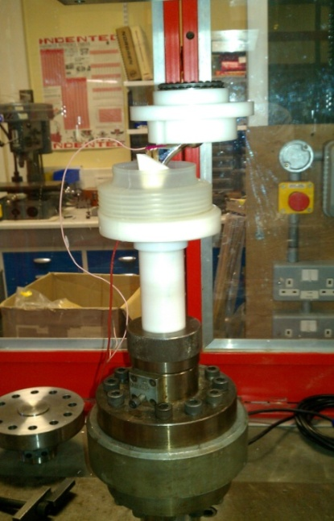  Thrust bearing  Silicone gaiter
(a) | (b)
Figure 1 - (a) CAD and (b) Image of test setup utilised in order to simulate a gait cycle

Table 2 - Commercially available cements tested in this study
Manufacturer | Brand | PMMA bone cement chemistry
DePuy International | SmartSet HV | Non-antibiotic with 15% w/w zirconium dioxide
DePuy International | SmartSet MV | Non-antibiotic with 10% w/w barium sulphate
DePuy International | SmartSet GHV | Gentamicin sulphate (4.22% w/w) with 14.37% w/w zirconium dioxide

2.3 Electrochemical measurements and corrosion morphologies observations
An integrated 3-electrode electrochemical cell was employed in order to monitor the electrochemical responses at the stem/cement interface as a result of dynamic loading. Intermittent Open Circuit Potential (OCP) values and Linear Polarisation Resistance (LPR) measurements were recorded throughout the test in order to quantify the corrosion behaviour at the stem cement interface. Electrochemical measurements were conducted using a PGSTAT101 potentiostat/galvanostat (Metrohm Autolab B.V, Utrecht. NL) from ±50mV_{OCP} at a scan rate of 0.25mV/s in order to quantify the fretting corrosion characteristics at the stem-cement interfaces. LPR and OCP measurements were taken before and after the application of dynamic loading and throughout the test at 0, 24, 25, 50, 100, 150 and 186hrs. Experimentally obtained R_{p} values inputted into the Stearn-Geary coefficient [11], assuming a Tafel constants of 120mV/dec to yield the corrosion current (I_{corr}). I_{corr} values were then plotted as a function of time and used as a method to rank the effects of PMMA bone cement chemistry with respect to fretting-corrosion. In addition to this, synchronised potentiostatic and load applied vs. time measurements were conducted in an attempt to get a high resolution snap shot of how the current released from a cemented femoral stem varies over one cycle. In order to do this, a potential of +50mV vs OCP was applied to the sample and the resultant current sampled at 25 times per second.
Upon completion of each test the electrolyte was drained into a sterile polyethylene bottle and stored in the freezer until analysis to prevent further degradation of the solution. Prior to analysis, samples were defrosted for 24hrs. 10mL of bulk electrolyte was then extracted using a polymer tipped pipette and stabilised in 2%HNO₃. Inductively coupled plasma mass spectrometry (ICP-MS) was utilised to determine concentrations of Co²⁺, Cr³⁺, Mo²⁺ and Fe²⁺ released during free corrosion conditions as a result of mass transfer from the crevice to the bulk electrolyte. Isotope Co 59, Cr, 52, Mo 96 and Fe 58 were used in order to quantify the amount of metal ions released from the metal-cement interface. Cr 52 was chosen to eliminate any interference from Cl and O present in the electrolyte. After cyclic loading and electrochemical measurements, each femoral stem was carefully removed from the PMMA bone cement and the surface morphology and chemistry observed. Each stem was macroscopically assessed for signs of visible wear and corrosion. The interfaces were further examined using Scanning Electron Microscopy (SEM) and Energy Dispersive X-ray spectroscopy (EDX) in order to gain an understanding of the interactions at these interfaces.

- Results
  - OCP measurements
OCP measurements were taken as semi-quantitative indications of material’s passivity (Figure 2). No significant differences in OCP were observed between any of the tests. When the cemented femoral stems were immersed in 0.9% NaCl, an initial OCP of around -0.08V was observed. This was seen to slowly ennoble with time typically reaching values in the range of 0.08 – 0.10V suggesting the development of a protective oxide film [12, 13]. A decrease in OCP was seen under the application of cyclic load, decreasing to around -0.266 to -0.358V. This decrease in OCP suggests a mechanically induced de-passivation of the surface, increasing the corrosion rate of the metallic implant. After 500,000 (138Hrs) cycles were complete the loading was removed. An increase in OCP from around -0.3 to -0.04V was seen demonstrating a re-passivation of the damaged surface and an apparent decrease in the corrosion rates of the cemented femoral stem.
Figure 2 – Measured OCP data for cemented femoral stems with cemented with various PMMA bone cements

  - LPR measurements
In order to assess the effects of PMMA bone cement chemistry on the degradation of cemented femoral stem, LPR measurements at different time intervals were utilised as an indication of the corrosion current of the cemented femoral stems. Figure 3 demonstrates the measured I_{corr} at various time intervals. Upon the application of cyclic loading, I_{corr} was seen to increase demonstrating an increase in the corrosion rate and metal ion release. It is interesting to note that a difference between the I_{corr} exists when different PMMA bone cements are used. PMMA bone cements containing BaSO₄ and gentamicin sulphate antibiotic demonstrated an increase in I_{corr} under cyclic loading, whilst the cements containing zirconium dioxide demonstrated the lowest measured I_{corr} values.
PMMA bone cements containing BaSO₄ demonstrated the highest I_{corr} before and after the application of cyclic loading and throughout the entire test suggesting that such PMMA bone cements create an environment preferential for electrochemical corrosion. Interestingly, the GHV bone cement, containing the gentamicin sulphate antibiotic, demonstrated the lowest I_{corr} both before and after dynamic loading. Conversely the GHV PMMA bone cement demonstrated a similar I_{corr} as the DePuy CMW MV PMMA bone cement under cyclic conditions suggesting an increased rate of localised dissolution at the stem-cement interface. The release mechanisms of gentamicin loaded antibiotic bone cements are fairly well understood. However the addition of the dynamic loading and deformation of the cement may accelerate release rates, increasing the sulphate within the interface resulting in an increased rate of electrochemical dissolution.
Figure 3 - Effects of PMMA bone cement on a femoral corrosion rate

  - Potentiostatic tests
Figure 4 demonstrates the typical current and load transients for 3 cycles obtained during dynamic loading. An interesting current transient was seen, demonstrating a high peak current at the lowest point of the loading cycle and a second lower current peak at maximum load. This shape of current transient was consistently seen throughout all tests conducted. Each current transient seemed to be constructed of a current peak at minimum load and a second peak interrupting the seemingly exponential current decay typically expected in passive alloys. Figure 4d highlights the current transient peaks as a function of load.

2.3kN  0.2kN | 2.3kN  0.2kN
(a) | (b)
2.3kN  0.2kN | Min. Load Max. Load  2.3kN  0.2kN
(c) | (d)
Figure 4 – Current and load transients vs. time at (a) 100,000 (b) 200,000 (c) 300,000 and (d) 400,000 loading cycles.
  - Ionic mass loss
Due to the nature of the system it is difficult to quantify the total mass loss from the metallic femoral stem gravimetrically due to the removal of femoral stem from the cement mantle and the formation and accumulation of corrosion product found within the cement mantle. The ionic mass loss due to oxidation can be calculated from Faraday’s relationship shown in equation 1.
$m=\left(\frac{Q}{F}\right)×\left(\frac{M}{n}\right)$ (1)
Where Q is the total electric charge passed through a substance ($Q=\int_{0}^{t}{Iδt}$, where t is the total time constant), F = 96,485 C mol⁻¹, M is the molar mass of the substance (58.93g assuming stoichiometric dissolution of the alloy) and n is the valence number of ions in the substance (in this case 2 was assuming oxidation according to $Co →{Co}^{2+}+{2e}^{-}$). ICP-MS was also utilised to quantify the amount of metallic ions present in the solution. It is important to appreciate that during ICP analysis, ionisation of any particles present in the solution may occur contributing to the measured ion level. Table 3 demonstrates the mass loss due to oxidation calculated from Faraday’s law and measured ion levels from ICP-MS analysis after 500,000 cycles. Pure electrochemical corrosion was seen to account for around 80% of metallic ion release in the tests using the HV and GHV PMMA bone cements when compared to the MV PMMA bone cement, which suggested pure electrochemical corrosion accounted for around 40% of the total ion release. It is thought that this increase may result from increased fretting wear of the cemented femoral stem. Calculated ionic mass loss demonstrates that the ion release due to corrosion is similar for femoral stems cemented with HV and MV PMMA bone cements. However the additional ions measured by ICP-MS may result from the ionisation of debris produced at the interface.

Table 3 - Ionic mass loss measured and calculated using ICP-MS and Faradays law after 0.5mil cycles
Test Name | Average total metal ion release from ICP (mg) | Average ion release due to corrosion calculated from Faradays law (mg) | Average ion release due to wear/particles (mg)
CMW Smartset HV | 0.79 | 0.65 | 0.14
CMW Smartset GHV | 1.26 | 1.03 | 0.22
CMW Smartset MV | 1.32 | 0.51 | 0.81
The relative ratios of Co, Cr and Mo were also observed (Figure 5). ICP-MS analysis of the solutions demonstrated that a preferential release of Co was seen, accounting 94-96% of the total ions released. Cr and Mo were seen to account for 2-3 and 1-2% of the total ion release respectively. These recent paper presented by Hart et al demonstrated that patients implanted with the Ultima TPS™ femoral stem incurred a preferential release of Cobalt in the surrounding tissues [14].
Figure 5 – relative ratios of Co, Cr and Mo measured using ICP-MS after 0.5million cycles.
Ionic mass loss due to corrosion per loading cycle was also calculated using Faraday’s law. Table 4 demonstrates the total ionic mass loss per unit cycle at various stages of the tests. Application of Faradays’ law to a single current transient demonstrated that on average 1.32×10⁻⁶mg of metal ions are liberated from the metallic femoral stem surface with every loading cycle. Using this average mass loss per loading cycle and assuming a test period of 500,000 cycles, the total mass due to pure electrochemical corrosion is expected to be around 0.66mg which is in good agreement with the values presented in table 3.
Table 4 - Ionic mass loss due to corrosion over one loading cycle.
Sampling point (no. cycles) | Total Charge Passed (Q) | Mass Loss (mg)
100,000 | 7.089×10⁻⁶ | 1.44×10⁻⁶
200,000 | 7.47×10⁻⁶ | 1.52×10⁻⁶
300,000 | 6.51×10⁻⁶ | 1.32×10⁻⁶
400,000 | 5.05×10⁻⁶ | 1.03×10⁻⁶
  - Post test analysis
Figure 6 shows the typical surface morphology, on a macroscopic level, of a cemented femoral stem and counterpart bone cement after being subjected to cyclic loading cycles. In order to access the interfaces each stem was carefully removed and the PMMA bone cement component sectioned though the centre using a hand saw. Fretting-corrosion damage to the surfaces could be typically seen in Gruen zones 1-7 and 2-4 on the anterior and posterior planes on all samples. Damage was also seen on the medial and lateral surfaces from Gruen zones 1-7. However an increased amount of damage was seen on the medial and lateral edges in Gruen zones 1-2 and 7-6 in the lateral and medial edges respectively due to the torsional loading effect.

Although the distribution of fretting-corrosion was seen to be consistent on all femoral stem subjected to cyclic loading, a macroscopic difference in the extent and occurrence of surface film formation was observed. A surface deposit, thought to be a metal oxide was also seen on the surface of the femoral stems cemented with DePuy CMW MV and GHV bone cements. A transfer film, thought to be predominantly Cr₂O₃, was also seen on the surface of the PMMA bone cement after cyclic testing. This was seen on all tests subjected to 500,000 cycles of cyclic loading. EDX was further conducted on the counterpart PMMA bone cement in order to ascertain the chemical composition of the deposit. EDX indicated that the transfer film was rich in Cr and O, whilst trace amounts of Co, Mo and cement radiopacifer were seen. The amount of Cr present on the film was seen to differ between with different PMMA bone cements with stems cemented with DePuy CMW MV bone cement demonstrating an increased amount of Cr present on the surface.
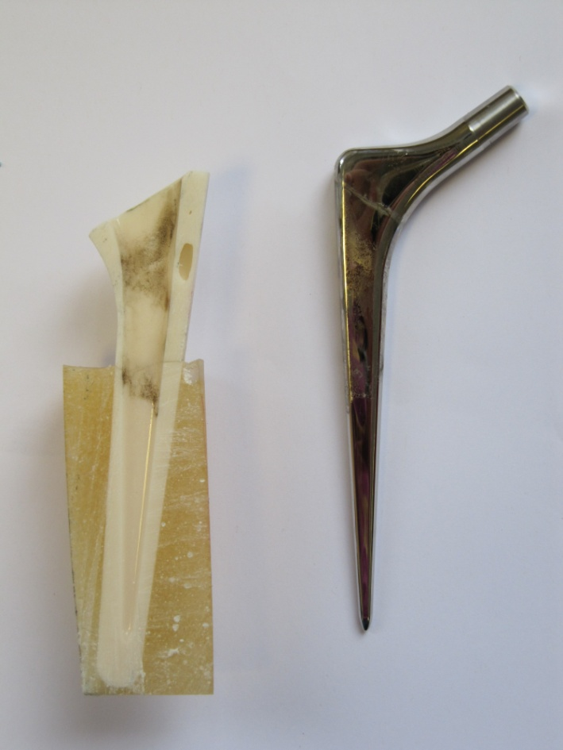 | 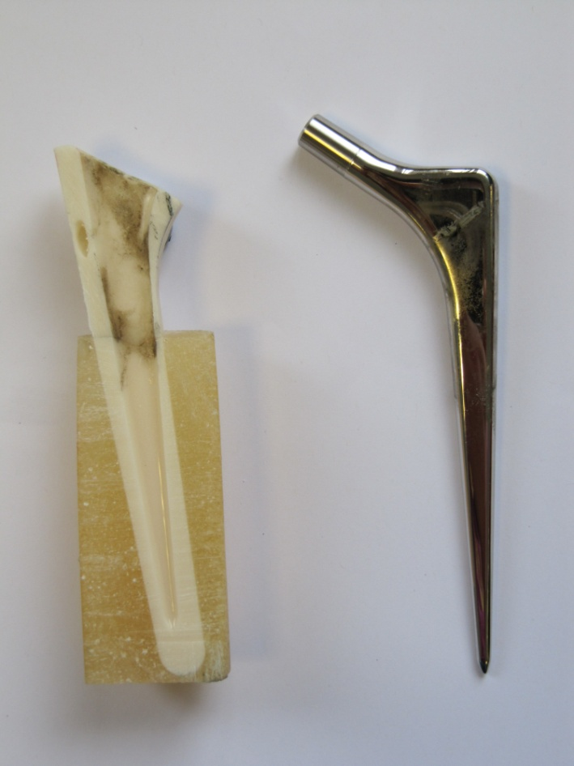
(a) | (b)
Figure 6 – Typical (a) anterior and (b) posterior surface morphology, on a macroscopic level, of a cemented femoral stem and counterpart bone cement
Figures 7 a-b demonstrate the typical surface morphology of the cemented femoral stem after 0.5million cycles. Ploughing of the femoral stem surface was seen in the proximal regions of the femoral stem demonstrating that fretting-corrosion was present at the proximal regions of the interface whilst a more corrosive inter-granular attack was seen in the distal regions of the cemented stems (Figures 7 c-d).
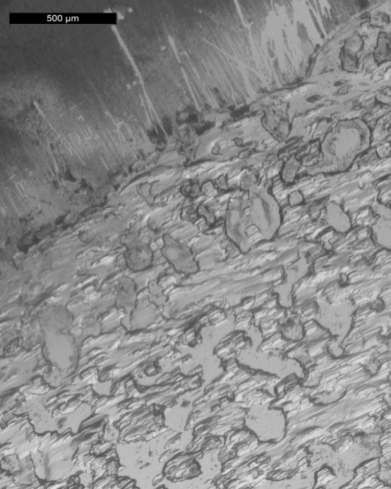
Within Stem-cement interface
Outside Stem-cement interface
(a) | (b)
(c) | (d)
Figure 7 – images of typical surface morphology after 0.5million cycles in (a-b) Gruen zone 1-7 and (c-d) Gruen zone 3-5

- Discussion
In this work, the electrochemical response and surface morphology of cemented CoCrMo femoral stems, subjected to fretting-corrosion conditions have been characterised using OCP, LPR, Potentiostatic and surface analysis techniques. The presence of fretting at the stem-cement interface has recently been studied by Zhang et al [15, 16], who identified that significant wear can occur at the stem-cement interface resulting in accelerated deterioration of a cemented femoral stem. Geringer et al have further presented extensive studies demonstrating how corrosion, and the local environment, can influence the overall mass loss of Metal-PMMA bone cement contacts in fretting-corrosion environments [17-19]. Fretting-corrosion is often defined as a wear phenomena occurring between two surfaces having oscillatory relative motion of small amplitude in which chemical dissolution dominates [20]. To date, the occurrence of fretting-corrosion at the stem-cement interface has been extensively reported as a source of wear and particle debris in clinical studies, being shown to elicit loosening of femoral component and osteolysis. Surface analysis of femoral stems tested in this study demonstrated similar wear location and surface morphologies to the clinical cases presented in [7] and in a case study presented by the author of this paper (Failure analysis of cemented Metal-on-Metal total hip replacements from a single centre cohort: WoM 2013). Retrieved femoral stems were seen to exhibit signs of ductile wear or elastic deformation accompanied by pitting of the surface typically in the anterolateral and posteromedial aspects of the stem, a similar observation that has been reported in this study. Furthermore, this has study demonstrated that the type and chemistry of PMMA bone cements can influence the corrosion regimes at the stem-cement interface. In addition, it has been demonstrated that pure electrochemical corrosion can account for up to 80% of the metal ions released from this interface.
Biomedical alloys typically owe their corrosion and wear properties due to their hardness and the formation of a protective oxide film, shielding the reactive substrate from the aqueous biological environment. However, when such a material is subjected to mechanical wear, the passive oxide film is removed exposing the reactive substrate to the environment resulting in accelerated dissolution and wear as a result. Many fretting-corrosion studies have been conducted demonstrating that often complex synergies between the wear and corrosion exist, making it difficult to understand and quantify the exact rates and mechanisms of degradation [18, 19]. The presence of galvanic interactions on the surface between passive and active regions, as well as mixed metal systems, has also been indentified further adding to the complexity of the issue [13]. Electrochemical results obtained in this study indicated that the application of cyclic loading resulted in a decrease and increase in OCP and I_{corr}, respectively, suggesting localised de-passivation of the cemented CoCrMo femoral stem surface [12, 13].
  - The Role of PMMA bone cement
The presence of radio-pacifiers was further seen to increase the I_{corr} suggesting an increase in metal ion release when different radio-pacifiers were used. Closer examination demonstrated that PMMA bone cements containing BaSO₄ demonstrated the highest I_{corr} values both under static and cyclic loading conditions suggesting that this particular PMMA bone cement may result in an environment preferential for localised corrosion. It is interesting to note that the DePuy GHV and HV bone cements demonstrated similar I_{corr} values under static conditions. However under the application of cyclic loading, the DePuy GHV PMMA bone cement was seen to exhibit an increased I_{corr} similar to the DePuy MV PMMA bone cement.
The integration of BaSO₄ and antibiotics in PMMA bone cements, aiding visibility under X-ray and for the treatment and prevention of infection for implanted orthopaedic devices, has become common clinical practice since the 1970’s, with gentamicin sulphate being extensively used as the primary antibiotic [9, 21]. However, studies to date have questioned the efficacy of the use of antibiotic impregnated cements as the release mechanisms are poorly understood and difficult to control whilst maintaining the integrity of the implant [10]. In the case of the gentamicin loaded PMMA bone cement, it is often the case that antibiotics are used in sulphate form to ensure their solubility in-vitro. The release rates and mechanisms of such PMMA cements have been documented by many authors, being shown to be a function of surface area and antibiotic content [10, 21-23]. However the influence of antibiotics and radio-pacifier release at the stem-cement interface under static and dynamic conditions is still unknown. A study by the author has demonstrated that PMMA bone cement chemistry can influence the initiation and propagation rates of localised crevice corrosion, with gentamicin sulphate and barium sulphate being seen to increase dissolution rates of CoCrMo and 316L stainless steel alloys using a combination of accelerated electrochemical testing and immersion tests [24]. It has long been established that the introduction of chloride and sulphate ions can increase a materials susceptibility to localised corrosion, with extensive research detailing the effects of these ions on the initiation and propagation mechanisms of localised corrosion. Studies have shown that chloride ions can be linked with the initiation stages of pitting corrosion, whilst sulphate ions have been shown to inhibit initiation, but promote propagation once the initiation has occurred on some alloys [25, 26]. Antibiotics are commonly used in sulphate form to ensure their solubility in-vivo and have been shown to leach out of the bone cement over time from exposed surfaces and pores [10]. It is thought that this leaching out of antibiotics from the PMMA bone cement may result in an addition of sulphate ions within the interface, creating conditions favourable of accelerated fretting-corrosion. A study by Newman et al [27] demonstrated that the addition of sulphate had an unexpected effect of lowering the critical pitting temperature of austenitic stainless steels at sufficiently high enough concentrations.
Due to the restricted geometry of the interface and the temperature both in-vivo and in-vitro, it is expected that a high concentration of SO₄ will be present due to the elution of antibiotics at the interface creating conditions preferential for the propagation of localised corrosion. Barium sulphate is also extensively used as a radiopaque agent to enable the bone cement to be visible under radiographs. However it is unknown if the barium sulphate leaches out through similar mechanisms as the antibiotics, or if a disassociation of the Ba and SO₄ occurs further influencing the chemistry of the crevice solution. From the results presented in this study it is thought that the presence of sulphate within the interface not only influences the passivation kinetics of the CoCrMo alloy, but will also increase the rate of dissolution during the mechanically induced depassivation of the surface due to the high concentration of electrochemically negative anions within the interface available to discharge and remove electrons from the metallic interface.
  - Origin of corrosion current transients and metallic ions
A variety of electrochemical techniques were utilised in order to understand how the wear at the stem-cement interface can influence the corrosion kinetics with respect to metal ion release from biomedical devices. Both the general tribo-corrosion response over 500,000 cycles and current transients per loading cycle has been characterised. In general, the results in this study demonstrate that the application of cyclic loading results in a mechanically induced de-passivation of the metallic alloy leaving the exposed substrate free to corrode according to the reaction outlined in equation 2.
$M→M^{n+}+{ne}^{-}$ (2)
However, potentiostatic measurements indicate that the surface is in a constant state of de-passivation and repassivation. Over each loading cycle the Cr rich passive film is fractured exposing the base alloy to the aqueous solution. Oxidation according to equation 2 is thought to occur at the point of contact between the stem and cement. Repassivation of the depassivated areas will also occur according to equation 3. Both the ionic dissolution and repassivation reactions result in the liberation of free electrons which are subsequently detected as current transients [13, 28]. Each current transient is the algebraic sum of the dissolution and oxide growth from the depassivated region (Equation 3)
$M+{nH}_{2}O→MO_{n}+2nH^{+}+2ne^{-}$ (3)
Figure 7 schematically demonstrates the depassivation and repassivation of the CoCrMo surface over one loading cycle. At the initial stages of loading the film, substrate, PMMA bone cement and points of contact are elastically deformed. As the load is increased, the yield stress of the passive film, CoCrMo substrate and PMMA bone cement is exceeded and rupture of the oxide film occurs, along with the potential generation of metallic debris. This results in the CoCrMo substrate being exposed to the solution resulting in an anodic current flow, participating in both equations 2 and 3. At the point where maximum load has been applied, the stem-cement interfaces are held together with the PMMA bone cement protecting most of the depassivated areas in the oxide film from the electrolyte resulting in no current flow. It is thought that the transfer and oxidation of metallic debris occurs when the CoCrMo and PMMA bone cement surfaces are in contact resulting in compressed Cr₂O₃ debris commonly found in fretting systems and also in clinical cases [7, 8, 29].
As the load is removed the surfaces gradually become separated until the contact area is sufficiently reduced to expose the ruptured oxide film and substrate to the electrolyte. A net anodic current flow resulting in the dissolution and repassivation of the oxide film occurs according to equations 2&3. A study by Goldberg [28] demonstrated that the total current (i_{t}) observed at a surface is the sum of the currents (equation 4) due to film growth (i_{f}) and ionic dissolution (I_{d}) (i_{t}=i_{f}+i_{d}). Where δ= oxide thickness, ρ= oxide film density, θ= area fraction covered by oxide, η = over potential for dissolution reaction and β= Tafel slope for dissolution. Goldberg also identified, through a series of scratch tests, that as the load increased, deeper scratches would occur resulting in a larger initial scratch area (A_{o}). As A_{o} increases, both terms in equation 4 increase resulting in an increase in current.
$i_{t}=\frac{δρFA_{o}}{M_{w}}\frac{dθ}{dt}+j_{crit}A_{0}(1-θ)\exp^{\frac{η_{f}}{β_{a}}}$ (4)
The plastic and elastic deformation of the surfaces could also result in the formation of 3rd body debris which will further contribute to the overall anodic current flow and metallic ion release due to an abrasion and mechanical depassivation mechanism when the load is applied and removed. This is an important consideration as particulates produced at the stem-cement interface have been associated with osteolysis and other inflammatory responses [30-32].
Studies investigating the repassivation kinetics of CoCrMo and other alloys have demonstrated that the magnitude of current decreases when multiple scratch’s or indentations are made. This phenomenon has been consistently seen by Goldberg, Sun and Fushimi [28, 33, 34] suggesting that the reformed oxide layer may display different properties to the originally formed oxide film. Sun et al [33] further proposed that localised deformation may also change the crystalline orientation of the alloy, promoting a strain induced transformation from FCC → HCP, affecting both tribological and corrosion characteristics of the material. A similar observation has been seen in this study with a decrease in I_{corr} and potentiostatic current measurements with increasing number of loading cycles. However further studies are required in order to understand how the electro-mechanical properties of passive film vary with load and gait cycle.
The characteristic current transients observed in Figure 4 also raise questions about the suitability of intermittent LPR measurements to determine the general corrosion behaviour of an alloy under tribo-corrosion conditions. Data presented in this study demonstrates that CoCrMo alloy surface is in a constant state of de-passivation and repassivation. LPR measurements are typically conducted ±50mV around OCP. However during cyclic loading OCP measurements reflect two distinct surface states present on the alloy surface active regions passive regions. Polarization of CoCrMo may result in certain areas being subjected to more aggressive polarisation conditions, due to the existence of a galvanic cell present across the surface of the alloy, potentially changing the tribological characteristics, local surface chemistry and reaction kinetics [13]. However it is generally accepted that the magnitude and duration of potentials applied in this study will not cause significant damage to the metallic surface or the composition of the oxide film.
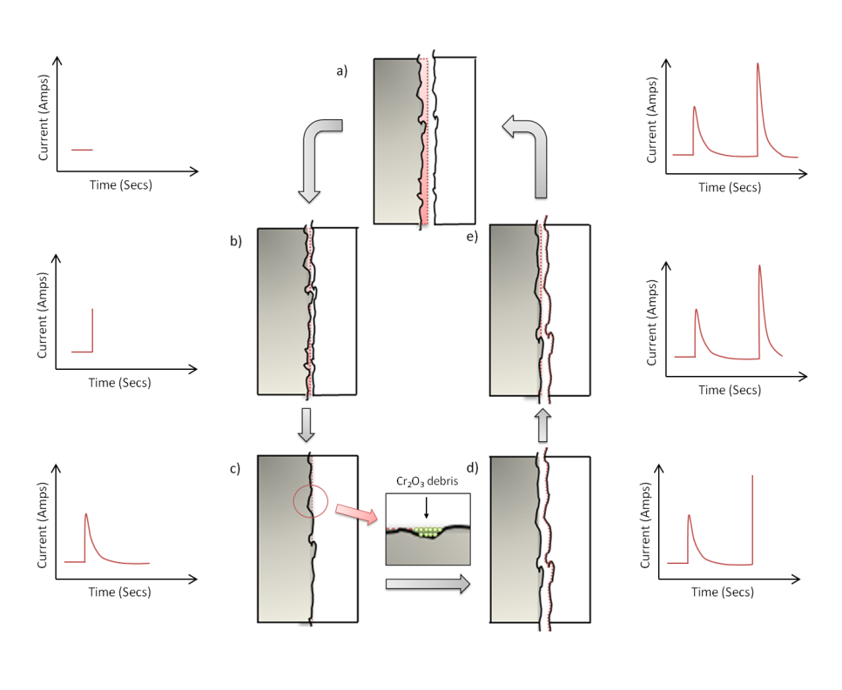
Figure 7 – Schematic representation of current transients observed at the stem-cement interface.
This study has also demonstrated the role fretting-corrosion plays in the generation and magnitude of metallic ions produced at the stem-cement interface. Solution analysis using ICP-MS has identified that a preferential release of Co is seen to account for 94% of all metallic ion release. This supports the data recently published by Hart et al [14] who analysed periprosthetic tissue from two cohorts of patients. Hart found that for patients with the Ultima TPS™ femoral stem (the same femoral stem used in this study); a preferential release of cobalt was seen in the retrieved tissue compared to patients who received hip resurfacing replacements. Hart et al hypothesised that this finding was due to the type of degradation mechanisms taking place at the interface. An in-vivo study by Heisel et al [35] demonstrated that metallic ions were released in a ratio according to the concentrations in the alloy. This further suggests that wear mechanism drastically influences the quantity and type of metallic ions released. The findings by Hesketh et al [12], who observed the tribo-corrosion behaviour of 36mm MoM bearings, further strengthens this argument demonstrating much lower corrosion currents than the stem-cement interface despite the same electrochemical testing and parameters being used. Although the overall mass loss is expected to be far higher from the bearing surfaces due to the mechanical removal of material, the ionic mass loss from stem-cement interface is expected to be similar, if not higher than the bearing surface due to the more corrosive degradation mechanism.
Auxiliary studies by the author have identified and quantified the surface morphology and chemistry of the ‘metallic staining’ typically seen on the PMMA bone cement and cemented portions of the retrieved and simulated THR. Thick layers, primarily consisting of Cr₂O₃ mixed with organic species (observed on the retrieved samples) were observed. No segregation of alloying species was seen when the microstructure of the alloy was observed under SEM/EDX conditions. High levels of Co can be best explained by the thermodynamic stability of the species. Thermodynamics can be used to evaluate the theoretical activity of a given metal or alloy in a known corrosion environment. However it is important to understand that the environment that actually affects the metal corresponds to a micro-environment, i.e. the local environment at the surface of the metal [11].The ability for any chemical reaction to occur, including the reaction of a metal within its environment is measured by the Gibbs free-energy change (ΔG) (equation 5). Where n is number of valence electrons involved in the reaction, F is Faraday’s constant and E_{cell} if the electrochemical cell potential (E_{cell} = E_{cathodic} – E_{anodic}). Where $E_{cathodic}=O_{2}+{4H}^{+}+4e^{-}→{2H}_{2}O=1.23V$) and $E_{anodic}= Co→{Co}^{2+}+2e^{-} = -0.28V or Cr→{Cr}^{3+}+3e^{-}= -0.74V$are the standard electrode potentials for the anodic and cathodic reactions respectively.
$∆G=-nFE_{cell}$ (5)
The more negative the value of ΔG, describes a greater tendency for reaction to occur. If the free-energy is positive, the reaction will have no tendency to occur at all. Although the Gibbs free energy change is a good indication of the material’s susceptibility to corrosion, it cannot be used to measure the corrosion rate of a material. It is thought that Cr is favoured as the species to undergo reaction due to the lower ΔG (-590290) resulting in the formation of Cr₂O₃ corrosion products within the interface. This leaves the soluble Cobalt (ΔG = -457120) to migrate and leave the interface due to an electrical potential being established due to the separation of anodic and cathodic areas due to fretting-crevice corrosion being established at the interface, explaining the high Cobalt levels observed in this study and Hart et al [14].
  - Consideration of other system variables
It is hypothesised that as well as the mechanically induced depassivation by cyclic micro motion, the chemistry within the stem-cement interface will drastically influence the dissolution rates and mechanisms. The introduction of radio-pacifier and antibiotic agents into the PMMA bone cement may cause favourable conditions for the propagation of electrochemical corrosion due to the introduction and leaching of aggressive anions into the stem-cement interface. Furthermore, the occurrence of ‘micro-pores’ and ‘micro-cracking’ of the PMMA bone cement at the stem-cement interface is thought to further increase the surface area of the PMMA bone cement increasing the concentration of sulphate found within the stem-cement interface. Sulphates have been described to increase corrosion rates at metallic surfaces by increasing the rates at which hydrogen is reduced at the metallic surface. As a result, excess metallic valance electrons at the metallic surface will be liberated at an increased rate resulting in more metallic ions being liberated from the metallic matrix. The combination of mechanical depassivation of an alloy and the presence of aggressive anions within the electrolyte will result in violent conditions capable of high amounts of mechanically induced dissolution. In addition to this it is expected, due to the restrictive nature of the interface, that a depletion of oxygen within the interface will occur resulting in a migration of anions and cations in and out of the interface, decreasing the pH within the interface further influencing the dissolution rates at the interface [7, 36-38]. It is also important to consider the abrasive nature of the radio-pacifiers added to the PMMA bone cements to ensure there visibility under X-ray conditions. Commercially available PMMA bone cements commonly use ZrO₂ and BaSO₄, two compounds known for their abrasive characteristics due to high fracture toughness. Some authors have hypothesized that the presence of such compounds may plough the surface of the material further increasing the fretting-corrosion damage found at these interfaces. In a recent study by Zhang et al [39], the influence of bone cement type on the fretting wear of polished femoral stems was observed using scanning electron and 3-D interferometery techniques. Zhang [39] concluded that no significant difference could be seen between femoral stem wear and type of PMMA bone cement used. Although this study has demonstrated a difference between commercially available PMMA bone cement, from the results presented in this study and studies conducted investigating the effects of PMMA bone cement chemistry on the static crevice corrosion mechanisms of CoCrMo alloys and evidence provided by Zhang, it is thought that the chemistry of the PMMA bone cement mainly contributes to the chemical dissolution of the alloy rather than the mechanical wear.
- Conclusions
Electrochemical techniques combined with visual, optical and electron microscopy and solution chemistry techniques have been utilised in order to identify the role PMMA bone cement has on the degradation of cemented femoral stems.
- A novel method has been developed to facilitate in-situ corrosion measurements of cemented femoral stems in a simulated biological environment. avariety of post test analysis techniques where also utilised to support the electrochemical data.
- Fretting-corrosion exists at the stem-cement interface and has been monitored using OCP and LPR electrochemical techniques, characterised by a decrease in OCP and increase in I_{corr} upon application of cyclic loading. Electrochemical measurements were further compliment with surface analysis demonstrating elastic deformation and gross slip of the CoCrMo surface, typical of fretting-corrosion.
- The type of PMMA bone cement can influence the rates of dissolution under static and cyclic conditions. The addition of gentamicin sulphate was seen to increase the I_{corr} representing an increase in localised dissolution. The type of radio-pacifier used was also seen to influence the rates of dissolution both under static and dynamic conditions.
- Potentiostatic measurements demonstrated a characteristic current transient per loading cycle with current peaks been seen at maximum and minimum load. The potentiostatic current was also seen to decrease with number of loading cycles suggesting a change in the electro-mechanical properties of the passive oxide film.
- Ion release measurements demonstrated a preferential release of Co into the solution whilst a Cr and O rich deposit was seen on the counterpart PMMA bone cement within the stem-cement interface. Faradic mass loss, calculated from measured corrosion currents, suggested that 80-82% of metal ions released resulted from fretting-corrosion at the stem-cement interface. It is thought that the additional 18-20% originate from the formation and migration of wear particulate.
References

[1] National Joint Registry. National Joint Registry for England and Wales: 8th Annual Report 2011. http://www.njrcentre.org.uk/njrcentre/default.aspx . Date Last Accessed (10-1-2012)
[2] I.Catelas, A.Petit, D.Zukor, J.Antoniou, O.Huk. TNF-a secretion and macrophage mortality induced bycobalt and chromium ions in vitro-Qualitative analysis of apoptosis. Biomaterials 2003;24:383-91.
[3] I.Catelas, A.Petit, H.Vali, A.Fragiskatos, R.Meilleur, D.Zukor, J.Antonoiu, O.Huk . Quantitative analysis of macrophage apoptosis vs. necrosis induced by cobalt andchromium ions in vitro. Biomaterials 2005;26:2441-53.
[4] J Jacobs, J.Gilbert, R.Urban. Current concepts review – Corrosion of metal orthopaedic implants. The Journal of Bone and Joint Surgery 1998;80:268-82.
[5] O.Huk, I.Catelas, F.Mwale, J.Antoniou, D.Zukor, A.Petit. Induction of Apoptosis and Necrosis by Metal Ions in Vitro. The Journal of Arthoplasty 2004;19:84-7.
[6] H.Dobbs, M.Minski. Metal ion release after total hip replacement. Biomaterials 1980;1:193-8.
[7] S.Donell, C.Darrah, J.Nolan, J.Wimhurst, A.Toms, T.Barker, C.Case, J.Tucker. Early failure of the Ultima metal – on – metal total hip replacement in the presence of normal plain radiographs. Journal of bone and joint surgery [Br] 2010;92:1501-8.
[8] B.Bolland DC, D.Langton, J.Millington, N.Arden, J.Latham. High Failure rates with a large-diameter hybrid metal-on-metal total hip replacement. Journal of Bone and Joint Surgery [Br] 2011;93:608-15.
[9] E.Lautenschlager, G.Marshall, K.Marks, J.Schwartz, C.Nelson. Mechanical strength of acrylic bone cements impregnated with antibiotics. Journal of Biomedical Materials Research 1976;10:837-45.
[10] H.van de Belt, D.Neut, D.Uges, W.Schenk, J.van Horn, H.van der Mei, H.Busscher. Surface roughness, porosity and wettability of gentamicin-loaded bone cements and their antibiotic release. Biomaterials 2000;21:1981-7.
[11] R W Revie. Thermodynamics:Corrosion tendancy and electrode potentials. In: Corrosion and corrosion control, 1 ed. New York: John Wiley and Sons, 2000:22-66.
[12] J. Hesketh, X. Hu, Y. Yan, D. Dowson, A. Neville. Biotribocorrosion: Some electrochemical observations from an instrumented Hip Joint Simulator. Tribology International.
[13] S.Mischler. Triboelectrochemical techniques and interpertation methods in tribocorrosion: A comparative evaluation. Tribology International 2008;41:573-83.
[14] A. Hart, P. Quinn, F. Lali, B. Sampson, J. Skinner, J. Powell, J. Nolan, K. Tucker K, S. Donell, A. Flanagan, J. Mosselmans. Cobalt from metal-on-metal hip replacements may be the clinically relevant active agent responsible for periprosthetic tissue reactions. Acta Biomaterialia.
[15] H.Zhang, L.Brown, L.Blunt, S.Barrans. Influence of Femoral stem surface finish on the apparent static shear strength at the stem-cement interface. Journal of mechanical behaviour of biomedical materials 2008;1:96-104.
[16] H.Zhang, L.Brown, L.Blunt, X.Jiang, S.Barrans. Understanding initiation and propagation of fretting wear on the femoral stem in total hip replacement. Wear 2009;266:566-9.
[17] J. Geringer, D. Macdonald. Modeling fretting-corrosion wear of 316L SS against poly(methyl methacrylate) with the Point Defect Model: Fundamental theory, assessment, and outlook. Electrochimica Acta 2012;79:17-30.
[18] J.Geringer, F.Atmani, B.Forest. Friction-corrosion of AISI 316L/bone cement and AISI 316L/PMMA contacts: ionic strength effect in tribological behaviour. Wear 2009;267:763-9.
[19] J.Pellier, J.Geringer, B.Forest. Fretting-corrosion between 316L SS and PMMA: Influence of ionic strength, protein and electrochemical conditions on material wear. Application to orthopeadic implants. Wear 2011;271:1563-71.
[20] R.B.Waterhouse. Fretting Corrosion: International series of monographs on materials science and technology, Pergamon press, 1972.
[21] G.Gece. Drugs: A review of promising novel corrosion inhibitors. Corrosion Science 2011;53:3873-98.
[22] Frutos Cabanillas P, D-¦¦üez Pe+¦a E, Barrales-Rienda JM, Frutos G Validation and in vitro characterization of antibiotic-loaded bone cement release. International Journal of Pharmaceutics 2000;209:15-26.
[23] Frutos P, Diez-Pe+¦a E, Frutos G, Barrales-Rienda JM Release of gentamicin sulphate from a modified commercial bone cement. Effect of (2-hydroxyethyl methacrylate) comonomer and poly(N-vinyl-2-pyrrolidone) additive on release mechanism and kinetics. Biomaterials 2002;23:3787-97.
[24] M.Bryant, X.Hu, R.Farrar, K.Brummitt, R.Freeman, A.Neville. Crevice Corrosion of Biomedical Alloys: A Novel Method of Assessing the Effects of Bone Cement and its Chemistry . In: Corrosion 2012. Vol. Salt Lake CIty, UT. USA, 2012.
[25] J.Flis, K.Kowalczyk Journal of Applied Electrochemisrty 1995;25:501.
[26] T.Lee, R.Kain. Factors influencing the crevice corrosion behaviour of stainless steels in seawater. National Association of Corrosion Engineers 1983.
[27] M. Moayed, R. Newman. Deterioration in critical pitting temperature of 904L stainless steel by addition of sulfate ions. Corrosion Science 2006;48:3513-30.
[28] J.Goldberg, J.Gilbert. Electrochemical responce of CoCrMo to high-speed fracture of its metal oxide using an electrochemical scratcg test method. J Biomed Res 1997;37:421-31.
[29] I.Feng, S. Barrans. An experimental study of fretting. Proceedings of the Institution of Mechanical Engineers 1956;170:1055-64.
[30] A.Lennon, B.McCormack, P.Predergast. The relationship between cement fatigue damage and implant surface finish in proximal femoral prostheses. Medical Engineering & Physics 2003;25:833-41.
[31] M.Archibeck, J Jacobs, K.Roebuck, T.Glant. The basic science of periprosthetic Osteolysis. The Journal of Bone and Joint Surgery [Br] 2000;82:1478.
[32] Y.Park, Y.Moon, S.Lim, J.Yang, G.Ahn, Y.Choi. Early Osteolysis following second generation metal on metal hip replacement. The Journal of Bone and Joint Surgery [Br] 2005;87:1515-21.
[33] D.Sun, J.Wharton, R.Wood. Micro- and Nano-scal Tribo-Corrosion of Cast CoCrMo. Tribol Lett 2011;41:525-33.
[34] K.Fushimi, K.Takase, K.Azumi, M.Seo. Current transients of passive iron observed during micro-indentation in pH 8.4 borate buffer solution. Electrichemica Acta 2006;51:1255-63.
[35] C.Heisel, N.Striech, M.Krachler, E.Jaubowitz, P.Kretzer. Characterization of the Running-in Period in Total Hip ResurfacingArthroplasty: An in Vivo and in Vitro Metal Ion Analysis. J Bone Joint Surg [Am] 2008;90:125-33.
[36] H.Willert, L.Broback, G.Buchhorn, P.Jemsen, G.Koster, I.Lang, P.Ochsner, R.Schenk . Crevice corrosion of cemented titanium alloy stems in total hip replacements. Clin Orthop Relat Res 1996;333:333-51.
[37] J.Oldfeild, W.Suttton. Crevice Corrosion of Stainless Steel I – A Mathematical Model. Corrosion journal 1978;13:13-22.
[38] J. Oldfield. Crevice corrosion of stainless steels - The importance of crevice geometry and alloy composition. metaux corrosion-industries 1981;56:134-47.
[39] H. Zhang, L. Blunt, X. Jiang, L. Fleming, S. Barrans. The influence of bone cement type on production of fretting wear on the femoral stem surface: A preliminary study. Clinical Biomechanics 2012;27:666-72.

*Corresponding author. Tel.: +44 (0)113 343 2126; fax: +44 (0)113 242 4611. E-mail address: m.g.bryant@leeds.ac.uk (Michael Bryant)

