Table A1 Details of study sites and associated ant species richness.
 |  |  | Species richness |  |  |  | Mean trophic position |  |  |  |  | Proportion of ant occurrences with  trophic position >3.5
Site number | Site name | Forest Area (ha) | Forest | Oil palm | % change |  | Forest | st. dev | Oil palm | st. dev |  | Forest | Oil palm
1 | Danum 1 | Continuous | 52 | 30 | -42.31 |  | 3.19 | 0.46 | 3.23 | 0.36 |  | 0.20 | 0.23
2 | Danum 2 | Continuous | 37 | 32 | -13.51 |  | 3.26 | 0.32 | 3.27 | 0.34 |  | 0.27 | 0.14
3 | Sapi* | 500 | 33 | 27 | -18.18 |  | 3.37 | 0.45 | 3.27 | 0.44 |  | 0.32 | 0.25
4 | Materis | 250 | 48 | 32 | -33.33 |  | 3.12 | 0.55 | 3.24 | 0.38 |  | 0.12 | 0.10
5 | Water catchment* | 120 | 33 | 17 | -48.48 |  | 3.21 | 0.26 | 3.24 | 0.32 |  | 0.02 | 0.07
6 | Sabasar* | 88 | 25 | 15 | -40.00 |  | 3.13 | 0.39 | 3.03 | 0.28 |  | 0.10 | 0.00
7 | Rekasar* | 85 | 28 | 18 | -35.71 |  | 3.13 | 0.35 | 3.14 | 0.41 |  | 0.09 | 0.09
8 | Yong Peng* | 57 | 23 | 22 | -4.35 |  | 3.28 | 0.34 | 3.15 | 0.38 |  | 0.16 | 0.07
9 | Meranti* | 30 | 16 | 11 | -31.25 |  | 3.16 | 0.30 | 3.16 | 0.29 |  | 0.00 | 0.00
10 | Jatu* | 13 | 15 | 17 | 13.33 |  | 3.20 | 0.41 | 3.12 | 0.32 |  | 0.26 | 0.05
11 | Lunpadas* | 11 | 27 | 25 | -7.41 |  | 3.16 | 0.40 | 3.12 | 0.41 |  | 0.09 | 0.09
12 | Delilah* | 5 | 20 | 34 | 70.00 |  | 3.18 | 0.30 | 3.10 | 0.37 |  | 0.05 | 0.03
#negative values for % change indicate lower species richness in oil palm than forest, positive values indicates higher species richness in oil palm.
*Fragments within or adjacent to RSPO compliant plantations.

Table A2 Results of analyses of seven ant species richness estimators examining relationships between species richness within forest fragment sites and adjacent oil palm plantations, and relationships between species richness in forest fragments with ln(fragment area). Forest vegetation quality (PC1 factor score), distance from coast and forest fragment isolation were not important predictors of forest ant species richness, and did not improve model fits. Thus only results for models including ln(fragment area) are presented. Analyses comparing forest and oil palm richness were run excluding a 5 ha site which was an outlier (Fig. 2).
 | relationship between richness in forest and adjacent oil palm (excluding 5ha site: n=11) |  |  |  | relationship between forest species richness and ln(fragment area) (n=10 sites)
 | adj. R2 | F1,9 | p |  | adj. R2 | F1,8 | p
Smax | 0.39 | 7.48 | 0.02 |  | 0.61 | 14.93 | 0.005
MMmean | 0.74 | 28.78 | 0.0004 |  | 0.55 | 12.13 | 0.008
Margalef's index | 0.49 | 10.78 | 0.009 |  | 0.58 | 13.41 | 0.006
Jackknife1 | 0.73 | 27.59 | 0.0005 |  | 0.57 | 13.02 | 0.007
Bootstrap | 0.68 | 21.96 | 0.001 |  | 0.52 | 10.76 | 0.01
ACE | 0.33 | 5.95 | 0.04 |  | 0.47 | 8.93 | 0.02
Chao1 | 0.35 | 6.40 | 0.03 |  | 0.49 | 9.52 | 0.01

Table A3- Results of the Principal Components Analysis of seven forest vegetation variables. Details for measuring variables are in the main text.
 | Component
 | 1 | 2 | 3
% variance accounted for | 37.90 | 16.71 | 14.87
Cumulative % | 37.90 | 54.61 | 69.48
Eigen value | 2.65 | 1.17 | 1.04
Variables:
ground cover (%) | -.349 | .579 | .547
tree density (trees/ ha) | .796 | -.018 | .388
sapling density (saplings/ ha) | .642 | -.110 | -.182
sapling GBH (mm) | .369 | .687 | -.481
tree GBH (mm) | .644 | -.499 | .008
canopy cover (%) | .727 | -.149 | .498
shade cover (%) | .638 | -.282 | -.282

Supplementary information A4- Proportion of groundcover in plantations. Graph A- mean and standard deviation of ground cover (arcsine square root transformed) within sites (N= 5 stations, hollow data points), and across sites (N= 12 sites, filled data point). Graph B- Percentage groundcover at stations with distance from forest (m), and spearman rank order correlation. Graph C- ln(Species richness) at stations with Percentage groundcover at stations, and Spearman rank order correlation.
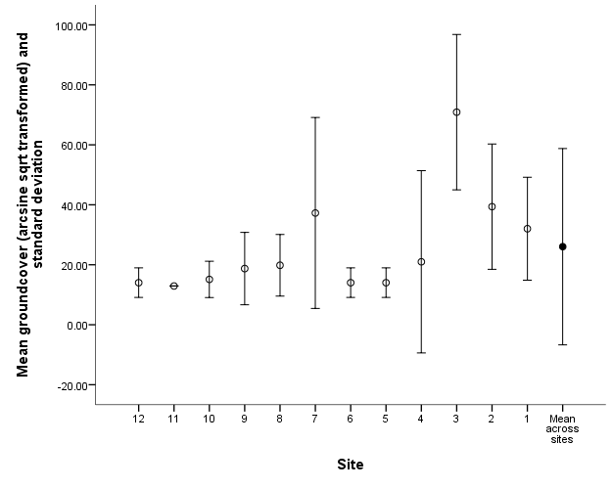
A

C
B
Spearman rank order correlation: r_{s}=-0.02, P=0.9
Spearman rank order correlation: r_{s}=-0.10, P=0.4

