Appendix D: Knight et al. (1992) Sensitivity Analysis

A sensitivity analysis was performed to evaluate the sensitivity of the model to the timing of application of manure in the Knight et al. (1992) experimental simulation, as this information is missing from the paper. The model was set up as in the Knight et al. (1992) manure deposition field trial and simulated on the 1st of each month (day 0 of the experiment). Model outputs of A. caliginosa population biomass for each application timing are presented in Fig. D.1 together with the the published data from Knight et al. (1992) (assuming 44.5% of the total population was equivalent to A. caliginosa).

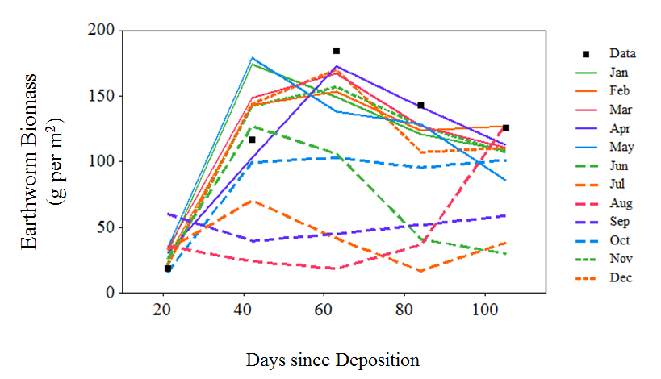
Fig D.1. Model outputs for varying the timing of manure application in Knight et al. (1992)’s manure deposition experiment. The model (lines) is simulated with day 0 of the experiment as the 1st of the respective month, whilst the data (points) is representative of A. caliginosa (44.5% of the total earthworm population) from Knight et al. (1992).

Total sum of square calculations between the data and model outputs showed manure applications in June – September to deviate from the data most. When plotted against average soil temperature and water potential values for each month (Fig D.2) it is clear that these factors are linked. This is due to the impact of soil water potential on the movement of A. caliginosa along the soil profile, with more negative soil water potentials representing drier soil conditions. At values below -25 kPa individuals enter a resting phase, and so are not active in the population. As soil water conditions become wetter with soil depth and cow manure is applied to the soil surface, the exposure of individuals in the population to more energy rich foods becomes reduced, explaining the observations in Fig D.1 & D.2.

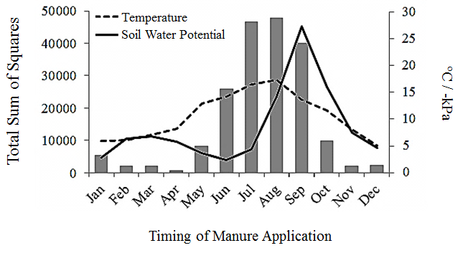
Fig D.2. Total sum of square values for model results when simulating Knight et al. (1992)’s manure deposition experiment with different application times (1st of each month), assessed against data on earthworm biomass at four different dates following application.

References
Knight, D., Ellio, W., Anderson, J.M., Scholefield, D., 1992. The role of earthworms in managed permenant pastures in Devon, England. Soil Biol. Biochem. 24, 1511-1517.

