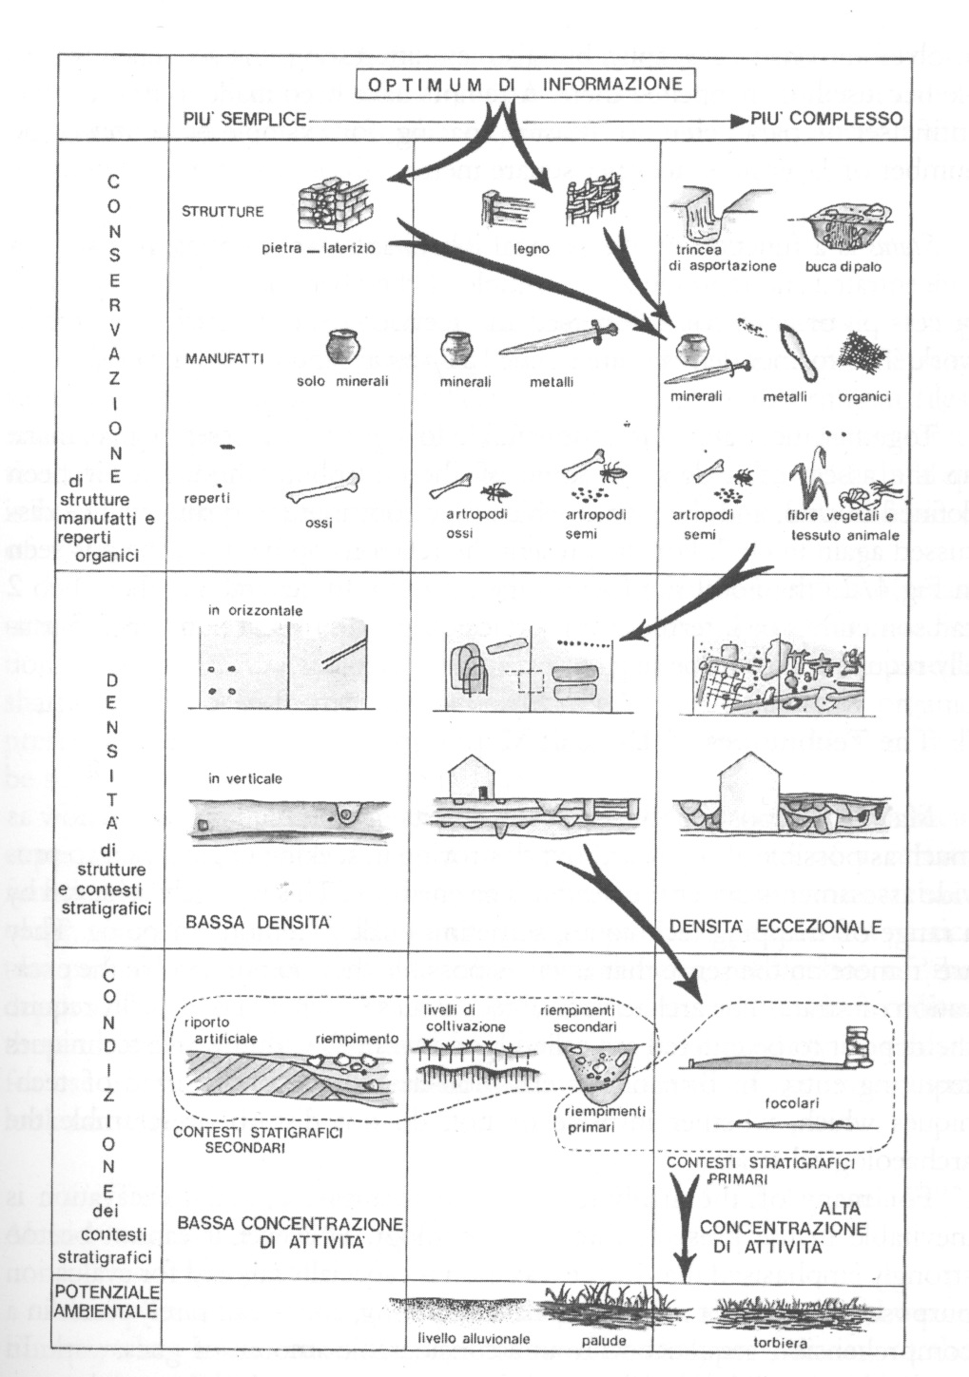
Figure 1 (after Carver 2003, Fig. 14/2 – reproduced with permission) showing how deposits can be classified by preservation, spacing and status. The arrows suggest a route which optimises information yield from a site (see text for further commentary on how this ‘optimum’ needs to be set beside specific research objectives).
Figure 2 (after Emery 1993, Fig. 4 – reproduced with permission) showing contours of stratigraphic complexity at the early medieval site of Coppergate, York. The numbers being illustrated were produced by counting stratigraphic interfaces across different parts of the excavated area. The open area (right) has much lower densities than the structurally-developed area (left), particular concentrations being evident along property boundaries between the three tenements inserted in the latter zone. At the top of the diagram, densities increase in both internal and external areas, as site development approaches the line of a road which bounded the site here.

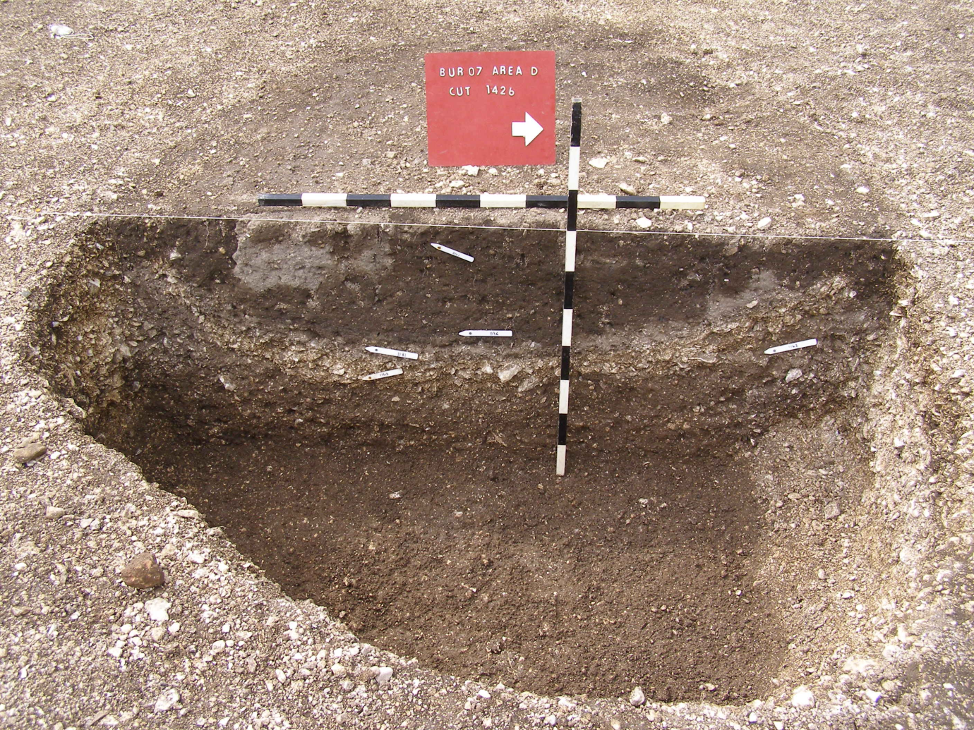
B
C
D
Figure 3 shows an early medieval pit in the course of excavation. Horizon A had not been reached at this stage, but was later found to comprise a thin layer in the base of the feature containing no finds diagnostic of original function. Horizon B, seen here partially excavated, consisted of soil dumped into the feature at the end of its useful life, broadly contemporary with A, although not related to the use of the immediate locality. Horizon C, formed by lenses of soil and natural chalk, suggests weathering from the sides of the feature after it had fallen out of use. Horizon D, much later in date than A-C, was probably a once-horizontal stratum sealing the pit which sunk into it as earlier fills subsided, to then survive later horizontal truncation at the surface.

Figure 4 (after Steane 1993, Fig. 3 – reproduced with permission) shows a ‘landuse diagram’ for the site of Brayford Wharf East, Lincoln, situated at the northern bank of the River Witham. The archaeological sequence runs from the 2nd to 20th centuries AD (left hand side). It shows, in a vertical dimension, the points at which human activity is evident (dumps, revetments and pits); when natural processes predominate (principally riverine deposits); and when truncation occurred. Horizontally, divisions 1-3 concern zones originally within the river (1), on dry land (3) and at the interface between these (2). Note the way in which reclamation gradually impacts on the position of the waterfront and differential truncation at the top of the sequence.

