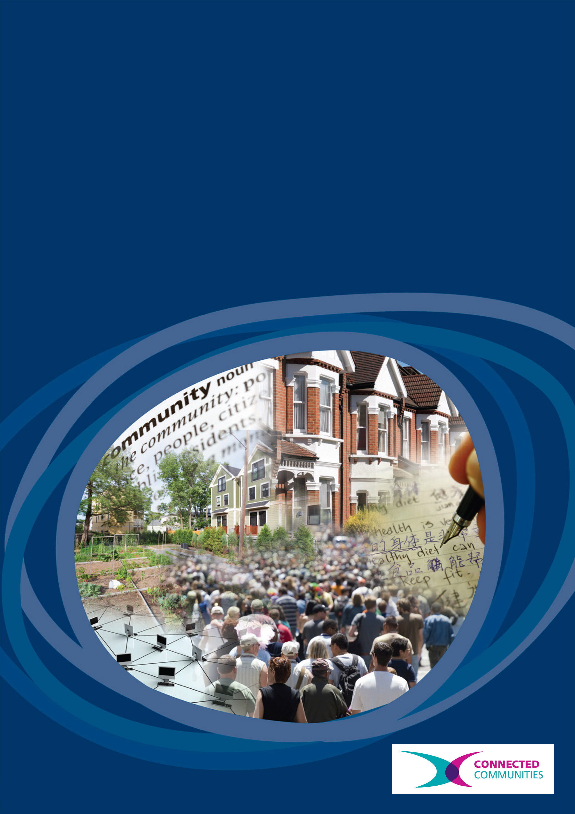
Connected Communities
‘Breaking up communities’? The social impact of housing demolition in the late twentieth century
Rebecca Tunstall and Stuart Lowe
‘Breaking up communities’?
The social impact of housing demolition in the late twentieth century

Rebecca Tunstall and Stuart Lowe
Executive Summary

15% of all homes present in metropolitan areas in England in 1955 had been demolished by 1985, as a result of slum clearance and urban redevelopment. Despite the significance of housing demolition in late twentieth century lives and cities, a literature review using systematic methods found a narrow evidence base on its social impact. Many sources were methodologically weak, and most did not offer before-and-after insights into resident experiences.

One widespread academic and popular summative assessment is that housing demolition ‘broke up communities’ in ways that community members regretted, and was responsible for some of the most profound changes in the nature of ‘community’ in the twentieth century. However, existing evidence is not strong enough to support this argument with confidence. Available evidence suggests that for many households movement was partly chosen; new homes and areas were not distant, and were often preferred. For many, old social networks were maintained or new social networks were preferred.

Additional sources including oral history, testimony of those involved, and archive research on patterns of movement offer great potential for better understanding. These matters are not just of historical concern, as substantial housing demolition also occurred in the 1990s and 2000s issues.
Researchers and Project Partners

The research team included:
- Rebecca Tunstall, Centre for Housing Policy, University of York
- Stuart Lowe, Department of Social Policy and Social Work, University of York
- Stephen Duffy, Centre for Reviews and Dissemination, University of York

The research team worked with about 40 individuals from a wide range of backgrounds who contributed to a study and information sharing day. Their names are listed in ‘Breaking up communities’? Record of a study and information sharing day, November 2nd 2012, York.
Key words

Demolition
Slum clearance
Displacement
Communities
Research methods

‘Breaking up communities’?

Questions about housing demolition in the late twentieth century
In several periods across the twentieth century, central government and local authorities across the UK have carried out large scale housing demolition. Homes were demolished principally to meet aims of housing policy by removing unsatisfactory homes and creating sites for new building. Waves of clearance in the 1930s, 1950s-1970s, and, arguably, in the late 1990s and 2000s, resulted in the movement of millions of households. Between 1955 and 1985, the period which this study focuses on, 1.5m homes were demolished in England and Wales, and 15% of all homes present in metropolitan areas in 1955 had been cleared by 1985. This means that population movement through slum clearance has been part of the history of a substantial minority of families, neighbourhoods and communities across the UK. In some of the bigger cities this process transformed the built environment and involved tens of thousands of households.

There are two main interpretations of slum clearance. Firstly, from the late nineteenth century up to the 1970s: slum clearance was seen as costly process and having many drawbacks, but essential and worthwhile for the eventual society wide, gains. Then in the late twentieth century, there was a reassessment. Clearance was increasingly seen as ineffective, expensive in money, and also costly in other terms. In particular, academic observers, practitioners and members of the affected areas argued that clearance had a huge, unrecognised social cost because it 'broke up communities'.

Until 2000, there was "remarkably, no general account of the incidence [let alone the impact] of slum clearance in England and Wales" (Yelling 2000 p126). There remains no authoritative account of its impact on communities or its 'social meaning': "the wider cultural and political significance of the massive transformation in working class life wrought by slum clearance and suburbanisation has barely begin to be explored" (Jones 2010a p513).The first stage of work in this area is to attempt to form a general account from existing sources.

Aims and methods

This project aimed to explore existing evidence offering insight into the social impact of housing demolition in the twentieth century, and the extent to which it offers support for the idea that slum clearance ‘broke up communities’.

Firstly the research used systematic search and review processes to identify evidence on housing demolition and related population movements, including surveys and case studies of neighbourhoods and individual testimony, drawn from published sources. The aim was to make sure well-known cases did not influence overall results too much, and to ensure that other examples were not overlooked. This is a relatively new approach in contemporary history. The review was carried out by Stephen Duffy, a specialist information scientist at

Secondly, selected evidence was reviewed for relevance, quality and for contributions to answering the following questions.
1. To what extent and for whom did areas subject to slum clearance contain established spatially-based social networks, valued by residents or their members?
2. What proportion of population movement associated with clearance was chosen, desired, accepted or forced?
3. To what extent did movers choose their destination neighbourhoods (and did they remain in their initial destination area)?
4. Did groups of residents from particular neighbourhoods move to the same destination neighbourhoods?
5. How far away did people move (and how long did they stay where they have moved to)?
6. To what extent and for how long did any established spatially-based social networks persist after the moves and clearance?
7. To what extent did those involved in clearance identify and regret any 'break up of community'?
8. How did those affected by clearance assess clearance and refocusing experience overall?
9. How important was any 'break up of community' to their assessment of the clearance and rehousing experience overall?
10. How did the answers to these questions vary across different periods, programmes, sites, individuals and social groups, and stages of processes?
11. How representative of the whole process and experience - across different periods, programmes, sites, social groups, and stages of
processes - are the findings from better-known case studies?
Thirdly, review results were presented at an information sharing day. This brought together 40 people with an interest in the subject, including those affected by clearance in the 1950s, 1960s and 1970s and more recently, both as residents, community activities and as employees of housing organisations, and academics. About half of those who attended also shared their experiences and viewpoints.
Finally, the review results were amended in the light of comments and extra material received at the information sharing day. They are available online.

Results of the literature search

Despite the significance of housing demolition in late twentieth century lives and cities, a literature review using systematic methods found a narrow and somewhat problematic evidence base for assessing its social impact.

The literature search identified just under one hundred sources. Many were excluded because they did not focus on the correct period or on the UK Few sources offered before-and-after insights into resident experiences, even over the short-term. Few had information on outcomes for residents. For example on health, education or cost of living, as well as their attitudes. Many sources were based on quite small samples. Most gave little information about sampling strategy or the socio-economic characteristics of the achieved sample.

The only ‘tracking study’ which we found, which talked to people before and after their moves, was the Ministry of Housing and Local Government’s study of people who moved from St. Mary’s in the centre of Oldham mainly to Oldham Corporation estates in the period 1963-1964/65. This study, published in 1970, interviewed 132 households before the move, 335 after, and 63 both before and after. Unlike most other studies, it explored variations in opinion between residents and the extent to which they could be linked to individual characteristics.

A number of studies talked to people in clearance areas before they moved, and asked about their expectations of the move itself and the new area (rather than actual experience). These include Brennan’s 1957-published study of households in the Gorbals, Glasgow, Vereker and May’s 1961 study of 574 households in the Crown Street area, Liverpool, Dennis et al.’s 1970’s study of 688 people in central Sunderland, Wilkinson and Sigsworth’s 1972 study of 3,370 in slum and ‘twilight’ areas in Leeds, Batley and York, and English et al.’s 1976 study of 1,025 people in area affected by Compulsory Purchase Orders in Newcastle, Liverpool, Tower Hamlets, Leeds, Manchester and ten smaller urban areas. This study used its relatively large sample to explore variations in opinion between areas and individuals, and what might explain them.

There is a larger number of studies which talked to people in new housing sites after they had moved in about their new homes, with recall of their old homes and areas. These studies included people who had moved because their homes were due to be demolished, but also generally included other people. The proportion in each group is sometimes not made clear, and former neighbourhoods are not always identified. This group includes probably the most famous relevant study, Young and Willmott’s 1957 Family and Kinship in East London. This work includes a sub-study of 47 households who moved from Bethnal Green in London in the 1950s to the Essex suburb of ‘Greenleigh’. The small number of interviews and the lack of clarity about sampling is notable. It appears they selected only families with at least two children, and included those who had moved voluntarily and not through demolition. Other studies include Hole’s 1959 study of 88 people who moved within Motherwell and Wishaw, outside Glasgow, with follow-up over a year. Cullingworth’s 1960 study interviewed 250 people who moved from Salford to Worsley (a suburb of Manchester), his 1961 study of 161 who moved from London to Swindon, Jephcott’s 1972 study of people who moved within Glasgow to high rise homes. Mogey’s 1955 study talked simultaneously to 30 people in a ‘slum’ area in Oxford and 30 in a new estate which was among the likely destinations for the first group (but these residents who had not necessarily all arrived following demolition). There are many more studies of movers to new estates, expanded towns, and New Towns which have been excluded because they do not make it clear that at least many new arrivals had experienced demolition and/or they do not ask residents to recall their old neighbourhood and compare it to the new one.

What the existing evidence shows - and doesn’t show

One widespread academic and popular summative assessment is that housing demolition ‘broke up communities’ and was responsible for some of the most profound changes in the nature of ‘community’ in the twentieth century. The implication is that clearance ‘broke up communities’ in ways that community members regretted, and which later proved to be negative. The nature of this assessment links to some of the arguments made in Young and Willmott’s methodologically problematic Family and Kinship in East London. Young and Willmott argued:
“very few people wish to leave the East End [of London]. They are attached to Mum and Dad, to the markets, to the pubs and settlement, to Club Row and the London Hospital” (Young and Willmott 1957 p155). Theirs was an influential study. As they said in a new edition released 40 years after the first:
“Our book was well-received. Extracts were published in the newspapers, the sales were a record for a sociological study, government ministers quoted us” (1990 pxvii).
In October 2012 this 50-year old study had almost 2000 citations in GoogleScholar, while the most citied amongst the other relevant studies had just 100 references and most had far fewer.

However, Young and Willmott’s own evidence is not strong enough to support the ‘breaking up communities’ argument. The authors themselves cautioned against over-interpretation of their results, which they said were “bound to be impressionistic” (1990 p122). Their contemporary Cullingworth noted this point “has been consistently ignored” (1960 p78). In the 1990 edition, the authors reinterpreted their results. They argued that while Greenleigh in the 1980s was unlikely to be “a reborn version” of Bethnal Green in the 1950s, “in general we were too gloomy about the future of such new places in the suburbs" (1990 pxxii) and that some aspects of the Bethnal Green community had survived the move.
When all the other relevant studies are considered, it suggests that slum clearance 1955-85 ‘broke up communities’ in the narrow and less significant sense that:
- It forced people to move
- After the move, the neighbourhood population was more geographically dispersed
- People generally had fewer relatives and friends living within the new neighbourhood than the old neighbourhood
However, existing evidence suggests that in places studied, for most people this ‘breaking up’ communities effect:
- Was less important than other positives and other negatives
- Did not outweigh the home and neighbourhood benefits most people got from moves
- For some people it was a positive.
This means that slum clearance 1955-85 did not ‘break up communities’ in the wider and more significant sense. Thus Young and Willmott may have been ‘too gloomy’ even in 1957.

Not all the studies contain information on the nature of pre-existing community in areas subject to slum clearance, but those that do suggest they did contain established, spatially-based social networks, which were valued by many residents. This does not suggest they were valued above other things, and in some cases at least some residents disliked the people in their area.

Available evidence from the above studies suggests that for many households, movement was favoured if not chosen. For example, while only 17% wanted to leave St. Mary’s, Oldham (MHLG 1970a, b), over half wanted to leave St. Ann’s, Nottingham (Coates and Silburn 1970), 57% were in favour of clearance in central Sunderland (Dennis 1972), and 72% wanted to move in Leeds (Wilkinson and Sigsworth 1972). For many new homes and areas were not distant and/or they were preferred. Some played some role in choosing the new neighbourhood. Many had at least some old neighbours within their new area. The vast majority moved within local authority boundaries – a matter of a few miles. Cases like the move from Bethnal Green to ‘Greenleigh’, 16 miles away, were exceptional. For many, old social networks, and particularly links with closest family and friends, were maintained to a liege extent after the move. In some cases, new social networks were preferred.

For many, no ‘break up of community’ was identified or regretted, or it was not salient in their overall assessment. It appears that the ‘breaking up community’ argument was most likely to apply to older, long-term residents, and those who stood to gain least from moving (home owners and those with better homes), and in cases where this applied to many residents. In their multi-site study, English et al. found that:
“80 per cent of young married households renting houses in poor condition were in favour of moving… three quarters of older households owning a good house were against” (1976 p194).
However, existing data cannot do more than indicate the diversity of experiences.

Additional sources with potential to add to the existing evidence base on twentieth century housing demolition include new oral history and reanalysis of existing oral histories, testimony of those involved, and archive research on patterns of movement and reactions. The record of the study and information sharing day organised as part of this project (see below) demonstrates the richness and diversity of perspectives to be gained from personal testimony.

These matters are not just of historical concern. Substantial numbers of homes were demolished in the 1990s and 2000s. Written evidence and the testimony of many who attended the study and information sharing day suggested that residents involved in more recent demolition face many similar issues.

Recommendations for future research
This field is important to urban studies, housing studies, sociology, social history, and family history, and remains a sensitive and important topic for many of those affected, even decades after moves. Given the weakness of the existing evidence base, the field would benefit from:
- Further searches and reviews of ‘very grey’ literature not accessible to formal searches;
- Further work on case studies in local archives;
- Secondary analysis of existing oral histories;
- New oral history taking into account resident and other viewpoints.
Those who wish to assess the social impact of housing demolition in the 1990s and 2000s may also face problems with the evidence base.
Given the limited support for the ‘strong’ version of the ‘breaking up communities’ thesis, future researchers in a wide range of fields should we wary of and ready to challenge received wisdoms.

The results of the review in detail
A summary of the results of the review and the full results of the review will be available at www.york.ac.uk/chp.
The results of the study and information sharing day can be found in: ‘Breaking up communities’? Record of a study and information sharing day, November 2nd 2012, York.

References and external links

Brennan, T. (1957) ‘Gorbals: A Study in Redevelopment’, Scottish Journal of Political Economy, Vol. 4, p114-126
Bryant, D. and Knowles, D. (1974) ‘Social Contacts on the Hyde Park Estate, Sheffield’, Town and Country Planning Review, Vol. 45, No. 2: 207-14.
Coates, K. and Silburn, R. (1970) Poverty: the Forgotten Englishmen, London, Penguin Books.
Cullingworth J. B. (1960) ‘The Worsley Survey’ Sociological Review, Vol. 8 No. 1 (July).
Cullingworth, J. B. (1961) ‘The Swindon Social Survey’ Sociological Review, Vol. 9 No. 2 (July).
Dennis, N. (1972) People and Planning: the Sociology of Planning in Sunderland, London, Faber.
Dennis, N. (1972) Public Participation and Planners’ Blight, London, Faber and Faber.
English, J., Madigan, R. and Norman, P. (1976) Slum Clearance: the social and administrative context in England and Wales, London, Croom Helm.
Hodges, M. W., Lupton, T., Mitchell, D. G. and Smith, C. S. (1954) Neighbourhood and Community. An enquiry into social relationships on housing estates in Liverpool and Sheffield, (Social Research Series), Liverpool, Liverpool University Press.
Jackson, J. N. (1959) ‘Dispersal – success or failure’ Journal of the Town Planning Institute, Vol. XLV, No. 2 (January)
Jephcott, P. (1971) Homes in High Flats, Edinburgh, Oliver and Boyd.
Jones, B (2010) ‘Slum clearance, privatization and residualization: the practices and politics of council housing in mid-twentieth century England’, Twentieth Century British History, Vol. 21, No. 4, pp. 510-539.
Ministry of Housing and Local Government (1970a) Living in a Slum, A Study of People living in a Central Slum Clearance Area- Oldham London, HMSO
Ministry of Housing and Local Government (1970a) Moving out of a slum: A study of people moving from St. Mary’s, Oldham London, HMSO
Vereker, C. and Mays, J. B. (1961) Urban Redevelopment and Social Change: A Study of Social Conditions in Central Liverpool 1955 - 56, Liverpool, Liverpool University Press.
Wilkinson, R. and D. M. Merry (1965). ‘A Statistical-Analysis of Attitudes to Moving - a Survey of Slum Clearance Areas in Leeds’, Urban Studies 2(1): 1-14.
Wilkinson, R. and E. M. Sigsworth (1963). ‘A survey of slum clearance areas in Leeds’, Yorkshire Bulletin of Economic and Social Research, 15: 25-51
Wilkinson, R. K. and Sigsworth, E. M. (1972) ‘Attitudes to the Housing Environment: An Analysis of Private and Local Authority Households in Batley, Leeds and York’, Urban Studies, 9:193-214.
Yelling, J. (2000). ‘The incidence of slum clearance in England and Wales, 1955-85’, Urban History 27(2): 234-254.
Yelling, J. A. (1999) ‘Residents’ Reactions to Post-War Slum Clearance in England’, Planning History, Vol. 21, No. 3: 5-12.
Young, M. and Willmott, P. (1957) Family and Kinship in East London, London, Routledge.

The Connected Communities

Connected Communities is a cross-Council Programme being led by the AHRC in partnership with the EPSRC, ESRC, MRC and NERC and a range of external partners. The current vision for the Programme is:

“to mobilise the potential for increasingly inter-connected, culturally diverse, communities to enhance participation, prosperity, sustainability, health & well-being by better connecting research, stakeholders and communities.”

Further details about the Programme can be found on the AHRC’s Connected Communities web pages at:

www.ahrc.ac.uk/FundingOpportunities/Pages/connectedcommunities.aspx

