Table of Contents
1. Supplementary Appendix 1........................................................................ 2-4
2. Supplementary Figs. 1–8......................................................................... 5-13
3. Supplementary Tables 1–9 .................................................................... 14-30
4. References ........................................................................................... 31-33

Supplementary Appendix 1: Aridity and grazing thresholds determined by one-dimensional threshold model

One-dimensional threshold model
To evaluate the responses to aridity and grazing, the relationships between all examined ecosystem variables and the two pressures were fitted using linear and non-linear (general additive models [GAM]¹) regressions. The linear and GAM models are developed with the assumption that a given ecosystem attribute changes gradually or nonlinearly but continuously with increases in pressure from the drivers. The best fit in each case was determined by the Akaike information criterion (AIC) and the Bayesian Information criterion (BIC), and the best model was the model with the lowest AIC value or BIC value.
The presence of thresholds was explored when non-linear regressions were better fits to the data. Two types of thresholds were explored: including a continuous threshold or a discontinuous threshold or breaking point, which refer to a continuous or abrupt change in a given variable with environmental pressure, respectively (Supplementary Fig. 5). We fitted threshold models including Segmented, Step and Stegmented to determine thresholds, and used AIC and BIC criteria to select the best model and the associated threshold. However, given that in some cases GAM regressions showed a better performance than threshold models, the thresholds produced by the Segmented models were used to determine the point of maximum curvature of the GAM regressions. The chngpt and gam packages in R were used to fit segmented/step/stegmented and GAM regressions, respectively. We enforced the transformation of the data into an approximately homogeneous distribution of aridity level by sampling. Specifically, we divided the dataset according to aridity in windows taken each 0.015 aridity units (43 windows) and sampled 80 points in each window to build our model with homogeneous distribution of aridity level. When a variable follows a bimodal distribution, quantile regressions were used to correct the maximum likelihood estimation of regular linear regressions that depend on ordinary least squares of the residuals.

Aridity and grazing thresholds
Gradual small increases in aridity lead to a marked change in ecosystem variables once a critical aridity threshold is reached (Extended Data Fig. 1, Supplementary Table 3). Generally, NDVI and plant species richness increased with grazing pressure before attaining equilibrium (Extended Data Fig. 2a and 2d). Grazing pressure was positively related to below-ground carbon density (Extended Data Fig. 2e). Both NDVI and below-ground carbon density showed abrupt changes at a grazing pressure of ~10 grazing livestock units per km² (Supplementary Table 5). Grazing had a neutral effect on the vegetation sensitivity index (Extended Data Fig. 2b), and on the sensitivity of vegetation to precipitation (Extended Data Fig. 2f). Above-ground carbon density first decreased with grazing pressure and increased above a threshold of 178 grazing livestock units per km² (Extended Data Fig. 2c). The four threshold models (Segmented, Generalized Additive Model (GAM), Step and Stegmented) provided a better fit to the data than the linear models (Supplemental Table 4 and 5), highlighting the presence of a discontinuity in dryland structure and functioning along the grazing gradient. Mann-Whitney U tests showed significant differences in the slope and/or intercept of the regressions fitted to the data before and after a threshold (Extended Data Fig. 2 a2–f2), emphasizing that our results are robust and conclusive.
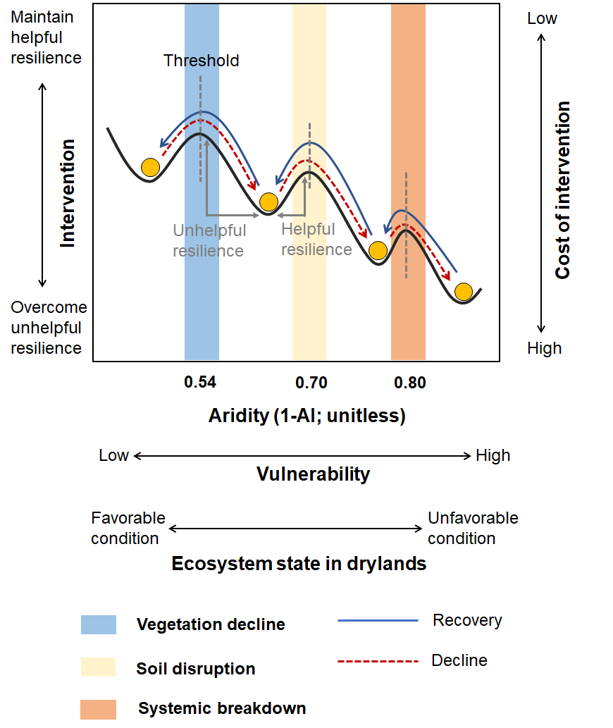

Supplementary Fig. 1. Sequence of aridity thresholds in global drylands. The schematic representation is derived from information in Berdugo, et al. ² and van den Elsen, et al. ³. Ecosystems that pass critical thresholds can experience major losses of biodiversity, ecosystem functioning and resilience, often leading to land abandonment, finally reducing the benefits humans obtain from those ecosystems⁴. Broad empirical evidence suggests that ecosystem structure and functioning are more prone to thresholds at differing critical values of environmental pressure^{2,5}. The abrupt changes occurred sequentially in three phases characterized by abrupt declines in plant productivity, soil fertility, and plant cover and richness at aridity values of approximately 0.54, 0.70, and 0.80, respectively².

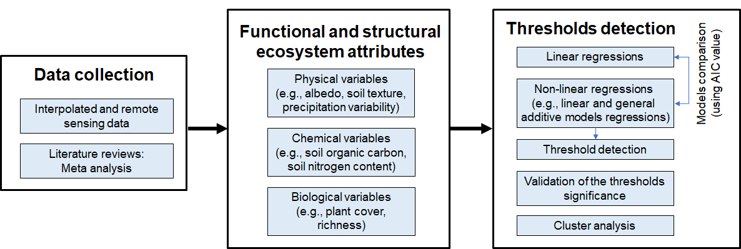

Supplementary Fig. 2. Workflow in the detection of aridity or grazing thresholds. Data were collected from a wide variety of datasets, including interpolated remote sensing information, and meta-analysis from literature review (Supplementary Table 1). 20 functional and structural ecosystem attributes were evaluated, including physical (e.g., albedo, soil texture, precipitation variability), chemical (e.g., soil organic carbon, soil nitrogen content), and biological (e.g., plant cover, richness) variables. The relationships between all examined ecosystem variables and aridity or grazing pressure were fitted using linear and non-linear regressions. When non-linear regressions were a better fit to the data, the presence of thresholds was explored using different threshold models. Validation of the significance of the thresholds and cluster analysis of the thresholds were then conducted.

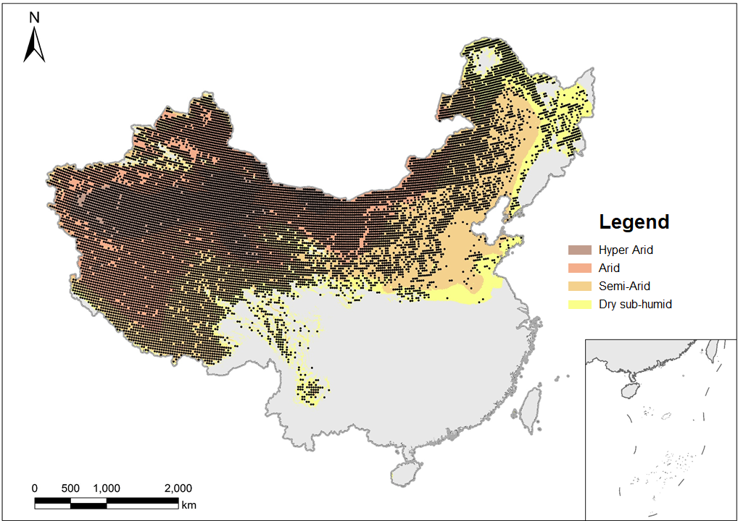

Supplementary Fig. 3. Map showing the points (black dots) where variables obtained from global maps and interpolations. The studied variables include vegetation cover, coefficient of variation of interannual precipitation; NDVI; soil organic carbon and nitrogen, sand content, shrubland occurrence and vegetation sensitivity index. The base map was obtained from the Global Aridity Index database⁶ and China Data Lab⁷.
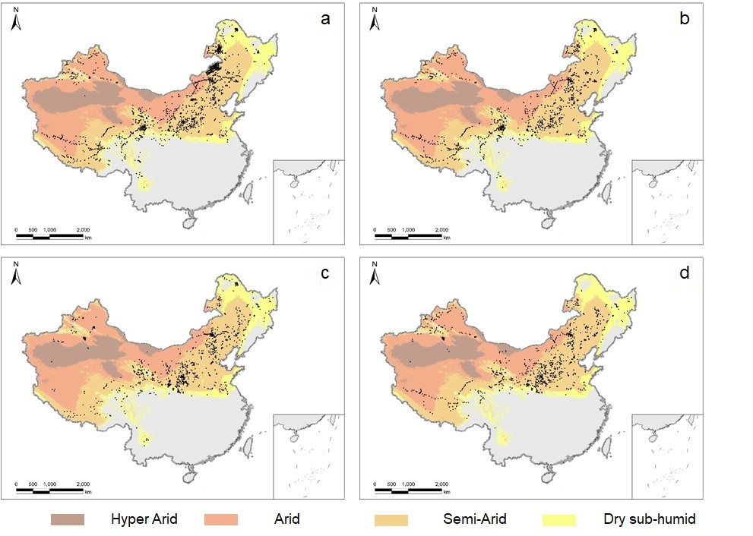

Supplementary Fig. 4. Location of the data points extracted from published literature in the drylands of China. Variables obtained from field survey including: (a) soil organic carbon density (0–20 cm); (b) soil organic carbon density (0–100 cm); (c) above-ground carbon density; and (4) below-ground carbon density. The base map was obtained from the Global Aridity Index database⁶ and China Data Lab⁷.
 | Threshold models
Continuous | 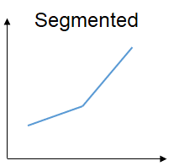 | 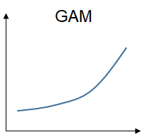
Discontinuous | 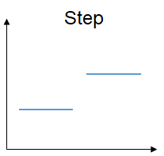 | 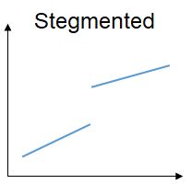

Supplementary Fig. 5. Threshold models used in this study. Segmented: a linear regression that modifies its slope (not 0 for both) at a threshold. Generalized Additive Model (GAM): a smooth non-linear continuous trend between the independent and dependent variables. Step: a linear discontinuous regression that changes only intercept but has its slope as 0 at both sides of a threshold. Stegmented: a linear discontinuous regression that exhibits changes both in intercept and slope at a threshold.
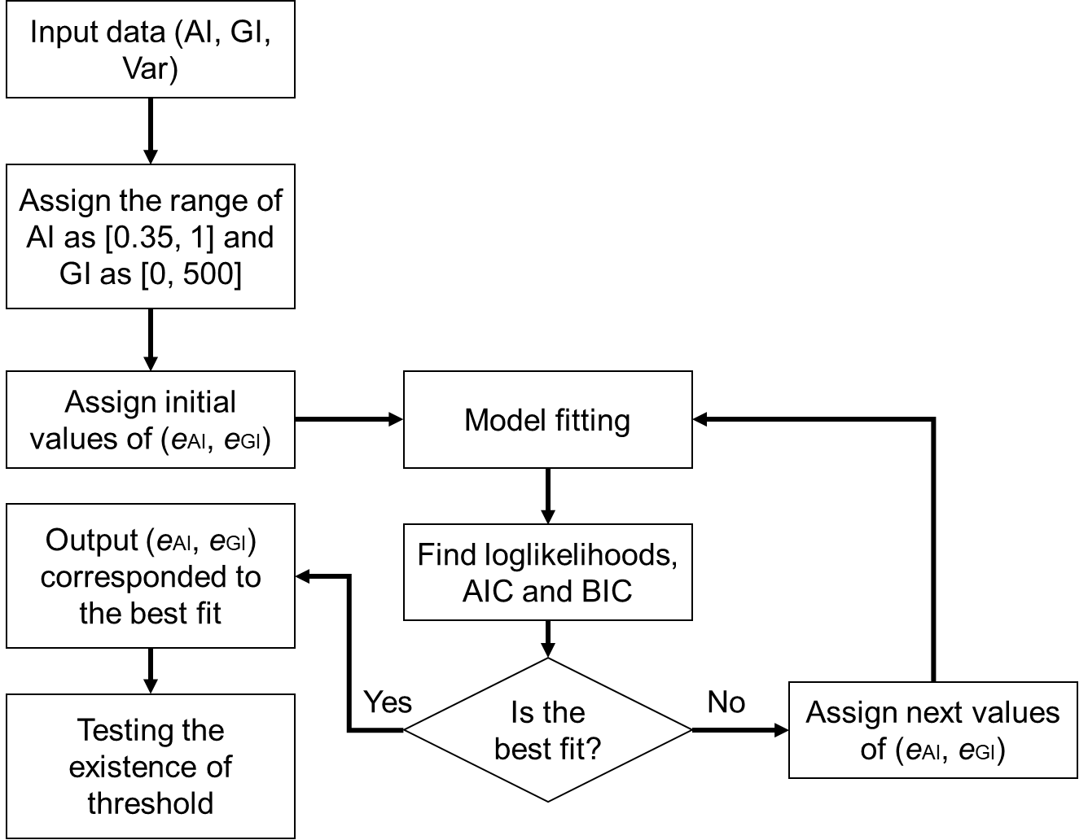

Supplementary Fig. 6. The algorithm of threshold detection. Abbreviations: AI, aridity index; GI, grazing pressure; Var, studied variables (e.g., vegetation fraction cover, inter-annual precipitation variability); e_{AI} and e_{GI} are two threshold parameters related to the predictors of AI and GI; AIC and BIC, criteria used to select the best threshold models.
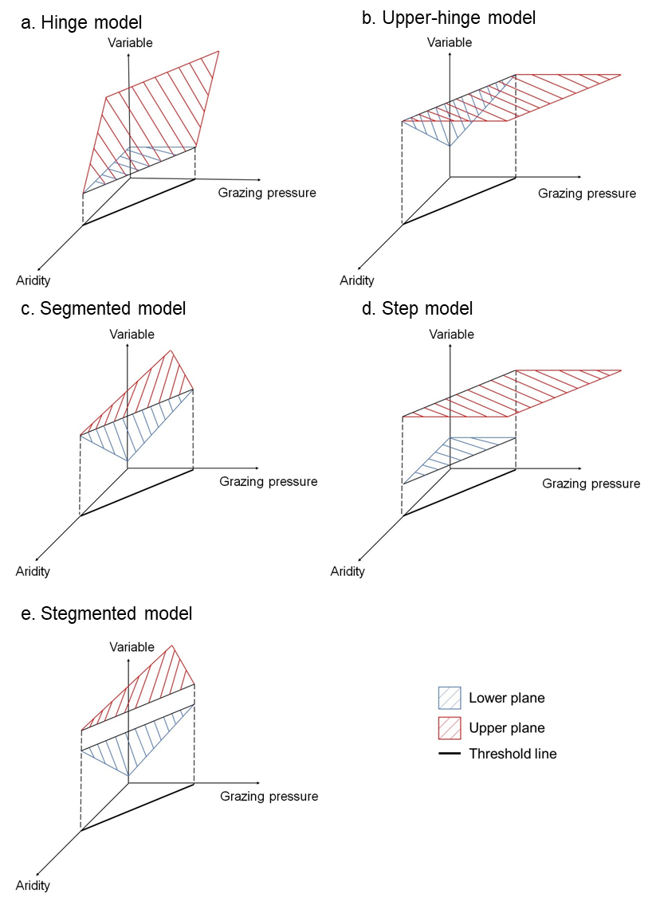

Supplementary Fig. 7. Nonlinear responses of ecosystem variables to the joint effects of aridity and grazing pressure. Brown planes and blue planes represent fitted planes at both sides of each threshold line (red line and detailed in a to e). Five different three-dimensional threshold models are examined, including a: hinge regression (a linear discontinuous regression that changes both intercept and slope (as 0 for brown plane) at both sides of a threshold line), b: upper hinge regression (a linear discontinuous regression that changes both intercept and slope (as 0 for blue plane) at both sides of a threshold line), c: segmented regression (a linear continuous regression that modifies its slope (not 0 for both) at a threshold line), d: step regression (a linear discontinuous regression changes only intercept but has its slope as 0 at both sides of a threshold line) and e: stegmented regression (a linear discontinuous regression that exhibits changes both in intercept and slope at a threshold line).
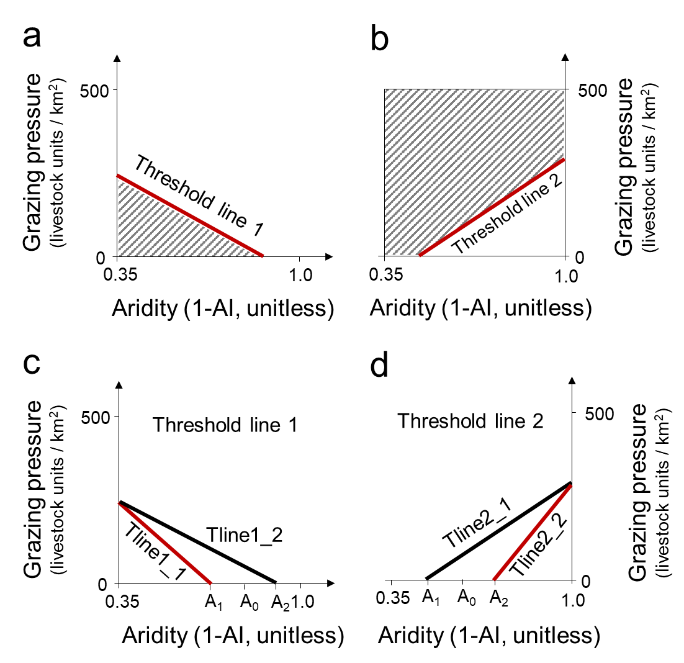

Supplementary Fig. 8. Hypothetical land degradation and thresholds in drylands in response to aridity and grazing pressure. (a-b) The negative relationship between aridity and optimal grazing pressure was determined by the two-dimensional threshold model. There are two scenarios and threshold line types based on original data distribution and automatic model selection: (a) the shaded area below the threshold line (Threshold line 1) is regarded as the ‘safe operating space’, in which for a particular aridity level there is a maximum allowable grazing pressure. (b) the shaded area above the threshold line (Threshold line 2) is regarded as the ‘unsafe operating space’, and the maximum allowable grazing pressure for a particular aridity is determined by 500 (the upper limit of the data)-current grazing level. (c-d) There are two scenarios for both Threshold lines 1 and 2: one type of line (Tline1_1 or Tline2_1) has the aridity threshold (A1, when grazing pressure equals to 0) lower than the threshold A0 determined by the one-dimensional threshold model without the effect of grazing, indicating the synergistic effect of aridity and grazing pressure on thresholds; and the other type of line (Tline1_2 or Tline2_2) has an aridity threshold (A2, when grazing pressure equals to 0) greater than A0, indicating the contrasting effect of aridity and grazing pressure on thresholds. AI = aridity index.

Supplementary Table 1. Description and origin of the map variables used in this study.
Variable  typology | Variables taken | Description | Provider | Database (product) | Reference | Resolution
Climate | Aridity index | The ratio of annual precipitation to annual potential evapotranspiration | CGIAR Consortium for Spatial Information | Global Aridity Index (Global-Aridity) and Global Potential Evapo-Transpiration (Global-PET) Geospatial Database. | ⁶ | 30 arc-secs
Climate | Albedo | White sky albedo (in case of totally diffuse illumination) | LP DAAC | MODIS (MCD43D product) | ⁸ | 250 m
Climate | Inter-annual precipitation variability | Coefficient of variation of interannual precipitation | University of Delaware, NCAR UCAR | TerraClimate 1958-2015 datasets | ⁹ | 4 km
Vegetation | Plant productivity (NDVI) | Normalized Difference Vegetation Index quantifies vegetation by measuring the difference between near-infrared (which vegetation strongly reflects) and red light (which vegetation absorbs). | LP DAAC | MODIS (MOD13Q1 product) | ¹⁰ | 250 m
Vegetation | Vegetation cover | Cover of trees and non-trees vegetation cover as interpolated from MODIS products | LP DAAC | MODIS (MOD44B product) | ¹¹ | 250 m
Vegetation | Percentage area of shrublands vs grasslands | Relative cover of places classified as shrublands vs those classified as grasslands | FAO | (MCD12Q1) MODIS | ¹² | 30 arc-secs
Vegetation | Vegetation sensitivity index | Vegetation sensitivity to climate fluctuations | Alistair Seddon | Vegetation Sensitivity Index (database at LEFT project: https://www.left.ox.ac.uk/) | ⁵ | 5 km
Vegetation | Sensitivity of Vegetation to Precipitation | The slope of regression between NDVI and precipitation, which could reflect changes in the structural and functional ecosystem state that leads to environmental deterioration. | LP DAAC | MODIS (MOD13Q1 product) | ¹³ | 1 km
Vegetation | Plant species richness | calculated by [Native Species Richness - Anthropogenic Species Loss + Anthropogenic Species Increase (Species Invasions + Crop Species + Ornamental Species)] | - | - | ¹⁴ | 0.05 °
Soil | Soil organic carbon | Soil organic carbon content, interpolated from global soil typology maps | ISRIC | ISRIC-WISE Soil Property Databases | ¹⁵ | 30 arc-secs
Soil | Soil nitrogen content | Soil nitrogen content, interpolated from global soil typology maps | ISRIC | ISRIC-WISE Soil Property Databases | ¹⁵ | 30 arc-secs
Soil | Silt + Clay content | Soil Silt and Clay content, interpolated from global soil typology maps | ISRIC | ISRIC-WISE Soil Property Databases | ¹⁵ | 30 arc-secs
Ecosystem | Ecosystem functions | Key ecosystem functions that drylands provided including water yield, soil conservation, carbon sequestration and habitat quality. | Published datasets | - | ¹⁶ | 1 km
Human activities | Grazing pressure | calculated as the sum of the number of livestock including cattle, goats and sheep (animals per km²) | FAO | - | ¹⁷ | 1 km

Supplementary Table 2. Distribution of variables for aridity. Variables used with their corresponding Akaike (AIC) and Bayesian (BIC) values after fitting one mode and two modes by gaussian mixture parameter estimate. Lower AIC/BIC values indicate a better fit of the model.
Variable typology | Variable name | One mode AIC | Two modes AIC | One mode BIC | Two modes BIC | Distribution
Soil | Soil carbon content | 1566.50 | 307.56 | 1578.62 | 337.86 | Bimodality
Soil | Soil nitrogen content | 778.36 | -278.53 | 790.48 | -248.23 | Bimodality
Soil | Soil C/N | -3491.22 | -4151.55 | -3478.96 | -4120.88 | Bimodality
Soil | Biocrust cover | -110.20 | -474.21 | -98.81 | -445.76 | Bimodality
Climate | Inter-annual precipitation variability | -3097.11 | -4015.95 | -3084.85 | -3985.30 | Bimodality
Vegetation | NDVI | 2189.49 | 1217.51 | 2201.78 | 1248.22 | Bimodality
Vegetation | Above-ground carbon density | 1449.45 | 1338.76 | 1458.10 | 1360.40 | Bimodality
Vegetation | Below-ground carbon density | 1020.53 | 931.36 | 1029.42 | 953.59 | Bimodality
Vegetation | Root-shoot ratio | 1675.54 | 1013.97 | 1684.91 | 1037.39 | Bimodality
Vegetation | Plant species richness | -1174.21 | -1329.02 | -1161.92 | -1298.32 | Bimodality
Vegetation | Vegetation fraction cover | 6372.35 | - | 6384.63 | - | Unimodality
Vegetation-Climate | Sensitivity of vegetation to precipitation | 3717.28 | 3451.01 | 3728.79 | 3479.77 | Bimodality
Ecosystem function | Water yield | 1964.05 | 1391.25 | 1976.32 | 1421.94 | Bimodality
Ecosystem function | Carbon sequestration | 3624.55 | 2657.08 | 3636.34 | 2686.54 | Bimodality

Supplementary Table 3. Best models obtained for each variable related to aridity. Variables used with their corresponding Akaike (AIC) and Bayesian (BIC) values after fitting linear, nonlinear and best aridity threshold models. Lower AIC/BIC values indicate a better fit of the model. Coefficients of determination (R²) from the lineal and best model fitted are also shown. GAM = General Additive Models.
Variable typology | Variable name | Aridity threshold | AIC linear | AIC nonlinear | Best AIC | BIC linear | BIC nonlinear | Best BIC | R²  linear | R²  threshold
Soil | Soil carbon content | 0.77 | 403.0 | 195.3 | GAM = 195.3 | 421.2 | 213.4 | GAM = 213.4 | 0.31 | 0.33
Soil | Soil nitrogen content | 0.80 | -201.3 | -375.4 | GAM = -375.4 | -183.1 | -357.2 | GAM = -357.2 | 0.27 | 0.26
Soil | Soil C/N | 0.71 | -3605.8 | -3634.1 | GAM = -3634.1 | -3587.4 | -3615.7 | GAM = -3615.7 | 0.03 | 0.07
Soil | Biocrust cover | 0.92 | -555.6 | -804.9 | GAM = -804.9 | -538.5 | -787.8 | GAM = -787.8 | 0.18 | 0.43
Climate | Inter-annual precipitation variability | 0.96 | -4215.9 | -4717.4 | GAM = -4717.4 | -4197.5 | -4699.0 | GAM = -4699.0 | 0.28 | 0.49
Vegetation | NDVI | 0.71 | -768.6 | -999.1 | GAM = -999.1 | -750.1 | -980.7 | GAM = -980.7 | 0.58 | 0.69
Vegetation | Above-ground carbon density | 0.62 | 1409.7 | 1379.4 | GAM = 379.4 | 1422.6 | 1392.4 | GAM = 1392.4 | 0.07 | 0.11
Vegetation | Below-ground carbon density | 0.81 | 960.5 | 954.7 | GAM = 954.7 | 973.8 | 968.0 | GAM = 968.0 | 0.09 | 0.15
Vegetation | Root-shoot ratio | 0.62 | 1382.3 | 1357.3 | GAM = 1357.3 | 1396.3 | 1371.4 | GAM = 1371.4 | 0.31 | 0.60
Vegetation | Plant species richness | 0.95 | -3280.2 | -3562.7 | GAM = -3562.7 | -3261.7 | -3544.3 | GAM = -3544.3 | 0.46 | 0.43
Vegetation | Vegetation fraction cover* | 0.74 | 3849.3 | 3663.8 | GAM = 3663.8 | 3867.7 | 3682.2 | GAM = 3682.2 | 0.52 | 0.54
Vegetation-Climate | Vegetation sensitivity index | 0.95 | -2025.3 | -2028.2 | GAM = -2028.2 | -2008.6 | -2011.6 | GAM = -2011.6 | 0.01 | 0.02
Vegetation-Climate | Sensitivity of vegetation to precipitation | 0.84 | 3615.7 | 3511.8 | GAM = 3511.8 | 3633.0 | 3529.1 | GAM = 3529.1 | 0.04 | 0.13
Ecosystem function | Water yield | 0.92 | 670.7 | 453.4 | GAM = 453.4 | 689.1 | 471.8 | GAM = 471.8 | 0.32 | 0.32
Ecosystem function | Carbon sequestration | 0.79 | 2567.5 | 2428.5 | GAM = 2428.5 | 2585.1 | 2446.2 | GAM = 2446.2 | 0.33 | 0.32
Note: All variables presented bimodality except for vegetation fraction cover with * that shows unimodality.

Supplementary Table 4. Distribution of variables for grazing pressure. Variables used with their corresponding Akaike (AIC) and Bayesian (BIC) values after fitting one mode and two modes by gaussian mixture parameter estimate. Lower AIC/BIC values indicate a better fit of the model.
Variable typology | Variable name | One mode AIC | Two modes AIC | One mode BIC | Two modes BIC | Distribution
Soil | Soil carbon content | 2139.9 | -4553.7 | 2154.2 | -4518.1 | Bimodality
Soil | Soil nitrogen content | 5728.1 | 3664.5 | 5742.8 | 3701.2 | Bimodality
Soil | Soil C/N | -6262.0 | -11501.0 | -6247.2 | -11463.8 | Bimodality
Soil | Biocrust cover | 1623.9 | 572.8 | 1638.1 | 608.4 | Bimodality
Climate | Inter-annual precipitation variability | -4579.8 | -8195.1 | -4564.9 | -8158.0 | Bimodality
Vegetation | NDVI | 9291.8 | 7286.1 | 9306.7 | 7323.2 | Bimodality
Vegetation | Above-ground carbon density | 8354.1 | 7330.0 | 8366.2 | 7360.4 | Bimodality
Vegetation | Below-ground carbon density | 3733.1 | 3469.0 | 3744.7 | 3497.8 | Bimodality
Vegetation | Root-shoot ratio | 6053.9 | 3092.6 | 6066.0 | 3122.6 | Bimodality
Vegetation | Plant species richness | -1501.9 | -1496.0 | -1487.0 | -1458.9 | Unimodality
Vegetation | Vegetation fraction cover | 19105.6 | / | 19120.5 | / | Unimodality
Vegetation-Climate | Vegetation sensitivity index | -5499.0 | -5692.2 | -5486.0 | -5659.6 | Bimodality
Vegetation-Climate | Sensitivity of vegetation to precipitation | 14315.5 | 13522.5 | 14329.7 | 13557.9 | Bimodality
Ecosystem function | Water yield | 11331.6 | 9929.4 | 11346.5 | 9966.5 | Bimodality
Ecosystem function | Carbon sequestration | 23807.1 | 0.0 | 23822.0 | 0.0 | Unimodality
Ecosystem function | Soil conservation | 27547.1 | / | 27562.0 | / | Unimodality
Ecosystem-Climate | Albedo | -19043.0 | -20037.0 | -19028.2 | -19999.9 | Bimodality

Supplementary Table 5. Best models obtained for each variable related to grazing pressure. Variables used with their corresponding Akaike (AIC) and Bayesian (BIC) values after fitting linear, nonlinear and best threshold models. Lower AIC/BIC values indicate a better fit of the model. Coefficients of determination (R²) from the lineal and best model fitted are also shown. GAM = General Additive Models.
Variable typology | Variable name | Threshold | AIC linear | AIC nonlinear | Best AIC | BIC linear | BIC nonlinear | Best BIC | R²  linear | R²  threshold
Soil | Soil carbon content* | 0.06 | 1950.4 | 1840.5 | GAM = 1840.5 | 1971.8 | 1861.8 | GAM = 1861.8 | 0.02 | 0.18
Soil | Soil nitrogen content* | 0.07 | 5676.5 | 5528.9 | GAM = 5528.9 | 5698.5 | 5551.0 | GAM = 5551.0 | 0.00 | 0.17
Soil | Soil C/N | 43.47 | -6434.1 | -6595.8 | GAM = -6595.8 | -6411.8 | -6573.5 | GAM = -6573.5 | 0.01 | 0.04
Soil | Biocrust cover | 0.06 | 1624.9 | 1246.5 | GAM = 1246.5 | 1646.2 | 1267.9 | GAM = 1267.9 | 0.00 | 0.49
Climate | Inter-annual precipitation variability | 0.06 | -4967.5 | -5166.1 | GAM = -5166.1 | -4945.3 | -5143.9 | GAM = -5143.9 | 0.03 | 0.07
Vegetation | NDVI | 11.38 | 7472.6 | 6467.5 | GAM = 6467.5 | 7494.9 | 6489.8 | GAM = 6489.8 | 0.14 | 0.28
Vegetation | Above-ground carbon density | 177.82 | 8347.5 | 8238.8 | GAM = 8238.8 | 8365.7 | 8257.0 | GAM = 8257.0 | 0.00 | 0.08
Vegetation | Below-ground carbon density | 9.42 | 3725.1 | 3690.6 | GAM = 3690.6 | 3742.3 | 3707.9 | GAM = 3707.9 | 0.00 | 0.05
Vegetation | Root-shoot ratio | 0.04 | 5766.7 | 5678.7 | GAM = 5678.7 | 5784.7 | 5696.8 | GAM = 5696.8 | 0.09 | 0.30
Vegetation | Plant species richness | 3.32 | -2526.5 | -2909.3 | Stegmented = -3375.5 | -2504.2 | -2887.0 | Stegmented = -3338.3 | 0.08 | 0.14
Vegetation | Vegetation fraction cover | 0.03 | 18962.9 | 18898.0 | Stegmented = 18730.3 | 18985.2 | 18920.2 | Stegmented = 18767.4 | 0.01 | 0.03
Vegetation-Climate | Vegetation sensitivity index | 86.85 | -5500.4 | -5513.5 | GAM = -5513.5 | -5480.8 | -5493.9 | GAM = -5493.9 | 0.00 | 0.01
Vegetation-Climate | Sensitivity of vegetation to precipitation | 10.79 | 14109.2 | 13700.0 | GAM = 13700.0 | 14130.4 | 13721.2 | GAM = 13721.2 | 0.02 | 0.10
Ecosystem function | Water yield | 11.44 | 10962.6 | 10661.1 | GAM = 10661.1 | 10984.8 | 10683.4 | GAM = 10683.4 | 0.03 | 0.06
Ecosystem function | Carbon sequestration* | 0.00 | 23672.9 | 23454.9 | Segmented = 21574.9 | 23695.1 | 23477.2 | Segmented = 21604.6 | 0.01 | 0.17
Ecosystem function | Soil conservation* | 0.07 | 27537.7 | 27454.9 | Stegmented = 27318.3 | 27560.0 | 27477.2 | Stegmented = 27355.4 | 0.00 | 0.02
Ecosystem-Climate | Albedo | 41.50 | -19051.7 | -19101.7 | GAM = -19101.7 | -19029.4 | -19079.4 | GAM = -19079.4 | 0.00 | 0.02
Note: All variables presented bimodality except for those with * that shows unimodality.

Supplementary Table 6. Best threshold models and threshold lines obtained for each variable related to the joint effects of aridity and grazing pressure. Variables used with their corresponding Akaike (AIC) and Bayesian (BIC) values after fitting thresholds models and the best threshold models with lowest AIC/BIC values. Coefficients of determination (R²) for the best model fitted are also shown.
Variable typology | Variable name | Best threshold line | Best AIC | Best BIC | Aridity threshold | Grazing threshold | R²  threshold
Soil | Soil carbon content | Threshold line 2 | Segmented = 16660 | Segmented = 16696 | 0.52 | 493.5 | 0.15
Soil | Soil nitrogen content | Threshold line 2 | Segmented = 15926 | Segmented = 15962 | 0.79 | 493.5 | 0.12
Soil | Soil silt + clay | Threshold line 2 | Segmented = 17869 | Segmented = 17905 | 0.96 | 99.7 | 0.05
Soil | Soil C/N | Threshold line 2 | Segmented = 5643 | Segmented = 5679 | 0.98 | 493.5 | 0.01
Soil | Biocrust cover | Threshold line 2 | Segmented = 6983 | Segmented = 7018 | 0.92 | 239.3 | 0.06
Climate | Inter-annual precipitation variability | Threshold line 2 | Segmented = 1650 | Segmented = 1686 | 0.95 | 478.5 | 0.07
Vegetation | NDVI | Threshold line 2 | Segmented = 7754 | Segmented = 7791 | 0.56 | 124.6 | 0.24
Vegetation | Above-ground carbon density | Threshold line 1 | Segmented = 12434 | Segmented = 12464 | 0.70 | 9.8 | 0.32
Vegetation | Below-ground carbon density | Threshold line 1 | Segmented = 7021 | Segmented = 7049 | 0.81 | 73.4 | 0.07
Vegetation | Root-shoot ratio | Threshold line 2 | Segmented = 9454 | Segmented = 9484 | 0.85 | 105.3 | 0.31
Vegetation | Plant species richness | Threshold line 2 | Segmented = 5386 | Segmented = 5422 | 0.94 | 89.7 | 0.10
Vegetation | Vegetation cover | Threshold line 1 | Segmented = 14072 | Segmented = 14105 | 0.68 | 29.9 | 0.34
Vegetation-Climate | Vegetation sensitivity index | Threshold line 1 | Step = 2689 | Step = 2708 | 0.75 | 443.7 | 0.00
Ecosystem function | Water yield | Threshold line 2 | Segmented = 16608 | Segmented = 16644 | 0.93 | 493.5 | 0.18
Ecosystem function | Carbon sequestration | Threshold line 1 | Segmented = 11534 | Segmented = 11567 | 0.85 | 493.5 | 0.14

Supplementary Table 7. Best models obtained for each variable with low and high sand content related to aridity. Variables used with their corresponding Akaike (AIC) and Bayesian (BIC) values after fitting linear, nonlinear and best aridity threshold models. Lower AIC/BIC values indicate a better fit of the model. Coefficients of determination (R²) from the lineal and best model fitted are also shown. GAM = General Additive Models.
Variable typology | Variable name | Sand content (%) | AIC linear | AIC threshold | AIC GAM | Best AIC | R²  linear | R²  threshold | R²  GAM | Aridity threshold
Soil | Soil carbon content | Low | 5363 | 5194 | 5194 | GAM = 5194 | 0.32 | 0.42 | 0.42 | 0.85
Soil | Soil carbon content | High | -352 | -396 | -390 | Segmented = -396 | 0.24 | 0.46 | 0.27 | 0.80
Soil | Soil nitrogen content | Low | -1309 | -1468 | -1414 | Segmented = -1468 | 0.14 | 0.28 | 0.20 | 0.85
Soil | Soil nitrogen content | High | 427 | 333 | 381 | Segmented = 333 | 0.30 | 0.34 | 0.32 | 0.80
Soil | Soil C/N | Low | -2029 | -2893 | -2065 | Segmented = -2893 | 0.00 | 0.12 | 0.03 | 0.53
Soil | Soil C/N | High* | -2157 | -2179 | -2170 | Stegmented = -2179 | 0.02 | 0.03 | 0.03 | 0.93
Soil | Biocrust cover | Low | -346 | -396 | -396 | GAM = -396 | 0.03 | 0.10 | 0.10 | 0.92
Soil | Biocrust cover | High | -393 | -672 | -672 | GAM = -672 | 0.30 | 0.43 | 0.43 | 0.80
Climate | Inter-annual precipitation variability | Low* | -2805 | -2946 | -2946 | GAM = -2946 | 0.28 | 0.34 | 0.34 | 0.95
Climate | Inter-annual precipitation variability | High | -1670 | -2617 | -2191 | Segmented = -2617 | 0.27 | 0.55 | 0.46 | 0.96
Vegetation | NDVI | Low | -3498 | -3596 | -3596 | GAM = -3596 | 0.64 | 0.66 | 0.66 | 0.59
Vegetation | NDVI | High | -225 | -377 | -319 | Segmented = -377 | 0.45 | 0.54 | 0.48 | 0.89
Vegetation | Above-ground carbon density | Low | 1799 | 1766 | 1766 | Segmented = 1766 | 0.26 | 0.28 | 0.28 | 0.76
Vegetation | Above-ground carbon density | High | 6041 | 5951 | 5951 | Segmented = 5951 | 0.11 | 0.13 | 0.13 | 0.41
Vegetation | Below-ground carbon density | Low | 790 | 783 | 783 | Segmented = 783 | 0.11 | 0.19 | 0.12 | 0.89
Vegetation | Below-ground carbon density | High | 2768 | 2744 | 2,744 | Segmented = 2744 | 0.06 | 0.07 | 0.07 | 0.81
Vegetation | Plant species richness | Low | -1546 | -1691 | -1691 | GAM = -1691 | 0.38 | 0.43 | 0.43 | 0.57
Vegetation | Plant species richness | High | -1729 | -1984 | -1984 | GAM = -1984 | 0.45 | 0.53 | 0.53 | 0.95
Vegetation | Vegetation cover | Low* | 1756 | 1665 | 1665 | GAM = 1665 | 0.61 | 0.64 | 0.64 | 0.80
Vegetation | Vegetation cover | High* | 1044 | 1030 | 1039 | Stegmented = 1030 | 0.29 | 0.30 | 0.30 | 0.40
Vegetation-Climate | Vegetation sensitivity index | Low | -1462 | -1466 | -1466 | GAM = -1466 | 0.00 | 0.01 | 0.01 | 0.37
Vegetation-Climate | Vegetation sensitivity index | High | -558 | -566 | -558 | Segmented = -566 | 0.02 | 0.02 | 0.02 | 0.95
Vegetation-Climate | Sensitivity of vegetation to precipitation | Low | 1627 | 1389 | 1559 | Segmented = 1389 | 0.16 | 0.23 | 0.21 | 0.83
Vegetation-Climate | Sensitivity of vegetation to precipitation | High | 1831 | 1750 | 1821 | Segmented = 1750 | 0.00 | 0.04 | 0.01 | 0.88
Ecosystem function | Water yield | Low | 195 | -197 | 80 | Segmented = -197 | 0.27 | 0.21 | 0.32 | 0.92
Ecosystem function | Water yield | High | 547 | 201 | 387 | Segmented = 201 | 0.34 | 0.41 | 0.40 | 0.94
Ecosystem function | Carbon sequestration | Low | 803 | -22 | 632 | Segmented = -22 | 0.36 | 0.29 | 0.42 | 0.76
Ecosystem function | Carbon sequestration | High | 1305 | 1255 | 1255 | GAM = 1255 | 0.20 | 0.24 | 0.24 | 0.89
Note: All variables presented bimodality except for those with * that shows unimodality.

Supplementary Table 8. Best models obtained for each variable with low and high sand content related to grazing pressure. Variables used with their corresponding Akaike (AIC) and Bayesian (BIC) values after fitting linear, nonlinear and best aridity threshold models. Lower AIC/BIC values indicate a better fit of the model. Coefficients of determination (R²) from the lineal and best model fitted are also shown. GAM = General Additive Models.
Variable typology | Variable name | Sand content (%) | AIC linear | AIC threshold | AIC GAM | Best AIC | R²  linear | R²  threshold | R²  GAM | Grazing pressure threshold
Soil | Soil carbon content | Low | 5702 | 5628 | 5671 | Stegmented = 5628 | 0.03 | 0.10 | 0.06 | 1.75
Soil | Soil carbon content | High | -42 | -332 | -152 | Segmented = -332 | 0.02 | 0.18 | 0.11 | 1.17
Soil | Soil nitrogen content | Low | -17 | -448 | -148 | Segmented = -448 | 0.04 | 0.34 | 0.11 | 0.04
Soil | Soil nitrogen content | High | 1025 | 844 | 937 | Segmented = 844 | 0.00 | 0.08 | 0.06 | 1.23
Soil | Soil C/N | Low | -2035 | -2931 | -2087 | Segmented = -2,931 | 0.02 | 0.11 | 0.05 | 0.03
Soil | Soil C/N | High* | -2179 | -2231 | -2230 | Stegmented = -2231 | 0.03 | 0.06 | 0.06 | 113.08
Soil | Biocrust cover | Low | -340 | -602 | -431 | Segmented = -602 | 0.02 | 0.39 | 0.14 | 0.16
Soil | Biocrust cover | High | 99 | -93 | -88 | Segmented = -93 | 0.01 | 0.40 | 0.14 | 0.10
Climate | Inter-annual precipitation variability | Low* | -2244 | -2312 | -2265 | Stegmented = -2312 | 0.00 | 0.04 | 0.01 | 0.14
Climate | Inter-annual precipitation variability | High | -1192 | -1421 | -1203 | Segmented = -1421 | 0.03 | 0.03 | 0.03 | 0.06
Vegetation | NDVI | Low | -1743 | -1859 | -1787 | Stegmented = -1859 | 0.00 | 0.07 | 0.03 | 0.04
Vegetation | NDVI | High | 389 | 236 | 236 | GAM = 236 | 0.20 | 0.27 | 0.27 | 71.87
Vegetation | Above-ground carbon density | Low | 1985 | 1919 | 1919 | Segmented = 1919 | 0.00 | 0.08 | 0.08 | 0.02
Vegetation | Above-ground carbon density | High | 6265 | 6210 | 6217 | Segmented = 6210 | 0.00 | 0.07 | 0.02 | 191.10
Vegetation | Below-ground carbon density | Low | 845 | 828 | 828 | Segmented = 828 | 0.00 | 0.03 | 0.03 | 15.67
Vegetation | Below-ground carbon density | High | 2840 | 2818 | 2818 | Segmented = 2818 | 0.01 | 0.02 | 0.02 | 148.49
Vegetation | Plant species richness | Low | -769 | -878 | -878 | GAM = -878 | 0.01 | 0.07 | 0.07 | 0.10
Vegetation | Plant species richness | High | -843 | -1003 | -860 | Segmented = -1003 | 0.07 | 0.07 | 0.08 | 26.91
Vegetation | Vegetation fraction cover | Low* | 3274 | 3170 | 3177 | Stegmented = 3170 | 0.05 | 0.11 | 0.10 | 0.22
Vegetation | Vegetation fraction cover | High* | 1534 | 1473 | 1485 | Stegmented = 1473 | 0.05 | 0.08 | 0.08 | 15.55
Vegetation-Climate | Vegetation sensitivity index | Low | -1444 | -1451 | -1451 | GAM = -1451 | 0.00 | 0.00 | 0.00 | 108.25
Vegetation-Climate | Vegetation sensitivity index | High | -545 | -551 | -545 | Segmented = -551 | 0.00 | 0.02 | 0.00 | 17.96
Vegetation-Climate | Sensitivity of vegetation to precipitation | Low | 1747 | 1561 | 1626 | Segmented = 1561 | 0.07 | 0.16 | 0.16 | 24.27
Vegetation-Climate | Sensitivity of vegetation to precipitation | High | 1820 | 1654 | 1737 | Segmented = 1654 | 0.01 | 0.10 | 0.08 | 9.63
Ecosystem function | Carbon sequestration | Low | 1487 | 852 | 1461 | Segmented = 852 | 0.00 | 0.08 | 0.02 | 114.85
Ecosystem function | Carbon sequestration | High | 1288 | 909 | 958 | Segmented = 909 | 0.21 | 0.40 | 0.42 | 13.20
Note: All variables presented bimodality except for those with * that shows unimodality.

Supplementary Table 9. A review of previous experiments with at least two levels of controlled grazing pressure and stocking rates in China’s drylands. Data set is mainly derived from published literature¹⁸.
Study area | MAP | ET | Aridity | Year | Grazing pressure | Stocking rate | Unit | Ref
Tibetan Plateau alpine shrublands and meadows | 568 | 426 | 0.792 | 2 | Low | 0.890 | yak/ha | ¹⁹
 |  |  |  |  | Moderate | 1.450 | yak/ha
 |  |  |  |  | High | 2.080 | yak/ha
Tibetan Plateau alpine shrublands and meadows | 568 | 426 | 0.792 | 2 | Low | 0.770 | yak/ha | ¹⁹
 |  |  |  |  | Moderate | 1.290 | yak/ha
 |  |  |  |  | High | 1.810 | yak/ha
Central Tibetan Plateau alpine steppe | 302 | 254 | 0.585 | NA | Low | 2.400 | head/ha | ²⁰
 |  |  |  |  | Moderate | 3.590 | head/ha
 |  |  |  |  | High | 5.990 | head/ha
Tibetan Plateau Alpine Shrublands And Meadows | 420 | 349 | 0.662 | 5 | Low | 2.400 | sheep/ha | ²¹
 |  |  |  |  | Moderate | 3.600 | sheep/ha
 |  |  |  |  | High | 6.000 | sheep/ha
Mongolian-Manchurian Grassland | 346 | 254 | 0.404 | 7 | Low | 1.500 | sheep/ha | ²²
 |  |  |  |  | Moderate | 4.500 | sheep/ha
 |  |  |  |  | High | 9.000 | sheep/ha
Mongolian-Manchurian grassland | 339 | 307 | 0.424 | 13 | Low | 1.330 | sheep/ha | ²³
 |  |  |  |  | Moderate | 4.000 | sheep/ha
 |  |  |  |  | High | 6.670 | sheep/ha
Mongolian-Manchurian grassland | 346 | 254 | 0.409 | 6 | Low | 0.083 | kg sheep/kg herbage | ²⁴
 |  |  |  |  | Moderate | 0.266 | kg sheep/kg herbage
 |  |  |  |  | High | 0.660 | kg sheep/kg herbage
Mongolian-Manchurian Grassland | 346 | 254 | 0.404 | 5 | Low | 1.500 | sheep/ha | ²⁵
 |  |  |  |  | Moderate | 4.500 | sheep/ha
 |  |  |  |  | High | 9.000 | sheep/ha
Mongolian-Manchurian grassland | 339 | 307 | 0.424 | 8 | Low | 1.330 | sheep/ha | ²⁶
 |  |  |  |  | Moderate | 2.670 | sheep/ha
 |  |  |  |  | High | 4.000 | sheep/ha
Central China Loess Plateau Mixed Forests | 425 | 337 | 0.443 | 3 | Moderate | 6.700 | sheep/ha | ²⁷
 |  |  |  |  | High | 9.300 | sheep/ha
Southeast Tibet shrublands and meadows | 663 | 500 | 0.772 | 10 | Moderate | 1.800 | yaks/ha | ²⁸
 |  |  |  |  | High | 3.200 | yaks/ha
Mongolian-Manchurian Grassland | 384 | 341 | 0.514 | 3 | Low | 0.230 | AU/ha | ²⁹
 |  |  |  |  | Moderate | 0.460 | AU/ha
 |  |  |  |  | High | 0.920 | AU/ha
Mongolian-Manchurian grassland | 363 | 300 | 0.488 | NA | Low | 2.000 | sheep/ha | ³⁰
 |  |  |  |  | Moderate | 4.000 | sheep/ha
 |  |  |  |  | High | 6.000 | sheep/ha
Mongolian-Manchurian grassland | 399 | 240 | 0.412 | 5 | Low | 2.000 | sheep/ha | ³¹
 |  |  |  |  | Moderate | 4.000 | sheep/ha
 |  |  |  |  | High | 6.000 | sheep/ha
Northeast China Plain deciduous forests | 418 | 372 | 0.438 | 5 | Low | 2.000 | sheep/ha | ³²
 |  |  |  |  | Moderate | 4.000 | sheep/ha
 |  |  |  |  | High | 6.000 | sheep/ha
Mongolian-Manchurian grassland | 399 | 240 | 0.412 | 4 | Low | 2.000 | sheep/ha | ³³
 |  |  |  |  | Moderate | 4.000 | sheep/ha
 |  |  |  |  | High | 6.000 | sheep/ha
Southeast Tibet shrublands and meadows | 482 | 299 | 0.789 | 17 | Low | 2.550 | sheep/ha | ³⁴
 |  |  |  |  | Moderate | 4.320 | sheep/ha
 |  |  |  |  | High | 5.430 | sheep/ha
Mongolian-Manchurian grassland | 399 | 240 | 0.411 | 14 | Low | 2.000 | sheep/ha | ³⁵
 |  |  |  |  | Moderate | 4.000 | sheep/ha
 |  |  |  |  | High | 6.000 | sheep/ha
Southeast Tibet shrublands and meadows | 470 | 425 | 0.712 | 16 | Low | 2.550 | sheep/ha | ³⁶
 |  |  |  |  | Moderate | 4.300 | sheep/ha
 |  |  |  |  | High | 5.350 | sheep/ha
Southeast Tibet Shrublands And Meadows | 686 | 490 | 0.872 | 20 | Low | 0.940 | yak/ha | ³⁷
 |  |  |  |  | Moderate | 1.550 | yak/ha
 |  |  |  |  | High | 2.860 | yak/ha
Note: MAP: mean annual precipitation; ET: mean annual real evapotranspiration; Aridity: calculated as MAP/Potential evapotranspiration (PET); AU: animal unit equivalents, with 1 AU defined relative to one mature cow (i.e., one cow = 1.00 AU). The other livestock numbers converted into AU are: one horse = 1.80 AU, one sheep = 0.15 AU, one goat = 0.10 AU, one camel = 1.25 AU, one donkey = 1.05 AU, and one mule = 0.15 AU³⁸.

References
1 Manzoni, S., Jackson, R. B., Trofymow, J. A. & Porporato, A. The global stoichiometry of litter nitrogen mineralization. Science 321, 684-686 (2008).
2 Berdugo, M. et al. Global ecosystem thresholds driven by aridity. Science 367, 787-790 (2020).
3 van den Elsen, E. et al. Advances in Understanding and Managing Catastrophic Ecosystem Shifts in Mediterranean Ecosystems. Frontiers in Ecology and Evolution 8, 323 (2020).
4 Maestre, F. T. et al. Structure and functioning of dryland ecosystems in a changing world. Annual Review of Ecology, Evolution, Systematics 47, 215-237 (2016).
5 Seddon, A. W., Macias-Fauria, M., Long, P. R., Benz, D. & Willis, K. J. Sensitivity of global terrestrial ecosystems to climate variability. Nature 531, 229-232 (2016).
6 Trabucco, A. & Zomer, R. J. (ed CGIAR Consortium for Spatial Information (CGIAR-CSI)) (Published online, available from:
https://figshare.com/articles/dataset/Global_Aridity_Index_and_Potential_Evapotranspiration_ET0_Climate_Database_v2/7504448/3, 2018).
7 Digital Map Database of, C. (Harvard Dataverse, 2020).
8 Liu, J. et al. Validation of Moderate Resolution Imaging Spectroradiometer (MODIS) albedo retrieval algorithm: Dependence of albedo on solar zenith angle. Journal of Geophysical Research: Atmospheres 114 (2009).
9 Abatzoglou, J. T., Dobrowski, S. Z., Parks, S. A. & Hegewisch, K. C. TerraClimate, a high-resolution global dataset of monthly climate and climatic water balance from 1958–2015. Scientific Data 5, 1-12 (2018).
10 Tucker, C. J. & Sellers, P. Satellite remote sensing of primary production. International Journal of Remote Sensing 7, 1395-1416 (1986).
11 Justice, C. et al. An overview of MODIS Land data processing and product status. Remote Sensing of Environment 83, 3-15 (2002).
12 Zomer, R. J., Trabucco, A., Bossio, D. A. & Verchot, L. V. Climate change mitigation: A spatial analysis of global land suitability for clean development mechanism afforestation and reforestation. Agriculture, Ecosystems & Environment 126, 67-80 (2008).
13 Li, C. et al. Drivers and impacts of changes in China’s drylands. Nature Reviews Earth & Environment 2, 858-873, doi:10.1038/s43017-021-00226-z (2021).
14 Ellis, E. C., Antill, E. C. & Kreft, H. All is not loss: plant biodiversity in the Anthropocene. PloS one 7, p.e30535 (2012).
15 Batjes, N. H. Harmonized soil property values for broad-scale modelling (WISE30sec) with estimates of global soil carbon stocks. Geoderma 269, 61-68 (2016).
16 Xu, J., Chen, J., Liu, Y. & Fan, F. Identification of the geographical factors influencing the relationships between ecosystem services in the Belt and Road region from 2010 to 2030. Journal of Cleaner Production 275, 124153 (2020).
17 FAO. Gridded livestock of the world 2007. 131 (Rome, 2007).
18 Herrero‐Jáuregui, C. & Oesterheld, M. Effects of grazing intensity on plant richness and diversity: A meta‐analysis. Oikos 127, 757-766 (2018).
19 Dong, Q. et al. Effects of yak grazing intensity on quantitative characteristics of plant community in a two-seasonal rotation pasture in Kobresia parva meadow. Chin J Ecol 30, 2233-2239 (2011).
20 Duan, M. et al. Effect of grazing on community characteristics and species diversity of Stipa purpurea alpine grassland in Northern Tibet. Acta Ecologica Sinica 30, 3892-3900 (2010).
21 Ganjurjav, H. et al. Effects of grazing by large herbivores on plant diversity and productivity of semi-arid alpine steppe on the Qinghai-Tibetan Plateau. The Rangeland Journal 37, 389-397 (2015).
22 Li, W., Zhan, S., Lan, Z., Ben Wu, X. & Bai, Y. Scale-dependent patterns and mechanisms of grazing-induced biodiversity loss: evidence from a field manipulation experiment in semiarid steppe. Landscape Ecology 30, 1751-1765 (2015).
23 Liu, Z. G., Li, Z. Q., Dong, M. & Johnston, B. The response of a shrub‐invaded grassland on the Inner Mongolia steppe to long‐term grazing by sheep. New Zealand Journal of Agricultural Research 49, 163-174 (2006).
24 Ren, J. S., Stenton-Dozey, J., Plew, D. R., Fang, J. & Gall, M. An ecosystem model for optimising production in integrated multitrophic aquaculture systems. Ecological Modelling 246, 34-46 (2012).
25 Wan, H. et al. Selective grazing and seasonal precipitation play key roles in shaping plant community structure of semi-arid grasslands. Landscape ecology 30, 1767-1782 (2015).
26 Shi-Ping, W., Yong-Hong, L., Yan-Fen, W. & Zuo-Zhong, C. Influence of different stocking rates on plant diversity of Artemisia frigida community in Inner Mongolia steppe. Journal of Integrative Plant Biology 43, 89 (2001).
27 Wang, Z., Johnson, D., Rong, Y. & Wang, K. Grazing effects on soil characteristics and vegetation of grassland in northern China. Solid Earth 7, 55-65 (2016).
28 Wu, G.-L., Li, X.-P., Cheng, J.-M., Wei, X.-H. & Sun, L. Grazing disturbances mediate species composition of alpine meadow based on seed size. Israel Journal of Ecology Evolution 55, 369-379 (2009).
29 Yan, R. et al. Impacts of differing grazing rates on canopy structure and species composition in Hulunber meadow steppe. Rangeland Ecology Management 68, 54-64 (2015).
30 Yang, D., Han, G., Hu, Y. & Wu, Y. Effects of grazing intensity on plant diversity and aboveground biomass of Stipa baicalensis grassland. Chinese Journal of Ecology 25, 1470-1475 (2006).
31 Zhang, T. H., Zhao, H. L., Li, S. G. & Zhou, R. L. Grassland changes under grazing stress in Horqin sandy grassland in Inner Mongolia, China. New Zealand Journal of Agricultural Research 47, 307-312 (2004).
32 Zhao, H., Zhang, T., Zhao, X. & Zhou, R. Effect of grazing on sandy grassland ecosystem in Inner Mongolia. The Journal of Applied Ecology 15, 420-424 (2004).
33 Zhao, H.-L., Zhang, T.-H., Zhao, X.-Y. & Zhou, R.-L. in 2nd International Conference on Environmental Science and Development, IPCBEE.
34 Zhou, H., Tang, Y., Zhao, X. & Zhou, L. Long-term grazing alters species composition and biomass of a shrub meadow on the Qinghai-Tibet Plateau. Pak. J. Bot. 38, 1055-1069 (2006).
35 Zhou, W., Xiang, D., Hu, Y., Li, Z. & Chen, B. Influences of long-term enclosure on the restoration of plant and AM fungal communities on grassland under different grazing intensities. Acta Ecologica Sinica 33, 3383-3393 (2013).
36 Zhu, H. et al. The effects of large herbivore grazing on meadow steppe plant and insect diversity. Journal of Applied Ecology 49, 1075-1083 (2012).
37 Zou, Y., Niu, D., Fu, H., Zhang, Y. & Wan, C. Moderate grazing promotes ecosystem carbon sequestration in an Alpine meadow on the Qinghai-Tibetan plateau. J Anim Plant Sci 25, 165-171 (2015).
38 Holechek, J. L. An approach for setting the stocking rate. Rangelands Archives 10, 10-14 (1988).

