The Early Exhibition and Publication of Persian Mīnāʾī and Lājvardīna Wares in Japan: 1915 to 1930
Richard Piran McClary (University of York)

Abstract
This article examines the introduction of two specific types of medieval polychrome overglaze ceramic wares produced in Iran into the Japanese art market, primarily through the prism of publications and records of various exhibitions held in Osaka, Kyoto and Tokyo in the years between 1924 and 1930. The rise in interest in this material in Europe and North America is far better known, but the early period in Japan has yet to be studied in detail. This article examines the phenomenon, and aims to integrate it into the wider global picture.

Introduction
A wide range of different types of Islamic ceramics started to enter the Japanese market in the early twentieth century, and two of the rarest and most striking are examined here. The early history of the collection, publication and display of mīnāʾī, and the technically related but aesthetically different lājvardīna, ware in Japan in the period between the two World Wars has yet to achieve detailed scholarly scrutiny.
Two recent articles (Kanda 2020; Moharramipour 2022) have shone some much-needed light on the wider context of the reception of what were broadly referred to as Persian ceramics in Japan, and have established a framework upon which this more specific study on polychrome overglaze painted wares builds.
As can be seen in much of the contemporaneous literature published on the subject in Europe, all Islamic ceramics were generally described as Persian in the early Japanese literature and exhibition catalogues (Kanda 2020, 148–150). Like the great majority of such vessels that were available in Europe, Iran and America in the interwar years, the ones that entered Japan were conglomerations of excavated sherds and plaster fill with extensive areas of modern overpaint. These elements were combined to create the fiction of completion, in order to serve the desires of collectors, with little reference to originality.
There is scant evidence available to ascertain by what means the archaeological fragments that were glued together and re-painted came to be in the hands of the dealers that offered them for sale in Tokyo. However, at least one bowl, sold in Tokyo in 1923 and first published in 1928, has a Paris customs stamp on it (fig. 2). In addition, it is likely that some of the pieces in the collection of Ōhara Magosaburō (1880–1943) that were in Japan by 1924 were also bought in Paris, by the artist Kojima Torajirō (1881–1929), but this cannot be definitively proven. The lājvardīna bottle owned by Ōhara Magosaburō and included in an exhibition in Kyoto in 1924 (fig. 6) was one of only two pieces of lajvardina were illustrated in Sarre and Martin’s catalogue to the large Meisterwerken muhammedanischer Kunst exhibition, held in Munich in 1910. However, nothing is known about its whereabouts or ownership from that point until it was in Japan. Paris was the global centre for the sale of Persian ceramics from the late-nineteenth century onwards, although by the 1920s a significant proportion of the sales of important existing collections of Islamic arts, including ceramics, were taking place in London.
What follows is an overview of the main Japanese exhibitions and publications that included examples of mīnāʾī and lājvardīna ware, covering the period from 1915 to 1930. The article concludes with a brief overview of how the market for such wares changed in the following decades. There was a significant increase in the volume of material in the country, and a shift in the source after the Second World War, with some collectors buying ceramics directly from dealers in Tehran, rather than just in Europe or Japan.
Of the two related types of overglaze wares produced in Iran in the thirteenth and fourteenth centuries CE, it was the slightly later lājvardīna wares that appear to have been the first to enter Japan, with the earliest published image of lājvardīna ware being of a tile. It is in colour, printed in what appears to be a woodblock technique (fig. 1). The current whereabouts of the tile is unknown, and it looks like some artistic licence has been taken, with the addition of what appears to be a figure from a piece of lustre ware added. It was published in Kyoto in 1915, in a catalogue of designs by the textile designer Sawada Seiichirō (1881–1963), and while the earliest recorded colour images of lājvardīna tiles were published in London in 1891, this is still an early example, and appears to the only one printed in this very distinctive technique.
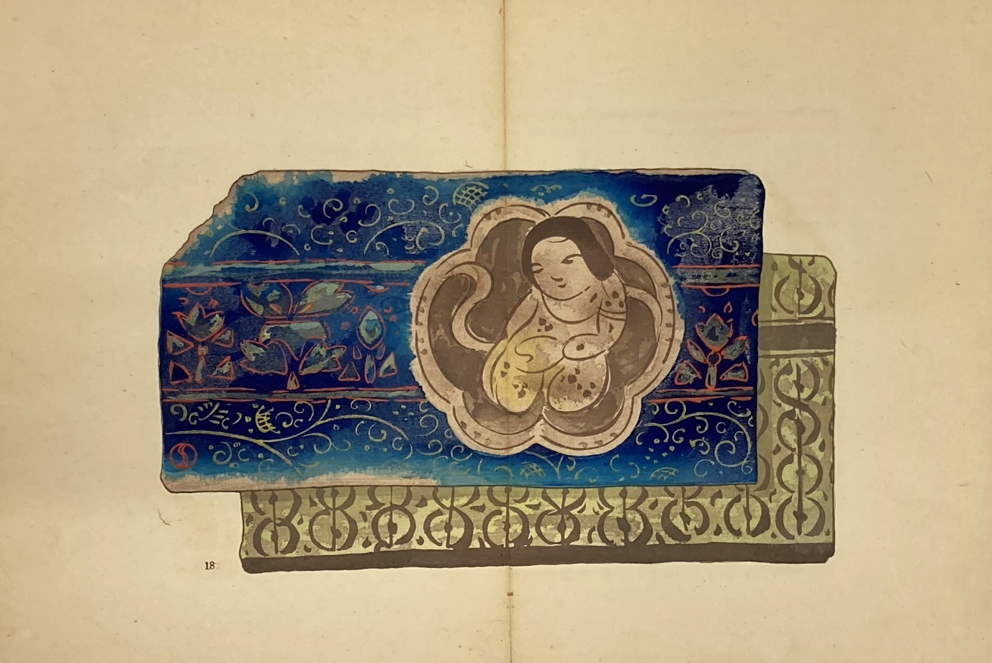
Figure 1: Lājvardīna tile illustrated in Sawada 1915, pl. 18.

The first known instances of Persian overglaze vessels entering Japan occurred during the second phase of the international market in Islamic ceramics. This saw a shift from the acquisition of unrestored fragments towards a preference for seemingly complete wares, but with extensive areas of modern fill and repainting. With the exception of the lājvardīna tile fragment published in 1915, there are only restored pieces known to be in Japanese collections until well after the Second World War. While the extensive amounts of repairs and plaster fill in these pieces were almost certainly less visible in the 1920s, the degradation of the glues and pigments makes such interventions much more apparent to the naked eye now.
From as early as 1915, it was clear that the colour of these types of glazed wares was the most important aspect, and explains why a colour image of a mīnāʾī bowl was included in one of the first sale catalogues to feature these wares in Japan, held by Yamanaka & Co. in 1924 (fig. 5). However, the significant additional expense meant that the two early examples aside, all the other images of mīnāʾī ware, and the far less common lājvardīna ware, published in the pre-war period were in black and white.
Unlike most examples of lājvardīna, the majority of pieces of mīnāʾī ware tend to feature miniature figural decoration. It can be seen from the, albeit limited, corpus of published pieces that the most popular type of mīnāʾī ware amongst collectors in Japan, from at least the early 1920s through to the post-war period, were Style 1c and Style 2 wares. This was primarily due to the presence of small figures, and these types of mīnāʾī, called ningyō te (doll type) in Japanese were highly prized.

Wares for Sale: Commercial Exhibitions and Catalogues
An exhibition was organized by Nichifutsu Geijutsusha (Franco-Japanese Art Company) at the Takenodai Exhibition Hall in Tokyo in April 1923, and despite being called the second French Contemporary Art Exhibition, it was the first exhibition held in Japan that is known to have featured Persian pottery. It included a mīnāʾī bowl that was subsequently displayed at the exhibition at the Tokyo School of Fine Arts in Ueno in 1928. The Style 1a bowl (fig. 2), with a large section of plaster fill and overpaint on about a third of the rim and a section of the cavetto, was bought by the famous collector of Persian pottery Shiobara Matasaku (1877–1955), and subsequently entered the collection of Tenri University Sankōkan Museum. This bowl appears to be the first recorded piece of mīnāʾī ware in Japan. The only other mīnāʾī bowl in Tenri is a heavily repaired and turquoise Style 3a bowl, and it is numbered next in the sequence (Acc. no. 07413, E54). It probably came from Shiobara as well, and may also have bought at the Nichifutsu Geijutsusha sale in 1923.
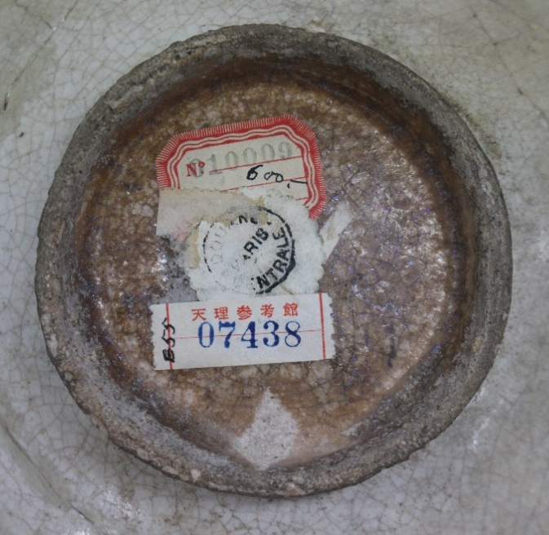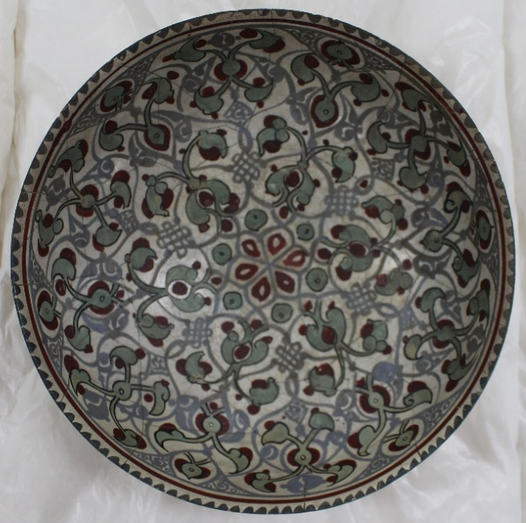
Figure 2: Underside detail and interior view of a Style 1a bowl bought by Shiobara Matasaku in 1923 and exhibited in Tokyo in 1928. Now in Tenri University Sankōkan Museum (07458, E55)

Subsequently, in 1926, which was the same year as the second Yamanaka & Co. exhibition to include mīnāʾī ware, Nichifutsu Geijutsusha had at least one more mīnāʾī bowl for sale in another exhibition. Although the catalogue for the sale, which also primarily consisted of French art, was not illustrated, an image of a Style 1b cavetto mīnāʾī bowl from the sale was subsequently included in a magazine published by the company, without any accompanying text.
As the marketfor Persian ceramics did not emerge in Japan until the middle of the 1920s, it not surprising that there was little appetite on the part of either dealers or collectors to purchase sherds. Instead, it is seemingly complete, if heavily restored and much-altered, pieces that were offered for sale and included in the earliest Japanese exhibitions of Islamic ceramics. Despite the lack of colour in the great majority of early publications, it is clear that the extensive areas of plaster fill were somewhat less visible in the 1920s than they are now, a century later, as the plaster, pigments and glues change colour over time in a way that glazed ceramic does not.
The initial examples of mīnāʾī ware published in Japan were in commercial sale catalogues and exhibition catalogues. There was limited scholarly analysis of the wares, and the main focus was on aesthetic appearance. The information that was given consisted mainly of an attribution to Persia, and a brief description of the decoration, as either geometric or figural. The only specific place mentioned is Rhages (Rayy) and the dating tends to range from the twelfth to the thirteenth century CE. In the catalogue for the Yamanaka & Co. sale held in October 1924, plate 17 is captioned “Persian pottery bowl faience polychrome”, while plate 35 is described as “Persian pottery bowl polychrome figures”. In the condensed version of the catalogue for the same sale, published the following month, the Style 1b cavetto bowl shown in colour in the earlier issue of the catalogue (fig. 3) is described as “Persian faience bowl equestrian design Rhages”.
Although the first image of a piece of lājvardīna to be published in Japan was in colour, and came out in 1915, it was to be another nine years before the some of the first pieces of mīnāʾī ware were published. One of the plates in the catalogue published to accompany a sale at the Osaka outlet of Yamanaka & Co in October 1924, titled Ejiputo Girisha Perusha Shina Kodai Bijutsu Tenkan (Exhibition of Ancient Art of Egypt Greece Persia and China) was in colour (fig. 3) (Yamanaka & Co. 1924). It is Style 1b a cavetto bowl and was to remain the only colour image of such a piece published in the country for many years. To put this single colour image in the Yamanaka & Co. catalogue into perspective, just two years earlier the catalogue of the Parish-Watson Collection featured eleven large full-page colour images of mīnāʾī bowls. This is the second known instance of mīnāʾī ware being available in Japan, after the Style 1a bowl in the Nichifutsu Geijutsusha sale in 1923, and there were a further two mīnāʾī bowls illustrated in the Yamanaka & Co. catalogue, in black and white. While it is not clear where Yamanaka & Co. sourced the mīnāʾī bowls that were illustrated in this or their other catalogues, they are known to have sourced antiquities in both Cairo and Istanbul.
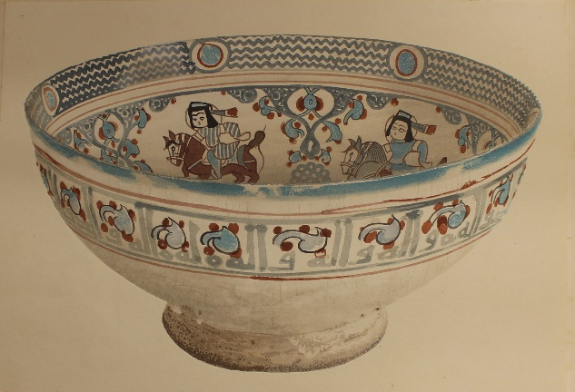
Figure 3: First colour image of mīnāʾī ware published in Japan, a Style 1b bowl, in the Yamanaka & Co. catalogue of 1924

There appears to have been less demand for mīnāʾī in the early period, prior to the 1930s, as the same bowl appeared in Yamanaka & Co. sale catalogues in 1924 and 1926. A Style 1c cavetto bowl (fig. 5) owned by Yamanaka & Co. and exhibited in Tokyo in 1928, became one of the earliest pieces to enter a major collection when they finally sold it to the Tokyo National Museum in 1932. This is of particular importance, as the majority of the mīnāʾī ware in Japan, in both public and private collections, was acquired after the Second World War. In addition, the Style 2a bowl with a flat rim exhibited in the same 1928 exhibition at the Tokyo School of Fine Arts was also unsold and still in the possession of Yamanaka & Co., having previously been included in the catalogue for their sale in 1926. That was their second sale which included pieces of mīnāʾī ware, held in Osaka from November tenth to the twelfth. Titled Tōzai kotō kinseki tenkan (Old Crafts from East and West), it included Greek and Indian antiquities, and the only pieces of Islamic art illustrated in the catalogue were the two mīnāʾī bowls (fig. 4). This prominence given to mīnāʾī ware indicates the relative prestige and value placed on this particular type of Persian pottery in Japan at the time, and also reflects the wider global trends of the time, with major books on Islamic ceramics published in French, German, and in English from both sides of the Atlantic, also featuring disproportionately large numbers of mīnāʾī bowls.
The two bowls in the 1926 Yamanaka & Co. catalogue are numbered 114 and 110, with the former being a Style 1c cavetto bowl, and the latter a flat rimmed Style 2a bowl (Yamanaka & Co. 1926). Both are photographed at an angle from above, which shows part of both the interior and exterior, but leaves the majority of the interior decoration obscured (fig. 4). This approach was not taken for any of the catalogues for the public loan exhibitions in the 1920s, with almost all being depicted with a single view from directly above, but there are examples where an additional side view of the bowl is included below.
Neither of the mīnāʾī bowls shown in the 1926 Yamanaka & Co. catalogue appear to have sold, as they lent both of them to an exhibition in Tokyo two years later (Kasamori 1928, 74 and 78). In 1930 two further sales were held by Yamanaka & Co., one in Kyoto and the another in Tokyo, that included items described as Persian ceramics, but no mīnāʾī or lājvardīna included in the illustrations. However, very few of the items in the sale were illustrated, and the descriptions are fairly generic, so it is entirely possible that there were pieces included in either one or both of the sales.
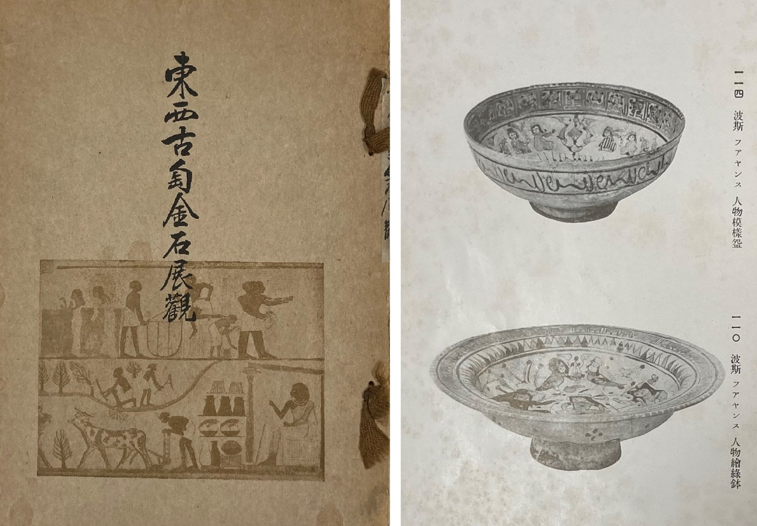
Figure 4: Cover and two mīnāʾī bowls from the 1926 Yamanaka & Co. catalogue
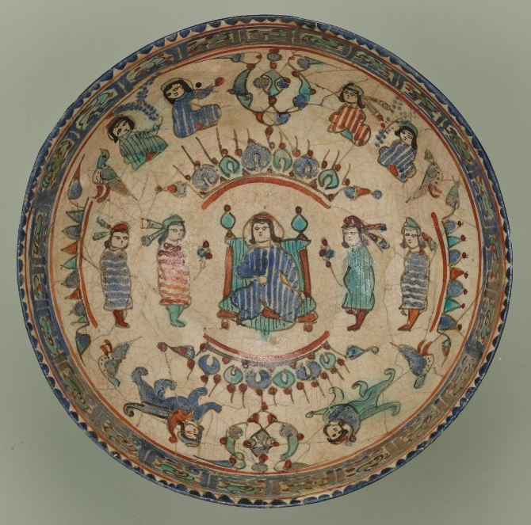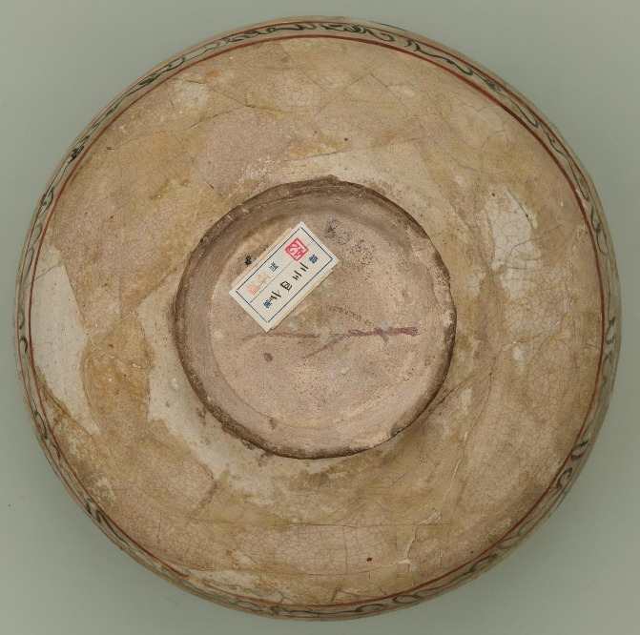
Figure 5: Style 1c bowl offered for sale by Yamanaka & Co. in 1926, exhibited in Tokyo in 1928 and sold to Tokyo National Museum in 1932 (TG-1205). Image source: ColBase: Integrated Collections Database of the National Institutes for Cultural Heritage, Japan (https://colbase.nich.go.jp/)

Not for Sale: Loan Exhibitions held in Public Institutions
The first exhibition featuring mīnāʾī and lājvardīna ware that was held in a major public institution in Japan occurred in 1924, at the Kyoto Imperial Museum. It was an exhibition of ceramics produced outside Japan and featured items loaned by Japanese collectors. One of the first of the collectors to acquire lājvardīna and mīnāʾī vessels was Ōhara Magosaburō, who had two of the first lājvardīna vessels known to be in Japan. One is a tall, bulbous, cobalt blue glazed bottle (fig. 6), similar to ones in the Louvre (OA6429) and the Aga Khan Museum (AKM799), and the other is a small dish. Both were illustrated in the exhibition catalogue and remain in the Ohara Museum of Art in Okayama. While both images are black and white, the bottle appears far more striking. It is very hard to tell from the image that the small dish is an example of lājvardīna ware at all and it only by comparing it with subsequent colour photographs of the same piece (Shikaku 2014, 18, fig.12) that it can be determined to be lājvardīna. At a subsequent exhibition in Tokyo in 1928, his small lājvardīna dish was exhibited again, and a slightly different, top-down, view of it was included in both editions of the catalogue.
Ōhara Magosaburō also had two of the earliest pieces of mīnāʾī ware in Japan, and some of the first to be published and exhibited there. The two bowls were both figural, a Style 1c and Style 2, and like his two pieces of lājvardīna, they were both illustrated in black and white in the catalogue of the 1924 loan exhibition at the Kyoto Imperial Museum (fig. 7).
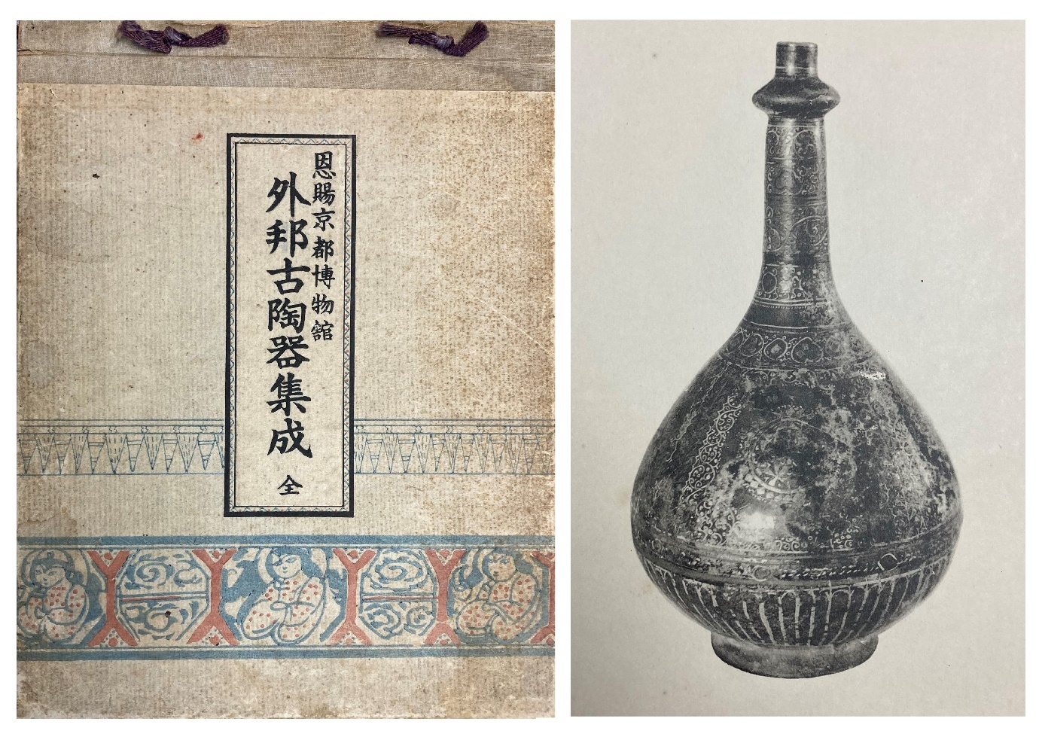
Figure 6: Cover and plate 2 of the catalogue for the exhibition at the Kyoto Imperial Museum in 1924
Figure 7: Style 2 and Style 1 mīnāʾī bowls owned by Ōhara in the catalogue of the exhibition held at the Kyoto Imperial Museum in 1924, plates 25 and 33

The next major exhibition to feature mīnāʾī ware was also held at the Kyoto Imperial Museum, two years after the first one, in 1926. Titled Gaihō kotōki shū (Collection of Old Foreign Ceramics), the catalogue included two mīnāʾī bowls (Tanaka 1926) (fig. 8). One is a Style 1b cavetto bowl, with a pair of affronted horsemen and a central tree in the base, with alternating roundels and pairs of seated figures with striped dress in the cavetto, below the standard Style 1 inscription band. The other bowl was a Style 1a cavetto bowl with alternating panels of geometric tilework-like designs and knotwork surrounded by birds, separated by bands of cursive script, and a central section of the same geometric design, encircled by additional cursive script. The text printed on each of the pieces of tissue paper separating the plates in the catalogue states that they are Persian bowls from Rayy, twelfth century and enamel painted, with the only difference being that the first one is described as painted with human figures, and the other with geometric designs.
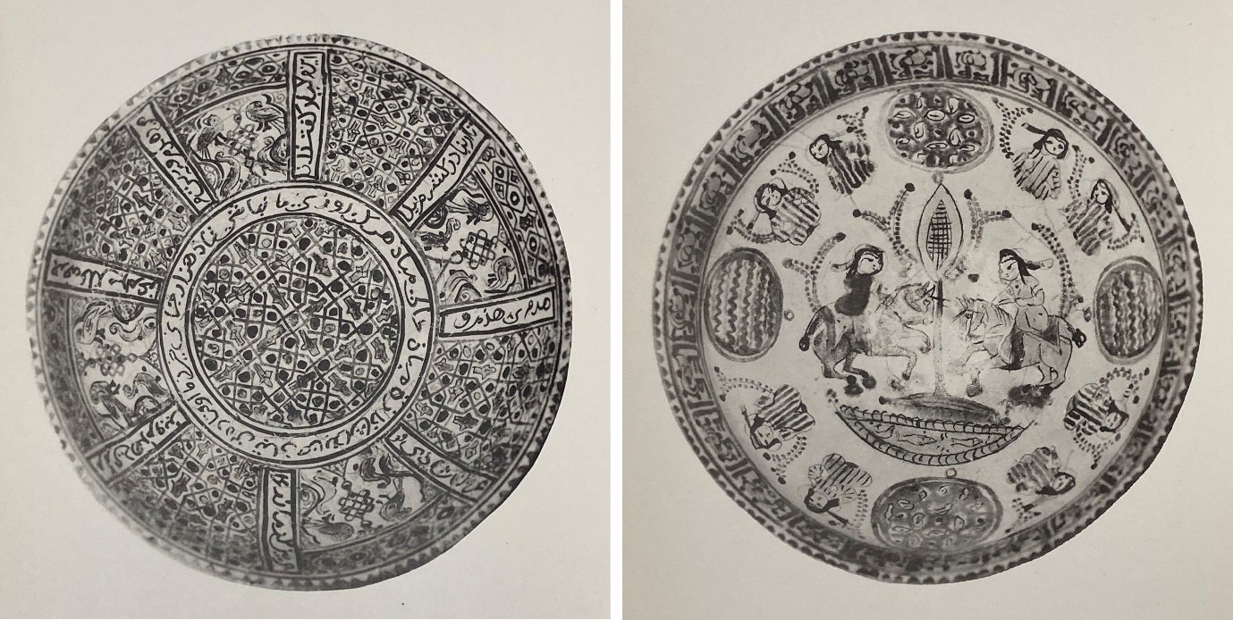
Figure 8: Style 1a (left) and Style 1b (right) bowls exhibited in Kyoto in 1926

The first public loan exhibition in Japan to feature a significant number of pieces of mīnāʾī ware was held in Tokyo in September of 1928. It was only on for three days, and was held at the Tokyo School of Fine Arts in Ueno. The exhibition included a wide range of pieces of Islamic art, including works on paper and carpets, but predominantly featured ceramic objects. It was organised by the Keimeikai Institute, and was titled Zaidan Hōjin Keimaikai sōritsu jūnen kinen tenrankai (Exhibition of Tenth Anniversary of Incorporated Foundation Kaimeikai). There was a lājvardīna dish (Kasamori 1928, 79), which was the same one that Ōhara lent to the loan exhibition in Kyoto in 1924, and nine mīnāʾī bowls illustrated in the exhibition catalogue, which was a far greater number that any other type of Islamic ceramic styles that were included in the exhibition, and reflects the wider global popularity of this specific type of wares. All nine of the mīnāʾī ware bowls depicted in the catalogue are on a white base glaze, they are all variants of either Style 1 or Style 2, and only three do not feature figural decoration. They came from three different sources, namely the art dealers Yamanaka & Co. (Kasamori 1928, 74, 77 and 78) and two private collectors. The three Style 1a bowls, which were the only ones with non-figural decoration, were owned by the industrialist Shiobara Matasaku, while three others, all figural and Style 2, were from the collection of Hosokawa Moritatsu (1883–1970). The exhibition was held in September, but the catalogue was not published until December of that year (Moharramipour 2022, 240), and such a time lag between the exhibition and the related catalogue is in contrast to the commercial catalogues of Yamanaka & Co., which were published in advance of their sales, and served to publicise and promote the event.
Both the sale and loan catalogues from the interwar period included very limited analysis, and the main focus was on the visual depiction of the wares. The majority of Japanese scholarship on the broader subject of Persian ceramics was published after the Second World War, but there was a Japanese translation of an article by the French art collector and curator Raymond Koechlin (1860–1931), which was originally published in 1912 and then translated by Sekine Hideo (1895–1987) in 1916.

The Post-War Boom
The documented list of collectors holding examples of mīnāʾī and lājvardīna in Japan in the 1920s and 1930s is very short, consisting of just Ōhara Magosaburō, Hosokawa Moritatsu and Shiobara Matasaku, in addition to the items held by the art dealer Yamanaka & Co. In contrast, by the early 1960s there is a much more expansive list of known Japanese collectors of mīnāʾī and lājvardīna wares, which highlights the massive increase in both the interest and the supply of this sort of material in the first two decades after the end of the Second World War. One of the most prolific art collectors in Japan in the post-war period was the oil magnate Idemitsu Sazō (1885–1881), who acquired a significant collection of mīnāʾī and lājvardīna ware.
In addition to collectors owning pieces for their own aesthetic pleasure, there are instances of some bowls in private collections being depicted in paintings by artist/collectors. The collector and artist Itō Shinsui (1898–1972) featured Persian pottery in a series of his paintings, one of which features two mīnāʾī bowls, a white Style 1 and a figural turquoise one, depicted on a gold background. They were both from his own collection, and the painting was included in his 1961 one-man show entitled Depicting Persian Pottery (Kanda 2020, 158). The current whereabouts of the painting is unknown, but it was published in colour in a series of unbound reproductions of the paintings shown in the 1961 exhibition. The depiction of mīnāʾī and other types of medieval Persian ceramics in paintings, in addition to the display of the wares and the publication of photographs of them, speaks to the visual appeal that they held in the cultural milieu of post-war Japan.

Conclusion
While the market for mīnāʾī and lājvardīna ware developed slightly later in Japan than it did in Europe and North America, and was significantly smaller in scale during the interwar years, there were numerous exhibitions featuring such vessels, with a small group of private collectors, and at least one national museum, acquiring pieces in the decade between 1923 and 1932.
Despite the small number of published pieces, a range of different modes of depiction were employed in the catalogues that feature images of mīnāʾī and lājvardīna ware. They are primarily depicted in black and white, presumably for reasons of cost, with a clear distinction between the commercial sale catalogues of Yamanaka & Co. These all show the bowls from an oblique angle, illustrating part of the exterior and only a little of the interior, and the images in the loan exhibition catalogues. The latter group, in contrast, all show the bowls from above, along with some that are also shown from the side as well. The depiction of both top and side views of mīnāʾī bowls was seen in some cases and not others, and while there is no evidence for how such decisions were made, especially in light of the small corpus, it may have been due to a desire to highlight the more unusual profiles.
There was a major expansion in both the volume of material and number of known collectors for such wares in Japan after the Second World War. However, it is clear that the foundation for the understanding, reception and display of these two distinctive and related typologies of Persian overglaze decorated stonepaste wares emerged during the course of the series of both sale and loan exhibitions held in Kyoto, Osaka and Tokyo, and the more widely circulated images in the related catalogues, in the brief period between 1923 and 1928.

Acknowledgments
I am deeply indebted to Tomoko Masuya for the huge amount of support and advice she has given me. The generous funding from the Japan Society for the Promotion of Science (JSPS), through the award of an Invitational Fellowship (S22051), allowed me to travel to Japan in 2022. I received a great deal of help from so many colleagues in Japan, and am especially grateful to Chieko Ando, Hajime Inagaki, Yui Kanda, Naomi Kaneko, Kazue Kobayashi, Keiko Mikasa, Zahra Moharramipour, Yoshihiro Oshimo, Ryuji Shikaku and Yoshinobu Tatsumi.

Bibliography
Gotō Hakuzan (ed.) 1924: Onshi Kyōto Hakubutsukan: Gaihō kotōki shūsei [Ancient Ceramics from Outside Japan at Kyoto Imperial Museum], Kyoto [in Japanese].
Iijima, A. (ed.) 2001: Burning Colours on Desert. 5000 years of Tile Design in Middle East, Okayama [in Japanese].
Itō Shinsui 1961: Perusha tōki o kaku [Depicting Persian Ceramics], Tokyo.
Kanda, Y. 2020: “Collection, Exhibition, Publication and Depiction of ‘Persian’ Ceramics in Japan from the late 1950s to the late 1980s,” The Transactions of the Asiatic Society of Japan 123, 147–170.
Kasamori Denhan (ed.) 1928: Zaidan Hōjin Keimeikai sōritsu jūnen kinen tenrankai zuroku [The Catalogue of the Exhibition to Commemorate the 10th Anniversary of the Founding of the Keimeikai Institute], Tokyo [in Japanese].
Kasamori Denhan (ed.) 1930: Tōyō kōgei shūsui [Selected Collections of Oriental Crafts], Tokyo [in Japanese].
Lermer, A. and Shalem, A. 2010: After One Hundred Years. The 1910 Exhibition “Meisterwerke muhammadanischer Kunst” Reconsidered, Leiden.
Masuya, T. 2007: “Nihon to Isurāmu Bijutsu [Japan and Islamic Art],” in M. Haneda (ed.), Yūrashia ni okeru bunka no kōryū to tempen [Cultural exchange and transformation in Eurasia], Tokyo, 97–104 [in Japanese].
McClary, R. 2020: “Calouste Gulbenkian, His Mīnā’ī Ware, and the Changing Islamic Art Market in the Early Twentieth Century,” Muqarnas XXXVII, 325–343.
McClary, R. 2021: “Mīnāʾī ware,” in The Encyclopaedia of Islam (Third Edition), Leiden, 4: 120–125.
Mikami Tsugio 1962: Islamic Pottery mainly from Japanese Collections Vol. 1, Tokyo.
Mikami Tsugio 1964: Islamic Pottery mainly from Japanese Collections Vol. 2, Tokyo.
Moharramipour, Z. 2022: “Japanese Art Dealers and Exhibitions of Persian Art in the 1920s”, in R. Ono and N. Unno (eds.), Modern Japan, and the Middle East and Muslim World, Tokyo, 239–274 [in Japanese].
Okano, T. (ed.) 2008: Brilliance of Persian Ceramics. Innovation and Revival in the 11th-14th Centuries, 2008 [in Japanese].
Ōsumi Tamezō. 1938: Tōki kōza: Perushia no tōki [Lectures on Ceramics: Persian Ceramics], Tokyo [in Japanese].
Riefstahl, R. M. 1922: The Parish-Watson Collection of Mohammadan Potteries, New York.
Rivière, H. 1913: La Céramique dans l’art Musulmane, Paris.
Sarre, F. and Martin. F. R. 1912. Die Ausstellung von Meisterwerken muhammedanischer Kunst in München, 1910. Munich.
Sawada Seiichirō 1915: Sekai mon’yō zenshū [Catalogue of Designs in the World], Kyoto [in Japanese].
Shikaku, R. (ed.) 2014: Kojima Torajirō wa mita!: Orient bunka tōzai no kakehashi [Torajiro Kojima Saw! Oriental Culture. Bridges Between East and West], Okayama [in Japanese].
Tanaka Denzaburō (ed.) 1926: Gaihō kotōki shū [Collection of Old Foreign Ceramics]. Kyoto [in Japanese].
Tezuka, N. and T. Hosokawa (eds.) 2010: The Collection of Dr. Tsugio Mikami. West Asia, South Asia and Africa, Tokyo.
Wallis, H. 1891: Persian Ceramic Art in the Collection of Mr. F. DuCane Godman. F.R.S. The Thirteenth Century Lustred Vases, London.
Yamanaka & Co. 1924: Ejiputo Girisha Perusha Shina kodai bijutsu tenkan [Exhibition of Ancient Art of Egypt Greece Persia and China], Osaka [in Japanese].
Yamanaka & Co. 1926: Tōzai kotō kinseki tenkan [Old Crafts of East and West], Osaka: [in Japanese].

From the Persian term for enamel. A type of inglaze and overglaze painted stonepaste ware, primarily vessels, but with a small number of tiles, produced in Iran in the late-twelfth to mid-thirteenth centuries CE. For further details see McClary 2021.
From the Persian term for lapis lazuli, in reference to the predominant colour being deep blue. The corpus of lājvardīna ware consists primarily of tiles, but with a small range of vessel forms also known, in stonepaste with overglaze painted decoration, in red and white, as well as extensive use of gold leaf. While most pieces are cobalt blue, there are some turquoise and very limited white examples. Very few pieces are dated, but the consensus is for a mid-thirteenth to early-fourteenth century CE date range.
See Kanda 2020, 148–149 for specific details concerning the pre-war period.
The Style 1a cavetto bowl, now in the Tenri University Sankōkan Museum, is examined in detail below.
He was the patron of Kojima Torajirō, and it is likely that several of the examples of Persian ceramics in Ōhara’s collection were acquired by Kojima during his trip to Paris in 1922–23. In 1921 Hara Ryōzaburō (1896–?) bought ten pieces of Persian ceramics in Paris from the Armenian dealer Dikran Kelekian for his father Hara Sankei (1868–1939) (Masuya 2007, 102), but it is not clear if any pieces of either mīnāʾī or lājvardīna were included in that group.
For a study of the exhibition see Lermer and Shalem, 2010. The bottle, in black and white, is shown in Sarre and Martin 1912.
McClary 2020, 332-334.
One example is the large (36.5 x 36.2 cm) square relief lājvardīna tile featuring a phoenix that the collector Yasuhara Shinjiro (1911–80) bought in Tehran in 1968. The tile is now in the Okayama Orient Museum (43-0086). I am indebted to Ryuji Shikaku for providing this information.
The tile upon which the image was based appears to be from the upper section of a square epigraphic tile, similar examples of which can be found in numerous collections, including the Louvre in Paris (AD244), the Ashmolean Museum in Oxford (EAX.3208) and the Victoria & Albert Museum in London (1521-1876).
Sawada 1915, pl. 18, with the description given as simply “Persian design”, the same text as was used for the lustre tiles that were depicted on pls. 16, 17, 19 and 20.
See the chromolithographs in Wallis 1891, pls. XV and XVI.
See McClary 2020, 325–343 for further details of this process.
The scholar and collector Mikami Tsugio (1907–1987) had an extensive collection of mīnāʾī and lājvardīna sherds, acquired in Saveh and Cairo, and now split between two institutions in Tokyo; the Middle Eastern Culture Center in Japan, and Aoyama Gakuin University. The latter has ten mīnāʾī sherds from Fustat, including Style 1 pieces (Tezuka and Hosokawa 2010, 29, pl. 48, nos. 1–10, 59, and 80), and a further four sherds from Saveh, including two Style 1 sherds, and one which is turquoise, with a human face (ibid., 31, pl. 54, nos. 1–3, and 6, 60–61, and 82 for the source, and sizes).
Yamanaka Sadajirō, born Adachi Sadajirō (1886–1936), was the head of Yamanaka & Co., which was based in Osaka but had outlets around the world. See Moharramipour 2022, 241–244 for details of the life and career of Yamanaka.
See McClary 2020, 337 for a summary of the taxonomic classification of mīnāʾī ware, and key characteristics of the main Styles.
Yui Kanda, personal communication 6 October 2022.
Several other exhibitions featuring Persian ceramics were held by Nichifutsu Geijutsusha between 1926 and 1929 (see Moharramipour 2022, 250–251 for details). However, it has not been possible to determine if any of them included pieces of mīnāʾī or lājvardīna ware. In addition, there was an exhibition organized by the Japan Art Association in 1925 that also included Persian pottery (ibid., 259), but it is not clear if it featured any of the types of overglaze wares under discussion here or not.
Moharramipour 2022, 247 and 274, and Shikaku 2014, 41–43.
The bowl (07458, E55) is 21.7 cm wide and 7.5 cm high. There are three stickers on the base of the bowl, a red and white one with “010009” typed onto it, and “600” written in ink, partially over the top of which is a white round label with a lobed edge. It has “DOUANE CENTRALE” printed round the outside and “PARIS” horizontally in the middle. Over this label is the Tenri Museum label, with the museum name printed in red Japanese kanji, then “07438” typed, and “E55” hand written in black ink. The presence of the number 600 suggests that was the price in French francs, and that it was a dealer’s label. There are also traces of a, now removed, label that was over the top of the French customs one. The museum records do not have any information concerning the year in which it was acquired (Yoshinobu Tatsumi, personal communication, 14 October 2022).
Zahra Moharramipour, personal communication, 18 October 2022. See Moharramipour 2022, 248, and ibid., 249, fig. 2 for a reproduction of the 1926 image of the bowl. The current whereabouts of the bowl is unknown.
For an example of how different the colour tone of the filled areas looks now, in contrast to the original sherds that have been glued back together, see fig. 5 for a recent image of the bowl sold to the Tokyo National Museum by Yamanaka & Co. in 1932 (acc. no. TG-1205).
The former Seljuq capital located just to the south of modern Tehran. It was largely destroyed and abandoned following the Mongol conquest.
See, for example, the description of the two mīnāʾī bowls included in the catalogue for the exhibition held in Kyoto in 1926 (Tanaka 1926).
Parish-Watson & Co. was an art dealer based in New York that operated from 1919 to 1938.
Riefstahl 1922, figs. 37, 42, 50–60. Reflecting the tastes of the time, and the more limited supply, there was only one lājvardīna bowl featured in the catalogue, and it was a half-page image in black and white (ibid., 239, fig. 89).
Moharramipour 2022, 245. Several dealers known to have supplied mīnāʾī ware to other collectors had offices in Cairo, including the Armenian dealers Kalebdjian Frères (McClary 2020, 335). In addition, Yamanaka & Co. opened outlets in New York (in 1894), Boston (in 1899) and London (in 1900) which created a global network for acquiring material (Masuya 2007, 103).
Keiko Mikasa, personal communication, 6 October 2022. The bowl (TG-1205) is in the Eastern Archaeology section of the museum.
Persian art was primarily associated with the arts of the ‘western’ world in Japan during the interwar years (Moharramipour 2022, 266), with works in a wide range of media displayed alongside both ancient Greek as well as modern French art in a number of the exhibitions that occurred in that period.
Examples include the 6 lājvardīna and 11 mīnāʾī wares illustrated in colour in Rivière 1913, pls. 43, 45, 52, 53, 56, 58, and pls. 47–51, 54, 57, 59, 61, 62 and 69 respectively. See also the 11 colour plates in Riefstahl 1922, figs. 37, 42, 50–60.
See the catalogue images of two bowls lent by Hosokawa Moritatsu to the 1928 exhibition in Tokyo (Kasamori 1928, 72–73).
It measures 14 cm in diameter.
See Gotō 1924, pl. 2, and pl. 3. See ibid., 6 for a brief description of the bottle in pl. 2.
The bottle is 31.2 cm high, with a maximum diameter of 17.4 cm and the foot ring is 8.5 cm wide. It was subsequently published by Mikami in 1962 (Mikami 1962, 19, no. 128).
Gotō 1924, pls. 25 and 33; pl. 25 has the Style 1c bowl, and pl. 33 has two bowls, with the mīnāʾī one being on the left. See ibid., 7–8 for a brief description of the bowls.
Two years later, in 1928, another exhibition including examples of Persian art was also held at the Kyoto Imperial Museum (Zahra Moharramipour, personal communication, 18 October 2022), but I have not had access to the catalogue, and cannot determine if any pieces of mīnāʾī or lājvardīna were included in the exhibition or not.
The plates in the catalogue are un-numbered, and the current whereabouts, and degree of originality, of the two bowls is unknown.
The catalogue, published in December of 1928, featured images of 246 of the approximately three thousand items included in the exhibition (Moharramipour 2022, 240). The original 1928 edition of the catalogue is Kasamori 1928. See pp. 70–79 for the mīnāʾī and lājvardīna wares. There are two Style 1a bowls on one page, both lent by Shiobara (p. 70); the Style 1a bowl lent by Shiobara, and now in Tenri (p. 71); a figural Style 2a bowl lent by Hosokawa (p. 72); a Style 2 bowl with two figures lent by Hosokawa (p. 73); the Style 1c bowl lent by Yamanaka & Co. and now in Tokyo National Museum, (p. 74); a Style 2a bowl with horseman lent by Hosokawa (p. 75); a figural bowl (p. 77) and a Style 2a bowl with a flat rim both lent by Yamanaka & Co. (p. 78); and the small lājvardīna dish lent by Ōhara (p. 79). The 1930 edition of the catalogue is Kasamori 1930. For scans of the 1928 and 1930 editions see: https://dl.ndl.go.jp/info:ndljp/pid/1030364, and https://dl.ndl.go.jp/info:ndljp/pid/1191275.
The two bowls on Kasamori 1928, 70 and the one now in Tenri on p. 71 of Ibid.
Kasamori 1928, 72, 73 and 75. Hosokawa belongs to a family of feudal lord, and his mīnāʾī ware bowls are now in the Eisei Bunko Museum in Tokyo.
Raymond Koechlin, “La Céramique dans l’Art Musulman”, Art et décoration 32 (1912): 185–192, published as Rēmon Kēkuran, “Kaikaikyō-koku no seitō-jutsu”, Bijutsu shimpo 262 (1916): 14–18. The first Japanese article written on the subject of Persian ceramics was published by Sampa Gyojin in 1919 (Masuya 2007, 101). The first monograph on Persian ceramics in Japanese was published in 1938 by the French-trained art critic Ōsumi Tamezō (1881–1961), based on material he gathered from French and British books (Kanda 2020, 149).
For details of the somewhat larger group of collectors of a broader range of types of Islamic art in Japan in the interwar years, see Masuya 2007, 102.
In his major two-volume publication Islamic Pottery, Mikami included pieces of mīnāʾī and lājvardīna from Hosokawa Moritatsu, as well as additional collectors in Tokyo (Maruyama Masatake, Azuma Noboru, Taji Shūichi, Ishiguro Kōjirō, Idemitsu Sazō, Sano Yūji, Sammy Y. Lee, and Koito Gentarō), Okayama (Okazaki Rimpei) and Osaka (Matsushita Kazuhiro and Watanabe Akira). He also lists institutions with pieces that are featured in the books, namely; Tokyo National Museum, Bridgestone Museum of Art (now Artizon Museum), Ohara Museum of Art, Tenri University Sankōkan Museum, and Itsuō Art Museum. See Mikami 1962, 9–20 and 58–64 [in Japanese], 4–5, and 18–19 [in English]; Mikami 1964, 10–17 and 96–105 [in Japanese], 4 and 31–33 [in English].
Apart from the depiction of mīnāʾī bowls in paintings, such as the one by Itō Shinsui, it is not clear that the style of Iranian ceramics being imported and collected had any impact on the production of contemporary ceramic wares in Japan in the twentieth century.
See Itō 1961, un-numbered plate. The original painting would have measured approximately 67 cm square, presuming it was the same size as other similar paintings in the exhibition. I am indebted to Yui Kanda for this information, and for the image of the painting.
The exceptions are the two pieces of lājvardīna owned by Ōhara and exhibited in Kyoto in 1924, with the bottle shown side on and the small dish at an angle from above in the manner seen in the Yamanaka & Co. catalogues. See See Gotō 1924, pl. 2 and pl. 3 right respectively.

