Post-Synthetic Silver Ion and Sulfurization Treatment for Enhanced Performance in Sb₂Se₃ Water Splitting Photocathodes

Pardis Adams, Ramon Schnyder, Thomas Moehl, Jan Bühler, Angel Labordet Alvarez, Mirjana Dimitrievska, Keith McKenna, Wooseok Yang* and S. David Tilley*

P. Adams, R. Schnyder, T. Moehl, J. Bühler, S. D. Tilley
Department of Chemistry, University of Zurich, Winterthurerstrasse 190, Zurich, 8057, Switzerland
E-mail: david.tilley@chem.uzh.ch

W. Yang
School of Chemical Engineering, Sungkyunkwan University (SKKU), Suwon, South Korea.

SKKU Institute of Energy Science and Technology (SIEST), Sungkyunkwan University,
Suwon 16419, South Korea.

E-mail: wooseok.yang@skku.edu

A. L. Alvarez, M. Dimitrievska
Transport at Nanoscale Interfaces Lab, EMPA, Ueberlandstrasse 129, Dübendorf, 8600, Switzerland

K. P. McKenna
School of Physics, Engineering and Technology, University of York, York, YO10 5DD, United Kingdom

Keywords: photoelectrochemical water splitting, Sb₂Se₃, solution treatments, sulfurization, silver ion

In the past decade, antimony selenide (Sb₂Se₃) has made significant progress as a solar energy conversion material. However, the photovoltage deficit continues to pose a challenge and is a major hurdle that must be overcome to reach its maximum solar conversion efficiency. In this study, various post-synthetic treatments have been employed, of which the combination of a solution phase silver nitrate treatment and sulfurization has shown to be the most effective approach to mitigate the photovoltage deficit in this Sb₂Se₃-based device. A significant enhancement in the photovoltage was observed after the treatments, as evident by the increase in the onset potential from 0.18 V to 0.40 V vs. reversible hydrogen electrode. Multiwavelength Raman shows that combining these two treatments removes amorphous Se and metallic Sb from the surface and yields a high-quality surface layer of Sb₂(S_{X-1}, Se_{x}) on the bulk Sb₂Se₃ photoabsorber layer. X-ray photoelectron spectroscopy with depth profiling reveals extensive incorporation of silver into the film. Density functional theory calculations suggest that silver ions can intercalate between the [Sb₄Se₆]_{n} ribbons and remain in the Ag⁺ state. This effective treatment combination brings the practicality of the Sb₂Se₃ photocathode for water splitting one step closer to large-scale applications.

1. Introduction
Hydrogen-generating technology has gained immense attention in recent years as a potential solution to the world's climate change and lingering dependency on fossil fuels.^{[1]} Due to its high energy density and clean combustion, hydrogen has the potential to decarbonize the energy sector and reduce greenhouse gas emissions.^{[2]} While hydrogen has long been recognized as a promising energy carrier, our fossil fuel-based economy and high capital costs associated with green hydrogen production methods have restricted the use of hydrogen fuels thus far.^{[3]} While green hydrogen production via photovoltaic (PV)-coupled electrolysis is ramping up, it currently relies on government subsidies to be cost competitive. Integrated approaches such as photoelectrochemical water-splitting (PEC), which benefit from thermal management, could produce hydrogen with higher conversion efficiencies and more cost-effectively.^{[4]} Significant effort and progress have been made toward reducing the cost of green hydrogen and optimizing the design and synthesis of various photoelectrodes and photocatalyst materials in the past decades.^{[5–8]} However, developing stable, efficient, and low-cost photocathode materials has remained a challenge in the field. Antimony selenide (Sb₂Se₃), which belongs to the family of binary chalcogenide compounds, is a promising candidate for use as a photocathode material in PEC water splitting as a potential alternative to crystalline silicon, which is currently the benchmark material for solar conversion technology. The structural complexity of Sb₂Se₃, consisting of [Sb₄Se₆]_{n} ribbons bonded through van der Waals forces, while covalent bonds hold together the Sb-Se atoms within the ribbons, give rise to a distinctive quasi-one-dimensional configuration. Its outstanding optoelectronic properties, such as a high absorption coefficient (>10⁵ cm⁻¹) in the visible light range, high carrier mobility (10 cm² V⁻¹ s⁻¹), as well as its low toxicity, low cost, and easy synthesis methods, position Sb₂Se₃ as an auspicious material for solar cells or solar water splitting. The quasi-direct and narrow band gap of Sb₂Se₃ (1.1-1.2 eV) is one of this material's beneficial characteristics, making it optimal for the hydrogen evolution reaction.^{[9,10]} This material also possesses some unique qualities, such as photocorrosion resistance^{[11]} and self-healing electronic defects^{[12]}, that add to the novelty and practicality of this material. Despite exhibiting exceptional characteristics, the power conversion efficiency (PCE) of Sb₂Se₃ is considerably lower than the maximum theoretical value of ~30% predicted by the Shockley-Queisser model. The main obstacle impeding the performance of this material is the low photovoltage, primarily attributed to defects at the interface between this material and its n-type counterpart, as well as the presence of mid-gap transition levels due to Sb_{Se} antisite defects, which trap charge carriers and increase the probability of recombination.^{[9,13–16]} Therefore, developing strategies for enhancing the photovoltage of the Sb₂Se₃ photocathode and understanding the photovoltage improvement mechanism is crucial to exploit this emerging light absorber's potential fully. As surface states are known to act as trapping sites and recombination centers, their passivation is key to achieving better charge separation and reduced recombination. Meanwhile, a sulfurization strategy was applied to suppress the bulk recombination centers formed by cation-anion defects in Sb₂Se₃ semiconductors.^{[17]} In our previous study, a simple solution-phase treatment, consisting of etching the surface oxide layer followed by CuCl₂ treatment, was employed to enhance the onset potential of the Sb₂Se₃ photocathode from 0.14 to 0.28 V vs. reversible hydrogen electrode (RHE).^{[18]} The sulfurization treatment was used in addition to the surface treatments, which together displayed a cumulative improvement in the onset potential of the photocathode. Here, we report further enhancement of the performance of the Sb₂Se₃ photocathode by thoroughly screening various solution-based metal treatments followed by sulfurization to suppress the recombination of the photo-excited carriers. Through multiwavelength Raman spectroscopy, it was possible to probe the surface and the bulk of the photoabsorber layer, which revealed changes in the composition and surface disorder before and after the treatments. Computational calculations were performed to understand the role of the metal cations in suppressing the detrimental mid-gap states in Sb₂Se₃. The silver ion plus sulfurization treatment displayed a cumulative improvement in the onset potential of the Sb₂Se₃ photocathode, reaching 0.4 V_{RHE}.

2. Results and Discussion
In this study, Sb₂Se₃ compact films were produced by selenizing electrodeposited Sb films.^{[11,18]} The Au layer functions as a hole-extracting contact, forming an ohmic contact with the photo absorber. Subsequently, a TiO₂ layer deposited through atomic layer deposition (ALD) was then applied to the Sb₂Se₃ photo absorber layer. The TiO₂ layer protects the active layer from potential corrosion in the electrolyte's acidic environment and establishes a p-n junction with the photo absorber, improving the charge separation within the system. Lastly, Pt is a catalyst for the hydrogen evolution reaction (HER), aiding in enhanced charge transfer. As visualized in Figure S1a, this is the foundation of all devices discussed in this paper. As previously observed, an etching with (NH₄)₂S and a simple solution-processed treatment at the interface of Sb₂Se₃ and TiO₂ can improve the device's overall performance.^{[18]} Therefore, a thorough screening of various metal solutions was undertaken to investigate whether this effect can be obtained using metal solutions other than CuCl₂, and a trend could be observed. To maintain the low toxicity of our system and treatments, highly toxic metals such as Cd or Hg were not included in our screening.
Metal Solutions | Photovoltage (V vs. RHE) | Photocurrent (mA/cm²) | Fill Factor (%)
CaCl₂ | 0.261 ±0.0303 | -15.1 ±0.832 | 31.4
CoCl₂ | 0.191 ±0.0474 | -14.2 ±1.85 | 25.4
NiCl₂ | 0.0733 ±0.0367 | -5.47 ±2.01 | 14.5
CuCl₂ | 0.286 ±0.0129 | -15.1 ±1.10 | 23.5
ZnCl2 | 0.296 ±0.0133 | -14.5 ±1.23 | 25.7
Ga(NO₃)₃ | 0.261 ±0.00380 | -14.8 ±1.22 | 30.9
AuCl₃ | -0.0400 ±0.00470 | -0.526 ±0.0655 | -
AgNO₃ | 0.322 ±0.0105 | -18.9 ±1.57 | 42.2
Untreated | 0.177 ±0.0346 | -14.4 ±0.751 | 21.0
Table 1 – Screening of various simple metallic solution treatments at the interface of Sb₂Se₃ and TiO₂. Photovoltage, photocurrent at 0 vs. RHE, fill factor, and their respective standard deviations were measured and calculated.
Before the metal solution treatments, all samples were etched with (NH₄)₂S. The following metal salts were chosen based on their position on the periodic table relative to CuCl₂. It was anticipated that perhaps a trend based on characteristics such as atomic radius, oxidation state, or electronegativity would arise; however, no conclusive trend was observed. As seen in Table 1 and Figure S1b, compared to the reference sample, NiCl₂ and AuCl₃ had detrimental effects on the performance of the device, while CoCl₂ had negligible effects (within the range of error). CaCl₂ and Ga(NO₃) show similar improvements to the samples only treated with (NH₄)₂S, meaning the metal treatment does not lead to further improvements. All other metal solutions improved at least the onset potential and fill factor of the Sb₂Se₃ devices. ZnCl₂ shows a similar effect to the previously studied CuCl₂. On the other hand, AgNO₃ has been shown to improve the onset potential, current density, and fill factor by a significant value. It was hypothesized that the AgNO₃ treatment would have a similar effect to the previously studied CuCl₂ treatment and mainly play a role on the surface of the photoabsorber. As shown in our previous studies^{[19]}, sulfur treatment was observed to have an additional positive effect on Sb₂Se₃ and passivate defects within the bulk. Therefore, it was anticipated that when a combination of AgNO₃ treatment and the sulfurization treatment were performed, both surface and bulk defects would be passivated and an accumulative improvement in the performance of the Sb₂Se₃ photocathode would be observed.
Figure 1 – All samples have an FTO/Ti/Au/Sb₂Se₃/TiO₂/Pt configuration. The disparity lies in the procedures before the TiO₂/Pt layer deposition (a) Cyclic voltammetry measurements vs. RHE in 1 M H₂SO₄ under simulated 1 sun illumination (b) Statistical box plot of photocurrents of 10 samples each at 0 V vs. RHE under 1 sun illumination (c) Statistical box plot of photovoltages of 10 samples each at 0 V vs. RHE under 1 sun illumination (d) IPCE measurements in 1 M H₂SO₄ at 0 V vs. RHE under 1% sun-white light bias.
An improvement in the performance of devices treated with AgNO₃ solution and AgNO₃ + sulfurization treatment, compared to the untreated sample, was indeed observed in the cyclic voltammetry (CV) measurements depicted in Figure 1a. While the current density increases from 14 mA cm⁻¹ to 19 mA cm⁻¹ at 0 vs. RHE, the onset potential increases significantly from 0.18 V to 0.40 V vs. RHE. As seen in Figure 1b, the AgNO₃ treatment improved the photovoltage from 0.18 V to 0.32 V, and sulfur treatment further improved the photovoltage from 0.32 V to 0.40 V vs. RHE, amongst the highest photovoltages achieved in PEC research on Sb₂Se₃ devices. As observed in Figure 1c, while the AgNO₃ treatment improved the photocurrent by about 27% compared to the untreated sample, the sulfur treatment did not influence the current density as it remained roughly in the same range before and after the sulfurization treatment. This is reflected in the incident photon to current efficiency (IPCE) and integrated current data in Figure 1d and Figure S2a, respectively. Additionally, Figure S2b shows the stability of each device over 5 hours. The drop in stability is attributed to the adhesion
Figure 2 – All samples are sputtered at a ~35 nm/min rate (a) Ag 3d spectrum of AgNO₃ treated Sb₂Se₃ (b) valance band spectrum of AgNO₃ treated Sb₂Se₃ (c) Se 3d spectrum of AgNO₃+S treated Sb₂Se₃ (d) S 2p spectrum of AgNO₃+S treated Sb₂Se₃.
of the Pt catalyst, which is weakened due to bubble formation. As discussed later, changes in the morphology and surface area may alter bubble formation and size, which can lead to improved stability. Various control experiments were undertaken to ensure the best order of treatment. In Figure S3a, the sulfurization treatment was applied to the untreated and etched films. While both treatments improved the devices' onset potential and current density compared to an untreated sample, they did not perform the same as the combined AgNO₃ and sulfurized device. In Figure S3b, various etching treatments before and after the sulfurization were applied; however, it was concluded that, even with the etching treatment before, after, and a combination of both, the AgNO₃ treatment remains a vital part of the treatment to achieve the best performance. Finally, the AgNO₃ treatment was also undertaken after the sulfurization treatment, which appears to have a rather detrimental effect (Figure S3c). Various characterization techniques were used to further study the films before and after each treatment to investigate the mechanism of action of the different treatments. To investigate the effect of the AgNO₃ treatment, the crystal orientation of the films was measured by X-ray diffraction (XRD). Figure S4a shows that the crystal orientation remains unchanged across all three samples, and there are no shifts in the lattice parameter, as seen in the zoomed-in spectra in Figure S4b. A sharp increase in the peak at 10.6 degrees corresponds to the (110) and the (011) peaks from Sb₂Se₃ and Sb₂S_{3,} respectively. This could therefore be an accumulative effect of these two peaks leading to such an increase. Moreover, as observed in Figure S5a-b, the absorption of the three samples was measured using diffuse reflectance spectroscopy (DRS), and their respective band gaps were calculated via the Kubelka-Munk (KM) function. No clear changes in the band gap were observed between the three samples, which further confirms that no crystal structure or material composition change was induced through the abovementioned treatments. X-ray photoelectron spectroscopy (XPS) provides a preview of how each treatment affects the surface and the bulk of the material. A sputter depth profiling of approximately 525 nm was undertaken for untreated, AgNO₃-only treated, and AgNO₃ + sulfur treated samples. During this sputter profile, the material was sputtered for 1 minute five times and finally for 10 minutes once to glimpse the bulk of the material. One minute of sputtering time was measured to be roughly 35 nm based on the thickness measurement of an untreated Sb₂Se₃ sample. The untreated sample's spectra, presented in Figure S6a-c, show no change in the Sb 3d, Se 3d, and valance band maxima (VBM) peak positions or intensity, staying constant throughout the film. No Ag or S peaks were present in the untreated sample. Figure S7a-b shows that the Sb 3d and Se 3d core levels of the AgNO₃-only treated sample remain unchanged. Meanwhile, Figure 2a displays a clear Ag peak in the Ag 3d core level spectra. The peak's intensity corresponding

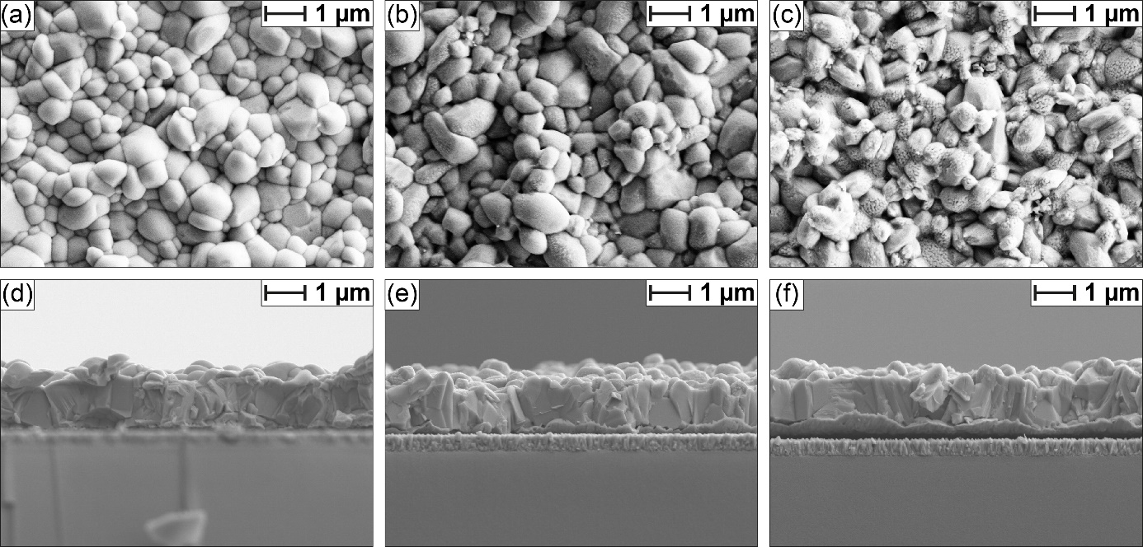
Figure 3 – (a) and (d) top view and cross-sectional SEM images of a typical untreated Sb₂Se₃ (b) and (e) top view and cross-sectional SEM images of a typical AgNO₃ treated Sb₂Se₃ (c) and (f) top view, and cross-sectional SEM images of a typical AgNO₃ + S treated Sb₂Se₃.
to the Ag concentration is at its highest before the sputtering and, therefore, at the very surface of the film. This intensity drops off deeper into the film; however, a soft peak remains even at roughly 525 nm. This signifies the integration of the Ag far into the film. The Ag⁺ ions easily diffuse into the films, either along grain boundaries or within the grains along the spacious van der Waals contacts. Although the amount of silver is large enough to be detected by XPS, no signs of change in the lattice parameter or band gap are observed (Figure S4 and Figure S5, respectively). It is therefore hypothesized that Ag⁺ may not only passivate surface states but also defects in the bulk. The decrease in the peak intensity of Ag 3d correlates with a decrease in the peak intensity of the state observed in the VBM spectra residing at 6.5 eV (Figure 2b), which corresponds to the Ag d states.^{[20]} In Figure 2c, an extremely weak Se 3d peak is observed before the sputtering, which indicates the formation of Sb₂S₃ or a mixture of Sb₂Se₃ and Sb₂S₃ on the surface. Meanwhile, the XPS spectra of the sulfur-treated Sb₂Se₃ only show a sulfur peak in the S 2p spectra before the sputtering and only the Se 2p peaks after already after the first minute of sputtering, indicating that the sulfur only exists within the first few tens of nanometers of the film (Figure 2d), in contrast to our previous work where the sulfur penetrated into the bulk.^{[17]} As observed in Figure S8a, the first Sb 3d peak of the sulfurized sample includes a shoulder at around 530.5 eV, which can signify some oxides on the surface, while the peak at 529.5 eV shows a combination of Sb₂S₃ and Sb₂Se₃ which overlaps with each other in this region^{[11]}. The Ag 3d peak and the density of states associated with AgNO₃ treatment in the VBM spectra are lower in intensity before the sputtering and increase further after the first sputtering cycle (Figure S8b and c), indicating that a thin layer of Sb₂(S_{X-1}, Se_{x}) coats the sample, which weakens the signal of the underlying elements. Sulfurization on the surface of the semiconductors is a well-known method amongst other semiconducting materials, such as copper indium gallium (di)selenide (CIGS), as a hole-blocking layer via valence band maxima modification.^{[21]} In Figure S8c, a change in the VBM can be seen in the first layer of the film after sulfurization. It is therefore proposed that the improvement in the performance of the device upon sulfurization arises from this VBM modification and, therefore, the hole-blocking effect. Figure 3a-c shows the morphological changes through a top-view scanning electron microscopy (SEM) image highlighting a surface roughening after each treatment, which aligns with our previous observation after the etching treatment.^{[18]} While the origin of some of the roughening and added texture is likely the etching treatment with (NH₄)₂S, which has been applied to all films except for the untreated sample, the other treatments may also be a contributing factor. These noticeable changes in the surface morphology enhance light trapping and scattering of the photoabsorber layer, which is supported by the different reflectance magnitudes of the DRS measurement in Figure S5. A combination of these phenomena further contributes to enhancing the Sb₂Se₃ performance. With the cross-sectional SEM images in Figure 3d-e, it can be confirmed that the AgNO₃ treatment and the sulfurization do not change the morphology below the film's surface.

Figure 4 – (a) Raman spectra of a typical untreated sample (b) Raman spectra of a typical AgNO₃ treated sample (c) Raman spectra of a typical AgNO₃ + S treated sample, all measured at three different wavelengths of 488, 532, and 785 nm.
Raman spectroscopy was used to obtain chemical and structural information about the surface and the bulk of the material before and after each treatment. This was achieved using multiwavelength excitation measurements with three lasers, 488, 532, and 785 nm, resulting in penetration depths of around 50, 100, and 500 nm inside the Sb₂Se₃ thin film, respectively. This means that measurements performed with a 488 nm laser will allow obtaining information from the surface region of the film, while measurements with 532 nm will probe the subsurface region, and finally, the measurements with 785 nm will allow characterization of the bulk of the film (Figure S9a). Figure 4 shows representative Raman spectra of Sb₂Se₃ thin films measured after each treatment. Figure 4a suggests the presence of amorphous Se at 254 cm⁻¹ and metallic Sb at 149 cm⁻¹ on the surface of the films. Interestingly, these signals are not observed in the subsurface and bulk of the semiconductor (532 and 785 nm excitation).^{[22,23]} These secondary phases on the surface region of the Sb₂Se₃ films could cause lower photovoltage and photocurrent in the untreated film. In Figure 4b, which depicts the Ag⁺ treated samples, the Sb metal and amorphous Se features no longer appear on the surface. However, the disorder on the surface increases, which is signified by the broadening of peaks with lower intensities when compared to the measurements of the untreated Sb₂Se₃ films under the same conditions. Broadening of peaks is correlated with reduced phonon lifetime, which
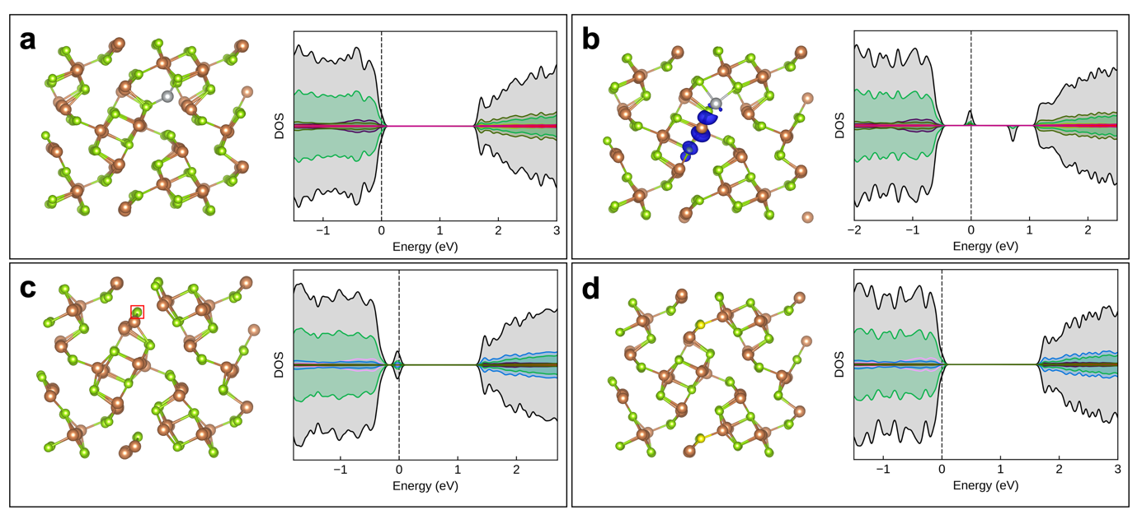
Figure 5 – Optimized structure and computed electronic density of states for various defects on the Sb₂Se₃(001) surface. (a) Ag⁺, (b) Ag⁺ + e (blue isosurface indicates electron density associated with the corresponding added occupied gap state), (c) V_{Se} (red square indicates the location of the vacancy), and (d) S_{Se}. Brown, green, silver, and yellow spheres represent Sb, Se, Ag, and S, respectively. The Fermi level is set to zero in the density of states plots and indicated with a vertical dashed line.
could indicate an increase in the defect density in the surface region or a lowering of the crystal quality, as seen in Figure S9b.^{[24]} Finally, in Figure 4c, peaks for the surface-related spectra sharpen after sulfurization, showing the crystal quality improvement. Additionally, peaks related to Sb₂(S_{1-x}, Se_{x})₃ solid solution phase appear in spectra measured with 488 and 532 nm excitation, suggesting the formation of this additional phase on the surface of these films.^{[25]} This corresponds well with the XPS S 2p peaks on the surface in Figure 2d, which disappear after the surface is sputtered. A visual representation of the abovementioned effects has been summarized in Figure S10.To provide insight into the impact of Ag and S on the structure and electronic properties of Sb₂Se_{3,} density functional theory (DFT) calculations were performed. Previously, the structure and electronic properties of Sb₂Se₃ surfaces and grain boundaries were investigated, and the same approach was employed in this study (details in Experimental).^{[12,24]} Stoichiometric and defect-free Sb₂Se₃ surfaces are found to readily reconstruct when cleaved to eliminate dangling bonds by forming new inter-ribbon bonds that leave the band gap free of gap states. Here the impact of various defects on the structure and electronic properties of the Sb₂Se₃ (001) surface were investigated. Figure 5a shows the structure and electronic properties of a silver ion (Ag⁺) adsorbed on the surface. Ag⁺ coordinates to two surface Se atoms, bridging between two adjacent Sb₂Se₃ ribbons. The computed density of states (DOS) indicates that no new states are introduced within the band gap. However, on adding an electron and full geometry optimization, the electron is found to localize primarily on the adjacent Sb atom, as shown in Figure 5b. A corresponding occupied deep gap state is observed in the DOS, as well as a second unoccupied state. These results indicate that, on the one hand, Ag is not reduced on the addition of electrons, so it is expected to favor the +1 oxidation state, but it can induce charge trapping on neighboring Sb atoms in Sb₂Se₃. Ag⁺ diffusing below the surface along the inter-ribbon channels is another possible outcome of this treatment (Figure S11). A 0.04 eV increase in energy associated with Ag⁺ in a sub-surface location suggests that deeper incorporation of Ag⁺ between the ribbons is plausible. Similar electron trapping is also observed, primarily on adjacent Sb atoms. Figure 5c shows the structure and DOS for a neutral selenium vacancy (V_{Se}) at the surface. This site considered here is the most stable, which is 0.52 eV more stable than a bulklike vacancy suggesting a strong preference for surfaces to be Se-deficient. The DOS reveals shallow occupied states close to the valance band maximum, primarily localized on Sb and Se atoms adjacent to the vacancy. On introducing S to passivate the surface vacancy (Figure 5d), the shallow gap states are eliminated, with a surface reconstruction similar to that observed for the stoichiometric and pure Sb₂Se₃(001) surface.

3. Conclusion
Overall, the photovoltage deficit limitation of Sb₂Se₃ photocathode material was addressed by implementing sulfurization in combination with a silver ion post-synthetic treatment. The results demonstrated a cumulative increase in the photovoltage more than double that of the untreated sample, reaching half of the theoretical maximum photovoltage for Sb₂Se₃. This notable enhancement indicates the successful removal of non-Sb₂Se₃ residues from the surface and favorable morphological changes, leading to improved light trapping and scattering. Furthermore, DFT calculations suggest that shallow defect passivation is achieved by adding sulfur to the surface of the Sb₂Se₃ absorber layer, which decreases recombination and improves the performance of these devices. Continued research and development in this area, building upon the success of the sulfurization treatment, the metal ion treatments, and the increased catalyst stability studies, hold promise for further enhancing the efficiency and stability of Sb₂Se₃-based photocathodes and advancing solar energy conversion technologies.

4. Experimental

Synthesis of PEC Devices
Pilkington's FTO TEC 15 substrates were cut into 1 x 2.5 cm samples and thoroughly cleaned using soapy distilled water, distilled water, acetone, and isopropyl alcohol (IPA). After drying with a nitrogen gun, the substrates undergo a 30-min UV/ozone cleaning process to remove any surface contaminants. Next, a Safematic CCU-010 sputter coater was utilized to deposit a 10 nm thick Ti layer and a 150 nm thick Au layer onto the FTO substrates. A three-electrode configuration was employed to electrodeposit Sb metal onto the FTO/Ti/Au substrates. The Sb electrodeposition solution consisted of 15 mM potassium antimony tartrate and 50 mM tartaric acid, with the pH adjusted to 1.3. An electrode potential of −0.3 V vs. Ag/AgCl was applied to limit the Sb thickness by controlling the charge passed to 1.4 C cm⁻². The deposition area was carefully monitored to achieve uniform thickness and optimal performance. The resulting Sb substrates were then selenized using a two-zone furnace. Selenium pellets were placed around the substrate, and the chamber was purged with argon. The temperature was ramped up to 350°C at a rate of 15°C min⁻¹ and held for 40 min. A 100 nm thick TiO₂ layer was deposited on the surface of the substrate using a Picosun R200 system via atomic layer deposition, with TDMAT and H₂O used as the source for Ti and O, respectively. The thickness of the TiO₂ layer was confirmed using ellipsometry on a silicon witness wafer. Finally, a 2 nm thick Pt layer was sputtered onto the photocathode. This method produces high-quality compact thin films without requiring sophisticated high vacuum equipment, but caution must be taken to prevent small leaks in the gas connection that can cause a Sb₂O₃ layer to form on top of the Sb₂Se₃.

Solution treatments
All treatments in this section were performed after the Sb₂Se₃ synthesis and before the TiO₂/Pt deposition. Before any treatments, Teflon tape was used to protect the exposed Au surface. The Sb₂Se₃ thin films were then dipped for 5 s into a clear yellow (NH₄)₂S solution (10% wt)and rinsed with distilled water before being dried under N₂ flow. This procedure improved the performance of devices in our previous publication and was therefore carried out as a first step before further treatments.^{[18]} After the etching procedure, the films were treated with a 10 mM solution of various metal chlorides or nitrates for the metal treatment screening stage. A thorough screening of the following metal solutions was undertaken: CaCl₂, CoCl₂, NiCl₂, CuCl₂, ZnCl₂, Ga(NO₃)₃, AuCl₃, and AgNO₃, dipping them into a transparent solution for 5 min. The films were then rinsed and dried under N₂ flow. The treatment solutions' aqueous and relatively non-toxic nature makes them simple to prepare and handle. Although some metal precursors, such as AuCl_{3,} were not fully soluble in water and precipitated in the solution. Moreover, the quick dipping treatment does not necessitate additional annealing or energy-intensive equipment.

Photoelectrochemical (PEC) characterization of Sb₂Se₃
The photoelectrochemical performance of the photocathodes was evaluated using a BioLogic SP-200 potentiostat in a three-electrode configuration, with simulated AM 1.5G illumination calibrated by a silicon diode from PV Measurements, Inc. (100 mW cm²), and a 1 M H₂SO₄ (pH 0) solution. The three-electrode configuration included an Ag/AgCl (3 M KCl) reference electrode, a freshly cleaned Pt wire counter electrode, and the photocathode as the working electrode. The CV was consistently measured with a scan speed of 10 mV s⁻¹, with scans performed from positive to negative to positive potential. The photocathode area was defined by epoxying (Loctite 9461) around an O-ring (ID 7 mm) placed on the sample surface. For IPCE measurements, a home-built IPCE system with a halogen light source, double monochromator, and white light bias from the LED was used. As mentioned, IPCE was measured in a three-electrode configuration at 0 V vs. RHE, with 5 nm wavelength intervals and 1% white light bias.

Morphology and crystal characterization
A Zeiss Gemini 450 SEM was used to capture top view and cross-section scanning electron microscopy (SEM) images of the Sb₂Se₃ thin films. X-ray diffraction (XRD) was performed using the Rigaku Smartlab diffractometer. The Sb₂Se₃, Sb₂S₃, and Au reference cards were sourced from the Cambridge Crystallographic Data Centre (CCDC) database.

XPS
A Physical Electronics (PHI) Quantum 2000 X-ray photoelectron spectrometer with monochromatic Al-Kα radiation was used for XPS depth profiling, operated at 15 kV and 32.3 W. The energy scale of the instrument was calibrated using an Au reference sample, and the analysis was conducted at 1 × 10⁻⁶ Pa with an electron take-off angle of 45° and a pass energy of 23.50 eV. Shirley background subtraction was performed using instrument-specific sensitivity factors for calculation, and core-level spectra were plotted to deconvolute spectra with contributions from multiple elements as necessary. A GL 30 asymmetric line shape was assumed for the core level emissions with a separation of ΔE = 9.34 eV for the Sb 3d doublet. The photoelectron spectra were used to determine surface elemental concentrations. Five times 1 min and one time 10 min sputtering steps were used for depth profiling. This equates to roughly 525 nm when calibrated with a Dektac profilometer before and after the sputtering.

UV-Vis (DRS)
The diffuse reflectance measurements were performed with a UV-3600 Plus from Shimadzu equipped with an integrating sphere. The bandgap (Eg) was determined by applying the Kubelka–Munk (K–M or F(R)) function. The measured reflectance spectra were transformed to the corresponding absorption coefficient spectra by applying the K–M function:
$$α≈F\left(R\right)=\frac{{(1-R)}^{}}{2R}$$
With α being the absorption coefficient, R being the reflectance, and γ an exponent depending on the type of band gap transition. As Sb₂Se₃ has an indirect allowed transition γ is 2. F(R) is then implemented into the Tauc function:
$${(αhv)}^{\frac{1}{}}=B\left(hv-E_{G}\right)={(F(R)hv)}^{\frac{1}{}}$$
Where h is the Planck constant, ν is the photon's frequency, E_{g} is the band gap energy, and B is a constant. The data is then plotted against the photon energy, and a linear fitting towards the x-axis is performed.^{[25]}

Raman Spectroscopy
In backscattering geometry, Raman measurements were acquired on a WITec Alpha 300 R confocal Raman microscope. Multiwavelength excitation Raman measurements using 488, 532, and 785 nm lasers were performed on all samples. The beam was focused on the sample with a microscope objective, resulting in a diameter spot of 800 nm for the 488 nm laser, 1 μm for the 532 nm laser, and 1.2 μm for the 785 nm laser, and reaching a radiant power of the order of 500 μW. Laser power conditions were selected based on a power study that measured the Raman spectrum at the same point on the material with increasing laser power densities, starting from the lowest power available. For each laser power, the spectrum was monitored for changes in peak positions, peak widths, or the appearance of new peaks. The highest power for which no changes in these parameters were observed was taken as the optimal laser power for measurements. The backscattered light was analyzed with two spectrometers: a 300 mm lens-based spectrometer with a grating of 1800 g/mm equipped with a thermoelectrically cooled CCD for 488 and 532 nm excitation and a 400 mm lens-based spectrometer with a grating of 1200 g/mm equipped with a cooled deep-depletion CCD for 785 nm excitation. All spectra were calibrated based on the reference Si Raman spectrum.

Computational
The Vienna Ab initio Simulation Package (VASP) was employed for the DFT calculations.^{[26]} For consistency with previous studies of surfaces, the HSE06 hybrid functional was employed.^{[27]} This was used with D3 Grimme dispersion corrections to describe van der Waals interactions^{[28]} which predict structure and electronic properties in excellent agreement with experimental for the bulk Sb₂Se₃ crystal. This approach has been previously applied to model intrinsic point defects in Sb2Se3[31] and surface and grain boundary defects.^{[12,24]} The bulk crystal was optimized using a 350 eV plane wave cut-off and a 2 × 2 × 6 gamma-centered k-point grid for Brillouin zone sampling. A supercell for the Sb₂Se₃(001) surface was constructed based on the optimized structure at the HSE+D3 level and included a vacuum gap of at least 10 Å. All surfaces were first optimized at the PBE+D3 level (including spin polarization) and then re-optimized at the HSE+D3 level until all forces were less than 0.01 eVÅ⁻¹. All surface structures and charge density isosurfaces were visualized using the VESTA package.^{[29]} The Sumo python package was used to produce density of states plots.^{[30]}

Supporting Information
Supporting information is available from the Wiley Online Library or from the author.

Acknowledgments
This work was supported by the University of Zurich, URPP LightChEC, and SNF Project # 184737. W.Y. would like to thank the National R&D Program through the National Research Foundation of Korea (NRF), funded by the Ministry of Science and ICT RS-2023-0025177. K. P. M. would like to acknowledge membership in the UK's HEC Materials Chemistry Consortium, funded by EPSRC (EP/R029431 and EP/X035859). This work used the ARCHER2 UK National Supercomputing Service (http://www.archer2.ac.uk). All data relating to the density functional theory calculations created during this research are available on request from the University of York Research database (doi TBC).

Received: ((will be filled in by the editorial staff))
Revised: ((will be filled in by the editorial staff))
Published online: ((will be filled in by the editorial staff))

References
[1] T. Hisatomi, K. Domen, Next Energy 2023, 1, 100006.
[2] M. G. Walter, E. L. Warren, J. R. McKone, S. W. Boettcher, Q. Mi, E. A. Santori, N. S. Lewis, Chem Rev 2010, 110, 6446–6473.
[3] J. A. Turner, Science 2004, 305, 972–974.
[4] I. Holmes-Gentle, S. Tembhurne, C. Suter, S. Haussener, Nat Energy 2023, 8, 586–596.
[5] V. Nandal, R. Shoji, H. Matsuzaki, A. Furube, L. Lin, T. Hisatomi, M. Kaneko, K. Yamashita, K. Domen, K. Seki, Nat Commun 2021, 12, 7055.
[6] J. Park, W. Yang, Y. Oh, J. Tan, H. Lee, R. Boppella, J. Moon, ACS Energy Lett 2019, 4, 517–526.
[7] D. Zhang, H. Cho, J. Yum, M. Mensi, K. Sivula, Adv Energy Mater 2022, 12, 2202363.
[8] W. Yang, R. R. Prabhakar, J. Tan, S. D. Tilley, J. Moon, Chem Soc Rev 2019, 48, 4979–5015.
[9] M. Huang, P. Xu, D. Han, J. Tang, S. Chen, ACS Appl Mater Interfaces 2019, 11, 15564–15572.
[10] T. D. C. Hobson, L. J. Phillips, O. S. Hutter, H. Shiel, J. E. N. Swallow, C. N. Savory, P. K. Nayak, S. Mariotti, B. Das, L. Bowen, L. A. H. Jones, T. J. Featherstone, M. J. Smiles, M. A. Farnworth, G. Zoppi, P. K. Thakur, T.-L. Lee, H. J. Snaith, C. Leighton, D. O. Scanlon, V. R. Dhanak, K. Durose, T. D. Veal, J. D. Major, Chemistry of Materials 2020, 32, 2621–2630.
[11] R. R. Prabhakar, W. Septina, S. Siol, T. Moehl, R. Wick-Joliat, S. D. Tilley, J Mater Chem A Mater 2017, 5, 23139–23145.
[12] K. P. McKenna, Adv Electron Mater 2021, 7, 2000908.
[13] C. N. Savory, D. O. Scanlon, J Mater Chem A 2019, 7, 10739–10744.
[14] U. Wijesinghe, G. Longo, O. S. Hutter, Energy Advances 2023, 2, 12–33.
[15] S. Dong, G. Li, J. Hong, R. Qi, S. Yang, P. Yang, L. Sun, F. Yue, Physical Chemistry Chemical Physics 2023, 25, 4617–4623.
[16] R. Cao, H. Cai, W. Lian, R. Tang, Y. Xiang, Y. Wang, T. Chen, J Mater Chem A Mater 2022, 10, 20482–20488.
[17] R. R. Prabhakar, T. Moehl, D. Friedrich, M. Kunst, S. Shukla, D. Adeleye, V. H. Damle, S. Siol, W. Cui, L. Gouda, J. Suh, Y. R. Tischler, R. van de Krol, S. D. Tilley, Adv Funct Mater 2022, 32, 2112184.
[18] P. Adams, F. Creazzo, T. Moehl, R. Crockett, P. Zeng, Z. Novotny, S. Luber, W. Yang, S. D. Tilley, J Mater Chem A 2023, 11, 8277–8284.
[19] R. R. Prabhakar, T. Moehl, D. Friedrich, M. Kunst, S. Shukla, D. Adeleye, V. H. Damle, S. Siol, W. Cui, L. Gouda, J. Suh, Y. R. Tischler, R. van de Krol, S. D. Tilley, Adv Funct Mater 2022, DOI 10.1002/adfm.202112184.
[20] Y.-T. Huang, S. R. Kavanagh, M. Righetto, M. Rusu, I. Levine, T. Unold, S. J. Zelewski, A. J. Sneyd, K. Zhang, L. Dai, A. J. Britton, J. Ye, J. Julin, M. Napari, Z. Zhang, J. Xiao, M. Laitinen, L. Torrente-Murciano, S. D. Stranks, A. Rao, L. M. Herz, D. O. Scanlon, A. Walsh, R. L. Z. Hoye, Nat Commun 2022, 13, 4960.
[21] T. Yashiro, M. Sugiyama, Jpn J Appl Phys 2022, 61, 051003.
[22] S. N. Yannopoulos, K. S. Andrikopoulos, J Chem Phys 2004, 121, 4747–4758.
[23] X. Wang, K. Kunc, I. Loa, U. Schwarz, K. Syassen, Phys Rev B 2006, 74, 134305.
[24] R. E. Williams, Q. M. Ramasse, K. P. McKenna, L. J. Phillips, P. J. Yates, O. S. Hutter, K. Durose, J. D. Major, B. G. Mendis, ACS Appl Mater Interfaces 2020, 12, 21730–21738.
[25] P. Makuła, M. Pacia, W. Macyk, J Phys Chem Lett 2018, 9, 6814–6817.
[26] G. Kresse, J. Furthmü, Efficient Iterative Schemes for Ab Initio Total-Energy Calculations Using a Plane-Wave Basis Set, 1996.
[27] A. V. Krukau, G. E. Scuseria, J. P. Perdew, A. Savin, J Chem Phys 2008, 129, 124103.
[28] S. Grimme, J Comput Chem 2004, 25, 1463–1473.
[29] K. Momma, F. Izumi, J Appl Crystallogr 2011, 44, 1272–1276.
[30] A. M Ganose, A. J Jackson, D. O Scanlon, J Open Source Softw 2018, 3, 717.

Defying the Photovoltage Dilemma: Antimony selenide strides forward as a remarkable solar energy material but faces a photovoltage deficit. This work investigates the combination of silver nitrate treatment and sulfurization, which leads to a substantial photovoltage boost due to the removal of impurity phases as well as the passivation of shallow defects.

Pardis Adams, Ramon Schnyder, Thomas Moehl, Jan Bühler, Angel Labordet Alvarez, Mirjana Dimitrievska, Keith McKenna, Wooseok Yang* and S. David Tilley*

Post-Synthetic Silver Ion and Sulfurization Treatment for Enhanced Performance in Sb₂Se₃ Water Splitting Photocathodes

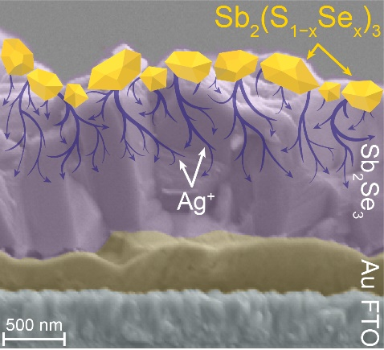

Supporting Information

Post-Synthetic Silver Ion and Sulfurization Treatment for Enhanced Performance in Sb₂Se₃ Water Splitting Photocathodes

Pardis Adams, Ramon Schnyder, Thomas Moehl, Angel Labordet Alvarez, Mirjana Dimitrievska, Keith McKenna, Wooseok Yang* and S. David Tilleyª*

Figure S1 – (a) Device structure of a typical Sb₂Se₃ film after treatments (b) Cyclic voltammetry measurements of the metal screening experiment.

Figure S2 – (a) Integrated current (mA cm⁻²) vs. wavelength calculated from IPCE measurements from the main text Figure 1d (b) Current density vs. time plots in 1 M H₂SO₄ at 0 V vs. RHE at 1 sun illumination (100 mW cm⁻²) for 5 hours.

Figure S3 – All devices have a FTO/Ti/Au/Sb₂Se₃/TiO₂/Pt configuration (a) only sulfurization treatment (blue) and (NH₄)₂S + sulfurization treatment (red) compared to the combined (NH₄)₂S + AgNO₃ + sulfurization treatment (b) (NH₄)₂S before (red), after (yellow) and both before and after (purple) sulfurization treatments compared to the combined (NH₄)₂S + AgNO₃ + sulfurization (c) AgNO₃ treatment before and after sulfurizations.

Figure S4 – (a) XRD patterns of untreated, AgNO₃ treated, and AgNO₃ + sulfurized treated Sb₂Se₃ samples (b) Zoomed in view of the spectra to highlight lack of peak shifting.

Figure S5 – (a) Diffuse reflectance spectra of the untreated, AgNO₃ and AgNO₃ + sulfurized Sb₂Se₃ devices (b) A band gap of ~1.18 eV for all three samples was determined via the Kubelka-Munk (K-M) function.

Figure S6 – XPS depth profiling of an untreated Sb₂Se₃ sample sputtered at a ~35 nm/min rate (a) Sb 3d core level (b) Se 3d core level, and (c) valence band maximum.

Figure S7 – XPS depth profiling of an AgNO₃ treated Sb₂Se₃ sample sputtered at a ~35 nm/min rate (a) Sb 3d core level (b) Se 3d core level.

Figure S8 – XPS depth profiling of an AgNO₃ + sulfurized Sb₂Se₃ sample sputtered at a ~35 nm/min rate (a) Sb 3d core level (b) Ag 3d core level, and (c) valence band maximum.

Figure S9 – Visual representation of each Sb₂Se₃ sample based on Raman measurements (a) Metallic Sb and amorphous Se in an untreated Sb₂Se₃ sample (b) Removal of metallic Sb and amorphous Se and integration of Ag into the Sb₂Se₃ film (c) Formation of Sb₂(S_{1-x}Se_{x}) on the surface of the Sb₂Se₃ film.

Figure S10 – (a) Visual representation of the penetration depth of the Raman lasers of each wavelength (b) Defect density and disorder levels of each sample when measured by the three different wavelengths of the Raman laser.

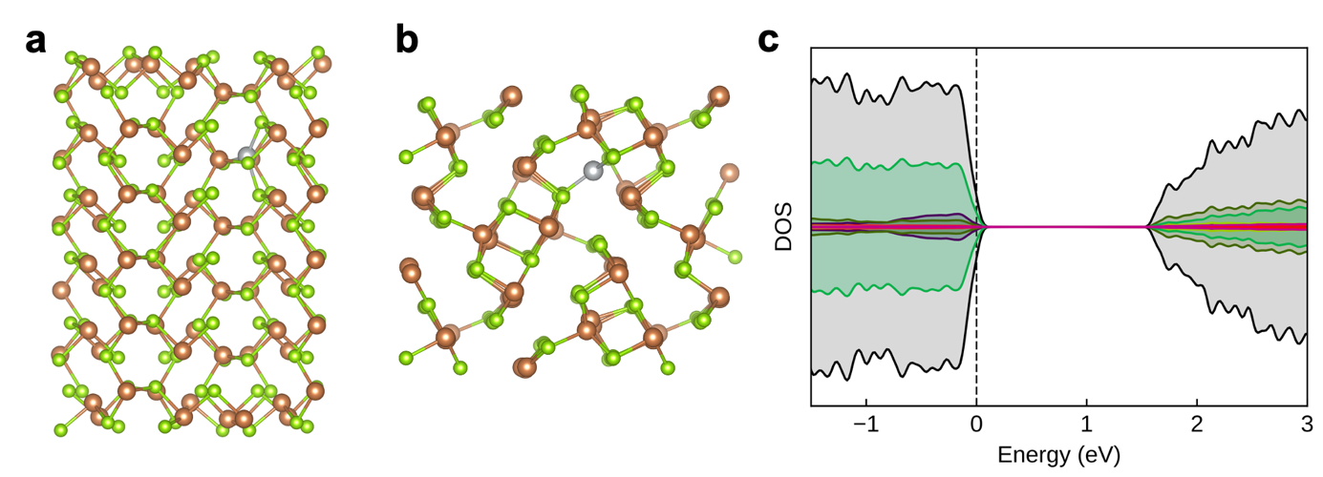
Figure S11 – (a) Side and (b) top views of the structure of the optimized structure of the Sb₂Se₃(001) surface with Ag⁺ incorporated between Sb₂Se₃ ribbons below the surface. (c) The corresponding computed density of states showing no states are introduced within the band gap. Brown, green, silver, and yellow spheres represent Sb, Se, Ag, and S, respectively.

