Efficient Spin-Orbit Torque switching in perpendicularly magnetized CoFeB facilitated by Fe₂O₃ underlayer
Zhuoyi Li^{1, #}, Xianyang Lu^{1, 2, #, *}, Zhe Zhang¹, Wenjia Li³, TaoTao Li^{2, 4}, Jian Zhou¹, Yu Yan¹, Ruobai Liu⁵, Jun Du⁵, Ronghua Liu⁵, Xinran Wang^{2, 4}, Yao Li¹, Liang He¹, Jing Wu^{3, 6}, Rong Zhang¹, Yongbing Xu^{1, 2, 3 *}
¹Jiangsu Provincial Key Laboratory of Advanced Photonic and Electronic Materials, School of Electronic Science and Engineering, Nanjing University, Nanjing 210093, China
²School of Integrated Circuits, Nanjing University, Suzhou 215163, China
³York-Nanjing Joint Center (YNJC) for Spintronics and Nano-engineering, Department of Electronics and Physics, University of York, York YO10 5DD, UK
⁴National Laboratory of Solid State Microstructures, School of Electronic Science and Engineering and Collaborative Innovation Center of Advanced Microstructures, Nanjing University, Nanjing 210093, China
⁵National Laboratory of Solid State Microstructures, School of Physics and Collaborative Innovation Center of Advanced Microstructures, Nanjing University, Nanjing 210093, China
⁶School of Integrated Circuits, Guangdong University of Technology, Guangzhou 510006, China

*Authors to whom correspondence should be addressed: xylu@nju.edu.cn and ybxu@nju.edu.cn
#Z. Li and X. Lu contributed equally to this work
Spin-orbit torque (SOT) is recognized as an effective way to manipulate magnetization in spintronic devices. For the low-power consumption and high-endurance requirements of future computer architectures, reducing the critical SOT switching current density and improving SOT efficiency is crucial, especially in the perpendicularly magnetized structures. Here, we have conducted a comprehensive study on improving the SOT efficiency of the Ta/CoFeB structure with a perpendicular magnetic anisotropy by inserting an oxide insulating layer Fe₂O₃ as the bottom layer. We found that only a 1-5 nm thickness of Fe₂O₃ significantly reduces the SOT critical switching current by 70% and enhances the spin Hall angle of Ta. The spin Hall angle increases from 0.078 for pure Ta/CoFeB to 0.13 for Fe₂O₃/Ta/CoFeB, and both types of spin orbit torques, damping-like and field-like torques, are significantly enhanced. It is suggested that the atomic diffusion of O from the Fe₂O₃ underlayer leads to the partial oxidization of the Ta layer as well as the Ta/CoFeB interfaces, accounting for the observed enhanced SOT efficiency. Our results provide a reliable method to improve the SOT performance in perpendicularly magnetized structures by inserting the oxide underlayer using magnetron sputtering, in favor of its potential real-world application in spintronic devices.

In recent years, the utilization of current-induced spin-orbit torque (SOT) to manipulate the magnetization of ultrathin ferromagnetic metals (FMs) has emerged as a highly effective method to realize high-performance and low-power spintronic memory¹⁻¹⁷. Current-induced magnetization switching by SOT is commonly observed in heterostructures with broken symmetry, such as heavy metal (HM)/FM structures^{6,18}. In heavy metal materials with strong spin-orbit coupling (SOC), such as Ta⁷, Pt^{8,19}, and W^{9,20}, the spin Hall effect generates pure spin currents that produce spin torque on the magnetization of the adjacent ferromagnetic layer with pronounced perpendicular magnetic anisotropy (PMA)^{18,21-24}.
Various approaches have been explored to enhance the efficiency of spin-orbit torque and current-induced magnetization switching, while one of them is to seek materials with large spin Hall angles, including single heavy metals, alloys and two heavy metal layers sandwiched with ultrathin ferromagnets, as well as doping and compositional regulation²⁵⁻²⁸. Recently, it is reported that by incorporating oxygen into the heavy metals layer and the interfaces such as W and Pt, it is possible to further improve the efficiency of charge-to-spin current conversion and decrease the critical current required for magnetization switching²⁹⁻³³. Even the light metal copper with weak SOC by natural oxidation can significantly enhance the spin Hall effect and increase the spin torque generation efficiency ³⁴.
Although it has been demonstrated that the efficiency of SOT can be enhanced by the incorporation of oxygen in the non-magnetic (NM) layer, two issues related to the FM layer materials and the oxidation method, respectively, remain unresolved. Most of the experimental demonstrations of oxidation-modulated SOT were carried out in structures with FM layers of NiFe alloy or thick CoFeB (CFB) films^{29,30,33,34}. These FM layers with in-plane magnetization limit the direct investigation of the current-induced magnetization switching using anomalous Hall effect (AHE). Furthermore, from a practical application perspective, the thin CoFeB film (around 1 nm)-based heterostructures with a PMA are highly desirable used in spintronic devices, which have been widely utilized in magnetic tunneling junctions (MTJs) ^{21,35-40}. Therefore, investigation of the oxidation-induced enhanced SOT in perpendicularly magnetized CoFeB-based structures is an urgent issue. On the other hand, it has been reported that the oxidized NM layers were usually fabricated by magnetron sputtering in a mixture of oxygen and argon gases^{29,30,33} or by simply natural oxidation in the air³⁴. However, the oxygen flow rate during magnetron sputtering or the time of the natural oxidation is very sensitive and difficult to be precisely controlled, limiting its practical application in the real world.
Here, we demonstrate that the insertion of a layer of α-Fe₂O₃ film underneath the Ta/CoFeB/MgO film significantly reduces the critical switching current (I_{SW}) and the applied assisting magnetic field. This approach in the current-induced switching process improves the SOT efficiency while maintaining a good perpendicular magnetic anisotropy (PMA) of the sample. It is demonstrated that after the insertion of a layer of Fe₂O₃ at the bottom layer, oxygen atoms diffused into the Ta layer and even reached the Ta/CoFeB interface after overall post-annealing. This diffusion enhances the spin Hall angle of the heavy metal Ta layer by improving the magnitude of both the damping-like torque and field-like torque by a factor of two. The critical current density is as low as 4×10⁶ A/cm² at an auxiliary field of only as small as 4 Oe. Our results provide a reliable method to introduce oxidation-based enhanced SOT using the magnetron sputtering technique, favoring the potential spintronic applications.
All samples were deposited in multilayer stacks on thermally Al₂O₃ substrates and Si substrates via DC/RF magnetron sputtering. The film structure of the substrate Al₂O₃/α-Fe₂O₃(2.0)/Ta(4.5)/CoFeB(1.0)/MgO(2.0)/Ta(2.0) (thickness in nanometers) is presented in Fig. 1(a), while the corresponding cross-section transmission electron microscope (TEM) image of the device structure in Fig. 1(b) shows a high-quality multilayer structure. The deposited films were then fabricated into Hall-bar structures as shown in Fig. 1(c). A charge current I_{x} flows through the channel, and the Hall voltage V_{H} is measured in the transverse direction. The Hall resistance is thus obtained by V_{H}/I_{x}. Fig. 1(d) shows the normalized Hall resistance (R_{H}) as a function of applied out-of-plane magnetic field (H_{z}) under a bias current of 0.2 mA for two samples: sample I was deposited on the substrate Si-SiO₂/Ta(5.0)/CoFeB(1.0)/MgO(2.0)/Ta(2.0), and sample II was deposited on the substrate Al₂O₃/α-Fe₂O₃(2.0)/Ta(4.5)/CoFeB(1.0)/MgO(2.0)/Ta(2.0). Both samples exhibit good PMA. The coercivity (H_{c}) of sample I was approximately 40 Oe, while the H_{c} of sample II with a layer of α-Fe₂O₃ film grown at the bottom was significantly reduced to 4 Oe. AHE curve (R_{H}-H_{z}) were then measured for samples with different α-Fe₂O₃ and Ta layer thicknesses at different temperatures (ranging from 300 K to 120 K). At 300K, the H_{c} of samples with α-Fe₂O₃ layer was in the range of 4-13 Oe, which is significantly smaller than that of the sample without α-Fe₂O₃. H_{c} of the samples increased and the R_{H} increased as the temperature decreased for all the samples (see Supplementary Information). All the samples present good PMA measured by vibration sample magnetometer (VSM).

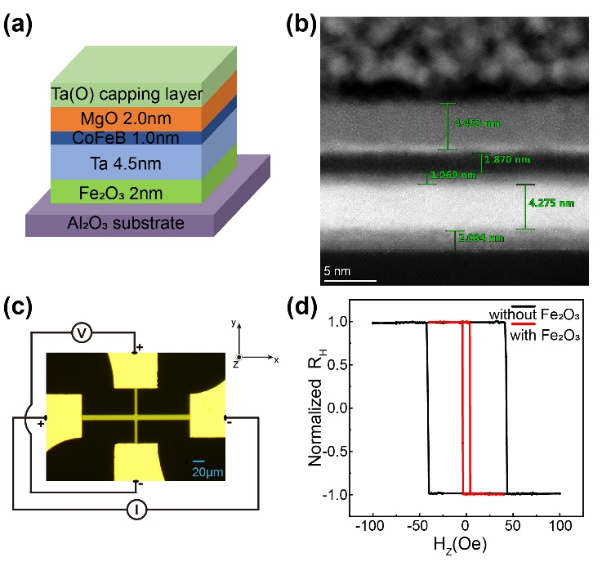
FIG 1. (a) The film structure of the multilayers. (b) The high-resolution cross-section transmission electron microscope (TEM) image of the multilayers. (c) Microscope image of one device with the dc experimental configuration. (d) The normalized Hall resistance (R_{H}) as a function of the out-of-plane magnetic field (H_{z}) for the sample I and II.

We firstly investigated the magnetization switching by the current-induced SOT in these CoFeB based heterostructures with PMA, where the required spin current was supplied by the underlying heavy metal Ta layer. To achieve SOT switching, a series of current pulses with a duration of 80 μs were applied while a fixed in-plane magnetic field along the current direction was applied to determine the switching polarity. After each current pulse, a tiny dc current (I=0.2 mA) was applied in order to measure the R_{H}. Fig. 2(a) shows the current-induced SOT magnetization switching loops for sample I and sample II under the applied in-plane magnetic field $H_{x}$ of $+18 Oe$ and $+4 Oe$, respectively, at 300 K. The I_{SW} for sample I and sample II, where the magnetization begins to switch, was found to be 10 mA and 3 mA, respectively. The current switching measurements were performed at various consecutive low in-plane external fields ($\left|H_{x}\right|≤40 Oe$) of sample II as shown in Fig. 2(c), and the SOT switching polarity can be controlled by the direction of the $H_{x}$. Full magnetization switching can be achieved even with a very small field of $\left|H_{x}\right|=4 Oe$. Meanwhile, the I_{SW} increases as the $H_{x}$ decreases. We also measured the switching curve of sample I under different external fields and found that the minimum in-plane field required for full switching was $\left|H_{x}\right|=18 Oe$ (see Supplementary Information). The results showed that the α-Fe₂O₃ underlayer of the underlying layer significantly reduced the I_{SW} of SOT by 70%. Thus, the lower critical current under lower applied filed in the structure of α-Fe₂O₃/Ta/CFB compared to Ta/CFB demonstrate that the inserted thin iron oxide layer underlayer is able to enhance the SOT switching efficiency.
To further investigate the process of current-induced switching, we captured the magnetic domain evolution during the switching process using a magneto-optical Kerr effect (MOKE) microscope⁴¹. Firstly, the sample was saturated at a large field to initialize the magnetization in the "up" direction and captured as a reference image. Subsequently, Kerr images were captured after each current pulse, and each MOKE images with enhanced contrast was obtained by subtracting the reference image. Fig. 2(b) shows the MOKE image and domain states after each pulse current I at an assisting field $H_{x}=+4 Oe$ for the Hall bar of sample II. The gray (dark) area in these MOKE images represents the “up” (“down”) magnetized state. When the pulsing current reached a critical value ($I=3 mA$), domain nucleation initially occurred at the left edge, followed by current-induced domain wall (DW) propagation that spread across the entire strip and the deterministic full switching. Additionally, reversible switching was monitored through reversed DW motion when applying opposite currents. Fig. 2(d) illustrates the temperature dependence of current-induced switching for sample II at the minimum assisting field, H_{min}, ranging from 120 K to 300 K. As the temperature decreases, the I_{SW} increases gradually, while the H_{min} remains almost unchanged. To investigate any possible effect of the AFM ordering, such as the Morin transition, on the SOT process, we measured the switching curves of a series of samples at various temperatures.

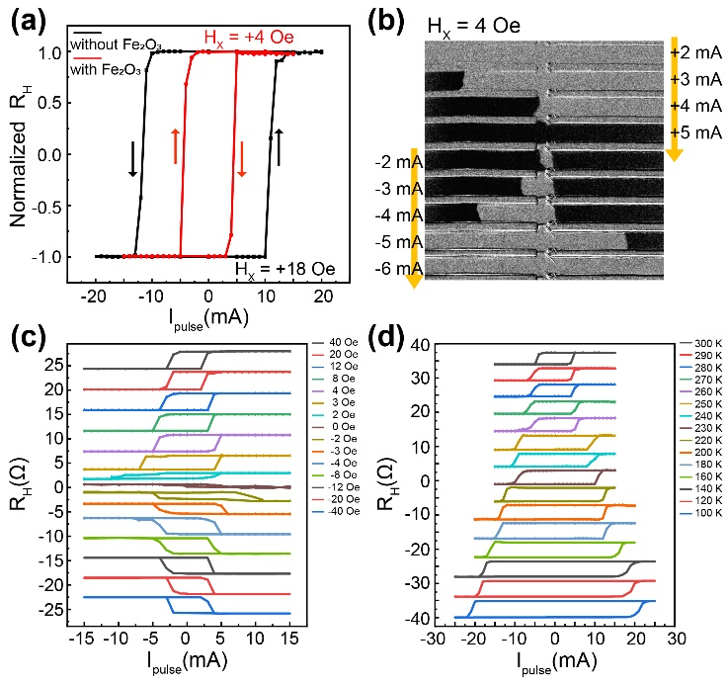
FIG 2. (a) Current-induced SOT magnetization switching loops for the sample I and II. (b) MOKE images showing the current-induced switching process of domain wall motion at H_{x}= + 4 Oe for the sample II. (c) Hall voltage V_{H} with the pulse current I_{pulse} for the sample II under different H_{x} at 300 K. (d) Temperature dependence of SOT switching loops for the sample II ranging from 120 to 300 K at the H_{min}.

Fig. 3(a) displays the current-induced SOT magnetization switching loops at 300 K for Ta/CFB and α-Fe₂O₃/Ta(t_{Ta})/CFB, where t_{Ta}=3.5, 4.0, 4.5, 5.0, 5.5, and 6.0 nm, at the corresponding minimum assisting in-plane magnetic field required to achieve 100% switching. Meanwhile, Fig. 3(b) shows the switching loops of Ta/CFB and α-Fe₂O₃(t_{Fe2O3})/Ta/CFB, respectively, at their minimum applied fields, where t_{Fe2O3}=1.0, 2.0, 3.0, and 5.0 nm. We found that regardless of the value of t_{Fe2O3}, the I_{SW} of α-Fe₂O₃/Ta/CFB was significantly smaller than that of Ta/CFB. Particularly, when t_{Fe2O3}=2 nm and t_{Ta}=4.5 nm, I_{SW} reached its minimum value of 3 mA, which was only 30% of that of Ta/CFB. We also measured the SOT current switching curves of the samples as a function of temperatures ranging from 120 K to 300 K, obtaining the H_{min} and the I_{SW} at this field, as shown in Fig. 3(c)- 3(f). It is shown that the H_{min} of Ta/CFB was 18 Oe, while that of α-Fe₂O₃/Ta/CFB was reduced to 3-8 Oe. Notably, the temperature had no significant effect on the H_{min} values. At 300 K, the I_{SW} of Ta/CFB was 10 mA while that of α-Fe₂O₃/Ta/CFB reduced to 3-7 mA, and I_{SW} gradually increased with decreasing temperature. This effect persisted even when the thickness of Ta reached 6 nm, and the thickness of α-Fe₂O₃ was only 1 nm. This suggests that the α-Fe₂O₃ layer enhances the strength of SOT and improves the efficiency of current switching⁴², and this improvement is quite robust regardless the thickness of the Ta and α-Fe₂O₃ layers. Interestingly, the switching curves at different temperatures did not appear to be influenced by the AFM ordering of α-Fe₂O₃, such as the Morin phase transition point (~260 K)⁴³⁻⁴⁵.

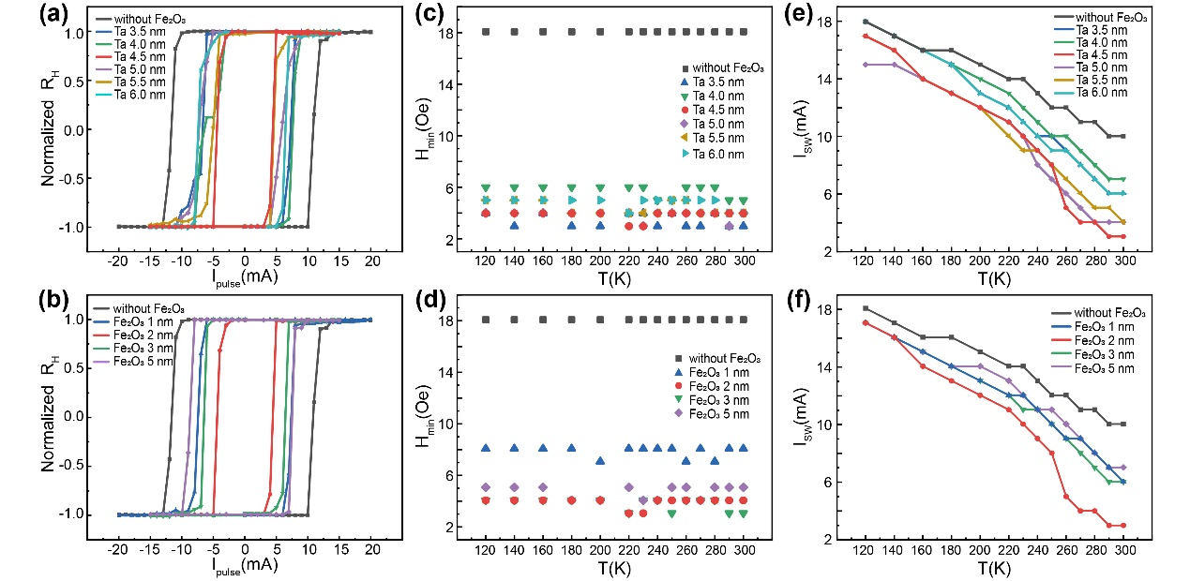
FIG 3. For Al₂O₃/α-Fe₂O₃(2.0)/Ta(t_{Ta})/CoFeB(1.0)/MgO(2.0)/Ta(2.0) film, t_{Ta}=3.5-6.0 nm and Al₂O₃/α-Fe₂O₃(t_{Fe2O3})/Ta(4.5)/CoFeB(1.0)/MgO(2.0)/Ta(2.0) film, t_{Fe2O3}=1.0-5.0 nm: (a)(b) Current-induced SOT magnetization switching loops. (c)(d) The H_{min} required for complete switching with different temperatures. (e)(f) The I_{sw} with different temperatures.

Harmonic Hall voltage measurements were performed to investigate current-driven magnetization tilting and quantify the resulting current-induced SOT effective fields⁴⁶⁻⁴⁹. These measurements quantify the longitudinal ($∆H_{L}$) and transverse effective fields ($∆H_{T}$) generated by the damping-like (H_{DL}) and field-like (H_{FL}) SOTs, respectively. We swept the magnetic field in the direction along (perpendicular to) the current $H∥I$ ($H⊥I$) in the longitudinal (transverse) scheme⁴⁸⁻⁵⁰.
Fig. 4(a)(c) and (b)(d) show the results of the first ($V_{ω}$) and second harmonic Hall voltage ($V_{2ω}$) measurements for sample I and sample II in the longitudinal and transverse scheme, respectively. The measurements were performed with an alternating current of $I_{AC}=1mA$ ($j_{AC}≈1.4×{10}^{6}A/{cm}^{2}$) and a magnetic field of $H_{L(T)}=± 3000 Oe$ for both $M_{Z}>0$ and $M_{Z}<0$. The values of $∆H_{L}$ and $∆H_{T}$ can be extracted by fitting the $V_{ω}$ and $V_{2ω}$ curves under a small magnetic field range using the following equation:^{6,46}
$ΔH_{L(T)}=-2{\left(\frac{dV_{2ω}}{dH_{L(T)}}\right)}/{\left(\frac{d^{2}V_{ω}}{dH_{L(T)}^{2}}\right)}$. (1)
The details of the fitting process are presented in the Supplementary Information.
Fig. 4(e) and 4(f) illustrates the $∆H_{L}$ and $∆H_{T}$ extracted from sample I and sample II as a function of the current I_{AC}, respectively. The effective fields exhibit a linear variation with I_{AC}, indicating that Joule heating or other artifacts that cause linear deviation in the current range can be considered negligible. The sign of $∆H_{L}$ depends on the direction of $M_{Z}$ while the sign of $∆H_{T}$ remains unchanged, showing that the current-induced effective field originates from the bulk SHE of the Ta layer in the sample^{46,51}. It is clearly shown in Fig. 4(e) and (f) that both $∆H_{L}$ and $∆H_{T}$ are significantly enhanced in the sample with α-Fe₂O₃ underlayer. Specifically, at $I_{AC}=1mA$ sample I exhibited a SOT effective fields of $∆H_{L}=5.24 Oe/mA$ and $∆H_{T}=11.73 Oe/mA$, while sample II showed $∆H_{L}=9.18 Oe/mA$ and $∆H_{T}=20.13 Oe/mA$. The values of $∆H_{L}$ and $∆H_{T}$ of sample II with α-Fe₂O₃ underlayer were almost doubled compared to sample I at the same current.
Furthermore, we determined the effective spin Hall angle $θ_{SH}$ by applying the formula $∆H_{L}=ℏθ_{SH}\left|j_{e}\right|/\left(2\left|e\right|M_{S}t_{F}\right)$^{52,53}, where $j_{e}$ is the charge current density, $e$ is the electron charge, $ℏ$ is the Planck constant, $M_{S}$ is the saturation magnetization of CoFeB, and $t_{F}$ is the thickness of CoFeB (1.0 nm). The calculated value of $θ_{SH}$ for sample I is approximately 0.078, while that of sample II increases to 0.13. $θ_{SH}$ of Ta/CoFeB is similar to the reported value of 0.08^{48,51,54}, which confirms the validity of the approach we used here. We also fixed the Ta thickness and performed harmonic tests for samples with Fe₂O₃ thicknesses of 1 nm, 3 nm, and 5 nm, respectively (see Supplementary Information). The results obtained that the spin Hall angle $θ_{SH}$ of the samples with Fe₂O₃ thickness of 1-5 nm are all around 0.12-0.13, and both the SOT effective field and spin Hall angle are significantly enhanced than that without Fe₂O₃ layer.

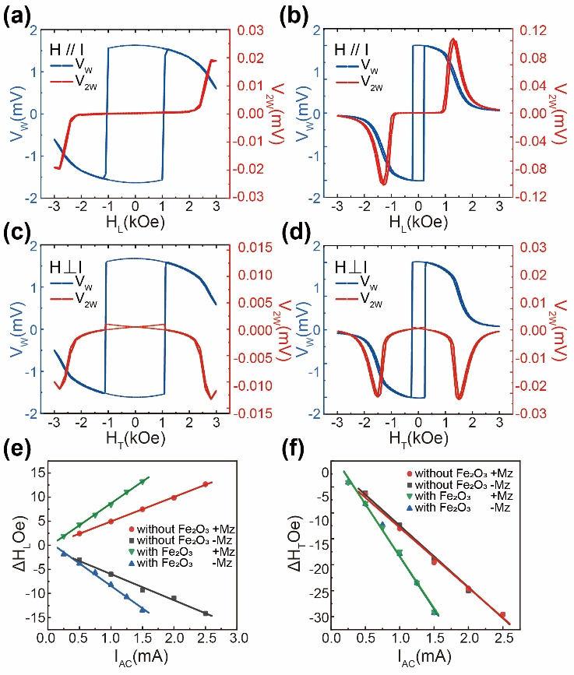
FIG 4. First and second harmonic loops in longitudinal configuration ($H∥I$) and in transverse configuration ($H⊥I$) for sample I (t_{Fe2O3}=0nm) (a)(c), and for sample II (t_{Fe2O3}=2nm) (b)(d), measured at $θ_{H}=2°$ and 300 K. The current-induced effective fields versus I_{AC} value are shown in (e) for longitudinal effective field $∆H_{L}$ and (f) for transverse effective field $∆H_{T}$.

To investigate the underlying mechanism of the enhanced SOT efficiency by the inserted Fe₂O₃ layer, the X-ray photoelectron spectroscopy (XPS) sputtering-depth profiling was conducted to determine the composition of each material at different depths⁴⁹. Fig. 5 (a) presents the relative atomic contents of Ta, O, Co, Fe, Mg, B and Si at different depths of the sample I measured during sputtering etching, while Fig. 5 (b) shows the relative atomic contents in sample II. The capping layer TaO_{x} was formed on the sample surface in air, leading to a high oxygen concentration. In sample I, the concentration of oxygen atoms decreases as the etching depth increases until the bottom Ta layer. It is shown that the bottom Ta layer is slightly oxided as it is near the SiO₂ substrate. In sample II, although the concentration of oxygen atoms distribution is the top Ta(O)/MgO/CoFeB is similar to that in smaple I, the relative atomic content of O in the bottom Ta layer increases significantly since the interface between the CoFeB and Ta layers and reaches a quite high level of ~50% near the Fe₂O₃ layer. No distinct differences are shown in the atomic concentrations of Ta, Mg, Co and B with respect to the etching depth between the two samples.
These observations suggest that some oxygen atoms diffuse from the underlying Fe₂O₃ layer into the Ta layer as well as the CoFeB/Ta interface, resulting in partial oxidation in the bottom Ta layer and the interface, as illustrated in Fig. 5 (c). This O atom diffusion plays a role on the crystallinity, oxygen content, and defect density of the CoFeB and Ta layers, which can ultimately affect the magnitude of the coercive fields of the CoFeB perpendicular films and the process of current-induced SOT magnetization switching. It has been reported that despite the atomic SOC of O being small, it can significantly alter the hybridization of Co, Fe and Ta orbitals near the interface, resulting in a change in wave function asymmetry near the nucleus and the enhancement of the Rashba effect^{29,55,56}. In addition, it is possible that the increase in oxidation level of the heavy metal layer could impact the SOC, leading to an enhancement of both the spin-orbit torque and the size of the spin Hall angle^{30,33,34}. Hence, the enhanced SOT of Fe₂O₃/Ta/CoFeB multilayers may be attributed to the modulation of the interfacial Rashba-type SOT via oxygen-induced orbital hybridization across the interface or by the control of the charge distribution near the interface. Additionally, the enlargement of the spin Hall angle resulting from the modification of the spin-orbit torque caused by the oxidation of the Ta layer further enhances the effect.

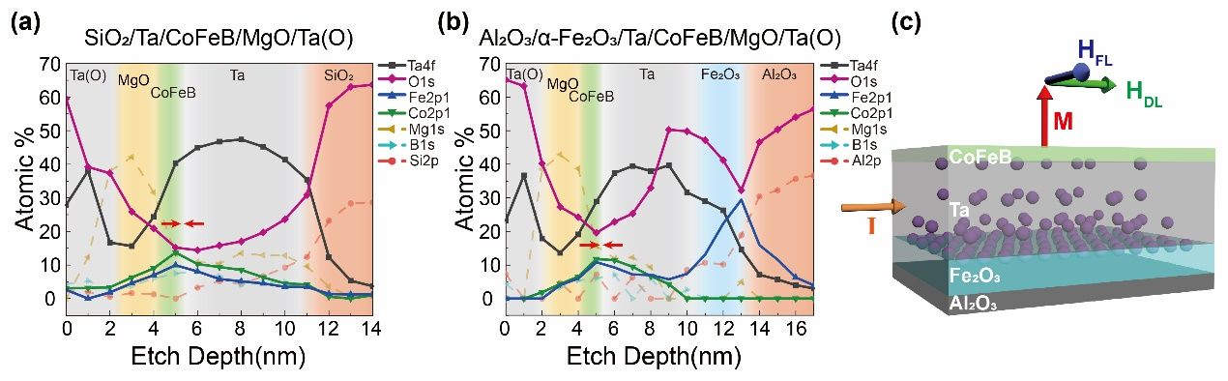
FIG 5. Variation in the relative atomic content of Ta, O, Co, Fe, Mg, B, Al and Si versus etching depth in XPS spectra of (a) sample I and (b) sample II. (c) Schematic diagram of the SOT effective field $H_{DL}$ and $H_{FL}$ in sample II when the magnetization is tilted perpendicular to the current direction. Diffused oxygen atoms are represented by purple spheres.

In conclusion, we have experimentally demonstrated the deterministic current-induced spin-orbit torque (SOT) switching in a magnetic heterostructure consisting of Fe₂O₃/Ta/CoFeB/MgO, which exhibits a robust perpendicular anisotropy. Our findings reveal that the Fe₂O₃ underlayer significantly reduces the critical magnetization switching current by 70% and enhances the efficiency of the SOT current-driven switching process. The current-driven effective fields induced by the SOT are determined using vector measurements in both the longitudinal and transverse directions. The nonvolatile modulation results in a significant enhancement of both the damping-like and field-like torque, as well as an increase in the spin Hall angle $θ_{SH}$ by approximately 85%. This enlarged $θ_{SH}$ significantly improves the SOT efficiency and may reduce the power consumption for the potential spintronic application. This efficient spin-orbit torque is suggested to be originated from the Ta(O)/ferromagnet interface, which is affected by the diffusion of O atoms from the underlying oxide. Our results provide an interesting path to enhancing the magnitude of spin-orbit torque and bridging the gap between oxide electronics and spintronics. Importantly, the observed enhancement of SOT efficiency is demonstrated to be robust regardless the thickness of Ta or Fe₂O₃ layers. Also, compared to the other oxidation-related methods, insertion of the iron oxidation underlayer grown by magnetron sputtering is more practical and stable for the potential applications in the development of next-generation spintronic devices. It should be noted that this mechanism is not directly influenced by the antiferromagnetic ordering and is not limited to antiferromagnetic materials like α-Fe₂O₃, thus it can be extended to other possible oxides, making it a general and effective approach.

ASSOCIATED CONTENT
Supplementary Information: Methods to sample preparation and measurement technique; The anomalous Hall effect, SOT switching and VSM measurement of the Fe₂O₃/Ta/CoFeB multilayers with different thicknesses; The harmonic Hall measurement and STEM measurement of sample I and sample II; The structural and magnetic properties of the α- Fe₂O₃(001) film; The AFM and XRD characterizations of Ta; The summary of reported typical oxidation methods for manipulating SOT effect of our device and those from the works of literature.

ACKNOWLEDGEMENTS
Z.L. and X.L. contributed equally to this work. This work is supported by the National Key Research and Development Program of China (Grant Nos. 2021YFB3601600), the National Natural Science Foundation of China (Grant Nos. 12104216, 12241403 and 61427812), and the Natural Science Foundation of Jiangsu Province of China (Nos. BK20200307, BK20192006, and BK20180056).

DATA AVAILABILITY
The data that support the findings of this work are available within the paper and its Supplementary Information. Additional data are available from the corresponding authors upon reasonable request.

Author contributions
X.L. and Y.X. conceived the project and designed the experiments. Z.L. and Z.Z. prepared the samples with the help from Y.Y., Y.L. and L.H.. Z.L. performed the SOT measurements with the help from W.L., J.Z., and R.L.. T.L. and X.W performed the AFM measurements. R.L. and J.D. performed the VSM measurements. Z.L., X.L. and Y.X. performed the data analysis and wrote the paper with contributions from all authors. All authors discussed the results, interpretation and conclusion.

Competing interests
The authors declare no competing interests.

References
[1]Jairo Sinova, Sergio O. Valenzuela, J. Wunderlich, C. H Back, and T. Jungwirth, Rev. Mod. Phys. 87, 1213 (2015).
[2]T. Jungwirth, J. Wunderlich, and K. Olejnik, Nat. Mater. 11, 382 (2012).
[3]A. Manchon, H. C. Koo, J. Nitta, S. M. Frolov, and R. A. Duine, Nat. Mater. 14, 871 (2015).
[4]A. Soumyanarayanan, N. Reyren, A. Fert, and C. Panagopoulos, Nature 539, 509 (2016).
[5]B. Dieny and M. Chshiev, Rev. Mod. Phys. 89 (2017).
[6]J. Kim, J. Sinha, M. Hayashi, M. Yamanouchi, S. Fukami, T. Suzuki, S. Mitani, and H. Ohno, Nat. Mater. 12, 240 (2013).
[7]L. Liu, C. F. Pai, Y. Li, H. W. Tseng, D. C. Ralph, and R. A. Buhrman, Science 336, 555 (2012).
[8]M. H. Nguyen, D. C. Ralph, and R. A. Buhrman, Phys. Rev. Lett. 116, 126601 (2016).
[9]Chi-Feng Pai, Luqiao Liu, Y. Li, H. W. Tseng, D. C. Ralph, and R. A. Buhrman, Appl. Phys. Lett. 101, 122404 (2012).
[10]Kang L. Wang, Xufeng Kou, Pramey Upadhyaya, Yabin Fan, Qiming Shao, Guoqiang Yu, and Pedram Khalili Amiri, Proc. IEEE 104, 1974 (2016).
[11]Tao Wang, John Q. Xiao, and Xin Fan, Spin 07, 1740013 (2017).
[12]G. Yu, P. Upadhyaya, Y. Fan, J. G. Alzate, W. Jiang, K. L. Wong, S. Takei, S. A. Bender, L. T. Chang, Y. Jiang, M. Lang, J. Tang, Y. Wang, Y. Tserkovnyak, P. K. Amiri, and K. L. Wang, Nat. Nanotechnol. 9, 548 (2014).
[13]Z. Zheng, Y. Zhang, V. Lopez-Dominguez, L. Sanchez-Tejerina, J. Shi, X. Feng, L. Chen, Z. Wang, Z. Zhang, K. Zhang, B. Hong, Y. Xu, Y. Zhang, M. Carpentieri, A. Fert, G. Finocchio, W. Zhao, and P. Khalili Amiri, Nat. Commun. 12, 4555 (2021).
[14]Y. K. Kato, R. C. Myers, A. C. Gossard, and D. D. Awschalom, Phys. Rev. Lett. 93, 176601 (2004).
[15]Lorenz Meier, Gian Salis, Ivan Shorubalko, Emilio Gini, Silke Schön, and Klaus Ensslin, Nat. Phys. 3, 650 (2007).
[16]K. Ando, Proc. Jpn. Acad., Ser. B 97, 499 (2021).
[17]D. Zhu, T. Zhang, X. Fu, R. Hao, A. Hamzic, H. Yang, X. Zhang, H. Zhang, A. Du, D. Xiong, K. Shi, S. Yan, S. Zhang, A. Fert, and W. Zhao, Phys. Rev. Lett. 128, 217702 (2022).
[18]K. Garello, I. M. Miron, C. O. Avci, F. Freimuth, Y. Mokrousov, S. Blugel, S. Auffret, O. Boulle, G. Gaudin, and P. Gambardella, Nat. Nanotechnol. 8, 587 (2013).
[19]Ioan Mihai Miron, Kevin Garello, Gilles Gaudin, Pierre-Jean Zermatten, Marius V. Costache, Stéphane Auffret, Sébastien Bandiera, Bernard Rodmacq, Alain Schuhl, and Pietro Gambardella, Nature 476, 189 (2011).
[20]S. Cho, S. C. Baek, K. D. Lee, Y. Jo, and B. G. Park, Sci. Rep. 5, 14668 (2015).
[21]J. Kim, J. Sinha, M. Hayashi, M. Yamanouchi, S. Fukami, T. Suzuki, S. Mitani, and H. Ohno, Nat. Mater. 12, 240 (2013).
[22]T. Suzuki, S. Fukami, N. Ishiwata, M. Yamanouchi, S. Ikeda, N. Kasai, and H. Ohno, Appl. Phys. Lett. 98, 142505 (2011).
[23]S. Fukami, T. Anekawa, C. Zhang, and H. Ohno, Nat. Nanotechnol. 11, 621 (2016).
[24]Paul M. Haney, Hyun-Woo Lee, Kyung-Jin Lee, Aurélien Manchon, and M. D. Stiles, Phys. Rev. B 87 (2013).
[25]Zelalem Abebe Bekele, Runze Li, Yucai Li, Yi Cao, Xionghua Liu, and Kaiyou Wang, Adv. Electron. Mater. 7, 2100528 (2021).
[26]Tian-Yue Chen, Chun-Te Wu, Hung-Wei Yen, and Chi-Feng Pai, Phys. Rev. B 96 (2017).
[27]Shouzhong Peng, Daoqian Zhu, Weixiang Li, Hao Wu, Alexander J. Grutter, Dustin A. Gilbert, Jiaqi Lu, Danrong Xiong, Wenlong Cai, Padraic Shafer, Kang L. Wang, and Weisheng Zhao, Nat. Electron. 3, 757 (2020).
[28]Lijun Zhu, Daniel C. Ralph, and Robert A. Buhrman, Phys. Rev. B 99 (2019).
[29]Liupeng Yang, Yining Fei, Kaiyuan Zhou, Lina Chen, Qingwei Fu, Liyuan Li, Chunjie Yan, Haotian Li, Youwei Du, and Ronghua Liu, Appl. Phys. Lett. 118, 032405 (2021).
[30]K. U. Demasius, T. Phung, W. Zhang, B. P. Hughes, S. H. Yang, A. Kellock, W. Han, A. Pushp, and S. S. P. Parkin, Nat. Commun. 7, 10644 (2016).
[31]X. Qiu, K. Narayanapillai, Y. Wu, P. Deorani, D. H. Yang, W. S. Noh, J. H. Park, K. J. Lee, H. W. Lee, and H. Yang, Nat. Nanotechnol. 10, 333 (2015).
[32]Hiroki Hayashi, Akio Asami, and Kazuya Ando, Phys. Rev. B 100 (2019).
[33]Hongyu An, Yusuke Kanno, Akio Asami, and Kazuya Ando, Phys. Rev. B 98 (2018).
[34]H. An, Y. Kageyama, Y. Kanno, N. Enishi, and K. Ando, Nat. Commun. 7, 13069 (2016).
[35]S. Ikeda, K. Miura, H. Yamamoto, K. Mizunuma, H. D. Gan, M. Endo, S. Kanai, J. Hayakawa, F. Matsukura, and H. Ohno, Nat. Mater. 9, 721 (2010).
[36]Y. Liu, J. Zhang, S. Wang, S. Jiang, Q. Liu, X. Li, Z. Wu, and G. Yu, ACS Appl. Mater. Interfaces 7, 26643 (2015).
[37]J. Torrejon, J. Kim, J. Sinha, S. Mitani, M. Hayashi, M. Yamanouchi, and H. Ohno, Nat. Commun. 5, 4655 (2014).
[38]Zongxia Guo, Jialiang Yin, Yue Bai, Daoqian Zhu, Kewen Shi, Gefei Wang, Kaihua Cao, and Weisheng Zhao, Proc. IEEE 109, 1398 (2021).
[39]Ao Du, Daoqian Zhu, Kaihua Cao, Zhizhong Zhang, Zongxia Guo, Kewen Shi, Danrong Xiong, Rui Xiao, Wenlong Cai, Jialiang Yin, Shiyang Lu, Cong Zhang, Yue Zhang, Shijiang Luo, Albert Fert, and Weisheng Zhao, Nat. Electron. 6, 425 (2023).
[40]Wang. Luding, Cheng. Houyi, Li. Pingzhi, and Zhao. Weisheng, Proc. Natl. Acad. Sci. 119 (2022).
[41]M. Montazeri, P. Upadhyaya, M. C. Onbasli, G. Yu, K. L. Wong, M. Lang, Y. Fan, X. Li, P. Khalili Amiri, R. N. Schwartz, C. A. Ross, and K. L. Wang, Nat. Commun. 6, 8958 (2015).
[42]Luqiao Liu, Takahiro Moriyama, D. C. Ralph, and R. A. Buhrman, Phys. Rev. Lett. 106, 036601 (2011).
[43]J. Han, P. Zhang, Z. Bi, Y. Fan, T. S. Safi, J. Xiang, J. Finley, L. Fu, R. Cheng, and L. Liu, Nat. Nanotechnol. 15, 563 (2020).
[44]N. Amin and S. Arajs, Phys. Rev. B 35, 4810 (1987).
[45]Sergey M. Suturin, Alexander M. Korovin, Sergey V. Gastev, Polina A. Dvortsova, Mikhail P. Volkov, Manuel Valvidares, and Nikolai S. Sokolov, Phys. Rev. Mater. 5 (2021).
[46]Masamitsu Hayashi, Junyeon Kim, Michihiko Yamanouchi, and Hideo Ohno, Phys. Rev. B 89 (2014).
[47]S. K. Li, X. T. Zhao, W. Liu, Y. H. Song, L. Liu, X. G. Zhao, and Z. D. Zhang, Appl. Phys. Lett. 114, 082402 (2019).
[48]X. Qiu, P. Deorani, K. Narayanapillai, K. S. Lee, K. J. Lee, H. W. Lee, and H. Yang, Sci. Rep. 4, 4491 (2014).
[49]Seonghoon Woo, Maxwell Mann, Aik Jun Tan, Lucas Caretta, and Geoffrey S. D. Beach, Appl. Phys. Lett. 105, 212404 (2014).
[50]Rajagopalan Ramaswamy, Xuepeng Qiu, Tanmay Dutta, Shawn David Pollard, and Hyunsoo Yang, Appl. Phys. Lett. 108, 202406 (2016).
[51]Can Onur Avci, Kevin Garello, Corneliu Nistor, Sylvie Godey, Belén Ballesteros, Aitor Mugarza, Alessandro Barla, Manuel Valvidares, Eric Pellegrin, Abhijit Ghosh, Ioan Mihai Miron, Olivier Boulle, Stephane Auffret, Gilles Gaudin, and Pietro Gambardella, Phys. Rev. B 89 (2014).
[52]A. V. Khvalkovskiy, V. Cros, D. Apalkov, V. Nikitin, M. Krounbi, K. A. Zvezdin, A. Anane, J. Grollier, and A. Fert, Phys. Rev. B 87 (2013).
[53]Li Ming Loong, Praveen Deorani, Xuepeng Qiu, and Hyunsoo Yang, Appl. Phys. Lett. 107, 022405 (2015).
[54]T. Y. Tsai, T. Y. Chen, C. T. Wu, H. I. Chan, and C. F. Pai, Sci. Rep. 8, 5613 (2018).
[55]O. Krupin, G. Bihlmayer, K. Starke, S. Gorovikov, J. E. Prieto, K. Döbrich, S. Blügel, and G. Kaindl, Phys. Rev. B 71 (2005).
[56]J. C. Sanchez, L. Vila, G. Desfonds, S. Gambarelli, J. P. Attane, J. M. De Teresa, C. Magen, and A. Fert, Nat. Commun. 4, 2944 (2013).

