Mapping out the Role of σ-Silane Complexes in the Ruthenium-Catalyzed Hydrosilylation of Nitriles.
Aswin Chandran,^{1,2} Raphael Ravel-Massol,¹ Laure Vendier,¹ John M. Slattery,*² Jason M. Lynam,*² Mary Grellier*¹
¹Laboratoire de Chimie de Coordination, UPR CNRS 8241, 205 Route de Narbonne, 31077 Toulouse, France, ²Department of Chemistry, University of York, Heslington, York, YO10 5DD, North Yorkshire, United Kingdom.

ABSTRACT: A combined synthetic, mechanistic, and computational study is reported, which provides unique insight into the role of σ-silane complexes in the catalytic hydrosilylation of nitriles. A novel, highly efficient, highly active, and regio-selective catalytic mono-hydrosilylation of aromatic nitriles with secondary silanes using a ruthenium dihydrogen catalyst is reported along with a novel mechanism for hydrosilylation of nitriles. Investigations into the mechanism of this transformation have revealed the influence of σ-Si–H complexes in fine-tuning the selectivity of this hydrosilylation reaction. Displacement of the dihydrogen ligand on the ruthenium pre-catalyst, ruthenium bis-(dihydrogen) complex [RuH₂(η²-H₂)₂(PCy₃)₂], 1, by diphenylsilane leads to the formation of new ruthenium σ-Si–H complexes, [RuH₂(η²-H₂)(η²-HSiHPh₂)(PCy₃)₂], 2, and [RuH₂(η³-H₂SiPh₂)(PCy₃)₂], 3. Complex 3 reacts readily with benzonitrile leading to hydrosilylation of the nitrile and coordination of the silylimine formed to the ruthenium as a σ-H–Si–N-silylimine complex, [RuH₂(η²-HSiPh₂NCHPh)(PCy₃)₂] (4). This systematic investigation of this reactivity led to the discovery of the first direct evidence of a N-silylimine coordinated ruthenium complex and its involvement in a catalytic hydrosilylation reaction. This led to the discovery of a catalytic protocol for the efficient and selective coupling of secondary silanes with a range of nitriles using 1 as the catalyst. It is proposed that complexes 3 and 4 are key intermediates on the catalytic reaction coordinate, which leads to the hydrosilylation of the nitrile. This is supported by DFT calculations, along with the observation that 3 and 4 are catalytically active. The Si–N bond formation was found to proceed via direct attack of the nitrile at the silicon atom in 3. Through carefully chosen structural studies and tests of the new ruthenium complexes, along with DFT calculations, the mechanism of the catalytic hydrosilylation of nitriles is successfully explained.
KEYWORDS: Mono-hydrosilylation, ruthenium σ-complexes, Si-H bond activation, selective reduction of nitriles.

INTRODUCTION
The significance of hydrosilylation of C–N triple bonds in organonitriles is well-established, as the resulting organosilicon products have a wide range of applications, particularly in organic synthesis.^{1–5} The hydrosilylated products formed, such as disilylamines are used as precursors for the synthesis of polymers containing Si–N bonds, such as polysilazanes and polysilsesquiazanes which are used as precursors for ceramics applications.^{6,7} N-silylamines are synthons for various catalytic transformations,⁸ including C–N bond-forming cross-coupling reactions⁹, meanwhile N-silylimines are well established for their use in enantioselective synthesis.^{10–15} However, the catalytic mono-addition of a Si–H bond to a C–N triple bond continues to be a synthetic challenge, which makes this transformation a key target for new catalysts.^{16–18} Controlling the selectivity of this transformation is particularly challenging as the initially formed N-silylimines, R₃Si–N=CHR may readily undergo a second addition to form the double-addition product disilylamines, (R₃Si)₂NCH₂R. However, a small number of metal^{19–23} and non-metal^{24,25} based catalysts for mono-hydrosilylation of nitriles to form N-silylimines selectively have begun to emerge recently. The interaction of hydrosilanes with transition metals has been well documented in the series of reviews by Corey.^{26–28} The catalytic mono-hydrosilylation of organonitriles with monohydrosilanes to synthesize N-silylimines selectively was achieved by Nikonov and co-workers using a cationic ruthenium complex [CpRu(NCMe)₂(P^{i}Pr₃)][B(C₆F₅)₄] as pre-catalyst with almost quantitative yields after 0.3 to 48 h at ambient temperature with 4-5 mol% of catalytic loading (Scheme 1a).¹⁶ A mechanism was proposed involving the formation of a ruthenium σ-Si–H silane complex, [CpRu(NCMe)(P^{i}Pr₃)(η²-HSiR₃)]⁺ followed by the nucleophilic abstraction of the silylium ion by one of the nitrile ligands to form a labile [CpRuH(NCMe)(P^{i}Pr₃)] complex. Oestreich et al. has reported a different cationic ruthenium catalyst²¹ (Scheme 1b), which effectively led to the formation of mono- and bis-hydrosilylated products depending upon the specific hydrosilane used. Oestreich et al. have studied the mechanism of cooperative Si-H bond activation using the Ru-S catalyst.²⁹ However, a fundamental and detailed study of the interactions between the silane, the nitrile functional group, and the ruthenium center along the pathway leading to Si–N and C–H bond formation needs to be investigated for a selective mono hydrosilylation of nitrile using secondary silane. Here we address this gap in knowledge by utilizing the ruthenium bis-dihydrogen dihydride complex, [RuH₂(η²-H₂)₂(PCy₃)₂] (1), which is well-established to activate silanes and forms a number of well-characterized σ-complexes.^{30–36} It was reasoned that 1 might be a highly active catalyst for the hydrosilylation of nitriles, as it is a well-established reagent for the activation of the Si–H bonds (Scheme 1c).^{32,35} In this work, the catalytic activity of complex 1 in nitrile hydrosilylation is reported. New ruthenium σ-Si-H complexes of fundamental interest have been characterized and isolated, and their role in the catalytic reaction has been identified. Combining these observations with DFT calculations enabled us to propose a reaction mechanism for the selective mono-hydrosilylation of nitriles using secondary silanes.
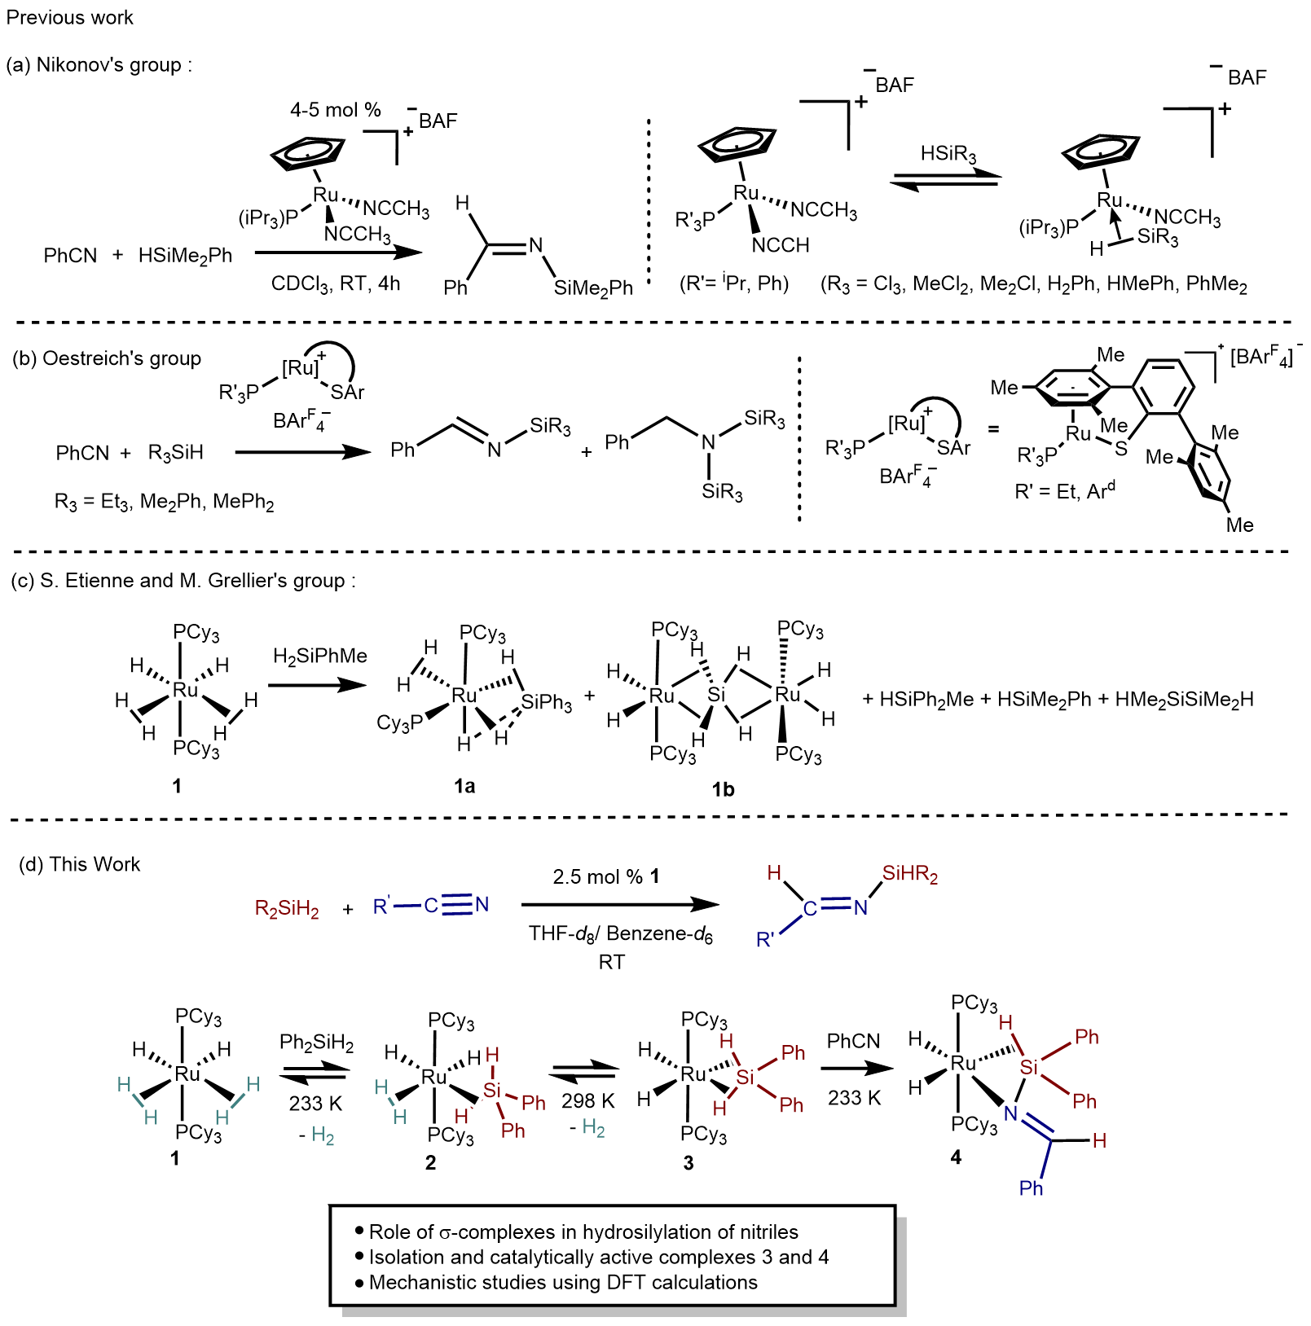
Scheme 1. (a) Catalytic chemoselective mono- or bis-hydrosilylation of nitriles using a ruthenium catalyst and synthesis of a ruthenium σ–Si–H silane complex implicated in the reaction. (b) Catalytic hydrosilylation of nitriles using a ruthenium-sulfur complex (c) Previous results for the reactivity of complex 1 with secondary silanes and benzonitrile. (d) New insights and novel catalysis from this work.
RESULTS AND DISCUSSION
Catalytic performance of [RuH₂(η²-H₂)₂(PCy₃)₂] (1) for the hydrosilylation of nitriles.
The fundamental premise of this work is that the established role of 1 in the coordination and activation of element-hydrogen bonds would (1) entail that it would be a catalyst for the hydrosilylation of nitriles and (2) enable mechanistic insight into the catalytic cycle, as the key Si–H σ-complexes were expected to be sufficiently stable to enable their role in the Si–N and C–H bond formation steps to be identified. Therefore, the ability of 1 to catalyze the desired reaction was investigated. Catalytic hydrosilylation of nitriles with a series of secondary silanes and nitriles was observed with 2.5 mol% of 1 (Table 1). The catalyst was found to be highly active and efficient, achieving near-complete conversion and excellent yield at room temperature. The complete conversion was typically observed in 15 minutes with a maximum TOF of 400 and 99% yield (Table 1, entry 3). In all cases, only the mono-addition of one of the Si–H bonds was observed: even when two equivalents of diphenylsilane (or a second equivalent was added when the first equivalent was consumed), no evidence for double silane addition giving the corresponding amine was obtained (Table 1, entry 10).
Complex 1 was found to be at least as efficient for the catalytic mono-hydrosilylation of nitriles when compared to previously reported ruthenium complexes, but in many cases, the performance is superior. For example, 1 exhibits a turnover frequency of 240 h⁻¹(at 50% conversion) and 185 h⁻¹(at 100% conversion) for the catalytic reaction between PhCN and Ph₂SiH₂, while catalyst [CpRu(NCMe)₂(PiPr₃)][B(C₆F₅)₄] shows a turnover frequency of only 6.3 (at 50%) for the similar mono-hydrosilylation of PhCN using PhMe₂SiH at room temperature.¹⁶ Compared to the Ru-S catalyst,²¹ the reaction time under mild conditions is significantly reduced from 18 h to 1 h.

Table 1. Catalytic hydrosilylation of nitriles with secondary silanes.
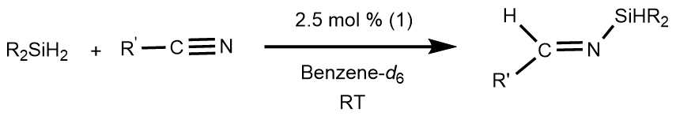
Entry | Nitrile | Silane | TON | TOF  [h⁻¹]^{[a]} | Conver-sion^{[b]}  (min) | Yield^{[c]}  (%) | Product
1 | PhCN | Ph₂SiH₂ | 40 | 185  (100%) | >99% (13) | 96%
2 | PhCN | Et₂SiH₂ | 40 | 171  (100%) | >99% (14) | 97%
3 | PhCN | PhMeSiH₂ | 40 | 400 (100%) | >99% (6) | 87%
4 |  | Ph₂SiH₂ | 40 | 240 (100%) | >99% (10) | 89%
5 |  | Ph₂SiH₂ | 40 | 240 (100%) | >99% (10) | 96%
6 |  | Ph₂SiH₂ | 38 | 53  (44.5 %) | >99% (150) | 85%
7 |  | Ph₂SiH₂ | 40 | 200 (100%) | >99% (12) | 86%
8 |  | Ph₂SiH₂ | 40 | 160 (100%) | >99% (15) | 99%
9 |  | Ph₂SiH₂ | 40 | 160 (100%) | >99% (15) | 89%
10 | PhCN | 2 Ph₂SiH₂ | 40 | 160  (100%) | >99% (15) | 100% | No further reaction after heating 60 °C for 1 day.
11 | CH₃CN | Ph₂SiH₂ | 0 | 0 | 0 | 0 | No catalytic reaction
General procedure – 2.5 mol % of [RuH₂(η²-H₂)₂(PCy₃)₂] was added to a solution of nitrile and silane in C₆D₆. [a] Calculated at the conversion shown in parentheses. [b] Calculated from ¹H NMR data. [c] Yield is determined by ¹H NMR.

Complex 1 was able to effectively catalyze the hydrosilation of a number of aryl nitriles (entries 4-9, Table 1) but was less effective with alkyl nitriles. No catalytic activity was observed in the case of coupling acetonitrile with diphenylsilane under the same conditions (Table 1, entry 11). No compound resulting from a mono or bis hydrosilylation was detected. This chemo selectivity for aryl nitrile was exploited for the hydrosilylation of 4-cyanophenylacetonitrile (Table 1, entry 9). Only the reduction of the cyano fragment attached to the aromatic ring was hydrosilylated in a good yield (89%). Different monohydrosilanes such as Ph₃SiH, PhMe₂SiH and Et₃SiH were also tested with PhCN in the same catalytic reaction conditions and no hydrosilylated products formation was observed.
Formation of novel ruthenium σ-silane complexes 2 and 3.
With the excellent catalytic activity of 1 observed and the substrate scope explored, selected stoichiometric reactions were conducted to understand the mechanism of the reaction. To achieve this, the interactions between 1 and the individual components of the catalytic reaction were investigated. Benzonitrile was chosen as the model aromatic nitrile, and diphenylsilane was chosen as the model secondary silane for stoichiometric reactions. The reactivity of 1 with nitriles has been documented in a patent.³⁷ The reactivity of benzonitrile with analogous complex 1-PCyp has been investigated previously and, depending on the stoichiometry, gives products that ultimately derive from N-coordination of PhCN to the metal and may also result in C–H bond activation of the phenyl group. ³⁸
It is well established that the ruthenium bis-dihydrogen complex, 1, may act as a precursor to ruthenium σ-Si–H complexes.^{32,33} However, a comprehensive study of the coordination of diphenylsilane at low temperatures has not been conducted. A previous study of the coordination of a dihydrosilane, H₂SiPhMe, to 1 at room temperature revealed a redistribution reaction of the silane and formation of the complexes 1a and 1b along with a mixture of different silanes (Scheme 1c). To understand the intimate interaction of diphenylsilane with complex 1, low-temperature conditions were deployed. These conditions enabled the spectroscopic identification of two new ruthenium complexes. The addition of diphenylsilane to a THF solution of 1 at 233 K, followed by slow warming to room temperature, resulted in the formation of σ-Si–H complexes [RuH₂(η²-H₂)(η²–HSiHPh₂)(PCy₃)₂], 2, and [RuH₂(η³-H₂SiPh₂)(PCy₃)₂], 3, (Scheme 2).
Scheme 2. Reversible coordination of Ph₂SiH₂ to complex 1 to form complexes 2 and 3.
To obtain a clearer understanding of the mechanism of silane coordination to 1, the reaction between 1 and Ph₂SiH₂ was performed in an NMR tube at 223 K just prior to introduction into the spectrometer, preset at the same temperature. The resulting ³¹P{¹H} NMR spectrum showed a single peak at 56.1 ppm, which was assigned to a new species, [RuH₂(η²-H₂)(η²-HSiHPh₂)(PCy₃)₂], 2, that possessed a single phosphorus environment. The ¹H NMR spectrum exhibited a triplet resonance at 5.87 ppm ( ³J_{PH} = 5 Hz) with two silicon satellites (¹J_{SiH} = 194 Hz); which, based on its chemical shift and Si–H coupling, was assigned to a Si–H group that was not coordinated to the ruthenium. A broad signal at −8.83 ppm that integrated to five hydrogens was assigned to the ruthenium-coordinated hydrogen atoms, as a similar resonance was observed in the known silane complex [RuH₂(H₂)(η²-HSiPh₃)(PCy₃)₂] (−8.3 ppm (br))³⁹, in which the ruthenium hydrides, the dihydrogen ligand, and the Si–H are all undergoing rapid exchange. The same assignment is therefore made in this case. In the ²⁹Si-DEPT spectrum, a singlet signal was observed at −9.9 ppm. This resonance exhibited a correlation with the hydride signal and the free Si–H signal in a ²⁹Si–¹H HMQC experiment (SI, Figure S16,17). The presence of a dihydrogen ligand in complex 2 is supported by the minimum T_{1,min} value (67 ms, at 283 K, 600 MHz). The optimized structure of 2 by DFT also confirms the η²-H₂ coordination (see SI, Section 10).
It was not possible to isolate complex 2 as it subsequently converted to complex 3; however, the coordination of diphenylsilane to 1 was shown to be reversible. The reaction of isolated complex 3 in THF-d₈ solution with 1.5 bar H₂ pressure resulted in the sequential formation of complex 2 followed by precursor bis-dihydrogen complex 1 (Scheme 2). The reaction was monitored by ¹H and ³¹P{¹H} NMR spectroscopy, and within 30 minutes at room temperature, the disappearance of signals corresponding to 3 and the appearance of signals corresponding to 2 and 1 was complete. After a day, further conversion to 1 was observed based on the integration values of the signals in ³¹P{¹H} and ¹H NMR. (SI, Figure S44, S45).
The formation of 3, [RuH₂(η³-H₂SiPh₂)(PCy₃)₂], may be rationalized as substitution for the dihydrogen ligand in complex 2 by the pendant Si–H bond. In complex 3, the silane may be considered as a bis-σ-Si–H complex in which both Si–H hydrogen atoms are coordinated in η² fashion to the metal. The conversion from 2 to 3 was observed at room temperature, and the use of a solvent in which complex 3 is sparingly soluble, along with a reduced pressure by applying vacuum using a Schenk line, helped to accelerate the conversion. The removal of dihydrogen led to a shift in equilibrium towards 3. The complete conversion was observed after seven hours in THF meanwhile, using pentane as a solvent and applying a vacuum to remove the dihydrogen released reduced the reaction time to under 10 minutes at room temperature. This technique led to the successful isolation of 3 with a yield of 92%.
The molecular structure of 3 was determined by NMR spectroscopy and X-ray crystallography, along with optimization using DFT modeling. The ¹H NMR spectrum of 3 in THF-d₈ exhibited a broad singlet resonance at -8.36 ppm (4H, RuH) at 298 K due to fast exchange between the hydride ligands. A singlet at 67.9 ppm was also observed in the ³¹P{¹H} NMR spectrum. Decreasing the temperature led to decoalescence of the high-field signals at a temperature below 273 K. At 193 K, the ¹H NMR spectrum exhibited a broad singlet around -5.8 ppm and a triplet at −12.33 ppm (²J_{P-H} = 25.8 Hz, 2H, RuH) (SI, Figure S23, S31). The ¹H{³¹P} NMR, at 193 K gives a sharpened signal at −5.82 ppm, leading to the observation of the silicon satellites with a ¹J_{Si-H} = 122 Hz. In this experiment, the signal at -12.33 was then simplified into a singlet with no detectable silicon satellites. These high field resonances exhibited a mutual correlation in the ¹H–¹H COSY experiment and in the ¹H–³¹P correlation experiment; both were coupled to the resonance in the ³¹P{¹H} spectrum at 67.9 ppm. These observations are consistent with the proposed formation of 3: the resonance at −5.82 ppm was assigned to the two hydrogen atoms involved in the Si–H interaction, with the ruthenium hydride resonance at −12.33 ppm being assigned to a classical dihydride. The T₁ measurements recorded (between 694 to 356 ms at 600MHz) with no minimum value over a range of temperatures (193 to 253 K) for the signal at −12.33 ppm are in agreement with classical dihydride coordination in complex 3 (SI, Table S1).
Although direct detection of a ²⁹Si resonance was not possible at any of the temperatures employed, ²⁹Si–¹H HMQC and 1D HSQC NMR (193 K) experiments demonstrated the presence of a resonance in the ²⁹Si NMR spectrum at 120.8 ppm (¹J_{Si–H} = 122.7 Hz). A similar downfield ²⁹Si chemical shift was obtained for ruthenium bis σ–Si–H complexes reported by Lipke and Tilley [PhBP^{Ph}₃]RuH(η³-H₂SiRR')] (RR' = PhMe, Ph₂, (PhBP^{Ph}₃) = tris(diphenylphosphinomethyl)borato ligand) at 154 ppm (¹J_{Si–H} = 65 Hz) and 141 ppm (¹J_{Si–H} = 68 Hz).⁴⁰ The ²⁹Si chemical shift is in agreement with the proposal that 3 contains a bis σ-Si–H, rather than a silylene, ligand as the latter are usually observed at >200 ppm.^{40–42}. Meanwhile, the higher J_{Si–H} coupling constant in 3 suggests that the Si–H bonds are weakly activated with a stronger Si–H interaction when compared to the examples reported by Lipke and Tilley. However, the Si–H coupling constant in 3 is within the range typically observed for a σ-Si–H interaction.³³ The characteristic chemical shift in the region for a σ-Si–H bond, along with stronger Si–H interaction, ruled out the possibility of the complete oxidative addition and identified the non-classical Ru–H–Si interaction.
Crystals of 3 suitable for study by single crystal X-ray diffraction were obtained by the slow cooling of a pentane-THF solution of 3 to 233 K. The ORTEP view of the molecular structure obtained by X-ray diffraction analysis of 3 is shown in Figure 1. The structure revealed that the complex exhibits two phosphine groups in a mutually trans geometry and two classical ruthenium hydrides, and two η²-Si–H hydrides in a plane perpendicular to the phosphine ligands, leading to a pseudo-octahedral geometry around the ruthenium center. The hydrogen atoms are also located around ruthenium in a plane perpendicular to the phosphine ligands. The ruthenium-silicon distance was found to be 2.2466 (10) Å; meanwhile, the shortest distance from the ruthenium atom to the two Si–H hydrogen atoms were 1.83 (3) and 1.79 (3) Å, respectively, which are comparable to a similar magnitude as reported in the complexes [(PhBP^{Ph}₃)RuH(η³–H₂SiRR')] (RR' = PhMe, Ph₂, (1.73(4), 1.76(4) Å)⁴⁰. The Si–H bonds were found to be 1.53 (3) and 1.49 (3) Å, compared to free Si–H bonds of silane (1.48 Å), suggesting that the Si–H bonds are weakly activated. This structural arrangement is consistent with the data from the NMR spectra, notably at low temperatures, the observation of two different resonances in the high field region, one for the classical dihydrides and one for the σ-Si–H bonds. The geometric environment around the ruthenium atom is similar to an analogous ruthenium boron complex [RuH₂(η²:η²-H₂BMes)(PCy₃)₂].⁴³ The similarity in geometry is also manifested in the characteristic ¹H NMR signals of this boron complex. The ruthenium hydrides were observed at −5.90 ppm (s, 2H) and −11.05 ppm (t, ²J_{P–H} = 25.2 Hz),⁴³ which are comparable to complex 3.
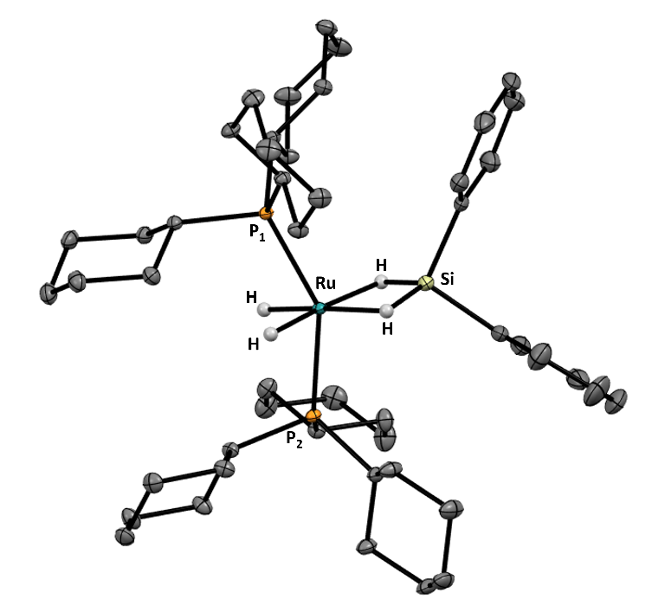
Figure 1. X-ray molecular structure of complex 3, [RuH₂(η³-H₂SiPh₂)(PCy₃)₂], drawn at 50% probability as ellipsoids (Hydrogen atoms have been removed for clarity with exception of those around ruthenium).
DFT calculations were used to optimize the geometry of 3, and particular attention was given to locating the hydrogen atoms around ruthenium. The bond lengths and angles are in good agreement with the X-ray molecular structure. For instance, the calculated distance between ruthenium and silicon atoms was determined to be 2.227 Å, which is in close agreement with the experimentally obtained measurement of 2.2466 (10) Å. A similar correlation was observed for Ru–P bond lengths, with calculated values of 2.304, 2.311 Å aligning closely with XRD-obtained values of 2.3275 (9), and 2.3338 (8) Å, respectively. The calculated distances between the ruthenium atom and the two Si–H hydrogen atoms were 1.83 Å, and the distance between the silicon atom and two Si–H hydrogen atoms was found to be 1.65 Å each, respectively. Characteristic bond lengths obtained by X-ray diffraction in comparison with the calculated values are presented in SI, Table S2.
In order to understand the coordination of the Ph₂SiH₂ to the ruthenium center, an NBO analysis was performed on complex 3. While the σ-donating NBOs have nearly the same population in 1 (1.70 e, σ (H₂)) and 3 (1.73 e, σ Si–H), the π back-bonding in 3 is slightly smaller (0.09 e, σ * Si–H) than in 1 (0.14 e, σ* (H₂)). The NLMO’s are also consistent with a bis-σ–Si–H description (see pLMNO representation in Figure 2).
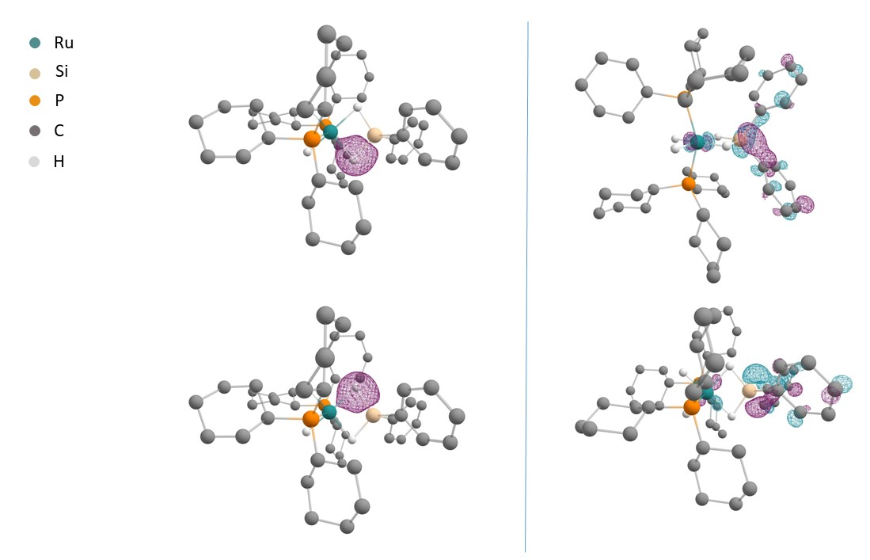
Figure 2. Left: pNLMO representation of the two Ru(η²-SiH) bonds. Right: LUMO of compound 3 (two perpendicular views). Hydrogen atoms attached to carbon atoms are omitted for clarity.
The NBO analysis on complex 2 confirms the σ-Si–H bond coordination mode. The donating NBOs have nearly the same population in (1.64 e, σ (H₂)) and (1.61 σ Si–H), (for comparison 1.97e, uncoordinated Si–H), but the π back-bonding is bigger (0.25 e σ * Si–H, 0.16 e, σ* (H₂)) than in 3. The NLMO’s are also consistent with a σ-Si–H, σ-H₂ bonding description (see pLMNO representation in Figure 3).
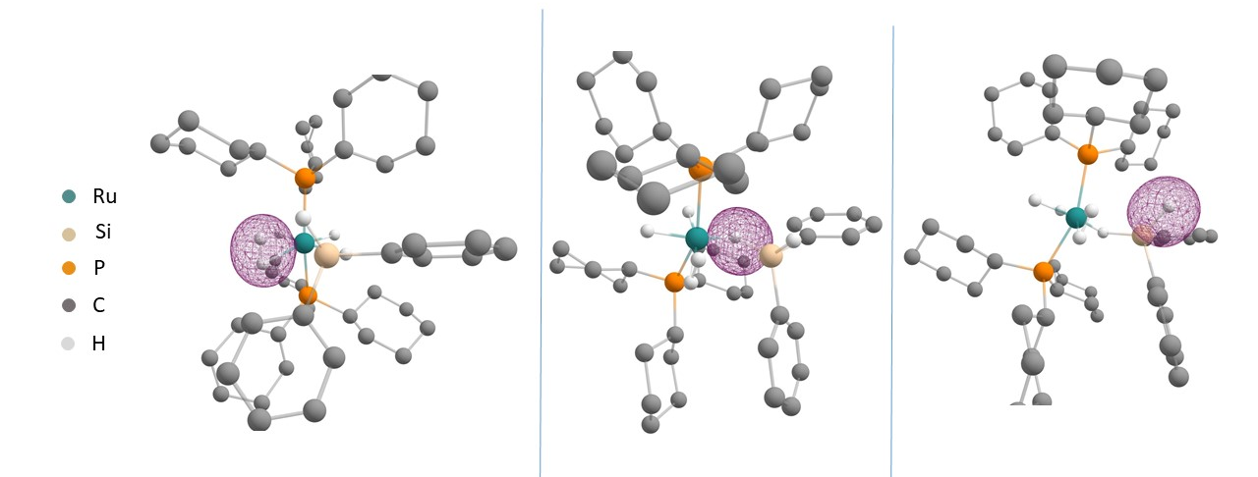
Figure 3. pNLMO representation of left: Ru(η²-H₂); middle: Ru(η²-SiH); right: uncoordinated Si–H, complex 2. Hydrogen atoms attached to carbon atoms are omitted for clarity.

Si–N bond formation from a σ-Si–H complex and PhCN
Having established the nature of the interaction between 1 and Ph₂SiH₂, our attention turned towards developing an understanding of the steps involved in Si–N and C–H bond formation. To achieve this, the stoichiometric reaction of complex 3 with an equivalent of benzonitrile was explored. Specific attention was given to the potential addition of the activated Si–H bond to the benzonitrile. It was found that a new ruthenium complex, 4, is formed, which contains an N-silylimine ligand resulting from the selective addition of only one Si–H bond of diphenylsilane to the nitrile group (Scheme 3).
Scheme 3. Reactivity of complex 3 with benzonitrile.
Addition of PhCN to a THF solution of 3 at 233 K, followed by warming to room temperature, afforded a new ruthenium complex with single resonance in the ³¹P{¹H} NMR spectrum at 66.1 ppm: this was assigned to complex 4. The high-field region of the ¹H NMR spectrum of 4 showed three hydride signals. At room temperature, these resonances appear as broad signals; however, on cooling to 273 K, the signals sharpened, allowing for important structural information to be obtained. A singlet at −5.86 ppm with satellite peaks of ¹J_{Si–H} = 130.5 Hz was assigned to a σ-bound Si–H group, whereas triplet resonances at −10.26 ppm (²J_{P–H} = 25.4 Hz) and −14.31 ppm (²J_{P–H} = 25.8 Hz) were assigned to two inequivalent ruthenium hydride ligands. Although the coupling between phosphorus and silicon-bound hydrogen atoms was not observed, likely due to the low coupling constant values and the broadness of the signals, the correlation between them was established by a ³¹P–¹H HMQC experiment. The ³¹P{¹H} signal at 66.1 ppm (s) became a quartet when the resonances for the cyclohexyl hydrogen atoms were selectively decoupled, confirming the presence of three hydrogen atoms bound to ruthenium. Interestingly, the ²⁹Si–¹H HMQC experiment found that the ¹J_{Si–H} coupling constant for the ²⁹Si signal at −43.6 ppm was 128.8 Hz, which agrees with the weakly activated σ-Si–H bond formulation. A resonance at 10.1 ppm in the ¹H NMR spectrum integrating to one hydrogen and the single bond correlation to a signal at 161.7 ppm observed in ¹³C-¹H HSQC NMR corresponding to a CH proved the presence of the imine functional group in 4.
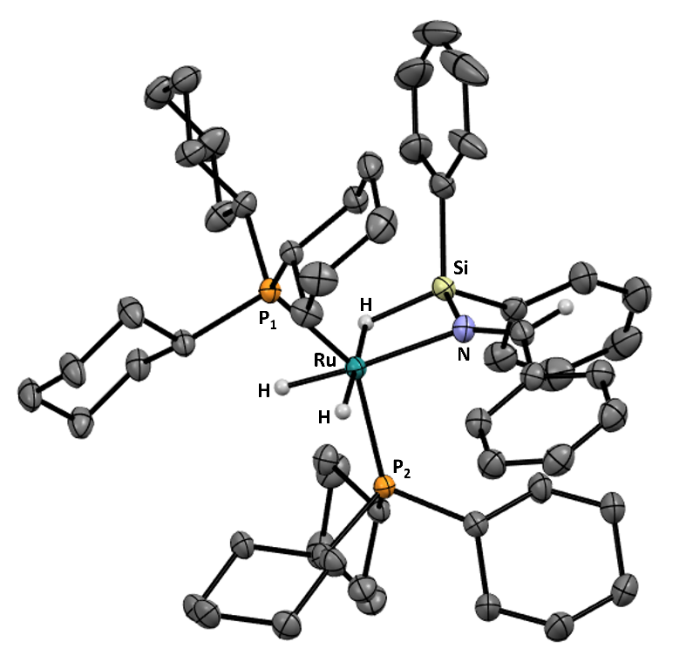
Figure 4. X-ray molecular structure of complex 4 drawn at 50% probability as ellipsoids (Hydrogen atoms have been removed for clarity with exception of those around ruthenium and NCH)
The molecular structure of 4 was confirmed by single crystal X-ray diffraction (Figure 4), which demonstrated the coordination of N-silylimine to ruthenium via an η²-Si–H bond and nitrogen atom. The ruthenium is in a pseudo-octahedral environment and is located in a plane along with Si, N, and hydrogen atoms. The distance between Ru and Si atoms was found to be 2.3503(9) Å, which is elongated compared to the precursor complex 3, as expected. The structure provided the following bond lengths Si–N 1.740 (4), Ru–N – 2.198(3), Ru–H – (1.5085(3), 1.6557(3), Ru–H_{Si} – 1.7183(3), N–C – 1.285 (6) Å and bond angles, P–Ru–P – 146.94 (3)°, Si–N–C – 133.5 (3)°. The formation of new Si–N, C–H bonds, as well as the reduction of nitrile bond to imine bond, were confirmed with these values. The comparison of selected experimental and computational bond lengths from a DFT-optimised structure is given in SI, Table S2.
To the best of our knowledge, the formation of 4 represents the first report of N-silylimine coordinated ruthenium complex. Hashimoto and co-workers studied similar reactivity of a ruthenium complex [{Ru(CO)₂(SiTol₂H)}₂(µ-dppm)(µ-η²:η²-H₂SiTol₂)] with benzonitrile, and they obtained a ruthenium μ-iminosilyl complex, [Ru₂(CO)₄- (µ-dppm)(µ-SiTol₂)(µ-R′CH=NSiTol₂)] stoichiometrically.⁴⁴
Further mechanistic study and computational chemistry
The stoichiometric reactions gave insights into the mechanism of coordination of diphenylsilane as well as benzonitrile to catalyst 1; however, in order to demonstrate the relevance of these observations to the catalytic cycle, the activity of the isolated ruthenium σ-complexes, silane-activated complex, 3, and N-silylimine coordinated complex, 4 was assessed. Reactions were performed with isolated complex 3 and 4 in the same manner as described in Table 1, and similar catalytic activity was observed (SI, Section 9.4). Specifically, when 1-2 mol % of catalyst (3 or 4) was added to a mixture of diphenylsilane and benzonitrile and complete conversion to corresponding N-silylimine, N-(diphenylsilyl)-1-phenylmethanimine (PhCHNSiHPh₂) was obtained exclusively at room temperature within 5 h. These experiments demonstrate that complexes 3 and 4 are catalytically competent and are potential intermediates in the catalytic reaction coordinate. Meanwhile, the addition of an excess of diphenylsilane after one equivalent of benzonitrile led to a mixture of ruthenium diphosphine complexes, including complexes 1, 2, 3, and unknown organometallic complexes. This suggests that initial diphenylsilane coordination to the metal and nitrile binding is needed to achieve the selectivity towards the N-silylimine. The reaction of complex 4 with one equivalent of diphenylsilane at 233 K and warming to room temperature led to a mixture involving the ruthenium σ-silane complex 2 and 3, proving the formation of 4 from 2 reversibly in the presence of an excess of silane (SI, Section 9.5)
These stoichiometric and catalytic experiments successfully established (1) the role of σ-silane complexes and (2) their relevance in catalytic activity in the catalytic hydrosilylation of nitriles reaction. Computational chemistry techniques were used to explore the mechanism of the catalytic reaction. The coordination of diphenylsilane to complex 1 was studied, followed by the two possibilities for the nitrile coordination, (1) to the electrophilic silicon center and (2) to the ruthenium center keeping one Si–H bonded in η² binding mode. The resulting DFT calculations indicated that the pathway involving the coordination to the silicon was favored in energy when compared to coordination to ruthenium (SI Figure S55). The proposed mechanism is shown in Scheme 4.
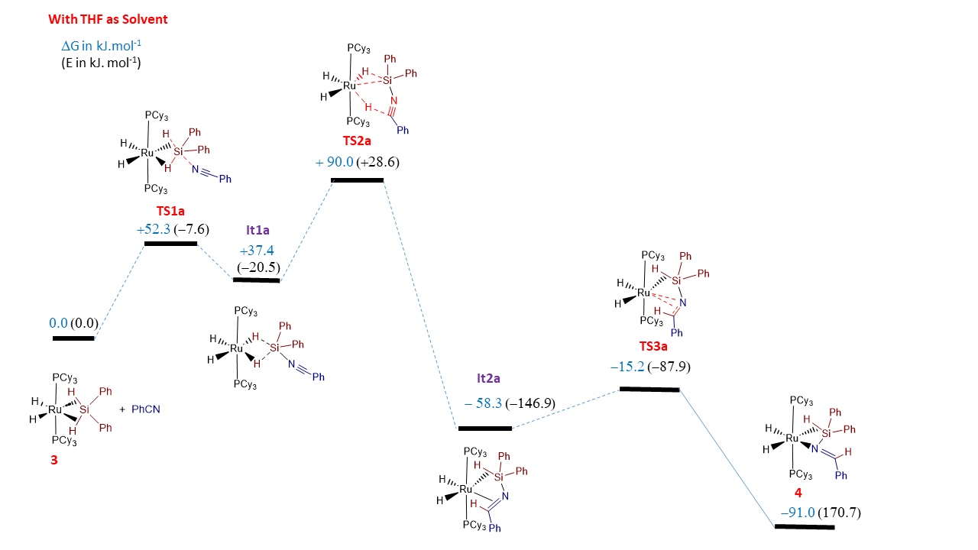
Scheme 4: DFT calculated steps of the catalytic hydrosilylation process at 298K, involving the nitrile coordination to the silicon center.
This preliminary coordination of the nitrile to the Si atom is supported by the LUMO of complex 3, which presents a lobe centered on the silicon atom (Figure 2). The nitrile coordination leads to an elongation of the Si–H bonds in It1a. Two of the nearby ruthenium hydrides are transferred to the Si atom and the C atom of the nitrile group, leading to the formation of a short-lived η²-imino;η²-Si–H bonded ruthenium intermediate It2a, through the transition state TS2a, which corresponds to the rate-determining transition state. The calculated N=C bond length in It2a is 1.35 Å, which is between a C=N (1.279Å) and C–N (1.465Å) bond distances. The NBO analysis on complex It2a confirms the σ-Si–H bond coordination mode by the donating NBOs population σ Si–H (1.72e) and back-bonding σ * Si–H (0.12e). A lone pair centered on the nitrogen pointing towards the ruthenium has a population of 1.23 electrons. The corresponding NLMO in NAO basis set shows a combination of 59.1% N; 17.3 % C, and 12.8% of Ru orbitals predominantly, with a lower contribution from Si (3.2%) and H (4.4%) in the η²-Si–H bond. This NLMO analysis is illustrated by a pNLMO representation in Figure 5, corresponding to a η²-imino coordination with a small contribution by the silicon-centered orbital.
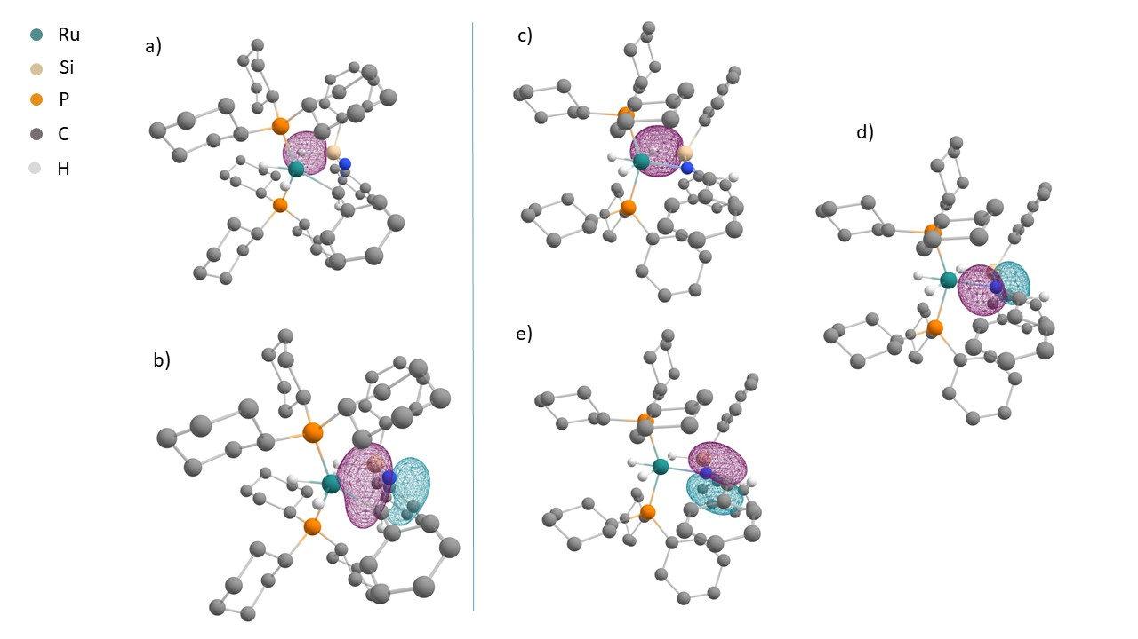
Figure 5. pNLMO representation at left: It2a intermediate a) Ru(η²-SiH) b) Ru(η²-C=N); right: complex 4 c) Ru(η²-SiH) d) Ru(κN-N=C); Hydrogen atoms attached to carbon atoms are omitted for clarity except for the imino fragment.
A more stable coordination mode involving a κN mode between the nitrogen and ruthenium atoms drives the formation of isolated complex 4. The C=N in 4 is no longer π-coordinated to the Ru and has a calculated bond distance of 1.28 Å, which is in the range of free imine C=N bond distances (1.279 Å).⁴⁵ Based on the experimental and DFT observations, we propose an overall representation of the pathway of the catalytic reaction, which involves the coordination of the diphenylsilane before the coordination of the nitrile and, thus the catalytic cycle (Scheme 5).
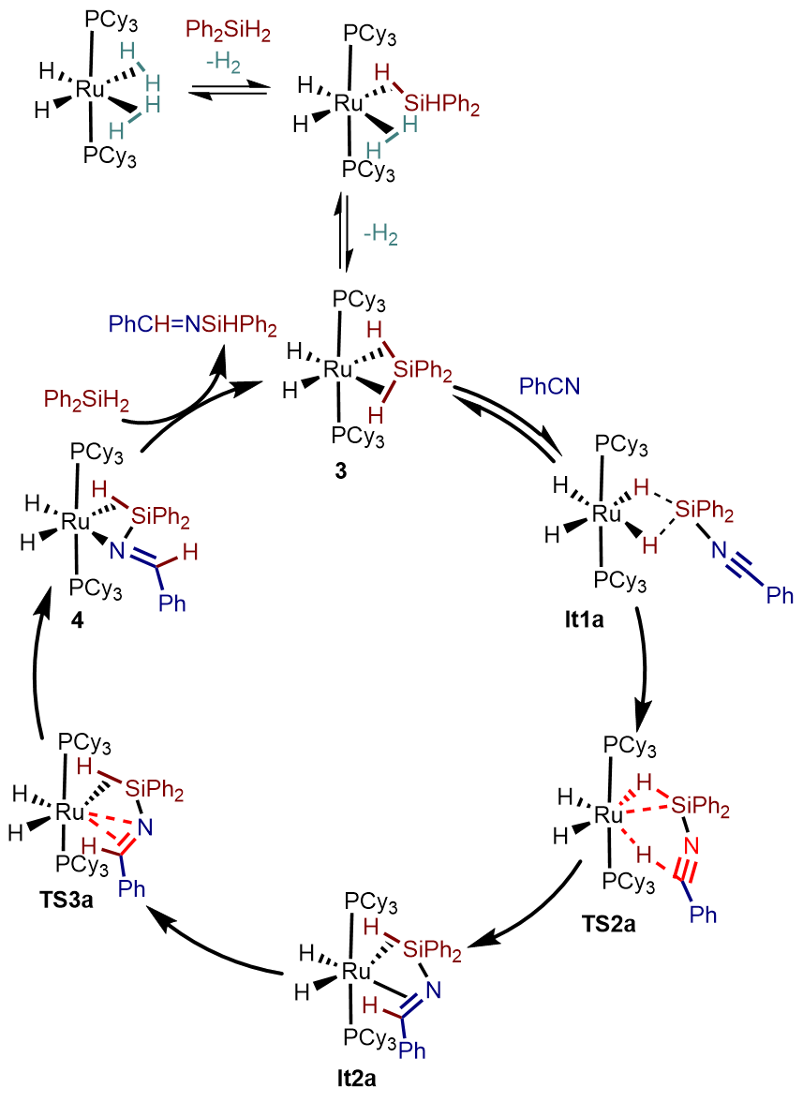
Scheme 5: Representation of the overall steps of the catalytic hydrosilylation process.

CONCLUSIONS
By evaluating the mechanism and role of ruthenium σ-complexes in the catalytic hydrosilylation of nitriles, complex 1 has been identified as a highly efficient catalyst for mono-hydrosilylation of nitriles using secondary silanes with exclusive selectivity for the formation of N-silylimines. The key mechanistic finding from this work lies in developing a clear understanding of the interactions between the nitrile group and Si and H atoms of the silane. The data in this paper show how the initial addition of the nitrile to the complex occurs at silicon rather than ruthenium and provide pathways for C–H and N–Si bond formation, leading to the selective formation of N-silylimines. The direct detection of N-silylimine bound to the ruthenium also demonstrates the synergy between the transition metal and functional groups involved in the formation of the new Si–N, and C–H bonds. Selected stoichiometric reactions under controlled temperature conditions were conducted, and key ruthenium σ-complexes involved in the catalytic reaction were identified. The reaction of complex 1 with diphenylsilane gives complexes 2 followed by 3 by the sequential displacement of the H₂ ligands, and further reaction with benzonitrile gives a quantitative formation of a ruthenium σ-N-silylimine complex 4. The molecular structure of 2, 3, and 4 were established by detailed NMR spectroscopy experiments. The new complexes 3 and 4 were isolated and characterized by X-ray diffraction. Complex 4 has a unique σ-Si–H interaction along with the nitrogen atom of the imine coordination to the ruthenium center. The isolation of these complexes and their active participation in catalysis helped to better understand the mechanism of the catalytic reaction. Two possible mechanisms were studied using DFT calculations, and along with the experimental pieces of evidence, a favorable mechanism developed using DFT is proposed. The ruthenium-based system of σ-Si–H complexes has proved its competence for the challenging transformation of nitriles to an imine oxidation state selectively but also enables low-energy pathways for Si–H bond cleavage and C–H bond formation.

ASSOCIATED CONTENT
Supporting Information.
The following files are available free of charge.
Experimental methods and structural characterization data including NMR spectral data of compounds 2, 3, 4, and catalytic products; X-ray data collection and structure refinement parameters. Supporting Information (PDF)
Crystal data of complexes 3 and 4 (cif)
AUTHOR INFORMATION
Corresponding Author
* mary.grellier@lcc-toulouse.fr
* jason.lynam@york.ac.uk
* john.slattery@york.ac.uk

Notes
The authors declare no competing financial interest.
ACKNOWLEDGMENT
This work has received funding from the European Union's Horizon 2020 research and innovation programme under the Marie Skłodowska-Curie grant agreement No 860322. We are grateful to the CNRS (Centre National de la Recherche Scientifique) and the University of York for providing all the facilities. We were also granted access for this research to the HPC resources of the CALMIP supercomputing center under the allocation 2021-2023-[p0909], Toulouse, France. JML is supported by a Royal Society Industrial Fellowship (INF\R1\221057)

REFERENCES
(1) Itazaki, M.; Nakazawa, H. Selective Double Addition Reaction of an E‒H Bond (E = Si, B) to a C≡N Triple Bond of Organonitriles. Molecules 2018, 23, 2769.
(2) Matisons, J.; Marciniec, B.; Maciejewski, H.; Pietraszuk, C.; Pawluc, P. Hydrosilylation A Comprehensive Review on Recent Advances In Advances in Silicon Science, Vol 1; Springer Dordrecht, 2009; pp 1-408.
(3) Roy, A. K. A Review of Recent Progress in Catalyzed Homogeneous Hydrosilation (Hydrosilylation). Adv. Organomet. Chem. 2007, 55, 1–59.
(4) Gibson, S. E.; Rudd, M. The Role of Secondary Interactions in the Asymmetric Palladium-Catalysed Hydrosilylation of Olefins with Monophosphane Ligands. Adv. Synth. Catal. 2007, 349, 781–795.
(5) Marciniec, B. Silicometallics and Catalysis. Appl. Organomet. Chem. 2000, 14, 527–538.
(6) Birot, Marc.; Pillot, J.-Paul.; Dunogues, Jacques. Comprehensive Chemistry of Polycarbosilanes, Polysilazanes, and Polycarbosilazanes as Precursors of Ceramics. Chem. Rev. 1995, 95, 1443–1477.
(7) Colombo, P.; Mera, G.; Riedel, R.; Sorarù, G. D. Polymer-Derived Ceramics: 40 Years of Research and Innovation in Advanced Ceramics. J. Am. Ceram. Soc. 2010, 93, 1805–1837.
(8) Verma, V.; Koperniku, A.; Edwards, P. M.; Schafer, L. L. N-Silylamines in Catalysis: Synthesis and Reactivity. Chem. Commun. 2022, 58, 9174–9189.
(9) Shimizu, K.; Minami, Y.; Goto, O.; Ikehira, H.; Hiyama, T. Silicon-Based C–N Cross-Coupling Reaction. Chem. Lett. 2014, 43, 438–440.
(10) Hong, K.; Morken, J. P. Catalytic Enantioselective One-Pot Aminoborylation of Aldehydes: A Strategy for Construction of Nonracemic α-Amino Boronates. J. Am. Chem. Soc. 2013, 135, 9252–9254.
(11) Makley, D. M.; Johnston, J. N. Silyl Imine Electrophiles in Enantioselective Catalysis: A Rosetta Stone for Peptide Homologation, Enabling Diverse N-Protected Aryl Glycines from Aldehydes in Three Steps. Org. Lett. 2014, 16, 3146–3149.
(12) Chen, G.-M.; Brown, H. C.; Brown, H. C. An Efficient Synthesis of N-Unsubstituted Imines as Organoborane Adducts Stable at Room Temperature: New Promising Intermediates for Synthesis. J. Am. Chem. Soc. 2000, 122, 4217–4218.
(13) Chen, G.-M.; Ramachandran, P. V.; Brown, H. C. The Critical Importance of Water in the Asymmetric Allylboration of N-Trimethylsilylbenzaldimines with B-Allyldiisopinocampheylborane. Angew. Chem. Int. Ed. 1999, 38, 825–826
(14) Itsuno, S.; Watanabe, K.; Ito, K.; El-Shehawy, A. A.; Sarhan, A. A. Enantioselective Synthesis of Homoallylamines by Nucleophilic Addition of Chirally Modified Allylboron Reagents to Imines. Angew. Chem. Int. Ed. 1997, 36, 109–110.
(15) Itsuno, S.; Watanabe, K.; El-Shehawy, A. A. Enantioselective Synthesis of Chiral Homoallyl Alcohols and Homoallylamines by Nucleophilic Addition of an Allylboron Reagent Modified by a Polymer-Supported Chiral Ligand. Adv. Synth. Catal. 2001, 343, 89–94.
(16) Gutsulyak, D. v.; Nikonov, G. I. Chemoselective Catalytic Hydrosilylation of Nitriles. Angew. Chem. 2010, 122, 7715–7718.
(17) Ojima, I. The Hydrosilylation Reaction. In The Chemistry of Organic Silicon Compounds; John Wiley & Sons, Ltd: Chichester, UK, 1989; pp1479–1526.
(18) Iglesias, M.; Fernández-Alvarez, F. J.; Oro, L. A. Non-Classical Hydrosilane Mediated Reductions Promoted by Transition Metal Complexes. Coord. Chem. Rev. 2019, 386, 240–266.
(19) Takaya, J.; Ogawa, K.; Nakaya, R.; Iwasawa, N. Rhodium-Catalyzed Chemoselective Hydrosilylation of Nitriles to an Imine Oxidation Level Enabled by a Pincer-Type Group 13 Metallylene Ligand. ACS Catal. 2020, 10, 12223–12228.
(20) Rit, A.; Zanardi, A.; Spaniol, T. P.; Maron, L.; Okuda, J. A Cationic Zinc Hydride Cluster Stabilized by an N-Heterocyclic Carbene: Synthesis, Reactivity, and Hydrosilylation Catalysis. Angew. Chem. Int. Ed. 2014, 53, 13273–13277.
(21) Wübbolt, S.; Oestreich, M. Exhaustive Chemoselective Reduction of Nitriles by Catalytic Hydrosilylation Involving Cooperative Si–H Bond Activation. Synlett 2017, 28, 2411–2414.
(22) Sahoo, R. K.; Nembenna, S. Zinc-Catalyzed Chemoselective Reduction of Nitriles to N-Silylimines through Hydrosilylation: Insights into the Reaction Mechanism. Inorg. Chem. 2023, 62, 12213–12222.
(23) Hamdaoui, M.; Desrousseaux, C.; Habbita, H.; Djukic, J. P. Iridacycles as Catalysts for the Autotandem Conversion of Nitriles into Amines by Hydrosilylation: Experimental Investigation and Scope. Organometallics 2017, 36, 4864–4882.
(24) Gandhamsetty, N.; Jeong, J.; Park, J.; Park, S.; Chang, S. Boron-Catalyzed Silylative Reduction of Nitriles in Accessing Primary Amines and Imines. J. Org. Chem. 2015, 80, 7281–7287.
(25) Pérez, M.; Qu, Z.-W.; Caputo, C. B.; Podgorny, V.; Hounjet, L. J.; Hansen, A.; Dobrovetsky, R.; Grimme, S.; Stephan, D. W. Hydrosilylation of Ketones, Imines and Nitriles Catalysed by Electrophilic Phosphonium Cations: Functional Group Selectivity and Mechanistic Considerations. Chem. Eur. J. 2015, 21, 6491–6500.
(26) Corey, J. Y. Reactions of Hydrosilanes with Transition Metal Complexes. Chem. Rev. 2016, 116, 11291–11435.
(27) Corey, J. Y. Reactions of Hydrosilanes with Transition Metal Complexes and Characterization of the Products. Chem. Rev. 2011, 111, 863–1071.
(28) Corey, J. Y.; Braddock-Wilking, J. Reactions of Hydrosilanes with Transition-Metal Complexes: Formation of Stable Transition-Metal Silyl Compounds. Chem. Rev. 1999, 99, 175–292.
(29) Stahl, T.; Hrobárik, P.; Königs, C. D. F.; Ohki, Y.; Tatsumi, K.; Kemper, S.; Kaupp, M.; Klare, H. F. T.; Oestreich, M. Mechanism of the Cooperative Si–H Bond Activation at Ru–S Bonds. Chem. Sci. 2015, 6, 4324–4334.
(30) Delpech, F.; Sabo-Etienne, S.; Daran, J. C.; Chaudret, B.; Hussein, K.; Marsden, C. J.; Barthelat, J. C. Ruthenium Complexes Containing Two Ru−(η²-Si−H) Bonds: Synthesis, Spectroscopic Properties, Structural Data, Theoretical Calculations, and Reactivity Studies. J. Am. Chem. Soc. 1999, 121, 6668–6682.
(31) Atheaux, I.; Delpech, F.; Donnadieu, B.; Sabo-Etienne, S.; Chaudret, B.; Hussein, K.; Barthelat, J. C.; Braun, T.; Duckett, S. B.; Perutz, R. N. Exchange Processes in Complexes with Two Ruthenium (η²-Silane) Linkages: Role of the Secondary Interactions between Silicon and Hydrogen Atoms. Organometallics 2002, 21, 5347–5357.
(32) Lachaize, S.; Sabo‐Etienne, S. σ-Silane Ruthenium Complexes: The Crucial Role of Secondary Interactions. Eur. J. Inorg. Chem. 2006, 2006, 4697–4699.
(33) Alcaraz, G.; Sabo-Etienne, S. NMR: A Good Tool to Ascertain σ-Silane or σ-Borane Formulations? Coord. Chem. Rev. 2008, 252, 2395–2409.
(34) Perutz, R. N.; Sabo-Etienne, S. The σ-CAM Mechanism: σ Complexes as the Basis of σ-Bond Metathesis at Late-Transition-Metal Centers. Angew. Chem. Int. Ed. 2007, 46, 2578–2592.
(35) Atheaux, I.; Donnadieu, B.; Rodriguez, V.; Sabo-Etienne, S.; Chaudret, B.; Hussein, K.; Barthelat, J.-C. A Unique Coordination of SiH₄: Isolation, Characterization, and Theoretical Study of (PR₃)₂H₂Ru(SiH₄)RuH₂(PR₃)₂. J. Am. Chem. Soc. 2000, 122, 5664–5665.
(36) Said, R. ben; Hussein, K.; Barthelat, J. C.; Atheaux, I.; Sabo-Etienne, S.; Grellier, M.; Donnadieu, B.; Chaudret, B. Redistribution at silicon by ruthenium complexes. Bonding mode of the bridging silanes in Ru₂H₄(μ-η²:η²:η²:η²-SiH₄)(PCy₃)₄ and Ru₂H₂(μ-η²:η²-H₂Si(OMe)₂)₃(PCy₃)₂. Dalton Trans. 2003, 3, 4139–4146.
(37) Beatty, R. P. and Paciello, R. A. Process for the preparation of ruthenum hydrogenation catalysts and products thereof. WO Patent 96/23802-804, 1996.
(38) Reguillo, R.; Grellier, M.; Vautravers, N.; Vendier, L.; Sabo-Etienne, S. Ruthenium-Catalyzed Hydrogenation of Nitriles: Insights into the Mechanism. J. Am. Chem. Soc. 2010, 132, 7854–7855.
(39) Sabo-Etienne, S.; Hernandez, M.; Chung, G.; Chaudret, B. Substitution Reactions of Coordinated Dihydrogen by Weakly Coordinating Ligands. Preparation of RuH₂(N₂)₂(PCy₃)₂ and RuH₂(η²-H₂)(HEPh₃)(PCy₃)₂ New J. Chem. 1994, 18, 175–177.
(40) Lipke, M. C.; Tilley, T. D. High Electrophilicity at Silicon in η ³ -Silane σ-Complexes: Lewis Base Adducts of a Silane Ligand, Featuring Octahedral Silicon and Three Ru–H–Si Interactions. J. Am. Chem. Soc. 2011, 133, 16374–16377.
(41) Thomas, C. M.; Peters, J. C. An η³-H₂SiR₂ Adduct of [{PhB(CH₂PiPr₂)₃}Fe^{II}H]. Angew. Chem. Int. Ed. 2006, 45, 776–780.
(42) Waterman, R.; Hayes, P. G.; Tilley, T. D. Synthetic Development and Chemical Reactivity of Transition-Metal Silylene Complexes. Acc. Chem. Res. 2007, 40, 712–719.
(43) Alcaraz, G.; Clot, E.; Helmstedt, U.; Vendier, L.; Sabo-Etienne, S. Mesitylborane as a Bis(σ-B-H) Ligand: An Unprecedented Bonding Mode to a Metal Center. J. Am. Chem. Soc. 2007, 129, 8704–8705.
(44) Hashimoto, H.; Aratani, I.; Kabuto, C.; Kira, M. Stoichiometric Hydrosilylation of Nitriles and Catalytic Hydrosilylation of Imines and Ketones Using a μ-Silane Diruthenium Complex. Organometallics 2003, 22, 2199–2201.
(45) Molecular Structure and Spectroscopy In CRC Handbook of Chemistry and Physics; CRC Press, 2014; pp 1515–1623.

