Anti-VEGF drugs compared with laser photocoagulation for the treatment of diabetic retinopathy

This document presents additional tables and figures covering:
- Systematic review details
- All meta-analyses and forest plots for PDR
- All network meta-analyses and threshold analyses for PDR
- All analyses of NPDR

Appendix 1: Systematic review processes

1.1: Database search strategies

The aim of the literature search was to identify RCTs on anti-vascular endothelial growth factors, angiogenesis inhibitors and other specific drugs used for the treatment of diabetic retinopathy.
An Information Specialist (HF) designed a preliminary search strategy in Ovid MEDLINE in consultation with the research team. The strategy consisted of terms for the condition (diabetic retinopathy), which were combined with terms for the intervention (anti-vascular endothelial growth factor, angiogenesis inhibitors, or specific drugs used for the treatment of diabetic retinopathy) using the Boolean operator AND. Text word searches for terms appearing in the title and abstracts of database records were included in the strategy alongside searches of relevant subject headings. An RCT study filter was applied using the Boolean operator AND. No date or language limits were applied. The final MEDLINE strategy was adapted for use in all resources searched.
The searches were performed on 27th August 2021. The following databases were searched: Ovid MEDLINE(R) ALL, Embase (Ovid), Science Citation Index Expanded (Web of Science), Conference Proceedings Citation Index Science (Web of Science), Cochrane CENTRAL (Wiley), Cochrane Database of Systematic Reviews (Wiley), DARE (CRD), PROSPERO (CRD), and Epistemonikos. The following trial registries were searched: WHO ICTRP, ClinicalTrials.gov, and the EU Clinical Trials Registry.
Search results were imported into EndNote 20 (Clarivate Analytics, US) and deduplicated. All search strategies are presented in full below.
The searches were updated on 13th July 2022 and again on 26th May 2023 using all the databases and strategies as used previously, except for DARE as this database is no longer updated. For each update search, the results of the databases were deduplicated against each other in a separate EndNote 20 Library before being merged with the results of the original EndNote Library and deduplicated for a second time.

Ovid MEDLINE(R) ALL
(includes Epub Ahead of Print, In-Process & Other Non-Indexed Citations, Ovid MEDLINE Daily and Ovid MEDLINE)
via Ovid http://ovidsp.ovid.com/
Date range searched: <1946 to May 25, 2023>
Date searched: 26 May 2023
Records retrieved: 3172

The MEDLINE strategy below includes a search filter to limit retrieval to RCTs using the Cochrane Highly Sensitive Search Strategy for identifying randomized trials in MEDLINE: sensitivity-maximizing version (2008 revision); Ovid format.

Lefebvre C, Glanville J, Briscoe S, Littlewood A, Marshall C, Metzendorf M-I, Noel-Storr A, Rader T, Shokraneh F, Thomas J, Wieland LS. Technical Supplement to Chapter 4: Searching for and selecting studies. In: Higgins JPT, Thomas J, Chandler J, Cumpston MS, Li T, Page MJ, Welch VA (eds). Cochrane Handbook for Systematic Reviews of Interventions Version 6.2 (updated February 2021). Cochrane, 2021. Available from: www.training.cochrane.org/handbook.

1 (*Diabetes Mellitus/ or *Diabetes Complications/) and exp *Retinal Diseases/ (3199)
2 Diabetic Retinopathy/ (29304)
3 ((diabet* or DM) adj3 (retinopath* or vitreoretinopath* or vitreo-retinopath* or chorioretinopath* or chorio-retinopath* or maculopath*)).ti,ab,kw. (30685)
4 (((proliferat* or PDR or pre-proliferat* or preproliferat* or non-proliferat* or nonproliferat* or NPDR or background) adj3 (retinopath* or vitreoretinopath* or vitreo-retinopath* or chorioretinopath* or chorio-retinopath*)) and (diabet* or DM)).ti,ab,kw. (7895)
5 (new blood vessel* and diabet*).ti,ab,kw. (273)
6 (((retin* or subretina* or sub-retina* or interretina* or inter-retina* or vitreoretin* or vitreo-retin* or chorioretin* or chorio-retin* or choroid* or macula* or intraocular or intra-ocular or intravitreal or intra-vitreal) adj4 (damage* or deteriorat* or degnerat* or disease* or edema or oedema or neovasculari?ation*)) and diabet*).ti,ab,kw. (13654)
7 ((retinal vein* adj3 (occlu* or obstruct* or clos* or stricture* or steno* or block* or emboli*)) and diabet*).ti,ab,kw. (1473)
8 or/1-7 (44519)
9 exp Vascular Endothelial Growth Factors/ai (9366)
10 exp Receptors, Vascular Endothelial Growth Factor/ai (3393)
11 (anti adj2 VEGF*).ti,ab,kw. (9210)
12 (anti-VEGF* or antiVEGF*).ti,ab,kw. (9455)
13 ((anti vascular or anti-vascular or antivascular) adj2 endothelial growth factor*).ti,ab,kw. (5745)
14 (((vascular endothelial adj2 growth factor*) or vasculotropin or VEGF* or vascular permeability factor* or VPF) adj2 (trap* or inhibit* or antagonist*)).ti,ab,kw. (11005)
15 (vascular proliferation adj4 inhibit*).ti,ab,kw. (38)
16 or/9-15 (28125)
17 Angiogenesis Inhibitors/ (28876)
18 exp Angiogenesis Inducing Agents/ai (118)
19 (angiogen* adj2 (antagonist* or inhibit*)).ti,ab,kw. (14831)
20 ((antiangiogen* or anti angiogen* or anti-angiogen*) adj2 (agent* or drug* or effect*)).ti,ab,kw. (10949)
21 (angiostatic adj2 (agent* or drug*)).ti,ab,kw. (103)
22 ((neovasculari?ation or vasculari?ation) adj2 inhibit*).ti,ab,kw. (1243)
23 or/17-22 (45139)
24 Aflibercept*.ti,ab,kw,rn. (3315)
25 (Eylea or Zaltrap or Ziv-Aflibercept or "AVE 0005" or AVE0005 or "AVE 005" or AVE005).ti,ab,kw. (316)
26 Bevacizumab/ (14139)
27 Bevacizumab*.ti,ab,kw,rn. (22533)
28 (Avastin or Mvasi or Alymsys or Aybintio or Equidacent or Onbevzi or Oyavas or Zirabev or rhuMAbVEGF or rhuMAb-VEGF or rhuMAb VEGF or "NSC 704865" or NSC704865).ti,ab,kw. (1675)
29 (IVB adj2 inject*).ti,ab,kw. (316)
30 Ranibizumab/ (4684)
31 Ranibizumab*.ti,ab,kw,rn. (6307)
32 (Lucentis or "rhuFab V2").ti,ab,kw. (456)
33 (IVR adj2 inject*).ti,ab,kw. (139)
34 Pegaptanib*.ti,ab,kw,rn. (671)
35 ("EYE 001" or EYE001 or Macugen or "NX 1838" or NX1838).ti,ab,kw. (140)
36 or/24-35 (28353)
37 8 and (16 or 23 or 36) (4979)
38 randomized controlled trial.pt. (593242)
39 controlled clinical trial.pt. (95314)
40 randomized.ab. (604126)
41 placebo.ab. (238387)
42 drug therapy.fs. (2592996)
43 randomly.ab. (408822)
44 trial.ab. (649200)
45 groups.ab. (2520111)
46 or/38-45 (5663345)
47 37 and 46 (3308)
48 exp animals/ not humans.sh. (5123796)
49 47 not 48 (3190)
50 limit 49 to yr="2000-Current" (3182)
51 remove duplicates from 50 (3172)

Key:
/ or .sh. = indexing term (Medical Subject Heading: MeSH)
/ai = indexing term with subheading for antagonists & inhibitors
exp = exploded indexing term (MeSH)
* or $ = truncation
? = adds up to 1 additional character
ti,ab,kw = terms in either title, abstract or keyword fields
rn = registry number/name of substance
adj3 = terms within three words of each other (any order).
pt = publication type
fs = floating sub-heading

Embase
via Ovid http://ovidsp.ovid.com/
Date range searched: <1974 to 2023 May 25>
Date searched: 26 May 2023
Records retrieved: 2558

The Embase strategy below includes the Cochrane Embase RCT filter (Ovid format).

Glanville J, Foxlee R, Wisniewski S, Noel-Storr A, Edwards M, Dooley G. Translating the Cochrane EMBASE RCT filter from the Ovid interface to Embase.com: a case study. Health Info Libr J. 2019 Jul 22. doi: 10.1111/hir.12269

1 *diabetes mellitus/ and exp *retina disease/ (4826)
2 exp diabetic retinopathy/ (53891)
3 ((diabet* or DM) adj3 (retinopath* or vitreoretinopath* or vitreo-retinopath* or chorioretinopath* or chorio-retinopath* or maculopath*)).ti,ab,kw. (43573)
4 (((proliferat* or PDR or pre-proliferat* or preproliferat* or non-proliferat* or nonproliferat* or NPDR or background) adj3 (retinopath* or vitreoretinopath* or vitreo-retinopath* or chorioretinopath* or chorio-retinopath*)) and (diabet* or DM)).ti,ab,kw. (11148)
5 (new blood vessel* and diabet*).ti,ab,kw. (391)
6 (((retin* or subretina* or sub-retina* or interretina* or inter-retina* or vitreoretin* or vitreo-retin* or chorioretin* or chorio-retin* or choroid* or macula* or intraocular or intra-ocular or intravitreal or intra-vitreal) adj4 (damage* or deteriorat* or degnerat* or disease* or edema or oedema or neovasculari?ation*)) and diabet*).ti,ab,kw. (20734)
7 ((retinal vein* adj3 (occlu* or obstruct* or clos* or stricture* or steno* or block* or emboli*)) and diabet*).ti,ab,kw. (2199)
8 or/1-7 (70501)
9 vasculotropin inhibitor/ (7663)
10 (anti adj2 VEGF*).ti,ab,kw. (15751)
11 (anti-VEGF* or antiVEGF*).ti,ab,kw. (16291)
12 ((anti vascular or anti-vascular or antivascular) adj2 endothelial growth factor*).ti,ab,kw. (7400)
13 (((vascular endothelial adj2 growth factor*) or vasculotropin or VEGF* or vascular permeability factor* or VPF) adj2 (trap* or inhibit* or antagonist*)).ti,ab,kw. (17346)
14 (vascular proliferation adj4 inhibit*).ti,ab,kw. (50)
15 or/9-14 (38838)
16 angiogenesis inhibitor/ (20415)
17 (angiogen* adj2 (antagonist* or inhibit*)).ti,ab,kw. (20444)
18 ((antiangiogen* or anti angiogen* or anti-angiogen*) adj2 (agent* or drug* or effect*)).ti,ab,kw. (15734)
19 (angiostatic adj2 (agent* or drug*)).ti,ab,kw. (125)
20 ((neovasculari?ation or vasculari?ation) adj2 inhibit*).ti,ab,kw. (1718)
21 or/16-20 (45260)
22 aflibercept/ (8877)
23 Aflibercept*.ti,ab,kw,dy,tn. (9141)
24 (Eylea or Zaltrap or Ziv-Aflibercept or "AVE 0005" or AVE0005 or "AVE 005" or AVE005).ti,ab,dy,tn. (1741)
25 bevacizumab/ (72890)
26 Bevacizumab*.ti,ab,kw,dy,tn. (75152)
27 (Avastin or Mvasi or Alymsys or Aybintio or Equidacent or Onbevzi or Oyavas or Zirabev or rhuMAbVEGF or rhuMAb-VEGF or rhuMAb VEGF or "NSC 704865" or NSC704865).ti,ab,kw,dy,tn. (11007)
28 (IVB adj2 inject*).ti,ab,kw. (395)
29 ranibizumab/ (12442)
30 Ranibizumab*.ti,ab,kw,dy,tn. (12826)
31 (Lucentis or "rhuFab V2").ti,ab,kw,dy,tn. (3216)
32 (IVR adj2 inject*).ti,ab,kw. (197)
33 pegaptanib.dy,tn. (2470)
34 Pegaptanib*.ti,ab,kw,dy,tn. (2544)
35 ("EYE 001" or EYE001 or Macugen or "NX 1838" or NX1838).ti,ab,kw,dy,tn. (1266)
36 or/22-35 (85594)
37 8 and (15 or 21 or 36) (8778)
38 randomized controlled trial/ (785964)
39 controlled clinical trial/ (469252)
40 Random$.ti,ab,ot. (1968994)
41 randomization/ (99178)
42 intermethod comparison/ (297283)
43 placebo.ti,ab,ot. (366311)
44 (compare or compared or comparison).ti,ot. (604093)
45 ((evaluated or evaluate or evaluating or assessed or assess) and (compare or compared or comparing or comparison)).ab. (2766233)
46 (open adj label).ti,ab,ot. (109016)
47 ((double or single or doubly or singly) adj (blind or blinded or blindly)).ti,ab,ot. (274477)
48 double blind procedure/ (210575)
49 parallel group$1.ti,ab,ot. (32223)
50 (crossover or cross over).ti,ab,ot. (124540)
51 ((assign$ or match or matched or allocation) adj5 (alternate or group or groups or intervention or interventions or patient or patients or subject or subjects or participant or participants)).ti,ab,ot. (415063)
52 (assigned or allocated).ti,ab,ot. (489023)
53 (controlled adj7 (study or design or trial)).ti,ab,ot. (450984)
54 (volunteer or volunteers).ti,ab,ot. (282270)
55 human experiment/ (650911)
56 trial.ti,ot. (403295)
57 or/38-56 (6311902)
58 37 and 57 (2810)
59 (rat or rats or mouse or mice or swine or porcine or murine or sheep or lambs or pigs or piglets or rabbit or rabbits or cat or cats or dog or dogs or cattle or bovine or monkey or monkeys or trout or marmoset$).ti,ot. and animal experiment/ (1227092)
60 animal experiment/ not (human experiment/ or human/) (2577203)
61 59 or 60 (2645661)
62 58 not 61 (2689)
63 limit 62 to yr="2000-Current" (2686)
64 remove duplicates from 63 (2558)

Key:
/ or .sh. = indexing term (Emtree Subject Heading)
exp = exploded indexing term (Emtree)
* or $ = truncation
? = adds up to 1 additional character
ti,ab,kw = terms in either title or abstract fields
dy,tn = drug index terms word or drug trade name fields
adj3 = terms within three words of each other (any order).
pt = publication type
ot = original title

Cochrane Central Register of Controlled Trials (CENTRAL)
via Wiley http://onlinelibrary.wiley.com/
Date range searched: Issue 5 of 12, May 2023
Date searched: 26 May 2023
Records retrieved: 1825

#1 ([mh ^"Diabetes Mellitus"] or [mh ^"Diabetes Complications"]) and [mh "Retinal Diseases"] 250
#2 [mh ^"Diabetic Retinopathy"] 1934
#3 ((diabet* or DM) NEAR/3 (retinopath* or vitreoretinopath* or chorioretinopath* or maculopath*)):ti,ab,kw 4547
#4 (((proliferat* or PDR or preproliferat* or nonproliferat* or NPDR or background) NEAR/3 (retinopath* or vitreoretinopath* or chorioretinopath*)) and (diabet* or DM)):ti,ab,kw 1326
#5 ("new blood" NEXT vessel* and diabet*):ti,ab,kw 32
#6 (((retin* or subretina* or interretina* or vitreoretin* or chorioretin* or choroid* or macula* or intraocular or intravitreal) NEAR/4 (damage* or deteriorat* or degnerat* or disease* or edema or oedema or neovasculari?ation*)) and diabet*):ti,ab,kw 3457
#7 ((retinal NEXT vein* NEAR/3 (occlu* or obstruct* or clos* or stricture* or steno* or block* or emboli*)) and diabet*):ti,ab,kw 254
#8 {OR #1-#7} 5751
#9 [mh "Vascular Endothelial Growth Factors"/ai] 758
#10 [mh "Receptors, Vascular Endothelial Growth Factor"/ai] 154
#11 (anti NEAR/2 VEGF*):ti,ab,kw 1610
#12 (antiVEGF*):ti,ab,kw 1523
#13 ((anti NEXT vascular or antivascular) NEAR/2 "endothelial growth" NEXT factor*):ti,ab,kw 699
#14 ((("vascular endothelial" NEAR/2 growth NEXT factor*) or vasculotropin or VEGF* or "vascular permeability" NEXT factor* or VPF) NEAR/2 (trap* or inhibit* or antagonist*)):ti,ab,kw 2048
#15 ("vascular proliferation" NEAR/4 inhibit*):ti,ab,kw 1
#16 {OR #9-#15} 3671
#17 [mh ^"Angiogenesis Inhibitors"] 1681
#18 [mh "Angiogenesis Inducing Agents"/ai] 0
#19 (angiogen* NEAR/2 (antagonist* or inhibit*)):ti,ab,kw 2126
#20 ((antiangiogen* or anti NEXT angiogen*) NEAR/2 (agent* or drug* or effect*)):ti,ab,kw 717
#21 (angiostatic NEAR/2 (agent* or drug*)):ti,ab,kw 10
#22 ((neovasculari?ation or vasculari?ation) NEAR/2 inhibit*):ti,ab,kw 37
#23 {OR #17-#22} 2691
#24 Aflibercept*:ti,ab,kw 1081
#25 (Eylea or Zaltrap or Ziv NEXT Aflibercept or "AVE 0005" or AVE0005 or "AVE 005" or AVE005):ti,ab,kw 252
#26 [mh ^Bevacizumab] 2633
#27 Bevacizumab*:ti,ab,kw 7386
#28 (Avastin or Mvasi or Alymsys or Aybintio or Equidacent or Onbevzi or Oyavas or Zirabev or rhuMAbVEGF or rhuMAb NEXT VEGF or "NSC 704865" or NSC704865):ti,ab,kw 941
#29 (IVB NEAR/2 inject*):ti,ab,kw 89
#30 [mh ^Ranibizumab] 1049
#31 Ranibizumab*:ti,ab,kw 2266
#32 (Lucentis or "rhuFab V2"):ti,ab,kw 451
#33 (IVR NEAR/2 inject*):ti,ab,kw 32
#34 Pegaptanib*:ti,ab,kw 166
#35 ("EYE 001" or EYE001 or Macugen or "NX 1838" or NX1838):ti,ab,kw 82
#36 {OR #24-#35} 10087
#37 #8 and (#16 or #23 or #36) 1847
#38 (rat or rats or rodent* or mouse or mice or "mus musculus" or "mus domesticus" or murine or murinae or bovine or sheep or ovine or "ovis aries" or porcine):ti,ab,kw 17188
#39 #37 not #38 with Publication Year from 2000 to 2023, in Trials 1825

Science Citation Index Expanded
via Web of Science, Clarivate Analytics https://clarivate.com/
Date range searched: 1900 – 26 May 2023
Date searched: 26 May 2023
Records retrieved: 2394

32 #29 NOT #30 2,394 Limited by 2000-01-01 to 2023-05-26
31 #29 NOT #30 2,410
30 TI=(animal or animals or rat or rats or rodent* or mouse or mice or "mus musculus" or "mus domesticus" or murine or murinae or porcine or pig or pigs or piglet or piglets or sow or sows or minipig or minipigs or sheep or ovine or "ovis aries" or lamb or lambs or ewe or ewes or rabbit or rabbits or leporide or leporidae or kitten or kittens or dog or dogs or puppy or puppies or monkey or monkeys or horse or horses or foal or foals or equine or bovine or calf or calves or cattle or heifer or heifers or hamster or hamsters or chicken or chickens or livestock or alpaca* or llama*) 3,259,653
29 #27 AND #28 2,524
28 TS=(random* or control* or trial* or "single blind" or "double blind" or "triple blind" or placebo) 8,083,064
27 #6 AND #26 6,121
26 #7 OR #8 OR #9 OR #10 OR #11 OR #12 OR #13 OR #14 OR #15 OR #16 OR #17 OR #18 OR #19 OR #20 OR #21 OR #22 OR #23 OR #24 OR #25 83,065
25 TS=("EYE 001" or EYE001 or Macugen or "NX 1838" or NX1838) 142
24 TS=(Pegaptanib*) 716
23 TS=(IVR NEAR/2 inject*) 177
22 TS=(Lucentis or "rhuFab V2") 564
21 TS=(Ranibizumab*) 9,347
20 TS=(IVB NEAR/2 inject*) 307
19 TS=(Avastin or Mvasi or Alymsys or Aybintio or Equidacent or Onbevzi or Oyavas or Zirabev or rhuMAbVEGF or rhuMAb-VEGF or "rhuMAb VEGF" or "NSC 704865" or NSC704865) 3,355
18 TS=(Bevacizumab*) 36,279
17 TS=(Eylea or Zaltrap or Ziv-Aflibercept or "AVE 0005" or AVE0005 or "AVE 005" or AVE005) 320
16 TS=(Aflibercept*) 4,076
15 TS=((neovascularisation or neovascularization or vascularisation or vascularization) NEAR/2 inhibit*) 1,858
14 TS=(angiostatic NEAR/2 (agent* or drug*) ) 105
13 TS=((antiangiogen* or "anti angiogen*" or anti-angiogen*) NEAR/2 (agent* or drug* or effect*) ) 11,802
12 TS=(angiogen* NEAR/2 (antagonist* or inhibit*) ) 19,846
11 TS=("vascular proliferation" NEAR/4 inhibit*) 44
10 TS=((("vascular endothelial" NEAR/2 "growth factor*") or vasculotropin or VEGF* or "vascular permeability factor*" or VPF) NEAR/2 (trap* or inhibit* or antagonist*) ) 14,540
9 TS=(("anti vascular" or anti-vascular or antivascular) NEAR/2 "endothelial growth factor*") 5,018
8 TS=(anti-VEGF* or antiVEGF*) 10,111
7 TS=(anti NEAR/2 VEGF*) 10,549
6 #1 OR #2 OR #3 OR #4 OR #5 43,073
5 TS=(("retinal vein*" NEAR/3 (occlu* or obstruct* or clos* or stricture* or steno* or block* or emboli*) ) and diabet*) 1,546
4 TS=(((retin* or subretina* or sub-retina* or interretina* or inter-retina* or vitreoretin* or vitreo-retin* or chorioretin* or chorio-retin* or choroid* or macula* or intraocular or intra-ocular or intravitreal or intra-vitreal) NEAR/4 (damage* or deteriorat* or degnerat* or disease* or edema or oedema or neovasculari?ation*) ) and diabet*) 16,980
3 TS=("new blood vessel*" and diabet*) 288
2 TS=(((proliferat* or PDR or pre-proliferat* or preproliferat* or non-proliferat* or nonproliferat* or NPDR or background) NEAR/3 (retinopath* or vitreoretinopath* or vitreo-retinopath* or chorioretinopath* or chorio-retinopath*) ) and (diabet* or DM) ) 7,763
1 TS=((diabet* or DM) NEAR/3 (retinopath* or vitreoretinopath* or vitreo-retinopath* or chorioretinopath* or chorio-retinopath* or maculopath*)) 36,053

Key:
TS= terms in either title, abstract, author keywords, and keywords plus fields
TI= search in title field
NEAR/3 = terms within three words of each other (any order).
* = truncation

Conference Proceedings Citation Index - Science
via Web of Science, Clarivate Analytics https://clarivate.com/
Date range searched: 1990 – 26 May 2023
Date searched: 26 May 2023
Records retrieved: 86

32 #29 NOT #30 86 Limited by 2000-01-01 to 2023-05-26
31 #29 NOT #30 89
30 TI=(animal or animals or rat or rats or rodent* or mouse or mice or "mus musculus" or "mus domesticus" or murine or murinae or porcine or pig or pigs or piglet or piglets or sow or sows or minipig or minipigs or sheep or ovine or "ovis aries" or lamb or lambs or ewe or ewes or rabbit or rabbits or leporide or leporidae or kitten or kittens or dog or dogs or puppy or puppies or monkey or monkeys or horse or horses or foal or foals or equine or bovine or calf or calves or cattle or heifer or heifers or hamster or hamsters or chicken or chickens or livestock or alpaca* or llama*) 295,290
29 #27 AND #28 92
28 TS=(random* or control* or trial* or "single blind" or "double blind" or "triple blind" or placebo) 1,616,551
27 #6 AND #26 458
26 #7 OR #8 OR #9 OR #10 OR #11 OR #12 OR #13 OR #14 OR #15 OR #16 OR #17 OR #18 OR #19 OR #20 OR #21 OR #22 OR #23 OR #24 OR #25 8,998
25 TS=("EYE 001" or EYE001 or Macugen or "NX 1838" or NX1838) 14
24 TS=(Pegaptanib*) 39
23 TS=(IVR NEAR/2 inject*) 1
22 TS=(Lucentis or "rhuFab V2") 29
21 TS=(Ranibizumab*) 564
20 TS=(IVB NEAR/2 inject*) 7
19 TS=(Avastin or Mvasi or Alymsys or Aybintio or Equidacent or Onbevzi or Oyavas or Zirabev or rhuMAbVEGF or rhuMAb-VEGF or "rhuMAb VEGF" or "NSC 704865" or NSC704865) 196
18 TS=(Bevacizumab*) 4,659
17 TS=(Eylea or Zaltrap or Ziv-Aflibercept or "AVE 0005" or AVE0005 or "AVE 005" or AVE005) 60
16 TS=(Aflibercept*) 577
15 TS=((neovascularisation or neovascularization or vascularisation or vascularization) NEAR/2 inhibit*) 177
14 TS=(angiostatic NEAR/2 (agent* or drug*) ) 6
13 TS=((antiangiogen* or "anti angiogen*" or anti-angiogen*) NEAR/2 (agent* or drug* or effect*) ) 634
12 TS=(angiogen* NEAR/2 (antagonist* or inhibit*) ) 1,209
11 TS=("vascular proliferation" NEAR/4 inhibit*) 6
10 TS=((("vascular endothelial" NEAR/2 "growth factor*") or vasculotropin or VEGF* or "vascular permeability factor*" or VPF) NEAR/2 (trap* or inhibit* or antagonist*) ) 1,025
9 TS=(("anti vascular" or anti-vascular or antivascular) NEAR/2 "endothelial growth factor*") 224
8 TS=(anti-VEGF* or antiVEGF*) 836
7 TS=(anti NEAR/2 VEGF*) 869
6 #1 OR #2 OR #3 OR #4 OR #5 5,826
5 TS=(("retinal vein*" NEAR/3 (occlu* or obstruct* or clos* or stricture* or steno* or block* or emboli*) ) and diabet*) 74
4 TS=(((retin* or subretina* or sub-retina* or interretina* or inter-retina* or vitreoretin* or vitreo-retin* or chorioretin* or chorio-retin* or choroid* or macula* or intraocular or intra-ocular or intravitreal or intra-vitreal) NEAR/4 (damage* or deteriorat* or degnerat* or disease* or edema or oedema or neovasculari?ation*) ) and diabet*) 2,140
3 TS=("new blood vessel*" and diabet*) 29
2 TS=(((proliferat* or PDR or pre-proliferat* or preproliferat* or non-proliferat* or nonproliferat* or NPDR or background) NEAR/3 (retinopath* or vitreoretinopath* or vitreo-retinopath* or chorioretinopath* or chorio-retinopath*) ) and (diabet* or DM) ) 642
1 TS=((diabet* or DM) NEAR/3 (retinopath* or vitreoretinopath* or vitreo-retinopath* or chorioretinopath* or chorio-retinopath* or maculopath*) ) 4,723

Key:
TS= terms in either title, abstract, author keywords, and keywords plus fields
TI= search in title field
NEAR/3 = terms within three words of each other (any order).
* = truncation

Cochrane Database of Systematic Reviews (CDSR)
via Wiley http://onlinelibrary.wiley.com/
Date range searched: Issue 5 of 12, May 2023
Date searched: 26 May 2023
Records retrieved: 14

#1 ([mh ^"Diabetes Mellitus"] or [mh ^"Diabetes Complications"]) and [mh "Retinal Diseases"] 250
#2 [mh ^"Diabetic Retinopathy"] 1934
#3 ((diabet* or DM) NEAR/3 (retinopath* or vitreoretinopath* or chorioretinopath* or maculopath*)):ti,ab,kw 4547
#4 (((proliferat* or PDR or preproliferat* or nonproliferat* or NPDR or background) NEAR/3 (retinopath* or vitreoretinopath* or chorioretinopath*)) and (diabet* or DM)):ti,ab,kw 1326
#5 ("new blood" NEXT vessel* and diabet*):ti,ab,kw 32
#6 (((retin* or subretina* or interretina* or vitreoretin* or chorioretin* or choroid* or macula* or intraocular or intravitreal) NEAR/4 (damage* or deteriorat* or degnerat* or disease* or edema or oedema or neovasculari?ation*)) and diabet*):ti,ab,kw 3457
#7 ((retinal NEXT vein* NEAR/3 (occlu* or obstruct* or clos* or stricture* or steno* or block* or emboli*)) and diabet*):ti,ab,kw 254
#8 {OR #1-#7} 5751
#9 [mh "Vascular Endothelial Growth Factors"/ai] 758
#10 [mh "Receptors, Vascular Endothelial Growth Factor"/ai] 154
#11 (anti NEAR/2 VEGF*):ti,ab,kw 1610
#12 (antiVEGF*):ti,ab,kw 1523
#13 ((anti NEXT vascular or antivascular) NEAR/2 "endothelial growth" NEXT factor*):ti,ab,kw 699
#14 ((("vascular endothelial" NEAR/2 growth NEXT factor*) or vasculotropin or VEGF* or "vascular permeability" NEXT factor* or VPF) NEAR/2 (trap* or inhibit* or antagonist*)):ti,ab,kw 2048
#15 ("vascular proliferation" NEAR/4 inhibit*):ti,ab,kw 1
#16 {OR #9-#15} 3671
#17 [mh ^"Angiogenesis Inhibitors"] 1681
#18 [mh "Angiogenesis Inducing Agents"/ai] 0
#19 (angiogen* NEAR/2 (antagonist* or inhibit*)):ti,ab,kw 2126
#20 ((antiangiogen* or anti NEXT angiogen*) NEAR/2 (agent* or drug* or effect*)):ti,ab,kw 717
#21 (angiostatic NEAR/2 (agent* or drug*)):ti,ab,kw 10
#22 ((neovasculari?ation or vasculari?ation) NEAR/2 inhibit*):ti,ab,kw 37
#23 {OR #17-#22} 2691
#24 Aflibercept*:ti,ab,kw 1081
#25 (Eylea or Zaltrap or Ziv NEXT Aflibercept or "AVE 0005" or AVE0005 or "AVE 005" or AVE005):ti,ab,kw 252
#26 [mh ^Bevacizumab] 2633
#27 Bevacizumab*:ti,ab,kw 7386
#28 (Avastin or Mvasi or Alymsys or Aybintio or Equidacent or Onbevzi or Oyavas or Zirabev or rhuMAbVEGF or rhuMAb NEXT VEGF or "NSC 704865" or NSC704865):ti,ab,kw 941
#29 (IVB NEAR/2 inject*):ti,ab,kw 89
#30 [mh ^Ranibizumab] 1049
#31 Ranibizumab*:ti,ab,kw 2266
#32 (Lucentis or "rhuFab V2"):ti,ab,kw 451
#33 (IVR NEAR/2 inject*):ti,ab,kw 32
#34 Pegaptanib*:ti,ab,kw 166
#35 ("EYE 001" or EYE001 or Macugen or "NX 1838" or NX1838):ti,ab,kw 82
#36 {OR #24-#35} 10087
#37 #8 and (#16 or #23 or #36) 1847
#38 (rat or rats or rodent* or mouse or mice or "mus musculus" or "mus domesticus" or murine or murinae or bovine or sheep or ovine or "ovis aries" or porcine):ti,ab,kw 17188
#39 #37 not #38 with Cochrane Library publication date Between Jan 2000 and May 2023, in Cochrane Reviews 14

Key:
mh = exploded indexing term (MeSH)
mh ^ = unexploded indexing term (MeSH)
/ai = indexing term with subheading for antagonists & inhibitors
* = truncation or additional characters within a word
? = adds up to 1 additional character
ti,ab,kw = terms in either title or abstract or keyword fields
near/3 = terms within three words of each other (any order)
next = terms are next to each other

Epistemonikos
via https://www.epistemonikos.org/
Date range searched: Inception - 26 May 2023
Date searched: 26 May 2023
Records retrieved: 1026

((title:((title:(((diabet* OR proliferat* OR PDR OR pre-proliferat* OR preproliferat* OR non-proliferat* OR nonproliferat* OR NPDR OR background) AND retinopath*)) OR abstract:(((diabet* OR proliferat* OR PDR OR pre-proliferat* OR preproliferat* OR non-proliferat* OR nonproliferat* OR NPDR OR background) AND retinopath*))) OR (title:((new blood vessel* AND diabet*)) OR abstract:((new blood vessel* AND diabet*)))) OR abstract:((title:(((diabet* OR proliferat* OR PDR OR pre-proliferat* OR preproliferat* OR non-proliferat* OR nonproliferat* OR NPDR OR background) AND retinopath*)) OR abstract:(((diabet* OR proliferat* OR PDR OR pre-proliferat* OR preproliferat* OR non-proliferat* OR nonproliferat* OR NPDR OR background) AND retinopath*))) OR (title:((new blood vessel* AND diabet*)) OR abstract:((new blood vessel* AND diabet*))))) AND (title:((anti AND VEGF*)) OR abstract:((anti AND VEGF*))) OR (title:((anti-VEGF* OR antiVEGF*)) OR abstract:((anti-VEGF* OR antiVEGF*))) OR (title:((("anti vascular" OR anti-vascular OR antivascular) AND "endothelial growth factor")) OR abstract:((("anti vascular" OR anti-vascular OR antivascular) AND "endothelial growth factor"))) OR (title:((("vascular endothelial growth factor" OR vasculotropin OR VEGF* OR "vascular permeability factor" OR VPF) AND (trap* OR inhibit* OR antagonist*))) OR abstract:((("vascular endothelial growth factor" OR vasculotropin OR VEGF* OR "vascular permeability factor" OR VPF) AND (trap* OR inhibit* OR antagonist*)))) OR (title:((angiogen* AND (antagonist* OR inhibit*))) OR abstract:((angiogen* AND (antagonist* OR inhibit*)))) OR (title:(((antiangiogen* OR "anti angiogen" OR anti-angiogen* OR angiostatic) AND (agent* OR drug* OR effect*))) OR abstract:(((antiangiogen* OR "anti angiogen" OR anti-angiogen* OR angiostatic) AND (agent* OR drug* OR effect*)))) OR (title:((Aflibercept* OR Eylea OR Zaltrap OR Ziv-Aflibercept OR "AVE 0005" OR AVE0005 OR "AVE 005" OR AVE005 OR Bevacizumab* OR Avastin OR Mvasi OR Alymsys OR Aybintio OR Equidacent OR Onbevzi OR Oyavas OR Zirabev OR rhuMAbVEGF OR rhuMAb-VEGF OR "rhuMAb VEGF" OR "NSC 704865" OR NSC704865 OR Ranibizumab* OR Lucentis OR "rhuFab V2" OR Pegaptanib* OR "EYE 001" OR EYE001 OR Macugen OR "NX 1838" OR NX1838)) OR abstract:((Aflibercept* OR Eylea OR Zaltrap OR Ziv-Aflibercept OR "AVE 0005" OR AVE0005 OR "AVE 005" OR AVE005 OR Bevacizumab* OR Avastin OR Mvasi OR Alymsys OR Aybintio OR Equidacent OR Onbevzi OR Oyavas OR Zirabev OR rhuMAbVEGF OR rhuMAb-VEGF OR "rhuMAb VEGF" OR "NSC 704865" OR NSC704865 OR Ranibizumab* OR Lucentis OR "rhuFab V2" OR Pegaptanib* OR "EYE 001" OR EYE001 OR Macugen OR "NX 1838" OR NX1838))) OR (title:(((IVB OR IVR) AND inject*)) OR abstract:(((IVB OR IVR) AND inject*))))
Filter: Publication year 2000-2023
Publication type: Systematic Reviews
= 1026

Key:
* = truncation
title: = searches in title field
abstract: = searches in abstract field

PROSPERO
via https://www.crd.york.ac.uk/prospero/
Date range: Inception – 26 May 2023
Date searched: 26 May 2023
Records retrieved: 159

#1 MeSH DESCRIPTOR Diabetic Retinopathy 107
#2 ((diabet* or DM) adj3 (retinopath* or vitreoretinopath* or vitreo-retinopath* or chorioretinopath* or chorio-retinopath* or maculopath*)) 609
#3 (((proliferat* or PDR or pre-proliferat* or preproliferat* or non-proliferat* or nonproliferat* or NPDR or background) adj3 (retinopath* or vitreoretinopath* or vitreo-retinopath* or chorioretinopath* or chorio-retinopath*)) and (diabet* or DM)) 110
#4 (new blood vessel* and diabet*) 9
#5 (((retin* or subretina* or sub-retina* or interretina* or inter-retina* or vitreoretin* or vitreo-retin* or chorioretin* or chorio-retin* or choroid* or macula* or intraocular or intra-ocular or intravitreal or intra-vitreal) adj4 (damage* or deteriorat* or degnerat* or disease* or edema or oedema or neovascularisation* or neovascularization*)) AND diabet*) 373
#6 ((retinal vein* adj3 (occlu* or obstruct* or clos* or stricture* or steno* or block* or emboli*)) and diabet*) 64
#7 #1 OR #2 OR #3 OR #4 OR #5 OR #6 740
#8 MeSH DESCRIPTOR Vascular Endothelial Growth Factors EXPLODE ALL TREES WITH QUALIFIER AI 0
#9 MeSH DESCRIPTOR Receptors, Vascular Endothelial Growth Factor EXPLODE ALL TREES WITH QUALIFIER AI 0
#10 (anti adj2 VEGF*) 327
#11 (anti-VEGF* or antiVEGF*) 327
#12 ((anti vascular or anti-vascular or antivascular) adj2 endothelial growth factor*) 153
#13 (((vascular endothelial adj2 growth factor*) or vasculotropin or VEGF* or vascular permeability factor* or VPF) adj2 (trap* or inhibit* or antagonist*)) 96
#14 (vascular proliferation adj4 inhibit*) 0
#15 #8 OR #9 OR #10 OR #11 OR #12 OR #13 OR #14 412
#16 MeSH DESCRIPTOR Angiogenesis Inhibitors 40
#17 MeSH DESCRIPTOR Angiogenesis Inducing Agents EXPLODE ALL TREES WITH QUALIFIER AI 0
#18 (angiogen* adj2 (antagonist* or inhibit*)) 74
#19 ((antiangiogen* or anti angiogen* or anti-angiogen*) adj2 (agent* or drug* or effect*)) 145
#20 (angiostatic adj2 (agent* or drug*)) 0
#21 ((neovascularisation* or neovascularization* or vascularisation* or vascularization*) adj2 inhibit*) 0
#22 #16 OR #17 OR #18 OR #19 OR #20 OR #21 224
#23 (Aflibercept*) 141
#24 (Eylea or Zaltrap or Ziv-Aflibercept or AVE 0005 or AVE0005 or AVE 005 or AVE005) 22
#25 MeSH DESCRIPTOR Bevacizumab 46
#26 (Bevacizumab*) 445
#27 (Avastin or Mvasi or Alymsys or Aybintio or Equidacent or Onbevzi or Oyavas or Zirabev or rhuMAbVEGF or rhuMAb-VEGF or rhuMAb VEGF or NSC 704865 or NSC704865) 59
#28 (IVB adj2 inject*) 0
#29 MeSH DESCRIPTOR Ranibizumab 7
#30 (Ranibizumab*) 142
#31 (Lucentis or rhuFab V2) 23
#32 (IVR adj2 inject*) 0
#33 (Pegaptanib*) 30
#34 (EYE 001 or EYE001 or Macugen or NX 1838 or NX1838) 5
#35 #23 OR #24 OR #25 OR #26 OR #27 OR #28 OR #29 OR #30 OR #31 OR #32 OR #33 OR #34 500
#36 #15 OR #22 OR #35 839
#37 #7 AND #36 159

Key:
MeSH DESCRIPTOR = indexing term: Medical Subject Heading (MeSH)
QUALIFIER AI = indexing term subheading for antagonists & inhibitors
EXPLODE ALL TREES = exploded indexing term (MeSH)
* = truncation
adj3 = terms within three words of each other (order specified).
:TI,KW = terms in either title or keyword fields

ClinicalTrials.gov
via https://clinicaltrials.gov/
Date searched: 26 May 2023
Records retrieved: 286

Two separate searches were used in Advanced Search, retrieving 286 records in total, which were imported into EndNote 20 and deduplicated.

- Condition or Disease: (diabetic retinopathy)
Other Terms: (Aflibercept OR Eylea OR Zaltrap OR Bevacizumab OR Avastin OR Mvasi OR Alymsys OR Aybintio OR Equidacent OR Onbevzi OR Oyavas OR Zirabev OR rhuMAb VEGF OR Ranibizumab OR Lucentis OR rhuFab OR Pegaptanib OR Macugen) = 190 hits

- Condition or Disease: (diabetic retinopathy)
Other Terms: ((VEGF OR vascular endothelial growth factor OR vasculotropin OR vascular permeability factor or VPF) AND (anti OR trap or inhibitor or antagonist)) = 96 hits

European Union Clinical Trials Register
via www.clinicaltrialsregister.eu/ctr-search/search
Date searched: 26 May 2023
Records retrieved: 163

Two separate searches were used, retrieving 163 records in total, which were imported into EndNote 20 and deduplicated.

- (("diabetic retinopathy") AND (Aflibercept OR Eylea OR Zaltrap OR Bevacizumab OR Avastin OR Mvasi OR Alymsys OR Aybintio OR Equidacent OR Onbevzi OR Oyavas OR Zirabev OR "rhuMAb VEGF" OR Ranibizumab OR Lucentis OR rhuFab OR Pegaptanib OR Macugen)) = 113 hits

- (("diabetic retinopathy") AND ((anti OR trap or inhibitor OR antagonist) AND (VEGF OR "vascular endothelial growth factor" OR vasculotropin OR "vascular permeability factor" OR VPF))) = 50 hits

WHO International Clinical Trials Registry Platform (ICTRP)
via https://trialsearch.who.int/
Date searched: 26 May 2023
Records retrieved: 198

Two separate searches were used in Advanced Search, retrieving 198 records in total, which were imported into EndNote 20 and deduplicated.

- Advanced Search
Condition: (diabetic retinopathy)
Intervention: (Aflibercept OR Eylea OR Zaltrap OR Bevacizumab OR Avastin OR Mvasi OR Alymsys OR Aybintio OR Equidacent OR Onbevzi OR Oyavas OR Zirabev OR rhuMAb VEGF OR Ranibizumab OR Lucentis OR rhuFab OR Pegaptanib OR Macugen)
Recruitment Status: ALL = 194 records for 180 trials

- Advanced Search
Condition: (diabetic retinopathy)
Intervention: ((VEGF OR vascular endothelial growth factor OR vasculotropin OR vascular permeability factor or VPF) AND (anti OR trap or inhibitor or antagonist))
Recruitment Status: ALL = 23 records for 18 trials

1.2: PRISMA flow chart

Figure 1 PRISMA flow diagram
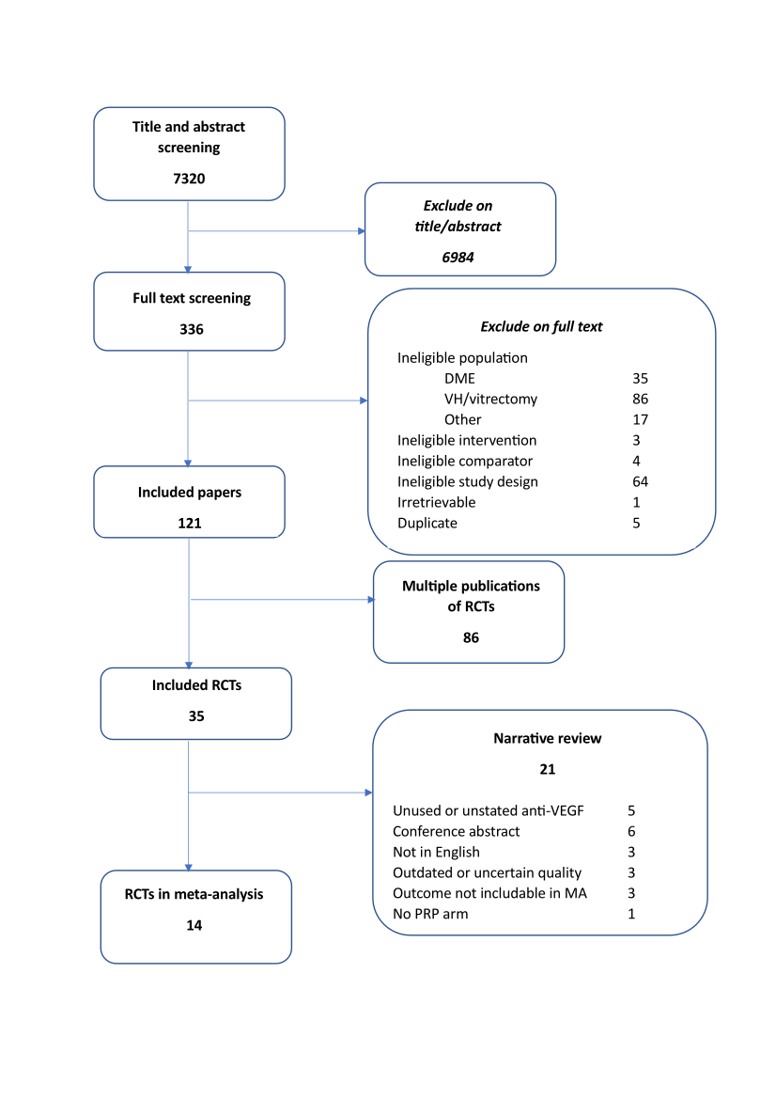

1.3 List of excluded studies

RCT of DME (35)
Bayer A G. An open-label, randomized, active-controlled, parallel-group, Phase-3b study of the efficacy, safety, and tolerability of three different treatment regimens of 2 mg aflibercept administered by intr.
Braimah I Z, Kenu E and Amissah-Arthur K N; Akafo S ; Kwarteng K O; Amoaku W M;. (2019). Safety of intravitreal ziv-aflibercept in choroido-retinal vascular diseases: A randomised double-blind intervention study. PLoS ONE [Electronic Resource], 14(10), pp.e0223944.
Bressler S B, Qin H, Beck R W; Chalam K V; Kim J E; Melia M ; Wells J A; 3rd ; Diabetic Retinopathy Clinical Research and Network;. (2012). Factors associated with changes in visual acuity and central subfield thickness at 1 year after treatment for diabetic macular edema with ranibizumab. Archives of Ophthalmology, 130(9), pp.1153-61.
Bressler S B, Qin H, Melia M ; Bressler N M; Beck R W; Chan C K; Grover S ; Miller D G; Diabetic Retinopathy Clinical Research and Network;. (2013). Exploratory analysis of the effect of intravitreal ranibizumab or triamcinolone on worsening of diabetic retinopathy in a randomized clinical trial. JAMA Ophthalmology, 131(8), pp.1033-40.
Bressler S B, Liu D, Glassman A R; Blodi B A; Castellarin A A; Jampol L M; Kaufman P L; Melia M ; Singh H ; Wells J A; Diabetic Retinopathy Clinical Research and Network;. (2017). Change in Diabetic Retinopathy Through 2 Years: Secondary Analysis of a Randomized Clinical Trial Comparing Aflibercept, Bevacizumab, and Ranibizumab. JAMA Ophthalmology, 135(6), pp.558-568.
Dep of Ophthalmology and Medical University of Vienna. A randomized, double-masked study with intraocular Bevacizumab (Avastin®) compared with intravitreal Ranibizumab (Lucentis®) in patients with persistent diabetic macular edema or persistent active. [online] . Available at: https://www.clinicaltrialsregister.eu/ctr-search/search?query=eudract_number:2008-001469-28.
Dhoot D, Hill L and Tarnowski K ; Stoilov I ;. (2018). Baseline factors associated with >= 2-step diabetic retinopathy (DR) severity improvement with ranibizumab (RBZ). Investigative Ophthalmology and Visual Science. Conference, 59(9).
Dhoot D S, Hill L F; Ghanekar A and Tarnowski K W; Ali F S;. (2021). Baseline Factors Associated with Diabetic Retinopathy Improvement in RIDE/RISE. Ophthalmology Retina, 5(1), pp.101-103.
Dhoot D S, Moini H and Reed K ; Du W ; Vitti R ; Berliner A J; Singh R P;. (2022). Functional outcomes of sustained improvement on Diabetic Retinopathy Severity Scale with intravitreal aflibercept in the VISTA and VIVID trials. Eye, 19, pp.19.
Dimitriou E, Theodossiadis P and Chatzirallis A ; Kazantzis D ; Theodossiadis G ; Chatziralli E ;. (2020). Intravitreal ranibizumab alone or in combination with panretinal photocoagulation for the treatment of proliferative diabetic retinopathy with coexistent macular edema: Long-term outcomes in real-life data. Investigative Ophthalmology and Visual Science. Conference, 61.
Ekinci M, Ceylan E and Cakici O ; Tanyildiz B ; Olcaysu O ; Cagatay H H;. (2014). Treatment of macular edema in diabetic retinopathy: Comparison of the efficacy of intravitreal bevacizumab and ranibizumab injections. Expert Review of Ophthalmology, 9(2), pp.139-143.
Euctr-009909-25-De . (2009). Evaluation of the efficacy and safety of a Macugen monotherapy versus Combined Therapies in the Treatment of Diabetic Retinopathy – a single centre, randomized, prospective Phase II trial. http://www.who.int/trialsearch/Trial2.aspx?TrialID=EUCTR2009-009909-25-DE
Glassman A R, Stockdale C R; Beck R W; Baker C, Bressler N M; Diabetic Retinopathy Clinical Research and Network;. (2012). Evaluation of masking study participants to intravitreal injections in a randomized clinical trial. Archives of Ophthalmology, 130(2), pp.190-4.
Gonzalez V H. (2006). Pegaptanib in Diabetic Retinopathy: improvements in Diabetic Macular Edema, Retinal Neovascularization, and Diabetic Retinopathy Severit. American academy of ophthalmology, pp.192.
Gonzalez V H and Wang P W; Ruiz C Q;. (2019). Panretinal Photocoagulation for Diabetic Retinopathy in the RIDE and RISE Trials: Not "1 and Done". Ophthalmology, 21, pp.21.
Gonzalez V H and Wang P W; Ruiz C Q;. (2021). Panretinal Photocoagulation for Diabetic Retinopathy in the RIDE and RISE Trials: Not "1 and Done". Ophthalmology, 128, pp.1448-1457.
Hassan M, Sadiq M A and Halim M S; Afridi R ; Nguyen N V; Sepah Y J;. (2018). Short-Term Effects of Ranibizumab on Diabetic Retinopathy Severity and Progression. Ophthalmology Retina, 2(7), pp.749-751.
Hassan M, Sadiq M A and Halim M S; Afridi R ; Nguyen N V; Sepah Y J;. (2018). Short-term effects of ranibizumab on diabetic retinopathy severity and progression in the ranibizumab for edema of the macula in diabetes - Protocol 3 with high dose (READ-3) study. Investigative Ophthalmology and Visual Science. Conference, 59(9).
Irct201205029617N . (2012). Efficacy of Macular laser Photocoagulation with or without Intravitreal Injection of Bevacizumab (Avastin) or Triamcinolone Acetonide for Diffuse Diabetic Macular Edema. http://www.who.int/trialsearch/Trial2.aspx?TrialID=IRCT201205029617N1
Mehta H, Lim L L and Nguyen V ; Qatarneh D ; Wickremasinghe S S; Hodgson L A. B; Quin G J; McAllister I L; Gillies M C; Fraser-Bell S ;. (2019). Development of New Proliferative Diabetic Retinopathy in the BEVORDEX Trial. Ophthalmology Retina, 3(3), pp.286-287.
Mitchell P, McAllister I and Larsen M ; Staurenghi G ; Korobelnik J F; Boyer D S; Do D V; Brown D M; Katz T A; Berliner A ; Vitti R ; Zeitz O ; Metzig C ; Lu C ; Holz F G;. (2018). Evaluating the Impact of Intravitreal Aflibercept on Diabetic Retinopathy Progression in the VIVID-DME and VISTA-DME Studies. Ophthalmology Retina, 2(10), pp.988-996.
Nct (2007). Laser-Ranibizumab-Triamcinolone for Proliferative Diabetic Retinopathy. https://clinicaltrials.gov/show/NCT00445003
Nct. (2009). Anterior and Posterior Segment Vascular Changes Following Laser and Anti-Vascular Endothelial Growth Factor (VEGF) Treatment of Diabetic Retinopathy.
Nct (2015). Laser Therapy Combined With Intravitreal Aflibercept vs Intravitreal Aflibercept Monotherapy (LADAMO). https://clinicaltrials.gov/show/NCT02432547
Novartis Pharma and A G . A 12-Month, 2-Arm, Randomized, Double-Masked, Multicenter Phase III Study Assessing the Efficacy and Safety of Brolucizumab every 4 weeks versus Aflibercept every 4 weeks in Adult Patients with Vis.
Novartis Pharma Gmb and H . A randomized, single-blinded, multicenter, phase IV study to compare systemic VEGF protein dynamics following monthly intravitreal injections of 0.5 mg ranibizumab versus 2 mg aflibercept until stu.
Novartis Pharma and A G . A Two-Year, Three-Arm, Randomized, Double Masked, Multicenter, Phase III Study Assessing the Efficacy and Safety of Brolucizumab versus Aflibercept in Adult Patients with Visual Impairment due to D.
Novartis Pharma and A G . A Two-Year, Two-Arm, Randomized, Double Masked, Multicenter, Phase III Study Assessing the Efficacy and Safety of Brolucizumab versus Aflibercept in Adult Patients with Visual Impairment due to Dia.
Oxurion N V. A Phase 2, randomised, single-masked, active-controlled, multicentre study to evaluate the efficacy and safety of intravitreal THR-317 administered in combination with ranibizumab, for the treatmen.
Quark Pharmaceuticals and Inc . An Open-Label Dose Escalation Study of PF-04523655 (Stratum I) Combined With A Prospective, Randomized, Double-Masked, Multi-Center, Controlled Study (Stratum II) Evaluating The Efficacy and Safety.
Sadiq M A, Hassan M and Soliman M K; Afridi R ; Do D V; Nguyen Q D; Sepah Y J;. (2017). Effects of Two Different Doses of Ranibizumab on Diabetic Retinopathy Severity. Ophthalmology Retina, 1(6), pp.566-567.
Sameen M, Khan M S and Mukhtar A ; Yaqub M A; Ishaq M ;. (2017). Efficacy of intravitreal bevacizumab combined with pan retinal photocoagulation versus panretinal photocoagulation alone in treatment of proliferative diabetic retinopathy. Pakistan Journal of Medical Sciences, 33(1), pp.142-145.
Sasongko M B, Rogers S and Constantinou M ; Sandhu S S; Wickremasinghe S S; Al-Qureshi S ; Lim L L;. (2020). Diabetic retinopathy progression 6 months post-cataract surgery with intravitreous bevacizumab vs triamcinolone: A secondary analysis of the DiMECAT trial. Clinical & Experimental Ophthalmology, 48(6), pp.793-801.
Shahraki T, Arabi A and Nourinia R ; Beheshtizadeh N F; Entezari M ; Nikkhah H ; Karimi S ; Ramezani A ;. (2022). Panretinal photocoaguliation versus intravitreal bevacizumab versus a proposed modified combination therapy for treatment of proliferative diabetic retinopathy: A Randomized Three-Arm Clinical Trial (CTPDR Study). Retina, 42, pp.1065-1076.
Yan P, Qian C and Wang W ; Dong Y ; Wan G ; Chen Y ;. (2016). Clinical effects and safety of treating diabetic macular edema with intravitreal injection of ranibizumab combined with retinal photocoagulation. Therapeutics & Clinical Risk Management, 12, pp.527-33.

RCT of vitreous haemorrhage or vitrectomy (86)
Ahmadieh H, Shoeibi N and Entezari S M;. (2008). Intravitreal Bevacizumab for Early Post-vitrectomy Hemorrhage in Diabetics: a Randomized, DoubleMasked Clinical Trial. American academy of ophthalmology, pp.181.
Ahmadieh H, Shoeibi N and Entezari M ; Monshizadeh R ;. (2009). Intravitreal bevacizumab for prevention of early postvitrectomy hemorrhage in diabetic patients: a randomized clinical trial. Ophthalmology, 116(10), pp.1943-8.
Ahn J, Woo S J and Chung H ; Park K H;. (2011). The effect of adjunctive intravitreal bevacizumab for preventing postvitrectomy hemorrhage in proliferative diabetic retinopathy. Ophthalmology, 118(11), pp.2218-26.
Albuquerque T L and Pierozzi G S; Araujo A C. C; Neto N H; Carregal T B; Martins M C; Souza J C; Carlos G A; Bordon A F;. (2014). Comparative, randomized, double blinded study of the use of Anti-VEGF in patients with vitreous hemorrhage or tractional retinal detachment secondary to diabetic retinopathy. Investigative Ophthalmology and Visual Science, 55 (13), pp.4391.
Aleman I, Castillo Velazquez and J ; Rush S W; Rush R B;. (2019). Ziv-aflibercept versus bevacizumab administration prior to diabetic vitrectomy: a randomised and controlled trial. British Journal of Ophthalmology, 103(12), pp.1740-1746.
Arevalo J F, Lasave A F; Kozak I and Al Rashaed S ; Al Kahtani E ; Maia M ; Farah M E; Cutolo C ; Brito M ; Osorio C ; Navarro P ; Wu L ; Berrocal M H; Morales-Canton V ; Serrano M A; Graue-Wiechers F ; Sabrosa N A; Alezzandrini A A; Gallego-Pinazo R ; Pan-American Collaborative Retina Study; Group ;. (2019). Preoperative Bevacizumab for Tractional Retinal Detachment in Proliferative Diabetic Retinopathy: A Prospective Randomized Clinical Trial. American Journal of Ophthalmology, 207, pp.279-287.
Bhavsar A. (2013). A Randomized trial evaluating intravitreal ranibizumab or intravitreal saline for vitreous hemorrhage from proliferative diabetic retinopathy. Investigative Ophthalmology and Visual Science. Conference, 54(15).
Bhavsar A R, Torres K and Beck R W; Friedman S M; Glassman A R; Maturi R K; Melia M ; Singer M A; Stockdale C R; Diabet Retinopathy Clin Res; Networ ;. (2013). Randomized Clinical Trial Evaluating Intravitreal Ranibizumab or Saline for Vitreous Hemorrhage From Proliferative Diabetic Retinopathy Diabetic Retinopathy Clinical Research Network. Jama Ophthalmology, 131(3), pp.283-293.
Castillo J, Aleman I and Rush S W; Rush R B;. (2017). Preoperative Bevacizumab Administration in Proliferative Diabetic Retinopathy Patients Undergoing Vitrectomy: A Randomized and Controlled Trial Comparing Interval Variation. American Journal of Ophthalmology, 183, pp.1-10.
Castillo Velazquez, J and Aleman I ; Rush S W; Rush R B;. (2018). Bevacizumab before Diabetic Vitrectomy: A Clinical Trial Assessing 3 Dosing Amounts. Ophthalmology Retina, 2(10), pp.1010-1020.
Chelala E, Nehme J and El Rami H ; Aoun R ; Dirani A ; Fadlallah A ; Jalkh A ;. (2018). Efficacy of Intravitreal Ranibizumab Injections in the Treatment of Vitreous Hemorrhage Related to Proliferative Diabetic Retinopathy. Retina, 38(6), pp.1127-1133.
ChiCtr . (2018). Feasibility study of anti-VEGF instead of intraoperative PRP in proliferative diabetic retinopathy. http://www.who.int/trialsearch/Trial2.aspx?TrialID=ChiCTR1800017448
ChiCtr . (2020). A prospective and randomized controlled clinical study for pre- and after-operative intravitreal injection of anti-VEGF combined with pars plana vitrectomy. http://www.who.int/trialsearch/Trial2.aspx?TrialID=ChiCTR2000029884
ChiCtr . (2021). A prospective randomized controlled study of long-acting dexamethasone implant to improve the prognosis of PDR patients after vitrectomy. http://www.who.int/trialsearch/Trial2.aspx?TrialID=ChiCTR2100043399
ChiCTR1800019455 . (2018). Effects of intraocular injection of different anti-VEGF drugs on inflammatory factors in aqueous humor of patients with diabetic retinopathy.
ChiCTR2000035032 . (2020). Efficacy of different doses of anti-VEGF with vitrectomy in the treatment of proliferative diabetic retinopathy.
Comyn O and Bainbridge J W. B. (2014). A pilot randomized controlled trial of ranibizumab pre-treatment for diabetic vitrectomy (The RaDiVit study). Investigative Ophthalmology and Visual Science, 55 (13), pp.2302.
Comyn O, Wickham L and Charteris D G; Sullivan P M; Ezra E ; Gregor Z ; Aylward G W; da Cruz L ; Fabinyi D ; Peto T ; Restori M ; Xing W ; Bunce C ; Hykin P G; Bainbridge J W;. (2017). Ranibizumab pretreatment in diabetic vitrectomy: a pilot randomised controlled trial (the RaDiVit study). Eye, 31(9), pp.1253-1258.
Comyn O, Lange C and Bainbridge J W. B;. (2019). Vitreous and plasma cytokine levels in subjects with advanced proliferative diabetic retinopathy in the Ranibizumab in Diabetic Vitrectomy (RaDiVit) Study. Investigative Ophthalmology and Visual Science. Conference, 60(9).
Cui J, Chen H and Lu H ; Dong F ; Wei D ; Jiao Y ; Charles S ; Gu W ; Wang L ;. (2018). Efficacy and Safety of Intravitreal Conbercept, Ranibizumab, and Triamcinolone on 23-Gauge Vitrectomy for Patients with Proliferative Diabetic Retinopathy. Journal of ophthalmology, 2018, pp.4927259.
da R Lucena D and Ribeiro J A; Costa R A; Barbosa J C; Scott I U; de Figueiredo-Pontes L L; Jorge R. (2009). Intraoperative bleeding during vitrectomy for diabetic tractional retinal detachment with versus without preoperative intravitreal bevacizumab (IBeTra study). British Journal of Ophthalmology, 93(5), pp.688-91.
di Lauro R, De Ruggiero P and di Lauro R ; di Lauro M T; Romano M R;. (2010). Intravitreal bevacizumab for surgical treatment of severe proliferative diabetic retinopathy. Graefes Archive for Clinical & Experimental Ophthalmology, 248(6), pp.785-91.
Diabetic Retinopathy Clinical Research and Network. (2013). Randomized clinical trial evaluating intravitreal ranibizumab or saline for vitreous hemorrhage from proliferative diabetic retinopathy. JAMA Ophthalmology, 131(3), pp.283-93.
Dong F, Yu C and Ding H ; Shen L ; Lou D ;. (2016). Evaluation of Intravitreal Ranibizumab on the Surgical Outcome for Diabetic Retinopathy With Tractional Retinal Detachment. Medicine, 95(8), pp.e2731.
Dong X. (2019). Effect of ranibizumab on the efficacy of vitrectomy in patients with PDR. [Chinese] Pdr. International Eye Science, 19(5), pp.809-812.
Luo. (2019). Effect of ranibizumab combined with vitrectomy on the serum VEGF-A and SDF-1 expression in patients with proliferative diabetic retinopathy. International eye science, 19(3), pp.438‐441.
Euctr-000780-21-Gb . (2007). A randomised, single-masked, Phase IV pilot study of the efficacy and safety of adjunctive intravitreal Avastin® (bevacizumab) in the prevention of early postoperative vitreous haemorrhage following diabetic vitrectomy - Intravitreal Avastin® in diabetic vitrectomy. http://www.who.int/trialsearch/Trial2.aspx?TrialID=EUCTR2007-000780-21-GB
Euctr-015559-25-Gb . (2010). Preoperative intravitreal ranibizumab for persistent diabetic vitreous haemorrhage: a randomized, double-masked, controlled study - Vitreous Haemorrhage Study. http://www.who.int/trialsearch/Trial2.aspx?TrialID=EUCTR2009-015559-25-GB
Euctr-024062-22-Gb . (2011). A prospective, randomised controlled trial of Ranibizumab pre-treatment in Diabetic Vitrectomy – a pilot study. - A pilot RCT of ranibizumab in diabetic vitrectomy - The RaDiVit Study. http://www.who.int/trialsearch/Trial2.aspx?TrialID=EUCTR2010-024062-22-GB
Farahvash M S, Majidi A R; Roohipoor R and Ghassemi F ;. (2011). Preoperative injection of intravitreal bevacizumab in dense diabetic vitreous hemorrhage. Retina, 31(7), pp.1254-60.
Ferraz D A, Morita C and Preti R C; Nascimento V P; Maia O O; de Barros A C; SayuriTakahashi B ; Takahashi W Y;. (2013). Use of intravitreal bevacizumab or triamcinolone acetonide as a preoperative adjunct to vitrectomy for vitreous haemorrhage in diabetics. Revista Brasileira De Oftalmologia, 72(1), pp.12-16.
Gao S, Lin Z and Chen Y ; Xu J ; Zhang Q ; Chen J ; Shen X ;. (2020). Intravitreal Conbercept Injection as an Adjuvant in Vitrectomy with Silicone Oil Infusion for Severe Proliferative Diabetic Retinopathy. Journal of Ocular Pharmacology & Therapeutics, 36(5), pp.304-310.
Genovesi-Ebert F, Rizzo S and Di Bartolo E; Miniaci S ; Vento A ; Palla M ; Cresti F ;. (2007). Injection of Intravitreal Avastin Before Vitrectomy Surgery in the Treatment of Severe Proliferative Diabetic Retinopathy. Iovs, 48, pp.ARVO E‐Abstract 5044.
Glassman A R, Beaulieu W T; Maguire M G; Antoszyk A N; Chow C C; Elman M J; Jampol L M; Salehi-Had H and Sun J K; Network Drcr Retina;. (2021). Visual Acuity, Vitreous Hemorrhage, and Other Ocular Outcomes After Vitrectomy vs Aflibercept for Vitreous Hemorrhage Due to Diabetic Retinopathy: A Secondary Analysis of a Randomized Clinical Trial. JAMA Ophthalmology, 139(7), pp.725-733.
Han X X, Guo C M; Li Y and Hui Y N;. (2012). Effects of bevacizumab on the neovascular membrane of proliferative diabetic retinopathy: reduction of endothelial cells and expressions of VEGF and HIF-1alpha. Molecular Vision, 18, pp.1-9.
Hernandez-Da Mota S. E and Nunez-Solorio S M;. (2010). Experience with intravitreal bevacizumab as a preoperative adjunct in 23-G vitrectomy for advanced proliferative diabetic retinopathy. European Journal of Ophthalmology, 20(6), pp.1047-52.
Hu B J, Zeng Q and Liu X L; Li X R; Song W J;. (2013). Influence of intravitreal avastin on the expression of cell factors in retinal proliferative membrane in proliferative diabetic retinopathy eye. [Chinese]. Zhonghua Shiyan Yanke Zazhi/Chinese Journal of Experimental Ophthalmology, 31(1), pp.55-59.
Hu Z, Cao X and Chen L ; Su Y ; Ji J ; Yuan S ; Fransisca S ; Mugisha A ; Zou W ; Xie P ; Liu Q ;. (2021). Monitoring intraocular proangiogenic and profibrotic cytokines within 7 days after adjunctive anti-vascular endothelial growth factor therapy for proliferative diabetic retinopathy. Acta Opthalmologica, 14, pp.14.
Jeon S and Lee W K. (2012). Intravitreal bevacizumab increases intraocular interleukin-6 levels at 1 day after injection in patients with proliferative diabetic retinopathy. Cytokine, 60(2), pp.535-9.
Jiang T T and Gu J X; Zhang P J; Chen W W; Chang Q. (2020). The effect of adjunctive intravitreal conbercept at the end of diabetic vitrectomy for the prevention of post-vitrectomy hemorrhage in patients with severe proliferative diabetic retinopathy: a prospective, randomized pilot study. Bmc Ophthalmology, 20(1), pp.9.
Jiao C, Spee C and He S ; Mullins R ; Eliott D ; Hinton D R; Sohn E H;. (2014). Angiofibrotic response to bevacizumab on fibrovascular membranes in proliferative Diabetic retinopathy. Investigative Ophthalmology and Visual Science, 55 (13), pp.5821.
Jorge D M, Tavares Neto and Jeds ; Poli-Neto O B; Scott I U; Jorge R ;. (2021). Intravitreal bevacizumab (IVB) versus IVB in combination with pars plana vitrectomy for vitreous hemorrhage secondary to proliferative diabetic retinopathy: a randomized clinical trial. International Journal of Retina and Vitreous, 7(1), pp.35.
Jprn-Umin . (2012). Low dose of intravitreal bevacizumab (Avastin) used as preoperative adjunct therapy for proliferative diabetic retinopathy. http://www.who.int/trialsearch/Trial2.aspx?TrialID=JPRN-UMIN000007482
Kanclerz P and Raczynska K . (2016). Preoperative bevacimab as an adjunct for vitrectomy in proliferative diabetic retinopathy patients. Ophthalmologica. Journal international d'ophtalmologie [International journal of ophthalmology], 236, pp.58‐.
Li Q, Wang J H and Zhang M M; Wang Y ;. (2016). Effect of Ranibizumab intravitreal injection before 23G-vitrectomy surgery in the treatment of patients with proliferative diabetic retinopathy. [Chinese]. International Eye Science, 16(10), pp.1959-1961.
Li B, Li M D and Ye J J; Chen Z ; Guo Z J; Di Y ;. (2020). Vascular endothelial growth factor concentration in vitreous humor of patients with severe proliferative diabetic retinopathy after intravitreal injection of conbercept as an adjunctive therapy for vitrectomy. Chinese Medical Journal, 133(6), pp.664-669.
Manabe A, Shimada H and Hattori T ; Nakashizuka H ; Yuzawa M ;. (2015). Randomized Controlled Study of Intravitreal Bevacizumab 0.16 Mg Injected One Day before Surgery for Proliferative Diabetic Retinopathy. Retina, 35(9), pp.1800-7.
Meng N and Ren B C. (2016). Effect of intravitreal injection of Bevacizumab for vitreous hemorrhage in patients with proliferative diabetic retinopathy. [Chinese]. International Eye Science, 16(5), pp.972-974.
Modarres M, Nazari H and Falavarjani K G; Naseripour M ; Hashemi M ; Parvaresh M M;. (2009). Intravitreal injection of bevacizumab before vitrectomy for proliferative diabetic retinopathy. European Journal of Ophthalmology, 19(5), pp.848-52.
Nct (2007). Intravitreal Bevacizumab for Proliferative Diabetic Retinopathy. https://clinicaltrials.gov/show/NCT00423059
Nct (2007). Evaluation of Ranibizumab in Proliferative Diabetic Retinopathy (PDR) Requiring Vitrectomy. https://clinicaltrials.gov/show/NCT00516464
Nct (2008). Preoperative Bevacizumab for Vitreous Hemorrhage. https://clinicaltrials.gov/show/NCT00596297
Nct (2009). Safety and Efficacy of Intravitreal Ranibizumab as a Preoperative Adjunct Treatment Before Vitrectomy Surgery in Proliferative Diabetic Retinopathy (PDR) Compared to Vitrectomy Alone. https://clinicaltrials.gov/show/NCT00931125
Nct (2011). Acute Changes in Intraocular Cytokines After Intravitreal Bevacizumab. https://clinicaltrials.gov/show/NCT01439178
Nct. (2011) Ranibizumab in Diabetic Vitrectomy. A Prospective, Randomised Controlled Trial of Ranibizumab Pre-treatment in Diabetic Vitrectomy - a Pilot Study. https://ClinicalTrials.gov/show/NCT01306981
Nct (2013). Prospective Randomized Controlled Study of Intravitreal Injection of Bevacizumab for Proliferative Diabetic Retinopathy. https://clinicaltrials.gov/show/NCT01854593
Nct (2013). Aflibercept Injection for Proliferative Diabetic Retinopathy. https://clinicaltrials.gov/show/NCT01805297
Nct (2013). Pre-Operative Intravitreal Bevacizumab for Tractional Retinal Detachment Secondary to Proliferative Diabetic Retinopathy. https://clinicaltrials.gov/show/NCT01976923
Nct (2015). Comparison of Interval Variation and Dosage in Preoperative Bevacizumab and Ziv-Aflibercept Administration in Proliferative Diabetic Retinopathy Undergoing Vitrectomy. https://clinicaltrials.gov/show/NCT02590094
Nct (2015). 25-G Vitrectomy With Ranibizumab or Triamcinolone Acetonide on PDR in China-Randomized Clinical Trial. https://clinicaltrials.gov/show/NCT02447185
Nct (2016). Intravitreal Injection of Ranibizumab Versus Sham Before Vitrectomy in Patients With Proliferative Diabetic Retinopathy. https://clinicaltrials.gov/show/NCT02857491
Nct (2020). Pre-vitrectomy Intravitreal Ranibizumab for Patients With Proliferative Diabetic Retinopathy Combined With Diabetic Macular Edema. https://clinicaltrials.gov/show/NCT04464694
Pakzad-Vaezi K, Albiani D A and Kirker A W; Merkur A B; Kertes P J; Eng K T; Fallah N ; Forooghian F ;. (2014). A randomized study comparing the efficacy of bevacizumab and ranibizumab as pre-treatment for pars plana vitrectomy in proliferative diabetic retinopathy. Ophthalmic Surgery and Lasers & Imaging Retina, 45(6), pp.521-4.
Petrarca R, Soare C and Wong R ; Desai R ; Neffendorf J ; Simpson A ; Jackson T L;. (2020). Intravitreal ranibizumab for persistent diabetic vitreous haemorrhage: a randomised, double-masked, placebo-controlled feasibility study. Acta Ophthalmologica, 98(8), pp.E960-E967.
Qi Q F and Shi Y W; Guo T. (2014). Clinical observation on preoperative application of Bevacizumab in proliferative diabetic retinopathy. [Chinese]. International Eye Science, 14(9), pp.1646-1648.
Ren X J, Bu S C; Zhang X M; Jiang Y F; Tan L Z; Zhang H and Li X R;. (2019). Safety and efficacy of intravitreal conbercept injection after vitrectomy for the treatment of proliferative diabetic retinopathy. Eye, 33(7), pp.1177-1183.
Reza N M, Hosein A M; Hesamsadat H and Amir E M; Narges H ; Amin N ;. (2019). Intravitreal tissue plasminogen activator in diabetic vitreous hemorrhage. International Journal of Pharmaceutical Research, 11(Supplementry 1), pp.823-827.
Sohn E H, He S and Kim L A; Salehi-Had H ; Javaheri M ; Spee C ; Dustin L ; Hinton D R; Eliott D ;. (2012). Angiofibrotic response to vascular endothelial growth factor inhibition in diabetic retinal detachment: report no. 1. Archives of Ophthalmology, 130(9), pp.1127-34.
Starnes D C, Lalane R and Walia H ; Farooq A ; Frazier H ; Marcus W ; Singh H ; Marcus D M;. (2019). Endolaserless vitrectomy with intravitreal aflibercept injection (IAI) for proliferative diabetic retinopathy (PDR)-related vitreous hemorrhage: LASER LESS TRIAL 1-year results. Investigative Ophthalmology and Visual Science. Conference, 60(9).
Su L, Ren X and Wei H ; Zhao L ; Zhang X ; Liu J ; Su C ; Tan L ; Li X ;. (2016). Intravitreal Conbercept (Kh902) for Surgical Treatment of Severe Proliferative Diabetic Retinopathy. Retina, 36(5), pp.938-43.
Sun M and Li M X. (2015). Study of anti-vascular endothelial growth factor medicine for proliferative diabetic retinopathy at perioperative period. [Chinese]. International Eye Science, 15(10), pp.1772-1774.
Sun L and Tao Y . (2017). Effects of Bevacizumab on CTGF and PEDF in proliferative membrane in patients with PDR. [Chinese]. International Eye Science, 17(6), pp.1051-1054.
Tegins E, Javaheri M and Eliott D ; Kim L ; Salehi-Had H ; Hinton D ; Sohn E ;. (2013). One year clinical outcomes of A randomized clinical trial investigating pre-operative adjunctive bevacizumab for tractional retinal detachment (TRD) due to proliferative diabetic retinopathy (PDR). Investigative Ophthalmology and Visual Science. Conference, 54(15).
Victor A A, Gondhowiardjo T D; Waspadji S and Wanandi S I; Bachtiar A ; Suyatna F D; Muhiddin H ;. (2014). Effect of laser photocoagulation and bevacizumab intravitreal in proliferative diabetic retinopathy: Review on biomarkers of oxidative stress. Medical Journal of Indonesia, 23(2), pp.79-86.
Wang Y P and Chen M Z; Chen G C; Chen Y J;. (2014). Clinical effect of vitrectomy with intravitreal ranibizumab for diabetic retinopathy. [Chinese]. International Eye Science, 14(7), pp.1257-1259.
Wildan A, Winarto and Kristina T N;. (2019). Aflibercept and bevacizumab injection effects on visual acuity of post vitrectomy diabetic retinopathy. Pakistan Journal of Medical and Health Sciences, 13(4), pp.1214-1218.
Yamaji H, Shiraga F and Shiragami C ; Nomoto H ; Fujita T ; Fukuda K ;. (2011). Reduction in dose of intravitreous bevacizumab before vitrectomy for proliferative diabetic retinopathy. Archives of Ophthalmology, 129(1), pp.106-7.
Yang X C, Xu J B; Wang R L; Mei Y and Lei H ; Liu J ; Zhang T ; Zhao H Y;. (2016). A Randomized Controlled Trial of Conbercept Pretreatment before Vitrectomy in Proliferative Diabetic Retinopathy. Journal of Ophthalmology, 2016, pp.8.
Yao T T, Yang Y and Jin X L; Wang Y X; Zhou Y L; Xu A J; He F L; Wang Z Y;. (2020). Intraocular pharmacokinetics of anti-vascular endothelial growth factor agents by intraoperative subretinal versus intravitreal injection in silicone oil-filled eyes of proliferative diabetic retinopathy: a randomized controlled pilot study. Acta Opthalmologica, 98(7), pp.e795-e800.
Yin N, Zhao S and Zhu H N;. (2017). Efficacy comparison of Conbercept and Ranibizumab as pre-treatment for pars plana vitrectomy in proliferative diabetic retinopathy. [Chinese]. International Eye Science, 17(7), pp.1300-1302.
Yu X Q and Cao G P; Tang M X;. (2015). Effect of vitrectomy combined medication hyperplastic on patients with diabetic retinopathy. [Chinese]. International Eye Science, 15(8), pp.1402-1404.
Zahaf A, Zghal I and Fekih O ; Zayani M ; Mahjoub A ; Bouguila H ;. (2015). Preoperative intravitreal bevacizumab effects on the course of Pars Plana vitrectomy in diabetic vitreous hemorrhage. Acta Ophthalmologica. Conference, 93(Supplement 255).
Zaman Y, Rehman A U and Memon A F;. (2013). Intravitreal Avastin as an adjunct in patients with proliferative diabetic retinopathy undergoing pars plana vitrectomy. Pakistan Journal of Medical Sciences, 29(2), pp.590-2.
Zhao X L, Yang G and Yang J ; Zhang J J;. (2017). Effect of intravitreal conbercept vs triamcinolone acetonide at the end of surgery on macular structure and function in patients with severe proliferative diabetic retinopathy. International Journal of Clinical and Experimental Medicine, 10(10), pp.14511-14518.
Zhou A Y, Zhou C J; Yao J and Quan Y L; Ren B C; Wang J M;. (2016). Panretinal photocoagulation versus panretinal photocoagulation plus intravitreal bevacizumab for high-risk proliferative diabetic retinopathy. International Journal of Ophthalmology, 9(12), pp.1772-1778.
Zhou J, Liu Z and Chen M ; Luo Z H; Li Y Q; Qi G Y; Liu T ;. (2018). Concentrations of VEGF and PlGF Decrease in Eyes After Intravitreal Conbercept Injection. Diabetes Therapy Research and Treatment and Education of Diabetes and Related Disorders, 9(6), pp.2393-2398.

Exclude population (others) (17)
Altaweel M M. 2006. "Changes in Severity of Diabetic Retinopathy Following Pegaptanib (Macugen®) Therapy". Iovs 47:ARVO E‐abstract 5441.
Chae J B and Joe S G; Yang S J; Lee J Y; Sung K R; Kim J Y; Kim J G; Yoon Y H;. 2014. "Effect of combined cataract surgery and ranibizumab injection in postoperative macular edema in nonproliferative diabetic retinopathy". Retina 34(1):149-56.
Cheema R A and Al-Mubarak M M; Amin Y M; Cheema M A;. 2009. "Role of combined cataract surgery and intravitreal bevacizumab injection in preventing progression of diabetic retinopathy: prospective randomized study". Journal of Cataract & Refractive Surgery 35(1):18-25.
Euctr-004648-12-Es . 2017. "this is a phase 3, multicenter, randomized, masked, controlled, parallel group study of 12 months duration in treatment naïve subjects with RVO". http://www.who.int/trialsearch/Trial2.aspx?TrialID=EUCTR2016-004648-12-ES
Dept of Ophthalmology and Medical University of Vienna. "European Intravitreal Avastin® Trial 1". https://www.clinicaltrialsregister.eu/ctr-search/search?query=eudract_number:2005-003132-21
JPRN-jRCTs031180307 (2019). "The effect of an anti-VEGF drug on proliferative retinopathy."
https://jrct.niph.go.jp/latest-detail/jRCTs031180307
Kodiak Sciences and Inc . . "A Prospective, Randomized, Double-masked, Active Comparator-controlled, Multi-center, Two-arm, Phase 3 Study to Evaluate the Efficacy and Safety of Intravitreal KSI-301 Compared with Intravitreal A".
Nct. (2017) "Analysis of Aqueous and Vitreous Humor". https://ClinicalTrials.gov/show/NCT02067013
Novartis Farmacéutica and S A . . "A 12-month, phase IIIb, randomized, visual acuity, assessor-masked, multicenter study assessing the efficacy and safety of ranibizumab 0.5mg in treat and extend regimen compared to monthly regimen".
Novartis Pharma Services and A G. . "A 24-month randomized, double-masked, multicenter, phase II study assessing safety and efficacy of verteporfin (Visudyne®) photodynamic therapy administered in conjunction with Lucentis™ versus Luc".
Novartis Pharma Services and A G. . "A 24-month, phase IIIb, open-label, randomized, activecontrolled, 3-arm, multicenter study assessing the efficacy and safety of an individualized, stabilization-criteria-driven PRN dosing regimen w".
Novartis Pharma Services and A G. . "A 24-month, phase IIIb, open-label, single arm, multicenter study assessing the efficacy and safety of an individualized, stabilization criteria-driven PRN dosing regimen with 0.5-mg ranibizumab in".
Novartis Pharma Services and A G. . "A 24-month, phase IIIb, randomized, double-masked, multicenter study assessing the efficacy and safety of two treatment regimens of 0.5 mg ranibizumab intravitreal injections guided by functional a".
Novartis Pharma and A G . . "A 64-week, two-arm, randomized, double-masked, multi-center, phase IIIb study assessing the efficacy and safety of brolucizumab 6 mg compared to aflibercept 2 mg in a treat-to-control regimen in pa".
Nct (2016). "Effects of Intravitreal Ranibizumab for Macular Edema With Nonproliferative Diabetic Retinopathy".
https://ClinicalTrials.gov/show/NCT02834663
Opthea Limited. . "A Phase 3, Multicentre, Double-masked, Randomised Study to Evaluate the Efficacy and Safety of Intravitreal OPT-302 in Combination with Ranibizumab, Compared with Ranibizumab Alone, in Participants".
Yu B and Liu Z . 2019. "The clinical efficacy of vitreous injection of ranibizumab in patients with ocular fundus disease and its effect on hemorheology". International Journal of Clinical and Experimental Medicine 12(9):11249-11256.

Irrelevant intervention (3)
Abadia B, Calvo P and Ferreras A ; Bartol F ; Verdes G ; Pablo L ;. (2016). Clinical Applications of Dexamethasone for Aged Eyes. Drugs & Aging, 33(9), pp.639-646.
Altun A, Kanar H S and Aki S F; Arsan A ; Hacisalihoglu A ;. (2021). Effectiveness and Safety of Coadministration of Intravitreal Dexamethasone Implant and Silicone Oil Endotamponade for Proliferative Diabetic Retinopathy with Tractional Diabetic Macular Edema. Journal of Ocular Pharmacology & Therapeutics, 37(2), pp.131-137.
Ctri . (2020). A Clinical Study to Assess and Compare the Efficacy and Safety of Hydroxychloroquine and Teneligliptin in Type 2 Diabetes Patients with Non-proliferative Diabetic Retinopathy. http://www.who.int/trialsearch/Trial2.aspx?TrialID=CTRI/2020/04/024637

Irrelevant comparator (4)
Antoszyk A N, Glassman A R; Beaulieu W T; Jampol L M; Jhaveri C D; Punjabi O S; Salehi-Had H and Wells J A; 3rd ; Maguire M G; Stockdale C R; Martin D F; Sun J K; Network Drcr Retina;. (2020). Effect of Intravitreous Aflibercept vs Vitrectomy With Panretinal Photocoagulation on Visual Acuity in Patients With Vitreous Hemorrhage From Proliferative Diabetic Retinopathy: A Randomized Clinical Trial. JAMA, 324(23), pp.2383-2395.
Khodabandeh A, Fadaifard S and Abdollahi A ; Karkhaneh R ; Roohipoor R ; Abdi F ; Ghasemi H ; Habibollahi S ; Mazloumi M ;. (2018). Role of combined phacoemulsification and intravitreal injection of bevacizumab in prevention of postoperative macular edema in non-proliferative diabetic retinopathy. Journal of Current Ophthalmology, 30(3), pp.245-249.
Shi R, Ma Y and Wang F ; Wang J P;. (2015). Effects of intravitreous injection on the expression of vascular endothelial growth inhibitor in vitreous of proliferative diabetic retinopathy. [Chinese]. International Eye Science, 15(6), pp.985-988.
Yan P, Zhang X H and Zhang L ; Li J ;. (2019). Effect of Intravitreal Injection of Ranibizumab Combined with Voritine on Hemorrhagic Proliferative Diabetic Retinopathy and Its Effect on Visual
Acuity and Endothelial Growth Factor. [Chinese]. Chinese Journal of Pharmaceutical Biotechnology, 26(2), pp.127-130.

No relevant outcomes (1)
Khalaf H, Rostamizadeh M and Gonzalez V H;. (2018). Foveal Avascular Zone in high risk proliferative diabetic retinopathy treated with intravitreal aflibercept injection (ELYSIAN). Investigative Ophthalmology and Visual Science. Conference, 59(9).

Inappropriate trial design (27)
Ababneh O H, Yousef Y A; Gharaibeh A M; Abu Ameerh and M A ; Abu-Yaghi N E; Al Bdour M D;. (2013). Intravitreal bevacizumab in the treatment of diabetic ocular neovascularization. Retina, 33(4), pp.748-55.
Abdallah W and Fawzi A A. (2009). Anti-VEGF therapy in proliferative diabetic retinopathy. International Ophthalmology Clinics, 49(2), pp.95-107.
Al-Khersan H, Hariprasad S M and Salehi-Had H ;. (2019). Dexamethasone and Anti-VEGF Combination Therapy for the Treatment of Diabetic Macular Edema. Ophthalmic Surgery and Lasers & Imaging Retina, 50(1), pp.4-7.
Bakri S J and Donaldson M J; Link T P;. (2006). Rapid regression of disc neovascularization in a patient with proliferative diabetic retinopathy following adjunctive intravitreal bevacizumab. Eye, 20(12), pp.1474-5.
Beaulieu W T and Bressler N M; Gross J G; Diabet Retinopathy Clinical; Res . (2017). Panretinal Photocoagulation Versus Ranibizumab for Proliferative Diabetic Retinopathy: Patient-Centered Outcomes From a Randomized Clinical Trial Reply. American Journal of Ophthalmology, 177, pp.233-233.
Bi S S, Jiang T and Chen Y ; Ma X F;. (2020). Effects of laser photocoagulation combined with anti-VEGF drugs at different time in the treatment of diabetic retinopathy. International eye science, 20, pp.613‐618.
Brown D M and Wykoff C C;. (2017). Intravitreal aflibercept for proliferative diabetic retinopathy. Lancet, 390(10108), pp.2141-2141.
Browning D J, Lee C and Stewart M W; Landers M B; 3rd ;. (2016). Vitrectomy for center-involved diabetic macular edema. Clinical Ophthalmology, 10, pp.735-42.
Chen E and Park C H. (2006). Use of intravitreal bevacizumab as a preoperative adjunct for tractional retinal detachment repair in severe proliferative diabetic retinopathy. Retina, 26(6), pp.699-700.
Chen Po-Yu, Wang Te-Wei and Wang Wei-Chen ; Liao Jou-Chien ; Yang Shuang-An ; Hsu Yu-Tien ;. (2020). Clinical outcome of Diabetic retinopathy with the treatment of photocoagulation versus Anti-VEGF.
Desapriya E, Khoshpouri P and Al-Isa A ;. (2017). Panretinal Photocoagulation Versus Ranibizumab for Proliferative Diabetic Retinopathy: Patient-Centered Outcomes From a Randomized Clinical Trial. American Journal of Ophthalmology, 177, pp.232-233.
Ergur O, Bayhan H A and Kurkcuoglu P ; Takmaz T ; Gurdal C ; Can I ;. (2009). Comparison of panretinal photocoagulation (PRP) with PRP plus intravitreal bevacizumab in the treatment of proliferative diabetic retinopathy. [Turkish] Proliferatif diyabetik retinopati tedavisinde tek basina panretinal fotokoagulasyon (PRF) ile PRF ve intravitreal bevacizumab kombinasyonunun karsilastirilmasi. Retina-Vitreus, 17(4), pp.273-277.
Gibson J M and McGinnigle S. (2016). Diabetes: Intravitreous ranibizumab for proliferative diabetic retinopathy. Nature Reviews Endocrinology, 12(3), pp.130-1.
Glassman A R. (2017). Results of a Randomized Clinical Trial of Aflibercept vs Panretinal Photocoagulation for Proliferative Diabetic Retinopathy: Is It Time to Retire Your Laser?. JAMA Ophthalmology, 135(7), pp.685-686.
Gross J G and Glassman A R;. (2016). A Novel Treatment for Proliferative Diabetic Retinopathy: Anti-Vascular Endothelial Growth Factor Therapy. JAMA Ophthalmology, 134(1), pp.13-4.
Gupta M P, Kiss S and Chan R V. P;. (2018). Reversal of Retinal Vascular Leakage and Arrest of Progressive Retinal Nonperfusion With Monthly Anti-Vascular Endothelial Growth Factor Therapy for Proliferative Diabetic Retinopathy. Retina, 38(9), pp.e74-e75.
Hershberger V, Hill L F and Tuomi L L; Ghanekar A ;. (2018). Ranibizumab-induced diabetic retinopathy improvement-results from patients at high risk for vision loss in ride/rise and protocol s. Diabetes, 67 (Supplement 1), pp.A158.
Krishnan R, Goverdhan S and Lochhead J ;. (2009). Intravitreal pegaptanib in severe proliferative diabetic retinopathy leading to the progression of tractional retinal detachment. Eye, 23(5), pp.1238-9.
Krzystolik M G, Filippopoulos T and Ducharme J F; Loewenstein J I;. (2006). Pegaptanib as an adjunctive treatment for complicated neovascular diabetic retinopathy. Archives of Ophthalmology, 124(6), pp.920-1.
Li J and Liu F . (2007). Clinical evidence on the treatment of non-proliferative diabetic retinopathy. Chinese Journal of Evidence-Based Medicine, 7(12), pp.894-898.
Melia M, Edwards A and Kollman C ;. (2012). Interim analysis with sample size re-estimation for binary outcome in a trial of intravitreal ranibizumab versus saline injection for prevention of vitrectomy in eyes with proliferative diabetic retinopathy and vitreous hemorrhage. Clinical Trials, 9 (4), pp.523-524.
Olsen T W. (2015). Anti-VEGF Pharmacotherapy as an Alternative to Panretinal Laser Photocoagulation for Proliferative Diabetic Retinopathy. JAMA, 314(20), pp.2135-6.
Ospedale Sacro Cuore-Don and Calabria. Evaluation of safety and efficacy on visual acuity outcome of intravitreal somministration of Bevacizumab in patients with diabetic retinopathy. [online] . Available at: https://www.clinicaltrialsregister.eu/ctr-search/search?query=eudract_number:2006-005315-10.
Parikakis E. (2018). Laser or Anti-VEGF for proliferative diabetic retinopathy. Acta Ophthalmologica, 96 (Supplement 261), pp.94.
Tan T E, Sivaprasad S and Wong T Y;. (2023). Anti-Vascular Endothelial Growth Factor Therapy for Complications of Diabetic Retinopathy-From Treatment to Prevention?. JAMA Ophthalmology, 141, pp.223-225.
Wise J. (2015). Lucentis offers treatment alternative for diabetic retinopathy, trial finds. BMJ, 351, pp.h6145.
Zucchiatti I and Bandello F . (2017). Intravitreal Ranibizumab in Diabetic Macular Edema: Long-Term Outcomes. Developments in Ophthalmology, 60, pp.63-70.

Not an RCT (17)
ChiCtr-Oon . (2017). Effect of anti VEGF on the expression of vitreous Ang2 in patients with PDR. http://www.who.int/trialsearch/Trial2.aspx?TrialID=ChiCTR-OON-17012170
Chung E J and Kang S J; Koo J S; Choi Y J; Grossniklaus H E; Koh H J;. (2011). Effect of intravitreal bevacizumab on vascular endothelial growth factor expression in patients with proliferative diabetic retinopathy. Yonsei Medical Journal, 52(1), pp.151-7.
Department of Ophthalmology and M U W;. Disease-modification under treatment with aflibercept in advanced diabetic retinopathy - A pilot study.
EUCTR2006-005315-10-IT . (2006). Evaluation of safety and efficacy on visual acuity outcome of intravitreal somministration of Bevacizumab in patients with diabetic retinopathy - ND.
He F and Yu W . (2020). Longitudinal neovascular changes on optical coherence tomography angiography in proliferative diabetic retinopathy treated with panretinal photocoagulation alone versus with intravitreal conbercept plus panretinal photocoagulation: a pilot study. Eye, 34(8), pp.1413-1418.
IRCT138903314232N1 . (2010). Intravitreal Bevacizumab (Avastin) therapy for Proliferative Diabetic Retinopathy.
Jprn-Umin . (2016). Evaluate the effect of intravitreal Bevacizumab injection for ocular proliferative diseases. http://www.who.int/trialsearch/Trial2.aspx?TrialID=JPRN-UMIN000020467
Kernt M, Cserhati S and Seidensticker F ; Liegl R ; Kampik A ; Neubauer A ; Ulbig M W; Reznicek L ;. (2013). Improvement of diabetic retinopathy with intravitreal Ranibizumab. Diabetes Research & Clinical Practice, 100(1), pp.e11-3.
Lopez-Lopez F, Gomez-Ulla F and Rodriguez-Cid M J; Arias L ;. (2012). Triamcinolone and bevacizumab as adjunctive therapies to panretinal photocoagulation for proliferative diabetic retinopathy. Isrn Ophthalmology Print, 2012, pp.267643.
Nct (2006). Intravitreal Bevacizumab for Management of Active Progressive Proliferative Diabetic Retinopathy (PDR). https://ClinicalTrials.gov/show/NCT00370721
Nct (2012). Analysis of Angiogenic Factor Levels in Eyes With Diabetic Retinopathy. https://ClinicalTrials.gov/show/NCT02026843
Nct (2012). Combined Triple Therapy in Diabetic Retinopathy (DRP). https://clinicaltrials.gov/study/NCT00806169
Nct (2012). Effect of Macugen(Pegaptanib)on Surgical Outcomes and VEGF Levels in Diabetic Patients With PDR (Diabetic Retinopathy or CSDME (Macular Edema).
https://ClinicalTrials.gov/show/NCT00446381
Nct (2015). Ziv-aflibercept in Ocular Disease Requiring Anti-VEGF Injection. https://ClinicalTrials.gov/show/NCT02486484
Park Y J, Ahn J and Kim T W; Park S J; Joo K ; Park K H; Shin J Y;. Efficacy of bevacizumab for vitreous haemorrhage in proliferative diabetic retinopathy with prior complete panretinal photocoagulation. Eye, pp.8.
Park J M and Lee S J;. (2015). The effect of panretinal photocoagulation and additive Intravitreal bevacizumab injections on central retinal vessel diameters in diabetic retinopathy. Acta Ophthalmologica. Conference, 93(Supplement 255).
Vidinova C N, Gouguchkova P T; Dimitrov T and Vidinov K N; Nocheva H ;. (2020). [Comparative Clinical and Ultrastructural Analysis of the Results from Ranibizumab and Aflibercept in Patients with PDR]. Klinische Monatsblatter fur Augenheilkunde, 237(1), pp.79-84.

Protocols of excluded and ongoing studies (20)
Frimley Park Hospital and N H S. Foundation Trust;. A randomised controlled trial of efficacy of Pegaptanib sodium in the prevention of proliferative diabetic retinopathy.
Fakultní nemocnice Královské and Vinohrady . A randomized, 12 months, active controlled study of the efficacy of repeated doses of intravitreal aflibercept in subjects with prolipherative diabetic retinopathy.
Euctr-000658-30-Ie . (2007). Randomised controlled trial of Intravitreal Bevacizumab vs. conventional treatment for proliferative diabetic retinopathy. - Randomised controlled trial of Intravitreal Bevacizumab vs. conventional treatment for proliferative. http://www.who.int/trialsearch/Trial2.aspx?TrialID=EUCTR2007-000658-30-IE
Euctr-001856-36-Fr . (2016). Efficacy and safety of Aflibercept (Eylea®) in proliferative diabetic retinopathy. http://www.who.int/trialsearch/Trial2.aspx?TrialID=EUCTR2013-001856-36-FR
Euctr-004203-39-Cz . (2014). Study of efect of intravitreal aflibercept in subjects with prolipherative diabetic retinopathy. http://www.who.int/trialsearch/Trial2.aspx?TrialID=EUCTR2013-004203-39-CZ
Euctr-006795-10-Gb . (2008). A randomised controlled trial of efficacy of Pegaptanib sodium in the prevention of proliferative diabetic retinopathy - EPPPDR. http://www.who.int/trialsearch/Trial2.aspx?TrialID=EUCTR2007-006795-10-GB
Isrctn . (2010). A prospective randomised controlled trial assessing the efficacy of Pegatanib sodium (Macugen®) in the prevention of proliferative diabetic retinopathy. http://www.who.int/trialsearch/Trial2.aspx?TrialID=ISRCTN27864936
Nct (2008). Ranibizumab for Treatment of Persistent Diabetic Neovascularization Assessed by Wide-Field Imaging. https://clinicaltrials.gov/show/NCT00606138
Nct (2011). Prospective, Randomized, Open Label, Phase II Study to Assess Efficacy and Safety of Macugen® (Pegaptanib 0.3 mg Intravitreal Injections) Plus Panretinal Photocoagulation and PRP (Monotherapy) in the Treatment With High Risk PDR. https://clinicaltrials.gov/show/NCT01281098
Nct (2013). Prevention of Macular Edema In Patients With Diabetic Retinopathy Undergoing Cataract Surgery. https://clinicaltrials.gov/show/NCT01988246
Nct (2013). Treatment With Intravitreal Aflibercept Injection For Proliferative Diabetic Retinopathy, The A.C.T Study. https://clinicaltrials.gov/show/NCT01813773
Nct. (2015). Safety and Efficacy of Aflibercept in Proliferative Diabetic Retinopathy. https://ClinicalTrials.gov/show/NCT02151695
Nct (2016). Conbercept vs Panretinal Photocoagulation for the Management of Proliferative Diabetic Retinopathy. https://clinicaltrials.gov/show/NCT02911311
Nct (2018). Intravitreal Aflibercept as Indicated by Real-Time Objective Imaging to Achieve Diabetic Retinopathy Improvement. https://clinicaltrials.gov/show/NCT03531294
Nct (2018). Multicenter Clinical Study of Anti-VEGF Treatment on High Risk Diabetic Retinopathy (DR). https://clinicaltrials.gov/show/NCT03452657
Nct (2020). A Multicenter, Randomized Study in Participants With Diabetic Retinopathy Without Center-involved Diabetic Macular Edema To Evaluate the Efficacy, Safety, and Pharmacokinetics of Ranibizumab Delivered Via the Port Delivery System Relative to the Comparator Arm. https://clinicaltrials.gov/show/NCT04503551
Nct (2020). Intravitreal Bevacizumab for Nonproliferative Diabetic Retinopathy. https://clinicaltrials.gov/show/NCT04511715
Nct (2020). Study of Efficacy and Safety of Brolucizumab Versus Panretinal Photocoagulation Laser in Patients With Proliferative Diabetic Retinopathy. https://ClinicalTrials.gov/show/NCT04278417
Nct (2021). Intravitreal Bevacizumab vs Laser vs Combination of Bevacizumab and Modified Laser in PDR. https://clinicaltrials.gov/show/NCT04800679
Tctr . (2021). Change of OCT findings after Intravitreal Anti-VEGF injection in patients with diabetic tractional retinal detachment : a Randomized Controlled Trial. http://www.who.int/trialsearch/Trial2.aspx?TrialID=TCTR20210524001

Irretrievable (1)
Neri Alvarez-Villalobos Humberto de León-Gutiérrez Fernando Ruiz-Hernandez. Safety and clinical effectiveness behavior of bevacizumab biosimilars in the intravitreal application.

1.4: Trials not included in meta-analyses

Table 1 Trials not included in meta-analyses
Trial | Key Paper(s) | Anti-VEGF | Comparator | Location | Sample size | Population
No PRP arm
RECOVERY | Alagorie 2021 | Aflibercept (monthly) | Aflibercept (quarterly) |  | 40 eyes | PDR
Conference abstracts
Garcia | Garcia-Aguirre 2008 | Bevacizumab | PRP | Mexico | 10 persons | NPDR, PDR
Ernst | Ernst 2012 | Bevacizumab | PRP | USA | 10 persons | NPDR, PDR
MEDICARE | Dufour 2017 | Aflibercept | PRP | France | 20 persons | PDR
Oh | Oh 2014 CA | Bevacizumab (+PRP) | PRP | South Korea | 125 persons | NPDR, PDR
Ramezani | Ramezani 2021 | Bevacizumab (+PRP) | PRP | Unknown | 153 eyes | PDR
Tardieu | Tardieu 2022 | Not stated | PRP | Unknown | 40 persons | PDR
Papers in Chinese
Bi | Bi 2020 | Ranibizumab (+PRP) | PRP | China | 120 persons | Unclear
Meng | Meng 2019 | Ranibizumab (+PRP) | PRP | China | 80 persons | PDR
Zhou | Zhou W 2017 | Bevacizumab (+PRP) | PRP | China | 30 persons | Unclear
Trials from before 2010
Cho | Cho 2009-2010 | Bevacizumab (+PRP) | PRP+Triamcinolone | China | 91 eyes | NPDR, PDR
Mirshahi | Mirshahi 2008 | Bevacizumab (+PRP) | PRP, Sham injection | Iran | 80 eyes | PDR
Tonello | Tonelo 2008 | Bevacizumab (+PRP) | PRP | Brazil | 30 eyes | PDR
Unused or unspecified anti-VEGFs
Chen / Zhou | Chen 2017 | Unclear | PRP | China | 120 persons | PDR
Gonzalez | Gonzalez 2007/2009/2014 | Pegaptanib sodium | PRP | USA | 20 persons | PDR
He | He 2020 | Conbercept (+PRP) | PRP | China | 44 eyes | PDR
Leal | Leal 2013 | Pegaptanib sodium (+PRP) | PRP | Portugal | 22 persons | PDR
Wang | Wang 2019 | Conbercept (+PRP) | PRP | China | 64 persons | NPDR, PDR
No protocol-specified outcomes
Helmy | Helmy 2023 | Ranibizumab | PRP | Egypt | 50 persons | PDR
Preti | Preti 2013 | Bevacizumab (+PRP) | PRP | S. America | 42 persons | PDR
Rentiya | Rentiya 2022 | Ranibizumab (+PRP) | PRP | Brazil | 30 persons | PDR

1.4: Risk of bias assessment

Table 2 Full Risk of Bias assessment- Table A
Trial | Randomization process |  | Deviations from intended interventions |  | Missing outcome data
 | Judgement | Comments | Judgement | Comments | Judgement | Comments
Ahmad 2012 | Some concerns | Randomised by "simple lottery". No further details.  No allocation concealment method reported.  No evidence of significant differences in key prognostic factors. | Some concerns | No placebo.  States "the physician did not know which eye has been injected", but the control group did not receive a placebo injection.  No CONSORT diagram, and no reporting of deviation from the intervention due to the trial context.  ITT/mITT not reported.  The risk that the analysis was not based on ITT principles cannot be excluded. | Low | All participants completed the 90 days follow-up.
Ali 2018 | Some concerns | States the study is randomised, with allocation by "simple lottery method". No further details.  No information on whether allocation was concealed. | Some concerns | No placebo. Contralateral design.  No CONSORT diagram, and no reporting of deviation from the intervention due to the trial context.  ITT/mITT not reported.  The risk that the analysis was not based on ITT principles cannot be excluded. | Some concerns | No information on loss to follow-up.  No evidence that the result was not biased by any possible missing outcome data.  Likelihood of significant missingness may be limited by relatively short follow-up duration.
CLARITY | Low | Computer generated with minimisation. Central allocation by trials unit.  No significant baseline imbalances. | Low | No placebo. "The treating ophthalmologists and participants were not masked."  CONSORT diagram reported. No evidence of deviation from intended intervention due to the trial context.  Analyses conducted according to ITT principles. | Low | Available for 91% (211/232) at 52 weeks.  Appropriate sensitivity analyses for missing BCVA data with prespecified alternative scenarios were conducted and showed no evidence of bias.
Ferraz 2015 | Some concerns | Described as randomised. No other details.  No details on allocation concealment.  Contralateral design.  No evidence of significant differences in key prognostic factors. | Some concerns | Placebo controlled. Contralateral design.  Trial registry entry described as single masked (participants).  Masking only reported for outcome assessors ("examiners" and participants), not for carers.  No CONSORT diagram, and no reporting of deviation from the intervention due to the trial context.  ITT/mITT not reported.  The risk that the analysis was not based on ITT principles cannot be excluded. | Low | 3% (2/60) eyes excluded due to VH in the control arm. It appears that all other randomised eyes were analysed.
Marashi 2017 | High | Described as randomised. No other details.  No details on allocation concealment.  80% had DME at baseline in the IVB arm, vs. 20% in the control arm.  Although the trial is small, the difference is large and considered unlikely to be due to chance alone. No adjustments for baseline imbalance were performed. | Some concerns | No placebo.  No CONSORT diagram, and no reporting of deviation from the intervention due to the trial context.  ITT/mITT not reported.  The risk that the analysis was not based on ITT principles cannot be excluded. | Some concerns | No information on loss to follow-up. Follow-up duration means that the risk of at least some loss to follow-up is high.  No evidence that the result was not biased by any possible missing outcome data.
PANORAMA | Low | Patients were randomized according to a central randomization scheme with treatment assignments provided by an interactive voice response system (IVRS)/interactive web response system (IWRS) to the designated study  pharmacist (or qualified designee).  Some differences in sex at baseline: higher rate of males in 2q16 (56%) and 2q8 (60%) compared with control (52%), but no other imbalances in reported baseline characteristics. | Low | Placebo controlled. Participants, outcome assessors and study personel were masked throughout the study period, except for study drug administration which was done by an unmasked physician.  Rates of participants not assessed were higher in the control group (73%) at 100 weeks (and 52 weeks) compared with aflibercept arms (84 & 83%), though participants were masked throughout the study period, and there was no evidence of changes from the intended intervention that occured because of the trial context.  All participants analysed. Last-observation carried forward (LOCF) imputation method used. | Low | Rates of participants not assessed were higher in the control group (73%) at 100 weeks compared with aflibercept arms (84 & 83%).  Sensitivity analysis: primary efficacy analysis was also performed using all observed measurements (regardless of whether rescue treatment was given). Protocol also stated that for sensitivity analyses, only true missing values would be imputed using the LOCF procedure, and that baseline values would be carried forward if all post-baseline observations were missing or nongradeable.  Sensitivity analysis results showed similar results to main analyses for DRSS, although all are based on the LOCF principle, and sensitivity analyses were not peformed for BCVA.  The risk that the higher rate of missingness in the control arm is partly due to its true value cannot be excluded. However, due to the size of the difference in missingness, any possible bias arising is likely to be small.
PRIDE | Some concerns | A number of differences in baseline characteristics, including key variables, although differences do not clearly favour one arm and may have occurred by chance. Differences in mean age (IVR: 52.5, PRP: 53, IVR+PRP: 55), age distribution (<65y: 86%, 86%, 72%); smoker (14%, 26%, 35%); duration of diabetes (25y, 23, 21), Mean mm2 NVD+NVE: 9.4, 5.4, 4.1; ETDRS: 83.3, 80.5, 80.0. | Low | No masking.  Analyses conducted based on ITT principle, using LOCF. | Some concerns | 23% (25/108) of randomised participants not measured at 12 months.  No significant differences in rates of missingness across groups.
PROTEUS | Low | Computer-generated block randomisation. Central allocation implemented through electronic platform.  Large and statistically significant difference in mean age (IVR+PRP: 58.8 yrs (13.3), PRP: 52.0 (11.9)). Non statistically significant difference in sex (31.7% vs. 41.3% female). Difference in time since diagnosis NR.  In a multivariate analysis, "age, HbA1c, and number of PRP treatments did not show a significant association with BCVA difference from baseline to month 12." Re-analysis with IPD provided by trialist suggested low concerns. | Low | CONSORT diagram reported. No evidence of deviation from intended intervention due to trial context.  ITT-principle based primary analysis. | Some concerns
PROTOCOL-S | Low | Permuted block randomisation. Stratification by site and presence of centrally involved DME.  Central allocation concealment with web-based tool from trials unit.  No evidence of baseline imbalances. | Low | No placebo. Masking only for outcome assessors.  All eyes randomised received the treatment allocated.  Analyses conducted according to ITT principles. | Low | 83% (382/394) completed 2 year follow-up. Of those, 5% (18/394) died, 12%(48/394) withdrew or missed their visit.  For missing data at 2 years, SAP reports "Markov chain Monte Carlo (MCMC) multiple imputation based on treatment group, the randomization stratification factors, and all available visual acuity data from assessment visits prior to 2 years."
PROTOCOL-W | Low | Central, web-based (DRCR network) randomisation, stratified by DR severity level.  No evidence of baseline imbalances | Low | Placebo controlled. Participants masked. Investigators and study coordinators unmasked.  CONSORT diagram reported. No evidence of deviation from intended intervention due to trial context.  Analyses conducted according to ITT principles. | Low | 68.5% (137/200, or 74.9% excluding 17 deaths) completed their 4 yr visit in intervention arm, vs. 67.3% (134/199, 73.2% excluding 16 deaths).  Multiple imputation (Markov model) used for missing data (assumes data are missing at random). Model included treatment group, study eye laterality, baseline DRSS, baseline visual acuity, and change in visual acuity from baseline to each protocol assessment visit up to and including 4 years. Missingness documented, balanced between arms and unlikely to depend on its true value.
Rebecca 2021 | Some concerns | Described as randomised. No other details.  No details on allocation concealment.  No evidence of significant differences in key prognostic factors. | Some concerns | No placebo.  No CONSORT diagram, and no reporting of deviation from the intervention due to the trial context.  ITT/mITT not reported.  The risk that the analysis was not based on ITT principles cannot be excluded. | Some concerns | No information on loss to follow-up. Follow-up duration means that the risk of at least some loss to follow-up is high.  No evidence that the result was not biased by any possible missing outcome data.
Roohipour 2019 | Some concerns | Random block method, but no further details on how allocation sequence was generated. No information on allocation concealment.  No evidence of significant differences in key prognostic factors. | Some concerns | No placebo. Contralateral design.  No CONSORT diagram, and no reporting of deviation from the intervention due to the trial context.  ITT/mITT not reported.  The risk that the analysis was not based on ITT principles cannot be excluded. | Some concerns | Significant loss to follow-up. Only 59% (19 out of 32) completed 10 months follow-up.  No evidence that the result was not biased by missing outcome data.  Reasons for loss to follow-up were NR. The risk that at least some missingness could be due to visual acuity outcomes cannot be excluded.
Sao Paulo A | Some concerns | Randomised based on a computer-generated sequence. No further details reported.  There were differences in age (mean PASCAL arm age was 7.5 years older than IVR and 2.2 years older than ETDRS) although they were not statistically significant. | Some concerns | No placebo.  No evidence of deviation from the intervention due to the trial context.  ITT/mITT not explicitly reported. | Some concerns | 13/48 (27%) withdrew. No significant difference in withdrawal between arms.  No evidence that the result was not biased by missing outcome data.  Reasons for loss to follow-up were NR. The risk that at least some missingness could be due to visual acuity outcomes cannot be excluded.
Sao Paulo B | Some concerns | Block randomisation (blocks of 2), allocation drawn randomly by technician from one of two identical opaque envelopes. No further information on randomisation and allocation concealment.  No evidence of significant differences in key prognostic factors. | Some concerns | No placebo.  No CONSORT diagram, and no reporting of deviation from the intervention due to the trial context.  ITT/mITT not reported.  The risk that the analysis was not based on ITT principles cannot be excluded. | Some concerns | Only 72.5% (29/40) participants analysed at 48 weeks.  No evidence that the result was not biased by missing outcome data.  Significant loss to follow-up. Reported reasons for loss to follow-up were generally appropriate (incl. 4 deaths and 2 ocular events, 4 did not return for assessment, 1 not specified). No clear imbalances between arms.

Table 3 Full Risk of Bias assessment - Table B
Trial | Measurement of the outcome |  | Selection of the reported result |  | Overall Bias
 | Judgment | Comments | Judgment | Comments | Judgment
Ahmad 2012 | High | Snellen chart, converted to logMAR  Participants unmasked (no placebo). No mention of blinding of outcome assessors.  Participants and study personnel may have been influenced by knowledge of the intervention. | Some concerns | Insufficient information about analysis plans. | High
Ali 2018 | High | Appears to be ETDRS, standard scale  No placebo | Some concerns | No protocol. | High
CLARITY | Some concerns | ETRDS, standard scale.  The lack of blinding of participants means raises some concerns, although appropriate steps were taken to mask the optometrists assessing BCVA.  Optometrists "masked to treatment allocation throughout the study. The  optometrists received the participants into the visual acuity lanes with a visual acuity-specific source data worksheet that included the PIN and details of the study eye and non-study eye to be refracted, but with no previous records or case report forms by which the patient’s treatment arm could be identified." | Low | A SAP "was finalised before data lock and agreed with oversight committees." | Low
Ferraz 2015 | Low | ETDRS  Outcome assessors masked throughout the study period. | Some concerns | Insufficient information about analysis plans. Outcome retrospectively reported in trial registry. | Some concerns
Marashi 2017 | High | Snellen scale, converted to logMAR  No placebo  Participants and study personel may have been influenced by knowledge of the intervention. | Low | Protocol registered around time of study start, and prespecified outcome and time point were reported. | High
PANORAMA | Low | ETRDS method  Outcome assessors were masked throughout the study period. | Low |  | Low
PRIDE | High | ETDRS, standard. No masking of outcome assessors. | Low | SAP not mentioned. Protocol registered before time of study start, and prespecified outcome and time point were reported. | Some concerns
PROTEUS | High | Standard ETDRS  No placebo. Participants and outcome assessors were aware of the intervention.  Participants and study personnel may have been influenced by knowledge of the intervention. | Low | No SAP. Outcome and follow-up specified in prospectively registered protocol. | Some concerns
PROTOCOL-S | Some concerns | E-ETDRS  Participants unmasked (no placebo), but protocol states that "visual acuity testers [...] will be masked to treatment group at annual visits". | Low | SAP v1.0 is dated March 2015.  Protocol first published December 2011, primary completion dated January 2015.  Outcome specified in prospectively registered protocol. | Low
PROTOCOL-W | Low | DRSS  Outcome assessors masked. | Low | SAP reported and finalized before unblinded outcome data were available for analysis. | Low
Rebecca 2021 | High | BCVA. Scale not reported, but standard outcome.  No placebo. Participants and outcome assessors were aware of the intervention.  Participants and study personnel may have been influenced by knowledge of the intervention. | Some concerns | Insufficient information about analysis plans. | High
Roohipour 2019 | High | BCVA measured using standard Snellen chart  No placebo.  Participants and study personnel may have been influenced by knowledge of the intervention. | Some concerns | SAP not mentioned in protocol or publication. 10 months follow-up assessment was not pre-specified (unlike 6 months). | High
Sao Paulo A | High | Standard ETDRS  No placebo. Participants were aware of the intervention. No masking of outcome assessor reported. | Some concerns | No SAP. Outcome and follow-up specified in protocol, but unclear if prospectively registered. | High
Sao Paulo B | High | ETDRS, converted to logMA  No blinding of outcome assessor, who performed the interventions.  Participants and study personnel may have been influenced by knowledge of the intervention. | Some concerns | Insufficient information about analysis plans. | High

Appendix 2: Proliferative diabetic retinopathy: All BCVA analyses

All figures and tables relate to the trials of proliferative diabetic retinopathy (PDR), excluding the two trials (PANORAMA, PROTOCOL W) of non-proliferative retinopathy. For their results, see Appendix 4.

2.1: Figures and forest plots summarising BCVA data

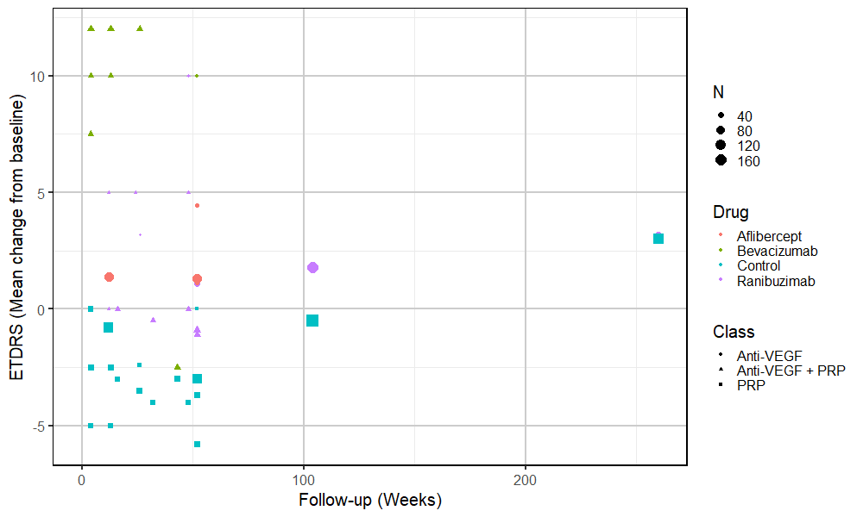
Figure 2 All ETDRS data (as mean change from baseline) by drug and type of intervention
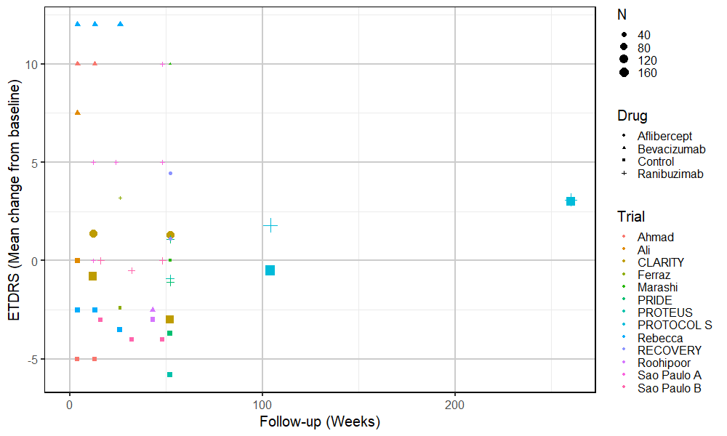
Figure 3 All ETDRS data (as mean change from baseline) by trial and drug type

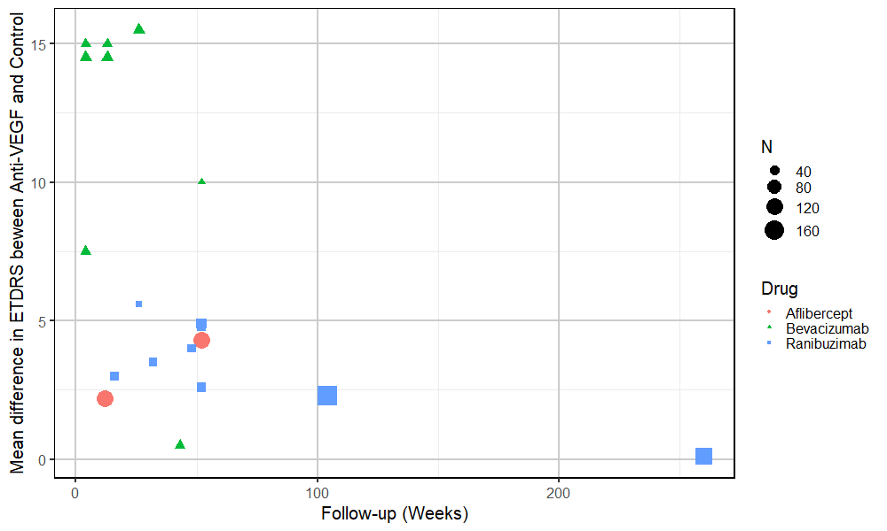
Figure 4 Mean difference in ETDRS between anti-VEGF and control arms over time

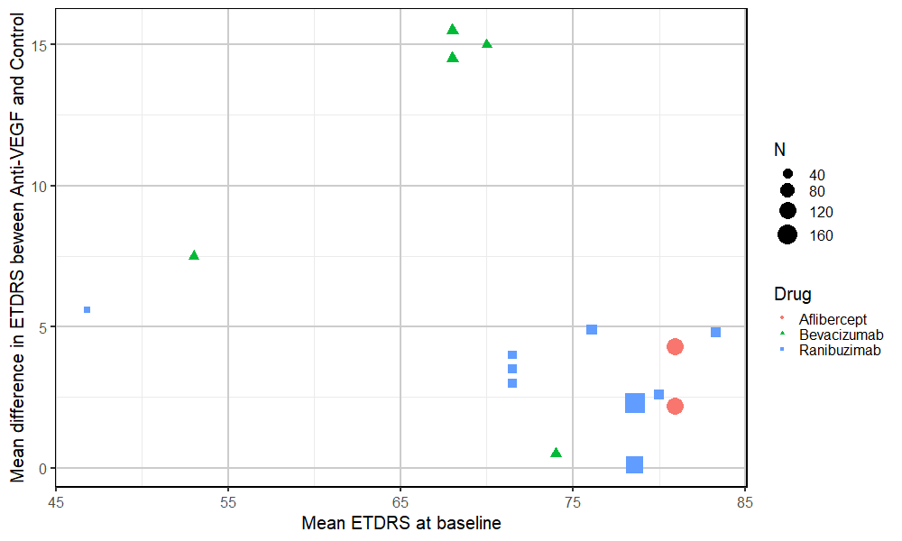
Figure 5 Mean difference between anti-VEGF and control arms by ETDRS at randomisation

Note from these figures that there appears to be a possible decline in benefit to vison over time, and that the benefit of ant-VEGF may be greater in people with poorer initial vision, but these difference may be confounded by differences between types of anti-VEGF.
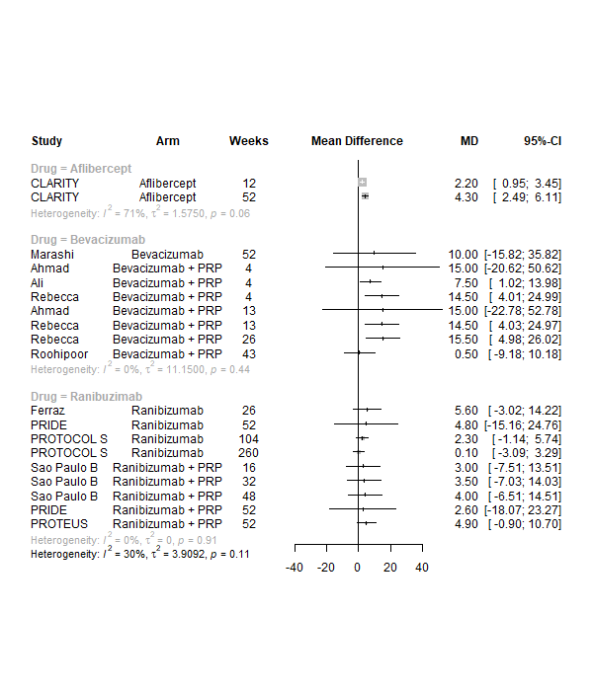
Figure 6 Forest plot of all mean differences in ETDRS between anti-VEGF and control (right side favours anti-VEGF)

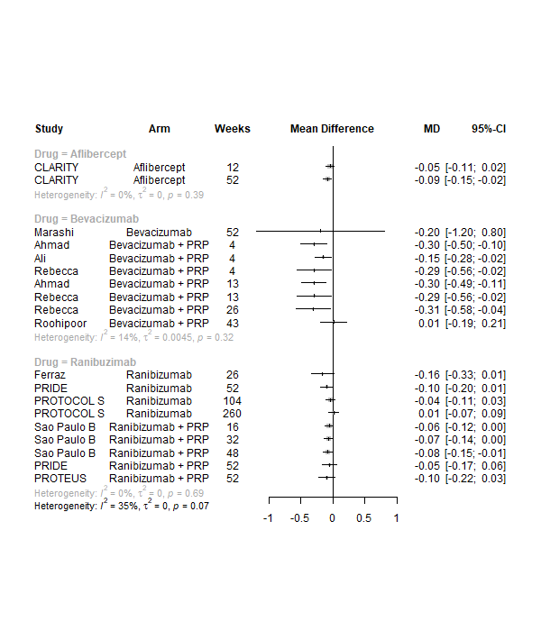
Figure 7 Forest plot of all mean differences in logMAR between anti-VEGF and control (left side favours anti-VEGF)

2.2 Forest plots of meta-analyses of BCVA

2.2.1 Up to 1 year

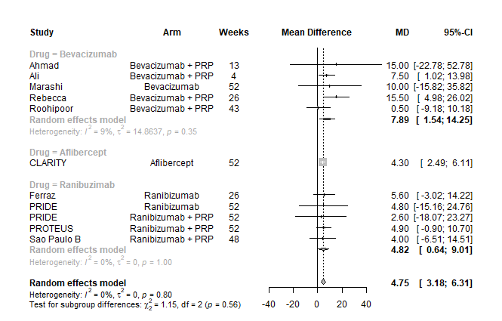
Figure 8 Meta-analysis of mean differences in ETDRS between anti-VEGF and control up to 1 year of follow-up (right side favours anti-VEGF)
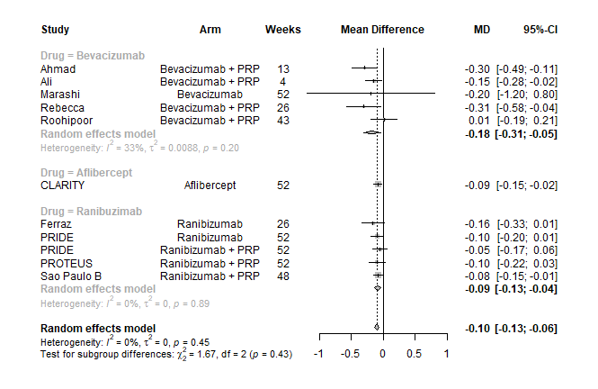
Figure 9 Meta-analysis of mean differences in logMAR between anti-VEGF and control up to 1 year of follow-up (left side favours anti-VEGF)

2.2.2 1 to 2 years’ follow-up

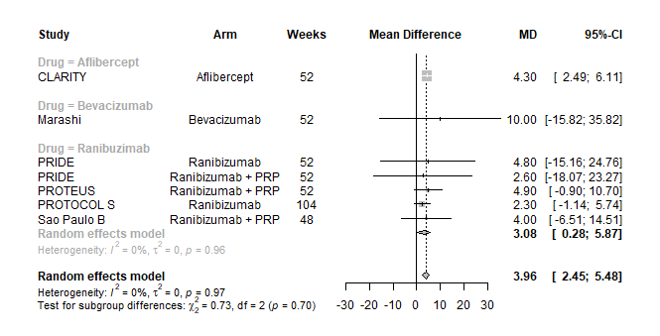
Figure 10 Meta-analysis of mean differences in ETDRS between anti-VEGF and control with 1 to 2 years' of follow-up (right side favours anti-VEGF)
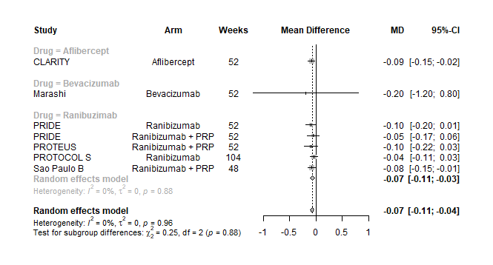
Figure 11 Meta-analysis of mean differences in logMAR between anti-VEGF and control with 1 to 2 years' of follow-up (left side favours anti-VEGF)

2.2.3 Maximum follow-up in trial (up to 2 years)
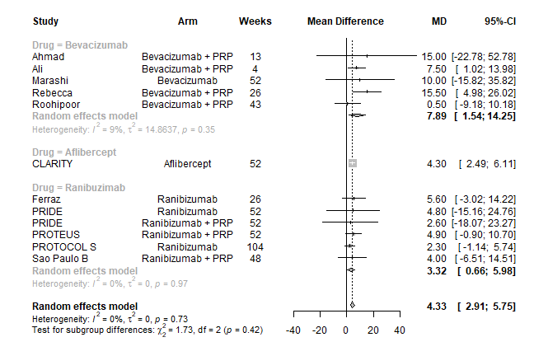
Figure 12 Meta-analysis of mean differences in ETDRS between anti-VEGF and control at end of trial (right side favours anti-VEGF)

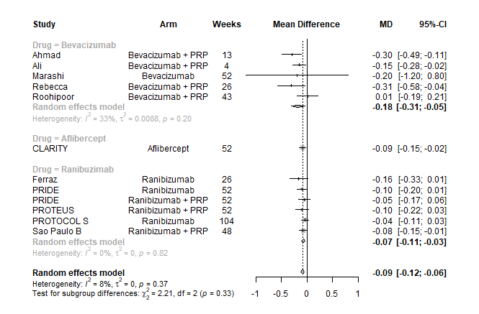
Figure 13 Meta-analysis of mean differences in logMAR between anti-VEGF and control at end of trial (left side favours anti-VEGF)

2.3: Network meta-analyses of BCVA (using logMAR)

Note: From this point forward on meta-analyses of BCVA measured using logMAR are presented. Some analyses using ETDRS were performed, but are not included here. Similarly, only random effects analyses are presented for simplicity, as differences between random and fixed effect analyses were minimal.

2.3.1 Analyses at up to 1 year of follow-up
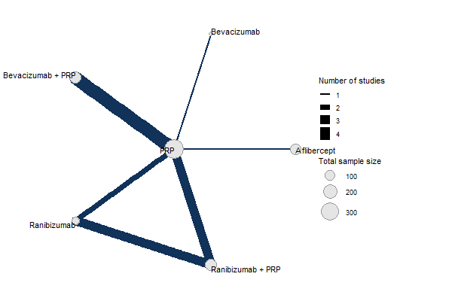
Figure 14 Network diagram of BCVA at up to 1 year of follow-up
Figure 15 All treatment comparisons for 1-year random-effects NMA of logMAR

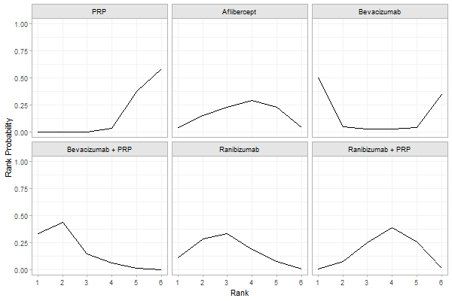
Figure 16 Probability of treatments for 1-year random-effects NMA of logMAR

Table 4 Results of NMA of logMAR up to 1 year - comparisons between treatments
Intervention | Comparator | Mean difference | 95% CI
Aflibercept | PRP | -0.084 | -0.222 | 0.056
Bevacizumab | PRP | -0.198 | -1.213 | 0.785
Bevacizumab + PRP | PRP | -0.172 | -0.279 | -0.069
Ranibizumab | PRP | -0.121 | -0.233 | -0.006
Ranibizumab + PRP | PRP | -0.078 | -0.165 | 0.013
Bevacizumab | Aflibercept | -0.115 | -1.142 | 0.853
Bevacizumab + PRP | Aflibercept | -0.088 | -0.273 | 0.082
Ranibizumab | Aflibercept | -0.037 | -0.213 | 0.130
Ranibizumab + PRP | Aflibercept | 0.006 | -0.151 | 0.173
Bevacizumab + PRP | Bevacizumab | 0.026 | -0.947 | 1.027
Ranibizumab | Bevacizumab | 0.077 | -0.913 | 1.098
Ranibizumab + PRP | Bevacizumab | 0.121 | -0.867 | 1.151
Ranibizumab | Bevacizumab + PRP | 0.051 | -0.095 | 0.208
Ranibizumab + PRP | Bevacizumab + PRP | 0.094 | -0.040 | 0.236
Ranibizumab + PRP | Ranibizumab | 0.043 | -0.067 | 0.160

Table 5 Results of NMA of logMAR up to 1 year – ranking probabilities
Treatment arm | Probability of ranking:
 | 1st | 2nd | 3rd | 4th | 5th | 6th
PRP | 0.00% | 0.13% | 0.65% | 4.93% | 37.65% | 56.65%
Aflibercept | 4.33% | 12.65% | 24.65% | 30.48% | 23.10% | 4.80%
Bevacizumab | 50.73% | 5.05% | 2.38% | 2.63% | 3.83% | 35.40%
Bevacizumab + PRP | 33.60% | 44.23% | 14.73% | 5.68% | 1.73% | 0.05%
Ranibizumab | 10.25% | 30.30% | 33.60% | 17.40% | 7.25% | 1.20%
Ranibizumab + PRP | 1.10% | 7.65% | 24.00% | 38.90% | 26.45% | 1.90%

2.3.2 Analyses at 1 to 2 years’ follow up

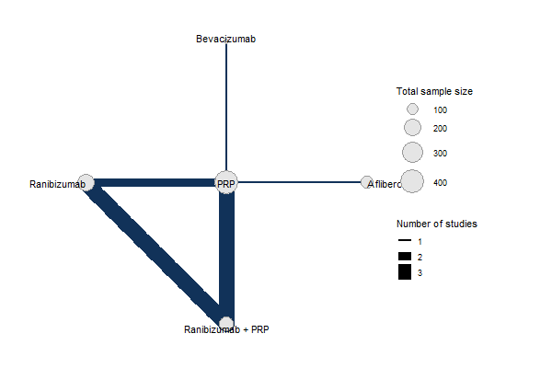
Figure 17 Network diagram of BCVA at up to 1 to 2 years of follow-up

Figure 18 All treatment comparisons for 1 to 2 year random-effects NMA of logMAR

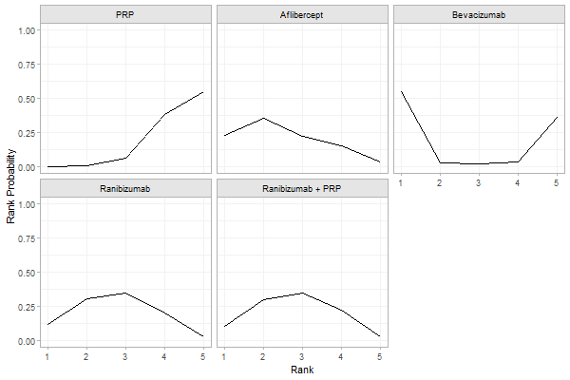
Figure 19 Probability of treatments for 1 to 2 year random-effects NMA of logMAR

Table 6 Results of NMA of logMAR 1 to 2 years - comparisons between treatments
Intervention | Comparator | Mean difference | 95% CI
Aflibercept | PRP | -0.080 | -0.225 | 0.100
Bevacizumab | PRP | -0.182 | -1.181 | 0.816
Ranibizumab | PRP | -0.072 | -0.171 | 0.017
Ranibizumab + PRP | PRP | -0.068 | -0.152 | 0.020
Bevacizumab | Aflibercept | -0.102 | -1.095 | 0.899
Ranibizumab | Aflibercept | 0.008 | -0.200 | 0.187
Ranibizumab + PRP | Aflibercept | 0.012 | -0.174 | 0.189
Ranibizumab | Bevacizumab | 0.110 | -0.887 | 1.104
Ranibizumab + PRP | Bevacizumab | 0.114 | -0.885 | 1.112
Ranibizumab + PRP | Ranibizumab | 0.004 | -0.100 | 0.114

Table 7 Results of NMA of logMAR 1 to 2 years – ranking probabilities
Treatment arm | Probability of ranking:
 | 1st | 2nd | 3rd | 4th | 5th
PRP | 0.05% | 1.20% | 6.25% | 37.93% | 54.58%
Aflibercept | 21.38% | 34.58% | 20.98% | 17.00% | 6.08%
Bevacizumab | 56.20% | 3.15% | 2.88% | 3.35% | 34.43%
Ranibizumab | 13.13% | 30.28% | 34.13% | 20.15% | 2.33%
Ranibizumab + PRP | 9.25% | 30.80% | 35.78% | 21.58% | 2.60%

2.3.3 Analysis at maximum follow-up time (up to 2 years)

Figure 20 All treatment comparisons for end-of-trial random-effects NMA of logMAR
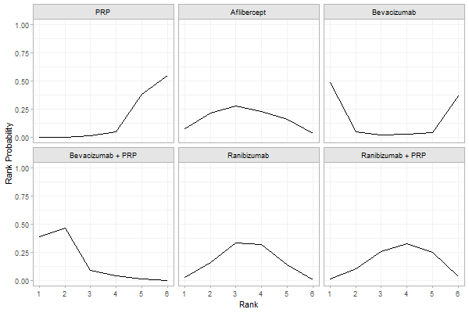
Figure 21 Probability of treatments for end-of-trial random-effects NMA of logMAR
Table 8 Results of NMA of logMAR at end of trial - comparisons between treatments
Intervention | Comparator | Mean difference | 95% CI
Aflibercept | PRP | -0.087 | -0.228 | 0.049
Bevacizumab | PRP | -0.209 | -1.176 | 0.782
Bevacizumab + PRP | PRP | -0.171 | -0.284 | -0.064
Ranibizumab | PRP | -0.085 | -0.177 | -0.004
Ranibizumab + PRP | PRP | -0.069 | -0.151 | 0.016
Bevacizumab | Aflibercept | -0.122 | -1.117 | 0.881
Bevacizumab + PRP | Aflibercept | -0.085 | -0.265 | 0.093
Ranibizumab | Aflibercept | 0.002 | -0.167 | 0.151
Ranibizumab + PRP | Aflibercept | 0.017 | -0.139 | 0.180
Bevacizumab + PRP | Bevacizumab | 0.038 | -0.956 | 1.030
Ranibizumab | Bevacizumab | 0.124 | -0.868 | 1.100
Ranibizumab + PRP | Bevacizumab | 0.140 | -0.830 | 1.116
Ranibizumab | Bevacizumab + PRP | 0.087 | -0.054 | 0.225
Ranibizumab + PRP | Bevacizumab + PRP | 0.102 | -0.032 | 0.243
Ranibizumab + PRP | Ranibizumab | 0.015 | -0.086 | 0.128

Table 9 Results of NMA of logMAR at end of trial – ranking probabilities

Treatment arm | Probability of ranking:
 | 1st | 2nd | 3rd | 4th | 5th | 6th
PRP | 0.00% | 0.63% | 4.80% | 35.88% | 58.70% | 0.00%
Aflibercept | 20.58% | 29.20% | 23.05% | 17.80% | 4.35% | 20.58%
Bevacizumab | 5.90% | 2.70% | 1.85% | 3.65% | 33.43% | 5.90%
Bevacizumab + PRP | 46.80% | 9.78% | 3.88% | 1.23% | 0.10% | 46.80%
Ranibizumab | 17.03% | 31.83% | 31.10% | 16.20% | 0.93% | 17.03%
Ranibizumab + PRP | 9.70% | 25.88% | 35.33% | 25.25% | 2.50% | 9.70%

2.4: NMAs allowing for interaction with follow-up time and BCVA at randomisation

2.4.1 Allowing for variation with follow-up time
Network meta-analyses incorporating all follow-up times (longest in each trial), allowing varying effect of anti-VEGF with follow-up time. Time variation is assumed to be the same for all types of anti-VEGF. A selection of output plots are presented. Results are presented for the predicted effects after 1 year of follow-up.

Figure 22 All treatment comparisons for time-adjusted random-effects NMA of logMAR

Table 10 Results of NMA of logMAR adjusting for time - comparisons between treatments
Intervention | Comparator | Mean difference | 95% CI
Aflibercept | PRP | -0.086 | -0.221 | 0.045
Bevacizumab | PRP | -0.199 | -1.218 | 0.858
Bevacizumab + PRP | PRP | -0.112 | -0.245 | 0.027
Ranibizumab | PRP | -0.119 | -0.214 | -0.023
Ranibizumab + PRP | PRP | -0.075 | -0.153 | 0.001
Bevacizumab | Aflibercept | -0.112 | -1.135 | 0.945
Bevacizumab + PRP | Aflibercept | -0.026 | -0.216 | 0.163
Ranibizumab | Aflibercept | -0.033 | -0.200 | 0.130
Ranibizumab + PRP | Aflibercept | 0.011 | -0.138 | 0.163
Bevacizumab + PRP | Bevacizumab | 0.086 | -0.957 | 1.127
Ranibizumab | Bevacizumab | 0.080 | -0.973 | 1.105
Ranibizumab + PRP | Bevacizumab | 0.123 | -0.919 | 1.138
Ranibizumab | Bevacizumab + PRP | -0.007 | -0.197 | 0.184
Ranibizumab + PRP | Bevacizumab + PRP | 0.037 | -0.123 | 0.195
Ranibizumab + PRP | Ranibizumab | 0.044 | -0.064 | 0.155

Table 11 Results of NMA of logMAR adjusting for time – ranking probabilities
Treatment arm | Probability of ranking:
 | 1st | 2nd | 3rd | 4th | 5th | 6th
PRP | 0.00% | 0.05% | 0.65% | 5.13% | 38.10% | 56.08%
Aflibercept | 7.60% | 19.98% | 25.30% | 25.10% | 17.48% | 4.55%
Bevacizumab | 51.98% | 3.88% | 2.58% | 2.78% | 4.35% | 34.45%
Bevacizumab + PRP | 18.73% | 30.70% | 17.90% | 17.35% | 12.35% | 2.98%
Ranibizumab | 19.40% | 34.13% | 25.88% | 14.88% | 5.25% | 0.48%
Ranibizumab + PRP | 2.30% | 11.28% | 27.70% | 34.78% | 22.48% | 1.48%

2.4.2 Allowing for variation over time and by logMAR at randomisation
Network meta-analyses incorporating all follow-up times (longes tin each trial), allowing for varying effect of anti-VEGF by follow-up duration and varying effect by trial mean logMAR at randomisation. Time and logMAR variation are assumed to be the same for all types of anti-VEGF. A selection of output plots are presented. Results are presented for the predicted effects after 1 year of follow-up and at mean baseline BCVA across trials.

Figure 23 All treatment comparisons for time-adjusted and baseline BCVA adjusted random-effects NMA of logMAR

Table 12 Results of NMA of logMAR adjusting for time and baseline BCVA - comparisons between treatments
Intervention | Comparator | Mean difference | 95% CI
Aflibercept | PRP | -0.085 | -0.310 | 0.119
Bevacizumab + PRP | PRP | -0.116 | -0.281 | 0.050
Ranibizumab | PRP | -0.117 | -0.247 | 0.011
Ranibizumab + PRP | PRP | -0.073 | -0.187 | 0.041
Bevacizumab + PRP | Aflibercept | -0.031 | -0.287 | 0.228
Ranibizumab | Aflibercept | -0.032 | -0.288 | 0.233
Ranibizumab + PRP | Aflibercept | 0.012 | -0.218 | 0.251
Ranibizumab | Bevacizumab + PRP | -0.001 | -0.239 | 0.225
Ranibizumab + PRP | Bevacizumab + PRP | 0.043 | -0.151 | 0.234
Ranibizumab + PRP | Ranibizumab | 0.044 | -0.112 | 0.203

Table 13 Results of NMA of logMAR adjusting for time and baseline BCVA – ranking probabilities
Treatment arm | Probability of ranking:
 | 1st | 2nd | 3rd | 4th | 5th
PRP | 0.08% | 0.70% | 4.23% | 19.50% | 75.50%
Aflibercept | 19.25% | 23.45% | 21.43% | 22.70% | 13.18%
Bevacizumab + PRP | 38.40% | 23.30% | 18.10% | 15.68% | 4.53%
Ranibizumab | 36.93% | 30.48% | 19.63% | 10.75% | 2.23%
Ranibizumab + PRP | 5.35% | 22.08% | 36.63% | 31.38% | 4.58%

2.5: NMAs of reduced networks

2.5.1 Assuming anti-VEGF and anti-VEGF+PRP are equivalent
This analysis assumes that anti-VEGF only arms and anti-VEGF+PRP arms have equal effect. To be used to assess differences between anti-VEGF types. A model allowing effect to vary with time and baseline logMAR was used. Results are presented for the predicted effects after 1 year of follow-up and at mean baseline BCVA across trials.

Figure 24 Results from a reduced network to compare anti-VEGFs

Table 14 Results of reduced network to compare anti-VEGFs - comparisons between treatments
Intervention | Comparator | Mean difference | 95% CI
Aflibercept | PRP | -0.091 | -0.245 | 0.063
Bevacizumab | PRP | -0.126 | -0.261 | 0.007
Ranibuzimab | PRP | -0.094 | -0.173 | -0.023
Bevacizumab | Aflibercept | -0.035 | -0.238 | 0.174
Ranibuzimab | Aflibercept | -0.003 | -0.166 | 0.163
Ranibuzimab | Bevacizumab | 0.032 | -0.142 | 0.200

Table 15 Results of reduced network to compare anti-VEGFs - ranking probabilities
Treatment | Probability of ranking:
 | 1st | 2nd | 3rd | 4th
PRP | 0.00% | 0.80% | 11.48% | 87.73%
Aflibercept | 25.08% | 32.93% | 33.35% | 8.65%
Bevacizumab | 53.60% | 23.33% | 20.18% | 2.90%
Ranibuzimab | 21.33% | 42.95% | 35.00% | 0.73%

2.5.2 Assuming all types of Anti-VEGF are equivalent
This analysis assumes that all three anti-VEGF drugs have equal effect. To be used to assess the overall effect of anti-VEGF. A model allowing effect to vary with time and baseline logMAR was used.
Figure 25 Results from a reduced network to compare treatment classes

Table 16 Results of reduced network to compare treatment classes - comparisons between treatments
Intervention | Comparator | Mean difference | 95% CI
Anti-VEGF | PRP | -0.089 | -0.180 | -0.019
Anti-VEGF + PRP | PRP | -0.108 | -0.192 | -0.039
Anti-VEGF + PRP | Anti-VEGF | -0.019 | -0.126 | 0.083

Table 17 Results of reduced network to compare treatment classes - ranking probabilities
Treatment | Probability of ranking:
 | 1st | 2nd | 3rd
PRP | 0.03% | 1.20% | 98.78%
Anti-VEGF | 33.05% | 65.88% | 1.08%
Anti-VEGF + PRP | 66.93% | 32.93% | 0.15%

2.6: Threshold analyses

Up to 1 year
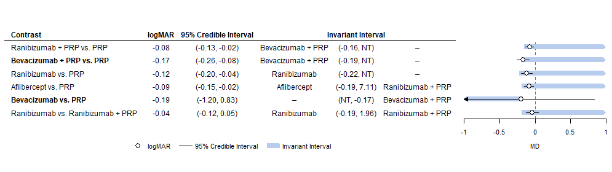
Figure 26 Threshold analyses of data up to 1 year of follow-up

1 to 2 years
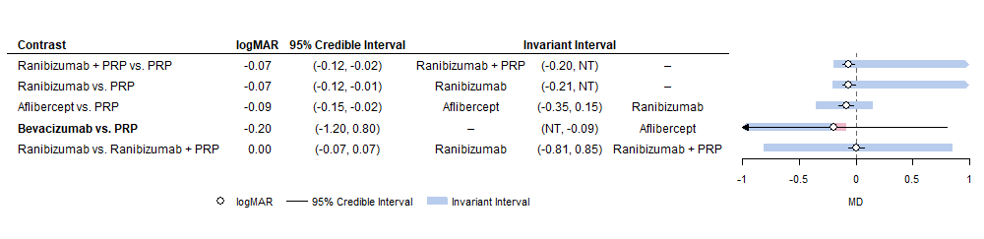
Figure 27 Threshold analyses of data with 1 to 2 years of follow-up

Maximum follow-up (up to 2 years)
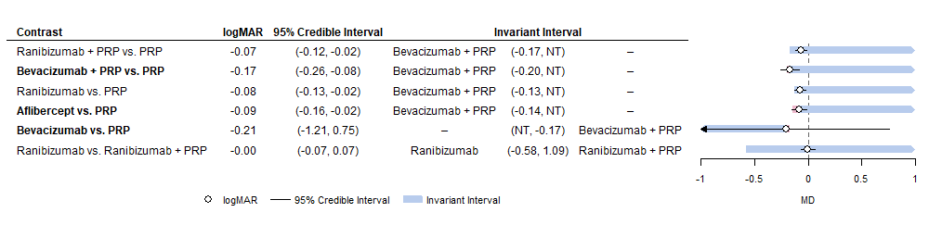
Figure 28 Threshold analyses of data at end of trial (up to 2 years)

Allowing for effect variation with time and baseline logMAR
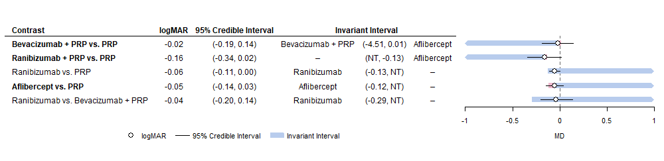
Figure 29 Threshold analyses of model adjusting for effect of time and baseline logMAR

Reduced network (for comparing anti-VEGFs)
Adjusted for follow-up time and BCVA at baseline
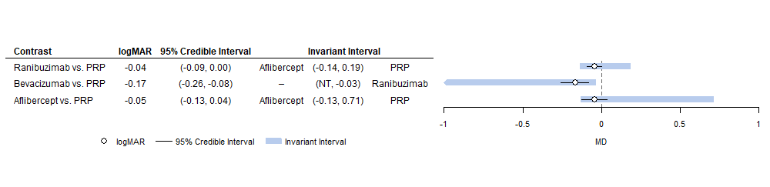
Figure 30 Threshold analysis of simplified network to compare anti-VEGF types, with time and baseline BCVA adjustment

Reduced network (comparing anti-VEGF to PRP)
Adjusted for follow-up time and BCVA at baseline
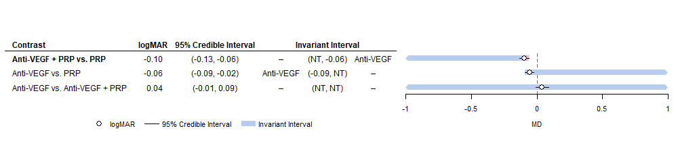
Figure 31 Threshold analyses of simplified network to compare anti-VEGF to PRP, adjusted for follow-up time and baseline BCVA

Appendix 3: Other outcomes

This appendix presents tables and figures for all analyses, using data from publications of included RCTs for outcomes other than BCVA. These mostly consist of forest plots without meta-analysis, because the evidence was generally too limited in extent, and too diverse in intervention and follow-up times, to justify a full meta-analysis.
As meta-analysis was not possible for most outcomes the forest plots without meta-analysis include trials of proliferative and non-proliferative retinopathy, to aid comparison.

3.1: Forest plots of outcomes without meta-analysis
These forest plots show results for all anti-VEGF types, and at all follow-up times. Note that this means some trials appear more than once in a forest plot.

NVD (neovascularization of the disc)
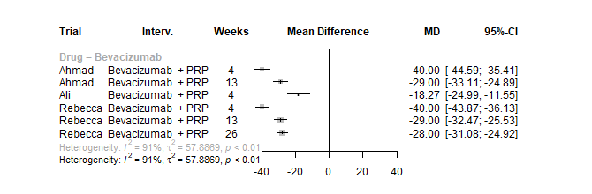
Figure 32 Forest plot of all NVD data (left side favours anti-VEGF)
NVE (neovascularization elsewhere)
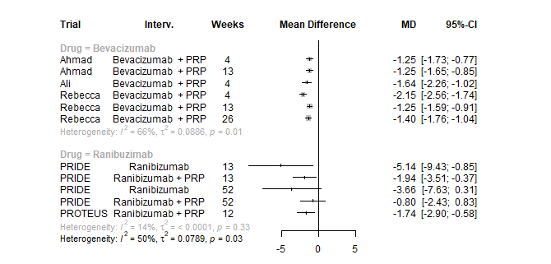
Figure 33 Forest plot of all NVE data (left side favours anti-VEGF)

Diabetic Macular Oedema (DMO)
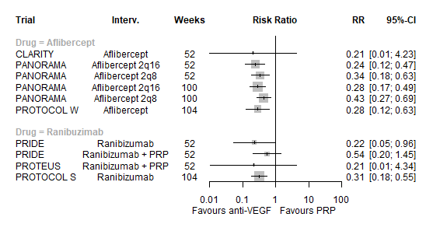
Figure 34 Forest plot of DME incidence (left side favours anti-VEGF)

Improvement in diabetic retinopathy severity score (DRSS)
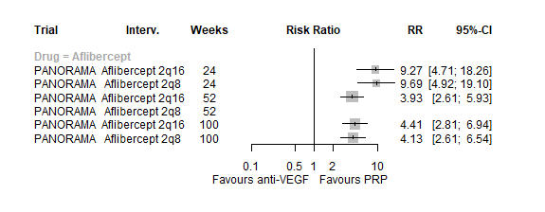
Figure 35 Forest plot of improvement in DRSS severity (right side favours anti-VEGF)

Proliferative retinopathy incidence
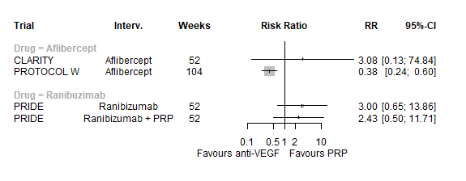
Figure 36 Forest plot of proliferative DR (left side favours anti-VEGF)

Regression of neovascularisation
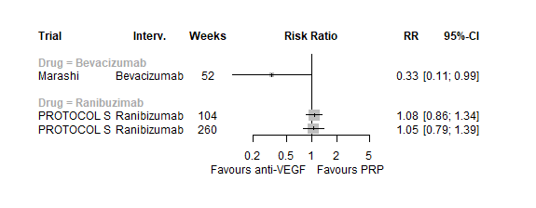
Figure 37 Forest plot of regressive neovascularisation (left side favours anti-VEGF)
Use of other treatments
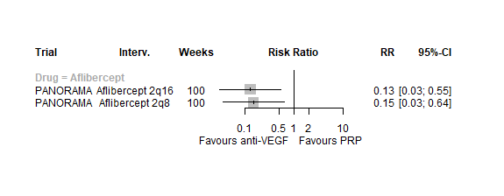
Figure 38 Forest plot of use of other treatments (left side favours anti-VEGF)
Vitrectomy
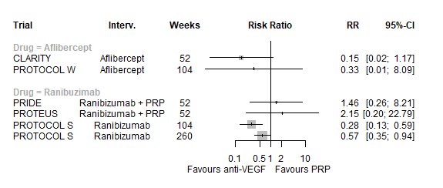
Figure 39 Forest plot of vitrectomy incidence (left side favours anti-VEGF)

Vitreous haemorrhage
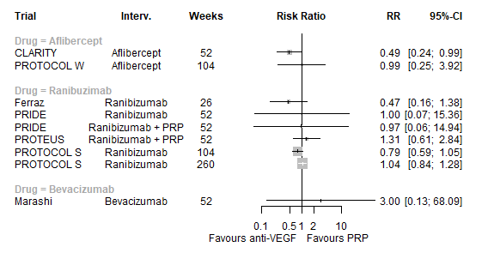
Figure 40 Forest plot of vitreous haemorrhage incidence (left side favours anti-VEGF)

3.2: Adverse Event outcomes
These forest plots show results for all anti-VEGF types, and at all follow-up times. Note that this means some trials appear more than once in a forest plot. For simplicity, only adverse event outcomes reported in two or more studies are presented.

Cataracts
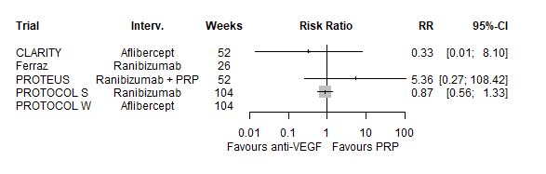
Figure 41 Forest plot of cataracts data (left side favours anti-VEGF)
Conjunctival haemorrhage
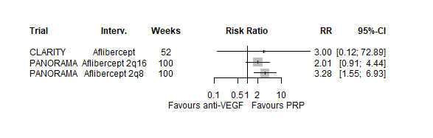
Figure 42 Forest plot of conjunctival haemorrhage data (left side favours anti-VEGF)

Cardiovascular mortality
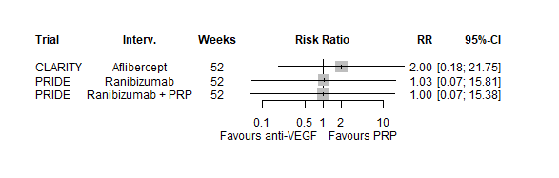
Figure 43 Forest plot of cardiovascular mortality data (left side favours anti-VEGF)

Death (all-cause mortality)
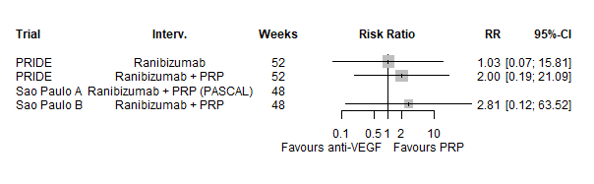
Figure 44 Forest plot of death data (left side favours anti-VEGF)

Myocardial infarction
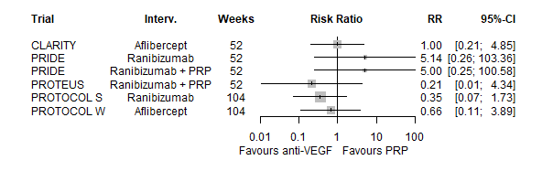
Figure 45 Forest plot of myocardial infarction data (left side favours anti-VEGF)
Ocular pain
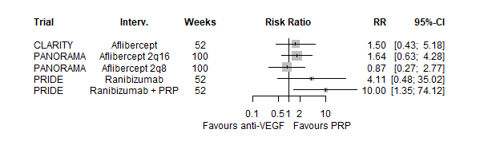
Figure 46 Forest plot of ocular pain data (left side favours anti-VEGF)

Raised intraocular pressure
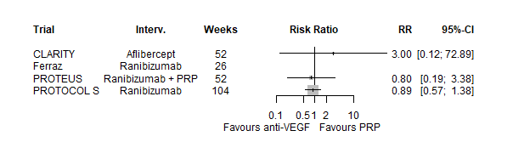
Figure 47 Forest plot of raised intraocular pressure data (left side favours anti-VEGF)

Retinal detachment
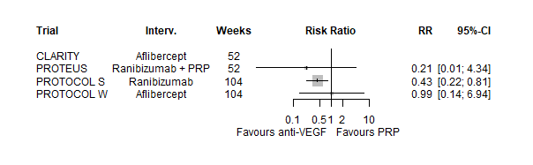
Figure 48 Forest plot of retinal detachment data (left side favours anti-VEGF)

Retinal tear
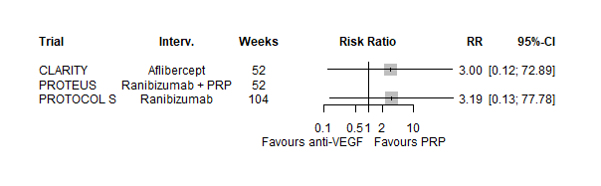
Figure 49 Forest plot of retinal data (left side favours anti-VEGF)

Serious adverse event (SAE, however defined)
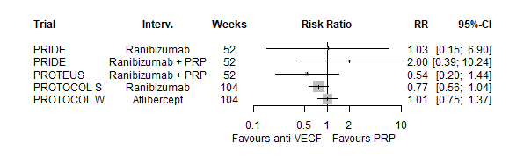
Figure 50 Forest plot of SAE data (left side favours anti-VEGF)

Stroke
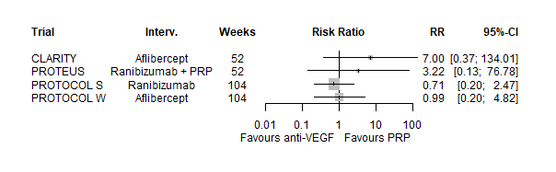
Figure 51 Forest plot of stroke data (left side favours anti-VEGF)

3.3: Meta-analyses of other outcomes and adverse events
All meta-analyses presented assumed that the impact of anti-VEGF on outcome (or adverse event) is the same for all types of anti-VEGF (in isolation or combined with PRP), and at all follow-up times. For trials with multiple time points, the longest follow-up was used. For trial with multiple arms only one anti-VEGF arm was used; arms using anti-VEGF alone were preferred.

NVE
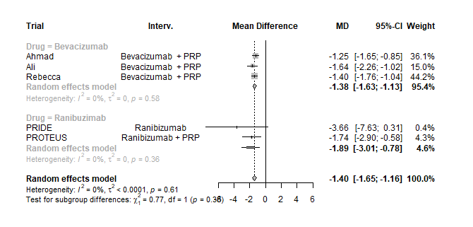
Figure 52 Meta-analysis of NVE (left side favours anti-VEGF)

NVD
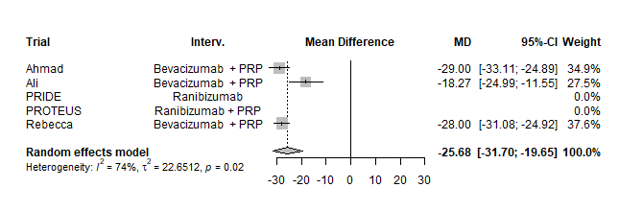
Figure 53 Meta-analysis of NVD (left side favours anti-VEGF)

Other non-vison outcomes
This forest plot shows the summary results of each meta-analysis (each bar is a meta-analysis result). Meta-analyses are restricted to trials of proliferative retinopathy. Full forest plots for each outcome are not presented.
Figure 54 Meta-analysis summary for non-vision outcomes in PDR trials (left side favours anti-VEGF)

Adverse events
This forest plot shows the summary results of each meta-analysis (each bar is a meta-analysis result). Meta-analyses are restricted to trials of proliferative retinopathy. Full forest plots for each outcome are not presented.
Figure 55 Meta-analysis summary for adverse events (left side favours anti-VEGF)

Appendix 4: Non-proliferative diabetic retinopathy

This section reports the findings of the two trials in non-proliferative retinopathy. As both trials compared aflibercept to sham injection no NMAs were performed. PANORAMA had two aflibercept arms: injections every 8 weeks or every 16 weeks. Only the 16 week arm is analysed here, as that was the schedule used in PROTOCOL W.
BCVA
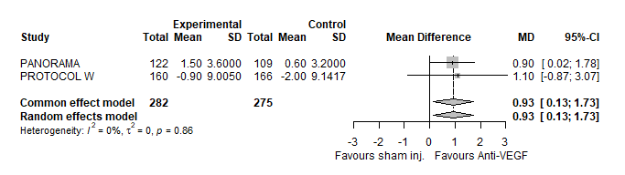
Figure 56 Mean difference in ETDRS after 2 years in NPDR trials

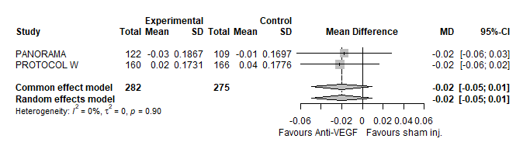
Figure 57 Mean difference in logMAR after 2 years in NPDR trials

Diabetic macular oedema in non-proliferative retinopathy
DMO was the only outcome other than BCVA reported in both trials of NPDR.
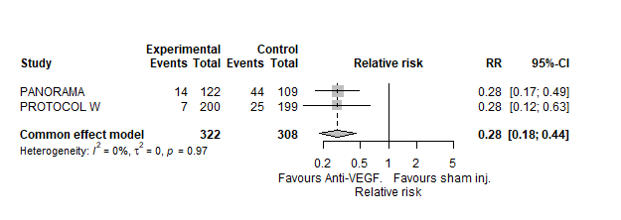
Figure 58 DMO incidence in NPDR trials
Other outcomes
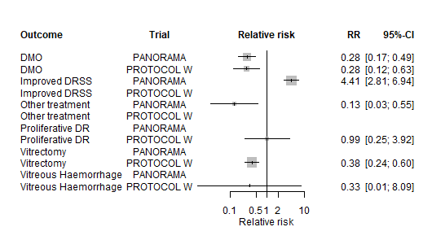
Figure 59 Non-BCVA outcomes in NPDR trials

Adverse events
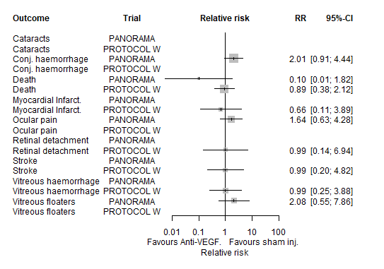
Figure 60 Adverse event outcomes in NPDR trials

