Achieving Cardiac Rehabilitation uptake targets: what is the value case for commissioners? A UK case-study

Hinde, S.¹, Harrison, A. S.², Bojke, L.¹ & Doherty, P. J.²
¹Centre for Health Economics, University of York, UK
²Department of Health Sciences, University of York, UK

All authors takes responsibility for all aspects of the reliability and freedom from bias of the data presented and their discussed interpretation

Corresponding author:
Sebastian Hinde,
Centre for Health Economics,
University of York,
Heslington,
North Yorkshire,
YO10 5DD,
England.
Sebastian.hinde@york.ac.uk
tel:+44 (0)1904 321455

Keywords
Cardiac rehabilitation, uptake, economic evaluation, commissioning, inequality

Sources of Funding
The research was co-funded by the NIHR Applied Research Collaboration (ARC) Yorkshire and Humber. The views expressed are those of the author(s), and not necessarily those of the NIHR or the Department of Health and Social Care.
AH, PD and the NACR data are funded by the British Heart Foundation grant (040/PSS/17/18/NACR).
Conflicts
The authors have no conflicts of interest to declare.
Data availability statement
This study used data from the National Audit of Cardiac Rehabilitation (NACR) funded by the British Heart Foundation and NHS England.

Abstract
Cardiac Rehabilitation (CR) has become an established intervention to support patient recovery after a cardiac event, with evidence supporting its effectiveness and cost-effectiveness in improving patient health and reducing future burden on healthcare systems. However, this evidence has focussed on the national value case for CR rather than at the point at which it is commissioned. This analysis uses the UK as a case-study to explore variation in current CR engagement and disassemble the value case from a commissioner perspective.
Using data collected by the National Audit of CR (NACR), and an existing model of cost-effectiveness, we present details on the current level of CR uptake by commissioning region (Specialist Clinical Networks) in light of the current UK target of achieving 85% uptake. We then interrogate the value case for achieving the target at a commissioner level, highlighting the expected profile of health benefits and healthcare system costs over the long-term. Importantly we consider where this may differ from the national value case.
Each commissioning region has a unique level of CR uptake and sociodemographic profile. Concurrently, the value case for commissioning CR relies on the upfront cost of the service being offset by long-term healthcare savings, and health improvements.
The shift in the UK and internationally to more localised commissioning necessitates evidence of cost-effectiveness that better reflects the realities of those decision makers. This paper provides vital additional data to facilitate such commissioners to understand the value case in increasing CR uptake in line with national policy.

- Introduction
In recent decades cardiac rehabilitation (CR) has become an established treatment component in the global struggle to reduce the rate of cardiovascular disease [1], which is responsible for 32% of all global deaths [2]. However, despite extensive evidence of its effectiveness in reducing repeat cardiac events rates of uptake have remained low [3].
In 2019 the UK’s NHS Long Term Plan [4] highlighted cardiovascular disease as one of eight major health conditions to be targeted by subsequent policy intervention, primarily due to its status as the biggest cause of premature mortality [5]. Key to the proposed range of policy interventions was the extension of (CR programmes, with the target of 85% of eligible patients with acute coronary syndrome (e.g. post heart attack patients) accessing care by 2028, up from 52% in 2017 [4, 6]. Concurrently, literature has identified that both patient and provider factors need to be addressed to achieve these uptake targets [7].
Within England there are currently 13 Strategic Clinical Networks (SCN), working across key NHS priority areas one of which is cardiovascular disease. SCNs are responsible for overseeing the delivery, quality, and innovation of care throughout the patient journey including CR programmes across their respect networks.
Employing internationally relevant methods of Health Technology Assessment (HTA) [8], CR has been shown to be a cost-effective use of the limited public healthcare budget, both in a UK and international setting [9]. More recently, a decision analytical model by Hinde et al. [10] supported this finding but found CR not to be cost-saving as indicated in a number of previous studies. Furthermore, this and a subsequent study [11] explored the impact of CR by socioeconomic status, finding that more deprived individuals were less likely to take up, complete, and benefit from CR programmes, suggesting some inequality issues to be addressed.
However, recent research has highlighted that there are a number of aspects where HTA economic evaluation methodology is not sufficient for decentralised commissioners of health, such as SCNs [12-14], bringing into question the appropriateness of applying such methods to decisions faced by such commissioners. Furthermore, commissioning of services such as CR is more complicated than the simplistic binary assessment of cost-effectiveness that HTA based analysis typically indicates, with issues such as equality of provision and poor programme uptake or completion of equal importance. [7]
In this paper we seek to produce meaningful, commissioner-level, evidence on the current provision of CR programmes and the health and cost-effectiveness case for extending the level of CR engagement to meet the ambitious targets laid out in the NHS Long Term Plan [4], with an aim of supporting local level commissioning decisions. To achieve this, we firstly summarise the existing landscape of CR provision and uptake across England using the most recent data from the National Audit of CR [6]. We apply this to an existing mathematical model of the long-term health implications of CR uptake [10] to estimate the potential health gains of achieving the NHS Long Term Plan targets. In the second part of the paper, we interrogate the aspects of the existing literature around the cost-effectiveness of CR which, while representing best practice from a national HTA economic evaluation perspective, have been shown to need additional consideration at local levels [12, 13]. Through doing so we seek to provide the relevant stakeholders with additional information with which to inform commissioning decisions.

- Methods
To achieve the aims of this paper we draw on the data for the National Audit of Cardiac Rehabilitation (NACR) covering the period 2016 to 2020 (the latest year the data was available at the time of analysis) [6] and utilise an existing decision analytical model of the cost-effectiveness of CR [10] which we have extended to provide more relevant information to the local context. An overview of the decision analytical model is provided in the Supplementary Appendix with more extensive details available from the original publications [10, 11]. These resources are used to conduct three analyses.
Firstly, we explore the system and patient level impacts from a national perspective of achieving or moving towards the NHS Long Term Plan’s target of achieving a CR uptake rate of 85%. This analysis re-examines the results of the original decision analytical model to estimate the impact of increases in the national uptake rate on hospital admissions, deaths (cardio-vascular related and all cause), quality adjusted life years (QALYs), and costs to the NHS. We also provide an estimate of the justifiable expenditure to achieve uptakes in CR, which uses publishes estimates of the marginal productivity of the English NHS [15] to determine the additional NHS budget that could be spent to achieve the health gains that result from increasing CR uptake, while remaining a cost-effective use of limited NHS funding.
Secondly, we use the latest NACR data to explore variations in the level of CR uptake across the thirteen SCNs contrasted against the average levels for England. In addition to reporting the level of uptake in each area we present the uptake by socio-economic group, using the index of multiple deprivation (IMD) to show the impact of deprivation on uptake but also explore the variation in this relationship across different SCNs. For the purpose of this analysis the SCNs have been anonymised.
Finally, we consider how the differences in the commissioning reality faced by SCNs compared to national decision makers impacts the value case for CR. This approach builds on previous work which has identified five areas where the conventional framework used to construct economic evaluations to inform national deliberations differs from the reality faced by those commissioning local services [12, 13].

- Results
  - What is the impact of increasing CR to move closer to the long term plan uptake target?
In Table 1 we explore the impact on cardiovascular and all cause deaths, quality adjusted life years (QALYs), as well as total costs both including and excluding the upfront cost of the CR. Additionally, an estimate of the justifiable expenditure to achieve the shift in CR uptake is reported, based on a marginal productivity estimate of the NHS of £12,936/QALY [15]. Table 1 additionally presents these incremental values for a range of other targets from the baseline of 50% uptake (the English CR uptake rate over the period 2016-2020). Finally, estimates are presented for any 1% change in uptake and any 1% change per individual eligible for CR in the annual cohort, these are provided to facilitate individual commissioner calculation. All of the results presented in Table 1 assume an annual eligible cohort of 118,544 [6] with a time horizon of 10 years. A 10 year time horizon was selected for these results as the time period indicated of most relevance by NHS England to inform the NHS Long Term Plan [4].

Table 1: Incremental values for national cohort (118544 eligible people per year) over 10 years
Scenario | new admissions | deaths - CV | deaths - all | QALYs* | Costs – all* | Costs- after CR*,** | Justifiable expenditure***
50% to 85% | -48,683 | -23,769 | -19,610 | 59,479 | £220,356,718 | -£89,855,917 | £549,058,659
50% to 65% | -20,864 | -10,187 | -8,404 | 25,491 | £94,438,594 | -£38,509,679 | £156,873,903
50% to 60% | -13,909 | -6,791 | -5,603 | 16,994 | £62,959,062 | -£25,673,119 | £235,310,854
50% to 70% | -27,819 | -13,582 | -11,206 | 33,988 | £125,918,125 | -£51,346,238 | £313,747,805
Any 1% change | -1,391 | -679 | -560 | 1,699 | £6,295,906 | -£2,567,312 | £15,687,390
any 1% increase per N in annual cohort | -0.012 | -0.006 | -0.005 | 0.014 | £53 | -£22 | £132
*All costs and QALYs represent undiscounted values
**This is excluding the cost of CR
***Justifiable expenditure is estimated as the additional cost that could be borne before the scenario no longer a cost-effective use of NHS resources

The scenario outlined in the NHS Long Term Plan [4](50% to 85%) highlights significant potential benefits of achieving the target, at both system and patient level. From a system level, hospital admissions would be expected to fall by 48,683 for the 10 year period and while total costs would increase, by £220mn, this is all the result of the additional upfront cost of CR, with costs over the 10 years falling by £90mn when the upfront cost of CR is excluded. It is important to note here that the cost of CR applied in the model, £748 per person who starts CR, may be more than applied elsewhere, for example the most recent national costing guide estimates of cost of £477 [16], for further details regarding the calculation of the higher cost see Hinde et al. [10]. The table further shows a justifiable expenditure of £549mn to achieve the 85% target for a 10 year period. This implies that if that level of NHS funding were allocated to successfully achieving the target, CR would still represent a cost-effective use of finite NHS resources. However, by extension this implies that if more were spent or the 85% target were not achieved it would not represent value for money.

  - What does CR uptake look like across the different local areas?
Figure 1 shows CR uptake rates and the eligible populations for the whole of England as well as for each SCN. Each area has their average uptake reported (the ‘X’ on the figure) as well as the distribution of uptake by IMD (reported through the bar charts), alongside the eligible annual population (the ‘-’). The values presented were provided by the NACR and are averages across 2016-2020.
The figure highlights several important elements of CR uptake. Firstly, looking at the values for England the average CR uptake of 50% is accompanied by a large variation in uptake by IMD, with the more deprived having progressively lower level of uptake ranging from 44% to 55%. However, this level of CR uptake and pattern of inequality is of limited generalisability across the different SCNs.
For example, SCN13 has a similar distribution of inequality in uptake to the national level but at a much lower overall level of uptake, with an average level of 38% (32% to 44%). In contrast, SCN1 has a much higher level of uptake (64%) but a different distribution by IMD, with the third and fourth groups having the highest uptake. Finally, both SCN2 and SCN8 have inequality gradients that are the inverse of the national distribution, with increasing deprivation being consistently associated with an increase in CR uptake.

Figure 1: uptake (mean and by IMD) and eligible annual population by anonymised SCN area, 2016-20 averages
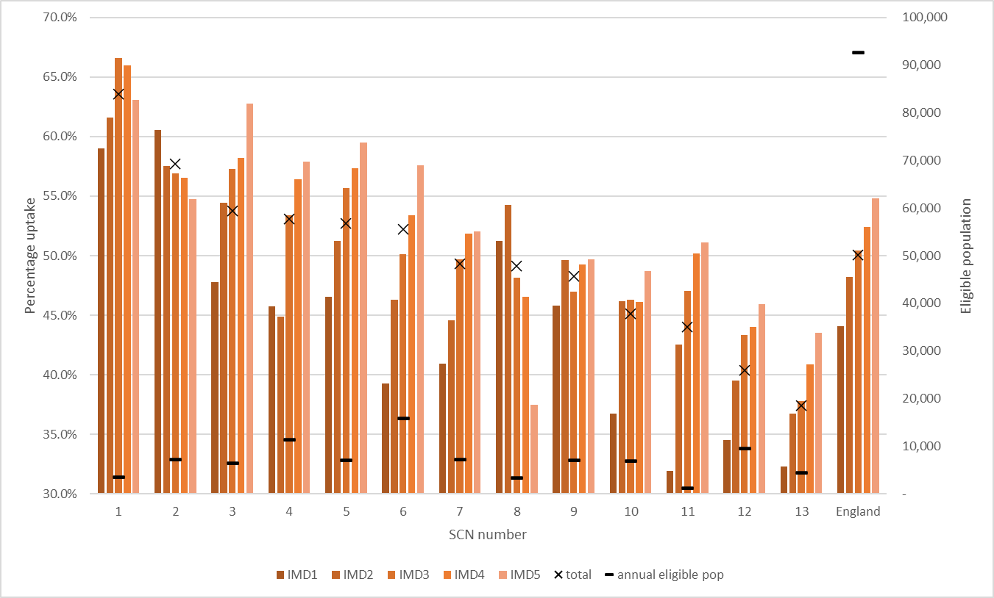
IMD – index of multiple deprivation, IMD1 is the most deprived, IMD5 the least
  - Making the economic case at a local level for achieving these targets
In Sections 3.1 and 3.2 we have highlighted that there is a substantial need and potential benefit to increasing the uptake of CR to achieve the ambitious target of 85% uptake in those who are eligible. However, Section 3.2 further demonstrated how the current blanket ambition fails to account for the large variation in current uptake level both between geographic areas and across socio-economic deprivation. In this section we explore how the economic case can address some of the challenges faced at a local level, in making the business case for commissioning interventions to increase CR uptake.
Previous literature has made the case that, at a local level, there are elements of the framework used to inform national cost effectiveness that are not necessarily relevant or are in need of additional consideration to be most informative to the needs of local commissioning [10, 13]. In this section we explore five elements in turn, reflecting on the relevance of each in a CR setting and presenting additional analyses to inform commissioning decisions.

    - Valuation of future costs and benefits
Under conventional HTA decision frameworks, a lifetime perspective is recommended [17], with both costs and outcomes discounted at a rate of 3.5% per year. However, the budgetary reality faced by many local commissioners makes the application of such a perspective challenging if not untenable as budgets may be required to be balanced within a financial cycle or targets set with a less than lifetime horizon. Therefore, while it might be the optimal solution for the NHS as a whole to take such a long perspective regarding the accumulation of costs and benefits, individual commissioners may by necessity deviate from such an approach.
From a health outcome perspective Figure 2A shows that the benefits of CR, measured here in terms of incremental QALYs gained over time, are relatively slow to accumulate, reaching a maximum undiscounted value of 0.6 QALYs. This slow but constant accumulation of patient benefit over their remaining lifetime is the result of CR acting to reduce the individual’s risk of future cardiac events at a modest but constant rate over the long term [3].
From a cost perspective the high upfront cost, that of the CR programme itself, is offset to some extent by medium term reductions in patient care need due to improved cardiac health. In the longer term this total cost saving is then in turn offset by patients who completed CR living longer lives and therefore being associated with additional healthcare costs later in life. This relationship is shown through the ‘U-shaped’ trend in Figure 2B. Importantly, in contrast to some previous studies of CR [9, 18] it is not expected to be cost-saving at any point in time, therefore implying some opportunity cost of the investment in CR whatever the time horizon considered.
Combining the health benefit and cost perspectives, Figure 2C presents the incremental cost-effectiveness ratio (ICER) of CR over time, which presents an estimate of the incremental cost per QALY gain which then requires a comparison to a cost-effectiveness threshold [19]. In the case of CR, the figures show that the upfront cost of CR implies that it is not expected to be cost-effective for the first few years after it is delivered but over the longer term it would be considered cost-effective.

    - Cost- effectiveness threshold
In cost-effectiveness analysis the threshold value is conventionally defined as the maximum a decision maker is willing to pay for an additional unit of health gain (e.g. a QALY) [20]. In a budget constrained system where health maximisation is the primary focus, the most appropriate cost-effectiveness threshold selected would be informed by the level of health that is displaced from any disinvestment necessary to fund the additional health improving intervention, i.e. the opportunity cost of the intervention.
In their methods guide for conducting economic evaluation NICE consider a threshold value of between £20,000 and £30,000 per QALY gain to be most appropriate [17]. NICE have further clarified that they consider this threshold value to not be a reflection of the opportunity cost of expenditure in the NHS alone, arguing that it includes a range of other unquantified factors, primarily relating to stimulating investment in the UK health sector [21]. This is supported by research which has estimated that the opportunity cost alone is significantly lower than the threshold applied by NICE, approximately to £13,000/QALY at a national level [15], or closer to £7,000/QALY for locally commissioned services [22].
Therefore, while the NICE threshold is conventionally used in economic evaluations to determine cost-effectiveness of healthcare interventions in a UK setting its appropriateness to local commissioners has been brought into question both in terms of what it signifies [12] and the value applied [15].
In the CR context, exploring the ICER over time (Figure 2C) demonstrates that the high upfront cost of the programme, but long-term health gains, results in the ICER value reducing quickly from over £100,000/QALY to within the NICE threshold range within a few years. This finding underpins the cost-effectiveness of providing CR programmes even at low thresholds and short time horizons but has implications for the estimated justifiable expenditure to increase CR uptake.

    - Budget and decision uncertainty
Under the NICE economic evaluation framework, the reporting of decision uncertainty, generated both through the potential cost and health benefits of completing interventions, is encouraged using a range of methodologies [17]. However, aversion to decision uncertainty is likely to be different at a local level than nationally [23].
All three graphs presented in Figure 2 include estimates of the uncertainty associated with each element of the cost effectiveness of CR, represented through 95% confidence intervals around the expected value. 25 years was selected as the maximum time period on the x-axis for these graphs as it is the time at which the respective curves flatten, i.e. all of the cohort being modelled has died.
Importantly, the increased cost and QALY uncertainty over time has no impact on the overall profile of cost-effectiveness, with Figure 2C indicating CR remains cost-effective at all point within the 95% confidence interval.
While these analyses show that decision uncertainty does not impact the overall assessment of the cost-effectiveness of CR in this analysis, it is important to note that the final decision about what is considered a reasonable level of uncertainty and the implications of worse outcomes should be made at the commissioner level. For example, the approach to uncertainty taken here assumes symmetry of preference, such that the potential for better than expected outweigh the risk of worse than expected outcomes. However, a commissioner may have asymmetries of preference, for example a strong aversion to avoiding CR costs that exceed some level that are not offset by the chance that CR is cost-saving in the long term. Issues such as this are discussed elsewhere in the literature [23, 24].

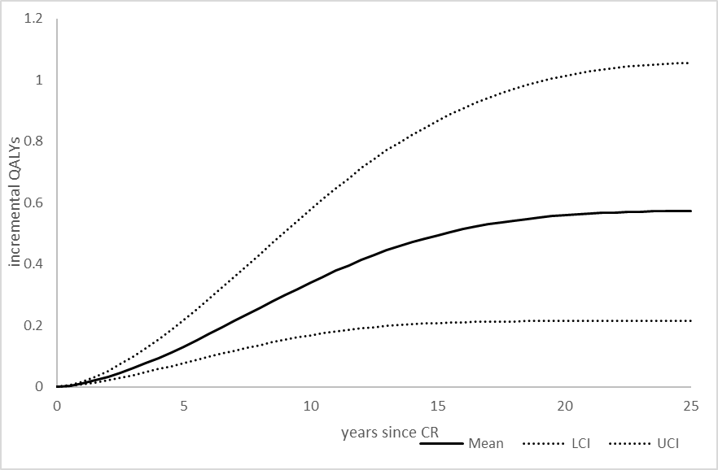
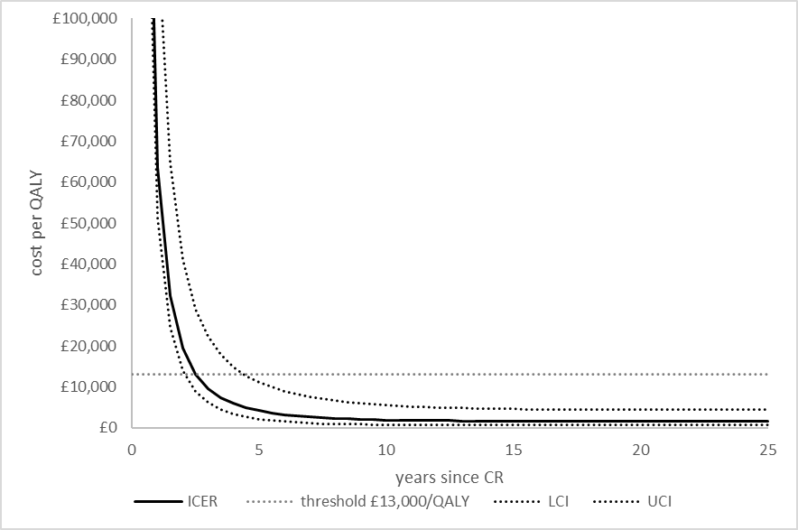
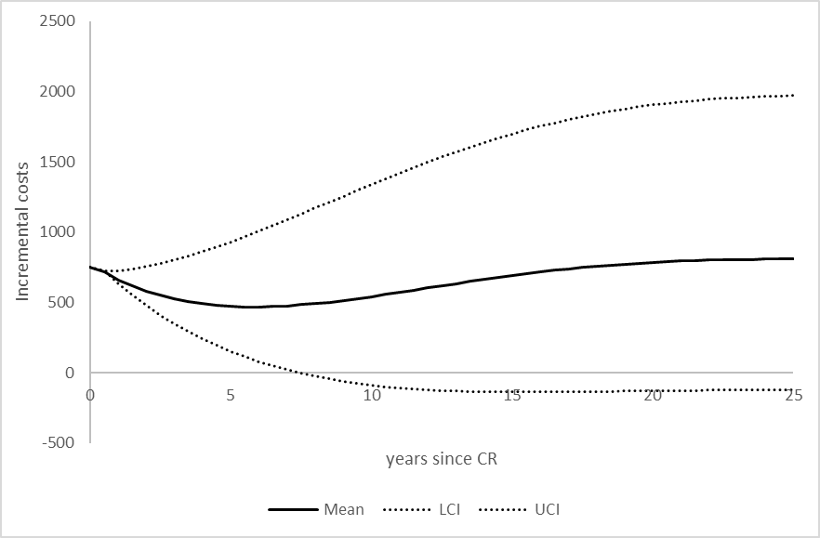
A
B
C
Figure 2: graphs of the undiscounted incremental QALYs (A), incremental costs (B), cost per QALY (C), and Net Monetary Benefit (D) over time of CR versus no CR with associated uncertainty

NB. costs (figure A) and QALY (B) are undiscounted over time, the ICER (C) are discounted at a rate of 3.5% consistent with the NICE methods guide

    - Scope of included costs and outcomes
Conventionally only the costs borne by the NHS and personal social services (PSS) and the QALY-based health impact on the individual are considered the primary focus of economic evaluation [25]. While NICE does support the inclusion of wider cost and outcomes implications [17], there is currently no agreed method on how best to incorporate these, primarily due to challenges in the accounting for different opportunity costs in different sectors [26]. However, estimates of such burden, be it positive or negative, remain an important consideration for commissioners.
In the case of CR these wider costs and outcomes can be conceptualised in three groups:
- Economic productivity. Existing evidence has demonstrated the significant economic burden of CV disease has been reported to be significant [27]. However, in terms of CR this is difficult to quantify currently as there is limited research directly linking CR engagement and economic productivity.
- Carer impact. Due to the mobility impact of cardiovascular disease it is associated with a significant burden on the close social network who bare much more the responsibility for providing support to the patient both in term of their own physical and mental health in addition to impacts on their own economic productivity [28]. The potential of CR to reduce future CV events implies a potential benefit to carers that is not currently incorporated into this analysis.
- Out of pocket costs. Prior to the covid-19 pandemic the majority of CR programmes consisted of group-based activities at fixed times, entailing a cost to the patient both in terms of travel costs and the opportunity cost of attending, for example time off work. However, since then there has been a shift to home-based or hybrid programmes which are expected to entail smaller patient out of pocket burden [29]. Additionally, CR’s reduction of future cardiovascular events is likely to have an impact on patient out of pocket costs.

    - Inequality
As reflected in Figure 1, socioeconomic inequality is a significant factor in the uptake of CR across all the SCNs, but to varying extent. Furthermore, previous research has highlighted how inequality impacts individual engagement with CR completion [11] as well as the propensity to benefit from it [10] with the most deprived gaining 0.1 QALY less from engaging with CR per person while costing the NHS more over their lifetime than the least deprived. Therefore, any programme to improve uptake in CR programmes must explicitly consider the socioeconomic implications.

Discussion
The role of health and social care analysis, including economic evaluation, must always be to inform and hold accountable decisions made by appointed decision makers [30]. It is therefore necessary for the evidence generated by such analyses to reflect differences between national commissioning and priority setting and that at a local level [12]. To date the economic evaluation literature related to the cost-effectiveness of CR has taken the conventional HTA framework, supported by NICE among others, which focusses on the lifetime cost-effectiveness of competing alternatives with a national level commissioner in mind [9].
However, the commissioning of CR primarily occurs at a regional level through the SCNs. As our analysis has shown, each SCN faces a unique landscape relative to each other and the national setting in terms of existing provision, patient need, and available funding, and therefore each has different requirements from an economic evaluation of CR. In addition to identifying this challenge we have sought to provide a broader overview of the implications of increasing CR uptake than is currently available in the literature. To achieve this we have explored the distinct elements which make up the case for cost-effectiveness of CR and the associated increase in uptake to achieve the NHS Long Term Plan’s target [4].
The strength of this paper is through increasing the accessibility and availability of evidence necessary to inform decision making at the point of commissioning. For CR this is a vital step if the NHS Long Term Plan uptake target is to be achieved, especially if it is to be achieved in a cost-effective way. By employing the decision model used to inform the NHS Long Term Plan this analysis also provides commissioners with additional understanding of how the national policy was informed by the evidence, and how it relates to their own area.
There are, however, a number of weaknesses associated with this analysis. While we have attempted to make the informing of decision making based on cost-effectiveness more relevant to local commissioners, there remain a number of area where this analysis is limited. For example, are analysis assumes that all costs relevant to the analysis are variable, and all budgets soft, with limited consideration of the issue of affordability. While these assumptions are routine in HTA economic evaluation they may play an important part when translating evidence to local commissioners, for further discussion read Howdon et al. [23].
The analysis was also forced to make a number of simplifying assumptions regarding the differences between the commissioning landscape faced by each SCN. The analysis presented only considers variation in socioeconomic characteristics (measured by IMD) and current CR uptake between the regions. When making commissioning decisions there are likely to be a number of other factors which impact the case for cost-effectiveness. These might include the cost of care such as hospitalisation, the local cost and existing supply of commissioning CR programmes, long term commissioning arrangements, as well as population characteristics such as the level of urbanisation of the population, ethnographic features, and levels of co-morbidities. These are all areas that require further research, such as the potential non-linearity between increasing CR uptake from currently levels and propensity to benefit, or analysis at a regional level prior to commissioning.
Furthermore, the analysis has assumed the effectiveness of CR at a local level matches the conclusions of an international meta-analysis [3], which informs the decision model. While this is appropriate given a lack of alternative evidence, the wide variation in current services offered by SCNs demonstrated in this paper, is likely to be associated with variation in effectiveness.
This study has also identified a number of areas where additional empirical and methodological work is required if commissioning decisions made at a local or regional level are to be well informed by economic evaluation research both in CR and more generally. Specific to CR, while this study has identified the variations in how far SCNs must go to achieve the 85% uptake target and the cost and health outcome implications of doing so, there is little research relating to the best way to achieve these increases, and to do so in an equitably way. Any interventions developed or subject to evaluation going forward would achieve greater policy impact through a clearer interrogation of the drivers of cost-effectiveness and the impact on inequality as we have reflected in this paper. Examples of such interventions include the rollout of home-based CR, such as the REACH-HF programme [29]. While such programmes may be effective in increasing total uptake by providing additional modalities of CR, carful recording is needed to ensure there are no detrimental impacts to more deprived groups.
From a more general perspective more research is required in understanding how economic evaluation methodology can best inform local commission decisions. While attempts have been made to interact with local processes [14], and to create appropriate frameworks to apply economic evaluation [12], these are in their relative infancy. Additionally methodological research is required about the most appropriate means of incorporating the additional considerations covered in Section 3.3.4 of this paper, relating to the scope of included costs and outcomes.

References
1. Price, K.J., et al., A review of guidelines for cardiac rehabilitation exercise programmes: Is there an international consensus? European Journal of Preventive Cardiology, 2020. 23(16): p. 1715-1733.
2. World Health Organisation (WHO). Cardiovascular diseases (CVDs): Key Facts. accessed:29/9/2022.
3. Anderson, L., et al., Exercise-Based Cardiac Rehabilitation for Coronary Heart Disease: Cochrane Systematic Review and Meta-Analysis. J Am Coll Cardiol, 2016. 67(1): p. 1-12.
4. NHS England, NHS Long Term Plan. NHS England: London, 2019.
5. Steel, N., et al., Changes in health in the countries of the UK and 150 English Local Authority areas 1990–2016: a systematic analysis for the Global Burden of Disease Study 2016. The Lancet, 2018. 392(10158): p. 1647-1661.
6. British Heart Foundation, National Audit of Cardiac Rehabilitation (NACR) Quality and Outcomes Report 2021. 2021, British Heart Foundation: Birmingham.
7. Harrison, A.S., et al., Factors influencing the uptake of cardiac rehabilitation by cardiac patients with a comorbidity of stroke. Int J Cardiol Heart Vasc, 2020. 27: p. 100471.
8. Goodacre, S. and C. McCabe, An introduction to economic evaluation. Emergency Medicine Journal, 2002. 19(3): p. 198-201.
9. Shields, G.E., et al., Cost-effectiveness of cardiac rehabilitation: a systematic review. Heart, 2018.
10. Hinde, S., et al., Improving cardiac rehabilitation uptake: Potential health gains by socioeconomic status. European Journal of Preventive Cardiology, 2019. 26(17): p. 1816-1823.
11. Hinde, S., et al., Quantifying the impact of delayed delivery of cardiac rehabilitation on patients’ health. European Journal of Preventive Cardiology, 2020.
12. Hinde, S., et al., The Relevant Perspective of Economic Evaluations Informing Local Decision Makers: An Exploration in Weight Loss Services. Applied Health Economics and Health Policy, 2020. 18(3): p. 351-356.
13. Hinde, S., et al., Health Inequalities: To What Extent are Decision-Makers and Economic Evaluations on the Same Page? An English Case Study. Applied Health Economics and Health Policy, 2022.
14. Frew, E. and K. Breheny, Health economics methods for public health resource allocation: a qualitative interview study of decision makers from an English local authority. Health Economics, Policy and Law, 2020. 15(1): p. 128-140.
15. Claxton, K., et al., Methods for the estimation of the National Institute for Health and Care Excellence cost-effectiveness threshold. Health Technol Assess, 2015. 19(14): p. 1-503, v-vi.
16. Department of Health and Social Care, Cardiac Rehabilitation: Costing Tool Guidance. 2010, DHSC: London.
17. National Institute for Health and Care Excellence, NICE health technology evaluations: the manual 2022, NICE: London.
18. National Institute for Health and Care Excellence, Secondary prevention after a myocardial infarction. 2015, NICE: London.
19. York Health Economics Consortium. Incremental Cost Effectiveness Ratio [online]. accessed: 01/08/2022.
20. York Health Economics Consortium. Cost-Effectiveness Threshold [online]. accessed: 01/08/2022.
21. National Institute for Health and Care Excellence, Carrying NICE over the threshold. 2015, NICE: London.
22. Martin, S., et al., How Responsive is Mortality to Locally Administered Healthcare Expenditure? Estimates for England for 2014/15. Appl Health Econ Health Policy, 2022. 20(4): p. 557-572.
23. Howdon, D., et al., Economic evaluation evidence for resource-allocation decision making: bridging the gap for local decision makers using English case studies. Applied Health Economics and Health Policy, 2022.
24. Lomas, J.R.S., Incorporating Affordability Concerns Within Cost-Effectiveness Analysis for Health Technology Assessment. Value in Health, 2019. 22(8): p. 898-905.
25. Drummond, M., Sculpher, M., Claxton, K., Stoddard, G., Torrance, G., Methods for the Economic Evaluation of Health Care Programmes. Oxford, 2015. Fourth Edition.
26. Walker, S., et al., Striving for a Societal Perspective: A Framework for Economic Evaluations When Costs and Effects Fall on Multiple Sectors and Decision Makers. Appl Health Econ Health Policy, 2019. 17(5): p. 577-590.
27. Liu, J.L., et al., The economic burden of coronary heart disease in the UK. Heart, 2002. 88(6): p. 597-603.
28. McHorney, C.A., et al., The impact of heart failure on patients and caregivers: A qualitative study. PLoS One, 2021. 16(3): p. e0248240.
29. Dalal, H.M., et al., The effects and costs of home-based rehabilitation for heart failure with reduced ejection fraction: The REACH-HF multicentre randomized controlled trial. Eur J Prev Cardiol, 2019. 26(3): p. 262-272.
30. Williams, A., Is the QALY a technical solution to a political problem? Of course not! Int J Health Serv, 1991. 21(2): p. 365-9; discussion 371-2.

