Graphical abstract
Dilute mycoprotein paste showing chitin (purple) and mycoprotein (pink)
Non-diluted (20 wt.%) mycoprotein paste with added egg white protein (binding hyphae together ?)

Highlights
- Interactions between egg white protein (EWP) and fungal hyphae were probed
- The EWP and hyphae form a viscoelastic solid with a complex microstructure
- EWP appears to coat the fungal hyphae surface
- Interactions between EWP and hyphae seem to be dominated by electrostatics
- Percentage solids, pH and ionic concentrations affect the composite behaviour

Understanding the microstructure of a functional meat analogue: demystifying interactions between fungal hyphae and egg white protein

Mary C. Okeudo-Cogan^{1, 2}, Brent S. Murray²**, Rammile Ettelaie², Simon D. Connell³, Stewart Radford⁴, Stuart Micklethwaite¹ and Anwesha Sarkar²*

¹School of Chemical and Process Engineering, University of Leeds, Leeds, LS2 9JT, UK
²Food Colloids and Bioprocessing Group, School of Food Science and Nutrition, University of Leeds, Leeds, LS2 9JT, UK
³School of Physics and Astronomy, University of Leeds, Leeds, LS2 9JT, UK
⁴Quorn Foods, Station Road, Stokesley, North Yorkshire, TS9 7AB, UK

Corresponding authors:
**Prof. Brent S. Murray
E-mail address: B.S.Murray@leeds.ac.uk (B.S. Murray).
*Prof. Anwesha Sarkar
E-mail address: A.Sarkar@leeds.ac.uk (A. Sarkar).
Food Colloids and Bioprocessing Group,
School of Food Science and Nutrition,
University of Leeds, Leeds LS2 9JT, UK.

Abstract
This study investigated the microstructure and interactions of heat treated concentrated Fusarium venenatum biomass, commonly referred to as ‘mycoprotein’ (MYC), as well as the impact of 3 wt. % egg white protein (EWP) on those interactions – EWP being frequently added as a ‘binding agent’. Confocal laser scanning microscopy (CLSM) and cryo-scanning electron microscopy (Cryo-SEM) combined with energy dispersive spectroscopy analysis (EDS) demonstrated the filamentous nature of the MYC, made up of chitin and protein, with a filament aspect ratio typically between 130 and 140. Protein extraction and analysis via SDS-PAGE electrophoresis suggested that the most abundant native protein in the MYC had a molecular weight of 69.2 kDa, probably belonging to the heat shock 70 (HSP70) group. Frequency sweep dynamic shear rheology measurements were performed at combinations of 3 different values of pH (3, 5 and 7), NaCl concentration ([NaCl] = 0, 100 and 200 mM), CaCl₂ concentration ([CaCl₂] = 0, 50 and 100 mM) and wt. % MYC solids (5, 10, 15 and 20) without added EWP and with added EWP (MYC-EWP). For MYC the storage modulus G´ was seen to increase strongly with increasing wt. % MYC solids but also with [NaCl] and [CaCl₂], the latter having greater impact at pH 5 and 7. The opposite trends were observed at pH 3, where G´ decreased with increasing concentration of ions, the highest G´ values for MYC occurring at pH 3 with no added salts. This suggests that electrostatic interactions between the MYC elements are key to the overall texture. On addition of EWP, there was good evidence that EWP completely coats the filaments so that, the hyphal interactions of MYC-EWP are then dominated by the response of EWP to changes in pH and salt composition. Gaining further understanding of the strength and distribution of the loci of these interactions is therefore key to better control of the texture of such meat analogues.
Keywords Fusarium venenatum; meat analogue; egg white protein; storage modulus; QuornTM
- Introduction
Fusarium venenatum A3/5 ATCC PTA-2684 (F. venenatum) is a ubiquitous soil-dwelling saprophytic filamentous fungus belonging to the fungal class Ascomycota (King, Brown, Urban, & Hammond-Kosack, 2018; Yoder & Christianson, 1998). F. venenatum is the main component of the QuornTM meat analogues and is grown aerobically in a continuous flow pressure-cycle reactor at high dilution rates (Finnigan, 2011; Whittaker, Johnson, Finnigan, Avery, & Dyer, 2020). The fungi does not produce mycotoxins at nutrient surplus and aerobic growth conditions (Wiebe, 2002). The growth broth, comprised of the fungi and other nutrients at about 1.5% w/v solids, is harvested continuously throughout growth campaigns that last over 30 days (Wiebe, 2002). More branched hyphal strains, known as variant C, begin to appear towards the end (Finnigan, Needham, & Abbott, 2017). The harvested broth is heat treated to reduce the ribonucleic acid (RNA) content to < 2 % then dewatered via centrifugation to ca. 20% w/v solids, commonly referred to as mycoprotein (MYC), which has a wet dough-like appearance.
Meat analogues have been defined as products that replace the functionality and characteristics of the muscle component of meat (Dekkers, Boom, & van der Goot, 2018). Such products are complex fibrous systems that must mimic the structure, sensory properties and nutritional profile of meat as far as possible, with the added appeal of more ethical and sustainable development and production processes. Meat analogues that are currently on the market are generally complex mixtures of protein fibres and/or biopolymers plus flavouring agents. These mixtures usually also require a number of structuring processes to produce a meat-like texture. Each biopolymer will have its own set of interactions with the other ingredients that will affect the overall organoleptic properties and also respond differently to the thermomechanical and texturizing processes applied, as well as compositional changes such as pH, salt content and overall solids content. The main component of most meat analogues is extruded plant protein, whilst a minority include filamentous microorganisms. These microorganisms require relatively less processing to establish the desired product properties, due to their inherent fibrous nature and a high protein content and protein quality.
F. venenatum filaments, or mycelia, have material properties that make them ideal for the development of superior meat analogues. The fungal filaments, or hyphae, typically have cross-sectional diameters of 3 to 5 μm and lengths of 400 to 700 μm (Finnigan, 2011), although detailed assessment of these structures and different length scales is still lacking. Relatively unbranched flexible hyphae with high aspect ratios give MYC increased mechanical strength and the potential to form a hierarchal fibre arrangement analogous to the muscle fibres in mammalian muscle tissue, under appropriate processing conditions. However, in order to optimize the required texture, additional proteins generally have to be included, typically egg white protein (EWP). In general, the EWP (added to the MYC at typically 3 wt.%) is hypothesized to act as gelling and binding agent (Wiebe, 2004), forming a fibre-protein gel composite, although the details of interactions between the two components are far from clear. For example, a slow freezing and storage step is also necessary for the composite to achieve the desired properties (Dekkers, et al., 2018; Finnigan, et al., 2017).
MYC is the main component of QuornTM’s vegetarian meat alternative products, with about 3% of EWP added as a binder (Wiebe, 2004). It is acknowledged that EWP influences the functionality of fungal fibre-protein gel composite but the nature of the interactions between EWP and MYC remains largely unexplored. EWP itself is a 10 wt. % mixture of proteins, each with distinct properties that impact on its overall characteristic. Ovalbumin (OVA) is the major protein in EWP, making up about 54 wt.% of the total protein (Abeyrathne, Lee, & Ahn, 2013), a phosphoglycoprotein belonging to the serpin super family. It has a molecular mass of 45 kDa, composed of 386 amino acids (Munialo, Euston, & de Jongh, 2018) with four free thiol groups with one internal of disulphide linkage between Cys 74 and Cys 121. The two free phosphorylation sites can have different degrees of phosphorylation (Munialo, 2015). The thiol groups play a role in the formation of intermolecular disulphide bridges and aggregation of the proteins, for example on unfolding at interfaces and/or on heating, leading to gelation and in this instance a fungal fibre – protein gel composite.
The current general shift away from animal- to more plant-based ingredients means that alternatives to EWP are being sought in the many products to which it is traditionally added, including meat analogues. In addition, EWP is a relatively common allergen, which may be a concern for some consumers. In order to replace EWP in the fungal fibre-protein gel composites a good fundamental understanding of the interactions between EWP and MYC is essential, which is what this study is aimed to achieve. This involved detailed microscopy and probing of the interactions, principally via rheological measurements, as a function of process variables relevant to actual production methods. We hypothesized that electrostatic interactions might be a key driver of the interplay between the fungal hyphae and the EWP and to test this the microstructure and rheology were studied as a function of process variables relevant to actual production methods: % MYC solids, pH and addition of different salts. The pH values - pH 5 and 7, salts (flavouring agents and firming ingredients such as NaCl and Calcium chloride (CaCl₂)) and their respective concentrations were chosen to be as close as possible to actual product levels with additional levels introduced for better understanding of the fungal hyphae-protein interactions. To our knowledge, this is the first study that has investigated these interactions and it leads to information that will be useful for improved design and formulation of such meat analogues.

- Materials and methods
2.1 Materials
Chilled and heat treated fungal hyphae paste, referred to as mycoprotein (MYC) throughout this work, of approximately 24% solids and egg white protein (EWP) powder were supplied by Quorn Foods (Stokesley, North Yorkshire, UK). The MYC had a density of 1.068 ± 0.004 g/cm³ as measured in triplicate on a density meter DMA 4500 (Anton Paar, Ostfildern, Germany). MYC was flash frozen in liquid nitrogen and stored at -80ºC for use later. When required the frozen MYC was thawed at room temperature in a closed container to prevent water loss. Fluorescein isothiocyanate (FITC) conjugated ovalbumin antibody was purchased from BioServ UK Ltd, (Sheffield, UK). Calcoﬂuor White Stain and Fast Green dye were purchased from Sigma-Aldrich (Dorset, UK). Reagents for sodium dodecyl sulphate polyacrylamide gel electrophoresis (SDS-PAGE) included: NuPAGE 4-12% Bis-Tris Protein Gels (1.0 mm 12-well); NuPAGE SDS Running Buffer (20X); NuPAGE Sample Buffer (4X) and Invitrogen Novex SeeBlue Pre-stained Protein Standard and were purchased from Thermo Fisher Scientific (Loughborough, UK). Analytical grade chemicals were used to prepare all samples unless otherwise specified. Distilled water was used throughout, or Type I (Milli-Q) water (Millipore, Bedford, UK), with a minimum resistivity of 18.2 MΩ cm, where stated.

2.2 Confocal laser scanning microscopy (CLSM)
The localisation of protein and chitin in the MYC were studied via a Zeiss LSM880 high resolution inverted confocal laser scanning microscope (Zeiss Inc., Heidenheim, Germany). MYC samples were stained with Calcofluor White for chitin and Fast Green for fungal proteins. Samples with added EWP (MYC-EWP) were also stained with the FITC anti-ovalbumin antibody stain to attempt to differentiate EWP from the fungal protein. CLSM images were acquired by selective excitation of the Calcofluor white, Fast Green and FITC at wavelengths of 380, 633 and 495 nm, respectively.
2.3 Cryo-scanning electron microscopy (Cryo-SEM) and Energy dispersive spectroscopy analysis (EDS)
The microstructures of MYC and MYC-EWP samples at 20% solids and pH 5 were analysed with an FEI Helios G4 CX Dual Beam™ cryo-scanning electron microscope (FEI, Oregon, USA). The sample preparation involved pressing the sample into a sample holder known as a cryo-shuttle. The sample was then surrounded by optimum cutting temperature (OCT) compound mixed with carbon to facilitate good thermal and electrical conductivity. The cryo-shuttle was then plunged into slushed nitrogen at -207 ºC and left to equilibrate. The frozen sample was put under vacuum, drawn into a vacuum pot then transferred to the preparation chamber under high vacuum (>10e⁻⁷ mbar). The stage and anti-contaminator were cooled to -140°C and -175°C, respectively, prior to sample insertion. The sample was fractured using a cooled knife. The exposed sample surface was sublimed at -50 ºC for 2 min and coated in iridium using the in-built sputter coater at 5 mA for 60 s. The sample was transferred into the SEM chamber at high vacuum and -140 ºC. Images were taken at 2 kV and 0.1 nA at a range of magnifications. Elemental microanalysis of sections of the sample surface at different positions were characterised using energy dispersive x-ray spectroscopy (EDS) using an Aztec Energy EDS system (Oxford Instruments, Oxfordshire, UK) with 150 mm X-max Silicon drift detector (SDD).

2.4 Rheological measurements
MYC and MYC-EWP samples were prepared at different weight percent solids, pH and salt compositions by gently mixing, via a spatula, the supplied fungal paste with the appropriate aqueous solution to achieve the desired final compositions. EWP was added at 3 wt. % for all MYC-EWP samples, similar to concentrations added in the commercial products. The samples were prepared at every permutation of 4 levels of wt. % solids (20, 15, 10 and 5%), 3 different pH values (3, 5 and 7), 3 levels of NaCl concentration ([NaCl] = 0, 100 and 200 mM), and 3 levels of CaCl₂ concentration ([CaCl2] = 0, 50 and 100 mM) without added EWP (MYC) and with added EWP (MYC-EWP). Making a total of 108 samples for MYC and MYC-EWP respectively. The choice of pH levels was determined by the natural pH of mycoprotein, which is approximately pH 6 with slight fluctuations between different batches and so pH 5 and 7 were also chosen to encompass the probable maximum range of these variations. The choice of pH 3 is therefore extreme but it was chosen in the light of initial results at pH 5 and 7, in order to test further our hypothesis that electrostatic interactions were a strong driving force for the interactions, since most egg white proteins are positively charged at pH 3 (principally OVA, which has a pI ~ 4.5). The concentrations of NaCl and CaCl₂ chosen were on or around 100 and 50 mM, respectively, which reflect typical levels used in the commercial products (Barone, Yazdi, Lillevang, & Ahrné, 2021; Wang, et al., 2022; Zhang, et al., 2022). CaCl₂ is an approved food additive in the European Union in many food products, supposedly as a firming, cross-linking and gelling agent (EFSA, et al., 2019; McClements & Grossmann, 2021).
The dynamic rheology of the samples was carried out using an Anton Paar MCR 302 rheometer (Anton Paar, Ostfildern, Germany) fitted with stainless steel serrated parallel plates (diameter 25 mm, profiled: 1 x 0.5). The gap was set at 0.65 mm. This gap width was used to prevent slippage of the samples observed at larger gaps. A blob of approximately 1.0 g of the paste sample was loaded onto the bottom geometry and the top geometry slowly lowered to the set the gap, gently squeezing out excess sample, which was trimmed off using a plastic spatula. The exposed periphery of the sample was covered with a thin layer of silicone oil (kinematic viscosity 360.5 mm² s⁻¹) to prevent moisture loss from the sample. The sample hood was also lowered throughout the experiments to control moisture loss and interference by environmental conditions. The temperature was maintained at 25 °C for all experiments.
Amplitude sweeps were carried out over the shear strain range of 0.001 - 10% at a constant angular frequency, ω, of 6.28 rad s⁻¹ to determine the linear viscoelastic region (LVER). The mechanical properties of MYC and MYC-EWP were then determined by performing oscillatory shear tests over a frequency range of 0.01 – 10 Hz, at a constant strain amplitude of 0.1%, which was within the LVER as determined from the amplitude sweeps. The data are presented as the storage G′ and loss modulus G″ calculated via the Anton Paar RheoCompass software. All samples were measured in triplicate.

2.5 Fungal protein extraction and SDS-PAGE
MYC was lyophilised using Alpha 1-2LD Plus (Martin Christ, Germany) freeze-drier at 1.6 mbar and -15 ºC for 24 h, with an additional final drying cycle at 0.04 mbar and -50 ºC for 2 h. The lyophilised sample was milled to fine powder using 15 mm stainless steel balls in a ball mill and 500 mg of the powdered sample was dispersed (via a vortex mixer) into 25 mL of extraction buffer that contained 100 mM dithiothreitol (DTT), 9 M Urea, 10 mM EDTA, 25 mM Tris-HCl, and 1.5% SDS at pH 6.76, as recommended by Osherov and May (1998). The dispersion was then centrifuged using a high speed Beckmann Coulter Centrifuge at 30,000 g at 4 °C for 20 min. The supernatant was collected and placed in Visking 5-24/32 dialysis tubing (Medicell international Ltd, London, UK) and dialyzed for 48 h against phosphate buffered saline (PBS) buffer at 4 °C. The pH of the protein extract after dialysis was 7.38. The protein concentration of the dialysed supernatant was estimated by the Bradford protein assay via a standard curve prepared using bovine serum albumin (BSA). Samples of the dialyzed supernatant, NuPAGE LDS Sample Buffer and Milli-Q water were mixed in the ratio 6.5: 2.5: 1 (v/v). The mixture was heated at 70 °C for 10 min and 10 μL of the mixture was loaded onto the NuPAGE 4-12% Bis-Tris Protein Gel. 10 μL of the pre-stained protein standard was loaded on the first lane of the gel. The gel was placed in and Invitrogen™ Mini Gel Tank system (Thermo Fisher Scientific, Loughborough, UK) submerged in a solution of running buffer and run at 200 V for 25 min. The gel was fixed using a mixture of Milli-Q water, methanol and acetic acid in the ratio 5 : 4 : 1 (v/v), for 1 h, then rinsed with Milli-Q water 2 or 3 times and stained for 2 h with Coomassie Brilliant Blue R-250 solution in 20% (v/v) isopropanol. The gel was de-stained for 12 h in Milli-Q water and scanned using a ChemiDoc™ XRS + System with Image LabTM Software (Bio-Rad Laboratories, Richmond, CA, USA). Protein band intensity and approximate molecular weight (M_{w}) were measured via Image Lab Software Version 6.0.
2.6 Zeta potential and particle size measurements
The electrophoretic mobility of diluted extracted fungal protein samples (0.03 mg/mL) at pH of 3, 5, 7 and 9 ± 0.1 were measured in triplicate at 25 ºC in DTS1070 folded capillary electrophoresis cells in a Malvern Zetasizer Ultra (Malvern instruments Ltd, Worcestershire, UK). The electrophoretic mobility (U_{E}) was converted by Zetasizer software into ζ-potential via Henry's equation:
$U_{E}=\frac{2εζF(ka)}{3η}$ (1)
where ε is the dielectric constant and η the viscosity of the medium (2 mM PBS buffer, assumed equivalent to pure water) and F(ka) = Henry's function, assumed = 1.5, i.e., using the Smoluchowski approximation. The mean hydrodynamic diameter (d_{H}) of the same samples were also measured in the Zetasizer Ultra with samples placed in DTS0012 disposable cuvettes (PMMA, Wertheim, Germany). Samples were equilibrated for 120 s at 25 ºC and analysed using backscattered light at a detection angle of 173º. The refractive index of the protein was set at 1.45. The software calculates d_{H} from the diffusion coefficient (D) using the Stokes-Einstein equation, assuming the particles are spherical:
$d_{H}=\frac{k_{B}T}{3πηD}$ (2)
where k_{B} is the Boltzmann constant and T is the temperature.
2.7 Statistical analysis
All reported means and standard deviations were calculated from measurements in triplicate. Mean separation was determined using the Welsh's test; Games-Howell Pairwise Comparison test at 5% level of significance were calculated using Minitab® 21 software.

- Results and discussion
3.1 Microstructural properties of diluted MYC components
Figure 1 shows representative CSLM images of a highly diluted (0.1 g L⁻¹) sample of MYC. This high dilution was necessary in order to clearly distinguish the features of the individual fibres/mycelia. The general morphology is as expected, with relatively little branching and thin filaments of expected width (3 – 5 μm) and aspect ratio typically between 130 and 140. The fungi mycelium is reported to have relatively little branching when grown in nutrient rich aerobic conditions and at less 30 days into the growth campaign (Finnigan, 2011; Whittaker, et al., 2020). The Calcofluor White stain for chitin (Figure 1c) is evenly distributed throughout the sample, but not apparently within the fibres, which is expected since this is the cell wall component. The protein stain Fast Green (Figure 1b) appears to be evenly distributed throughout the whole hyphal structure, i.e., both within the hyphae and the hyphal wall. The composite image Figure 1d suggests a higher concentration of the protein within the hyphae but the resolution of the CLSM technique and the uncontrolled relative intensities of the two colours makes it impossible to say what fraction of protein might be within or on the outside of the hyphae, relative to that inside. At least some protein within the fungal cells is likely released during the processing of the fungal growth broth to the paste.
The hyphal proteins were extracted and analysed by SDS PAGE. Figure 2 shows an image of the gel after staining and indicates that there are at least several dozen proteins present fairly evenly spread over a M_{w} range of 8 to 136 kDa, including one strong band at approximately 70 kDa. This might belong to the Heat Shock 70 kDa protein (HSP70) group. HSP70 are ubiquitous chaperone proteins that range in molecular weight from 66 – 78 kDa that are expressed by both prokaryotic and eukaryotic cells when exposed to a wide range of stresses (Mayer, 2021; Sarkar, Kundnani, & Grover, 2013), for example as the broth begins to be heat-processed to remove the RNA. The extracted fungal proteins appear to aggregate at pH 3 forming particles that settle within 5 min – see Figure 3 – whereas this aggregation was not observed between pH 5 and 9. This trend is confirmed by the data in Table 1, that show that the measured hydrodynamic diameter (d_{H}) at pH 3 (524 ± 60 nm) is about four times larger than at pH 5 (112.7 ± 0.6 nm), whilst at pH 7 and 9 d_{H} is slightly higher than at pH 5 (148 – 149 nm). The polydispersity index is also much higher at pH 3 than at the higher pH values. At the same time the visibility and settling out of the aggregates at pH 3 seen in Figure 3 suggest the d_{H} values measured must be gross underestimates of the actual particle sizes. Probably all that is being measured are the particles that remain in suspension whilst the majority of the material at pH 3 has settled out in the sample cuvette. This phenomenon might also influence the ζ-potential measurements on the samples, also shown in Table 1, where again it is seen that the properties at pH 3 are significantly different compared to those at the higher pH values. At pH 3 the average ζ = – 20.7 mV whilst at pH 5 to 9 the ζ values are significantly higher in magnitude (more negative) and similar, though increasing slightly from - 31.8 ± 0.3 to - 36.3 ± 0.5 mV, respectively. Further work is required to identify these dominant fungal proteins but clearly their charge and aggregation properties vary as a function of pH and if they are distributed throughout the filaments, as Figure 1 suggests. This may have consequences on how the filaments interact with each other and added salts and/or EWP binder.
3.2 Microstructure of MYC paste
Figure 4a shows a representative cryo-SEM image of 20 wt. % solids MYC paste and much more detail of the morphology of the individual fibres is visible. Occasionally the cross-section of a broken fibre is visible, which seems to have a ‘stippled’ appearance, with some very small (< 20 nm) roundish structures visible. On detailed examination, it is seen that the fibre surface is not smooth, perhaps also decorated with the some sub-20 nm structures and occasional thin strands of material that appear to connect individual fibres together. These strands are probably a mixture of fungal proteins and polysaccharides, also containing various salts and low molecular weight organic material. This appears to be confirmed by EDS of similar cryo-SEM images, as detailed in Figure 5, that show the distribution of various elements throughout the MYC paste. Sulphur is taken as a marker for the sulphur-containing amino acids and therefore fungal protein, sulphur assumed to be relatively absent in any polysaccharide components. Unlike the elements C, N and O, which presumably do originate mainly from the chitin in the fungal cell walls, sulphur does not appear to be exclusively co-located with the fungal hyphae, but appears everywhere in the image. This indicates that although some fungal protein may be on the surface of the filaments, it is also present at significant levels in the medium between the filaments. Figure 4b shows that the addition of 200 mM NaCl and 100 mM CaCl₂ causes a significant change in the appearance of the MYC. Most notable is that the strands between the filaments are thicker, more sheet-like and more numerous. EDS of these samples (not shown) did not reveal any change in the probable distribution of the components.
3.3 Rheology of MYC and MYC-EWP pastes
Figure 6 shows the extracted storage modulus G´ at a shear strain of 0.1 % and frequency of 0.1 Hz from the rheological measurements on the 20 % MYC paste samples. As described earlier, these measurements were within the LVER, as illustrated by the frequency sweep data in Figure S1. This supplementary data also shows that the MYC paste behaves as a predominantly viscoelastic solid (i.e., G´ >> G´´) under these conditions and for this reason only the G´ values are used in this paper to compare samples and the effect of solution conditions. [Supplementary Figures S2 to S5 show the full picture on the trends and dependence of G´ of all measured samples at different frequencies]. Figures 6a, b and c plot G´ data for pH values 3, 5 and 7, respectively, as a function of added [NaCl] and also at three different levels of added [CaCl₂]. In addition, data are shown for samples with added 3 wt. % EWP (filled symbols) to compare with the corresponding data for no added EWP (unfilled symbols). It should be noted that these levels of salts and EWP are representative of the range of conditions in many real products. The pH of the products is thought to be mainly between pH 5 and 7 so pH 3 is probably a little lower than in most cases. However, it was thought instructive to test the system at this more ‘extreme’ low pH, in order to more clearly elucidate the combined effects of component surface charge and the interaction of this charge with the salt levels.
Figure 6a shows that G´ was highest at pH 3 under conditions of no added salts or EWP, with a value of 46.4 kPa, more than five times higher than G´ under similar conditions at pH 5 (Figure 6b). This highlights the significant impact pH has on the texture of the MYC. At this pH the fungal proteins appear to aggregate more, as seen in Figure 3b and also in the d_{H} measurements in Table 1 at zero added [NaCl], whilst their net ζ-potential is less negative than at pH 5 or 7. Enhanced aggregation of these proteins at pH 3 might explain the higher G´ values, particularly if this aggregation leads to aggregation of the hyphae to which at least some of the fungal proteins are adsorbed, as Figure 5 suggests. For MYC at pH 3 G´ is observed to decrease with increase of [NaCl] from 0 to 100 and 200 mM, irrespective of the added [CaCl₂] (0, 50 or 100 mM). Increased [NaCl] will increasingly screen attraction and repulsion between opposite and like charges, respectively, i.e., weaken any association between the components that is electrostatic in origin. This might explain the decrease in G´, although it might also be explained by decreased protein solubility, i.e., precipitation of protein, which will then be less likely to bind things together. In terms of the additional effect of [CaCl₂] on G´ of MYC at pH 3, all values are lower at higher values of [CaCl₂]. The divalent nature of the Ca²⁺ means that it is a much more effective screening agent than Na⁺, whilst Ca²⁺ is also well known to induce specific cross-linking between ionized carboxylate groups in biopolymers (Wang, et al., 2022; Zhang, et al., 2022). Until the exact nature of the fungal proteins present is known the true explanation is not clear. What is clear is that, at pH 3 in the presence of added EWP, i.e., for the MYC-EWP composites, the variations in G´ with increasing [NaCl] are considerably flattened and indeed the trend in G´ with [NaCl] reverses, with the values of G´ at [NaCl] = 200 mM > than at [NaCl] = 100mM, at all three [CaCl₂]. Clearly the presence of the EWP significantly moderates the interaction between the components at this pH and this might be expected because pH 3 is below the pI of ovalbumin (between 4.5 and 4.7 (Munialo, et al., 2018)), which will therefore be net positively charged, whilst the MYC components are still negatively charged (see Table 1).
Figure 6b shows the data for the same conditions as in Figure 6a, but at pH 5. MYC with no added NaCl or CaCl₂ is much lower than at pH 3, as noted above. Furthermore, on addition of NaCl at [CaCl₂] = 0 there was a pronounced rise in G´, entirely opposite to what was observed at pH 3. The ζ-potential and d_{H} results (Table 1) indicate that the fungal protein at this pH is more highly (negatively) charged and better dispersed. Somehow this leads to a stronger composite, possibly because the protein is better able to distribute itself amongst the fibrils, whilst a higher [NaCl] screens these charges and induces flocculation and a stronger network. Now the addition of CaCl₂ further strengthens this composite (i.e., higher G´ at all [NaCl]), either by further enhanced screening or some specific cross-linking. At the highest level of CaCl₂ (100 mM) addition of EWP causes a very slight suppression of G´ at [NaCl] = 0, but the main effect is the enhancement of the other values of G´ to various extents, so that all the G´ values tend to converge to similar values (between ca. 15 and 20 kPa). This suggests that the EWP now starts to dominate the behaviour irrespective of the [NaCl] or [CaCl2], which agrees with its proposed role as a binding agent, able to cope with variations in levels of salts that might occur in different products. If the EWP completely coats the fungal hyphae at this pH then, since this is close to the pI of ovalbumin pH (see above), the net charge on the filaments may be at a minimum at pH 5 compared to pH 3 and 7, leading to minimal screening effects by NaCl and CaCl₂.
Figure 6c shows the corresponding rheological data behaviour but at pH 7. Overall the trends and G´ values with respect to the added salts are rather similar to at pH 5 (Figure 6b) just described, perhaps reflecting the rather similar charge and aggregation properties of the fungal protein at these two pH values (see Table 1). On the other hand, complete coverage of the hyphae by EWP should enhance the overall negative charge on the fibres, considering again the pI of ovalbumin. The main notable difference is the suppression of G´ by adding EWP, in contrast to the largely enhancing effect at pH 5. Interestingly, the G´ values in presence of 200 mM NaCl, 100 mM CaCl₂ and EWP are rather similar at pH 7 and 5, again indicating the levelling up effect on the texture that EWP has for the more complex and concentrated formulations (in terms of proteins and salts). Overall the results in Figure 6 indicate that the pH of the system could have a major controlling effect on the texture, whilst the addition of EWP seems to mediate against this, possibly because it comes to coat all the fibres and dominate the behaviour of the system – this is addressed further below. It should not be forgotten that the further processing stages of the paste involve slow freezing and therefore concentration of ions, proteins, etc. in the aqueous medium between the fibres.
The trends in G´ with added salts and EWP described above for MYC = 20 wt. % solids are largely the same at lower wt% MYC solids, though as the wt.% solids decreases, the absolute differences between the samples also become smaller and therefore harder to measure accurately. For completeness, supplementary Figures S6 to S8 show the corresponding G´ measurements at 15, 10 and 5 wt. % solids, respectively. A key point to note, however, is the strong dependence of G´ on the wt. % solids, under any conditions. In other words the trends are the same, but the absolute values are all lower at lower wt. % solids. For example, at pH 5 with no added salts or EWP, G´ values were 8.5 kPa, 3.5 kPa, 0.82 kPa and 0.05 kPa at 20 %, 15 %, 10 % and 5 % solids, respectively. This is expected as the rheology of a colloidal dispersion is dependent on the number density and strength of the contacts between particles of the dispersed phase, whilst the rheology of a fibre-gel composite would be expected to depend more on the strength of fibres (fungal hyphae) and the strength of the binding of the fibres to the matrix (in this case the protein between the hyphae), as well as the mechanical properties of the matrix itself (in this case possibly a protein gel). At pH 5, addition of 50 mM CaCl₂ to 15 % MYC (Figure S6 b) increased the G´ from 3.5 kPa to 9.0 kPa, which is greater than G´ of 20 % MYC with no added salts (Figure 6b). A greater impact on the G´ of 15% MYC at pH 5 is seen with the addition of 100 mM CaCl₂, increasing G´ to 11.8 kPa. Thus addition of CaCl₂ at 50 mM is enough to reverse the impact of lowering the MYC solids by 5 % at this pH. Clearly, the effect of % MYC solids is dominant to the solidity of the paste, but the overall performance might be optimized by adjustment of pH and salt levels. It is acknowledged that although electrostatic interactions appear to be the key controlling mechanism, other forces such as hydrophobic interactions, hydrogen bonds, disulphide linkages may have some impact on the overall interactions of the MYC composite system, though these are more likely to vary as a result of the subsequent heat processing steps, yet to be investigated.
3.4 Effects of EWP + salts on the microstructure of the MYC-EWP paste
It therefore worth considering whether the added level of EWP is indeed sufficient to completely cover all the fibres. The following estimation indicates that this is indeed the case. The theoretical maximum EWP surface coverage (Γ) of the fungal hyphae was calculated using equation (3) modified from Morales Chabrand, Kim, Zhang, Glatz, and Jung (2008) and equation (4) from Eichhorn and Sampson (2010):
$ᴦ =\frac{M_{EWP/MYC}}{S_{f}}$ (3)
$s_{f}=\frac{P}{Aρ}$ (4)
where M_{EWP/MYC} is the mass ratio of EWP to fungal fibre; S_{f} is the specific fibre surface area; P is their mean cross-sectional perimeter; A the mean fibre cross-sectional area and ρ is the density of the fungal hyphae. Assuming the fungal hyphae to be unbranched with a diameter of 4 μm, the value of Γ obtained is 33 mg m⁻². Note that this calculation assumes that all the EWP added adsorbs, whereas in reality there will be a concentration in the bulk aqueous phase in equilibrium with the adsorbed surface concentration. Nevertheless, since values for typical saturated monolayer protein coverage are in the region of 1 and 3 mg m⁻² (Hunt & Dalgleish, 1994), this indicates that 3 wt. % addition of EWP to 20 wt. % MYC solids is more than enough to achieve complete coverage. Indeed there may even be multilayers of EWP on the hyphae surface. The CLSM image in Figure 7, where an anti-OVA antibody conjugated with FITC was used to highlight EWP, suggests that at least the major component of EWP (ovalbumin) completely coats the surface of the fungal hyphae surface when dispersed together, forming a at least a monolayer. This protein layer was not dislodged after a few series of washing steps indicating that the protein is fairly strongly bound to the fibril surface.
The results in the previous section demonstrated important effects of EWP on the texture of the MYC paste, many of which were hypothesized as due to EWP coating the fungal hyphae. It was therefore pertinent to go back a re-examine the microstructure of the paste under similar conditions. Figure 8 shows cryo-SEM images of MYC-EWP (20 wt. % MYC + 3 wt. % EWP) at pH 7. Figures 8a and b show representative images in the absence and presence of added salts (200 mM NaCl and 100 mM CaCl₂), respectively, for comparison with Figures 4a and b, under the same conditions except with no added EWP. Comparing Figure 8a with Figure 4a clearly indicates the presence of more thin strands of material between the hyphae when EWP is present. Without EWP the fibre surface appears relatively ‘clean’. Figure 8b shows that when the salts are present as well, there seems to be an even more dense coating on the hyphae, with thicker, sheet-like stands between them, thicker and more prominent even than with the salts but no EWP (Figure 4b) and more lateral aggregation or fusion of adjacent strands. Figure 8 therefore seems to corroborate the rheological findings and the results of CLSM of the MYC-EWP systems using the (FITC) conjugated ovalbumin antibody, supporting the idea of extensive coating of the hyphae by added EWP, possibly also enhanced by the presence of salts at this pH. It should be remembered, however, that knowledge is still lacking on the nature and concentration of the fungal proteins also present in the system. Competition between the two types of protein for the hyphal surface will be dependent on each protein’s relative concentration, thermodynamic stability and kinetic factors (Dickinson, 2011), at the same time remembering that EWP is also a mixture of proteins. In addition, all these factors will be affected by the additional heat treatments the MYC-EWP system receives in processing of the paste to product.

4. Conclusions
The base material for a set of meat analogue products - mycoprotein paste (MYC) - has been shown to behave as a viscoelastic solid, with the storage modulus G´ dominating over the loss modulus (G´´) at low frequency and strain. The G´ measurements enabled probing of the interactions between the fungal hyphae and proteins in the MYC with added EWP and showed that wt. % MYC solids and pH had the largest impact on G´. Conditions of higher acidity (pH 3) gave rise to a G´ 5 times greater than at more neutral pH conditions (pH 5 and 7). The addition of NaCl and CaCl₂ also affected G´, although the effects were complicated due a combination of electrostatic screening, specific calcium crosslinking and the electrostatic properties of EWP adsorbed to the surface of the hyphae, which in turn were all affected by the pH of the system. In general CaCl₂ had a greater impact than NaCl.
The addition of EWP seemed to have a moderating influence, altering G´ so that the rigidities converged to similar values under range of salt conditions and pH studied, possibly indicating one of its key effects when added as a ‘binding’ agent in the industrial processing of the paste. Simple calculations show that 3 wt. % EWP addition to a typical MYC solids content (20 wt. %) is more than enough to completely cover the hyphal surface. CLSM and cryo-SEM imaging provided further evidence that the hyphae were completely covered in EWP, which would again agree with the idea that hyphal interactions become dominated by interactions between EWP-coated surfaces – certainly be a prerequisite for an effective binding agent. Although this study has gone some way to gaining a better understanding of the main factors controlling the microstructure and texture of the MYC paste, many questions remain. In particular, whether the fungal protein and the EWP act in synergistically or antagonistically and, connected with this, what is their distribution throughout the system. In addition, what is the impact of further heat treatment and freezing on these aspects? In future we hope to try and answer some of these questions by directly measuring the interaction forces between the hyphal elements under these different conditions.

5. Acknowledgements
This research was supported through a studentship supported by the EPSRC Centre for Doctoral Training in Molecules to Product (EP/SO22473/1), in collaboration with Quorn Foods, UK. The authors greatly acknowledge their support of this work. The authors also gratefully acknowledge Bioimaging Facility and LEMAS, both at the University of Leeds for their support & assistance in this work.

References
Abeyrathne, E. D. N. S., Lee, H. Y., & Ahn, D. U. (2013). Egg white proteins and their potential use in food processing or as nutraceutical and pharmaceutical agents—A review. Poultry Science, 92(12), 3292-3299.
Dekkers, B. L., Boom, R. M., & van der Goot, A. J. (2018). Structuring processes for meat analogues. Trends in Food Science & Technology, 81, 25-36.
Dickinson, E. (2011). Mixed biopolymers at interfaces: Competitive adsorption and multilayer structures. Food Hydrocolloids, 25(8), 1966-1983.
Eichhorn, S. J., & Sampson, W. W. (2010). Relationships between specific surface area and pore size in electrospun polymer fibre networks. Journal of The Royal Society Interface, 7(45), 641–649.
Finnigan, T., Needham, L., & Abbott, C. (2017). Mycoprotein: A Healthy New Protein With a Low Environmental Impact. In S. R. Nadathur, J. P. D. Wanasundara & L. Scanlin (Eds.), Sustainable Protein Sources (pp. 305-325). San Diego: Academic Press.
Finnigan, T. J. A. (2011). Mycoprotein: origins, production and properties. In G. O. Phillips & P. A. Williams (Eds.), Handbook of Food Proteins (pp. 335-352): Woodhead Publishing.
Hunt, J. A., & Dalgleish, D. G. (1994). Adsorption behaviour of whey protein isolate and caseinate in soya oil-in-water emulsions. Food Hydrocolloids, 8(2), 175-187.
King, R., Brown, N. A., Urban, M., & Hammond-Kosack, K. E. (2018). Inter-genome comparison of the Quorn fungus Fusarium venenatum and the closely related plant infecting pathogen Fusarium graminearum. BMC Genomics, 19(1), 269.
Mayer, M. P. (2021). The Hsp70-Chaperone Machines in Bacteria. 8.
Morales Chabrand, R., Kim, H.-J., Zhang, C., Glatz, C. E., & Jung, S. (2008). Destabilization of the Emulsion Formed during Aqueous Extraction of Soybean Oil. 85(4), 383-390.
Munialo, C. D. (2015). Energy storage and dissipation in deformed protein-based networks on seconds time scale is controlled by submicron length scales. Wageningen University, Wageningen.
Munialo, C. D., Euston, S. R., & de Jongh, H. H. J. (2018). Protein gels. In R. Y. Yada (Ed.), Proteins in Food Processing (Second Edition) (pp. 501-521): Woodhead Publishing.
Osherov, N., & May, G. S. (1998). Optimization of protein extraction from Aspergillus nidulans for gel electrophoresis. Fungal Genetics Report, 45.
Sarkar, N. K., Kundnani, P., & Grover, A. (2013). Functional analysis of Hsp70 superfamily proteins of rice (Oryza sativa). Cell Stress and Chaperones, 18(4), 427-437.
Wang, Q., Tang, Y., Yang, Y., Lei, L., Lei, X., Zhao, J., Zhang, Y., Li, L., Wang, Q., & Ming, J. (2022). Interactions and structural properties of zein/ferulic acid: The effect of calcium chloride. Food Chemistry, 373, 131489.
Whittaker, J. A., Johnson, R. I., Finnigan, T. J. A., Avery, S. V., & Dyer, P. S. (2020). The Biotechnology of Quorn Mycoprotein: Past, Present and Future Challenges. In H. Nevalainen (Ed.), Grand Challenges in Fungal Biotechnology (pp. 59-79). Cham: Springer International Publishing.
Wiebe, M. (2002). Myco-protein from Fusarium venenatum : a well-established product for human consumption. Applied Microbiology and Biotechnology, 58(4), 421-427.
Wiebe, M. G. (2004). QuornTM Myco-protein - Overview of a successful fungal product. Mycologist, 18(1), 17-20.
Yoder, W. T., & Christianson, L. M. (1998). Species-Specific Primers Resolve Members ofFusariumSectionFusarium: Taxonomic Status of the Edible “Quorn” Fungus Reevaluated. Fungal Genetics and Biology, 23(1), 68-80.
Zhang, J., Jiang, L., Yang, J., Chen, X., Shen, M., Yu, Q., Chen, Y., & Xie, J. (2022). Effect of calcium chloride on heat-induced Mesona chinensis polysaccharide-whey protein isolation gels: Gel properties and interactions. LWT, 155, 112907.

Tables
Table 1. Physicochemical characteristics of fungal protein solutions at pH 3, 5, 7 and 9, respectively. Columns with means ± standard deviation with the same superscripts are not statistically different at confidence of p ≥ 0.05.

pH | Hydrodynamic diameter (d_{H}) (nm) | Polydispersity index (PDI) | ζ-potential (mV) | Electrophoretic mobility (μm.cm/V.s)
3.0 | 524.0 ± 60ª | 0.617 ± 0.05ª | -20.7 ± 0.8ª | -1.63 ± 0.06ª
5.0 | 112.7 ± 0.6^{b} | 0.452 ± 0.02^{b} | -31.8 ± 0.3^{b} | -2.49 ± 0.03^{b}
7.0 | 147.7 ± 0.6^{c} | 0.311 ± 0.01^{b} | -34.1 ± 1.3^{bc} | -2.67 ± 0.10^{bc}
9.0 | 148.7 ± 1.2^{c} | 0.3 ± 0.00^{b} | -36.3 ± 0.5^{c} | -2.84 ± 0.04^{c}

Figures

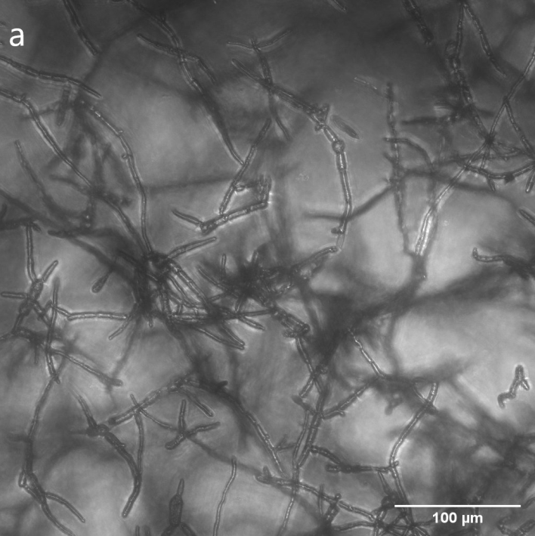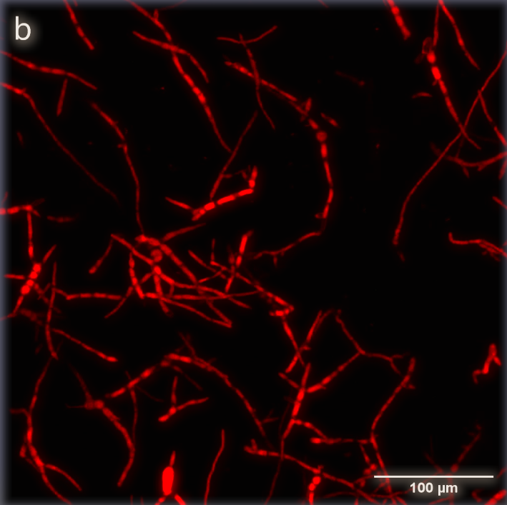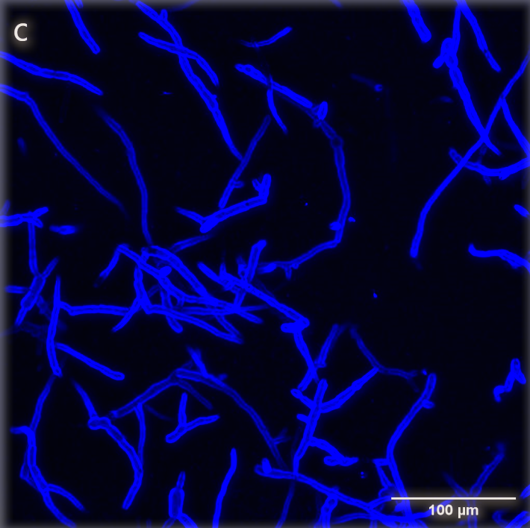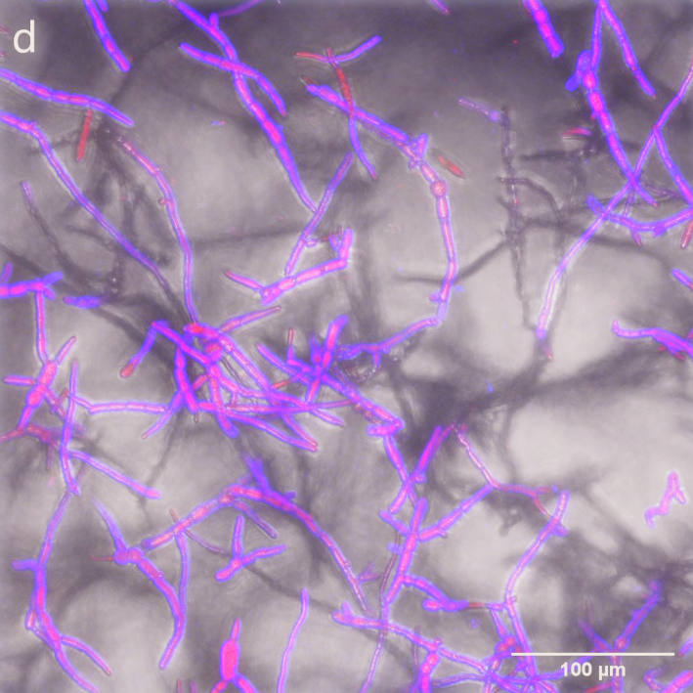
Figure 1. Confocal micrographs of 0.1 g L⁻¹ dispersion of MYC showing a) fungal hyphae viewed under white light b) fungal protein stained with Fast Green excited at 633 nm c) chitin stained with Calcofluor White excited at 380 nm and d) distribution of fungi fibre and protein in the fungal hyphae with the excitation of both Fast Green and Calcofluor White channels. Scale bar represents 100 μm.
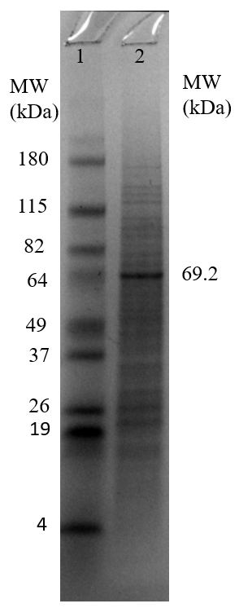
Figure 2. Image of SDS-PAGE gel of fungal protein extract. Band 1 is for the protein standards and band 2 is for the fungal protein extract.

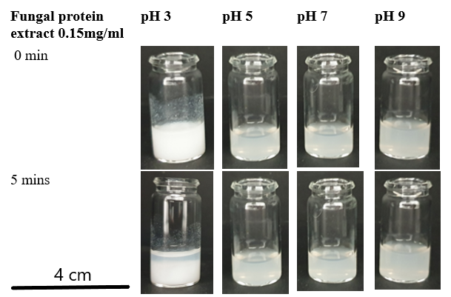
Figure 3. Macroscopic images of fungal protein extract at 0.15 mg mL⁻¹ at different pH values. Scale bar represents 4 cm.

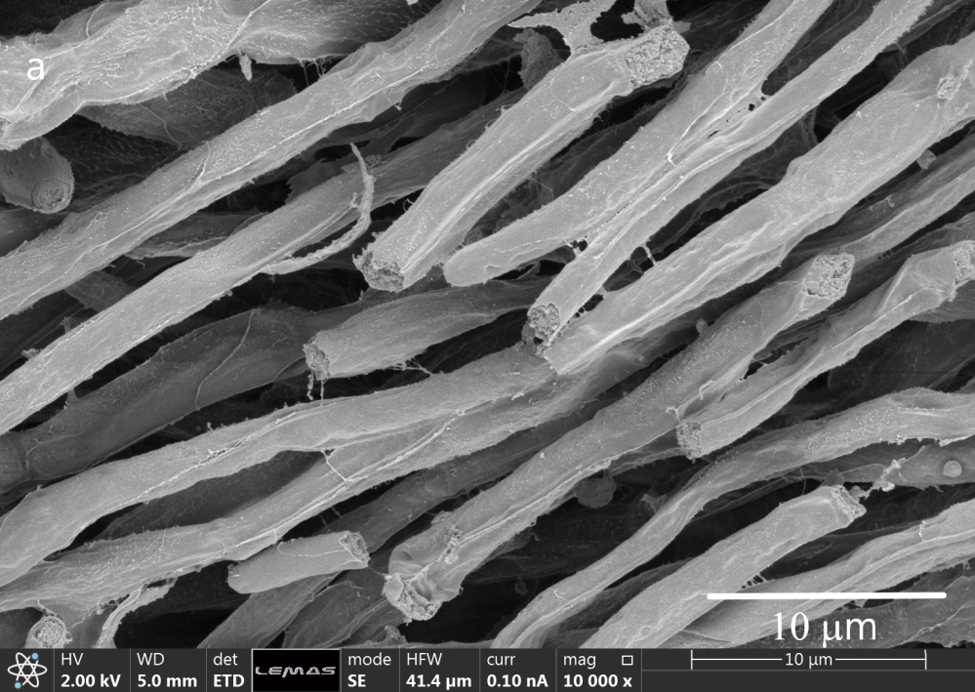
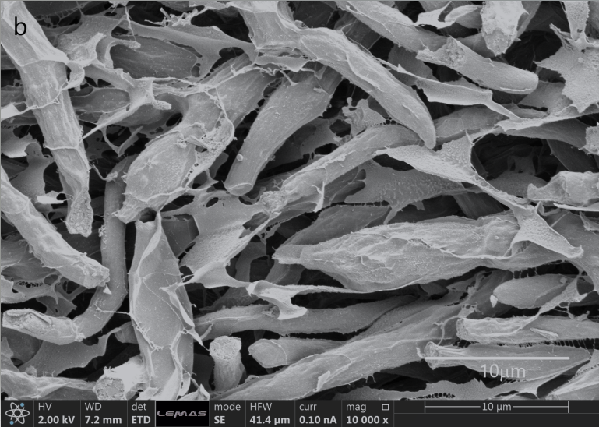
Figure 4. Cryo-SEM image of MYC (20 wt. %) at pH 7 a) no added salts and b) added salts of 200 mM NaCl and 100 mM CaCl₂. Scale bar represents 10 μm.

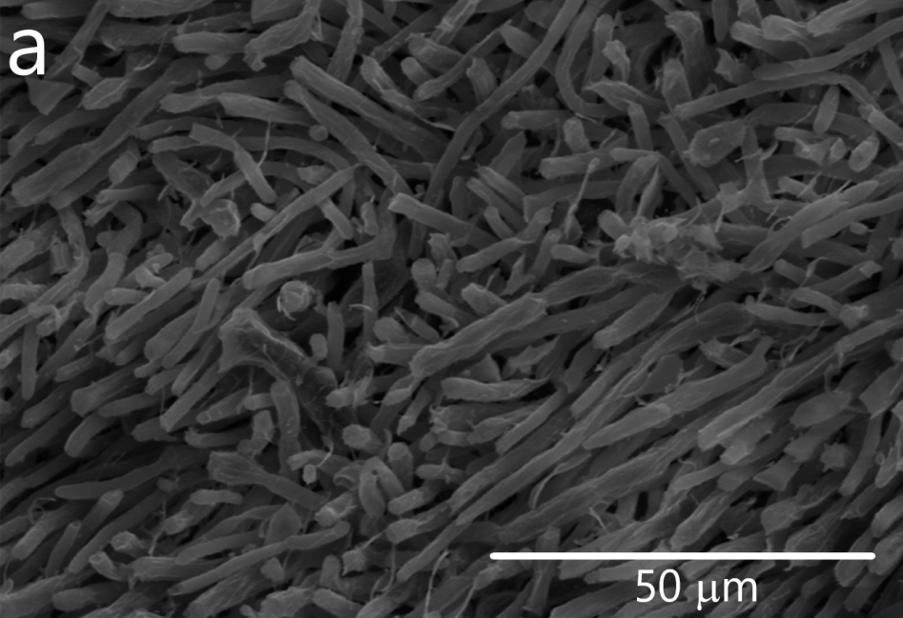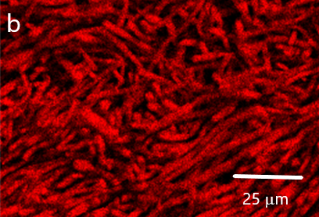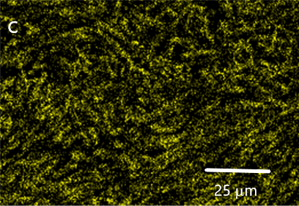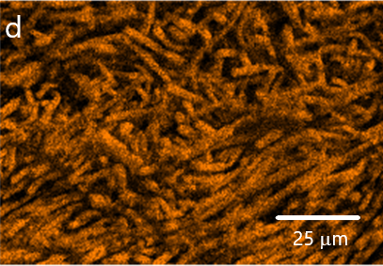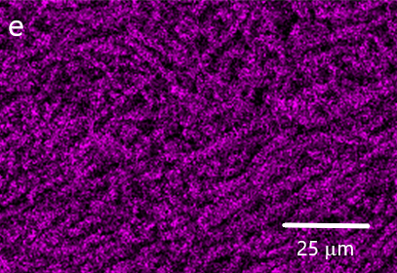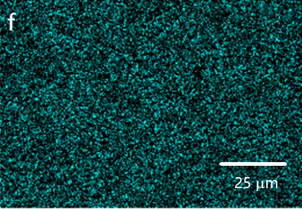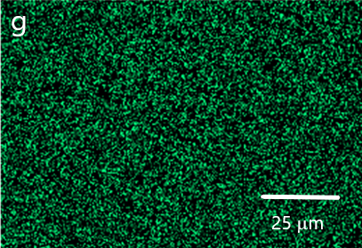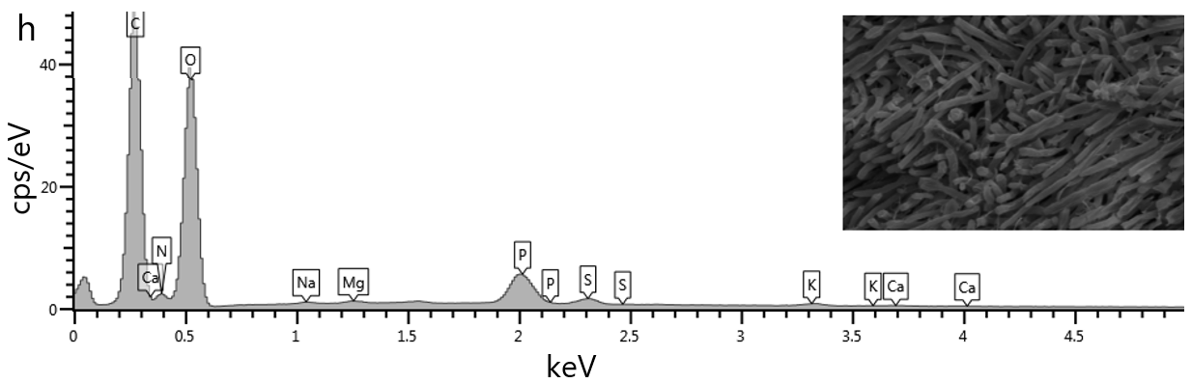
Figure 5. Elemental mapping of MYC (20 wt. %) at pH 7 showing a) relative elemental composition b) Carbon c) Nitrogen d) Oxygen e) Phosphorus f) Sulphur g) Potassium h) relative elemental composition distribution obtained from Cryo-SEM EDS. Scale bar represents 25 μm.
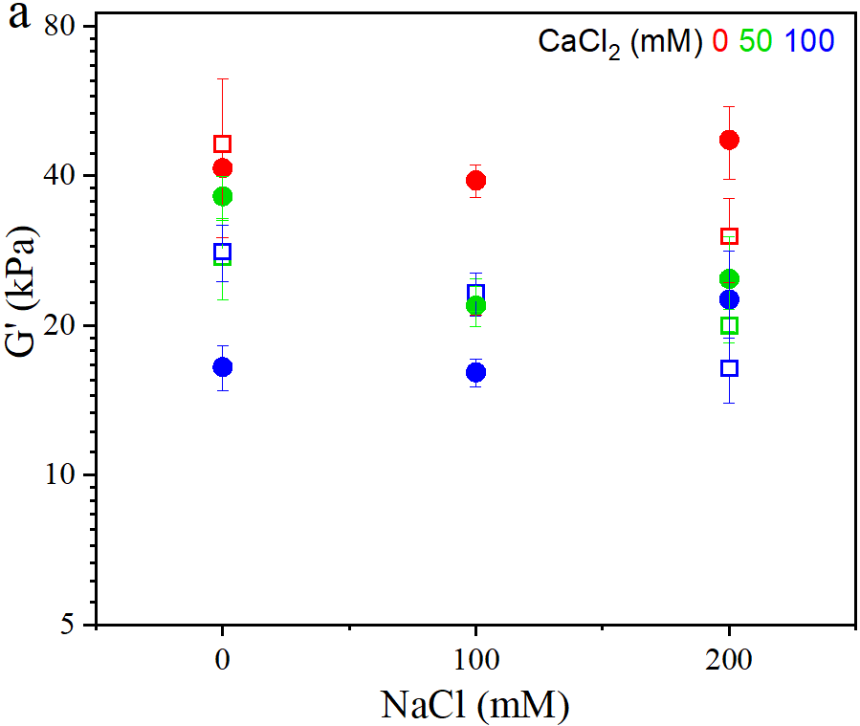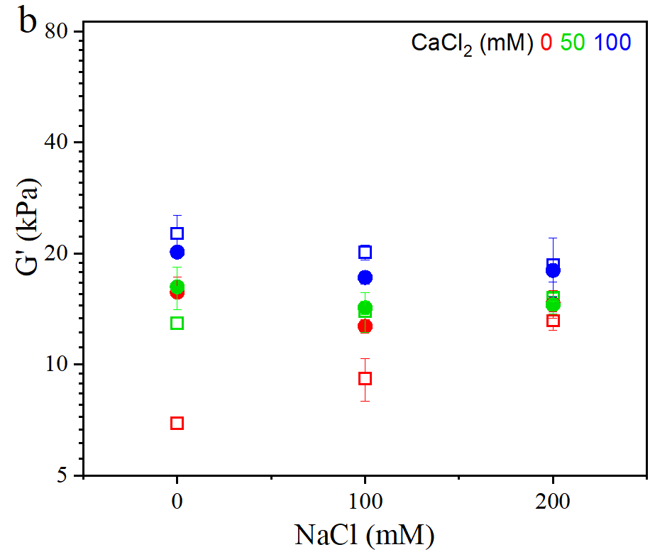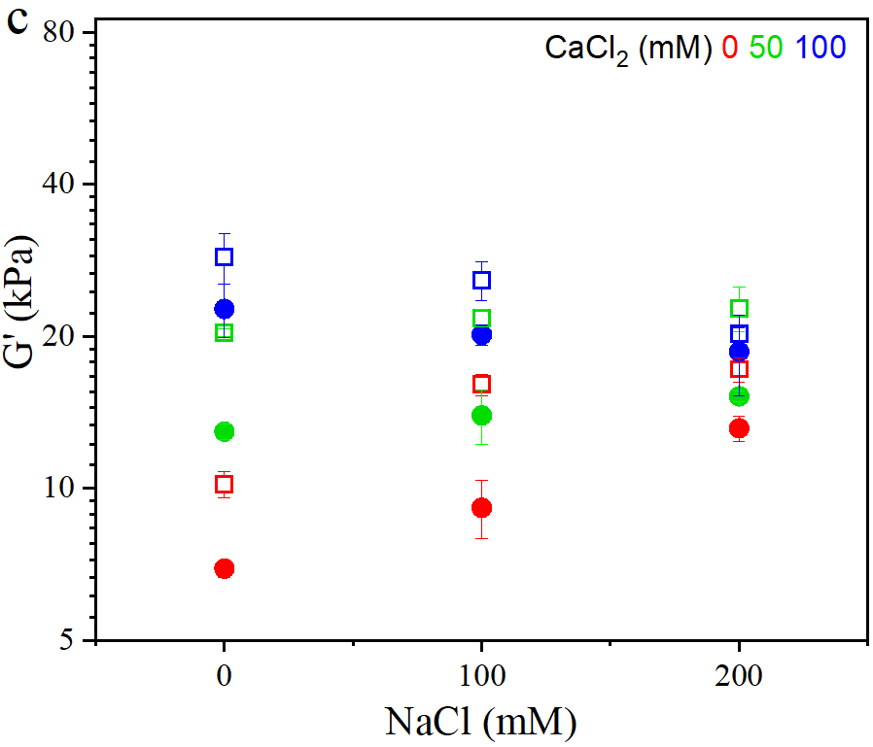
Figure 6. Mean storage modulus (G') of 20 wt. % of MYC (□ , open square) and MYC-EWP (●, filled circle) as a function of concentration of NaCl and also at 3 CaCl₂ concentrations – 0 (red), 50 (green) and 100 mM (blue) at: a) pH 3, b) pH 5, and c) pH 7. All G’ measured at 0.1% shear strain and a frequency of 0.1 Hz.
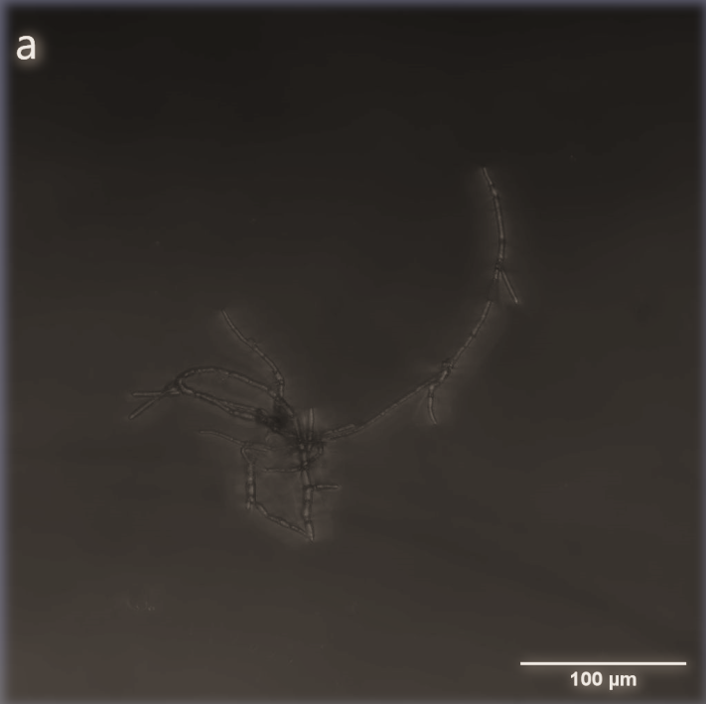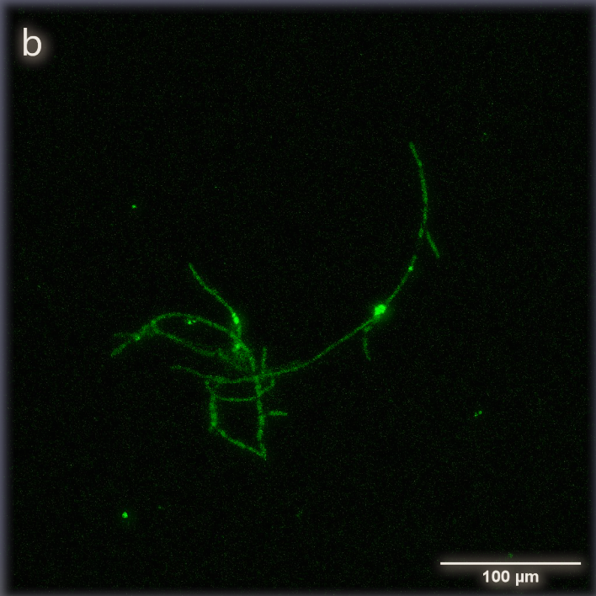
Figure 7. Confocal micrographs of 0.1 g L⁻¹ dispersion of MYC and 1.0 g L⁻¹ dispersion of EWP showing a) fungal hyphae and EWP viewed under white light b) EWP labelled with anti-OVA conjugated with FITC excited at 495 nm. This dispersion was washed twice in distilled water to remove EWP that was not bound to the fungal hyphae surface. Scale bar represents 100 μm.
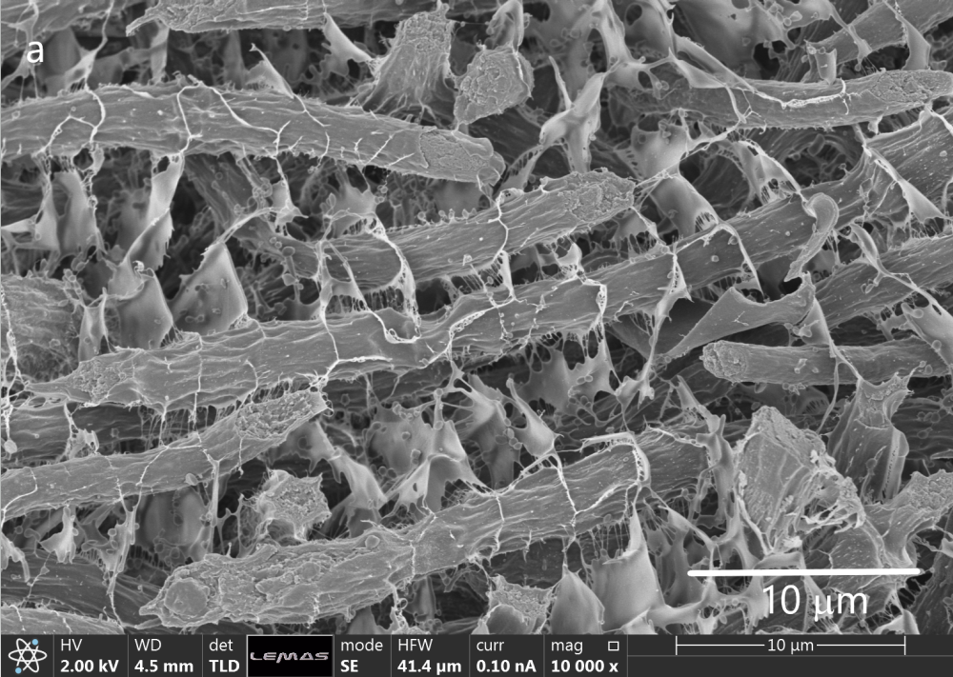
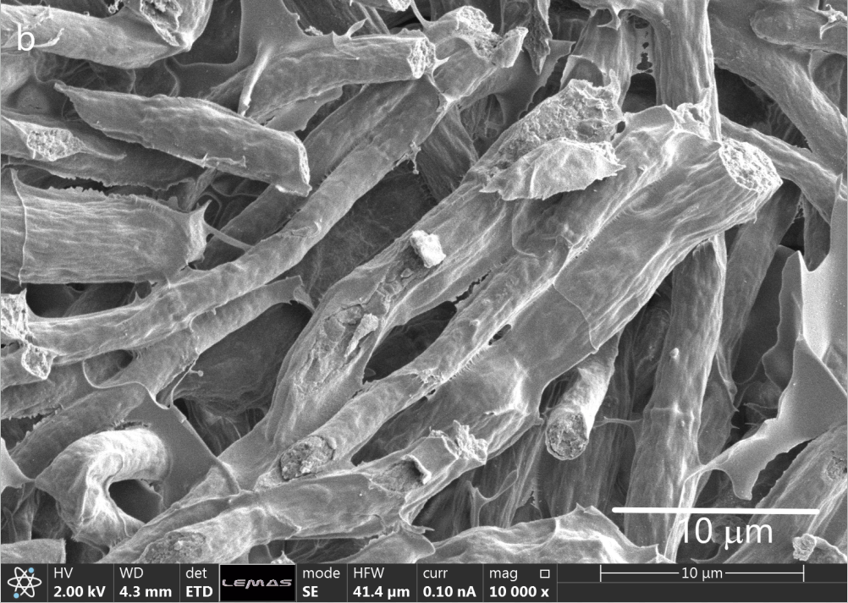
Figure 8. Cryo-SEM image of MYC-EWP (20 wt. %) at pH 7 a) no added salts and b) added salts of 200 mM NaCl and 100 mM CaCl₂. Scale bar represents 10 μm.
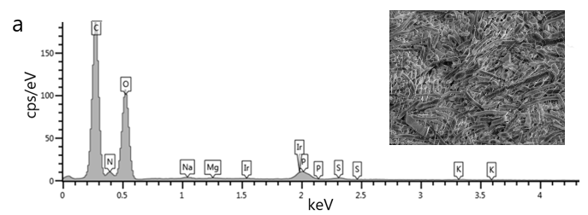

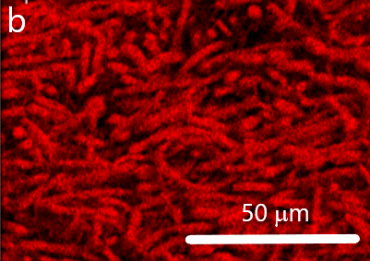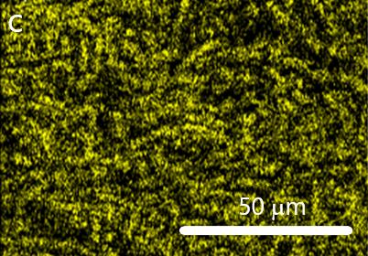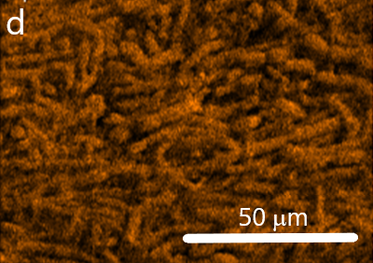
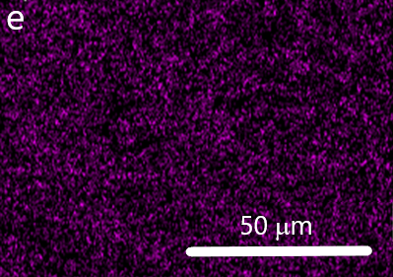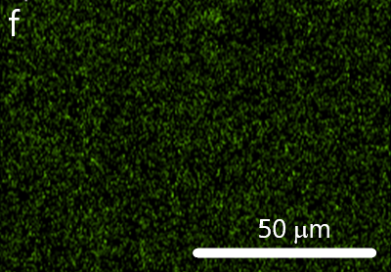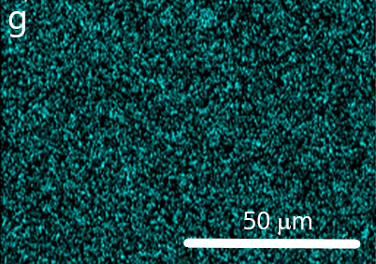
Figure 9. Elemental mapping of MYC-EWP (20 wt. %) containing 3% EWP at pH 7 showing a) relative elemental composition b) Carbon c) Nitrogen d) Oxygen e) Sodium f) Magnesium g) Sulphur distribution obtained from Cryo-SEM EDS. Scale bar represents 50 μm.

Supplementary Document

Understanding the microstructure of a functional meat analogue: demystifying interactions between fungal hyphae and egg white protein

Mary .C. Okeudo-Cogan^{1, 2}, Brent .S. Murray²**, Rammile Ettelaie², Simon Connell³, Stewart Radford⁴, Stuart Micklethwaite¹, and Anwesha Sarkar²*

¹School of Chemical and Process Engineering, University of Leeds, Leeds, LS2 9JT, UK
²Food Colloids and Bioprocessing Group, School of Food Science and Nutrition, University of Leeds, Leeds, LS2 9JT, UK
³School of Physics and Astronomy, University of Leeds, Leeds, LS2 9JT, UK
⁴Quorn Foods, Station Road, Stokesley, North Yorkshire, TS9 7AB, UK

Corresponding authors:
**Prof. Brent S. Murray
E-mail address: B.S.Murray@leeds.ac.uk (B.S. Murray).
*Prof. Anwesha Sarkar
E-mail address: A.Sarkar@leeds.ac.uk (A. Sarkar).
Food Colloids and Bioprocessing Group,
School of Food Science and Nutrition,
University of Leeds, Leeds LS2 9JT, UK.
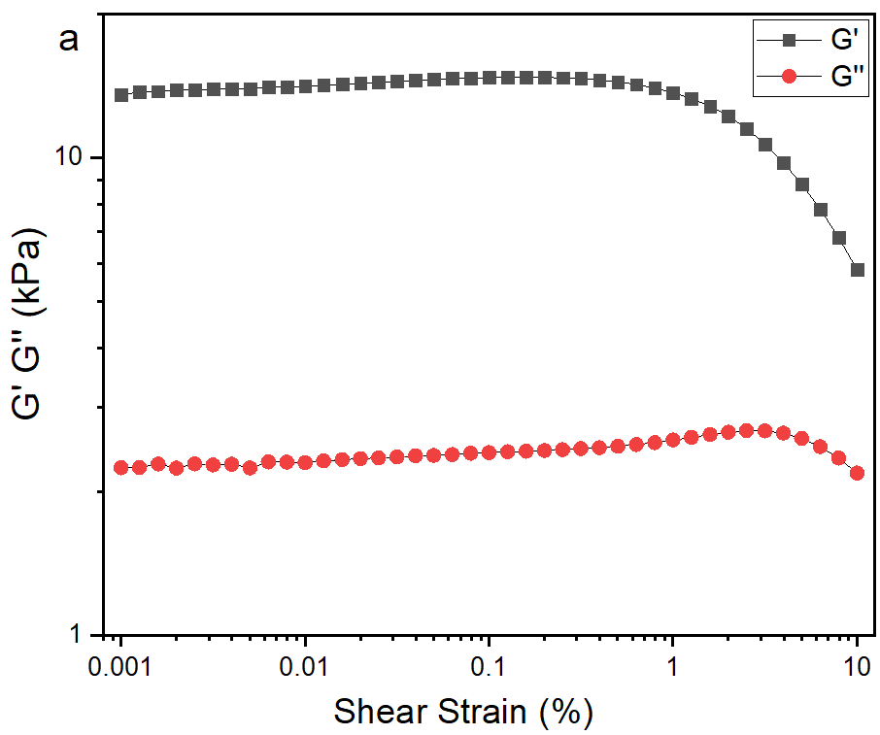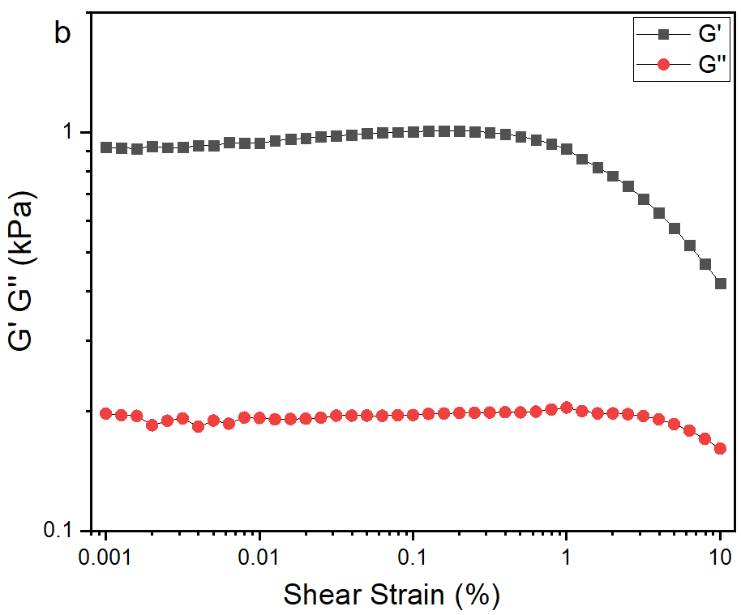
Figure S1. G´ and G´´ of MYC at a) 20% solids and b) 10% at pH 5 with no added salts measured at a frequency of 1 Hz. The linear viscoelastic region is between 0.001 and 1% shear strain at all measured percentage solids.

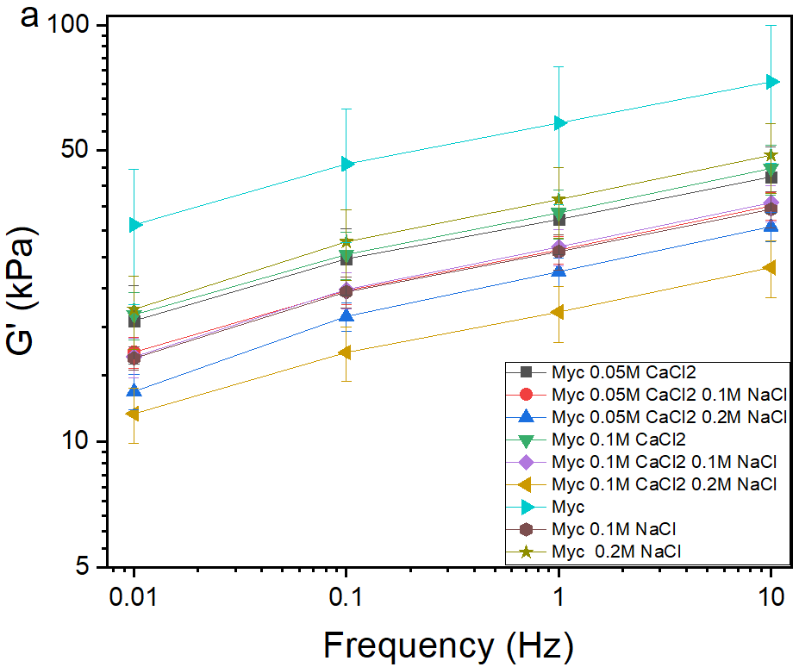 | 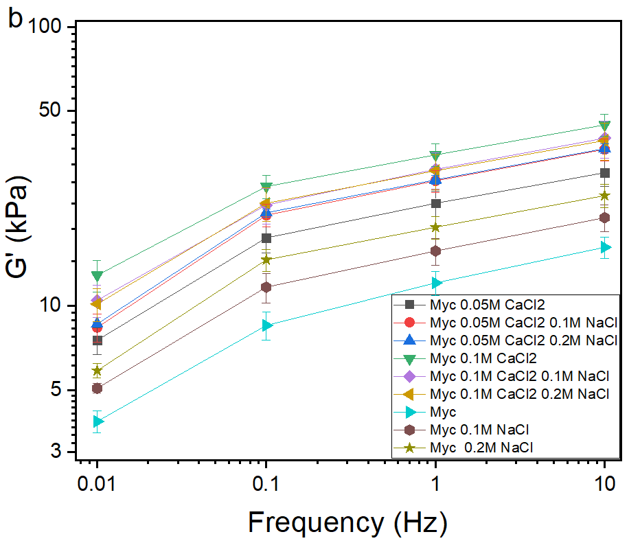
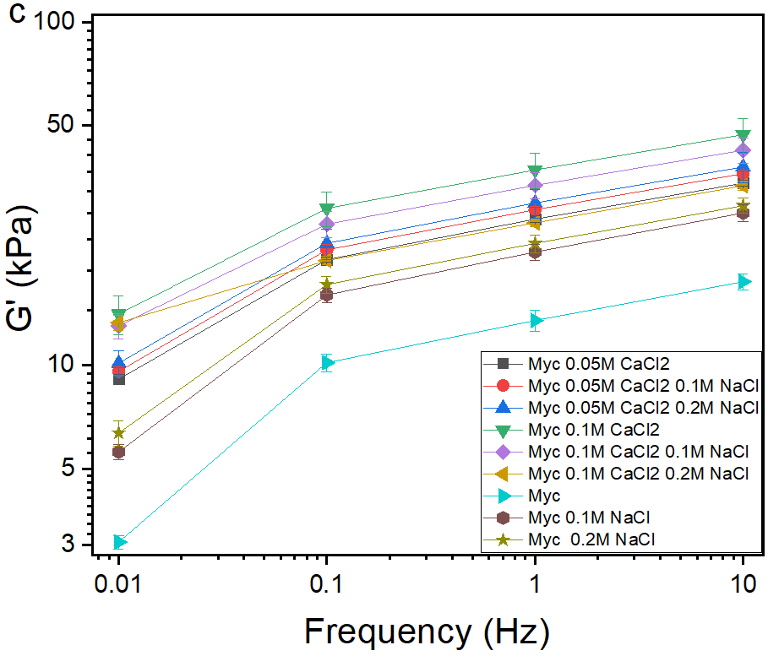 | 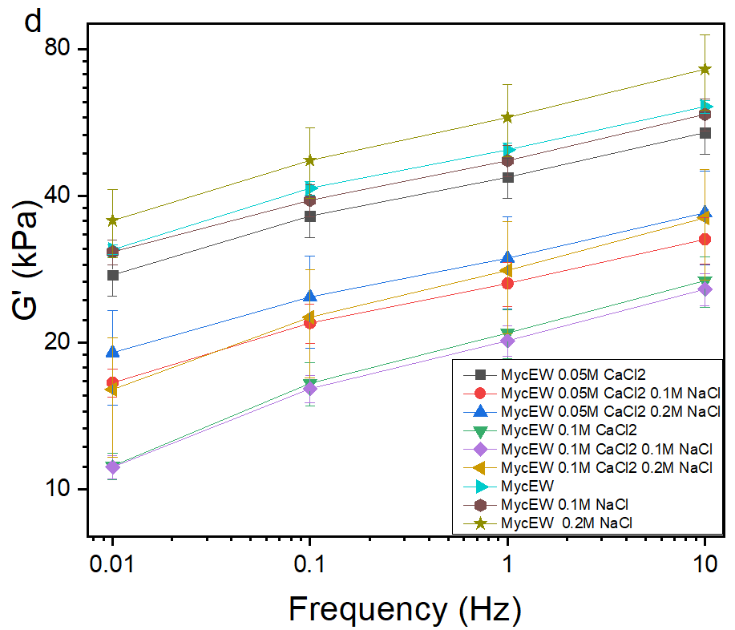
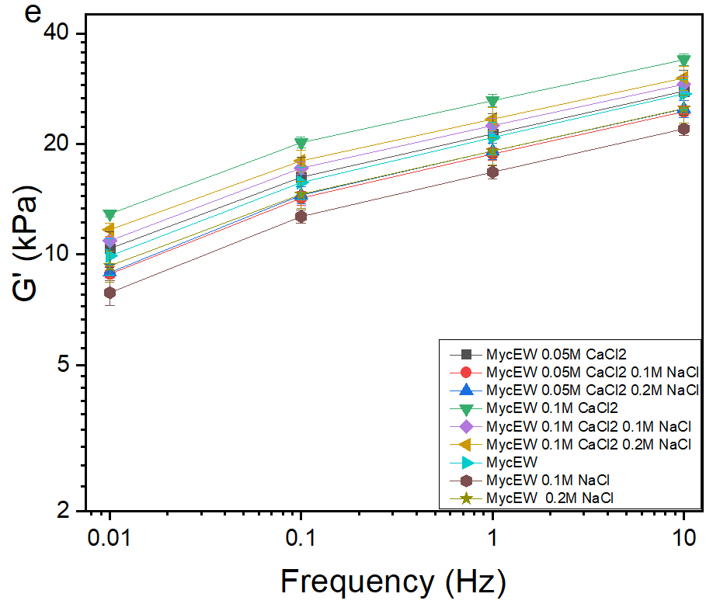 | 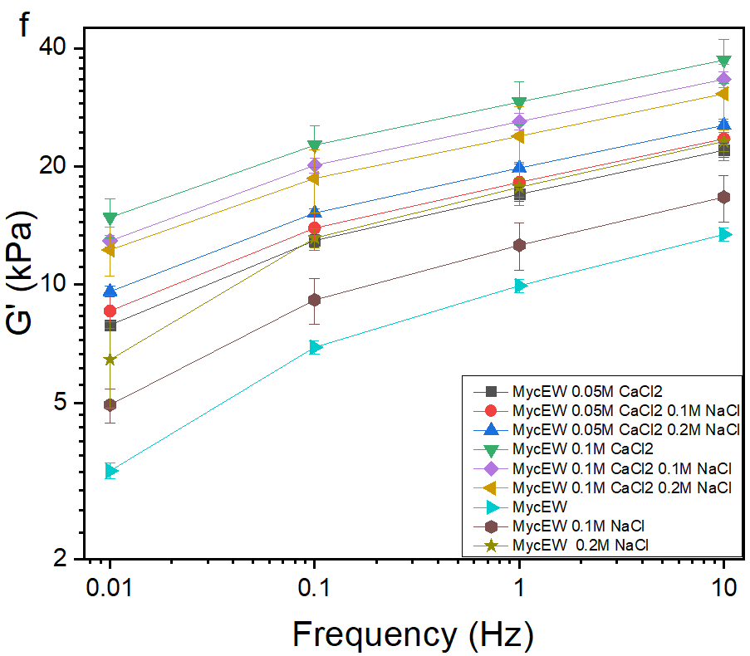

Figure S2. G´ as a function of frequency of 20 wt. % MYC at a) pH 3 b) 5. c) 7 and MYC-EWP at d) pH 3 e) 5 and f) 7 at 0.1% shear strain and 25 ºC respectively.
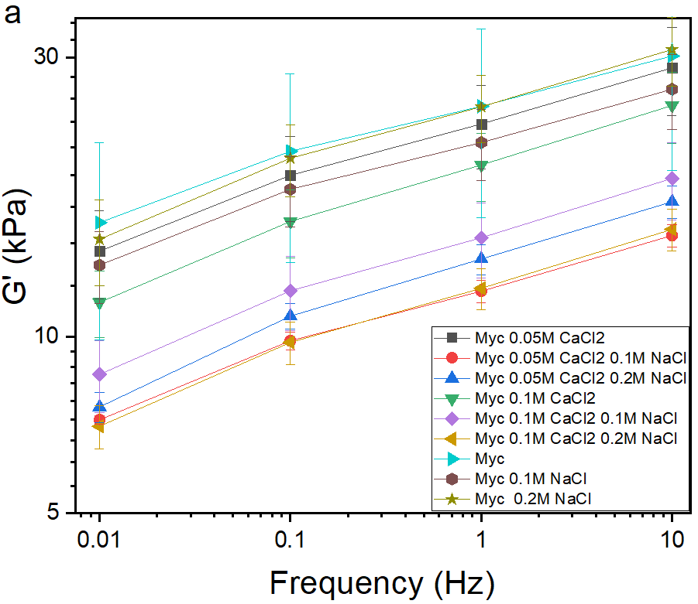 | 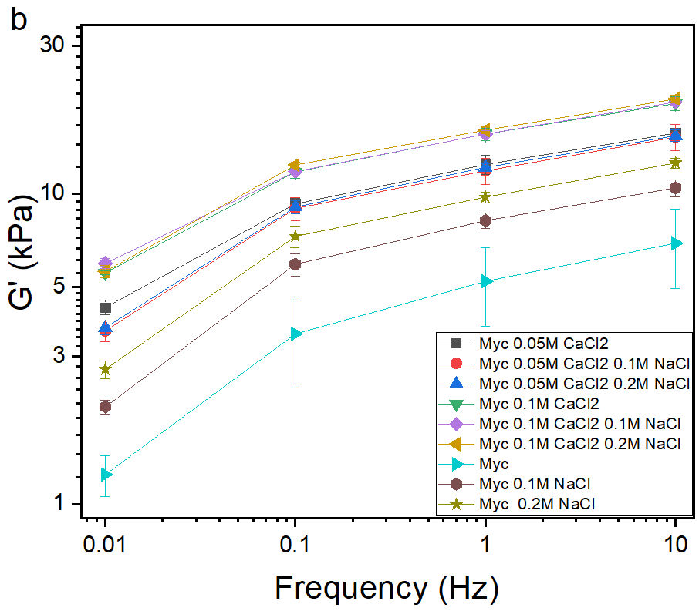
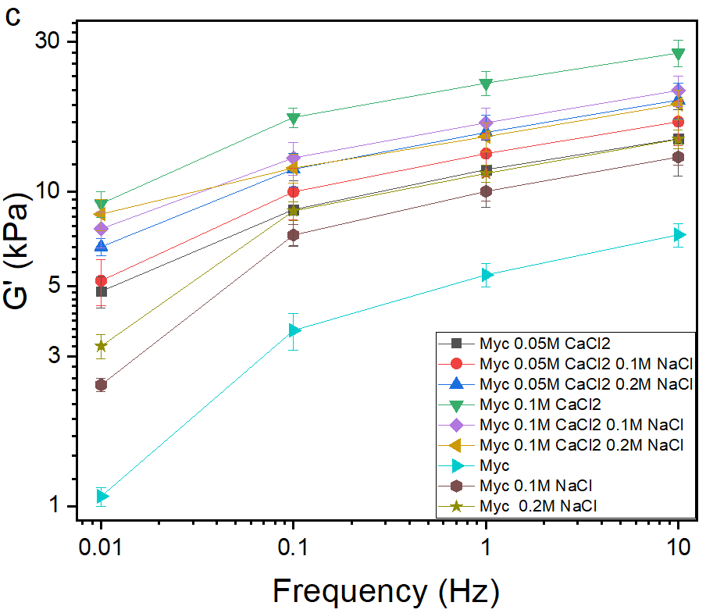 | 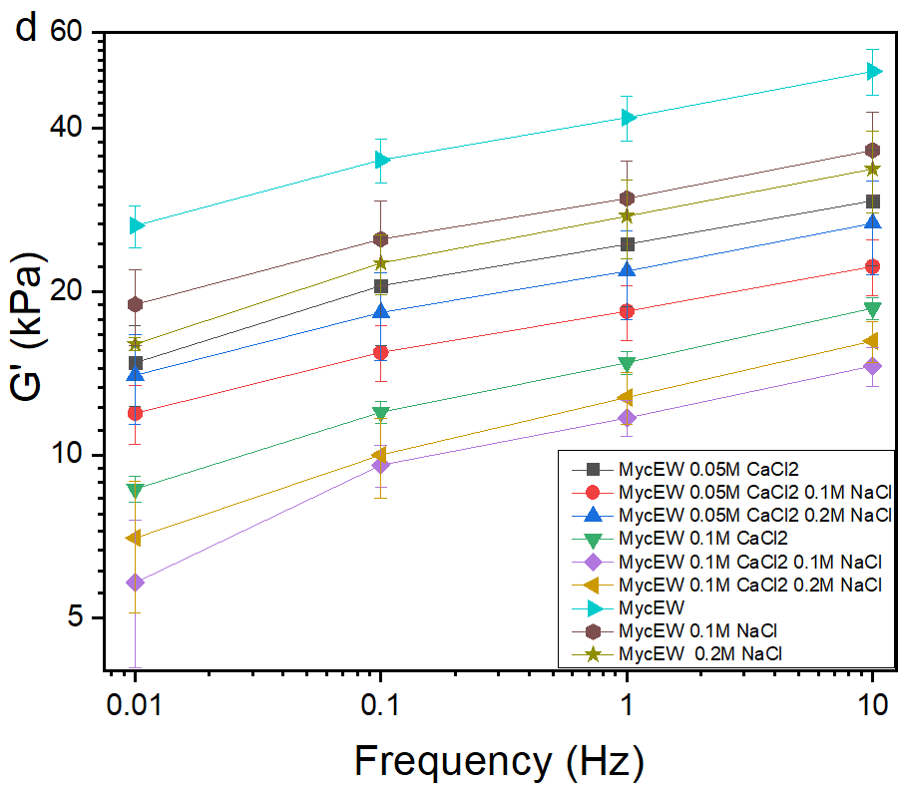
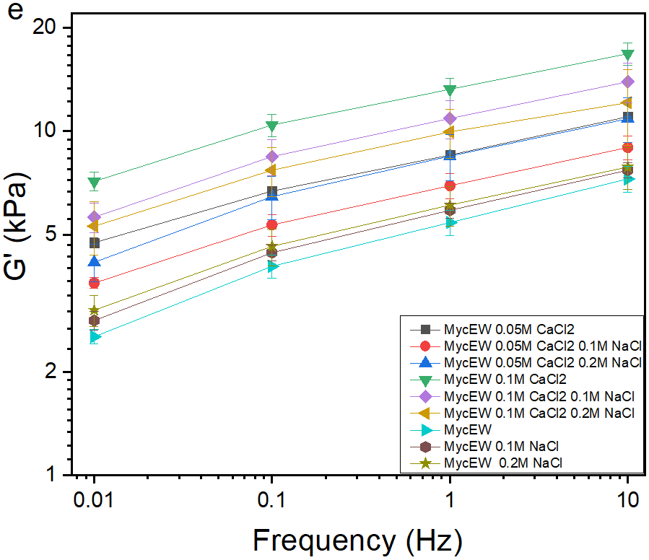 | 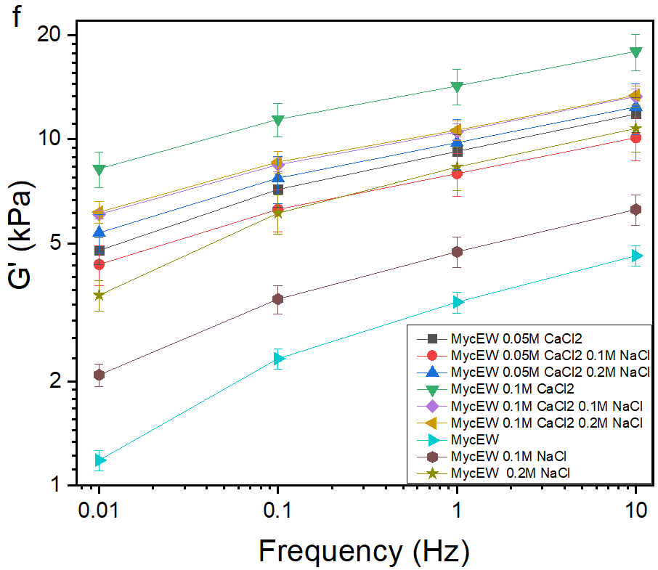

Figure S3. G´ as a function of frequency of 15 wt. % MYC at a) pH 3 b) 5. c) 7 and MYC-EWP at d) pH 3 e) 5 and f) 7 at 0.1% shear strain and 25 ºC respectively.
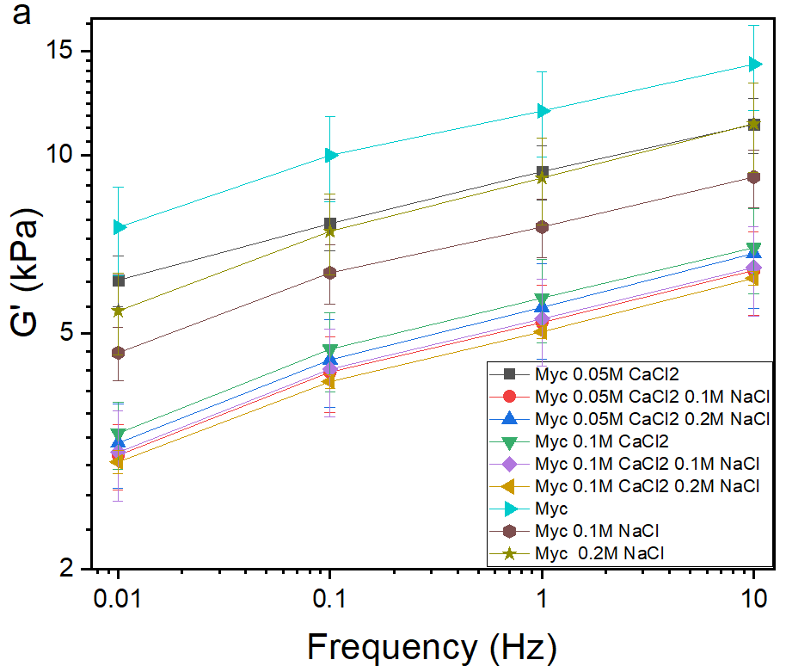 | 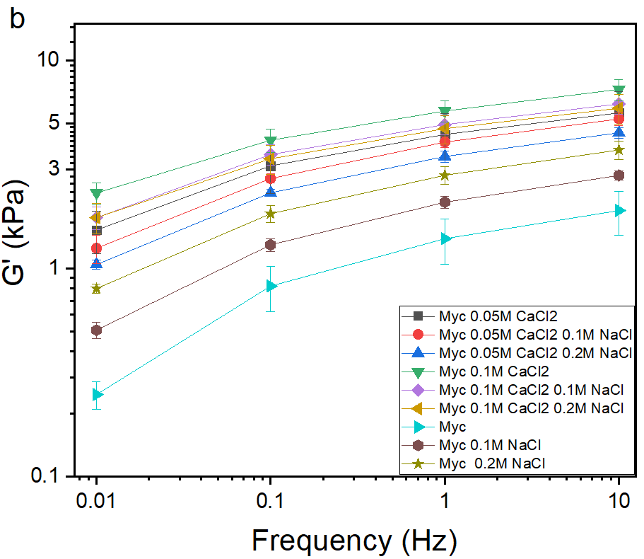
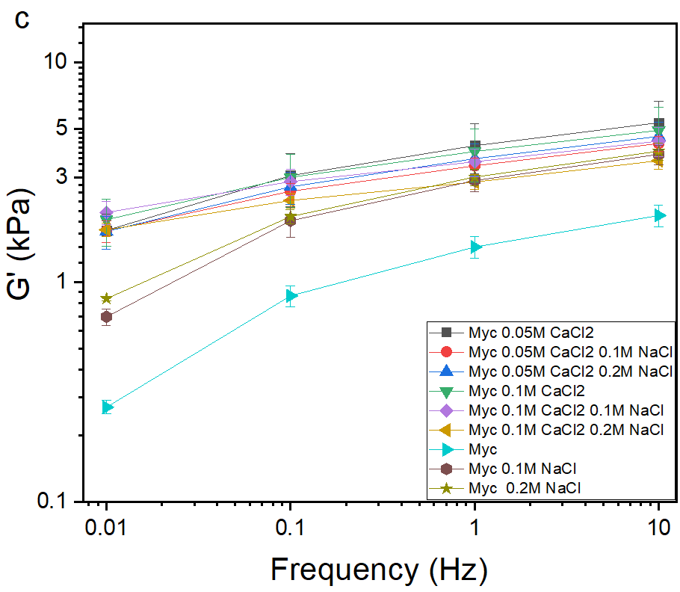 | 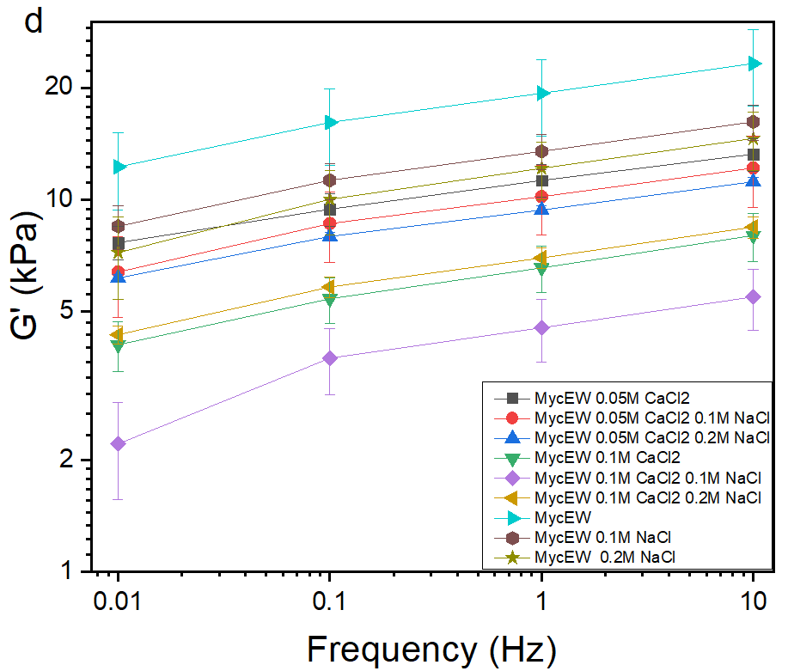
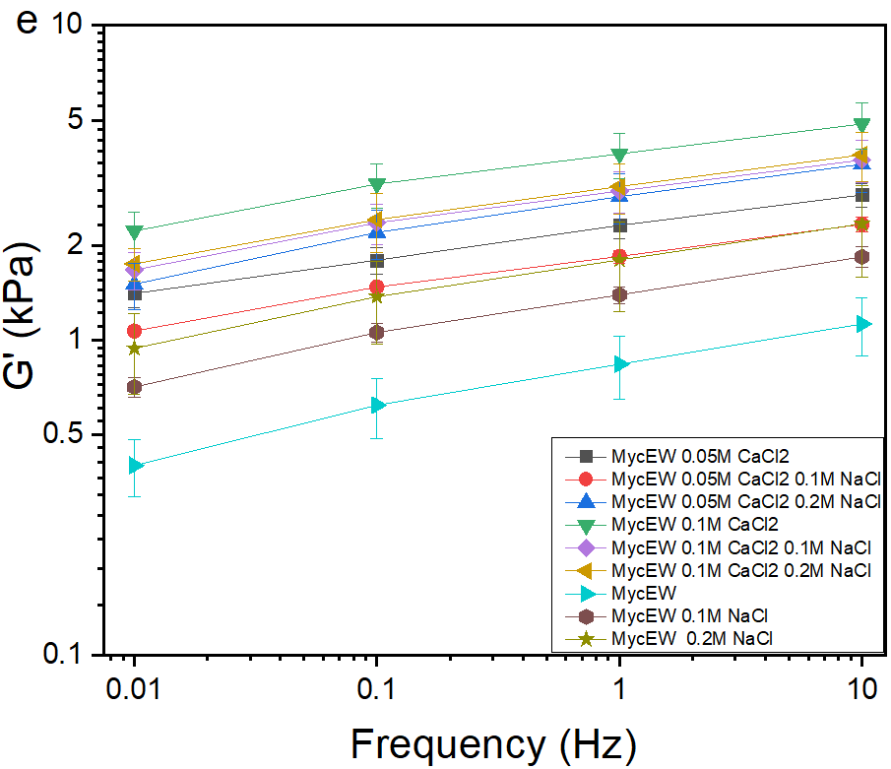 | 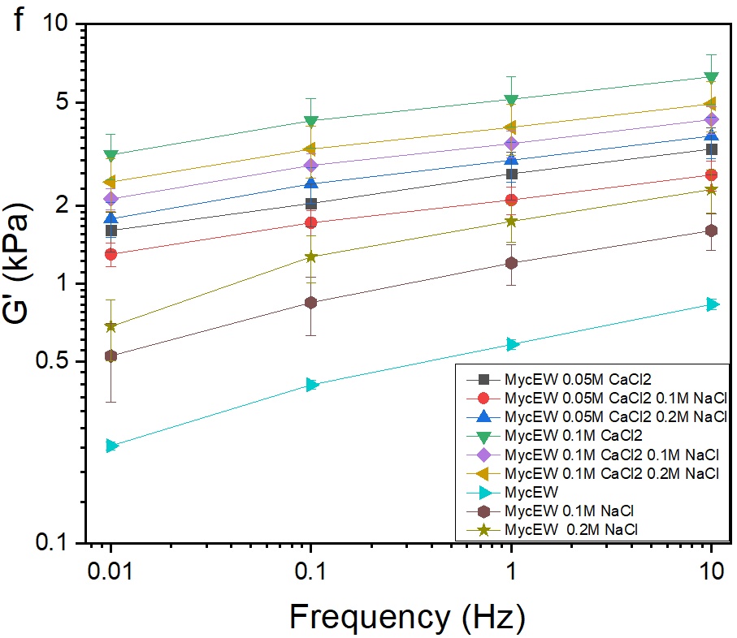

Figure S4. G´ as a function of frequency of 10 wt. % MYC at a) pH 3 b) 5. c) 7 and MYC-EWP at d) pH 3 e) 5 and f) 7 at 0.1% shear strain and 25 ºC respectively.

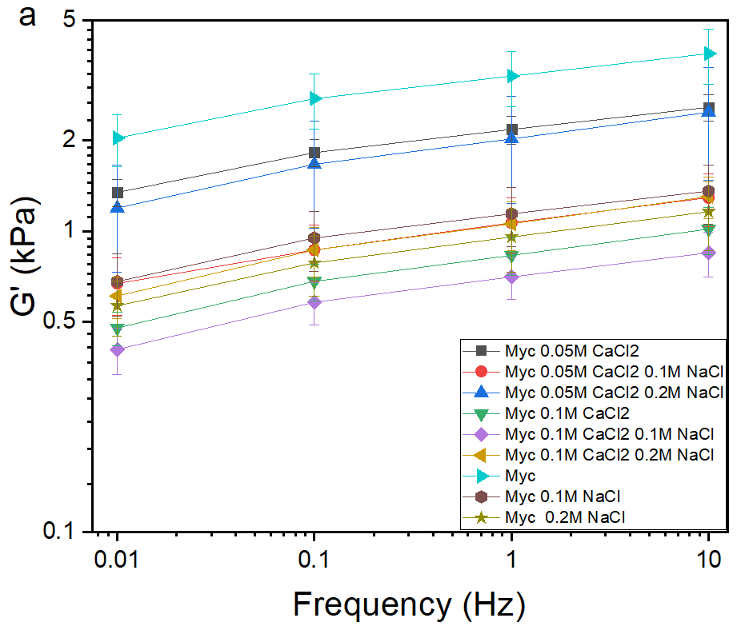 | 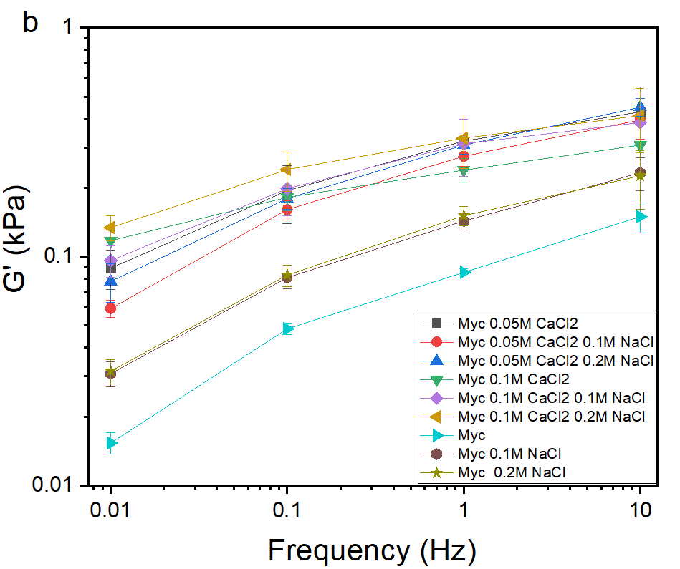
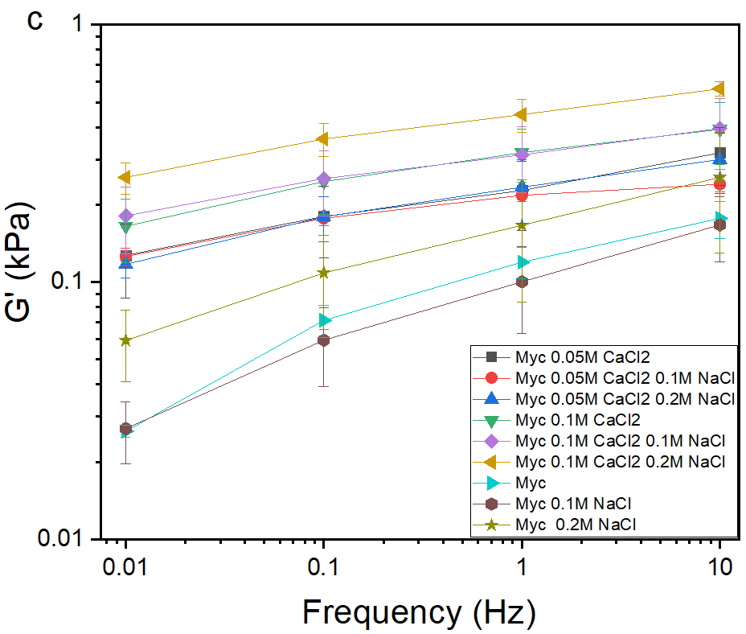 | 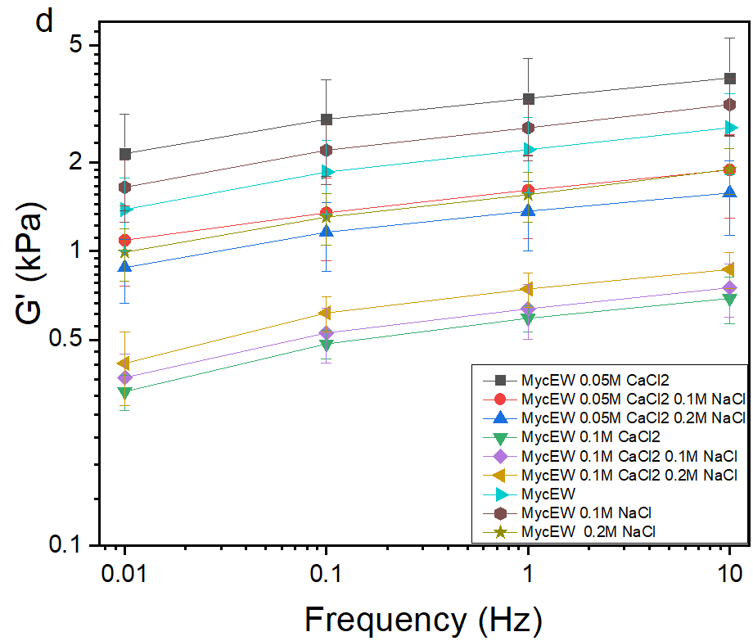
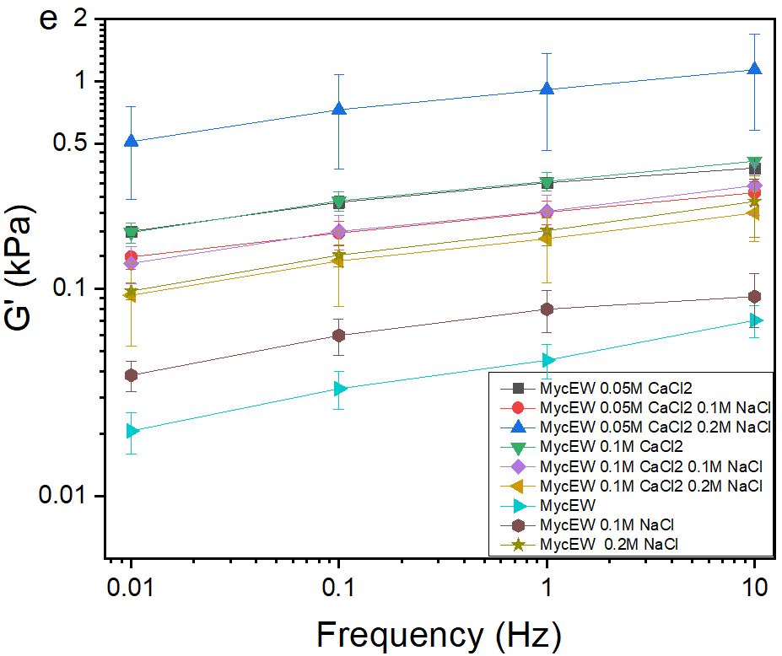 | 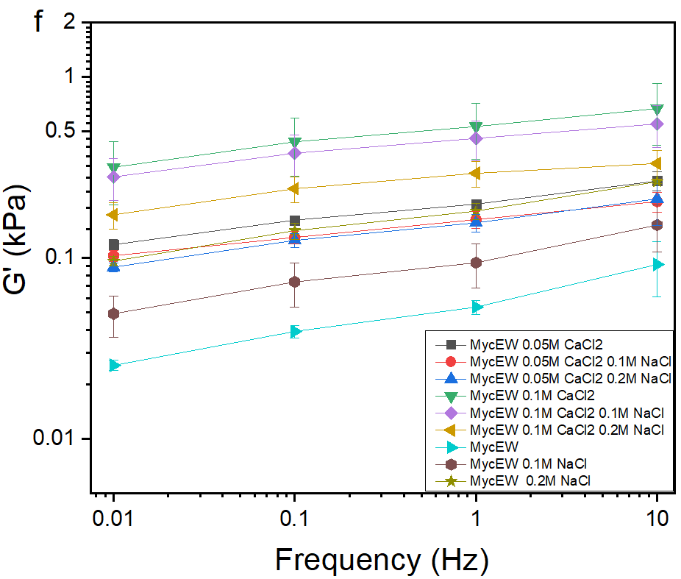

Figure S5. G´ as a function of frequency of 5 wt. % MYC at a) pH 3 b) 5. c) 7 and MYC-EWP at d) pH 3 e) 5 and f) 7 at 0.1% shear strain and 25 ºC respectively.
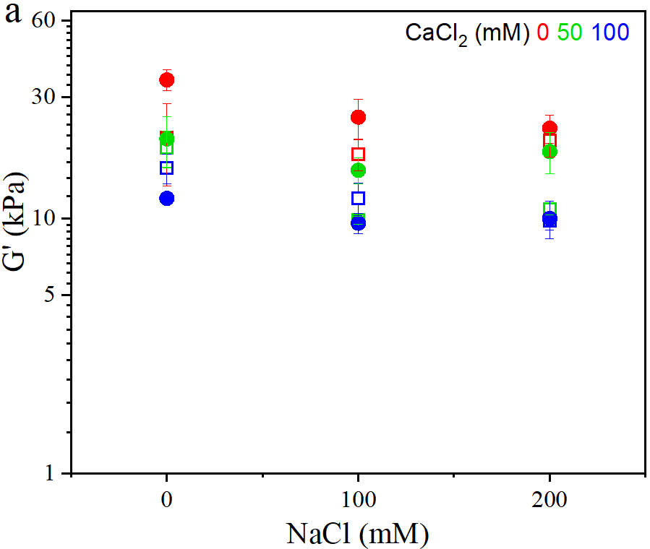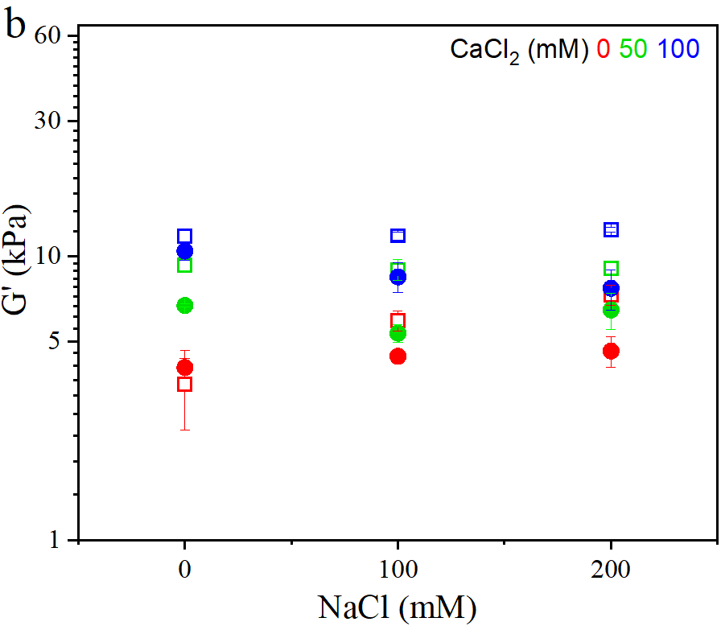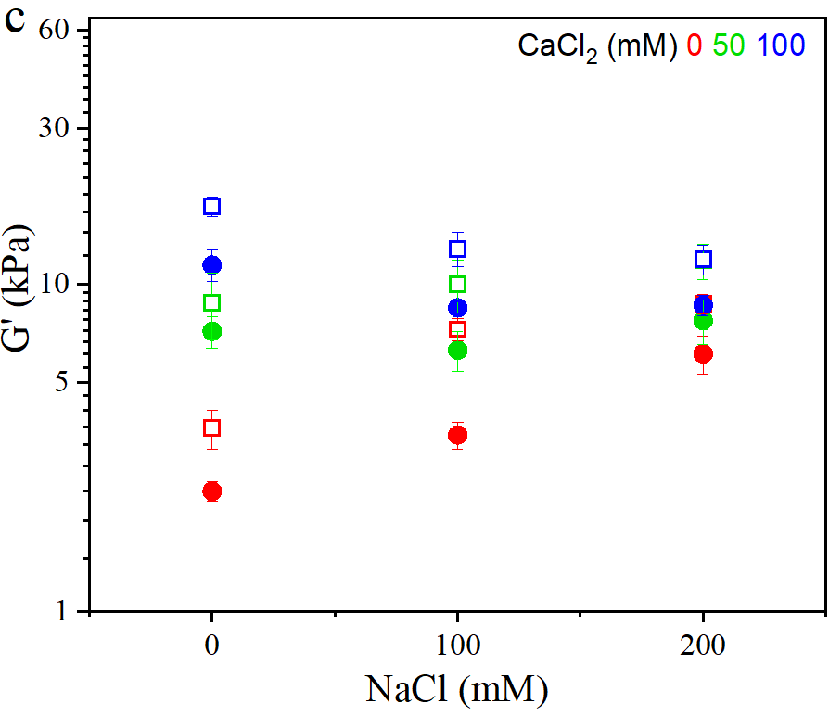
Figure S6. G´ of 15 wt % of MYC □ and MYC-EWP ● at a) pH 3, b) pH 5, and c) pH 7 respectively and at different levels of NaCl, CaCl₂ measured at 0.1% shear strain and a frequency of 0.1 Hz.
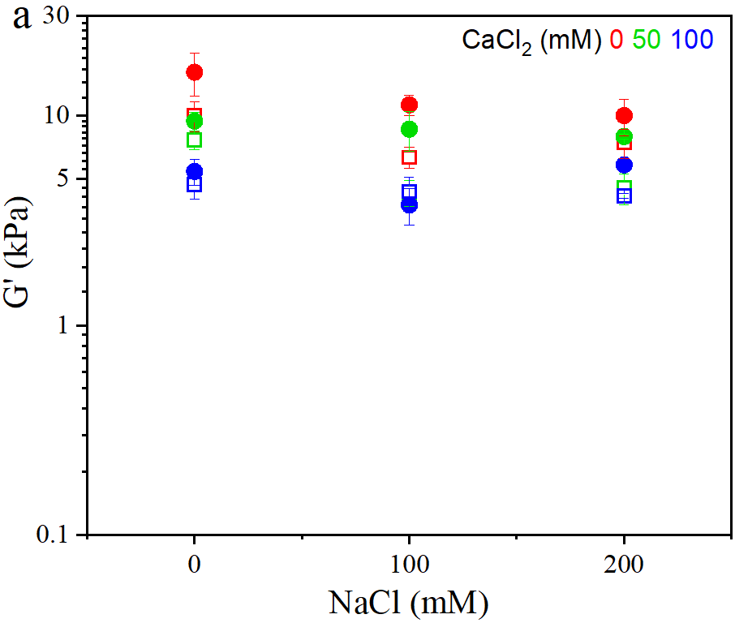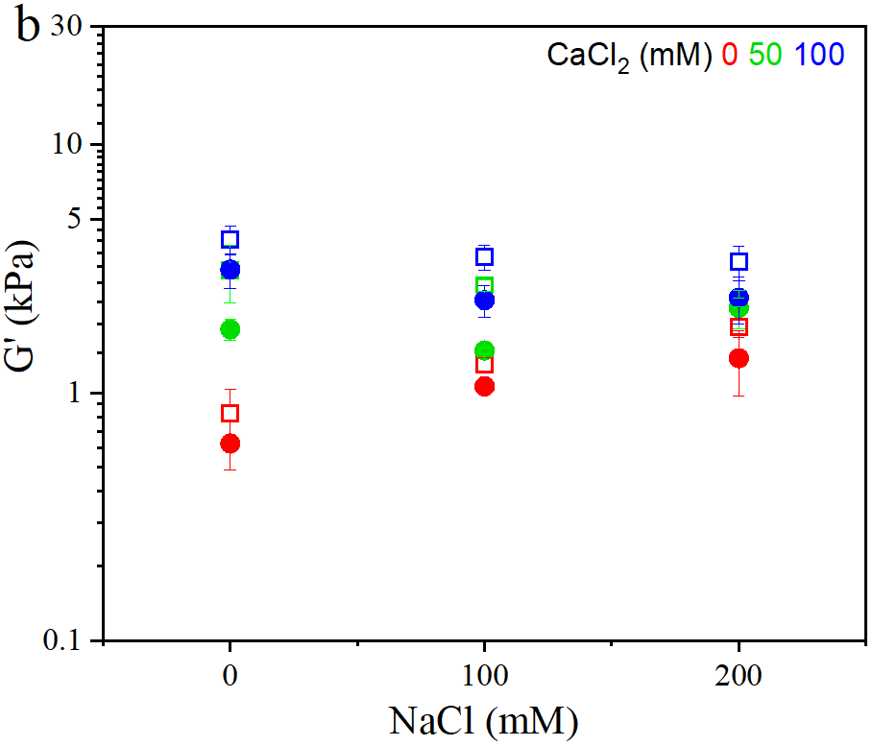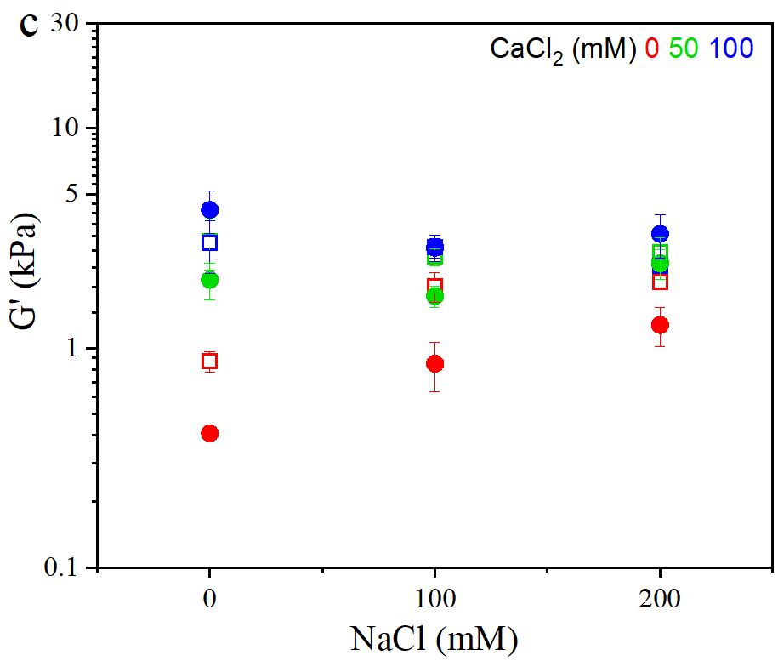
Figure S7. G´ of 10 wt % of MYC □ and MYC-EWP ● at a) pH 3, b) pH 5, and c) pH 7 respectively and at different levels of NaCl, CaCl₂ measured at 0.1% shear strain and a frequency of 0.1 Hz.
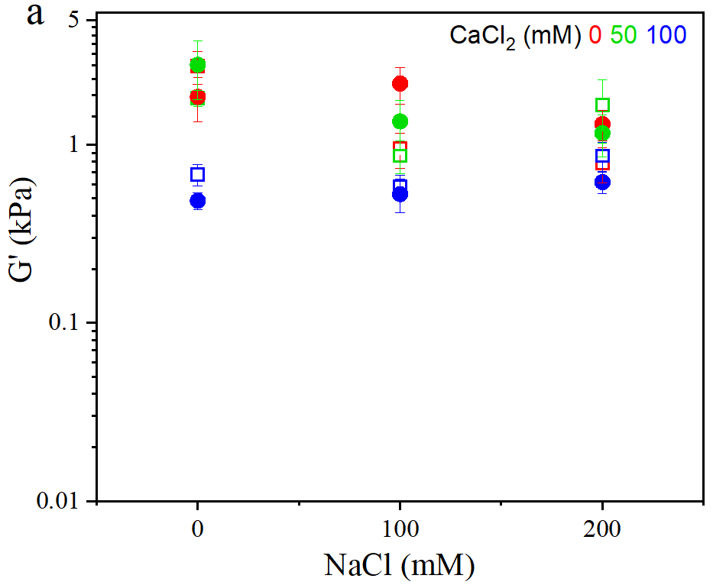
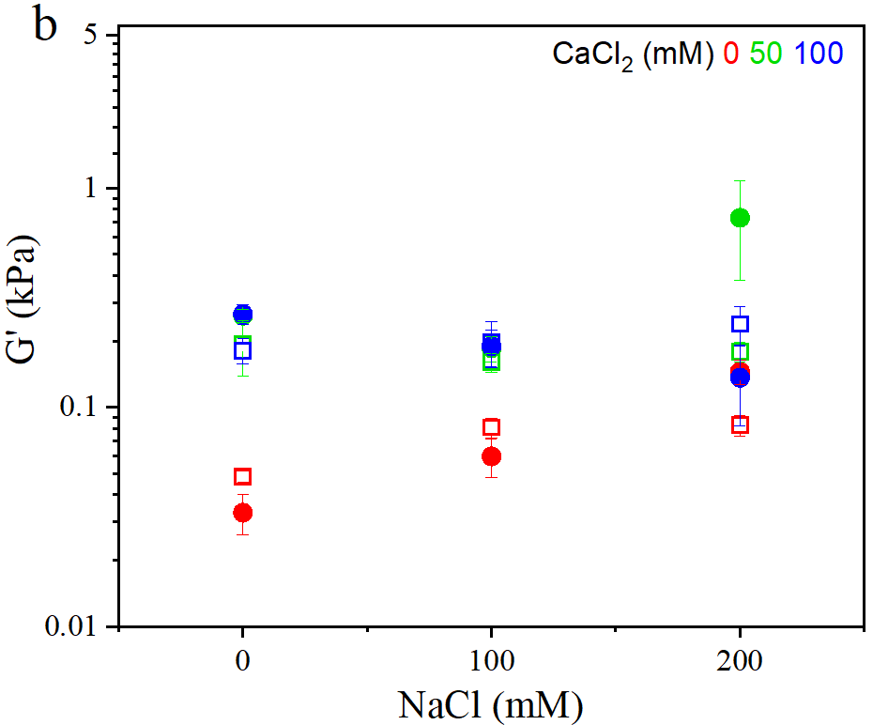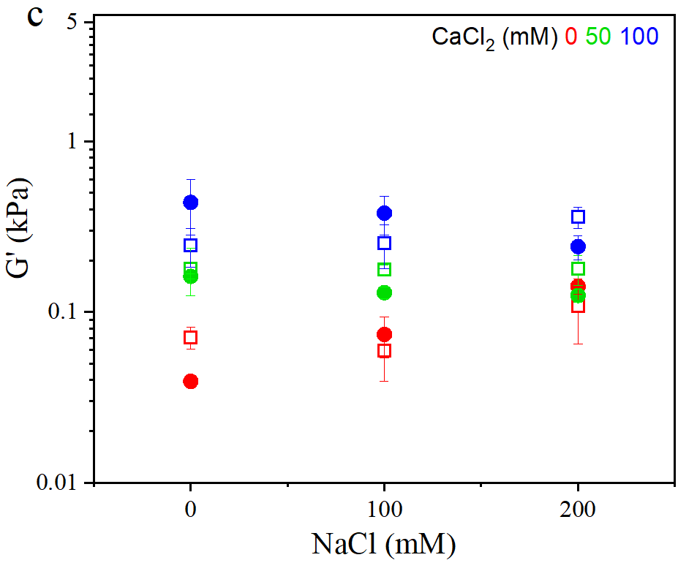
Figure S8. G´ of 5 wt % of MYC □ and MYC-EWP ● at a) pH 3, b) pH 5, and c) pH 7 respectively and at different levels of NaCl, CaCl₂ measured at 0.1% shear strain and a frequency of 0.1 Hz.

