Current-Induced Crystallisation in a Heusler-Alloy-Based Giant Magnetoresistive Junction for Neuromorphic Potentiation
Zhenyu Zhou,¹⁾ William Frost,²⁾ David C. Lloyd,¹⁾ Takeshi Seki,³⁾ Takahide Kubota,^{3),a)} Rafael Ramos,^{4),b)} Eiji Saitoh,^{4),5),6),7)} Koki Takanashi ^{3),c)} and Atsufumi Hirohata ^{1),}*
¹⁾ Department of Electronic Engineering, University of York, York YO10 5DD, United Kingdom
²⁾ Department of Physics, University of York, York YO10 5DD, United Kingdom
³⁾ Institute for Materials Research, Tohoku University, Sendai, 980-8577, Japan
⁴⁾ WPI Advanced Institute for Materials Research, Tohoku University, Sendai 980-8577, Japan
⁵⁾ Department of Applied Physics, University of Tokyo, Tokyo 113-8656, Japan
⁶⁾ Advanced Science Research Center, Japan Atomic Energy Agency, Tokai 319-1195, Japan
⁷⁾ Institute of AI and Beyond, University of Tokyo, Tokyo 113-8656, Japan
^{a)} Present Address: Department of Advanced Spintronics Medical Engineering, Tohoku University, Sendai 980-0845, Japan
^{b)} Present Address: Centro Singular de Investigación en Química Biolóxica e Materiais Moleculares (CIQUS), Departamento de Química-Física, Universidade de Santiago de Compostela, 15782 Santiago de Compostela, Spain
^{c)} Present Address: Advanced Science Research Center, Japan Atomic Energy Agency, Tokai 319-1195, Japan
* Corresponding author: atsufumi.hirohata@york.ac.uk
Abstract
Recent development in neuromorphic computation allows us to achieve low power and highly efficient calculations better than the conventional von Neumann computation. In order to achieve realistic synaptic operation, potentiation to add weighting to strengthen a selected artificial synapse. Such functionality can be achieved by reducing the electrical resistance of the artificial synapse. Recently, a ferromagnetic Heusler alloy used in a magnetoresistive junction has been demonstrated to crystallise via the layer-by-layer mode by introducing an electrical current pulse. In this study, we have extended the current-induced crystallisation to a junction with epitaxially-grown Heusler alloy after post-annealing for crystallisation. By combining this potentiation functionality with the neuromorphic operation, realistic synaptic computation can be developed.
1. Introduction
Devices made based on neuromorphic architectures have now been developed by several different companies [1],[2],[3]. These devices can be classified by whether they use digital, analogue or a combination of both to model the neurological network and its properties, an example characteristic of a neurological network is synaptic plasticity. The digital approaches enable greater flexibility and repeatability; however, the analogue approach enables greater energy efficiency. These recent developments have proven that neuromorphic computing is a feasible and attractive alternative to the conventional von Neumann architecture, even exceeding the classic architecture for certain tasks. For example, a bioinspired processor named “Loihi”, fabricated using 14 nm fabrication techniques, has been demonstrated to solve optimisation problems with more than “three orders of magnitude superior energy-delay-product” compared to a central processing unit (CPU) based on the traditional von Neumann architecture [1]. This shows that bioinspired systems are significantly more energy efficient per switching event. In addition, neuromorphic chips have been integrated with other platforms and systems [2]. For example, it was found that integrating such a chip with a robotic platform uses “less than 10% of the resources on the 48-node board”. This means that neuromorphic systems are highly efficient and significantly advantageous with their optimum usage.
The advantages of neuromorphic systems are further supported by a mixed design using both analogue and digital components but precluding synaptic plasticity as "neighbour neurons share the same input" which means that this architecture will not be able to ”learn” [3]. Since there will be no change in synaptic weight, this was a choice of design as Neurogrid's shared dendrite architecture (SD) maximises throughput and offers greater configurability while being area efficient compared to the above two systems. The “Neurogrid” system is reported to be "five orders of magnitude better than a personal computer" [3]. For real-time simulations, Neurogrid uses only a few watts to simulate a million neurons, comparably a standard computer with wattage several hundreds of orders of magnitude and is approximately 9,000 times slower. However, Neurogrid is still four to five orders of magnitude worse than the performance of the human brain, requiring further study in this field.
Therefore, neuromorphic architectures have the potential to complete tasks such as data classification, and anomaly detection simulation of models in real-time efficiently, while minimising errors. A prototype of a neuromorphic chip outperformed a state-of-the-art software demonstrating spike-timing-dependent plasticity (STDP) through the "Pong Game" [4]. Here, the chip demonstrated "at least three orders of magnitude more energy efficient than the software simulation", furthermore the simulation using the software took 96 times longer than the neuromorphic chip [4]. However, in an era of rapidly changing technologies, these chips made using silicon and complementary metal oxide semiconductor (CMOS) technologies will provide less value over time as beyond von Neumann device level components become more viable, which will eventually replace or be complementary to CMOS. Thus, the findings from these studies may not provide an accurate overview of the actual potential of neuromorphic computing devices. Accordingly, researchers have become increasingly interested in the application of non-volatile memory as potential substitutes for CMOS logic gates and silicon devices in the design and construction of neuromorphic systems. Several different alternative devices are currently being developed. One example of this is a floating gate transistor (FGMOS), used in analogue or mixed-signal neuromorphic systems to simulate synaptic behaviours, where it acts as analogue memory cells for synaptic weight or parameter storage [5]. This device can operate in subthreshold memristive mode and can achieve up to 65 dissimilar resistive states as well as analogue data retention, this has been tested to show STDP which mimics control of the biological function of an action potential. Many other alternatives to CMOS have also been currently under investigation, including memristors, phase change materials and possible optical implementations [6]. Additionally, spintronic devices with a magnetoresistive (MR) junction have been studied for neuromorphic computation [7][8][9]. Here, a magnetic moment is used as an information carrier, offering up to 100 times higher efficiency than the 10 nm CMOS technology.
We have recently demonstrated potentiation functionality via current-induced crystallisation of a ferromagnetic Heusler alloy used in giant MR (GMR) junctions [10], which offers additional memory functionality for neuromorphic computation as demonstrated in a synapse in a human brain. This has been achieved by the layer-by-layer crystallisation on a unique (110) plane [11],[12]. In this study, we measure similar potentiation in the other Heusler alloys with a conventionally-used (100) plane in a GMR junction, which has been annealed for crystallisation, to confirm the applicability of the current-induced crystallisation to store the access time to the junction permanently. By discriminating the crystallisation process from the Joule heating, we develop a standardised approach for the potentiation operation.
2. Experimental Procedures
A GMR multilayer, consisting of Cr (20)/Ag (40)/Co₂Fe_{0.4}Mn_{0.6}Si (5)/Ag_{0.78}Mg_{0.22} (5)/Co₂Fe_{0.4}Mn_{0.6}Si (5)/Ag (2)/Au (5) (thickness in nm), was grown on a MgO(001) substrate at room temperature using an ultrahigh vacuum (UHV) sputtering system (ULVAC, MPS series) [13],[14]. The seed and Heusler alloy layers were annealed at 650 and 500ºC, respectively, to improve the interfacial smoothness and to promote crystallisation and ordering of these layers. The multilayer was patterned into a series of elongated pillars with long axes from 100 nm to 800 nm using a combination of photo- and electron-beam lithography and Ar-ion milling. The milling was stopped at the surface of the bottom Co₂Fe_{0.4}Mn_{0.6}Si layer. To electrically isolate bottom and top Co₂Fe_{0.4}Mn_{0.6}Si layers, an insulator consisting of Cr (1)/AlO (2)/Fe₂O₃ (5) (thickness in nm) was sputtered, followed by the top electrode fabrication.
The fabricated GMR nanopillars were measured using a non-magnetic probe station (HiSOL, HMP-400 SMS) with a Keithley 2400 sourcemeter and a Keithley 2182A nanovoltmeter as reported previously [10]. Firstly, the initial magnetic properties of devices were measured, where a current-voltage (I-V) curve was taken under an externally applied field of ± 1 kOe and a sensing current of 50 μA flowing perpendicular to the pillar, which was repeated several times for every pillar for reliability purposes. The data were collected for every 5 Oersted steps, providing a GMR curve. The devices then underwent current induced annealing under current pulse applications of 100 up to 500 μA for 100 up to 300 μs, where the sensing current was set to be approximately 1/10 of the annealing current. Between every pulse introduction, the device was allowed to be cooled for 1 ms.
3. Results and Discussion
Figure 1 shows an asymmetric GMR curve, confirming a significant change in resistance between the parallel and antiparallel configurations as previously reported due to the presence of ferromagnetic insulator to isolate the pillar [13]. The corresponding initial GMR ratio is detected to be 7% for the negative to positive sweep, while a larger GMR ratio of 38% is seen from positive to negative, showing significant difference as expected and confirming the crystallisation of the Heusler-alloy layers by the conventional thermal annealing during the deposition as discussed in [13], leading to ~90% L2₁ ordering achieved [14]. By taking statistic tests for 250 samples within the linear regions, the resistance is measured to be 1.57 Ω with a standard error of 6.13 mΩ.
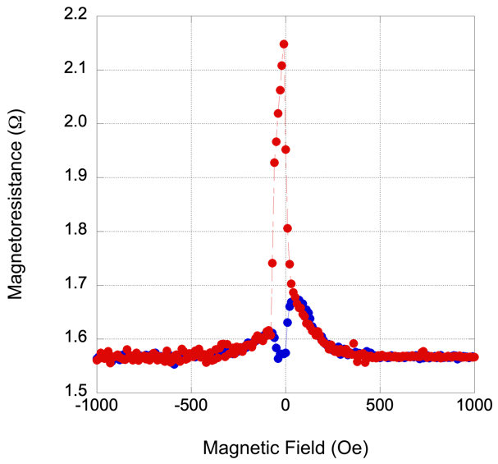
Figure 1: Representative GMR curve of a Co₂Fe_{0.4}Mn_{0.6}Si (5)/Ag_{0.78}Mg_{0.22} (5)/ Co₂Fe_{0.4}Mn_{0.6}Si (5) junction measured at a sensing current of 50 µA before the current-induced annealing. Red dots show the magnetic field swept from positive to negative saturation and blue the reverse field sweep, respectively.
Current pulses with an amplitude of 500 µA for 100 µs are then introduced into the GMR pillar for the crystallisation of a part of the Heusler-alloy ferromagnetic layers. The current-induced crystallisation predominantly improves the crystallinity and sharpness of the Heusler-alloy/non-magnet interfaces as the bulk region of the Heusler-alloy layers are fully crystallised by the optimised annealing condition [13]. As shown in Fig. 2(a), the initial change in resistance is significant, i.e., 0.0005% reduction after 200 time pulse introduction. After 1,500 time pulse introduction, the junction resistance is found to be reduced by (1.58 ± 3.02) mΩ. This confirms the current-induced crystallisation can be achieved even in a conventional Heusler-alloy film epitaxially grown on a (100) surface. However, the change and gradient are smaller by ~25% as compared with those on a (110) surface, where the crystallisation energy has been reported to be reduced over 50% [10],[11],[12]. The increase in the resistance observed in the 300 current pulse range is also indicative of an energy barrier to further crystallisation and annealing. The increase in ΔR/R_{max} is due to the resistive heating of the pillar until a critical energy density is reached, the energy barrier overcome and the decrease in current can once more be observed. Note that ΔR/R_{max} reaches saturation after ≤ 1,000 pulse introduction in this study, which is much less than the previous study [10], indicating the current-annealing is achieved in a smaller volume. Further current introduction as a pulse of 500 µA and 200 µs reduced the resistance change ΔR/R_{max} by 0.04% after 400 time pulse introduction as shown in Fig. 2(b). Under this condition, the resistance change is smoother than the above 100 µs case, which is ideal for the potentiation operation.
Here, the GMR ratios are found to increase further on the same device with increasing the number of pulses introduced for the current amplitude between 100 and 500 μA and the duration from 200 to 500 μs. However by increasing the current pulse to 600 µA for 100 µs and above, almost monotonic increase in ΔR/R_{max} is obtained as seen in Figs. 2(c) and (d), indicating the Joule heating dominates over the crystallisation. A large fluctuation even to negative in ΔR/R_{max} was observed for longer and larger current pulses, e.g., for the cases in Fig. 2(b) and (c), within the first 15 time pulse introduction, which may be induced by the incomplete motion of the interfacial atoms in the Heusler-alloy layer due to inhomogeneous thermal gradient and electromigration. Even so, by comparing with the initial state, ΔR/R_{max} = 0, each measurement shows almost monotonic decrease in ΔR/R_{max} as expected.
(a)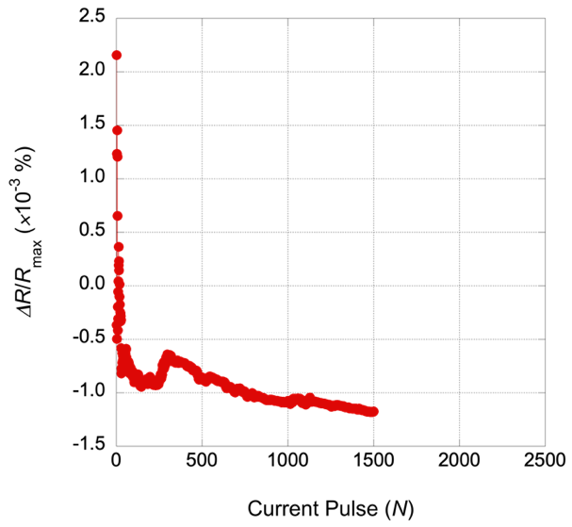 (b)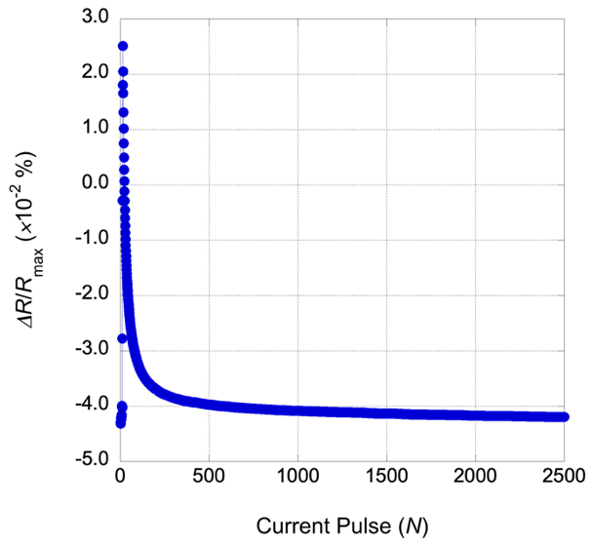
(c)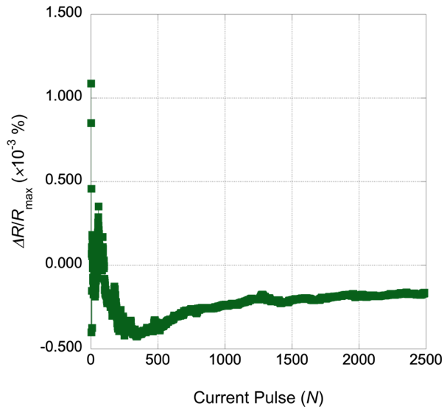 (d) 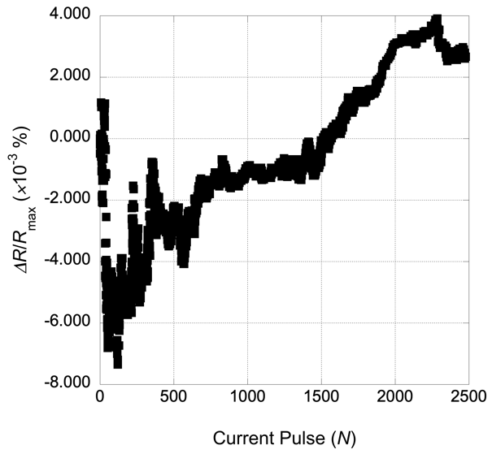
Fig. 2 Resistance change in the antiparallel magnetic configuration in the GMR pillar, which was normalised by the maximum antiparallel resistance before the current-pulse applications, by the current induced annealing using 500 µA for (a) 100 µs and (b) 200 µs, (c) 600 µA for 100 µs, and (d) 1 mA for 250 µs.
These results are expected as it is the observable effect of the Heusler-alloy crystallisation. After a series of pulses, the resistance becomes saturated, showing that the crystallisation is completed at the specific energy level provided by the current. This resistance decrease is shown through annealing where diffusion of atoms occurs within the crystalline lattices in the GMR nanopillar, where the material progresses towards an equilibrium state. The heat generated through current pulses via Joule heating is used to increase the rate of diffusion by providing the energy needed to break the bonds between atoms on the lattice; the movement of atoms led to its redistribution which removes dislocations from the lattices in the multilayers. Most importantly, stress relieving the materials is achieved by heating them at 5% to 20% of their melting temperature allowing the altering of the corresponding electrical resistivity, thus causing resistance to decrease. Such an effect has been reported in low-density granular films [15]. They report that for low annealing temperatures, defects, disorder, and mismatch stress are found to be reduced in granular films, reducing the overall film resistance. Such cases do not show the eventual saturation of the device resistance within their measurements.
On the other hand, our previous study unambiguously confirms the current-induced crystallisation in the corresponding transmission electron micrographs (TEMs) [10]. This increase in the GMR ratio is possibly caused by an improvement in the quality of the Heusler-alloy layers and their interfaces caused by atomic diffusion brought about by annealing via current pulses, reducing the spin scattering in the GMR junction. As seen for the larger pulses, once the crystallisation has been completed to a certain extent, the current pulses introduced are used for Joule heating.
Another possible cause to reduce the junction resistance is the improvement of the GMR interface by Joule heating. The relationship between improvements in the GMR ratio and the improvement in the quality of the interface between the multilayers has been investigated by Rafaja et al. [16]. They concluded that through annealing the device, the quality of the interface improved, as soft annealing at low temperatures reverses the diffusion of intermixed atomic species at the interfaces caused by the penetration of highly energetic atoms while depositing, causing an increase in the GMR ratio. A similar relationship between interfacial quality and GMR ratio have been reported by Bannikova et al. [17] and Ebert et al. [18], which may be due to electromigration. Previous research also has found that at high temperatures, there is a significant degradation of the GMR signal [17]. However, in this study, no reduction in the MR ratios is found. Hence, we can conclude the crystallisation of the Heusler alloys by the current pulses dominates the changes within the junctions.
Similar to our previous report [10], the Joule heating can be estimated using a simple model. The shape of the GMR pillar is an ellipse with the long and short axes of 510 and 280 nm with the total Co₂Fe_{0.4}Mn_{0.6}Si thickness of 10 nm. The heating value required to increase the temperature from 300 to 353 K is calculated by multiplying the mass, specific heat capacity and increased temperature, resulting in 2.8 × 10⁻¹¹ J using the parameters for Co for simple estimation. This value is almost comparable with the Joule heating by applying an electrical current of 500 µA into the above ellipse at a voltage of 100 µV for 200 µs, leading to 1.0 × 10⁻¹¹ J. One can therefore conclude that only the interfacial regions of the ternary/quaternary Heusler alloy films may be partially crystallised, especially at the interfaces attached to the non-magnetic layer, by simply flowing a pulsed current of 100 µs or longer into the films, offering the improvement of the interfacial quality, which effectively controls the spin-polarised electron transport.
4. Conclusion
Conventional giant magnetoresistive (GMR) junctions with ferromagnetic Heusler-alloy layers were used to demonstrate current-induced crystallisation. Due to the higher crystallisation energy than the layer-by-layer mode used in our previous report [10], the change observed in the junction resistance and the resistance changes ΔR/R_{max} were up to 0.04%. This may indicate the crystallisation predominantly improve the quality of the Heusler-alloy layer in the vicinity of the interface against the non-magnetic layer. Even so, the current-induced crystallisation can be used as potentiation via the reduction in the resistance by combining with the neuromorphic computation demonstrated with MR junctions. By forming an array of such a junction in parallel, a junction accessed more than the others can be accessed preferentially, mimicking the potentiation in our brain. The potentiation of a junction can be modified by accessing the other junctions in the array more, which can offer a realistic learning process using an artificial synapse.
Acknowledgements
This work was partially supported by EPSRC (Grant Nos. EP/V007211/1 and EP/V047779/1), JST CREST (Grant No. JPMJCR17J5) and GIMRT Program of the Institute for Materials Research, Tohoku University (Proposal No. 202012-RDKBR-0504). R.R. acknowledges support from Grant RYC 2019-026915-I funded by the MCIN/AEI/ 10.13039/501100011033 and by "ESF investing in your future", the Xunta de Galicia (ED431F 2022/04, ED431B 2021/013, Centro Singular de Investigación de Galicia Accreditation 2019-2022, ED431G 2019/03) and the European Union (European Regional Development Fund - ERDF).
Data Access Statement
Research data supporting this publication are available from the corresponding author upon request.
Conflict of Interest declaration
The authors declare that they have no affiliations with or involvement in any organisation or entity with any financial interest in the subject matter or materials discussed in this manuscript.
References
- M. Davies, N. Srinivasa, T. H. Lin, G. Chinya, Y. Cao, S. H. Choday, G. Dimou, P. Joshi, N. Imam, S. Jain, Y. Liao, C. K. Lin, A. Lines, R. Liu, D. Mathaikutty, S. McCoy, A. Paul, J. Tse, G. Venkataramanan, Y. H. Weng, A. Wild, Y. Yang and H. Wang, “Loihi: A neuromorphic manycore processor with on-chip learning,” IEEE Micro. 38, 82 (2018).
- S. B. Furber, F. Galluppi, S. Temple and L. A. Plana, “The SpiNNaker project,” Proc. IEEE 102, 652 (2014).
- B. V. Benjamin, P. Gao, E. McQuinn, S. Choudhary, A. R. Chandrasekaran, J. M. Bussat, R. Alvarez-Icaza, J. V. Arthur, P. A. Merolla and K. Boahen, “Neurogrid: A mixed-analog-digital multichip system for large-scale neural simulations,” Proc. IEEE 102, 699 (2014).
- T. Wunderlich, A. F. Kungl, E. Müller, A. Hartel, Y. Stradmann, S. A. Aamir, A. Grübl, A. Heimbrecht, K. Schreiber, D. Stöckel, C. Pehle, S. Billaudelle, G. Kiene, C. Mauch, J. Schemmel, K. Meier and M. A. Petrovici, “Demonstrating advantages of neuromorphic computation: A pilot study,” Front. Neurosci. 13, 3 (2019).
- L. Danial, E. Pikhay, E. Herbelin, N. Wainstein, V. Gupta, N. Wald, Y. Roizin, R. Daniel and S. Kvatinsky, “Two-terminal floating-gate transistors with a low-power memristive operation mode for analogue neuromorphic computing,” Nat. Electron. 2, 596 (2019).
- K. Roy, A. Jaiswal and P. Panda, “Towards spike-based machine intelligence with neuromorphic computing,” Nature 575, 607 (2019).
- J. Grollier, D. Querlioz and M. D. Stiles, “Spintronic nanodevices for bioinspired computing,” Proc. IEEE 104, 2024 (2016).
- A. Kurenkov, S. Fukami and H. Ohno, “Neuromorphic computing with antiferromagnetic spintronics,” J. Appl. Phys. 128, 010902 (2020).
- J. Grollier, D. Querlioz, K. Y. Camsari, K. Everschor-Sitte, S. Fukami and M. D. Stiles, “Neuromorphic spintronics,” Nat. Electron. 3, 360 (2020).
- W. Frost, K. Elphick, M. Samiepour and A. Hirohata, “Current-induced crystallisation in Heusler alloy films for memory potentiation in neuromorphic computation,” Sci. Rep. 11, 17382 (2021).
- J. Sagar, L. R. Fleet, M. Walsh, L. Lari, E. D. Boyes, O. Whear, T. Huminiuc, A. Vick and A. Hirohata, “Over 50% reduction in the formation energy of Co-based Heusler alloy films by two-dimensional crystallisation,” Appl. Phys. Lett. 105, 032401 (2014).
- W. Frost, M. Samiepour and A. Hirohata, “Low-temperature deposition of Heusler alloys with perpendicular magnetic anisotropy,” J. Magn. Magn. Mater. 484, 100 (2019).
- W. Frost, T. Seki, T. Kubota, R. Ramos, E. Saitoh, K. Takanashi and A. Hirohata, “Evaluation of edge domains in giant magnetoresistive junctions,” Appl. Phys. Lett. 118, 172405 (2021).
- T. Kubota, Y. Ina, Z. Wen, H. Narisawa and K. Takanashi, "Current perpendicular-to-plane giant magnetoresistance using an L1₂ Ag₃Mg spacer and Co₂Fe_{0.4}Mn_{0.6}Si Heusler alloy electrodes: Spacer thickness and annealing temperature dependence," Phys. Rev. Mater. 1, 044402 (2017).
- S. Ge, H. Li, C. Li, L. Xi, W. Li and J. Chi, “Giant magnetoresistance in electro-deposited Co-Cu granular film,” J. Phys.: Condens. Matter 12, 5905 (2000).
- D. Rafaja, J. Ebert, G. Miehe, N. Martz, M. Knapp, B. Stahl, M. Ghafari, H. Hahn, H. Fuess, P. Schmollngruber, P. Farber and H. Siegle, “Changes in the real structure and magnetoresistance of Co₉₀Fe₁₀/Cu and Co₉₀Fe₁₀/Cu₈₅Ag₁₀Au₅ multilayers after annealing,” Thin Solid Films 460, 256 (2004).
- N. S. Bannikova, M. A. Milyaev, L. I. Naumova, V. V. Proglyado, T. P. Krinitsina, T. A. Chernyshova and V. V. Ustinov, “Effect of annealing on magnetoresistance and microstructure of multilayered CoFe/Cu systems with different buffer layer,” Phys. Met. Metallography 116, 156 (2015).
- J. Ebert, M. Ghafari, B. Stahl and H. Hahn, “Annealing of Co_{x}Cu_{1-x}/Cu multilayers,” MRS Proc. 746, 26 (2003).

