Branch network structure, authority and lending behavior

Abstract:
Using a novel dataset of Ukrainian banks, this paper examines the link between the structure of branch network and bank lending. Bank regional branches are categorized into contact points without loan decision-making authority and more independent delegated branches which can make loan decisions. We find that a large and dispersed network of contact points can help increase credit supply and mitigate risks through diversification. Further, banks benefit from the information advantage brought by the presence of delegated branches in local markets. However, the longer distance between headquarters and local delegated branches, the more amplified agency problems become, which outweighs the benefits. Our findings suggest that the optimal structure could be a centralized network of delegated branches combined with a diversified access point network.

JEL classification: G01, G21
Keywords: consolidation, centralization, decision-making, lending, access points, delegated branches

Introduction
Over the past few decades, a trend of bank consolidation has been seen around the world, which has drawn economists’ attention. As a result, there is a large literature investigating the consequences of bank consolidation, such as its impacts on market power, stability, or credit availability. However, the existing literature has not yet accounted for the fact that the effects of consolidation might vary according to the operational and geographical structures of branch networks. For instance, the closure of branches that only provide fee-based services might not necessarily affect a bank’s credit supply to local borrowers. Further, the impacts of the branch closure might be not the same across different geographical markets. It could be also the case that the consequences of the consolidation for centralized banks are different from those for their decentralised counterparts. These issues lead to the question of the banks’ optimal structure in the post-consolidation period.
In this study, we aim to answer that question by employing unique and confidential data about the consolidation of Ukrainian banks from 2008 to 2016. Our data are combined from three different datasets including (1) financial data at the bank level, (2) data on lending at the bank-region level, and (3) data on the consolidation of banks differentiated by branch types and regions. Using these data, we track the changes in the networks of (1) branches having authority to make loan decisions (hereafter delegated branches or decision-making branches) and (2) branches not having decision-making authority (hereafter contact points, access points, or information-collecting branches).
While delegated branches play the role of local decision makers (e.g., loan approvals), overall activities are supervised and managed by bank headquarters which are the central decision makers. Most Ukrainian banks’ headquarters are located in the city of Kyiv, which is also an approximately geographical centre relative to other regions of Ukraine (Figure 1). Taking advantage of this unique setup, we examine the influence on credit supply and risk management of dispersion between the top decision makers (headquarters) and local ones (delegated branches). Data at bank-region level then allow us to assess the consequences for bank lending in local markets if delegated branches are removed. We also investigate the role of access points, branches without decision making power, in facilitating the decision-making process.
(Figure 1 about here)
We find that banks with a more dispersed network of decision-making branches experience lower levels of bad loans, although the effect is weak. This result suggests that the local decision makers can make use of soft information, which is difficult to transmit to upper levels in overseeing local loan performance. Moreover, a more dispersed network of access points can increase the banks’ geographical reach, and thus, allow them to diversify their loan portfolios. Consequently, banks are able to increase loan origination and lower the levels of non-performing loans.
The analysis of the joint effects of the dispersion of two branch types shows that banks face higher risks if both access points and delegated branches are more dispersed from headquarters. This can be explained by the differences in the impacts of the delegated branch dispersion from the perspectives of headquarters and that of local managers. As mentioned above, the dispersion of delegated branches provides local managers with an information advantage, which is beneficial for risk management. In contrast, from headquarters’ viewpoint, the dispersion can create agency problems such as local managers’ tendency to build “mini-empires”. Further, headquarters’ supervision of local branches is also less effective when the distance between headquarters and local market branches is greater. These issues are then amplified by the dispersion of access points which are also a part of these “mini-empires”. Therefore, to minimize costs while maximizing the benefits, banks should opt for a centralized structure of delegated branches, while maintaining a dispersed network of access points.
The examination at the bank-region level shows that the presence of delegated branches correlates positively with the levels of local loans granted. This could be because the authority given to local managers allows greater scope for relationship lending. The result could also reflect overlending due to competition pressure since delegated branches of a bank that are located in the same local market have to compete with each other for resources from head office. Furthermore, a large number of local access points can positively affect loan supply and risk management, which provides additional evidence for the important role of access points.
However, the large local branch networks, as indicated by the higher number of both branch types, provide banks with more market power in the local markets and allow them to cherry pick their clients. As a result, local loan officers can choose high-quality borrowers and reduce loan sizes, resulting in a decline in local loans but lower risks. This “cherry-picking” effect can be facilitated by the more (geographically) diversified information provided by the access points. The importance of access points is confirmed further when we examine the link between the access point network and bank lending (1) when decision making is fully centralised at headquarters and (2) in the presence of an exogenous shock to the Ukrainian banks’ branch networks.
Our study contributes to several strands of literature. The first strand assesses the impact of geographical diversification/dispersion on bank risk and provides mixed results. For example, Deng and Elysiani (2008) find that geographical diversification can enhance bank value and reduce bank risks through diversifying loan portfolios. In contrast, some other studies find that geographical diversification can increase risks due to a lack of information about new markets and the more complex organizational structure (e.g., Demsetz and Strahan, 1997; Acharya et al., 2006). Despite the inconclusive results on the diversification-risk relationship, one common finding among these studies is that longer distances between headquarters and local branches can negatively affect bank stability via several channels. The first channel is weakened monitoring and amplified agency problems, as longer distances make it more difficult for managers at headquarters to supervise local branch managers (Brickley et al., 2003; Goetz et al., 2013). The second channel is diseconomies of scale. As suggested by Berger et al. (2005), a narrower branch network provides banks with the advantage of using soft information in making loan decisions. Following these studies, we also investigate the link between geographical diversification and bank lending by taking into account the distance between headquarters and local branches. However, our study is distinct in that we differentiate between the dispersion of delegated branches and the dispersion of access points. In addition, we also assess the interplay between the dispersion of two branch types.
The second strand of the literature focuses on delegation in decision-making. Aghion and Tirole (1997) suggest that decentralised structures allow subordinates to participate in institutions and incentivise them to produce better information. On the downside, head offices might lose control over subordinates. Further, centralised decision-making is only optimal if the principals receive relevant and valuable information from their subordinates, and they can verify the quality of information (Dessein, 2002). In a similar vein, Stein (2002) shows that the performance of firms with different decision-making structures depends on the type of information available. If information about a project is soft and not easily transmissible, firms with decentralised decision-making can make better investment decisions. In contrast, the hard and easily transmissible information confers advantages to centralised firms.
Building on the vast theoretical literature, several studies have empirically investigated the issues related to decision-making authority, such as the factors affecting the degree of delegation or the impact of delegation on capital allocation (e.g., Bloom et al., 2012; Graham et al., 2015). Studies on decision-making delegation in the banking context, however, are scarce, possibly due to a lack of data. Closest to our paper is the work by Dlugosz et al. (2018), who examine the effects of local branches’ ability to set their own deposit rates (rate setters) on deposit-taking and loan-making activities. The results show that following the natural disasters, rate setting right allows those branches to increase deposit rates more, hence experience higher level of deposits in the affected markets. Furthermore, banks with rate setters are more likely to expand lending in the affected counties. Our study is different in several ways. First, in the context of Dlugosz et al.’s study (2018), although some branches have ability to set interest rates and some do not, there is no difference in authority to make loan/deposit decisions. In our setting, we are able to differentiate branches with and without authority to decide on loan applications, which offers us insights into the effect of decision-making delegation within a bank. Second, our study does not only examine the impact of decision-making delegation but also examine its impact in relation with banks’ geographical structure.
The rest of the paper is organized as follows. In Section 2, we provide an overview of the operational and geographical structure of Ukrainian banks. In Section 3, we discuss our empirical specifications and describe the dataset. Section 4 is a discussion of our results. Section 5 gives conclusions.

Overview about the geographical and operational structure of Ukrainian banks
The operational structure of the Ukrainian banks can be described as follows. The top decision makers are the banks’ headquarters, responsible for overarching supervision and for taking important decisions, such as decisions on granting loans to big corporate customers. The lower-tier decision makers are those regional branches that have the authority to make (local) loan decisions (delegated branches). The local decision makers also have controls over other local branches that do not have decision making authority (access points or non-delegated branches). Their main roles include (1) widening the banks’ reach to customers especially individual ones; (2) collecting hard information about local customers, such as their credit history or any applications for loans they have made to other banks; and (3) providing fee-based services.
In recent years, the geographical structure of the Ukrainian banking sector has dramatically changed due to several factors. The trend of foreign banks to intensively acquire local banks in the 2005-2011 period resulted in an increase in the number of access points, while the number of active banks decreased (Figure 2). There are two reasons for the expansion of access points. First, the foreign banks offered quite a high price, about double the value of equity, to acquire the domestic banks. Second, the main aims of the foreign banks’ acquisitions were to expand their operations geographically de jure, and to “buy” local banks’ clients de facto. Thus, domestic banks mainly targeted for foreign acquisition were those with developed branch networks, which in turn created incentives for local banks to open new access points. However, the situation has reversed since 2012, with the gradual withdrawal of foreign-owned banks from the Ukrainian market, leading to a steady reduction in the number of banks and branches. Branch and bank declines have been accelerating since 2014 through the consolidation imposed by the National Bank of Ukraine (NBU) as a part of a reform program to create a transparent and efficient banking sector (Rashkovan and Kornyliuk, 2015).
When regional branches close, the geographical structure of branch networks also changes. In 2008, delegated branches tended to be located in more economically or financially developed markets such as Kyiv region and the city of Kyiv, Dnipropetrovsk, Kharkiv, Lviv, and Poltava regions. This suggests that before the reform, the banks’ choice of where to locate delegated branches could have been driven by the demand side. If banks maintain this strategy after consolidation, one would expect a disproportional distribution in favor of the markets that are more developed. However, in fact we do not observe this – the distribution of the number of delegated branches in 2016 is relatively even among the various markets. Similarly, the degree to which access points are disproportionally distributed has been reduced over the 2008-2016 period.
(Figure 2 about here)
The above transformations raise the question of the optimal structure of branch networks for facilitating the centralization of decision making. The fact that most headquarters are placed in the city of Kyiv, coupled with the uniqueness of Ukraine’s geography, provides us with an ideal setting to answer this question. More specifically, we examine the relationship between the dispersion of headquarters and local branches and bank lending. Furthermore, we also analyse the consequences of the removal of branches from a region on local lending practices.

Data and empirical strategy

Empirical specifications

Structure of branch networks and bank lending
In the first part of our analysis, we employ the following model to examine the relationship between post-consolidation network structure and the banks’ lending/risk management.
$Y_{bt}=β_{0}+β_{1}{Dispersion}_{bt}^{delegated branches}+β_{2}{Dispersion}_{bt}^{access points}+β_{3}{Dispersion}_{bt}^{delegated branches}×{Dispersion}_{bt}^{access points}+{Controls}_{bt}β_{4}+ ϵ_{b}+θ_{t}+ε_{bt}$ (1)
where b refers to a bank and t refers to a time period. The dependent variable is either (1) Loans/TA which is the ratio of loans to total assets or (2) NPL which is the ratio of non-performing loans to total loans. To account for the potentially different effects on corporate loans and individual loans, we also measure Loans/TA and NPL separately for these two loan types.
Following previous studies (e.g., Gosh 2015), we include a vector of control variables, Controls, to account for other factors that can affect the banks’ risk management and credit creation. These variables include Wholesale funding (the ratio of funding from non-bank financial institutions to total funding), Size (the natural logarithm of total assets), Equity/Assets (the ratio of total equity to total assets), Deposits/Assets (the ratio of total deposits to total assets), Provisions (the ratio of loan loss provisions to total assets), Other banks’ delegated branches (the natural logarithm of the number of delegated branches of other banks), and Other banks’ access points (the natural logarithm of the number of access points of other banks). In the regression, we also control for time fixed effect ($θ_{t}$) and bank fixed effect ($ϵ_{b}$). Finally, $ε_{bt}$ is the error term. All financial variables are trimmed at the 1st and 99th percentile level of their distributions by quarter.
The dispersion variable, Dispersion, indicates the geographical dispersion of branches taking headquarters as the focus. Adopting the approach used in previous studies (e.g., Deng and Elyasiani, 2008; Degl’Innocenti et al., 2017), we construct a dispersion measure for a bank operating in m regions by considering the geographical distance between headquarter location and other regions (distance_{i}) as follows:
$${Dispersion}_{i}=\sum_{i=1}^{m}{\left[\frac{{Branches}_{i}}{\sum{{Branches}_{i}}}×ln⁡(1+{distance}_{i})\right]}$$
where Dispersion is the either the dispersion of delegated branches or access points. By construction, with the same number of branches, the level of dispersion is higher if those branches are located further away from headquarters. Dispersion takes a value of zero if banks cut their delegated branches in all distant markets and only retained those in the headquarters’ market, or if banks cut all local delegated branches and centralized decision-makings at headquarters.

Local branches and local lending
When consolidating their networks, banks adjust the number of delegated branches and access points throughout their markets, but the scale of adjustments is different across markets. This variation in turn might result in different impacts on loan supply and risk management among markets within the same bank network. To test this possibility, we employ the following empirical specification:
$Y_{bmt}=β_{0}+β_{1}{Delegated branches}_{bmt}+β_{2}{Access points}_{bmt}+β_{3}{Delegated branches}_{bmt}×{Access points}_{bmt}+{Controls}_{bmt}β_{4}+ ϵ_{b}+θ_{mt}+ε_{bmt}$ (2)
where b indexes banks, m indexes markets, and t indexes time periods. The dependent variable is either (1) Ln(loans) which is the natural logarithm of loans granted by a bank in a regional market or (2) NPL which is the ratio of non-performing loans to the total loans of a bank in a market. Delegated branches and Access points are the natural logarithm of the number of delegated branches or the number of access points of each bank in each market plus one, respectively.
To control for competitiveness as well as the general consolidation process in a market, we include the following variables: Other banks’ delegated branches in the market and Other banks’ access points in the market, which are the natural logarithm of the number of delegated branches and access points of other banks in a market, respectively. As a bank’s investment in a market might depend on the importance of that market to banks, we control for this by employing Accrued income from loans which is the ratio of total accrued income from loans granted by a bank in a region to the sum of total accrued income and total overdue income from loans. We also include dummy variables to control for the bank- ($ϵ_{b}$), bank-region ($τ_{bm}),$ and time ($θ_{t}$) fixed effects. Finally, $ε_{bmt}$ is the error term.

Data and sample
Our data are combined from three datasets including (1) data on Ukrainian banks’ branch networks, differentiated by branches with or without decision-making authority, (2) loan data at the bank-region level, and (3) income statement and balance sheet data at the bank level. The branch network data allow us to determine for each bank, in each region, the number of decision-making branches and the number of branches that serve as contact points.
Our original sample consists of 176 banks covering the period from 2008 Q1 to 2016 Q4. During this period, the Ukrainian banking sector faced difficulties related to the negative geopolitical and economic conditions. Thus, to achieve the cleanest sample that fits our research questions, we need to perform several cleaning steps. First, we exclude banks that are headquartered in Crimea, Luhansk, and Donetsk. It is because the ongoing conflict in Eastern Ukraine has disrupted the operations and physical presences of these banks’ head offices, making it difficult to examine the effects of local branches – headquarter dispersion. Second, we exclude insolvent banks, banks that are in elimination mode or have been excluded from the State Register, and reorganised banks. This screening reduced our sample by 103 banks. Third, banks which are active as of 2016 Q4 but do not have any access points throughout the examined period are also excluded, further reducing our sample by 35 banks. Fourth, we exclude data on banks that were involved in mergers and acquisitions. This process provides us with the cleanest data set, in which the changes in the banks’ branch network structures were made intentionally by banks. At the same time, any possible changes in the branch networks caused by merger and acquisition activities or the suspension of the banks’ operations are ruled out. Finally, observations with missing income statement and/or balance sheet data are removed. After cleaning, our panel data set consists of 26 banks.
Panel A of Table 1 presents descriptive statistics for the estimation sample at the bank level. Interest-taking activities play an important role in the operations of Ukrainian banks, since total loans make up more than half of their assets on average. Most loans are made in the form of corporate loans – their total value is about three times more than loans to households and individuals. However, corporate loans that are classified as bad loans account for about seven percent of total loans. In addition, the proportion of problem loans generated from loans to firms is one-and-a-half times higher than the proportion of bad loans generated by loans to individuals. Regarding the dispersion of branch networks within a bank, we observe a more dispersed network of contact points, while networks of decision-making branches are likely be more concentrated towards headquarters markets.
In terms of other banks’ characteristics, around eight percent of total assets are made up by loan loss provisions, reflecting Ukrainian banks’ general expectations of huge loan losses, and thus an unstable banking system. Additionally, while total deposits account for 35% of the banks’ assets, only 3.2% of total customers’ funds are raised from the wholesale market. Equity capital plays quite an important role as more than 17% of total assets are shareholders’ equity. Our data also reveal that the networks of access points are much larger compared to the networks of delegated branches – the average number of access points is about 33 times higher than that of decision-making branches.
(Table 1 about here)
At the bank-region level, in addition to the data cleaning steps specified above, we further exclude Crimea, Luhansk, and Donetsk to rule out the possibility that changes in local network structure have been induced by geopolitical issues rather than the banks’ strategies. We also exclude unusual data that might bias the results. Our final sample contains 394 bank-region pairs with 9,420 observations. Summary statistics for the estimation sample at the bank-region level are presented in Panel B of Table 1. On average, a bank operates one delegated branch and 27 access points in each region. The competition between the access points of different banks in a market is quite intense as the average number of access points of any given bank’s competitors is 476 branches. In terms of loan origination, there is not much difference in the loans granted to corporations and to individuals. However, the non-performing loans generated from personal loans are slightly higher than the ones from corporate loans (i.e., on average, the amount of non-performing personal loans in a region accounts for 9% of a bank’s total non-performing loans while the statistic for the local non-performing corporate loans is 6%). In addition, around 40% of the income from loans is collected on time, whereas the rest are overdue.
Figure 3 shows the changes in the number of active banks as well as the evolution of branches by types over time. Overall, we observe a downward trend in the number of banks and branches over the 2008-2016 period. The number of active banks dropped from nearly 180 in 2008 Q1 to less than 80 banks by the end of 2016. The sharpest fall in the number of active banks was in 2014 with the start of the consolidation process imposed by the NBU. The ongoing geopolitical conflict between Ukraine and Russia and the negative economic conditions are other factors that also contribute to the significant decline in the number of active banks. As of 2016 Q4, the number of banks in our analysis (26 banks) accounts for about 38% of the total number of active banks. From 2008 till late 2012, the average number of decision-making branches declined significantly from nearly 7 branches to about 3 branches per active bank then stabilized afterwards. This trend suggests Ukrainian banks’ strategy of centralising the decision-making process at headquarter level. The access point network, however, develops in a different pattern. The 2008 - early 2014 period witnessed the relatively stable number of access points. However, since 2014, the average number of contact points declined substantially, which is in line with the change in the number of active banks. Over the examined period, the number of access points of banks included in our analysis makes up of about 50% of all the banks’ access points.
(Figure 3 about here)

Results

The dispersion of branch networks and overall lending/risk management
Estimated results for Model (1) are presented in Table 2 where Panels A and B show results with Loans/TA and NPL as the dependent variables, respectively. In Panel A, the coefficients on Dispersion^{access points} are significant and positive, suggesting that a more dispersed network of contact points is beneficial to the banks’ credit supply. In terms of economic significance, a 10% increase in the dispersion of the access point network is associated with an increase of 0.007, 0.004, and 0.003 in Loans^{total}/TA, Loans^{corporate}/TA and Loans^{personal}/TA, respectively. In contrast, the coefficients on delegated branch dispersion are not statistically significant. In Panel B, we observe the negative and significant relationship between the dispersion of both two types of branches and the non-performing loans ratio. More specifically, if the dispersion of decision-making branches increases by 10%, NPL^{total} and NPL^{personal} decline by about 0.002. The effect of the dispersion of access points on NPL is similar to that on lending: for a 10% increase in Dispersion^{access points}, NPL^{total}, NPL^{corporate}, and NPL^{personal} decrease by 0.007, 0.003, and 0.004, respectively.
(Table 1 about here)
While the dispersion of each network type alone has a positive impact on overall risk management, we observe the opposite effect when the network types share the same dispersion pattern. In other words, a more dispersed network of access points results in higher risks if the delegated branch network is also more dispersed. The finding supports Granja et al. (2018), who suggest that distant lending is generally associated with deteriorated loan quality, and thus, increasing risks. These results are also visualised in Figures 4 and 5, which show the predicted Loans^{total}/TA and NPL^{total} with respect to the changes in the dispersion of decision-making branches and contact points. As can be seen, the optimal structure for minimising risks and maximising credit supply is to combine a more dispersed access point network with a more centralised delegated branch network.
(Figures 4 and 5 about here)
The positive impacts of the dispersion of access points on credit supply and risk management could be explained by this branch type’s main role, which is to increase the banks’ access to clients. This role goes hand-in-hand with the availability of a large amount of information about loan applicants such as their credit history or to whom they have also applied for loans, which is gathered at contact points. The collected information is then delivered to the local delegated branches or headquarters, where loan decisions are made. In general, banks with a more dispersed network of access points enjoy higher levels of credit supply since they have access to more clients. In the meantime, using information on geographically diversified loan applicants, banks can lower overall risks through counterbalancing higher risks in some markets with lower risks in others (Deng and Elyasiani, 2008).
These findings provide support for Liberti and Mian (2009), who find that the greater the distance between information collecting agents and decision makers, the less they rely on soft information, and the more they use hard information. Since the process of information collection, storage, and dissemination can be facilitated by the adoption of advanced technology (Petersen and Rajan, 2002), (centre) decision-making agents could have instant and frequent access to hard information about local borrowers, which is beneficial for monitoring issued loans. As a result, banks with more dispersed networks of access points are more willing to expand lending knowing that they can intervene quickly if loan conditions deteriorate. The effects are stronger if loans are transactional based as decisions on this type of loans are made purely based on hard information and transaction loans can be easily replicated by any other banks (Boot and Thakor, 2000). Consequently, the more dispersed networks of contact points create opportunities for banks to attract new individual customers who have not been previously served, or who want to switch their banks.
The estimates also reveal the advantages and disadvantages of the delegated branch dispersion from headquarters’ perspective and from that of local managers. On the one hand, loan officers at the local delegated branches have access to soft information about local borrowers. Given the difficulties in disseminating soft information, the presence of delegated branches in those local markets that are farther away from head offices could help banks to better control local loan quality. Soft information also allows local decision makers to preserve a bank’s relationship lending with local firms and individuals.
On the other hand, a more dispersed network of decision-making branches may lead to agency problems. More specifically, the greater distance between head offices and local branches can hinder headquarters’ ability to supervise local loan officers’ actions and to enforce headquarters’ lending policies (Alessandrini et al., 2008). Hence, local decision makers might devote less time and efforts to screen loan applications and monitor granted loans, subsequently leading to higher credit risks. Furthermore, it has been shown that local managers who have been granted decision-making authorities tend to build their own mini empires (e.g., Harris and Raviv, 1996; Graham et al., 2015). This tendency can also cause divergences from the head offices’ interests and hinder effective control of by headquarters over local delegated branches, especially distant ones.
From headquarters’ standpoint, the costs of a dispersed delegated branch network thus might outweigh the benefits, since the agency problems are exacerbated by the dispersion of access points that are also part of a mini empire. In other words, a centralised structure of delegated branches, coupled with the dispersion of access points, is more beneficial to banks. This is because in the centralised structure, head offices can more closely supervisor local loan officers’ activities, thus, reducing risks associated with agency problems. At the same time, banks can issue loans at a greater distance using hard information about the local borrowers’ creditworthiness that has been transmitted from contact points (Berger et al., 2005). Moreover, recent developments such as new airline routes or new technological innovations could facilitate in-person communications, reduce the soft information transmission costs, and reduce agency costs which in turn could boost distant lending (Berger, 2003; Mocetti et al., 2017; Levine et al., 2020).
In terms of the effects of other banks’ characteristics, we find that better capitalised banks are safer. This result supports the moral hazard hypothesis which suggests that a low level of capitalization induces incentives to take on excessive risk in lending along with poor loan monitoring (Berger and De Young, 1997). Further, moral hazard incentives also occur at banks that have low credit quality, which incentivizes them to increase the riskiness of their loan portfolios (Ghosh, 2015). As the result, the low equity to assets ratio and a higher level of loan loss provisions are positively related to the high level of bad loans.

The presence of bank branches in a regional market and local lending/risk management
The correlations between the presence of bank branches in a regional market and local credit supply/risks are presented in Table 3. We find that a higher number of local delegated branches is positively related to the total amount of loans issued in that market – regardless of loan type. In terms of economic significance, if a bank increases the number of delegated branches in a local market by 1%, the volume of loans issued in that market is expected to increase by about 2%. The figures for corporate loans and personal loans are 3.2% and 2.5%, respectively. The results suggest there is a significant economic impact on credit supply from the presence of delegated branches in local markets. Moreover, the positive impact of the presence of delegated branches on corporate lending are larger than the effects on personal loans, supporting previous findings that firms are more likely to rely on relationship lending compared to individual borrowers (Berger et al., 2003). While the expansion of the local decision-making branch network is beneficial to local lending, it also leads to less effective risk management, as indicated by a higher non-performing loan ratio. If the number of delegated branches increases by 10%, the NPL^{total}, NPL^{corporate}, and NPL^{personal} ratio increase by 0.004, 0.002, and 0.005, respectively.
We also acknowledge the significant and positive correlation between the number of access points and credit creation/risk management in local markets. Specifically, if the number of a bank’s local contact points increases by 1%, the total amount of loans granted in the market increases by 0.8%. The increases in the amount of local corporate loans and personal loans issued are 1.4% and 0.8%, respectively. Further, for a given local market, the expansion of 10% in the number of contact points leads to a decline of 0.002 in the ratio of problem loans to the bank’s total loans.
(Table 3 about here)
Interestingly, a larger number of local delegated branches, coupled with a large number of access points, brings both pros and cons. That is, while more branches of both types are correlated with a reduction in local credit supply, there is a negative impact on the level of non-performing loans. These effects are visualised in Figures 6 and 7. As can be seen, the optimal structure for a bank’s local branch network is to keep the small number of delegated branches while expanding the network of contact points, i.e., at least 20 branches in a market.
(Figures 6 and 7 about here)
These findings provide insight into the important role of bank branch presence in local lending. First, we find support for the previous finding about the role of contact points as (hard) information collectors. Given that the main function of access points is to attract customers, collect information from borrowers, and transfer the information to decision makers, having a large number of access points in a region can help banks geographically diversify their pools of loan applicants within that region. Geographical diversification of loan applicants then enables banks to grant more (transactional based) loans with better quality in local markets, leading to the lower amount of bad loans. However, since the information-collecting agents have no authority to make lending decisions, they might instead have incentives to conceal from decision makers bad loan conditions or unfavorable information about the local borrowers with whom they have a personal relationship (Berger and Udell, 2002).
Second, there is evidence of the presence of relationship lending in the local credit supply and relationship lending is more likely to exist with the presence of local delegated branches. Thus, removing local decision-making branches means cutting relationship with long-term clients irrespective of the borrower and loan types. On the contrary, the expansion of these branches provides loan officers in the new delegated branches with opportunities to issue loans to local borrowers with whom they have a personal relationship. The intensity of relationship lending is enhanced by the increased competition (Boot and Thakor, 2000; Dinc, 2000; Canales and Nanda, 2012). In our study, a large number of delegated branches indicates fiercer competition among local decision makers who have preference for empire building while competing directly in the internal capital market. The enhanced competition creates extra pressure on local loan officers regarding their performance, resulting in overinvestment regardless of the borrowers’ quality. Additionally, while local loan officers have incentives to generate new loans, they devote less effort to monitoring the existing ones (Berger and Udell, 2002). Taken together, one would expect the higher levels of non-performing loans, which is consistent with the results by Granja et al. (2018).
Third, the results on the interaction between large networks of local delegated branches and access points imply that local loan officers tend to “cherry pick”, as documented in the literature (e.g., Sapienza, 2002; Canales and Nanda, 2012). More specifically, the large networks of both types of branches indicates that banks have a relatively large empire in a region, providing it with monopoly power. Thus, local decision makers might have incentives to cherry pick the highest-quality clients and restrict loan sizes. Consequently, in regions where the number of both access points and delegated branches is large, the level of both new loans and of non-performing loans decreases. This effect is more profound for loans to individuals and households which are made based on hard information.

The effects of dispersion of access points when decision-making is fully centralised
We have found that the dispersion of access points is beneficial to the banks’ decision-makings as it provides a geographically diversified pool of information. To check whether the effect holds when banks are fully centralised and headquarter is the only decision-making agent, we employ the following model:
$Y_{bt}=β_{0}+β_{1}{Completed time}_{b}+{β_{2}Dispersion}_{bt}^{access points}+β_{3}{Completed time}_{b}×{Dispersion}_{bt}^{access points}+{Controls}_{bt}β_{4}+ ϵ_{b}+θ_{t}+ε_{bt}$ (3)
where b indexes banks and t indexes time periods. Completed time is equal to one for quarters after banks have closed all delegated branches, zero for quarters before that. The dependent variable is either the Loans/TA or NPL ratio. We employ the same control variables as the ones in Model (1). This model is estimated on the sample of banks that have completed the centralization process.
To examine bank lending in local markets in the condition of local delegated branches no longer existing, we adjust Model (2) as follows.
$Y_{bmt}=β_{0}+β_{1}{Completed time}_{bm}+β_{2}{Access points}_{bmt}+β_{3}{Completed time}_{bm}×{Access points}_{bmt}+{Controls}_{bmt}β_{4}+ ϵ_{b}+θ_{mt}+ε_{bmt}$ (4)
where b indexes banks, m indexes markets and t indexes time periods. Completed time is equal to one for quarters after banks have closed all delegated branches in a market, zero for quarters before that. The dependent variable is either the Ln(loans) or NPL ratio. Control variables are the similar to the ones in Model (2).
The estimated results are reported in Tables 4 and 5. The results regarding the independent effect of the dispersion of information-collecting branches and the size of local contact point network are consistent with the baseline findings. Moreover, the estimates of the interaction terms highlight the importance of the presence of local access points in increasing the banks’ access to clients and facilitating the decision-making process in the absence of local delegated branches. That is, after the removal of all local delegated branches, an expansion of 1% in the number of access points can indeed lead to increases of 0.3%, 0.6%, and 0.4% in the amount of total, corporate, and personal loans, respectively.
(Tables 4 and 5 about here)

The effects of access point dispersion in the event of an exogenous shock
In this section, we use an exogenous shock to the Ukrainian banking sector to test the robustness of the impacts of access point network structure. In particular, the geopolitical conflict between Ukraine and Russia has led to the closure of bank branches in conflict areas (Pham et al., 2020; 2021), resulting in changes in the banks’ branch structures. Banks are more likely to be exposed to the conflict if they had previously placed more branches in the conflict regions (Crimea, Donetsk, and Luhansk). Thus, after the onset of the conflict in 2014 Q1, the more conflict-exposed banks have lost more branches and their network structures have been more affected. Furthermore, we are only interested in the share of access points as there were not many delegated branches in the conflict regions even before 2014 Q1. Our difference-in-differences regression is as follows.
$Y_{bt}{=β}_{0}{+β}_{1}{Conflict}_{t}{+β_{2}{Dispersion}_{bt}^{access points}+β}_{3}C{onflict}_{t}×{{Share}_{b,2014 Q1}+β_{4}{Conflict}_{t}×{Dispersion}_{bt}^{access points}+β}_{5}{Conflict}_{t}×{Share}_{b,2014 Q1}×{Dispersion}_{bt}^{access points}+{{Controls}_{bt}β}_{6}+ϵ_{b}+θ_{t}+ε_{bt}$ (5)
where Conflict is equal to one for quarters from 2014 Q1 and zero otherwise. Share is the ratio of the number of access points in the conflict regions compared to the bank’s total number of access points as of 2014 Q1. The dispersion (of access points) variable and control variables are those defined previously. Since we are interested in examining the role of access points only, we estimate this model only on the sample of active banks that have located their headquarters in the city of Kyiv regardless of the number of delegated branches. The time span is from 2013 Q3 to 2015 Q3.
The estimated results are presented in Table 6. We find that banks that place more access points in the conflict regions are indeed more exposed to the conflict, thus experiencing a sharper reduction in their credit supply. At the same time, the more affected banks also face an increase in the levels of bad loans as clients in the conflict regions are more reluctant to repay the loans. However, these negative impacts of conflict exposure could be mitigated by the more dispersed network of contact points. More specifically, since 2014 Q1, the geographical diversification of access points may have helped more conflict exposed banks increase their lending and reduce the levels of problem loans. These results suggest the positive impact of geographical diversification: a diversified network of access points can help more conflict-affected banks enhance their access to the local clients, thus, increasing lending in other regions to make up for losses in the conflict regions. Additionally, given the already high levels of risk, decision-making agents of the more affected banks are more likely to be risk averse. Therefore, they might have incentives to perform better risk management by making use of information generated from the diversified access point networks.
(Table 6 about here)

Endogeneity and sample selection issues
Since the estimation sample includes only 26 banks, our results might suffer from the sample selection bias. To address this concern, the following system of equations is employed:
$Y_{bt}=β_{0}+X_{bt}β_{1}+ε_{bt}$ (6)
${Selected}_{bt}=α_{0}+Z_{bt}α_{1}+ϵ_{bt}$ (7)
Equation (6) is the outcome equation identical to Equation (1). The outcome variables in this equation (i.e., Loans/TA or NPL) are only observed if the bank is active as of 2016 Q4, has at least one access point, and it is not involved in M&As (Selected = 1). Vector X contains all explanatory variables specified in Equation (1). Equation (7) is the selection equation which models the selection into being included in the analysis. In this equation, vector Z contains all variables in X and external instruments. Following Felici and Pagnini (2008), the following variables are employed as the instruments: (1) LabourCost which is the ratio of admin expenses to total income and (2) Services which is the ratio of commission income to gross income.
Ideally, we would like to estimate the above equations by following the framework proposed by Wooldridge (1995) which allows for correcting the selection bias while controlling for bank fixed effects. In the first stage, one needs to use Mundlak’s (1978) modelling device to model bank fixed effect as a linear function of Z and an error term. The selection equation now becomes:
${Selected}_{bt}=α_{0}+Z_{bt}α_{1}+\overline{Z_{b}}α_{2}+v_{bt}$ (8)
However, the fact that the measure of access point dispersion is always zero for most of the unselected banks leads to the collinearity among several covariates which then raise the convergence problem when estimating (8). For this reason, we resort to employ the standard Heckman correction to estimate our model, without controlling for the unobserved bank heterogeneity. The results, albeit need to be interpreted with caution, are consistent with the baseline results (Appendix Tables 1 and 2). To further check the robustness of our results with respect to the sample selection bias, we also re-estimate Models (1) and (2) on the sample of 69 banks of which status as of 2016 Q4 was active. Again, the findings are largely similar to the main results (Tables 7 and 8).
(Tables 7 and 8 about here)
In addition to the sample selection bias, there are also concerns about endogeneity. The first source of endogeneity is simultaneity, that is, the degree of lending and loan performance could affect banks’ operational structure which in its turn determine the dispersion of branch networks. Yet, it is reasonable to assume that banks are less likely to make contemporaneous changes to the operational structure, e.g., the performance in this financial year would lead to the changes in the following financial year instead of instant changes. Thus, the simultaneity is less of a concern in our analysis. Second, the endogeneity could also arise from the measurement error. Given that banks need to adhere to the accounting standard set by the National Bank of Ukraine and further screening was conducted to remove outliners, we believe that the measurement error is unlikely. The final source of endogeneity is the omitted variable bias. Since it is unclear which unobserved factor we should control for, we use the lagged dependent variable as a proxy variable to partially address this concern (Wooldridge, 2020). The first difference generalized method of moments (GMM) estimator is employed to estimate this dynamic panel data model. The results, reported in Tables 9 and 10, show that although we lose the statistical significance of some covariates, the estimates are quantitatively similar to the baseline results.
(Tables 9 and 10 about here)

Conclusion
In this study, we examine the impact of branch network structure on credit supply and risk management. Our results reveal that it is not only the structure that matters – the functions of branches are also important. Since the main role of access points is to enhance the banks’ access to clients, the geographic dispersion of this branch type can help banks diversify their pools of loan applicants. As a result, banks can increase their lending while reducing overall risks. At the same time, information about the local borrowers’ creditworthiness is delivered to decision-making agents to use in loan screening and monitoring. Given instant access to up-to-date information, banks are willing to grant more loans and enjoy lower levels of non-performing loans as they can intervene promptly if loan conditions are not met.
The dispersion of delegated branches which have authority to make loan decisions, in contrast, can affect bank lending in different ways. On the one side, local delegated branches have access to soft information that is difficult to disseminate. Thus, the dispersion of this branch type can help banks monitor loan quality in distant markets better. On the other side, the distance between headquarters and local decision-making branches leads to several agency problems. For instance, the greater distance makes headquarters’ supervision less effective. Moreover, local managers, especially ones in distant markets, tend to have a preference of building their own mini empires. Therefore, they might have incentives to deviate from headquarters’ strategies rather than act in the headquarters’ interests. Our analysis shows that the dispersion of delegated branches, coupled with the dispersion of access points, intensifies agency costs, making banks worse off in terms of risk management. Hence, to achieve high levels of credit supply while maintaining the low levels of risk, the banks’ optimal network structure is to combine a more centralised delegated branch network and a more dispersed network of access points.
Since banks structure their branch networks differently across markets, we further study the link between the presence of local branches and lending in local markets. We find that the intensity of delegated branches in a market is positively related to the origination of local loans. Since the loan officers in delegated branches are granted decision-making authorities, they have incentives to issue loans to local borrowers with whom they have personal relationships. In other words, having a large network of delegated branches in a local market provides loan officers with opportunities to engage in relationship lending. Similar to the results at the bank level, the larger number of access points in a region can increase local lending and improve risk management as banks can geographically diversify their local loan portfolios.
Our analysis also shows that banks having large networks of both access points and delegated branches in a region might be not beneficial to local borrowers. This is because having large networks provides banks with more market power in local markets, which in turn increases “cherry-picking” incentives. In this case, local decision makers of more (locally) powerful banks tend to issue (smaller) loans to the best borrowers, leading to a reduction in the levels of granted loans but better loan performance. The process can be facilitated by having hard information about geographically diversified borrowers collected by the contact point networks. The role of access points in improving the banks’ access to customers and facilitating decision-making is confirmed when we examine the impact of the access point networks on lending of (1) banks that centralised the decision-making process at headquarters level and (2) banks that are more exposed to the geopolitical conflict between Ukraine and Russia that started in 2014 Q1.
Our results offer some policy implications. First, the consolidation process should take into account the functions and branch networks’ structure. More specifically, delegated branches should be centralised while there is a need for a more dispersed network of access points. In addition, banks should place more contact points in distant markets, which could help their head offices in risk management while expanding credit supply in these markets. Second, the adoption of information technology should be promoted to make the monitoring process and information dissemination more efficient. This would provide headquarters or decision-making agents more incentives to provide loans in remote or under-served areas, which in turn benefits customers.

Acknowledgements
We are grateful to participants of Swansea University Seminar for comments. Any remaining errors are our own. The views expressed herein are those of the authors and do not necessarily reflect the views of the National Bank of Ukraine.

Funding
This research did not receive any specific grant from funding agencies in the public, commercial, or not-for-profit sectors.

Data Statement
Research data are confidential and cannot be shared.

References
Acharya, V.V., Hasan, I. and Saunders, A., 2006. Should banks be diversified? Evidence from individual bank loan portfolios. The Journal of Business, 79(3), pp.1355-1412.
Aghion, P. and Tirole, J., 1997. Formal and real authority in organizations. Journal of Political Economy, 105(1), pp.1-29.
Alessandrini, P., Presbitero, A.F. and Zazzaro, A., 2008. Banks, distances and firms' financing constraints. Review of Finance, 13(2), pp.261-307.
Berger, A., Klapper, L., Miller, M. and Udell, G., 2003. Relationship lending in the Argentine small business credit market. In: Margaret Miller (ed.) Credit Reporting Systems and the International Economy. MIT Press, Cambridge, Massachusetts, pp.255-270.
Berger, A.N. and DeYoung, R., 1997. Problem loans and cost efficiency in commercial banks. Journal of Banking & Finance, 21(6), pp.849-870.
Berger, A.N. and Udell, G.F., 2002. Small business credit availability and relationship lending: The importance of bank organisational structure. The Economic Journal, 112(477).
Berger, A.N., 2003. The economic effects of technological progress: Evidence from the banking industry. Journal of Money, Credit, and Banking, 35(2), pp.141-176.
Berger, A.N., Miller, N.H., Petersen, M.A., Rajan, R.G. and Stein, J.C., 2005. Does function follow organizational form? Evidence from the lending practices of large and small banks. Journal of Financial Economics, 76(2), pp.237-269.
Bloom, N., Sadun, R. and Van Reenen, J., 2012. The organization of firms across countries. The Quarterly Journal of Economics, 127(4), pp.1663-1705.
Boot, A.W. and Thakor, A.V., 2000. Can relationship banking survive competition? The Journal of Finance, 55(2), pp.679-713.
Brickley, J.A., Linck, J.S., and Smith Jr, C.W., 2003. Boundaries of the firm: evidence from the banking industry. Journal of Financial Economics, 70(3), pp.351-383.
Canales, R. and Nanda, R., 2012. A darker side to decentralized banks: Market power and credit rationing in SME lending. Journal of Financial Economics, 105(2), pp.353-366.
Degl’Innocenti, M., Mishra, T., and Wolfe, S., 2017. Branching, lending and competition in Italian banking. The European Journal of Finance, pp.1-28.
Demsetz, R.S. and Strahan, P.E., 1997. Diversification, size, and risk at bank holding companies. Journal of Money, Credit, and Banking, 29(3), pp.300-313.
Deng, S.E. and Elyasiani, E., 2008. Geographic diversification, bank holding company value, and risk. Journal of Money, Credit and Banking, 40(6), pp.1217-1238.
Dessein, W., 2002. Authority and communication in organizations. The Review of Economic Studies, 69(4), pp.811-838.
Dinc, I.S., 2000. Bank reputation, bank commitment, and the effects of competition in credit markets. The Review of Financial Studies, 13(3), pp.781-812.
Dlugosz, J., Gam, Y.K., Gopalan, R., and Skrastins, J., 2018. Decision-making delegation in banks. Working Paper.
Felici, R. and Pagnini, M., 2008. Distance, bank heterogeneity and entry in local banking markets. The Journal of Industrial Economics, 56(3), pp.500-534.
Ghosh, A., 2015. Banking-industry specific and regional economic determinants of non-performing loans: Evidence from US states. Journal of Financial Stability, 20, pp.93-104.
Goetz, M.R., Laeven, L. and Levine, R., 2013. Identifying the valuation effects and agency costs of corporate diversification: Evidence from the geographical diversification of US banks. The Review of Financial Studies, 26(7), pp.1787-1823.
Graham, J.R., Harvey, C.R. and Puri, M., 2015. Capital allocation and delegation of decision-making authority within firms. Journal of Financial Economics, 115(3), pp.449-470.
Granja, J., Leuz, C., and Rajan, R., 2018. Going the extra mile: Distant lending and credit cycles. National Bureau of Economic Research Working Paper No. w25196.
Harris, M. and Raviv, A., 1996. The capital budgeting process: Incentives and information. The Journal of Finance, 51(4), pp.1139-1174.
Levine, R., Lin, C., Peng, Q., and Xie, W., 2020. Communication within banking organizations and small business lending. The Review of Financial Studies, 33(12), pp.5750-5783.
Liberti, J.M. and Mian, A.R., 2009. Estimating the effect of hierarchies on information use. The Review of Financial Studies, 22(10), pp.4057-4090.
Mocetti, S., Pagnini, M., and Sette, E., 2017. Information technology and banking organization. Journal of Financial Services Research, 51(3), pp.313-338.
Mundlak, Y., 1978. On the pooling of time series and cross section data. Econometrica, 46, pp.69-85.
Petersen, M.A. and Rajan, R.G., 2002. Does distance still matter? The information revolution in small business lending. The Journal of Finance, 57(6), pp.2533-2570.
Pham, T., Talavera, O., and Tsapin, A., 2021. Shock contagion, asset quality and lending behaviour: The case of war in Eastern Ukraine. Kyklos, 74(2), pp.243-269.
Pham, T., Talavera, O., and Yang, J., 2020. Multimarket competition and profitability: Evidence from Ukrainian banks. Oxford Economic Papers, 72(2), pp.517-545.
Rashkovan, V. and Kornyliuk, R., 2015. Concentration of Ukraine’s banking system: Myths and Facts. Visnyk of the National bank of Ukraine, (234), pp.6-38.
Sapienza, P., 2002. The effects of banking mergers on loan contracts. The Journal of Finance, 57(1), pp.329-367.
Stein, J.C., 2002. Information production and capital allocation: Decentralized versus hierarchical firms. The Journal of Finance, 57(5), pp.1891-1921.
Wooldridge, J.M., 1995. Selection corrections for panel data models under conditional mean independence assumptions. Journal of Econometrics, 68(1), pp.115-132.
Wooldridge, J.M., 2020. Introductory Econometrics: A Modern Approach. Boston, MA: Cengage Learning, Inc.

Tables
Table 1. Descriptive statistics
 | Mean | SD | Obs.
 | (1) | (2) | (3)
Panel A. Bank level
Risk
NPL^{total} | 0.103 | 0.149 | 876
NPL^{corporate} | 0.065 | 0.115 | 882
NPL^{personal} | 0.041 | 0.097 | 881
Credit creation
Loans^{total}/TA | 0.542 | 0.174 | 897
Loans^{corporate}/TA | 0.398 | 0.185 | 898
Loans^{personal}/TA | 0.145 | 0.165 | 898
Branch dispersion
Dispersion^{delegated branches} | 2.925 | 2.710 | 898
Dispersion^{access points} | 5.238 | 0.800 | 898
Other characteristics
Other banks’ delegated branches | 360.990 | 278.284 | 898
Other banks’ access points | 13666.216 | 1825.436 | 898
Wholesale funding | 0.032 | 0.051 | 898
Provisions | 0.084 | 0.081 | 898
Deposits/Assets | 0.345 | 0.143 | 898
Size | 15.200 | 1.897 | 898
Equity/Assets | 0.173 | 0.136 | 898
Panel B. Bank-region level
Risk
NPL^{total} | 0.136 | 0.182 | 8,680
NPL^{corporate} | 0.060 | 0.114 | 7,077
NPL^{personal} | 0.092 | 0.150 | 8,890
Credit creation
Ln(loans^{total}) | 10.846 | 2.435 | 9,420
Ln(loans^{corporate}) | 9.834 | 3.505 | 8,066
Ln(loans^{personal}) | 9.539 | 2.590 | 9,398
Branch structure
Delegated branches | 0.775 | 2.337 | 9,420
Access points | 27.013 | 57.835 | 9,420
Other characteristics
Other banks’ delegated branches | 11.267 | 10.838 | 9,420
Other banks’ access points | 476.368 | 208.314 | 9,420
Accrued income from loans | 0.403 | 0.336 | 9,420
This table presents descriptive statistics for bank level data (Panel A) and bank-region level data (Panel B). In Panel A, Dispersion^{delegated branches} and Dispersion^{access points} are the dispersion of delegated branches and access points, respectively. NPL^{corporate}, NPL^{personal}, NPL^{total} are the ratios of non-performing loans granted to firms, to individuals, and total non-performing loans over total loans, respectively. Loans^{corporate}/TA, Loans^{personal}/TA, and Loans^{total}/TA are ratios of loans granted to firms, to individuals, and total loans to total assets, respectively. Wholesale funding is the ratio of deposits from non-bank financial institutions to total funding from customers. Size is the natural logarithm of total assets. Equity/Assets is the ratio of total equity to total assets. Deposits/Assets is the ratio of total deposits to by total assets. Provisions is the ratio of loan loss provisions to total assets. Other banks’ delegated branches and Other banks’ access points are the number of delegated branches and access points of other banks, respectively. In Panel B, Ln(loans^{corporate}), Ln(loans^{personal}), and Ln(loans^{total}) are the natural logarithm of corporate loans, personal loans, and total loans, respectively. NPL^{corporate}, NPL^{personal}, NPL^{total} are the ratios of non-performing loans granted to firms, to individuals, and total non-performing loans over total loans, respectively. Delegated branches and Access points are the number of delegated branches and access points of each bank in each market, respectively. Other banks’ delegated branches and Other banks’ access points are the number of delegated branches and access points of other banks in a market, respectively. Accrued income from loans is the ratio of total accrued income from loans granted by a bank in a market to the sum of total loans accrued income from loans and the overdue income from loans.

Table 2. Relationship between branch network structure and lending/risk management at the bank level
 | Total | Corporate | Personal
 | (1) | (2) | (3)
 | Panel A. Loans/TA
Dispersion^{delegated branches} | 0.004 | 0.007 | -0.003
 | (0.008) | (0.006) | (0.007)
Dispersion^{access points} | 0.071*** | 0.044*** | 0.027**
 | (0.011) | (0.009) | (0.011)
Dispersion^{delegated branches}×Dispersion^{access points} | -0.002 | -0.003** | 0.001
 | (0.002) | (0.001) | (0.001)
Ln(Other banks’ delegated branches) | 0.172*** | 0.175*** | -0.003
 | (0.057) | (0.066) | (0.018)
Ln(Other banks’ access points) | 1.523** | 1.236* | 0.285
 | (0.736) | (0.721) | (0.248)
Wholesale funding | -0.041 | 0.032 | -0.076
 | (0.102) | (0.110) | (0.076)
Provisions | 0.192*** | 0.155** | 0.040
 | (0.071) | (0.065) | (0.035)
Deposits/Assets | 0.539*** | 0.412*** | 0.127***
 | (0.056) | (0.054) | (0.032)
Size | 0.037** | 0.044*** | -0.007
 | (0.018) | (0.017) | (0.011)
Equity/Assets | 0.076 | 0.043 | 0.031
 | (0.105) | (0.085) | (0.055)
Obs. | 897 | 898 | 898
 | Panel B. NPL
Dispersion^{delegated branches} | -0.023*** | -0.002 | -0.022***
 | (0.005) | (0.003) | (0.005)
Dispersion^{access points} | -0.067*** | -0.029*** | -0.043***
 | (0.012) | (0.008) | (0.009)
Dispersion^{delegated branches}×Dispersion^{access points} | 0.006*** | 0.002*** | 0.004***
 | (0.001) | (0.001) | (0.001)
Other banks’ delegated branches | -0.023 | 0.013 | -0.039**
 | (0.055) | (0.053) | (0.016)
Other banks’ access points | 0.187 | 0.561 | -0.520**
 | (0.427) | (0.403) | (0.248)
Wholesale funding | 0.253* | -0.155** | 0.514***
 | (0.142) | (0.075) | (0.122)
Provisions | 1.169*** | 0.903*** | 0.229***
 | (0.100) | (0.105) | (0.062)
Deposits/Assets | -0.172*** | -0.075** | -0.097***
 | (0.042) | (0.036) | (0.032)
Size | -0.020 | 0.011 | -0.035***
 | (0.016) | (0.013) | (0.008)
Equity/Assets | -0.194** | -0.142* | -0.039
 | (0.088) | (0.073) | (0.047)
Obs. | 876 | 882 | 881
This table presents estimated results for Model (1). In all regressions, a constant term as well as bank and time fixed effects are included but not reported. Robust standard errors are presented in parentheses. Panels A and B show results for regressions with Loans/TA and NPL as the dependent variable, respectively. Columns (1)-(3) show results with total loans, corporate loans, and personal loans, respectively. Dispersion^{delegated branches} and Dispersion^{access points} are the dispersion of delegated branches and access points, respectively. Wholesale funding is the ratio of deposits from non-bank financial institutions to total funding from customers. Size is the natural logarithm of total assets. Equity/Assets is the ratio of total equity to total assets. Deposits/Assets is the ratio of total deposits to by total assets. Provisions is the ratio of loan loss provisions to total assets. Other banks’ delegated branches and Other banks’ access points are the natural logarithms of the number of delegated branches and access points of other banks, respectively. ∗, ∗∗, and ∗∗∗ denote 10%, 5%, and 1% significance level, respectively.

Table 3. Relationship between branch networks and lending/risk management at the bank-region level
 | Total | Corporate | Personal
 | (1) | (2) | (3)
 | Panel A. Ln(loans)
Delegated branches | 2.049*** | 3.196*** | 2.476***
 | (0.141) | (0.226) | (0.096)
Access points | 0.822*** | 1.443*** | 0.891***
 | (0.056) | (0.111) | (0.044)
Delegated branches×Access points | -0.380*** | -0.614*** | -0.451***
 | (0.027) | (0.042) | (0.018)
Other banks’ delegated branches | -0.247*** | -0.541*** | 0.026
 | (0.040) | (0.080) | (0.032)
Other banks’ access points | -0.404* | -0.181 | -0.864***
 | (0.232) | (0.549) | (0.193)
Accrued income from loans | 1.018*** | 1.465*** | 0.241***
 | (0.068) | (0.132) | (0.055)
Obs. | 9,419 | 8,065 | 9,520
 | Panel B. NPL
Delegated branches | 0.041*** | 0.022** | 0.054***
 | (0.011) | (0.009) | (0.007)
Access points | -0.023*** | 0.006 | -0.018***
 | (0.005) | (0.004) | (0.004)
Delegated branches×Access points | -0.012*** | -0.008*** | -0.015***
 | (0.002) | (0.002) | (0.002)
Other banks’ delegated branches | -0.027*** | -0.030*** | 0.001
 | (0.005) | (0.004) | (0.004)
Other banks’ access points | -0.111*** | 0.056** | -0.134***
 | (0.036) | (0.024) | (0.030)
Accrued income from loans | -0.227*** | -0.135*** | -0.129***
 | (0.007) | (0.007) | (0.006)
Obs. | 8,803 | 7,201 | 9,014
This table presents estimated results for Model (2). In all regressions, a constant term as well as bank, bank-market, and time fixed effects are included but not reported. Robust standard errors are presented in parentheses. Panels A and B show results for regressions with Ln(loans) and NPL as the dependent variable, respectively. Columns (1)-(3) show results with total loans, corporate loans, and personal loans, respectively. Delegated branches and Access points are the natural logarithm of the number of delegated branches and access points of each bank in each market, respectively. Other banks’ delegated branches in the market and Other banks’ access points in the market are the natural logarithm of the number of delegated branches and access points of other banks in each market, respectively. Accrued income from loans is the ratio of accrued income from issued loans to the sum of accrued and overdue income from issued loans of a bank in a market. ∗, ∗∗, and ∗∗∗ denote 10%, 5%, and 1% significance level, respectively.

Table 4. Effects of access point dispersion under the full centralization at the bank level
 | Loans/TA |  |  | NPL
 | Total | Corporate | Personal | Total | Corporate | Personal
 | (1) | (2) | (3) | (4) | (5) | (6)
Completed time | 0.652*** | 0.521* | 0.139 | -0.363* | -0.285** | -0.103
 | (0.244) | (0.293) | (0.115) | (0.213) | (0.126) | (0.155)
Dispersion^{access points} | 0.164*** | 0.127** | 0.038 | -0.132*** | -0.078*** | -0.062*
 | (0.055) | (0.062) | (0.029) | (0.045) | (0.029) | (0.033)
Completed time×  Dispersion^{access points} | -0.115** | -0.093* | -0.024 | 0.067* | 0.048** | 0.024
 | (0.046) | (0.055) | (0.021) | (0.040) | (0.024) | (0.029)
Other banks’ delegated branches | 1.345*** | 1.046*** | 0.296*** | 0.211 | 0.611*** | -0.380*
 | (0.197) | (0.164) | (0.104) | (0.176) | (0.177) | (0.199)
Other banks’ access points | 2.324* | 2.972*** | -0.648 | -3.249*** | -3.085*** | -0.692
 | (1.256) | (1.148) | (0.763) | (1.130) | (1.192) | (1.087)
Wholesale funding | 0.233* | 0.241* | -0.014 | 0.075 | -0.269*** | 0.459***
 | (0.124) | (0.125) | (0.094) | (0.131) | (0.080) | (0.123)
Provisions | 0.249*** | 0.224*** | 0.032 | 1.046*** | 0.781*** | 0.233***
 | (0.067) | (0.063) | (0.042) | (0.095) | (0.110) | (0.066)
Deposits/Assets | 0.629*** | 0.446*** | 0.184*** | -0.115** | -0.042 | -0.074**
 | (0.074) | (0.063) | (0.040) | (0.048) | (0.039) | (0.035)
Size | 0.059*** | 0.066*** | -0.007 | -0.031** | -0.002 | -0.034***
 | (0.023) | (0.021) | (0.013) | (0.014) | (0.011) | (0.010)
Equity/Assets | 0.010 | 0.022 | -0.016 | -0.059 | -0.063 | -0.008
 | (0.117) | (0.094) | (0.064) | (0.076) | (0.060) | (0.058)
Obs. | 717 | 718 | 718 | 696 | 702 | 701
This table presents estimated results for the examination of the effects of access point dispersion at the bank level when banks close all delegated branches. In all regressions, a constant term as well as bank and time fixed effects are included but not reported. Robust standard errors are presented in parentheses. The dependent variables in Columns (1)-(6) are Loans^{total}/TA, Loans^{corporate}/TA, Loans^{personal}/TA, NPL^{total}, NPL^{corporate}, and NPL^{personal}, respectively. Loans^{corporate}/TA, Loans^{personal}/TA, and Loans^{total}/TA are the ratios of loans granted to firms, to individuals and total loans over total assets, respectively. NPL^{corporate}, NPL^{personal}, and NPL^{total} are the ratios of non-performing loans granted to firms, to individuals, and total non-performing loans over total loans, respectively. Dispersion^{access points} is the dispersion of access points. Completed time equals one for quarters since banks complete the fully centralised consolidation, zero for quarters before that. Wholesale funding is the ratio of deposits from non-bank financial institutions to total funding from customers. Size is the natural logarithm of total assets. Equity/Assets is the ratio of total equity to total assets. Deposits/Assets is the ratio of total deposits to by total assets. Provisions is the ratio of loan loss provisions to total assets. Other banks’ delegated branches and Other banks’ access points are the natural logarithms of the number of delegated branches and access points of other banks, respectively. ∗, ∗∗, and ∗∗∗ denote 10%, 5%, and 1% significance level, respectively.

Table 5. Effects of access point network under the full centralization at the bank-region level
 | Ln(loans) |  |  | NPL
 | Total | Corporate | Personal | Total | Corporate | Personal
 | (1) | (2) | (3) | (4) | (5) | (6)
Completed time | -1.447*** | -2.370*** | -1.725*** | -0.005 | -0.053*** | -0.032***
 | (0.150) | (0.238) | (0.110) | (0.012) | (0.010) | (0.009)
Access points | 0.697*** | 1.008*** | 0.702*** | -0.012* | -0.014*** | 0.004
 | (0.073) | (0.122) | (0.055) | (0.006) | (0.005) | (0.003)
Access points× Completed time | 0.324*** | 0.572*** | 0.360*** | 0.007 | 0.028*** | 0.015***
 | (0.053) | (0.081) | (0.038) | (0.005) | (0.004) | (0.005)
Other banks’ delegated branches | -0.915*** | -1.363*** | -0.426*** | -0.000 | -0.037*** | 0.037***
 | (0.078) | (0.126) | (0.053) | (0.009) | (0.007) | (0.005)
Other banks’ access points | -0.712* | -2.100*** | -0.819*** | -0.146*** | -0.080** | -0.072**
 | (0.375) | (0.650) | (0.262) | (0.045) | (0.038) | (0.034)
Accrued income from loans | 1.322*** | 2.086*** | 0.228*** | -0.240*** | -0.169*** | -0.086***
 | (0.091) | (0.139) | (0.071) | (0.009) | (0.008) | (0.006)
Obs. | 4,159 | 4,071 | 4,213 | 3,809 | 3,760 | 4,015
This table presents estimated results for the examination of the effects of access point dispersion at the bank-region level when banks close all delegated branches in the region. In all regressions, a constant term as well as bank, bank-market, and time fixed effects are included but not reported. Robust standard errors are presented in parentheses. The dependent variables in Columns (1)-(6) are Ln(loans^{total}), Ln(loans^{corporate}), Ln(loans^{personal}), NPL^{total}, NPL^{corporate}, and NPL^{personal}, respectively. Ln(loans^{corporate}), Ln(loans^{personal}), and Ln(loans^{total}) are the natural logarithm of corporate loans, personal loans, and total loans, respectively. NPL^{corporate}, NPL^{personal}, and NPL^{total} are the ratios of non-performing loans granted to firms, to individuals, and total non-performing loans over total loans, respectively. Completed time equals one for quarters since banks complete the fully centralised consolidation in a market, zero for quarters before that. Access points is the natural logarithm of the number of access points of each bank in each market. Other banks’ delegated branches in the market and Other banks’ access points in the market are the natural logarithm of the number of delegated branches and access points of other banks in each market, respectively. Accrued income from loans is the ratio of accrued income from issued loans to the sum of accrued and overdue income from issued loans of a bank in a market. ∗, ∗∗, and ∗∗∗ denote 10%, 5%, and 1% significance level, respectively.

Table 6. Effects of access point dispersion in the presence of the geopolitical conflict
 | Loans/TA |  |  | NPL
 | Total | Corporate | Personal | Total | Corporate | Personal
 | (1) | (2) | (3) | (4) | (5) | (6)
Conflict | 0.144 | 0.350 | -0.205 | -0.187 | -0.313 | 0.118
 | (0.343) | (0.334) | (0.148) | (0.343) | (0.359) | (0.141)
Dispersion^{access points} | 0.006 | 0.013 | -0.007** | 0.004 | 0.009 | -0.004
 | (0.011) | (0.011) | (0.003) | (0.009) | (0.006) | (0.007)
Share×Conflict t | -3.333*** | -2.253*** | -1.080*** | 2.513*** | 1.405*** | 1.092***
 | (0.430) | (0.459) | (0.223) | (0.340) | (0.275) | (0.276)
Dispersion^{access points}  ×Conflict | -0.034*** | -0.039*** | 0.005 | 0.018*** | 0.011** | 0.009*
 | (0.009) | (0.012) | (0.006) | (0.006) | (0.005) | (0.005)
Dispersion^{access points}  ×Share×Conflict | 0.578*** | 0.391*** | 0.187*** | -0.487*** | -0.272*** | -0.217***
 | (0.083) | (0.089) | (0.038) | (0.062) | (0.050) | (0.046)
Other banks’ delegated branches | 0.866* | 1.120** | -0.255 | -0.234 | -0.045 | -0.141
 | (0.491) | (0.417) | (0.197) | (0.351) | (0.403) | (0.221)
Other banks’ access points | -1.819 | -1.576 | -0.243 | -0.736 | -1.566 | 0.659
 | (1.517) | (1.326) | (0.681) | (1.871) | (1.958) | (0.586)
Wholesale funding | 0.311 | 0.317 | -0.007 | -0.122 | -0.249** | 0.115
 | (0.236) | (0.223) | (0.056) | (0.110) | (0.121) | (0.140)
Provisions | 0.132 | 0.178 | -0.046 | 0.906*** | 0.606*** | 0.328*
 | (0.154) | (0.134) | (0.097) | (0.244) | (0.155) | (0.186)
Deposits/Assets | -0.097 | -0.195 | 0.099*** | -0.183** | -0.158** | -0.060
 | (0.137) | (0.151) | (0.032) | (0.074) | (0.072) | (0.040)
Size | 0.010 | 0.047 | -0.037 | -0.062 | 0.037 | -0.101**
 | (0.049) | (0.046) | (0.033) | (0.038) | (0.031) | (0.039)
Equity/Assets | -0.057 | -0.099 | 0.042 | -0.164 | -0.008 | -0.157*
 | (0.106) | (0.100) | (0.061) | (0.125) | (0.087) | (0.086)
Obs. | 517 | 517 | 517 | 515 | 503 | 517
This table presents estimated results for the examination of the effects of dispersion of access points in the presence of the exogenous shock to the banks’ branch networks. Regressions are estimated at the bank level. In all regressions, a constant term as well as bank and time fixed effects are included but not reported. Robust standard errors are presented in parentheses. The dependent variables in Columns (1)-(6) are Loans^{total}/TA, Loans^{corporate}/TA, Loans^{personal}/TA, NPL^{total}, NPL^{corporate}, and NPL^{personal}, respectively. Loans^{corporate}/TA, Loans^{personal}/TA, and Loans^{total}/TA are the ratios of loans granted to firms, to individuals and total loans over total assets, respectively. NPL^{corporate}, NPL^{personal}, and NPL^{total} are the ratios of non-performing loans granted to firms, to individuals, and total non-performing loans over total loans, respectively. Conflict equals one for quarters since 2014 Q1, zero otherwise. Share is the share of access points in Crimea, Donetsk, and Luhansk as of 2014 Q1. Dispersion of access points is the dispersion of access points. Wholesale funding is the ratio of deposits from non-bank financial institutions to total funding from customers. Size is the natural logarithm of total assets. Equity/Assets is the ratio of total equity to total assets. Deposits/Assets is the ratio of total deposits to by total assets. Provisions is the ratio of loan loss provisions to total assets. Other banks’ delegated branches and Other banks’ access points are the natural logarithms of the number of delegated branches and access points of other banks, respectively. ∗, ∗∗, and ∗∗∗ denote 10%, 5%, and 1% significance level, respectively.

Table 7. Relationship between branch network structure and lending/risk management at the bank level (sample of all banks whose status as of 2016 Q4 is active)
 | Total | Corporate | Personal
 | (1) | (2) | (3)
 | Panel A. Loans/TA
Dispersion^{delegated branches} | -0.031*** | -0.019** | -0.013***
 | (0.012) | (0.010) | (0.004)
Dispersion^{access points} | 0.023*** | 0.009** | 0.014***
 | (0.005) | (0.004) | (0.003)
Dispersion^{delegated branches}×Dispersion^{access points} | 0.004* | 0.002 | 0.002**
 | (0.002) | (0.002) | (0.001)
Other banks’ delegated branches | 0.228*** | 0.245*** | -0.017
 | (0.060) | (0.068) | (0.020)
Other banks’ access points | -1.091* | -0.904 | -0.184
 | (0.651) | (0.593) | (0.285)
Wholesale funding | 0.157*** | 0.091* | 0.060**
 | (0.059) | (0.047) | (0.028)
Provisions | 0.166*** | 0.049 | 0.117***
 | (0.042) | (0.045) | (0.024)
Deposits/Assets | -0.017 | -0.023 | 0.008
 | (0.041) | (0.039) | (0.020)
Size | 0.012 | 0.027*** | -0.015**
 | (0.012) | (0.010) | (0.007)
Equity/Assets | -0.121** | -0.086 | -0.034
 | (0.056) | (0.053) | (0.028)
Obs. | 2,370 | 2,372 | 2,381
 | Panel B. NPL
Dispersion^{delegated branches} | -0.009*** | 0.002 | -0.012***
 | (0.003) | (0.003) | (0.003)
Dispersion^{access points} | -0.009*** | -0.006** | -0.007***
 | (0.003) | (0.003) | (0.002)
Dispersion^{delegated branches}×Dispersion^{access points} | 0.002*** | 0.001 | 0.002***
 | (0.001) | (0.001) | (0.001)
Other banks’ delegated branches | -0.011 | 0.019 | -0.034**
 | (0.049) | (0.049) | (0.017)
Other banks’ access points | 1.265*** | 0.602* | 0.518*
 | (0.392) | (0.309) | (0.267)
Wholesale funding | -0.012 | -0.047* | 0.051*
 | (0.040) | (0.028) | (0.029)
Provisions | 1.025*** | 0.817*** | 0.247***
 | (0.081) | (0.057) | (0.052)
Deposits/Assets | -0.086*** | -0.098*** | 0.009
 | (0.016) | (0.014) | (0.010)
Size | -0.027** | -0.005 | -0.027***
 | (0.011) | (0.007) | (0.009)
Equity/Assets | -0.157*** | -0.152*** | -0.025
 | (0.038) | (0.034) | (0.023)
Obs. | 2,351 | 2,313 | 2,352
This table presents estimated results for Model (1) on the sample of 69 banks with active status as of 2016 Q4. In all regressions, a constant term as well as bank and time fixed effects are included but not reported. Robust standard errors are presented in parentheses. Panels A and B show results for regressions with Loans/TA and NPL as the dependent variable, respectively. Columns (1)-(3) show results with total loans, corporate loans, and personal loans, respectively. Dispersion^{delegated branches} and Dispersion^{access points} are the dispersion of delegated branches and access points, respectively. Wholesale funding is the ratio of deposits from non-bank financial institutions to total funding from customers. Size is the natural logarithm of total assets. Equity/Assets is the ratio of total equity to total assets. Deposits/Assets is the ratio of total deposits to by total assets. Provisions is the ratio of loan loss provisions to total assets. Other banks’ delegated branches and Other banks’ access points are the natural logarithms of the number of delegated branches and access points of other banks, respectively. Have delegated branches is a dummy variable which equals one if a bank has delegated branches in a quarter, zero otherwise. ∗, ∗∗, and ∗∗∗ denote 10%, 5%, and 1% significance level, respectively.

Table 8. Relationship between branch networks and lending/risk management at the bank-region level (sample of all banks whose status as of 2016 Q4 is active)
 | Total | Corporate | Personal
 | (1) | (2) | (3)
 | Panel A. Ln(loans)
Delegated branches | 1.469*** | 2.826*** | 1.554***
 | (0.094) | (0.157) | (0.074)
Access points | 1.164*** | 1.768*** | 1.095***
 | (0.038) | (0.073) | (0.037)
Delegated branches×Access points | -0.273*** | -0.571*** | -0.270***
 | (0.019) | (0.031) | (0.014)
Other banks’ delegated branches | -0.066*** | -0.155*** | 0.131***
 | (0.024) | (0.044) | (0.024)
Other banks’ access points | -0.003 | 0.720** | -0.682***
 | (0.154) | (0.344) | (0.151)
Accrued income from loans | 1.089*** | 1.852*** | 0.037
 | (0.046) | (0.083) | (0.044)
Obs. | 20,573 | 18,567 | 20,529
 | Panel B. NPL
Delegated branches | -0.007 | 0.003 | 0.018***
 | (0.008) | (0.007) | (0.006)
Access points | -0.029*** | 0.017*** | -0.033***
 | (0.004) | (0.003) | (0.003)
Delegated branches×Access points | -0.004** | -0.006*** | -0.008***
 | (0.002) | (0.002) | (0.001)
Other banks’ delegated branches | -0.003 | -0.014*** | 0.014***
 | (0.003) | (0.003) | (0.002)
Other banks’ access points | 0.014 | 0.093*** | -0.073***
 | (0.024) | (0.017) | (0.020)
Accrued income from loans | -0.260*** | -0.156*** | -0.141***
 | (0.005) | (0.005) | (0.004)
Obs. | 19,082 | 17,077 | 19,572
This table presents estimated results for Model (2) on the sample of 69 active banks as of 2016 Q4. In all regressions, a constant term as well as bank, bank-market, and time fixed effects are included but not reported. Robust standard errors are presented in parentheses. Panels A and B show results for regressions with Ln(loans) and NPL as the dependent variable, respectively. Columns (1)-(3) show results with total loans, corporate loans, and personal loans, respectively. Delegated branches and Access points are the natural logarithm of the number of delegated branches and access points of each bank in each market, respectively. Other banks’ delegated branches in the market and Other banks’ access points in the market are the natural logarithm of the number of delegated branches and access points of other banks in each market, respectively. Accrued income from loans is the ratio of accrued income from issued loans to the sum of accrued and overdue income from issued loans of a bank in a market. ∗, ∗∗, and ∗∗∗ denote 10%, 5%, and 1% significance level, respectively.

Table 9. GMM estimation – Bank level
 | Total | Corporate | Personal
 | (1) | (2) | (3)
 | Panel A. Loans/TA
Loans/TA_{t-1} | 0.529*** | 0.479*** | 0.460***
 | (0.116) | (0.127) | (0.172)
Dispersion^{delegated branches} | -0.032** | -0.005 | -0.009
 | (0.015) | (0.006) | (0.007)
Dispersion^{access points} | 0.002 | 0.043** | -0.038
 | (0.031) | (0.019) | (0.037)
Dispersion^{delegated branches}×Dispersion^{access points} | 0.008** | 0.001 | 0.003
 | (0.003) | (0.001) | (0.002)
Other banks’ delegated branches | -0.057 | -0.025 | -0.088
 | (0.081) | (0.083) | (0.098)
Other banks’ access points | -0.188 | 1.158* | -1.261
 | (1.345) | (0.594) | (0.951)
Wholesale funding | 0.196 | 0.013 | 0.136*
 | (0.171) | (0.093) | (0.075)
Provisions | 0.460*** | 0.448*** | -0.032
 | (0.104) | (0.119) | (0.083)
Deposits/Assets | 0.268*** | 0.241*** | -0.021
 | (0.068) | (0.066) | (0.045)
Size | -0.164*** | -0.096*** | -0.057**
 | (0.025) | (0.032) | (0.028)
Equity/Assets | -0.069 | -0.160* | 0.087**
 | (0.113) | (0.083) | (0.037)
Obs. | 843 | 846 | 846
 | Panel B. NPL
NPL_{t-1} | 0.540*** | 0.850*** | 0.732***
 | (0.132) | (0.072) | (0.221)
Dispersion^{delegated branches} | -0.011 | -0.001 | -0.015
 | (0.009) | (0.004) | (0.010)
Dispersion^{access points} | -0.049*** | -0.033** | -0.029*
 | (0.014) | (0.015) | (0.016)
Dispersion^{delegated branches}×Dispersion^{access points} | 0.002 | 0.001 | 0.002
 | (0.002) | (0.001) | (0.002)
Other banks’ delegated branches | -0.108 | -0.084 | -0.009
 | (0.076) | (0.065) | (0.020)
Other banks’ access points | -0.292 | -0.344 | 0.168
 | (0.587) | (0.438) | (0.298)
Wholesale funding | -0.104 | -0.137** | 0.033
 | (0.099) | (0.066) | (0.084)
Provisions | 0.398** | 0.195* | 0.101*
 | (0.166) | (0.117) | (0.056)
Deposits/Assets | -0.041 | -0.062 | -0.060
 | (0.038) | (0.039) | (0.039)
Size | -0.056** | -0.051** | -0.045**
 | (0.022) | (0.022) | (0.023)
Equity/Assets | -0.230* | -0.189 | 0.022
 | (0.134) | (0.126) | (0.039)
Obs. | 817 | 826 | 826
This table presents estimated results for Model (1) where the lagged dependent variable is added as a covariate. This dynamic panel data model is estimated using the GMM estimator. In all regressions, a constant term and time fixed effects are included but not reported. Robust standard errors are presented in parentheses. Panels A and B show results for regressions with Loans/TA and NPL as the dependent variable, respectively. Columns (1)-(3) show results with total loans, corporate loans, and personal loans, respectively. Dispersion^{delegated branches} and Dispersion^{access points} are the dispersion of delegated branches and access points, respectively. Wholesale funding is the ratio of deposits from non-bank financial institutions to total funding from customers. Size is the natural logarithm of total assets. Equity/Assets is the ratio of total equity to total assets. Deposits/Assets is the ratio of total deposits to by total assets. Provisions is the ratio of loan loss provisions to total assets. Other banks’ delegated branches and Other banks’ access points are the natural logarithms of the number of delegated branches and access points of other banks, respectively. Have delegated branches is a dummy variable which equals one if a bank has delegated branches in a quarter, zero otherwise. ∗, ∗∗, and ∗∗∗ denote 10%, 5%, and 1% significance level, respectively.

Table 10. GMM estimation – Bank -market level
 | Total | Corporate | Personal
 | (1) | (2) | (3)
 | Panel A. Ln(loans)
Ln(loans)_{t-1} | 0.229*** | 0.543*** | 0.209***
 | (0.045) | (0.056) | (0.043)
Delegated branches | 0.264* | 0.110 | 0.743***
 | (0.150) | (0.243) | (0.256)
Access points | 0.079 | 0.048 | 0.181**
 | (0.048) | (0.188) | (0.085)
Delegated branches×Access points | -0.014 | 0.098 | -0.122**
 | (0.036) | (0.065) | (0.056)
Other banks’ delegated branches | 0.045 | -0.020 | -0.000
 | (0.083) | (0.143) | (0.061)
Other banks’ access points | 0.834* | 1.847 | -0.159
 | (0.501) | (1.334) | (0.339)
Accrued income from loans | 0.501*** | 0.784*** | 0.014
 | (0.096) | (0.226) | (0.058)
Obs. | 8,756 | 7,492 | 8,852
 | Panel B. NPL
NPL_{t-1} | 0.398*** | 0.457*** | 0.557***
 | (0.064) | (0.075) | (0.093)
Delegated branches | 0.007 | 0.020 | -0.006
 | (0.015) | (0.017) | (0.010)
Access points | -0.013 | -0.001 | -0.010*
 | (0.009) | (0.011) | (0.006)
Delegated branches×Access points | -0.004 | -0.006 | -0.001
 | (0.003) | (0.004) | (0.002)
Other banks’ delegated branches | -0.008 | 0.000 | -0.013**
 | (0.008) | (0.007) | (0.005)
Other banks’ access points | -0.051 | -0.013 | -0.104***
 | (0.049) | (0.043) | (0.038)
Accrued income from loans | -0.142*** | -0.098*** | -0.057***
 | (0.016) | (0.016) | (0.009)
Obs. | 7,996 | 6,586 | 8,274
This table presents estimated results for Model (2) where the lagged dependent variable is added as a covariate. This dynamic panel data model is estimated using GMM estimator. In all regressions, a constant term as well as bank and time fixed effects are included but not reported. Robust standard errors are presented in parentheses. Panels A and B show results for regressions with Ln(loans) and NPL as the dependent variable, respectively. Columns (1)-(3) show results with total loans, corporate loans, and personal loans, respectively. Delegated branches and Access points are the natural logarithm of the number of delegated branches and access points of each bank in each market, respectively. Other banks’ delegated branches in the market and Other banks’ access points in the market are the natural logarithm of the number of delegated branches and access points of other banks in each market, respectively. Accrued income from loans is the ratio of accrued income from issued loans to the sum of accrued and overdue income from issued loans of a bank in a market. ∗, ∗∗, and ∗∗∗ denote 10%, 5%, and 1% significance level, respectively.

Figures
Figure 1. Distance from a region to Kyiv
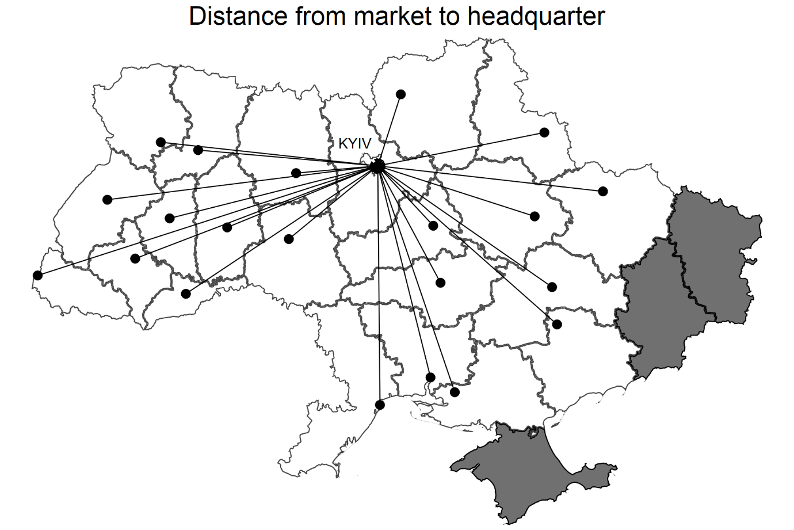
This figure shows the distance between each regional centre to Kyiv city which is the proxy of the region (local market) – headquarter distance. The darker regions are the conflict regions (Crimea, Luhansk, and Donetsk).
Figure 2. Distribution of delegated branches and access points across Ukrainian regions
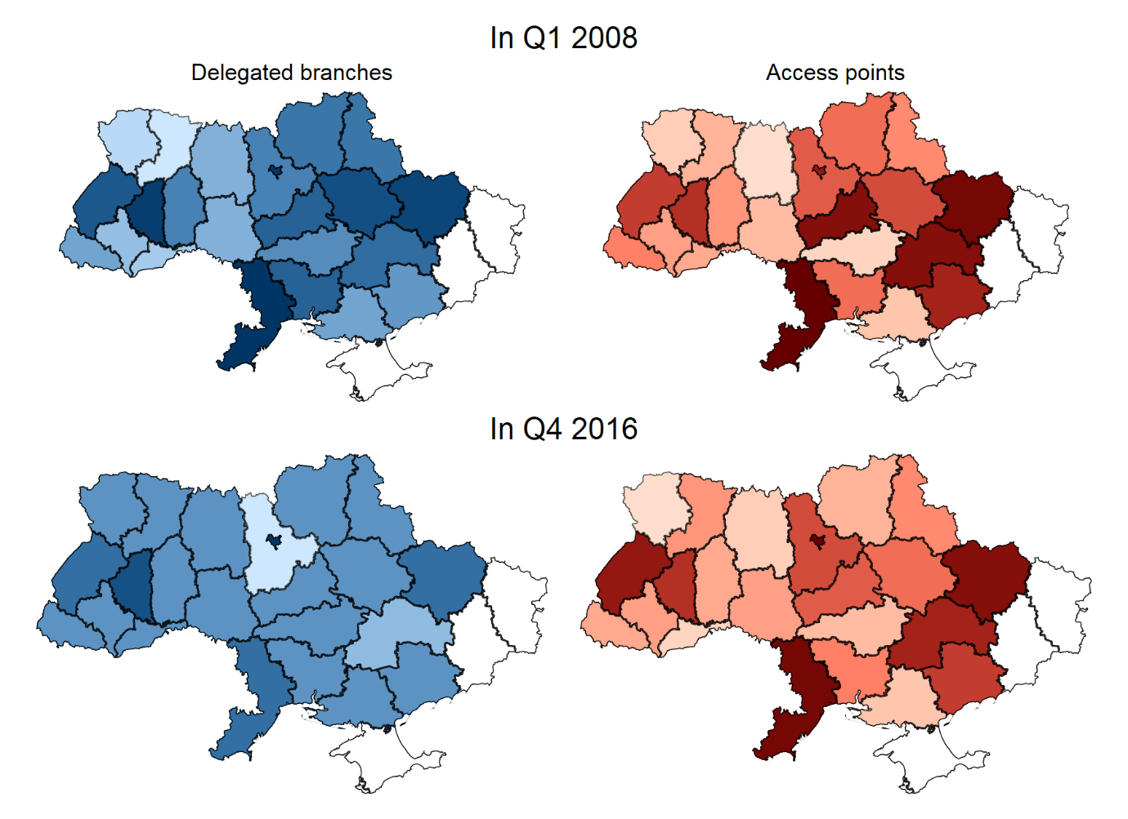
This figure shows the distribution of delegated branches and information-collecting branches across regions over time. The darker shades show the higher intensity of branches.
Figure 3. Evolution of branches by types over time
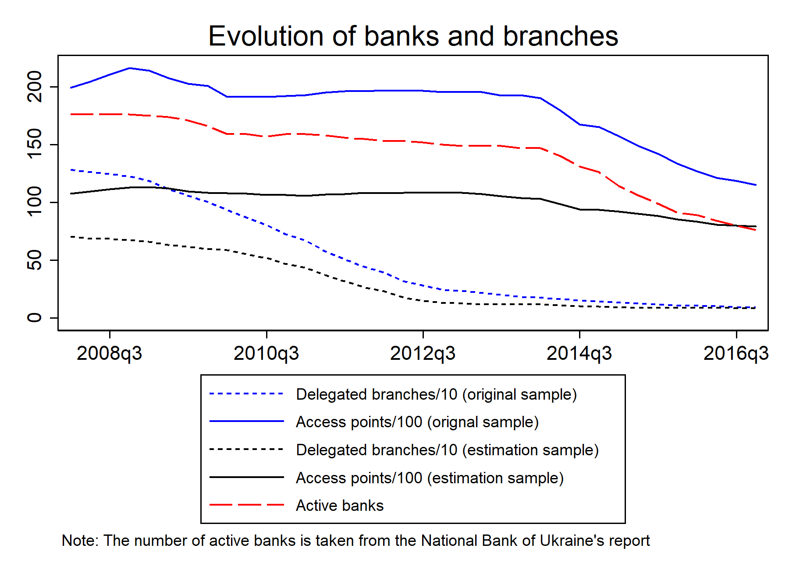This figure shows the average number of delegated branches and access points of multimarket banks over time.
Figure 4.
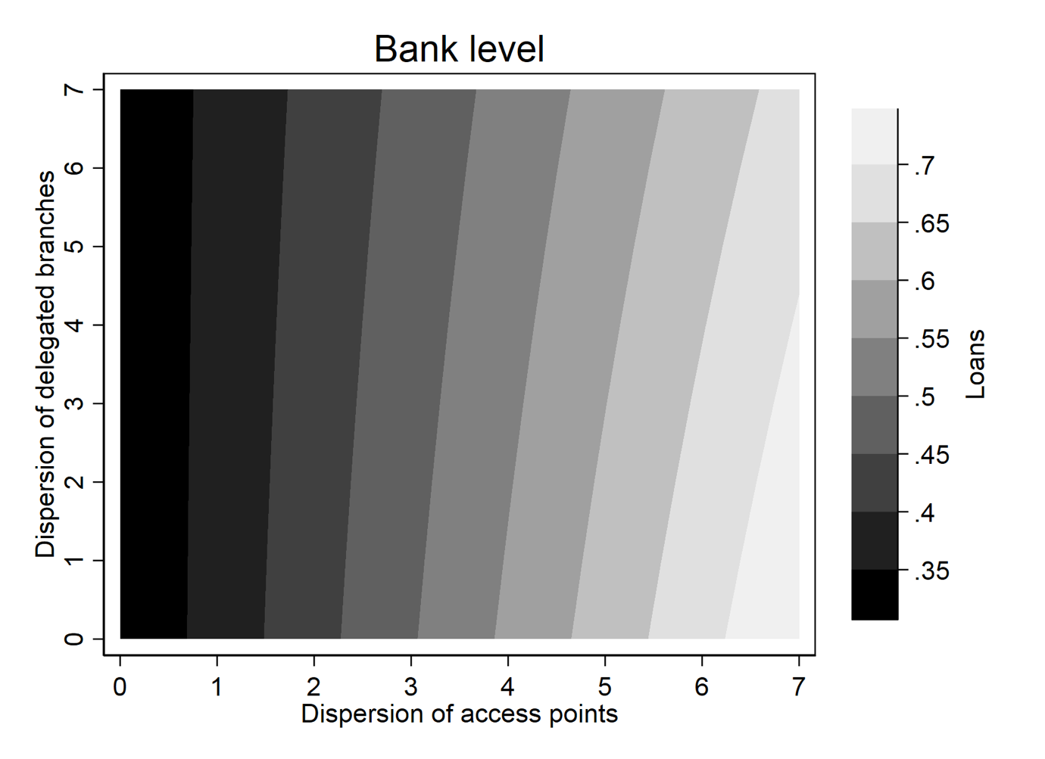
This figure shows the marginal effects of the dispersion of delegated branches and access points on predicted Loans^{total}/TA.
Figure 5.
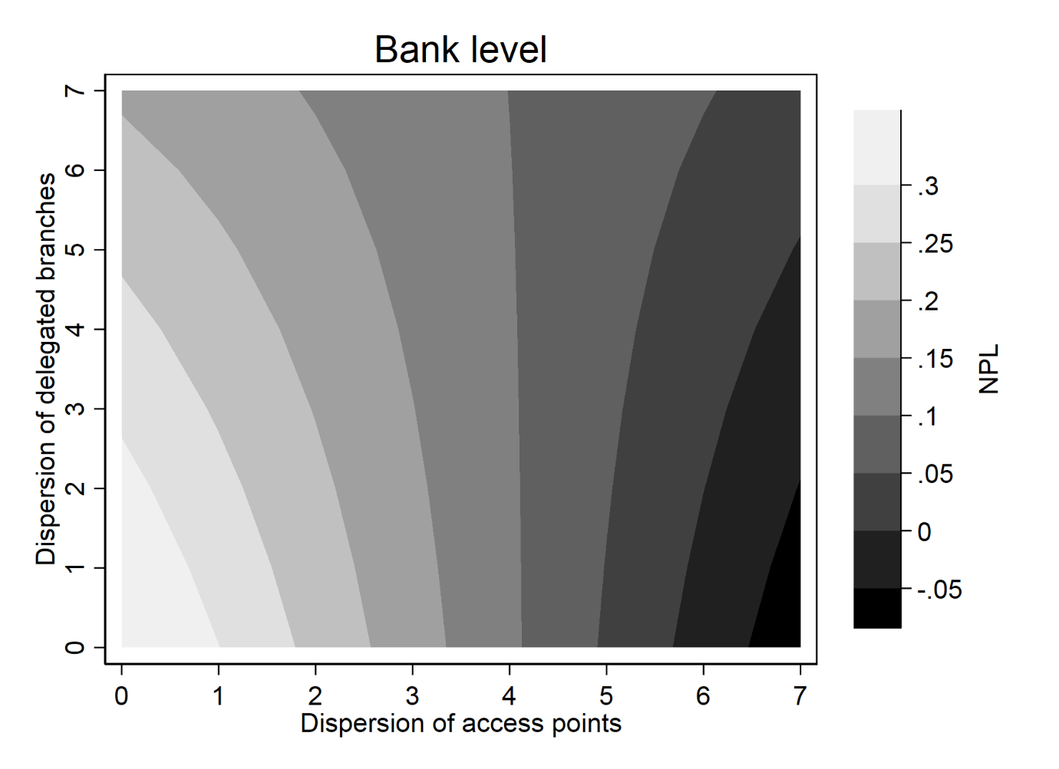
This figure shows the marginal effects of the dispersion of delegated branches and access points on predicted NPL^{total} ratio.
Figure 6.
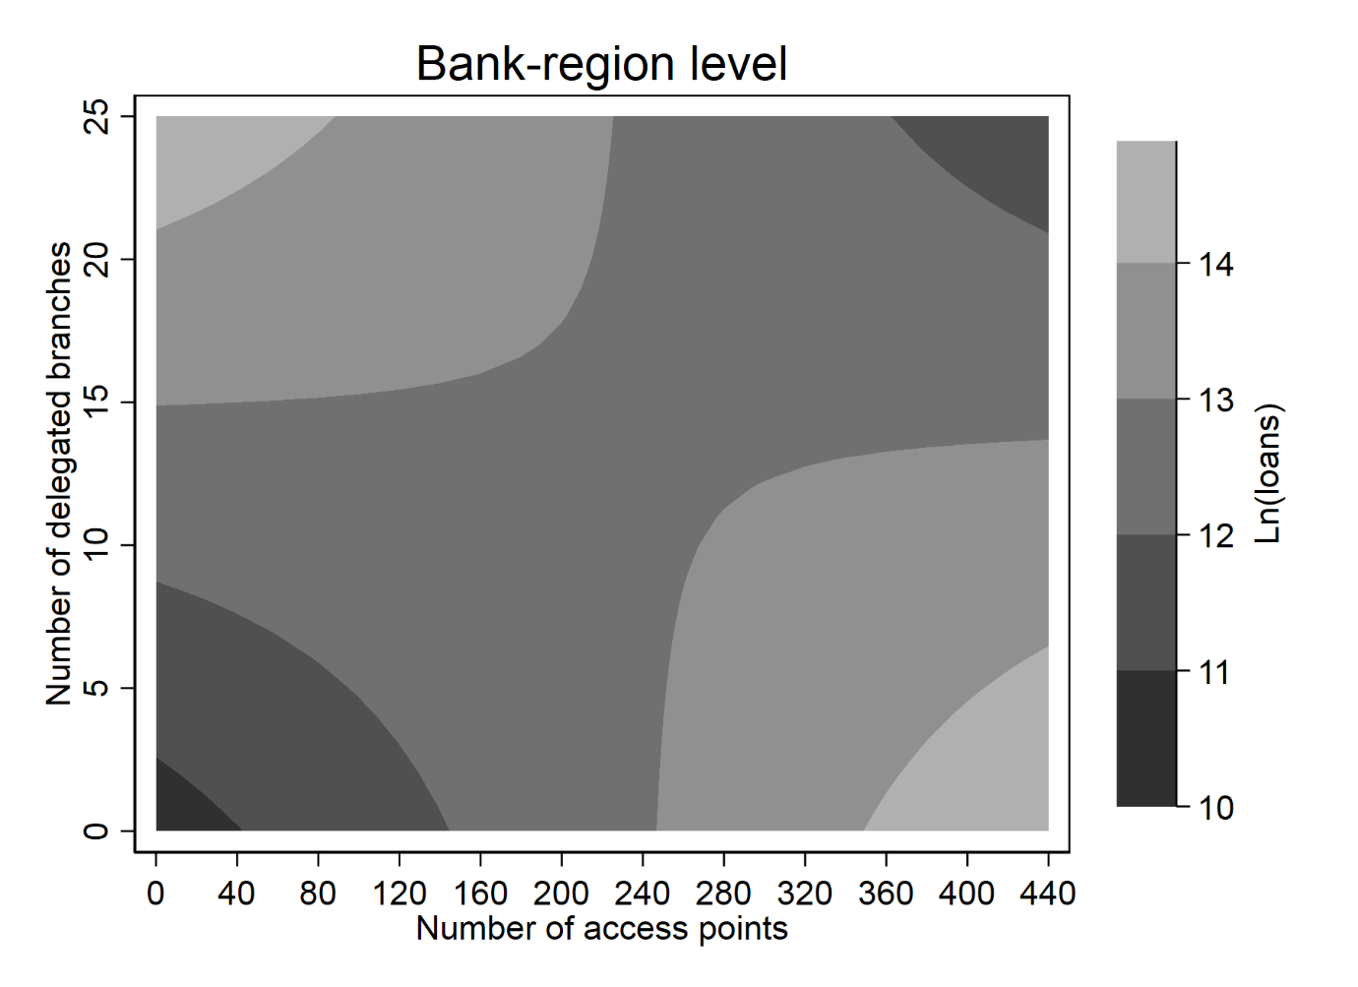
This figure shows the marginal effects of the number of local delegated branches and access points on predicted Ln(loans^{total}).
Figure 7.
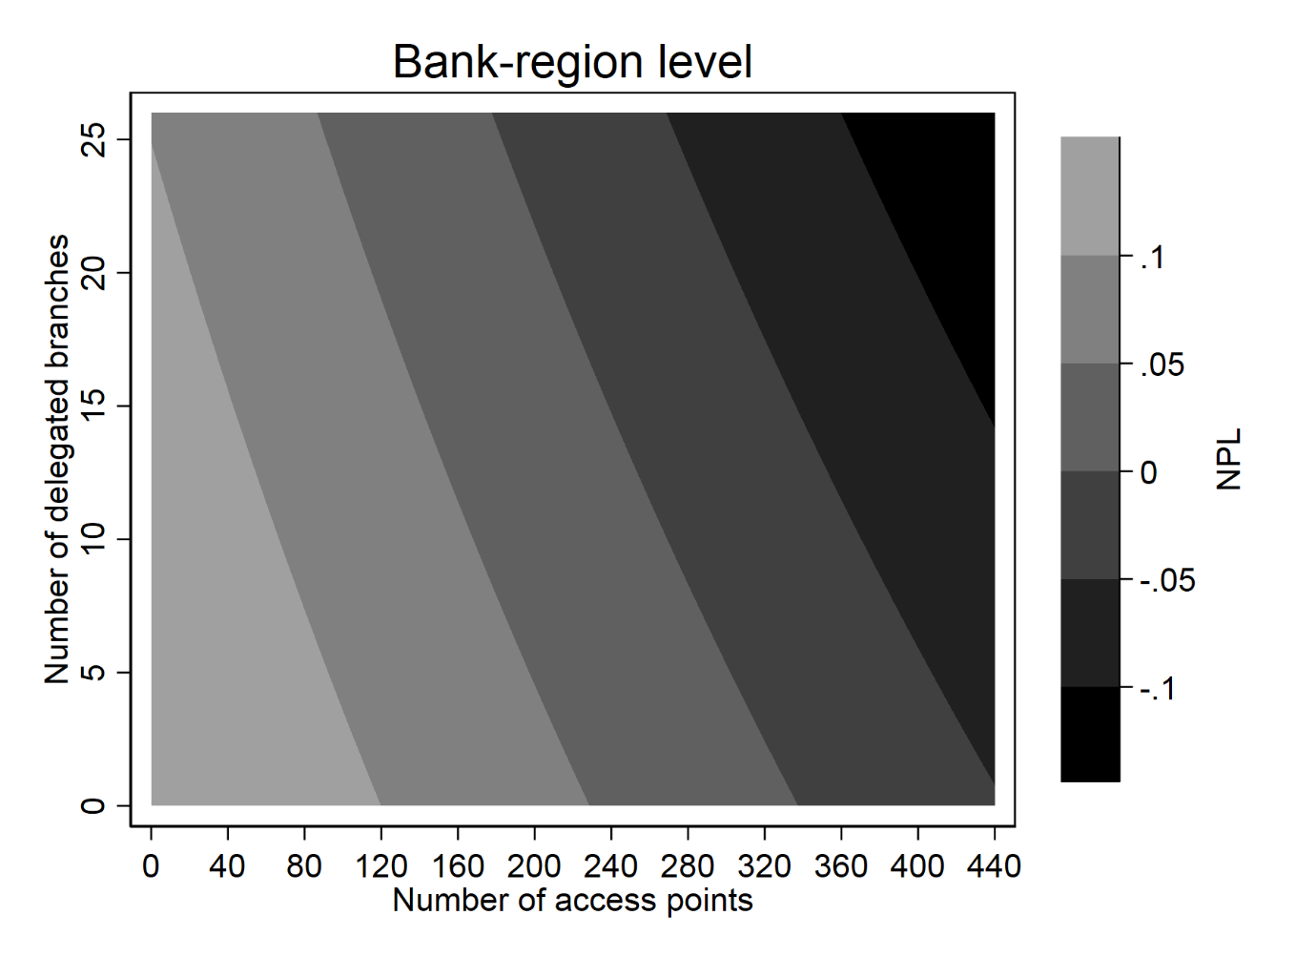 This figure shows the marginal effects of the number of local delegated branches and access points on predicted NPL^{total} ratio.

Appendix
Appendix Table 1. Heckman correction – Effects on lending
 | Total | Corporate | Personal
 | (1) | (2) | (3)
Outcome equation
Dispersion^{delegated branches} | 0.096*** | 0.076*** | 0.019
 | (0.021) | (0.023) | (0.018)
Dispersion^{access points} | 0.059*** | 0.040*** | 0.018**
 | (0.010) | (0.011) | (0.009)
Dispersion^{delegated branches}×Dispersion^{access points} | -0.019*** | -0.014*** | -0.004*
 | (0.003) | (0.003) | (0.002)
Other banks’ delegated branches | 0.020** | -0.054*** | 0.074***
 | (0.009) | (0.010) | (0.008)
Other banks’ access points | 0.084 | 0.028 | 0.057
 | (0.076) | (0.082) | (0.063)
Wholesale funding | -0.345*** | -0.837*** | 0.487***
 | (0.120) | (0.141) | (0.112)
Provisions | 0.178** | -0.320*** | 0.499***
 | (0.071) | (0.083) | (0.066)
Deposits/Assets | 0.699*** | 0.297*** | 0.406***
 | (0.055) | (0.064) | (0.051)
Size | 0.001 | -0.003 | 0.003
 | (0.005) | (0.006) | (0.004)
Equity/Assets | -0.136*** | -0.187*** | 0.057
 | (0.052) | (0.062) | (0.049)
Selection equation
LabourCost | 0.000 | 0.000 | 0.000
 | (0.006) | (0.006) | (0.006)
Services | 0.020 | 0.020 | 0.020
 | (0.018) | (0.018) | (0.018)
Dispersion^{delegated branches} | 0.691*** | 0.692*** | 0.692***
 | (0.056) | (0.056) | (0.056)
Dispersion^{access points} | 0.225*** | 0.225*** | 0.225***
 | (0.022) | (0.022) | (0.022)
Dispersion^{delegated branches}×Dispersion^{access points} | -0.095*** | -0.095*** | -0.095***
 | (0.012) | (0.012) | (0.012)
Other banks’ delegated branches | -0.028 | -0.028 | -0.028
 | (0.058) | (0.058) | (0.058)
Other banks’ access points | -1.677*** | -1.679*** | -1.679***
 | (0.380) | (0.380) | (0.380)
Wholesale funding | -1.629*** | -1.637*** | -1.637***
 | (0.463) | (0.463) | (0.463)
Provisions | -0.597* | -0.596* | -0.596*
 | (0.347) | (0.347) | (0.347)
Deposits/Assets | 0.815*** | 0.817*** | 0.817***
 | (0.171) | (0.171) | (0.171)
Size | -0.093*** | -0.094*** | -0.094***
 | (0.025) | (0.025) | (0.025)
Equity/Assets | -0.406* | -0.406* | -0.406*
 | (0.235) | (0.235) | (0.235)
Mills | 0.172*** | 0.116* | 0.053
 | (0.061) | (0.067) | (0.052)
Obs. | 2,379 | 2,380 | 2,380
This table presents estimated results for Model (1) with Loans/TA as the dependent variable, using the Heckman method to address sample selection bias. In all regressions, a constant term is included but not reported. Robust standard errors are presented in parentheses. Panel A shows result for the outcome equation while Panel B shows results for selection equation. Columns (1)-(3) show results with total loans, corporate loans, and personal loans, respectively. Dispersion^{delegated branches} and Dispersion^{access points} are the dispersion of delegated branches and access points, respectively. Wholesale funding is the ratio of deposits from non-bank financial institutions to total funding from customers. Size is the natural logarithm of total assets. Equity/Assets is the ratio of total equity to total assets. Deposits/Assets is the ratio of total deposits to by total assets. Provisions is the ratio of loan loss provisions to total assets. Other banks’ delegated branches and Other banks’ access points are the natural logarithms of the number of delegated branches and access points of other banks, respectively. In the selection equation, LabourCost and Services are the external instruments. LabourCost is the ratio of admin expenses to total income. Services is the ratio of commission income to gross income. ∗, ∗∗, and ∗∗∗ denote 10%, 5%, and 1% significance level, respectively.

Appendix Table 2. Heckman correction – Effects on NPL
 | Total | Corporate | Personal
 | (1) | (2) | (3)
Main equation
Dispersion^{delegated branches} | -0.010 | -0.006 | -0.008
 | (0.015) | (0.012) | (0.011)
Dispersion^{access points} | -0.021*** | -0.009 | -0.016***
 | (0.008) | (0.006) | (0.006)
Dispersion^{delegated branches}×Dispersion^{access points} | 0.005** | 0.002 | 0.004**
 | (0.002) | (0.002) | (0.002)
Other banks’ delegated branches | -0.015** | -0.020*** | 0.002
 | (0.007) | (0.006) | (0.005)
Other banks’ access points | -0.096** | -0.038 | -0.056
 | (0.049) | (0.042) | (0.036)
Wholesale funding | 0.460*** | 0.036 | 0.562***
 | (0.099) | (0.077) | (0.067)
Provisions | 1.214*** | 0.683*** | 0.496***
 | (0.055) | (0.047) | (0.039)
Deposits/Assets | -0.164*** | -0.094*** | -0.077**
 | (0.042) | (0.036) | (0.031)
Size | -0.012*** | 0.001 | -0.012***
 | (0.004) | (0.003) | (0.003)
Equity/Assets | -0.124** | -0.124*** | 0.032
 | (0.051) | (0.041) | (0.033)
Selection equation
LabourCost | -0.001 | 0.000 | -0.000
 | (0.006) | (0.006) | (0.006)
Services | 0.023 | 0.021 | 0.022
 | (0.019) | (0.018) | (0.019)
Dispersion^{delegated branches} | 0.704*** | 0.697*** | 0.698***
 | (0.056) | (0.056) | (0.056)
Dispersion^{access points} | 0.245*** | 0.234*** | 0.235***
 | (0.023) | (0.022) | (0.022)
Dispersion^{delegated branches}×Dispersion^{access points} | -0.098*** | -0.096*** | -0.096***
 | (0.012) | (0.012) | (0.012)
Other banks’ delegated branches | -0.036 | -0.043 | -0.044
 | (0.059) | (0.059) | (0.058)
Other banks’ access points | -1.529*** | -1.600*** | -1.530***
 | (0.380) | (0.380) | (0.380)
Wholesale funding | -1.931*** | -1.549*** | -1.584***
 | (0.517) | (0.473) | (0.478)
Provisions | -0.527 | -0.468 | -0.487
 | (0.363) | (0.355) | (0.351)
Deposits/Assets | 0.902*** | 0.848*** | 0.878***
 | (0.177) | (0.175) | (0.174)
Size | -0.107*** | -0.104*** | -0.096***
 | (0.026) | (0.026) | (0.025)
Equity/Assets | -0.901*** | -0.764*** | -0.678***
 | (0.261) | (0.254) | (0.247)
Mills | 0.051 | 0.013 | 0.037
 | (0.042) | (0.035) | (0.031)
Obs. | 2,358 | 2,364 | 2,363
This table presents estimated results for Model (1) with NPL as the dependent variable, using the Heckman method to address sample selection bias. In all regressions, a constant term is included but not reported. Robust standard errors are presented in parentheses. Panel A shows result for the outcome equation while Panel B shows results for selection equation. Columns (1)-(3) show results with total loans, corporate loans, and personal loans, respectively. Dispersion^{delegated branches} and Dispersion^{access points} are the dispersion of delegated branches and access points, respectively. Wholesale funding is the ratio of deposits from non-bank financial institutions to total funding from customers. Size is the natural logarithm of total assets. Equity/Assets is the ratio of total equity to total assets. Deposits/Assets is the ratio of total deposits to by total assets. Provisions is the ratio of loan loss provisions to total assets. Other banks’ delegated branches and Other banks’ access points are the natural logarithms of the number of delegated branches and access points of other banks, respectively. In the selection equation, LabourCost and Services are the external instruments. LabourCost is the ratio of admin expenses to total income. Services is the ratio of commission income to gross income. ∗, ∗∗, and ∗∗∗ denote 10%, 5%, and 1% significance level, respectively.

By 2016, about 69 per cent of banks locate their headquarters in Kyiv city.
In 2014, the top five regions with the highest gross regional product per capita included Kyiv region and the city of Kyiv, and Dnipropetrovsk, Poltava, Zaporizhzhya, and Kharkiv regions. In 2016 the top five regions with the highest share of enterprises are Kyiv region and the city of Kyiv, and Dnipropetrovsk, Odesa, Kharkiv, and Lviv regions.
Distance is measured by the geodic distance between two regions’ geographical centres.
We also experiment with the squared terms of branch network measures to control for non-linearity and get quantitatively consistent results. These results are available upon request.
As of 2016 Q4, the total number of active banks was 69. Total assets and total loans of banks included in our main analysis account for 57-58% of the whole system’s assets and loans.
Unusual data include NPL ratios and the ratios of the share of loans issued by a bank in a region to total loans of the bank that are greater than 1.
As a robustness check, we perform our analysis with the sample of banks whose status as of 2016 Q4 is active. Results of this analysis are presented in Section 4.5.
Note that this is the partial effect of Dispersion^{access points} when Dispersion^{delegated branches} is 0, i.e., when a bank does not have any delegated branch, or all delegated branches are in the same regional market with the head office.
This is the partial effect of Delegated branches when there is no access point in a given regional market.
Estimations with different time intervals yield quantitatively similar results and are available upon request.

