Medicating Nature: Are Human-Use Pharmaceuticals Poisoning the Environment?
Alistair B. A. Boxall, John L. Wilkinson, Alejandra Bouzas-Monroy
Department of Environment and Geography, University of York, Heslington, York, UK, YO10 5 NG
The diclofenac and vulture story
In 2003, Vibha Prakash and co-workers published a paper documenting the catastrophic decline in the populations of vulture species across India between the early 1990s and 2000 (Prakash et al., 2003). The authors pointed towards ‘infectious agents’ as the cause of the population decline and called for urgent action to confirm this and mitigate the problem. Subsequent forensic investigatory work (e.g., Oaks et al., 2004; Schultz et al., 2004) showed that the cause of the population decline was diclofenac, a commonly used non-steroidal anti-inflammatory pharmaceutical in humans, which was being widely used in the region to treat cattle. The rate of decline in vulture populations is one of the most rapid ever observed in any bird species and led to IUCN listing three vulture species as critically endangered. The crash in the vulture populations may also have indirectly affected human health from an increase in the incidence in rabies and other diseases resulting from increased numbers of scavenging feral dogs and cats and rodents associated with the vulture population decline (Markandya et al. 2008). This was one of the first examples of an active pharmaceutical ingredient (API) impacting the natural environment and the story provides an excellent illustration of how environmental residues of molecules that we use every day to treat and prevent illness can have major impacts on the natural environment and on human health. We now recognize that other APIs might also be causing impacts.
Multiple pharmaceuticals enter the environment through multiple pathways
In Europe, over 2000 APIs are used to prevent and treat disease in humans (Burns et al., 2018) and these can be released to the environment at all stages in a product’s lifecycle, from manufacture, through use to ultimate disposal (Boxall, 2004). The most significant source of pharmaceuticals to the environment is through excretion by the patient, although emissions from inappropriate disposal of unused medicines and manufacturing processes are also possible. In countries with developed and functioning waste and wastewater management systems, parent APIs and their metabolites are excreted in the urine and feces which are then transported via the sewer system to a treatment facility. While some APIs, such as paracetamol, will be extensively removed by the treatment system, others, such as carbamazepine (an anticonvulsant) and lidocaine (an anesthetic), will survive the treatment process and are released to surface waters in the effluent from the treatment process. APIs also have the potential to enter soils when processed sewage sludge is used as a fertilizer or wastewater effluent is used for irrigation (Boxall, 2004). In countries with limited or poorly functioning waste and waste management systems, APIs will also be released via direct emissions of untreated urine and fecal material from pipes, overflowing pit latrines and exhauster trucks; emissions from unmanaged waste dump sites; general littering; and emissions from manufacturing facilities (Wilkinson et al., 2022). The natural environment therefore receives a complex mix of APIs from multiple sources. As use of these molecules by society is continuous, emissions to the environment are continuous and, once in the environment, many of these APIs can persist for months to years (Boxall, 2004).
Pharmaceutical contamination is widespread
Given the widespread use of APIs and the connectivity between use and the natural environment, it is not surprising that human-use APIs occur widely in surface waters and soils across the globe (Aus der Beek et al., 2016). In a recent study, we explored the extent of API pollution across the world by measuring sixty-one commonly used APIs at 1052 locations on 258 rivers across 104 countries, representing the influence of 471.4 million people (Wilkinson et al., 2022). APIs were detected in 909 of the sampling locations studied. Fifty-three of the 61 APIs were found in at least one sample with the number of APIs detected in different countries ranging from 0 (Iceland and Venezuela) to 37 (US) (Figure 1 A). The most commonly APIs that were detected belonged to classes used to treat or control type 2 diabetes, depression, epilepsy, pain, inflammation, allergies, and microbial infections. The most contaminated site was in La Paz in Bolivia, where the cumulative pharmaceutical concentration was 297 µg l⁻¹. On-the-ground observations at this site indicated that it was subject to rubbish dumping and there was also evidence of exhauster tank emissions. The highest cumulative API concentrations were seen in low- to middle-income countries in Sub-Saharan Africa, South Asia, and South America (Figure 1 B) which were characterized by areas with low water flow, poor control of pharmaceutical use, poor wastewater and waste management infrastructure and pharmaceutical manufacturing. At some sites multiple APIs were detected with the most complex mixture being seen at a site on the Kai Tak River in Hong Kong where thirty-four different APIs were detected. As this study used a consistent approach to monitor API at a global scale, it allowed us, for the first time, to compare levels of pollution and subsequent risks across countries. The study demonstrated that API contamination is widespread across the globe, which raises the question: ‘Are these APIs causing harm in the environment?’.
Multiple effects on organisms are possible
Pharmaceuticals are biologically active and designed to interact with receptors or biochemical pathways, known as targets, in the treated patient, often at exceptionally low doses. A recent analysis of the degree of conservation of the drug targets for 975 APIs in fish, invertebrates and algae indicated > 90% of all human drug targets had orthologues in the zebrafish (Dania rerio), 64% of the targets had orthologues in the water flea (Daphnia pulex) and 34% in the green algae (Chlamydomonas reinhardtii) (Gunnarsson et al., 2018). It might, therefore, be expected that APIs could affect organisms in the environment at low concentrations and there are numerous laboratory and controlled field studies supporting this. A good example is a 7-year whole lake studies with ethinyl estradiol (EE2), a synthetic estrogen used as a contraceptive. In the study, EE2 was added weekly to the lake to give a concentration of 5–6 ng·l⁻¹ which is around an order of magnitude higher than concentrations seen in riverine systems. The chronic exposure led to feminization of male fathead minnow (Pimephales promelas) and a near extinction of this species from the lake. The effects of antidepressants have also been extensively investigated with numerous studies assessing impacts on organism behavior (e.g., Brodin et al., 2014). Taken together, these show that antidepressant APIs can affect a range of behaviors in fish and invertebrates including aggression, sociality, feeding, reproduction, boldness, and response to light. These effects occur at levels as low as 8 ng l⁻¹ (Brodin et al., 2014). If these effects occur in the natural environment, they could alter how organisms feed and interact and have negative consequences for population survival. Effects for other API classes include impacts on a plethora of biochemical endpoints, such as glucose levels, thyroid hormone levels, acetylcholinesterase activity and chlorophyll concentrations in either fish, invertebrates or plants, effects on microbial functioning, and impacts on fish and invertebrate growth (e.g., Boxall et al., 2004; Bouzas-Monroy et al., 2022).
But do these ecotoxicological effects seen in these controlled experiments occur in the real world? To answer this question, Bouzas-Monroy et al. (2022) used published ecotoxicological and pharmacological data to derive ‘safe’ concentrations for the 53 APIs detected in the global monitoring of pharmaceuticals study. When these concentrations were compared to the concentrations measured at each of the sampling locations, 43.5% of the 1052 sampling locations were found to have concentrations of APIs of ecotoxicological concern. Twenty-three APIs occurred at concentrations exceeding “safe” concentrations, including substances from the antidepressant, antimicrobial, antihistamine, β-blocker, anticonvulsant, antihyperglycemic, antimalarial, antifungal, calcium channel blocker, benzodiazepine, painkiller, progestin, and lifestyle compound classes. At the most polluted site in La Paz and the site on the Kai Tak River in Hong Kong with the highest number of APIs detected, effects were predicted on multiple taxonomic groups and multiple endpoints within a single taxon (see Figure 2A and B). At these sites, concentrations of some APIs in fish plasma are expected to exceed levels that would occur in a human receiving the API and an unacceptable impact on algal growth, daphnia growth, fish biochemistry and behaviors is expected (Figure 2 A and B). It is likely that these multi-trophic level and multi-endpoint effects will exacerbate the impacts of APIs on the ecological communities in these systems, although the implications of these interactions are still unclear.
Human exposure and effects are also possible
Pharmaceutical pollution is also likely affecting human health. Monitoring data show that APIs can migrate from the environment into drinking water supplies (Aus der Beek et al., 2016). APIs can also be accumulated into crops (Schapira et al., 2020) providing a pathway for human exposure to environmental residues of APIs in soils. Monitoring studies of the antiepileptic medicine carbamazepine in urine taken from different human cohorts in Israel (Schapira et al., 2021) demonstrates that environmental residues of APIs can end up in the human body with a substantial proportion of the 245 study participants (75.9% of adults, 19.6% of children), none of whom were prescribed carbamazepine therapeutically, having detectable levels of carbamazepine in their urine. The main contributor to this exposure was believed to be consumption of fruit and vegetables grown in areas irrigated with treated wastewater – a frequent practice in arid regions such as Israel which is also forecast to increase in other regions of the World because of climate change. While the levels of human exposure to APIs from drinking water and food consumption are extremely low and orders of magnitude lower than acceptable daily intakes, exposure will occur to multiple APIs across the lifetime of a human so there are concerns over the potential impacts of such chronic low-level mixture exposures on health.
While the direct toxicological risks of APIs to the environment are low, there are major concerns over the indirect risks to human health from antimicrobial APIs and their potential to select for resistance in microbes. In 2019, 1.27 M deaths globally were attributed directly to antimicrobial resistance (AMR)(Murray et al., 2022) and this number is forecast to increase into the future with OECD estimating an extra 10 M extra yearly deaths caused by drug resistant diseases by 2050. There is increasing recognition that the natural environment is contributing to this crisis through a pool of resistance genes present in the environment. This pool results from a mix of naturally occurring resistance, resistance genes released in animal and human waste and resistance resulting from exposure to pollutants, such as APIs used as antibiotics (Wellington et al., 2012). Recognising the potential importance of the environment as a source of resistance, the Antimicrobial Industry Alliance (AMRIA) has developed a series of “safe” target concentrations to control antimicrobial emissions from manufacturing plants which allows us to establish the scale of the problem. Comparison of these ‘safe’ concentrations with measured concentrations of antimicrobials from the global monitoring of pharmaceuticals study shows that 174 of the 1052 sites sampled had antimicrobial concentrations of potential concern for resistance selection. Cyprus, Bolivia and Pakistan had the greatest proportion of monitoring locations at risk with 100, 90 and 89% of sites respectively having concentrations exceeding the AMRIA targets. Concentrations of eight antimicrobials (ciprofloxacin, clarithromycin, enrofloxacin, erythromycin, lincomycin, sulfamethoxazole and trimethoprim) exceeded the ‘safe’ target concentration in at least one location. The greatest exceedance of the safe target was seen for metronidazole at a site in Bangladesh receiving wastewater emissions and located close to a site owned by a generic pharmaceutical manufacturing company. At this site, concentrations of metronidazole were more than three hundred times higher than the safe target concentration (Wilkinson et al., 2022).
Action is needed to understand the scale of the problem and to clean up the most contaminated sites
It is now clear that environmental contamination by APIs is widespread and that a considerable proportion of rivers globally have concentrations of APIs of concern for both ecological and human health. Our understanding of the scale of the problem is, however, still limited. Work to date has focused on only a small proportion of APIs on the market and we lack an understanding of the occurrence and effects of most APIs in use. Even though initiatives like the global monitoring of pharmaceuticals project are providing insights into the level of API pollution across the globe, most research still focuses on systems in higher income economies so for many countries we still have limited or no understanding of the risks. Impact assessment work also generally compares laboratory findings with field measurements of exposure so it is not yet clear whether these theoretical impacts occur in reality. Moving forwards, global collaborative efforts are needed to characterize the exposure, effects, and the in-field impacts of the universe of APIs and the drivers of these impacts. The global monitoring of pharmaceuticals project, which involved partners from across the globe, provides a potential blueprint for these types of studies.
It is, however, clear that many locations, particularly in poor-resource settings, are grossly polluted with APIs. The observations for the antimicrobials are particularly alarming. Given the scale of the AMR crisis, even with the uncertainties around impacts of environmental exposure, if we are to fulfill the United Nations' 17 Sustainable Development Goals, particularly Goal 6, “Clean Water and Sanitation” (United Nations, 2015), work is urgently needed to reduce antimicrobial emissions into these systems. While advanced wastewater treatment technologies, typically used in N. America and Europe, would be an effective solution, they are not currently practical in the most contaminated systems which typically have limited or no sewer connectivity. In the short term we need to look to more imaginative low cost, minimal maintenance and low energy solutions to fix the problem. An integrated approach is required involving better regulation, education of API users, adoption of the AMRIA standards by all manufacturing plants, improving the functioning of existing waste and waste management infrastructure and development of novel low-cost treatment systems such as nature-based solutions, that can be applied at the source. By combining these approaches, we will be able to reduce the residues of APIs, and other chemical pollutants, in the environment, benefiting both ecological and human health and enabling us to avoid future incidents like the vulture story.

References
Aus der Beek, T., Weber, F. A., Bergmann, A., Hickmann, S., Ebert, I., Hein, A., & Küster, A. (2016). Pharmaceuticals in the environment—Global occurrences and perspectives. Environmental Toxicology and Chemistry, 35(4), 823– 835
Burns, E. E., Carter, L. J., Snape, J., Thomas-Oates, J., & Boxall, A. B. A. (2018). Application of prioritization approaches to optimize environmental monitoring and testing of pharmaceuticals. Journal of Toxicology and Environmental Health—Part B: Critical Reviews, 21(3), 115–141.
Oaks, J.L., Gilbert, M., Virani, M.Z., Watson, R.T., Meteyer, C.U., Rideout, B.A., Shivaprasad, H.L., Ahmed, S., Chaudry, M.J.I., Arshad, M., Mahmood, S., Ali, A. & Khan, A.A. (2004) Diclofenac residues as the cause of population decline of vultures in Pakistan. Nature, 427, 630–633.
Bouzas-Monroy, A. Wilkinson, J.L., Melling, M., Boxall, A.B.A. (In Press) Assessment of the potential ecotoxicological effects of pharmaceuticals in the World's rivers. Environ. Toxicol. Chem. 41(8): 2008-2020.
Boxall, A. B. A. (2004). The environmental side effects of medication: How are human and veterinary medicines in soils and water bodies affecting human and environmental health? EMBO Reports, 5(12), 1110–1116.
Brodin, T., Piovano, S., Fick, J., Klaminder, J., Heynen, M., & Jonsson, M. (2014). Ecological effects of pharmaceuticals in aquatic systems— Impacts through behavioural alterations. Philosophical Transactions of the Royal Society of London. Series B, Biological Sciences, 369, Article 20130580.
Gunnarsson, L., Snape, J. R., Verbruggen, B., Owen, S. F., Kristiansson, E., Margiotta-Casaluci, L., Österlund, T., Hutchinson, K., Leverett, D., Marks, B., & Tyler, C. R. (2019). Pharmacology beyond the patient—The environmental risks of human drugs. Environment International, 129, 320–332.
Kidd, K. A., Blanchfield, P. J., Mills, K. H., Palace, V.P.,Evans, R. E., Lazorchak, J. M., & Flick, R. W. (2007). Collapse of a fish population after exposure to a synthetic estrogen. Proceedings of the National Academy of Science of the United States of America, 104, 8897–8901.
Markandya, A., Taylor, T., Longo, A., Murty, M.N., Murty, S., Dhavala, K. (2008) Counting the cost of vulture decline—An appraisal of the human health and other benefits of vultures in India. Ecol. Econ. 67: 194-204.
Murray, C. J., Ikuta, K. S., Sharara, F., Swetschinski, L., Aguilar, G. R., Gray, A., Han, C., Bisignano, C., Rao, P., Wool, E., & Johnson, S. C. (2022). Global burden of bacterial antimicrobial resistance in 2019: A systematic analysis. Lancet, 399, 629–655.
Prakash, V., Pain, D.J., Cunningham, A.A., Donald, P.F., Prakash, N., Verma, A., Gargi, R., Sivakumar, S. & Rahmani, A.R. (2003) Catastrophic collapse of Indian white-backed Gyps bengalensis and long-billed Gyps indicus vulture populations. Biological Conservation, 109, 381–390.
Schapira, M., Orly, M., Golan, N., Kalo, D., Mordehay, V., Kirshenbaum, N., Goldsmith, R., Chefetz, B., Paltiel, O. (2020) Involuntary human exposure to carbamazepine: A cross-sectional study of correlates across the lifespan and dietary spectrum. Environ. Internat. 143: 105951.
Shultz, S., Baral, H.S., Charman, S., Cunningham, A.A., Das, D., Ghalsasi, G.R., Goudar, M.S., Green, R.E., Jones, A., Nighot, P., Pain, D.J. & Prakash, V. (2004) Diclofenac poisoning is widespread in declining vulture populations across the Indian subcontinent. Proceedings of the Royal Society of London, B (Supplement): 271, S458–S460.
Wellington, E. M. H., Boxall, A. B. A., Cross, P., Feil, E. J., Gaze, W. H., Hawkey, P. M., Johnson-Rollings, A. S., Jones, D. L., Lee, N. M., Otten, W., Thomas, C. M., & Williams, A. P. (2013). The role of the natural environment in the emergence of antibiotic resistance in Gram-negative bacteria. Lancet Infectious Diseases, 13(2), 155–165. https://doi.org/10.1016/S1473-3099(12)70317-1
Wilkinson, J. L., Boxall, A. B. A., Kolpin, D. W., Leung, K. M. Y., Lai, R. W. S., Galbán-Malagón, C., Adell, A. D., Mondon, J., Metian, M., Marchant, R. A., Bouzas-Monroy, A., Cuni-Sanchez, A., Coors, A., Carriquiriborde, P., Rojo, M., Gordon, C., Cara, M., Moermond, M., Luarte, T., & Teta, C. (2022). Pharmaceutical pollution of the world's rivers. Proceedings of the National Academy of Sciences of the Unites States of America, 119(8): e2113947119. https://doi.org/10.1073/PNAS.2113947119

Figure 1. A. Numbers of active pharmaceutical ingredients detected in surface waters in the global monitoring of pharmaceuticals project. B. Mean cumulative concentrations of sixty-one active pharmaceutical ingredients in surface waters for each country monitored in the global monitoring of pharmaceuticals project. Data taken from Wilkinson et al. (2022).
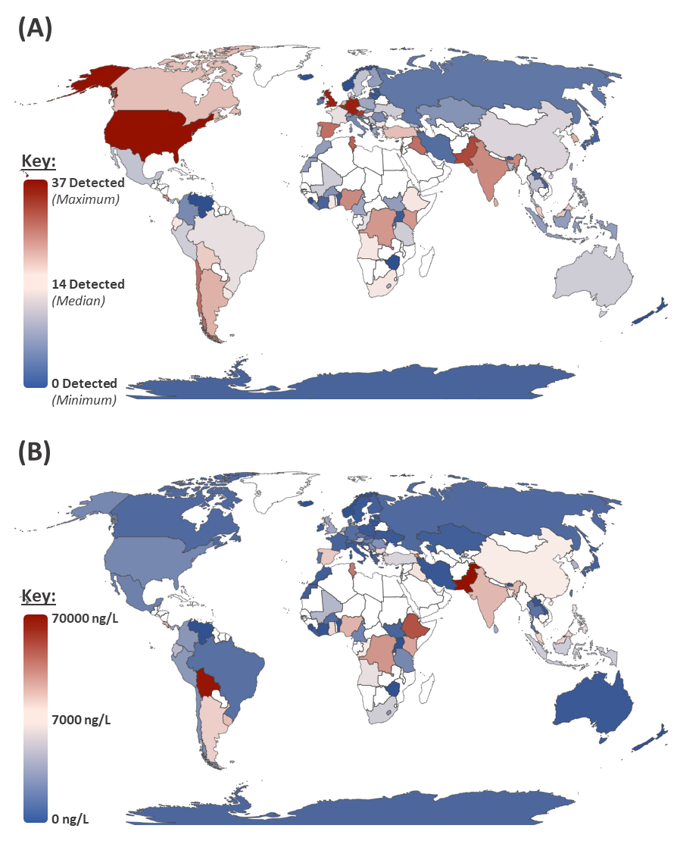
Figure 2. A and B. Spider plots indicating the level of exceedance of ‘safe’ values for a range of endpoints by active pharmaceutical ingredient (API) at locations on rivers in La Paz in Bolivia and the Kai Tak River in Hong Kong. The CEC is the concentration in the water needed for the API concentration in exposed fish to reach the human plasma therapeutic concentration for an API. The numbers are hazard quotients and if these exceed one, an effect is considered possible. C. Proportion of sites by country exceeding the ‘safe’ concentrations for antimicrobial compounds proposed by the AMR Industry Alliance.
