Universal Basic Income is affordable and feasible: evidence from UK economic microsimulation modelling

Howard Robert Reed, Director, Landman Economics. howard@landman-economics.co.uk
Matthew Thomas Johnson, Professor of Politics, Northumbria University. ORCID ID: 0000-0002-9987-7050. matthew7.johnson@northumbria.ac.uk
Stewart Lansley, Visiting Fellow, University of Bristol. ORCID ID: 0000-0001-9352-9779. stewartlansley@aol.com
Elliott Aidan Johnson, Associate Senior Research Fellow, Northumbria University. ORCID ID: 0000-0002-0937-6894. elliott.johnson@northumbria.ac.uk
Graham Stark, Open University & Virtual Worlds. ORCID ID: 0000-0002-4740-8711. graham.stark@virtual-worlds.biz
Kate E. Pickett, Professor of Epidemiology, University of York. ORCID ID: 0000-0002-8066-8507. kate.pickett@york.ac.uk

Abstract: Critics of Universal Basic Income (UBI) have claimed that it would be either unaffordable or inadequate. This discussion paper tests this claim by examining the distributional impacts of three UBI schemes broadly designed to provide pathways to attainment of the Minimum Income Standard (MIS). We use microsimulation of data from the Family Resources Survey to outline the static distributional impacts and costs of the schemes. Our key finding is that even the fiscally neutral starter scheme would reduce child poverty to the lowest level achieved since 1961 and achieve more than the anti-poverty interventions of the New Labour Governments from 2000. The more generous schemes would make further inroads into the UK’s high levels of poverty and inequality, but at greater cost. We conclude by assessing fiscal strategies to reduce the up-front deficit of higher schemes, providing a more positive assessment of affordability and impact than critics have assumed.
Key words: Universal Basic Income; microsimulation modelling; poverty; inequality; Minimum Income Standard

Introduction
The UK is a high poverty and high inequality country. Both have risen sharply since the post-1961 low point in the late 1970s (see Figure 1), with profound consequences for health and social outcomes, life chances and social resilience (Wilkinson & Pickett 2006; 2017, Lansley 2021, 209-31). As a result, there is now a growing debate about how to reform the system of social protection and create greater economic equality.
One of the key policies proposed is a Universal Basic Income (UBI). There are many different moral, economic and health justifications for UBI, but evidence on more complex impacts is uneven due to the absence of existing trials that are universal, unconditional and of a size sufficient to make a difference to lives within the UK (Johnson, Johnson & Webber 2020). However, the Welsh Government (Welsh Government 2022) has introduced a pilot of a basic income for Care Leavers at a level (£1,600 a month) capable of enabling individuals to live independently and securely without having to rely on employment or conditional welfare schemes. While, properly evaluated, this pilot ought significantly to enhance understanding of the effect of unconditional payments, it will not enable consistent generalisation due to its being paid to an extremely vulnerable and disadvantaged cohort that is not representative of the UK population. Given the cluster of structural social weaknesses increasingly recognised, including by the Conservative Government (Secretary of State for Levelling Up, Housing and Communities 2022), and given the number of social, employment, health and environmental crises that call for simple, easy-to-administer policies capable of addressing multiple issues, there is genuine need among policymakers to evaluate the potential contribution of UBI schemes (Johnson et al. 2022b).

Figure 1: Trends in poverty and inequality (1977-2020)
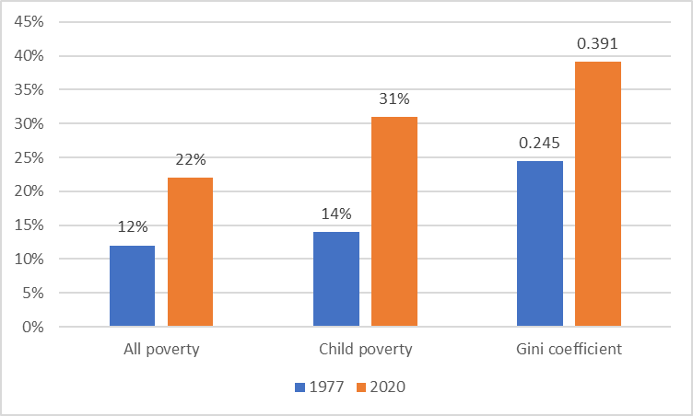
Source: Institute for Fiscal Studies (2022)
In this discussion paper, we put forward an examination of the distributional impacts of three UBI schemes broadly designed to provide pathways to attainment of the Minimum Income Standard (MIS). This is the income needed by different types of households to reach a socially acceptable minimum living standard, as determined in part by the general public (Hirsch 2019, 4). The first is a starter scheme to provide an entry payment; the second an intermediate scheme; and the third a full MIS payment to which increases in less generous schemes could be aimed at over time. We use microsimulation of data from the Family Resources Survey to outline the static distributional impacts and costs of the schemes. We then present a series of fiscal options by which to pay for them.

The UK’s crisis of poverty and inequality
There is now a large body of evidence about the impact of today’s heightened rates of inequality and poverty. Studies have shown that higher inequality has created brittle economies that are especially prone to turbulence and weak growth (Ostry, Berg & Tsangarides 2014). The UK has become a country with a built-in bias to inequality and a social support system that offers a weak level of protection. As a result, the negative impact of a series of rolling shocks – from rapid deindustrialisation, weak wage growth and the 2008 financial crisis to a decade of austerity and now COVID-19 – have been borne most heavily by low-income citizens in a way that has intensified this bias (Lansley, 2021, 209-38).
Because of the impact of inequality and the low level of benefits compared with comparable nations (OECD 2022), the poorest fifth of Britons are today much poorer than their counterparts in other, more equal nations. Germany’s poorest fifth, for example, are a third better off on average than those in Britain (Figure 2).

Figure 2: Average incomes of poorest fifth in other countries compared with the UK, 2018, Ratio: UK=1
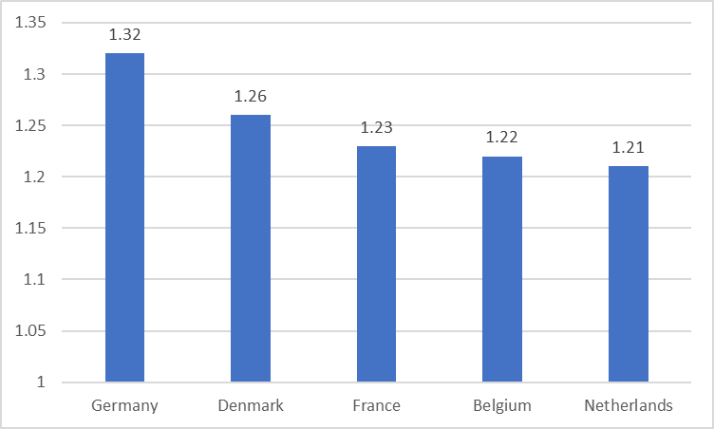
Source: Calculated by the authors from OECD (2018).
This lack of protection is particularly true for those of working age. Although conditional forms of welfare may have a role to play in supporting those with particular needs, today’s ‘hyper means-tested system’ (Pt2 2020) requires complex and often intrusive and inefficient administration, imposes perverse incentives for inactivity (Johnson, Degerman & Geyer 2019; Johnson & Spring 2018) and has contributed to rising levels of personal stress (Johnson & Johnson 2019). It is ill-suited to today’s economic model of extensive low pay and insecure and often intermittent work for a growing minority of the workforce. It fails to meet the principles of universalism and entitlement originally advanced by Sir William Beveridge in 1942 and implemented in the post-war reforms. Benefit levels are low compared with other rich countries (OECD 2022). The real level of child benefit has fallen by a quarter since 2010, while the main adult unemployment payment has been falling steadily as a share of average earnings (Brewer & Gardiner 2020). Working-age benefits come with an extreme level of conditionality and a greatly eroded principle of entitlement. In the middle years of the 2010s, five million sanctions were issued against benefit claimants (Webster 2018). Sanctions were suspended during lockdown but have now been reinstated and extended (Lansley 2022).
Because of these faults, there have been calls, eighty years on from his original report, for a new Beveridge plan (see e.g., The Guardian 2022). Public attitudes towards benefit recipients have become more sympathetic (British Social Attitudes 2020). The soft-right think tank, Bright Blue, has set up a Commission to review the existing social security system, while another, ResPublica, launched a ‘Conservative anti-poverty month’ in June 2021 (Bright Blue 2021).
An important effect of the pandemic, and then the cost-of-living crisis, has been a significant increase in state intervention to provide financial support to business and individuals, a move widely interpreted as a weakening of the anti-state, neoliberal rule book. However, the Job Retention Scheme, colloquially known as furlough, and other forms of support to employers and the self-employed were granted with low levels of conditionality and were expressly vulnerable to fraud (HM Treasury 2022a). Those payments also paid people not to work. As the post-pandemic cost of living crisis worsened, the Government then sought to grant support to around 80% of households through the Energy Bills Rebate (HM Treasury 2022b). While these interventions, along with the Levelling Up agenda, are signs of a partial ideological shift, we argue that the logical conclusion of that shift goes beyond minor revisions of the existing system.

A guaranteed, non-means-tested Universal Basic Income
The transformative politics of change initiated by the Labour Government of 1945 helped to achieve peak equality and a low point for poverty in the late 1970s. This was aided by a number of equality-promoting instruments, including a more comprehensive system of social insurance, free health care, family allowances (later merged into child benefit) and a progressive tax system.
Tackling today’s heightened levels of inequality and poverty requires new equality-promoting instruments. Here we test the anti-poverty and pro-equality potential of UBI. This universal and largely unconditional payment, benefiting those in and out of work, would embrace the principle of an entitlement to a ‘national minimum of civilised life’ promoted by Beatrice and Sidney Webb before the First World War (Royal Commission on the Poor Laws and the Relief of Distress 1909) and the 1942 Beveridge proposals (Beveridge 1942). Depending on its level, it would replace some existing benefits, though parts of the existing system would remain, even in more generous schemes, in order to support needs associated with disability, maternity and housing (Stirling & Arnold 2019). All legal UK residents would be entitled, with legal migrants eligible after an agreed minimum number of years of residence.
While it has mostly stayed marginal to the social policy debate, interest in the idea has been rising on the UK social and political agenda in just a few years. The reasons for this include people’s recognition of the impacts of poverty, inequality and insecurity in their lives (Nettle et al. 2021; Johnson, Johnson & Nettle 2022) and increasing awareness of a number of trials around the globe. In the UK, 40 citizen-led local UBI advocacy hubs have been formed and 30 local councils have declared interest in running pilots. More than 500 leading public figures called for an emergency basic income as a response to the COVID-19 crisis (The Independent 2020), the Financial Times has called for a national debate on its merits (Financial Times 2020) and even former critics, such as the Joseph Rowntree Foundation, are now taking a more sympathetic approach (Joseph Rowntree Foundation 2021). While UBI is backed by the Green Party, the Liberal Democrats, and, at least in principle, the SNP, it has yet to gain support from the present Westminster government and Labour’s current leadership.
However, the Welsh pilot basic income scheme may have begun to shift assessment of political viability. This is the first such pilot of unconditional payments for adults in the UK and has honed interest among policymakers in the practical implications of the policy. It is being used as a pilot for universal roll out of the scheme.

One of the key criticisms of UBI is that it is unaffordable. This has been supported by Martinelli’s (2017) assessment of five UBI schemes, each of which have payments significantly below those we set out in this paper, which build on levels we identified as having the potential to promote health (Johnson et al. 2021). The schemes examined by Martinelli ranged from £42.19 per week for all adults and children (total annual cost of £140bn) to £115.29 for working age adults, £197.79 for pensioners (65+ for men and 62+ for women) and £109.20 for under 18s (total annual cost of £427bn). Martinelli (2017, 74) concluded that the lower scheme has too low a payment to provide the benefits noted above compared with the current system, while a more generous scheme would be too expensive. He believes that an intermediate scheme may ‘represent the worst of both worlds: … unable to ‘piggyback’ on existing systems and institutions, requiring brand new ones operating alongside those that already exist’ and representing ‘greater rather than reduced administrative complexity and cost’ (Martinelli 2017, 74).
We have argued elsewhere (Johnson et al. 2021) that Martinelli fails to recognise the shift in public perception of deficits following the pandemic and that his static microsimulation (which considers only up-front impact on public finances) fails to account for the range of dynamic social gains, for example, on health, which would reduce the initial gross cost of schemes. Here, although we look at static microsimulation, we set out potential means of covering the costs of schemes up-front. We have also provided elsewhere (Johnson et al. 2022a) preliminary modelling of the scale of health savings that could be achieved from the schemes based only on two conditions (anxiety and depression) among 14- to 24-year-olds.

Testing three possible schemes
Here, we put Martinelli’s claim to the test with analysis of three schemes (and an additional two variations) that stretch from an updated version of an entry-level starter scheme (Lansley & Reed 2019) up to a full Minimum Income Standard payment (MIS). This is because our model of impact indicates that meeting basic needs has the potential affect health positively and MIS is a measure of the costs needed to meet basic needs. However, we acknowledge that lower schemes may be able to impact health partially via this pathway or via other pathways. As such, and given discussions around affordability, it was important to provide options on a trajectory to MIS. We used the Landman Economics Tax-Transfer Model (TTM) to microsimulate the impacts of the schemes and compare against the present UK tax-benefit system baseline. The model (see Reed et al, 2022) was originally developed for the Institute for Public Policy Research and is also used by the Resolution Foundation and the Joseph Rowntree Foundation. We modelled: gross costings of each scheme; direct taxes, NICs and benefits; distributional impacts on income deciles; percentage of gainers and losers; impact on inequality of disposable incomes and poverty rates. The figures are corrected for non-take-up of Universal Credit and other means-tested payments (take-up of UBI is assumed to be universal, by definition). They do not include dynamic impacts in health, economic activity, etc., though all the schemes would offer improved health gains, in a way that would lower existing health inequalities, especially in the more generous schemes.
Each scheme is intended to meet the following conditions. That it would: be paid to all eligible citizens, without condition; raise the incomes of lower income groups; reduce the percentage gap between the top and bottom through fiscal reform; be high enough to make a material difference to people’s lives; raise the level of universality in the social security system, thus reducing reliance on means-testing; minimise losses for low-income households; minimise the amount of disruption involved in moving to a new system of income support; and enjoy broad public support. Affordability was a consideration, with up-front fiscally neutral options included in all formulations. However, affordability can be defined in a number of ways, with up-front borrowing during both the pandemic and cost-of-living crisis accepted by both main parties as a reasonable approach. We have tested such schemes among critical ‘red wall’ voters and have found evidence that the schemes enjoy support (Johnson, Johnson & Nettle 2022). The payments for the three schemes are shown in Table 1, and more details about payments, eligibility as well as proposed scheme-specific taxation changes are provided in the following tables. We do not address, here, how such payments would be administered as it does not have a direct impact on economic modelling. However, we have indicated elsewhere that payments should be made to individuals where possible in order, for example, to promote autonomy and avoid embedding existing power dynamics (Johnson, Johnson & Webber 2020). For under-18s, there would need to be further examination as to when young people should receive the full or partial payment, or whether it should go to the parent/guardian.

Table 1: Universal Basic Income payments by household type for scheme 1, 2, 2a, 3 and 3a
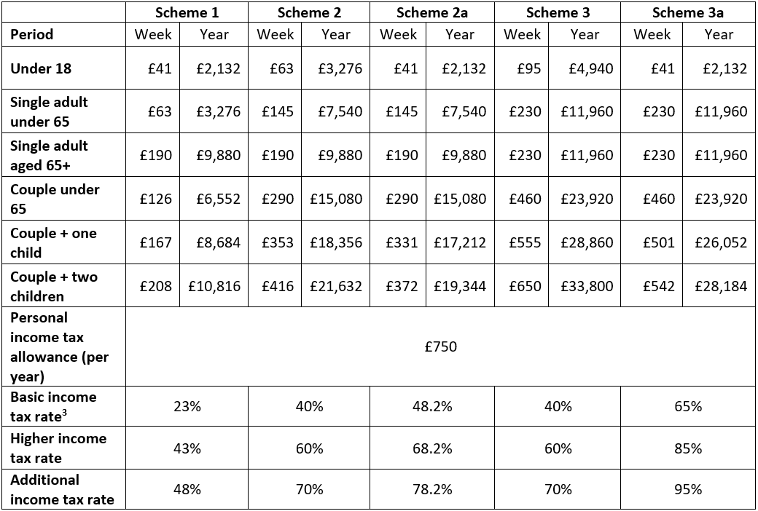
Scheme 1 is a modest ‘lower level’ scheme with payments of £41 per child and £63 per adult under 65. As illustrated in Table 2, it has been designed so that it is very close to being fiscally neutral in static terms in order to address Martinelli’s affordability and adequacy question. The scheme involves no additional calls on public finances: the cost of the extra payments would be exactly offset by the extra revenue from internal changes in tax rates and National Insurance Contributions (NICs).
Scheme 2 is an intermediate scheme set at the mid-point between the lower and upper levels. As Table 3 illustrates, other changes are the same as in Scheme 1. Scheme 2a includes the lower £41 payment to children that is consistent with a Minimum Income Standard (MIS) payment level for children and is still almost twice the 2021/22 Child Benefit payment for the first child.
Scheme 3 is a higher-level scheme with payments high enough to ensure that all families reach the MIS. Table 4 sets out funding formulation. Scheme 3a includes the lower MIS £41 payment for children.

Table 2: Tax-benefit formula for Scheme 1
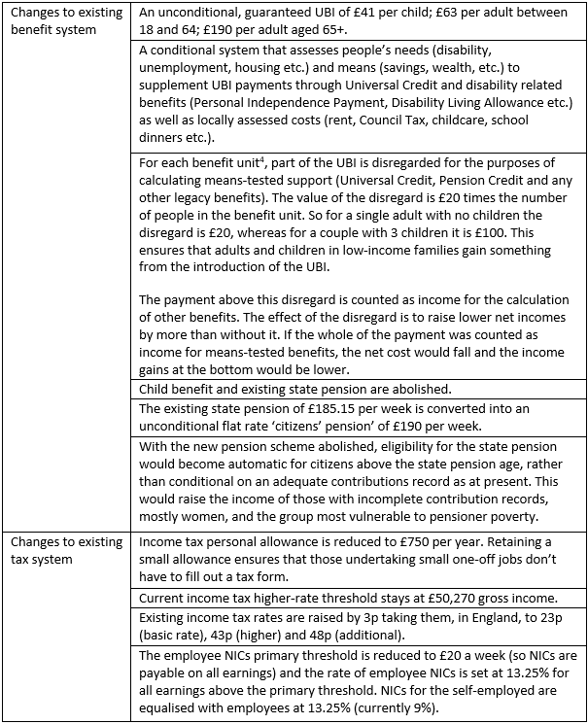

Table 3: Tax-benefit formula for Scheme 2 and 2a
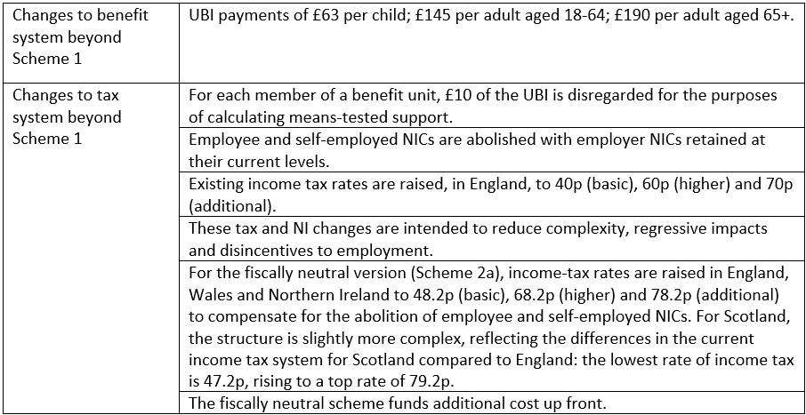

Table 4: tax-benefit formula for Scheme 3 and 3a
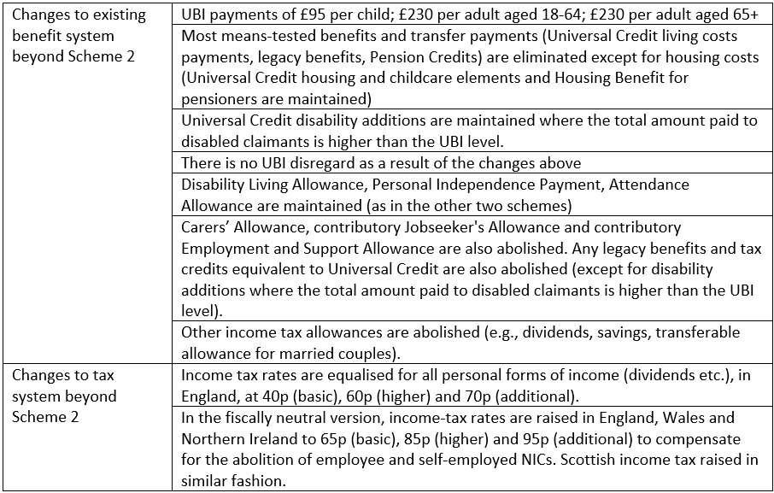

Inequality and costings
We designed the schemes with a series of progressive taxation reforms that yielded sufficient revenue to ensure fiscal neutrality. These reforms have the effect of creating a more progressive income tax system, including the clawing back of the payments to those on the highest income. Each scheme, for example, involves the reduction of the personal tax allowance to £750 per year . The personal allowance above this level currently costs £91bn but is of less benefit to those with earning below the threshold (currently £12,570). They are unable to take full advantage of this tax-free amount, while those who pay the higher rate effectively benefit twice compared with basic rate payers. For higher rate taxpayers, some of their income is brought into the 20% rate that would otherwise fall in the 40% rate and some is brought into the 20% rate that would otherwise fall in the 40% rate. A reform to reduce the personal allowance would be highly progressive in its own right if the revenue savings were used to fund a flat-rate payment as even those with no income currently would benefit.
We achieved fiscal neutrality for Scheme 1 but produced both fiscally neutral and non-neutral versions of schemes 2, 2a, 3 and 3a. For our purposes, overall fiscal balance is achieved when the cost of the additional benefits are fully met by the additional revenue from tax changes. As illustrated in Table 5, the non-fiscally neutral versions of these schemes leave large budgetary deficits ranging from £76.8bn in 2a to £284.3bn for the full MIS scheme. By way of illustration, to achieve fiscal neutrality solely through reform of marginal income tax rates, an increase to 48.2p, 68.2p and 78.2p is required for Scheme 2 (Table 3) and 65p, 85p and 95p for Scheme 3 (Table 4).

Table 5: Costings of schemes (£bn)
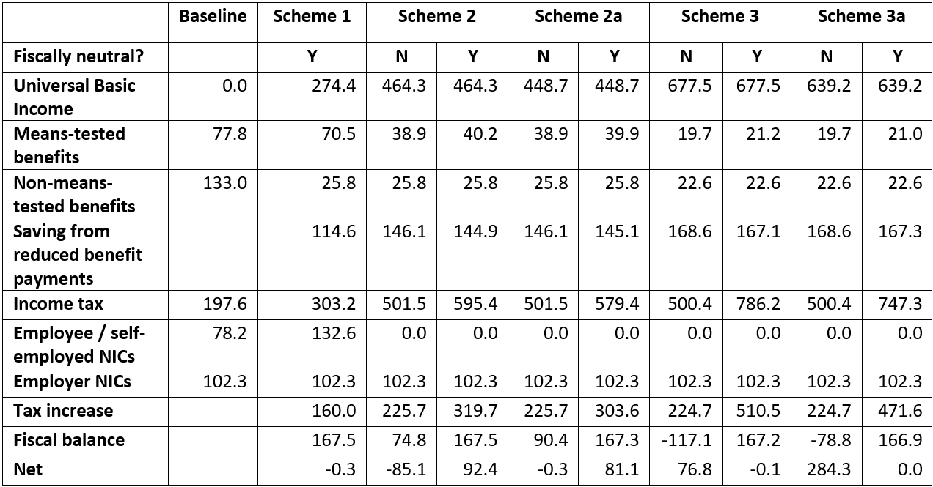
The distributional impacts of the schemes are significantly progressive. As Table 6 shows, even Scheme 1 achieves a significant average increase in income for the lowest (139.5%) and a smaller increase for the second lowest (8.2%) decile.

Table 6: Percentage point distributional impacts of schemes on benefit unit incomes by deciles
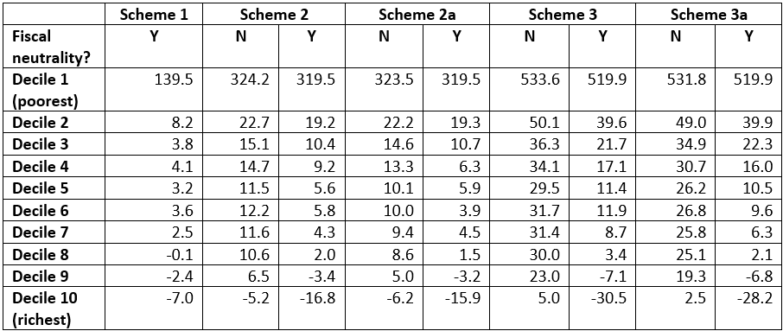
There are several key household effects from Scheme 1 compared with the base system. Child poverty falls by more than half, from 27.3% to 12.5%. This takes the level of child poverty to below the level of 14.0% in 1977 shown in Figure 1. Working-age poverty falls by just over a quarter, from 19.4% to 14.9 %, while pensioner poverty falls by 54%, from 16.7 to 7.7%, well below the lowest post-1961 rate of 14% in the early 1980s. Overall, 49.4% of benefit units gain, while 50.6% lose. Importantly, the Gini coefficient summary measure of inequality falls by 12.5%, taking it back towards the peak equality level achieved in 1977.
The gains are concentrated among the poorest and the losses among higher income groups. Middle income benefit units in deciles 4-7 gain small amounts on average. There are no losers among the poorest tenth, but 32.7% among the second decile and 49% amongst the third decile. About half of the losers lose less than 5%. The losses in these deciles are driven by income tax and NIC increases. It would be possible to avoid losses completely for benefit units in the lowest three deciles in the short run by including a package of transitional protection alongside the UBI scheme, whereby any low-income benefit unit losing out from the introduction of UBI receives a compensation payment so that it is no worse off than in the baseline scenario. In 2022-23, a transitional protection package for the bottom three deciles would cost around £2.4bn. As such, Scheme 1 shows that it is possible to design a UBI scheme that is affordable and highly progressive. The scheme achieves significant reductions in poverty through redistribution from higher income groups, reduces inequality, and would also eliminate the negative effects of the current punitive system of conditionality. In this way the scheme would increase the redistributive power of the tax-benefit system – which has been eroded over recent decades – while adding a guaranteed minimum.
As Table 7 demonstrates, schemes 2 and 3 achieve much greater reductions in means-testing (despite retention of some disability and housing payments), complexity and inequality. The schemes are significantly more redistributive, with more winners and fewer losers, even with the significant increases in marginal income tax rates in the fiscally neutral formulations. Importantly, a much larger proportion of the working population benefits, with only the top two deciles losing in fiscally neutral formulations. This leads to increased approval by voters (Johnson, Johnson & Nettle 2022). Scheme 3 almost eliminates poverty overall, with those remaining in poverty still significantly increasing their income to MIS level. Some recipients notionally remain in poverty because the relative poverty level is increased radically. In this context, the relevance of the relative poverty measure may need to be re-evaluated. This meets a robust adequacy criterion, enabling people to satisfy their needs for a minimally decent life through the payment. The payment for adults is higher than any modelled by Martinelli.

Table 7: The impact of introducing schemes 1, 2 and 3: winners and losers, changes in poverty, inequality and means-testing levels, as at 2022/3
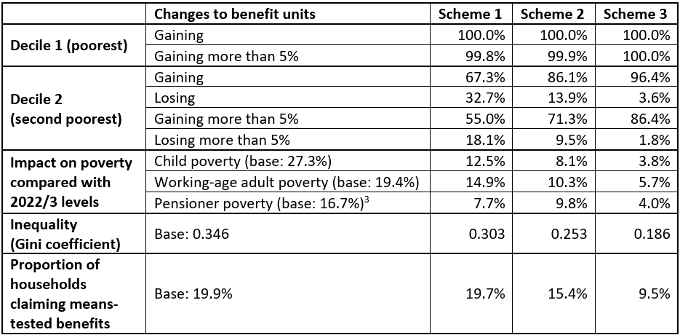
If MIS represents a threshold for adequacy, there is at least prima facie reason for sympathy with Martinelli’s claim of unaffordability for both schemes 2 and 3. Policies aimed at cutting inequality and poverty through stronger state redistributive measures would incur additional revenue costs, and therefore higher taxes on higher income groups.
Although only representative trials, such as those involving whole populations of towns, can provide the evidence on the scale of impact, it is important to recognise that the potential dynamic gains of UBI would mitigate these upfront costs over time, especially through the potential gains in improvements in public health. We have suggested elsewhere that hundreds of billions of pounds are lost to caring for avoidable ill-health (Johnson et al. 2021). Our work on the social gradient in health – ‘whereby people who are less advantaged in terms of socioeconomic position have worse health (and shorter lives) than those who are more advantaged’ (Donkin 2014) – indicates that this would provide significant health gains capable of reducing health and social care burdens on public budgets. Preliminary modelling findings focusing only on anxiety and depression among 14- to 24-year-olds indicate that tens of thousands of clinical cases could be avoided or delayed through the introduction of the schemes (Johnson et al. 2022a, 17-18) with resulting savings in the tens of millions of pounds.
It should also be noted that, given the potential social gains, there are alternative ways of meeting the up-front costs of more generous schemes, and achieving fiscal neutrality, other than through the modelled rises in income tax rates which carry risks to labour market incentives. The Demos calculator, which is based on the Landman TTM, estimates that, in 2020: charging Capital Gains Tax at current Income Tax rates would raise £10bn per year; a tax on private wealth, which currently stands at some £14.6tr (Office for National Statistics 2019), levied at 1% per year above £1m on financial wealth would raise £3bn per year; replacing Inheritance Tax with a Lifetime Receipts Tax on gifts worth more than £100,000 to the recipient (across total lifetime) would raise £8bn per year; and applying VAT to private school fees and private medical care would raise £6bn per year. Raising the rate of corporation tax by 1p raises £2.6–2.8bn (KAI Indirect Taxes, Customs and Coordination 2018). A range of further, costed possibilities are outlined in Lansley and Reed (2019).

Conclusion
These results provide a substantive response to those who claim that UBI is either unaffordable or inadequate. In fact, a modest UBI scheme along the lines of Scheme 1 would be affordable, feasible and highly progressive. It could be implemented within the lifetime of a single parliament (or in stages over a longer time period) and, significantly, would take poverty rates for children and pensioners to below their post-1961 low points. This would be a significant historic achievement. It would constitute a pro-equality measure of a similar degree of radicalism to those adopted by the Labour Government of 1945 and would deliver more on poverty reduction than New Labour’s post-2000 programme. There would also be important, if limited, long-term social gains in areas like health and criminal justice, though these would be greater with more generous payments (see Johnson et al. 2020, for theoretical discussion of this).
While significantly more costly, modelling of Scheme 3 demonstrates that it would be possible in principle to build a society where nobody falls below MIS, with inequality (as measured by the Gini coefficient) at an all-time low. In a static model, potentially politically challenging changes to the tax-benefit system would be required, including through higher marginal tax rates on incomes. However, as we have shown elsewhere, public perception may not be correlated with up-front cost, with support in red wall constituencies standing at 49% for Scheme 1, 62% for Scheme 2 and 57% for Scheme 3 (Johnson, Johnson & Nettle 2022). In part, this is because schemes 2 and 3 explicitly benefit a much broader body of voters, especially those in work. Managing these dynamics adds an additional complexity to assessment of feasibility.

Funding
This research was kindly funded by the Wellcome Trust as part of ‘Assessing the prospective impacts of Universal Basic Income on anxiety and depression among 14-24-year-olds’ (grant number 223553/Z/21/Z).

References
Beveridge, W. (1942) Social Insurance and Allied Services, Cmnd 6404, HMSO.
Brewer, M. & Gardiner, L. (2020) Key take-aways from the Chancellor’s package of measures to support workers in the coronavirus crisis. Resolution Foundation (Online), 22 March, <https://www.resolutionfoundation.org/comment/key-take-aways-chancellors-package-of-measures-to-support-workers-coronavirus-crisis/> [Accessed: 8 March 2022].
Bright Blue (2021) ‘Bright Blue’, Bright Blue (Online), 22 March, <https://www.brightblue.org.uk/shaky-foundations-press-release> [Accessed: 8 March 2022].
British Social Attitudes (2020) BSA 38 (Online), <https://bsa.natcen.ac.uk/latest-report/british-social-attitudes-38/introduction.aspx> [Accessed: 8 March 2022].
Donkin, A.J.M. (2014) ‘Social Gradient’, in Cockerham, W.C., Dingwall, R. & Quah, S. (eds.), The Wiley Blackwell Encyclopedia of Health, Illness, Behavior, and Society, Chichester: John Wiley & Sons, Ltd, pp. 2172–2178. DOI: 10.1002/9781118410868.wbehibs530.
Hirsch, D. (2019) A Minimum Income Standard for the United Kingdom in 2019. York: Joseph Rowntree Foundation.
HM Treasury (2022a) Government Action on Fraud in Covid Support Schemes, <https://www.gov.uk/government/publications/government-action-on-fraud-in-covid-support-schemes/government-action-on-fraud-in-covid-support-schemes> [Accessed: 21 April 2022].
HM Treasury (2022b) ‘Millions to receive £350 boost to help with rising energy costs’, Gov.uk, 3 February, <https://www.gov.uk/government/news/millions-to-receive-350-boost-to-help-with-rising-energy-costs> [Accessed: 8 March 2022].
Institute for Fiscal Studies (2022) ‘Living Standards, Inequality and Poverty Spreadsheet’, Institute for Fiscal Studies (Online), <http://www.ifs.org.uk/fiscalFacts/povertyStats> [Accessed: 8 March 2022].
Johnson, E.A., et al. (2022a) Levelling mental health gradient, London: Royal Society of Arts, <https://www.thersa.org/reports/universal-basic-income-anxiety-depression-mental-health-crisis-interim-report>.
Johnson, E.A., Johnson, M.T. & Webber, L. (2020) ‘Measuring the health impact of Universal Basic Income as an upstream intervention: holistic trial design that captures stress reduction is essential’, Evidence & Policy. DOI: 10.1332/174426420X15820274674068.
Johnson, E. & Spring, E. (2018) The Activity Trap, Manchester: Activity Alliance. <https://www.activityalliance.org.uk/how-we-help/research/4404-the-activity-trap-benefits-or-being-fit-october-2018>.
Johnson, E.A., Webster, H. Thorold, R., Morrison, J., Mathers, A., Reed, H., Kypridemos, C., Villadsen, A., Parra-Mujica, F., Cookson, R., Nettle, D., Pickett, K. & Johnson, M.T. (2022a) Levelling the mental health gradient among young people: How Universal Basic Income can address the crisis in anxiety and depression, London: Royal Society of Arts, <https://www.thersa.org/reports/universal-basic-income-anxietydepression-mental-health-crisis-interim-report>.
Johnson, M.T. & Johnson, E.A. (2019) ‘Stress, Domination and Basic Income’, Social Theory & Health, 17(2): 253-271. DOI: 10.1057/s41285-018-0076-3.
Johnson M.T., Degerman, D. & Geyer, R. (2019) Exploring the health case for UBI. Basic Income Studies 14(2): 1-11. DOI: 10.1515/bis-2019-0008.
Johnson, M.T., Johnson, E.A., Nettle, D. & Pickett, K.E. (2022b) ‘Designing trials of Universal Basic Income for health impact’, Journal of Public Health, 44(2): 408-416. DOI: 10.1093/pubmed/fdaa255.
Johnson, M.T., Johnson, E.A., Webber, L., Friebel, R., Lansley, S., Reed, H. & Wildman, J. (2021) ‘Modelling the size, cost and health impacts of Universal Basic Income’, Health Services & Outcomes Research Methodology, 21: 459-476. DOI: 10.1007/s10742-021-00246-8.
Johnson, M.T., Johnson, E.A. & Nettle, D. (2022) ‘Are ‘red wall’ constituencies really opposed to progressive policy? Examining the impact of materialist narratives for Universal Basic Income’, British Politics, resubmitted 15 August 2022. Data: https://osf.io/7gra2/. DOI: 10.17605/OSF.IO/XJVRZ.
Joseph Rowntree Foundation (2021) ‘Is Universal Basic Income a good idea?’, JRF (Online), 27 May, <https://www.jrf.org.uk/report/universal-basic-income-good-idea> [Accessed: 8 March 2022].
KAI Indirect Taxes, Customs and Coordination (2018) Direct effects of illustrative tax changes, London: HMRC.
Lansley, S. (2022) ‘Intensifying sanctions on claimants is a mistake’, Transforming Society (Online), 4 February, <https://www.transformingsociety.co.uk/2022/02/04/intensifying-sanctions-on-claimants-is-a-mistake/> [Accessed: 8 March 2022].
Lansley, S. (2021) The Richer, The Poorer, Bristol: Policy Press.
Lansley, S. & Reed, H. (2019) Basic Income For All, London: Compass.
Martinelli, L. (2017) Assessing the Case for a Universal Basic Income in the UK. Bath: Institute for Policy Research.
Nettle, D., Johnson, E., Johnson, M. & Saxe, R. (2021) ‘Why has the COVID-19 pandemic increased support for Universal Basic Income?’, Humanities and Social Science Communications, 8, 79. DOI: 10.1057/s41599-021-00760-7.
OECD (2018) Better Life Index. Available at: https://www.oecdbetterlifeindex.org/.
OECD (2022), Benefits in unemployment, share of previous income (indicator). DOI: 10.1787/0cc0d0e5-en [Accessed: 21 April 2022].
Office for National Statistics (2019) Total wealth in Great Britain. ONS (online), <https://www.ons.gov.uk/peoplepopulationandcommunity/personalandhouseholdfinances/incomeandwealth/bulletins/totalwealthingreatbritain/april2016tomarch2018> [Accessed: 18 February 2022].
Ostry, J.D., Berg, A. & Tsangarides, C.G. (2014) ’Redistribution, Inequality and Growth’, IMF Discussion Paper.
Pt2 (2020) Universal Credit, London: Pt2.
Reed, H., Lansley, S., Johnson, M., Johnson, E. & Pickett, K.E. (2022) Tackling Poverty: the power of a universal basic income, London: Basic Income Conversation.
Royal Commission on the Poor Laws and the Relief of Distress (1909) Minority Report of the Royal Commission on the Poor Laws and the Relief of Distress, London: HMSO.
Secretary of State for Levelling up, Housing and Communities (2022) Levelling Up, Westminster: HM Government.
Stirling, A. & Arnold, S. (2019). Nothing personal. London: The New Economics Foundation.
The Guardian (2022) ‘Call for new Beveridge report as number of destitute UK households doubles during Covid’, The Guardian, 20 February, <https://www.theguardian.com/society/2021/feb/20/call-for-new-beveridge-report-as-number-of-destitute-uk-households-doubles-during-covid> [Accessed 8 March 2022].
The Independent (2020) ‘Why more than 500 political figures and academics globally have called for universal basic income in the fight against coronavirus’, The Independent, 18 March, <https://www.independent.co.uk/voices/letters/coronavirus-universal-basic-income-ubi-poverty-economy-business-migrants-a9408846.html> [Accessed 24 March 2020].
Tomlinson, D. (2018) Irregular Payments, London: Resolution Foundation.
Webster, D. (2018) Submission to Work and Pensions Committee, May, London: UK Government.
Welsh Government (2022) ‘Basic income for care leavers in Wales, pilot announced’, GOV.WALES, 15 February, https://gov.wales/basic-income-care-leavers-wales-pilot-announced [Accessed: 21 March 2022].
Wilkinson, R. G., & Pickett, K. E. (2006) ‘Income inequality and population health’, Social science & medicine, 62(7): 1768-1784. DOI: 10.1016/j.socscimed.2005.08.036.
Wilkinson, R. G., & Pickett, K. E. (2017) ‘The enemy between us’, European Journal of Social Psychology, 47(1): 11-24. DOI: 10.1002/ejsp.2275.

Poverty is relative poverty (measured as the proportion of individuals in households falling below 60% of median net household income) after housing costs. The Gini coefficient is a summary measure of inequality (where 0 is complete equality and 1 complete inequality). This is the Gini for household net income (after housing costs).
In some formulations, there may be conditions attached based on relatively extreme conditions. For example, if someone commits serious crime and is imprisoned, it can be argued both that their needs are being met financially by the state already and that basic income must be accompanied by very basic good citizenly behaviour.
Income tax rates refer to those in England, Wales and Northern Ireland. See tables 2, 3 and 4 for further information on Scotland.
A benefit unit refers to a subset of a household, consisting of a single adult or a married or cohabiting couple and any dependent children.

