Testing the effect of oxidizing pre-treatments on amino acids in benthic and planktic foraminifera tests

Emily Millman^{a,1}
ª School of Marine Science and Policy, University of Delaware, 700 Pilottown Road, Lewes, DE, 19958, US, corresponding author, emillman@wustl.edu

Lucy Wheeler^{b}
^{b} Department of Chemistry, University of York, York, YO10 5DD, UK, lw944@york.ac.uk

Katharina Billupsª
ª School of Marine Science and Policy, University of Delaware, 700 Pilottown Road, Lewes, DE, 19958, US, kbillups@udel.edu

Darrell Kaufman^{c}
^{c} School of Earth and Sustainability, Northern Arizona University, Flagstaff, AZ, 86011, US, darrell.kaufman@nau.edu

Kirsty E.H. Penkman^{b}
^{b} Department of Chemistry, University of York, York, YO10 5DD, UK, kirsty.penkman@york.ac.uk

Abstract
Amino acid racemization (AAR) is a geochronological method that uses the ratio of D- to L- configurations in optically active amino acids from carbonate fossils to determine the time elapsed since the death of an organism. Although AAR techniques have been widely applied to foraminiferal tests, there have been limited dedicated assessments of the potential of isolating a bleach-resistant, intra-crystalline fraction of proteins to improve the reliability of AAR in this biomineral system. In this study, we evaluate the effect of two oxidative pre-treatments (hydrogen peroxide and bleach) on amino acid concentrations and D/L values in sub-modern benthic foraminifers (Ammonia spp. and Haynesina germanica) and well-preserved mid Holocene and mid Pleistocene planktic foraminifers (Pulleniatina obliquiloculata, Globorotalia truncatulinoides, and Globorotalia tumida). The oxidative pre-treatments successfully reduced the amino acid content of the foraminiferal tests to a residual fraction, and with the exception of Ammonia spp., neither pre-treatment substantially affected the relative proportion of individual amino acids. The bleaching pre-treatment does not consistently alter D/L values when compared to peroxide pre-treatment, but it does tend to reduce the subsample variability in D/L values, albeit only to a small degree in an inconsistent fashion. Therefore, we recommend that a relatively weak oxidative pre-treatment with 3% hydrogen peroxide is sufficient for foraminifera-based AAR applications.

Keywords
amino acid racemization, benthic foraminifera, planktic foraminifera, method testing, intra-crystalline protein diagenesis, Ocean Drilling Program

1. Introduction
Amino acid racemization (AAR) is a diagenetic process that has been used as a geochronological tool for decades. AAR is the interconversion of amino acids from their L- to D- enantiomeric configuration, which starts upon the death of an organism and subsequent breakdown of proteins (Bada and Schroeder, 1975; Wehmiller and Hare, 1971). The D- to L- ratio of amino acids (D/L) is thus a measure of the extent of racemization and increases with time (and temperature), from values of ~0 in modern materials to equilibrium values of ~1 (for most amino acids), when the forward and reverse reaction rates are equal (e.g., McCoy, 1987; Miller and Mangerud, 1985). AAR is applicable to a wide range of fossiliferous material (e.g., mollusks, foraminifera, eggshell, and ostracods), depositional environments (e.g., marine, lacustrine, and fluvial) as well as to determine stratigraphic relationships (e.g., correlations, the reworking of fossils, and detecting unconformities) (Miller et al., 2013; Walker, 2005). Since the 1970s, AAR has been used as a relative (e.g., Kaufman and Miller, 1992; Miller et al., 1979; Penkman et al., 2011, 2013; Walker, 2005; Wehmiller, 1977, 2013) or absolute (e.g., Goodfriend, 1989; Hearty et al., 2004; Kosnik et al., 2013; Macko and Aksu, 1986; Sejrup et al., 1984) dating tool for Quaternary deposits. In order to reliably use D/L values in fossil material to calculate the time elapsed since the death of the organism (i.e., as a geochronometer), it is essential that external influences on racemization rates and the effects of modern contamination are minimized.
To this end, one advancement in AAR geochronology is the development of the intra-crystalline protein diagenesis (IcPD) approach, which uses a chemical oxidant, bleach (NaOCl), to remove the inter-crystalline protein “mesh” between the biomineral crystallites while leaving behind proteins that are embedded within the crystallites (Penkman et al., 2008; Sykes et al., 1995; Towe, 1980). This approach provides more consistent results in mollusks, corals, and eggshells than more gentle cleaning methods involving sonication in deionized water or weak oxidation with dilute hydrogen peroxide (3% H₂O₂) (Crisp et al., 2013; Demarchi et al., 2013a, 2013b; Hendy et al., 2012; Ortiz et al., 2015, 2018; Penkman et al., 2008, 2011). While bleaching pre-treatments have been used during the preparation of foraminiferal tests for AAR (Kaufman et al., 2013; Nicholas, 2012), dedicated assessments of the IcPD approach to this class of biominerals are limited (Hearty et al., 2004; Stathoplos and Hare, 1993). Recently, a study detailing the effects of bleach on the tests of the planktic foraminifer Neogloboquadrina pachyderma (sinistral) suggested that the IcPD approach reduces the influences of open-system behavior when compared to a sonication-only pre-treatment (Wheeler et al., 2021). However, peroxide pre-treatments were not considered by Wheeler et al. (2021) for comparison with the bleach pre-treatment.
In this study, we test the effects of different oxidative pre-treatments on the amino acid composition and D/L values for several benthic and planktic foraminiferal species. Specifically, we assess the effects of sonication, various peroxide concentrations, and the addition of bleach on the composition of amino acids, the D/L values within individual amino acids, and the inter-sample variability of D/L values. This study merges data generated in two separate efforts: one focusing on benthic foraminifera from surface sediments (0-5 cm, sub-modern) and the other on planktic foraminifera from deep sea sediment cores (~6 ka to ~410 ka). The primary goal in the former study was to establish whether an oxidation-resistant protein fraction can be isolated from benthic foraminiferal tests and to assess the effects of these pre-treatments on amino acid composition and D/L values. In the latter study, the original research question asked whether or not pre-treatment with bleach had a significant effect on amino acid composition, inter-species differences in D/L, and D/L variability of previously peroxide-cleaned planktic foraminiferal tests ranging in age from the mid Holocene through the mid Pleistocene. Although the study designs were independent, both approaches have similar implications for understanding the effect of oxidative pre-treatment on foraminiferal proteins, thereby warranting integration into a common framework within this paper.

2. Methods
2.1 Sample selection
The first set of samples involves benthic foraminifers from surface (0-5 cm) sediments collected in the Humber Estuary, a mid-latitude, coastal plain estuary formed by the Ouse and Trent rivers in the northeastern United Kingdom (Table 1). Sample collection was carried out in February, 2018. Although these samples were not independently dated, they most likely represent a modern assemblage of foraminifera. However, reworking of the salt-marsh sediment is a possibility (Figueira and Hayward, 2014); radiocarbon dating of basal peats in the area gives a maximum age of a few thousand years (Long et al., 1998). To reflect the uncertainty in their age, we refer to these samples as “sub-modern.” Abundant foraminiferal species include several belonging to Ammonia and Haynesina gemanica. The speciation of Ammonia is challenging; therefore, we refer to them collectively as “Ammonia spp.” (Hayward et al., 2004). The extent of AAR in Ammonia spp. has been used to date Quaternary sea-level deposits (e.g., Blakemore, 2014; Dowling et al., 1998; Nicholas, 2012; Scourse et al., 1999), but to the authors’ knowledge, H. germanica has not previously been used in foraminiferal-based AAR studies.
The second set of samples involves planktic foraminifers that were picked from three Ocean Drilling Program (ODP) sites (Sites 1056, 1059, and 1062) and one piston core (KNR140-JPC37) located on Blake Bahama Outer Ridge (BBOR) in the northwestern subtropical Atlantic Ocean (Table 1). We use three species, Globorotalia truncatulinoides, Globorotalia tumida, and Pulleniatina obliquiloculata, because of their relatively high abundance, large tests, resistance to dissolution (e.g., Hemleben, 1989), and their demonstrated applicability to AAR research (e.g., Hearty et al., 2004; Kaufman, 2006; Kaufman et al., 2013; Stathoplos and Hare, 1993; Wehmiller and Hall, 1997). By analyzing multiple species, we also assess potential inter-species differences in amino acid concentration, composition, and variability in amino acid D/L values.
At the BBOR, samples span the mid Holocene through mid Pleistocene (~6 – 410 ka, Table 1). Mid-Holocene samples from BBOR were initially located in the cores using published age models (Grützner et al., 2002). Early Holocene through mid Pleistocene-aged samples from Site 1056 and KNR140 JPC-37 were identified using the cores’ δ¹⁸O stratigraphy (Billups et al., 2004; Hagen and Keigwin, 2002, respectively). The time equivalency of the mid Holocene samples from the three BBOR sites was subsequently confirmed to within ~1-2 ka (Table 1) using rapid, low precision, ¹⁴C analyses (Bush et al., 2013; Watson, 2019). These were conducted on mono-specific planktic foraminiferal tests at the Keck AMS facility at the University of California Irvine with calibration to calendar ages following the convention of Stuvier and Polach (1977).

Table 1. Site locations and sampling intervals.
Location | Longitude, Latitude | Water Depth (m) | Core  Intervals (cm) | Sediment Depth (mcd)¹ | Age (ka)² | Age (ka)³
Sub-modern
Humber Estuary | 54°N, 0°E | - | 0-5 | 0.00-0.05 | - | -
Mid Holocene
1056D, 1H-1 | 32°N, 76°W | 2178 | 62, 64, 68, 70 | 0.62-0.70 | 6.0-6.5 | 4.8-5.0
1059A, 1H-1 | 32°N, 75°W | 2997 | 44, 50, 54 | 0.44-0.56 | 6.0-6.5 | 5.0-5.4
1062B, 1H-1 | 28°N, 74°W | 4780 | 62 | 0.62-0.64 | 7.1 | 7.0
Early Holocene
KNR140 JPC37 | 31°N, 75°W | 2997 | 150 | 1.50 | 10.5 | -
Late Pleistocene
KNR140 JPC37 | 32°N, 75°W | 2997 | 1112 | 11.12 | 51.5 | -
Mid Pleistocene
1056B, 5H-7 | 32°N, 76°W | 2178 | 44 | 35.34-35.36 | 410 | -
¹MCD stands for meters composite depth.
²Stratigraphic ages (see Section 2.1).
³AMS ¹⁴C dates. For Site 1062, this is the average of two ages (6.68 and 7.23 ka).

2.2 Experimental methods
Experiments involving benthic foraminifera from the Humber Estuary were carried out at the Northeast Amino Acid Racemization (NEaar) laboratory (University of York, UK). Experiments (Figure 1a) consisted of a series of extended oxidation pre-treatments using hydrogen peroxide (3% and 30% w/v H₂O₂) or bleach (12% w/v NaOCl), compared to “unbleached” samples treated only by sonication in purified water.
Experiments involving planktic foraminifera from the BBOR were conducted at the University of Delaware. These experiments compared foraminifer tests oxidized for 2 h with 3% w/v H₂O₂ (referred to as “3% H₂O₂”) to those additionally oxidized for 48 h with 12% w/v NaOCl (referred to as “12% NaOCl-addition”) (Figure 1b). The pre-treatments used by the University of Delaware are akin to a subset of the pre-treatments by the University of York.
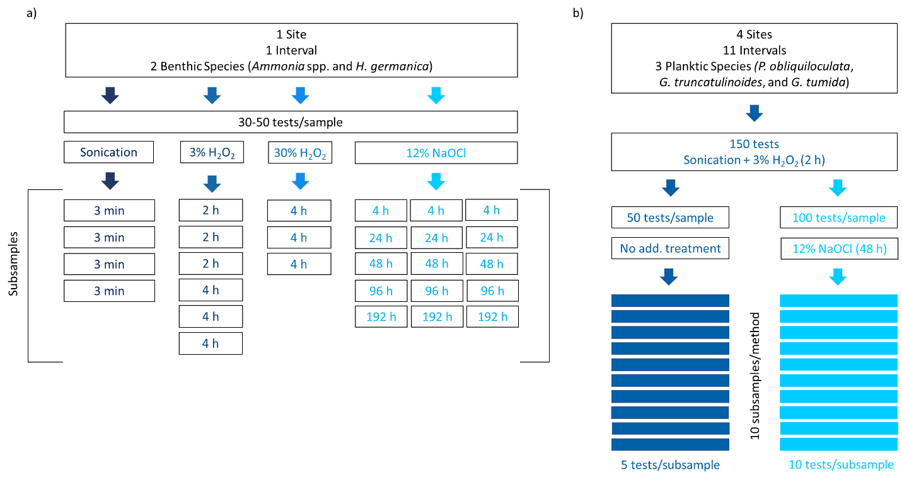
Figure 1. Visual representation of the pre-treatment methodology for a) the sequential pre-treatment experiments (University of York) and b) the comparison between 3% H₂O₂-only and the 12% NaOCl-addition pre-treatments (University of Delaware). Discussion of these methods can be found in Sections 2.2.1 and 2.2.2.

2.2.1 Sequential pre-treatment experiments (University of York)
Tests of Ammonia spp. and H. germanica from the surface sediments of the Humber estuary tidal flats were picked from the 63 – 500 μm fraction and whole tests were cleaned prior to pre-treatment by sonicating repeatedly with purified water (18.0 MΩ) until the water was clear. Each replicate sample consisted of 30 – 50 monospecific tests with 3 – 4 replicates for each species and pre-treatment. Each replicate was prepared separately in sterilized 0.1 mL conical-bottomed micro-reaction vials (Thermo Scientific). Tests were crushed in the vials with a clean needle before a second round of sonication (3 x 1 minute, rinsing with purified water between each sonication). For “unbleached” samples, no further pre-treatment was carried out prior to analysis.
Oxidative pre-treatments were carried out for various durations (2 – 192 h) using hydrogen peroxide (3% and 30% w/v H₂O₂) and bleach (12% w/v NaOCl) (Figure 1a). Oxidizing agent (20 μL) was added to each replicate sample, with periodic agitation to ensure complete exposure of the biomineral to the oxidizing agent. The oxidizing agent was then removed by pipette and the biomineral rinsed with purified water six times and HPLC-grade methanol once then air dried prior to demineralization.
For the hydrolysis step, all samples were demineralized in the micro-reaction vials with 10 μL 7 M HCl, flushed with nitrogen, and heated at 110°C for 24 h. Samples were then dried under vacuum and stored at room temperature prior to rehydration for analysis. Samples were rehydrated with 8 or 10 µL of rehydration fluid (indicating that some samples had to be diluted and reanalyzed on the HPLC), comprising 0.01 M HCl, 1.5 mM NaN₃, and 0.01 mM L-homo-arginine (L-hArg), an internal synthetic amino acid standard used to quantify the abundance of amino acids in each vial. Amino acid enantiomers were resolved by reversed phase HPLC at the NEaar lab using a slightly modified method of Kaufman and Manley (1998) with the additions of Kaufman (2000) for analyzing microfossils. Of the total sample volume, 2 µL of the rehydrated samples were injected into the HPLC where they underwent pre-column derivatization with o-phthaldialdehyde (OPA) and N-isobutyryl-L-cysteine (IBLC) followed by chiral separation with a C₁₈ stationary phase (Hypersil BDS, 5 µm) and fluorometric detection (Kaufman and Manley, 1998). Procedural blanks were analyzed for each experiment to quantify background levels of amino acid contamination. Due to the limited number of replicates analyzed for each pre-treatment (Figure 1), statistical comparisons were not carried out for this series of experiments.

2.2.2 Comparison between oxidative pre-treatments (University of Delaware)
Bulk sediment samples from the three ODP core sites on BBOR (Table 1) were processed using standard techniques involving disaggregation in a buffered sodium metaphosphate solution, washed over a 63 µm sieve with deionized water, and left to air dry. The sediments from the piston core were already processed according to Hagen and Keigwin (2002). From each core interval (n = 11), we aimed to pick about 150 individuals of P. obliquiloculata, G. truncatulinoides, and G. tumida from the >350 µm fraction.
The 150 species-specific tests from each core interval (n = 19) were placed into individual 16 mm glass culture tubes. Each tube was filled with deionized water and sonicated briefly to loosen surface contaminants. To remove organic contaminants, the tests were soaked in 3% w/v H₂O₂ for 2 h, rinsed three times with reagent grade H₂O, decanted, and air dried under laminar flow; this is a common cleaning step in other foraminifera AAR studies (e.g., Kaufman et al., 2008). Once clean, the 150 tests of each species for each core interval were split into samples of 50 and 100 tests. The samples containing 50 tests were then subdivided into 10 subsamples composed of 5 individuals on average, which were placed into sterilized, conical bottomed 0.1 mL micro-reaction vials (e.g., Figure 1b). Subsamples were hydrolyzed, rehydrated, and analyzed using a similar procedure to the one used by the University of York (Section 2.2.1). The difference is that samples were hydrolyzed with 7 µL 6 M HCl, flushed with nitrogen, and heated at 110°C for 6 h, in order to minimize hydrolysis-induced racemization in the older samples. This heating time is shorter than the NEaar hydrolysis protocol, but the difference will not impact the paired comparisons as the D/L values are not being directly compared between the two studies (e.g., Dungworth 1975; Williams and Smith, 1977). Samples were then rehydrated with 4 µL of the rehydration fluid, and all 4 µL of the sample was injected into the column for analysis. Amino acid enantiomers were resolved by reversed phase high performance liquid chromatography at the Amino Acid Geochronology Lab (Northern Arizona University, AZ) using the same parameters as above (Section 2.2.1).
The samples containing 100 tests were further treated with bleach following Penkman et al. (2008), with modifications. First, each group of 100 tests were divided into 10 subsamples (e.g., Figure 1b), each containing 9 tests on average, and placed into separate glass test tubes. Second, to isolate the intra-crystalline fraction, tests in each subsample were gently broken and 12% NaOCl was added to fill three fourths of the tube. Third, the tubes were agitated, left for 24 h, re-agitated to ensure complete exposure to the bleach, and soaked for another 24 h. After 48 h, the bleach was pipetted off and samples were rinsed with purified water 3 – 5 times before being left to dry under laminar flow. The dry fragments were transferred to conical bottomed 0.1 mL micro-reaction vials and hydrolyzed, rehydrated, and analyzed using the same procedure as the peroxide-cleaned samples.

2.3 Data screening
In this study, we focus on the D/L values of aspartic acid and glutamic acid, which are two of the most abundant amino acids in foraminiferal protein and best resolved chromatographically (Kaufman et al., 2013). However, during hydrolysis, asparagine and glutamine are irreversibly hydrolyzed to aspartic acid and glutamic acid respectively; therefore, these amino acids are analytically indistinguishable and reported as Asx and Glx (Hill, 1965). The integrity of AAR data can be assessed using a range of diagnostic criteria, such as serine (Ser) abundance, depth or age trajectories, covariance of concentrations or D/L values, and variability of replicate subsamples (Kosnik and Kaufman, 2008). Cut-offs for sample exclusion are determined empirically and are known to depend on age and taxonomy (Kaufman, 2006; Kosnik and Kaufman, 2008). Here we followed the three-step screening procedure from Kosnik and Kaufman (2008) to systematically identify subsample outliers that could influence the resulting mean D/L values for each sample.
First, the concentration of Ser, a labile amino acid which should be present only in low concentrations within fossils due to its rapid rate of decomposition, was used to identify subsamples contaminated by modern amino acids (Kaufman, 2006; Kaufman et al., 2013; Kosnik and Kaufman, 2008). Although this criterion is not applicable to the sub-modern material from Humber Estuary, because the low extent of protein breakdown means that Ser concentrations remain high, individual subsamples from the BBOR cores with L-Ser/L-Asx values ≥ 0.9 were rejected. Second, the covariance between the D/L values of Glx and Asx was visually assessed to identify subsamples with D/L values that substantially deviate from the linear relationship of all subsamples within a species (Kaufman, 2006; Kaufman et al., 2013). Third, subsamples with D/L Asx or Glx values that fell beyond ±2σ of the mean of the rest of the group were rejected (Kaufman, 2006; Kaufman et al., 2013).
No outliers were identified in the estuarine data set, likely due to the small number of replicates for each pre-treatment (n = 3 – 4). Screening of the BBOR data (n = 381) resulted in the rejection of 46 (12.1%) individual data points. Of these, 14 (3.7%) were rejected based on high Ser content, 7 (1.8%) were rejected as outliers based on the expected linear Asx D/L vs. Glx D/L trend for a species, and 25 (6.6%) were rejected due to falling beyond the ±2σ of the mean of the group. The rejection rate is slightly lower for the samples pretreated with hydrogen peroxide (19 out of 196 subsamples rejected, 9.7%) as opposed to samples pretreated with bleach (27 out of 185 subsamples rejected, 14.6%).

3. Results

3.1 Amino acid concentration
Our results show that the choice of pre-treatment affects the concentration of total hydrolysable amino acids ([THAA]) in both benthic (Figure 2) and planktic foraminifer tests (Figure 3). Regarding the benthic foraminifer tests, sequential oxidation illustrates that when treated with 12% bleach, the total concentration of amino acids decreases by ~90% in the first 4 h of bleaching, then remains at consistently low levels for the remainder of the oxidation period, regardless of species (Figure 2). This suggests that the residual fraction of proteins isolated within 4 h of bleach exposure represents a bleach-resistant intra-crystalline protein fraction. The results of the H₂O₂ pre-treatment experiments are more species dependent. In Ammonia spp., the variability of [THAA] in the unbleached samples precludes a quantitative comparison of the proportion of amino acids removed by each oxidation pre-treatment, although a smaller proportion of amino acids are removed by the 4 h 3% H₂O₂ and 30% H₂O₂ treatments than the 4 h 12% NaOCl treatment (Figure 2a). This suggests that H₂O₂ is not a strong enough oxidizing agent to isolate the bleach-resistant intra-crystalline fraction, at least within 4 h, in Ammonia spp. Conversely, the 4 h treatments with 3% H₂O₂, 30% H₂O₂ and 12% NaOCl all remove a similar proportion of amino acids in H. germanica (Figure 2b). The concentration of THAA in Ammonia spp. remains stable up to 192 h, while there appears to be a further gradual loss of amino acids after prolonged bleaching (>96 h) in H. germanica, indicating possible etching of the mineral matrix (Dickinson et al., 2018; Penkman et al., 2008).
In comparison to the benthic foraminifer species (Figure 2), the planktic foraminifer species (Figure 3) have higher amino acid concentrations when treated with 3% H₂O₂. This observation most likely corresponds to the larger size of the planktic species. The 24 h bleach pre-treatment reduces [THAA] by ~90% in the sub-modern, benthic foraminifera, whereas [THAA] is reduced by 41 – 72% in the down-core, planktic foraminifera. This difference could be explained by the sample age difference. For G. truncatulinoides and P. obliquiloculata, bleach reduces [THAA] by 68 – 72% in mid to early Holocene-aged samples but only 41 – 57% in mid Pleistocene-aged samples. Thus, it appears bleach removes a smaller proportion of amino acids as the age of the samples increase, indicating a loss of open-system inter-crystalline amino acids during the early stages of diagenesis. This pattern has been observed in a variety of mollusk species (e.g., Ortiz et al., 2015, 2017; Penkman et al., 2008; Sykes et al., 1995).
In sum, bleaching foraminifer tests more effectively reduces [THAA] as opposed to either peroxide treatment, in both benthic and planktic foraminifer species. This reduction is more drastic in the sub-modern benthic foraminifera, where little to no diagenesis has taken place to remove the easily accessible inter-crystalline amino acids.

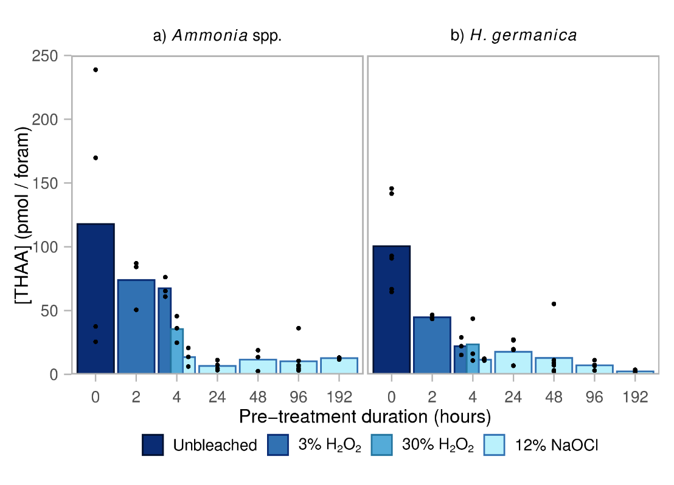
Figure 2. Concentration of total hydrolysable amino acids ([THAA]) in unbleached (i.e., H₂O sonication only) and oxidized (i.e., H₂O₂ or NaOCl) samples of modern benthic species a) Ammonia spp. and b) H. germanica from surface sediments of the Humber Estuary. The colored bars show the average concentration at each time point. Due to the small number of replicates analyzed at each time point in this suite of experiments, all data points are shown as solid black points.
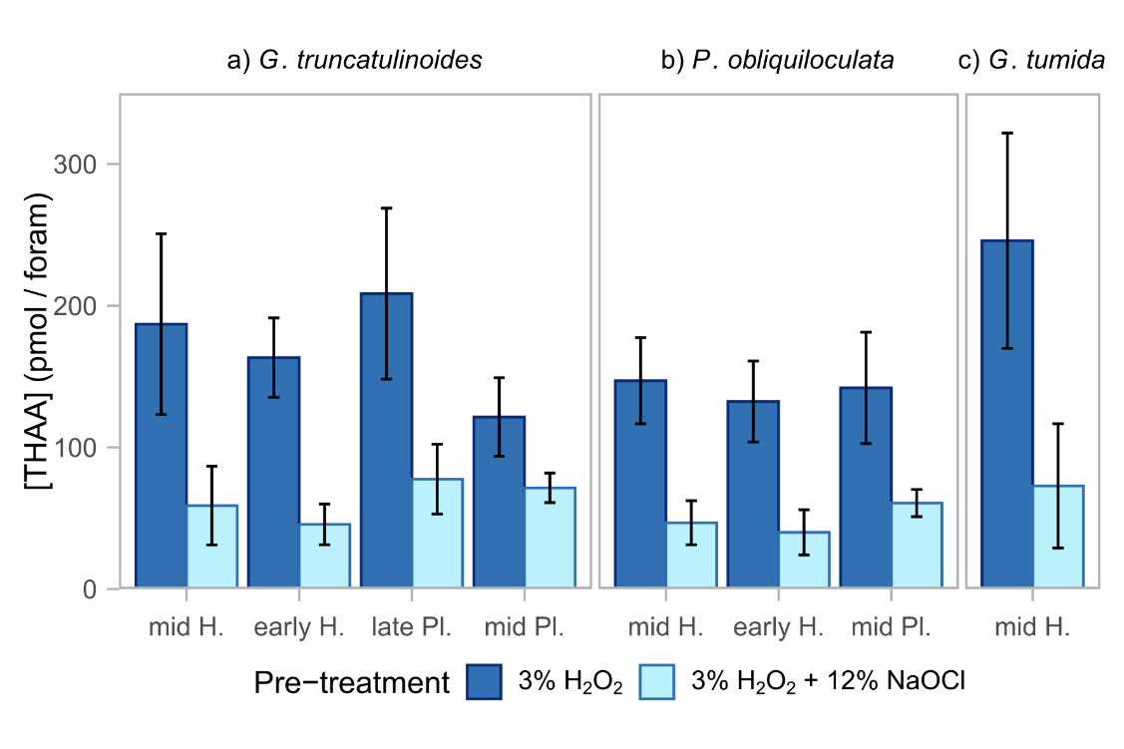
Figure 3. Concentration of total hydrolysable amino acids ([THAA]) for a) G. truncatulinoides, b) P. obliquiloculata, and c) G. tumida pre-treated with 3% H₂O₂ only or 3% H₂O₂ plus 12% NaOCl. Mean [THAA] is separated based on sample age (mid Holocene, early Holocene, late Pleistocene, and mid Pleistocene) for each pre-treatment. Error bars represent the ±1σ around the mean. All differences are statistically significant at the 95% confidence interval (P-values < 0.05).

3.2 Amino acid composition
The pre-treatment methods do not have a consistent effect on the relative proportion of individual amino acids among the foraminifera species used in the two experiments. The largest effect is observed for the benthic species Ammonia spp. (Figure 4a), where increasing the strength of the oxidizing agent increases the proportion of Asx, Glx, and Ala but decreases the proportion of Gly, especially for the 12% NaOCl treatment. In H. germanica, samples treated with 3% and 30% H₂O₂ have a lower %Ala and higher %Asx than the unbleached samples, but compositionally the samples treated with 12% NaOCl are more similar to the unbleached samples (Figure 4b). This may be due to the large inter-replicate variability of composition, especially for Asx and Gly (Figure S1). The more similar composition of H. germanica protein between the different pre-treatments is consistent with the similar concentrations for this species for the 4 h treatments at different oxidizing agent strengths, in contrast to Ammonia spp. (Figure 2).
For the planktic foraminifera, the amino acid composition is relatively similar between pre-treatments and across species and ages (Figure 5). With the addition of 12% NaOCl, there is a slight reduction in the %Gly and %Phe with an increase in %Ala observed for G. truncatulinoides, P. obliquiloculata, and G. tumida. The small differences observed in the THAA composition of the older planktic species (in contrast to the sub-modern benthic species) could be due to the loss of easily accessible inter-crystalline proteins during the early stages of diagenesis, where afterwards the THAA composition becomes relatively stable against aging and oxidative effects.

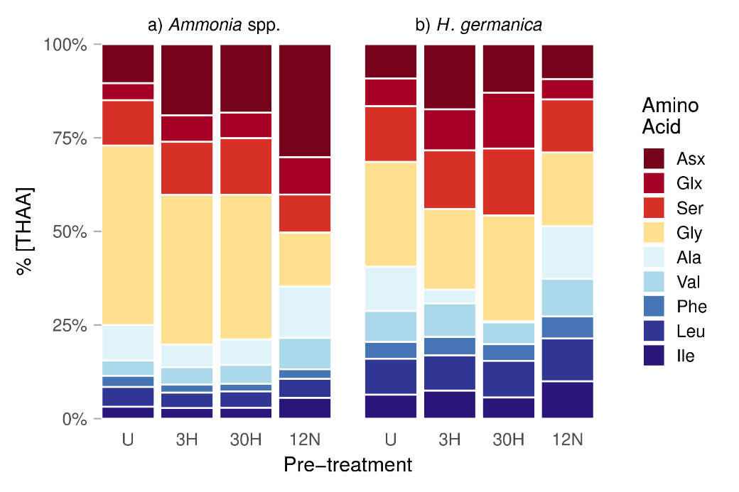
Figure 4. Relative proportion of amino acids (%THAA) in benthic foraminifer tests from estuarine surface samples for a) Ammonia spp. b) H. germanica. Four different pre-treatments were used: H₂O sonication only (Unbleached, U), 4h 3% H₂O₂ (3H), 4h 30% H₂O₂ (30H), and 4h 12% NaOCl (12N).

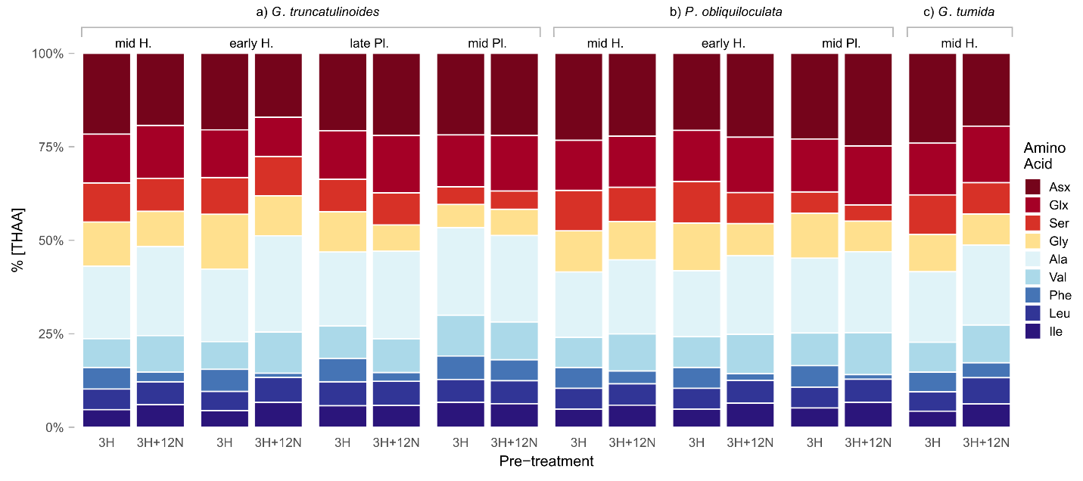Figure 5. Relative proportion of amino acids (%THAA) in planktic foraminifer tests from deep marine sites aged mid Holocene (H) to mid Pleistocene (Pl) for a) G. truncatulinoides, b) P. obliquiloculata, and c) G. tumida. Two different pre-treatments were used: 3% H₂O₂ only (3H) and 3% H₂O₂ + 12% NaOCl (3H+12N).

3.3 D/L differences between pre-treatments
D/L values for Asx and Glx were investigated because these amino acids are the most common for AAR age or temperature reconstructions (Goodfriend et al., 1996; Kaufman, 2003, 2006; Kaufman et al., 2008, 2013; Miller et al., 2013). Within the data scatter, there are no robust trends for pre-treatment conditions in the D/L values of the benthic foraminifer samples, regardless of whether or not the samples were treated beyond sonication with H₂O (Figure 6). In H. germanica, there may be a slight decrease in Asx and Glx D/L values between the sonication-only samples and samples subjected to short oxidation times (2 – 4 h), followed by a slight trend of increasing D/L between 4 and 192 h of bleach exposure (Figure 6b). This pattern has been observed in various mollusk shells (Penkman et al., 2008) and ostracods (Bright and Kaufman, 2011), and could indicate a catalytic effect of NaOCl on racemization following the initial removal of inter-crystalline amino acids. This combined with the slight decrease in amino acid concentration in H. germanica after 92 h (Figure 2b) suggests that the fraction of amino acids isolated by the initial bleach exposure is not resistant to chemical influences. However, given the small number of replicate analyses (n = 3 – 4) and relatively large overall variability in D/L values, this observation should be treated with caution.
For the planktic foraminifera, the addition of bleach to peroxide treated samples does not have a consistent impact on the D/L values of Asx or Glx. The differences in mean D/L between the pre-treatments are fairly small (e.g., average 7% and 11% for Asx and Glx, respectively) and are not consistent in direction (Figures 7 and 8; Table 2). The relatively large number of subsamples measured at BBOR afford statistical analyses to support these results. Welch independent t-tests for the mid Holocene samples show that 8/14 mean D/L Asx values and 5/14 mean D/L Glx values had significant differences (P < 0.05) between the two pre-treatments (Figure 7; Table 2). Unlike the mid Holocene samples, the early Holocene to mid Pleistocene-aged samples show a lack of significant change in the mean D/L values between the two differing treatment methods. The t-test results show that only 1/5 mean D/L Asx values and 1/5 mean D/L Glx values are significantly different (Table 2). This indicates that the D/L values of older samples (>10.5 ka) are less affected by the bleaching pre-treatment. Nevertheless, a pattern did emerge for species specific effects regardless of sample age. For samples that showed significant differences in their mean D/L values, bleach increased the D/L values of all P. obliquiloculata samples (5/5), decreased the D/L values of most G. truncatulinoides samples (4/5), and both increased and decreased the D/L values of G. tumida samples (Figures 7 and 8).
Due to the increase in the familywise error rate when carrying out individual t-tests, a three-way analysis of variance (ANOVA) was used to confirm the results for normally distributed data, whereas individual Kruskal-Wallis tests were used for not normally distributed data (Table 3). The ANOVA evaluated three variables that can contribute to differences in the D/L ratios: 1) pre-treatment, 2) planktic foraminifer species, and 3) ODP site (i.e., sample age and water depth). The ANOVA and Kruskal-Wallis results align with those from the t-tests, indicating that the D/L of some Holocene-aged samples are significantly different between the two pre-treatments, whereas the D/L of Pleistocene-aged samples are not significantly different. As a whole, the Kruskal-Wallis tests for samples aged 6.0 – 410.0 ka show that the pre-treatment may have a larger effect on the D/L of Glx, possibly due to the slower racemization rate of this amino acid. The statistical results also suggest that that there are significant differences in the mean D/L arising from the species used (further explored in Section 3.4) and sampling site, which is expected due to varying sample age and water temperature at each site.
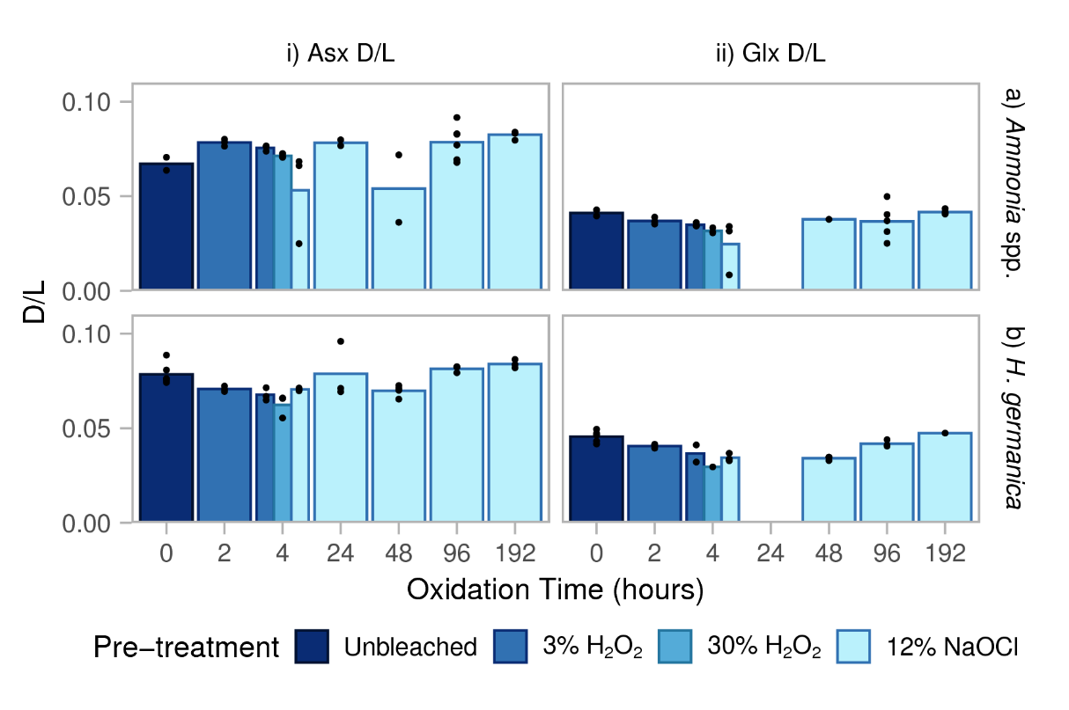
Figure 6. Trends in i) Asx and ii) Glx THAA D/L with increasing oxidation time for a) Ammonia spp. and b) H. germanica from the estuarine surface. The top of the bar reflects the average concentration derived from individual measurements (solid black circles). Note that the gap at 24 h indicates that no Glx D/L values were collected for that particular oxidation step due to low amino acid concentrations.

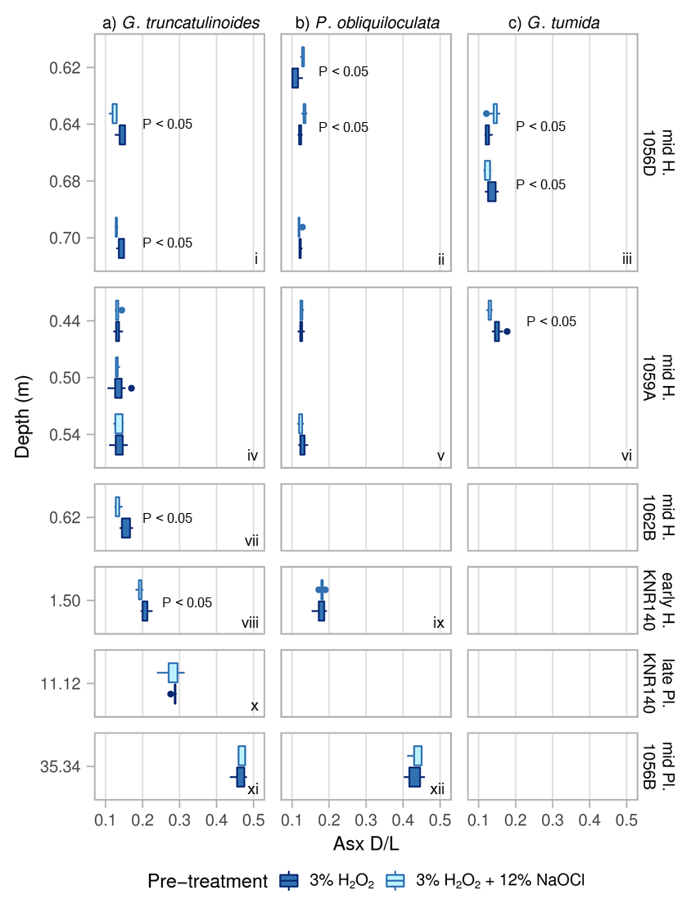
Figure 7. Asx D/L values from ODP Sites 1056D, 1059A, 1062B, KNR140 JPC-37, and 1056B comparing the effects of bleaching on sample mean and standard deviation within a) G. truncatulinoides, b) P. obliquiloculata, and c) G. tumida. Samples are dated mid Holocene (H) to mid Pleistocene (Pl). The box is plotted from the first quartile to the third quartile with whiskers extending the full range and circular data points representing subsample values outside of the range by >1.5 times the interquartile range. Pre-treatment comparisons with statistically significant differences are noted with P-values < 0.05.
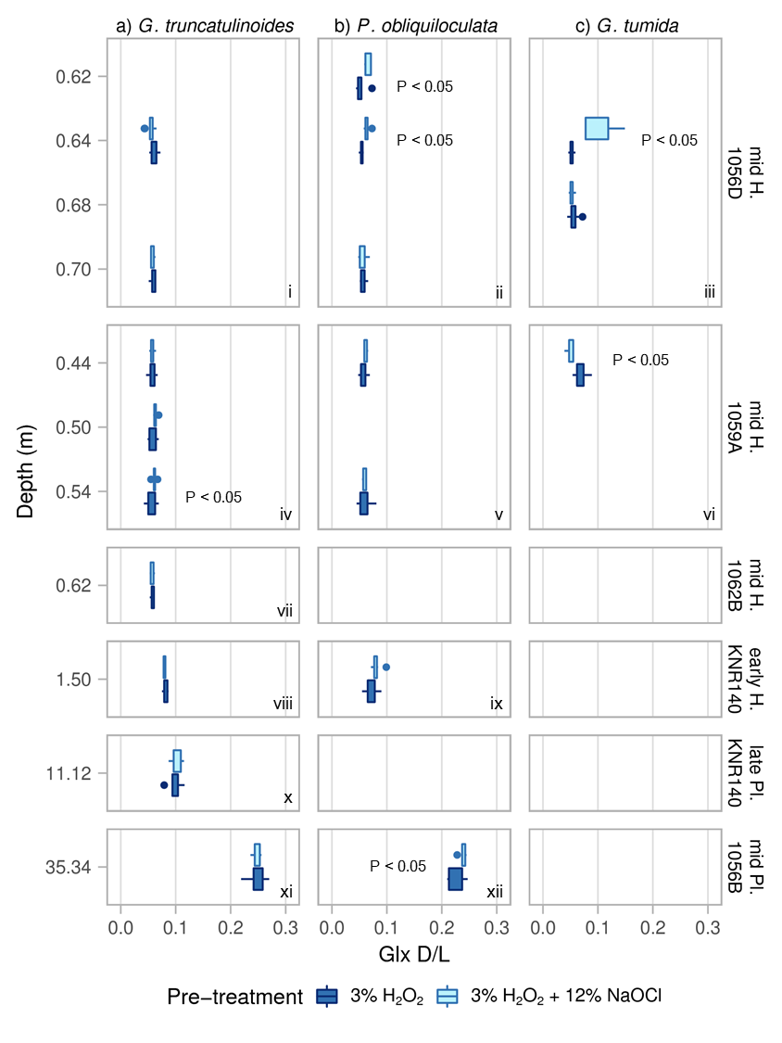
Figure 8. Glx D/L values from ODP Sites 1056D, 1059A, 1062B, KNR140 JPC-37, and 1056B comparing the effects of bleaching on sample mean and standard deviation within a) G. truncatulinoides, b) P. obliquiloculata, and c) G. tumida. Samples are dated mid Holocene (H) to mid Pleistocene (Pl). The box is plotted from the first quartile to the third quartile with whiskers extending the full range and circular data points representing subsample values outside of the range by >1.5 times the interquartile range. Pre-treatment comparisons with statistically significant differences are noted with P-values < 0.05.
Table 2. Mean D/L values for planktic foraminifera from the BBOR and P-values for statistical significance between the pre-treatments.

Site | Sediment Depth (m) | ¹Species | D/L Asx |  |  |  | D/L Glx
 |  |  | H₂O₂ | ²NaOCl | ³P-value |  | H₂O₂ | ²NaOCl | ³P-value
Mid Holocene (6.0-7.1 ka)
1056D | 0.62 | P. obliq | 0.110 | 0.129 | 0.0093* |  | 0.053 | 0.064 | 0.0434*
1056D | 0.64 | P. obliq | 0.121 | 0.134 | 0.0002* |  | 0.054 | 0.063 | 0.0005*
1056D | 0.70 | P. obliq | 0.122 | 0.120 | 0.3131 |  | 0.057 | 0.056 | 0.9175
1056D | 0.64 | G. trun | 0.143 | 0.123 | 0.0004* |  | 0.060 | 0.054 | 0.0715
1056D | 0.70 | G. trun | 0.143 | 0.129 | 0.0014* |  | 0.060 | 0.058 | 0.4209
1056D | 0.64 | G. tum | 0.124 | 0.143 | 0.0004* |  | 0.052 | 0.100 | 0.0002*
1056D | 0.68 | G. tum | 0.136 | 0.124 | 0.0334* |  | 0.057 | 0.052 | 0.2189
1059A | 0.44 | P. obliq | 0.124 | 0.126 | 0.5682 |  | 0.057 | 0.062 | 0.1603
1059A | 0.54 | P. obliq | 0.129 | 0.123 | 0.1310 |  | 0.060 | 0.060 | 0.9817
1059A | 0.44 | G. trun | 0.134 | 0.132 | 0.4346 |  | 0.057 | 0.057 | 0.9568
1059A | 0.50 | G. trun | 0.135 | 0.132 | 0.6323 |  | 0.058 | 0.063 | 0.0983
1059A | 0.54 | G. trun | 0.136 | 0.136 | 0.9809 |  | 0.056 | 0.061 | 0.0057*
1059A | 0.44 | G. tum | 0.152 | 0.130 | 0.0009* |  | 0.069 | 0.051 | 0.0007*
1062B | 0.62 | G. trun | 0.154 | 0.133 | 0.0134* |  | 0.058 | 0.057 | 0.7570
Early Holocene (10.5 ka)
KNR140 | 1.50 | P. obliq | 0.178 | 0.181 | 0.6082 |  | 0.072 | 0.081 | 0.1233
KNR140 | 1.50 | G. trun | 0.207 | 0.193 | 0.0042* |  | 0.081 | 0.080 | 0.3287
Late Pleistocene (51.5 ka)
KNR140 | 11.12 | G. trun | 0.286 | 0.280 | 0.4878 |  | 0.098 | 0.101 | 0.6806
Mid Pleistocene (410.0 ka)
1056B | 35.34 | P. obliq | 0.432 | 0.437 | 0.6963 |  | 0.225 | 0.239 | 0.0386*
1056B | 35.34 | G. trun | 0.463 | 0.469 | 0.4254 |  | 0.249 | 0.247 | 0.8414
¹ P. obliq = Pulleniatina obliquiloculata, G. trun = Globorotalia truncatulinoides, G. tum = Globorotalia tumida
² NaOCl stands for samples treated with 3% H₂O₂ plus 12% NaOCl.
³ P-values from independent t-tests for the difference of means. Samples with P < 0.05 show a significant difference in the means of the treatments, indicated by an asterisk.

Table 3. P-values from three-way ANOVA models used to determine whether the pre-treatments, planktic foraminifera species, and ODP sites (i.e., water depth) significantly impacted the mean D/L of Asx and Glx.
Sample Age  (ka) | D/L Asx P-values¹ |  |  |  | D/L Glx P-values¹
 | Treatment | Species | Site |  | Treatment | Species | Site
6.0 – 10.5² | 0.0096* | 0.0000* | 0.0000* |  | 0.0081* | 0.3296 | 0.0000*
51.5 – 410.0 | 0.7753 | 0.0044* | 0.0000* |  | 0.2647 | 0.0004* | 0.0000*
6.0 – 410.0² | 0.1868 | 0.0000* | 0.0000* |  | 0.0260* | 0.0219* | 0.000*
¹ P < 0.05 show a significant difference in the mean D/L between groups.
² The Shapiro-Wilks test for normality showed that the Glx data for samples aged 6.0 – 10.5 ka and the whole dataset for samples aged 6.0 – 410.0 ka were non-normally distributed. Therefore, individual Kruskal-Wallis tests were used.

3.4 D/L differences between foraminifer species
At the genus level, differences in the rate of amino acid racemization in foraminifera are well documented in the literature (Kaufman, 2006; Kaufman et al., 2013; King and Neville, 1977). Here we evaluate the effect of oxidative pre-treatments on foraminifer D/L values at the species level. We obtained sufficient tests from P. obliquiloculata, G. truncatulinoides, and G. tumida from six mid Holocene to late Pleistocene intervals to evaluate species differences in D/L values (Table 4). However, we were able to obtain enough tests for only one species comparison from both the early Holocene and late Pleistocene sample sets, and none from the mid Pleistocene interval.
Akin to the ANOVA and Kruskal-Wallis results (Table 3), the t-tests show that significant differences in the D/L values tend to exist between co-occurring planktic species in the majority of intervals (Table 4). For D/L Asx, 8/10 intervals of both peroxide-treated and additional bleach-treated comparisons show significant differences, although not for the same species pair (Table 4). For D/L Glx, about half of the comparisons show significant differences for the peroxide (5/10 intervals) versus the additional bleach treatments (6/10 intervals). These latter comparisons could illustrate that differences in D/L Glx values are less species-specific than D/L Asx in this range, and adding bleach does not change this result appreciatively. Alternatively, the slower racemization rate of Glx could result in smaller D/L differences between different species in this age range.
Focusing on the individual D/L Asx comparisons where species differences are more apparent, there is no consistent change in the species differences with the particular pre-treatment method. The difference in D/L Asx in P. obliquiloculata versus G. truncatulinoides is significant in 5/6 pairs whether or not bleach is added and is significant in the sixth comparison after bleach is added. The P. obliquiloculata versus G. tumida comparison, on the other hand, is inconclusive as the addition of bleach results in a significant difference in one of the two analysis pairs (1056D, 0.64 m) while it removes significance in the other example (1059A, 0.44 m). The difference in D/L Asx between G. truncatulinoides and G. tumida is significant for both examples when treated with peroxide only, but adding bleach appears to diminish the difference in one (1056D, 0.64 m versus 1059A, 0.44 m, respectively). These data suggest that adding bleach does not better define existing species differences in D/L Asx with respect to samples treated with peroxide only.
Samples from the BBOR also allow an examination of species-specific differences in racemization rates. We visualize these by regressing the D/L values of the same amino acid from two species against one another (Figure 9). For this purpose, we focus on results from P. obliquiloculata and G. truncatulinoides because they are present at three age horizons (mid Holocene, early Holocene and late Pleistocene) providing a common temporal reference frame. In this analysis, a slope of 1 reflects identical observed racemization rates (i.e., same D/L values for a given sample horizon), while deviations from a slope of 1 indicate slower or faster racemization rates, resulting in lower or higher D/L values, respectively, for a given time. Globorotalia truncatulinoides racemizes faster than P. obliquiloculata by 5% for Asx and 13% for Glx if pre-treated with peroxide only and 9% for Asx and 6% for Glx if pre-treated with peroxide and bleach (Figure 9). The similarity of the slopes suggests that the choice of pre-treatment has little effect on species-specific racemization rates for Asx (Figure 9a). However, bleach reduces the apparent species effect in samples with the higher D/L Glx values (i.e., older tests), resulting in a decrease in the apparent racemization rate of G. truncatulinoides compared to P. obliquiloculata (Figure 9b).

Table 4. Results of Welch’s independent t-tests to evaluate species differences in the D/L values of Asx and Glx among two pre-treatments (3% H₂O₂ only versus 3% H₂O₂ plus 12% NaOCl).

Site | Sediment Depth (m) | Species Comparison¹ | D/L Asx P-values² |  |  | D/L Glx P-values²
 |  |  | H₂O₂ | NaOCl³ |  | H₂O₂ | NaOCl³
Mid Holocene (6.0-7.1 ka)
1056D | 0.64 | P. obliq vs G. trun | 0.0001* | 0.0068* |  | 0.0298* | 0.0058*
1056D | 0.64 | P. obliq vs G. tum | 0.3591 | 0.0348* |  | 0.2565 | 0.0014*
1056D | 0.64 | G. trun vs G. tum | 0.0005* | 0.0004* |  | 0.0057* | 0.0002*
1056D | 0.70 | P. obliq vs G. trun | 0.0000* | 0.0014* |  | 0.2992 | 0.6660
1059A | 0.44 | P. obliq vs G. trun | 0.0009* | 0.0081* |  | 0.9325 | 0.0208*
1059A | 0.44 | P. obliq vs G. tum | 0.0001* | 0.1150 |  | 0.0180* | 0.0026*
1059A | 0.44 | G. trun vs G. tum | 0.0028* | 0.4641 |  | 0.0112* | 0.0301*
1059A | 0.54 | P. obliq vs G. trun | 0.1224 | 0.0024* |  | 0.2867 | 0.3451
Early Holocene (10.5 ka)
KNR140 | 1.50 | P. obliq vs G. trun | 0.0003* | 0.0022* |  | 0.0692 | 0.7268
Late Pleistocene (51.5 ka)
1056B | 35.34 | P. obliq vs G. trun | 0.0017* | 0.0336* |  | 0.0050* | 0.1108
¹ P. obliq = Pulleniatina obliquiloculata, G. trun = Globorotalia truncatulinoides, G. tum = Globorotalia tumida.
² P-values from independent t-tests of the subsamples where the null hypothesis was that the true difference in means is equal to 0. Samples with P < 0.05 (asterisk) show a significant difference in the means between species.
³ NaOCl stands for samples treated first with H₂O₂ and additionally with NaOCl.

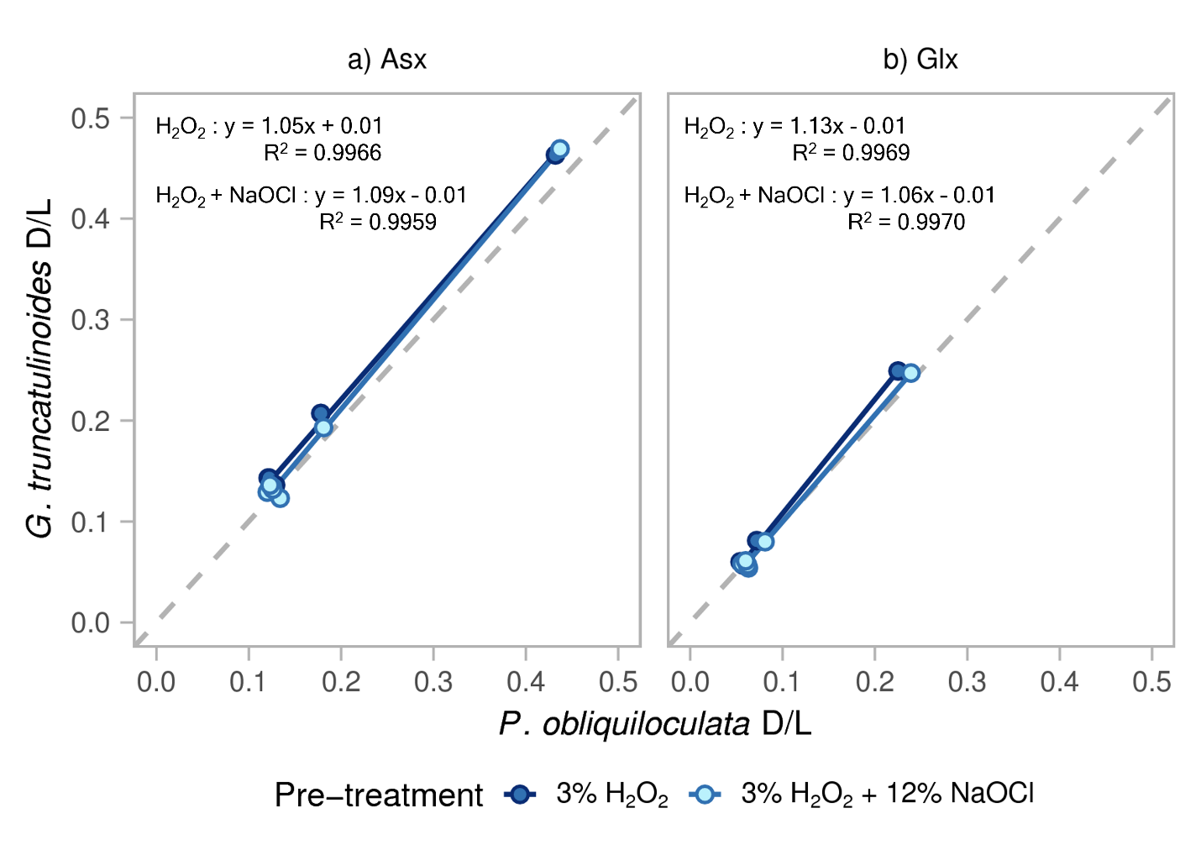
Figure 9. Extent of racemization (D/L) in a) Asx and b) Glx measured in six coeval intervals of P. obliquiloculata and G. truncatulinoides (Table 2). The slope indicates the relative racemization rates for the species where i) slope =1 indicates that both species racemize at the same rate, ii) slope > 1 indicates that G. truncatulinoides racemizes faster than P. obliquiloculata, and iii) slope < 1 indicates that P. obliquiloculata racemizes faster than G. truncatulinoides.

3.5 D/L variability within planktic foraminifera
The subsamples for each interval and species in the planktic foraminifer study also afford a closer look at the effects of bleach on the replicability of sample mean D/L values. To describe this subsample variability, and to normalize it to the mean values, we use a coefficient of variation (CV). To quantify the average change (e.g., ΔCV, Table 5) in the subsample variability between the pre-treatments for Asx and Glx, we subtract the CV for samples treated with H₂O₂-only from the CV for samples also treated with NaOCl. Accordingly, a decrease in the subsample variability is described by a decrease in the CV and indicates an improvement in replicability due to the additional bleaching pre-treatment. However, it is important to note that these statistical analyses are limited. While there are 14 mid Holocene aged samples for comparison, there are only 2 early Holocene, 1 late Pleistocene, and 2 mid Pleistocene-aged samples for comparison. We must therefore be careful when interpreting the statistics for the older samples (n = 5).
Overall, the results show that bleaching can reduce the subsample variability, although not consistently. For example, in 14 out of the 19 samples analyzed (74%), mean D/L for Asx and Glx show an improved CV with the bleaching method (negative values in Table 5, Figure 10). However, the improvement for Asx is small, on average -3.4% ± 3.1%, with most samples falling within ±0.5% of the 1:1 regression line, suggesting that there is minimal difference between the CV of the two treatments. More specifically, we note that mid Holocene samples, for which we have the largest amount of data (n = 14) show the largest variations in the effect of adding bleach in comparison to the older samples (Table 5; Figure 10). Less than half of these samples show noticeable reductions in their CV with bleaching (ΔCV < -4%; Fig. 10). For Asx, the late Pleistocene sample shows a notable increase in its CV after bleaching (ΔCV = 6%), while the early Holocene and mid Pleistocene samples are on or to the right of the 1:1 line (ΔCV = 0 to -4.6%). For Glx, all samples older than mid Holocene fall to the right of the 1:1 line (ΔCV = -2.8 to -5.6%), suggesting that bleach may more consistently reduce the inter-sample variability of D/L Glx.

Table 5. Average intra-sample variability in D/L values as described by the coefficient of variation (CV) compared between the 3% H₂O₂-only and 12% NaOCl-addition pre-treatments of planktic foraminiferal tests.

Site | Sediment Depth (m) | Species¹ | D/L Asx CV (%) |  |  |  | D/L Glx CV (%)
 |  |  | H₂O₂ | NaOCl² | ΔCV³ |  | H₂O₂ | NaOCl² | ΔCV³
Mid Holocene (6.0-7.1 ka)
1056D | 0.62 | P. obliq | 10.0 | 3.0 | -7.0 |  | 20.0 | 8.0 | -12.0
1056D | 0.64 | P. obliq | 3.7 | 3.9 | 0.2* |  | 5.5 | 7.7 | 2.2*
1056D | 0.70 | P. obliq | 2.7 | 3.3 | 0.6* |  | 9.7 | 13.8 | 4.8*
1056D | 0.64 | G. trun | 7.9 | 6.7 | -1.2 |  | 11.0 | 13.1 | 2.1*
1056D | 0.70 | G. trun | 6.1 | 2.3 | -3.8 |  | 8.2 | 5.9 | -2.3
1056D | 0.64 | G. tum | 5.6 | 7.8 | 2.2* |  | 6.9 | 25.7 | 18.8*
1056D | 0.68 | G. tum | 9.5 | 6.6 | -2.9 |  | 16.6 | 7.8 | -8.8
1059A | 0.44 | P. obliq | 4.5 | 3.2 | -1.3 |  | 12.3 | 5.1 | -7.2
1059A | 0.54 | P. obliq | 6.7 | 5.1 | -1.6 |  | 17.9 | 5.6 | -12.3
1059A | 0.44 | G. trun | 5.1 | 4.6 | -0.5 |  | 10.1 | 6.3 | -3.8
1059A | 0.50 | G. trun | 15.1 | 2.9 | -12.2 |  | 13.0 | 4.8 | -8.2
1059A | 0.54 | G. trun | 10.2 | 7.3 | -2.9 |  | 13.4 | 4.4 | -9.0
1059A | 0.44 | G. tum | 8.5 | 4.6 | -3.9 |  | 15.3 | 12.4 | -2.9
1062B | 0.62 | G. trun | 8.8 | 6.9 | -1.9 |  | 5.5 | 7.2 | 1.7*
Early Holocene (10.5 ka)
KNR140 | 1.50 | P. obliq | 7.6 | 3.0 | -4.6 |  | 16.6 | 11.0 | -5.6
KNR140 | 1.50 | G. trun | 5.4 | 3.3 | -2.1 |  | 6.9 | 2.7 | -4.2
Late Pleistocene (51.5 ka)
KNR140 | 11.12 | G. trun | 2.1 | 8.1 | 6.0* |  | 13.8 | 10.1 | -2.8
Mid Pleistocene (410.0 ka)
1056B | 35.34 | P. obliq | 4.2 | 4.2 | 0.0 |  | 6.1 | 3.3 | -2.8
1056B | 35.34 | G. trun | 3.4 | 2.0 | -1.4 |  | 6.2 | 3.0 | -3.2
¹ P. obliq = Pulleniatina obliquiloculata, G. trun = Globorotalia truncatulinoides, G. tum = Globorotalia tumida
² NaOCl stands for samples treated first with H₂O₂ and additionally with NaOCl.
³ The values with an asterisk show an increase in variance with the NaOCl bleaching pre-treatment where $∆CV=CV_{NaOCl}-CV_{H_{2}O_{2}}$.

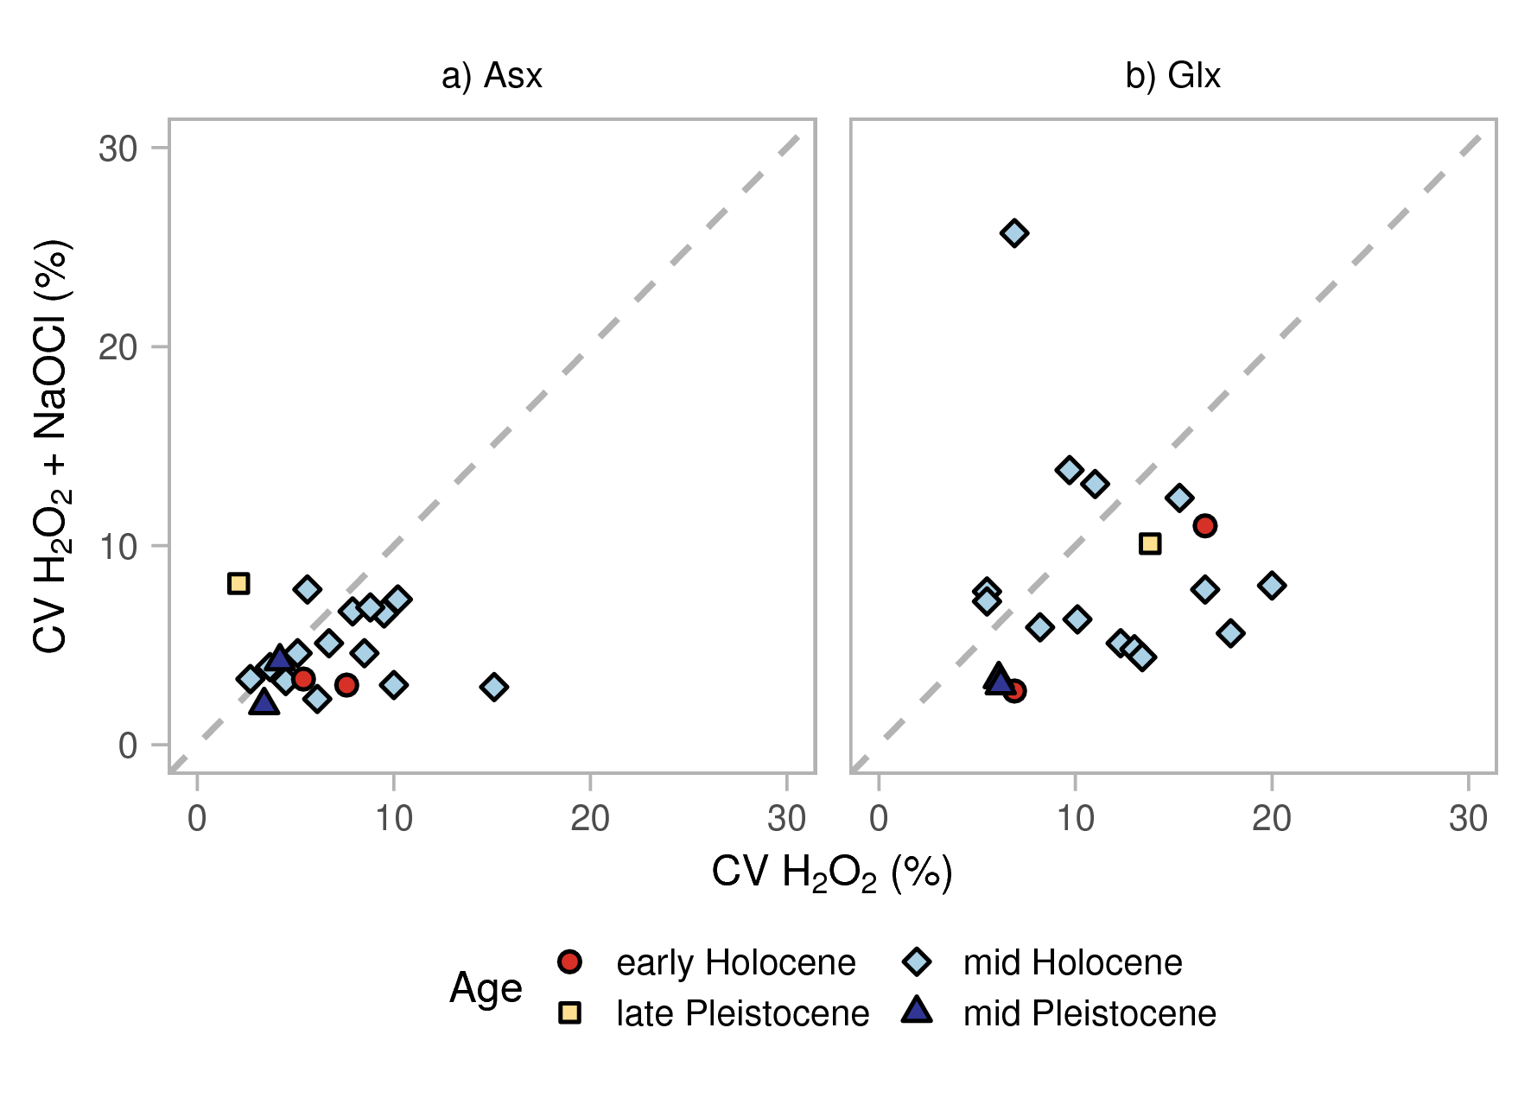
Figure 10. Relationship between the coefficient of variation (CV) pertaining to the two pre-treatment methods in planktic foraminifera for a) Asx and b) Glx. The diagonal dashed line indicates the 1:1 relationship on which the points should fall if additional treatment with bleach does not produce a change in the CV. Points to the left of the line indicate that additional bleaching increases the CV with respect to peroxide treatment only; points to the right of the line indicate that the CV is lower after bleaching with respect to peroxide treatment only.

4. Discussion
This study shows the effects of oxidative pre-treatments on biomineral amino acids within foraminiferal tests by combining the results of two studies: 1) sequential oxidation experiments involving peroxide versus bleach conducted on sub-modern benthic Ammonia spp. and H. germanica, and 2) experiments testing the effects of bleach on peroxide pre-treated mid Holocene through mid Pleistocene planktic species (P. obliquiloculata, G. truncatulinoides, and G. tumida). Our integrated results suggest that bleach more effectively reduces [THAA] in a sample in comparison to sonication-only treatments (Figure 2), while peroxide moderately reduces [THAA] (Figures 2 and 3). These results demonstrate that bleach pre-treatment is effective in removing exogenous and/or inter-crystalline proteins in accordance with previous studies (e.g., Crisp et al., 2013; Demarchi et al., 2013a, 2013b; Hendy et al., 2012; Ortiz et al., 2015, 2018; Penkman et al., 2008, 2011). This is important because contamination by surface amino acids is of particular concern in foraminifera due to the high surface area-to-mass ratio related to test porosity (Hearty et al., 2004; Stathoplos and Hare, 1993).
While oxidative pre-treatments reduce [THAA] of foraminifera (Figures 2 and 3), neither hydrogen peroxide nor bleach substantially affect the proportion of individual amino acids in a sample (Figures 4 and 5), with the exception of Ammonia spp. For this benthic species, increasing the strength of the oxidizing agent causes the proportion of Asx, Glx, and Ala to increase and the proportion of Gly to decrease, most noticeably in the 12% NaOCl treatment. In contrast to Ammonia spp., the compositional differences between the pre-treatments for H. germanica and the planktic species are less pronounced. This has also been observed in naturally aged N. pachyderma (Wheeler et al., 2021), and suggests that in general, the inter- and intra-crystalline fractions of foraminifera have similar amino acid compositions. The different pattern seen in Ammonia spp. could be due to the sonication and weak oxidizing treatments being less effective at removing surface organic material for this species than the others investigated, although the variability of the composition data precludes a firm conclusion.
Effective removal of surface contaminants by bleach could also partly explain the overall reduction in the subsample variability in D/L values of bleach-treated samples with respect to those treated with peroxide only. Replicate analyses of the BBOR samples suggests that bleaching tends to reduce the variability within samples, albeit with differences in the extent depending on the amino acid. For D/L Asx, the reduction in CV is minimal overall, not very consistent, and not apparent in older samples. For D/L Glx, bleaching more effectively reduces the CV at all ages, although the difference in variability between bleached and peroxide-only samples is inconsistent. This slight reduction in D/L variability in bleached samples, especially younger samples, is consistent with bleaching experiments carried out on Neogloboquadrina pachyderma (sinistral) (Wheeler et al., 2021). Although the bleach pre-treatment appears to isolate the intra-crystalline fraction of foraminiferal amino acids, the small reduction in subsample variability does not warrant the additional preparation time and larger sample size that the bleach pre-treatment requires. Instead, the hydrogen peroxide pre-treatment is sufficient at removing surface contaminants from foraminiferal tests, resulting in D/L values that are not statistically different between the pre-treatments.
Neither set of experiments demonstrates a consistent effect of oxidation on Asx and Glx D/L values that warrant extensive chemical pre-treatment. For the sub-modern benthic foraminifer species, there is no observable difference in D/L values between tests that were H₂O sonicated, peroxide-treated, or bleach-treated (Figure 6). Bleaching does cause statistically significant differences in the D/L values of mid Holocene-aged planktic foraminifera tests, although the differences are small and are inconsistent in their direction and magnitude (Table 2; Figures 7 and 8). In early Holocene through mid Pleistocene-aged samples, additional bleaching of peroxide-treated foraminifer tests does not consistently affect the overall D/L values. These irregularities suggest that most of the surface contaminants are removed before the oxidizing pre-treatments are applied; an interpretation that is supported by the observation that neither pre-treatment method consistently affects the D/L values of a sample.
Species-specific differences in D/L values are evident in several samples. By comparing down-core changes in D/L values for coeval species, we can see how the pre-treatments affect apparent species-specific racemization rates (Figure 9). The down-core changes in D/L values for G. truncatulinoides and P. obliquiloculata are similar, but not the same, suggesting small differences in racemization rates. The results show that D/L Asx in G. truncatulinoides has a higher racemization rate than in P. obliquiloculata, and pre-treatment has minimal effect on the rate (e.g., D/L Asx in G. truncatulinoides racemizes 5% and 9% faster than in P. obliquiloculata for H₂O₂ and NaOCl treated samples, respectively). Conversely, the bleach pre-treatment reduces the species differences for D/L Glx, where D/L Glx in G. truncatulinoides racemizes 13% and 6% faster than in P. obliquiloculata for H₂O₂ and bleach treated samples, respectively.
The bleach pre-treatment does not affect the overall trend of planktic foraminiferal D/L values over time (Figure 11), meaning D/L increases with age, reflecting the increased proportion of D-Asx and D-Glx due to the increased extent of racemization in older fossils. While the overall trend is consistent, the pre-treatments induce a relatively small effect on the D/L values of Glx in G. truncatulinoides (Figure 11a), but not in P. obiquiloculata (Figure 11b). Thus, in this study, bleaching of foraminifer tests does not improve the replicability of D/L values of planktic foraminiferal species. While analyzing only the bleach-isolated intra-crystalline fraction of amino acids can reduce the variability of D/L values in some biominerals, this study suggests that this is not the case for foraminifera. This behavior is also seen in ostracod valves (Bright and Kaufman, 2011) and some aragonitic mollusks (e.g., Orem and Kaufman, 2011; Demarchi et al., 2015; Ortiz et al., 2017).
The most likely explanation for why the older (mid Holocene through mid Pleistocene) foraminiferal tests do not show differences in D/L values between the pre-treatments could be because some of the more easily accessed free amino acids and matrix proteins from the inter-crystalline fraction have already been removed over time, possibly due to leaching (diffusive loss) and/or microbial influences (Demarchi and Collins, 2015; Ortiz et al., 2015, 2017; Penkman et al., 2008). Therefore, the amino acids remaining in these older samples would be likely dominated by the intra-crystalline fraction, which is resistant to exposure to chemical oxidation (Penkman et al., 2008; Stathoplos and Hare, 1993, Wheeler et al., 2021). For peroxide treated mid Holocene samples (~5 ka), a larger proportion of inter-crystalline proteins would remain due to the younger age of these samples.

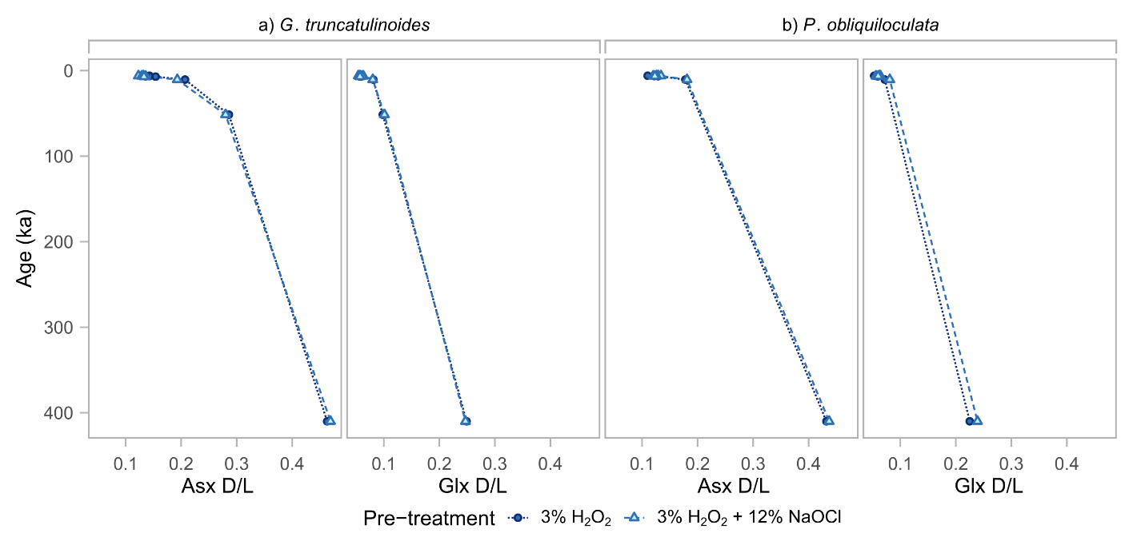

Figure 11. Early Holocene through mid Pleistocene (10.5 – 410.0 ka) changes in a) G. truncatulinoides b) and P. obliquiloculata D/L Asx (and D/L Glx in c and d for the two species respectively) for peroxide treated (dark blue circles) and bleached (light blue triangles).

7. Conclusions
If foraminifer tests contain a closed-system intra-crystalline protein fraction, bleaching should isolate this fraction and reduce post-depositional environmental influences on the preservation of amino acids (i.e., contamination by exogenous amino acids, microbial decomposition, and leaching), thus improving the analytical variability (Penkman et al., 2008). We evaluate the effects of oxidative pre-treatments on benthic and planktic foraminiferal species through sequential oxidation experiments on sub-modern benthic foraminifer tests (0 – 5 cm sample depth) and through comparative oxidation experiments using peroxide and peroxide plus bleach on three species of planktic foraminiferal tests (~6.0 – 410.0 ka). We investigate how bleach pre-treatment affects the variability in foraminiferal D/L values in three foraminiferal species of different ages. The results indicate that bleaching for 24 h reduces amino acid concentrations but does not completely remove amino acids within the foraminifer tests. This decrease in amino acid concentration reflects the removal of exogenous and/or easily accessed matrix proteins and the subsequent isolation of bleach resistant intra-crystalline amino acids.
The effective removal of surface contaminants and labile inter-crystalline matrix proteins by bleach can explain the overall reduction in subsample variability and change in some D/L values observed in our mid Holocene foraminifer tests. The older (i.e., early Holocene to mid Pleistocene) foraminiferal tests do not show differences in D/L values across the various pre-treatments and the reduction in subsample variability in D/L values is less apparent, especially for Asx. This could be due to the removal of easily accessed free amino acids and matrix proteins over time due to leaching and/or microbial influences, leaving behind a greater proportion of intra-crystalline amino acids.
In conclusion, due to the lack of consistent improvement in foraminiferal D/L variability between oxidation by hydrogen peroxide and bleach, the short oxidation procedure using hydrogen peroxide appears to be sufficient for AAR studies involving foraminifera. Analyzing the bleach-resistant fraction of amino acids requires a larger sample size and additional preparation time and does not yield results that are substantially better than results derived from the less time-intensive peroxide pre-treatment. This study shows that the inconsistent reduction in variability produced by the IcPD bleach pre-treatment does not outweigh the additional analyst time and larger sample size required, and therefore the short (2 h) 3% H₂O₂ oxidation protocol is recommended.

Data Availability
All data will be published in the NOAA data archive.

Acknowledgments
Funding: This work was supported by the Petroleum Research Fund (PRF #56964-ND), administered by the American Chemical Society (ACS) (KB); the University of York Chemistry Department; the National Science Foundation (award #1855381); and the European Research Council (ERC) under the European Union’s Horizon 2020 research and innovation program (grant agreement #865222) as part of the EQuaTe study. This research used samples collected by the Ocean Drilling Program (ODP) and provided by the International Ocean Discovery Program (IODP). ODP and IODP are sponsored by the U.S. National Science Foundation (NSF) and participating countries.

We thank the editors and reviewers for their time. EM thanks Katherine Whitacre for running the instrument at Amino Acid Geochronology Lab, and John Wehmiller for insights and discussions regarding methods and application of AAR. LW would also like to thank Sheila Taylor and Maria Gehrels for technical support and Graham Rush for Humber estuary sample collection. Lastly, EM and LW thank Jordon Bright for insight with the manuscript.

References
Bada, J.L., Schroeder, R.A., 1975. Amino acid racemization reactions and their geochemical implications. Naturwissenchaften 62, 71–79. https://doi.org/10.1007/BF00592179
Billups, K., Chaisson, W., Worsnopp, M., Thunell, R., 2004. Millennial-scale fluctuations in subtropical northwestern Atlantic surface ocean hydrography during the mid-Pleistocene. Paleoceanography 19, PA2017. https://doi.org/10.1029/2003PA000990
Blakemore, A.G., 2014. Middle Pleistocene to Holocene sea-level changes and coastal evolution on the Mount Gambier coastal plain, southern Australia (PhD Thesis). University of Wollongong.
Bright, J., Kaufman, D.S., 2011. Amino acid racemization in lacustrine ostracodes, part I: Effect of oxidizing pre-treatments on amino acid composition. Quaternary Geochronology 6, 154–173. https://doi.org/10.1016/j.quageo.2010.11.006
Brooks, A.S., Hare, P.E., Kokis, J.E., Miller, G.H., Ernst, R.D., Wendorf, F., 1990. Dating Pleistocene Archeological Sites by Protein Diagenesis in Ostrich Eggshell. Science 248, 60–64. https://doi.org/10.1126/science.248.4951.60
Bush, S.L., Santos, G.M., Xu, X., Southon, J.R., Thiagarajan, N., Hines, S.K., Adkins, J.F., 2013. Simple, rapid, and cost effective: a screening method for ¹⁴C analysis of small carbonate samples. Radiocarbon 55, 631–640. https://doi.org/10.1017/S0033822200057787
Crisp, M., Demarchi, B., Collins, M., Morgan-Williams, M., Pilgrim, E., Penkman, K., 2013. Isolation of the intra-crystalline proteins and kinetic studies in Struthio camelus (ostrich) eggshell for amino acid geochronology. Quaternary Geochronology 16, 110–128. https://doi.org/10.1016/j.quageo.2012.09.002
Demarchi, B., Clements, E., Coltorti, M., van de Locht, R., Kröger, R., Penkman, K., Rose, J. 2015. Testing the effect of bleaching on the bivalve Glycymeris: A case study of amino acid geochronology on key Mediterranean raised beach deposits. Quaternary Geochronology 25, 49 – 65. https://doi.org/10.1016/j.quageo.2014.09.003
Demarchi, B., Collins, M., 2015. Amino Acid Racemization Dating. Encyclopedia of Scientific Dating Methods, Encyclopedia of Earth Sciences Series, pp. 13–26.
Demarchi, B., Collins, M.J., Tomiak, P.J., Davies, B.J., Penkman, K.E.H., 2013a. Intra-crystalline protein diagenesis (IcPD) in Patella vulgata. Part II: Breakdown and temperature sensitivity. Quaternary Geochronology 16, 158–172. https://doi.org/10.1016/j.quageo.2012.08.001
Demarchi, B., Rogers, K., Fa, D.A., Finlayson, C.J., Milner, N., Penkman, K.E.H., 2013b. Intra-crystalline protein diagenesis (IcPD) in Patella vulgata. Part I: Isolation and testing of the closed system. Quaternary Geochronology 16, 144–157. https://doi.org/10.1016/j.quageo.2012.03.016
Dickinson, M.R., Lister, A.M., Penkman K.E.H., 2019. A new method for enamel amino acid racemization dating: a closed system approach. Quaternary Geochronology 50, 29 – 46. https://doi.org/10.1016/j.quageo.2018.11.005
Dowling, L.A., Sejrup, H.P., Coxon, P., Heijnis, H., 1998. Palynology, aminostratigraphy and U-series dating of marine gortian interglacial sediments in cork harbour, Southern Ireland. Quaternary Science Reviews 17, 945–962. https://doi.org/10.1016/S0277-3791(98)00027-4
Dungworth G., 1975. Optical configuration and the racemization of amino acids in sediments and in fossils – A review. Chemical Geology 17, 135–153. https://doi.org/10.1016/0009-2541(76)90027-9
Figueira, B., Hayward, B. W., 2014. Impact of reworked foraminifera from an eroding salt marsh on sea-level studies, New Zealand. New Zealand Journal of Geology and Geophysics 57, 378–389. https://doi.org/10.1080/00288306.2014.924971
Gehres, W.R., Roe, H.M., Charman, D.J., 2001. Foraminifera, testate amoebae and diatoms as sea-level indicators in UK saltmarshes: a quantitative multiproxy approach. Journal of Quaternary Science 16, 201–220. https://doi.org/10.1002/jqs.588
Goodfriend, G.A., 1989. Complementary Use of Amino-Acid Epimerization and Radiocarbon Analysis for Dating of Mixed-Age Fossil Assemblages. Radiocarbon 31, 1041–1047. https://doi.org/10.1017/S0033822200012698
Goodfriend, D.A., Brigham-Grette, J., Miller, G.H., 1996. Enhanced age resolution of the marine Quaternary record in the Arctic using aspartic acid racemization dating of bivalve shells. Quaternary Research 45, 176–187. https://doi.org/10.1006/qres.1996.0018
Grützner, J., Giosan, L., Franz, S.O., Tiedemann, R., Cortijo, E., Chaisson, W.P., Flood, R.D., Hagen, S., Keigwin, L.D., Poli, S., Rio, D., Williams, T., 2002. Astronomical age models for Pleistocene drift sediments from the western North Atlantic (ODP Sites 1055–1063). Marine Geology 189, 5–23. https://doi.org/10.1016/S0025-3227(02)00320-1
Hagen, S., Keigwin, L.D., 2002. Sea-surface temperature variability and deep water reorganisation in the subtropical North Atlantic during Isotope Stage 2–4. Marine Geology 189, 145–162. https://doi.org/10.1016/S0025-3227(02)00327-4
Hayward, B.W., Holzmann, M., Grenfell, H.R., Pawlowski, J., Triggs, C.M., 2004. Morphological distinction of molecular types in Ammonia – towards a taxonomic revision of the world’s most commonly misidentified foraminifera. Marine Micropaleontology 50, 237–271. https://doi.org/10.1016/S0377-8398(03)00074-4
Hearty, P.J., O’Leary, M.J., Kaufman, D.S., Page, M.C., Bright, J., 2004. Amino acid geochronology of individual foraminifer (Pulleniatina obliquiloculata) tests, north Queensland margin, Australia: A new approach to correlating and dating Quaternary tropical marine sediment cores. Paleoceanography 19, PA4022. https://doi.org/10.1029/2004PA001059
Hendy, E.J., Tomiak, P.J., Collins, M.J., Hellstrom, J., Tudhope, A.W., Lough, J.M., Penkman, K.E.H., 2012. Assessing amino acid racemization variability in coral intra-crystalline protein for geochronological applications. Geochimica et Cosmochimica Acta 86, 338–353. https://doi.org/10.1016/j.gca.2012.02.020
Hemleben, C.H., Spindler, M., Anderson O.R., 1989. Modern Planktonic Foraminifera. Springer Verlag, pp. 363.
Hill, R.L., 1965. Hydrolysis of Proteins, in: Advances in Protein Chemistry. Elsevier, pp. 37–107. https://doi.org/10.1016/S0065-3233(08)60388-5
Kaufman, D., 2003. Amino acid paleothermometry of Quaternary ostracodes from the Bonneville Basin, Utah. Quaternary Science Reviews 22, 899–914. https://doi.org/10.1016/S0277-3791(03)00006-4
Kaufman, D., 2006. Temperature sensitivity of aspartic and glutamic acid racemization in the foraminifera Pulleniatina. Quaternary Geochronology 1, 188–207. https://doi.org/10.1016/j.quageo.2006.06.008
Kaufman, D.S., Polyak, L., Adler R., Channell, J.E.T., Xuan, C., 2008. Dating late Quaternary plaktonic foraminifer Neogloboquadrina pachyderma from the Arctic Ocean using amino acid racemization. Paleoceanography 23, PA3224. https://doi.org/10.1029/2008PA001618
Kaufman, D.S., Cooper, K., Behl, R., Billups, K., Bright, J., Gardner, K., Hearty, P., Jakobsson, M., Mendes, I., O’Leary, M., Polyak, L., Rasmussen, T., Rosa, F., Schmidt, M., 2013. Amino acid racemization in mono-specific foraminifera from Quaternary deep-sea sediments. Quaternary Geochronology 16, 50–61. https://doi.org/10.1016/j.quageo.2012.07.006
Kaufman, D.S., Manley, W.F., 1998. A new procedure for determining enantiomeric (D/L) amino acid ratios in fossils using reverse phase liquid chromatography. Quaternary Science Reviews 17, 987–1000. https://doi.org/10.1016/S0277-3791(97)00086-3
Kaufman, D.S., Miller, G.H., 1992. Overview of amino acid geochronology. Comparative Biochemistry and Physiology Part B: Comparative Biochemistry 102, 199–204. https://doi.org/10.1016/0305-0491(92)90110-D
King, K., Neville, C., 1977. Isoleucine epimerization for dating marine sediments: Importance of analyzing monospecific foraminiferal samples. Science 195, 1333–1335. https://doi.org/10.1126/science.195.4284.1333
Kosnik, M.A., Kaufman, D.S., 2008. Identifying outliers and assessing the accuracy of amino acid racemization measurements for geochronology: II. Data screening. Quaternary Geochronology 3, 328–341. https://doi.org/10.1016/j.quageo.2008.04.001
Kosnik, M.A., Kaufman, D.S., Hua, Q., 2013. Radiocarbon-calibrated multiple amino acid geochronology of Holocene molluscs from Bramble and Rib Reefs (Great Barrier Reef, Australia). Quaternary Geochronology 16, 73–86. https://doi.org/10.1016/j.quageo.2012.04.024
Long, A.J., Innes, J.B., Kirby, J.R., Lloyd J.M., Rutherford, M.M., Shennan, I., Tooley, M.J., 1998. Holocene sea-level change and coastal evolution in the Humber estuary, eastern England: an assessment of rapid coastal change. The Holocene 8, 229–247. https://doi.org/10.1191/095968398677984183
Macko, S.A., Aksu, A.E., 1986. Amino acid epimerization in planktonic foraminifera suggests slow sedimentation rates for Alpha Ridge, Arctic Ocean. Nature 322, 730–732. https://doi.org/10.1038/322730a0
McCoy, W.D., 1987. The precision of amino acid geochronology and paleothermometry. Quaternary Science Reviews 6, 43–54. https://doi.org/10.1016/0277-3791(87)90016-3
Miller, G.H., Hollin, J.T., Andrews, J.T., 1979. Aminostratigraphy of UK Pleistocene deposits. Nature 281, 539–543. https://doi.org/10.1038/281539a0
Miller, G.H., Kaufman, D.S., Clarke, S.J., 2013. Amino Acid Dating, in: Encyclopedia of Quaternary Science. Elsevier, pp. 37–48.
Miller, G.H., Mangerud, J. (1985). Aminostratigraphy of European marine interglacial deposits. Quaternary Science Reviews, 4, 215–278. https://doi.org/10.1016/0277-3791(85)90002-2
Nicholas, W.A., 2012. Aminostratigraphy of semi-enclosed basins (PhD Thesis). University of Wollongong.
Orem, C.A., Kaufman, D.S., 2011. Effects of basic pH on amino acid racemization and leaching in freshwater mollusk shell. Quaternary Geochronology 6, 233–245. https://doi.org/10.1016/j.quageo.2010.11.005
Ortiz, J.E., Gutiérrez-Zugasti, I., Torres, T., González-Morales, M., Sánchez-Palencia, Y., 2015. Protein diagenesis in Patella shells: Implications for amino acid racemisation dating. Quaternary Geochronology 27, 105–118. https://doi.org/10.1016/j.quageo.2015.02.008
Ortiz, J.E., Torres, T., Sánchez-Palencia, Y., Ferrer, M., 2017. Inter- and intra-crystalline protein diagenesis in Glycymeris shells: Implications for amino acid geochronology. Quaternary Geochronology 41, 37–50. https://doi.org/10.1016/j.quageo.2017.05.007
Ortiz, J.E., Sánchez-Palencia, Y., Gutiérrez-Zugasti, I., Torres, T., González-Morales, M., 2018. Protein diagenesis in archaeological gastropod shells and the suitability of this material for amino acid racemisation dating: Phorcus lineatus (da Costa, 1778). Quaternary Geochronology 46, 16–27. https://doi.org/10.1016/j.quageo.2018.02.002
Penkman, K.E.H., Kaufman, D.S., Maddy, D., Collins, M.J., 2008. Closed-system behaviour of the intra-crystalline fraction of amino acids in mollusc shells. Quaternary Geochronology 3, 2–25. https://doi.org/10.1016/j.quageo.2007.07.001
Penkman, K.E.H., Preece, R.C., Bridgland, D.R., Keen, D.H., Meijer, T., Parfitt, S.A., White, T.S., Collins, M.J., 2011. A chronological framework for the British Quaternary based on Bithynia opercula. Nature 476, 446–449. https://doi.org/10.1038/nature10305
Penkman, K.E.H., Preece, R.C., Bridgland, D.R., Keen, D.H., Meijer, T., Parfitt, S.A., White, T.S., Collins, M.J., 2013. An aminostratigraphy for the British Quaternary based on Bithynia opercula. Quaternary Science Reviews 61, 111–134. https://doi.org/10.1016/j.quascirev.2012.10.046
Ren, H., Thunell, R., Sigman, D.M., Prokopenko, M.G., 2010. Nitrogen isotopic composition of planktonic foraminifera from the modern ocean and recent sediments. AGU Fall Meeting Abstracts, PP34A-04.
Ren, H., Sigman, D.M., Thunell, R., Prokopenko, M.G., 2012. Nitrogen isotopic composition of planktonic foraminifera from the modern ocean and recent sediments. Limnology and Oceanography 57, 1011–1024. https://doi.org/10.4319/lo.2012.57.4.1011
Scourse, J.D., Austin, W.E.N., Sejrup, H.P., Ansari, M.H., 1999. Foraminiferal isoleucine epimerization determinations from the Nar Valley Clay, Norfolk, UK: implications for Quaternary correlations in the southern North Sea basin. Geological Magazine 136, 543–560. https://doi.org/10.1017/S0016756899002812
Sejrup, H.P., Rokoengen, K., Miller, G.H., 1984. Isoleucine epimerization in Quaternary benthonic foraminifera from the Norwegian Continental Shelf: A pilot study. Marine Geology 56, 227–239. https://doi.org/10.1016/0025-3227(84)90015-X
Stathoplos, L., Hare, P.E., 1993. Bleach removes labile amino acids from deep sea planktonic foraminiferal shells. Journal of Foraminiferal Research 23, 102–107. https://doi.org/10.2113/gsjfr.23.2.102
Sykes, G.A., Collins, M.J., Walton, D.I., 1995. The significance of a geochemically isolated intracrystalline organic fraction within biominerals. Organic Geochemistry 23, 1059–1065. https://doi.org/10.1016/0146-6380(95)00086-0
Tomiak, P.J., Penkman, K.E.H., Hendy, E.J., Demarchi, B., Murrells, S., Davis, S.A., McCullagh, P., Collins, M.J., 2013. Testing the limitations of artificial protein degradation kinetics using known-age massive Porites coral skeletons. Quaternary Geochronology 16, 87–109. https://doi.org/10.1016/j.quageo.2012.07.001
Towe, Kenneth M., 1980. Preserved organic ultrastructure: an unreliable indicator for Paleozoic amino acid biogeochemistry, in: Biogeochemistry of amino acids. John Wiley and Sons, pp. 65–74.
Walker, M.J.C., 2005. Quaternary Dating Methods. John Wiley and Sons, pp. 184–195.
Ward, J.N., Pond, D.W., Murray, J.W., 2003. Feeding of benthic foraminifera on diatoms and sewage-derived organic matter: an experimental application of lipid biomarker techniques. Marine Environmental Research 56, 515–530. https://doi.org/10.1016/S0141-1136(03)00040-0
Watson, E., 2019. Amino acid racemization of planktonic foraminifera: Pretreatment effects and temperature reconstruction (Masters Thesis). University of Delaware.
Wehmiller, J.F., 1977. Amino acid studies of the Del Mar, California, midden site: Apparent rate constants, ground temperature models, and chronological implications. Earth and Planetary Science Letters 37, 184–196. https://doi.org/10.1016/0012-821X(77)90163-7
Wehmiller, J.F., 2013. United States Quaternary coastal sequences and molluscan racemization geochronology – What have they meant for each other over the past 45 years? Quaternary Geochronology 16, 3–20. https://doi.org/10.1016/j.quageo.2012.05.008
Wehmiller, J.F., Hall, F.R., 1997. Amino acid racemization geochronological studies of selected Leg 155 samples (Scientific Results No. 155), Proceedings of the Ocean Drilling Program. Ocean Drilling Program, College Station, TX, pp. 375–378.
Wehmiller, J.F., Hare, P.E., 1971. Racemization of amino acids in marine sediments. Science, 173, 907–911. https://doi.org/10.1126/science.173.4000.907
Wheeler, L.J., Penkman, K.E.H., Sejrup, H.P., 2021. Assessing the intra-crystalline approach to amino acid geochronology of Neogloboquadrina pachyderma (sinistral). Quaternary Geochronology 61, 101131. https://doi.org/10.1016/j.quageo.2020.101131
Williams, K.M., Smith, G. G., 1977. A critical evaluation of the application of amino acid racemization to geochronology and geothermometry. Origins of Life and Evolution of Biospheres 8, 91–144. https://doi.org/10.1007/BF00927978

