Patient Experiences of Scaphoid Waist Fractures and their Treatment - a Qualitative Investigation.

Abstract

Aims.
To explore individuals’ experience of a scaphoid waist fracture and its subsequent treatment.

Patients and Methods.
A purposive sample of 49 participants of the SWIFFT trial of initial surgery compared with plaster cast treatment for fractures of the scaphoid waist. More male participants (35/49) and more younger participants (28/49) were included.

Participants were interviewed 6 weeks or 52 weeks post-recruitment to the trial, or at both time points. Interviews were semi-structured and analysed inductively to generate cross-cutting themes which typify experience of the injury and views upon the treatment options.

Results.
Data shows that individual circumstances might exaggerate or mitigate the limitations associated with a scaphoid fracture, and that an individual’s sense of recovery is subjective and more closely aligned with perceived functional abilities than it is with bone union.
Misconceptions that surgery promises a speedier and more secure form of recovery means that some individuals, whose circumstances prescribe a need for quick return to function, express a preference for this treatment modality. Clinical consultations need to negotiate the imperfect relationship between bone union, normal function, and an individuals’ sense of recovery. Enhancing patients’ perceptions of regaining function, with removable splints and encouraging home exercise, will support satisfaction with care and discourage premature risk taking.
Conclusions.
Clinical decision making in the management of scaphoid fractures should recognise that personal circumstances will influence how functional limitations are experienced. It should also recognise that function overrides a concern for bone union, and that the consequences of fractures are poorly understood. Where possible clinicians should reinforce in individuals a sense that they are making progress in their recovery.

Introduction.

The SWIFFT trial has recently demonstrated that cast treatment (followed by surgery when necessary) is the most appropriate course of action when managing scaphoid waist fractures ^{[1-3]}. However, uncertainties remain about how patients view their injury, experience treatment, and about whether there are circumstances that might inform how this treatment strategy is applied or adapted.

Limited prior qualitative research suggests that injuries of the wrist have a wide-ranging impact ^{[4-11].} Wrist disorders affect domestic, recreational and employment life, and span activities that require fine motor skills as well as those that require strength ^{[9]}. They can have a financial impact ^{[9, 10]} and can change the way that we relate to others in work ^{[4, 7, 11]} and elsewhere ^{[9-11]}. They may cause individuals to feel anxious, frustrated, disillusioned, emotionally distressed or even depressed ^{[6, 8, 9, 11]}; they may lead individuals to become more dependent upon others ^{[9-11]}.

That individuals often initially consider wrist injuries as relatively minor ^{[5, 11]} means that these wide-ranging consequences are not always immediately recognised and recovery is viewed with some uncertainty ^{[8, 10]}. In some studies, “regaining normality” has been recognised as an important (although vague) threshold for patients ^{[7, 9, 12]}, and plaster cast removal has been associated with “the start of recovery” ^{[10]}. An extended period in a plaster cast may be associated with an increased sense of limitation and dissatisfaction ^{[10]}.

This limited literature shows that an individual’s assessment of injury and treatment may be contextually driven, i.e. different people experience their injury differently, have different recovery expectations and have different preferences for treatment. Those with caring responsibilities (such as single parents) and those with particular economic circumstances (such as the self-employed) might feel practical limitations more acutely ^{[10]}. Those that are unable to perform their normal roles (as a spouse, a caregiver, a worker) may experience a sense of loss for these roles ^{[4];} those that prize independence may find reliance upon others challenging ^{[8]}.

The aim of this qualitative study is to explore the experience of a scaphoid fracture and its treatment from the perspective of those that took part in the SWIFFT trial. Gaining this form of detailed, lived-experience insight can contribute in a meaningful fashion to better focused shared decision making^{[13]}, improved patient-centred care^{[14, 15]}, and is important in understanding services and service improvement^{[16]}.

This study complements the clinical insight ^{[1, 2]} generated in the SWIFFT trial by considering patient preference for treatment options, and those factors that might be pertinent in this. Data generated here will support clinicians in the management of scaphoid fractures, providing knowledge about the sort of information that patients require when considering treatments, and about how best to communicate this.

Methods.

This is a qualitative interview study nested within the SWIFFT trial ^{[1, 2, 17]}.

NRES Committee East Midlands – Derby (Ethics reference 13/EM/0154) awarded ethical approval for this research.

Participants
Participants were selected purposively ^{[18]} from those recruited to the SWIFFT trial, and from amongst those that declined to participate in the trial but were willing to take part in an interview. To reflect the clinical population sampling sought to recruit more male than female participants (in a ratio of 2:1), and more young people (in a ratio of 2:1 favouring those under 30 years of age). Equal numbers of those cast and those treated surgically, and equal numbers of those with manual and non-manual occupations completed the purposive plan.
Written informed consent was obtained for all participants.

Data collection
SWIFFT trial participants were invited to take part in two interviews, one within 6 weeks of randomisation and a second at 52 weeks. Those not in the trial were invited to a single interview, within 6 weeks of the approach about the SWIFFT trial.

Both earlier and later interviews covered similar topics and were organised in three parts: i) impact of the fracture, ii) treatment, and iii) participation in clinical research (see figure 1). Interviews at 6 weeks were intended to allow reflection whilst still experiencing treatment; interviews at 52 weeks were intended to reflect upon the patient journey. The same interview schedule was used with participants who had declined to participate in the trial - with some adjustment as to how questions were phrased.

<<fig1>>

Where possible interviews were undertaken face-to-face at a time and location convenient to the participant. In other cases, where the participant preferred or geography made face-to-face impractical, interviews were undertaken via telephone.

All interviews were digitally recorded and transcribed in full; transcripts were anonymised. Data were stored on a password protected, networked drive and handled using the NVivo (version 11) software package ^{[19].}

Data analysis
Data were analysed using an inductive, thematic approach ^{[20]}. Points of interest in the transcripts were coded with a descriptive label; these labels were reviewed, refined, and organised within broader themes (see figure 2 for examples). Themes were reviewed for internal and external coherence; their utility in addressing the research questions considered and themes finalised and prioritised.

<< fig2>>

Coding was led by PL with other authors (JD & SB) reviewing and validating interpretations. Interview data, coding and thematic interpretations were periodically shared with the SWIFFT Trial Management Group, PPI group and at meetings of local, clinical principal investigators. The adequacy of the sample, completeness of the data, and appropriateness of interpretations were considered and iterative amendments to data collection and analytic process made when pertinent.

Results.

64 interviews were undertaken with 49 individuals. Interviews took place between January 2014 and April 2016. Demographics are shown in table 1.

**Table 1 here**

Approximately half of all interviews were with males under the age of 30 (31/64), a key demographic for scaphoid fractures.

In the SWIFFT trial those who were cast as the primary treatment were cast for an average of 65 days. In the surgical arm local post-operative procedures were followed with splints or plaster cast used, in this arm immobilisation was on average for 26 days (including 9 days prior to surgery).

Interviews varied in length from 13-73 minutes – typically 40-45 minutes at 6 weeks and 20-25 minutes at 52 weeks.

Eleven core themes and 37 sub-themes were identified in the data – a fuller presentation of the data is made elsewhere ^{[1]}, here we focus upon that data which illuminates experience of injury and treatment preference.

Theme 1 – The impact of a scaphoid waist fracture
Whilst often considered a relatively minor injury interviewees described a range of practical challenges and the consequent psycho-social impact associated with these (see figure 3). Personal circumstances were important in how practical and psycho-social consequences were experienced.

**Figure 3 here**

Practical Limitations.
All participants described some degree of practical limitation, although this varied according to the hand injured (dominant or non-dominant), the severity of the injury (pain level, swelling and immobilisation) and the need for dexterity or manual strength (in employment or leisure pursuits):

“3 months of not driving for me would be 3 months of hell really. Because I’d be so reliant especially for work … it would have affected my work so much…” [Surgery2097, male, under 30, 52wk interview]

“Well [work] that’s actually been OK. I think … doing the stuff in the office you are using a mouse and computer; it’s never really impacted that much at work … I’m probably not really affected in work that much” [S1281, male, over 30, 6wk interview]

Psycho-social Impact.
Complaints about boredom and frustration were common; less common were descriptions of feeling depressed: “I need to find other things to do with my time … I feel really bad, I feel depressed …”
[S2284, male, under 30, 52wk]; “I started to get very depressed and it affected me badly. I
wasn’t coming out of my room” [Plaster1023, male, under 30, 6wk].

Some younger participants described becoming reliant upon family, some moving back into the parental home. For those with caring responsibilities being unable to contribute at home meant becoming more reliant upon others:

“[Interviewer – How did your wife cope?] With great difficulty, because I was someone who was very active and I turned into someone who’s not … able just to take the mower out of the shed and mow the lawn or take my daughter to the park on the swings or my son on the field with the football and just I couldn’t drive for a long time .... Everything was kind of left to her.” [P1020, male, over 30, 52wk]

Few suggested that such reliance was problematic but changed roles and relationships were manifest in domestic and work relationships as well as in social and leisure networks.

Theme 2 – Treatment experiences
Plaster cast
The inconvenience of a plaster cast was a common complaint. Ranging from the mundane – “I couldn’t flush the toilet”, “I can’t use a knife and fork”, “sleeping is awkward”, “[the cast] ruined so many clothes” – to more significant feelings of losing independence:

“I’ve become more reliant on other people ... I try and do what I usually do and I get annoyed ‘cause I can’t do it … err, so I’ve become more submissive I suppose in that sense, and sort of wait for someone to help out.” [P1485, male, under 30, 6wk]

The length of time required in a plaster cast exaggerated this sense of functional limitation: “12 weeks is kind of pushing it really, for how long I was to wear this thing for” [P1807, male, under 30, 52wk]; “I was probably a bit surprised with how long it took to heal because it had just been like a small bone” [P1161, male, over 30, 52wk]. That this is an uncertain period was not frequently mentioned, but does seem worthy of record:

“[it would be good] if you could see the healing process before the six weeks [when the cast is removed], because I think six weeks is a hell of a long time for somebody to kind of stop doing 50% of the things that they’d normally do to then still not be any better off. It’s kind of a kick in the teeth. I mean if you was in the cast for three weeks and your healing [could be checked] or just to know something halfway through probably would have been a little bit better.” [P1020, male, over 30, 52wk]

Uncertainty may be a factor in half of those treated in a plaster cast interviewed at 52 weeks expressing some concerns about their recovery (5/10).

Surgery
The opportunity for surgical treatment was a commonly cited reason for participating in the SWIFFT trial (theme 3 explores this more fully). Thus, it is unsurprising that few who experienced surgery expressed concerns about its safety or appropriateness.
Any risks associated with surgery were broadly dismissed or overlooked; “you know nothing’s ever 100% perfect … but you know I’ve had surgery before and you know the results of that were outstanding so anxiety none at all. I’ve got full faith [in surgery]” [S1345, male, over 30, 6wk]. Some concerns about scarring were mentioned and some described pain following surgery, but neither of these impact upon a general sense of satisfaction. Local anaesthetic was the only aspect that caused any concern: “it was a step too far, I couldn’t do that.” [S1452, male, under 30, 52wk]; “I was just like ‘oh no’ and she said instantly in my face she could see how I weren’t up for that!” [S1244, female, over 30, 52wk]
All those interviewed at 52 weeks (n=9) indicated that their recovery had exceeded their expectations, often framing this in relation to regaining function quickly:
“I was playing sports pretty much soon after it came out of cast and stuff” [S1452, male, under 30, 52wk].
“I was at work on the Tuesday. So, I only missed one day of work and that was the day they did the surgery.” [S1175, male, over 30, 52wk]

Theme 3 – Factors in treatment preference.
Views about the different treatments were often informed by a common-sense notion of what healing involves and by personal circumstances which might shape functional recovery (see figure 4).

** Fig 4 here**

Plaster cast
A preference for plaster cast was often framed in relation to the body repairing itself naturally: “a natural healing process” [P1360, male, under 30, 6wk]; “the natural path” [P1986, female, over 30, 6wk]. Those who were unwilling to be randomised in the SWIFFT trial often rationalised things in this way, suggesting that they felt that surgery was unnecessary for a minor fracture. Some of those in the trial expressed similar viewpoints: “I prefer non-intervention if possible … my upfront view was never do surgical intervention if you don’t need to …” [P1542, female, over 30, 6wk]

Surgery
A preference for surgical treatment was presented alongside the perception that it would offer a quicker recovery:

“I didn’t really want to stay in a cast for sort of however long, it was already annoying me once I put it on. And yeah, I think it was more speed rather than anything [informing surgery preference]” [S1452, male, under 30, 6wk]

Some believed that surgery offers a stronger repair: “I personally [would] have loved the surgery … because it’s got a screw in it … it’s going to be stronger” [S1265, male, under 30, 6wk]. This was aligned with a belief that surgery is a more active form of treatment: “[it’s a] more involved healing process ... getting it treated rather than just waiting for it to heal in a cast.” [S1339, male, under 30, 6wk]; “the healing process then starts straightaway, doesn’t it with the bone back together where it should be.” [S1244. Female, over 30, 6wk]. Surgery was considered by some as offering greater certainty: “I think there’s just a lot more certainty ... something’s happening. It’s happening now, I’m going to be getting better” [P1360, male, under 30, 6wk].

Personal circumstances
Economic and employment factors were often presented as driving a need for a stronger fix or for a speedier recovery (which might subsequently inform a preference for surgery):

“the operation would be better in my circumstances [manual worker] because it will be a stronger fix.” [S1008, male, under 30, 6wk]

“my mind was already sort of going towards the surgery side anyway ... we run an events catering business and June and July are the busiest sort of two months of the year for us and I kind of needed the use of my hand back” [S1345, male, over 30, 6wk]

Less tangible factors also informed a preference for treatments which are perceived to offer quicker recovery: “I would have probably have put myself at risk by wanting to become independent again.” [S1658, female, over 30, 6wk]; “I’d run the risk of trying to get back quicker and then ending up [hurting myself]” [S1759, male, under 30, 52wk]; “[I’m] very independent and I have to work and drive … being in a cast for eight to ten weeks was quite scary.” [S1749, female, over 30, 6wk]. Interviewees did, however, recognise that circumstances can change, and that in different contexts they would prefer a different treatment:

“I’m actually happier that I didn’t go for surgery … If I was entering a different situation in a different time, I’d be like oh I really do hope that I do get the surgery because I cannot be in a cast for more than two weeks …” [P1030, male, over 30, 6wk]

Discussion.

Summary of evidence
This qualitative research offers detailed, contextualised insight into the experience and treatment of scaphoid fractures. It complements the clinical and economic assessments presented elsewhere ⁽¹⁻³⁾ and reinforces that a scaphoid fracture may have both functional ^{[4-11]} as well as psychosocial consequences ^{[6, 8, 9, 11]}.

This work develops the notion that contextual factors might exaggerate or mitigate the impact of a fracture and/or shape an individual’s sense of recovery ^{[10]}. Here we argue that occupation, broader familial responsibilities, access to familial (or other social) support and leisure/lifestyle pursuits (amongst many others) all subtly influence how a fracture is experienced and shape ambitions for recovery.

We also suggest that an individual’s sense of recovery is subjective and more closely aligned with perceived functional abilities than it is with bone union. This potential disjuncture is further embedded and exaggerated in some cases (especially a younger, male population) by an initial assessment that a scaphoid fracture is a minor injury. Where this is the case consequent frustrations at the slowness of recovery or being incapacitated by a plaster cast may lead to risk taking behaviour. Consequently, diagnosis and treatment discussions need careful consideration; notably helping the patient to appreciate the imperfect relationship between personal circumstances, functional limitations associated with treatment, returning to normal functioning, and bone union.

Individuals in our sample were most activated by the impact upon their functional abilities and surgery was commonly perceived to be an active form of repair, offering less time in plaster and thus a quicker return to such normal activities. Whilst the SWIFFT trial findings do not bear this out ^{[1, 2]} it is worth reflecting that such misconceptions may persist especially for those where economic or familial circumstances dictate a desire for a prompt return to functional normality. To negotiate this, clinical consultations need to accommodate both lay perceptions of functional recovery alongside clinical data about bone union and treatment complications. Participants in our sample were either ignorant of, or unconcerned by, such complications or for the longer-term consequences of a scaphoid fracture.

The culmination of these general points - fractures being subjectively experienced and a desire for prompt, active treatment that returns functional normality - might lead clinicians to consider strategies which reinforce a subjective sense of recovery whilst not jeopardising the process of bone union. Where external mobilisation is used transferring to removable splints at an earlier time-point (if clinically appropriate) may support a patients’ subjective sense of recovery. Encouraging the use of (or increasing) home exercise (again if clinically appropriate) might also bolster a sense of active recovery. Measures such as these could reinforce the subjective sense of progress and recovery that interviewees here desired; such reinforcement may help some to resist the risky behaviours (born of impatience and frustration) that some of our sample described.

Strengths and weaknesses
This paper contributes to the literature on hand and wrist injury experiences. It incorporates the largest interview sample of scaphoid fracture patients and allows direct comparison of surgical and cast treatment. We should of course note that interviewees are largely self-selected - restricted to those SWIFFT trial participants willing to take part in an interview; and acknowledge that this population demonstrated a general preference for surgical treatment prior to recruitment ^{[1, 2]}. We should also acknowledge that drop-out between the 6 and 52 week was greater than expected and that this limits the potential for connecting early and later experiences. However, whilst longitudinal comparison is not possible, sufficient data were generated at 52 weeks to be confident of our findings; 19 interviews exceeding the generally acknowledged threshold of 12 interviews required to achieve thematic saturation^{[21, 22]} . We should also flag that those interviewees added at 52 weeks were from our key demographic (males under 30) to ensure that approximately 50% of all data was generated with this key scaphoid fracture population.

Conclusion
This paper provides novel insight to support clinical decision making and improved patient centred care in scaphoid fracture management by demonstrating those non-clinical factors which are pertinent to patients. It demonstrates that lay understanding of fracture and treatment need to be carefully negotiated in clinical discussions.
To support shared clinical decision making in the management of scaphoid waist fractures clinicians need to be aware: (i) that personal circumstances (economic, familial, etc.) will influence how functional limitations are experienced; (ii) that subjective experience of function overrides abstract concerns for bone union; (iii) that beyond immediate functional impairment understanding of the consequences of the fracture are low; and, (iv) that a sense of making progress in recovery is important for individuals and this should be supported by clinicians where possible.

Figure 1 – Interview topics.
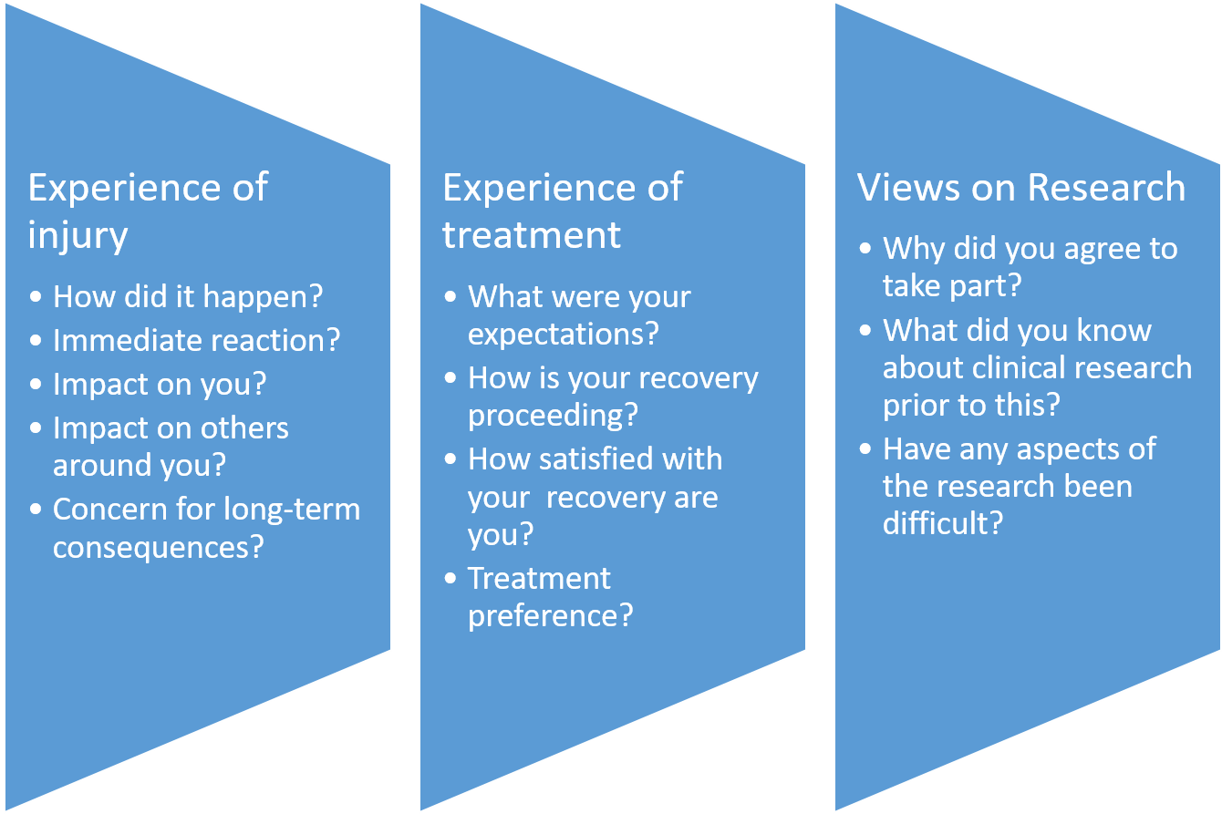

Table 1: Interviews undertaken in SWIFFT
 | Male (under 30) | Female (under 30) | Surgery | Cast
Baseline interviews | 31 (22) | 14 (2) | 17 | 28*
52wk interviews | 13 (9) | 6 (1) | 9 | 10
All interviews | 44 (31) | 20 (3) | 26 | 38
*All individuals who declined to participate in the SWIFFT trial but agreed to be interviewed about their scaphoid fracture were cast as primary treatment.

Figure 2 – Themes and codes, examples from the coding book.
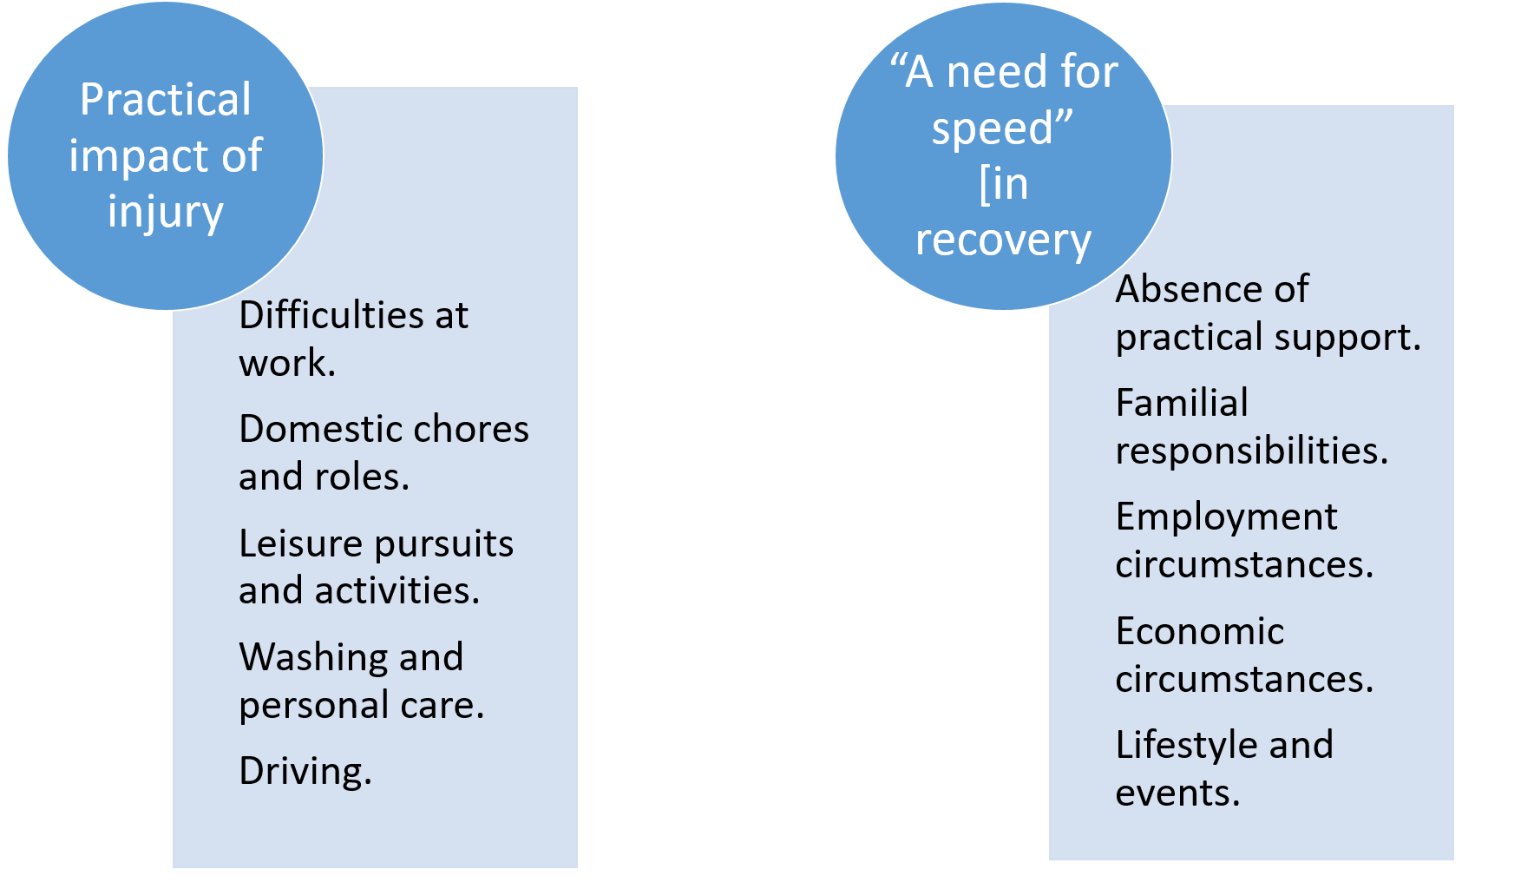

Figure 3 – Experience of the fracture.

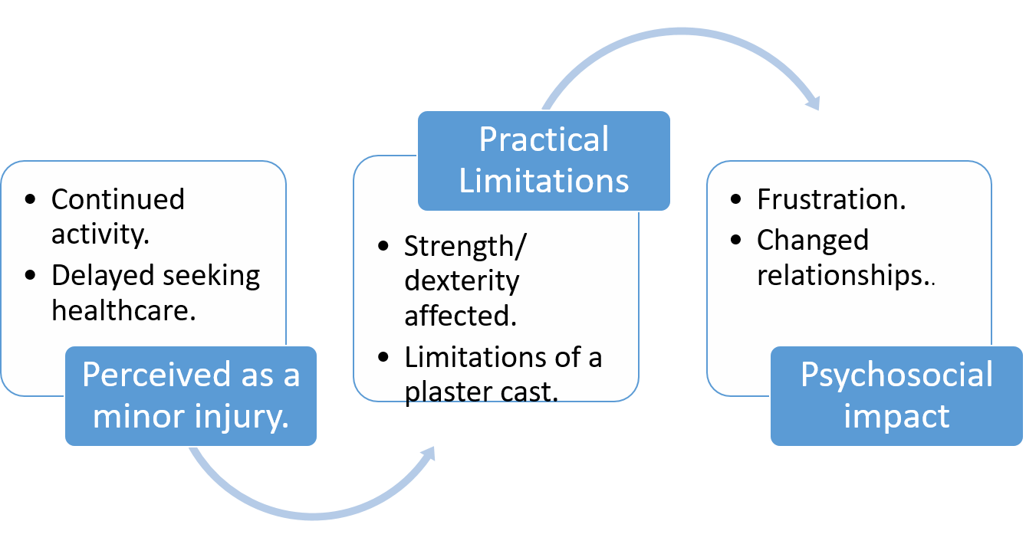

Figure 4 – Factors in treatment preference.
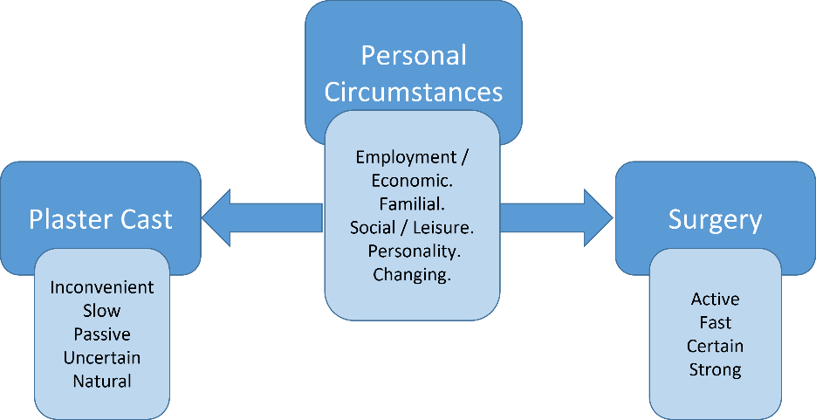

References.
1. Dias, J., et al., Surgical fixation compared with cast immobilisation for adults with a bicortical fracture of the scaphoid waist: the SWIFFT RCT. Health Technol Assess, 2020. 24(52).
2. Dias, J.J., et al., Surgery versus cast immobilisation for adults with a bicortical fracture of the scaphoid waist (SWIFFT): a pragmatic, multicentre, open-label, randomised superiority trial. The Lancet, 2020. 396(10248): p. 390-401.
3. Hinde, S., et al., Cost-effectiveness of surgery versus cast immobilization for adults with a bicortical fracture of the scaphoid waist : an economic evaluation of the SWIFFT trial. Bone Joint J, 2021. 103-b(7): p. 1277-1283.
4. Schier, J.S. and J. Chan, Changes in Life Roles After Hand Surgery. Journal of Hand Therapy, 2007. 20(1): p. 57-69.
5. O'Brien, L. and S. Presnell, Patient Experience of Distraction Splinting for Complex Finger Fracture Dislocations. Journal of Hand Therapy, 2010. 23(3): p. 249.
6. Chan, J. and J. Spencer, Adaptation to Hand Injury: an evolving experience. American Journal of Occupational Therapy, 2004. 58(2): p. 128-139.
7. Ammann, B., T. Satink, and M. Andresen, Experiencing occupations with chronic hand disability: narrative of hand-injured adults. Hand Therapy, 2012. 17(4): p. 87-94.
8. Fitzpatrick, N. and L. Finlay, "Frustrating Disability": the lived experience of coping with the rehabilitation phase following flexor tendon surgery. International Journal of Qualitative Studies in Health and Well-being, 2008. 3: p. 143-154.
9. Bialocerkowski, A., Difficulties associated with wrist disorders - a qualitative study. Clinical Rehabilitation, 2002. 16: p. 429-440.
10. Watson, N.J., S.A. Martin, and J.L. Keating, The impact of wrist fracture, surgical repair and immobilization on patients: a qualitative study. Clinical Rehabilitation, 2018. Published online ahead of print February 1st 2018.
11. Bamford, R. and D.-M. Walker, A qualitative investigation into the rehabilitation experience of patients following wrist fracture. Hand Therapy, 2010. 15(3): p. 52-61.
12. Claydon, J., L. Robinson, and S. Aldridge, Patients' perceptions of repair, rehabilitation and recovery after major orthopaedic trauma: a qualitative study. Physiotherapy, 2017. 103(3): p. 322-29.
13. Coulter, A., et al., A systematic development process for patient decision aids. BMC Med Inform Decis Mak, 2013. 13 Suppl 2(Suppl 2): p. S2.
14. Zeh, S., et al., What do patients expect? Assessing patient-centredness from the patients’ perspective: an interview study. BMJ Open, 2021. 11(7): p. e047810.
15. Vennedey, V., et al., Patients’ perspectives of facilitators and barriers to patient-centred care: insights from qualitative patient interviews. BMJ Open, 2020. 10(5): p. e033449.
16. Berwick, D.M., Medical Associations: Guilds or Leaders? Either Play the Role of Victim or Actively Work to Improve Healthcare Systems. BMJ: British Medical Journal, 1997. 314(7094): p. 1564-1565.
17. Dias, J., et al., Scaphoid Waist Internal Fixation for Fractures Trial (SWIFFT) protocol: a pragmatic multi-centre randomised controlled trial of cast treatment versus surgical fixation for the treatment of bi-cortical, minimally displaced fractures of the scaphoid waist in adults. BMC Musculoskeletal Disorders, 2016. 17(1): p. 248.
18. Lavrakas, P.J., Purposive Sampling, in Encyclopedia of Survey Research Methods. 2008, Sage: CA.
19. QSR International Pty Ltd NVivo. 2018.
20. Braun, V. and V. Clarke, Using Thematic Analysis in Psychology. Qualitative Research in Psychology, 2006. 3(2): p. 77-101.
21. Guest, G., E. Namey, and M. Chen, A simple method to assess and report thematic saturation in qualitative research. PLoS One, 2020. 15(5): p. e0232076.
22. Guest, G., A. Bunce, and L. Johnson, How Many Interviews Are Enough?:An Experiment with Data Saturation and Variability. Field Methods, 2006. 18(1): p. 59-82.

