High Speed Photon Doppler Velocimetry for Laser Driven flyer acceleration studies
S. Chaurasia^{1, 2*}, Ashutosh Mohan¹, A. K. Poswal³, John Pasley⁴
¹High Pressure & Synchrotron Radiation Physics Division, Bhabha Atomic Research Centre, Mumbai, 85, India
²Homi Bhabha National Institute, Department of Atomic Energy, Mumbai- 400094, India
³Atomic & Molecular Physics Division, Bhabha Atomic Research Centre, Mumbai – 400085, India
⁴York Plasma Institute, Department of Physics, University of York, York, YO10 5DQ, UK
(Email: *shibu@barc.gov.in)

Abstract
We implement a high-speed velocimetry technique, Photon Doppler Velocimetry (PDV), for the measurement of the rear-surface velocity of a laser driven flyer. This system is compact and rugged compared to the VISAR and Fabry-Perot interferometer-based diagnostics that are often employed in laser-driven flyer experiments in order to measure the velocity of fast-moving surfaces. The main components of this system are an ultra-low bandwidth 2W CW laser operating at 1550 nm, an optical circulator, a fibre-optic probe, a fast photodiode (< 35 ps rise time and bandwidth > 10 GHz) and a high bandwidth (8 GHz) digitizer with 20 GSa/s sampling rate. The maximum flyer velocity that can be measured by our implementation of this diagnostic is 5 km / s which is limited by the bandwidth of electronic components used in the system. Here, we also describe the optimization of the diagnostic using different types of speakers and with different in-house developed software depending on the applications. Finally, the system is used in measuring the rear-surface velocity of a laser-driven flyer in air. The maximum flyer velocity measured is ~ 1.49 km/s. One dimensional (1-D) radiation-hydrodynamics simulations using the HYADES code are performed and are found to be in excellent agreement with the measured velocities.

Keywords: Plasma diagnostics - interferometry, spectroscopy and imaging, Photon Doppler velocimetry, Laser-driven flyer, Laser-plasma diagnostics, Laser-driven shock waves.

PACS Nos.: 06.30, 06.60., 07.30, 07.60, 42.79.

1. Introduction
Properties of materials under extreme conditions (high pressure & high temperature) are of prime importance in a number of research fields including planetary science, geophysics and fusion research. Various shock wave experimental techniques are frequently employed to generate extreme dynamic pressures and temperatures in the materials under shock loading. Target surfaces can be driven to velocities of the order of km/s by a range of different approaches to shock-wave mediated dynamic-loading including experiments utilizing energetic materials, gas guns and laser-irradiation. Amongst these methods, laser driven shock experiments are most usually preferred in laboratory settings. Laser drivers enable easy synchronization with diagnostics, and facilitate small scale experiments that do not generally damage anything besides the sample that is being irradiated. These factors, amongst others, enable experiments to be performed at high repetition rates. Laser-driven flyer launching involves the focussing of a ~ nanosecond high energy laser pulse onto a solid payload either directly or through a transparent glass layer immediately adjacent to the payload (confined geometry). Rapid heating near the surface of the target results in expansion, which propels some or all of the still solid material in the opposite direction. There are, of course, a couple of disadvantages associated with this technique; namely difficulty in resolving dynamics in small samples and the associated difficulty of achieving adequate spatial uniformity in such targets. In addition, lasers-plasma interactions can result in preheating of regions of the target that would ideally remain cold. However, these problems can be mitigated by special target design and larger focal spot-on targets.
The two main diagnostics, based on interferometry, employed for measuring surface velocities in the km/s regime in laser-driven experiments are VISAR [1, 2] and Fabry-Perot based systems [3, 4]. Both the systems are vulnerable to abrupt changes in velocity and rely upon having a second etalon built into the system to resolve fringe jump ambiguities. Recently, another diagnostic known as high-speed Photon Doppler velocimetry (PDV) has emerged as an alternative to the above-mentioned techniques. It is compact, simple to operate, and relatively inexpensive due to the fact that it utilizes off-the-shelf components that are widely employed in the telecommunications industry. Optical velocimetry is a powerful diagnostic technique for measuring dynamic behaviour of materials under shock loading conditions [5, 6]. Being compact, simple to reconstruct and robust makes it very useful to non-ideal experimental conditions [7, 8]. PDV, also known as ‘heterodyne velocimetry’ [9, 10], has been widely used for tracking particle velocities in shock physics experiments including those driven by lasers, energetic materials, electromagnetic accelerators such as rail and coil guns and gas guns [6, 11–12].
In the present manuscript, we describe the development of a high-speed optical velocimetry diagnostic for laser-driven foil targets. The theory behind the operation of the diagnostic is described in section II and the instrumentation and data analysis software developments are described in sections III and IV respectively. Results of the laser driven flyer experiments and its comparison with 1-D radiation-hydrodynamics simulations are presented in section V. A detailed comparison on the two analysis methods has been provided as supplementary material for better understanding and maintaining the brevity of manuscript.

2. Theory of the PDV diagnostic
The fundamental mechanism of PDV is based on Michelson interferometry in which reflected light (from the moving target) with Doppler shifted [13, 14] frequency interferes with the reflected light from the fixed mirror and generates beat frequencies in the range of a few GHz. These beat frequencies are low enough that they can be monitored with a large bandwidth photo-detector and oscilloscope. A basic schematic of the PDV system is shown in figure 1. In this schematic, the reference beam is taken as a Fresnel reflection of around 3.5% from the glass-air interface at the waveguide exit / entrance and other beam is the light reflected from the target. If both the signals are coherent, they will interfere. It is possible to show that the intensity of the light (S) reaching to the detector can be written in terms of the laser output power (P) and the amount of reflected light from the target that is gathered by the fibre (R) (see Fig. 1):
$S(t)=P\left[{\left\{\frac{\left(n-1\right)}{\left(n+1\right)}\right\}}^{2}+R+2\sqrt{R}\frac{\left(n-1\right)}{\left(n+1\right)}cos⁡\left(2π\frac{\overset{→}{d}⋅\overset{^}{n}}{λ_{0}∕2}+φ(t)\right)\right]$ … (1)
or $S\left(t\right)=I_{0}\left(t\right)+ I_{R}\left(t\right)+2 {\left(I_{0}\left(t\right).I_{R}\left(t\right)\right)}^{1/2}cos⁡\left(2π\frac{\overset{→}{d}⋅\overset{^}{n}}{λ_{0}∕2}+φ(t)\right)$ … (2)
Here, $n$ is refractive index of fibre, n̂ is unit vector in the direction normal to the probe, d is the distance of the target from probe,$λ_{0}$ is the operating wavelength (1550 nm), ϕ is the relative phase between the Doppler shifted and reference laser beams, $I_{0}\left(t\right)$ and $I_{R}\left(t\right)$ are the reference and reflected beams intensities respectively. In equation (2), the first two terms represent dc component of the collected signal while the third component contains the information about temporal evolution of beat frequency between the two beams. When the distance (d) changes by$λ_{0}∕2$, oscillatory signal changes by one cycle. So, for a moving target, the relation between the beat frequency of interference pattern and flyer velocity (v) at any time (t) is given by [10, 15]:
$f (t)=\frac{2}{λ}\overset{→}{v}(t)⋅\overset{^}{n}$ … (3)
For normal incidence, $\overset{→}{v}(t)⋅\overset{^}{n}=v(t)$. If the central operating wavelength ($λ_{0})$ of the laser is 1550 nm, we get:
$v\left(\frac{m}{s}\right)=\frac{λ_{0} (nm)}{2}f\left(t) (GHz\right)=775\left(nm\right).f\left(t\right)(GHz)$ … (4)
From the above equation, it is clear that for a flyer velocity of 1000 m/s, the system bandwidth requirement is 1.29 GHz. In the present study, the detector and digitizer have bandwidth > 8 GHz implying that the system can be used for the measurement of flyer velocity up to 5 km/s.
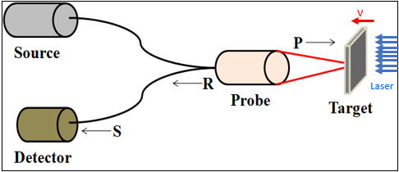
Figure 1. Schematic of Photon Doppler Velocimetry: P denotes laser output delivered to the target, R represents the reflected light collected by the probe and S represent the resultant light received by detector.

3. Instrumentation
The 2-watt CW erbium-doped fibre laser system (NKT Photonics make) with bandwidth < 1 kHz used in this setup is a combination of oscillator and amplifier. The oscillator (Koheras ADJUSTIK) is an erbium-doped fibre oscillator and can oscillate in the wavelength range 1535 nm – 1580 nm. In the present diagnostic, it is set to operate at 1550 nm. This oscillator can deliver a laser beam with a power of up to 40 mW with bandwidth ˂ 0.1 kHz which makes it suitable for low noise applications due to high coherency. The output of this oscillator is fed to an erbium-doped fibre amplifier (Koheras BOOSTIK) which amplifies the final laser output power up to 2 W. The output laser power can be adjusted to any value between 100 mW and 2 W with a linearly polarized output beam.
The velocimetry system described here is a four-channel package restricted by the four-channel input of the digitizer. In the present set up, the design of the velocimeter is slightly different than the schematic shown in figure 1. The velocimeter presented in figure 1 does not have control over the amplitude of the Fresnel reflected light from the glass-air interface which is fixed to 3.5 %. To overcome this problem, in our design, a reference beam is drawn directly from the laser output using a beam splitter 1 x 2 (90 : 10) and this is then sent to a 2 x 1 combiner via a variable attenuator as shown in figure 2a. All fibre optic components including probes are being used with FC/APC (Angled Physical Contact) type connectors to avoid any spurious signal generated due to multiple reflections from various joints. The angled contacts ensure that no reflected light from the glass-air interfaces reaches the detector. So, there is only one controlled reference beam which is drawn directly from the laser. For a four channel PDV system, the output from the fibre laser system is divided into four equal parts using a fibre optic 1 x 4 beam splitter (25 % in each arm i.e., a maximum of 500 mW). The output from each arm is further connected to a 1 x 2 beam splitter (as mentioned before) with a splitting ratio of 90:10. The arm carrying 90% of the laser power from the splitter is connected to port 1 of fibre optic circulator which transfers the beam to port 2. The fibre optic probe with focal length of 97 mm (Oz optics: LPF-04-1 550-9/1 25-S-1 5-97-6.2 AS-40-3A-3-5) connected to port 2 of the circulator sends the laser beam to the moving target (flyer surface) and simultaneously collects a fraction of the light which is reflected / scattered from the target surface. This Doppler shifted reflected light is then transferred from port 2 to port 3 of the circulator. The reflected light is then combined with un-shifted reference light coming from the other port of the beam splitter (through VOA) using a 2 x 1 beam combiner. The variable attenuator (VOA) helps us to control the amplitude of the reference beam so as to better match it with the reflected beam in an endeavour to produce high quality interference fringes. Since both the beams are coherent and of similar power, the interference is uniform. The output of the combiner is connected to an inline power meter followed by a pre-amplifier (SHR-LPA-10-20) and then to the InGaAs photodiode (ALPHALAS make- UPD-35-IR2-FC) with rise time ˂ 35 ps (bandwidth ˃ 10 GHz). A detailed schematic of one of the channels of our 4-channel PDV diagnostic is shown in figure 2a. The other three channels are exact replicas of the described layout. All the fibre optic components used in our PDV implementation are from Oz Optics.
The majority of the components of the four channel PDV system are housed in a 19” rack mounted cabinet. The output of the photodiode is fed to a 20 GSa / s digitizer (Keysight Infiniium series) through a high bandwidth cable terminated with SMA connectors. A photograph of the complete system (including laser system) arranged in the 19” rack is shown in figure 2b and the interference fringes recorded by the digitizer from a 2W speaker powered by a function generator are shown in figure 2c.
(a)
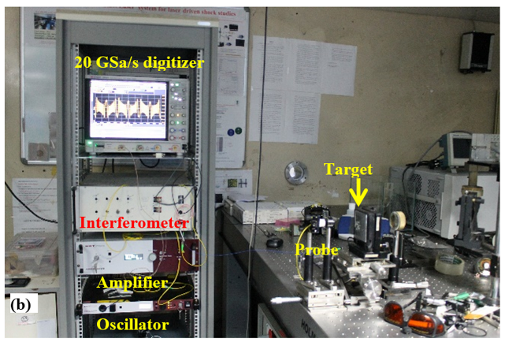 | 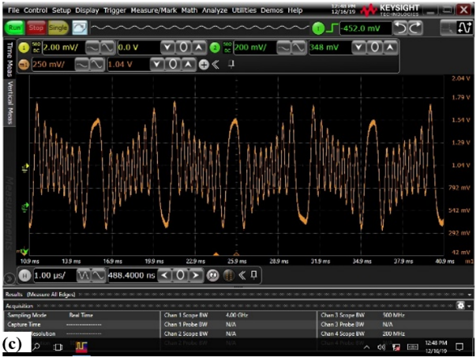
Figure 2. (a) Schematic of one unit of the velocimetry system, (b) Photograph of complete Photon Doppler Velocimetry (PDV) system mounted in a 19” rack and (c) Screenshot of the oscilloscope showing recorded spectra of a 2W speaker being operated at time period of 10 ms and applied voltage of 10 mV.

4. Data analysis and software
There is no off-the-shelf universal software available for the analysis of the PDV data. The details of such software vary according to the precise diagnostic configuration implemented and to the choice of mathematical methods employed for the analysis. To analyse the data generated by the PDV developed in our lab, we have developed two analysis tools based upon two different algorithms in Python described in the following subsections:
4.1. Hilbert transform (HT) based algorithm
In Hilbert transform based implementation of the software, a high pass filter is applied to the recorded signal in order to remove very low frequency components and the DC component from it. Thereafter, if the sampling rate is very high compared to the PDV signal oscillation frequency, a low-frequency filter with frequency of ~10 times the PDV signal frequency is also applied to remove the noise in the signal. After that, an analytical signal is obtained by implementing Hilbert transform (HT) on the PDV signal. Thereafter, the instantaneous frequency is evaluated as follows:
Figure 3. Flow chart of implementation of Hilbert transform (HT) on the PDV signal.
To validate the accuracy of this data analysis software, we carried out experiments to measure the speed of the vibrating diaphragm and the frequency of the speakers as discussed below:
The performance and accuracy of the algorithm is tested by measuring the speed of the moving surface of a disc horn powered by a variable power supply (12 volt, 5W). It has a flat circular steel diaphragm driven by an electromagnet acting on it in one direction and a spring restoring it in the opposite direction. An Aluminium foil of 50-micron thickness is glued onto the flat steel diaphragm located at the centre of the horn for better reflection of laser light. The laser beam at 1550 nm wavelength is focussed on this foil using a fibre optic focuser. Figure 4a shows the raw data of the vibrating speaker recorded by the photodiodes, as well as a sinusoidal fitting done for the background subtraction indicated by the green line. The high pass filter is applied on the background subtracted data and the filtered data is shown in figure 4b. The instantaneous frequency profile at time t corresponding to the interference fringes at that time is shown in figure 4c. The computed speed-time graph using equation 4 is shown in figure 4d. The maximum speed achieved is 50 mm/s which agrees with the data provided in the data sheet. In order to understand the sensitivity of the diagnostic with respect to the velocity changes, another set of experiments are performed using a 2W speaker powered by a function generator. The change in the frequency of the vibrations for different voltages and frequencies are shown in figure 5a-c. It can be seen from the figure that for the similar applied frequency, if the applied voltage changes from 10 mV to 1 V, the interference frequency increases drastically which indicates the enhanced speed of the diaphragm, however, the oscillation frequency is similar (black and blue curve of figure 5a and c). The change in speed of the diaphragm with varying applied voltage is shown in Figure 6.
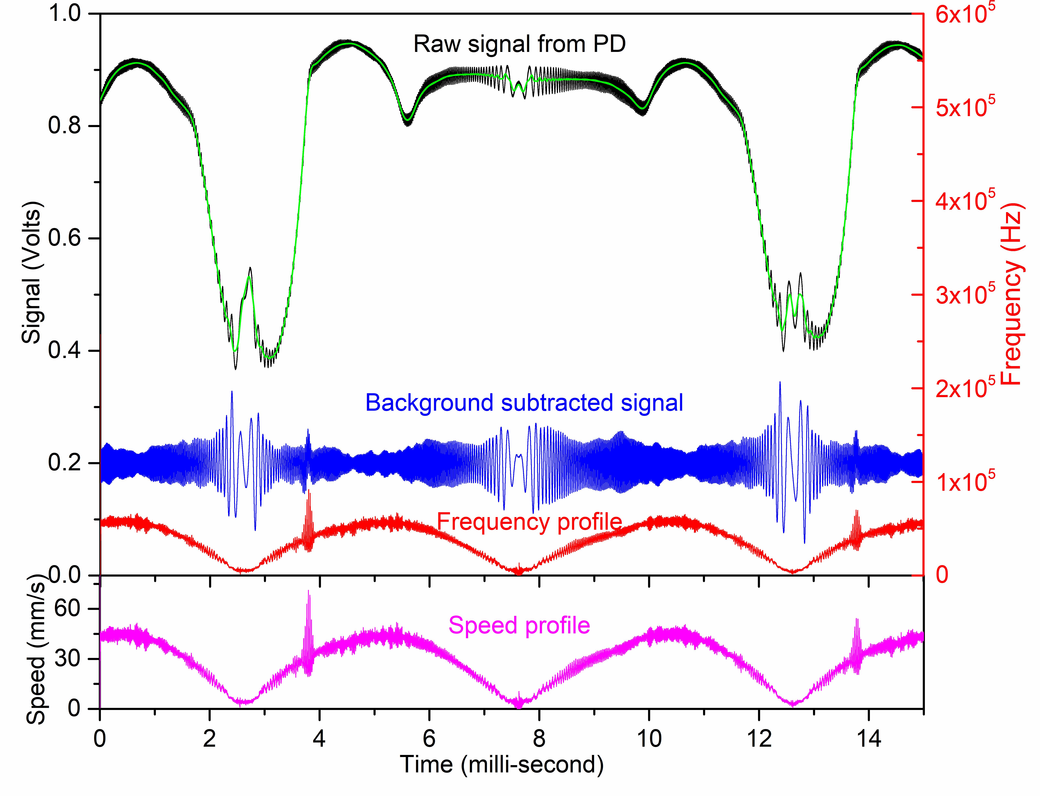
(d)
(c)
(b)
(a)
Figure 4. (a) Experimental data of vibrating speaker recorded by photodiodes overlapped with sinusoidal fitting done for the background subtraction (green line), (b) background subtracted and high pass filtered signal, (c) time dependent frequency profile extracted from background subtracted interference fringes (d) calculated speed with respect to time for a horn.
(c)
(b)
(a)
Figure 5. The background subtracted and noise cancelled data from the velocimeter for function generator setting of (a) 100 Hz, 10 mV, (b) 20 Hz, 10mV and (c) 100 Hz, 1V.

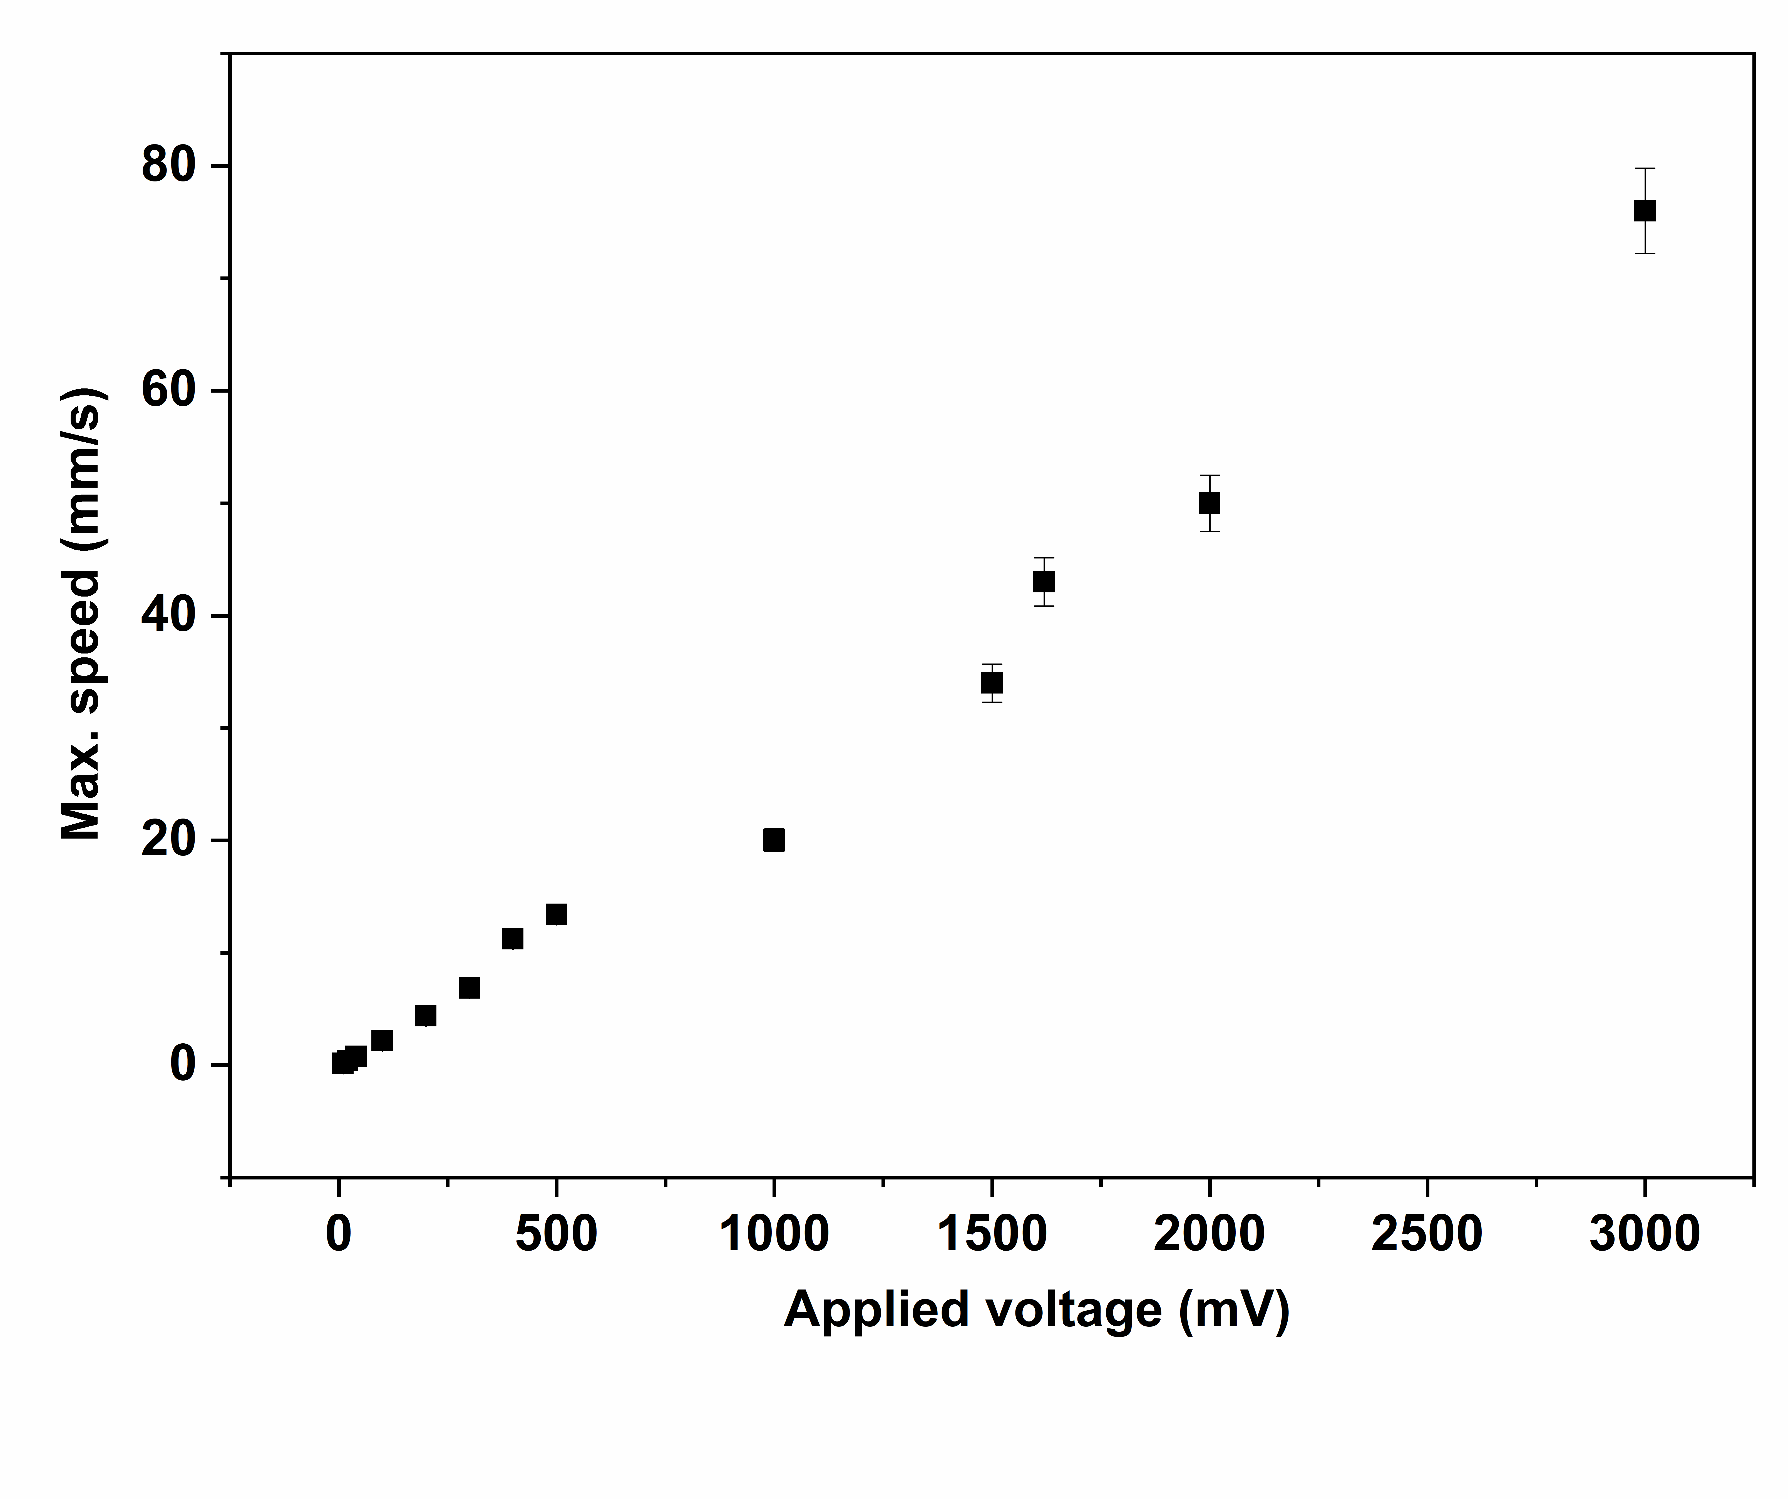
Figure 6: Variation in speed of vibrating surface of a 2W speaker with applied voltage.
This software, in general, is good for strong, less noisy and low frequency signals such as signals from speakers or solid flyers. Details of this method is presented in the supplementary material.
4.2. Short-time Fourier transform (STFT) based algorithm
In laser-driven flyer experiments, the reflectivity of the flyer goes down drastically due to which the signal-to-noise ratio is poor and also the amplitude is very low. HT based algorithm is extremely unreliable in such cases (See supplementary material for details). To overcome this problem, we employ the second piece of software that we developed, which is based upon short time Fourier transformation (STFT) for finding the frequency and hence the velocity. The mathematical expression of STFT is as follows:
…(5)
Here, x(t) is signal with time, is window time, and w(t-) is the window function at time t with window length τ.
Various lengths of each segment have been tried to find an optimum value with an overlap of greater than half of a segment length in order to get better temporal resolution. The window length determines the frequency and temporal resolution in STFT. The frequency and temporal resolution in STFT is determined by the following equation:
… (6)
Here Δt is the window length and Δf is the frequency resolution. Window of 512 points length (25.6 ns) was used with each subsequent window overlapping with the previous one on 507 points (25.35 ns). This implies effect shift in time of 0.25 ns and provides reasonable frequency and temporal resolution for analysing Laser-driven flyers’ PDV data. The values of Δt and Δf in our case are 25.6 ns and 14 MHz respectively and the corresponding velocity resolution is 10.85 m/s.
Of the two analysis tools developed, HT based algorithm gives more accurate frequency values than the short time Fourier transformation (STFT) based approach. However, STFT is the preferred choice for fast analysis of noisy and high frequency data such as in laser-driven flyer velocity measurement. A detailed comparison of the two analysis methods can be found in the supplementary material for better understanding.
5. Laser driven Flyer experiment
Pulsed lasers can be used to produce pressure pulses with durations of femto-seconds to tens of nanoseconds, in contrast to the micro-second duration pressure pulses produced by gas-guns etc [16-18]. Direct ablation Laser-driven micro-flyers have been demonstrated, by several researchers, to be capable of large duration pressure pulses similar to guns etc while retaining the attractive ultra-high strain rates of laser experiments [19-20]. Since laser-driven shock experiments are associated with such short time scales and fast loading conditions, it is difficult to establish the true shock state and obtain correlation with resulting materials effects. In a partial remedy to these issues, the confined geometry arrangement was proposed by Fabbro et al., followed by others [21-23]. In this method, an expanding plasma is confined between a transparent glass window and the ablating target, generating a pressure between the flyer and the glass window that accelerates the flyer toward the target specimen. This confined geometry enhances the magnitude of the shock pressure as well as the duration of the pressure pulse. The longer pressure pulse minimizes the rarefaction of the target and produces a more stable flyer velocity. This somewhat decouples the pressure profile from the laser beam profile and overcomes the problems associated with unconfined ablation.
In the present studies a 2 J / 8 ns Nd: YAG laser system (EKSPLA NL120) is used for the shock generation in the sample in confined geometry. The target geometry consists of a 25 µm aluminium foil glued to a 100 mm x 100 mm x 5 mm optically transparent glass slab. The target is mounted on a motorized stage so that each shot can be taken on fresh target. The laser is incident from the glass side and the optical fibre probe of the PVD system is focused on the aluminium side. The schematic of the flyer acceleration setup is shown in figure 7a. The laser with output energy ranging from 300 mJ (1.2 GW/cm²) to 500 mJ (2 GW/cm²) / 8 ns @ 1064 nm wavelength is focused to a diameter of 1.8 mm on the Aluminium through the glass. The probe beam is focused at the centre of the shocked region to a diameter of 200 µm, which is significantly less than the pump beam diameter. This probe diameter is chosen in order to ensure that the region of the flyer that this probe is reflecting from is relatively planar. The interference fringes due to the mode beating between the reference laser light and the Doppler shifted light reflected from the moving surface are recorded by the PDV as shown in figure 7b. The frequency profile for flyer acceleration at 2 GW/cm² extracted from figure 7b is shown in figure 7c and the corresponding flyer velocity profile in air is shown in figure 7d which is ⁓1.49 km/sec. Here, the laser pulse profile (red line) in figure 7b-d is measured at the target surface using a fast photodiode, which also shows the time zero marker.
We also perform 1-D radiation-hydrodynamics simulations using the HYADES code [24] in order to better understand our results. HYADES is a Lagrangian radiation-hydrodynamics simulation code, which uses a flux-limited diffusion model of electron transport; in these simulations the flux limit set at 5% of the free-streaming limit. A multi-group diffusion approximation is employed to mimic thermal radiation transport within the target, utilising 40 radiation groups arranged logarithmically from 0.1 eV to 500 eV. The equation of state (EOS) for glass and aluminium were taken from the SESAME library.
The temporal evolution of the flyer velocity for a period of 300 ns after the laser pulse interacts with the target is generated using HYADES (orange line) and presented in figure 7e along with the experimental results (Blue line) at a laser intensity of 2 GW/cm². Experimental and simulated scaling of flyer velocities with laser intensities are shown in figure 7f. It is observed that the experimental flyer velocities are in excellent agreement with the simulated data.
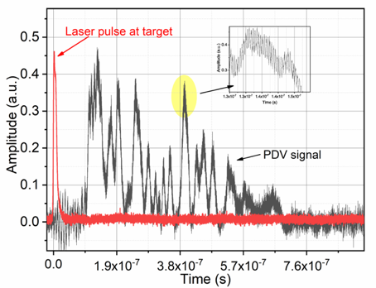
(b)
(a)
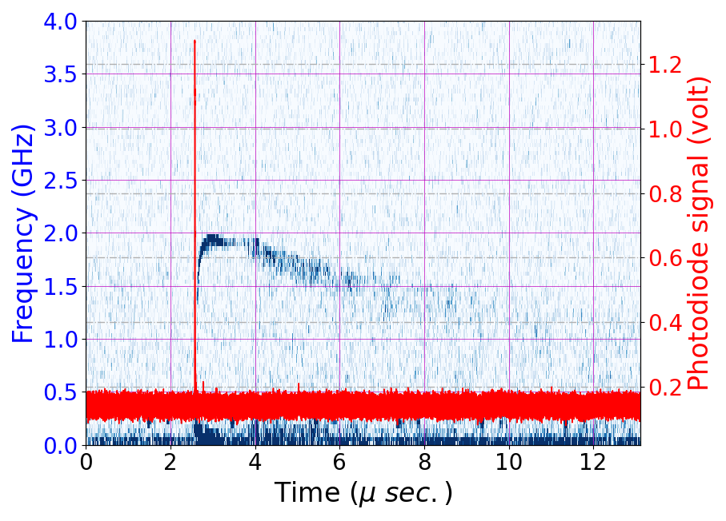  (c)  ← Laser pulse at the target | 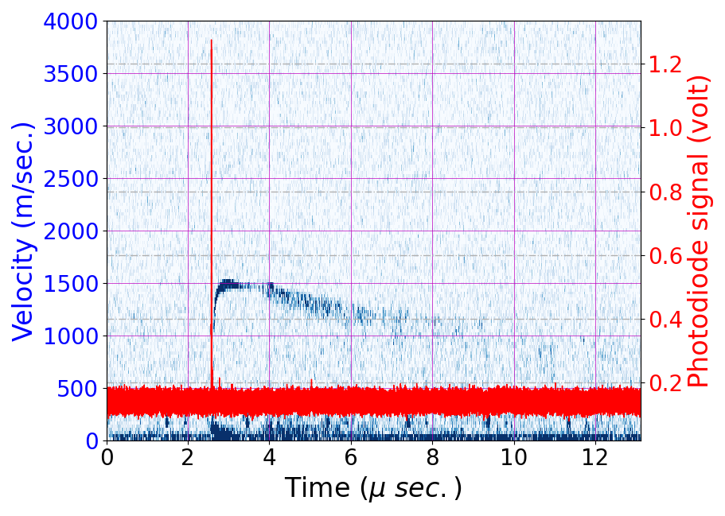  (d)  ← Laser pulse at the target
(e) |  | 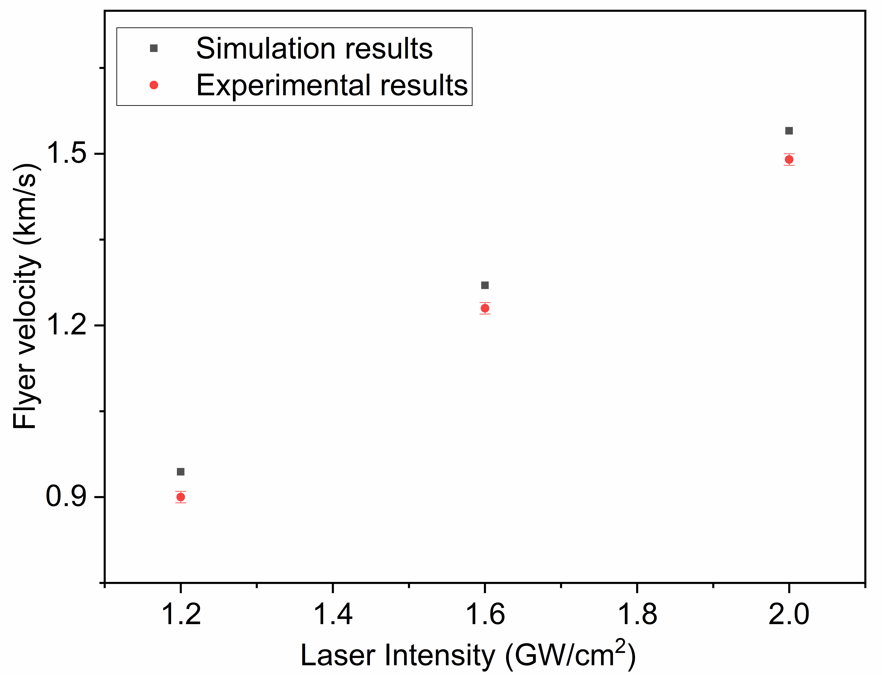  (f)
Figure 7. (a) Experimental set up for the laser driven mini-flyer. (b) Interferometer raw data along with the laser pulse on target. (c) Extracted frequency profile using software and (d) corresponding free surface velocity record measured by the PDV (e) Simulated velocity profile generated using the 1-D HYADES code. (f) Experimental and simulated scaling of flyer velocity with laser intensities.

Conclusion
A high-speed four channel Photon Doppler Velocimeter (PDV) has been developed. The system is characterised by using different types of speakers of variable frequencies and amplitudes. Two data analysis codes have been developed based on Hilbert transformation (HT) and short time Fourier transformation (STFT) based techniques. The laser driven flyer facility is created using a 2 J / 8 ns Nd: YAG laser system. The velocity of a laser driven flyer (in confined geometry) in air has been measured up to 1.49 km/s. 1-D radiation-hydrodynamics simulations have also been performed to simulate the flyer dynamics, showing excellent agreement with the experimental results. This PDV described here can be extended up to four channels, meaning that it can be applied to up to four separate targets simultaneously, with a limitation on the maximum measurable flyer velocity of 5 km /s in each channel for this diagnostics.

Acknowledgements
The authors are thankful to the Head of the HP&SRPD for her consistent support during the development of the PDV. The authors are also thankful to Diwakar Singh Munda, Ritesh Sabale, Krishna Bhangre and Usha Rao of HP&SRPD for their support. The authors acknowledge the support received from Mr. Gautam for fruitful discussion on fibre optics related work and polishing high power laser fibre tip.
References
- L M Barker and R E Hollenbach, J. Appl. Phys., 43, 4669 (1972).
- W F Hemsing, Rev. Sci. Instrum., 50, 73 (1979).
- C F McMillan, D R Goosman, N L Parker, L L Steinmetz, H H Chau, T Huen, R K Whipkey and S J Perry, Rev. Sci. Instrum., 59, 1 (1988).
- D R Goosman, Appl. Opt., 30, 3907 (1991).
- D H Dolan and S C Jones, Rev. Sci. Instrum., 78, 076102 (2007).
- O T Strand, D R Goosman, C Martinez and T L Whitworth, Rev. Sci. Instrum., 77, 083108 (2006).
- D H Dolan, Rev. Sci. Instrum., 91, 051501 (2020).
- R L Gustavsen, T D Aslam, B D Bartram and B C Hollowell, J. Phys.: Conf. Ser., 500, 052015 (2014).
- P Mercier, J Benier, P A Frugier, G Contencin, J Veaux, S Lauriot-Basseuil and M Debruyne, Proceedings Volume 7126, 28th International Congress on High-Speed Imaging and Photonics, Canberra, Australia, 2008.
- D B Holtkamp, IEEE Int. Conf. on Mega-gauss Magnetic Field Generation, Santa Fe, New Mexico, USA, 2018.
- S Liu, D Wang, T Li, G Chen, Z Li, and Q Peng, Rev. Sci. Instrum., 82, 023103 (2011).
- A R Valenzuela, G Rodriguez, S A Clarke, and K A Thomas, Rev. Sci. Instrum., 78, 013101 (2007).
- P W Fish, Phys. Educ., 6, 20 (1971).
- R H Belansky and K H Wanser, Am. J. Phys., 61, 1014 (1993).
- P Mercier, J Bénier, P A Frugier, G Contencin, J Veaux, S L Basseuil and M Debruyne, Proceedings Volume 7126, 28th International Congress on High-Speed Imaging and Photonics, Canberra, Australia, 2008.
- M J Davis, Int. J. Appl. Glass Sci., 7, 364 (2016).
- T Hongo, A Matsuda, K Kondo, K G Nakamura and T Atou, Jpn. J. Appl. Phys., 44, 5006 (2005).
- A D Curtis, A A Banishev, W L Shaw and D D Dlott, Rev. Sci. Instrum., 85, 043908 (2014).
- D L Paisley, D C Swift, R P Johnson, R A Kopp and G A Kyrala, AIP Conference Proceedings, 620, 1343 (2002).
- S Tripathi, S Chaurasia, P Leshma and L J Dhareshwar, Pramana – J. Phys., 79, 1471 (2012).
- R Fabbro, J Fournier, P Ballard, D Devaux, and J Virmont, J. Appl. Phys., 68, 775 (1990).
- K E Brown, W L Shaw, X Zheng, and D D Dlott, Rev. Sci. Instrum., 83, 103901 (2012).
- S Stekovic, H K Springer, M Bhowmick, D D Dlott, Rev. Sci. Instrum., 129, 195901 (2021).
- HYADES is a commercial product of Cascade Applied Sciences, email larsen@casinc.com

Figure legends
Figure 1. Schematic of Photon Doppler Velocimetry: P denotes laser output delivered to the target, R represents the reflected light collected by the probe and S represent the resultant light received by detector.
Figure 2. (a) Schematic of one unit of the velocimetry system, (b) Photograph of complete Photon Doppler Velocimetry (PDV) system mounted in a 19” rack and (c) Screenshot of the oscilloscope showing recorded spectra of a 2W speaker being operated at time period of 10 ms and applied voltage of 10 mV.
Figure 3. Flow chart of implementation of Hilbert transform (HT) on the PDV signal.
Figure 4. Figure 4. (a) Experimental data of vibrating speaker recorded by photodiodes overlapped with sinusoidal fitting done for the background subtraction (green line), (b) background subtracted and high pass filtered signal, (c) time dependent frequency profile extracted from background subtracted interference fringes (d) calculated speed with respect to time for a horn.
Figure 5. The background subtracted and noise cancelled data from the velocimeter for function generator setting of (a) 100 Hz, 10 mV, (b) 20 Hz, 10mV and (c) 100 Hz, 1V.
Figure 6. Variation in speed of vibrating surface of a 2W speaker with applied voltage.
Figure 7. (a) Experimental set up for the laser driven mini-flyer. (b) Interferometer raw data along with the laser pulse on target. (c) Extracted frequency profile using software and (d) corresponding free surface velocity record measured by the PDV (e) Simulated velocity profile generated using the 1-D HYADES code. (f) Experimental and simulated scaling of flyer velocity with laser intensities.

Figures

Figure 1. Schematic of Photon Doppler Velocimetry: P denotes laser output delivered to the target, R represents the reflected light collected by the probe and S represent the resultant light received by detector.

(a)
Figure 2. (a) Schematic of one unit of the velocimetry system, (b) Photograph of complete Photon Doppler Velocimetry (PDV) system mounted in a 19” rack and (c) Screenshot of the oscilloscope showing recorded spectra of a 2W speaker being operated at time period of 10 ms and applied voltage of 10 mV.

Figure 3. Flow chart of implementation of Hilbert transform (HT) on the PDV signal.

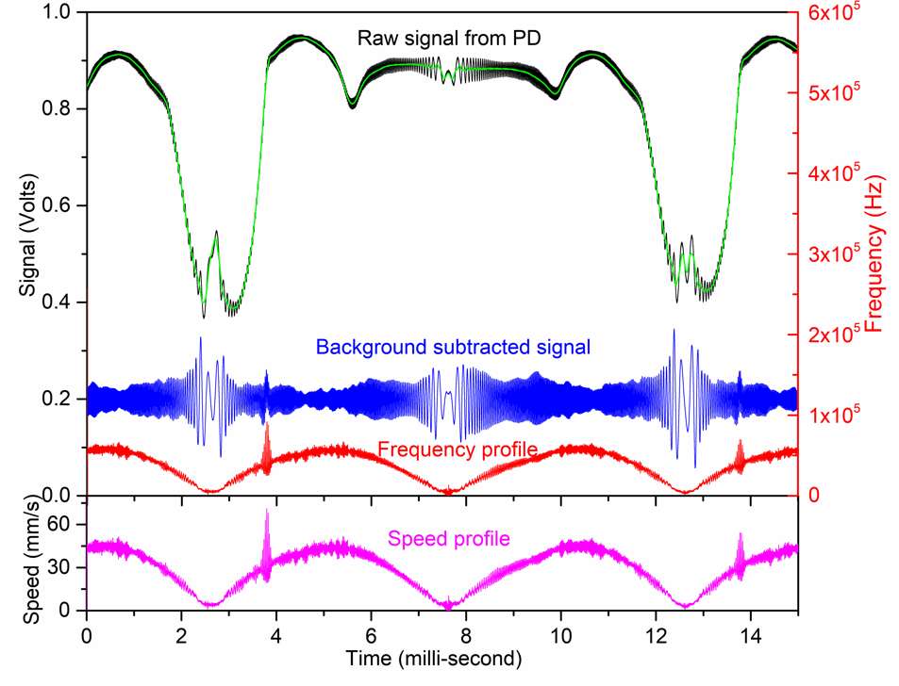
(d)
(c)
(b)
(a)
Figure 4. (a) Experimental data of vibrating speaker recorded by photodiodes overlapped with sinusoidal fitting done for the background subtraction (green line), (b) background subtracted and high pass filtered signal, (c) time dependent frequency profile extracted from background subtracted interference fringes (d) calculated speed with respect to time for a horn.

(c)
(b)
(a)
Figure 5. The background subtracted and noise cancelled data from the velocimeter for function generator setting of (a) 100 Hz, 10 mV, (b) 20 Hz, 10mV and (c) 100 Hz, 1V.

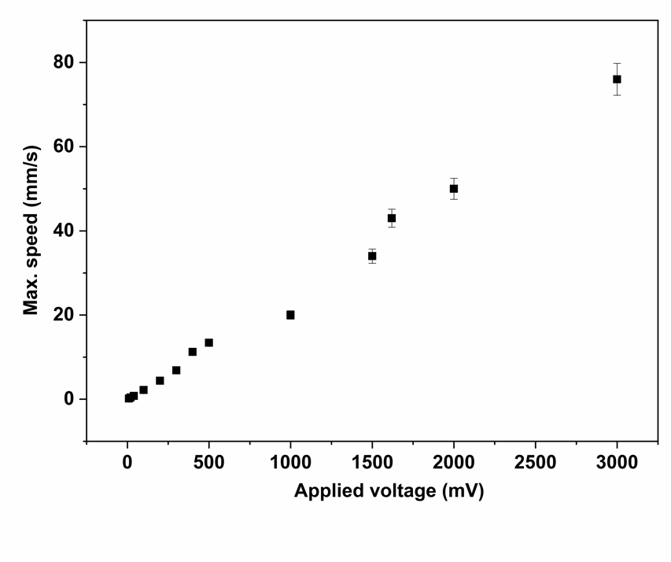
Figure 6: Variation in speed of vibrating surface of a 2W speaker with applied voltage.

(b)
(a)
← Laser pulse at the target | (d)  ← Laser pulse at the target
(e) |  | 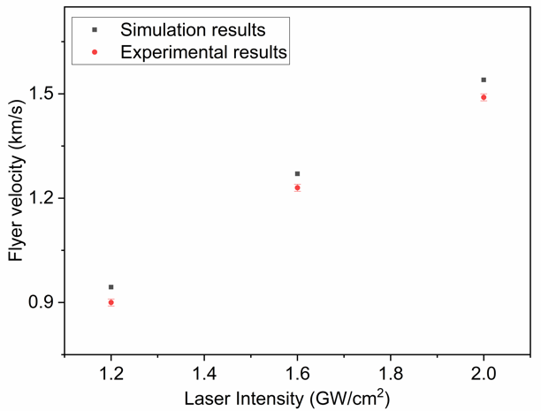  (f)
Figure 7. (a) Experimental set up for the laser driven mini-flyer. (b) Interferometer raw data along with the laser pulse on target. (c) Extracted frequency profile using software and (d) corresponding free surface velocity record measured by the PDV (e) Simulated velocity profile generated using the 1-D HYADES code. (f) Experimental and simulated scaling of flyer velocity with laser intensities.
(c)

