Behavioural activation in nursing homes to treat depression (BAN-Dep):
Results from a clustered, randomised, single-blinded, controlled clinical trial

Osvaldo P. Almeida, MD, PhD, FRANZCP¹
Hema Patel, BSc (Hons) ¹
Diana Velasquez, RN²
Rachael Kelly, BSci, GradDip(PublHealth)¹
Rhoda Lai, BA (Hons) ²
Andrew H. Ford, MBBS, PhD, FRANZCP¹
Eleanor Curran, MBBS, PhD, FRANZCP^{2,9}
Leon Flicker, MBBS, PhD, FRANZCP¹
Terence W. H. Chong, MBBS, MP, MBA, FRANZCP^{2,6}
Christopher Etherton-Beer, MBBS, PhD, FRANZCP¹
Dina LoGiudice, MBBS, PhD, FRANZCP³
Kathryn A. Ellis, MAPS, MPsych, PhD ^{2,7}
Angelita Martini, GradEipEd, MPHC, PhD⁴
Alissa Westphal, BApplSc(OccTher)Hons, GradDipSc(ApplStats)²
David Ekers, RMN, MSc, PhD⁸
Simon Gilbody, MBChB, DPhil, FRCPsych⁵
Nicola T. Lautenschlager, MBBS, MD, FRANZCP^{2,9}

¹ Medical School, University of Western Australia, Perth, Australia.
² Department of Psychiatry, University of Melbourne, Melbourne, Australia
³ Department of Medicine, University of Melbourne, Melbourne, Australia
⁴ Brightwater Care Group, Perth, Australia
⁵ Mental Health and Addictions Research Group, HYMS & University of York, York, UK
⁶ St Vincent’s Hospital Melbourne, Melbourne, Australia
⁷ Melbourne School of Psychological Sciences, University of Melbourne, Melbourne, Australia
⁸ Tees Esk and Wear Valleys NHS FT/MHARG, University of York, York, UK
⁹ NorthWestern Mental Health, Royal Melbourne Hospital, Melbourne, Australia

Running title: BAN-Dep trial

Word count: 3461

Correspondence: Osvaldo P. Almeida, WA Centre for Health & Ageing (M577), Medical School, University of Western Australia, 35 Stirling Highway, Perth, WA 6009, Australia. E: osvaldo.almeida@uwa.edu.au
ABSTRACT
Objectives: To determine if behavioural activation (BA) delivered by trained staff decreases prevalence of clinically significant symptoms of depression among older adults living in residential aged care facilities (RACFs).
Methods: Clustered, randomised, single-blinded, controlled trial of BA for adults aged over 60 years living permanently in a RACF with symptoms of depression (Patient Health Questionnaire, PHQ-9 ≥ 5). BA was delivered over 8-12 weeks using a structured workbook. The proportion of residents with PHQ-9 ≥ 10 at weeks 12, 26 and 52, as well as anxiety symptoms (GAD-7), physical (PCS) and mental (MCS) quality of life, loneliness, and loss to follow-up were main outcomes of interest
Results: We recruited 54 RACFs (26 intervention) and 188 of their residents (89 intervention). Participants were aged 61-100 years and 132 (70.2%) were women. PHQ-9 ≥ 10 interacted with BA at week 12 (OR=0.34, 95%CI=0.11-1.07), but differences between the groups were not statistically significant at any time-point. GAD-7 ≥ 10 interacted with BA at week 26 (OR=0.12, 95%CI=0.02-0.58), but not at any other time-point. Overall, the intervention had no effect on the scores of the PHQ-9, GAD-7, PCS, MCS, and loneliness scale. Loss to follow-up was similar between groups. Adherence to all stages of the intervention was poor (36.2%).
Conclusions: Disruption by the COVID-19 pandemic and staffing issues in RACFs undermined recruitment and adherence. In such a context, a BA program delivered by RACF staff was not associated with better mental health outcomes for residents over 52 weeks.

Key-words: depression, anxiety, loneliness, quality of life, behavioural activation, aged care, nursing home, prevention, treatment, randomised controlled trial.
INTRODUCTION
Depression is a common clinical syndrome among older adults living in residential aged care facilities (RACFs). Clinically significant symptoms of depression, as measured by the Geriatric Depression Scale (GDS-15), were present in 49 (50.5%) of 97 older adults recently admitted to an aged care facility in Australia,¹ with data from the US National Nursing Home Survey suggesting that a depressive disorder affects at least 1 in every 3 residents.² Despite its high prevalence, the presence of depression among aged care residents may go unnoticed, so that appropriate treatment may not be made available.³ When treatment is introduced, it is often limited to the use of antidepressant medications,^{4,5} even though supportive evidence of efficacy remains scant,⁶ particularly when symptoms are associated with cognitive impairment.⁷

Non-pharmacological strategies may have an important and under-recognized role in the treatment of depression in RACFs, particularly those that include an active behavioural component.⁸ A clustered randomised controlled trial of a multidisciplinary care intervention reduced the prevalence of depression in Dutch RACFs, although the benefit was limited to residents without significant cognitive impairment.⁹ In that trial, the intervention included a ‘pleasant activities plan’ delivered by nursing staff and recreational therapists (i.e., behavioural activation), ‘life review or meditation’ delivered by a psychologist, and ‘antidepressant treatment or psychiatric review’. Existing evidence suggests that nurse-led interventions that include a BA component may have the best chance of success in decreasing depression symptom severity among RACF residents.¹⁰ Along these lines, the BE-ACTIV clustered trial recruited 23 American RACFs and 82 residents with depression, of whom 42 were living in intervention RACFs.¹¹ The intervention consisted of a 10-session BA program delivered by a trained therapist that included sessions on education, scheduling of pleasant activities, management of barriers, increasing pleasant events, monitoring and maintenance of gains, and a summary session. A larger proportion of participants living in intervention than in control facilities experienced remission of symptoms after 3 months, but these gains were lost by 6 months,¹¹ possibly because the intervention relied on the input of external therapists.

More recently, BA interventions have been manualised to enable delivery by trained carers without mental health background,¹² including primary care and community pharmacy settings.^{13,14} We designed the present trial to test the efficacy of a BA program delivered by trained RACF staff to reduce the 12-month prevalence of clinically significant symptoms of depression among older adults living in Australian RACFs.

METHODS
Study design and setting
The Behavioural Activation in Nursing homes to treat Depression (BAN-Dep) was a clustered randomised controlled trial that recruited RACFs and their respective older residents in Victoria and Western Australia, Australia. Recruitment commenced on the 24th September 2018 and closed recruitment on the 22nd June 2021. The trial was registered with the Australian and New Zealand Clinical Trials Registry (ACTRN12618000634279), and the study protocol has been published.¹⁵ Recruitment was discontinued before we were able to reach the target number of facilities and participants because of restrictions imposed by the COVID-19 pandemic. Data collection closed on 24 March 2022.

Participants
We recruited 54 Australian RACFs, 30 in Victoria and 24 in Western Australia. Participating facilities were required to appoint at least one mental health champion (MHC – working no less than 0.5 full-time equivalent). Eligible resident participants were aged 60 years or over, reported symptoms of low mood or hopelessness, or lack of interest or pleasure in usual activities,¹⁶ and scored 5 or more on the Patient Health Questionnaire (PHQ-9).¹⁷ Potentially eligible participants were recruited by the relevant MHC, with eligibility being subsequently confirmed by the research team as follows. Participants were required to score 18 or more on the Mini-Mental State Examination (MMSE), be able to communicate effectively in English, and have capacity to provide informed consent. We excluded residents with severe sensory impairment, psychotic symptoms, or suicidal thoughts. The Ethics Committees of the University of Western Australia (RA/4/20/4234) and of Melbourne Health (HREC/18/MH/47) approved the study protocol and procedures, and all participants provided written informed consent.

Intervention
Staff in all facilities were offered an online educational package about depression among aged care residents. The package consisted of 5 to 7 modules (according to professional background):¹⁸ (1) understanding anxiety and depression, (2) anxiety and depression in older people, (3) promoting mental health of older adults in the community, (4) promoting mental health of aged care residents, (5) identifying and responding to suicidal ideation in aged care settings, (6) managing anxiety and depression of aged care residents, (7) looking after one’s mental health at work. Each module took about 25 minutes to complete, and those who completed the program received a certificate and 6 hours of continuing professional development for registered nursing staff. Aged care staff were encouraged to complete these modules over a period of 4 weeks. During this time, residents were screened for eligibility.

The MHCs of facilities randomly assigned to receive BA training completed and additional 12 hours of training (delivered over 2 days) on the use of a structured BA program.¹³ They were provided a BA work book and a MHC script for use with each participating resident, who were then encouraged to work through one module each week over 8-12 weeks. The modules were: (1) recognition of the symptoms of depression, (2) mood and activity diaries, (3) types of activities (tailored to meet resident’s needs and living environments), (4) breaking jobs down into easier tasks, (5) the benefits of activities, (6) finding ways to be active, (7) spotting symptoms of depression, and (8) action plan and activity scheduling. One module was delivered each week, apart from modules 7 and 8, which were delivered together. The activities of each module could be delivered in one or two sessions during the week, but all components had to be covered during this period. Participants had 12 weeks to complete the 8 modules (i.e., breaks were allowed), and one or more of the modules could be revisited during this time. MHCs had free access to the study’s BA therapists (one in Melbourne and one in Perth) for supervision and troubleshooting. They were required to record the completion of all steps of the BA program, as presented by the workbook manual, to ensure that the intervention was delivered in a structured and consistent manner, as described in the protocol of the study.¹⁵ The forms were then checked for completion: not completed, partly completed, completed. MHCs and residents were allowed to keep the intervention booklet and study manual to guide ongoing activity, but such additional activities were neither structured nor monitored.

Outcome measurements
The primary outcome of interest of the study was the proportion of residents living in BA and control RACFs with PHQ-9≥10 12, 26 and 52 weeks after the baseline assessment. The scale has robust psychometric properties, is sensitive to change over time, and scores ≥ 10 have good sensitivity and specificity to establish the presence of major depressive episodes.^{17,19}

Other outcome measures assessed symptoms of anxiety (Brief Measure for Assessing Generalised Anxiety Disorder, GAD-7),²⁰ quality of life (12-item Short-Form health survey, SF-12, which yields a mental (MCS) and a physical (PCS) component sub-score),²¹ loneliness (DeJong Gierveld Loneliness scale),²² and the Montreal Cognitive Assessment (MoCA).²³ Other study measures included age, sex, place of birth, education, marital status, bone fracture following a fall in the past year,²⁴ self-reported acquired hearing loss, self-reported impaired vision that interferes with reading, smoking history, self-reported history of past depression, and the modified Barthel index.²⁵

Sample size
Details about our sample size calculations have been published.¹⁵ Briefly, using published data from the CASPER trial,¹³ we calculated that 666 residents (333 per group) would be required accounting for clustering per RACF (n = 100 RACFs) and an anticipated 25% loss to follow up.¹⁵

Randomisation and blinding
The randomisation of RACFs was stratified by state (i.e., Victoria and Western Australia) and run in random blocks of 4, 6 or 8 (1:1 assignment). The randomisation table was generated by computer, and the person responsible for disclosing treatment assignment to the BA therapist was not involved in recruitment, or data collection or management. Due to the nature of the intervention, MHCs, BA therapists and residents were aware of treatment allocation, but the research officer responsible for collection of study measures was kept blind throughout the entire period of data collection (no access to database, training diary, and instructed not to discuss treatment with staff or residents).

Statistical methods
Data were managed and analysed using Stata 17.0 (StataCorp, 2021). We used descriptive statistics to summarise the characteristics of the sample as counts, proportions, mean and standard deviation of the mean (mean ± SD). We compared the sociodemographic and clinical characteristics of participants using Pearson chi-square statistic (χ²). The age of participants living in control and BA facilities at the baseline assessment was compared with a t-test.

We used logit models for panel data (xtlogit) to analyse (i) the primary outcome (the proportion of participants in BA and control facilities with PHQ-9 ≥ 10 over 12, 26 and 52 weeks), and the effect of the intervention on clinically significant symptoms of anxiety (GAD-7 ≥ 10) and SF-12 ≤ 30 (i.e., 2 standard deviations below the population average). We used multilevel mixed regression models (xtmixed) to examine changes in PHQ-9, GAD-7, SF-12 and loneliness scores over 12, 26 and 52 weeks according to treatment assignment. Both xtlogit and xtmixed generate results that are intention-to-treat and do not exclude cases with missing data. These analyses were adjusted for the effect of clustering by RACF.

Finally, we used Pearson chi-square to compare the cumulative proportion of participants living in BA and control RACFs lost during follow up. Post-hoc analyses examined the effect of the intervention among residents who completed all modules of the BA program.

Alpha was set at 5% and all probability tests (p-value) were two-tailed.

RESULTS
We had planned to recruit 100 aged care facilities and 666 residents. Due to the COVID-19 pandemic and grant restrictions, we had to stop recruitment before reaching this target. Figure 1 shows the flow of participants during the 52 weeks of the trial. We screened 843 residents for eligibility, of whom 188 (22.3%) fulfilled the entry criteria of the study. The age of participants ranged from 61 to 100 years (mean ± SD = 83.9 ± 8.5) and 132 (70.2%) of the 188 were women. Table 1 shows their sociodemographic and clinical characteristics according to group. The mean ± SD age of control and BA residents was 84.5 ± 8.2 and 83.3 ± 8.8 years (t = 0.95, df = 186, p =0.341).

FIGURE 1
TABLE 1

Effect of BA training on the presence of clinically significant symptoms of depression
Figure 2 shows the proportion of participants residing in control and BA facilities with PHQ-9 ≥ 10 at weeks 0, 12, 26 and 52. A repeated measures logit model adjusted for the effect of clustering by RACF showed that the interaction between BA and time was not statistically significant (OR = 1.00, 95%CI = 0.98-1.01; z = -0.52, p = 0.605). A mixed regression model showed no evidence that treatment with BA was associated with lower PHQ-9 total scores (mean change of main effect = -0.27, z = 0.34, p = 0.731), and the interaction between the BA intervention on changes of PHQ-9 scores over time was not statistically significant (interaction mean change = -0.03, 95%CI = -0.06 to 0.00; z = -1.83, p = 0.068 – figure 3).

FIGURE 2

Effect of BA training on symptoms of anxiety, quality of life, loneliness and cognitive scores
At the baseline assessment, 15 of 99 participants living in control and 20 of 89 living in intervention facilities showed evidence of clinically significant symptoms of anxiety. At the subsequent assessments that took place at weeks 12, 26 and 52 the respective numbers were 9 (11.7%) of 77 and 10 (14.9%) of 67, 16 (23.5%) of 68 and 7 (11.3%) of 62, and 9 (18.0%) of 50 and 11 (23.4%) of 47. A multilevel logit model for repeated measures adjusted for clustering by showed that the overall interaction between BA and time was not statistically significant (OR= 1.01, 95%CI = 0.99-1.03; z = 0.65, p = 0.515). Similarly, a mixed regression model for repeated measures revealed no obvious interaction between BA and time on GAD-7 (mean difference over time between groups = -0.00, 95%CI = -0.02 to 0.02; z = -0.12, p = 0.906 – see details of scores at each time point in eTable 2).

We also examined the number of participants with MCS ≤ 30 living in control and BA facilities at weeks 12, 26 and 52: 26 (34.2%) of 76 and 22 (33.8%) of 65 at week 12, 18 (27.3%) of 66 and 11 (19.0%) of 58 at week 26, and 10 (20.8%) of 48 and 8 (19.0%) of 42 at week 52. Multilevel logit model for repeated measures adjusted for clustering showed no obvious interaction between BA and time on the odds of MCS < 30 (z = -1.87, p = 0.062). Likewise, the respective number of participants with PCS ≤ 30 at weeks 12, 26 and 52 was 23 (30.3%) of 76 and 20 (30.8%) of 65 at week 12, 19 (28.8%) of 66 and 19 (32.8%) of 58 at week 26, and 23 (47.9%) of 48 and 15 (35.7%) of 42 at week 52. The cluster-adjusted logit model for repeated measures showed no evidence of interaction between the intervention and time (z = 0.24, p = 0.808). eTable 2 lists the details of MCS and PCS scores of participants during the 52 weeks of the study. We also examined the effect of the intervention on loneliness scores over time. There was no evidence that the BA shifted the scores over time (z = -1.41, p = 0.159). Finally, we examined the MoCA scores of participants over time. The results of these analyses for each assessment are listed on eTable 2. There was no difference between the groups on MoCA scores at any of the assessments. MoCA data were missing partly or completely for 114 (60.6%) of 188 of participants, so that no additional analyses were performed.

Loss to follow up
The respective number of residents in control (n = 99) and BA (n = 89) facilities lost to assessment over time was: 22 (22.2%) and 22 (24.7%) by week 12 (χ² = 0.16, df = 1, p = 0.686), 31 (31.3%) and 26 (29.2%) by week 26 (χ² = 0.10, df = 1, p = 0.754), and 48 (48.5%) and 42 (47.2%) by week 52 (χ² = 0.03, df = 1, p = 0.859). Among those who were lost, 13 (13.1%) of 99 and 9 (10.1%) of 89 participants living in control and BA facilities died during the study (χ² = 0.41, df = 1, p = 0.520). Additional reasons for non-participation included cognitive decline (n = 6), move to a different facility (n = 3), and withdrawal because of frailty, lack of motivation, or because of restrictions associated with the COVID-19 pandemic (n = 63). In addition, 8 (30.8%) of the 26 MHCs responsible for the delivery of the BA intervention either resigned or discontinued the delivery of the program due to time constraints.

Post hoc analyses: clinical outcomes among controls and participants who completed all BA stages
Only 25 (36.2%) of the 69 participants living in BA-trained facilities completed all 8 stages of the BA program. eTable 1 (supplementary material) summarises the clinical outcomes of these participants and contrast them with controls. The proportion of participants with PHQ-9 ≥ 10, GAD-7 ≥ 10, MCS ≤ 30 and PCS ≤ 30 was similar at all assessment time-points. A larger proportion of controls (48 of 99) than BA completers (5 of 25) were lost during follow up (χ² = 6.62, df = 1, p = 0.010). No further analyses were performed due to the relatively high proportion of participants with missing data. Ten (18.5%) of the 54 participating RACF were closed during the study because of COVID-19 (6 were BA facilities), leading to discontinuation of the intervention and loss of participants. Another 9 (34.6%) of the 26 RACFs assigned the BA intervention had their MHCs abandon the delivery of the intervention because of competing demands on their time (including COVID-19 related changes) or because of changed employment arrangements. After the start of the pandemic, managers of RACFs expressed reluctance to accept our invitation to participate in the study at this point in time, so that the recruitment of new facilities had to be discontinued prematurely (a total of 440 facilities were invited to participate – figure 1).

DISCUSSION
Among residents of RACFs with symptoms of depression, a relatively lower proportion of participants living in BA facilities showed evidence of clinically significant symptoms of depression after 12 weeks, although such benefits were not apparent after 26 and 52 weeks. The intervention had no noticeable effect on depression or anxiety scores, as assessed by the PHQ-9 and GAD-7, or on loneliness scores, as assessed by the DeJong Gierveld Loneliness scale. The impact of the intervention on the quality of life of participants was negligible.

The routines of the BAN-Dep trial were severely disrupted by the COVID-19 pandemic, limiting our ability to recruit RACFs and affecting the availability of staff to complete the required training and deliver the structured program of activities to residents. Consequently, the trial was unable to recruit the expected number of participants. Such a context may have also contributed to the high proportion of participants lost during follow up (many RACFs went into lock down due to COVID-19 outbreaks). Hence, we acknowledge concerns about the potential limited validity and generalisability of our findings. Nonetheless, our analyses have revealed clinically relevant patterns that merit discussion.

The intervention groups were well balanced for sociodemographic and clinical measures, and the severity of depressive symptoms declined from baseline to week 12 in both groups, with the proportion of participants with clinically significant symptoms of depression declining more markedly among those living in intervention than control RACFs. The loss of clinical benefit after 12 weeks seems consistent with the results of the BE-ACTIV trial.¹¹ BAN-Dep attempted to circumvent the issue of sustainability and cost by training carers working in RACFs on how to use BA to manage older residents with depressive symptoms – however, the adherence of MHCs (trained carers) to the BA program was suboptimal, and this was partly driven by staff turnover and time constraints associated with the COVID-19 pandemic and chronic shortages of care personnel.^{26,27} This suggests that a better integrated collaborative care approach that does not rely solely on RACF staff may be required to sustain the initial gains on mood associated with the use of BA.¹³ We also acknowledge that the relatively low PHQ-9 scores of participants may have further limited the power of the study to detect a potential effect of the intervention, although we did not observe an obvious trend in this regard. Finally, it is possible that a small effect of BA may have been overridden by the general procedures of the study, including the online training.

The effects of the intervention on symptoms of anxiety, loneliness and quality of life were negligible, although a lower proportion of residents of intervention RACFs had clinically significant symptoms of anxiety at week 26. For loneliness, visitor restrictions associated with the COVID-19 pandemic may have limited any potential benefits of the intervention. The reverse was true for the physical component summary of quality of life, which was relatively lower among residents of intervention than control facilities at week 26. Again the main effect of the intervention was not statistically significant.

The results of the BAN-Dep trial cannot be considered conclusive, and they neither prove nor disprove the merits of BA to manage older adults with symptoms of depression living in RACFs. Evidence from other sources indicates that BA is an efficacious and cost-effective treatment of depression,^{28,29} and may contribute to reduce social isolation even when public health restrictions associated with the COVID-19 pandemic are in place.³⁰ However, extending such benefits to older adults living in RACFs has been challenging.

In conclusion, the BAN-Dep trial was closed prematurely because of the COVID-19 pandemic. The study recruited 188 participants living in 54 RACFs in Australia, with available results suggesting that training staff of RACFs on how to use BA produces non-sustainable improvements in mood. The high turnover of RACF staff may affect quality of care and contribute to decrease the engagement of remaining staff in non-routine activities, particularly in an environment dominated by the pandemic.³¹ The introduction of professional or financial incentives that encourage RACF staff to actively engage in the delivery of structured BA programs could provide the additional impetus required to enhance the adherence of staff, and thus residents. The careful refinement of remote delivery of the intervention could also contribute to promote greater access and sustainability of such programs.

Acknowledgements
This study was supported by a competitive project grant from beyondblue and the National Health and Medical Research Council of Australia (GNT115029). The funding agencies were not involved in the design or conduction of the study, nor were they involved in the analysis, drafting of the manuscript, or the decision to publish the results.

We also thank participating RACF staff and residents for their generous support of this study despite competing challenges and demands on their time.

The authors have no conflicts of interest to declare in relation to this study.

Data disclosure statement
The results of this study have not been presented or published elsewhere.

Author contributions
OPA, NTL, LF, AHF, DL, CEB and SG designed and obtained funding for the study. SG and DE produced the workbook for the intervention, and DE contributed to the training of HP and DVR. HP, DVR and AW trained and supervised the mental health champions. RK and RL were responsible for the collection of study measures. All Australian authors assisted with the recruitment of aged care facilities and of participants. OPA completed the analysis of the data. All authors contributed to the drafting of the paper, critical review of its contents, and approved the submission of its final version for publication.

REFERENCES
1. Kotynia-English R, McGowan H, Almeida OP: A randomized trial of early psychiatric intervention in residential care: impact on health outcomes. Int Psychogeriatr 2005; 17:475-485.

2. Seitz D, Purandare N, Conn D: Prevalence of psychiatric disorders among older adults in long-term care homes: a systematic review. Int Psychogeriatr 2010; 22:1025-1039.

3. McCabe MP, Karantzas GC, Mrkic D, et al: A randomized control trial to evaluate the beyondblue depression training program: does it lead to better recognition of depression? Int J Geriatr Psychiatry 2013; 28:221-226.

4. Hanlon JT, Handler SM, Castle NG: Antidepressant prescribing in US nursing homes between 1996 and 2006 and its relationship to staffing patterns and use of other psychotropic medications. J Am Med Dir Assoc 2010; 11:320-324.

5. Midlov P, Andersson M, Ostgren CJ, et al: Depression and use of antidepressants in Swedish nursing homes: a 12-month follow-up study. Int Psychogeriatr 2014; 26:669-675.

6. Boyce RD, Hanlon JT, Karp JF, et al: A review of the effectiveness of antidepressant medications for depressed nursing home residents. J Am Med Dir Assoc 2012; 13:326-331.

7. Banerjee S, Hellier J, Dewey M, et al: Sertraline or mirtazapine for depression in dementia (HTA-SADD): a randomised, multicentre, double-blind, placebo-controlled trial. Lancet 2011; 378:403-411.

8. Cuijpers P, van Straten A, Warmerdam L: Behavioral activation treatments of depression: a meta-analysis. Clin Psychol Rev 2007; 27:318-326.

9. Leontjevas R, Gerritsen DL, Smalbrugge M, et al: A structural multidisciplinary approach to depression management in nursing-home residents: a multicentre, stepped-wedge cluster-randomised trial. Lancet 2013; 381:2255-2264.

10. Markle-Reid M, McAiney C, Forbes D, et al: An interprofessional nurse-led mental health promotion intervention for older home care clients with depressive symptoms. BMC Geriatr 2014; 14:62.

11. Meeks S, Van Haitsma K, Schoenbachler B, et al: BE-ACTIV for depression in nursing homes: primary outcomes of a randomized clinical trial. J Gerontol B Psychol Sci Soc Sci 2015; 70:13-23.

12. Gilbody S, Brabyn S, Mitchell A, et al: Can We Prevent Depression in At-Risk Older Adults Using Self-Help? The UK SHARD Trial of Behavioral Activation. Am J Geriatr Psychiatry 2022; 30:197-207.

13. Gilbody S, Lewis H, Adamson J, et al: Effect of Collaborative Care vs Usual Care on Depressive Symptoms in Older Adults With Subthreshold Depression: The CASPER Randomized Clinical Trial. JAMA 2017; 317:728-737.

14. Chew-Graham CA, Kitchen CEW, Gascoyne S, et al: The feasibility and acceptability of a brief psychological intervention for adults with long-term health conditions and subthreshold depression delivered via community pharmacies: a mixed methods evaluation-the Community Pharmacies Mood Intervention Study (CHEMIST). Pilot Feasibility Stud 2022; 8:27.

15. Velasquez Reyes D, Patel H, Lautenschlager N, et al: Behavioural activation in nursing homes to treat depression (BAN-Dep): study protocol for a pragmatic randomised controlled trial. BMJ OPEN 2019; 9:e032421.

16. Whooley MA, Avins AL, Miranda J, et al: Case-finding instruments for depression - Two questions are as good as many. J Gen Intern Med 1997; 12:439-445.

17. Kroenke K, Spitzer RL, Williams JB: The PHQ-9: validity of a brief depression severity measure. J Gen Intern Med 2001; 16:606-613.

18. Mellor D, Kiehne M, McCabe MP, et al: An evaluation of the beyondblue Depression Training Program for aged care workers. Int Psychogeriatr 2010; 22:927-937.

19. Lowe B, Kroenke K, Herzog W, et al: Measuring depression outcome with a brief self-report instrument: sensitivity to change of the Patient Health Questionnaire (PHQ-9). J Affect Disord 2004; 81:61-66.

20. Spitzer RL, Kroenke K, Williams JB, et al: A brief measure for assessing generalized anxiety disorder: the GAD-7. Arch Intern Med 2006; 166:1092-1097.

21. Sanderson K, Andrews G: The SF-12 in the Australian population: cross-validation of item selection. Aust N Z J Public Health 2002; 26:343-345.

22. Gierveld JD, Van Tilburg T: A 6-item scale for overall, emotional, and social loneliness - Confirmatory tests on survey data. Res Aging 2006; 28:582-598.

23. Nasreddine ZS, Phillips NA, Bedirian V, et al: The Montreal Cognitive Assessment, MoCA: a brief screening tool for mild cognitive impairment. J Am Geriatr Soc 2005; 53:695-699.

24. Almeida OP, Hankey GJ, Golledge J, et al: Depression and the risk of fractures in later life: the Health In Men Cohort Study. MATURITAS 2021; 145:6-11.

25. Mahoney FI, Barthel DW: Functional evaluation: The Barthel Index: a simple index of independence useful in scoring improvement in the rehabilitation of the chronically ill. Maryland State Med J 1965; 14:61-65.

26. McGilton KS, Escrig-Pinol A, Gordon A, et al: Uncovering the Devaluation of Nursing Home Staff During COVID-19: Are We Fuelling the Next Health Care Crisis? J Am Med Dir Assoc 2020; 21:962-965.

27. Xu H, Intrator O, Bowblis JR: Shortages of Staff in Nursing Homes During the COVID-19 Pandemic: What are the Driving Factors? J Am Med Dir Assoc 2020; 21:1371-1377.

28. Ekers D, Webster L, Van Straten A, et al: Behavioural activation for depression; an update of meta-analysis of effectiveness and sub group analysis. Plos One 2014; 9:e100100.

29. Ekers D, Godfrey C, Gilbody S, et al: Cost utility of behavioural activation delivered by the non-specialist. Br J Psychiatry 2011; 199:510-511.

30. Gilbody S, Littlewood E, McMillan D, et al: Behavioural activation to prevent depression and loneliness among socially isolated older people with long-term conditions: The BASIL COVID-19 pilot randomised controlled trial. PLoS Med 2021; 18:e1003779.

31. Castle NG, Engberg J, Men A: Nursing home staff turnover: impact on nursing home compare quality measures. GERONTOLOGIST 2007; 47:650-661.

Table 1. Baseline sociodemographic and clinical characteristics of aged care residents according to their randomisation group.
 |  | Control  N=99  n (%) | BA  N=89  n (%) | χ² Statistic (df) | p-value
Age ≥ 85 years |  | 54 (54.5) | 44 (49.4) | 0.49 (1) | 0.490
Female sex |  | 70 (70.7) | 62 (69.7) | 1.12 (1) | 0.571
Australian born |  | 70 (71.4)¹ | 54 (60.7) | 2.41 (1) | 0.120
Completed university education |  | 17 (17.7)³ | 12 (13.5) | 0.62 (1) | 0.430
Widowed |  | 53 (54.6)² | 42 (48.3)² | 0.74 (1) | 0.388
Bone fracture after fall < 1 year |  | 12 (12.1) | 17 (19.1) | 1.75 (1) | 0.186
Hearing loss |  | 53 (53.5) | 54 (60.7) | 0.97 (1) | 0.324
Impaired vision for reading |  | 39 (39.4) | 39 (43.8) | 0.38 (1) | 0.539
Smoking | Never  Past  Current | 55 (56.1)¹  37 (37.8)  6 (6.1) | 42 (47.2)  41 (46.1)  6 (6.7) | 1.52 (2) | 0.468
Mostly lonely (score ≥ 3/6) |  | 43 (43.9)¹ | 49 (55.1) | 2.33 (1) | 0.127
Barthel: severe or dependent |  | 36 (36.4) | 26 (29.2) | 1.08 (1) | 0.298
Past depression |  | 43 (43.4) | 32 (36.0) | 1.09 (1) | 0.296
PHQ-9 ≥ 10 |  | 42 (42.4) | 40 (44.9) | 0.12 (1) | 0.728
GAD-7 ≥ 10 |  | 15 (15.1) | 20 (22.5) | 1.66 (1) | 0.198
SF-12 MCS ≤ 30 |  | 20 (20.6)² | 23 (25.8) | 0.72 (1) | 0.399
SF-12 PCS ≤ 30 |  | 32 (33.0)² | 31 (34.8) | 0.07 (1) | 0.791
BA: behavioural activation
χ² Statistic: Pearson chi-square statistic; df: number of degrees of freedom.
^{n}number of participants in the randomisation group for whom information was not available.

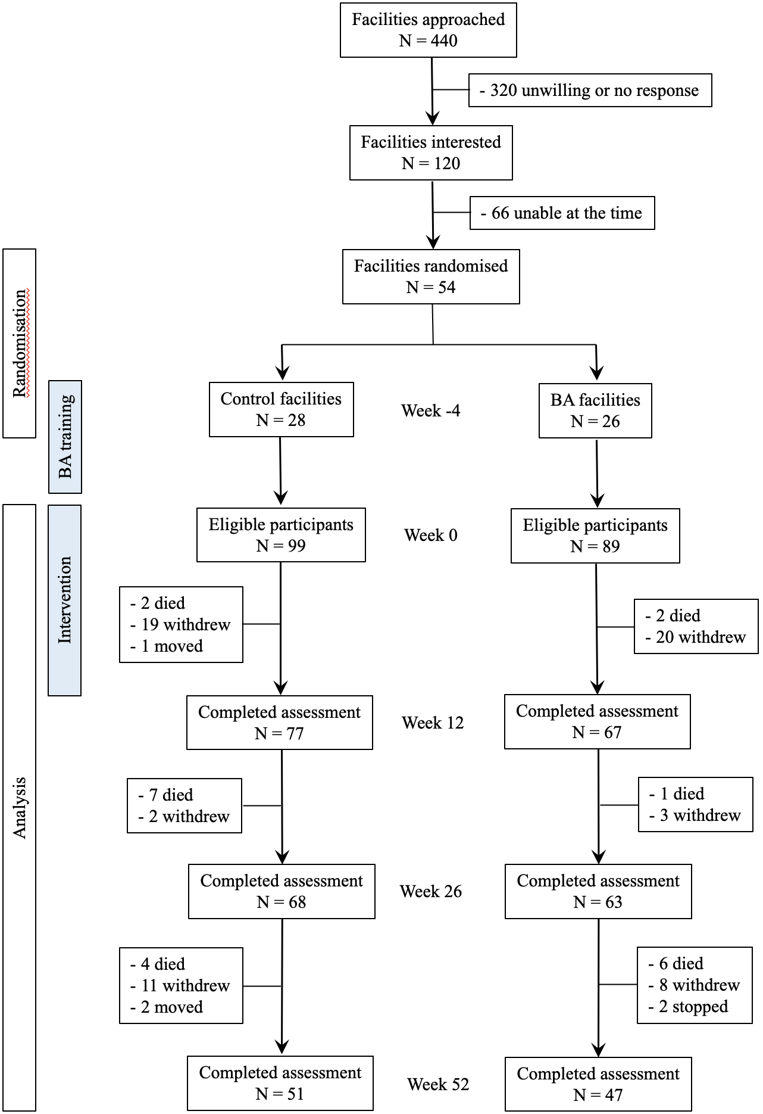

Figure 1. The flowchart shows the selection and randomisation of residential aged care facilities, and the flow of participants during the trial.

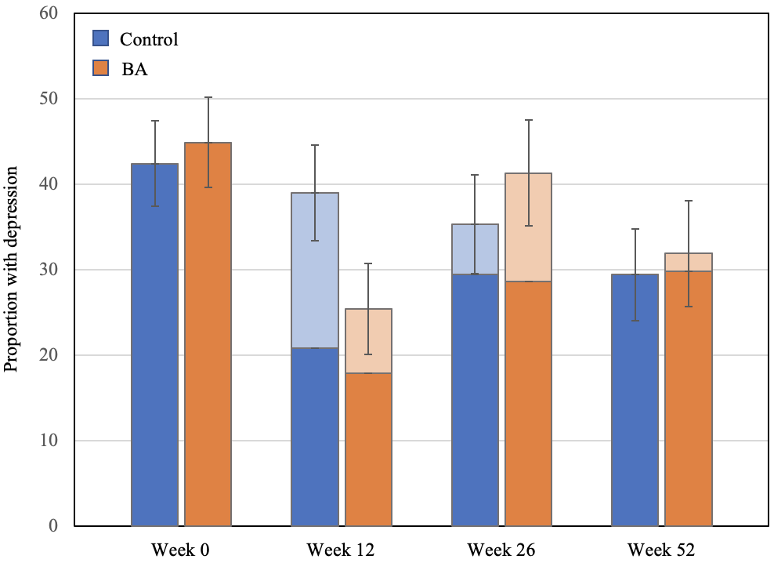

Figure 2. The bars show the proportion of participants with clinically significant symptoms of depression (PHQ-9 ≥ 10) at weeks 0, 12, 26 and 52. The whisker depict the standard error of the proportions. The darker colours represent prevalent cases (i.e., depression present in a previous assessment) and the lighter colours new cases of depression at weeks 12, 26 and 52. The logit model examining the interaction with at each time-point relative to baseline showed that the odds ratio of depression at week 12 was 0.34 (95%CI = 0.11-1.07; z = -1.85, p = 0.064), 1.32 (95%CI = 0.35-4.93; z = 0.41, p = 0.678) at week 26, and 1.20 (95%CI = 0.35-4.05; z = 0.29, p = 0.771) at week 52. The overall effect of the intervention over time was not statistically significant (z = -0.52, p = 0.605).

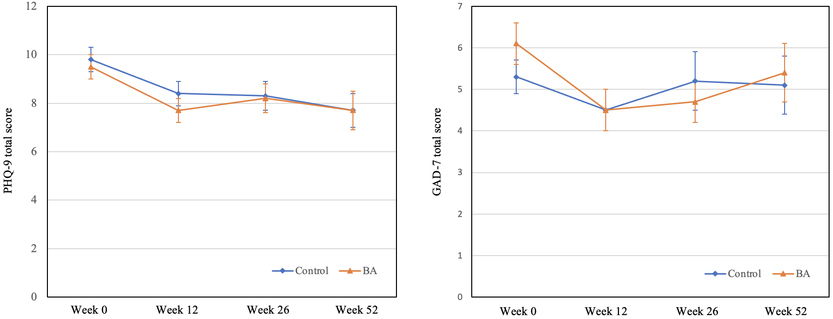

Figure 3. PHQ-9 (left panel) and GAD-7 (right panel) scores according to whether participants lived in control or BA intervention facilities. The diamonds and triangles depict the mean score and the whiskers the standard error of the mean at weeks 0, 12, 26 and 52.

