Human and animal subsistence in northern Iberia during the Late Chalcolithic-Bronze Age : biomolecular insights from Muela de Borja, Ebro Valley
Laura C. Viñas-Caron^{1,2*}, Isidro Aguilera³, Tina Jakob⁴, Joe W. Walser III⁵, Luke Spindler^{1,6}, Maria Fontanals-Coll¹, Michelle Alexander¹
1. BioArCh, Department of Archaeology, University of York, York, UK
2. GLOBE Institute, University of Copenhagen, Copenhagen, Denmark
3. Museo de Zaragoza, Gobierno de Aragón, Zaragoza, Spain
4. Department of Archaeology, Durham University, Durham, UK
5. National Museum of Iceland, Reykjavik, Iceland
6. School of Archaeology, University of Oxford, Oxford, UK

*Corresponding author contact: laura@palaeome.org

Abstract
This study explores human diet and animal management strategies in multiple Late Chalcolithic and Bronze Age (2550-1200 cal BCE) sites (Moncín, Majaladares, El Estrechuelo and El Balcón) located in Muela de Borja in the Ebro Valley, Northern Iberia, through the application of stable carbon (δ¹³C) and nitrogen (δ¹⁵N) isotope analysis and zooarchaeology by mass spectrometry (ZooMS). Thirty-three animal and nine human bones were analysed across the four sites. ZooMS enabled us to identify a number of fragmented animal bones whose species representation reflected that of the wider zooarchaeological assemblage. The isotopic results complemented by a Bayesian stable isotope mixing model (BSIMM) indicate that all humans had a relatively uniform diet consisting of C₃ terrestrial plant and animal resources, despite representing a range of burial sites and a broad chronology. In contrast, animals had a highly variable diet, which suggests the existence of diverse feeding and management strategies within and between species. When comparing data from these sites to other published sites of a similar chronology, we see regional patterns in δ¹³C and δ¹⁵N that reflect environmental differentiation. These results provide a deeper understanding of the diversity of human and animal dietary practices during the Late Chalcolithic and Bronze Age in the Ebro Valley and Northern Iberia.
Keywords
Diet, animal husbandry, stable isotopes, ZooMS, prehistory, Spain
Authors’ contributions
MA and IA designed the research. IA provided samples and contextual information. TJ and JWW conducted the osteoarchaeological analysis and interpretation. LCVC and LS performed the stable isotope and ZooMS experiments. LCVC, MA and MFC performed data analysis and interpretation. LCVC wrote the original draft, with critical input from MA and MFC. All authors reviewed and approved the manuscript.

Acknowledgments
We thank Matthew Von Tersch and Krista McGrath from BioArCh, University of York, for assistance in Mass Spectrometry and ZooMS. Thanks also go to Helen Goodchild for creating the maps and James Nottingham who aided us with zooarchaeological identifications, both at the Department of Archaeology, University of York. We also thank Simon Hickinbotham, University of York, for assistance with Bacollite software and Ricardo Fernandes, Max Planck Institute for the Science of Human History, with IsoMemo.

Introduction
The late third and second millennium BCE, corresponding to the Late Chalcolithic and Bronze Age in the Iberian Peninsula, is considered to be a time of increasing social differentiation and connectivity that reshaped early farming societies. It is in this time period that we see the introduction of new forms of agriculture that increased the productivity and variety of cereals cultivated, most notably millets in the Bronze Age (Buxó and Piqué 2008; Moreno-Larrazabal et al. 2015), but also the wider use of animal by-products beyond meat (Sherratt 1983; Greenfield 2010). While the archaeological record provides some hints at the nature of subsistence patterns during this period, there are still many aspects which remain unclear. Stable isotope analysis is increasingly applied to dietary studies in the Iberian Peninsula and potentially offers a deeper understanding of not only past diets and economies but also farming and animal husbandry practices. Carbon and nitrogen stable isotope data has made a significant contribution to the debates surrounding the introduction of millet in the Bronze Age (López-Costa et al. 2015) as well as the incorporation of irrigation practices and manuring during this period (Araus et al. 1997; Ferrio Díaz et al. 2005; Aguilera et al. 2008; Mora-González et al. 2016, 2018; Knipper et al. 2020). Furthermore, social asymmetries that start to occur in the material culture from many parts of the Iberian Peninsula at this time period appear to be mirrored by human dietary differences (e.g. Waterman et al. 2016; Fernández-Crespo and Schulting 2017; Díaz-Zorita Bonilla et al. 2019; Molina-González et al. 2019; Knipper et al. 2020), although not universally. The degree to which dietary trends were widespread or distinctive across all regions of the peninsula during the Chalcolithic and Bronze Age remains unexplored. This is particularly notable given the mosaic of cultural and environmental variability that exists in the Iberian Peninsula (López-Costa and Alexander 2019).
Studies so far indicate that societies in southern Iberia experienced greater social inequality than communities from the north during this period, demonstrated by new hilltop settlements, individual burial practices and differentiated material culture indicating the presence of hierarchy in organisation, as in the well-studied Early Bronze Age Argar culture (2200-1550 BCE) (Lull et al. 2011; 2015). In the north, however, populations present a general continuity in settlement and burial practice, despite certain novelties in ceramic technologies (e.g. Beaker ceramics) or metallurgical practices (Lillios 2019). This has recently been argued to be an indicator that these groups were more stable and resilient than those of the south (Blanco-González et al. 2018) despite a genetic turnover observed in the whole peninsula during the Chalcolithic and Bronze Age transition (Olalde et al. 2019; Villalba-Mouco et al. 2021). Our current understanding of the societies of northeast Iberia during the Late Chalcolithic and Bronze Age, however, is patchy, partly due to the elusive nature of the archaeological evidence in this period and uneven research history. The sites that do exist are typically small and defined by clusters of underground features frequently interpreted as storage pits and other domestic facilities (Lillios 2019). More permanent sites have, however, occasionally been identified, particularly in upland areas, such as those under consideration here from the Ebro valley e.g. Moncín and Majaladares, and caves also continued to be occupied as burial and habitation spaces. The varied nature of the sites themselves attests to the diversity of local groups that were present across Northern Iberia, living in a mosaic of environments, with differing material cultures and subsistence strategies.
The diet of humans and animals they subsisted on provides information on individual and community choices influenced by environmental factors, resource availability and social preferences (López-Costas and Alexander 2019). In this paper, we aim to reconstruct past human and animal diets from a prehistoric population that lived in the Muela de Borja Plateau, Ebro Valley, between ca. 2550 to 1200 cal BCE. To that end, we applied stable carbon (δ¹³C) and nitrogen (δ¹⁵N) isotope analysis to human (n=9) and animal (n=33) remains from multiple sites located in the Muela de Borja (Moncín, Majaladares, El Estrechuelo and El Balcón) and compared this data to published isotopic datasets from contemporary populations from across the northern Iberian Peninsula. Animal samples were also subject to zooarchaeology by mass spectrometry (ZooMS) to assign species to unidentifiable bone fragments and distinguish morphologically challenging species (e.g. sheep and goat). Collectively, this biomolecular approach provides a detailed overview of human dietary patterns and animal management practices during the Late Chalcolithic and Bronze Age and sheds light on how subsistence choices affected the economic development of local communities and their environmental resilience.

Background to the archaeological sites
The Muela de Borja Plateau is a geostructural unit of 50 km² that rises to 805 metres in height with views to the wooded Moncayo Mountain Massif, to the west, and the Ebro River, to the east, with its floodplains and green areas (Harrison 2007). These favourable geographical conditions (altitude, prominence, topography, and water provision) softened the semiarid climate and vegetation of the region and facilitated the development of a prehistoric community from which 42 sites have been identified and investigated to date (see Aguilera 2017). Four of these sites are under consideration here, situated in the highest part of the plateau, close to water sources (Fig. 1). These sites were chosen due to the available information on the diversity of the flora and fauna and a rich funerary record that allows us to understand the territorial organisation and history of the human community. The four sites are outlined below.
Moncín
The site of Moncín is located in the Muela de Borja (UTM coordinates: X= 617322; Y= 4635386). The archaeological excavations began in 1979, conducted by R. J. Harrison, and lasted until 1987. This complex site consists of an open-air settlement (Moncín ext.), a large cave with both a funerary and residential use (Moncín I and II), and, finally, a small burial cavity (Moncín III). Radiocarbon (¹⁴C) dating of the open-air site indicates that human populations occupied the settlement from approximately 2550 to 1250 cal BCE, that is, from the Late Chalcolithic to the Late Bronze Age (Harrison et al. 1994). Despite the disturbance of the archaeological layers by later human activities, excavations revealed the presence of numerous artefacts, including a repertory of ceramics from the distinctive Bell Beaker Maritime style (2550-2350 cal BCE) included within the Late Chalcolithic; the regional Bell Beaker Ciempozuelos style (2350-2000 cal BCE); the so-called “Epicampaniform”, that comprises the Arbolí type, representative of the Early Bronze Age (2000-1700 cal BCE) in northeast Iberia; and, finally, the Cogotas I style during the Late Bronze Age (1500-1200 cal BCE). Notably, 21 rectangular dwellings built of timber frames resting on stone bases, with hard clay floors and central hearths, were identified in the site, which does not present any internal organisation. Underground silos were also documented, arranged in the centre of the site. Additionally, it was possible to recover an assemblage of scattered human remains belonging to different individuals dating to 2200-1750 cal BCE, which covers the Late Chalcolithic-Early Bronze Age phases.
The large cave Moncín I-II contained various human remains in different chambers and, most remarkably, several cave paintings consisting of anthropomorphic and geometric figures. AMS dating of two human bones from different individuals provided an estimated age of 1902-1735 cal BCE that, together with the presence of Bell Beaker sherds from the Ciempozuelos type, indicates a Late Chalcolithic chronology and that it was used at least until the Middle Bronze Age (1700-1500 cal BCE) and Late Bronze Age (1500-1200 cal BCE), as denoted by the recovery of Proto-Cogotas and Cogotas I pottery. Finally, Moncín III consisted of a secondary burial deposition. Partial human bones belonging to 4 individuals were found without any associated burial goods, and AMS dating of one of the bones revealed that the cave was used around 1624 cal BCE (Middle Bronze Age).
Majaladares
The Majaladares site is similarly located in the Muela of Borja, approximately 3 km from Moncín (X=614664; Y=4636819). It consists of an open-air settlement (Majaladares ext.), two caves used as a dwelling and burial space (Majaladares I and II) that originally must have been a single cave, and, finally, a third cavity (Majaladares III) with exclusive funerary use. Excavations in the open-air site took place in 1990-1994 and 1999 and revealed a rich archaeological sequence dating from 2350 to 1250 cal BCE, which ranges from the Late Chalcolithic to the Late Bronze Age (Harrison 2007). It extends over three terraces and has been subject to processes of re-deposition, resulting in the removal of the materials, including Ciempozuelos, Epicampaniform and Cogotas I pottery. As in Moncín, timber and stone buildings with central hearths were documented, but no storage pits could be found. Moreover, during the excavations, some human bone fragments were identified.
Between 1986 and 1988, excavations were carried out in Majaladares II cave, under the direction of I. Aguilera. The work brought to light three different occupation phases that altogether, according to radiocarbon dating of wood charcoal and fauna, started around 2350 cal BCE and ended in 1500 cal BCE (Late Chalcolithic-Middle Bronze Age), with a period of decline during the Early Bronze Age . Among the abundant archaeological artefacts found on the site, there were Bell Beaker, Epicampaniform and Cogotas I pottery. There is evidence of fauna, wood charcoal, and seeds, as well as disarticulated human remains.
El Estrechuelo
El Estrechuelo (X=616006; Y=4635950) was discovered in 1981 by I. Aguilera and partially excavated in 1984. It is a small sepulchral cave with accumulative secondary burials close to an open-air living area (Aguilera 1986). It contains at least six individuals that were found entirely disarticulated with a small number of ceramic fragments, some belonging to the Late Bell Beaker phase (Epicampaniform, 2000-1700 cal BCE). AMS dating of two human bones showed that the cave was used over a long period (2355 and 1335 cal BCE).
El Balcón
El Balcón (X=615069; Y=4637555) was discovered in 1978 by I. Aguilera through a superficial prospection. It includes an open-air site and a rock shelter where a human femur, belonging to an adult, was discovered, along with other archaeological materials that denote a residential use (Aguilera 1985, unpublished report). The presence of incised and impressed pottery (Bell Beaker Ciempozuelos, 2350-2000 cal BCE) indicates a Late Chalcolithic chronology.
- The osteoarchaeological assemblage
The human individuals from La Muela de Borja were mainly buried in caves, generally inside natural cavities, but some remains were found dispersed outside the caves mixed with domestic archaeological sediments. The skeletal remains were found completely disarticulated and without burial goods due to the different phases of the funerary practices of these communities: a previous removal of the flesh by natural means; the collection of clean bones; and their final deposition in cavities and natural holes inside the studied caves. However, it is also possible that some of these remains represent disturbed primary burials. In some instances, bones showed evidence for rodent gnawing.
The incompleteness of the skeletons prevented the full anthropological study of all the individuals potentially buried in each site, although the preservation was generally good. Preliminary studies of the human osteological remains found in Muela de Borja (Musgrave 1994; Jakob and Walser 2016, unpublished report; Aguilera 2017), estimated a minimum number of individuals (MNI) of 44: 25 from Moncín; 9 from Majaladares; 6 from El Estrechuelo; 1 from El Balcón; 1 from El Barranco de la Albaradilla; and 2 from La Calleja. The morphological sex could be determined for a total of 15 adults (5 females and 10 males), but the sex of 24 individuals (9 adults, 18 subadults and 2 of unknown age) remains undetermined (Table 1).
Sex determination was carried out using standard osteological techniques, as described by Buikstra and Ubelaker (1994). Assessment of biological sex relies on the preservation of the skull and the pelvis and can only be carried out once sexual characteristics have developed, during late puberty and early adulthood. Therefore, no attempt was made to estimate sex in individuals younger than 18 years. Since no pelvic remains were present, sex estimation relied on morphological features of the cranium and mandible, as well as metric evaluation of sexually dimorphic areas of long bones.
Non-adult and adult age was determined using standard age estimation methods, as outlined in Scheuer and Black (2000) and Brothwell (1981). Age estimation of non-adult individuals is most reliant using dental development and eruption criteria. However, no teeth were recovered from any of the non-adult skeletal remains and therefore age estimation is based on long bone length and fusion of epiphyses. The subadults from the different sites ranged between 0.5 and 12.5 years. Age estimation of adult remains had to be based on dental wear since no other anatomical areas used for age estimation such as the pubic symphysis or auricular surface were preserved. However, age estimation of adult individuals can be inaccurate and, in many cases, no precise age other than ‘adult’ (>18 years) could be established.
The available anthropological data did not provide any meaningful information on the demography of the population but gave some insights into skeletal morphology. Stature for male and female adults was probably slightly higher compared to published data from the same time periods and geographical area (Lalueza-Fox 1998), but this is only based on the measurement of a small number of completely preserved long bones (N=10) (Jakob and Walser 2016, unpublished report). Some postcranial signs, such as the high prevalence of the third trochanter or Allen’s Fossa, might suggest an intense activity connected to walking through rough and rugged mountainous areas (Lozanoff et al. 1985; Göhring 2021). A rare anatomical variant (concha bullosa), which predisposes to infections such as sinusitis, was present in a male from El Estrechuelo, and this probably represents one of the oldest examples reported so far (Mays et al. 2011, 2014).
Despite the small number of skeletal elements available for analysis, a relatively high prevalence of traumatic lesions in the form of healed fractures and soft-tissue trauma (entheseal changes) and joint diseases (degenerative joint disease and osteoarthritis) were described. Some non-specific infectious disease (affecting the visceral aspect of ribs, one lower leg bone and the endocranial aspect of an adult frontal bone) and two benign bone tumours (osteomata) were also reported among the sites. The palaeopathological analysis did not show any sign of interpersonal violence, and oral health (caries, calculus) was good overall. However, ante-mortem tooth loss was frequent. Some teeth (e.g. incisors) are rarely lost during life and deliberate removal (dental avulsion) has to be considered. Non-specific stress indicators (cribra orbitalia and enamel hypoplasia) related to potential nutritional and/or disease suffered by the non-adult population were also observed, but in only a minimum of three individuals. It is important to highlight that all the interpretations provided by the osteological analyses must be tentative due to the incomplete nature of the osteological data.

Zooarchaeological and archaeobotanical evidence for diet
Based on the information obtained from the analysis of the faunal assemblages (Legge 1994; Legge 2007), the most abundant remains were sheep/goat (50.5% and 26.8% for Moncín and Majaladares Ext., respectively) and cattle (14.0% and 15.3%), with horses also prominent (8.9% and 24.5%), and only a few pigs (6.1% and 6.2%) (Fig. 2). Horses were used as a source of meat, as evidenced by fractures and cut marks (Legge 2007, p. 174). Wild resources also played a significant role in the economy and diet. Hunting is evidenced by numerous remains of wild animals such as lynx, the wildcat, the badger, the rabbit and particularly the red deer, which was found in relatively high percentages (20.5% and 25.9%), all hunted for their skins, fur, meat and antler (Legge 2007, pp. 172-73). Other species present in the sites in lower proportions are roe deer, dogs, wolves, foxes or brown bear.
Mortality patterns suggest that the husbandry of sheep and goats was directed towards meat, dairy and wool productions as similar distributions of young and adult specimens were found, while there is good evidence that the cattle herds were kept mainly for the exploitation of dairy products and meat, to a lesser extent. In Moncín, in particular, there is a prominence of old females (>8 years) and 30% of the individuals were under a month old. Also, zooarchaeological evidence of traction-related pathologies in bovids from Moncín may indicate the use of these animals for agriculture (Legge 1994). However, given the lack of plough marks or remains of the ploughs themselves, it is difficult to determine the extent to which communities may have employed plough cultivation in Muela de Borja.
Cereal remains from the sites were dominated by wheat (Triticum durum), followed by barley (Hordeum vulgare) (Wetterstrom 1994; Alcolea et al. 2018). Pulses, including lentils (Lens culinaris), were cultivated, and there is evidence of flax (Linum usitatissimum). Wild fruits, especially acorns (Quercus sp.), were consumed. Finally, a range of weed species was commonly reported, including grasses such as Chenopodium, Polygonum, Malva and Rumex (Wetterstrom 1994; Alcolea et al. 2018).
Altogether, these communities had a diversified economy relying on herding and specialised hunting and a plant economy based on farming wheat and barley, with some pulses and complementary collecting of wild fruits and plants.

Stable isotope analysis for dietary reconstruction
Carbon (δ13C) and nitrogen (δ15N) stable isotope analysis has proven to be an invaluable tool for reconstructing changes in diet, animal husbandry practices and environmental conditions. This method is based on the principle that the carbon and nitrogen isotopic values of the foods consumed by humans and animals are recorded in their tissues after (somewhat) predictable isotope fractionation (DeNiro and Epstein 1978, 1981). Stable isotope analysis in bone collagen reflects the protein component of an individual’s diet rather than the whole diet and provides a dietary average of the foods consumed during the last years of life as bone is continually being remodelled (Hedges et al. 2007).
Carbon isotope values are commonly used to discriminate the intake of plants with different photosynthetic pathways (i.e. C₃ and C₄). C₃ plants include cereals such as wheat and barley and most fruits and vegetables found in Europe, while C₄ plants are represented by tropical grasses and crops such as maize, sorghum, sugarcane and millet. In this region, C₄ plants are relatively rare, but millet has been identified from the Early-Middle Bronze Age in northeast Iberia and so may have been available to the individuals sampled from the area (Alonso and Bouby 2017; Tarongi 2017). C₄ plants generally display higher values than C₃ plants, with average δ¹³C values of −12‰ and −26‰, respectively (Smith and Epstein 1971; O’Leary 1981). Carbon values can also be employed to elucidate the contribution of terrestrial or marine resources in the diet, as the latter are enriched in ¹³C (Schoeninger and DeNiro 1984).
Nitrogen isotope values can be used to assess the position that an individual occupies in the food chain. The widely accepted value for isotopic spacing between diet and consumer tissue is 3–5‰, although this value may be higher (Bocherens and Drucker 2003; O’Connell et al. 2012). Because of this, individuals with mostly animal protein in their diet have higher δ¹⁵N values than those consuming mainly plants (Hedges and Reynard 2007). Furthermore, as aquatic food chains tend to be longer than terrestrial ones, marine and freshwater resources usually exhibit higher δ¹⁵N values than terrestrial resources (Schoeninger et al. 1983). This difference can help to distinguish between the consumption of aquatic or C₄ foods when samples are ¹³C-enriched. However, it is highly unlikely that aquatic resources are of consequence here, given the site location, and although freshwater fish may have conceivably been available, there is no evidence for this in the zooarchaeological record from the sites.
Finally, isotopic results must be interpreted cautiously since carbon and nitrogen isotope variation in animal and human tissues could reflect environmental factors affecting the soil-plant system at the base of the food chain (e.g. temperature, precipitation, aridity, salinity, soil composition or manuring) as well as physiologic and metabolic factors (e.g. Szpak 2014; Reitsema 2013). Thus, analysing the values of humans, animals and plants together, wherever possible, can offer further information about past human and animal diets.

Materials
A total of 9 individual humans from the range of sites and different deposition types, inside and outside caves, were selected for δ13C and δ15N isotope analysis (Table 2). Samples were taken from bone and belong to different skeletal elements, depending on their availability and overall preservation. When selecting samples for destructive analysis, we were interested to explore through the use of biomolecular analysis the potential information of fragmentary remains that were not to be used for museum display. Other criteria included the selection of samples representing a range of different sites and locations to avoid sampling the same individual twice. Sex and age were assigned morphologically as described in the osteoarchaeological section and represent adults (>18 years) in the majority with one non-adult (BAA7, 2.5-5.5 years).
These samples were combined with faunal data from Moncín and Majaladares to provide an isotopic baseline for understanding human diet but also to examine questions related to environmental variability and animal husbandry practices. Animal bones were previously studied using zooarchaeological methods, but identification was not always possible due to the high fragmentation of the remains. To explore the potential of these fragmentary remains but also ensure taxonomic diversity, we selected 33 animal remains, including 10 samples that could be either sheep or goat (Ovis aries/Capra hircus), 5 cattle (Bos taurus), 1 deer (Cervidae), 1 horse (Equus caballus) and 16 unidentifiable bone fragments (Table 3).

Biomolecular methods

Collagen extraction and stable isotope analysis
Collagen extraction and stable isotope analysis were performed at the BioArCh laboratories in the Department of Archaeology, University of York (UK). Bone collagen was extracted following the method described by Longin (1971) with modifications proposed by Brown et al. (1988). The surface of the bone was cleaned by air-abrasion to remove any possible surface contaminants and then approximately 300-400 mg of clean bone was obtained. Bone fragments were demineralised using 0.6 M hydrochloric acid (HCl), at 4°C until fully demineralized, then rinsed with ultrapure water and gelatinised with pH3 HCl at 80°C for 48 hours. The supernatant containing the collagen was eeze-filtered and then ultrafiltered (30 kDa Amicon ultrafilters). The samples were frozen and freeze dried for 48 h. Finally, collagen extracts were weighed in duplicate into tin capsules (0.9-1.1 mg) and were analysed by EA-IRMS in a Sercon GSL elemental analyser coupled to a Sercon 20-22 continuous flow isotope ratio mass spectrometer (Sercon, Crewe, UK). Results are reported as per mil (‰) relative to the internationally accepted standards of VPDB for δ¹³C and AIR for δ¹⁵N.
Overall accuracy of the measurements was determined according to Kragten (1994) by combining uncertainties in the values of standard reference materials and sample replicates within each analytical run. These were international standards IAEA 600 (caffeine: δ¹³C_{raw}= -27.59 ±0.06‰, δ¹³C_{true}= -27.77 ±0.043‰, δ¹⁵N_{raw}= 0.86 ±0.07‰, δ¹⁵N_{true}= 1 ±0.2‰), IA CANE (sugar cane: δ¹³C_{raw}= -11.75 ±0.05‰, δ¹³C_{true}= -11.64 ±0.03‰), IAEA N2 (ammonium sulphate: δ¹⁵N_{raw}= 20.3 ±0.14‰, δ¹⁵N_{true}= 20.3 ±0.2‰) and an internal standard (fish gelatin: δ¹³C_{raw}= -15.31 ±0.03‰, δ¹³C_{true}=-15.32 ±0.03‰, δ¹⁵N_{raw}= 15.04 ±0.13‰, δ¹⁵N_{true}= 15.2 ±0.12‰). Maximum uncertainty was 0.16‰ (1σ) for ẟ¹³C and 0.22‰ (1σ) for ẟ¹⁵N. In addition, a bovine bone control was extracted and analysed within the same batch, producing the following average values (δ¹³C= -23.32 ±0.10‰, δ¹⁵N=6.32 ±0.16‰). This was within the overall mean value from 50 separate extracts of this bone sample, which produced values of ẟ¹³C = -23.19 ±0.19‰ and ẟ¹⁵N =6.29 ±0.30‰.

Statistical tests
Statistics were carried out using R and significance level was set at 0.05 for all tests. Given the reduced number of samples, Kruskal-Wallis tests and nonparametric post-hoc analyses were employed. For comparisons of two groups, Mann-Whitney U tests were applied.

Bayesian mixing models and spatial interpolations
A Bayesian stable isotope mixing model (BSIMM) was used to estimate the proportional contribution of different food sources to the human individuals using ReSources (version 1.0.39 https://www.isomemoapp.com/app/resources), an online application of FRUITS (Food reconstruction using isotopic transferred signals, Fernandes et al. 2014). A concentration dependent and routed model for Bayesian estimations was used. The model was built with estimations for the macronutrient (proteins, carbohydrates and lipids) composition of food groups following Fernandes et al. (2015), combining lipids and carbohydrates into a single fraction, ‘Energy’. The average δ¹³C and δ¹⁵N values for the nutrient fractions (proteins and energy), of each source were estimated from bone collagen values using the fractionations reported in Fernandes et al. (2015). These are: ∆¹³C_{protein-collagen} =-2‰, ∆¹³C_{lipids-collagen} =-8‰ and ∆¹⁵N_{protein-collagen}=+2‰ for terrestrial mammals and ∆¹³C_{protein-collagen} =-1‰, ∆¹³C_{lipids-collagen} =-7‰ and ∆¹⁵N_{protein-collagen}=+2‰ for fish. The offset for plants assumed the δ¹⁵N value of plant protein was the same as the average bulk plant δ¹⁵N value and for δ¹³C, the offsets were ∆¹³C_{bulk-protein}= -2‰ and ∆¹³C_{bulk-carbohydrates} = +0.5 ‰. A conservative uncertainty of 1‰ was used for all offsets. The diet-collagen offsets of 4.8 ± 0.2‰ for δ¹³C and 5.5 ± 0.5‰ for δ¹⁵N, were used taking into account varying macronutrient concentrations (Fernandes et al. 2012, 2015), and assuming that nitrogen derived exclusively from protein (100%) and carbon derived from both protein, (74 ± 4%) and carbohydrates/lipids, (26 ± 5%).
As there is no evidence for C₄ plant or aquatic resource consumption at the site, three main source food groups were used in the model: domestic herbivores (cattle, sheep, goat and horse), and wild herbivores (deer) and C₃ plants. The mean values for domestic herbivores, (δ¹³C= -20.1 ± 0.9‰ δ¹⁵N= 6.0 ± 1.6‰, n=29), wild herbivores (δ¹³C= -20.0 ± 0.3‰ δ¹⁵N= 3.8 ± 0.3‰, n=3) derive from the present study. The mean values for C₃ plants (wheat [Triticum sp.] and barley [Hordeum vulgare], δ¹³C= -22.2 ± 0.5‰ δ¹⁵N= 7.0 ± 0.8‰, n=21) were taken from published data from an Iron Age site in north-central Iberia dating to the 4th-3rd centuries BCE (Fernández-Crespo 2019a). Priors were incorporated to reduce uncertainties in dietary estimations and produce more ‘realistic’ outputs based on prior knowledge. One prior was based on the physiological assumption that acceptable levels of dietary protein intake should conservatively range between 5 and 45% (Fernandes et al. 2014). A second prior considered that plant foods would make up a more significant proportion of the diet in comparison to animal foods in prehistoric societies (Larsen 2003; Cheung and Szpak 2020) and, finally, the third prior assumes that domestic herbivores would make up a greater proportion of the diet in comparison to wild herbivores, following the species representation in the zooarchaeological assemblage from the sites.
The spatial distribution of our δ¹³C and δ¹⁵N data in combination with comparative published studies of contemporaneous populations from the region was explored using the Bayesian model AverageR. This is available as an R-based open access App (https://www.isomemoapp.com) within the Pandora and IsoMemo initiatives, version 1.9.1. Further details can be found in Cubas et al. (2020). The mean of the δ¹³C and δ¹⁵N values and the standard error of the mean (SEM) were calculated for each site by considering an area within an 80 km radius around the given geographical coordinates.

ZooMS analysis
Collagen peptide mass fingerprinting, also known as Zooarchaeology by Mass Spectrometry (ZooMS), was carried out to aid in the identification of animal remains from Moncín and Majaladares. Bones are identified due to existing differences in the mass of their peptides, which arise as a result of collagen type I (COL1) amino acid sequence variations between species. This method, thus, provides the possibility to identify fragmentary bone remains and distinguish species that are often difficult to separate morphologically, such as goat and sheep (Buckley et al. 2010).
ZooMS analysis was carried out on all 33 animal remains based on the method described by Buckley (2009). Fifty microliters of 50mM ammonium bicarbonate buffer (AmBic, NH₄HCO₃, pH 8.0) and 1 μL of trypsin solution (0.4 µg µl) were added to the collagen remaining from stable isotope analysis (<1 mg) and then incubated at 37°C overnight. One microliter of 5% trifluoroacetic acid (TFA) was added to cease protein digestion. Extracted peptides were then purified using C18 resin ZipTips (Agilent) and eluted with 50 μL of 50% acetonitrile (ACN)/0.1% TFA. One microliter of the sample was spotted in triplicate onto a 384 MALDI plate with 1 μL of α-cyano-4-hydroxycinnamic acid matrix solution and dried to air. MALDI analysis was carried out using a Bruker Ultraflex III MALDI-TOF mass spectrometer at the University of York. Replicates were averaged using the open-source software mMass (Strohalm et al. 2010). The m/z values were then manually examined to detect the presence of relevant peptide markers and compared with a reference database built with previously published data (Buckley et al. 2010, 2014; Kirby et al. 2013). In case of unclear classification, we used Bacollite, a new automatic method used for species identification that provides a confidence score (Hickinbotham et al. 2020).

Results

Species identifications
ZooMS results are presented in Table 3 and Fig. 3. Manual identifications were possible for 30 of 33 samples. Overall, the most abundant species was cattle (Bos taurus), followed by goat (Capra hircus), horse (Equus sp.), sheep (Ovis aries), red deer (Cervus elaphus) and pig (Sus domesticus). As the evolutionary rate of collagen is relatively slow, there are instances in which there are no differences within type I collagen, which means closely related species cannot always be differentiated. As can be seen, in the case of MN13, it was only possible to narrow down the identification to a handful of possible species (cat, tiger, polecat and lynx) because of the presence of markers shared between these different species. Despite this, considering the range of species present in the region today and the archaeological assemblages from the study area, we were able to exclude tiger and polecat and refine our identification to wild cat or lynx. Henceforth, we will refer to this sample as a “felid”. Another example was the inability to separate dogs from wolves since ZooMS cannot discriminate between domestic animals and their wild counterparts, naming it a “canid”. Finally, three samples could only be identified as sheep or red deer due to poor preservation of the collagen. Bacollite analysis indicates that sheep is more probable (Fig. S1) and was accepted as the final identification, especially in the light of the isotopic values of these samples (see below).
The frequencies of the different species are consistent with the zooarchaeological data. Unfortunately, in our study, we did not identify any rabbit which seemed to be a wild resource used by this community. The observed proportion of sheep and goat individuals does not show a preference for a specific species, although the number of bones analysed here is reduced and cannot be taken as representative of the whole assemblage.

Stable isotopes
δ¹³C and δ¹⁵N isotopic compositions of human and animal remains are presented in Table 2 and 3 and Figure 4, with summary statistics in Table 4. All samples provided good collagen yields, with carbon and nitrogen percentages and atomic C:N ratios located within the accepted ranges (Ambrose 1990; DeNiro 1985; van Klinken 1999).
The range of δ¹³C and δ¹⁵N values of wild herbivores (red deer) reflect the consumption of C₃ plants and provide a good baseline for the natural ecological background during the Late Chalcolithic-Bronze Age. The isotopic values of domestic herbivores (goat, sheep and cattle) also indicate a clear dietary reliance on C₃ resources but, instead, are highly variable compared to the deer. δ¹³C values for sheep (δ¹³C = -19.9 ± 0.6‰) and goat (δ¹³C = -19.8 ± 0.5‰) were similar and, although differences in their average nitrogen values can be observed, with sheep (δ¹⁵N = 6.8 ± 1.2‰) having slightly higher nitrogen values than goat (δ¹⁵N = 5.7 ± 1.1‰), this is not statistically significant (see below). Cattle possess the widest range of carbon and nitrogen isotope values among the animals here. Their δ¹⁵N values range between 4.6 and 9.0‰, with a mean value of 7.1 ± 1.5, and their δ¹³C between -22.0 and -18.2‰, with a mean value of -19.9 ± 1.2‰. Lastly, horses show ¹³C-depleted values (δ¹³C = -21.2 ± 0.6‰), while their nitrogen values (δ¹⁵N = 3.9 ± 0.4‰) are within the range of δ¹⁵N values possessed by wild herbivores.
The diet of the various domestic (cattle n=8, sheep n=7, goat n=7, horse n=5) and wild herbivores (deer n=3) was compared using a Kruskal-Wallis test, with samples from both sites combined, to assess if the observed differences were significant. No significant difference was observed in δ¹³C values (𝜒²=8.94, df=4, p=0.06), whereas δ¹⁵N values differed significantly between species (𝜒²=18.84, df=4, p=0.008). Post-hoc pairwise comparisons using Dunn’s test with Bonferroni adjustment (Table S2) showed that cattle and sheep differed significantly from horses (p= <0.005 and p=0.03, respectively). Differences were also found between cattle and deer (p=0.02). Goats did not differ significantly from sheep or any other species (p>0.05).
Domestic pigs are omnivorous feeders. However, the isotopic values of the pig analysed here (δ¹³C= -19.9‰; δ¹⁵N=6.3‰) fall in the same range observed for the herbivores. The only canid yielded values similar to humans (δ¹³C = -18.8‰; δ¹⁵N = 9.2‰). Carnivores are represented by a single felid with a δ¹³C value of -19.7‰ and a δ¹⁵N value of 8.5‰. Its nitrogen value places carnivores at a slightly lower level than humans and the canid.
Finally, humans had a relatively uniform diet, despite representing a range of burial sites and a broad chronology. The δ¹³C values range from -19.9 ‰ to -18.3‰ (mean = -19.2 ± 0.5‰), and the δ¹⁵N values range from 8.8‰ to 10.1‰ (mean = 10.1±0.6‰). The population of Muela de Borja predominantly consumed C₃ plants and terrestrial animal resources, with no evidence of aquatic or C₄ resource consumption. When the diet of Moncín (n=4, including Moncín I, III and external) and Majaladares (n=3, Majaladares I, II and external) was compared through a Mann-Whitney U test, carbon (W=3, p=0.4) and nitrogen values (W=7, p=0.86) were found to be similar, although comparison was not possible with El Balcón and El Estrechuelo due to small sample sizes. Interestingly, the one non-adult (BAA7) sampled from Moncín I had a δ¹⁵N value of 8.8‰, which is >1‰ lower than the next lowest value possessed by an adult at that site.
Dietary homogeneity among adults is also indicated by the Bayesian Mixing Model that shows a diet with consistent proportions of three defined food groups, C₃ cereals, domestic herbivores and wild herbivores between individuals, with C₃ cereals making up ≥60% of the diet with a moderate intake of domesticated animal products (≥25%), and wild herbivores (deer) comprising ≤10% of the diet (Fig. 5 and Table 2). Although the contribution from wild animals is small, they likely played a regular contribution to the human diet. This evidence supports the zooarchaeological findings and highlights the utility of the BISSM model in identifying the potential contribution of this food resource which would otherwise be masked in the isotope data of the site.

Discussion

Animals and the environment of the site
At Muela de Borja, the variability in δ¹³C and δ¹⁵N values possessed by the animals indicates diversity in feeding locations and management strategies. This variance could reflect the use of various pastures/fodder for different animals, which could in turnbe explained by the small-scale movement or exchange of animals across different ecological regions in the landscape with distinctive isotopic values (Stevens et al. 2013; Jones et al. 2019), or the existence of diverse herds managed by small social units for household consumption (Szpak et al. 2014).
The δ¹³C values for animals ranged within the expected values for an open C₃-dominated environment, with some patterns of variation. Cattle, in particular, possess a wide range of δ¹³C values (-22‰ to -18.2‰). For example, one individual (MJ8) with a δ¹³C value of -22‰ could have grazed in a forested environment like the Moncayo area, where depletion in ¹³C occurs due to a ‘canopy effect’ (Drucker et al. 2008). The individual with the highest δ¹³C values may have been grazing at the river valley area where modern plants have been shown to exhibit higher δ¹³C than in mountain areas in the Ebro basin (Tornero et al. 2018), or, potentially they could have had a small contribution of C₄ to their diet. C₄ crops such as millet are not mentioned in the archaeobotanical records of Muela de Borja in this period (Wetterstrom 1994; Alcolea et al. 2018). However, millet has been identified from the Early-Middle Bronze Age (c. 2100-1350/1250 cal BCE) in northeast Iberia and thus was available in other areas in the region (Alonso and Bouby 2017; Tarongi 2017). Horses possess notably lower δ¹³C values than other herbivores, although this is due to their differing digestive physiology characterised by hindgut fermentation (Hedges 2003; Hamilton et al. 2009; Stevens et al. 2013).
A wide spread of δ¹⁵N values is exhibited by the animal data. High δ¹⁵N values between 8-9‰ observed in some domesticated herbivores, particularly cattle and sheep, could be explained by numerous environmental and anthropogenic factors. In particular, aridity raises nitrogen isotope values (Austin and Vitousek 1998; Handley et al. 1999; Amundson et al. 2003). An increase in aridity and temperature towards the end of the period, especially from 2000-1600 cal BCE, is indicated by palaeoenvironmental studies carried out in the Muela de Borja and surroundings (Aguilera 2017). However, the deer at the site that presumably reflect a diet of local and naturally available vegetation do not show increased δ¹⁵N values. Anthropogenic activity is instead more likely to have influenced the δ¹⁵N values of domestic herbivores. Manuring, in particular, leads to ¹⁵N enrichment in plants which drives up δ¹⁵N values in the animals that consume them (Bogaard et al. 2007, 2013; Fraser et al. 2011). Pollen diagrams indicate that populations in the Muela de Borja employed the surrounding fields for herding and farming (Aguilera 2017). Based on this, it has been hypothesised that the location of pasturing herds near the villages would have enabled the integration of animal and crop husbandry, with fields that were periodically left fallow to provide fodder for animals and the use of animal manure to maintain soil fertility. This explanation fits well with the herbivore data presented here and could indicate that those herbivores with the highest δ¹⁵N values were located closest to the human settlements where anthropogenic activity, including manuring, raises herbivore δ¹⁵N values (Hedges et al. 2005). Other herbivores with the lower δ¹⁵N values similar to that reported for deer, e.g. horses, may have instead grazed in similar areas in the landscape, further indicating that horses, unlike other domestic herbivores found at the site, were not being foddered on crops enriched in ¹⁵N through manuring. Finally, however, if any of these fragments of animal bone represent non-adult specimens, a potential nursing signal cannot be discounted for high δ¹⁵N values among herbivores (Balasse and Tresset 2002), as nursing elevates nitrogen values to a higher trophic level. This is particularly relevant for cattle, as dairying was hypothesised for this species at the site due to an elevated proportion of young individuals (Legge 1994; Legge 2007).
The dog exhibits δ¹³C and δ¹⁵N values close to the humans, suggesting that they were at a similar trophic level, consuming comparable proportions of animal protein. This similarity indicates that the dog lived alongside humans and had access to similar food directly through feeding and/or food waste. A close relationship between humans and dogs manifested through similar diets is a common pattern in archaeology (Guiry 2012), and isotopic studies of dogs and humans from Bronze Age sites in north-east Iberia contemporaneous to those analysed here have reported a similar pattern of human management of dog diets (Grandal-d’Anglade et al. 2019; Albizuri et al. 2021). A variety of feeding and management practices, including more or less animal protein, in pig diets associated with free-range or enclosed management has been reported for pigs at prehistoric sites in northern Iberia (Navarrete et al. 2017; Villalba-Mouco et al. 2018b; Grandal-d’Anglade et al. 2019; Jones et al. 2019). The nitrogen isotope value (6.3‰) of the single pig from Muela de Borja is consistent with the bulk of the herbivores at the sites, which may be associated with a free-ranging diet. The carnivorous felid has a δ¹⁵N value higher to a wild cat (Felis silvestris) reported from the Late Neolithic-Chalcolithic site of San Juan Cave (=6.7‰) in the Ebro basin (Villalba-Mouco et al. 2018a) but is comparable to other European wildcats (Krajcarz et al. 2020) having an opportunistic diet of available prey.
Finally, as not all the remains have been directly radiocarbon dated, it is important to note that faunal remains might not be strictly contemporaneous and isotopic differences between them could thus parallel temporal trends in agricultural practices identified in Muela de Borja. Specifically, the period between 2200-1800 BCE (Late Chalcolithic-Early Bronze Age) is concordant with a process of agricultural intensification in Moncín associated with increased deforestation and soil degradation evident in diverse paleoenvironmental records (Aguilera, 2017). Pollen analyses conducted in cave Majaladares II suggest a transformation in the type of farming practised around 1450-1200 BCE (Late Bronze Age), probably in response to these environmental changes. A more pastoral lifestyle, indicated by the presence of non-cultivated open spaces, and an economy increasingly oriented towards the cultivation of legumes over cereals was adopted. Legume consumption would have resulted in lower δ¹⁵N values (Fraser et al. 2011). Perhaps this occurred in response to the sustained human impact on the environment coupled with the deterioration of climatic conditions characterised by lower temperatures and an increase in aridity, which ultimately led to the gradual abandonment of Muela de Borja. These environmental and agronomic changes may have engendered variability in the animal isotopic data from Muela de Borja, although the humans, as discussed below, are surprisingly uniform in their isotopic values.

Human diet
The human isotope values from Moncín, Majaladares, El Estrechuelo and El Balcón are consistent with the archaeobotanical and zooarchaeological evidence and indicate a homogeneous diet based on C₃ terrestrial resources. The consumption of C₄ plants like millet can therefore be excluded for humans. Additionally, a regular input of marine or freshwater resources has not been observed, something supported by the lack of ictiofaunal remains recovered at the sites, although the recovery methods may not have been optimum for their discovery. The uniform diet between individuals from different sites reinforces the lack of specialisation in subsistence activities in each settlement. Moreover, although it is a small dataset, the similarity between the humans buried in caves and open-air sites suggests that funeral rites were not based on social parameters or, if it was based on status, overall diet did not reflect those differences.
The one non-adult individual (2.5-5.5 years) analysed possessed the lowest δ¹⁵N value among the humans at the site indicating a potential difference between adults and non-adults, although obviously, one individual is not sufficient to interpret on a population level. A lower δ¹⁵N value for non-adult individuals has also been reported from other broadly contemporaneous sites in this geographic region (e.g. Fernández-Crespo et al. 2018; Villalba-Mouco et al. 2019) and linked either with a differential protein intake due to age-related differences in diet, physiological processes during growth or compromised health status (Beaumont et al. 2013). Osteological analysis of the skeletal population at these sites revealed the presence of Cribra orbitalia and enamel hypoplasia in the non-adult population that could be related to nutritional stress, altogether painting a picture of non-adults experiencing potentially stressful health conditions at this time.
Figure 6 presents a comparison of our results with other Late Neolithic-Chalcolithic sites in the Ebro Valley that have both human and herbivore (wild and domestic) data (Fernández-Crespo and Schulting 2017, Villalba-Mouco et al. 2018a, 2019). What is notable here is that the humans at Muela de Borja are among those that possess the highest values for both δ¹³C and δ¹⁵N in the Ebro valley. Statistically, Kruskal-Wallis tests indicate significant differences between human diet at the different sites or groups of sites incorporated in Figure 6 for both nitrogen (𝜒²=75.9, df=3, p<0.005) and carbon values (𝜒²=92.6, df=3, p<0.005). Post-hoc pairwise comparisons using Dunn’s test with Bonferroni adjustment showed that the populations of Muela de Borja and San Juan Cave both differ from Cueva de Abauntz and the multiple sites of La Rioja (p<0.005 in both cases) in having higher isotopic values overall. Furthermore, the wild and domestic herbivores from Muela de Borja together display the widest range in δ¹³C and δ¹⁵N values among sites in this geographical area which overall indicates the diversity in the environments and foddering strategies that were exploited at these sites, remembering that not all sites are strictly contemporaneous so chronology may also be a factor here. Differences are also statistically evident in carbon (𝜒²=27.2, df=3, p<0.005) and nitrogen (𝜒²=11.4, df=3, p=0.009) values for the herbivore data in the sites plotted here, where again, in the case of carbon, both San Juan Cave and Muela de Borja stand apart with higher δ¹³C values. In terms of nitrogen, however, only San Juan Cave and Cueva de Abauntz (p=0.01) differ significantly, largely due to the narrow ranges in δ¹⁵N values at these sites which possess low and high δ¹⁵N values respectively within the overall range of values seen at both Muela de Borja and sites at La Rioja.

Wider comparisons with other Late Neolithic-Bronze Age sites from northern Iberia
To understand the diet at Muela de Borja and the Ebro Valley in the context of dietary patterns in contemporary populations across the region, our adult human and herbivore results are compared to those previously published from northern Iberian sites spanning the Late Neolithic/Chalcolithic and Bronze Age (e.g. Stevens et al. 2014; López-Costas et al. 2015; Fernández-Crespo and Schulting 2017; Fernández-Crespo et al. 2016, 2019b, 2021; Aranburu-Mendizabal et al. 2018; Sarasketa-Gartzia et al. 2018, 2019; Villalba-Mouco et al. 2018a, 2019; Grandal-d’Anglade et al. 2019; Jones et al. 2019; González-Rabanal et al. 2020; Albizuri et al. 2021). We compiled a δ¹³C and δ¹⁵N dataset of 347 humans and 141 herbivores (cattle, sheep, goat, horse, deer). Herbivore data, in particular, enable us to disentangle the role of environmental factors as opposed to human activities, but the low number of faunal remains compared with human remains included in individual studies limits the interpretations that can be drawn. Taken together, however, the information allows us to detect some preliminary trends.
We observe a broad north-south gradient in mean δ¹³C values, for both humans and animals, across Northern Iberia (Fig. 7a-d and S2), with lower values at the Atlantic coast and higher values in the inland and Mediterranean area. Consumption of marine, freshwater and C₄ resources is reported infrequently among these sites, irrespective of their distance from the sea, and is thus unlikely to explain these differences. In terms of δ¹⁵N values, herbivores and humans present the same gradient seen in the δ¹³C values, with humans in the middle Ebro Valley demonstrating overall higher mean δ¹⁵N values which may indicate both humans and animals consumed plants enriched by manuring, however it is more likely that this reflects an environmental influence, as noted by others (e.g. Fernández-Crespo et al. 2016, Villalba-Mouco et al. 2019; Jones et al. 2019). Figure 7 demonstrates that the isotopic patterning we see reflects that of the Köppen-Geiger climate classifications across the region (Fig 7, panel e) with the Ebro valley in particular identified with an arid steppe climate in contrast to the dry temperate areas toward the Mediterranean coast and the wetter temperate areas in the north of the region. This relationship between climate and isotope values for humans and animals in the region provides an interesting avenue for future investigation.
Conclusions
The diet of humans buried with different funerary practices at multiple sites in the Muela de Borja show remarkable similarity across a wide chronological scale over around 1300 years. Considerable isotopic variability among the domestic and wild animals found at these sites reflects the diverse environments and animal strategies in use by the populations there and can be explained by a combination of factors, including access to different forage, animal mobility/trading, and possible agricultural/manuring practices. Temporal variations, however, will also play a role in the absence of more precise dates. Altogether, these data provide a deeper understanding of the diversity of human and animal dietary practices during the Late Chalcolithic and Bronze Age in the Ebro Valley and Northern Iberia, hinting at the complex use of the environmentally diverse landscape and its role in dietary economies.
Declarations
Funding: This work was carried out while LCVC held an ERASMUS+ Traineeship hosted by MA at BioArCh, University of York. LCVC is currently funded by the European Union’s Horizon 2020 research and innovation programme under the Marie Skłodowska-Curie grant agreement No 801199 and Danish National Research Foundation DNRF128. IA is a member of the Spanish project HAR2015-65620-P (Paisaje y sociedad: el valle medio del Ebro entre el 6000 y el 500 cal ANE (MINECO/FEDER).
Conflicts of interest/competing interests: The authors declare no competing interests.

References
Aguilera I (1986) La cueva sepulcral de El Estrechuelo (Borja, Zaragoza). Noticia preliminar. Cuadernos de Estudios Borjanos 17-18:17-31
Aguilera I (2017) La comunidad prehistórica de la Muela de Borja. 2550-1200 cal. ANE. Dissertation, Universidad de Zaragoza
Aguilera M, Araus JL, Voltas J, Rodríguez‐Ariza MO, Molina F, Rovira N, Buxo R, Ferrio JP (2008) Stable carbon and nitrogen isotopes and quality traits of fossil cereal grains provide clues on sustainability at the beginnings of Mediterranean agriculture. Rapid Commun Mass Spectrom 22(11):1653-1663. https://doi.org/10.1002/rcm.3501
Albizuri S, Grandal-d’Anglade A, Maroto J, Oliva M, Rodríguez A, Terrats N, Palomo A, López-Cachero FJ (2021) Dogs that Ate Plants: Changes in the Canine Diet During the Late Bronze Age and the First Iron Age in the Northeast Iberian Peninsula. J World Prehist 34:75-119. https://doi.org/10.1007/s10963-021-09153-9
Alcolea M, Tarongi M, Aguilera I (2018) Estudio arqueobotánico de la cueva de Majaladares II (Tarazona, Zaragoza). In: Lorenzo Lizalde JI (ed) Actas I Congreso Nacional de Arqueología Profesional. Colegio Oficial de Doctores y Licenciados en Filosofía y Letras y en Ciencias de Aragón, Spain, pp 527-533
Alonso N, Bouby L (2017) Plant Resources from the Bronze Age and the first Iron Age in the northwestern arc of the Mediterranean Basin. Comptes Rendus Palevol 16(4):363-377. https://doi.org/10.1016/j.crpv.2017.01.004
Ambrose SH (1990) Preparation and characterization of bone and tooth collagen for isotopic analysis. J Archaeol Sci 17(4):431-451. https://doi.org/10.1016/0305-4403(90)90007-R
Amundson R, Austin AT, Schuur EA, Yoo K, Matzek V, Kendall C, Uebersax A, Brenner D, Baisden WT (2003) Global patterns of the isotopic composition of soil and plant nitrogen. Glob Biogeochem Cycles 17(1):1031. https://doi.org/10.1029/2002GB001903
Aranburu-Mendizabal A, Sarasketa-Gartzia I, Arrizabalaga A, Salazar-García DC, Jakintza Taldea A, Iriarte-Chiapusso MJ (2018) El yacimiento calcolítico de Karea (Aia) en el contexto de las cuevas sepulcrales de Guipuzkoa (País Vasco). Munibe Antropologia-Arkeologia 69:1-14. https://doi.org/10.21630/maa.2018.69.09
Araus JL, Febrero A, Buxó R, Camalich MD, Martín D, Molina F, Rodriguez‐Ariza MO, Romagosa I (1997) Changes in carbon isotope discrimination in grain cereals from different regions of the western Mediterranean Basin during the past seven millennia. Palaeoenvironmental evidence of a differential change in aridity during the late Holocene. Glob Change Biol 3(2):107-118. https://doi.org/10.1046/j.1365-2486.1997.00056.x
Austin AT, Vitousek PM (1998) Nutrient dynamics on a precipitation gradient in Hawai'i. Oecologia 113(4):519-529. https://doi.org/10.1007/s004420050405
Balasse M, Tresset A (2002) Early weaning of Neolithic domestic cattle (Bercy, France) revealed by intra-tooth variation in nitrogen isotope ratios. J Archaeol Sci 29(8):853-859. https://doi.org/10.1006/jasc.2001.0725
Beaumont J, Gledhill A, Lee‐Thorp J, Montgomery J (2013) Childhood diet: a closer examination of the evidence from dental tissues using stable isotope analysis of incremental human dentine. Archaeometry 55(2):277-295. https://doi.org/10.1111/j.1475-4754.2012.00682.x
Beck HE, Zimmermann NE, McVicar TR, Vergopolan N, Berg A, Wood EF (2018) Present and future Köppen-Geiger climate classification maps at 1-km resolution. Sci data 5(1): 1-12. https://doi.org/10.1038/sdata.2018.214
Blanco-González A, Lillios KT, López-Sáez JA, Drake BL (2018) Cultural, demographic and environmental dynamics of the Copper and Early Bronze Age in Iberia (3300–1500 BC): towards an interregional multiproxy comparison at the time of the 4.2 ky BP event. J World Prehist 31(1):1-79. https://doi.org/10.1007/s10963-018-9113-3
Bocherens H, Drucker D (2003) Trophic level isotopic enrichment of carbon and nitrogen in bone collagen: case studies from recent and ancient terrestrial ecosystems. Int J Osteoarchaeol 13(1-2):46-53. https://doi.org/10.1002/oa.662
Bogaard A, Heaton TH, Poulton P, Merbach I (2007) The impact of manuring on nitrogen isotope ratios in cereals: archaeological implications for reconstruction of diet and crop management practices. J Archaeol Sci 34(3):335-343. https://doi.org/10.1016/j.jas.2006.04.009
Bogaard A, Fraser R, Heaton TH, Wallace M, Vaiglova P, Charles M, Jones G, Evershed RP, Styring AK, Andersen NH, Arbogast RM (2013) Crop manuring and intensive land management by Europe’s first farmers. PNAS 110(31):12589-12594. https://doi.org/10.1073/pnas.1305918110
Brothwell DR (1981) Digging up Bones. Oxford University Press, Oxford
Brown TA, Nelson DE, Vogel JS, Southon JR (1988) Improved collagen extraction by modified Longin method. Radiocarb 30:171-177. https://doi.org/10.1017/S0033822200044118
Buckley M, Collins M, Thomas-Oates J, Wilson JC (2009) Species identification by analysis of bone collagen using matrix-assisted laser desorption/ionisation time-of-flight mass spectrometry. Rapid Commun Mass Spectrom 23:3843-3854. https://doi.org/10.1002/rcm.4316
Buckley M, Whitcher Kansa S, Howard S, Campbell S, Thomas-Oates J, Collins M (2010) Distinguishing between archaeological sheep and goat bones using a single collagen peptide. J Archaeol Sci 37(1):13-20. https://doi.org/10.1016/j.jas.2009.08.020
Buckley M, Fraser S, Herman JS, Melton ND, Mulville J, Pálsdóttir AH (2014) Species identification of archaeological marine mammals using collagen fingerprinting. J Archaeol Sci 41:631-641. https://doi.org/10.1016/j.jas.2013.08.021
Buikstra J, Ubelaker D (1994) Standards for data collection from human skeletal remains. Arkansas Archaeological Survey Research Series 44, Fayetteville
Buxó R, Piqué R (2008) Arqueobotánica. Los usos de las plantas en la península Ibérica. Ariel Prehistoria, Barcelona
Cheung C, Szpak P (2020) Interpreting past human diets using stable isotope mixing models. J Archaeol Method Theory 28:1106-1142. https://doi.org/10.1007/s10816-020-09492-5
Cubas M, Lucquin A, Robson HK, Colonese AC, Arias P, Aubry B, Billard C, Jan D, Diniz M, Fernandes R, Valcarce RF (2020) Latitudinal gradient in dairy production with the introduction of farming in Atlantic Europe. Nat commun 11(1):1-9. https://doi.org/10.1038/s41467-020-15907-4
DeNiro MJ (1985) Post-mortem preservation and alteration of in vivo bone collagen isotope ratios in relation to palaeodietary reconstruction. Nature 317:806-809. https://doi.org/10.1038/317806a0
DeNiro MJ, Epstein S (1978) Influence of diet on the distribution of carbon isotopes in animals. Geochim Cosmochim Acta 42(5):495-506. https://doi.org/10.1016/0016-7037(78)90199-0
DeNiro MJ, Epstein S (1981) Influence of diet on the distribution of nitrogen isotopes in animals. Geochim Cosmochim Acta 45(3):341-351. https://doi.org/10.1016/0016-7037(81)90244-1
Díaz-Zorita Bonilla M, Aranda Jiménez G, Bocherens H, Escudero Carrillo J, Sánchez Romero M, Lozano Medina Á, Alarcón García E, Milesi García L (2019) Multi-isotopic diet analysis of south-eastern Iberian megalithic populations: the cemeteries of El Barranquete and Panoría. Archaeol Anthropol Sci 11(8):3681-3698. https://doi.org/10.1007/s12520-018-0769-5
Drucker DG, Bridault A, Hobson KA, Szuma E, Bocherens H (2008) Can carbon-13 in large herbivores reflect the canopy effect in temperate and boreal ecosystems? Evidence from modern and ancient ungulates. Palaeogeogr Palaeoclimatol Palaeoecol 266(1-2):69-82. ​​https://doi.org/10.1016/j.palaeo.2008.03.020
Fernandes R, Nadeau MJ, Grootes PM (2012) Macronutrient-based model for dietary carbon routing in bone collagen and bioapatite. Archaeol Anthropol Sci 4(4):291-301. https://doi.org/10.1007/s12520-012-0102-7
Fernandes R, Millard AR, Brabec M, Nadeau M-J, Grootes P (2014) Food Reconstruction Using Isotopic Transferred Signals (FRUITS): A Bayesian model for diet reconstruction. PLoS One 9(2):e87436. https://doi.org/10.1371/journal.pone.0087436
Fernandes R, Grootes P, Nadeau MJ, Nehlich O (2015) Quantitative diet reconstruction of a Neolithic population using a Bayesian mixing model (FRUITS): the case study of Ostorf (Germany). Am J Phys Anthropol 158(2):325-340. https://doi.org/10.1002/ajpa.22788
Fernández-Crespo T, Schulting RJ (2017) Living different lives: early social differentiation identified through linking mortuary and isotopic variability in Late Neolithic/Early Chalcolithic north-central Spain. PLoS One 12:e0177881. https://doi.org/10.1371/journal.pone.0177881
Fernández-Crespo T, Mujika JA, Ordoño J (2016). Aproximación al patrón alimentario de los inhumados en la cista de la Edad del Bronce de Ondarre (Aralar, Guipúzcoa) a través del análisis de isótopos estables de carbono y nitrógeno sobre colágeno óseo. Trabajos de Prehistoria 73(2):325-334. https://doi.org/10.3989/tp.2016.12177
Fernández‐Crespo T, Czermak A, Lee‐Thorp JA, Schulting RJ (2018) Infant and childhood diet at the passage tomb of Alto de la Huesera (north‐central Iberia) from bone collagen and sequential dentine isotope composition. Int J Osteoarchaeol 28(5):542-551. https://doi.org/10.1002/oa.2659
Fernández-Crespo T, Ordoño J, Bogaard A, Llanos A, Schulting R (2019a) A snapshot of subsistence in Iron Age Iberia: the case of La Hoya village. J Archaeol Sci: Rep 28:102037. https://doi.org/10.1016/j.jasrep.2019.102037
Fernández-Crespo T, Ordoño J, Barandiarán I, Andrés MT, Schulting RJ (2019b) The Bell Beaker multiple burial pit of La Atalayuela (La Rioja, Spain): stable isotope insights into diet, identity and mortuary practices in chalcolithic Iberia. Archaeol Anthropol Sci 11(8):3733-3749. https://doi.org/10.1007/s12520-018-0610-1
Fernández-Crespo T, Ordoño J, Schulting RJ (2021) Subsistence shift and socio-economic response to cultural and climate changes among north-central Iberian megalithic groups. J Archaeol Sci 133:105451. https://doi.org/10.1016/j.jas.2021.105451
Ferrio Díaz JP, Araus JL, Buxó R, Voltas J, Bort J (2005) Water management practices and climate in ancient agriculture: inference from the stable isotope composition of archaeobotanical remains. Veget Hist Archaeobot 14(4):510-517. https://doi.org/10.1007/s00334-005-0062-2
Fraser RA, Bogaard A, Heaton T, Charles M, Jones G, Christensen BT, Halstead P, Merbach I, Poulton PR, Sparkes D, Styring AK (2011) Manuring and stable nitrogen isotope ratios in cereals and pulses: towards a new archaeobotanical approach to the inference of land use and dietary practices. J Archaeol Sci 38(10):2790-2804. https://doi.org/10.1016/j.jas.2011.06.024
Göhring A (2021) Allen’s fossa - An attempt to dissolve the confusion of different nonmetric variants on the anterior femoral neck. Int J Osteoarchaeol 31(4):513-522. https://doi.org/10.1002/oa.2968
González-Rabanal B, Marín-Arroyo AB, Jones JR, Pérez LA, Vega-Maeso C, González-Morales MR (2020) Diet, mobility and death of Late Neolithic and Chalcolithic groups of the Cantabrian Region (northern Spain). A multidisciplinary approach towards studying the Los Avellanos I and II burial caves. J Archaeol Sci: Rep 34:102644. https://doi.org/10.1016/j.jasrep.2020.102644
Grandal-d’Anglade A, Albizuri S, Nieto A, Majó T, Agustí B, Alonso N, Antolín F, López JB, Moya A, Rodríguez A, Palomo A (2019) Dogs and foxes in Early–Middle Bronze Age funerary structures in the northeast of the Iberian Peninsula: Human control of canid diet at the sites of Can Roqueta (Barcelona) and Minferri (Lleida). Archaeol Anthropol Sci 11(8):3949-3978. https://doi.org/10.1007/s12520-019-00781-z
Greenfield HJ (2010) The Secondary Products Revolution: the past, the present and the future. World Archaeol 42(1):29-54. https://doi.org/10.1080/00438240903429722
Guiry EJ (2012) Dog as analogs in human stable isotope based paleodietary reconstructions: a review and consideration for future use. J Archaeol Method Theory 19(3):351-376. ​​https://doi.org/10.1007/s10816-011-9118-z
Hamilton J, Hedges REM, Robinson M (2009) Rooting for pigfruit: pig feeding in Neolithic and Iron Age Britain compared. Antiquity 83(322):998-1011. https://doi.org/10.1017/S0003598X00099300
Handley LL, Austin AT, Stewart GR, Robinson D, Scrimgeour CM, Raven JA, Heaton THE, Schmidt S (1999) The 15N natural abundances (δ15N) of ecosystem samples reflects measures of water availability. Aust J Plant Physiol 26(2):185-199. https://doi.org/10.1071/PP98146
Harrison RJ (2007) Majaladares (Spain): A Bronze Age village of farmers, hunters and herders. Verlag Marie Leidorf GmbH, Rahden.
Harrison RJ, López GM, Legge AJ (1994) Moncín: un poblado de la Edad del Bronce (Borja, Zaragoza). Gobierno de Aragón, Departamento de Educación y Cultura, Zaragoza.
Hedges REM (2003) On bone collagen—apatite–carbonate isotopic relationships. Int J Ostearchaeol 13(1-2):66-79. https://doi.org/10.1002/oa.660
Hedges REM, Reynard LM (2007) Nitrogen isotopes and the trophic level of humans in archaeology. J Archaeol Sci 34(8):1240-1251. https://doi.org/10.1016/j.jas.2006.10.015
Hedges REM, Thompson J, Hull BD (2005) Stable isotope variation in wool as a means to establish Turkish carpet provenance. Rapid Commun Mass Spectrom 19(22):3187-3191. https://doi.org/10.1002/rcm.2118
Hedges REM, Clement JG, Thomas CDL, O’Connell TC (2007) Collagen turnover in the adult femoral mid-shaft: modelled from anthropogenic radiocarbon tracer measurements. Am J Phys Anthropol 133(2):808-816. https://doi.org/10.1002/ajpa.20598
Hickinbotham S, Fiddyment S, Stinson TL, Collins MJ (2020) How to get your goat: automated identification of species from MALDI-ToF spectra. Bioinform 36(12):3719-3725. https://doi.org/10.1093/bioinformatics/btaa181
Jones JR, Maeso CV, Ballestero EC, Martín LV, Arceo MED, Marín-Arroyo AB (2019) Investigating prehistoric diet and lifeways of early farmers in central northern Spain (3000–1500 CAL BC) using stable isotope techniques. Archaeol Anthropol Sci 11(8):3979-3994. https://doi.org/10.1007/s12520-019-00841-4
Kirby DP, Buckley M, Promise E, Trauger S, Holdcraft TR (2013) Identification of collagen-based materials in cultural heritage. Analyst 138(17):4849-4858. https://doi.org/10.1039/C3AN00925D
Knipper C, Rihuete-Herrada C, Voltas J, Held P, Lull V, Micó R, Risch R, Alt KW (2020) Reconstructing Bronze Age diets and farming strategies at the early Bronze Age sites of La Bastida and Gatas (southeast Iberia) using stable isotope analysis. PLoS ONE 15(3):e0229398. https://doi.org/10.1371/journal.pone.0229398
Kragten J (1994) Tutorial review. Calculating standard deviations and confidence intervals with a universally applicable spreadsheet technique. Analyst 119(10):2161-2165. https://doi.org/10.1039/AN9941902161
Krajcarz M, Krajcarz MT, Baca M, Baumann C, Van Neer W, Popović D, Sudoł-Procyk M, Wach B, Wilczyński J, Wojenka M, Bocherens H (2020) Ancestors of domestic cats in Neolithic Central Europe: Isotopic evidence of a synanthropic diet. PNAS 117(30):17710-17719. https://doi.org/10.1073/pnas.1918884117
Lalueza-Fox C (1998) Stature and sexual dimorphism in ancient Iberian populations. Homo J Comp Hum Biol 49(3): 260-272
Larsen C (2003) Animal source foods and human health during evolution. J Nutr 133(11): 3893S–3897S. https://doi.org/10.1093/jn/133.11.3893S
Legge AJ (1994) Restos faunísticos y su interpretación. Animal remains and their interpretation. In: Harrison RJ, López GM, Legge AJ (eds) Moncín: un poblado de la Edad del Bronce (Borja, Zaragoza). Gobierno de Aragón, Departamento de Educación y Cultura, Zaragoza, pp 453-482
Legge AJ (2007) Animals and economy at Majaladares. In: Harrison RJ (ed) Majaladares (Spain): A Bronze Age village of farmers, hunters and herders. Verlag Marie Leidorf GmbH, Rahden, pp 167-182
Lillios KT (2019) The Emergence of Ranked Societies: The Late Copper Age to Early Bronze Age (2,500–1,500 BCE). In: Lillios KT (ed) The Archaeology of the Iberian Peninsula: From the Paleolithic to the Bronze Age. Cambridge University Press, Cambridge, pp 27-292
Longin R (1971) New method of collagen extraction for radiocarbon dating. Nature 230:241-242. https://doi.org/10.1038/230241a0
López-Costas O, Alexander M (2019) Paleodiet in the Iberian Peninsula: exploring the connections between diet, culture, disease and environment using isotopic and osteoarchaeological evidence. Archaeol Anthropol Sci 11(8):3653-3664. https://doi.org/10.1007/s12520-019-00886-5
López-Costas O, Müldner G, Martínez Cortizas A (2015) Diet and lifestyle in Bronze Age Northwest Spain: the collective burial of Cova do Santo. J Archaeol Sci 55:209-218. https://doi.org/10.1016/j.jas.2015.01.009
Lozanoff S, Sciulli PW, Schneider KN (1985) Third trochanter incidence and metric trait covariation in the human femur. J Anat 143:149-159.
Lull V, Micó R, Rihuette Herrada C, Risch R (2011) El Argar and the beginning of class society in the western Mediterranean. In: Hansen S, Müller J (eds) Sozialarchäologische Perspektiven: gesellschaftlicher Wandel 5000–1500 v Chr zwischen Atlantik und Kaukasus. Deutsches Archäologisches Institut, Von Zabern, Berlin, pp 381-414
Lull V, Micó R, Rihuette C, Risch R (2015) Transition and conflict at the end of the 3rd millennium BC in south Iberia. In: Meller H, Arz H-W, Jung R, Risch R (eds) Proceedings of the 2200 BC–A climatic breakdown as a cause for the collapse of the old world? Landesmuseum für Vorgeschichte, Halle, pp 365-407
Mays S, Vincent S, Snow M, Robson-Brown K (2011) Concha bullosa, a neglected condition in palaeopathology. Int J Paleopathol 1(3-4): 184-187. https://doi.org/10.1016/j.ijpp.2012.02.002
Mays S, Mavrogordato M, Lambert J, Sofaer J (2014) The prevalence and health implications of concha bullosa in a population from mediaeval England. Int J Ostearchaeol 24(5): 614-622. https://doi.org/10.1002/oa.2246
Molina‐González F, Nocete‐Calvo F, Delgado‐Huertas A, Cámara‐Serrano JA, Martínez‐Sánchez RM, Jiménez‐Brobéil S, Miranda‐León MT, Riquelme‐Cantal JA, Spanedda L, Pérez‐Bareas C, Lizcano‐Prestel R (2019) Diet and environment in south‐eastern Iberia during the Bronze Age, based on isotope analysis of human remains. Oxf J Archaeol 38(2):189-213. https://doi.org/10.1111/ojoa.12164
Mora-González A, Delgado-Huertas A, Granados-Torres A, Contreras Cortés F, Jover Maestre FJ, López Padilla JA (2016) The isotopic footprint of irrigation in the western Mediterranean basin during the Bronze Age: the settlement of Terlinques, southeast Iberian Peninsula. Veget Hist Archaeobot 25(5):459-468. https://doi.org/10.1007/s00334-016-0560-4
Mora-González A, Delgado-Huertas A, Granados-Torres A, Cortés FC, Soldevila IP, Espino DD (2018) Complex agriculture during the second millennium BC: isotope composition of carbon studies (δ¹³C) in archaeological plants of the settlement Cerro del Castillo de Alange (SW Iberian Peninsula, Spain). Veget Hist Archaeobot 27(3):453-462. https://doi.org/10.1007/s00334-017-0634-y
Moreno-Larrazabal A, Teira-Brión A, Sopelana-Salcedo I, Arranz-Otaegui A, Zapata L (2015) Ethnobotany of millet cultivation in the north of the Iberian Peninsula. Veg Hist Archaeobotany 24(4):541–554. https://doi.org/10.1007/s00334-015-0518-y

Musgrave J (1994) Restos humanos. Human remains. In: Harrison RJ, López GM, Legge AJ (eds) Moncín: un poblado de la Edad del Bronce (Borja, Zaragoza). Gobierno de Aragón, Departamento de Educación y Cultura, Zaragoza, pp 513-518
Navarrete V, Colonese AC, Tornero C, Antolin F, Von Tersch M, Eulàlia Subirà M, Comes P, Rosell‐Melé A, Saña M (2017) Feeding management strategies among the Early Neolithic pigs in the NE of the Iberian Peninsula. Int J Ostearchaeol 27(5):839-852. https://doi.org/10.1002/oa.2598
O'Connell TC, Knealec CJ, Tasevska N, Kuhnle GGC (2012) The diet body offset in human nitrogen isotopic values: a controlled dietary study. Am J Phys Anthropol 149(3):426-434. https://doi.org/10.1002/ajpa.22140
O’Leary MH (1981) Carbon isotope fractionation in plants. Phytochem 20(4):553-567. https://doi.org/10.1016/0031-9422(81)85134-5
Olalde I, Mallick S, Patterson N et al (2019). The genomic history of the Iberian Peninsula over the past 8000 years. Science 363(6432):1230-1234. https://doi.org/10.1126/science.aav4040
Paniagua LL, García-Martín A, Moral FJ, Rebollo FJ (2019) Aridity in the Iberian Peninsula (1960–2017): Distribution, tendencies, and changes. Theor Appl Climatol 138(1):811-830. https://doi.org/10.1007/s00704-019-02866-0
Reitsema LJ (2013) Beyond diet reconstruction: stable isotope applications to human physiology, health, and nutrition. Am J Hum Biol 25(4):445-456. https://doi.org/10.1002/ajhb.22398
Sarasketa-Gartzia I, Villalba-Mouco V, le Roux P, Arrizabalaga Á, Salazar-García DC (2018) Late Neolithic-Chalcolithic socio-economical dynamics in northern Iberia. A multi-isotope study on diet and provenance from Santimamiñe and Pico Ramos archaeological sites (Basque Country, Spain). Quat Int 481:14-27. https://doi.org/10.1016/j.quaint.2017.05.049
Sarasketa-Gartzia I, Villalba-Mouco V, Le Roux P, Arrizabalaga Á, Salazar-García DC (2019) Anthropic resource exploitation and use of the territory at the onset of social complexity in the Neolithic-Chalcolithic Western Pyrenees: a multi-isotope approach. Archaeol Anthropol Sci 11(8):3665-3680. https://doi.org/10.1007/s12520-018-0678-7
Scheuer L, Black S (2000) Developmental juvenile osteology. Academic Press, London
Schoeninger MJ, DeNiro MJ (1984) Nitrogen and carbon isotopic composition of bone collagen from marine and terrestrial animals. Geochim Cosmochim Acta 48(4):625-639. https://doi.org/10.1016/0016-7037(84)90091-7
Schoeninger MJ, DeNiro MJ, Tauber H (1983) Stable nitrogen isotope ratios of bone collagen reflect marine and terrestrial components of prehistoric human diet. Science 220(4604):1381-1383. https://doi.org/10.1126/science.6344217
Sherratt A (1983) The secondary exploitation of animals in the Old World. World archaeol 15(1):90-104. https://doi.org/10.1080/00438243.1983.9979887
Smith BN, Epstein S (1971) Two categories of ¹³C/¹²C ratios for higher plants. Plant Physiol 47(3):380-384. https://doi.org/10.1104/pp.47.3.380
Stevens RE, Lightfoot E, Hamilton J, Cunliffe BW, Hedges RE (2013) One for the master and one for the dame: stable isotope investigations of Iron Age animal husbandry in the Danebury Environs. Archaeol Anthropol Sci 5(2):95-109. https://doi.org/10.1007/s12520-012-0114-3
Stevens RE, Hermoso-Buxán XL, Marín-Arroyo AB, Gonzalez-Morales MR, Straus LG (2014) Investigation of Late Pleistocene and Early Holocene palaeoenvironmental change at El Mirón cave (Cantabria, Spain): Insights from carbon and nitrogen isotope analyses of red deer. Palaeogeogr, Palaeoclimatol, Palaeoecol 414:46-60. https://doi.org/10.1016/j.palaeo.2014.05.049
Strohalm M, Kavan D, Novak P, Volny M, Havlicek V (2010) mMass 3: a cross-platform software environment for precise analysis of mass spectrometric data. Anal Chem 82(11):4648-4651. https://doi.org/10.1021/ac100818g
Szpak P (2014) Complexities of nitrogen isotope biogeochemistry in plant-soil systems: implications for the study of ancient agricultural and animal management practices. Front Plant Sci 5:288. https://doi.org/10.3389/fpls.2014.00288
Szpak P, Millaire JF, White CD, Longstaffe FJ (2014) Small scale camelid husbandry on the north coast of Peru (Virú Valley): insight from stable isotope analysis. J Anthropol Archaeol 36:110-129. https://doi.org/10.1016/j.jaa.2014.08.005
Tarongi Chavarri M (2017) Análisis comparativo de los estudios carpológicos de la Depresión del Ebro durante el III y I milenio a. C. Un estado de la cuestión. Revista d'arqueologia de Ponent 27:41-59.
Tornero C, Aguilera M, Ferrio JP, Arcusa H, Moreno-García M, García-Reig S, Rojo-Guerra M (2018) Vertical sheep mobility along the altitudinal gradient through stable isotope analyses in tooth molar bioapatite, meteoric water and pastures: a reference from the Ebro valley to the Central Pyrenees. Quat Int 484:94-106. https://doi.org/10.1016/j.quaint.2016.11.042
van Klinken GJ (1999) Bone collagen quality indicators for palaeodietary and radiocarbon measurements. J Archaeol Sci 26:687-695. https://doi.org/10.1006/jasc.1998.0385
Villalba-Mouco V, Sauqué V, Sarasketa-Gartzia I, Pastor MV, le Roux PJ, Vicente D, Utrilla P, Salazar-García DC (2018a) Territorial mobility and subsistence strategies during the Ebro Basin Late Neolithic-Chalcolithic: a multi-isotope approach from San Juan cave (Loarre, Spain). Quat Int 481:28-41. https://doi.org/10.1016/j.quaint.2017.05.051
Villalba‐Mouco V, Utrilla P, Laborda R, Lorenzo JI, Martínez‐Labarga C, Salazar‐García DC (2018b). Reconstruction of human subsistence and husbandry strategies from the Iberian Early Neolithic: A stable isotope approach. Am J Phys Anthropol 167(2):257-271. https://doi.org/10.1002/ajpa.23622
Villalba-Mouco V, Sarasketa-Gartzia I, Utrilla P, Oms FX, Mazo C, Mendiela S, Cebrià A, Salazar-Garcia DC (2019) Stable isotope ratio analysis of bone collagen as indicator of different dietary habits and environment conditions in northeastern Iberia during the 4th and 3rd millennium cal B.C. Archaeol Anthropol Sci 11(8):3931-3947. https://doi.org/10.1007/s12520-018-0657-z
Villalba-Mouco V, Oliart C, Rihuete-Herrada C et al (2021) Genomic transformation and social organization during the Copper Age-Bronze Age transition in southern Iberia. Sci Adv 7(47), eabi7038. https://www.science.org/doi/abs/10.1126/sciadv.abi7038
Waterman AJ, Tykot RH, Silva AM (2016) Stable isotope analysis of diet‐based social differentiation at late Prehistoric collective burials in south‐western Portugal. Archaeometry 58(1):131-151. https://doi.org/10.1111/arcm.12159
Wetterstrom W (1994) Plantas carbonizadas. Carbonized plants remains. In: Harrison RJ, López GM, Legge AJ (eds) Moncín: un poblado de la Edad del Bronce (Borja, Zaragoza). Gobierno de Aragón, Departamento de Educación y Cultura, Zaragoza, pp 483-509

Figures
Fig. 1 Map of the Iberian Peninsula indicating the location of the sites under study (Moncín, Majaladares, El Estrechuelo, El Balcón) with comparative sites from northern Iberia: Cova do Santo (1), Los Avellanos Cave (2), Abrigo de la Castañera (3), El Mirón (4), Pico Ramos (5), Santimamiñe (6), Karea (7), Kurtzebide (8), Ondarre and Esnaurreta II (9), Cueva de Abauntz (10), Arroyal I, Fuente Celada and Ferrocarril-La Dehesa (11), El Hornazo (12), La Cascaja (13), Las Yurdinas II (14), Los Husos I (15), Peña Larga (16), Hipogeo de Longar (17), El Sotillo (18), San Martín (19), Alto de la Huesera (20), Chabola de la Hechicera (21), La Atalayuela (22), San Juan Cave (23), Minferri (24) Cova de la Guineu (25) and Can Roqueta (26). Some sites are plotted together due to their proximity. Coordinates of the sites can be found in Table S1. Map by Helen Goodchild, Department of Archaeology, University of York.
Fig. 2 Percentage of species identified in the zooarchaeological record based on MNI in the sites of Moncín (a) and Majaladares (b) exterior
Fig. 3 Number of identified fragments and species obtained from the ZooMS data in Moncín (a) and Majaladares (b)
Fig. 4 Plot of human and animal bone collagen δ¹³C and δ¹⁵N values from Moncín, Majaladares, El Estrechuelo and El Balcón
Fig. 5 Estimation of the resource’s contribution (%) to the diet of the adult individuals from Moncín, Majaladares, El Estrechuelo and El Balcón, obtained from the Bayesian Mixing Model ReSources
Fig. 6 Boxplot comparison of the (a) δ¹³C and (b) δ¹⁵N values for humans and herbivores from multiple sites of La Rioja (N=178), Cueva de Abauntz (N=49), San Juan Cave (N=39) and Muela de Borja (N=38)
Fig. 7 Isoscapes representing δ¹³C (a) and δ¹⁵N (b) mean values for herbivores, and δ¹³C (c) and δ¹⁵N (d) mean values for humans. Plots with standard error of the mean can be found in Fig S2. (e) Map showing the location of the sites (see Fig.1 for the names) and Köppen-Geiger climate classifications according to Beck et al. (2018). Arid (B), temperate (C) and cold (D) climates are distinguished.
Figure 1

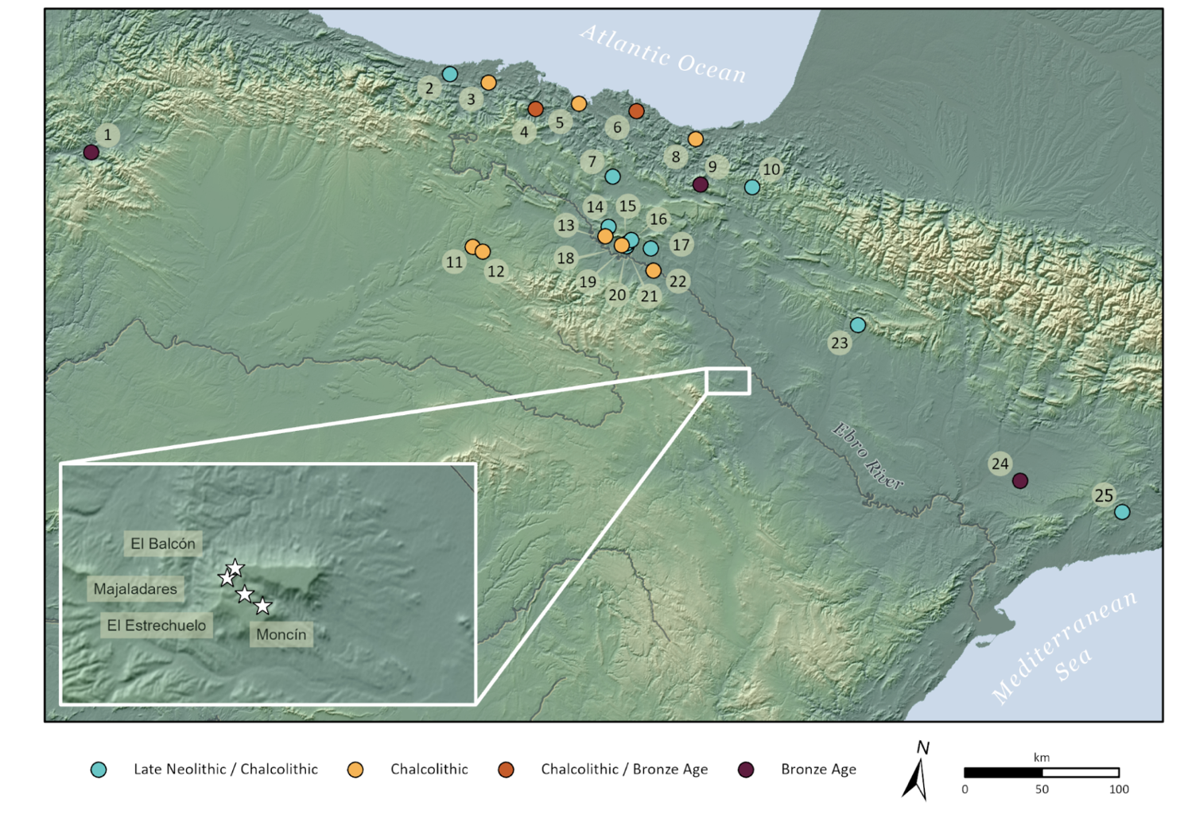

Figure 2
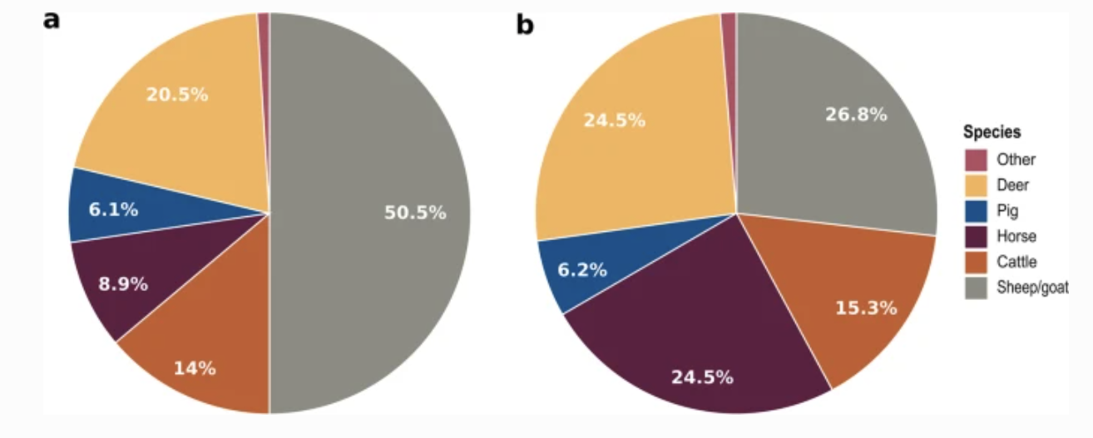

Figure 3

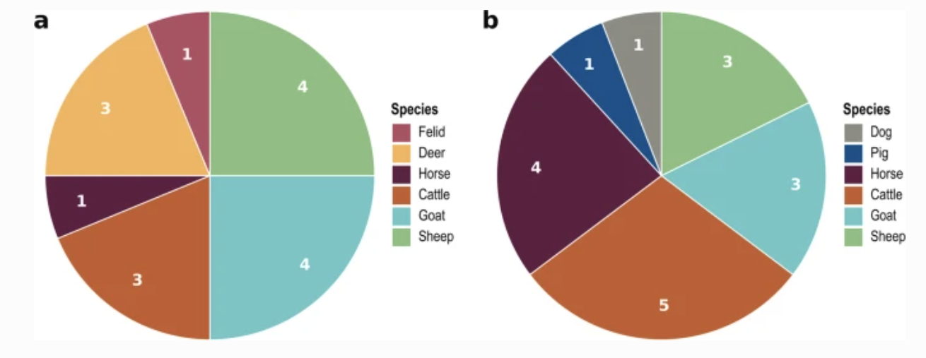

Figure 4

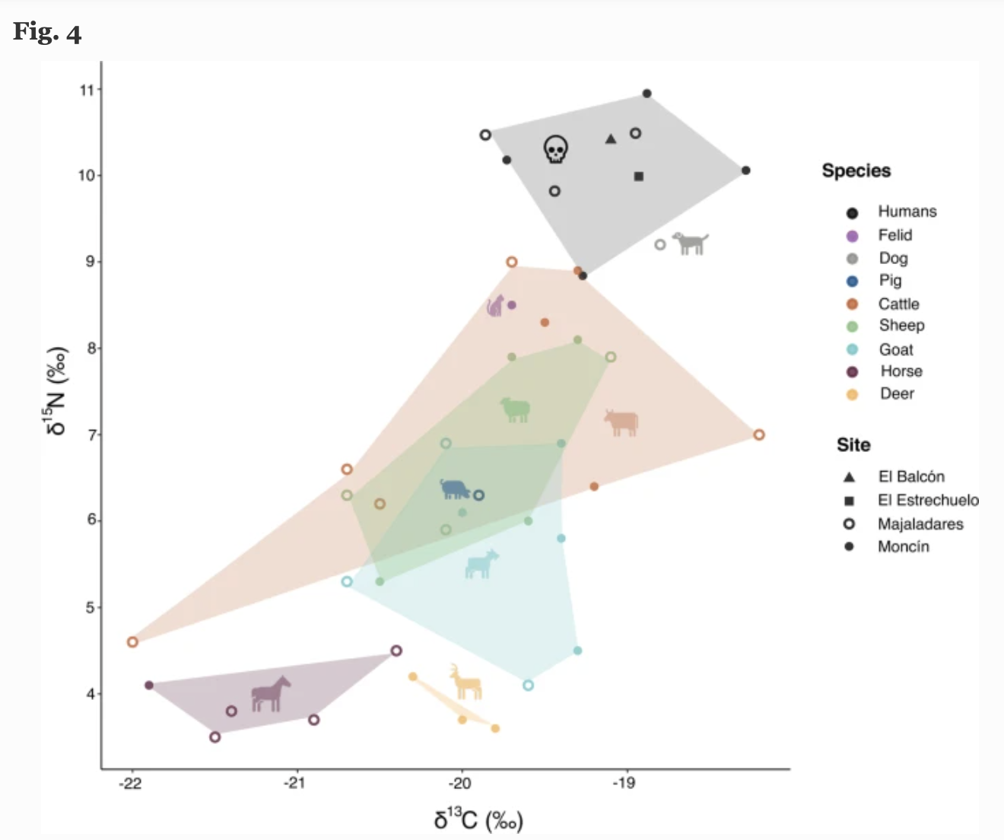

Figure 5
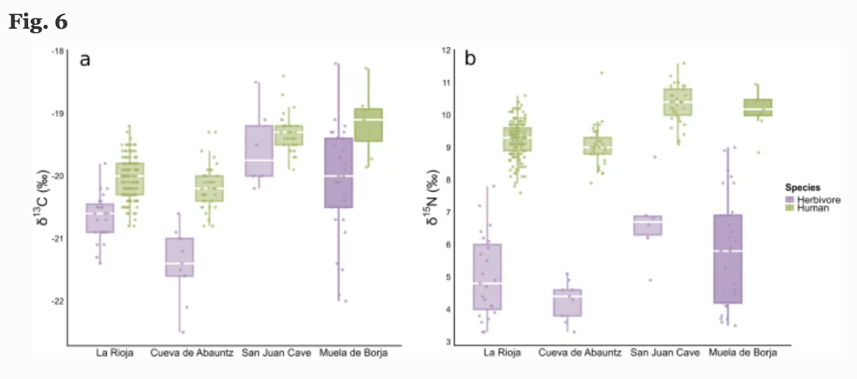
Figure 6
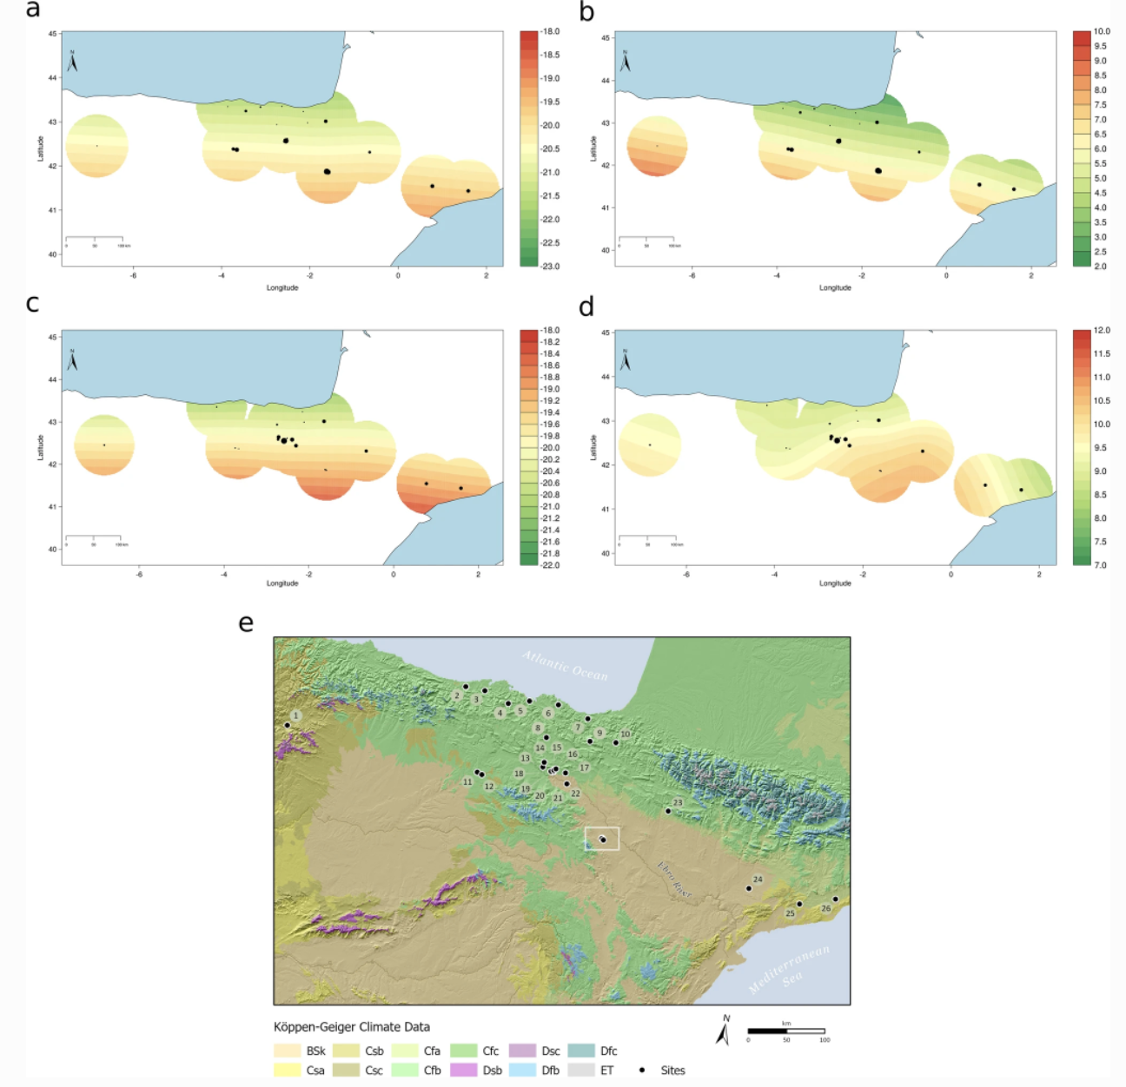

Tables
Table 1 Minimum number of individuals (MNI) recovered from the Muela de Borja sites, differentiated by age estimations and morphological sex determinations

Muela de Borja | Subsite | Adults |  |  | Subadults | Undetermined | MNI
 |  | Female | Male | Undetermined | Undetermined
Moncín | Moncín ext. | - | 1 | 4 | 2 | - | 7
 | Moncín I | - | 2 | 1 | 6 | - | 9
 | Moncín II | - | 1 | - | 3 | - | 4
 | Moncín III | 2 | - | - | 2 | - | 4
 | Moncín IV | 1 | - | - | - | - | 1
 | Total | 3 | 4 | 5 | 13 | - | 25
El Estrechuelo | El Estrechuelo | 1 | 2 | - | 1 | 2 | 6
Majaladares | Majaladares ext. | - | 1 | - | 1 | - | 2
 | Majaladares I | - | - | 1 | - | - | 1
 | Majaladares II | 1 | - | 1 | 2 | - | 4
 | Majaladares III | - | 1 | - | 1 | - | 2
 | Total | 1 | 2 | 2 | 4 | - | 9
El Balcón | El Balcón | - | - | 1 | - | - | 1
Barranco de La Albaradilla | Barranco de La Albaradilla | - | - | 1 | - | - | 1
La Calleja | Calleja I | - | 1 | - | - | - | 1
 | Calleja II | - | 1 | - | - | - | 1
 | Total | - | 2 | - | - | - | 2

Table 2 Stable carbon and nitrogen isotope results and bone collagen quality indicators of human remains. The estimated caloric contribution of food sources is also reported in %, reported as the mean ± 1σ
Sample | Site | Element sampled | Age | Yield (%) | %C | %N | C/N | δ13C (‰) | δ¹⁵N (‰) | C3 cereals (%) | Domestic Herbivores (%) | Wild Herbivores (%)
BAA1 | Majaladares ext. | Cranium | Adult | 2.1 | 34.5 | 12.3 | 3.3 | -19.9 | 10.5 | 61±14 | 28±10 | 11±8
BAA2 | Majaladares I | Rib | Adult | 7.4 | 43.1 | 15.8 | 3.2 | -19.0 | 10.5 | 60±13 | 29±10 | 11±8
BAA3 | Majaladares II | Rib | Adult | 13.2 | 44.5 | 16.2 | 3.2 | -19.4 | 9.8 | 61±14 | 28±10 | 11±8
BAA5 | Moncín I | Vertebra | Adult | 5.0 | 42.7 | 15.5 | 3.2 | -18.3 | 10.1 | 61±14 | 28±10 | 11±8
BAA6 | Moncín ext. | Rib | Adult | 9.7 | 40.7 | 15.0 | 3.2 | -18.9 | 11.0 | 61±14 | 28±10 | 10±8
BAA7 | Moncín I | Rib | Non-adult | 12.6 | 47.9 | 17.4 | 3.2 | -19.3 | 8.8 | 61±15 | 27±10 | 12±8
BAA8 | Moncín III | Vertebra | Adult | 10.1 | 45.0 | 16.3 | 3.2 | -19.7 | 10.2 | 61±15 | 28±11 | 11±8
BAA9 | El Estrechuelo | Rib | Adult | 8.2 | 44.0 | 16.0 | 3.2 | -18.9 | 10.0 | 60±14 | 28±10 | 11±8
BAA10 | El Balcón | Femur | Adult | 9.0 | 41.5 | 15.2 | 3.2 | -19.1 | 10.4 | 61±14 | 28±10 | 11±8

Table 3 Stable carbon and nitrogen isotope results and bone collagen quality indicators of animal remains. ZooMS identifications are also reported

Sample | Site | Element sampled | Morphological ID | ZooMS ID | Yield (%) | %C | %N | C/N | δ13C (‰) | δ¹⁵N (‰)
MN1 | Moncín | Metacarpal | Sheep/Goat | Sheep | 7.3 | 44.5 | 16.1 | 3.2 | -19.7 | 7.9
MN2 | Moncín | Talus | Unidentified | Sheep | 2.1 | 47.6 | 17.1 | 3.3 | -19.6 | 6.0
MN3 | Moncín | Phalanx II | Deer | Red deer | 6.8 | 45.2 | 16.3 | 3.2 | -19.8 | 3.6
MN4 | Moncín | Phalanx II | Unidentified | Sheep | 3.4 | 38.0 | 13.8 | 3.2 | -20.5 | 5.3
MN5 | Moncín | Mandible | Sheep/Goat | Sheep | 12.3 | 41.9 | 15.4 | 3.2 | -19.3 | 8.1
MN6 | Moncín | Pelvis | Sheep/Goat | Goat | 11.2 | 44.1 | 16.1 | 3.2 | -19.4 | 5.8
MN7 | Moncín | Tarsal | Unidentified | Red deer | 2.8 | 41.9 | 15.3 | 3.2 | -20.0 | 3.7
MN8 | Moncín | Vertebra | Unidentified | Cattle | 13.2 | 47.3 | 17.3 | 3.2 | -19.3 | 8.9
MN10 | Moncín | Humerus | Sheep/Goat | Goat | 10.6 | 43.9 | 15.8 | 3.2 | -19.4 | 6.9
MN11 | Moncín | Long bone fragment | Unidentified | Red deer | 4.9 | 36.1 | 13.1 | 3.2 | -20.3 | 4.2
MN12 | Moncín | Calcaneus | Horse | Horse | 6.4 | 40.5 | 14.5 | 3.3 | -21.9 | 4.1
MN13 | Moncín | Femur | Unidentified | Cat/Tiger/Polecat/Lynx | 13.6 | 43.6 | 15.8 | 3.2 | -19.7 | 8.5
MN14 | Moncín | Pelvis | Sheep/Goat | Goat | 10.9 | 45.2 | 16.5 | 3.2 | -20.0 | 6.1
MN15 | Moncín | Mandible | Cattle | Cattle | 13.3 | 44.8 | 16.3 | 3.2 | -19.5 | 8.3
MN16 | Moncín | Mandible | Cattle | Cattle | 9.7 | 45.5 | 16.7 | 3.2 | -19.2 | 6.4
MN17 | Moncín | Metatarsal | Sheep/Goat | Goat | 6.1 | 43.8 | 16.0 | 3.2 | -19.3 | 4.5
MJ1 | Majaladares | Mandible | Sheep/Goat | Goat | 8.9 | 41.1 | 15.0 | 3.2 | -20.1 | 6.9
MJ3 | Majaladares | Radius | Unidentified | Sheep | 16.2 | 42.0 | 15.4 | 3.2 | -20.1 | 5.9
MJ4 | Majaladares | Tibia | Unidentified | Sheep | 11.6 | 44.0 | 15.8 | 3.3 | -20.7 | 6.3
MJ5 | Majaladares | Phalanx I | Cattle | Cattle | 4.3 | 40.7 | 14.9 | 3.2 | -18.2 | 7.0
MJ6 | Majaladares | Humerus | Sheep/Goat | Goat | 10.7 | 43.7 | 15.8 | 3.2 | -19.6 | 4.1
MJ7 | Majaladares | Ulna | Sheep/Goat | Sheep | 10.5 | 43.0 | 15.7 | 3.2 | -19.1 | 7.9
MJ8 | Majaladares | Mandible | Cattle | Cattle | 10.5 | 44.8 | 16.3 | 3.2 | -22.0 | 4.6
MJ9 | Majaladares | Vertebra | Unidentified | Cattle | 9.6 | 43.7 | 15.9 | 3.2 | -19.7 | 9.0
MJ10 | Majaladares | Vertebra | Unidentified | Horse | 7.6 | 43.4 | 15.8 | 3.2 | -20.4 | 4.5
MJ11 | Majaladares | Phalanx II | Unidentified | Pig | 9.9 | 46.2 | 16.8 | 3.2 | -19.9 | 6.3
MJ13 | Majaladares | Carpal or tarsal | Unidentified | Horse | 2.9 | 36.8 | 12.7 | 3.4 | -21.5 | 3.5
MJ14 | Majaladares | Fragment | Unidentified | Horse | 1.5 | 38.5 | 13.8 | 3.3 | -21.4 | 3.8
MJ15 | Majaladares | Phalanx II | Cattle | Cattle | 14.3 | 44.6 | 16.3 | 3.2 | -20.5 | 6.2
MJ16 | Majaladares | Phalanx III | Cattle | Cattle | 15.6 | 44.0 | 16.1 | 3.2 | -20.7 | 6.6
MJ17 | Majaladares | Vertebra | Unidentified | Dog/Wolf | 13.1 | 43.7 | 15.9 | 3.2 | -18.8 | 9.2
MJ19 | Majaladares | Mandible | Sheep/Goat | Goat | 5.8 | 41.2 | 14.7 | 3.3 | -20.7 | 5.3
MJ20 | Majaladares | Rib | Unidentified | Horse | 7.2 | 45.1 | 16.3 | 3.2 | -20.9 | 3.7

Table 4 Summary statistics with Number of individuals (N), Mean (M), Median (Mdn), Standard Deviation (SD), Minimum (Min) and Maximum (Max) of the isotopic values of human and animal remains

 |  | δ13C (‰) |  |  |  |  | δ¹⁵N (‰)
 | N | M | Mdn | SD | Min | Max | M | Mdn | SD | Min | Max
Humans | 9 | -19.2 | -19.3 | 0.5 | -19.9 | -18.3 | 10.1 | 10.2 | 0.6 | 8.8 | 11.0
Cattle | 8 | -19.9 | -19.6 | 1.2 | -22.0 | -18.2 | 7.1 | 6.8 | 1.5 | 4.6 | 9.0
Goat | 7 | -19.8 | -19.6 | 0.5 | -20.7 | -19.3 | 5.7 | 5.8 | 1.1 | 4.1 | 6.9
Sheep | 7 | -19.9 | -19.7 | 0.6 | -20.7 | -19.1 | 6.8 | 6.3 | 1.2 | 5.3 | 8.1
Horse | 5 | -21.2 | -21.4 | 0.6 | -21.9 | -20.4 | 3.9 | 3.8 | 0.4 | 3.5 | 4.5
Red deer | 3 | -20.0 | -20.0 | 0.3 | -20.3 | -19.8 | 3.8 | 3.7 | 0.3 | 3.6 | 4.2
Pig | 1 | -19.9 | - | - | - | - | 6.3 | - | - | - | -
Canid | 1 | -18.8 | - | - | - | - | 9.2 | - | - | - | -
Felid | 1 | -19.7 | - | - | - | - | 8.5 | - | - | - | -

