Effect of thermal cycling on the corrosion behaviour of stainless steels and Ni-based alloys in molten salts under air and argon
Qingyang Liu^{a,b,*}, Jiong Qian^{b,c}, Richard Barker^{a,b}, Chun Wang^{a,b}, Anne Neville^{a,b} and Frederick Pessu^{a,b}.
- Institute of Functional Surface, School of Mechanical Engineering, University of Leeds, Leeds, LS2 9JT, United Kingdom.
- Jiuli Corrosion and Integrity Centre Laboratory (University of Leeds), Leeds, LS2 9JT, United Kingdom.
- Engineering Research Centre of High-Performance Nuclear Power Pipe Forming of Zhejiang Province, Huzhou 313028, China
* Corresponding author: Qingyang Liu; Email: mnql@leeds.ac.uk

Keywords:
Thermal cycling; Spallation; Argon; Concentrated Solar Power; Multi-corrosion layer.

Highlight:
- Intermittent cooling effect during thermal cycles mitigate corrosion process in air.

- Tests in Ar was observed to increase CR compared to test in air.

- Multi-corrosion layers were observed to protect the metal and dense layer.

Abbreviation
CR: corrosion rate; IN 625: Inconel 625; In 825: Incoloy 825; CSP: concentrated solar power; HTFs: heat transfer fluids; TC: thermal cycling; ISO: isothermal

Abstract
High temperature corrosion of materials in molten salt is of great interest to renewable energy production industry, especially the wide application of molten salts as thermal energy transfer fluid and storage media in concentrated solar power plants. Molten nitrate salt is used in concentrated solar power plants due to its good balance of thermo-physical properties and cost. Storage tanks and heat transfer pipes are widely made of corrosion resistance alloys such as austenitic stainless steels and nickel-based alloys. The corrosion issues between salt-metal interface poses a critical challenge to safety operation and efficiency. In this study, the corrosion behaviour of stainless steels and Ni-based alloys; AISI 321 and 347, IN 625 and In 825, in Solar (nitrate) salts has been experimentally investigated under isothermal (at 565°C) and thermal cycling (between 565°C and 290°C) conditions, and under air and argon atmosphere. Corrosion assessment of test alloys were achieved using gravimetric measurement in a simulated metal-salt environment in a furnace for 14 days. The micro-morphology and cross-sectional analysis of the corroded surfaces were investigated by a combination of scanning electron microscopy, energy dispersive X-ray diffraction techniques. Compared with isothermal condition in air, thermal cycling in air reduces the corrosion rate of test materials, the severity of corrosion attack and the thickness of corrosion product layers due to the lower exposure time at maximum temperature and cooling effect during thermal cycling, especially in stainless steels. Compared with thermal cycling in air, the obtained corrosion rate was observed to be higher for thermal cycling in argon due to the formation of thick and fragile outer layer of NaFeO₂ that easily spalls during the corrosion process. A more resilient and potentially more protective inner layer of Cr₂O₃ and NiO are observed to form in stainless steels and nickel alloys respectively. The formation of intermediate layer of Fe₂O₃ is believed to offer some barrier to potential molten salt induced dissolution of the inner Cr and Ni-rich layer.

Introduction
The potential of renewable energy to help reduce the consumption of conventional fuel energy and the emission of carbon dioxide has attracted more attention from government of nations and researchers worldwide over the last few decades (Walczak et al., 2018). Solar energy has shown great promise due to the abundant amount of energy reaching the Earth (Pelay et al., 2017; Walczak et al., 2018) from the sun, and the amount of solar thermal electricity achievable by concentrated solar power (CSP) plants (Alva et al., 2018; Desideri and Campana, 2014). In CSP systems, molten salts (especially mixture of NaNO₃ and KNO₃) are currently widely used as heat transfer fluids (HTFs) and sensible heat storage materials to collect, transfer and store energy in heat collectors, heat transfer pipes and hot tanks, respectively. This inevitably poses significant corrosion threat to all the metallic components, which are exposed to various types of molten salts; nitrate, carbonate and chloride salt, at extremely high temperature (typically ranging from 400 – 800 °C) (Bell et al., 2019) (Ma et al., 2022). These metallic components are susceptible to degradation due to high temperature fatigue, creep and intergranular corrosion at the metal-salt interface (Liu et al., 2021). Considering the potential for corrosion to occur, the optimal combination of molten salt and resilient metallic materials is critical for mitigating the risk of catastrophic failure of metal components used in CSP plants. Stainless steels and Ni-based alloys are widely used in CSP plants due to their good thermo - mechanical properties, good corrosion and oxidation resistance (Ma et al., 2022). Ni-based alloys have overwhelming superiority in relation to resistance to pitting corrosion, crevice attack and stress corrosion cracking when compared to stainless steels and low alloyed carbon steels (Walczak et al., 2018).
In a typical operation of CSPs, different profiles of thermal cycles are encountered that include; daytime heating and night – time cooling (Liu et al., 2022), and sudden drop in solar irradiation temperatures due to extreme weather changes (clouds, gust of cold winds, etc). This also introduces new complexities to the thermal fatigue induced material failure mechanisms. This aspect of molten salt – metal interactions have not been extensively researched up until now, and as a result not clearly understood. Only a few open literatures have investigated the effect of thermal cycling on the corrosion performance of candidate metal used in CSP plants under different gas atmospheres (Sutter et al., 2021). Bradshaw.et.al, (Bradshaw and Goods, 2001b) first attempted thermal cycling test in air with a 7.5-hour hot and 0.5-hour cold cycle and found that thermal cycling moderately increased the corrosion rate of three stainless steels compared with test under isothermal condition. The results presented only focused on characterising the corrosion rate and corrosion layer without providing persuasive and comprehensive evidence to explain the observed increase in corrosion rate due to thermal cycling.
Many methods have been recently explored to mitigate or retard the corrosion process, such as salt purification (Ding et al., 2019), alloy surface graphitisation (Gonzalez et al., 2019) or surface coating (Meißner et al., 2021), and controlling the cover atmosphere (Bonk et al., 2020; Vignarooban et al., 2015). Referring to the research related to cover gas atmospheres in CSPs, it is still unclear what the actual concentration of oxygen within CSPs is, particularly as there are no real –time data on this to-date. Although some researchers have concluded that presence of oxygen in molten salt increases corrosion rate, it is believed that there could an optimum oxygen concentration above which oxygen could become a corrosion problem. This scope of research has not been explored. Vignarooban(Vignarooban et al., 2015) found that corrosion rate of C-276 in open container at 500˚C is 10 times higher than in sealed container even at 800˚C. Therefore, they concluded that the atmospheric air plays a big role in inducing the corrosion in the molten-salt/alloy systems. From a recent research (Bonk et al., 2020), the rate of decomposition of nitrate ions to nitrite ions is shown to be higher at higher temperature in both open and closed test atmosphere, thus resulting in higher oxide ion content. This is shown in the Figure 1 (adapted from (Bonk et al., 2020)).
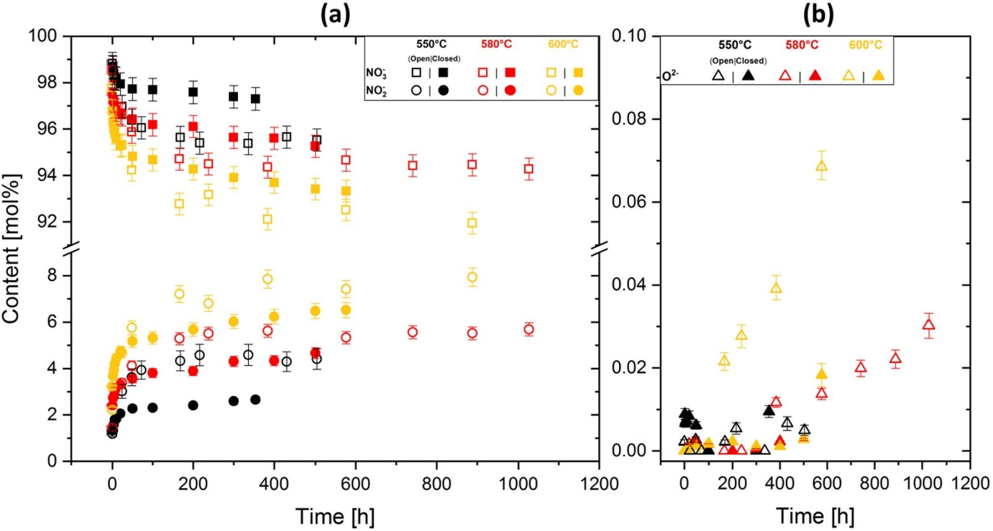
Figure 1 Nitrate-nitrite content (a) and oxide ions (b) in Solar Salt stored in open atmosphere and closed atmosphere at 550 °C, 580 °C and 600 °C. Adapted from Ref (Bonk et al., 2020)
This study therefore experimentally investigates the effect of thermal cycling in air, and the effect of cover gas under thermal cycling conditions on the corrosion characteristics of stainless steels and Ni-based alloys in molten nitrate salts at 565°C. Gravimetric and advance surface characterisation methods were implemented to understand the formation mechanism and protectiveness of corrosion layers. The scope of work explored in this study also aims at elucidating the synergistic effect of thermal cycling and cover atmosphere on the corrosion process. The results and findings in this study provides new empirical insights to guide the process of characterising and selection of suitable materials for use with molten salt in concentrated solar power plants.

Experimental system description

Experimental material
Two types of stainless steels; AISI 321 and 347, and two types of Ni-based alloys; Inconel 625 and Incoloy 825 were used in this study. Each sample has a surface area of 23 mm x 13 mm, and 3 mm thick. The as-received pipes were supplied by Zhejiang JIULI Hi-tech Metals Co., Ltd China, with nominal compositions presented in Table 1. The details and standard of the sample preparation are use BS ISO 17224:2015 for reference. The sample surface was grinded to 1200 grits by silicon carbide paper and polished with diamond suspension, then rinsed with acetone, ethanol, and deionized water. This is later followed by hot-air drying. The prepared samples were kept in a desiccator and weighed (m₀) using an analytical balance (0.01mg, Ohaus Analytical Plus balance, New Jersey, United States) before being put inside the oven. The corrosion experiments under argon cover gas were performed in a gas-control oven as shown in Figure 2. The argon gas is continuously passed over the molten salt during the tests with the flow rate of 800 ml/minute.
Solar salt (60 wt.% NaNO₃ and 40 wt.% KNO₃) was selected for this study and was purchased from Alfa Aesar with analytical reagent purity (99.5% KNO₃ and 99.5% NaNO₃). The salts were weighed to achieve the required ratio, homogeneously mixed and dried at 120 °C for 24 h in a furnace before the experiments. The amount of corrosive molten salt in each crucible are required to be at least 20ml per 1cm² of samples’ area according to British Standard ISO 17245:2015. The solar salt density at 565°C was 1.72 g/cm³, which is obtained by extrapolating data from literature (Wei et al., 2020). After referring to the surface area, the amount of solar salt for each crucible is 413g (248g NaNO₃ and 165g KNO₃).
Four samples of each alloy were placed horizontally in each Al₂O₃ crucible. The homogeneous salts were poured into each sample-containing crucible before being transferred into the furnace to dry under air/argon atmosphere for 12 hours at 180 °C. The crucibles are designed to have lids with a large height to avoid any potential molten salt creeping (Martin et al., 2018). The XRD test was conducted to examine the salt composition before and after the test to check the salt condition. The furnace is gradually heated up to test temperature before commencing the test.
Table 1: Alloy composition of AISI 321 and 347, IN 625 and In 825 (wt%).
Alloy | C | Mn | Si | P | Cu | Cr | Ni | Ti | Nb | Mo | Fe
AISI 321 | 0.018 | 1.44 | 0.519 | 0.035 | - | 17.33 | 9.24 | 0.225 | - | - | Bal.
AISI 347 | 0.049 | 0.95 | 0.402 | 0.026 | 0.11 | 17.35 | 9.65 | - | 0.656 | - | Bal.
IN 625 | 0.018 | 0.04 | 0.142 | 0.001 | 0.03 | 21.69 | 62.36 | 0.211 | 3.31 | 8.65 | 3.06
In 825 | 0.008 | 0.67 | 0.258 | 0.0119 | 1.75 | 22.6 | 40.18 | 0.943 | 0.025 | 2.88 | 30.32

Table 2 Main component contents and purity of the test salt (wt%), from supplier data.
Components | KNO3 | NaNO3
Main component, % | 99.5% | 99.5%
Insoluble, % | 0.002 | 0.002
IO₃⁻, % | <0.0005 | <0.0005
SO₄²⁻, % | 0.003 | 0.003
NO₂⁻, % | <0.001 | <0.001
Ca, % | 0.004 | 0.005
Mg, % | 0.002 | 0.002

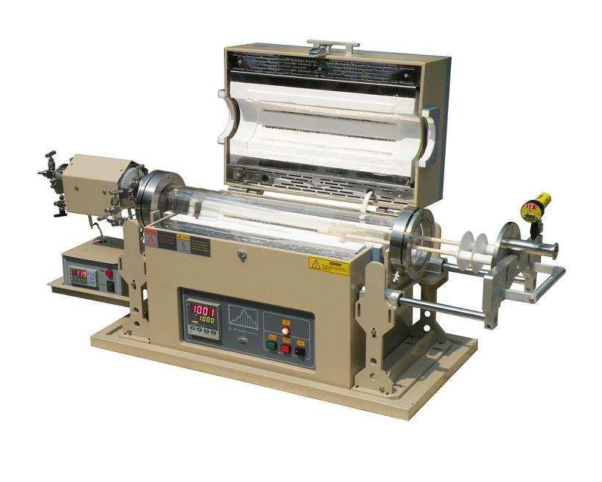
Figure 2: The structure of tubular furnace whole and part. 1-gas inlet; 2-gas exit; 3-test chamber; 4-heating unit; 5-crucible; 6-specimen; 7-molten salt; 8-thermocouple, with a flow rate of 800ml/min.
In order to investigate the corrosion behaviour of studied samples under thermal cycling conditions, tests were performed at a constant temperature of 565 °C for isothermal corrosion as a reference condition. Under thermal cycling conditions, the temperature was controlled to fluctuate between 290 and 565 °C, representing peak-time heating of molten salt and night-time cooling of molten salt in CSP storage tanks and flow lines (Bradshaw and Goods, 2001b; Liu, 2021). The selection of duration of exposure of materials to molten salts in these configurations are designed to replicate as closely as possible the real-time cycle between daytime 12-hour heating and night-time 12-hour cooling. The temperature range to be explored was chosen based on the melting point of solar salt at 220°C and its stability limit at 565°C. The thermal cycling profile are shown in Figure 3. The total test duration in this study for both isothermal and thermal cycling test is 14 days (14 cycles).
Figure 3: Time-temperature profile of isothermal immersion and thermal cycling (heating and cooling rate at 10°C/min with 25-min interval)
After each experiment, the samples were descaled to remove the corrosion product using a standardised procedure of washing for 20-min with 10% HNO₃ at 60°C (for austenitic stainless steels), and 10% H₂SO₄ at 20-25°C (for Ni-based alloys) as described in ASTM G1-03 (G1-03, 2017) and BS EN ISO 8407:2014 (2015). Weight change before and after immersion test were calculated via Equation 1, while corrosion rate is estimated using Equation 2. It is assumed that the molten salt - metal interface is corroding uniformly.
$$\frac{∆m}{S}=\frac{m_{0}-m_{1}}{S}$$ | Equation 1
$$CR(μm/y)=\frac{87600 ∆m}{ρ S t}$$ | Equation 2
Where m₀ represents the initial weight and m₁ is the weight of specimen after corrosion. Δm/S is descaled mass loss per unit area (mg/cm²), $ρ$ is alloy density in g/cm³, t is the immersion time (h). Three parallel samples were used to determine the mass loss data to ensure accuracy.

Microstructure analysis and surface characterization
A Bruker D8 X-ray diffractometer was used for X-ray diffraction analysis of alloys to identify the corrosion product on the surface using monochromatic Cu Kα radiation (λ=1.5418 Å). XRD patterns were collected in the 2θ range from 10° to 90° with a 1.5°/min scan rate. The surface morphology and cross-sections analysis of samples were investigated using Carl Zeiss EVO MA15 scanning electron microscope (SEM). The SEM was integrated with an Oxford Instruments Aztec Energy dispersive X-ray (EDS) system with an 80mm X-max SDD detector which provided secondary and backscattered imaging, EDS elemental mapping and line scans. The incident beam voltage of 20 keV was employed and working distance of 12–13 mm.

Results and discussions

Post-experiment salt characterization
Prior to the sample analysis on the corrosion mechanism, the content of salt and aggressiveness of salt system need to be checked before and after different tests to figure out how the salt chemistry change by altering the thermal effect and switch of atmosphere.
Considering the salt chemistry, X-ray Diffraction patterns of salt before and after test has been presented in Figure 4. As shown in Figure 4 (a), the as-received salt was identified as only mixture of (Na, K) NO₃, and the main patterns of the post-test salts were similar to that of the as-received salt, indicating the conditions of molten salt kept stable. The significant difference between as-received salt and tested salt are that salts after isothermal and thermal cycling test in air and argon exhibited peaks of (Na, K) NO₂ with the varying intensity around 30.001 (100 % intensity) degree and 32.065° (55% intensity, according to Reference code 00–006-0392). This is evidenced that the presence of the nitrites ions from the decomposition from nitrate after 2-week immersion. The main peak of (Na, K) NO₂ at 30.001 degree exhibited highest in Figure 4 (d) after 2-week Argon thermal cycling, air-isothermal salt ranked second and air thermal cycled salt showed lowest intensity. It is worth noting that the peak at 32.065° (not main peak for NaNO₃ with 14% intensity and main peak for NaNO₂ with 55% intensity) in Figure 4 (d) for 2-week argon thermal cycling shows a 2500 a.u. intensity higher than that in Figure 4 (a), (b) and (c) for as received, 2-week air isothermal and 2-week air thermal cycling test respectively. Many researchers (Bonk et al., 2020; Han et al., 2021) also confirmed that the presence of NaNO₂ influenced the thermal physical properties and corrosiveness (Liu et al., 2022) of molten salt. This clear evidence could confirmed that the salt aggressiveness after 2-week thermal cycling in argon is higher than that in air both isothermal and thermal cycling due to increase in nitrite concentration from solar salt decomposition. The detailed comparison of peak intensity of NaNO₂ after different test conditions are shown in Table 3.
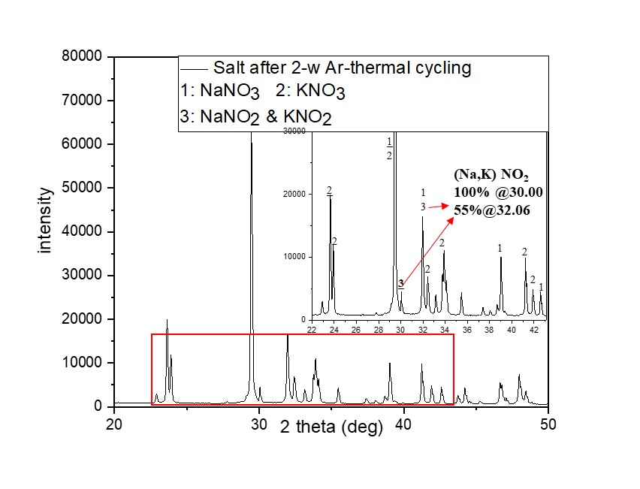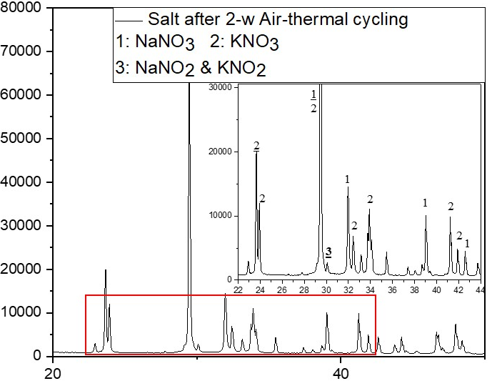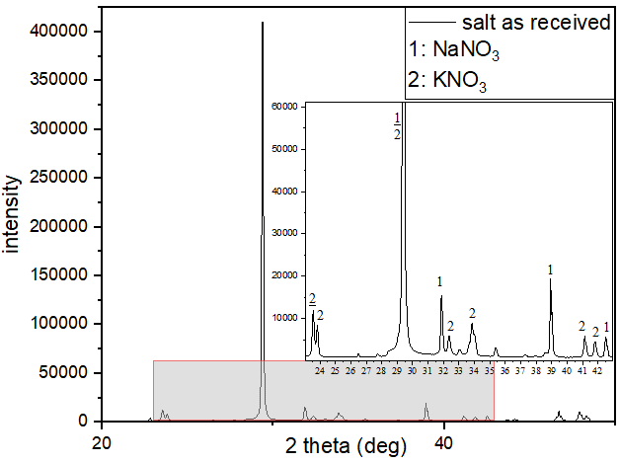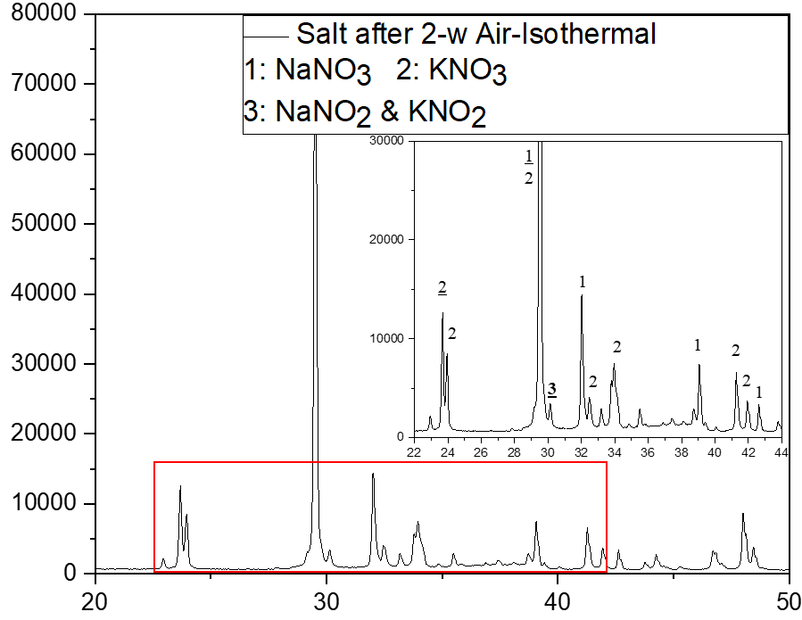
(a)
(b)
(c)
(d)
Figure 4 XRD results of solar salt before and after immersion test, (a) as received; (b) after 2-week air isothermal; (c) after 2-week air thermal cycling and (d) after 2-week argon thermal cycling (Reference code 00-006-0392, 00-036-1474 and 00-05-0377)
Table 3: Main peaks intensity of NaNO₂
 | NaNO₂ intensity at 30 2theta (100% intensity) | NaNO₂ intensity at 32 2theta (55% intensity) | NaNO₃ intensity at 32 2theta (14% intensity)
As-received salt | 0 | 0 | 14085
2-week Air isothermal | 3366 | 0 | 14293
2-week Air thermal cycling | 2781 | 0 | 14532
2-week Ar thermal cycling | 4500 | 2500 | 14032

Effect of Thermal Cycling in Air

Corrosion rate measurements and corrosion rate characterisation
Figure 5 shows the weight loss and corrosion rate of stainless steels and Ni-based alloys after 14-day immersion test under isothermal and thermal cycling under air, and thermal cycling under argon atmosphere (Figure 5). Generally, stainless steels exhibited higher weight loss and corrosion rate than that of Ni-based alloys under all conditions.
Referring to Figure 5 (a) for samples exposed to air, the corrosion rate from isothermal test was higher than that from thermal cycling tests. The effect of thermal cycling appears to substantially suppress the corrosion process. This is linked to the intermittent cooling at 290°C and the long residence time in the cooling phase (12 hrs) per thermal cycle. The repeated cooling phase is believed to be suppressing the kinetics of corrosion and oxide formation, thereby reducing material loss rate. This intermittent cooling effect could also provide a break in aggressive molten salt - metal interaction enhanced by high temperature to minimise the thermal effects on initially formed corrosion oxide layers at 565°C. This trend was observed for both stainless steel and nickel alloys in this study and shown to restrict the potential transformation from dense oxide layers to loose/porous oxide layers. Detailed evidence and analysis are presented and discussed in the next section on surface characterisation later in this paper.
Figure 5 Mass loss (and corrosion rate) of AISI 321 AISI 347 IN 625 and In 825 specimens at different temperature gradient and atmosphere in solar salt for 14 days. (ISO indicates ‘isothermal’ and TC indicates ‘thermal cycling’ in the figure and the same below)

Corrosion product characterisation: XRD analysis and SEM surface observation
Figure 6 and Figure 7 shows the XRD patterns and SEM images respectively, of the corroded surface of AISI 321, AISI 347, IN 625 and In 825 after 14-day immersion in solar salt under isothermal and thermal cycling in air, and thermal cycling in argon. Referring to the XRD patterns in Figure 6, it is shown that the oxide layers formed on the surface of AISI 321 and AISI 347 in solar salt consists of different combination of iron oxide (Fe₂O₃), iron chromium spinel (FeCr₂O₄), sodium ferrite (NaFeO₂), and chromium oxide (Cr₂O₃). The specific combination of oxide chemistries is dependent on the type of test and cover gas atmosphere. The possible reaction to form the corrosion products are as follows:
$${NO}_{3}^{-}⇌{NO}_{2}^{-}+\frac{1}{2}O_{2}(g)$$ | Equation 3
$${2NO}_{2}^{-}⇌{NO}_{2}(g)+NO(g)+O^{2-}$$ | Equation 4
$$Cr+\frac{3}{4}O_{2}→{\frac{1}{2}Cr}_{2}O_{3}$$ | Equation 5
$$Ni+{\frac{1}{2}O}_{2}→NiO$$ | Equation 6
$$3Fe+2O_{2}→{Fe}_{3}O_{4}$$ | Equation 7
$${2Fe}_{3}O_{4}+\frac{1}{2}O_{2}→3{Fe}_{2}O_{3}$$ | Equation 8
$$\frac{1}{2}{Fe}_{2}O_{3}+\frac{1}{2}O_{2}+e^{-}+{Na}^{+}→NaFeO_{2}$$ | Equation 9
$$Fe+{Cr}_{2}O_{3}+\frac{1}{2}O_{2}→Fe{Cr}_{2}O_{4}$$ | Equation 10
Referring to XRD patterns in Figure 6 (a1, a2) and (b1, b2), Cr₂O₃ can be identified on the surface under thermal cycling condition in air, but not under isothermal condition for AISI 321, and for similar test scenarios In AISI 347. While it is expected that Cr₂O₃ forms as a passivating oxide layer in air, the observed trend indicates confirms the formation of Cr₂O₃ in argon atmosphere according to Equation 3 Equation 4 and Equation 5. However, under isothermal condition in air; particularly for AISI 321, the absence of Cr₂O₃ on the XRD pattern is likely due to its dissolution after long residence time of immersion in molten salt (Ahmed, 2013; Bell et al., 2019) . In AISI 347, a similar trend is observed, but observed in terms of lower intensity of the peak Cr₂O₃ under isothermal condition than in thermal cycling in air. These results suggests that under thermal cycling conditions in air, and in comparison with isothermal condition in air, the thermal effect on the resilience of Cr₂O₃ oxide layer is suppressed. This has the potential to reduce the likelihood for Cr₂O₃ oxide layer breakdown/dissolution and overall metal loss rate for test under thermal cycling in air than under isothermal condition in air.
The observed effect of thermal cycling in air is due to the effect of intermittent cooling on the stability of Cr₂O₃ passive layer as already described above. This is evident in the SEM images in Figure 7 (a1) and (a2) and Figure 7 (b1) and (b2) for isothermal and thermal cycling test in air of AISI 321 and AISI 347 respectively. The SEM images show the corrosion product layers to be dense and more protective under thermal cycling conditions than in isothermal condition. More coarse grains are found on the rougher isothermal surfaces. The cross-section analysis and EDS line scan is presented in Figure 8 (a1) and (a2) for AISI 321, and Figure 8 (b1) and (b2) for AISI 347 after isothermal and thermal cycling test in air respectively. The results confirms the corrosion layer to be thinner, dense and more compact with retained integrity under thermal cycling condition (~2.5 µm thickness for AISI 321) than in isothermal condition (~6 µm thickness for AISI 321). These visual evidence correlates with the corrosion rate data in Figure 5 and the underpinning mechanism described above. The cross-section analysis and EDS line scans in Figure 8 (a1 and a2) and (b1 and b2) for AISI 321 and 347 respectively, also confirms the evidence of an outer layer of Fe₂O₃ and inner Cr₂O₃ and/or FeCr₂O₄ layer. This correlates with the XRD patterns in Figure 6 (a1 and a2) and (b1 and b2) for AISI 321 and 347 respectively. However, for AISI 321 in air and isothermal condition, Fe₂O₃ dominates the corrosion product layer due to the dissolution of initially formed Cr₂O₃. Observations of dissolution of dense inner chromium oxide layer in nitrate salt and the formation of a Fe₂O₃ layer in molten salt has been reported (Bell et al., 2019; Walczak et al., 2018). Fe₂O₃ is able to provide some barrier to molten nitrate salt but likely not comparable to that offered by the compact Cr₂O₃ layer formed under thermal cycling conditions in air (Ahmed, 2013; Bell et al., 2019; Bradshaw and Goods, 2001a; Goods et al., 1994).
Similar observation can be deduced from the corrosion rate data, XRD pattern, SEM and EDS line scan of cross sections for nickel alloys in this study, particularly In 825. For nickel alloys, the chemistry of the corrosion products identified on XRD were similar for both isothermal and thermal cycling tests in air (see Figure 6 (c1 and c2) and (d1 and d2) for IN 625 and In 825 respectively). Nickle oxides (NiO) formed on the corrosion surface of IN 625, while NiO, Fe₂O₃ and FeCr₂O₄ was identified on In 825. The latter is due to the high Fe content in In 825, as provided in Table 1. In addition to the higher corrosion rate under isothermal condition than thermal cycling, the visual evidence from SEM and EDS line scan from cross section analysis shows that the corrosion product layer are more dense, compact and thinner (~2.1µm thickness for In 825) under thermal cycling than under isothermal condition (~4.1 µm for In 825) in air. Referring to Figure 6 (c1 and c2) for IN 625, the morphology for NiO formed in air under both isothermal and thermal cycling conditions are similar and exhibiting relative smooth surface even with clear polishing scratch, which correlates with the close corrosion rates for both systems as shown in Figure 5. This reflects the superior corrosion properties over 14 days of IN 625 over the other alloys considered in this study.

Effect of Cover gas on corrosion characteristics during thermal Cycling

Corrosion rate measurements and corrosion rate characterisation
Referring to Figure 5 (b), corrosion rates recorded after immersion test under thermal cycling in argon is ~5 times higher than that in air across the studied alloys (except for IN 625). This has been linked to a combination of specific reaction pathways that influences the corrosiveness of solar salt, the impact of delayed passivation from Cr₂O₃ and formation of other non-protective oxide layers. It is has been reported that the corrosiveness of the solar salt results from the breakdown of nitrate salts, leading to the conversion of nitrate to nitrite, with the release of Na⁺ and oxide ions (around 0 % and 0.01 % in open and sealed environment at 550 °C respectively). This reaction pathway is also known to occur in sealed environment with no supply of oxygen (Bonk et al., 2020) according to the reactions in Equation 3 and Equation 4.
In this case, the rate of corrosion will be determined by the ionic strength of molten salts at high temperatures, the rate of availability of oxide and Na⁺ ions, and the rate of passive Cr₂O₃ oxide formation and breakdown. The latter will likely be delayed by the rate of availability of oxide ions. A combination of high temperature material dissolution in ionic molten salt and delayed passivation acts to control the rate of passivation of the molten salt – metal interface leading to a higher corrosion rate after 14 days. For the thermal cycling test in air, it is likely that the excess supply of oxygen promotes the quick formation of a thin and dense layer of chromium oxide (Cr₂O₃) to protect the corrosion interface early in the 14 days test. As a result, the corrosion rate over 14 days exposure time is lower for thermal cycling test in air than in argon. It is worth noting that this does not imply that this trend will continue beyond 14 days of exposure.

Corrosion product characterisation: XRD analysis and SEM surface observation
Referring to results from thermal cycling under argon atmosphere and in comparison with thermal cycling test in air, NaFeO₂ corrosion layer was also identified only on the surface of samples from thermal cycling tests in argon. The formation of NaFeO₂ is believed to have followed the reaction of the outer Fe₂O₃ (already described above to offer some shielding to Cr₂O₃) and Na⁺ from the molten salt according to the Equation 9 above.
Na⁺ in Figure 6 (a3, b3) and d3) is provided from the nitrate salts. NaFeO₂ has been observed in this study to be a porous, loosely held and non-protective outer layer as shown in SEM images in Figure 7 (a3, b3 and d3) for AISI 321, AISI 347, and In 825 respectively for thermal cycling test in argon. NaFeO₂ is not present on samples after thermal cycling tests in air as shown by the XRD patterns in Figure 6 (a2, b2 and d2) for AISI 321, AISI 347 and In 825 respectively. The XRD pattern in Figure 6 (a3, b3 and d3) in argon also show the presence of Cr₂O₃, FeCr₂O₄ and Fe₂O₃. The oxygen consumed to form these oxides is provided by Equation 3 and Equation 4.
Referring to the EDS line scan from cross section analysis, it is evident in Figure 8 (a3, b3 and d3) for AISI 321, AISI 347 and In 825 respectively, that Cr₂O₃/FeCr₂O₄ is formed as an inner layer and Fe₂O₃ is formed as an outer layer under argon cover gas. Note that Na is not identified on this line scans to confirm the presence of NaFeO₂. However, this has been shown on a complimentary top view EDS map in Figure 7 to confirm the presence of the porous and non-protective NaFeO₂ as the outmost layer formed under argon cover gas. It is therefore evident that the cross sectional corrosion product footprint for AISI 321 and AISI 347 consists of a Cr₂O₃ and/or FeCr₂O₄ inner layer, Fe₂O₃ middle layer and an outer non-protective NaFeO₂ outer layer for test under thermal cycling condition in argon. For In 825, there is an additional intermediate NiO layer in argon, while the cross sectional corrosion product footprint for thermal cycling test in air consists of a Cr₂O₃ and/or FeCr₂O₄ inner layer and a Fe₂O₃ outer layer.
In terms of the overall corrosion rate for test under thermal cycling in argon, the formation of NaFeO₂ via Equation 9 is likely to undermine the integrity of Fe₂O₃ layer to expose the inner layers to aggressive molten salt species (Ahmed, 2013; Bell et al., 2019; Bradshaw and Goods, 2001a; Goods et al., 1994). As shown by the SEM images in Figure 7 (a3, b3 and d3) for AISI 321, AISI 347 and In 825 respectively, NaFeO₂ is susceptible to breakdown by spallation. This is likely to contribute to an increase in corrosion rate. The other mechanism that is likely to contribute to material loss rate is the delay in formation of passive Cr₂O₃ and/or FeCr₂O₄ in stainless steels and Nickel alloys.
Delayed passivation will also imply a non-equilibrium of availability of Cr, Fe at the molten salt – alloy interface. The outward diffusion of these atoms (D’Souza et al., 2021) from bulk material to corrosion interface occurs in synergy with the concentration gradient induced by high temperature oxidation, resulting in the migration of atoms to the interface. The absence of a prompt supply of oxygen to promote quick passivation of the interface will lead to the formation of thicker films of a mixture of the oxides these oxide layers; including NaFeO₂, as soon as oxygen becomes available via Equation 3 and Equation 4.
To better understand the formation mechanism of these oxides at initial oxidation stage, the possible reactions occurring on the surface of stainless steels were listed in Table 4 together with the corresponding standard free energies of formation (ΔG^{θ}) of oxides formation. The change of Gibbs free energy (ΔG) the oxides was calculated by Equation 11 (Tan et al., 2017) (Yin et al., 2021), and listed in Table 4 as well.
$$ΔG={ΔG}^{θ}+RT ln(\frac{(α_{O})}{(α_{M}){({pO}_{2})}^{1/2}})$$ | Equation 11
The formation of Cr₂O₃ in both AISI 321 and 347 corresponds to lowest ΔG value (~ -1018 kJ/mol) at 565 ˚C, indicating Cr₂O₃ preferentially formed on the surfaces of stainless steels.
As we discussed the solubility of chromium compounds in nitrate salt (Slusser et al., 1985), other oxides started to formed once average Cr concentration was lower than a critical value (N_{Cr}*) (Wagner, 1952). Afterwards, as Fe-based alloys, rapid oxidation triggered the formation of Fe-based oxides at this oxidation stage. It’s well known that FeO is preferentially formed at temperature over 600 °C (Birks et al., 2006) and Fe₃O₄ and Fe₂O₃ tend to form at temperatures below 570 °C (Yin et al., 2021). From the ΔG values of oxides and the diffusivity order of metallic ions in chromia (D_{Fe} > D_{Ni} > D_{Cr}) (Lobnig et al., 1992), Fe₃O₄ and Fe₂O₃ starts to form and hence protect further Cr depletion from the base material, which can be well understood in terms of ionic diffusion during the oxidation process. The outward diffusion of Fe in the Cr₂O₃ and high affinity of Fe to oxygen resulted in mixture oxides of Fe and Cr. After dissolution of Cr-oxide, Fe₂O₃ was found on the topmost of the surface of stainless steels after corrosion in molten salt at 565 ˚C, which was also expected to provide a barrier to further limit Cr depletion from the base material afterwards. It is worthwhile that Fe₂O₃ tended to convert to NaFeO₂ with increase of exposure time and temperature, thus losing its protection. While in air the passive Cr₂O₃ formed on the early stage and higher diffusion rate of Fe in Cr₂O₃ resulted in formation of Fe₂O₃ to further shield the dissolution of Cr₂O₃ into molten salt.
Table 4 Standard free energies of formation of possible oxides and change of Gibbs free energy of corresponding reactions in AISI 321 and 347 stainless steels with molten salt at 565 ˚C.
Alloy | Reaction | ∆G°(kJ/mol) 25˚C 1atm | ∆G(kJ/mol) 565℃(838K)
Alloy | Reaction | ∆G°(kJ/mol) 25˚C 1atm | AISI 321 | AISI 347
Fe₂O₃ | 2Fe+1.5O₂= Fe₂O₃ | -742.2 | -721.276 | -721.24
Fe₃O₄ | 3Fe+2O₂=Fe₃O₄ | -1015.5 | -1015.5 | -986.83
Cr₂O₃ | 2Cr+1.5O₂=Cr₂O₃ | -1058 | -1018.658 | -1018.549
NiO | Ni+0.5O₂=NiO | -211.7 | -189.520 | -189.75

This is evident from the cross-section analysis in Figure 8 (a3, b3 and d3) for AISI 321, AISI 347 and In 825 respectively. The film thickness is ~11µm, ~12 µm and ~7µm under thermal cycling test in argon, and ~2.5µm, ~2.5 µm and ~2.1µm under thermal cycling test in air for AISI 321, AISI 347 and In 825 respectively. The thickness of the Cr₂O₃ and/or FeCr₂O₄ layers in AISI 321 and 347, and Cr₂O₃ and/or FeCr₂O₄, and NiO indicated by the EDS line scans in Figure 8 (a3, b3 and d3) for AISI 321, AISI 347 and In 825 respectively supports the underpinning mechanisms described here. All of these mechanisms are believed to act in synergy to increase corrosion rate under thermal cycling conditions in argon than in air over 14 days.
(a1)

(b1)

(c1)

(d1)

(a2)

(a3)

(b2)

(b3)

(c2)

(c3)

(d2)

(d3)

Figure 6 XRD patterns of studied alloys under different immersion conditions (phase number with underline meaning the 100% intensity peaks), (a) AISI 321, (b)AISI 347, (c) IN 625 and (d) In 825 after 14-day immersion test in Solar salt at (1) ISO in air (2)TC in air (3)TC in argon, respectively.
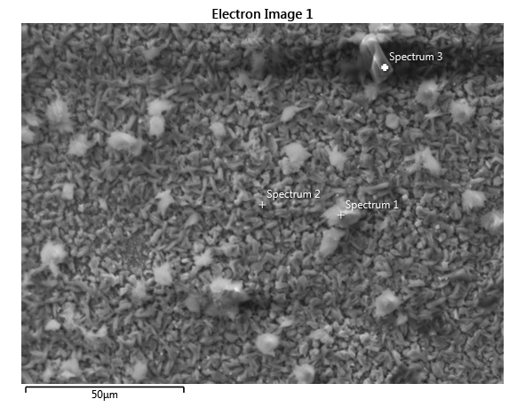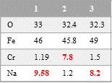
(b1)

(a1)

(a2)

(a3)

(b3)

(c3)

(d3)

(d2)

(d1)

(c1)

(c2)

(b2)

1
2
3
Spallation area
Figure 7 SEM top surface of the oxide scales formed on (a) AISI 321, (b)AISI 347, (c) IN 625 and (d) In 825 after 14-day immersion test in Solar salt at (1) ISO in air (2)TC in air (3)TC in argon, respectively.
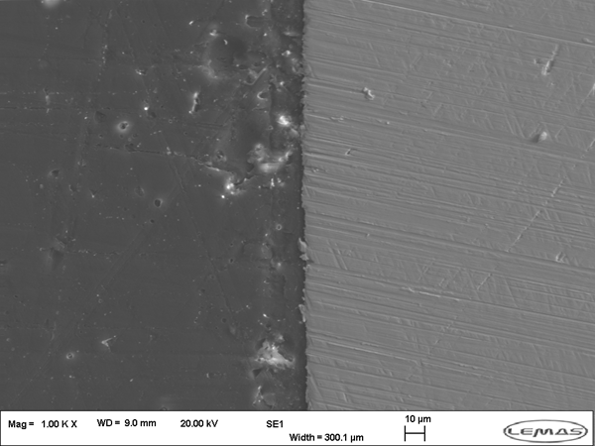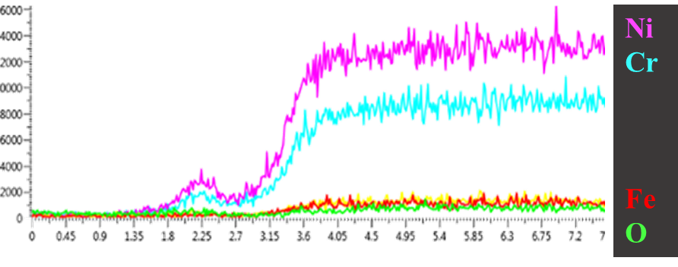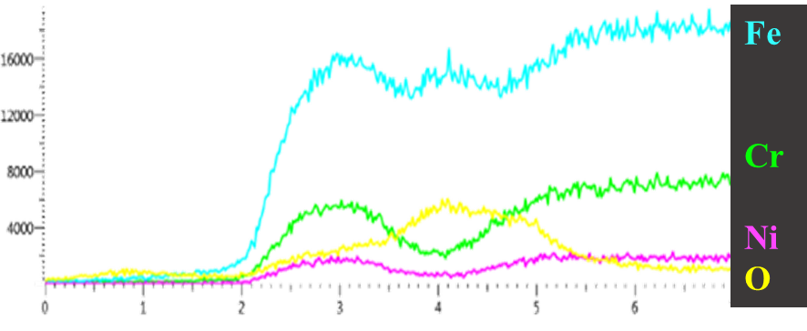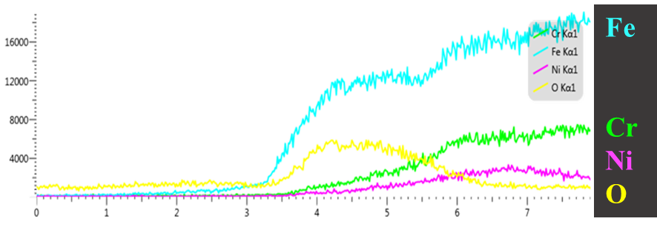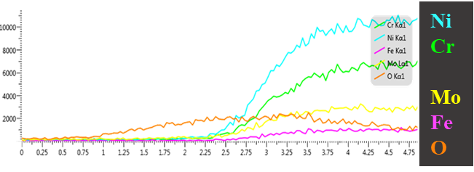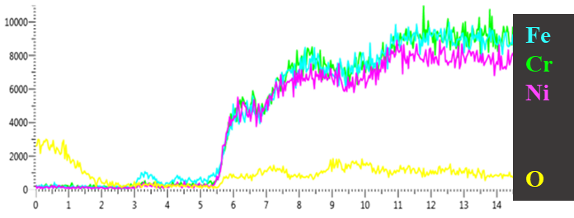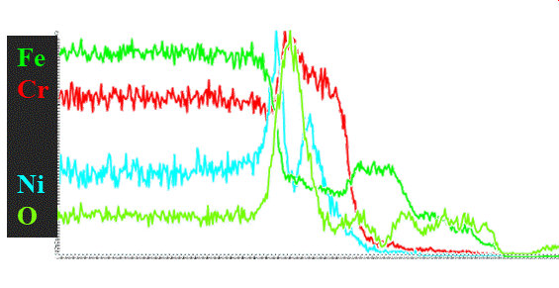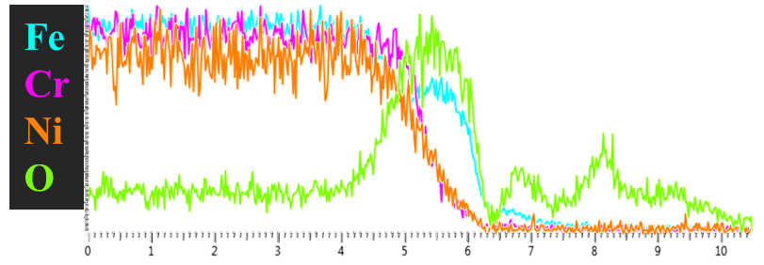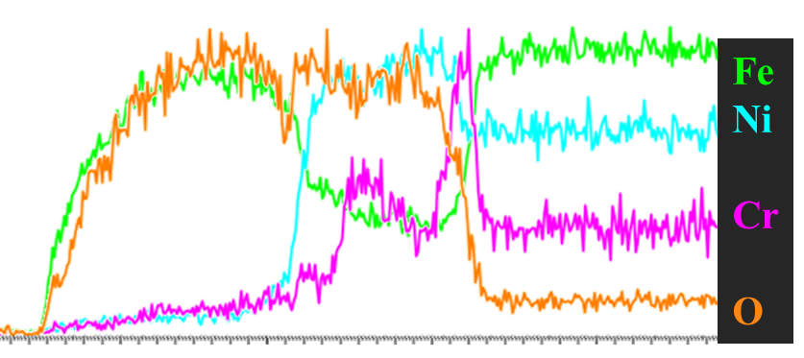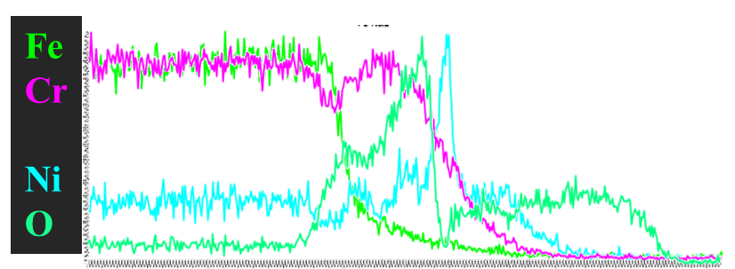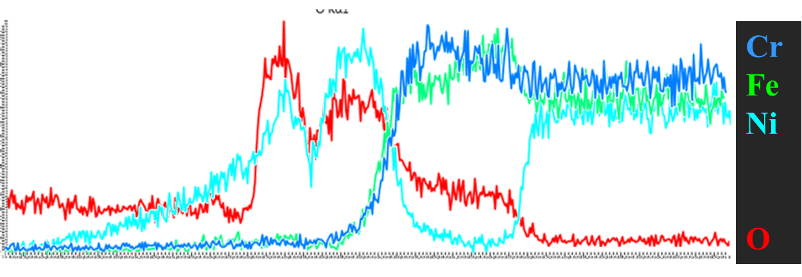
(a1)

(a3)

(b1)

(b3)

(c3)

(d1)

(c1)

(a2)

(b2)

(c2)

(d2)

~6 µm
~2.5 µm
~11 µm
~12 µm
~7 µm
~2.5 µm
~2.1 µm
~4.1 µm
~2.5 µm
(d3)

Figure 8 SEM-EDS profile of the oxide scales formed on (a) AISI 321, (b)AISI 347, (c) IN 625 and (d) In 825 after 14-day immersion test in Solar salt at (1) ISO in air (2) TC in air (3)TC in argon, respectively.

Discussion
The corrosion products formed on the stainless-steel surface have been previously reported and are also confirmed in this study to be Fe₂O₃, Cr₂O₃ and FeCr₂O₄ (Zhang et al., 2020) based on the Equation 5, Equation 8 and Equation 10 (Hu et al., 2018). Meanwhile, according to Equation 9 the Fe₂O₃ outer layer is converted to NaFeO₂ which is non-protective and consequently results in the corrosion rate increasing (Bradshaw and Goods, 2001a). In this study, the NaFeO₂ was identified as the corrosion product on the samples under thermal cycling in argon.
For nickel-based alloys, they exhibited better corrosion resistance than stainless steels in this study as shown by the result from mass loss measurements and SEM observation. The corrosion resistance of these studied alloys obeys IN 625 > In 825 > AISI 347 > AISI 321. Only NiO was found on the surface of IN625, while NiO and mixed oxide of Fe and Cr are the main corrosion products formed on the surface In 825, via Equation 5, Equation 6 and Equation 10.
From the results above, the corrosion rate of isothermal immersed samples is higher than that under thermal cycling condition in air. This is similar to the conclusion reported in the literature (Liu, 2021) where thermal cycling decreased the corrosion rate of the three stainless steels moderately when compared to isothermal immersion corrosion tests in argon at higher temperature. Thermal cycling effects suppresses the corrosion process due to the slowing down the kinetics of corrosion and oxide formation, and the overall thermal effects during the cooling phase. The longer residence time of 12 hrs at maximum temperature promoted the dissolution of initially formed Cr₂O₃ in isothermal condition. Also thinner, dense and more compact corrosion layer was observed to form on TC samples. Iron oxide is able to provide some protection in molten nitrate salt but likely not comparable to the compact Cr₂O₃ layer formed under thermal cycling conditions in air (Ahmed, 2013; Bell et al., 2019; Bradshaw and Goods, 2001a; Goods et al., 1994).
The corrosion rate, and thickness of corrosion layers and/or corrosion attack depth imply that the corrosion rate is higher when the oven is sealed with argon than open air. The formation and spallation behaviour of NaFeO₂ is likely to contribute to an increase in corrosion rate under thermal cycling in argon. The other mechanism that contribute to higher rate loss is the delay in preferential formation of passive Cr₂O₃ due to the availability of oxide ions decomposed from nitrate. The outward diffusion of Fe and Cr from bulk material to corrosion interface is driven by high temperature, resulting increased concentration of atoms at the corrosion interface. The absence of a prompt supply of oxygen to promote quick passivation of the interface will lead to the formation of thicker films of these oxide layers as soon as oxygen becomes available via Equation 3 and Equation 4. While in air the passive Cr₂O₃ formed on the early stage and higher diffusion rate of Fe in Cr₂O₃ resulted in formation of Fe₂O₃ to protect the dissolution of Cr₂O₃ into molten salt (Ahmed, 2013). All of these mechanisms are believed to act in synergy to increase corrosion rate under thermal cycling conditions in argon than in air over 14 days.
As the results shown in this study, the certain combination of temperature and atmosphere could lead to different level of corrosion. And the inert atmospheres (Bell et al., 2021), which were considered to limit corrosion in other molten salt mixtures, can increase the corrosion rate of alloy. It is not recommended to purge the air with argon in the storage tanks or transfer pipes in the real application where it may cause higher corrosion damage. Also thermal cycling caused by alternation of day and night can mitigate the corrosion to a certain extent by reducing the kinetic of corrosion reaction during cooling period.

Conclusion
The different corrosion behaviours of stainless steels and Ni-based alloys exposed solar salt under isothermal and thermal cycling in air and argon for 14 days were investigated.
- Thermal cycling effects suppresses the corrosion process in air by slowing down of the kinetics of corrosion and oxide formation, and reducing the thermal effect on oxide layer stability during the cooling phase. This results in thinner, dense and more compact oxide layers forming on the samples.
- The formation and spallation behaviour of NaFeO₂ is likely the main contributor to an increase in corrosion rate under thermal cycling in argon. The delayed preferential formation of passive Cr₂O₃ due to the limitation of availability of oxide ions from decomposed nitrate also result in severer corrosion in argon than in air.
- The multi-layer was found on surface of stainless steels and In 825 after immersion test in argon under thermal cycling condition. The composition of double layer were different: outer Fe₂O₃ layer and inner mixed oxides of (Fe, Cr) constituted the corrosion layer of Stainless steels, while outer NiO and inner mixed oxides of (Fe, Cr) constituted the corrosion layer of In 825.
- The results presented in this study show that a combination of different alloy, salt and gas atmosphere could lead to different corrosion outcomes. However, thermal cycling has been shown to suppress the corrosion process significantly under any gas atmosphere; including inert argon atmosphere. The application of argon atmosphere to reduce the corrosion in other molten salt has been shown in this study to have the potential to increase the rate of metal loss in molten salt systems.

Declaration of competing interest
The authors declared that they have no conflicts of interest to this manuscript.

Acknowledgements
Special thanks to Dr Stuart Micklethwaith in LEMAS for his help on SEM surface observation. The authors acknowledge the funding and support from Zhejiang JIULI Hi-tech Metals Co., Ltd through the Jiuli Hi-tech Metals Co – University of Leeds corrosion integrated centre.

Data Availability
The raw/processed data required to reproduce these findings cannot be shared at this time as the data also forms part of an ongoing study.

CRediT authorship contribution statement
Qingyang Liu: Conceptualization, Methodology, Formal analysis, Investigation, Resources, Writing - original draft. Jiong Qian: Review & editing. Richard Barker: Supervision. Chun Wang: Supervision. Anne Neville: Resources, Supervision. Frederick Pessu: Supervision, Resources, Conceptualization, Methodology, Writing - review & editing.

References
2015. BSI Standards Publication Corrosion of metals and alloys — Test method for high temperature corrosion testing of metallic materials by immersing in molten salt or other liquids under static conditions. https://www.iso.org/standard/59473.html.
Ahmed, O., 2013. Corrosion behaviour of AISI 304 stainless steel in contact with eutectic salt for concentrated solar power plant applications.
Alva, G., Lin, Y., Fang, G., 2018. An overview of thermal energy storage systems. Energy 144, 341-378.
Bell, S., Rhamdhani, M.A., Steinberg, T., Will, G., 2021. Aggressive corrosion of C-276 nickel superalloy in chloride/sulphate eutectic salt. Solar Energy 227, 557-567.
Bell, S., Steinberg, T., Will, G., 2019. Corrosion mechanisms in molten salt thermal energy storage for concentrating solar power. Renewable and Sustainable Energy Reviews 114.
Birks, N., Meier, G.H., Pettit, F.S., 2006. Introduction to the high temperature oxidation of metals. Cambridge university press.
Bonk, A., Braun, M., Sötz, V.A., Bauer, T., 2020. Solar Salt – Pushing an old material for energy storage to a new limit. Applied Energy 262, 114535.
Bradshaw, R.W., Goods, S.H., 2001a. Corrosion of alloys and metals by molten nitrates. Sandia National Lab.(SNL-CA), Livermore, CA (United States).
Bradshaw, R.W., Goods, S.H., 2001b. Corrosion resistance of stainless steels during thermal cycling in alkali nitrate molten salts. Sandia National Laboratories.
D’Souza, B., Zhuo, W., Yang, Q., Leong, A., Zhang, J., 2021. Impurity driven corrosion behavior of HAYNES® 230® alloy in molten chloride Salt. Corrosion Science 187, 109483.
Desideri, U., Campana, P.E., 2014. Analysis and comparison between a concentrating solar and a photovoltaic power plant. Applied Energy 113, 422-433.
Ding, W., Gomez-Vidal, J., Bonk, A., Bauer, T., 2019. Molten chloride salts for next generation CSP plants: Electrolytical salt purification for reducing corrosive impurity level. Solar Energy Materials and Solar Cells 199, 8-15.
G1-03, A., 2017. Standard Practice for Preparing, Cleaning, and Evaluating Corrosion Test Specimens. www.astm.org.
Gonzalez, M., Nithiyanantham, U., Carbó-Argibay, E., Bondarchuk, O., Grosu, Y., Faik, A., 2019. Graphitization as efficient inhibitor of the carbon steel corrosion by molten binary nitrate salt for thermal energy storage at concentrated solar power. Solar Energy Materials and Solar Cells 203.
Goods, S., Bradshaw, R., Prairie, M., Chavez, J., 1994. Corrosion of stainless and carbon steels in molten mixtures of industrial nitrates. Sandia National Lab.(SNL-CA), Livermore, CA (United States).
Han, Y., Zhang, C., Wu, Y., Lu, Y., 2021. Investigation on thermal performance of quaternary nitrate-nitrite mixed salt and solar salt under thermal shock condition. Renewable Energy 175, 1041-1051.
Hu, Y., Han, Y., Qin, Y., Zhou, H., 2018. Corrosion Behavior of 45 Steel in Molten Nitrate Salts with 3wt% Impurities at 773.15K. IOP Conference Series: Materials Science and Engineering 394, 032117.
Liu, Q., 2021. The corrosion behaviour of stainless steels and Ni-based alloys in nitrate salts under thermal cycling conditions in Concentrated Solar Power plants. Solar Energy.Under review.
Liu, Q., Barker, R., Wang, C., Qian, J., Neville, A., Pessu, F., 2022. The corrosion behaviour of stainless steels and Ni-based alloys in nitrate salts under thermal cycling conditions in concentrated solar power plants. Solar Energy 232, 169-185.
Liu, Q., Qian, J., Barker, R., Wang, C., Neville, A., Pessu, F., 2021. Application of double loop electrochemical potentio-kinetic reactivation for characterizing the intergranular corrosion susceptibility of stainless steels and Ni-based alloys in solar nitrate salts used in CSP systems. Engineering Failure Analysis 129, 105717.
Lobnig, R., Schmidt, H., Hennesen, K., Grabke, H., 1992. Diffusion of cations in chromia layers grown on iron-base alloys. Oxidation of Metals 37(1), 81-93.
Ma, L., Zhang, C., Wu, Y., Lu, Y., 2022. Comparative review of different influence factors on molten salt corrosion characteristics for thermal energy storage. Solar Energy Materials and Solar Cells 235, 111485.
Martin, C., Bonk, A., Braun, M., Odenthal, C., Bauer, T., 2018. Investigation of the long-term stability of quartzite and basalt for a potential use as filler materials for a molten-salt based thermocline storage concept. Solar Energy 171, 827-840.
Meißner, T.M., Oskay, C., Bonk, A., Grégoire, B., Donchev, A., Solimani, A., Galetz, M.C., 2021. Improving the corrosion resistance of ferritic-martensitic steels at 600 °C in molten solar salt via diffusion coatings. Solar Energy Materials and Solar Cells 227, 111105.
Pelay, U., Luo, L., Fan, Y., Stitou, D., Rood, M., 2017. Thermal energy storage systems for concentrated solar power plants. Renewable and Sustainable Energy Reviews 79, 82-100.
Slusser, J., Titcomb, J., Heffelfinger, M., Dunbobbin, B.J.J., 1985. Corrosion in molten nitrate-nitrite salts. 37(7), 24-27.
Sutter, F., Oskay, C., Galetz, M.C., Diamantino, T., Pedrosa, F., Figueira, I., Glumm, S., Bonk, A., Agüero, A., Rodríguez, S., Reche-Navarro, T.J., Caron, S., 2021. Dynamic corrosion testing of metals in solar salt for concentrated solar power. Solar Energy Materials and Solar Cells 232, 111331.
Tan, Q., Mo, N., Jiang, B., Pan, F., Atrens, A., Zhang, M.-X., 2017. Combined influence of Be and Ca on improving the high-temperature oxidation resistance of the magnesium alloy Mg-9Al-1Zn. Corrosion Science 122, 1-11.
Vignarooban, K., Xu, X., Wang, K., Molina, E.E., Li, P., Gervasio, D., Kannan, A.M., 2015. Vapor pressure and corrosivity of ternary metal-chloride molten-salt based heat transfer fluids for use in concentrating solar power systems. Applied Energy 159, 206-213.
Wagner, C., 1952. Theoretical analysis of the diffusion processes determining the oxidation rate of alloys. Journal of the electrochemical Society 99(10), 369.
Walczak, M., Pineda, F., Fernández, Á.G., Mata-Torres, C., Escobar, R.A., 2018. Materials corrosion for thermal energy storage systems in concentrated solar power plants. Renewable and Sustainable Energy Reviews 86, 22-44.
Wei, X., Yin, Y., Qin, B., Wang, W., Ding, J., Lu, J., 2020. Preparation and enhanced thermal conductivity of molten salt nanofluids with nearly unaltered viscosity. Renewable Energy 145, 2435-2444.
Yin, Y., Tan, Q., Zhao, Y., Sun, Q., Shi, Z., Bermingham, M., Zhuang, W., Huang, H., Zhang, M.-X., 2021. A cost-effective Fe-rich compositionally complicated alloy with superior high-temperature oxidation resistance. Corrosion Science 180, 109190.
Zhang, X., Zhang, C., Wu, Y., Lu, Y., 2020. Experimental research of high temperature dynamic corrosion characteristic of stainless steels in nitrate eutectic molten salt. Solar Energy 209, 618-627.

