Strontium isotope analysis reveals prehistoric mobility patterns in the southeastern Baltic area

Gytis Piličiauskas
Archaeology department, Lithuanian Institute of History, Tilto st. 17, Vilnius 01101, Lithuania
Corresponding author email: gytis.piliciauskas@gmail.com

Edvardas Simčenka
Archaeology department, Lithuanian Institute of History, Tilto st. 17, Vilnius 01101, Lithuania

Kerstin Lidén
Archaeological Research Laboratory, Stockholm University, SE-10691 Stockholm, Sweden

Justina Kozakaitė
Faculty of Medicine, Vilnius University, M. K. Čiurlionio st. 21, Vilnius 03101, Lithuania

Žydrūnė Miliauskienė
Faculty of Medicine, Vilnius University, M. K. Čiurlionio st. 21, Vilnius 03101, Lithuania

Giedrė Piličiauskienė
Archaeology department, Vilnius University, Universiteto st. 7, Vilnius 01513, Lithuania

Ellen Kooijman
Department of Geosciences, Swedish Museum of Natural History, Box 50 007 SE-104 05 Stockholm, Sweden

Petras Šinkūnas
Department of Geology and Mineralogy, Institute of Geosciences, Vilnius University, M. K. Čiurlionio st. 21, Vilnius 03101, Lithuania

Harry K. Robson
BioArCh, Department of Archaeology, University of York, York, North Yorkshire, YO10 5DD, UK

Abstract
We measured ⁸⁷Sr/⁸⁶Sr for all available human remains (n = 40) dating from the Mesolithic to the Bronze Age (ca. 6400-800 cal BC) in Lithuania. In addition, local baselines of archaeological fauna from the same area were constructed. We identified significant and systematic offsets between ⁸⁷Sr/⁸⁶Sr values of modern soils and animals and archaeological animals due to currently unknown reasons. By comparing ⁸⁷Sr/⁸⁶Sr human intra-tooth variation with the local baselines we identified 13 non-local individuals, accounting for 25-50% of the analysed population. We found no differences in the frequency of local vs. nonlocals between male and female hunter-gatherers. Six Mesolithic-Subneolithic individuals with ⁸⁷Sr/⁸⁶Sr values >0.7200 may have come from southern Finland and/or Karelia. Two Mesolithic-Subneolithic individuals from the Donkalnis cemetery with ⁸⁷Sr/⁸⁶Sr values <0.7120 likely came from the Lithuanian Baltic coast. These data demonstrate coastal-inland mobility of up to 85 km, which is also supported by archaeological evidence. The standard deviation in the intra-tooth ⁸⁷Sr/⁸⁶Sr indicates that mobility did not increase with the adoption of pottery technology at ca. 5000 cal BC but rather slowly decreased during the Neolithic and Bronze Age periods. We interpret this as a result of the introduction and subsequent intensification of farming. The least mobile way of life was practised by Subneolithic coastal communities during the 4th millennium cal BC, although ⁸⁷Sr/⁸⁶Sr do not exclude that they migrated along the coastline.

Keywords
Strontium isotope analysis, migration, mobility, southeastern Baltic, Stone Age, Bronze Age

I. Introduction
Recently, ancient DNA (aDNA) research has demonstrated that large-scale and long-distance human migrations took place throughout many European regions at the onset of and during the Neolithic and the Bronze Age (Allentoft et al. 2015; Haak et al. 2015; Mathieson et al. 2018; Olalde et al. 2018; Saag et al. 2021). The aDNA studies show that human mobility and migration were among the main agents for many cultural and economic changes throughout prehistory. Moreover, throughout the southeastern Baltic area, multiple and extensive, and in some cases sudden, economic and cultural changes took place during the Stone and Bronze Ages. Subneolithic Porous Ware ceramic was, in many areas, replaced by Neolithic Globular Amphora, Rzucewo, and Corded Ware ceramics during the period from ca. 3200-2800 cal BC (Piličiauskas 2018; Rimantienė 1989, 2002). Simultaneously, animal husbandry was incorporated into a mixed-type of economy in which wild resources continued to be exploited alongside domesticated species (Piličiauskas et al. 2020; Robson et al. 2019). At ca. 1300 cal BC barley cultivation commenced throughout the region (Piličiauskas et al. 2021), which was later supplemented by millet cultivation at ca. 1000 cal BC (Antanaitis-Jacobs et al. 2002; Piličiauskas et al. in prep.). At ca. 700 cal BC a wide range of plants were cultivated at the same time as farming intensified, at least in some coastal areas of Lithuania (Minkevičius et al. 2020).

In addition to genetics, mobility patterns can be identified via ⁸⁷Sr/⁸⁶Sr analysis. Strontium isotope analysis has, during more than three decades, proved itself as a useful tool for assessing human and animal mobility in the past (Ericson 1985; Gregoricka 2013; Knudson et al. 2012; Price et al. 1994; Shaw et al. 2010). The essence of the method lies in the ability of living organisms to incorporate strontium, as a substitute to calcium, into their tissues including highly durable tooth enamel. Strontium has four isotopes of which ⁸⁷Sr is radiogenic, and forms from ⁸⁷Rb, with a half-life of 49.23 billion years. The strontium ratio (⁸⁷Sr/⁸⁶Sr) varies according to geology, with older rocks having higher ⁸⁷Sr/⁸⁶Sr ratios. The biologically available strontium retains the ⁸⁷Sr/⁸⁶Sr ratio throughout its incorporation from soil to plants to humans, because these isotopes do not fractionate in the same way as the lighter isotopes of carbon and nitrogen. As tooth enamel does not remodel after its final mineralisation, it maintains the ⁸⁷Sr/⁸⁶Sr ratio that was recorded during the formation of the tooth. By analysing the ⁸⁷Sr/⁸⁶Sr values in human tooth enamel and through comparison with the ⁸⁷Sr/⁸⁶Sr ratio of the bioavailable strontium of fauna, flora, water and soils, it is possible to establish whether a person had been feeding on local resources during tooth formation (Bentley 2006; Holt et al. 2021; Montgomery 2010; Szostek et al. 2015). This enables us to trace the first generation of immigrants but only when there is a difference between the bioavailable strontium values at the place of birth/childhood and death. Moreover, by high-resolution micro-sampling of a single tooth, intra-tooth ⁸⁷Sr/⁸⁶Sr variation may be recorded, which reflects a chronological sequence (see e.g. Balasse 2002, 2003), that can provide further insights in how humans or animals moved during tooth enamel mineralisation (e.g. Boethius et al. 2021; Glykou et al. 2018; Lazzerini et al. 2021). However, in order to use ⁸⁷Sr/⁸⁶Sr in mobility studies it is essential to know the bioavailable ⁸⁷Sr/⁸⁶Sr across large areas. Presently very few ⁸⁷Sr/⁸⁶Sr measurements have been reported from Eastern Europe, compared to the numerous studies that have been carried out in Western, Central and Northern Europe (e.g. Bataille et al. 2020; Bentley and Knipper 2005; Blank et al. 2021; Borić and Price 2013; Fraser et al. 2018; Frei et al. 2019; Lahtinen et al. 2021; Price et al. 1994; Szczepanek et al. 2018). For instance, we were unable to find any bioavailable ⁸⁷Sr/⁸⁶Sr data for Belarus. For Lithuania, only data of modern grazing and agricultural soils was available prior to our study (Hoogewerff et al. 2019). For northeast Poland, ⁸⁷Sr/⁸⁶Sr of natural mineral waters has been published (Voerkelius et al. 2010). For Latvia, ⁸⁷Sr/⁸⁶Sr measurements on three snail shells (Price et al. 2020), seven domestic animals and 19 human bone samples are known (Petersone-Gordina et al. 2022), whilst from northwest Russia a ⁸⁷Sr/⁸⁶Sr baseline for the Staraya Ladoga area was recently published (Price et al. 2020). In Estonia, ⁸⁷Sr/⁸⁶Sr analysis has been applied in order to trace the origins of Bronze and Viking Age communities (Oras et al. 2016; Price et al. 2020).

Due to the lack of research in our study area, we made a first attempt to trace mobility in the southeastern Baltic area during the Stone and Bronze Ages using ⁸⁷Sr/⁸⁶Sr analysis. Furthermore, our aim was to compare mobility patterns throughout the region from the Late Mesolithic to the Bronze Age. In this study we present ⁸⁷Sr/⁸⁶Sr data for all available human remains in Lithuania (n = 40) originating from 10 archaeological sites, dating from ca. 6400-800 cal BC. In contrast with previous mobility studies, which largely employed thermal ionisation mass spectrometry (TIMS), we widely applied laser ablation-multi collector-inductively coupled plasma-mass spectrometry (LA-MC-ICP-MS) in order to trace human mobility during the formation of tooth enamel. Based on archaeological animal tooth enamel ⁸⁷Sr/⁸⁶Sr ratios, local strontium ratio baselines were constructed for seven regions. For this, 68 archaeological faunal teeth enamel samples were analysed and the results were combined with an additional 40 archaeological faunal measurements reported by Piličiauskienė et al. (2022). In addition, we measured ⁸⁷Sr/⁸⁶Sr ratios in four modern rodents and leaves from 12 modern trees; the results cautioned us about the use of modern samples and allowed us to evaluate the extent and coverage of the sea spray effect on the Baltic coast. In doing so, we identified non-local individuals, in some cases discussed their possible places of origin, evaluated the numbers of non-locals and mobility during the Stone and Bronze Ages, and discussed mobility patterns connected to major economic and cultural transitions.

II. Materials and Methods
II.1. Human remains
We sampled all available non cremated human remains (n = 40) dating to the Stone and Bronze Ages, which contained teeth recovered from Lithuania. They were stored at the Faculty of Medicine, Vilnius University. We preferentially sampled the M1 (22/40) and M2 (11/40) in humans, although M3 (2/40), P1 (2/40) and P2 (2/40) were also sampled in cases when M1 and M2 were absent. In one case (i.e. Šventoji 43), a deciduous tooth (dm1) was analysed. The majority of the analysed individuals (26/40) have been directly ¹⁴C dated while the remainder were dated by contextual ¹⁴C dates. New ¹⁴C dates, acquired during the IZOMOB project, will be published separately (Simčenka et al. in prep). The dates of the studied individuals cover a long time span, ranging from the Late Mesolithic to the Late Bronze Age, ca. 6400-800 cal BC (Table 1).

The human remains in this study are mainly from inland Lithuanian Mesolithic-Neolithic cemeteries (Donkalnis (n = 11), Spiginas (n = 2), and Kretuonas 1B (n = 5)), Corded Ware Culture (hereafter CWC) single graves (Gyvakarai (n = 1), Biržai (n = 1), and Plinkaigalis (n = 2)), from refuse layers of Subneolithic-Neolithic dwelling sites (Šventoji 23 (n = 5), Šventoji 43 (n = 2), Kretuonas 1C (n = 3), and Kretuonas 1/1A (n = 4)), as well as from a single Late Bronze Age sacrificial site (Turlojiškė (n = 4)) (Table 1; Fig. 1). Turlojiškė is a wetland site that was used for depositing 20-45 years old male individuals. Two of the five preserved skulls demonstrate that the individuals suffered blunt force trauma, which was likely their cause of death due to a lack of healing. Furthermore, only parts of the skeletons were deposited in the boggy lake and two lacked skulls (Merkevičius 2012). For many of the other sites, extensive stable isotope analysis and radiocarbon dating has been performed previously (see Piličiauskas et al. 2011, 2017a and references therein). The only exception is the Šventoji 43 Subneolithic settlement which contained loose human teeth. This site has been investigated and published recently (Piličiauskas et al. 2019).

No. | Site name | Site type | Grave or Find No. | Sex | Age | Tooth | Period | Dating cal BC | References for chronology
1 | Biržai | Single grave |  | Male | 30-35 | M1 (26) | Neolithic | 2570-2350 | Piličiauskas et al. 2017a
2 | Donkalnis | Cemetery | 1 | Female | 18-20 | M1 (26) | Subneolithic | 3520-3140 | Butrimas 2019
3 | Donkalnis | Cemetery | 3 | Female | 25-30 | M3 (28) | Subneolithic | 4730-4530 | Antanaitis-Jacobs et al. 2009
4 | Donkalnis | Cemetery | 5 | Unknown | 5-9 | M1 (26) | Mesolithic | 6060-5900 | Piličiauskas et al. 2017a
5 | Donkalnis | Cemetery | 6 | Female | >30 | M2 (37) | Subneolithic | 4720-4530 | Piličiauskas et al. 2017a
6 | Donkalnis | Cemetery | 7 | Male | ~50 | P2 (25) | Subneolithic | 3520-3370 | Simčenka et al. in prep
7 | Donkalnis | Cemetery | I | Male | >30 | M2 (47) | Subneolithic | 4710-4505 | Simčenka et al. in prep
8 | Donkalnis | Cemetery | III | Male | 20-30 | M1 (36) | Subneolithic | 4650-4400 | Simčenka et al. in prep
9 | Donkalnis | Cemetery | IV | Unknown | adult | M1 (36) | Subneolithic | 4780-4560 | Simčenka et al. in prep
10 | Donkalnis | Cemetery | V | Unknown | 20-30 | M1 (26) | Mesolithic | 5315-5060 | Simčenka et al. in prep
11 | Donkalnis | Cemetery | VI | Unknown | 6-8 | M1 (26) | Subneolithic | 4450-4270 | Simčenka et al. in prep
12 | Donkalnis | Cemetery | 2 | Male | 20-25 | M1 (36) | Mesolithic | 6060-5915 | Butrimas 2019
13 | Gyvakarai | Single grave | I402 | Male | 35-45 | M2 (27) | Neolithic | 2620-2470 | Piličiauskas et al. 2017a
14 | Kretuonas 1 | Settlement | pl2:O94:sl.s | Unknown |  | M1 (16) | Subneolithic-Neolithic | 4750-1800 | Girininkas and Daugnora 2015; Simčenka et al. in prep
15 | Kretuonas 1 | Settlement | pl2:R94:sl.s | Unknown |  | M1 (46) | Subneolithic-Neolithic | 4750-1800 | Girininkas and Daugnora 2015; Simčenka et al. in prep
16 | Kretuonas 1 | Settlement | I404H | Unknown |  | M2 (27) | Subneolithic-Neolithic | 4750-1800 | Girininkas and Daugnora 2015; Simčenka et al. in prep
17 | Kretuonas 1A | Settlement | B2:88-89 | Male | 20-30 | M2 (37) | Subneolithic-Neolithic | 4750-1800 | Girininkas and Daugnora 2015; Simčenka et al. in prep
18 | Kretuonas 1B | Cemetery | 1 | Female | 20-25 | M1 (16) | Subneolithic | 4460-3820 | Antanaitis-Jacobs et al. 2009
19 | Kretuonas 1B | Cemetery | 2 | Unknown | 14-16 | M1 (36) | Subneolithic | 4550-3820 | Piličiauskas et al. 2017a
20 | Kretuonas 1B | Cemetery | 5 | Male | 25-30 | M1 (36) | Subneolithic | 4450-4340 | Piličiauskas et al. 2017a
21 | Kretuonas 1B | Cemetery? | 5242 (4?) | Unknown | ? | M2 (47) | Subneolithic | 4550-3820 | Piličiauskas et al. 2017a
22 | Kretuonas 1B | Cemetery? | 5502 (6?) | Unknown | ? | M1 (16) | Subneolithic | 4550-3820 | Piličiauskas et al. 2017a
23 | Kretuonas 1C | Settlement | 2a | Male | 20-30 | M1 (46) | Neolithic | 2200-1800 | Girininkas and Daugnora 2015
24 | Kretuonas 1C | Settlement | Č102 | Unknown |  | M2 (47) | Neolithic | 2200-1800 | Girininkas and Daugnora 2015
25 | Kretuonas 1C | Settlement | C100 | Unknown |  | M1 (46) | Neolithic | 2200-1800 | Girininkas and Daugnora 2015
26 | Plinkaigalis | Cemetery | 241 | Female | 50-55 | P1 (44) | Neolithic | 2860-2410 | Antanaitis-Jacobs et al. 2009
27 | Plinkaigalis | Cemetery | 242 | Female | >40 | M2 (17) | Neolithic | 3260-2630 | Antanaitis-Jacobs et al. 2009
28 | Spiginas | Cemetery | 2 | Male | ~50 | M2 (47) | Neolithic | 2130-1750 | Piličiauskas et al. 2017a
29 | Spiginas | Cemetery | 4 | Female | 30-35 | M1 (46) | Mesolithic | 6440-6230 | Butrimas et al. 1985
30 | Šventoji 23 | Settlement | 1 | Male | 25-35 | M3 (48) | Subneolithic | 3500-3120 | Piličiauskas et al. 2017b
31 | Šventoji 23 | Settlement | 2 | Male | 25-35 | P1 (24) | Subneolithic | 3640-3380 | Piličiauskas et al. 2017b
32 | Šventoji 23 | Settlement | 3 | Unknown | 7-11 | M2 (37) | Subneolithic | 3635-3380 | Piličiauskas et al. 2017b
33 | Šventoji 23 | Settlement | 4 | Unknown | 20-30 | M1 (46) | Subneolithic | 3640-3120 | Piličiauskas et al. 2017b
34 | Šventoji 23 | Settlement | 5 | Unknown | 13-18 | P2 (15) | Subneolithic | 3640-3120 | Piličiauskas et al. 2017b
35 | Šventoji 43 | Settlement | P1 L27/6 | Unknown | 5-7 | M1 (46) | Subneolithic | 3900-3650 | Piličiauskas et al. 2019
36 | Šventoji 43 | Settlement | P2 Q33/5 | Unknown | 5-10 | dm1 (84) | Subneolithic | 3900-3650 | Piličiauskas et al. 2019
37 | Turlojiškė | Wetland deposits | 2 (II-3) | Male | 25-30 | M1 (16) | Late Bronze Age | 1015-797 | Mittnik et al. 2018
38 | Turlojiškė | Wetland deposits | 3 (96-III-2) | Male | 35-45 | M2 (16) | Late Bronze Age | 928-810 | Piličiauskas et al. 2017a
39 | Turlojiškė | Wetland deposits | 4 (98-II-10) | Male | 20-25 | M1 (46) | Late Bronze Age | 1001-825 | Simčenka et al. in prep
40 | Turlojiškė | Wetland deposits | 6 (99-II-7) | Male | 20-25 | M1 (16) | Late Bronze Age | 916-806 | Simčenka et al. in prep
Table 1. Human teeth studied

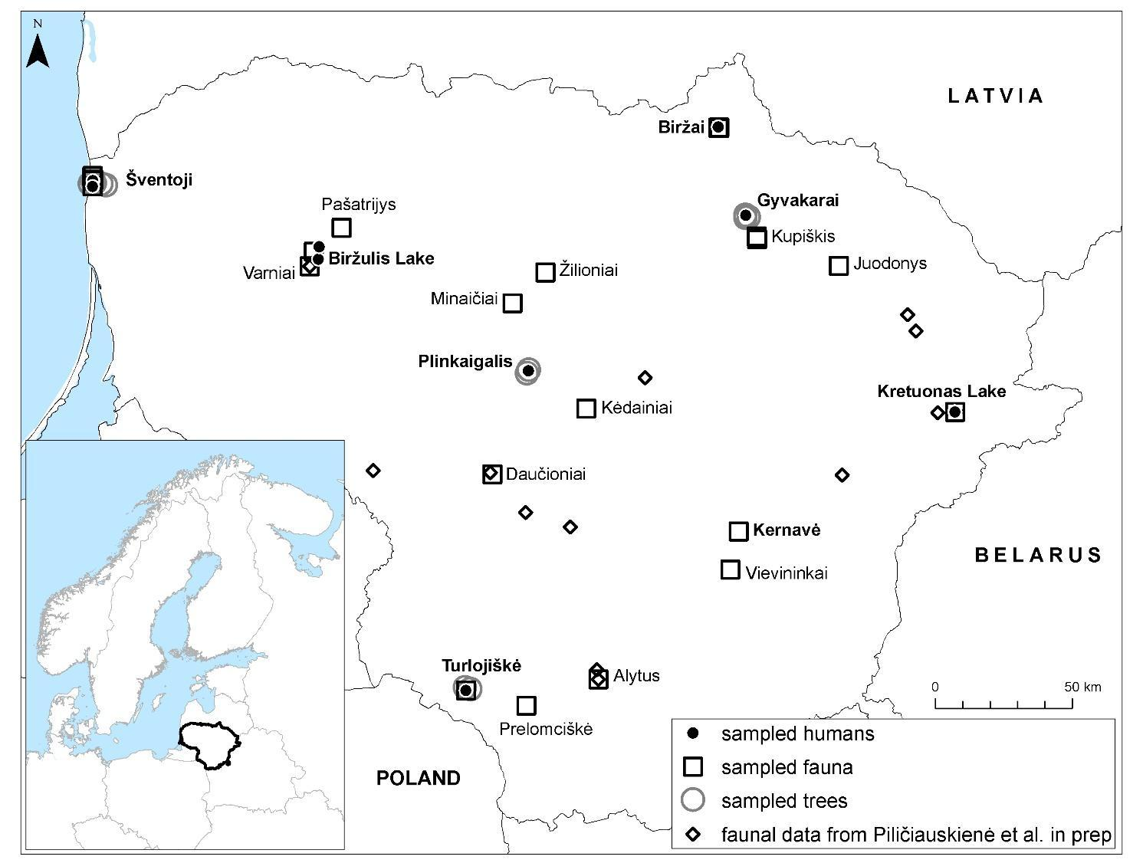
Fig. 1. Locations of human, animal and plant samples analysed in this study

II.2. Faunal remains
Modern day Lithuania is mainly covered by glacial deposits ( SI2). Since the variation of ⁸⁷Sr/⁸⁶Sr ratios in the bioavailable strontium, in the glacial deposits, was expected to be considerable and hard to predict, our strategy was to create ⁸⁷Sr/⁸⁶Sr baselines for every area from which human remains were sampled. In order to reconstruct the archaeological strontium isotope baselines and to avoid Sr “pollution” in modern water and soil, we only used archaeological faunal remains. Using fauna further enabled us to avoid extreme ⁸⁷Sr/⁸⁶Sr values, which are likely to be present in plants (Bentley 2006). Firstly, we identified zooarchaeological remains from the same sites from where we had sampled human remains. If absent, we identified animal bones from the nearest archaeological sites, most often situated up to 10 km from the human remains. We selected animals, especially small species with small home ranges, but this was not always possible. Therefore, many species of both wild and domestic taxa were incorporated into our study (Table 2). The chronology of the sampled animal remains was very wide, from the Subneolithic (e.g. Daktariškė 5) to the early modern period (e.g. Varniai). We decided to include animals predating the 19th century AD for the reconstruction of the local strontium baseline, since local fertilisers were in use until World War II. The only modern animal remains analysed in this study were the teeth of four small rodents from Minaičiai village.

No. | Site | Species | Dating | ⁸⁷Sr/⁸⁶Sr
1 | Alytus | Beaver (Castor fiber L.) | Iron Age | 0.712512
2 | Alytus | Beaver (Castor fiber L.) | Iron Age | 0.713009
3 | Alytus | Roe deer (Capreolus capreolus L.) | Iron Age | 0.714884
4 | Biržai | Sheep (Ovis aries L.) | medieval | 0.716664
5 | Biržai | Sheep (Ovis aries L.) | medieval | 0.715811
6 | Biržai | Sheep (Ovis aries L.) | medieval | 0.715327
7 | Biržai | Pig (Sus scrofa domesticus L.) | medieval | 0.713332
8 | Biržai | Sheep/goat (Ovis aries L./Capra hircus L.) | medieval | 0.715223
9 | Biržai | Sheep (Ovis aries L.) | medieval | 0.714752
10 | Biržai | Sheep/goat (Ovis aries L./Capra hircus L.) | medieval | 0.715311
11 | Biržai | Pig (Sus scrofa domesticus L.) | medieval | 0.712829
12 | Biržai | Pig (Sus scrofa domesticus L.) | medieval | 0.712579
13 | Daktariškė 5 | Beaver (Castor fiber L.) | Subneolithic-EBA | 0.714841
14 | Daktariškė 5 | Goat (Capra hircus L.) | EBA | 0.714250
15 | Daktariškė 5 | Sheep/goat (Ovis aries L./Capra hircus L.) | EBA | 0.713485
16 | Daktariškė 5 | Beaver (Castor fiber L.) | Subneolithic-EBA | 0.713292
17 | Daktariškė 5 | Red deer (Cervus elaphus L.) | Subneolithic-EBA | 0.714950
18 | Daučioniai | Marten (Martes martes L.) | Iron Age | 0.714397
19 | Daučioniai | Pig (Sus scrofa domesticus L.) | Iron Age | 0.715258
20 | Juodonys | Pig (Sus scrofa domesticus L.) | LBA-Iron Age | 0.715664
21 | Juodonys | Pig (Sus scrofa domesticus L.) | LBA-Iron Age | 0.715380
22 | Kėdainiai | Pig (Sus scrofa domesticus L.) | medieval | 0.712175
23 | Kėdainiai | Cattle (Bos taurus L.) | medieval | 0.715965
24 | Kernavė | Small rodent | medieval | 0.714902
25 | Kernavė | Hare (Lepus timidus/L. europaeus P.) | medieval | 0.717023
26 | Kernavė | Beaver (Castor fiber L.) | medieval | 0.714411
27 | Kernavė | Small rodent | medieval | 0.714252
28 | Kernavė | Small rodent | medieval | 0.715429
29 | Kernavė | Hare (Lepus timidus/L. europaeus P.) | medieval | 0.716675
30 | Kernavė | Hare (Lepus timidus/L. europaeus P.) | medieval | 0.716236
31 | Kretuonas 1C | Beaver (Castor fiber L.) | Neolithic | 0.714215
32 | Kretuonas 1C | Marten (Martes martes L.) | Neolithic | 0.714270
33 | Kretuonas 1C | Marten (Martes martes L.) | Neolithic | 0.714248
34 | Kretuonas 1C | Beaver (Castor fiber L.) | Neolithic | 0.714769
35 | Kretuonas 1D | Beaver (Castor fiber L.) | Neolithic | 0.716665
36 | Kretuonas 1D | Roe deer (Capreolus capreolus L.) | Neolithic | 0.714617
37 | Kretuonas 1D | Roe deer (Capreolus capreolus L.) | Neolithic | 0.713601
38 | Kretuonas 1D | Marten (Martes martes L.) | Neolithic | 0.715623
39 | Kretuonas 1D | Beaver (Castor fiber L.) | Neolithic | 0.714069
40 | Kupiškis | Cattle (Bos taurus L.) | medieval | 0.718725
41 | Kupiškis | Cattle (Bos taurus L.) | medieval | 0.718586
42 | Kupiškis | Cattle (Bos taurus L.) | medieval | 0.717330
43 | Kupiškis | Sheep/goat (Ovis aries L./Capra hircus L.) | medieval | 0.717161
44 | Kupiškis | Sheep/goat (Ovis aries L./Capra hircus L.) | medieval | 0.717412
45 | Kupiškis hillfort | Sheep/goat (Ovis aries L./Capra hircus L.) | Iron Age | 0.717587
46 | Kupiškis hillfort | Pig (Sus scrofa domesticus L.) | Iron Age | 0.717082
47 | Minaičiai | Small rodent | Modern | 0.710317
48 | Minaičiai | Small rodent | Modern | 0.707845
49 | Minaičiai | Small rodent | Modern | 0.707411
50 | Minaičiai | Small rodent | Modern | 0.709168
51 | Pašatrijys | Marten (Martes martes L.) | Iron Age | 0.717884
52 | Pašatrijys | Beaver (Castor fiber L.) | Iron Age | 0.714339
53 | Prelomciškė | Sheep/goat (Ovis aries L./Capra hircus L.) | Iron Age | 0.713690
54 | Prelomciškė | Pig (Sus scrofa domesticus L.) | Iron Age | 0.713655
55 | Šventoji 2 | Beaver (Castor fiber L.) | Subneolithic | 0.713814
56 | Šventoji 23 | Beaver (Castor fiber L.) | Subneolithic | 0.709482
57 | Šventoji 26 | Beaver (Castor fiber L.) | Subneolithic | 0.714338
58 | Šventoji 3 | Dog (Canis familiaris L.) | Subneolithic | 0.710034
59 | Šventoji 4 | Beaver (Castor fiber L.) | Subneolithic | 0.709612
60 | Šventoji 4 | Dog (Canis familiaris L.) | Subneolithic | 0.709989
61 | Šventoji 4 | Roe deer (Capreolus capreolus L.) | Subneolithic | 0.711298
62 | Šventoji 43 | Fox (Vulpes vulpes L.) | Subneolithic | 0.713400
63 | Šventoji 43 | Roe deer (Capreolus capreolus L.) | Subneolithic | 0.714821
64 | Turlojiškė | Water vole (Arvicola terrestris L.) | LBA | 0.712793
65 | Turlojiškė | Water vole (Arvicola terrestris L.) | LBA | 0.714260
66 | Turlojiškė | Water vole (Arvicola terrestris L.) | LBA | 0.712696
67 | Turlojiškė | Water vole (Arvicola terrestris L.) | LBA | 0.712657
68 | Varniai | Pig (Sus scrofa domesticus L.) | Early Modern | 0.714592
69 | Varniai | Pig (Sus scrofa domesticus L.) | Early Modern | 0.716614
70 | Vievininkai | Small rodent | Early Modern | 0.714941
71 | Vievininkai | Small rodent | Early Modern | 0.716168
72 | Žilioniai | Cattle (Bos taurus L.) | Iron Age | 0.715472
Table 2. ⁸⁷Sr/⁸⁶Sr measurements for animal teeth enamel via ID-TIMS. External precision (2σ) = 0.000013. EBA – Early Bronze Age, LBA – Late Bronze Age

II.3. Modern plants
When very few animals or when only a single species (e.g. water vole from Turlojiškė) was available for analysis or when the faunal remains came from a fairly large distance (ca. 10-40 km) from the analysed human remains (e.g. Gyvakarai and Plinkaigalis), we sampled leaves of seven young modern trees (lime, ash, alder, and aspen). Furthermore, we decided to use modern tree leaves in order to investigate the sea spray effect on the Baltic coast and for this we sampled leaves from five trees (aspen and birch) growing 50 to 6000 metres from five sites along the modern coastline. Young trees between 1.5-3.0 m in height were chosen in order to avoid deep rooted systems. Close to each sampled tree, the subsoil lithology was recorded by a soil core sampler. Since Sr-rich and easily weatherable carbonates can highly contribute to ⁸⁷Sr/⁸⁶Sr in soil, the presence of carbonates in the subsoil was evaluated by reacting sediments from ca. 0.5 m in depth with drops of diluted (10%) hydrochloric acid (Table 3).

No. | Sample | Site | Subsoil | Species, height | Lat. | Long. | ⁸⁷Sr/⁸⁶Sr
1 | SV1 | Šventoji | Fine-medium sand, non-calcareous | Aspen (Populus tremula), 1.5 m | 55.9877 | 21.1665 | 0.716509
2 | SV2 | Šventoji | Fine sand, non-calcareous | Aspen (Populus tremula), 1.5 m | 55.9915 | 21.1384 | 0.712911
3 | SV3 | Šventoji | Gravelly sand, non-calcareous | Birch (Betula pendula), 2 m | 55.9925 | 21.1005 | 0.713778
4 | SV4 | Šventoji | Fine-medium sand, non-calcareous | Birch (Betula pendula), 3 m | 55.9950 | 21.0901 | 0.708499
5 | SV5 | Šventoji | Fine-medium sand, non-calcareous | Aspen (Populus tremula), 1.5 m | 55.9900 | 21.0727 | 0.710816
6 | TRL1 | Turlojiškė | Clay, calcareous | Lime (Tilia cordata), 2 m | 54.3690 | 23.2983 | 0.713153
7 | TRL2 | Turlojiškė | Till, non-calcareous | Lime (Tilia cordata), 1.5 m | 54.3633 | 23.3303 | 0.714883
8 | PLIN1 | Plinkaigalis | Deluvial loam, calcareous | Ash (Fraxinus excelsior), 2 m | 55.4131 | 23.6475 | 0.71598
9 | PLIN2 | Plinkaigalis | Till, calcareous | Ash (Fraxinus excelsior), 2 m | 55.4026 | 23.6378 | 0.712086
10 | GVK1 | Gyvakarai | Till, calcareous | Alder (Alnus incana), 1.5 m | 55.9184 | 24.9120 | 0.711082
11 | GVK2 | Gyvakarai | Gravelly sand, non-calcareous | Alder (Alnus incana), 3 m | 55.9096 | 24.9113 | 0.715833
12 | GVK3 | Gyvakarai | Till, non-calcareous | Aspen (Populus tremula), 2 m | 55.9119 | 24.9304 | 0.715114
Table 3. ⁸⁷Sr/⁸⁶Sr measurements for modern tree leaves via ID-TIMS including species and subsoil descriptions. External precision (2σ) = 0.000013

II.4. Sources of bioavailable Sr
The territory of Lithuania has experienced numerous glaciations, as such it is covered with a sequence of Quaternary deposits, mainly of glacial origin, the thicknesses of which reach more than 200 m in the highlands, but in places in the lowlands they are negligible (Aleksa 2007; Gorlach et al. 2015). In addition, in numerous river outcrops pre-Quaternary rocks are exposed. In many regions, the surface is covered by glacial till, while patches of glaciofluvial sand and gravel or fine glaciolacustrine sediments are also common. Larger areas of sandy outwash and clayey glaciolacustrine sediments are also present. Glacial deposits contain Precambrian igneous and metamorphic rocks, transported by ice sheets from Scandinavia and pre-Quaternary sedimentary rocks eroded by glaciers more locally, mostly including Silurian, Devonian, Permian or Cretaceous carbonates ( SI2). The proportion of Precambrian and carbonate rock components, however, varies. According to some estimates, deposits transported from Scandinavia may compose ca. 25% of the glacial till in Lithuania (Kudaba 1983).

It may be assumed that three sources contributed to the formation of the bioavailable Sr in Lithuania: (i) high radiogenic Sr from Precambrian rock debris transported from Scandinavia by the ice sheets, (ii) low radiogenic Sr from marine carbonates, and (iii) low radiogenic Sr from the Baltic Sea which may have been incorporated into living organisms via marine foods or may have been introduced into soils of the coastal zone via the sea spray effect. In central and northern Sweden, the Proterozoic igneous and metamorphic rocks have ⁸⁷Sr/⁸⁶Sr values between 0.7200 and 0.7400 as demonstrated from measurements of surface water and archaeological animals (Bäckström and Price 2016; Löfvendahl et al. 1990; Price et al. 2018). Since marine carbonate rocks inherit their ⁸⁷Sr/⁸⁶Sr from seawater, they also contain more Sr and weather faster than other rock types (Palmer and Edmond 1992). Cretaceous marine carbonates have low ⁸⁷Sr/⁸⁶Sr in the order of 0.7073-0.7078 (McArthur et al. 2001; Veizer et al. 1997), whereas Silurian, Ordovician, Devonian marine carbonate rocks have ⁸⁷Sr/⁸⁶Sr between 0.7078 and 0.7093 (Cramer et al. 2011; Diener et al. 1996; Edwards et al. 2015). Foods from marine environments have the same isotopic values as seawater. Although surface water near Gotland in the Baltic Sea yielded a ⁸⁷Sr/⁸⁶Sr value of 0.7093 (Andersson et al. 1992), values vary throughout the Baltic Sea due to the different catchment areas of all the rivers that enter it (Åberg and Wickman 1987; Löfvendahl et al. 1990). Significant consumption of marine fish or seals may shift consumers’ ⁸⁷Sr/⁸⁶Sr towards the value of seawater (see Eriksson et al. 2018; Lahtinen et al. 2021). However, due to the process of biopurification, marine dietary components contribute up to five times less Sr to the human diet compared to terrestrial ones (Fornander et al. 2015). Sea spray can have a similar effect on ⁸⁷Sr/⁸⁶Sr in humans since marine radiogenic Sr can then be mixed with the ⁸⁷Sr/⁸⁶Sr found in terrestrial settings. In a study by Snoeck (2014), a significant impact of the sea spray effect in ⁸⁷Sr/⁸⁶Sr values was reported from up to 200 metres from the coastline (see also Alonzi et al. 2020). Considering that most of the areas analysed in this study are located between 80 and 320 km away from the Baltic Sea and long-distance transport of large quantities of seafood is highly unlikely during the Stone and Bronze Ages, it may be assumed that a sea-derived Sr would only influence one of the areas in this study, Šventoji (Fig. 1).

II.5. Regions studied
For each of the seven study regions a Quaternary geological map with the locations of the sampled human, faunal and modern tree samples is given ( SI3). The first region, Šventoji, is located on the Baltic Sea coast in northwestern Lithuania. Here, Subneolithic dwellings and fishing sites are found on a sandy Littorina Sea terrace, on the banks as well as in the middle of the former lagoonal lake. Marine and Baltic Ice Lake sand and gravel cover large areas and stretch 5 km inland from the modern coastline. Further inland, glacial till rises to the surface ( SI3:A). The second region includes Biržulis Lake with the Donkalnis and Spiginas Stone Age cemeteries that are located on islands in the lake. The lake is situated in the Žemaičiai Upland and surrounded by morainic hills composed of till in the south and east, and with glaciofluvial landforms in the northwest (SI3: B). The third region includes the Plinkaigalis cemetery that is situated in the Middle Lithuanian Lowland, on the bank of the Šušvė River. It is surrounded by a rather extensive flat plain of glacial till with a narrow belt of an undulating surface stretching from south to north. However, large patches of glaciofluvial sand and gravel and fine proglacial lake sediments occur further to the west and south (SI3: C). The fourth region includes the Turlojiškė Bronze Age site and is situated in the Dzūkų Upland, in the middle of a former lake. The present-day peat bog is on a slightly undulated glaciofluvial and glaciolacustrine sediment surface, surrounded by ice-marginal hills composed of glacial till (SI3: D). The fifth, Biržai, is a city in northern Lithuania at the mouth of the Apaščia River at the human-made Širvėna Lake. The surroundings are part of the Pasvalys Plain with a surface mainly covered by glacial till. However, large patches of glaciolacustrine sand exist only 5-10 km to the north and northeast (SI3: E). The sixth region, Gyvakarai, is situated on the small Žvikė stream that flows through the Pasvalys Plain. Glacial till dominates the plain surface covered by patches of glaciofluvial and glaciolacustrine sediments (SI3: F). The seventh and final region, Kretuonas Lake, is situated on the border of a large glaciofluvial undulating plain to the west with a hilly ice-marginal landscape, mainly composed of glacial till, to the east. A rather large area to the southeast right beside the modern lake is covered by sand deposited in the proglacial lake of the last glaciation (SI3: G).

II.6. Methods
⁸⁷Sr/⁸⁶Sr analysis was carried at the Vegacenter at the Swedish Museum of Natural History in Stockholm by isotope dilution-thermal ionisation mass spectrometry (ID-TIMS) and laser ablation-multi collector-inductively coupled plasma-mass spectrometry (LA-MC-ICP-MS). The ⁸⁷Sr/⁸⁶Sr values are presented at four decimal places throughout this study.

II.6.1. Isotope dilution-thermal ionisation mass spectrometry
ID-TIMS was used for bulk analysis of animal teeth and tree leaves in this study. The tooth samples were washed in an ultrasonic bath; first in ultra-pure water and then in ethanol. A Dremel tool was used for polishing, after which a piece of the polished section was used for strontium extraction, followed by further washing in ultrapure water and ethanol. The extracted samples were treated with 0.1M acetic acid for 4 hours at room temperature (Balasse and Ambrose 2002), followed by an ultra-pure water wash and drying, weighing and dissolution in 8M nitric acid in Savillex beakers on a hot plate (95°C).

The dried and homogenised plant material was weighed and, similar to the teeth, dissolved in Savillex beakers. Nitric acid (8M) and hydrogen peroxide were repeatedly added for oxidation and dissolution. The dried, dissolved samples were converted to chloride form by addition of 6M HCl. After drying, both types of samples were re-dissolved in 6M HCl and purified using a Sr specific ion exchange procedure (Delmonte et al. 2008).

The purified samples were mixed with a silicotungstic ionisation enhancer, loaded on Re single filaments and analysed using a Thermo Scientific Triton thermal ionisation mass spectrometer (TIMS). Two hundred 8 sec. integrations were recorded in multi-collector static mode, applying rotating gain compensation. Measured ⁸⁷Sr intensities were corrected for Rb interference using ⁸⁷Rb/⁸⁵Rb = 0.38600 and ratios were reduced using the exponential fractionation law and ⁸⁸Sr/⁸⁶Sr = 8.375209. The isotope data were normalised to the NBS 987 Sr isotope reference, repeated analyses of which during the course of the analytical sessions for animal and plant samples yielded an external reproducibility of 17 ppm (n = 12) and 18 ppm (n = 20) respectively.

II.6.2. Laser ablation-multi collector-inductively coupled plasma-mass spectrometry
LA-MC-ICP-MS was used for the human teeth in this study. In situ ⁸⁷Sr/⁸⁶Sr analysis was conducted on tooth samples using a NWR193 excimer laser ablation system (Electro Scientific Industries) coupled to a Nu Plasma II multi-collector ICP mass spectrometer (Nu Instruments Ltd.) at the Vegacenter, Swedish Museum of Natural History, Stockholm. The instrument operating conditions are listed in SI1: Table 1 and the isotope data for each ablated tooth are given in SI1: Tables 3-42. The method follows the procedures outlined in Boethius et al. (2021) and Glykou et al. (2018).

Ablations were made on the outer surface of the tooth enamel using line-scans with a 130 μm spot size starting at the tip of the tooth and moving down towards the enamel–dentine junction. The number of ablation lines per tooth ranged from 9 to 20, depending on the size of the tooth. Prior to each ablation, the tooth was pre-ablated using a laser spot size of 150 μm to remove potential surface contamination, which could be caused by its depositional soil environment. The results show no increase in either rare earth elements (REE) or Rb, compared to the reference materials, which indicates pre-ablation was successful. Analyses were also monitored for potential sampling of dentine, which may occur when the enamel layer is thin. Dentine has a lower density and a more porous structure than enamel and can be more easily contaminated. This can lead to anomalous divergence in ⁸⁷Rb/⁸⁶Sr, but this was not observed for any analyses.

Possible isobaric interferences were corrected by subtracting a gas blank (84Kr) and by peak stripping (e.g., doubly charged REE, Ca-dimers/argides, 87Rb; cf. Glykou et al. 2018). A polyatomic interference on m/z 87 has also been reported (Horstwood et al. 2008) and is described as (Ca/Ar)31P16O+. This interference has been reduced by a thorough low oxide tuning of the gases (Willmes et al. 2016). To verify successful removal of all interferences, two reference materials (RM) with known Sr concentrations and ratios were repeatedly analysed throughout analytical sessions (SI1:Table 2). A spine from a velvet belly lantern shark (Etmopterus spinax) was used as the primary RM and a tooth from a mountain hare (Lepus timidus) was used as the secondary RM. The analyses on the shark spine yielded a ⁸⁷Sr/⁸⁶Sr of 0.70919 ± 0.00034 (2SD, n = 103), which agrees well with the value of seawater of 0.709179 ± 0.000002 (Mokadem et al. 2015). The hare tooth yielded a ⁸⁷Sr/⁸⁶Sr of 0.71002 ± 0.00017 (2SD, n = 22). This is in agreement with the value determined by TIMS (0.709988 ± 0.000015; Triton, Thermo Scientific) at the Swedish Museum of Natural History.

III. Results
III.1. ⁸⁷Sr/⁸⁶Sr measurements and outliers
LA-ICP-MS measurements on 40 human teeth are presented in Table 1 and Supplementary Information SI1, ID-TIMS measurements on 72 animal teeth enamel samples in Table 2, and ID-TIMS measurements on leaves of 12 modern trees in Table 3. Before reconstruction of local ⁸⁷Sr/⁸⁶Sr baselines and a Lithuanian isoscape, two outlier measurements were identified and not used for further interpretations. Among the 72 animal teeth analysed for our project, a pig from Kėdainiai (0.7122) was considered to be an outlier due to an unusually low ⁸⁷Sr/⁸⁶Sr ratio for central Lithuania. It could have been transported to the medieval town of Kėdainiai from a distant area, e.g. southwestern or coastal Lithuania. A beaver, from the Kretuonas 1C Neolithic settlement, was considered a second outlier (Piličiauskienė et al. 2022). The notably higher isotopic ratio of the beaver (0.7201) compared to the other animals from the Lake Kretuonas area (0.7136-0.7167) may indicate that either non-local animals had been sampled or it represents a localised anomaly. The analysed beaver tooth was removed from an isolated mandible found in the refuse layer and may have been transported to the site from elsewhere. Animal teeth are commonly used as pendants in this area from this time period (Girininkas and Daugnora 2015).

III.2. Local ⁸⁷Sr/⁸⁶Sr baselines
In order to identify non-local humans, we reconstructed ⁸⁷Sr/⁸⁶Sr baselines, based on the mean value +2 SD of archaeological fauna, for the seven regions where human remains were sampled from (Fig. 2). The robustness of those baselines is, however, greatly variable because of the different number and species of animals analysed, as well as the different distances between the studied sites containing animal and human remains. At Biržai, human remains are located up to 0.5 km from sites from which the animal remains originated, at Turlojiškė up to 1 km, at Šventoji up 4 km, at Kretuonas up to 6.3 km, at Biržulis up to 9 km, at Gyvakarai up to 10 km, and at Plinkaigalis up to 40 km ( SI3).

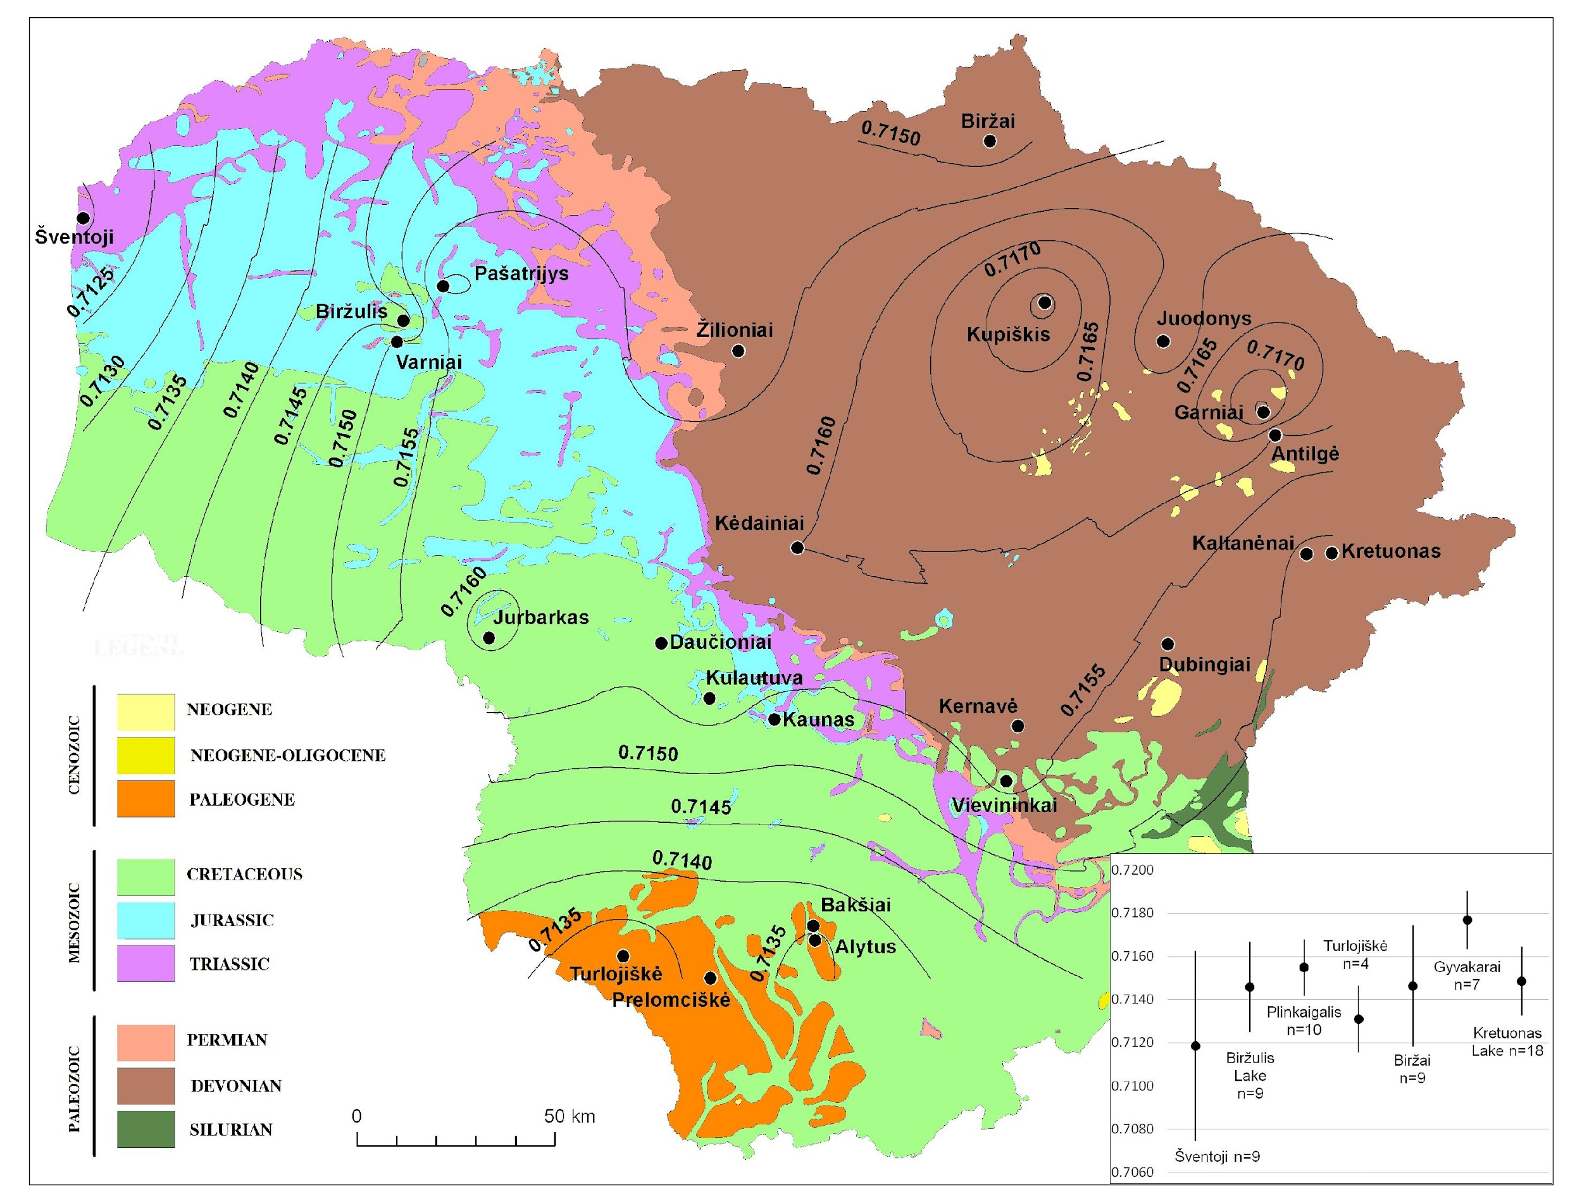
Fig. 2. ⁸⁷Sr/⁸⁶Sr isoscape in Lithuania mapped onto a modified Pre-Quaternary geological map 1:200 000 after the Lithuanian Geological Survey (https://www.lgt.lt/epaslaugos/elpaslauga.xhtml) and ⁸⁷Sr/⁸⁶Sr baselines based on the mean value + 2 SD of archaeological fauna of the seven regions where human remains were sampled from

III.2. ⁸⁷Sr/⁸⁶Sr isoscape in Lithuania
For the reconstruction of the ⁸⁷Sr/⁸⁶Sr isoscape in Lithuania, we averaged ⁸⁷Sr/⁸⁶Sr ratios of archaeological fauna at each of the 24 localities. In doing so we grouped data from several sites only in cases when they were situated up to 4 km one from another. Then, the obtained means were used for interpolation of the isoscape using the Kriging method (Cressie 1991). The isoscape revealed several geographical trends in the variability of ⁸⁷Sr/⁸⁶Sr in the biosphere (Fig. 2). For instance, Garniai and Kupiškis, both situated in northeastern Lithuania, demonstrate the highest faunal averaged ⁸⁷Sr/⁸⁶Sr ratios (0.7177) among all of the analysed sites (Fig. 2). It can be assumed that the glacial deposits in this area contain more Precambrian rocks debris with high radiogenic Sr. In the central part of the country, the mean ⁸⁷Sr/⁸⁶Sr ratios of archaeological fauna vary between ca. 0.7142-0.7161. Southern Lithuanian appeared to have notably low bioavailable ⁸⁷Sr/⁸⁶Sr in the order of ca. 0.7131-0.7137 (Fig. 2). In southwestern Lithuania, calcareous soils are common in which carbonates are found mostly as chalk debris, rather than limestone or dolomite crumbs or boulders. Cretaceous chalk from surface glacial and proglacial deposits may lower the ⁸⁷Sr/⁸⁶Sr ratios. However, the impact of in situ pre-Quaternary carbonates on the bioavailable Sr was negligible. For instance, at Biržai and Kupiškis, where Devonian dolomite and limestone are covered by only ca. 1-20 m thick glacial deposits, the mean ⁸⁷Sr/⁸⁶Sr ratios of archaeological fauna appeared to be higher (0.7146 ± 0.0014 and 0.7177 ± 0.0007 respectively) to that of many other areas in Lithuania with much thicker cover of Quaternary deposits ( SI4).

However, the lowest bioavailable ⁸⁷Sr/⁸⁶Sr was recorded at Šventoji on the Baltic coast. The Šventoji animals were sampled at five archaeological sites situated at 800-1100 metres from the modern coastline ( SI:3A) and they have unusually variable ⁸⁷Sr/⁸⁶Sr within the range 0.7095-0.7148 and a mean value of 0.7119 (Fig. 2). Some of ⁸⁷Sr/⁸⁶Sr values are close to the ⁸⁷Sr/⁸⁶Sr ratio of Baltic Sea water (0.7092-0.7093) measured between Gotland and the Latvian coast (Andersson et al. 1992). Therefore, we hypothesised, that bioavailable ⁸⁷Sr/⁸⁶Sr at Šventoji was influenced by the sea spray effect (see Alonzi et al. 2020; Snoeck 2014) and that animals with lower ⁸⁷Sr/⁸⁶Sr lived closer to the coast than animals with higher ⁸⁷Sr/⁸⁶Sr. This has further been confirmed by ⁸⁷Sr/⁸⁶Sr in modern tree leaves (Table 3 ). At the Baltic coast, we found a positive correlation between distance from the coast and high radiogenic Sr in the leaves of young modern trees (Fig. 3). It appeared that the sea spray effect is very profound, in a very flat landscape with a similar geology, up to 1.5 km from the coastline, and might still have an impact up to 5 km from the coastline. It has, however, no influence on the biologically available Sr further inland.

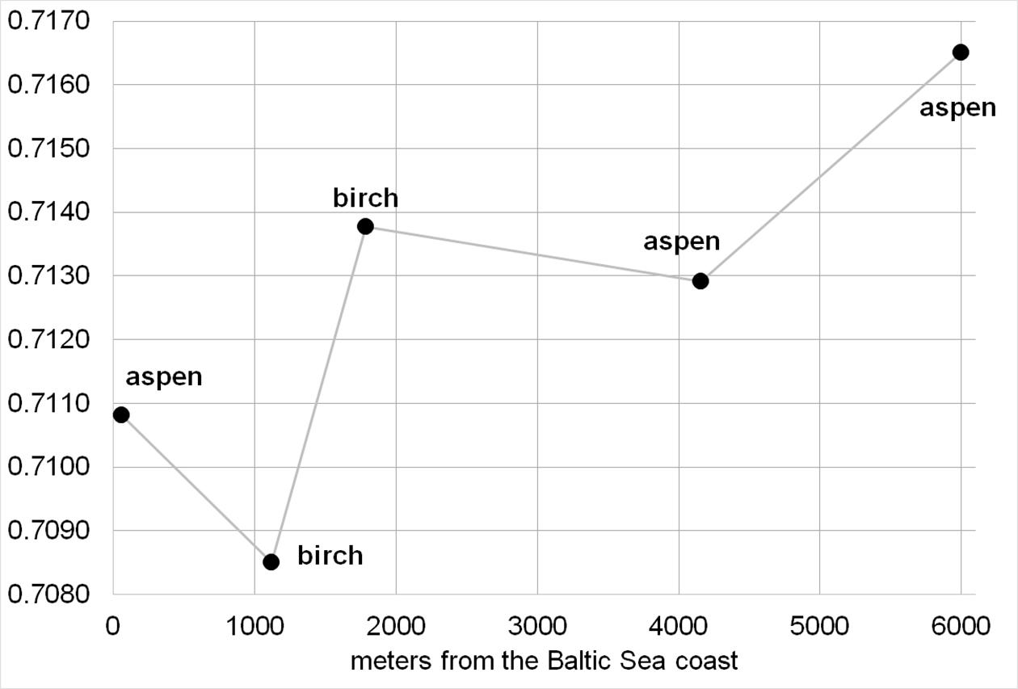
Fig. 3. ⁸⁷Sr/⁸⁶Sr in modern trees leaves at Šventoji in respect to their distance to the Baltic Sea coast

IV. Discussion
IV.1. Modern samples for palaeomobility studies. Are they reliable?
In 2019, Hoogewerff et al. published ⁸⁷Sr/⁸⁶Sr ratios obtained from grazing and agricultural soils across a large part of Europe. The study contained measurements from 17 locations in Lithuania, 10 in Latvia, 14 in Estonia, 64 in Poland and 94 in Ukraine. In these countries ⁸⁷Sr/⁸⁶Sr values of archaeological fauna were either absent or very few, therefore, Hoogewerff et al.’s data might be useful for reconstructing local baselines in Lithuania. To do this it is essential to know whether ⁸⁷Sr/⁸⁶Sr ratios of modern soils are significantly altered by any modern agents. Therefore, we compared ⁸⁷Sr/⁸⁶Sr values in modern soils and archaeological animals. Firstly, we interpolated Lithuanian soil data by the Natural Neighbour method (Cressie 1991). Then, we extracted ⁸⁷Sr/⁸⁶Sr for each locality from which the animal remains were analysed for our study. Finally we plotted the interpolated soil values against measured faunal values ( SI5). From this plot a statistically significant (a paired-samples t-test, t = 17.71, df = 23, p < 0.001) offset between ⁸⁷Sr/⁸⁶Sr in modern soils and archaeological fauna is evident, with the former being lower by 0.0081 ± 0.0022. In addition, four small modern rodents from Minaičiai gave a mean ⁸⁷Sr/⁸⁶Sr value of 0.7087 which is very close to the soil but inconsistent with the archaeological animals ⁸⁷Sr/⁸⁶Sr at any of the closest localities, e.g. Žilioniai (0.7152), Kėdainiai (0.7160) and Pašatrijys (0.7161) (SI5 ). Therefore it seems that ⁸⁷Sr/⁸⁶Sr in both soils and modern animals is affected by non-local strontium. Chemical fertilisers may be the reason for this (see Böhlke and Horan 2000). In Lithuania non-natural fertilisers have been extensively used after World War II. In addition, polluted precipitation may also introduce low radiogenic Sr into modern soils and animals. It has been estimated that in some cases precipitation may supply up to 50-75% of the Sr available for plants (Graustein and Armstrong 1983; Sanusi et al. 1995).

Furthermore, we also found that the ⁸⁷Sr/⁸⁶Sr ratios of modern plants (5/12) were incompatible with those of archaeological animals. The uptake of strontium by vegetation is dependent on many factors including fungi, root-depth and taxon (Dijkstra et al. 2003; Isermann 1981). Local anomalies in the geological background may also greatly influence the ⁸⁷Sr/⁸⁶Sr in plants, for instance these may be caused by clastic carbonate components within glacial deposits. For example, at Gyvakarai, 2.0-3.0 m high alder and aspen trees, have only slightly lower ratios (0.7158 and 0.7151 respectively) compared to the local baseline based on archaeological fauna (0.7163-0.7190), while another 1.5 m high aspen had a much lower ⁸⁷Sr/⁸⁶Sr value of 0.7111 (Fig. 4). This aspen with the lowest ⁸⁷Sr/⁸⁶Sr value was growing on calcareous subsoil, whilst the remaining two were growing on non-calcareous subsoil (Table 3). At Turlojiškė, from two young 1.5-2.0 m high lime trees that were growing 2.2 km apart, one had a ⁸⁷Sr/⁸⁶Sr value of 0.7131, which is within the local baseline (0.7116-7147), whilst the other had a higher ⁸⁷Sr/⁸⁶Sr value of 0.7149 (Fig. 5). Once again, the tree growing on calcareous clay had a lower ⁸⁷Sr/⁸⁶Sr value than the one growing on non-calcareous clay loam (Table 3). At Plinkaigalis, two ash trees that were both 2.0 m high and growing on calcareous subsoil showed very distant ⁸⁷Sr/⁸⁶Sr values of 0.7160 and 0.7121. While the higher value is within the local baseline based on archaeological fauna (0.7142-0.7168), the other is much lower (Fig. 4). In this case, a more thorough analysis of the carbonate content in surface deposits is required in order to explain the anomalously low radiogenic value. Finally, the best fit between modern plant and archaeological animal ratios was found in the coastal area at Šventoji (Fig. 6). However, this could be due to the sea spray effect, which is affecting the area today as well as in prehistory.

To summarise, we identified lower ⁸⁷Sr/⁸⁶Sr in modern soils and animals and in some cases also modern plant samples compared to the archaeological fauna throughout Lithuania, however, the reasons for this are far from clear. Based on these offsets we advise caution when using modern samples for the reconstruction of local baselines and isoscapes in Lithuania.

Fig. 4. ⁸⁷Sr/⁸⁶Sr intra-tooth variation of the human individuals from the Biržai, Plinkaigalis and Gyvakarai CWC graves plotted onto a local baselines, which were constructed from data obtained from archaeological animals (shaded in grey; at 2 SD). ID-TIMS measurements of modern tree leaves are denoted by black triangles
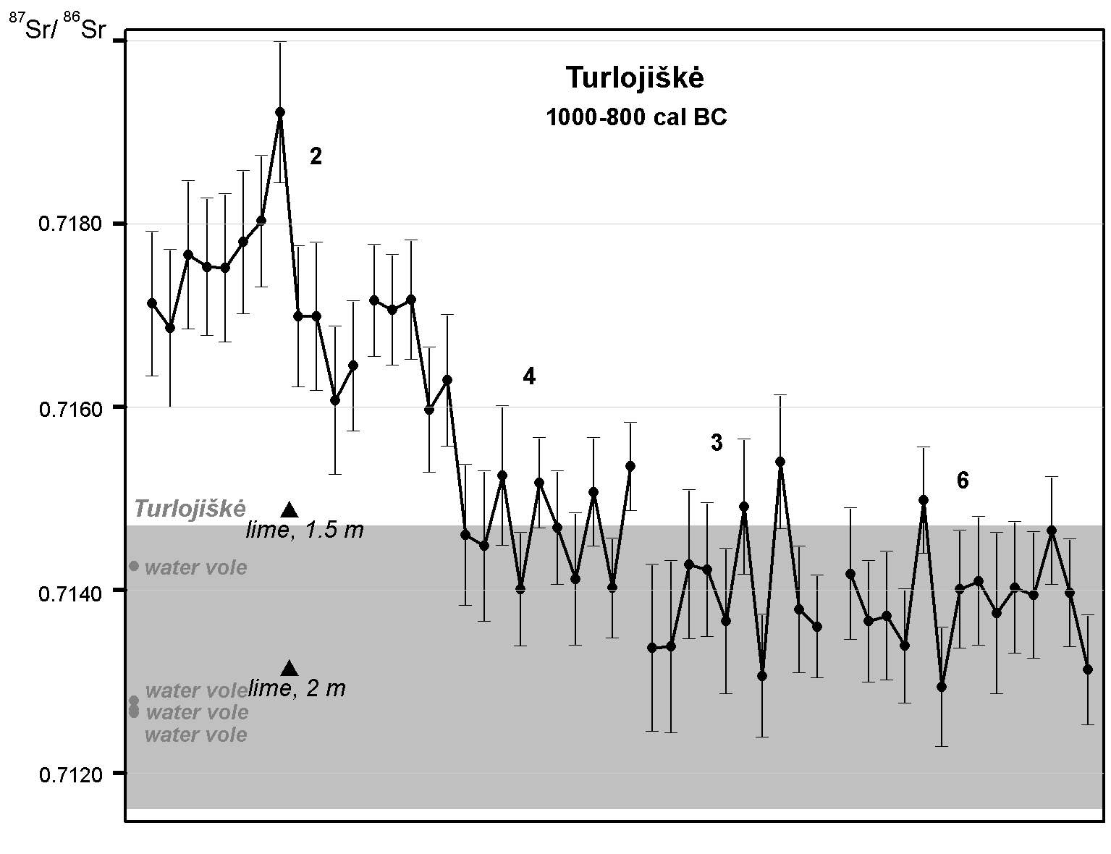
Fig. 5. ⁸⁷Sr/⁸⁶Sr intra-tooth variation of the four human individuals from the Turlojiškė Late Bronze wetland deposition plotted onto a local baseline, which was constructed from data obtained from archaeological animals (shaded in grey; at 2 SD). ID-TIMS measurements of modern tree leaves are denoted by black triangles

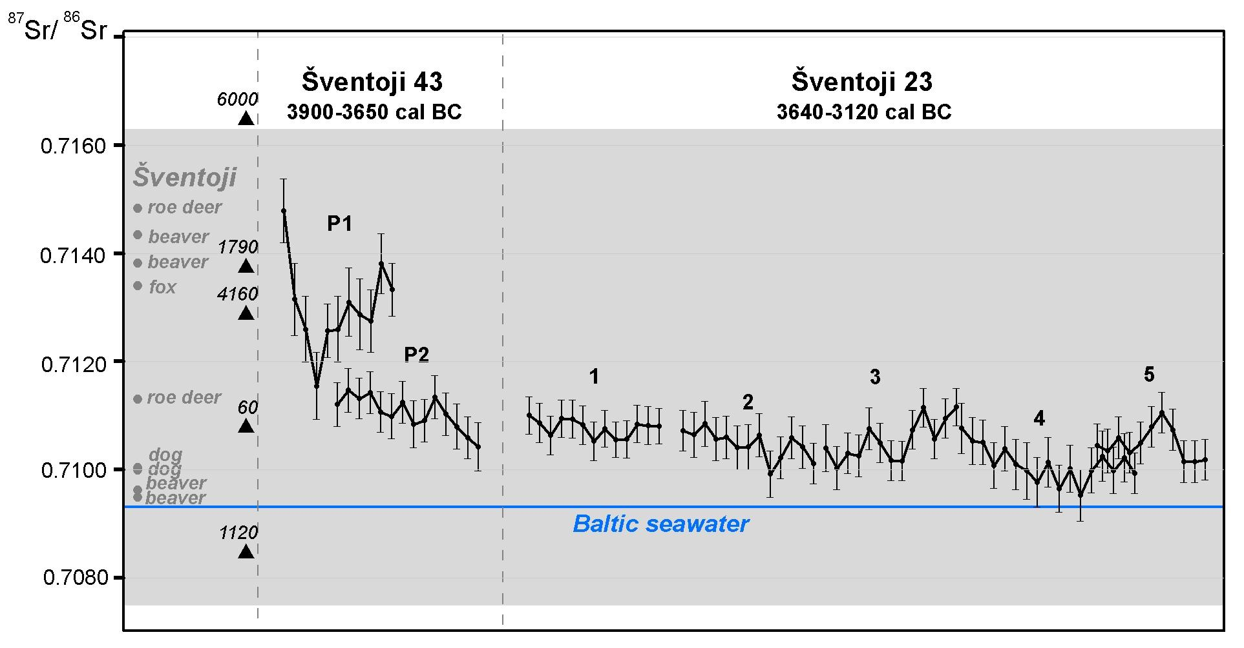
Fig. 6. ⁸⁷Sr/⁸⁶Sr intra-tooth variation of seven human individuals from the Šventoji Subneolithic dwelling sites plotted onto a local baseline, which was constructed from data obtained from archaeological animals (shaded in grey; at 2 SD). ID-TIMS measurements of modern tree leaves are denoted by black triangles while accompanying numbers show their distance to the Baltic coastline

IV. 1. Mobility patterns
We compiled ⁸⁷Sr/⁸⁶Sr intra-tooth variation curves from multiple ⁸⁷Sr/⁸⁶Sr measurements for each human tooth and plotted them onto local baselines reconstructed from ⁸⁷Sr/⁸⁶Sr ratios (2 SD) of archaeological fauna (Fig. 4-9). According to radiographic and histological studies, enamel of the permanent M1 tooth forms at the age of 0-3 years, 3-6 years for M2, 8-11 years for M3, 2-6 years for premolars, and prior to birth and up to 0.5 years for dM1 (Massler et al. 1941; Reid and Dean 2006). Since we preferentially sampled permanent M1 and M2 teeth from humans, the majority of the intra-tooth variation curves reflect the chronological sequence during early childhood (0-6 years). Despite this, there were several exceptions, the permanent M3 teeth from Šventoji 23 ‘grave’ 1 and Donkalnis grave 3, both of which mineralised during late childhood (8-11 years), and the deciduous dM1 from Šventoji 43, which mineralised prior to birth and during early infancy.

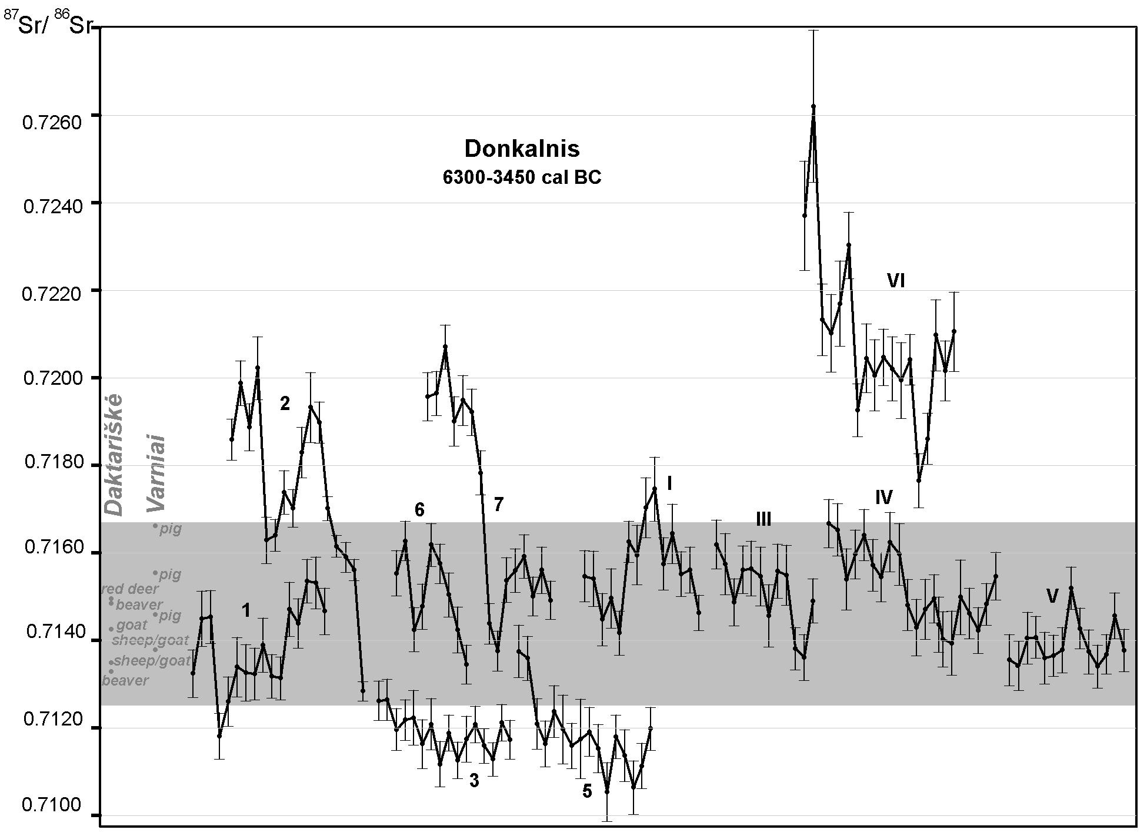
Fig. 7. ⁸⁷Sr/⁸⁶Sr intra-tooth variation for 11 human individuals from the Donkalnis Mesolithic-Subneolithic cemetery plotted onto a local baseline, which was constructed from data obtained from archaeological animals (shaded in grey; at 2 SD)

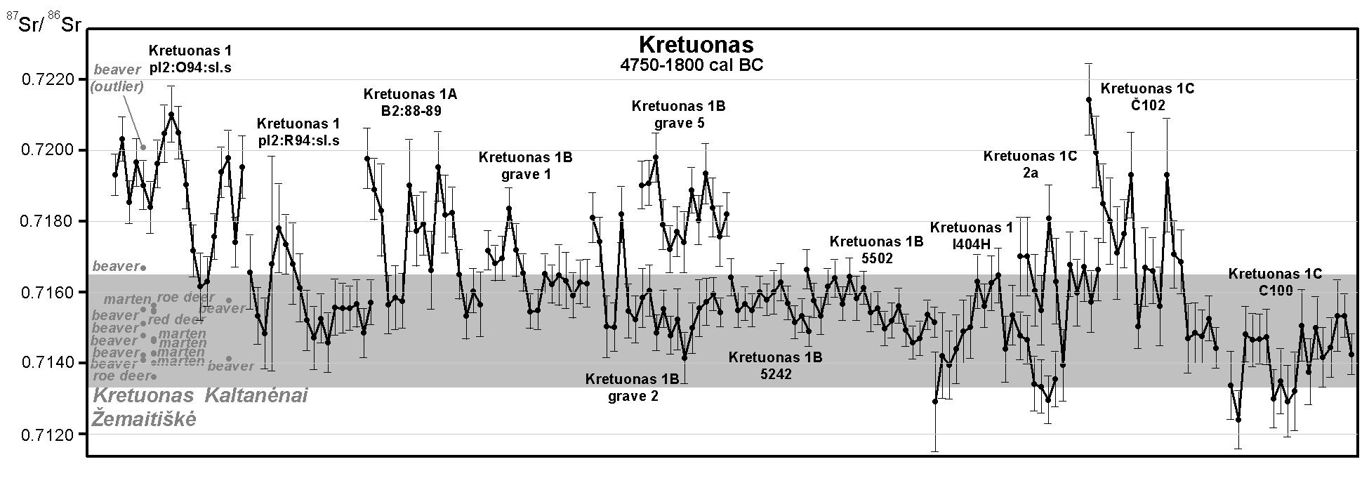
Fig. 8. ⁸⁷Sr/⁸⁶Sr intra-tooth variation for 12 human individuals from the Kretuonas Subneolithic-Neolithic site plotted onto a local baseline, which was constructed from data obtained from archaeological animals (shaded in grey; at 2 SD)

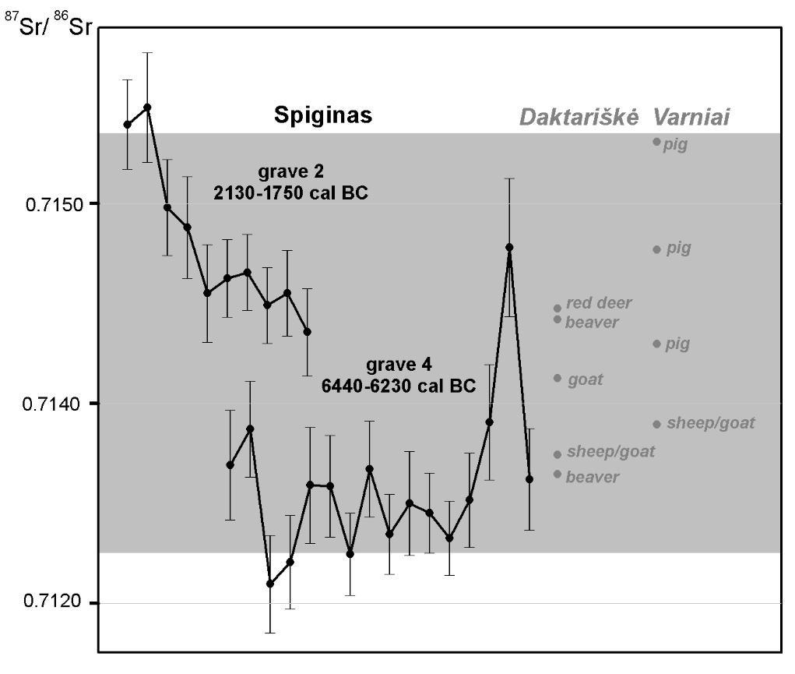
Fig. 9. ⁸⁷Sr/⁸⁶Sr intra-tooth variation for two individuals from the Spiginas Mesolithic-Neolithic cemetery plotted onto a local baseline, which was constructed from data obtained from archaeological animals (shaded in grey; 2 SD)

On the basis of ⁸⁷Sr/⁸⁶Sr intra-tooth variation curves and SD values, which were calculated for each individual from multiple ⁸⁷Sr/⁸⁶Sr measurements on the same tooth, we grouped human teeth measurements into four clusters termed here as local sedentary, local relocated, semi-local and non-local. Under local sedentary, we assume individuals whose ⁸⁷Sr/⁸⁶Sr intra-tooth variation range does not exceed the local baseline and demonstrates low SD up to ±0.00035, i.e. individuals that are likely to have been born locally and did not leave the region during mineralisation of the tooth enamel. Individuals bearing local ⁸⁷Sr/⁸⁶Sr but exhibiting significant ⁸⁷Sr/⁸⁶Sr intra-tooth variation (SD > ±0.00035) were grouped together as local relocated. They were most likely locally born but changed their place of residence within an analysed region or moved between several areas with overlapping bioavailable ⁸⁷Sr/⁸⁶Sr. Alternatively, high intra-tooth variation inside of the local baseline range may indicate dietary shifts to seasonally available resources (e.g. migratory fish or waterfowl) or changes in the place of foraging, fishing or hunting without relocation of a whole group. Under the non-local category, we placed individuals whose all or at least two first measurements are outside of the local baseline. They had to be born outside the region of death. Some of these people had already moved into the local region during mineralisation of the analysed tooth throughout their childhood (e.g. Kretuonas 1B grave 2) but some did so later as is shown by their ⁸⁷Sr/⁸⁶Sr intra-tooth variation curves. The final group is semi-locals. In this case ⁸⁷Sr/⁸⁶Sr in the oldest part of the enamel (tooth crown) is within the local baseline. However, subsequent measurements exceed the local ⁸⁷Sr/⁸⁶Sr range. This implies that these individuals were most likely born locally but during childhood they changed their place of residence, entering an area with different bioavailable ⁸⁷Sr/⁸⁶Sr values.

Fig. 10. ⁸⁷Sr/⁸⁶Sr intra-tooth variation SDs estimated for different prehistoric periods and mobility patterns revealed by strontium isotope ratios in Lithuania.
* Four individuals supposedly dating to the Subneolithic-Neolithic were attributed to the Subneolithic here.
** Data for the Roman and Migration periods (ca. 1-600 cal AD) of the Iron Age are from Kurila et al. (in prep)

In order to reveal trends in mobility patterns during the Stone and Bronze Ages, we estimated the percentages of local sedentary, local relocated, semi-local and non-local ⁸⁷Sr/⁸⁶Sr intra-tooth values for the Late Mesolithic (ca. 7000-5000 cal BC), the Subneolithic (ca. 5000-2900 cal BC), the Neolithic (ca. 2900-1800 cal BC), and the Bronze Age (ca. 1800-500 cal BC) periods (Fig. 10 ). Not surprisingly, likely locally born individuals, classified as local relocated, local sedentary or semi-local, made the core of the population (50-75%) during all periods. Non-locals made up a substantial part (25-50%) of the Stone and Bronze Age individuals. An increase of non-locals during the Subneolithic (33%) and the Bronze Age (50%) periods compared to the Mesolithic (25%) and the Neolithic (25%) periods was present. However, this overrepresentation may be due to the very low number of sampled individuals from the Mesolithic, Neolithic and Bronze Age periods and also due to the very likely sacrificial nature of the Turlojiškė Late Bronze Age site. We should also wish to point out that in many areas of Lithuania the bioavailable ⁸⁷Sr/⁸⁶Sr values overlap at 0.7140-0.7160 (Fig. 2). This range could also be expected for neighbouring countries with similar geology. Furthermore, it has been estimated that more than 90% of the terrestrial samples throughout the world have ⁸⁷Sr/⁸⁶Sr that fall within the range of 0.7060 and 0.7200 (Bataille et al. 2020). Overlapping baselines across large areas reduce the possibility of identifying non-locals via ⁸⁷Sr/⁸⁶Sr analysis. Therefore, we should consider 25-50% non-locals as a minimum value.

Profound, and in many cases cyclic, variation in ⁸⁷Sr/⁸⁶Sr intra-tooth values in an individual is classified by us as a local relocated or semi-local individual, suggesting seasonal mobility to be a common phenomenon. This was identified in the Mesolithic, Subneolithic and Neolithic individuals, and perhaps some of the Bronze Age individuals. This finding fits well with the mixed-type economy recently proposed for the southeastern Baltic population during the Neolithic and the Early Bronze periods, based on carbon and nitrogen stable isotope data, organic residue analysis of ceramic vessels, and recent macrobotanical analyses (Piličiauskas et al. 2017a, 2020, 2021; Robson et al. 2019). It seems that mobile stockbreeding and extensive barley farming was supplemented by the continued exploitation of wild resources for some time. Strontium isotopic data from Turlojiškė argues for the continuation of a mobile way of life and perhaps also extensive farming into the Late Bronze Age, despite evidence for intensive farming around fortified settlements (Minkevičius et al. 2020). Our interpretation of the ⁸⁷Sr/⁸⁶Sr values of the Turlojiškė humans may, however, be incorrect (i.e. evidence for increasing mobility) due to the sacrificial nature of the site. Nevertheless, it seems that several types of economies involving different degrees of sedentism are likely to have coexisted in the southeastern Baltic during the Bronze Age. Sedentary populations may have ploughed permanent fields and practised manuring in the vicinity of the fortified settlements. However, further away from the local centres, in forested areas, semi-nomadic communities may have practised slash-and-burn agriculture.
We demonstrate that under conditions of similar geology, in this case glacial and proglacial surface deposits, intra-tooth ⁸⁷Sr/⁸⁶Sr standard deviations may be used as proxy data for ascertaining the degree of mobility among prehistoric communities. We averaged intra-tooth ⁸⁷Sr/⁸⁶Sr standard deviations for five prehistoric periods, Mesolithic, Subneolithic, Neolithic, Bronze Age, and Iron Age (Fig. 10) and found that the beginning of pottery technology at ca. 5000 cal BC did not reduce the mobility of hunter-gatherers in Lithuania. Furthermore, decreasing intra-tooth ⁸⁷Sr/⁸⁶Sr variation from the Neolithic to the Iron Age is in agreement with the introduction and subsequent slow and long-lasting intensification of farming and transition to a more sedentary way of life.

Based on ⁸⁷Sr/⁸⁶Sr analysis, Stone Age year-round settlements may only have existed on the Baltic coast in Lithuania. At the coastal Šventoji sites, five of the seven Subneolithic individuals had a very low ⁸⁷Sr/⁸⁶Sr intra-tooth variation with standard deviations between 0.0002 and 0.0003. Here, very rich marine and lagoonal food resources were available (Piličiauskas et al. 2017b). However, neither the ⁸⁷Sr/⁸⁶Sr ratios within the local baseline nor the very low intra-tooth variation curves contradict the hypothesis that coastal fishers moved up and down the Baltic coast. Further, it is interesting to note that none of the inland Stone or Bronze Age individuals showed intra-tooth ⁸⁷Sr/⁸⁶Sr standard deviations below 0.0004. Such low variation only reappears during the Iron Age (Fig. 10), which may be connected with the intensification of agriculture, in connection to the introduction of iron tools, at the beginning of the Roman Period (Michelbertas 1986).

Sex-biased mobility patterns were not possible to examine for the Neolithic and the Bronze Age due to the relatively low number of individuals (n = 8 and 4 respectively), and the few secure sex determinations among them. However, if we combine all of the analysed Mesolithic and Subneolithic hunter-gatherers into a single group, 13 individuals have been sexed. According to the ⁸⁷Sr/⁸⁶Sr data, two out of five females and four out of eight males were non-local. Thus, there is no significant difference in mobility patterns between males and females in the southeastern Baltic hunters-gatherer communities.

Comparing the degree of mobility of the inhabitants of the southeastern Baltic during the Stone and Bronze Ages to that of other European regions is challenging, not least due to the different geologies but also the different methods applied. In previous mobility studies, TIMS was mostly used, which measures the ⁸⁷Sr/⁸⁶Sr ratio of bulk enamel samples and does not provide any data on intra-tooth variation. In our study LA-ICP-MS was employed which records intra-tooth variation that can further be used as proxy data to infer mobility patterns. Unfortunately, there are too few studies from Estonia and Finland (Oras et al. 2016) and they also derive from different periods (Lahtinen et al. 2021) to compare with our data from Lithuania. More extensive studies have been undertaken on Swedish and Danish individuals. Intriguingly, the number of non-locals dating to the Neolithic in Lithuania compared to those from the Early-Middle Neolithic in southwestern Sweden appear to be somewhat comparable (25 and 18% respectively); whilst the number of non-locals dating to the Bronze Age in Lithuania was similar to those from the Neolithic to Early Bronze Age of southwestern Sweden (50 and 47% respectively) (Blank et al. 2021). Furthermore, the mobility patterns of coastal Subneolithic fishers at Šventoji, show no or only a single non-local (14%) which is similar to the Neolithic Pitted Ware culture people on Gotland (9% of non-locals) (Ahlström and Price 2021). However, in both regions the low number of non-local ⁸⁷Sr/⁸⁶Sr ratios in humans is most likely the effect of the significant consumption of marine-derived protein or at Šventoji by the sea spray effect rather than reduced mobility. On the same island of Gotland, 23 individuals dated to the Middle Neolithic (ca. 3300-2350 cal BC) and Late Neolithic-Early Bronze Age showed increased migration to Gotland during the latter period based on ⁸⁷Sr/⁸⁶Sr data (Fraser at al. 2018). On the island of Öland, ⁸⁷Sr/⁸⁶Sr ratios from nine individuals from the passage grave at Resmo, dating to the Neolithic and the Bronze Age (ca. 3500-1000 cal BC), have been analysed and at least five non-local individuals representing at least two different geographical regions of origin were identified. It was also noted that non-local individuals were more frequent during the Bronze Age than during previous periods (Fornander et al. 2015). In Denmark, also based on ⁸⁷Sr/⁸⁶Sr data, mobility increased as well as the variation in the geographical origin of the migrants during the Early Bronze Age (ca. 1700-1100 cal BC) in parallel to the emergence of long-distance metal trade (Frei et al. 2019). However, Lithuania in contrast to southwestern Sweden, Gotland, Öland, and Denmark, did not demonstrate a significant increase in mobility during the Neolithic or Bronze Age (Fig. 10). Perhaps this may partly be explained by the delayed adoption of agriculture in the southeastern Baltic, which occurred ca. 1500 years later than the spread of stockbreeding (Piličiauskas et al. 2021). In addition, inland Lithuania was a periphery of the metal trade network during the Bronze Age (Luchtanas and Sidrys 1999).

IV.2. The origins of non-locals
Another very important question arises after identifying non-locally born individuals –– where did they come from? It is, however, rather hard to suggest potential areas of origin for the identified migrants due to the very few ⁸⁷Sr/⁸⁶Sr measurements available from Eastern Europe as well as the overlapping local baselines inside Lithuania and adjoining countries and territories. For instance, two Late Bronze Age non-locals at Turlojiškė (2 and 4) (Fig. 5) and four Subneolithic-Neolithic non-locals at Kretuonas (Kretuonas 1A B2, Kretuonas 1B graves 1, 2 and 5) (Fig. 8) may have come from multiple areas in Lithuania having bioavailable ⁸⁷Sr/⁸⁶Sr ranges of ca. 0.7160-0.7190 (Fig. 2). Only in extreme cases with higher and lower ⁸⁷Sr/⁸⁶Sr, more specific places of origin may be suggested for several individuals. For instance, 6/13 Mesolithic-Neolithic non-locals show ⁸⁷Sr/⁸⁶Sr intra-tooth values which begin from above 0.7200. Such high ratios are not known in Lithuania with the exception of a single beaver from Kretuonas 1C (0.7201). Therefore, these people most likely arrived from outside of modern day Lithuania. Such high ⁸⁷Sr/⁸⁶Sr values are known from Fennoscandia where Precambrian rocks with high radiogenic Sr are exposed (Fig. 1; Åberg and Wickman 1987; Voerkelius et al. 2010; Lahtinen et al. 2021). However, there is currently no evidence that Stone Age peoples were able to cross the Baltic Sea in other places than through Denmark or the Åland Islands. The shortest way to the Baltic Shield from the southeastern Baltic was through Karelia or southern Finland. Therefore, it may be speculated that the Mesolithic individual at Donkalnis 2, the Subneolithic individuals Donkalnis 7 and VI (Fig. 7 ), the Subneolithic-Neolithic individuals Kretuonas 1 (pl2:O94) and Kretuonas 1C (Č102) (Fig. 8), as well as the Neolithic individual from the Gyvakarai CWC grave (Fig. 4) were born in the northeastern Baltic region rather than the southeastern. Such a distant origin (ca. 500-700 km) for a relatively high number of analysed Lithuanian Stone Age people (6/36) is not unexpected in light of aDNA and archaeological data. The individual from Donkalnis 7, dated to 3521-3371 cal BC, has previously been reported as having a substantial part of its ancestry from Eastern Hunter-Gatherers (30%) compared to other people from Donkalnis and Spiginas that have a Western Hunter-Gatherer ancestry, without or with a very small Eastern Hunter-Gatherer genetic component (0-10%) (Mittnik et al. 2018). Archaeologically, the Eastern Hunter-Gatherer ancestry in the eastern Baltic, including Lithuania, is the Comb Ware culture. Its pottery spread widely throughout the region from ca. 3900-3500 cal BC (Nordqvist 2018; Piličiauskas et al. 2019). Furthermore, at the same time amber, Carboniferous flint and slate tools started to be transported routinely in large quantities between southeastern Baltic, northwestern Russia and southern Finland (Núñez and Franzén 2011; Piličiauskas et al. 2019; Tarasov and Nordqvist 2021; Zhulnikov 2008). Based on the aDNA and ⁸⁷Sr/⁸⁶Sr data, these contacts involved long-distance migration of individuals or perhaps even groups of hunter-gatherers. Furthermore, it seems that these routes were already active during the Late Mesolithic as demonstrated by the non-local (according to the Sr data) individual from Donkalnis 2 that dates from ca. 6400-6110 cal BC (Antanaitis-Jacobs et al. 2009).

A different picture concerns the male in the CWC grave at Gyvakarai, dated to ca. 2620-2470 cal BC (Piličiauskas et al. 2017a), which according to aDNA data, lacks the minor Anatolian component which is very common for other CWC people (Mittnik et al. 2018). Genetically, he stands very close to the nomadic Yamnaya culture people. However, bioavailable ⁸⁷Sr/⁸⁶Sr above 0.7200 is so far unknown from the southeastern European steppe while in central Europe, high radiogenic Sr is found in isolated patches in the Carpathian Mountains (Gerling 2015). Therefore, southern Finland and Karelia appear to be the most plausible candidates of origin for the Mesolithic and Subneolithic people as well as the Gyvakarai individual. Thus, Gyvakarai may represent a case of long-distance trade or a return migration by CWC individual(s) who entered southern Finland at ca. 2800 cal BC (Nordqvist 2018).

Finally, it might be possible to suggest the origin of humans with ⁸⁷Sr/⁸⁶Sr lower than the local baselines. At the Donkalnis cemetery –– Mesolithic grave 5 and Subneolithic grave 3 (Fig. 7) represent two such cases. Animals with ⁸⁷Sr/⁸⁶Sr ratios in-between 0.7100-0.7120 are only known from a single place in Lithuania, which is Šventoji on the Baltic coast (Fig. 2). Such low bioavailable ⁸⁷Sr/⁸⁶Sr ratios are determined by the seawater Sr transported onto the coast via sea spray. Human mobility between Lake Biržulis and the Baltic Sea, a distance of 85 km, may have been a common practice during the Subneolithic. Numerous amber finds at the Daktariškė 5 dwelling site situated at a distance of 2.6 km from the Donkalnis cemetery on the same Biržulis Lake supports this (Piličiauskas 2018).

V. Conclusions
- Even in areas entirely covered by glacial deposits, it is possible to identify patterns of migration due to significant variation of bioavailable ⁸⁷Sr/⁸⁶Sr.
- We documented significant and systematic ⁸⁷Sr/⁸⁶Sr offsets between modern soils, animals and in some cases plants and archaeological animal samples. Thus, this finding cautions against the use of modern samples for palaeomobility studies at least in the southeastern Baltic region.
- Strontium isotope analysis via LA-MC-ICP-MS not only allowed us to identify migration but also enabled us to evaluate the degree of mobility through recorded ⁸⁷Sr/⁸⁶Sr intra-tooth variation. Furthermore, using LA-MC-ICP-MS it is possible to trace immigrants who moved to their places of death/burial even before final mineralisation of tooth enamel.
- According to ⁸⁷Sr/⁸⁶Sr ratios, non-locally born individuals made up at least 25-50% of the population during the Stone and Bronze Ages. Their numbers may have been higher due to the overlapping ⁸⁷Sr/⁸⁶Sr baselines.
- Six of the 11 Mesolithic and Subneolithic non-locals had higher ⁸⁷Sr/⁸⁶Sr ratios than 0.7200, indicating that they might have come from southern Finland and/or Karelia. Two Mesolithic and Subneolithic individuals from the Donkalnis cemetery with ⁸⁷Sr/⁸⁶Sr lower than 0.7120 are suggested to have come from the Lithuanian coast of the Baltic sea indicating a mobility between the coast and the inland up to 85 km. Overlapping ⁸⁷Sr/⁸⁶Sr baselines as well as an absence or scarcity of bioavailable ⁸⁷Sr/⁸⁶Sr data from the neighbouring countries complicates the interpretation of places of origin for other non-locals.
- Medium/high ⁸⁷Sr/⁸⁶Sr intra-tooth variation (SD range 0.0004-0.0023) appeared to be a characteristic of inland people from the Mesolithic, Subneolithic, Neolithic, and the Bronze Age periods while the lowest (SD range 0.0002-0.0003) were only found among the coastal Subneolithic fishers and seal hunters. This suggests that seasonal mobility has been practised widely not only by inland Mesolithic-Subneolithic hunter-gatherers but also by the first animal herders and farmers. ⁸⁷Sr/⁸⁶Sr data suggests that the most sedentary way of life was among Subneolithic coastal people during the 4th millennium cal BC for whom numerous marine and lagoonal food resources were available. Alternatively, the lowest intra-tooth variation at the coastal zone may be caused by the sea spray effect which, according to ⁸⁷Sr/⁸⁶Sr ratios of modern tree leaves, is significant up to 5 km from the Baltic coast.

Acknowledgements
This research was financially supported by the Research Council of Lithuania (S-MIP-20-49) and was implemented in collaboration with the Vegacenter (joint publication with Vegacenter #049). NordSIMS-Vegacenter is funded by the Swedish Research Council as a national research infrastructure. We thank Karin Wallner and Hans Schöberg for the chemical preparation and ID-TIMS analyses and Melanie Kielman-Schmitt for the LA-ICPMS support.

Declarations
The authors have no relevant financial or non-financial interests to disclose.

References

Åberg G, Wickman FE (1987) Variations ⁸⁷Sr/⁸⁶Sr in water from streams discharging into the Bothnian Bay, Baltic Sea. Nordic Hydrology 18(1):33‐42. https://doi.org/10.2166/nh.1987.0003

Ahlström T, Price TD (2021) Mobile or stationary? An analysis of strontium and carbon isotopes from Västerbjers, Gotland, Sweden. J Archaeol Sci Rep 36:102902. https://doi.org/10.1016/j.jasrep.2021.102902

Aleksa P (2007) Kvartero nuogulų storis Lietuvoje. Geologijos akiračiai 1:64-68

Allentoft ME, Sikora M, Sjögren K-G, Rasmussen S, Rasmussen M, Stenderup J, Damgaard PB, Schroeder H, Ahlstrom T, Vinner L et al (2015) Population genomics of Bronze Age Eurasia. Nature 522:167-172. https://doi.org/10.1038/nature14507

Alonzi E, Pacheco-Forés S, Gordon GW, Kujit I, Knudson KJ (2020) New understandings of the Sea Spray Effect and its impact on bioavailable radiogenic strontium isotope ratios in coastal environments. J Archaeol Sci Rep 33:102452. https://doi.org/10.1016/j.jasrep.2020.102462

Andersson PS, Wasserbur GJ, Ingri J (1992) The sources and transport of Sr and Nd isotopes in the Baltic Sea. Earth Planet. Sci. Lett. 113:459-472. https://doi.org/10.1016/0012-821X(92)90124-E

Antanaitis-Jacobs I, Kisielienė D, Stančikaitė M (2002) Macrobotanical and palynological research at two archaeological sites in Lithuania. Nordic archaeobotany-NAG 2000 in Umeå. Archaeol Environ 15:5-21

Antanaitis-Jacobs I, Richards M, Daugnora L, Jankauskas R, Ogrinc N (2009) Diet in early Lithuanian prehistory and the new stable isotope evidence. Archaeologia Baltica 12:12–30

Bäckström Y, Price TD (2016) Social identity and mobility at a pre-industrial mining complex, Sweden. J Archaeol Sci 66:154-168. https://doi.org/10.1016/j.jas.2016.01.004

Balasse M (2002) Reconstructing dietary and environmental history from enamel isotopic analysis: Time resolution of intra-tooth sequential sampling. Int J Osteoarchaeol 12:155-165. https://doi.org/10.1002/oa.601

Balasse M (2003) Potential biases in sampling design and interpretation of intra-tooth isotope analysis. Int J Osteoarchaeol 13:3-10. https://doi.org/10.1002/oa.656

Balasse M, Ambrose SH (2002) The seasonal mobility model for prehistoric herders in the south-western cape of South Africa assessed by isotopic analysis of sheep tooth enamel. J Archaeol Sci 29:917-932. https://doi.org/10.1006/jasc.2001.0787

Bataille CP, Crowley BE, Wooler MK, Bowen GJ (2020) Advances in global bioavailable strontium isoscapes. Palaeogeogr Palaeoclimatol Palaeoecol 555:109849. https://doi.org/10.1016/j.palaeo.2020.109849

Bentley RA (2006) Strontium isotopes from the earth to the archaeological skeleton: a review. J Archaeol Method Theory 13:135-187. https://doi.org/10.1007/s10816-006-9009-x

Bentley RA, Knipper C (2005) Geographic patterns in biologically-available strontium, carbon and oxygen isotopes signatures in prehistoric SW Germany. Archaeometry 47:629-644. https://doi.org/10.1111/j.1475-4754.2005.00223.x

Blank M, Sjögren K-G, Knipper C, Frei KM, Malmström H, Fraser M, Svensson EM, Günther T, Yngve H, Jakobsson M, Götherström A, Storå J (2021) Mobility patterns in inland southwestern Sweden during the Neolithic and Early Bronze Age. Archaeol Anthropol Sci 13:64. https://doi.org/10.1007/s12520-021-01294-4

Boethius A, Kjällquist M, Kielman-Schmitt M, Ahlström T, Larsson L (2021) Early Holocene Scandinavian foragers on a journey to affluence: Mesolithic fish exploitation, seasonal abundance and storage investigated through strontium isotope ratios by laser ablation (LA-MC-ICP-MS). PLoS ONE 16(1):e0245222. https://doi.org/10.1371/journal.pone.0245222

Böhlke JK, Horan M (2000) Strontium isotope geochemistry of groundwaters and streams affected by agriculture, Locust Grove, MD. Applied Geochemistry 15(5):599-609. https://doi.org/10.1016/S0883-2927(99)00075-X

Borić D, Price TD (2013) Strontium isotopes document greater human mobility at the start of the Balkan Neolithic. Proc Natl Acad Sci U S A 110(9):3298-3303. https://doi.org/10.1073/pnas.1211474110

Boulton GS, Dongelmans P, Punkari M, Broadgate M (2001) Palaeoglaciology of an ice sheet through a glacial cycle: the European ice sheet through the Weichselian. Quaternary Science Reviews 20:591-625. https://doi.org/10.1016/S0277-3791(00)00160-8

Cramer BD, Munnecke A, Schofield DI, Haase KM, Haase-Schramm A (2011) A revised ⁸⁷Sr/⁸⁶Sr curve for the Silurian: implications for global ocean chemistry and the Silurian timescale. J Geol 119(4):335-349

Cressie N (1991) Statistics for spatial data. Wiley, New York

Delmonte B, Andersson PS, Hansson M, Schöberg H, Petit JR, Basile-Doelsch I, Maggi V (2008) Aeolian dust in East Antarctica (EPICA-Dome C and Vostok): Provenance during glacial ages over the last 800 kyr. Geophysical Research Letters 35(7):1-6. https://doi.org/10.1029/2008GL033382

Diener A, Ebneth S, Veizer J, Buhl D (1996) Strontium isotope stratigraphy of the middle Devonian: brachiopods and conodonts. Geochim Cosmochim Acta 60:639-652. https://doi.org/10.1016/0016-7037(95)00409-2

Dijkstra FA, Van Breemen N, Jongmans AG, Davies GR, Likens GE (2003) Calcium weathering in forested soils and the effect of different tree species. Biogeochemistry 62:253-275. https://doi.org/10.1023/A:1021132132199

Edwards CT, Saltzman MR, Leslie SA, Bergstrom SM, Sedlacek ARC, Howard A, Bauer JA, Sweet WC, Young SA (2015) Strontium isotope (⁸⁷Sr/⁸⁶Sr) stratigraphy of Ordovician bulk carbonate: implications for preservation of primary seawater values. GSA Bull 127(9-10):1275-1289. https://doi.org/10.1130/B31149.1

Ericson JE (1985) Strontium isotope characterization in the study of prehistoric human ecology. J Hum Evol 14(5):503-514. https://doi.org/10.1016/S0047-2484(85)80029-4

Eriksson G, Frei KM, Howcroft R, Gummesson S, Molin F, Lidén K, Frei R, Hallgren F (2018) Diet and mobility among Mesolithic hunter-gatherers in Motala (Sweden) - The isotope perspective. J Archaeol Sci Rep 17:904-918. https://doi.org/10.1016/j.jasrep.2016.05.052

Fraser M, Sjödin P, Sanchez-Quinto F, Evans J, Svedjemo G, Knutsson K, Götherström A, Jakobsson M, Wallin P, Storå J (2018) The Stone Cist Conundrum. A multidisciplinary approach to investigate Late Neolithic/Early Bronze Age population demography on the Island of Gotland. J Archaeol Sci Rep 20:324-337. https://doi.org/10.1016/j.jasrep.2018.02.045

Frei KM, Bergerbrant S, Sjögren KG, Jørkov ML, Lynnerup N, Harvig L, Allentoft ME, Sikora M, Price TD, Frei R, Kristiansen K (2019) Mapping human mobility during the third and second millennia BC in present-day Denmark. PLoS ONE 14:e0219850. https://doi.org/10.1371/journal.pone.0219850

Gerling C (2015) Prehistoric mobility and diet in the West Eurasian steppes 3500 to 300 BC: An isotopic approach. Walter de Gruyter GmbH, Berlin.

Girininkas A, Daugnora L (2015) Ūkis ir visuomenė Lietuvos priešistorėje. I. Klaipėdos universiteto leidykla, Klaipėda

Glykou A, Eriksson G, Storå J, Schmitt M, Kooijman E, Lidén K (2018) Intra-and inter-tooth variation in strontium isotope ratios from prehistoric seals by laser ablation (LA)-MC-ICP-MS. Rapid Communications in Mass Spectrometry 32(15):1215-1224. https://doi.org/10.1002/rcm.8158

Gorlach A, Kalm V, Hang T (2015) Thickness distribution of Quaternary deposits in formerly glaciated part of East European Plain. J Maps 11(4):625-635. https://doi.org/10.1080/17445647.2014.954646

Graustein WC, Armstrong RL (1983) The use of ⁸⁷Sr/⁸⁶Sr ratios to measure atmospheric transport into forested watersheds. Science 219(4582):289-292. DOI: 10.1126/science.219.4582.289

Gregoricka LA (2013) Residential mobility and social identity in the periphery: strontium isotope analysis of archaeological tooth enamel from southeastern Arabia. J Archaeol Sci 40(1):452-464. https://doi.org/10.1016/j.jas.2012.07.017

Haak W, Lazaridis I, Patterson N, Rohland N, Mallick S, Llamas B, Brandt G, Nordenfelt S, Harney E, Stewardson K, Fu Q, Mittnik A, Bánffy E, Economou C, Francken M, Friederich S, Pena RG, Hallgren F, Khartanovich V, Khokhlov A, Kunst M, Kuznetsov P, Meller H, Mochalov O, Moiseyev V, Nicklisch N, Pichler SL, Risch R, Rojo Guerra MA, Roth C, Szécsényi-Nagy A, Wahl J, Meyer M, Krause J, Brown D, Anthony D, Cooper A, Alt KW, Reich D (2015) Massive migration from the steppe was a source for Indo-European languages in Europe. Nature 518:284–285. https://doi.org/10.1038/nature14317

Hoogewerff JA, Reimann C, Ueckermann H, Frei R, Frei KM, van Aswegen T, Stirling C, Reid M, Clayton A, Ladenberger A (2019) Bioavailable ⁸⁷Sr/⁸⁶Sr in European soils: a baseline for provenancing studies. Sci Total Environ 672:1033-1044. https://doi.org/10.1016/j.scitotenv.2019.03.387

Holt E, Evans JA, Madgwick R (2021) Strontium (⁸⁷Sr/⁸⁶Sr) mapping: A critical review of methods and approaches. Earth-Science Reviews 216:103593. https://doi.org/10.1016/j.earscirev.2021.103593

Horstwood M, Evans J, Montgomery J (2008) Determination of Sr isotopes in calcium phosphates using laser ablation inductively coupled plasma mass spectrometry and their application to archaeological tooth enamel. Geochimica et Cosmochimica Acta 72(23): 5659-5674. https://doi.org/10.1016/j.gca.2008.08.016

IGME5000 (2005) The 1:5 Million International Geological Map of Europe and Adjacent Areas (IGME5000). http://www.europe-geology.eu/onshore-geology/geological-map/igme5000/

Isermann K (1981) Uptake of stable strontium by plants and effects on plant growth. In: Skoryna SC (ed) Handbook of Stable Strontium. Springer, US, pp 65-86

Knudson KJ, Pestle WJ, Torres Rouff C, Pimentel G (2012) Assessing the life history of an Andean traveller through biogeochemistry: stable and radiogenic isotope analyses of archaeological human remains from Northern Chile. Int J Osteoarchaeol 22(4):435-451. https://doi.org/10.1002/oa.1217

Kurila L, Piličiauskienė G, Simčenka E, Lidén K, Kooijman E, Miliauskienė Ž (in prep) Late Roman and Migration Period Elites from Lithuania – Locals or Migrants? Reinterpretation of the Current Concept Based on ⁸⁷Sr/⁸⁶Sr Stable Isotope Analysis.

Lahtinen M, Arppe L, Nowell G (2021) Source of strontium in archaeological mobility studies—marine diet contribution to the isotopic composition. Archaeol Anthropol Sci 13:1. https://doi.org/10.1007/s12520-020-01240-w

Lazzerini N, Balter V, Coulon A, Tacail T, Marchina C, Lemoine M, Bayarkhuu N, Turbat Ts, Lepetz S, Zazzo A (2021) Monthly mobility inferred from isoscapes and laser ablation strontium isotope ratios in caprine tooth enamel. Scientific Reports 11:2277. https://doi.org/10.1038/s41598-021-81923-z

Löfvendahl R, Aberg G, Hamilton PJ (1990) Strontium in rivers of the Baltic Basin. Aquatic Science 52:315-329. https://doi.org/10.1007/BF00879760

Luchtanas A, Sidrys RV (1999) Bronzos plitimas rytiniame Pabaltijo regione iki Kristaus. Archaeologia Lituana 1:15-55

Massler M, Shour I, Poncher HG (1941) Developmental pattern of the child as reflected in the calcification pattern of the teeth. Am J Dis Child 62:33-67

Mathieson I, Alpaslan-Roodenberg S, Posth C, Szécsényi-Nagy A, Rohland N, Mallick S, Olalde I, Broomandkhoshbacht N, Candilio F, Cheronet O, Fernandes D, Ferry M, Gamarra B, Fortes GG, Haak W, Harney E, Jones E, Keating D, Krause-Kyora B, Kucukkalipci I, Michel M, Mittnik A, Nägele K, Novak M, Oppenheimer J, Patterson N, Pfrengle S, Sirak K, Stewardson K, Vai S, Alexandrov S, Alt KW, Andreescu R, Antonović D, Ash A, Atanassova N, Bacvarov K, Gusztáv MB, Bocherens H, Bolus M, Boroneanţ A, Boyadzhiev Y, Budnik A, Burmaz J, Chohadzhiev S, Conard NJ, Cottiaux R, Čuka M, Cupillard C, Drucker DG, Elenski N, Francken M, Galabova B, Ganetsovski G, Gély B, Hajdu T, Handzhyiska V, Harvati K, Higham T, Iliev S, Janković I, Karavanić I, Kennett DJ, Komšo D, Kozak A, Labuda D, Lari M, Lazar C, Leppek M, Leshtakov K, Vetro DL, Los D, Lozanov I, Malina M, Martini F, McSweeney K, Meller H, Menđušić M, Mirea P, Moiseyev V, Petrova V, Price TD, Simalcsik A, Sineo L, Šlaus M, Slavchev V, Stanev P, Starović A, Szeniczey T, Talamo S, Teschler-Nicola M, Thevenet C, Valchev I, Valentin F, Vasilyev S, Veljanovska F, Venelinova S, Veselovskaya E, Viola B, Virag C, Zaninović J, Zäuner S, Stockhammer PW, Catalano G, Krauß R, Caramelli D, Zariņa G, Gaydarska B, Lillie M, Nikitin AG, Potekhina I, Papathanasiou A, Borić D, Bonsall C, Krause J, Pinhasi R, Reich D (2018) The genomic history of southeastern Europe. Nature 555:197-203. https://doi.org/10.1038/nature25778

McArthur JM, Howarth RJ, Bailey TR (2001) Strontium isotope stratigraphy: LOWESS Version 3: best fit to the marine Sr-isotope curve for 0–509 Ma and accompanying look-up table for deriving numerical age. J Geology 109(2):155-170. http://dx.doi.org/10.1086/319243

Merkevičius A (2012) Turlojiškė archaeological complex. In: Zabiela G, Baubonis Z, Marcinkevičiūtė E (eds) Archaeological investigations in independent Lithuania (1990-2010). Society of the Lithuanian Archaeology, Vilnius, pp 12-16

Michelbertas M (1986) Senasis geležies amžius Lietuvoje. I-IV amžius. Mokslas, Vilnius

Minkevičius K, Podėnas V, Urbonaitė-Ubė M, Ubis E, Kisielienė D (2020) New evidence on the southeast Baltic Late Bronze Age agrarian intensification and the earliest AMS dates of Lens culinaris and Vicia faba. Veg Hist Archaeobot 29:327-338. https://doi.org/10.1007/s00334-019-00745-2

Mokadem F, Parkinson IJ, Hathorne EC, Anand P, Allen JT, Burton KW (2015) High-precision radiogenic strontium isotope measurements of the modern and glacial ocean: Limits on glacial–interglacial variations in continental weathering. Earth and Planetary Science Letters 415:111-120. https://doi.org/10.1016/j.epsl.2015.01.036

Montgomery J (2010) Passports from the past. Investigating human dispersals using strontium isotope analysis of tooth enamel. Ann Hum Biol 37(3):325-346. https://doi.org/10.3109/03014461003649297

Nordqvist K (2018) The Stone Age of north-eastern Europe 5500–1800 cal BC. Bridging the gap between the East and the West. Acta Universitatis Ouluensis, B Humaniora 160. University of Oulu, Oulu

Núñez M, Franzén P (2011) Baltiško gintaro radiniai Šiaurės Suomijoje 4000–2000 m. pr. Kr. Archaeologia Lituana 12:10-24

Olalde I, Brace S, Allentoft ME, Armit I, Kristiansen K, Booth T, Rohland N, et al (2018) The Beaker phenomenon and the genomic transformation of northwest Europe. Nature 555:190-196. https://doi.org/10.1038/nature25738

Petersone-Gordina E, Montgomery J, Millard AR, Nowell G, Peterkin J, Roberts C, Gerhards G, Zelčs V (2022) Strontium isotope identification of possible rural immigrants in 17th century mass graves at St Gertrude church cemetery in Riga, Latvia. Archaeometry. https://doi.org/10.1111/arcm.12759

Palmer MR, Edmond JM (1992) Controls over the strontium isotope composition of river water. Geochim Cosmochim Acta 56(5):2099-2111. https://doi.org/10.1016/0016-7037(92)90332-D

Piličiauskas G (2018) Virvelinės keramikos kultūra Lietuvoje 2800–2400 cal BC. Lietuvos istorijos institutas, Vilnius

Piličiauskas G, Lavento M, Oinonen M, Grižas G (2011) New ¹⁴C Dates of Neolithic and Early Metal Period Ceramics in Lithuania. Radiocarbon 53(4):629-643. https://doi.org/10.1017/S0033822200039096

Piličiauskas G, Jankauskas R, Piličiauskienė G, Craig OE, Charlton S, Dupras T (2017a) The transition from foraging to farming (7000–500 cal BC) in the SE Baltic: A re-evaluation of chronological and palaeodietary evidence from human remains. J Archaeol Sci Rep 14:530-542. https://doi.org/10.1016/j.jasrep.2017.06.004

Piličiauskas G, Piličiauskienė G, Jankauskas R, Dupras T (2017b) Reconstructing Subneolithic and Neolithic diets of the inhabitants of the SE Baltic coast (3100−2500 cal BC) using stable isotope analysis. Archaeol Anthropol Sci 9:1421-1437. https://doi.org/10.1007/s12520-017-0463-z

Piličiauskas G, Kisielienė D, Piličiauskienė G, Gaižauskas L, Kalinauskas A (2019) Comb Ware culture in Lithuania: new evidence from Šventoji 43. Lietuvos archeologija 45:43-96

Piličiauskas G, Kluczynska G, Kisielienė D, Skipitytė R, Peseckas K, Matuzevičiūtė S, Lukešová H, Lucquin A, Craig OE, Robson HK (2020) Fishers of the Corded Ware Culture in the Eastern Baltic. Acta Archaeologica 91(1):95-120. https://doi.org/10.1111/j.1600-0390.2020.12223.x

Piličiauskas G, Vengalis R, Minkevičius K, Kisielienė D, Ežerinskis Ž, Šapolaitė J, Robson HK (2021) The earliest evidence for crop cultivation during the Early Bronze Age in the southeastern Baltic. J Archaeol Sci Rep 36:102881. https://doi.org/10.1016/j.jasrep.2021.102881

Piličiauskas G, Vengalis R, Minkevičius K, Skridlaitė G, Piličiauskienė G (in prep) Towards better understanding of economy and culture of the southeastern Baltic during the Bronze Age: Tarbiškės settlements.

Piličiauskienė G, Kurila L, Simčenka E, Lidén K, Kooijman E, Kielman-Schmitt M, Piličiauskas G (2022) The Origin of Late Roman Period–Post-Migration Period Lithuanian Horses. Heritage 5(1):332-352. https://doi.org/10.3390/heritage5010018

Price TD, Grupe G, Schröter P (1994) Reconstruction of migration patterns in the Bell Beaker period by stable strontium isotope analysis. Applied Geochemistry 9(4):413-417. https://doi.org/10.1016/0883-2927(94)90063-9

Price TD, Arcini C, Gustin I, Drenze L, Kalmring S (2018) Isotopes and Human Burials at Viking Age Birka and the Mälaren Region, East Central Sweden. J Anthropol. Archaeol. 49:19-38. https://doi.org/10.1016/j.jaa.2017.10.002

Price TD, Peets J, Allmäe R, Maldre L, Price N (2020) Human remains, context, and place of origin for the Salme, Estonia, boat burials. J Anthropol. Archaeol. 58:101149. https://doi.org/10.1016/j.jaa.2020.101149

Reid DJ, Dean MC (2006) Variation in modern human enamel formation times. J Hum Evol 50(3): 329-346. https://doi.org/10.1016/j.jhevol.2005.09.003

Rimantienė R (1989) Nida. Senųjų baltų gyvenvietė. Mokslas, Vilnius

Rimantienė R (2002) Rutulinių amforų kultūra Vakarų Lietuvoje. Lietuvos archeologija 23:41-50

Robson HK, Skipitytė R, Piličiauskienė G, Lucquin A, Heron C, Craig OE, Piličiauskas G (2019) Diet, cuisine and consumption practices of the first farmers in the southeastern Baltic. Archaeol Anthropol Sci 11:4011-4024. https://doi.org/10.1007/s12520-019-00804-9

Sanusi A, Wortham H, Millet M, Mirabel P (1995) Chemical composition of rainwater in eastern France. Atmospheric Environment 30(1):59-71. https://doi.org/10.1016/1352-2310(95)00237-S

Saag L, Vasilyev SV, Varul L, Kosorukova NV, Gerasimov DV, Oshibkina SV, Griffith SJ, Solnik A, Saag L, D’Atanasio E, Metspalu E, Reidla M, Rootsi S, Kivisild T, Scheib CL, Tambets K, Kriiska A, Metspalu M (2021) Genetic ancestry changes in Stone to Bronze Age transition in the East European plain. Science Advances 7(4):eabd6535. https://doi.org/10.1126/sciadv.abd6535

Shaw B, Buckley H, Summerhayes G, Anson D, Garling S, Valentin F, Mandui H, Stirling C, Reid M (2010) Migration and mobility at the Late Lapita site of Reber–Rakival (SAC), Watom Island using isotope and trace element analysis: a new insight into Lapita interaction in the Bismarck Archipelago. J Archaeol Sci 37(3):605-613. https://doi.org/10.1016/j.jas.2009.10.025

Simčenka E, Kozakaitė J, Piličiauskienė G, Piličiauskas G (in prep) Human diet during Stone Age and Early Metal Period (7000–1 cal BC) in Lithuania: an update of chronology and δ¹³C and δ¹⁵N data.

Snoeck C (2014) Impact of strontium sea spray effect on the isotopic ratio (⁸⁷Sr/⁸⁶Sr) of plants in coastal Ireland. Quaternary Newsletter 134:37-39

Szczepanek A, Belka Z, Jarosz P, Pospieszny Ł, Dopieralska J, Frei KM, Rauba-Bukowska A, Werens K, Górski J, Hozer M, Mazurek M (2018) Understanding Final Neolithic communities in south-eastern Poland: New insights on diet and mobility from isotopic data. PloS ONE 13(12):e0207748. https://doi.org/10.1371/journal.pone.0207748

Szostek K, Madrzyk K, Cienkosz-Stepańczak B (2015) Strontium isotopes as an indicator of human migration – easy questions, difficult answers. Anthropol Rev 78(2):133-156. https://doi.org/10.1515/anre-2015-0010

Tarasov A, Nordqvist K (2021) Made for exchange: The Russian Karelian lithic industry and hunter-fisher-gatherer exchange networks in prehistoric north-eastern Europe. Antiquity 1-17. https://doi:10.15184/aqy.2021.133

Veizer J, Buhl D, Diener A, Ebneth S, Podlah OG, Bruckschen P, Jasper T, Korte C, Schaaf M, Ala D, Azmy K (1997) Strontium isotope stratigraphy: potential resolution and event correlation. Palaeogeography Palaeoclimatology Palaeoecology 132(1-4):65-77. https://doi.org/10.1016/S0031-0182(97)00054-0

Voerkelius S, Lorenz GD, Rummel S, Quétel CR, Heiss G, Baxter M, Brach-Papa C, Deters-Itzelsberger P, Hoelzl S, Hoogewerff J, Ponzevera E (2010) Strontium isotopic signatures of natural mineral waters, the reference to a simple geological map and its potential for authentication of food. Food Chemistry 118(4):933-940. https://doi.org/10.1016/j.foodchem.2009.04.125

Willmes M, Kinsley L, Moncel MH, Armstrong R, Aubert M, Eggins S, Grün R (2016) Improvement of laser ablation in situ micro-analysis to identify diagenetic alteration and measure strontium isotope ratios in fossil human teeth. J Archaeol Sci 70:102-116. https://doi.org/10.1016/j.jas.2016.04.017

Zhulnikov A (2008) Exchange of amber in northern Europe in the III millennium BC as a factor of social interactions. Estonian J Archaeol 12:3-15

Supplementary information

SI1. ⁸⁷Sr/⁸⁶Sr measurements (LA-MC-ICP-MS) on human teeth enamel

SI2. Pre-Quaternary geological map of Eastern and Northern Europe (based on IGME5000, 2005) and the maximum extent of the last glaciation ice sheet with trajectories of the major ice streams which existed during the decay of the ice sheet according to Boulton et al. (2001)

SI3. Fig. 3. Archaeological sites with human, animal and plant samples analysed mapped onto a Quaternary geological map 1:200 000 after Lithuanian Geological Survey (https://www.lgt.lt/epaslaugos/elpaslauga.xhtml). H – Holocene, LP – Late Pleistocene, MP – Middle Pleistocene

SI4. Mean 87Sr/86Sr ratios of archaeological fauna from this study and from Piličiauskienė et al. (in prep) plotted on the interpolation of thickness of Quaternary deposits (from Aleksa 2007 with permission)

SI5. Measured 87Sr/86Sr ratios of fauna and interpolated 87Sr/86Sr ratios of modern grazing and agricultural soil (from data published by Hoogewerff et al. 2019). Note that all animals are from archaeological sites with a single exception of Minaičiai (marked with *) in which four modern small rodents were analysed

