Editorial
Advances in Antiferromagnetic Spintronics
Atsufumi Hirohata ^{1,}*
Citation: Hirohata, A. Advances in Antiferromagnetic Spintronics . Magnetochemistry 2022, 8, x. https://doi.org/10.3390/xxxxx
Academic Editor: Atsufumi Hirohata
Received: date
Accepted: date
Published: date
Publisher’s Note: MDPI stays neutral with regard to jurisdictional claims in published maps and institutional affiliations.
Copyright: © 2022 by the authors. Submitted for possible open access publication under the terms and conditions of the Creative Commons Attribution (CC BY) license (https://creativecommons.org/licenses/by/4.0/).
¹ Department of Electronic Engineering, University of York, York YO10 5DD, United Kingdom
* Correspondence: atsufumi.hirohata@york.ac.uk
Abstract: Antiferromagnetic spintronics is one of the emerging topics in spintronics due to a wide range of advantages, including terahertz operation, no stray field, and highly efficient spin generation. The discussion of this topic covers aspects ranging from the development of new antiferromagnetic materials to the applications of these materials in devices. Traditionally, antiferromagnets were treated as less common magnetic materials for fundamental studies and applications. However, recent miniaturisation and high-frequency operation have revealed them to be advantageous over the conventional ferromagnets. This Special Issue reviews the current status and future perspectives of antiferromagnetic spintronics.
Keywords: spintronics; antiferromagnet; spin Hall effect; anomalous Hall effect; Néel temperature; exchange bias

Magnetoresistance (MR) controls signal-to-noise ratios and the corresponding size of conventional spintronic devices [1]. For example, the read head of a hard disk drive (HDD), which has been the most commonly used magnetic storage, decreases the size by improving the MR ratios from a few % with anisotropic MR (AMR), up to ~80% with giant MR (GMR) [2] to up to ~600% with tunnelling MR (TMR) [3] at room temperature. This trend increases its areal recording density due to the reduction of the resulting data bit size. However, the MR ratio has not been improved over the last decade as shown in Fig. 1. This has caused the improvement of magnetic storages and memories slower. In addition, cross-talk between TMR junctions due to the stray fields from their ferromagnetic layers cannot be ignored for further integration. This means alternative materials and/or mechanisms are required to be developed for next-generation spintronic devices, especially for storage and memory applications. One of the strong candidates is antiferromagnetic materials which do not produce any stray fields.
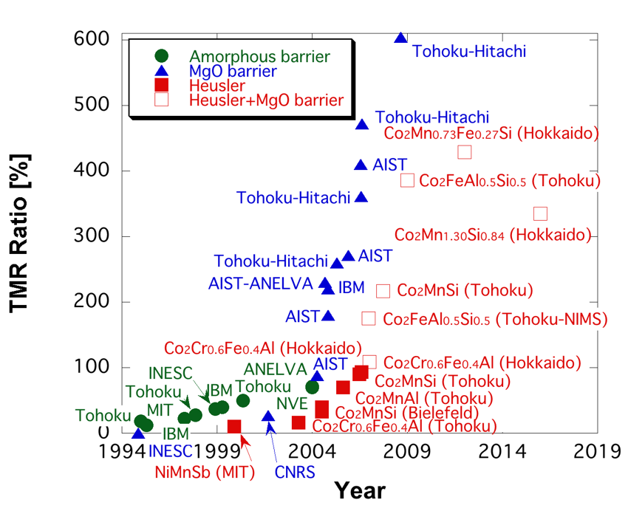
Figure 1. Evolution of TMR ratios at room temperature [4].
Antiferromagnetic materials have been investigated intensively both theoretically and experimentally since the initial discovery by Louis Néel [5]. One of the major applications of antiferromagnets has been to induce interfacial exchange coupling to pin the magnetisation of a neoghbouring ferromagnetic layer. This results in a shift in the corresponding magnetisation curve, which can prove a spin-valve structure [6]. The spin-valve is a basic building block for a HDD read head. Recently by flowing an electrical current in an antiferromagnetic layer, spin polarisation has been demonstrated to be induced, leading to antiferromagnetic spintronics [7]. For these applications, an IrMn₃ alloy has been predominantly used due to its corrosion resistance and robustness against device fabrication processes in nanometer-scale in both thickness and in-plane dimensions. However in order to increase the signals of the antiferromagnetic devices, the development of a new material is highly required.
This special issue consists of one review and six research articles. First four articles cover the development of new antiferromagnets for magnetic recording and beyond. Vallejo-Fernandez et al. provided a review on the recent progress in antiferromagnetic films to induce exchange bias onto a neigbouring ferromagnetic film at room temperature [8]. They focused on MnN, achieving the exchange bias of >1 kOe and the anisotropic constant of ~10⁶ erg/cm³.Such a film can offer an alternative to the antiferromagnetic IrMn₃ used in a magnetic recording to avoid the use of critical raw materials.
Similar efforts using oxides were made by Shiratsuchi et al. to achieve a large perpendicular exchange bias induced by the magnetoelectric effect in Cr₂O₃ [9] The effect can be used to control antiferromagnetic domain states, which can be read out by the magnetisation of the adjacent ferromagnetic layer coupled via the exchange bias induced at their interface. They identified two switching processes, the magnetoelectric field cooling and isothermal modes. The asymmetry yields was reported to be 3.7±0.5 ps/m at 273K, which is comparable to that of the bulk Cr₂O₃.
Additionally, Huminiuc et al. grew and characterised polycrystalline Ni₂MnAl Heusler alloy films [10]. For the demonstration of room-temperature antiferromagnetism, Fe and Co have been used for partial substitution of Ni. The Fe substitution showed an increase in the magnetic moment with increasing Fe content, while Co substitution can effectively reduce the crystallisation temperature down to 300 °C but with ferromagnetic Co₂MnAl segregation. Further compositional optimisation can achieve the stoichiometry while maintaining the reduced crystallisation in the pseudo-B2 phase temperature for antiferromagnetic spintronics.
Ranjbar et al. also reported a large perpendicular exchange energy in rare earth alloys, Tb_{x}Co_{100-x}/Cu/[Co/Pt]₂ heterostructures [11]. They controlled two competing mechanisms; the effect of Tb content on saturation magnetisation and the coercivity of heterostructures. They demonstrated that the perpendicular exchange energy can be controlled by the Cu interlayer thickness between 0.2 and 0.3 nm up to 1 erg/cm² at x=24 at room temperature. Such a structure can be used in a magnetic memory and sensor.
As a new application, magnetisation dynamics in antiferrmagnets were also covered by three articles in theoretically and experimentally. Chen et al. demonstrated the manipulation of magnetisation dynamics in time- and frequency-domains in a synthetic antiferromagnet using micromagnetic simulations [12]. They found the time-evolution magnetisations of the two ferromagnets oscillate in-phase at the acoustic mode and out-of-phase at the optic mode. Their simulations confirmed the magnon coupling can be induced in a hybridised resonance mode with the phase difference up to 90° with respect to the coupling strength. Their method can provide an opportunity to control the magnon interaction in a synthetic antiferromagnet.
Safin et al. discussed a new model to detect THz frequency signals using antiferromagnetic resonance [13]. The conversion of an electromagnetic signal in THz-frequency into a direct current (DC) voltage was calculated to be achievable via the inverse spin Hall effect in an antiferromagnet/heavy metal bilayer. Their calculations agreed with experimentally measured detector sensitivity of 10⁻⁵~10⁻⁶ V/W. The sensitivity can be improved by increasing the magnitude of the bias magnetic field, or by decreasing the thickness of the antiferromagnetic layer.
Kim et al. reported the deposition of crystalline gadolinium iron garnet (GdIG) using a metal organic decomposition method [14]. They demonstrated antiferromagnetic exchange of the rare earth Gd in a ferrimagnetic insulator. For the optimised GdIG fims, the magnetic compensation was measured to be at 270 K and the damping constant was measured to be of an order of 10⁻³ by ferromagnetic resonance measurements Such deposition method can offer high-throughput procedure for ultrafast magnonic applications. Magnons (the quanta of spin waves) can be used to encode information in beyond Moore computing applications.
Supplementary Materials: None.
Author Contributions: Not applicable.
Funding: This work was partially supported by EPSRC (EP/V007211/1 and EP/V047779/1), Royal Society International Exchange Programme and JST CREST (JPMJCR17J5).
Institutional Review Board Statement: Not applicable.
Informed Consent Statement: Not applicable.
Data Availability Statement: The study did not report any data.
Acknowledgments: Not applicable.
Conflicts of Interest: The authors declare no conflict of interests. The funders had no role in the design of the study; in the collection, analysis, or interpretation of data; in the writing of the manuscript, or in the decision to publish the results.

References
- Hirohata, A.; Yamada, K.; Nakatani, Y.; Prejbeanu, L.; Diény, B.; Pirro, P.; Hillebrands, B. Review on spintronics: Principles and device applications, J. Magn. Magn. Mater. 2020, vol. 509, pp. 166711.
- Jung, J. W.. Sakuraba, Y.; Sasaki, T. T.; Miura, Y.; Hono, K. Enhancement of magnetoresistance by inserting thin NiAl layers at the interfaces in Co₂FeGa_{0.5}Ge_{0.5}/Ag/Co₂FeGa_{0.5}Ge_{0.5} current-perpendicular-to-plane pseudo spin valves, Appl. Phys. Lett. 2016, vol. 108, pp. 102408.
- Ikeda, S.; Hayakawa, J.; Ashizawa, Y.; Lee, Y. M.; Miura, K.; Hasegawa, H.; Tsunoda, M.; Matsukura, F.; Ohno, H. Tunnel magnetoresistance of 604% at 300K by suppression of Ta diffusion in CoFeB∕MgO∕CoFeB pseudo-spin-valves anneal, Appl. Phys. Lett. 2008, vol. 93, pp. 082508.
- Elphick, K.; Frost, W.; Samiepour, M;. Kubota, T.; Takanashi, K.; Sukegawa, H.; Mitani, S.; Hirohata, A. Heusler alloys for spintronic devices: Review on recent development and future perspectives, Sci. Technol. Adv. Mater. 2020, vol. 22, pp. 235.
- Néel, L. Propriétés magnétiques des ferrites, Annales de Physique 1948, vol. 3, pp. 137.
- Fontana, Jr., R. E.; Gurney, B. A.; Lin, T.; Speriosu, V. S.; Tsang, C. H.; Wilhoit, D. R. Spin valve magnetoresistive sensor with antiparallel pinned layer and improved exchange bias layer, and magnetic recording system using the sensor, U. S. Patent 5,701,223 (1997). US Patent 5,701,223 (1997).
- Jungwirth, Marti, T. X.; Wadley P.; Wunderlich, J. Antiferromagnetic spintronics, Nature Nanotech. 2016, vol. 11, pp. 231.
- Vallejo-Fernandez G.; Meinert, M. Recent developments on MnN for spintronic applications, Magnetochemistry 2021, vol. 7, pp. 116.
- Shiratsuchi, Y.; Tao, Y.; Toyoki, K.; Nakatani, R. Magnetoelectric induced switching of perpendicular exchange bias using 30-nm-thick Cr₂O₃ thin film, Magnetochemistry 2021, vol. 7, pp. 36.
- Huminiuc, T.; Whear, O.; Vick, A. J.; Lloyd, D. C.; Vallejo-Fernandez, G.; O’Grady, K.; Hirohata, A. Growth and characterisation of antiferromagnetic Ni₂MnAl Heusler alloy films, Magnetochemistry 2021, vol. 7, pp. 127.
- Ranjbar, S.; Sumi, S.; Tanabe, K.; Awano, H. Large perpendicular exchange energy in Tb_{x}Co_{100−x}/Cu(t)/[Co/Pt]₂ heterostructures, Magnetochemistry 2021, vol. 7, 141.
- Chen, X.; Zheng, C.; Zhou, S.; Liu, Y.; Zhang, Z. Manipulation of time- and frequency-domain dynamics by magnon-magnon coupling in synthetic antiferromagnets, Magnetochemistry 2022, vol. 8, pp. 7.
- Safin, A.; Nikitov, S.; Kirilyuk, A.; Tyberkevych, V.; Slavin, A. Theory of antiferromagnet-based detector of terahertz frequency signals, Magnetochemistry 2022, vol. 8, pp. 26.
- Kim, H.; Van, P.-C.; Jung, H.; Yang, J.; Jo, Y.; Yoo, J.-W.; Park, A. M.; Jeong, J.-R.; Kim, K.-J. Deposition of crystalline GdIG samples using metal organic decomposition method, Magnetochemistry 2022, vol. 8, pp. 28.

