Fire resistance of geopolymer concrete: A critical review
Mugahed Amran ^{1, 2,} *, Shan-Shan Huang³, Solomon Debbarma⁴, Raizal S.M. Rashid⁵
¹ Department of Civil Engineering, College of Engineering, Prince Sattam Bin Abdulaziz University, 11942 Alkharj, Saudi Arabia
² Department of Civil Engineering, Faculty of Engineering and IT, Amran University, 9677 Amran, Yemen
³ Department of Civil and Structural Engineering, the University of Sheffield, Sir Frederick Mappin Building, Mappin Street, Sheffield S1 3JD, UK
⁴ Ingram School of Engineering, Texas State University, San Marcos, Texas 78666, United States
⁵ Department of Civil Engineering, Faculty of Engineering, Universiti Putra Malaysia, 43400 Serdang, Selangor, Malaysia

Corresponding author: m.amran@psau.edu.sa and mugahed_amran@hotmail.com

Abstract: Although a novel inorganic family of geopolymer concrete (GPC) is a promising building material. The need for understanding its resistance against fire at high temperatures is considered essential to ensure its long-term durability. Physical examinations of the degree of cracking, spalling, brittleness, and loss of strength in GPC upon exposure to high temperatures and during fires provide an indicator of their resilience to such conditions. The addition of recycled fibers (RFs) to GPC has been reported as a strategy for overcoming these limitations and preventing concrete microstructure deterioration. Therefore, the development of RF-reinforced GPC (RF-RGPC) to resist fire has become research imperative. The use of RFs derived from industrial wastes provides additional benefits, such as waste reduction, resource conservation, reduced processing costs compared with virgin fibers, and the elimination of waste disposal in landfills. Moreover, RF-RGPC is an inorganic polymer binder made through the alkali activation of reactive aluminosilicate materials that comprise RFs, which increase its structural reliability. In this regard, conducting a critical literature review of current updates related to the fire performance of RF-RGPC subjected to elevated temperatures and during fires is urgently necessary. This study provides critical reviews on the type of RFs, spalling mechanism, physical inspection and properties of RF-RGPCs. It also comprehensively demonstrated the influence of fire on the properties of RF-RGPC after high temperature exposure. The major findings of this study are expected to introduce this unique, cutting-edge, accessible, and environment-friendly RF-RGPC as a promising, durable and heat- and fire-resistant building material for the current infrastructure and sustainable construction industries.

Keywords: Applications, fire resistance, geopolymer concrete, recycled fiber, recycled fiber-reinforced GPC.

Table of contents
1 Introduction 3
2 The fibers 7
2.1 Recycled inorganic and carbon fibers 9
2.2 Recycled steel, basalt, and textile fibers 9
2.3 Recycled polymer fibers 10
3 Spalling mechanism of RF-RGPC 16
4 Physical inspection of RF-RGPC matrix 18
5 Properties of RF-RGPC 18
5.1 Microstructure property 18
5.2 Thermal resistance 20
5.3 Fracture energy 22
5.4 Fire resistance 23
5.5 Elevated temperature 27
6 Multi-scale modeling of RF-RGPCs 32
7 Hotspot research topics for future investigations 36
8 Conclusion 37
9 References 38

Abbreviations
ASR | Alkali-silica reaction
FA | Fly ash
FRP | Fiber-reinforced polymer
GGBFS | Granulated blast furnace slag
GPC | Geopolymer concrete
MK | Metakaolin
PA | Polyamide
PET | Polyethylene terephthalate
PP | Polypropylene
RCF | Recycled carpet fibers
RF | Recycled fibers
RF-RGPC | Recycled fiber-reinforced GPC
RHA | Rice husk ash
RM | Red mud
RPF | Recycled plastic fiber
RSF | Recycled steel fiber
PVC | Polyvinyl chloride
SF | Silica fume
TC | Thermochemical
TF-RGPC | Textile fiber-reinforced GPC
TH | Thermo-hygral
TM | Thermomechanical
HDPE | High-density polyethylene

Introduction
Geopolymer concrete (GPC) was invented by Davidovits primarily for 3D amorphous aluminosilicates in late 1978 [1,2]. The hardened product of GPC is resistant to weather and can tolerate temperatures of up to 1000 °C–1200 °C [3]. Therefore, GPC is regarded as an alternate cementitious material that is generated by combining a base material with a high volume of silica and alumina [2,4–6]. One of the most important reasons for the increased interest in GPC compared with other types of concrete is the reduction in CO₂ emissions achieved by using geological products in concrete. Recent research has reportedly focused on using GPC instead of ordinary Portland cement (OPC) to reduce CO₂ emissions [7–10]. The geopolymerization mechanism comprises the reaction of alumina solids and amorphous silica with an alkali to produce amorphous aluminosilicate binders [11]. GPC can be composed of granulated blast furnace slag (GGBFS) [12], silica fume (SiF) [2], fly ash (FA) [10,13–16], red mud (RM) [17], rice husk ash (RHA) [18–21], and metakaolin (MK) [22] as primary raw materials with geological origin or common by-product materials [7,23]. The mechanism by which GPC dries and strengthens differs significantly from that of OPC. GPC exhibits exceptional mechanical characteristics, with compressive strength exceeding 100 MPa [24]. GPC demonstrates excellent potential for acid resistance, fire resistance, and alkali–silica reaction (ASR) [25]. It has an inorganic structure and does not burn in contrast with organic polymers; it is nontoxic, nonsmoking, and has a low processing temperature compared with ceramic composites [1]. Given its fire-resistant capability, GPC can be used as a green construction material with enormous possibilities for sustainable development and as infill [26].
GPC is similar to its counterpart high-strength concrete in terms of losing its hardened strength after being exposed to fire, causing cracking, followed by spalling [27–32]. Moreover, concrete is acknowledged to perform considerably better under compression load than under tensile load because of its brittleness [33]. GPC is also comparable with normal concrete in terms of brittleness [7,34]. When the elastic tension of structural concrete elements without reinforcement reaches its limit, microcracks occur, followed by macrocracks, and eventually failure [35]. Water and other harmful elements seep into cracks, corroding steel. Therefore, small cracks exert a significant effect on concrete’s long-term resilience. In addition, GPC performs better than OPC at high temperatures [36,37]. Similarly, GPC retains its compressive strength under elevated temperatures, and the bond between its cement paste and steel bar is stronger than that of OPC [38,39]. GPC’s weakness arises from its brittle nature. Hence, the brittleness of GPC and OPC is also evaluated, with GPC having smoother fracture planes than OPC [40]. Changes in binder material morphology also affect the microstructure of the matrix, reducing fracture load. The brittleness of GPC has to be reduced to obtain a high-performance maintainable construction material [41]. Incorporating fibers into cement-based products can help overcome the aforementioned disadvantage [7]. Avoiding concrete microstructure degradation is another challenging issue [42,43]. One of the utmost practical solutions for this issue is the use of recycled fibers (RFs) (refer to RF classification in Fig. 1 [44]) from postconsumer or industrial waste, with additional benefits, such as waste reduction, resource conservation, lower processing costs than virgin fibers, and eliminating the need for waste landfills [45]. Moreover, the use of RFs in GPC can efficiently enhance the stiffness, shrinkage, and durability properties of concrete, such as resistance to fire, particularly the bending strength of reinforced GPC after exposure to elevated temperatures. Natural raw resources, such as fibers and aggregates, can be used to construct green and eco-friendly structures [46].
RF-reinforced GPC (RF-RGPC) is a noncombustible, heat-resistant, and inorganic polymer binder produced through the alkali activation of reactive aluminosilicate materials that comprise RFs, which increase its structural integrity. RF-RGPC is composed of randomly oriented and consistently distributed short discrete RFs [47]. RFs include recycled plastic fibers (RPFs) [48–52], recycled carbon fibers (RCFs) [53–56], recycled steel fibers (RSFs) [57–63], and recycled textile/fabric fibers [64–70], recycled natural fibers (RNFs) [66,71–80]; which imbue varying properties to concrete [81]. Moreover, the characteristics of RF-RGPC changes with varying concrete, geometry, RF material, orientation, distribution, and density. RFs should be uniformly distributed throughout the concrete mixture to function effectively [81]. They can increase concrete strength by improving the tensile and flexural strengths, toughness, and ductility of the RF-RGPC mixture [82–84]. Many types of fibers are recycled in concrete mixtures, and they are typically available in metallic or polymeric form. Examples include RSFs, RGFs, natural fibers, synthetic fibers, and pre-consumer/postconsumer waste fibers [85]. In accordance with previous studies, the use of polypropylene (PP) fibers in concrete is a common practice to reduce the risk of concrete spalling in case of fire [86–88]. Other scholars used maleic anhydride-grafted PP to cover the surface of waste plastic fibers to decrease de-bonding between concrete and fibers, improving the dispersion properties of RFs [89]. The addition of small-diameter PP fibers to the tunnel lining not only provides reinforcement but also reduces spalling and lining damage in the event of a fire accident [90].
The current comprehensive review determines that a green construction material with excellent fire-resistant and mechanical performance is required for structural applications [35]. A few studies also investigated RGFs [91,92], recycled tire steel fibers [93] (reported to have the highest melting point of 1435 °C) [94], textile fibers [95,96], and recycled carbon fibers [97,98] in GPC. Many scholars also conducted research on the performance of these RF types during a fire; such research is required to understand the effect of fire on the long-term performance of GPC [81].

Types of RF used to reinforce GPC composites
Natural
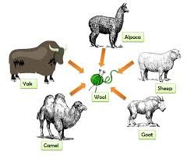Animal
Vegetable (Cellulosic)

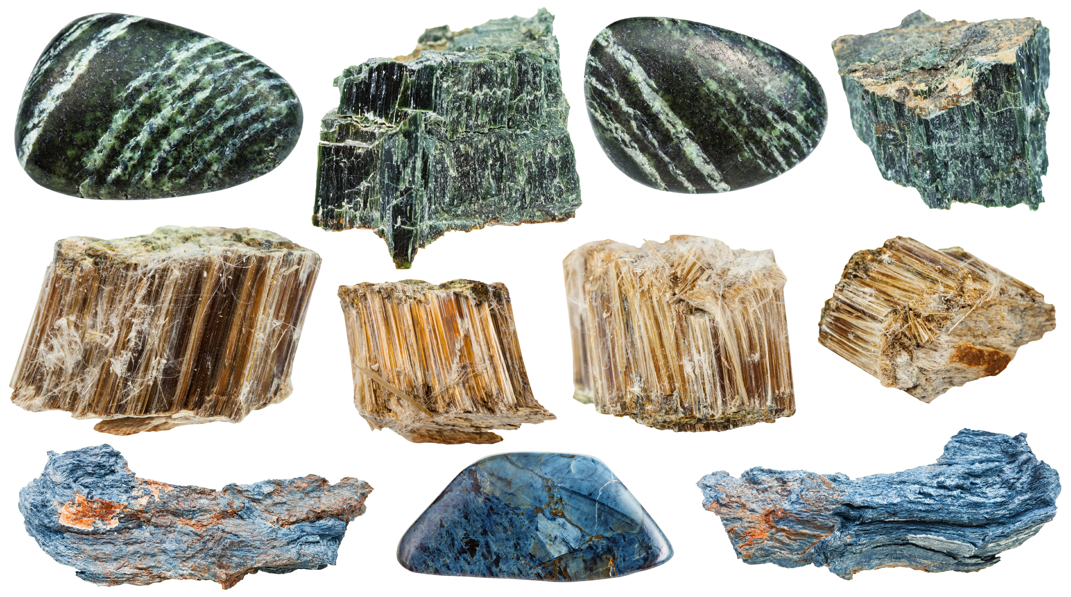Mineral (Asbestos)
Avian
Silk
Wool/hair
Amosite
Crocidolite
Tremolite

Chrysotile
Carbon

Ceramic
Boron
Silica carbide

Etc.
Hooked-end
Wavy
Flat-end
Crimped
Stainless
Seed

Bast
Leaf
Fruit
Stalk
Cotton
Kapok
Milkweed
Hemp
Jute
Flax
Kenaf
Ramie
Sisal
Abaca
Banana
Agave
Henequen
Coir
Oil palm
Wheat
Maize
Rice
Barley
Oat
Polyester
Aramid
Polyamide
Acrylic
Etc.
Artificial
Organic
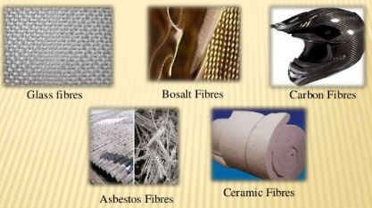Inorganic
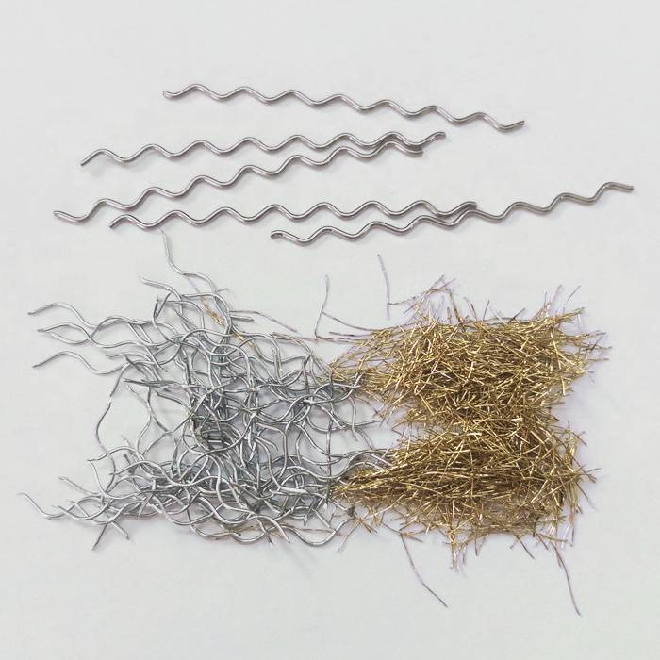Steel fibers
Mulberry
Cane/grass/reed
Bamboo
Bagasse
Corn
Esparto
Fig. 1: Classification of RFs used to reinforce GPC composites (Adapted from [44])

Long-term performance characteristics, such as the shrinkage, creep, and fatigue performance of concrete with RFs, will require a more detailed and comprehensive investigation in the future. However, a careful mix design is required to achieve significant chemical stability, low-volume variations, strength endurance, and spalling resistance [35]. Factors, such as precursor choice, aggregates, total alkali content, and water content, are critical and should be controlled. GPC can predictably satisfy this requirement. However, to determine the updated behavior of GPC during a fire, a critical literature review should be performed on current state-of-the-art developments related to the fire-resistant performance of RF-RGPCs subjected to high levels of temperature and during a fire. Table 1 summarizes the previous findings on the effect of varying temperatures on GPC specimens.
Table 1. Previous studies on the effects of fire on GPCs
Temperature level, °C | Observations | Refs.
300–700 | GPC mortar exhibited more tensile and bending strength temperature depreciation than OPC mortar but less bond and compressive strength degradation. | [99]
600 | Compressive strength was considerably improved with a Na₂SiO₃/NaOH ratio of 3, and residual compressive resistance was increased to 600 °C. | [100]
200–800 | During heat cycles, the compressive resistance of GPC decreased. Loss of mass and compressive strength increased as temperature rose. | [101]
500 | Even after exposure to high temperatures, the MK/FA-based GPC samples presented bending and compressive performance similar to the OPC specimens. GPC based on MK/FA is a feasible alternative to normal OPC. | [102]
100–900 | The strength of combined sodium and potassium GPC (30%–40%) remained unaltered after exposure to elevated temperatures, whereas the strength of GPC produced with sodium was reduced by 10%. | [103]
800 | The study identified the two most important characteristics for GPC activity at high temperatures (800 °C), namely, 10 mm aggregate size and GPC matrix. The result of a large loss of GPC concrete at high temperatures is thermal instability between the GPC matrix and aggregates at low and high temperatures. | [104]
1300–1400 | GPC exerted a considerable effect on thermal shrinkage reduction as Si/Al ratio increased due to porosity reduction during sintering and dehydroxylation. | [105]
800–1000 | Following fire exposure, the GPC samples suffered less damage in terms of cracking than the OPC concrete specimens. For exposure between 800 °C and 1000 °C, significant spalling was observed in the OPC samples, but not in the GPC samples. | [106]
550 | Compared with the original strength value, the strength of GPC paste increased by 192% at 550 °C, while the strength of OPC paste only changed slightly. Nevertheless, the proportion residual strength of GPC and OPC after heating to 550 °C was similar. | [107]
900 | All the GPC specimens presented reduced compressive strength after being exposed to a high temperature of 900 °C. Although the GPC mixtures exhibited excellent chemical stability at the microscale, their volume was weakly maintained at the mesoscale, and thermal shrinkage was extremely high. | [108,109]
800 | GPC beams had the same deformation characteristics as reinforced cement beams at room temperature. The strain compatibility technique underestimated the deformation behavior of enhanced GPC beams when subjected to high temperatures. | [110]
600–900 | The amount of Si-O-Na bonds in the GPC samples was reduced via cross-linking polymer modifications at 600 °C. After the occurrence of large morphological changes, such as the formation of a complex pore structure, thermal action at 900 °C considerably reduced oxygen and articulated sodium. | [111]
800 | The linear dimensional stability of GPC paste and mortar remains unaltered until 800 °C. The inclusion of 10% micro silica increased the filling effect, improving compressive strength while compromising the integrity of the bulk GPC specimen. | [112]
200–800 | The rubberized GPC lost strength at increased heats only slightly more than the control GPC because of irregularities in the thermal expansion of integral materials. | [113]

The fibers
The use of fibers has been effective in enhancing the toughness, shrinkage, durability, and cracking resistance of concrete by bridging cracks in concrete before the latter is pulled out or stressed to the point of rupture [114–118]. Moreover, the use of RFs contributes to proper waste management and conventional resource conservation [119]. Fibers can be natural or artificial [120,121], and they can be classified into the following categories in accordance with their shape: i) continuous fibers [122,123], ii) discontinuous fibers [124,125] (typically short fibers with a diameter of 3–5 μm) [126,127,73,128,129], iii) whiskers (typical diameter is <1 μm) [130], and iv) particulates. Fibers can be further classified on the basis of their inter-filament configuration , as follows: RSFs [81], RCFs [131], rCFs [132], polyvinyl alcohol (PVA) fibers [133], RGFs [127], sisal fibers [79], and linen fibers [134]. These categories can be further classified into i) nonwoven fibers (PP [135,136], flax [115], and cotton fibers [137]) and ii) woven fibers (glass mat , cotton fabric [138], tyre fibers [93,139] and flax fabric fibers [115]). Meanwhile, biodegradable, nontoxic, and renewable fibers, such as flax [115], sisal [140], bamboo [121], pulp [141], jute [121], and sugarcane [142], are classified as cellulosic fibers [143] (some of these RFs are depicted in Fig. 2 [44]).

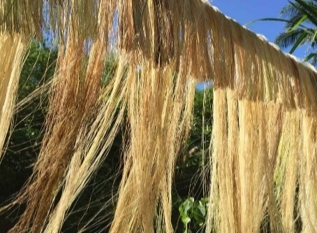  Abaca | 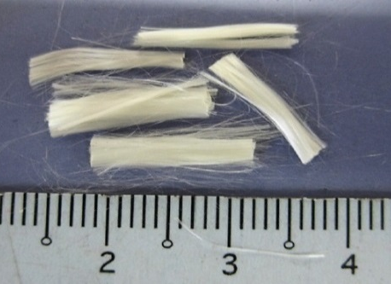  Acrylic | 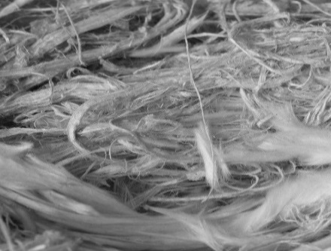  Asbestos | 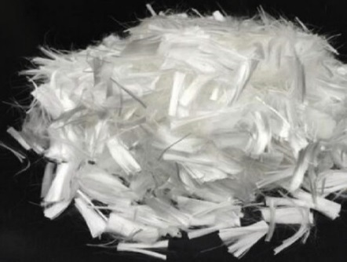Polypropylene | 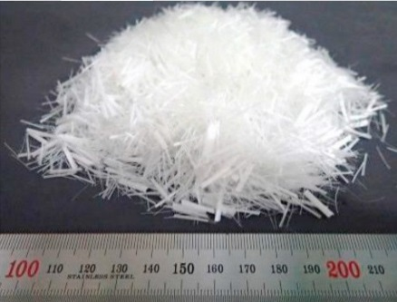Polyvinyl alcohol
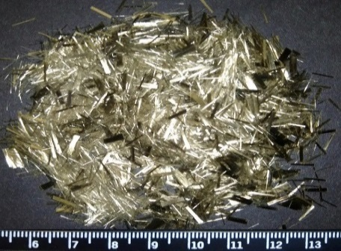  Basalt | 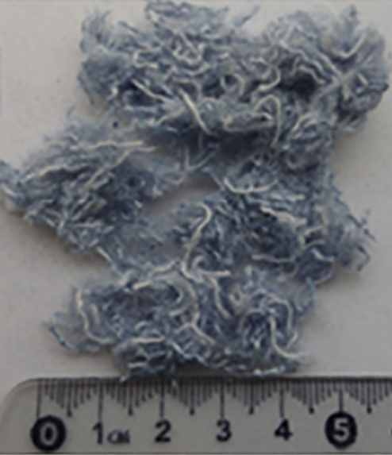  Cotton | 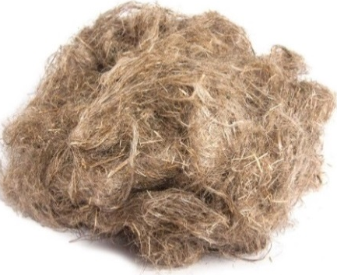Flax | Hooked-end steel | 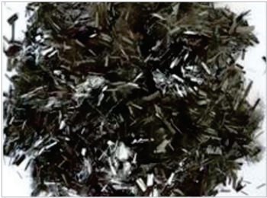  Glass
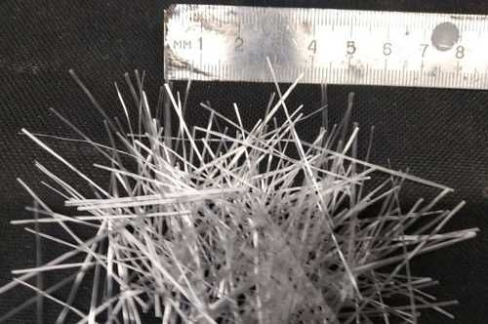Glass | 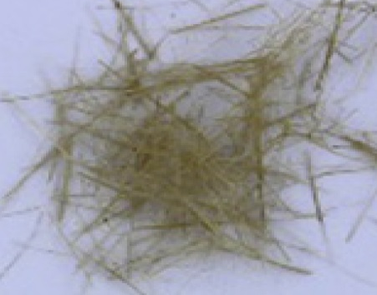Hemp | 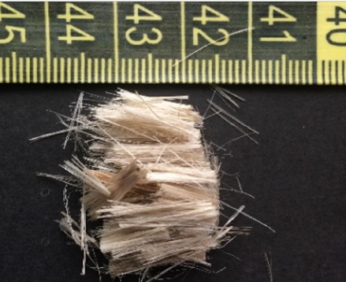Jute | 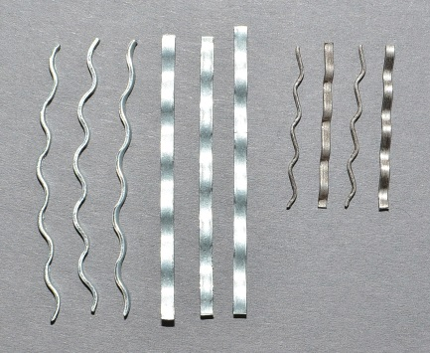  Crimped steel fiber | 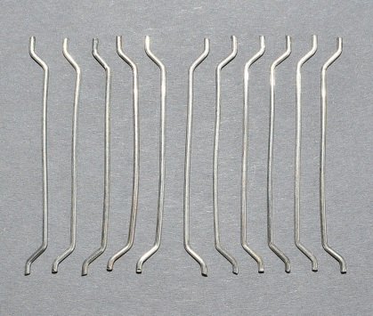  Flat-end steel fiber
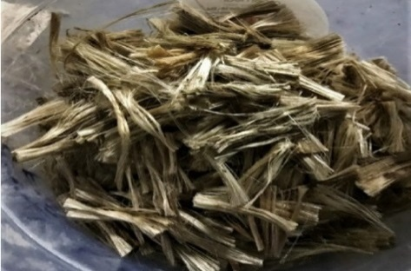Kenaf | 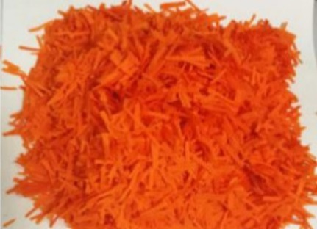Nylon | 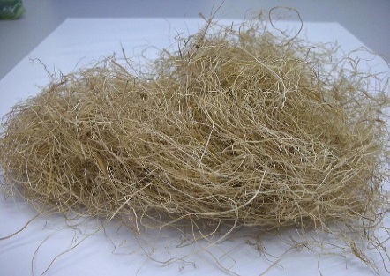Palm | Polyester | 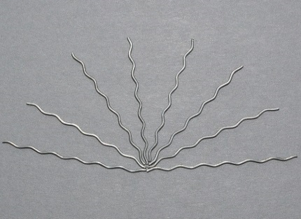  Wavy steel fiber
Fig. 2: Typical RFs used to reinforce GPC composites (Adapted from [44])
The use of spiral-shaped and hooked-end RSFs reportedly improved the tensile strength and compressive strength of GPC [144]. Moreover, an improvement of approximately 32.1% in bond strength was noted when wavy RSF composite was used [145].

Recycled inorganic and carbon fibers
Inorganic fibers are typically considered cost-effective alternatives to RCFs in terms of high-temperature resistance [52]. When subjected to high temperatures of up to 1000 °C, the mechanical strength of basalt fiber-reinforced GPC improved due to enhanced bonding between recycled basalt fibers (RBFs) and the matrix after the sintering process [146]. At 600 °C–1000 °C, the use of alumina fibers and recycled refractory particles promotes the retention of the high mechanical strength and energy absorption of MK-GPC due to the controlled composite volumetric contraction of thermally stable fibers [147]. Moreover, the use of inorganic fibers, such as silicon carbide or alkali-resistant (AR) glass, in GPC results in high thermal stability at 1000 °C [148].
However, defects due to the use of inorganic fibers at high temperatures have also been reported [149]. For example, a flexural strength of 194 MPa at 600 °C was recorded without significant deterioration when RBF-reinforced GPC was used, but it crystallized and melted at higher temperatures [150]. This situation can be compounded by oxygen transition through the porous matrix [151]. A tensile strength of 245 MPa was also observed with the use of RCF-GPC composite, sustaining approximately 60% of its strength after exposure to fire at 800 °C [152]. A nearly similar observation was made when GPC reinforced with micro RCFs was used, retaining more than 50% of its compressive strength at 800 °C [153]. This result may be explained by the adequate interaction between RCFs and the binder at higher temperatures, hindering the formation of cracks and the deformation of the matrix [92,151,154]. Meanwhile, sol (SiO₂) impregnation improved the mechanical strength of RCF-reinforced GPC by approximately 35% at higher temperatures up to 900 °C [155]. Despite several benefits, such as improved mechanical strength, high thermal resistance, and high energy absorption, high cost and partial carbon oxidation at high temperatures still limit the practical application of RCF-reinforced GPC [151,156].

Recycled steel, basalt, and textile fibers
The use of 0.5% RSFs (by volume) in GPC exhibits strength retention up to 600 °C [157]. It is reported that the stainless steel-reinforced GPC retained approximately 59% and 44% of its flexural strength at 800 °C and 1050 °C, respectively. The incorporation of steel fibers improves the tensile strength and flexural strength of GPC [158,159]. Moreover, the use of steel fibers improves the shear strength of GPC [160]. When steel fibers were utilized in proportions of 0–3% by volume and heat-cured, durability properties (water absorption, sorptivity, and water permeability) significantly improved as reported in [161]. Alumina chopped fibers can be utilized to enhance GPC at elevated temperatures [162]. RBFs from melting volcanic rocks at 1500 °C–1700 °C are inexpensive inert filler with excellent strength, durability, and thermal properties [163]. The Moh’s hardness scale of RBFs is typically within the range of 8–9; RBFs exhibit superior abrasion resistance and satisfactory acid attack resistance [52,164]. The applicability of RBFs ranges from extremely low (nearly −200 °C) to extremely high (nearly 700 °C–800 °C), but RBFs may undergo structural changes at higher temperatures [165].
Although fiber-reinforced polymer (FRP) has several benefits, its application is limited due to its low resistance to high temperatures [166]. Textile fiber-reinforced GPC (TF-RGPC) offers a promising solution to mitigating the poor resistance of FRP to high temperatures. TF-RGPC composites consist of fabric grids and a cementitious agent (typically mortar) that functions as matrix and binder. Textile-reinforced mortar (TRM) composites exhibit higher fire resistance compared with epoxy resin utilized in FRPs; TRM is also more compatible with the concrete substrate [167].

Recycled polymer fibers
Synthetic polymer fibers are extensively manufactured from raw materials or recycled from plastic waste [52]. The utilization of RFs in civil engineering applications is a formidable and sustainable solution for the proper waste management of widely used plastics, such as polyethylene (PE), PE terephthalate (PET), PP, and PVA [168]. PET is the most widely used plastic; it is used in the manufacturing of containers for liquids, foods, and others. An alternative solution to proper waste management is the shredding of PET bottles and containers to produce short fibers of various lengths, commonly known as polymeric fibers. PP, which is derived from monomeric C₃H₆, is a pure hydrocarbon like paraffin wax with various shapes, sizes, and properties [169]. Low cost, inert characteristic at high pH, controlled concrete plastic shrinkage, and easy dispersion are some of the benefits associated with the use of such polymeric fibers [170]. However, using these polymeric fibers can also result in low thermal resistance, low elastic modulus, and poor interfacial contact with the cement matrix due to their inherent hydrophobic characteristics [171–173]. Nevertheless, the production of polymeric fibers through the recycling of PET bottles has a promising future in the concrete industry.
The use of PET fibers will not only exhibit comparable mechanical properties but will also yield cost-effective and environmental benefits [174]. Meanwhile, the use of PVA fibers can achieve higher tensile strength and concrete modulus within the range of ~0.8–2.5 GPa and ~29–42 GPa, respectively. Such result is attributed to the strong chemical bond with the cement matrix caused by the presence of the hydroxyl group in PVA’s molecular chains [175]. However, the cost of PVA is high; in addition, its high chemical bond can lead to fiber rupture, limiting the tensile strength capacity of GPC [52,176–178]. By contrast, the characteristics of PE fibers are highly dependent on their molecular mass, polydispersity, and crystallinity degree of [179]. High-density PE fibers are reported to have a tensile strength and modulus of elasticity of approximately 3.5 GPa and 110 GPa, respectively [180]. In addition, PE fibers are hydrophobic [181]. However, when eco-friendly and energy-efficient polymeric fibers are preferred, monofilament cellulosic fibers, such as jute, hemp, kenaf, bagasse, and sisal, can be utilized as alternatives in cement composites [143]. Cellulosic fibers are abundantly available at a low price; they have low density, reduce thermal conductivity, and provide satisfactory mechanical properties when used in cementitious composites.
However, the use of cellulosic fibers in cement composites has four major problems, which are as follows: i) poor durability, ii) reduced workability of fresh composite at high fiber content, iii) varying material properties, and iv) poor matrix interaction [143,182,183]. The incorporation of volatilizable and low-temperature decomposable fibers is also not suggested for high-temperature applications due to high shrinkage and porosity formation in GPC at high temperatures [146,184–186]. Table 2 summarizes the influence of type and contents of materials used in RF-RGPC/RC at different temperatures and its effect on various GPC properties.

Table 2. Influences of the type and contents of materials used in RF-RGPC/RC at different temperatures
Type of RFs | Dosage in concrete, vol% | Size of fiber, mm | Aluminosilicate | Activators |  | Observations |  | References
 |  |  |  | NaOH  (√) | Na₂SiO₃ (√) | Temperature/curing condition, °C | Major findings
RSFs | 0.5, 1.0, 1.5, 2.0 | 6–13 L | GGBFS, SiF | √ | √ | 100 | Drying shrinkage decreased with increasing RSFs. | [187]
Macro and micro RSFs | 1.0, 1.5, 2.0 | 6 ± 1 L  0.2 ± 0.05 D | FA, GGBFS | √ (14 M) | √ | 23 ± 2 | RSF-RGPC exhibited better resistance to corrosion. | [188]
RSFs | 0.25, 0.5, 0.75, 1.0 | 30 L, 0.5 D, AS of 60 | FA | √ (10 M) | √ | 60–105 | GPC presented better durability characteristics with RSF inclusion. | [189]
Micro RSFs, PP | 0.5, 1, 2, 3, 4 | 12–22 0.04–0.20 D | FA | √ (16 M) | √ | 60–105 | Inclusion of PPF reduced flexural strength. | [190]
RSFs | 0.5, 0.75, 1.0 | ~5–10 | FA | √ | √ | ~100 | Inclusion of RSFs increased flexural and fracture properties. | [191]
Crimped RSFs | 0.25, 0.75, 1.5, 1.75, 2 | 12–20 L  40–150 µm D | FA | √ (14 M) | √ | 20 ± 2 | Addition of RTS fibers resulted in reduced crack widths. | [63]
Hooked-end RSFs | 0.4, 0.5, 0.6, 0.8 | 35 L, 65 AR | GGBFS, POFA | √ (12 M) | √ | 26–29 | RSFs, oil palm shell as coarse aggregate type (crushed or uncrushed). | [192]
RSF, HSPE, and PP | 2–4 | 0.30 D, 25 L | FA, GGBFS | √ (12 M) | √ | 3–80 | GPC retained integrity at higher levels of confinement. | [193]
Hooked-end RSFs | 0.5, 1, 2 | 30 l, 40 AR | GGBFS, nano-silica FA | √ | √ | ~70 | RSF inclusion improved flexural performance and bonding strength. | [194]
Polyolefin, hooked-end RSFs | 0.35 | 60 L, 0.5, 0.75  1D | FA | √ | √ | ~1100 | Increased durability and substantially reduced carbon emissions. | [195]
Macro RSFs and PP | 0, 0·45, 0·90, 1·80 | 19 L | FA | √ | √ | 23 ± 2 | Slight reduction in compressive strength was observed with the use of PP fibers. | [196]
RSFs | ~1.5 | 8–25 L,  1D | GGBFS | - | √ | 24–60 | RSF inclusion exhibited a mechanical performance | [197]
RSFs | 2, 3, and 5 | 30 D, 0.5 L | FA | √ | - | 60–300 | RSF inclusion increased flexural strength. | [198]
RSFs and PVA | 1, 2 | 0.6–1.18 D | FA | √ (8 M) | √ | 20–60 | RSF/PVA/hybrid improved ductility. | [199]
RSFs | 0.5, 1.0 | 35 L, 12 D, 65 AR | FA | √ (14 M) | √ | ~60 | Shear capacity improved with RSF inclusion. | [200]
RSFs and zirconia | 0.5, 1.0 | 3.5 μm D, 20–35 L | FA | √, KOH | √, K₂SiO₃ | 200–1000 | RSFs enhanced the stiffness of the composite. | [147]
RSFs | 0.5, 1.0, 2 | 13 L, 0.16 D | FA, GGBFS, SiF | - | K₂SiO₃ | 21–90 | RSFs improved fiber–matrix interfacial bond. | [201]
RSFs and PP | 1, 2 | 30–30 L, 0, 5 D, 65 AR | FA, GGBFS | √ | √ | 23 ± 2 | RSF/PP fibers increased the flow of FA-based GPC. | [202]
Galvanized RSFs | ~1 | 1 D | FA | √ (4 M,6 M,8 M) | √ | 21 ± 2 | An increase in the interfacial bond between the matrix and fibers. | [203]
Hooked RSFs | 0.25, 0.50, 0.75 | 60 L, 35 D, 80–65 AR | POFA, MK | √ (14 M) | √ | 28–65 | RSF addition improved toughness. | [204]
RSFs | ~5 | 16 L, 0.8 D, 20 AR | GGBFS | √ (12 M, 14 M, 16 M) | - | ~ 70 | RSF content attained high-strength GPC composite. | [205]
Micro and macro RSFs | 1, 2 | 6–18 L, 0.2–0.55 D, 30–33 AR | FA, GGBFS | √ (14 M), | √ | 21 ± 2 | Addition of hybrid RSFs provided the highest improvement in peak axial load and ductility. | [206]
E-RGFs | 0.25–1 | 3, 6, and 8 L | FA | √ (14 M) | √ | 21 ± 2 | Strength properties were found to be improved by 1%. | [207]
RGFs | 0.01, 0.02, 0.03, 0.04 | 12 L, 14 5 μm D | FA | √ (14 M) | √ | 21–90 | RGF inclusion achieved higher strengths in short curing (72 h) | [208]
RGFs | 0.1–0.5 | 600 AR | FA | √ | √ | 27–100 | Split tensile strength increased. | [209]
RGFs | ~2 | 16 D | FA, GGBFS | √ | - | 21 ± 2 | Serviceability performance was enhanced with higher reinforcement ratio. | [210]
RCFs | 1–2 | 6 L, 7 μm D | MK, FA | - | √, K₂SiO₃ | 25–800 | RCF inclusion attained higher fire resistance | [102]
RCFs, E-glass, PVA, and PVC | ~1 | 7±1 L, 10–18 µm D | MK, ladle slag | √ (8 M) | √ | ~700 | Inclusion of fibers exhibited an increase in toughness. | [158]
RBFs | 1–2 | 18 L, 15 µm D | FA, GGBFS | √ (8 M) | √ | 23 ± 2 | RBF inclusion significantly improved deformation. | [211]
Alumina-coated RSFs | 0.25, 0.50, 0.75 | 0.66 D, 45 AR | MK | - | - | 10–80 | Alumina-coated RSF contents enhanced bond strength. | [212]
RSFs | 0.5, 1 | 300 L, 0.6 D | FA | √ (12 M) | √ | 20–60 | 1% RSF had the highest compressive strength | [213]
RSFs | 0.5, 1, 1.5 | 30 L, 0.5 D | GGBFS | √ | √ |  | RSFs decreased fracture energy and increased ductility. | [214]
RSFs | ~1.5 | 15 L, 0.12 D | FA, GGBFS, SiF | √ | √ | 20 ± 2 | RSF inclusion, ceramic ball aggregates. | [215]
RSFs | 1, 2, 3 | 6–13 L, 0.12–0.20 D | FA, GGBFS, SiF | √ | √ | 20–80 | Toughening efficiency and inferior strengthening | [216]
RSFs | 0.20, 0.15, 0.10 | 61–66 L, 0.75–0.8 D | FA, GGBFS | √ | √ | 20 ± 2 | Effect of NiTi–RSF on the fresh and mechanical properties of GPC | [217]
RSFs | 1, 2, 3 | 6–13 L, 0.12 D, 108 AR | FA, GGBFS, SiF | √ | √ | 20–80 | Reducing RSF content improved fracture performance | [218]
RBFs | 1–2 | 25–25.62 µm D | RHA | √ (12 M) | √ | 20–25 | RBF content helped reduce drying shrinkage | [219]
PP | 0.5, 1, 2 | 30–36 L, 0.5 D | MK | √ | - | 20 ± 2 | PP inclusion increased the flow of GPC | [220]
PP, micro RSFs | 0.5, 1, 2, 3, 4 | 12–20 L, 0.04–0.2 D | FA | √ (16 M) | - | 20–150 | RSF/PP inclusion significantly improved energy absorption | [190]
PP | 0.2–0.8 | 3 L, 10 µm D | MK, FA | √ | - | 80–900 | PP inclusion considerably improved strength and toughness | [221]
RSFs, PP, and PVA P | 0.4, 0.8, 1, 1.2 | 6–12 L, 0.075–0.17 D | FA, GGBFS | √ (12 M) | - | 23–80 | PP, PVA, and RSF inclusions improved toughness, shrinkage behavior, and abrasion resistance | [222]
PP and RSFs | 1.8–9 | 58–60 L | FA | √ (14 M) | √ | 20–60 | Addition of hybrid RSF/PP improved flexural strength and toughness. | [223]
PP | 0.3, 0.5, 1 | ~30 L, 0.5 D | MK | √ (8 M), | √ | 20 ± 2 | PP inclusion dramatically improved durability | [224]
Micro PP and RSFs | 0.25, 0.5, 0.75, 1 | 12–20 L, 0.04–0.2 D | FA, GGBFS | √ (10 M, 12 M, 14 M), | √ | 20 ± 2 | Hybrid PP inclusion improved mechanical properties. | [225]
PP, RBFs, and RSFs | 0.1–0.5 | 12–13 L, 18–30 μm D, 0.2 D | FA, GGBFS | √ | √ | 150–196 | Addition of PP and RBFs improved strength properties. | [226]
PP | 0.05, 0.15 | ~30 L, 0.5 D | FA | √ (8 M) | √ | 70–90 | PP inclusion enhanced ductility and compressive strength. | [227]
PP | 0.02–0.06 | 6 L, 18 μm D | MK | √ (12 M) | √ | 65–1000 | PP inclusion attained higher fire resistance. | [186]
PP | 0.5, 1 | 6 L, 20 µm D, 300 AR | RHA, nano-Al₂O₃ | √ | √ | 200–700 | PP fibers improved mechanical properties. | [228]
Cotton fiber | ~0.025–0.05 | 4–16 D | FA | √ (8 M) | √ | 20 ± 2 | Cotton fiber inclusion exhibited tendencies for crack bridging. | [229]
STF | 1, 3, 5 | 30 L, 0.5 D | FA | √ and Na–K water glass |  | 60–105 | Addition of STF improved bonding and matrix of GPC. | [230]
Coconut and sisal fibers | 0.5, 0.75, 1.0 | 35–40 L, 20–179 µm D | FA | √ (10 M) | √ | 25–60 | Coconut and sisal fiber content improved indirect tensile strength. | [231]
Jute and sisal fibers | 0.5–3.0 | 10 L, 53 and 137 µm D | Fired clay | √ | √ | ~65 | Sisal and jute fiber content significantly increased properties. | [232]
PVA fibers | 0.5, 1, 1.5, 2 | 8 ± 0.5 L,  12 ± 0.5 L,  40–100 µm D | FA, GGBFS | √ | - | 20 ± 2 | Inclusion of PVA fibers improved tensile properties and flexural toughness | [233]
PVA | ~0.02 | 12 L, 39 µm D | GGBFS | CaOH | √ | 23 ± 3 | PVA fiber exhibited high ductility and self-controlled crack width | [234]
PVA | ~1 - 2 | 12 L, 0.015 D | FA, GGBFS, SiF | - | √, K₂SiO₃ | 20 ± 2 | PVA fiber inclusion, GPC cover depth | [235]
PE and PVA | ~0.2 | 8–12 L, 12–40 µm D | FA, GGBFS | NaOH powder | - | 23–60 | PE and PVA fiber inclusion exhibited higher tensile ductility | [180]
Annotations: Length (L), Diameter (D), and Aspect ratio (AR)

Spalling mechanism of RF-RGPC
Concrete deterioration due to fire damage is generally caused by two mechanisms: i) thermal dilation, which is directly associated with the temperature field [Fig. 3 (a)], and ii) vapor pressure, which is associated with mass transfer of liquid phases [Fig. 3 (b)] [236]. In general, the concentration of beam shear cracks is reduced as the volume proportion of fiber increases; consequently, the crack pattern changes from being governed by a combination of shear and flexure to being governed by flexure only [237].
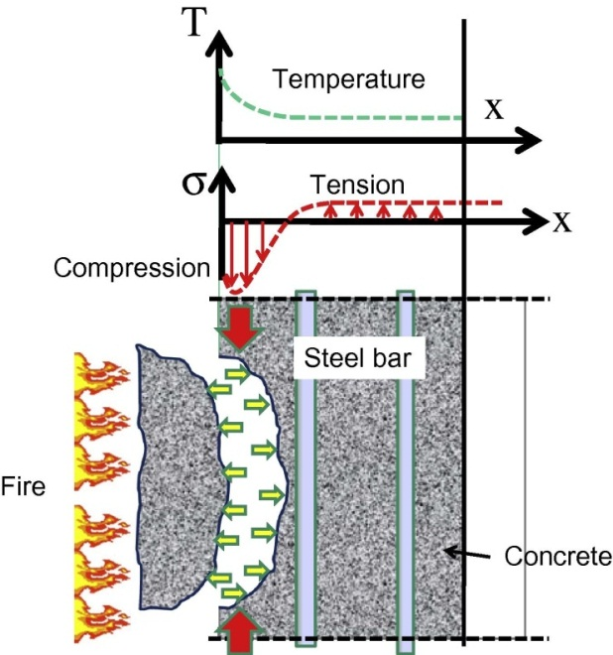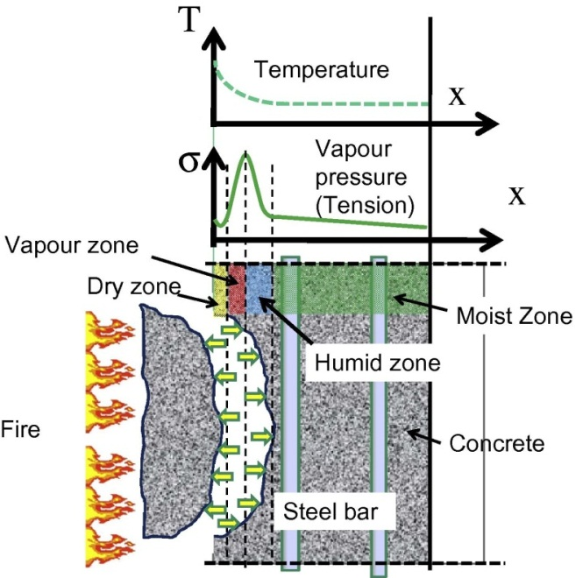
a) Thermal dilation b) Vapour pressure
Fig. 3: Spalling mechanism (adopted from [236])
A similar behavior can also be observed in concrete structures reinforced with fibers because the addition of fibers enhances shear resistance more effectively than flexural resistance [238,239]. Accordingly, the addition of high fiber dosage to GPC beams results in high flexural response with flexural cracks. Moreover, the addition of PFs exhibits a similar but less effective effect on reducing shear cracks due to PF’s inferior stiffness and less amount of fibers bridging the cracks [240]. The addition of fibers can help mitigate or even prevent the spalling of the concrete cover of GPC beams because of the crack bridging effect; spalling is due to the reflected tensile stress waves [241]. In another study, the use of smaller aggregates (10 mm) increased spalling and resulted in the formation of large cracks in GPC; by contrast, the use of larger aggregates exhibited better performance under elevated temperatures [104]. However, concrete deteriorates when exposed to high temperatures. Fire-induced concrete deterioration can also be classified into three types: i) thermo-hygral (TH) damage, i.e., pore pressure builds up in concrete at 220 °C−320 °C due to the blockage of moisture; ii) thermochemical (TC) damage, which is due to the decomposition of CaO at temperatures higher than 700 °C; and iii) thermomechanical (TM) damage, in which external loads and thermal gradients cause thermal stress at 430 °C−660 °C [242]. Notably, the incorporation of PP moderates the damage in concrete [243,244].
For example, the addition of PP at below 150 °C results in minute weight losses in the concrete, but such losses increase substantially between 150 °C and 350 °C [245]. Moreover, PP fibers typically melt at temperatures ranging from 166 °C to 170 °C [246,247]. The type and geometry of fibers also affect the pore pressure of high-strength concrete after fire exposure. For example, the use of 12 mm PP fibers exhibited higher resistance to fire damage compared with when 6 mm PP fibers was utilized [248]. Moreover, the use of 12 mm PP fibers demonstrated better performance than that of using 6 mm PP fibers at a high temperature of 600 °C [249]. The addition of 1.0% PP fibers at 600 °C achieved higher toughness and lower residual strength of concrete [250]. Fig. 4 shows the typical appearances of plain and fiber-reinforced concrete specimens after heating–cooling cycles at 600 °C. The figure clearly shows that plain concrete suffered from severe cracking and partial spalling after being subjected to high temperature. Moreover, visible cracks are deep and extended around the surface of the plain concrete specimens. By contrast, Fig. 4 shows less cracking in the RGPC specimens; that is, cracks appear shallower and shorter compared with those in the plain concrete specimens. A conclusion can be drawn that GPCs and alkali-activated materials (AAMs) exhibit better fire resistance than OPC concrete [102,251,252].
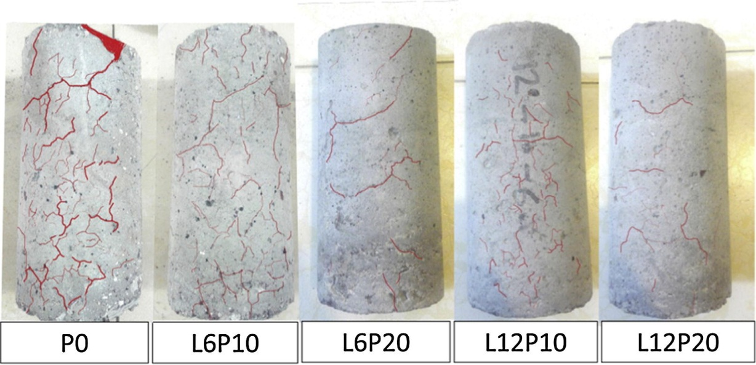
Annotations: Plain concrete (P0), 6 mm in length PP fiber with fiber dosage of 1 kg/m³ (L6P10), 6 mm in length PP fibre with fiber dosage of 2 kg/m³ (L6P20), 12 mm in length PP fibre with fiber dosage of 1 kg/m³ (L12P10), and 12 mm in length PP fibre with fiber dosage of 2 kg/m³ (L12P20)
Fig. 4: Density of cracks in specimens after heating–cooling cycle at 600 °C (adopted from [249])

Physical inspection of RF-RGPC matrix
The incorporation of fibers as reinforcement can significantly alter concrete brittleness, and a significant breakthrough in concrete technology was recently achieved using fibers in RGPC. The physical inspection of neat GPC and GPC composites at high temperatures of 200 °C, 400 °C, and 800 °C is illustrated in Fig. 5 [153]. Neat GPC exhibits higher amount, width, and length of thermal cracks than GPC composites. Cracks increase further as temperature increases. This result can be explained by the dehydration/dihydroxylation of GPC and the volumetric expansion of unreacted SiO₂ [253]. Moreover, the presence of high thermal resistant thin carbon microfibers can possibly bridge cracks and cause the development of thermal cracks at higher temperatures [254]. The initial peak loads observed at ambient and 4 h curing durations were similar, but a higher initial peak load was observed when curing until 24 h [58]. Similarly, a higher ultimate peak load and a notably steeper softening post-ultimate peak were observed after 24 h of curing. This result was mostly attributed to the enhanced PVA fiber–matrix bond developed during prolonged heat-curing duration, resulting in fiber fracture with low energy toughness. Another study also reported the high performance of RF-RGPC due to the remarkably high fiber–matrix interfacial bond between macro RSFs and the cementitious matrix [255]. Shaikh [199] observed enhanced performance when a high RSF content of 2% was added primarily due to the higher ultimate load with higher RSF modulus. In another study, SF-RGPC exhibited no crack at 400 °C but showed signs of cracks at 600 °C [256]. Significant cracks were observed on the surface at 800 °C, but no major surface cracking occurred, although fine cracks were formed in a few locations [256].

Properties of RF-RGPC

Microstructure property
The use of fibers in concrete helps improve ductility, cracking resistance, impact resistance, and durability properties [257–259]. It is also effective in improving the tensile strength and thermal insulation of lightweight concrete [260–264]. Moreover, the addition of fibers helps reduce the growth of initial cracks and improves the shrinkage and early-age tensile strength of concrete [265,266]. Concrete with two different types of fibers exhibits higher ductility and impact resistance [267,268]. For example, the addition of PP and glass fibers improves the bonding of the fibrocement paste interface, and thus, increases strength [269]. The formation of cracks and low sturdiness in concrete are primarily due to differential volume changes within the concrete matrix that result from temperature variation in concrete [270]. Rudnik [271] concluded that the addition of PP fibers with a length of 12 mm and dosage levels of 1.8−3 kg/m³ achieved inconsiderable thermal stability when concrete specimens were heated from 100 °C–600 °C. However, residual concrete properties increased when PP fibers were utilized at 1, 2, and 3 kg/m³ dosage levels, w/c of 0.3, 0.35, and 0.4, and heating temperatures ranging from 100 °C to 600 ° [272]. From the literature, a conclusion can be drawn that the inclusion of RFs can improve the properties of RF-RGPC. Fig. 6 shows the SEM micrographs of neat GPC and GPC composites at different temperature exposure levels.
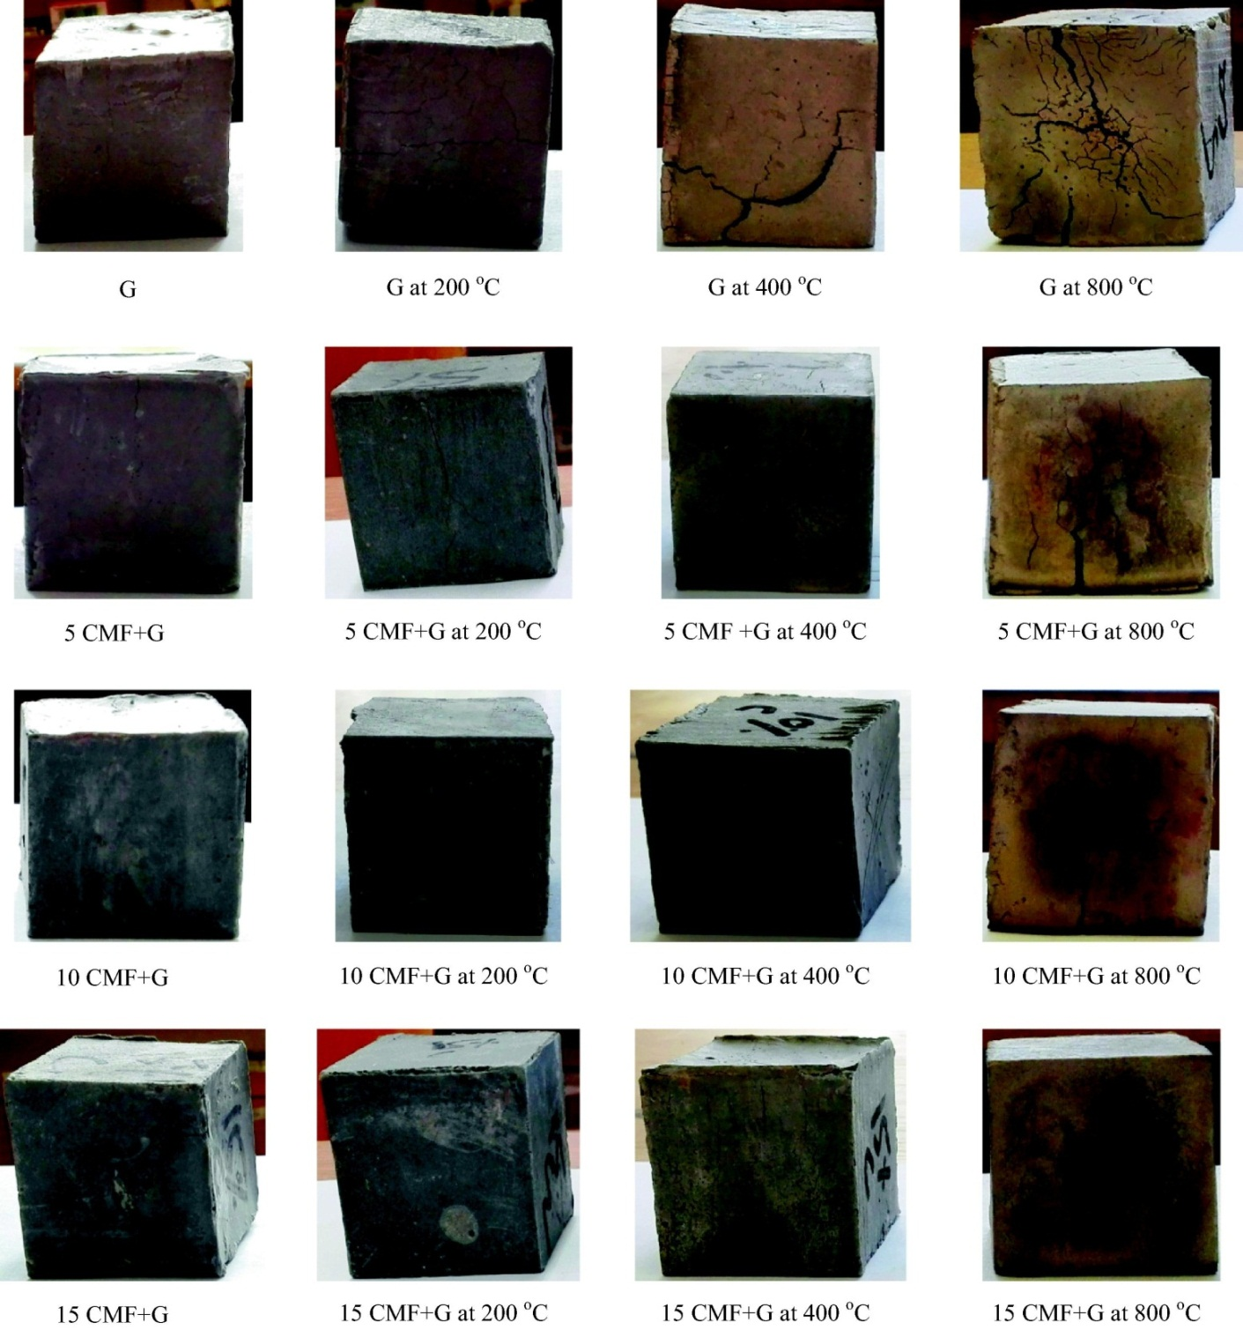
Fig. 5: Physical inspections of carbon microfiber GPC composites after exposure to elevated temperatures (adopted from [153])
Before exposure to high temperatures, a dense and homogeneous matrix that consisted of aluminosilicate gel was observed in all the samples [153]. No degradation of RCFs occurred under alkali action on the smooth surfaces of RCFs in the GPC matrix. The presence of a GPC layer on the fiber ends pulled out from the matrix confirmed the strong adhesion between the GPC gel and fiber surface [273]. In addition, crack deflections caused by carbon microfibers resulted in the formation of curvilinear small cracks in the GPC composites, whereas straight cracks were detected on the fractured surfaces of neat GPC (Fig. 6) [153]. Hence, a conclusion can be drawn that the inclusion of carbon microfibers can be advantageous in preventing any catastrophic fracture of GPCs. In addition, the use of carbon microfibers helps decrease thermal stresses and restricts the swelling of unreacted GPC phases, indicating their high thermal resistance. Therefore, carbon microfibers are suitable for high-temperature applications.

Thermal resistance
As mentioned earlier, GPC composites exhibit higher thermal resistance than the conventional OPC concrete [273,274]. The thermal resistance of fiber-reinforced geopolymer composite (FRGC) typically depends on the mix design of GPC, fiber type, dosages, and its thermal compatibility. The use of carbon FRGC resulted in 60% residual tensile strength (nearly 245 MPa) when subjected to fire at 800 °C [152]. Another study reported 50% residual compressive strength when micro carbons were added to FRGC [153]. Similarly, the control of cracks and improvement in bending at high temperatures were effective when RCFs were utilized in MK/FA-based GPC composite [102]. However, incorporating chopped RCFs at temperatures between 20 °C and 700 °C did not exert any significant influence on compressive strength, although improvement in residual bending strength was observed at temperatures ranging from 20 °C to 500 °C. The use of 50% MK, 50% FA, and 2% chopped RCF is recommended to produce an efficient fire-resistant material.
The incorporation of RCFs has also been reported to enhance the thermal efficiency of carbon FRGC [102,151–154]. The addition of 0.5 vol.% of RSFs retained the strength of FRGC at 600 °C [157]. In another study, the addition of chopped alumina FRGC maintained flexural strength by approximately 59% and 49% when exposed to fire at 800 °C and 1050 °C [162]. Meanwhile, the incorporation of a steel mesh layer into 125–175 mm-thick GPC panels achieved a high heat transfer rate and less cracking/spalling after being subjected to fire for 2 h. Consequently, superior fire endurance with a residual load capacity within the range of 61%–71% was demonstrated by the FRGC panels compared with the OPC panels.

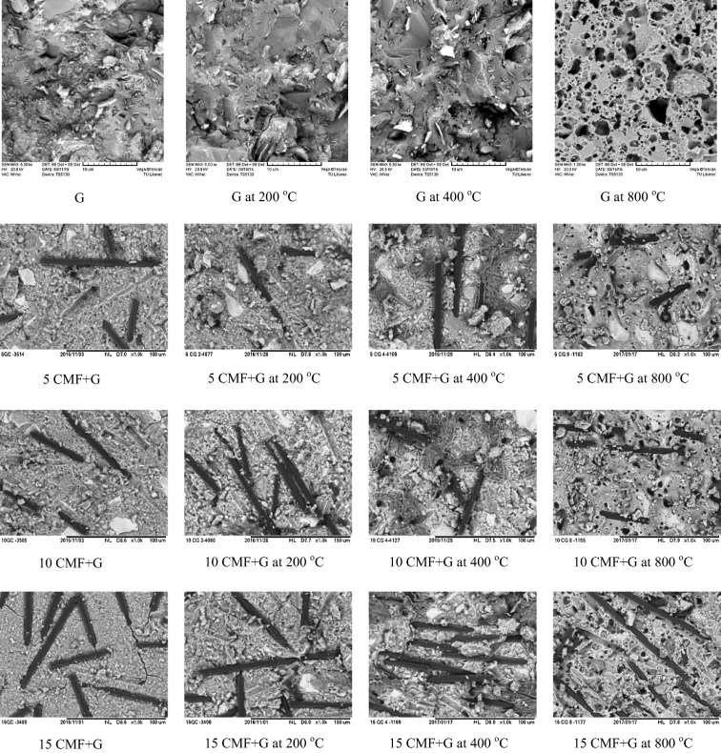
Fig. 6: Typical fracture surface microstructure of carbon microfiber GPC after exposure to elevated temperature (adopted from [153])

Compared with OPC concrete, steel fiber-RGC specimens presented higher residual strength due to the recorded less internal damage caused by lower temperature differential. This finding indicates the superior fire resistance of steel FRGC compared with OPC concrete. It is also reported that similar findings when steel FRGC specimens were exposed at high temperatures [275].
The addition of inorganic fibers, such as RBFs, improves the residual mechanical strength of GPC when subjected up to 1000 °C; such improvement is mostly attributed to enhanced fiber–matrix bonding [146]. However, lower strength loss was also reported due to the maintenance of shape, length, and mechanical integrity by RBFs after exposure to fire [276]. Improved residual strength with low volumetric shrinkage and low mass loss in FA-GPC composites was also achieved when carbon and RBFs were utilized at 1 wt.% [277]. In addition, the use of RCFs demonstrated better post-fire exposure performance compared with basalt FRGC largely due to its compact composition, high fiber–matrix bonding, and less voids. Meanwhile, the addition of silicon carbide or AR-RGF improved thermal stability and residual strength when exposed to high temperatures of up to 1000 °C [148,149]. By contrast, incorporating synthetic fibers into GPC is not suggested due to high shrinkage and the formation of large voids at high temperatures [146,185,186]. The use of PVA and RBFs to produce foamed GPC improved flexural behavior at high temperatures [146].
Moreover, PVA fibers are suitable under ambient temperature conditions; they can provide high resistance to flexure and help avoid total failure under load. However, PVA fibers can start degrading beyond 150 °C. In such cases, RBFs are more suitable than PVA fibers. Nonetheless, foamed FRGC is suitable as an insulating lightweight material, and it exhibits the capability to enhance insulation capacity and reduce thermal capacity by approximately 30% [144]. Good stability with high residual flexural strength was observed in MK-based GPC when SiF and colemanite waste were utilized at a proportion of 20% and the GPC was exposed to fire at 900 °C [144]. Similarly, the use of aluminum powder and PP fibers in foamed MK-based GPC achieved a minimum fire rating of 60 min although the un-foamed GPC exhibited the best fire rating of 97 min [186]. Furthermore, the use of basalt and PVA fibers in MF-based and colemanite-based GPC realized higher residual strength and better structural integrity even at high temperatures of 200 °C, 400 °C, and 600 °C [278].

Fracture energy
Previous studies reported that the inclusions of fibers may decrease residual compressive strength after exposure to fire; however, fracture energy after fire exposure is significantly higher than before fire exposure [279]. For example, the addition of RSFs to GPC improves ductility and enhances fracture energy and the stress intensity factor [191]. Although the bending and rupture characteristics of GPC are similar to those of OPC, GPC has better post-peak characteristics. The bending strength and energy absorption capacity of FA-based GPC is significantly improved with the addition of steel microfibers [280]. In another study, an increase in fiber volume increased the composite strength of GPC when subjected to stress while reducing cracking spacing and width [281]. Moreover, an improvement in the fracture energy of FA-GPC with reduced propagation of cracks was observed with the addition of 0.75% of RSFs (by volume) [191]. Kim et al. [119] demonstrated that the incorporation of 0.5%–2% of hooked RSFs (0.5 mm diameter and 30 mm length) improved the fracture toughness of slag-based GPC largely due to bridging action. Similarly, the use of 2% straight copper-coated RSFs (0.18 mm diameter and 13 mm length) enhanced fractural toughness [282]. In another study, an improvement in fracture energy of approximately 2.2–3.6 was observed when RSFs with grade 45 was added to normal weight concrete [283]. As cracks propagate in the concrete matrix, effective stiffness is reduced due to fracture [284,285]. Hence, a conclusion can be drawn that the improved ductility and better post-cracking responses of RGPC and normal reinforced concrete can be indicated by their higher toughness.

Fire resistance
Since the inception of GPC technology, its capability to resist fire has been comprehensively studied to understand and develop heat-resistant, nonflammable, noncombustible materials as early as the 1970s [3]. GGBFS is an excellent material that can be utilized to develop fire-resistant GPC [251]. As K₂O content in GGBFS increases, the setting time, compressive strength, and fire resistance of GPC increase [23]. GPCs has higher thermal resistance than OPC concrete [274]. The fire resistance of RF- incorporated GPC is dependent on GPC and fiber properties, along with thermal compatibility between fibers and the matrix [273]. Compared with OPC concrete, heat passes more swiftly in GPC specimens when subjected to fire [106]. The color of GPC specimens change from brown to red beyond 650 °C. Noteworthy spalling occurred in the OPC concrete specimens at temperatures ranging from 800 °C and 1000 °C. Meanwhile, spalling was not observed in the GPC specimens when they were subjected to the same temperatures. At 400 °C, 650 °C, 800 °C, and 1000 °C, visible cracks were found on the surfaces of the OPC concrete specimens, whereas inconsequential cracking was observed on the surface of the GPC specimens at 800 °C and 1000 °C. This finding indicates the improved cracking resistance and spalling of GPC concrete when exposed to fire. The damage pattern, visual appearance, and color alteration of GPC specimens after being subjected to high temperatures was reported by Lahoti et al. [108], wherein the evaporation of free water from the pores occurred on the specimens at 300 °C and several extensive and finer cracks were observed. By contrast, the GPC specimens exhibited a more perceptible smashup through cracks at 900 °C fire exposure. Mathewa and Joseph [110] demonstrated that at 800 °C fire exposure, the GPC beam specimens with 20 mm concrete cover cracked at 66% of the cracking load at ambient atmospheric temperature, while only 75% of the referred load was observed with the beam with 40 mm concrete cover. Rickard and Riessen [286] observed that the tested GPC panels exhibited surface cracks on cold and hot sides after fire testing. In their study, cracking originated from the cold phase of the tested panels only after the early dehydration of 1 h ended, suggesting the absence of wide-ranging damage through water evaporation. The discrepancy shrinkage from the hot phase to the cold phase of the specimen can be the reason for the formation of cracks during the cold phase of the tested specimens [287].
The use of basalt and carbon fibers exhibited the peak point of failure in GPC after flexural resistance [288]. Vickers et al. [289] observed thermal stability enhancement due to the addition of fibers [288]. The compressive strength of FA-based GPC (Si:Al augmented ratio from 2 to 3) was inferior to 20 MPa when the samples were fired at 1000 °C. When Si:Al was less than two, the drift in compressive capacity was reversed by a 132% boost in compressive strength consequent to thermal resistance for the control mix [289]. Cao et al. [290] concluded that FA-based GPC blended with calcium aluminate cement (CAC) concrete exhibited higher resistance to fire than OPC concrete at 200 °C–800 °C. Moreover, cement-based concrete was more sensitive to chemical decomposition due to higher temperatures. By contrast, GPC mortars were more stable and durable with the inclusion of CAC, improving fire resistance. Another study reported that the compressive strength of GPC is enhanced as PVA fiber ratio increases when exposed to high temperatures of 20 °C, 400 °C, 600 °C, and 800 °C, as shown in Fig. 7 [185].
Reportedly, the GPC is as brittle as cement concrete, and using recycled PET fiber to RGPC rather than virgin polymeric fibers will promote environmental acceptability of RGPCs significantly [291]. The incombustibility of GPCs along with the excellent high-temperature resistance of inorganic and carbon fibers can also be employed to make composites for applications, for example, to improve the thermal resistance [292]. When recycled fibers are used, the high-temperature recital of RGPC composites is influenced not only by the intrinsic features of GPC or fiber, but also by the thermal compatibility of the matrix and the fiber [52]. Recycled PET bottles to make fiber has recently been shown to have a bright future in the construction industry, after verification of fire performance based on testing numerous R-PET-RGPCs under temperatures range between 400 – 1050 °C [52]. The molecular mass, polydispersity, and degree of crystallinity of PE fibers all play a role in their characteristics [179]. When alternative inorganic fibers, such as silicon-carbide or AR-glass, were utilized in GPCs, high thermal stability was observed at temperatures up to 1000 °C [148]. However, at high temperatures, some investigations found flaws in various inorganic fiber composites. A recycled basalt fiber-reinforced GPC, for instance, had a flexural strength of 194 MPa up to 600 °C without substantial degradation, but melted and crystallized at higher temperatures [150]. This can exacerbated by oxygen transfer through the porous matrix [151]. Only one study has been reported on the behavior of MK-based, heat-cured (at 45°C) GPC reinforced with recycled PET fiber [293]. The strength of the MK-based GPC composite was found to be reduced when the PET fibre volume fractions increased. Hardening behavior and bending strength of PET fibre RGPC composites (ambient cured) containing 1.5% PET fibre, on the other hand, was found to be higher than those of PVA counterparts [291]. PET fibers offer mechanical characteristics that are comparable to PP and nylon fibers, where they are more economical and ecologically friendly to produce [294].

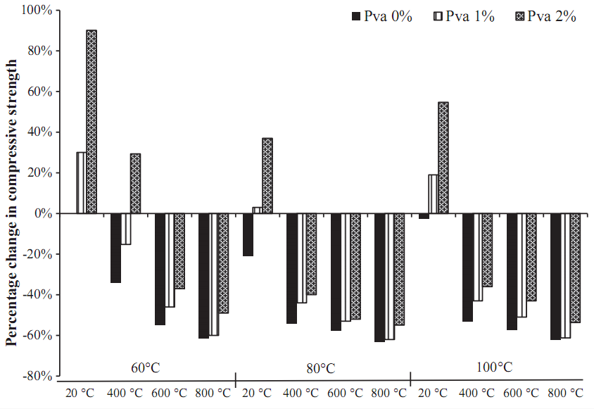
Fig. 7: Effect of PVA on the fire resistance of GPC (adopted from [185])

Despite the fact that research and recycled inorganic fibers are still in their early life, the distinctive portfolio of characteristics that micro/nano-carbon fibers bring to the game is being used to develop GPC composites with greater energy dissipation as well as high thermal and electrical conductivity [52,295]. This is linked to more local fractures near the fibers, which reduces the GPC composite's strength [171]. They also avoid stress concentration and local fractures by converting internal concentrated stresses applied in diverse orientations into a uniform distribution [295]. Furthermore, a carbon fiber GPCs with a tensile strength of about 245 MPa was reported to retain about 60% of its strength after being exposed to fire of 800 °C [152]. At 800 °C, recycled micro-carbon fiber-RGPCs had a nearly identical results, retaining over 50% of the compressive strength [153]. This is because at high temperatures, the contact between binder and carbon fiber is sufficient, preventing crack development and matrix distortion [92,151,154]. Furthermore, it was found that Sol-SiO₂ impregnation improved the strength properties of recycled carbon fiber-RGPC by about 35% at increased temperatures up to 900 °C and prolonged carbon fiber degradation [155]. Despite their excellent hardened properties, thermal resistance, and fracture energy; carbon fiber-RGPCs are limited in their practical uses due to its high cost and thermal decomposition of carbon at extreme temperatures [151,156].
A low-temperature and volatilizable decomposable fibers are not suggested for high-temperature applications because their disintegration at high temperatures causes considerable porosity and shrinkage creation in the GPC composites [184–186,296]. Some niche applications for recycled PVA and PE fiber-RGPCs have been investigated due to their high strengths, flexibility and stiffness, ductility, and hydrophilic nature, including the advancement of residual stresses GPC composites, which necessitate a concrete with impact resistance and ultra-high ductility [297,298]. Nevertheless, the high chemical interaction of PVA combined with the low lateral resistance of PVA fibers causes fiber rupture, limiting the tensile strain capacity of the GPC composite (cured at 60 °C) [297]. Due to its intrinsic hydrophobic features, PVA fibers has poor low modulus of elasticity, thermal resistance, and interfacial contact with GPC matrices (as it was stored in ambient conditions with an average temperature and humidity of 32°C) [171]. A comparable use for PP fiber-RGPC has been investigated in addition to making the composite more economical and eco-friendly [171,190]. Recycled PP fibers provide a number of advantages over synthetic fibers, including lightweight characteristics, low thermal conductivity, cost efficiency, and alkali and acid resistance [299]. The effect of basalt fiber on the strengths, shrinkage, and morphology of FA-based GPC is also investigated. It is discovered that basalt fiber improves the rate of CASH, CSH, and NASH formation, which can improve the paste's durability and mechanical characteristics [300].
The influence of PP fibers on the flexural strength of GPC composites has also been reported [224]. The effect of steel, PP, and polyvinyl alcohol fibers on GPC composites was investigated, and it was discovered that they boost the flexural strength of the GPC composite significantly [222]. The inclusion of fibers can greatly minimize or even prevent shrinkage strains in some circumstances. It has been stated that adding 0.5% PP fibers or steel fibers reduces shrinkage substantially, whereas adding 2% steel fibers nearly eliminates shrinkage [52,190,280]. In most circumstances, the fracture and creep of a GPC composite is less than that of an OPC composite [52,301]. A 5% recycled steel fiber-RGPC has been found to retain strength up to 600 °C [157]. Another study found that when recycled steel reinforced GPC is heated to 800 and 1050 °C, it retains roughly 59% and 44% of its flexural strength, respectively, and that alumina chopped fiber can be employed to enhance the GPC for a higher yield strength at high-level of temperatures [162].
In addition, inorganic fibers are less expensive than regenerated recycled carbon fibers when it comes to high-temperature resistance. When recycled basalt fiber-reinforced GPC was exposed to high temperatures up to 1000 °C, the hardened properties increased, which was ascribed to better basalt fiber-to-matrix adhesion after sintering [296]. At 600–1000 °C, MK-based GPCs reinforced with high recycled refractory particles and alumina fibers showed improved strength preservation as well as increased energy absorption. This is due to the high thermal stability fibers governing the volumetric shrinkage of the composite [147]. Furthermore, microhardness study demonstrated that the fiber is a critical for the geopolymeric binder's bonding. Similarly, the use of steel fibers in GPC are also utilized in GPCs to prevent shrinkage and improve heat resistance, fracture energy, fire resistance, fracture energy, high temperature, and post-cracking behavior [280].

Elevated temperature
GPC exhibited the best possible shrinkage of 17% at 1000 °C, but the value declined to 12%–13% when alumina and quartz were added [302]. When mineral fibers of wollastonite was utilized in MK-based GPC, its stiffness was enhanced as the volume of fibers increased to 5% and matched well with the high level of pH used in the formation of GPC [287]. The inclusion of basalt, glass, and carbon fibers can enhance the fire-resistance performance of GPC. Dissimilar specimens upheld 50% of the flexural strength of GPC specimens after 1 h and 2 h of thermal exposure at 600 °C and 1000 °C when glass, carbon, and basalt fibers were utilized. Good-quality adhesion was observed within the GPC matrix [287]. The behavior of GPC is altered by viscous flow appearance, while fibers depend on the different dilatometric coefficients at 1000 °C. Subsequently, the addition of fiber reinforcement to the GPC matrix contributes to its improved mechanical performance and heat resistance, with carbon and basalt fibers exhibiting the best performance. In general, the shrinkage of GPC is estimated at a high temperature of 1000 °C [303]. Duan et al. [304] demonstrated that MK-based and FA-based GPC demonstrated superior durability and microstructural characteristics over OPC concrete when exposed to higher temperatures. The physical characteristics of fibers, matrix, and RFGPC at room temperature were reported in Samal [105]. The differential scanning calorimetry curve of the GPC composite exhibited two peaks. The first peak occurred at 101 °C (helped in water vapor evaporation and dehydration); the second peak contributed to the mass loss of GPC at 248 °C [305]. The cured fly ash-based GPCs had a brownish-gray appearance, as shown in Fig. 8 [306]. It is found that the color of these fly ash-based GPCs turned into "redden" after subjecting to different levels of temperatures (after firing). During this extreme exposure to temperature, iron species originally trapped inside fly ash particles oxidized. The degree of "reddening" in the fly ash-based GPC with iron oxide concentration of 16.4wt% was seen to be proportional to the iron content, changing color more considerably than the same fly ash-based GPC obtained from different source with iron oxide content of 4.1wt% [306]. The structural alterations that occurred after fire may be seen with the naked eye. In samples heated to higher than 600°C, macrocracks can be visible in this fly ash-based GPC (Fig. 8). Furthermore, Table 3 summarizes the influences of the parameters of the RFs on the properties of RF-RGPC composites.
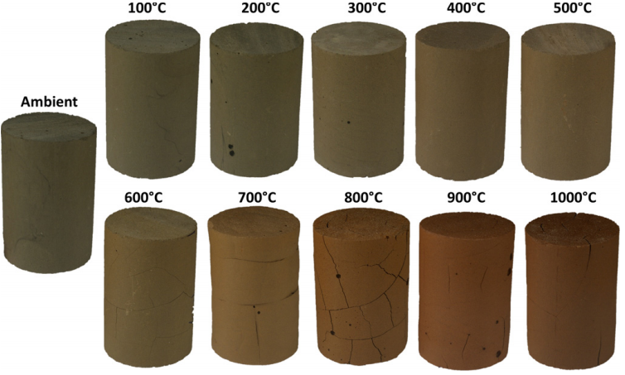
Fig. 8: Photographs of GPCs ﬁred to different levels of temperatures (Adapted from [306])
Table 3. Influences of the parameters of the RFs on the properties of RF-RGPC composites
Type of RFs | Dosage in concrete, vol% | Size of fibers, mm |  |  |  |  | Properties |  |  |  | Curing condition, °C | Key findings  (√) Improved properties and (-) unknown |  |  |  |  |  |  | Refs.
 |  | Diameter | Length | Width | Thickness | Young’s modulus, GPa | Specific gravity | Tensile strength, MPa | Density, g/cm³ (Ultimate strain) | Elongation, %/ melting point, °C |  | Delay cracking and prevent damage | Increase strengths and elastic modulus | Ductility index and shrinkage | Absorption, sorptivity, and chloride penetration | Stiffness and toughness | Post-cracking and energy absorption | Fire resistance
WPFs | 0.5, 1.0, 1.5, and 2.0 | - | 30 | 4 | 0.35 | - | 1.12 |  | - | - | 21 ± 2 | √ | √ | √ | - | √ | - | √ | [307]
PET | 0.5 and 1.0% | - | 50 | 2 | 0.5 | - | 1.38 | 155 | - | - | 21 ± 2 | √ | - | √ | - | √ | √ | √ | [308]
WCFs, PP | 0.5, 1.0, 1.5, and 2.0 | 0.45 | 30 | - | - | - | - | 32.4 | 940 kg/m³ | 170 | 27 ± 2 | √ | √ | - | - | √ | √ | √ | [309]
PP | 0, 0.91, and 4.55 kg/m³ | 0.45 | 20 | - | 45 AR | - | - | - | 1020 g/lit | - | 20–500 | √ | √ | √ | √ | √ | √ | √ | [310]
PET | 1.0 | 1.1 | 40, 52 | - | 0.7 | - | 1.34 | 550, 263, 274 | (27, 26, 19, 29) | - | ~20 | √ | √ | √ | - | √ | - | √ | [311]
PP | 4.0 kg/m³ and 6.0 kg/m³ | - | 47 | 1.5 | 0.7 | 3129 | - | 284.1, | - | 12.6 | 110–250  20 ± 2 | √ | √ | √ | - | √ | √ | √ | [312]
PET | 0.5, 0.75, and 1.0 | - | 50  50 | 1.3  0.9 | 0.2  0.38 | - | - | 420.7  550 | 1.38,  10.2  0.91, 6 | 11.2,  15 | 20 ± 1 | √ | √ | √ | - | √ | - | √ | [89]
WMPs | 0.25, 0.50, 0.75, 1.0, and 1.25 | - | 20 | 2 | 0.07 | - | - | 600 | 0.915–945 kg | 8–10 | 100 ± 5  50 ± 2 | √ | √ | √ | √ | √ | √ | √ | [313–318]
PET | 0 and 1.0 | - | 50 | - | - | 1017 | 1.38 | 420.7,  5.4 | - | 11.2 | 23 ± 2  20 ± 3 | √ | √ | - | √ | - | - | √ | [319]
Long fibers | 0.6 and 0.8 | 7 | - | 2 | 5 | - |  | 270 | - | - | 21 ± 2 | √ | - | √ | - | - | √ | √ | [320]
PET | 0.5, 1.0, and 1.5 | 0.7 | 40, 30 | - | - | - | 1.34 | 450 | - | - | 40–280 | √ | √ | √ | - | √ | - | √ | [174]
Waste carpet fibers (WCFs) | 2.3, 4.6, 6.8, 9.1, and 11.4 kg/m³ | 0.45 | 20 | - | - | - | - | 400 | 910 kg/m³ | 170 | 20–900 | √ | √ | √ | √ | √ | √ | √ | [321]
PET bottle | 0.2, 0.4, 0.6, and 0.8 | - | 50 | 2.3 | 0.25 | 7.05 | 1.11 | 989 , | 0.91 | 160–170 | 27° ± 2 | √ | √ | √ | - | √ | - | √ | [322]
PP | 0, 0.5, 1, and 1.5 | - | 2–40 | 0.11 | 0.75–107 AR | - | - | 5228 | - | 6–8 | 20–200 | √ | √ | √ | √ | √ | √ | √ | [323]
PET bottle | 0.05, 0.15, and 0.25 | - | 15 | 1.13 | 13.27 AR | - | 0.92 | 31.5 | 0.9 (Ultimate strain,52%) | - | 21 ± 2 | √ | √ | √ | - | √ | - | √ | [324]
PET | 0, 1.5, and 2.5 | - | 50 | 1 | 50 AR | −3100 | 1.38 | 450 | - | - | 21 ± 2 | √ | √ | √ | - | √ | - | √ | [325]
RSF | 0, 0.13, 0.15, 0.19, 0.23, 0.26, 0.40, and 0.46 | 0.25 | 26 | - | - | - | - | 2377 | - | - | 20 ± 2 | √ | √ | √ | - | √ | - | √ | [326]
PET | 13.4 kg/m³ | 1.1 | 40 | - | - | - | 1.34 | 550, 274 | (27, 19%) |  | 20 ± 5 | √ | √ | √ | - | √ | - | √ | [327]
PP WCFs | 0.25, 0.5, 0.75, 1.0, and 1.25 | 0.45 | 20 | - | - | - | - | 400 | 910 kg/m³ | 170 | 21 ± 2 | √ | √ | √ | √ | √ | √ | √ | [328]
PET | 0.75 and 1.0 | - | 40 | 1.2 | 0.4 | - | 1.24 | - | - | - | 21 ± 2 | √ | √ | √ | - | √ | - | √ | [329]
WCFs | 4.73, 9.45, 14.18, and 18.90 kg/m³ | 0.45 | 30 | - | - | - | - | 32.4 | 945 kg/m³ | 170 | 27 ± 2 | √ | √ | √ | - | √ | - | √ | [330]
PET | 0.26, 05 of 0.75% | 30–50 µm | 32 | 2, 5 | 0.1 | 3100 | - | - | - | - | 20° ±2 | √ | √ | √ | - | √ | - | √ | [331]
WCFs | 1.0 vol% | - | - | - | - | - | - | 32.4 | 945 kg/m³ | 170 | 23–170 | √ | √ | √ | √ | √ | √ | √ | [332]
PP | 0, 0.25, 0.5, 0.75, 1.0 and 1.25 | 0.45 | 30 | - | - | - | - | 32.4 | 945 kg/m³ | 170 | 100–800 | √ | √ | √ | √ | √ | √ | √ | [333]
RSF | 6.0%, 2.0 | 0.23, 0.8–1.55 | - | - | - | - | - | 2000  1250 | - | - | 21 ± 2 | √ | √ | √ | - | √ | - | √ | [334]
PET | 0, 1.5, and 3% | - | 40 | 4 | - | - | - | - | 447 kg/m³ | - | 21 ± 2 | √ | √ | √ | - | √ | - | √ | [335]
RSF | 2, 4, 6, and 8 | 0.3–1.3 | 20–60 | - | - | - | - | 1500–1900 | 1.6 g/cm³ | - | 20 ± 2 | √ | √ | √ | - | √ | - | √ | [336]
RSF | 2.0 and 6.0 | 0.2 | 3–22 | - | - | - | - | 2000 | - | - | 20 ± 2 | √ | √ | √ | - | √ | - | √ | [337]
Steel fibers | NA | 0:27 | 12 | - | 47 AR |  | - | 2235 | - | - | ~20 | √ | √ | √ | - | √ | √ | √ | [125]
PP | ~0.45 | 10 μm | 47 | 1.5 | 0.7 | 0.619 | - | 313 | 900–920 | 154–170 | 60–170 | √ | √ | √ | √ | √ | √ | √ | [338]
RSF | 0, 0.5, and 1.0 | 0.25–1 | 20–65 | - | - | - | - | 870 | 3014 kg/m³ | - | 20 ± 2 | √ | √ | √ | - | √ | - | √ | [339]
Waste steel fibers | 0–59.7 kg/m³ | 0.62, 0.29, 1.37, 0.9 | 50,52,60 | - | - | - | - | 1000–1330 | - | - | 20 ± 2 | √ | √ | √ | - | √ | - | √ | [340]
RSF | 10, 15, 20, 22.5, 30, and 35 kg/m³ | 0.22 | 23 | - | - | 200 | - | 2570 | - | - | 22 ± 3 | √ | √ | √ | - | √ | - | √ | [341]
HDPE | 0.5, 1.0 | 100 µm | 3–10 | 100 µm | 40 AR | 0.672 | 2.73 | 25.22 | - | - | 20 ± 2 | √ | √ | √ | - | √ | - | √ | [342]
STF | (0, 0.5, 1, and 1.5%), WTP (0, 0.5, and 1.0%) | 0.22, 0.21 | 23, 8.7 | - | - | 200, 3.21 | - | 2570,  475 | - | - | 20 ± 2 | √ | √ | - | - | √ | - | √ | [343]
Recycled steel fibers | 0, 0.025, 0.50, and 0.75 | 0.4, 1.3 | 20, 40 | - | - | - | - | 2000 | - | - | 21 ± 2 | √ | √ | √ | - | √ | - | √ | [344]
RSF | 0.5–1.5 | 0.15, 0.014 | 2–30  8 ± 1.5 | 150 µm | 13–200 AR | 210 | - | 2850 | 7850 | - | 21 ± 2 | √ | √ | √ | - | √ | - | √ | [345]
PP | 0.013–5.3 | 10 | 3.1–9.5 | 1.1–3.2 µm | - | 47.8–73.1 | - | 11.2–13.9 | 1760–2080 | - | 100–800 | √ | √ | √ | √ | √ | √ | √ | [346]
Waste steel scrap | 0, 0.5,  0.75, and 1.5 | - | - | - | 50–60 AR | 205 | - | - | 7850 kg/m³ | Poisson’s ratio = 0. | 21 ± 2 | √ | √ | √ | - | √ | √ | √ | [347]
PP | ~0.5 | 0.70 | 6 | - | - | 93.1–110 | - | - | 900 |  | 20–50 | √ | √ | √ | √ | √ | √ | √ | [348]
PET | ~0.4 | ~0.5 | 20–25 | 340 µm | 9 AR | 3.83 | - | 108 | - | - | 20 ± 2 | √ | √ | √ | - | √ | - | √ | [349]
Waste steel fibers | 1.5 and 3.0 | 0.6 | 40 | - | - | 200 | - | 1280 | - | - | 21 ± 2 | √ | √ | √ | - | √ | - | √ | [350]
RSF | 0.5, 0.75, 1, 1.5, 2 | 10 μm | 8.7, | 21.1 µm | 20 AR | 3.21 | 3.15 | 475 | 1160 | >210 | 21 ± 2 | √ | √ | √ | √ | √ | - | √ | [351]
Annotations: Aspect ratio (AR), Waste metalized plastic (WMP), Waste plastic fibers (WPFs), Recycled copper fibers (RCF), High-density polyethylene (HDPE).

Multi-scale modeling of RF-RGPCs
A number of studies have attempted to shorten the time it takes to find an acceptable proportional mix to obtain the desired attributes of GPCs, one of which is modeling with the development of empirical equations [352]. There are various methods for modeling the properties of construction materials (for example, RF-RGPCs), such as computational modeling, statistical techniques, and recently developed methods for example regression analysis [353]. The advancement of advanced materials and concrete sciences has created a need to better understand materials and achieve their processes and properties over a wide range of length and time scales [354]. Despite the need for research, little work has been conducted on simulating the polymerization progression of RF-RGPCs [355]. Despite substantial advancements in the use of FR-RGPCs, their efficiency in reinforced matrix has not been fully established. Only a few studies, particularly on the use of steel fibers in GPCs, have been undertaken [161,162,199]. Steel fiber-RGPCs, on the other hand, are of great interest, and various research have been conducted to report on their performance and properties [199].
Analytical and numerical modeling is an intriguing area of these activities that is generally followed in fibre-RGPCs systems. Although modeling studies on RGPCs are restricted, a large number of papers dealing with modeling of specific properties of steel fiber-RGPCs are available. For example, a micromorphic model has been constructed to assess the mechanical characteristics of steel-RGPCs [356]. The effects of formwork surface on the mechanical properties and final orientation of steel fiber-RGPC/OPC concrete are investigated [357]. Given that GPC rises in strength after exposure to high temperatures, GPC's fire resistance is predicted to be superior to OPC concrete, which loses almost all of its strength after exposure to high temperatures at around 800°C [358,359]. There are several simulation tools available for studying the gelation and polymerization processes in GPCs [358]. Until now, the major simulation techniques for studying GPCs are density functional theory, molecular dynamics, molecular mechanics, and Monte Carlo simulations [360]. The fire performance of fly ash-GPC combined with slag is being investigated [361]. The compressive strength of GPC paste measured at ambient temperature ranged from 3 to 83 MPa, and the specimens were tested for fire performance after being exposed to 800 °C. It is discovered that higher initial strength leads to increased residual strength. After 800°C exposure, some specimens with poor beginning strength showed increased strength. It is also discovered that as the initial strength grew, the ductility of the specimen reduced, as evidenced by the compressive stress versus strain curves.
Fig. 9 depicts the 3D characterisation of carbon fiber-RGPCs as well as the interior structure of the GPCs following damage. The 3D image was recreated using the Voxel software program and its internal structure was studied using micro computed tomography [105]. The composite before and after damage with different damage locations revealed a fiber breakage and matrix rupture in the central damage area. As a result, the Si/Al concentration ratio has a considerable influence on the thermal behavior of the GPC matrix, such as shrinkage or cracking. This was attributable to the matrix's denification with decreased porosity. Previous research has shown that geopolymers with a high Al/Si ratio have thermal properties up to 1300–1400 ° C [105]. When exposed to high temperatures, the RF-RGPCs composite exhibits evaporating of hydroxide and gas, which induces more crystalline phase [362]. In the case of MK-GPCs, the crystallisation of dense sodium aluminosilicate phases, notably nepheline, occurred at 800 °C. At 1000 °C, the number of amorphous phases decreases from 66% to 43%. This could be attributed to crystallisation converting into nepheline (NaAlSiO₄) and anortoclase (NaAlSi₃O₈). Mineral phases such as quartz, hematite, and maghemite are likely to have decreased in intensity, implying a drop in quantity [363,364]. These phases have melting points higher than 1000 °C. Quartz and mullite, on the other hand, have melting temps of 1713 °C and1830 °C, respectively.
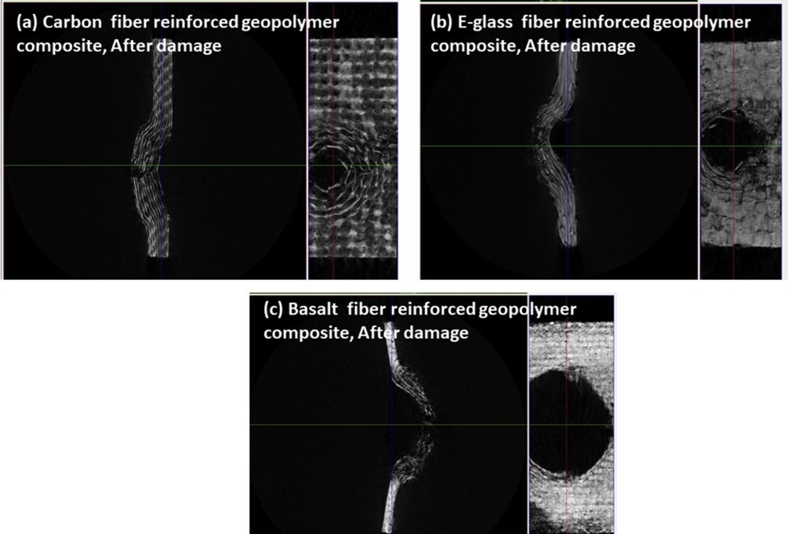
Fig. 9: Fiber breakage analysis at the areas of damage in basalt, carbon, and E-glass fiber-RGP (Adapted from [105])

Moreover, pair distribution function approach was employed to get novel insights into the natural ecosystem of aluminum atoms in MK [365]. Aluminum's environment is critical in precursors since it is thought to be responsible for the increase reactivity of cementitious gel systems [360]. Furthermore, other researchers investigated the local structure of kaolinite precursor material to determine the nanostructures and changes occurring when it is transformed to MK. Wave function-based approaches were utilized to investigate the dissolving mechanisms of Al-Si minerals in very alkaline solutions [366]. According to the major findngs, Al species break more easily than Si, causing them to disperse in preference to Si in the surrounding environment, considerably altering the dissolution enthalpy. Provis and Deventer [367] created a reaction kinetic model for understanding the early stages of polymerization. GPCs are studied using a more scientific approach, which includes numerous of mathematical modelling tools such as pair distribution statistical and thermodynamics functions. The Si/Al species ordering inside the tetrahedral aluminosilicate gel framework was described using a statistical thermodynamic model. This kinetic model concisely detailed raw material dissolving, the rearrangement of xSiOx(OH)4x and monomeric Al(OH)⁻⁴ species discharged from a solid source into diverse aluminosilicates, and the coupling of zeolite and amorphous precursor gel structures [360]. The numerical simulations were compatible with the mechanisms previously postulated to occur during the early stages of polymerization when compared to calorimetric and energy dispersive X-ray diffraction data.
Generally, the model includes gel chemistry information as well as a context for examining the behavior of GPC-forming phases. However, understanding the characteristics of precursor materials is required in order to get precise knowledge about their microscopic structure using advanced and comprehensive and molecular prediction models [368]. As a result, despite earlier efforts, an in-depth understanding of the reaction rates of all atomistic processes happening during geopolymerization remains elusive up-to-date, the researchers, worldwide, are still trying to investigate GPC gels at increased temperatures using computational models and variable quantities of silica and alumina species. Moreover, characteristics such as fly ash, activation method, and silica/alumina ratio of K-A-S-H and N-A-S-H gels that affect RF-RGPC resistance must be explored further [360]. To address these challenges, efficient sophisticated machine learning tools must be used.
The fundamental reasons for the increased tensile strain capacity of temperature variation cured one-part strain hardening geopolymer composite (SHGC) could be described in terms of the two pseudo strain hardening performance indices provided by Kanda [369], which could be estimated based on fiber-bridging micromechanics modeling. Yang et al [370] micromechanics-based model was applied to estimate the fiber-bridging constitutive law σ(δ) of the constructed one-part SHGCs. This showed that both PSH performance indices surpass unity in all developed composites, implying that the requisite micromechanics-based strength and energy conditions of relatively stable flat crack growth are met, resulting in the successive development of numerous cracking [371]. Typically, only one element of a GPC matrix is modelled at the nanoscale [372]. A mesoscale model, on the other hand, is required to gain a better understanding of the interaction effects of different components in a FR-GPC. Furthermore, an understanding of the material's mechanical behavior on the mesoscale is required for accurate design and forecast of its failure mechanisms on the macroscale (structural element scale) [372]. The fracture toughness of steel-fiber-reinforced aluminosilicate GPCS was examined experimentally and modelled using beam elements for fibers and solid finite elements for the GPC [373]. To explicitly characterize the air-void distribution, a numerical modeling system based on the discrete-element method (DEM) was devised, although the mortar binder was specified on the micro/mesoscale while taking into account the cohesive performance of foamed GPCs [374].
Mesoscale simulations were carried out by Shahbazi [375] using a lattice beam model, with concrete considered to be an inhomogeneous material comprised of three phases — cement paste, an aggregate, and an internal transition zone (ITZ). It is reported that GPC was used as possible reinforcing for-aluminum nanocomposites to improve their characteristics and minimize production costs [376]. Fig. 10 depicts the plastic strains in a fiber-reinforced GPC. The numerical model identified locations in the pure bending area where cracks were perpendicular to the beam axis, as found in tests [377]. In tension areas where large plastic deformations in the GPC occurred, the reinforcing bars were exposed to high axial force. The simulation demonstrates that there are plastic strain localisation zones on both sides of the specimen, which correlate to possible cracking zones. In a normal tension test experiment, a comparable damage mechanism can be detected (see Fig. 10) [372].
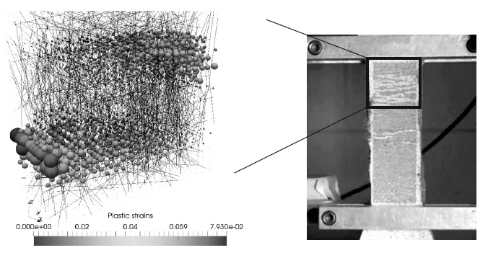
Fig. 10: Plastic stresses in a GPC at 1% axial strain compared with experimental results (Adapted from [378])

Furthermore, the level of structural defects has a major impact on the elastic moduli at the molecular scale, according to numerical simulation of the hardened characteristics of a RSF-GPC [379]. The chemical composition, as measured by the Si:Al ratio, is also important. Results from macroscale experiments in the literature show that E increases with Si:Al [380] As a whole, the analysis demonstrates an analogous, but somewhat weak, trend, with the crystalline structure displaying a continuous rise from Si:Al = 1 to 1.5, and the amorphous and deficient structures revealing a mild increment from Si:Al = 1.5 to 2 [379,381]. However, because the actual observations are on macroscopic samples, the trend in E may be influenced by heterogeneities at greater length scales (e.g., microstructural features) that molecular simulations cannot describe [382]. In contrast to what has been reported in materials with identical chemical compositions at the macroscale, wet skeletal density does not probably be a significant predictor of increases in elastic moduli [379].

Hotspot research topics for future investigations
On the basis of this comprehensive review, the following hotspot research topics were highlighted and recommended for further consideration in future studies and investigations by researchers worldwide.
- A green construction material with excellent fire and mechanical performance is required for structural applications [35].
- A few studies dealt with RGFs, textile fibers, carbon fibers, and recycled tire steel fibers as they presented the highest melting point (1435 °C) in GPC.
- Furthermore, additional research on the performance of these types of RFs at high temperatures is required to investigate the effect of fire on long-term composites [81].
- The long-term performance characteristics of concrete, such as shrinkage, creep, and fatigue life of GPC with RFs, will require a more detailed and comprehensive study in the future.
- A proper mix design is required to achieve significant chemical stability, low volume variations, strength endurance, and spalling resistance [35].
- The parameters for sample aggregate use, choice of precursor, total alkali concentration in GPC, water content, and other variables are crucial and should be monitored. Assuming that GPC will exhibit good fit is also safe [35].
- Further study is necessary to update databases, codes, and realistic design standards while dealing with various fibers, factors, and situations [144].
- Undertaking a comprehensive literature review on current state-of-the-art developments related to the fire performance of RF-RGPC subjected to high temperatures is urgently necessary.
- Different durability properties may result from changes in the structure and properties of GPC paste and the presence of fibers in it. Consequently, testing the durability of ultra-high performance fibred reinforce geopolymer concrete (UHPF-RGPC) in a variety of settings and comparing the findings are critical [383].
- Additional research on the adhesion (onto the concrete substrate) and durability of microfiber-reinforced GPC mortars for rehabilitation is required [58].
- When using fibers to improve the properties of boroaluminosilicate GPC, some elements must be addressed, such as the type of fibers and raw materials used and as their different effects on various properties [202].
- The primary difficulties for cellulose cement composites in the near future are increasing the durability and mechanical performance of these composites without raising production costs [143].
- Water permeability, gas permeability, chloride resistance, and freeze–thaw resistance are some durability features that should be thoroughly investigated.
- To address issues related to fiber dispersion, quality, and workability, further research is required.
- Long-term data on many fresh, mechanical, and durability properties of fiber RGPC composites are lacking, and thus, more studies are highly imperative [144].
- The authors believe that a comprehensive review or investigation of the use of RFs in biology for the fabrication of biodegradable composite materials, electromagnetic absorption, nuclear remediation and transportation, mining engineering, deep sea civil infrastructure, and environmental applications is urgently required [163].
- More studies are necessary to better determine the limiting and crucial temperature limitations of various FRP systems to sustain their effectiveness at high temperatures and during fires [166].

Conclusion
The in-depth review of RF-RGPC as structural material determined that this material is suitable for ensuring long-term durability and providing safety and security to human life and property. Its superior mechanical and durability properties at high temperatures have placed this material as competition cement-based GPC in the construction and infrastructure industries. RF-RGPC has elicited considerable attention and strong interest over the last few decades because of its advantages of low energy cost, high early strength, excellent durability, sustainability, and less brittleness, in addition to its unique fireproof structural material attributable to its ceramic-like properties and inherent inorganic structure.
The addition of RFs to GPC is a strategy for overcoming these limitations and preventing concrete microstructure deterioration. Therefore, the development of RF-RGPC to resist fire has become a research imperative. The use of RFs derived from post-consumer or industrial waste provides additional benefits, such as waste reduction, resource conservation, reduced processing costs compared with virgin fibers, and the elimination of waste disposal in landfills. Moreover, RF-RGPC is a noncombustible, heat-resistant, and inorganic polymer binder made through the alkaline activation of reactive aluminosilicate materials that comprise RFs, which increase its structural reliability. In this regard, conducting a critical literature review on current updates related to the fire performance of RF-RGPC subjected to elevated temperatures and during fires is significantly required. The influence of fire on the mechanical properties of RF-RGPC after exposure to high temperatures was thoroughly reviewed.
The contribution of this work is to adopt the “research into practice” concept by reviewing the fire-resistant behavior of RF-RGPC at high temperatures to introduce this unique, cutting-edge, accessible, and environment-friendly construction material by promoting it as a potentially promising, maintainable, durable, heat- and fire-resistant building material for the current infrastructure and construction industries. All reports agree that this construction material outperforms its OPC competitors. Consequently, RF-RGPC can be positioned at the center of an innovative and necessary transition from the current RF-RGPC to the future’s revolutionary inventive green construction composites with the “go green, think green, act green” concepts.

Acknowledgments: The authors gratefully acknowledge the financial support given by Deanship of Scientific Research at Prince Sattam bin Abdulaziz University, Alkharj, Saudi Arabia and the Department of Civil Engineering, Faculty of Engineering and IT, Amran University, Yemen, for this research.

Conflicts of Interest: The authors declare no conflicts of interest.

References

[1] Davidovits J. Geopolymers. J Therm Anal 1991;37:1633–56. https://doi.org/10.1007/bf01912193.
[2] Amran YHM, Alyousef R, Alabduljabbar H, El-Zeadani M. Clean production and properties of geopolymer concrete; A review. J Clean Prod 2020;251:119679. https://doi.org/10.1016/j.jclepro.2019.119679.
[3] Davidovits J. Geopolymers - Inorganic polymeric new materials. J Therm Anal 1991;37:1633–56. https://doi.org/10.1007/BF01912193.
[4] Nodehi M, Taghvaee VM. Alkali-Activated Materials and Geopolymer: a Review of Common Precursors and Activators Addressing Circular Economy. Circ Econ Sustain 2021. https://doi.org/10.1007/s43615-021-00029-w.
[5] Nodehi M, Aguayo F. Ultra high performance and high strength geopolymer concrete. J Build Pathol Rehabil 2021;6:1–29. https://doi.org/10.1007/s41024-021-00130-5.
[6] Subash, N., Avudaiappan, S., Adish Kumar, S., Amran, M., Vatin, N., Fediuk, R., & Aepuru R. Experimental Investigation on Geopolymer Concrete with Various Sustainable Mineral Ashes. Materials (Basel) 2021;14:7596.
[7] Behforouz B, Balkanlou VS, Naseri F, Kasehchi E, Mohseni E, Ozbakkaloglu T. Investigation of eco-friendly fiber-reinforced geopolymer composites incorporating recycled coarse aggregates. Int J Environ Sci Technol 2020;17:3251–60. https://doi.org/10.1007/s13762-020-02643-x.
[8] Nodehi M. A comparative review on foam-based versus lightweight aggregate-based alkali-activated materials and geopolymer. Innov Infrastruct Solut 2021;6:1–20. https://doi.org/10.1007/s41062-021-00595-w.
[9] Nodehi M, Mohamad Taghvaee V. Sustainable concrete for circular economy: a review on use of waste glass. Glas Struct Eng 2021. https://doi.org/10.1007/s40940-021-00155-9.
[10] Amran M, Debbarma S, Ozbakkaloglu T. Fly ash-based eco-friendly geopolymer concrete: A critical review of the long-term durability properties. Constr Build Mater 2021. https://doi.org/10.1016/j.conbuildmat.2020.121857.
[11] Verdolotti L, Iannace S, Lavorgna M, Lamanna R. Geopolymerization reaction to consolidate incoherent pozzolanic soil. J Mater Sci 2008;43:865–73. https://doi.org/10.1007/s10853-007-2201-x.
[12] Matthes W, Vollpracht A, Villagrán Y, Kamali-Bernard S, Hooton D, Gruyaert E, et al. Ground granulated blast-furnace slag. RILEM State-of-the-Art Reports, 2018. https://doi.org/10.1007/978-3-319-70606-1_1.
[13] Karayannis VG, Moustakas KG, Baklavaridis AN, Domopoulou AE. Sustainable ash-based geopolymers. Chem Eng Trans 2018. https://doi.org/10.3303/CET1863085.
[14] Amran M, Fediuk R, Murali G, Avudaiappan S, Ozbakkaloglu T, Vatin N, et al. Fly ash-based eco-efficient concretes: A comprehensive review of the short-term properties. Materials (Basel) 2021;14. https://doi.org/10.3390/ma14154264.
[15] Onaizi AM, Lim NHAS, Huseien GF, Amran M, Ma CK. Effect of the addition of nano glass powder on the compressive strength of high volume fly ash modified concrete. Mater Today Proc 2021. https://doi.org/10.1016/j.matpr.2021.08.347.
[16] Arularasi V, Thamilselvi P, Avudaiappan S, Flores EIS, Amran M, Fediuk R, et al. Rheological behavior and strength characteristics of cement paste and mortar with fly ash and GGBS admixtures. Sustain 2021;13. https://doi.org/10.3390/su13179600.
[17] Dharmendra S. Ravat SGS, Dave S V. Utilization of Red Mud in Geopolymer Concrete-A Review. Int J Adv Eng Res 2017;4.
[18] Kumar S, Sangwan P, V DRM, Bidra S. Utilization of Rice Husk and Their Ash : A Review. J Chem Environ Sci 2013.
[19] Amran M, Fediuk R, Murali G, Vatin N, Karelina M, Ozbakkaloglu T, et al. Rice husk ash‐based concrete composites: A critical review of their properties and applications. Crystals 2021;11:1–33. https://doi.org/10.3390/cryst11020168.
[20] Siddika A, Amin MR, Rayhan MA, Islam MS, Mamun MA Al, Alyousef R, et al. Performance of sustainable green concrete incorporated with fly ash, rice husk ash, and stone dust. Acta Polytech 2021;61:279–91. https://doi.org/10.14311/AP.2021.61.0279.
[21] Ash RH, Avudaiappan S, Prakatanoju S, Amran M, Aepuru R. Experimental Investigation and Image Processing to Predict the Properties of Concrete with the Addition of Nano Silica and 2021:1–17.
[22] Payá J, Agrela F, Rosales J, Morales MM, Borrachero MV. Application of alkali-activated industrial waste. New Trends Eco-efficient Recycl. Concr., 2019. https://doi.org/10.1016/b978-0-08-102480-5.00013-0.
[23] Amran M, Murali G, Khalid NHA, Fediuk R, Ozbakkaloglu T, Lee YH, et al. Slag uses in making an ecofriendly and sustainable concrete: A review. Constr Build Mater 2021;272. https://doi.org/10.1016/j.conbuildmat.2020.121942.
[24] Atiş CD, Görür EB, Karahan O, Bilim C, Ilkentapar S, Luga E. Very high strength (120 MPa) class F fly ash geopolymer mortar activated at different NaOH amount, heat curing temperature and heat curing duration. Constr Build Mater 2015. https://doi.org/10.1016/j.conbuildmat.2015.08.089.
[25] You S, Ho SW, Li T, Maneerung T, Wang CH. Techno-economic analysis of geopolymer production from the coal fly ash with high iron oxide and calcium oxide contents. J Hazard Mater 2019;361:237–44. https://doi.org/10.1016/j.jhazmat.2018.08.089.
[26] Duxson P, Fernández-Jiménez A, Provis JL, Lukey GC, Palomo A, Van Deventer JSJ. Geopolymer technology: The current state of the art. J Mater Sci 2007;42:2917–33. https://doi.org/10.1007/s10853-006-0637-z.
[27] Khoury GA. Compressive strength of concrete at high temperatures: a reassessment. Mag Concr Res 2009. https://doi.org/10.1680/macr.1992.44.161.291.
[28] Vydra V, Vodák F, Kapičková O, Hošková Š. Effect of temperature on porosity of concrete for nuclear-safety structures. Cem Concr Res 2001;31:1023–6. https://doi.org/10.1016/S0008-8846(01)00516-6.
[29] Komonen J, Penttala V. Effects of high temperature on the pore structure and strength of plain and polypropylene fiber reinforced cement pastes. Fire Technol 2003;39:23–34. https://doi.org/10.1023/A:1021723126005.
[30] Khoury GA. Passive fire protection of concrete structures. Proc Inst Civ Eng Struct Build 2008;161:135–45. https://doi.org/10.1680/stbu.2008.161.3.135.
[31] Zhao J, Zheng JJ, Peng GF, Sun PS. Spalling and cracking modelling of high-performance concrete exposed to elevated temperatures. Mag Concr Res 2017;69:1276–87. https://doi.org/10.1680/jmacr.16.00139.
[32] Abid SR, Murali G, Amran M, Vatin N, Fediuk R, Karelina M. Evaluation of mode II fracture toughness of hybrid fibrous geopolymer composites. Materials (Basel) 2021;14:1–14. https://doi.org/10.3390/ma14020349.
[33] Saradar A, Tahmouresi B, Mohseni E, Shadmani A. Restrained shrinkage cracking of fiber-reinforced high-strength concrete. Fibers 2018;6. https://doi.org/10.3390/fib6010012.
[34] Amran M, Al-Fakih A, Chu SH, Fediuk R, Haruna S, Azevedo A, et al. Long-term durability properties of geopolymer concrete: An in-depth review. Case Stud Constr Mater 2021;15. https://doi.org/10.1016/j.cscm.2021.e00661.
[35] Lahoti M, Tan KH, Yang EH. A critical review of geopolymer properties for structural fire-resistance applications. Constr Build Mater 2019;221:514–26. https://doi.org/10.1016/j.conbuildmat.2019.06.076.
[36] Chithambar Ganesh A, Muthukannan M, Rajeswaran M, Uma Shankar T, Selvam M. Comparative study on the behaviour of geopolymer concrete using M-sand and conventional concrete exposed to elevated temperature. Int J Civ Eng Technol 2018;9:981–9.
[37] Effect of Elevated Temperature over Geopolymer Concrete. Int J Eng Adv Technol 2019;9:450–3. https://doi.org/10.35940/ijeat.a1025.1291s419.
[38] Jiang X, Zhang Y, Xiao R, Polaczyk P, Zhang M, Hu W, et al. A comparative study on geopolymers synthesized by different classes of fly ash after exposure to elevated temperatures. J Clean Prod 2020;270. https://doi.org/10.1016/j.jclepro.2020.122500.
[39] Jiang X, Xiao R, Zhang M, Hu W, Bai Y, Huang B. A laboratory investigation of steel to fly ash-based geopolymer paste bonding behavior after exposure to elevated temperatures. Constr Build Mater 2020;254. https://doi.org/10.1016/j.conbuildmat.2020.119267.
[40] Sarker PK, Haque R, Ramgolam K V. Fracture behaviour of heat cured fly ash based geopolymer concrete. Mater Des 2013;44:580–6. https://doi.org/10.1016/j.matdes.2012.08.005.
[41] Pan Z, Sanjayan JG, Rangan BV. Fracture properties of geopolymer paste and concrete. Mag Concr Res 2011;63:763–71. https://doi.org/10.1680/macr.2011.63.10.763.
[42] Babrauskas V. Fire safety design and concrete. Fire Saf J 1994;23:439–42. https://doi.org/10.1016/0379-7112(94)90007-8.
[43] HARMATHY TZ. THERMAL PROPERTIES OF CONCRETE AT ELEVATED TEMPERATURES. J Mater 1970;5:47–74.
[44] Amran, M., Fediuk, R., Abdelgader, H. S., Murali, G., Ozbakkaloglu, T., Lee, Y. H., & Lee YY. Fiber-reinforced alkali-activated concrete: A review. J Build Eng 2021;45:103638. https://doi.org/10.1016/j.jobe.2021.103638.
[45] Wang Y, Wu HC, Li VC. Concrete Reinforcement with Recycled Fibers. J Mater Civ Eng 2000;12:314–9. https://doi.org/10.1061/(asce)0899-1561(2000)12:4(314).
[46] Onuaguluchi O, Panesar DK. Hardened properties of concrete mixtures containing pre-coated crumb rubber and silica fume. J Clean Prod 2014;82:125–31. https://doi.org/10.1016/j.jclepro.2014.06.068.
[47] Shanthini D, Grija S, Abinaya S, Devaki R. Fibre reinforced geopolymer concrete - A review. Int J Civ Eng Technol 2016;7:435–8.
[48] Zhang H, Sarker PK, Wang Q, He B, Jiang Z. Strength and toughness of ambient-cured geopolymer concrete containing virgin and recycled fibres in mono and hybrid combinations. Constr Build Mater 2021;304. https://doi.org/10.1016/j.conbuildmat.2021.124649.
[49] Shaikh FUA. Tensile and flexural behaviour of recycled polyethylene terephthalate (PET) fibre reinforced geopolymer composites. Constr Build Mater 2020;245. https://doi.org/10.1016/j.conbuildmat.2020.118438.
[50] Shaikh FUA. Mechanical properties of recycled polyethylene terephthalate (PET) fiber-reinforced fly ash geopolymer and fly ash-slag-blended geopolymer composites. Compos. Mater., 2021, p. 265–84. https://doi.org/10.1016/b978-0-12-820512-9.00003-4.
[51] Chithambar Ganesh A, Deepak N, Deepak V, Ajay S, Pandian A, Karthik. Utilization of PET bottles and plastic granules in geopolymer concrete. Mater. Today Proc., vol. 42, 2020, p. 444–9. https://doi.org/10.1016/j.matpr.2020.10.170.
[52] Ranjbar N, Zhang M. Fiber-reinforced geopolymer composites: A review. Cem Concr Compos 2020. https://doi.org/10.1016/j.cemconcomp.2019.103498.
[53] Manzi S, Lancellotti I, Masi G, Saccani A. Alkali-Activated Binders From Waste Incinerator Bottom Ashes and Metakaolin Reinforced by Recycled Carbon Fiber Composites. Front Mater 2020;7. https://doi.org/10.3389/fmats.2020.583400.
[54] Wang Y, Zhang S, Li G, Shi X. Effects of alkali-treated recycled carbon fiber on the strength and free drying shrinkage of cementitious mortar. J Clean Prod 2019;228:1187–95. https://doi.org/10.1016/j.jclepro.2019.04.295.
[55] Saccani A, Manzi S, Lancellotti I, Lipparini L. Composites obtained by recycling carbon fibre/epoxy composite wastes in building materials. Constr Build Mater 2019;204:296–302. https://doi.org/10.1016/j.conbuildmat.2019.01.216.
[56] Tiesong L, Dechang J, Meirong W, Peigang H, Defu L. Effects of fibre content on mechanical properties and fracture behaviour of short carbon fibre reinforced geopolymer matrix composites. Bull Mater Sci 2009. https://doi.org/10.1007/s12034-009-0011-2.
[57] Khan MZN, Hao Y, Hao H, Shaikh F uddin A. Mechanical properties and behaviour of high-strength plain and hybrid-fiber reinforced geopolymer composites under dynamic splitting tension. Cem Concr Compos 2019. https://doi.org/10.1016/j.cemconcomp.2019.103343.
[58] Bhutta A, Farooq M, Banthia N. Performance characteristics of micro fiber-reinforced geopolymer mortars for repair. Constr Build Mater 2019. https://doi.org/10.1016/j.conbuildmat.2019.04.210.
[59] Ranjbar N, Mehrali M, Mehrali M, Alengaram UJ, Jumaat MZ. High tensile strength fly ash based geopolymer composite using copper coated micro steel fiber. Constr Build Mater 2016;112:629–38. https://doi.org/10.1016/j.conbuildmat.2016.02.228.
[60] Luo X, Xu JY, Li W. Basalt fiber reinforced porous aggregates-geopolymer based cellular material. Funct Mater Lett 2015;8. https://doi.org/10.1142/S1793604715500058.
[61] El-Sayed TA, Shaheen YBI. Flexural performance of recycled wheat straw ash-based geopolymer RC beams and containing recycled steel fiber. Structures 2020;28:1713–28. https://doi.org/10.1016/j.istruc.2020.10.013.
[62] Zhong H, Zhang M. Effect of recycled tyre polymer fibre on engineering properties of sustainable strain hardening geopolymer composites. Cem Concr Compos 2021;122. https://doi.org/10.1016/j.cemconcomp.2021.104167.
[63] Wang Y, Chan CL, Leong SH, Zhang M. Engineering properties of strain hardening geopolymer composites with hybrid polyvinyl alcohol and recycled steel fibres. Constr Build Mater 2020;261. https://doi.org/10.1016/j.conbuildmat.2020.120585.
[64] Samal S, Thanh NP, Petríková I, Marvalová B. Improved mechanical properties of various fabric-reinforced geocomposite at elevated temperature. JOM 2015;67:1478–85. https://doi.org/10.1007/s11837-015-1420-x.
[65] Assaedi H, Shaikh FUA, Low IM. Effect of nanoclay on durability and mechanical properties of flax fabric reinforced geopolymer composites. J Asian Ceram Soc 2017;5:62–70. https://doi.org/10.1016/j.jascer.2017.01.003.
[66] Alomayri T, Shaikh FUA, Low IM. Synthesis and mechanical properties of cotton fabric reinforced geopolymer composites. Compos Part B Eng 2014;60:36–42. https://doi.org/10.1016/j.compositesb.2013.12.036.
[67] Alomayri T, Shaikh FUA, Low IM. Thermal and mechanical properties of cotton fabric-reinforced geopolymer composites. J Mater Sci 2013;48:6746–52. https://doi.org/10.1007/s10853-013-7479-2.
[68] Yan L, Kasal B, Huang L. A review of recent research on the use of cellulosic fibres, their fibre fabric reinforced cementitious, geo-polymer and polymer composites in civil engineering. Compos Part B Eng 2016;92:94–132. https://doi.org/10.1016/j.compositesb.2016.02.002.
[69] Assaedi H, Shaikh FUA, Low IM. Influence of mixing methods of nano silica on the microstructural and mechanical properties of flax fabric reinforced geopolymer composites. Constr Build Mater 2016;123:541–52. https://doi.org/10.1016/j.conbuildmat.2016.07.049.
[70] Assaedi H, Alomayri T, Shaikh FUA, Low IM. Characterisation of mechanical and thermal properties in flax fabric reinforced geopolymer composites. J Adv Ceram 2015. https://doi.org/10.1007/s40145-015-0161-1.
[71] Amalia N, Hidayatullah S, Nurfadilla, Subaer. The mechanical properties and microstructure characters of hybrid composite geopolymers-pineapple fiber leaves (PFL). IOP Conf. Ser. Mater. Sci. Eng., vol. 180, 2017. https://doi.org/10.1088/1757-899X/180/1/012012.
[72] Amalia F, Akifah N, Nurfadilla, Subaer. Development of coconut trunk fiber geopolymer hybrid composite for structural engineering materials. IOP Conf. Ser. Mater. Sci. Eng., 2017. https://doi.org/10.1088/1757-899X/180/1/012014.
[73] Silva G, Kim S, Aguilar R, Nakamatsu J. Natural fibers as reinforcement additives for geopolymers – A review of potential eco-friendly applications to the construction industry. Sustain Mater Technol 2020. https://doi.org/10.1016/j.susmat.2019.e00132.
[74] Camargo MM, Taye EA, Roether JA, Redda DT, Boccaccini AR. A review on natural fiber-reinforced geopolymer and cement-based composites. Materials (Basel) 2020;13:1–29. https://doi.org/10.3390/ma13204603.
[75] KORNİEJENKO K, ŁACH M, DOĞAN SAĞLAMTİMUR N, FURTOS G, MİKUŁA J. The overview of mechanical properties of short natural fiber reinforced geopolymer composites. Environ Res Technol 2020;3:21–32. https://doi.org/10.35208/ert.671713.
[76] Sankar K, Sá Ribeiro RA, Sá Ribeiro MG, Kriven WM, Colombo P. Potassium-Based Geopolymer Composites Reinforced with Chopped Bamboo Fibers. J Am Ceram Soc 2017;100:49–55. https://doi.org/10.1111/jace.14542.
[77] Zhou B, Wang L, Ma G, Zhao X, Zhao X. Preparation and properties of bio-geopolymer composites with waste cotton stalk materials. J Clean Prod 2020;245. https://doi.org/10.1016/j.jclepro.2019.118842.
[78] Galzerano B, Formisano A, Durante M, Iucolano F, Caputo D, Liguori B. Hemp reinforcement in lightweight geopolymers. J Compos Mater 2018;52:2313–20. https://doi.org/10.1177/0021998317744036.
[79] Correia EA, Torres SM, Alexandre MEO, Gomes KC, Barbosa NP, Barros SDE. Mechanical performance of natural fibers reinforced geopolymer composites. Mater. Sci. Forum, 2013. https://doi.org/10.4028/www.scientific.net/MSF.758.139.
[80] Yanou RN, KAZE RC, Adesina A, Nemaleu JGD, Jiofack SBK, Djobo JNY. Performance of laterite-based geopolymers reinforced with sugarcane bagasse fibers. Case Stud Constr Mater 2021;15. https://doi.org/10.1016/j.cscm.2021.e00762.
[81] Ahmed HU, Faraj RH, Hilal N, Mohammed AA, Sherwani AFH. Use of recycled fibers in concrete composites: A systematic comprehensive review. Compos Part B Eng 2021;215. https://doi.org/10.1016/j.compositesb.2021.108769.
[82] Brandt AM. Fibre reinforced cement-based (FRC) composites after over 40 years of development in building and civil engineering. Compos Struct 2008;86:3–9. https://doi.org/10.1016/j.compstruct.2008.03.006.
[83] Yildirim G, Sahmaran M, Ahmed HU. Influence of Hydrated Lime Addition on the Self-Healing Capability of High-Volume Fly Ash Incorporated Cementitious Composites. J Mater Civ Eng 2015;27:4014187. https://doi.org/10.1061/(asce)mt.1943-5533.0001145.
[84] Mohammed BH, Sherwani AFH, Faraj RH, Qadir HH, Younis KH. Mechanical properties and ductility behavior of ultra-high performance fiber reinforced concretes: Effect of low water-to-binder ratios and micro glass fibers. Ain Shams Eng J 2021. https://doi.org/10.1016/j.asej.2020.11.008.
[85] Mohammadi Y, Carkon-Azad R, Singh SP, Kaushik SK. Impact resistance of steel fibrous concrete containing fibres of mixed aspect ratio. Constr Build Mater 2009;23:183–9. https://doi.org/10.1016/j.conbuildmat.2008.01.002.
[86] Khaliq W, Kodur V. Effectiveness of Polypropylene and Steel Fibers in Enhancing Fire Resistance of High-Strength Concrete Columns. J Struct Eng 2018;144:4017224. https://doi.org/10.1061/(asce)st.1943-541x.0001981.
[87] Maluk C, Bisby L, Terrasi GP. Effects of polypropylene fibre type and dose on the propensity for heat-induced concrete spalling. Eng Struct 2017;141:584–95. https://doi.org/10.1016/j.engstruct.2017.03.058.
[88] Yermak N, Pliya P, Beaucour AL, Simon A, Noumowé A. Influence of steel and/or polypropylene fibres on the behaviour of concrete at high temperature: Spalling, transfer and mechanical properties. Constr Build Mater 2017;132:240–50. https://doi.org/10.1016/j.conbuildmat.2016.11.120.
[89] Kim SB, Yi NH, Kim HY, Kim JHJ, Song YC. Material and structural performance evaluation of recycled PET fiber reinforced concrete. Cem Concr Compos 2010;32:232–40. https://doi.org/10.1016/j.cemconcomp.2009.11.002.
[90] Shuttleworth P. Fire Protection of Concrete Tunnel Linings. Third Int Conf Tunn Fires 2001:157–65.
[91] Shaikh FUA, Patel A. Flexural behavior of hybrid PVA fiber and AR-Glass textile reinforced geopolymer composites. Fibers 2018. https://doi.org/10.3390/fib6010002.
[92] Doan T, Louda P, Kroisova D, Bortnovsky O, Thang N. New Generation of Geopolymer Composite for Fire-Resistance. Adv. Compos. Mater. - Anal. Nat. Man-Made Mater., 2011. https://doi.org/10.5772/17933.
[93] Figueiredo FP, Huang SS, Angelakopoulos H, Pilakoutas K, Burgess I. Effects of Recycled Steel and Polymer Fibres on Explosive Fire Spalling of Concrete. Fire Technol 2019;55:1495–516. https://doi.org/10.1007/s10694-019-00817-9.
[94] Girardi F, Giannuzzi GM, Mazzei D, Salomoni V, Majorana C, Di Maggio R. Recycled additions for improving the thermal conductivity of concrete in preparing energy storage systems. Constr Build Mater 2017;135:565–79. https://doi.org/10.1016/j.conbuildmat.2016.12.179.
[95] Zhang HY, Yan J, Kodur V, Cao L. Mechanical behavior of concrete beams shear strengthened with textile reinforced geopolymer mortar. Eng Struct 2019;196. https://doi.org/10.1016/j.engstruct.2019.109348.
[96] Bisby L. Fire Resistance of Textile Fiber Composites Used in Civil Engineering. Text. Fibre Compos. Civ. Eng., 2016, p. 169–85. https://doi.org/10.1016/B978-1-78242-446-8.00008-2.
[97] Drchalová J, Mňahončáková E, Vejmelka R, Kolísko J, Bayer P, Černý R. Hydric and mechanical properties of carbon fiber reinforced cement composites subjected to thermal load. Constr Build Mater 2004;18:567–78. https://doi.org/10.1016/j.conbuildmat.2004.04.015.
[98] Çavdar A. A study on the effects of high temperature on mechanical properties of fiber reinforced cementitious composites. Compos Part B Eng 2012;43:2452–63. https://doi.org/10.1016/j.compositesb.2011.10.005.
[99] Zhang HY, Kodur V, Wu B, Cao L, Wang F. Thermal behavior and mechanical properties of geopolymer mortar after exposure to elevated temperatures. Constr Build Mater 2016;109:17–24. https://doi.org/10.1016/j.conbuildmat.2016.01.043.
[100] Hosan A, Haque S, Shaikh F. Compressive behaviour of sodium and potassium activators synthetized fly ash geopolymer at elevated temperatures: A comparative study. J Build Eng 2016;8:123–30. https://doi.org/10.1016/j.jobe.2016.10.005.
[101] Duan P, Yan C, Zhou W. Compressive strength and microstructure of fly ash based geopolymer blended with silica fume under thermal cycle. Cem Concr Compos 2017;78:108–19. https://doi.org/10.1016/j.cemconcomp.2017.01.009.
[102] Zhang HY, Kodur V, Qi SL, Cao L, Wu B. Development of metakaolin-fly ash based geopolymers for fire resistance applications. Constr Build Mater 2014;55:38–45. https://doi.org/10.1016/j.conbuildmat.2014.01.040.
[103] Lahoti M, Wong KK, Tan KH, Yang EH. Effect of alkali cation type on strength endurance of fly ash geopolymers subject to high temperature exposure. Mater Des 2018;154:8–19. https://doi.org/10.1016/j.matdes.2018.05.023.
[104] Kong DLY, Sanjayan JG. Effect of elevated temperatures on geopolymer paste, mortar and concrete. Cem Concr Res 2010;40:334–9. https://doi.org/10.1016/j.cemconres.2009.10.017.
[105] Samal S. Effect of high temperature on the microstructural evolution of fiber reinforced geopolymer composite. Heliyon 2019;5. https://doi.org/10.1016/j.heliyon.2019.e01779.
[106] Sarker PK, Kelly S, Yao Z. Effect of fire exposure on cracking, spalling and residual strength of fly ash geopolymer concrete. Mater Des 2014;63:584–92. https://doi.org/10.1016/j.matdes.2014.06.059.
[107] Pan Z, Sanjayan JG, Collins F. Effect of transient creep on compressive strength of geopolymer concrete for elevated temperature exposure. Cem Concr Res 2014;56:182–9. https://doi.org/10.1016/j.cemconres.2013.11.014.
[108] Lahoti M, Wong KK, Yang EH, Tan KH. Effects of Si/Al molar ratio on strength endurance and volume stability of metakaolin geopolymers subject to elevated temperature. Ceram Int 2018;44:5726–34. https://doi.org/10.1016/j.ceramint.2017.12.226.
[109] Rudenko A, Biryukov A, Kerzhentsev O, Fediuk R, Vatin N, Vasilev Y, et al. Nano- and micro-modification of building reinforcing bars of various types. Crystals 2021;11. https://doi.org/10.3390/cryst11040323.
[110] Mathew G, Joseph B. Flexural behaviour of geopolymer concrete beams exposed to elevated temperatures. J Build Eng 2018;15:311–7. https://doi.org/10.1016/j.jobe.2017.09.009.
[111] Kljajević LM, Nenadović SS, Nenadović MT, Bundaleski NK, Todorović B, Pavlović VB, et al. Structural and chemical properties of thermally treated geopolymer samples. Ceram Int 2017;43:6700–8. https://doi.org/10.1016/j.ceramint.2017.02.066.
[112] Sivasakthi M, Jeyalakshmi R, Rajamane NP, Jose R. Thermal and structural micro analysis of micro silica blended fly ash based geopolymer composites. J Non Cryst Solids 2018;499:117–30. https://doi.org/10.1016/j.jnoncrysol.2018.07.027.
[113] Luhar S, Chaudhary S, Luhar I. Thermal resistance of fly ash based rubberized geopolymer concrete. J Build Eng 2018;19:420–8. https://doi.org/10.1016/j.jobe.2018.05.025.
[114] Parant E, Rossi P, Jacquelin E, Boulay C. Strain rate effect on bending behavior of new ultra-high-performance cement-based composite. ACI Mater J 2007;104:458–63. https://doi.org/10.14359/18901.
[115] Yan L, Chouw N, Jayaraman K. Flax fibre and its composites - A review. Compos Part B Eng 2014. https://doi.org/10.1016/j.compositesb.2013.08.014.
[116] Ma Q, Guo R, Zhao Z, Lin Z, He K. Mechanical properties of concrete at high temperature-A review. Constr Build Mater 2015;93:371–83. https://doi.org/10.1016/j.conbuildmat.2015.05.131.
[117] Amran M, Fediuk R, Vatin N, Lee YH, Murali G, Ozbakkaloglu T, et al. Fibre-reinforced foamed concretes: A review. Materials (Basel) 2020. https://doi.org/10.3390/ma13194323.
[118] Onuaguluchi O, Banthia N. Plant-based natural fibre reinforced cement composites: A review. Cem Concr Compos 2016. https://doi.org/10.1016/j.cemconcomp.2016.02.014.
[119] Kim SW, Jang SJ, Kang DH, Ahn KL, Yun H Do. Mechanical properties and eco-efficiency of steel fiber reinforced alkali-activated slag concrete. Materials (Basel) 2015;8:7309–21. https://doi.org/10.3390/ma8115383.
[120] Fuqua MA, Huo S, Ulven CA. Natural fiber reinforced composites. Polym Rev 2012. https://doi.org/10.1080/15583724.2012.705409.
[121] Verma D, Gope PC, Maheshwari MK, Sharma RK. Bagasse fiber composites-A review. J Mater Environ Sci 2012.
[122] Wang H, Belarbi A. Ductility characteristics of fiber-reinforced-concrete beams reinforced with FRP rebars. Constr Build Mater 2011;25:2391–401. https://doi.org/10.1016/j.conbuildmat.2010.11.040.
[123] Filho JDAM, Silva FDA, Toledo Filho RD. Degradation kinetics and aging mechanisms on sisal fiber cement composite systems. Cem Concr Compos 2013. https://doi.org/10.1016/j.cemconcomp.2013.04.003.
[124] Li V. Post-Crack Scaling Relations for Fiber-Reinforced Cementitious Composties. J Mater Civ Eng 1992;41:41–57.
[125] Caggiano A, Xargay H, Folino P, Martinelli E. Experimental and numerical characterization of the bond behavior of steel fibers recovered from waste tires embedded in cementitious matrices. Cem Concr Compos 2015;62:146–55. https://doi.org/10.1016/j.cemconcomp.2015.04.015.
[126] Arunothayan AR, Nematollahi B, Ranade R, Bong SH, Sanjayan J. Development of 3D-printable ultra-high performance fiber-reinforced concrete for digital construction. Constr Build Mater 2020;257. https://doi.org/10.1016/j.conbuildmat.2020.119546.
[127] García D, Vegas I, Cacho I. Mechanical recycling of GFRP waste as short-fiber reinforcements in microconcrete. Constr Build Mater 2014;64:293–300. https://doi.org/10.1016/j.conbuildmat.2014.02.068.
[128] Melinamani D, Prasad RV. Keratin based materials for sustainable nanobiocomposite for multiple applications and method of its processing., 2018.
[129] Leo S, Horiguchi T. Effect of short fibers on residual permeability and mechanical properties of hybrid fibre reinforced high strength concrete after heat exposition 2006;36:1672–8. https://doi.org/10.1016/j.cemconres.2006.05.006.
[130] Alshaaer M, Mallouh SA, Al-Kafawein J, Al-Faiyz Y, Fahmy T, Kallel A, et al. Fabrication, microstructural and mechanical characterization of Luffa Cylindrical Fibre - Reinforced geopolymer composite. Appl Clay Sci 2017. https://doi.org/10.1016/j.clay.2017.03.030.
[131] Witik RA, Teuscher R, Michaud V, Ludwig C, Månson JAE. Carbon fibre reinforced composite waste: An environmental assessment of recycling, energy recovery and landfilling. Compos Part A Appl Sci Manuf 2013;49:89–99. https://doi.org/10.1016/j.compositesa.2013.02.009.
[132] Akbar A, Liew KM. Assessing recycling potential of carbon fiber reinforced plastic waste in production of eco-efficient cement-based materials. J Clean Prod 2020;274. https://doi.org/10.1016/j.jclepro.2020.123001.
[133] Liu JC, Tan KH. Mechanism of PVA fibers in mitigating explosive spalling of engineered cementitious composite at elevated temperature. Cem Concr Compos 2018;93:235–45. https://doi.org/10.1016/j.cemconcomp.2018.07.015.
[134] Silva G, Kim S, Castañeda A, Donayre R, Nakamatsu J, Aguilar R, et al. A Comparative Study of Linen (Flax) Fibers as Reinforcement of Fly Ash and Clay Brick Powder Based Geopolymers. IOP Conf. Ser. Mater. Sci. Eng., 2018. https://doi.org/10.1088/1757-899X/416/1/012107.
[135] Zhong H, Zhang M. Experimental study on engineering properties of concrete reinforced with hybrid recycled tyre steel and polypropylene fibres. J Clean Prod 2020;259. https://doi.org/10.1016/j.jclepro.2020.120914.
[136] Lesovik, Valery, Roman Fediuk, Mugahed Amran, Arbi Alaskhanov, Aleksandr Volodchenko, Gunasekaran Murali, Valery Uvarov and ME. 3D-Printed Mortars with Combined Steel and Polypropylene Fibers. Fibers 2021;9:79.
[137] Korniejenko K, Frączek E, Pytlak E, Adamski M. Mechanical Properties of Geopolymer Composites Reinforced with Natural Fibers. Procedia Eng., 2016. https://doi.org/10.1016/j.proeng.2016.07.395.
[138] Alomayri T, Assaedi H, Shaikh FUA, Low IM. Effect of water absorption on the mechanical properties of cotton fabric-reinforced geopolymer composites. J Asian Ceram Soc 2014. https://doi.org/10.1016/j.jascer.2014.05.005.
[139] Figueiredo FP, Shah AH, Huang SS, Angelakopoulos H, Pilakoutas K, Burgess I. Fire Protection of Concrete Tunnel Linings with Waste Tyre Fibres. Procedia Eng., vol. 210, 2017, p. 472–8. https://doi.org/10.1016/j.proeng.2017.11.103.
[140] Castoldi R de S, Souza LMS de, de Andrade Silva F. Comparative study on the mechanical behavior and durability of polypropylene and sisal fiber reinforced concretes. Constr Build Mater 2019. https://doi.org/10.1016/j.conbuildmat.2019.03.282.
[141] Anju TR, Ramamurthy K, Dhamodharan R. Biochar 101: An Introduction to an Ancient Product Offering Modern Opportunities. Constr Build Mater 2016;9:1–6.
[142] Makul N, Sua-Iam G. Characteristics and utilization of sugarcane filter cake waste in the production of lightweight foamed concrete. J Clean Prod 2016. https://doi.org/10.1016/j.jclepro.2016.02.111.
[143] Ardanuy M, Claramunt J, Toledo Filho RD. Cellulosic fiber reinforced cement-based composites: A review of recent research. Constr Build Mater 2015;79:115–28. https://doi.org/10.1016/j.conbuildmat.2015.01.035.
[144] Farhan KZ, Johari MAM, Demirboğa R. Impact of fiber reinforcements on properties of geopolymer composites: A review. J Build Eng 2021;44:102628. https://doi.org/10.1016/j.jobe.2021.102628.
[145] Singh AP, Singhal D. Effect of Fibre Shapes on Compressive and Bond Strengths of Steel Fibre Reinforced Concrete. J Inst Eng Civ Eng Div 1998;79:136–9.
[146] Masi G, Rickard WDA, Bignozzi MC, Van Riessen A. The effect of organic and inorganic fibres on the mechanical and thermal properties of aluminate activated geopolymers. Compos Part B Eng 2015. https://doi.org/10.1016/j.compositesb.2015.02.023.
[147] Bernal SA, Bejarano J, Garzón C, Mejía De Gutiérrez R, Delvasto S, Rodríguez ED. Performance of refractory aluminosilicate particle/fiber-reinforced geopolymer composites. Compos Part B Eng 2012;43:1919–28. https://doi.org/10.1016/j.compositesb.2012.02.027.
[148] Mills-Brown J, Potter K, Foster S, Batho T. The development of a high temperature tensile testing rig for composite laminates. Compos Part A Appl Sci Manuf 2013. https://doi.org/10.1016/j.compositesa.2013.04.009.
[149] Puertas F, Gil-Maroto A, Palacios M, Amat T. Alkali-activated slag mortars reinforced with ar glassfibre. Performance and properties. Morteros Escoria Act Alcalinamente Reforz Con Fibra Vidr AR Comport Y Propiedades 2006;56:79–90. https://doi.org/10.3989/mc.2006.v56.i283.10.
[150] Welter M, Schmücker M, MacKenzie KJD. Evolution of the fibre-matrix interactions in basalt-fibre-reinforced geopolymer-matrix composites after heating. J Ceram Sci Technol 2015;6:17–24. https://doi.org/10.4416/JCST2014-00034.
[151] Samal S, Phan Thanh N, Petríková I, Marvalová B, Vallons KAM, Lomov S V. Correlation of microstructure and mechanical properties of various fabric reinforced geo-polymer composites after exposure to elevated temperature. Ceram Int 2015;41:12115–29. https://doi.org/10.1016/j.ceramint.2015.06.029.
[152] Lyon RE, Balaguru PN, Foden A, Sorathia U, Davidovits J, Davidovics M. Fire-resistant aluminosilicate composites. Fire Mater 1997;21:67–73. https://doi.org/10.1002/(SICI)1099-1018(199703)21:2<67::AID-FAM596>3.0.CO;2-N.
[153] Behera P, Baheti V, Militky J, Naeem S. Microstructure and mechanical properties of carbon microfiber reinforced geopolymers at elevated temperatures. Constr Build Mater 2018;160:733–43. https://doi.org/10.1016/j.conbuildmat.2017.11.109.
[154] Lin TS, Jia DC, He PG, Wang MR. Thermal-mechanical properties of short carbon fiber reinforced geopolymer matrix composites subjected to thermal load. J Cent South Univ Technol (English Ed 2009;16:881–6. https://doi.org/10.1007/s11771-009-0146-8.
[155] He P, Jia D, Wang M, Zhou Y. Improvement of high-temperature mechanical properties of heat treated Cf/geopolymer composites by Sol-SiO2 impregnation. J Eur Ceram Soc 2010;30:3053–61. https://doi.org/10.1016/j.jeurceramsoc.2010.07.031.
[156] Astutiningsih S, Nugroho YS, Sastry SML, Nurjaya DM. Effect of heat exposure on the flexural strength of reinforced carbon and glass fibers geopolymer matrix composites. High Temp. Ceram. Matrix Compos. 8, 2014, p. 219–25. https://doi.org/10.1002/9781118932995.ch23.
[157] Shaikh FUA, Hosan A. Mechanical properties of steel fibre reinforced geopolymer concretes at elevated temperatures. Constr Build Mater 2016. https://doi.org/10.1016/j.conbuildmat.2016.03.158.
[158] Natali A, Manzi S, Bignozzi MC. Novel fiber-reinforced composite materials based on sustainable geopolymer matrix. Procedia Eng., vol. 21, 2011, p. 1124–31. https://doi.org/10.1016/j.proeng.2011.11.2120.
[159] Mubarak, M., Muhammad Rashid, R. S., Amran, M., Fediuk, R., Vatin, N., & Klyuev S. Mechanical Properties of High-Performance Hybrid Fibre-Reinforced Concrete at Elevated Temperatures. Sustainability 2021;13:13392.
[160] Ng TS, Amin A, Foster SJ. The behaviour of steel-fibrereinforced geopolymer concrete beams in shear. Mag Concr Res 2013;65:308–18. https://doi.org/10.1680/macr.12.00081.
[161] Bernal S, De Gutierrez R, Delvasto S, Rodriguez E. Performance of an alkali-activated slag concrete reinforced with steel fibers. Constr Build Mater 2010;24:208–14. https://doi.org/10.1016/j.conbuildmat.2007.10.027.
[162] Zhao Q, Nair B, Rahimian T, Balaguru P. Novel geopolymer based composites with enhanced ductility. J Mater Sci 2007. https://doi.org/10.1007/s10853-006-0527-4.
[163] Dhand V, Mittal G, Rhee KY, Park SJ, Hui D. A short review on basalt fiber reinforced polymer composites. Compos Part B Eng 2015;73:166–80. https://doi.org/10.1016/j.compositesb.2014.12.011.
[164] Wei B, Cao H, Song S. Tensile behavior contrast of basalt and glass fibers after chemical treatment. Mater Des 2010;31:4244–50. https://doi.org/10.1016/j.matdes.2010.04.009.
[165] Sarasini F, Tirillò J, Seghini MC. Influence of thermal conditioning on tensile behaviour of single basalt fibres. Compos Part B Eng 2018;132:77–86. https://doi.org/10.1016/j.compositesb.2017.08.014.
[166] Firmo JP, Correia JR, Bisby LA. Fire behaviour of FRP-strengthened reinforced concrete structural elements: A state-of-the-art review. Compos Part B Eng 2015;80:198–216. https://doi.org/10.1016/j.compositesb.2015.05.045.
[167] Awani O, El-Maaddawy T, Ismail N. Fabric-reinforced cementitious matrix: A promising strengthening technique for concrete structures. Constr Build Mater 2017;132:94–111. https://doi.org/10.1016/j.conbuildmat.2016.11.125.
[168] Siddique R, Khatib J, Kaur I. Use of recycled plastic in concrete: A review. Waste Manag 2008;28:1835–52. https://doi.org/10.1016/j.wasman.2007.09.011.
[169] Lima PRL, Barros JAO, Roque AB, Fontes CMA, Lima JMF. Short sisal fiber reinforced recycled concrete block for one-way precast concrete slabs. Constr Build Mater 2018. https://doi.org/10.1016/j.conbuildmat.2018.07.184.
[170] Larena A, Pinto G. The effect of surface roughness and crystallinity on the light scattering of polyethylene tubular blown films. Polym Eng Sci 1993;33:742–7. https://doi.org/10.1002/pen.760331204.
[171] Ranjbar N, Mehrali M, Behnia A, Pordsari AJ, Mehrali M, Alengaram UJ, et al. A comprehensive study of the polypropylene fiber reinforced fly ash based geopolymer. PLoS One 2016. https://doi.org/10.1371/journal.pone.0147546.
[172] Richardson AE. Compressive strength of concrete with polypropylene fibre additions. Struct Surv 2006;24:138–53. https://doi.org/10.1108/02630800610666673.
[173] Bhutta A, Borges PHR, Zanotti C, Farooq M, Banthia N. Flexural behavior of geopolymer composites reinforced with steel and polypropylene macro fibers. Cem Concr Compos 2017. https://doi.org/10.1016/j.cemconcomp.2016.11.014.
[174] Ochi T, Okubo S, Fukui K. Development of recycled PET fiber and its application as concrete-reinforcing fiber. Cem Concr Compos 2007. https://doi.org/10.1016/j.cemconcomp.2007.02.002.
[175] Hisseine OA, Tagnit-Hamou A. Characterization and nano-engineering the interface properties of PVA fibers in strain-hardening cementitious composites incorporating high-volume ground-glass pozzolans. Constr Build Mater 2020;234. https://doi.org/10.1016/j.conbuildmat.2019.117213.
[176] Redon C, Li VC, Wu C, Hoshiro H, Saito T, Ogawa A. Measuring and Modifying Interface Properties of PVA Fibers in ECC Matrix. J Mater Civ Eng 2001;13:399–406. https://doi.org/10.1061/(asce)0899-1561(2001)13:6(399).
[177] Kanda T, Li VC. Interface Property and Apparent Strength of High-Strength Hydrophilic Fiber in Cement Matrix. J Mater Civ Eng 1998;10:5–13. https://doi.org/10.1061/(asce)0899-1561(1998)10:1(5).
[178] Nematollahi B, Qiu J, Yang E-H, Sanjayan J. Micromechanics constitutive modelling and optimization of strain hardening geopolymer composite. Ceram Int 2017;43:5999–6007. https://doi.org/10.1016/j.ceramint.2017.01.138.
[179] Zheng Z, Feldman D. Synthetic fibre-reinforced concrete. Prog Polym Sci 1995;20:185–210. https://doi.org/10.1016/0079-6700(94)00030-6.
[180] Nematollahi B, Sanjayan J, Qiu J, Yang EH. High ductile behavior of a polyethylene fiber-reinforced one-part geopolymer composite: A micromechanics-based investigation. Arch Civ Mech Eng 2017;17:555–63. https://doi.org/10.1016/j.acme.2016.12.005.
[181] Choi J Il, Lee BY, Ranade R, Li VC, Lee Y. Ultra-high-ductile behavior of a polyethylene fiber-reinforced alkali-activated slag-based composite. Cem Concr Compos 2016. https://doi.org/10.1016/j.cemconcomp.2016.04.002.
[182] Azwa ZN, Yousif BF, Manalo AC, Karunasena W. A review on the degradability of polymeric composites based on natural fibres. Mater Des 2013. https://doi.org/10.1016/j.matdes.2012.11.025.
[183] Chen R, Ahmari S, Zhang L. Utilization of sweet sorghum fiber to reinforce fly ash-based geopolymer. J Mater Sci 2014;49:2548–58. https://doi.org/10.1007/s10853-013-7950-0.
[184] Zhang YJ, Li S, Wang YC, Xu DL. Microstructural and strength evolutions of geopolymer composite reinforced by resin exposed to elevated temperature. J Non Cryst Solids 2012;358:620–4. https://doi.org/10.1016/j.jnoncrysol.2011.11.006.
[185] Tanyildizi H, Yonar Y. Mechanical properties of geopolymer concrete containing polyvinyl alcohol fiber exposed to high temperature. Constr Build Mater 2016;126:381–7. https://doi.org/10.1016/j.conbuildmat.2016.09.001.
[186] Rickard WDA, Vickers L, van Riessen A. Performance of fibre reinforced, low density metakaolin geopolymers under simulated fire conditions. Appl Clay Sci 2013;73:71–7. https://doi.org/10.1016/j.clay.2012.10.006.
[187] Aydin S, Baradan B. The effect of fiber properties on high performance alkali-activated slag/silica fume mortars. Compos Part B Eng 2013. https://doi.org/10.1016/j.compositesb.2012.09.080.
[188] Farhan NA, Sheikh MN, Hadi MNS. Experimental Investigation on the Effect of Corrosion on the Bond Between Reinforcing Steel Bars and Fibre Reinforced Geopolymer Concrete. Structures 2018. https://doi.org/10.1016/j.istruc.2018.03.013.
[189] Ganesan N, Abraham R, Deepa Raj S. Durability characteristics of steel fibre reinforced geopolymer concrete. Constr Build Mater 2015. https://doi.org/10.1016/j.conbuildmat.2015.06.014.
[190] Ranjbar N, Talebian S, Mehrali M, Kuenzel C, Cornelis Metselaar HS, Jumaat MZ. Mechanisms of interfacial bond in steel and polypropylene fiber reinforced geopolymer composites. Compos Sci Technol 2016. https://doi.org/10.1016/j.compscitech.2015.11.009.
[191] Sundar Kumar S, Pazhani KC, Ravisankar K. Fracture behaviour of fibre reinforced geopolymer concrete. Curr Sci 2017;113:116–22. https://doi.org/10.18520/cs/v113/i01/116-122.
[192] Islam A, Alengaram UJ, Jumaat MZ, Ghazali NB, Yusoff S, Bashar II. Influence of steel fibers on the mechanical properties and impact resistance of lightweight geopolymer concrete. Constr Build Mater 2017. https://doi.org/10.1016/j.conbuildmat.2017.06.092.
[193] Khan MZN, Hao Y, Hao H, Shaikh FUA, Liu K. Mechanical properties of ambient cured high-strength plain and hybrid fiber reinforced geopolymer composites from triaxial compressive tests. Constr Build Mater 2018;185:338–53. https://doi.org/10.1016/j.conbuildmat.2018.07.092.
[194] Gülşan ME, Alzeebaree R, Rasheed AA, Niş A, Kurtoğlu AE. Development of fly ash/slag based self-compacting geopolymer concrete using nano-silica and steel fiber. Constr Build Mater 2019. https://doi.org/10.1016/j.conbuildmat.2019.03.228.
[195] Wimpenny D, Duxson P, Cooper T, Provis J, Zeuschner R. Fibre reinforced geopolymer concrete products for underground infrastructure. Concr. 2011, Perth, Aust., 2011.
[196] Atis CD, Tanyildizi H, Karahan O. Statistical analysis for strength properties of polypropylene-fibre- reinforced fly ash concrete. Mag Concr Res 2009;61:557–66. https://doi.org/10.1680/macr.2007.00033.
[197] Bernal S, De Gutierrez R, Delvasto S, Rodriguez E. Performance of an alkali-activated slag concrete reinforced with steel fibers. Constr Build Mater 2010. https://doi.org/10.1016/j.conbuildmat.2007.10.027.
[198] Nazari A, Maghsoudpour A, Sanjayan JG. Flexural strength of plain and fibre-reinforced boroaluminosilicate geopolymer. Constr Build Mater 2015;76:207–13. https://doi.org/10.1016/j.conbuildmat.2014.12.002.
[199] Shaikh FUA. Deflection hardening behaviour of short fibre reinforced fly ash based geopolymer composites. Mater Des 2013. https://doi.org/10.1016/j.matdes.2013.03.063.
[200] Mo KH, Yeoh KH, Bashar II, Alengaram UJ, Jumaat MZ. Shear behaviour and mechanical properties of steel fibre-reinforced cement-based and geopolymer oil palm shell lightweight aggregate concrete. Constr Build Mater 2017. https://doi.org/10.1016/j.conbuildmat.2017.05.017.
[201] Al-Majidi MH, Lampropoulos A, Cundy AB. Steel fibre reinforced geopolymer concrete (SFRGC) with improved microstructure and enhanced fibre-matrix interfacial properties. Constr Build Mater 2017;139:286–307. https://doi.org/10.1016/j.conbuildmat.2017.02.045.
[202] Bagheri A, Nazari A, Sanjayan JG. Fibre-reinforced boroaluminosilicate geopolymers: A comparative study. Ceram Int 2018. https://doi.org/10.1016/j.ceramint.2018.06.085.
[203] Carabba L, Santandrea M, Carloni C, Manzi S, Bignozzi MC. Steel fiber reinforced geopolymer matrix (S-FRGM) composites applied to reinforced concrete structures for strengthening applications: A preliminary study. Compos Part B Eng 2017;128:83–90. https://doi.org/10.1016/j.compositesb.2017.07.007.
[204] Bashar II, Alengaram UJ, Jumaat MZ, Islam A, Santhi H, Sharmin A. Engineering properties and fracture behaviour of high volume palm oil fuel ash based fibre reinforced geopolymer concrete. Constr Build Mater 2016. https://doi.org/10.1016/j.conbuildmat.2016.02.022.
[205] Khalaj MJ, Khoshakhlagh A, Bahri S, Khoeini M, Nazerfakhari M. Split tensile strength of slag-based geopolymer composites reinforced with steel fibers: Application of Taguchi method in evaluating the effect of production parameters and their optimum condition. Ceram Int 2015;41:10697–701. https://doi.org/10.1016/j.ceramint.2015.05.002.
[206] Farhan NA, Sheikh MN, Hadi MNS. Behaviour of Ambient Cured Steel Fibre Reinforced Geopolymer Concrete Columns Under Axial and Flexural Loads. Structures 2018. https://doi.org/10.1016/j.istruc.2018.07.001.
[207] Panda B, Chandra Paul S, Jen Tan M. Anisotropic mechanical performance of 3D printed fiber reinforced sustainable construction material. Mater Lett 2017;209:146–9. https://doi.org/10.1016/j.matlet.2017.07.123.
[208] Vijai K, Kumutha R, Vishnuram BG. Properties of glass fibre reinforced geopolymer concrete composites. Asian J Civ Eng 2012;13:511–20.
[209] Sathanandam T, Awoyera PO, Vijayan V, Sathishkumar K. Low carbon building: Experimental insight on the use of fly ash and glass fibre for making geopolymer concrete. Sustain Environ Res 2017;27:146–53. https://doi.org/10.1016/j.serj.2017.03.005.
[210] Maranan GB, Manalo AC, Benmokrane B, Karunasena W, Mendis P. Evaluation of the flexural strength and serviceability of geopolymer concrete beams reinforced with glass-fibre-reinforced polymer (GFRP) bars. Eng Struct 2015;101:529–41. https://doi.org/10.1016/j.engstruct.2015.08.003.
[211] Xu J, Li W, Huang X, Li P. Deformation property of basalt fiber reinforced geopolymeric concrete under impact loading. Kuei Suan Jen Hsueh Pao/ J Chinese Ceram Soc 2009;37:1137–41.
[212] Riahi S, Nemati A, Khodabandeh AR, Baghshahi S. Investigation of interfacial and mechanical properties of alumina-coated steel fiber reinforced geopolymer composites. Constr Build Mater 2021;288. https://doi.org/10.1016/j.conbuildmat.2021.123118.
[213] Charkhtab Moghaddam S, Madandoust R, Jamshidi M, Nikbin IM. Mechanical properties of fly ash-based geopolymer concrete with crumb rubber and steel fiber under ambient and sulfuric acid conditions. Constr Build Mater 2021;281. https://doi.org/10.1016/j.conbuildmat.2021.122571.
[214] Ghasemzadeh Mousavinejad SH, Gashti MF. Effects of alkaline solution to binder ratio on fracture parameters of steel fiber reinforced heavyweight geopolymer concrete. Theor Appl Fract Mech 2021;113:102967. https://doi.org/10.1016/j.tafmec.2021.102967.
[215] Liu J, Wu C, Liu Z, Li J, Xu S, Liu K, et al. Investigations on the response of ceramic ball aggregated and steel fibre reinforced geopolymer-based ultra-high performance concrete (G-UHPC) to projectile penetration. Compos Struct 2021;255. https://doi.org/10.1016/j.compstruct.2020.112983.
[216] Liu Y, Zhang Z, Shi C, Zhu D, Li N, Deng Y. Development of ultra-high performance geopolymer concrete (UHPGC): Influence of steel fiber on mechanical properties. Cem Concr Compos 2020;112. https://doi.org/10.1016/j.cemconcomp.2020.103670.
[217] Wang Y, Aslani F, Valizadeh A. An investigation into the mechanical behaviour of fibre-reinforced geopolymer concrete incorporating NiTi shape memory alloy, steel and polypropylene fibres. Constr Build Mater 2020;259. https://doi.org/10.1016/j.conbuildmat.2020.119765.
[218] Liu Y, Shi C, Zhang Z, Li N, Shi D. Mechanical and fracture properties of ultra-high performance geopolymer concrete: Effects of steel fiber and silica fume. Cem Concr Compos 2020;112:103665. https://doi.org/10.1016/j.cemconcomp.2020.103665.
[219] Saloni, Parveen, Pham TM. Enhanced properties of high-silica rice husk ash-based geopolymer paste by incorporating basalt fibers. Constr Build Mater 2020;245. https://doi.org/10.1016/j.conbuildmat.2020.118422.
[220] Lowry DR, Kriven WM. Effect of high tensile strength polypropylene chopped fiber reinforcements on the mechanical properties of sodium based geopolymer composites. Ceram. Eng. Sci. Proc., vol. 31, 2010, p. 47–56. https://doi.org/10.1002/9780470944103.ch5.
[221] Zhang ZH, Yao X, Zhu HJ, Hua SD, Chen Y. Preparation and mechanical properties of polypropylene fiber reinforced calcined kaolin-fly ash based geopolymer. J Cent South Univ Technol (English Ed 2009. https://doi.org/10.1007/s11771-009-0008-4.
[222] Al-mashhadani MM, Canpolat O, Aygörmez Y, Uysal M, Erdem S. Mechanical and microstructural characterization of fiber reinforced fly ash based geopolymer composites. Constr Build Mater 2018. https://doi.org/10.1016/j.conbuildmat.2018.02.061.
[223] Sukontasukkul P, Pongsopha P, Chindaprasirt P, Songpiriyakij S. Flexural performance and toughness of hybrid steel and polypropylene fibre reinforced geopolymer. Constr Build Mater 2018;161:37–44. https://doi.org/10.1016/j.conbuildmat.2017.11.122.
[224] Mohseni E. Assessment of Na2SiO3 to NaOH ratio impact on the performance of polypropylene fiber-reinforced geopolymer composites. Constr Build Mater 2018;186:904–11. https://doi.org/10.1016/j.conbuildmat.2018.08.032.
[225] Khamar N, Kumar R V. Properties of Hybrid Fibre Reinforced Geopolymer Concrete under Ambient Curing. Int J Sci Res 2015;4:729–34.
[226] Guo X, Pan X. Mechanical properties and mechanisms of fiber reinforced fly ash–steel slag based geopolymer mortar. Constr Build Mater 2018. https://doi.org/10.1016/j.conbuildmat.2018.05.198.
[227] Reed M, Lokuge W, Karunasena W. Fibre-reinforced geopolymer concrete with ambient curing for in situ applications. J Mater Sci 2014;49:4297–304. https://doi.org/10.1007/s10853-014-8125-3.
[228] Mohseni E, Jafar Kazemi M, Koushkbaghi M, Zehtab B, Behforouz B. Corrigendum to “Evaluation of mechanical and durability properties of fiber-reinforced lightweight geopolymer composites based on rice husk ash and nanoalumina” (Construction and Building Materials (2019) 209 (532–540), (S0950061819305483), (10.1016/j.con. Constr Build Mater 2020;232. https://doi.org/10.1016/j.conbuildmat.2019.117262.
[229] Heard WF, Basu PK, Slawson T, Nordendale NA. Characterization and performance optimization of a cementitious composite for quasi-static and dynamic loads. Procedia Eng., vol. 10, 2011, p. 3020–5. https://doi.org/10.1016/j.proeng.2011.04.500.
[230] Mucsi G, Szenczi Á, Nagy S. Fiber reinforced geopolymer from synergetic utilization of fly ash and waste tire. J Clean Prod 2018;178:429–40. https://doi.org/10.1016/j.jclepro.2018.01.018.
[231] Wongsa A, Kunthawatwong R, Naenudon S, Sata V, Chindaprasirt P. Natural fiber reinforced high calcium fly ash geopolymer mortar. Constr Build Mater 2020;241. https://doi.org/10.1016/j.conbuildmat.2020.118143.
[232] Silva G, Kim S, Bertolotti B, Nakamatsu J, Aguilar R. Optimization of a reinforced geopolymer composite using natural fibers and construction wastes. Constr Build Mater 2020;258. https://doi.org/10.1016/j.conbuildmat.2020.119697.
[233] Xu F, Deng X, Peng C, Zhu J, Chen J. Mix design and flexural toughness of PVA fiber reinforced fly ash-geopolymer composites. Constr Build Mater 2017;150:179–89. https://doi.org/10.1016/j.conbuildmat.2017.05.172.
[234] Lee BY, Cho CG, Lim HJ, Song JK, Yang KH, Li VC. Strain hardening fiber reinforced alkali-activated mortar - A feasibility study. Constr Build Mater 2012;37:15–20. https://doi.org/10.1016/j.conbuildmat.2012.06.007.
[235] Al-Majidi MH, Lampropoulos AP, Cundy AB, Tsioulou OT, Al-Rekabi S. A novel corrosion resistant repair technique for existing reinforced concrete (RC) elements using polyvinyl alcohol fibre reinforced geopolymer concrete (PVAFRGC). Constr Build Mater 2018;164:603–19. https://doi.org/10.1016/j.conbuildmat.2017.12.213.
[236] Ozawa M, Uchida S, Kamada T, Morimoto H. Study of mechanisms of explosive spalling in high-strength concrete at high temperatures using acoustic emission. Constr Build Mater 2012;37:621–8. https://doi.org/10.1016/j.conbuildmat.2012.06.070.
[237] Lee JY, Yuan T, Shin HO, Yoon YS. Strategic use of steel fibers and stirrups on enhancing impact resistance of ultra-high-performance fiber-reinforced concrete beams. Cem Concr Compos 2020;107. https://doi.org/10.1016/j.cemconcomp.2019.103499.
[238] Bikakis GSE, Kalfountzos CD, Theotokoglou EE. Elastic buckling response of rectangular GLARE fiber-metal laminates subjected to shearing stresses. Aerosp Sci Technol 2019;87:110–8. https://doi.org/10.1016/j.ast.2019.02.020.
[239] Folino P, Ripani M, Xargay H, Rocca N. Comprehensive analysis of Fiber Reinforced Concrete beams with conventional reinforcement. Eng Struct 2020;202. https://doi.org/10.1016/j.engstruct.2019.109862.
[240] Tran TT, Pham TM, Hao H. Effect of hybrid fibers on shear behaviour of geopolymer concrete beams reinforced by basalt fiber reinforced polymer (BFRP) bars without stirrups. Compos Struct 2020;243. https://doi.org/10.1016/j.compstruct.2020.112236.
[241] Tran TT, Pham TM, Huang Z, Chen W, Hao H, Elchalakani M. Impact response of fibre reinforced geopolymer concrete beams with BFRP bars and stirrups. Eng Struct 2021;231. https://doi.org/10.1016/j.engstruct.2020.111785.
[242] Liu JC, Tan KH, Yao Y. A new perspective on nature of fire-induced spalling in concrete. Constr Build Mater 2018;184:581–90. https://doi.org/10.1016/j.conbuildmat.2018.06.204.
[243] Hiremath PN, Yaragal SC. Performance evaluation of reactive powder concrete with polypropylene fibers at elevated temperatures. Constr Build Mater 2018;169:499–512. https://doi.org/10.1016/j.conbuildmat.2018.03.020.
[244] Liu X, Ye G, De Schutter G, Yuan Y, Taerwe L. On the mechanism of polypropylene fibres in preventing fire spalling in self-compacting and high-performance cement paste. Cem Concr Res 2008;38:487–99. https://doi.org/10.1016/j.cemconres.2007.11.010.
[245] Ju Y, Wang L, Liu H, Tian K. An experimental investigation of the thermal spalling of polypropylene-fibered reactive powder concrete exposed to elevated temperatures. Sci Bull 2015;60:2022–40. https://doi.org/10.1007/s11434-015-0939-0.
[246] Li Y, Tan KH, Yang EH. Influence of aggregate size and inclusion of polypropylene and steel fibers on the hot permeability of ultra-high performance concrete (UHPC) at elevated temperature. Constr Build Mater 2018;169:629–37. https://doi.org/10.1016/j.conbuildmat.2018.01.105.
[247] Kalifa P, Chéné G, Gallé C. High-temperature behaviour of HPC with polypropylene fibres - From spalling to microstructure. Cem Concr Res 2001;31:1487–99. https://doi.org/10.1016/S0008-8846(01)00596-8.
[248] Bangi MR, Horiguchi T. Effect of fibre type and geometry on maximum pore pressures in fibre-reinforced high strength concrete at elevated temperatures. Cem Concr Res 2012;42:459–66. https://doi.org/10.1016/j.cemconres.2011.11.014.
[249] Eidan J, Rasoolan I, Rezaeian A, Poorveis D. Residual mechanical properties of polypropylene fiber-reinforced concrete after heating. Constr Build Mater 2019;198:195–206. https://doi.org/10.1016/j.conbuildmat.2018.11.209.
[250] Sukontasukkul P, Jamnam S, Sappakittipakorn M, Fujikake K, Chindaprasirt P. Residual flexural behavior of fiber reinforced concrete after heating. Mater Struct Constr 2018;51. https://doi.org/10.1617/s11527-018-1210-3.
[251] Cheng, T. W., & Chiu, J. P. (2003). Fire-resistant geopolymer produced by granulated blast furnace slag. Minerals engineering, 16(3), 205-210. n.d.
[252] Duan P, Yan C, Zhou W, Luo W. Thermal Behavior of Portland Cement and Fly Ash–Metakaolin-Based Geopolymer Cement Pastes. Arab J Sci Eng 2015;40:2261–9. https://doi.org/10.1007/s13369-015-1748-0.
[253] Ye J, Zhang W, Shi D. Effect of elevated temperature on the properties of geopolymer synthesized from calcined ore-dressing tailing of bauxite and ground-granulated blast furnace slag. Constr Build Mater 2014;69:41–8. https://doi.org/10.1016/j.conbuildmat.2014.07.002.
[254] Zhang HY, Kodur V, Qi SL, Wu B. Characterizing the bond strength of geopolymers at ambient and elevated temperatures. Cem Concr Compos 2015;58:40–9. https://doi.org/10.1016/j.cemconcomp.2015.01.006.
[255] Bhutta A, Farooq M, Zanotti C, Banthia N. Pull-out behavior of different fibers in geopolymer mortars: Effects of alkaline solution concentration and curing. Mater Struct Constr 2017;50. https://doi.org/10.1617/s11527-016-0889-2.
[256] Shaikh FUA, Hosan A. Mechanical properties of steel fibre reinforced geopolymer concretes at elevated temperatures. Constr Build Mater 2016;114:15–28. https://doi.org/10.1016/j.conbuildmat.2016.03.158.
[257] Ahmad Z, Saman HM, Tahir PM. Oil palm trunk fiber as a bio-waste resource for concrete reinforcement. Int J Mech Mater Eng 2010;5:199–207.
[258] Badogiannis EG, Christidis I, Tzanetatos GE. Evaluation of the mechanical behavior of pumice lightweight concrete reinforced with steel and polypropylene fibers. Constr Build Mater 2019;196:443–56. https://doi.org/10.1016/j.conbuildmat.2018.11.109.
[259] Dawood ET, Ramli M. High strength characteristics of cement mortar reinforced with hybrid fibres. Constr Build Mater 2011;25:2240–7. https://doi.org/10.1016/j.conbuildmat.2010.11.008.
[260] Hamoush S, Abu-Lebdeh T, Cummins T. Deflection behavior of concrete beams reinforced with PVA micro-fibers. Constr Build Mater 2010;24:2285–93. https://doi.org/10.1016/j.conbuildmat.2010.04.027.
[261] Wang J, Dai Q, Si R, Guo S. Mechanical, durability, and microstructural properties of macro synthetic polypropylene (PP) fiber-reinforced rubber concrete. J Clean Prod 2019;234:1351–64. https://doi.org/10.1016/j.jclepro.2019.06.272.
[262] Yew MK, Mahmud H Bin, Ang BC, Yew MC. Influence of different types of polypropylene fibre on the mechanical properties of high-strength oil palm shell lightweight concrete. Constr Build Mater 2015;90:36–43. https://doi.org/10.1016/j.conbuildmat.2015.04.024.
[263] Gündüz L. The effects of pumice aggregate/cement ratios on the low-strength concrete properties. Constr Build Mater 2008;22:721–8. https://doi.org/10.1016/j.conbuildmat.2007.01.030.
[264] Rashad AM. A short manual on natural pumice as a lightweight aggregate. J Build Eng 2019;25. https://doi.org/10.1016/j.jobe.2019.100802.
[265] Aslani F, Liu Y, Wang Y. The effect of NiTi shape memory alloy, polypropylene and steel fibres on the fresh and mechanical properties of self-compacting concrete. Constr Build Mater 2019;215:644–59. https://doi.org/10.1016/j.conbuildmat.2019.04.207.
[266] Li JJ, Niu JG, Wan CJ, Jin B, Yin YL. Investigation on mechanical properties and microstructure of high performance polypropylene fiber reinforced lightweight aggregate concrete. Constr Build Mater 2016;118:27–35. https://doi.org/10.1016/j.conbuildmat.2016.04.116.
[267] Gündüz L. Use of quartet blends containing fly ash, scoria, perlitic pumice and cement to produce cellular hollow lightweight masonry blocks for non-load bearing walls. Constr Build Mater 2008;22:747–54. https://doi.org/10.1016/j.conbuildmat.2007.01.008.
[268] Jayakumar VJ, Anandan S. Composite strain hardening properties of high performance hybrid fibre reinforced concrete. Adv Civ Eng 2014;2014. https://doi.org/10.1155/2014/363649.
[269] Song PS, Hwang S, Sheu BC. Strength properties of nylon- and polypropylene-fiber-reinforced concretes. Cem Concr Res 2005;35:1546–50. https://doi.org/10.1016/j.cemconres.2004.06.033.
[270] Zega CJ, Di Maio AA. Recycled concrete made with different natural coarse aggregates exposed to high temperature. Constr Build Mater 2009;23:2047–52. https://doi.org/10.1016/j.conbuildmat.2008.08.017.
[271] Rudnik E, Drzymała T. Thermal behavior of polypropylene fiber-reinforced concrete at elevated temperatures. J Therm Anal Calorim 2018;131:1005–15. https://doi.org/10.1007/s10973-017-6600-1.
[272] Behnood A, Ghandehari M. Comparison of compressive and splitting tensile strength of high-strength concrete with and without polypropylene fibers heated to high temperatures. Fire Saf J 2009;44:1015–22. https://doi.org/10.1016/j.firesaf.2009.07.001.
[273] Ranjbar N, Mehrali M, Alengaram UJ, Metselaar HSC, Jumaat MZ. Compressive strength and microstructural analysis of fly ash/palm oil fuel ash based geopolymer mortar under elevated temperatures. Constr Build Mater 2014. https://doi.org/10.1016/j.conbuildmat.2014.04.064.
[274] Zhao R, Sanjayan JG. Geopolymer and Portland cement concretes in simulated fire. Mag Concr Res 2011;63:163–73. https://doi.org/10.1680/macr.9.00110.
[275] Sarker PK, McBeath S. Fire endurance of steel reinforced fly ash geopolymer concrete elements. Constr Build Mater 2015;90:91–8. https://doi.org/10.1016/j.conbuildmat.2015.04.054.
[276] Ali N, Canpolat O, Aygörmez Y, Al-Mashhadani MM. Evaluation of the 12–24 mm basalt fibers and boron waste on reinforced metakaolin-based geopolymer. Constr Build Mater 2020;251. https://doi.org/10.1016/j.conbuildmat.2020.118976.
[277] Shaikh F, Haque S. Behaviour of Carbon and Basalt Fibres Reinforced Fly Ash Geopolymer at Elevated Temperatures. Int J Concr Struct Mater 2018;12. https://doi.org/10.1186/s40069-018-0267-2.
[278] Arslan AA, Uysal M, Yılmaz A, Al-mashhadani MM, Canpolat O, Şahin F, et al. Influence of wetting-drying curing system on the performance of fiber reinforced metakaolin-based geopolymer composites. Constr Build Mater 2019;225:909–26. https://doi.org/10.1016/j.conbuildmat.2019.07.235.
[279] Peng GF, Yang WW, Zhao J, Liu YF, Bian SH, Zhao LH. Explosive spalling and residual mechanical properties of fiber-toughened high-performance concrete subjected to high temperatures. Cem Concr Res 2006;36:723–7. https://doi.org/10.1016/j.cemconres.2005.12.014.
[280] Ranjbar N, Mehrali M, Mehrali M, Alengaram UJ, Jumaat MZ. High tensile strength fly ash based geopolymer composite using copper coated micro steel fiber. Constr Build Mater 2016. https://doi.org/10.1016/j.conbuildmat.2016.02.228.
[281] Ganesan N, Indira PV, Santhakumar A. Influence of steel fibres on tension stiffening and cracking of reinforced geopolymer concrete. Mag Concr Res 2014;66:268–76. https://doi.org/10.1680/macr.13.00273.
[282] Alrefaei Y, Dai JG. Tensile behavior and microstructure of hybrid fiber ambient cured one-part engineered geopolymer composites. Constr Build Mater 2018. https://doi.org/10.1016/j.conbuildmat.2018.07.012.
[283] Şahin Y, Köksal F. The influences of matrix and steel fibre tensile strengths on the fracture energy of high-strength concrete. Constr Build Mater 2011;25:1801–6. https://doi.org/10.1016/j.conbuildmat.2010.11.084.
[284] Huang H, Talreja R. Numerical simulation of matrix micro-cracking in short fiber reinforced polymer composites: Initiation and propagation. Compos Sci Technol 2006;66:2743–57. https://doi.org/10.1016/j.compscitech.2006.03.013.
[285] Mo KH, Yap KKQ, Alengaram UJ, Jumaat MZ. The effect of steel fibres on the enhancement of flexural and compressive toughness and fracture characteristics of oil palm shell concrete. Constr Build Mater 2014;55:20–8. https://doi.org/10.1016/j.conbuildmat.2013.12.103.
[286] Rickard WDA, Van Riessen A. Performance of solid and cellular structured fly ash geopolymers exposed to a simulated fire. Cem Concr Compos 2014;48:75–82. https://doi.org/10.1016/j.cemconcomp.2013.09.002.
[287] Luhar S, Nicolaides D, Luhar I. Fire resistance behaviour of geopolymer concrete: An overview. Buildings 2021;11:1–30. https://doi.org/10.3390/buildings11030082.
[288] Rickard WDA, Temuujin J, Van Riessen A. Thermal analysis of geopolymer pastes synthesised from five fly ashes of variable composition. J Non Cryst Solids 2012;358:1830–9. https://doi.org/10.1016/j.jnoncrysol.2012.05.032.
[289] Vickers L, Rickard WDA, Van Riessen A. Strategies to control the high temperature shrinkage of fly ash based geopolymers. Thermochim Acta 2014;580:20–7. https://doi.org/10.1016/j.tca.2014.01.020.
[290] Cao, Y.; Tao, Z.; Pan, Z.; Murphy, T.; Wuhrer, R. Fire Resistance of Fly Ash-Based Geopolymer Concrete Blended with Calcium Aluminate Cement. In Proceedings of the 1st International Conference on Structural Engineering Research, Sydney, Australia, 20–22, 2017:210–220.
[291] Shaikh FUA. Tensile and flexural behaviour of recycled polyethylene terephthalate (PET) fibre reinforced geopolymer composites. Constr Build Mater 2020. https://doi.org/10.1016/j.conbuildmat.2020.118438.
[292] Hammell JA, Balaguru PN, Lyon RE. Strength retention of fire resistant aluminosilicate-carbon composites under wet-dry conditions. Compos Part B Eng 2000;31:107–11. https://doi.org/10.1016/S1359-8368(99)00072-4.
[293] A. Bhutta, P.H.R. Borges NB. Mechanical properties of ME-based geopolymer composites reinforced with PVA and PET fibres. 9th RILEM Symp Fibre Reinf Concr 2016.
[294] Ochi T, Okubo S, Fukui K. Development of recycled PET fiber and its application as concrete-reinforcing fiber. Cem Concr Compos 2007;29:448–55. https://doi.org/10.1016/j.cemconcomp.2007.02.002.
[295] Ranjbar N, Mehrali M, Mehrali M, Alengaram UJ, Jumaat MZ. Graphene nanoplatelet-fly ash based geopolymer composites. Cem Concr Res 2015. https://doi.org/10.1016/j.cemconres.2015.06.003.
[296] Masi G, Rickard WDA, Bignozzi MC, Van Riessen A. The effect of organic and inorganic fibres on the mechanical and thermal properties of aluminate activated geopolymers. Compos Part B Eng 2015;76:218–28. https://doi.org/10.1016/j.compositesb.2015.02.023.
[297] Nematollahi B, Qiu J, Yang EH, Sanjayan J. Micromechanics constitutive modelling and optimization of strain hardening geopolymer composite. Ceram Int 2017;43:5999–6007. https://doi.org/10.1016/j.ceramint.2017.01.138.
[298] Choi J Il, Song K Il, Song JK, Lee BY. Composite properties of high-strength polyethylene fiber-reinforced cement and cementless composites. Compos Struct 2016. https://doi.org/10.1016/j.compstruct.2015.11.046.
[299] Das CS, Dey T, Dandapat R, Mukharjee BB, Kumar J. Performance evaluation of polypropylene fibre reinforced recycled aggregate concrete. Constr Build Mater 2018;189:649–59. https://doi.org/10.1016/j.conbuildmat.2018.09.036.
[300] Punurai W, Kroehong W, Saptamongkol A, Chindaprasirt P. Mechanical properties, microstructure and drying shrinkage of hybrid fly ash-basalt fiber geopolymer paste. Constr Build Mater 2018;186:62–70. https://doi.org/10.1016/j.conbuildmat.2018.07.115.
[301] Chen S, Wu C, Yan D. Binder-scale creep behavior of metakaolin-based geopolymer. Cem Concr Res 2019;124. https://doi.org/10.1016/j.cemconres.2019.105810.
[302] Kamseu E, Rizzuti A, Leonelli C, Perera D. Enhanced thermal stability in K2O-metakaolin-based geopolymer concretes by Al2O3 and SiO2 fillers addition. J Mater Sci 2010;45:1715–24. https://doi.org/10.1007/s10853-009-4108-1.
[303] Duxson P, Lukey GC, van Deventer JSJ. Thermal evolution of metakaolin geopolymers: Part 1 - Physical evolution. J Non Cryst Solids 2006;352:5541–55. https://doi.org/10.1016/j.jnoncrysol.2006.09.019.
[304] Duan P, Yan C, Zhou W, Luo W, Shen C. An investigation of the microstructure and durability of a fluidized bed fly ash-metakaolin geopolymer after heat and acid exposure. Mater Des 2015;74:125–37. https://doi.org/10.1016/j.matdes.2015.03.009.
[305] Zhang YJ, Li S, Wang YC, Xu DL. Microstructural and strength evolutions of geopolymer composite reinforced by resin exposed to elevated temperature. J Non Cryst Solids 2012. https://doi.org/10.1016/j.jnoncrysol.2011.11.006.
[306] Rickard WDA, Kealley CS, Van Riessen A. Thermally induced microstructural changes in fly ash geopolymers: Experimental results and proposed model. J Am Ceram Soc 2015;98:929–39. https://doi.org/10.1111/jace.13370.
[307] Al-Hadithi AI, Abdulrahman MB, Al-Rawi MI. Flexural behaviour of reinforced concrete beams containing waste plastic fibers. IOP Conf. Ser. Mater. Sci. Eng., vol. 737, 2020. https://doi.org/10.1088/1757-899X/737/1/012173.
[308] Marthong C, Marthong S. An experimental study on the effect of PET fibers on the behavior of exterior RC beam-column connection subjected to reversed cyclic loading. Structures 2016;5:175–85. https://doi.org/10.1016/j.istruc.2015.11.003.
[309] Abdul Awal ASM, Mohammadhosseini H, Hossain MZ. Strength, modulus of elasticity and shrinkage behaviour of concrete containing waste carpet fiber. Int J GEOMATE 2015;9:1441–6. https://doi.org/10.21660/2015.17.4345.
[310] Xuan W, Chen X, Yang G, Dai F, Chen Y. Impact behavior and microstructure of cement mortar incorporating waste carpet fibers after exposure to high temperatures. J Clean Prod 2018;187:222–36. https://doi.org/10.1016/j.jclepro.2018.03.183.
[311] Fraternali F, Ciancia V, Chechile R, Rizzano G, Feo L, Incarnato L. Experimental study of the thermo-mechanical properties of recycled PET fiber-reinforced concrete. Compos Struct 2011;93:2368–74. https://doi.org/10.1016/j.compstruct.2011.03.025.
[312] Yin S, Tuladhar R, Riella J, Chung D, Collister T, Combe M, et al. Comparative evaluation of virgin and recycled polypropylene fibre reinforced concrete. Constr Build Mater 2016;114:134–41. https://doi.org/10.1016/j.conbuildmat.2016.03.162.
[313] Mohammadhosseini H, Alyousef R, Abdul Shukor Lim NH, Tahir MM, Alabduljabbar H, Mohamed AM, et al. Waste metalized film food packaging as low cost and ecofriendly fibrous materials in the production of sustainable and green concrete composites. J Clean Prod 2020;258. https://doi.org/10.1016/j.jclepro.2020.120726.
[314] Zeyad AM, Johari MAM, Alharbi YR, Abadel AA, Amran YHM, Tayeh BA, et al. Influence of steam curing regimes on the properties of ultrafine POFA-based high-strength green concrete. J Build Eng 2021;38. https://doi.org/10.1016/j.jobe.2021.102204.
[315] Amran M, Murali G, Fediuk R, Vatin N, Vasilev Y, Abdelgader H. Palm oil fuel ash-based eco-efficient concrete: A critical review of the short-term properties. Materials (Basel) 2021;14:1–33. https://doi.org/10.3390/ma14020332.
[316] Mosaberpanah MA, Amran YHM, Akoush A. Performance investigation of palm kernel shell ash in high strength concrete production. Comput Concr 2020;26:577–85. https://doi.org/10.12989/cac.2020.26.6.577.
[317] Al-Hokabi A, Hasan M, Amran M, Fediuk R, Vatin NI, Klyuev S. Improving the early properties of treated soft kaolin clay with palm oil fuel ash and gypsum. Sustain 2021;13. https://doi.org/10.3390/su131910910.
[318] Amran, M., Lee, Y. H., Fediuk, R., Murali, G., Mosaberpanah, M. A., Ozbakkaloglu, T., ... & Karelia M. Palm Oil Fuel Ash-Based Eco-Friendly Concrete Composite: A Critical Review of the Long-Term Properties. Materials (Basel) 2021;14:7074.
[319] Won JP, Jang C Il, Lee SW, Lee SJ, Kim HY. Long-term performance of recycled PET fibre-reinforced cement composites. Constr Build Mater 2010;24:660–5. https://doi.org/10.1016/j.conbuildmat.2009.11.003.
[320] Atlaoui D, Bouafia Y. Experimental characterization of concrete beams elements reinforced by long fiber chips. J Adhes Sci Technol 2017;31:844–57. https://doi.org/10.1080/01694243.2016.1233620.
[321] Mohammadhosseini H, Yatim JM. Microstructure and residual properties of green concrete composites incorporating waste carpet fibers and palm oil fuel ash at elevated temperatures. J Clean Prod 2017. https://doi.org/10.1016/j.jclepro.2016.12.168.
[322] Thomas LM, Moosvi SA. Hardened properties of binary cement concrete with recycled PET bottle fiber: An experimental study. Mater. Today Proc., vol. 32, 2020, p. 632–7. https://doi.org/10.1016/j.matpr.2020.03.025.
[323] Francioso V, Moro C, Castillo A, Velay-Lizancos M. Effect of elevated temperature on flexural behavior and fibers-matrix bonding of recycled PP fiber-reinforced cementitious composite. Constr Build Mater 2021;269. https://doi.org/10.1016/j.conbuildmat.2020.121243.
[324] Anandan S, Alsubih M. Mechanical strength characterization of plastic fiber reinforced cement concrete composites. Appl Sci 2021;11:1–21. https://doi.org/10.3390/app11020852.
[325] Awoyera PO, Olalusi OB, Iweriebo N. Physical, strength, and microscale properties of plastic fiber-reinforced concrete containing fine ceramics particles. Materialia 2021;15. https://doi.org/10.1016/j.mtla.2020.100970.
[326] Aiello MA, Leuzzi F, Centonze G, Maffezzoli A. Use of steel fibres recovered from waste tyres as reinforcement in concrete: Pull-out behaviour, compressive and flexural strength. Waste Manag 2009;29:1960–70. https://doi.org/10.1016/j.wasman.2008.12.002.
[327] Fraternali F, Spadea S, Berardi VP. Effects of recycled PET fibres on the mechanical properties and seawater curing of Portland cement-based concretes. Constr Build Mater 2014. https://doi.org/10.1016/j.conbuildmat.2014.03.019.
[328] Mohammadhosseini H, Abdul Awal ASM, Mohd Yatim JB. The impact resistance and mechanical properties of concrete reinforced with waste polypropylene carpet fibres. Constr Build Mater 2017;143:147–57. https://doi.org/10.1016/j.conbuildmat.2017.03.109.
[329] Mohammed AA, Rahim AAF. Experimental behavior and analysis of high strength concrete beams reinforced with PET waste fiber. Constr Build Mater 2020;244. https://doi.org/10.1016/j.conbuildmat.2020.118350.
[330] . HM. PHYSICAL AND MECHANICAL PROPERTIES OF CONCRETE CONTAINING FIBERS FROM INDUSTRIAL CARPET WASTE. Int J Res Eng Technol 2013;2:464–8. https://doi.org/10.15623/ijret.2013.0212078.
[331] Foti D. Preliminary analysis of concrete reinforced with waste bottles PET fibers. Constr Build Mater 2011;25:1906–15. https://doi.org/10.1016/j.conbuildmat.2010.11.066.
[332] Zareei SA, Ameri F, Bahrami N, Shoaei P, Musaeei HR, Nurian F. Green high strength concrete containing recycled waste ceramic aggregates and waste carpet fibers: Mechanical, durability, and microstructural properties. J Build Eng 2019;26. https://doi.org/10.1016/j.jobe.2019.100914.
[333] Alrshoudi F, Mohammadhosseini H, Tahir MM, Alyousef R, Alghamdi H, Alharbi Y, et al. Drying shrinkage and creep properties of prepacked aggregate concrete reinforced with waste polypropylene fibers. J Build Eng 2020;32:101522. https://doi.org/10.1016/j.jobe.2020.101522.
[334] Pilakoutas K, Neocleous K, Tlemat H. Reuse of tyre steel fibres as concrete reinforcement. Eng Sustain 2004;157:131–8. https://doi.org/10.1680/ensu.157.3.131.48644.
[335] Adnan HM, Dawood AO. Strength behavior of reinforced concrete beam using re-cycle of PET wastes as synthetic fibers. Case Stud Constr Mater 2020;13. https://doi.org/10.1016/j.cscm.2020.e00367.
[336] Papakonstantinou CG, Tobolski MJ. Use of waste tire steel beads in Portland cement concrete. Cem Concr Res 2006;36:1686–91. https://doi.org/10.1016/j.cemconres.2006.05.015.
[337] Graeff AG, Pilakoutas K, Neocleous K, Peres MVNN. Fatigue resistance and cracking mechanism of concrete pavements reinforced with recycled steel fibres recovered from post-consumer tyres. Eng Struct 2012;45:385–95. https://doi.org/10.1016/j.engstruct.2012.06.030.
[338] Yina S, Tuladhar R, Sheehan M, Combe M, Collister T. A life cycle assessment of recycled polypropylene fibre in concrete footpaths. J Clean Prod 2016;112:2231–42. https://doi.org/10.1016/j.jclepro.2015.09.073.
[339] Samarakoon SMSMK, Ruben P, Wie Pedersen J, Evangelista L. Mechanical performance of concrete made of steel fibers from tire waste. Case Stud Constr Mater 2019;11. https://doi.org/10.1016/j.cscm.2019.e00259.
[340] Sengul O. Mechanical behavior of concretes containing waste steel fibers recovered from scrap tires. Constr Build Mater 2016;122:649–58. https://doi.org/10.1016/j.conbuildmat.2016.06.113.
[341] Hu H, Papastergiou P, Angelakopoulos H, Guadagnini M, Pilakoutas K. Mechanical properties of SFRC using blended manufactured and recycled tyre steel fibres. Constr Build Mater 2018;163:376–89. https://doi.org/10.1016/j.conbuildmat.2017.12.116.
[342] Ozerkan NG, Tokgoz DDG, Kowita OS, Antony SJ. Assessment of microstructural and mechanical properties of hybrid fibrous self-consolidating concretes using ingredients of plastic wastes. Nat Environ Pollut Technol 2016;15:1161–8.
[343] Chen M, Zhong H, Chen L, Zhang Y, Zhang M. Engineering properties and sustainability assessment of recycled fibre reinforced rubberised cementitious composite. J Clean Prod 2021;278. https://doi.org/10.1016/j.jclepro.2020.123996.
[344] Golpasand GB, Farzam M, Shishvan SS. Behavior of recycled steel fiber reinforced concrete under uniaxial cyclic compression and biaxial tests. Constr Build Mater 2020;263. https://doi.org/10.1016/j.conbuildmat.2020.120664.
[345] Pająk M, Janiszewski J, Kruszka L. Laboratory investigation on the influence of high compressive strain rates on the hybrid fibre reinforced self-compacting concrete. Constr Build Mater 2019;227. https://doi.org/10.1016/j.conbuildmat.2019.116687.
[346] Zhou B, Zhang M, Wang L, Ma G. Experimental study on mechanical property and microstructure of cement mortar reinforced with elaborately recycled GFRP fiber. Cem Concr Compos 2021;117. https://doi.org/10.1016/j.cemconcomp.2020.103908.
[347] Shewalul YW. Experimental study of the effect of waste steel scrap as reinforcing material on the mechanical properties of concrete. Case Stud Constr Mater 2021;14. https://doi.org/10.1016/j.cscm.2021.e00490.
[348] Signorini C, Volpini V. Mechanical performance of fiber reinforced cement composites including fully-recycled plastic fibers. Fibers 2021;9:1–15. https://doi.org/10.3390/fib9030016.
[349] Cheng W, Liu G, Chen L. Pet fiber reinforced wet-mix shotcrete with walnut shell as replaced aggregate. Appl Sci 2017;7. https://doi.org/10.3390/app7040345.
[350] Akid ASM, Shah SMA, Sobuz MDHR, Tam VWY, Anik SH. Combined influence of waste steel fibre and fly ash on rheological and mechanical performance of fibre-reinforced concrete. Aust J Civ Eng 2021. https://doi.org/10.1080/14488353.2020.1857927.
[351] Naser MH, Naser FH, Dhahir MK. Tensile behavior of fiber reinforced cement mortar using wastes of electrical connections wires and galvanized binding wires. Constr Build Mater 2020;264. https://doi.org/10.1016/j.conbuildmat.2020.120244.
[352] Ahmed HU, Mohammed AS, Mohammed AA, Faraj RH. Systematic multiscale models to predict the compressive strength of fly ash-based geopolymer concrete at various mixture proportions and curing regimes. PLoS One 2021;16. https://doi.org/10.1371/journal.pone.0253006.
[353] Mehdipour V, Stevenson DS, Memarianfard M, Sihag P. Comparing different methods for statistical modeling of particulate matter in Tehran, Iran. Air Qual Atmos Heal 2018;11:1155–65. https://doi.org/10.1007/s11869-018-0615-z.
[354] Toward computational materials design: The impact of density functional theory on materials research. MRS Bull 2006;31:659–65. https://doi.org/10.1557/mrs2006.174.
[355] White CE, Provis JL, Proffen T, van Deventer JSJ. Molecular mechanisms responsible for the structural changes occurring during geopolymerization: Multiscale simulation. AIChE J 2012;58:2241–53. https://doi.org/10.1002/aic.12743.
[356] Oliver J, Mora DF, Huespe AE, Weyler R. A micromorphic model for steel fiber reinforced concrete. Int J Solids Struct 2012;49:2990–3007. https://doi.org/10.1016/j.ijsolstr.2012.05.032.
[357] Švec O, Žirgulis G, Bolander JE, Stang H. Influence of formwork surface on the orientation of steel fibres within self-compacting concrete and on the mechanical properties of cast structural elements. Cem Concr Compos 2014;50:60–72. https://doi.org/10.1016/j.cemconcomp.2013.12.002.
[358] Teng TL, Chu YA, Chang FA, Chin HS. Calculating the elastic moduli of steel-fiber reinforced concrete using a dedicated empirical formula. Comput Mater Sci 2004;31:337–46. https://doi.org/10.1016/j.commatsci.2004.04.003.
[359] Crozier DA, Sanjayan JG. Tests of load-bearing slender reinforced concrete walls in fire. ACI Struct J 2000;97:243–51. https://doi.org/10.14359/853.
[360] Kupwade-Patil K, Soto F, Kunjumon A, Allouche EN, Mainardi DS. Multi-scale modeling and experimental investigations of geopolymeric gels at elevated temperatures. Comput Struct 2013;122:164–77. https://doi.org/10.1016/j.compstruc.2013.01.005.
[361] Guerrieri M, Sanjayan JG. Behavior of combined fly ash/slag-based geopolymers when exposed to high temperatures. Fire Mater 2010;34:163–75. https://doi.org/10.1002/fam.1014.
[362] Oh JE, Monteiro PJM, Jun SS, Choi S, Clark SM. The evolution of strength and crystalline phases for alkali-activated ground blast furnace slag and fly ash-based geopolymers. Cem Concr Res 2010. https://doi.org/10.1016/j.cemconres.2009.10.010.
[363] Azreen NM, Rashid RSM, Mugahed Amran YH, Voo YL, Haniza M, Hairie M, et al. Simulation of ultra-high-performance concrete mixed with hematite and barite aggregates using Monte Carlo for dry cask storage. Constr Build Mater 2020;263. https://doi.org/10.1016/j.conbuildmat.2020.120161.
[364] Azreen NM, Rashid RSM, Haniza M, Voo YL, Mugahed Amran YH. Radiation shielding of ultra-high-performance concrete with silica sand, amang and lead glass. Constr Build Mater 2018;172:370–7. https://doi.org/10.1016/j.conbuildmat.2018.03.243.
[365] White CE, Provis JL, Proffen T, Riley DP, Van Deventer JSJ. Density functional modeling of the local structure of kaolinite subjected to thermal dehydroxylation. J Phys Chem A 2010;114:4988–96. https://doi.org/10.1021/jp911108d.
[366] Xu H, Van Deventer JSJ. Ab initio calculations on the five-membered alumino-silicate framework rings model: Implications for dissolution in alkaline solutions. Comput Chem 2000;24:391–404. https://doi.org/10.1016/S0097-8485(99)00080-7.
[367] Provis JL, van Deventer JSJ. Geopolymerisation kinetics. 2. Reaction kinetic modelling. Chem Eng Sci 2007;62:2318–29. https://doi.org/10.1016/j.ces.2007.01.028.
[368] Van Hoang V. Composition dependence of static and dynamic heterogeneities in simulated liquid aluminum silicates. Phys Rev B - Condens Matter Mater Phys 2007;75. https://doi.org/10.1103/PhysRevB.75.174202.
[369] Kanda T, Li VC. Practical design criteria for saturated pseudo strain hardening behavior in ECC. J Adv Concr Technol 2006;4:59–72. https://doi.org/10.3151/jact.4.59.
[370] Yang EH, Wang S, Yang Y, Li VC. Fiber-bridging constitutive law of engineered cementitious composites. J Adv Concr Technol 2008;6:181–93. https://doi.org/10.3151/jact.6.181.
[371] Nematollahi B, Sanjayan J, Qiu J, Yang EH. Micromechanics-based investigation of a sustainable ambient temperature cured one-part strain hardening geopolymer composite. Constr Build Mater 2017;131:552–63. https://doi.org/10.1016/j.conbuildmat.2016.11.117.
[372] Sliseris J. Numerical Estimation of the Mechanical Properties of a Steel-Fiber-Reinforced Geopolymer Composite. Mech Compos Mater 2018;54:621–34. https://doi.org/10.1007/s11029-018-9770-4.
[373] Sanjayan JG, Nazari A, Pouraliakbar H. FEA modelling of fracture toughness of steel fibre-reinforced geopolymer composites. Mater Des 2015;76:215–22. https://doi.org/10.1016/j.matdes.2015.03.029.
[374] Nguyen TT, Bui HH, Ngo TD, Nguyen GD. Experimental and numerical investigation of influence of air-voids on the compressive behaviour of foamed concrete. Mater Des 2017;130:103–19. https://doi.org/10.1016/j.matdes.2017.05.054.
[375] Shahbazi S, Rasoolan I. Meso-scale finite element modeling of non-homogeneous three-phase concrete. Case Stud Constr Mater 2017;6:29–42. https://doi.org/10.1016/j.cscm.2016.10.002.
[376] David Raja Selvam J, Robinson Smart DS, Dinaharan I. Microstructure and some mechanical properties of fly ash particulate reinforced AA6061 aluminum alloy composites prepared by compocasting. Mater Des 2013;49:28–34. https://doi.org/10.1016/j.matdes.2013.01.053.
[377] Nguyen KT, Ahn N, Le TA, Lee K. Theoretical and experimental study on mechanical properties and flexural strength of fly ash-geopolymer concrete. Constr Build Mater 2016;106:65–77. https://doi.org/10.1016/j.conbuildmat.2015.12.033.
[378] Ohno M, Li VC. A feasibility study of strain hardening fiber reinforced fly ash-based geopolymer composites. Constr Build Mater 2014;57:163–8. https://doi.org/10.1016/j.conbuildmat.2014.02.005.
[379] Lolli F, Manzano H, Provis JL, Bignozzi MC, Masoero E. Atomistic Simulations of Geopolymer Models: The Impact of Disorder on Structure and Mechanics. ACS Appl Mater Interfaces 2018;10:22809–20. https://doi.org/10.1021/acsami.8b03873.
[380] Duxson P, Lukey GC, Van Deventer JSJ. Physical evolution of Na-geopolymer derived from metakaolin up to 1000 °c. J Mater Sci 2007;42:3044–54. https://doi.org/10.1007/s10853-006-0535-4.
[381] Martinez L, Andrade R, Birgin EG, Martínez JM. PACKMOL: A package for building initial configurations for molecular dynamics simulations. J Comput Chem 2009;30:2157–64. https://doi.org/10.1002/jcc.21224.
[382] Kuenzel C, Vandeperre LJ, Donatello S, Boccaccini AR, Cheeseman C. Ambient temperature drying shrinkage and cracking in metakaolin-based geopolymers. J Am Ceram Soc 2012. https://doi.org/10.1111/j.1551-2916.2012.05380.x.
[383] Mousavinejad SHG, Sammak M. Strength and chloride ion penetration resistance of ultra-high-performance fiber reinforced geopolymer concrete. Structures 2021;32:1420–7. https://doi.org/10.1016/j.istruc.2021.03.112.

