Abstract
Semantic cognition allows us to make sense of our varied experiences, including the words we hear and the objects we see. Contemporary accounts identify multiple interacting components that underpin semantic cognition, including diverse unimodal “spoke” systems that are integrated by a heteromodal “hub”, and control processes that allow us to access weakly-encoded as well as dominant aspects of knowledge to suit the circumstances. The current study examined how these dimensions of semantic cognition might be related to whole-brain-derived components (or gradients) of connectivity. A nonlinear dimensionality reduction technique was applied to resting-state functional magnetic resonance imaging from 176 participants to characterise the strength of two key connectivity gradients in each individual: the principal gradient captured the separation between unimodal and heteromodal cortex, while the second gradient corresponded to the distinction between motor and visual cortex. We then examined whether the magnitude of these gradients within the semantic network was related to specific aspects of semantic cognition by examining individual differences in semantic and non-semantic tasks. Participants whose intrinsic connectivity showed a better fit with Gradient 1 had faster identification of weak semantic associations. Furthermore, a better fit with Gradient 2 was linked to faster performance on picture semantic judgments. These findings show that individual differences in aspects of semantic cognition can be related to components of connectivity within the semantic network.
Key words: Cortical Gradients, Semantic Network, Functional Connectivity, Modalities, Semantic Association Strength

1 Introduction
The controlled semantic cognition (CSC) framework suggests that meaningful thought and behaviour emerges from the interaction of separable neurocognitive components underpinning semantic representation and control (Jefferies, 2013; Lambon Ralph, Jefferies, Patterson, & Rogers, 2017; Patterson, Nestor, & Rogers, 2007; Thompson-Schill, Esposito, Aguirre & Farah, 1997; Wagner, Paré-Blagoev, Clark, & Poldrack, 2001; Whitney, Kirk, O'Sullivan, Lambon Ralph, & Jefferies, 2011). First, unimodal “spokes” within visual, auditory and sensory-motor cortex provide information about what objects look like, sound like, feel like, how they move and so on (Lambon Ralph et al., 2017; Patterson et al., 2007). Second, these spoke representations are drawn together by one or more heteromodal “hubs” allied to the default mode network (DMN; Lambon Ralph et al., 2017; Patterson et al., 2007; Pulvermüller, 2013; Reilly, Peelle, Garcia, & Crutch, 2016); computational modelling has shown both hub and spoke regions play a critical role in semantic representation (Rogers et al., 2004). In particular, the anterior temporal lobe (ATL) hub is implicated in semantic retrieval across modalities (such as word and picture associations) and is thought to show graded information convergence, with ventrolateral ATL maximally distant from all inputs and consequently fully heteromodal (Lambon Ralph et al., 2017; Patterson et al., 2007). Third, to control what we retrieve, hub and spoke semantic representations interact with semantic control processes associated with a left-hemisphere network, centred on inferior frontal gyrus (IFG) and posterior middle temporal gyrus (pMTG; Badre & Wagner, 2007; Chiou, Humphreys, Jung, & Lambon Ralph, 2018; Davey et al., 2016; Jefferies, 2013; Lambon Ralph et al., 2017). This control network is thought to be heteromodal, supporting both word and picture tasks when non-dominant features or weak associations have to be brought to the fore (Krieger-Redwood, Teige, Davey, Hymers, & Jefferies, 2015). The semantic control network partially overlaps with domain-general executive regions (Davey et al., 2016; Fedorenko, Duncan, & Kanwisher, 2013; Whitney et al., 2011) and is situated between DMN regions implicated in heteromodal semantic representation and multiple-demand control regions (Wang, Margulies, Smallwood, & Jefferies, 2020; Wang, Gao, Smallwood, & Jefferies, 2021).
Studies have previously reported individual differences in semantic cognition and resting-state brain connectivity that are consistent with the CSC framework (Gonzalez Alam, Karapanagiotidis, Smallwood, & Jefferies, 2019; Mollo et al., 2016; Vatansever et al., 2017; Wang, X. et al., 2018). Resting-state coupling between control, heteromodal representation and spoke regions has been shown to predict individual differences in semantic comprehension and fluency (Mollo et al., 2016), and connectivity between large-scale brain networks also predicts variability in semantic cognition (Vatansever et al., 2017). The semantic control network is strongly left-lateralised, with connectivity between IFG and pMTG being more pronounced in the left hemisphere than the right hemisphere; consequently, participants with stronger left-lateralised intrinsic connectivity have better controlled semantic cognition (Gonzalez Alam et al., 2019; Gonzalez Alam et al., 2021). Furthermore, Wang and colleagues (2018) demonstrated that better semantic control is predicted by increased structural covariance between left pMTG and left anterior middle frontal gyrus.
While these previous studies all focused on specific brain regions or networks, we adopted a complementary approach, examining large-scale components of connectivity or ‘gradients’, which capture key features of cortical organization across multiple distant brain regions (Huntenburg, Bazin, & Margulies, 2018; Margulies et al., 2016). Diffusion embedding, a nonlinear dimensionality reduction technique (Coifman & Lafon, 2006; Margulies et al., 2016; Vos de Wael et al., 2018) was used to derive the gradients from connectivity matrices in the present study. Similar to the way that principal component analysis (PCA) transforms the data to a low-dimensional space to explain maximal variance, this technique derives dimensions of connectivity variation across the cortex. Gradients are extracted from the group-averaged connectivity matrix and then plotted on the cortical surface (see the process of deriving gradients in Figure 1A, the hierarchy of processing from distinct unimodal regions to integrative heteromodal regions in Figure 1B, and the resulting gradients one to three in Figure 1C). This type of decomposition has revealed highly similar key dimensions of connectivity difference within the cortex across multiple datasets (e.g., in the same dataset as used in the present study (McKeown et al., 2020), the Human Connectome Project (HCP; dataset for Margulies et al., 2016; Hong et al., 2020); openly-shared Autism Brain Imaging Data Exchange iInitiative (ABIDEI and II; http://fcon_1000.projects.nitrc.org/indi/abide; for Hong et al., 2019); the Chinese Color Nest Project (CCNP; for Dong, Margulies, Zuo, & Holmes, 2021) and across research groups (e.g., Dong et al., 2021; Hong et al., 2019; 2020), as well as in studies assessing functional changes across the lifespan (Bethlehem et al., 2020).
The principal gradient, G1, explaining the most variance and ranging from heteromodal DMN regions, through multiple-demand control regions, to unimodal regions, captures the processing hierarchy of cortical regions, and therefore reflects a gradual shifting from the heteromodal to sensory-motor regions. Individual differences of G1 could reflect the extent of separation between the two ends of G1. This gradient may correspond to the functional transition from perception and action systems to DMN regions underpinning memory (Murphy et al., 2019) and the integration and abstraction of information (Lanzoni et al., 2020). In line with this view, G1 correlates with spatial distance along the cortical surface between unimodal and heteromodal areas (Margulies et al. 2016). It also captures the order of large-scale networks in the cortex, from primary systems, through attention networks and the frontoparietal control network to DMN at its apex. The second gradient, G2, differentiates “spoke” modalities, with visual cortex at one end and somatosensory/motor cortex at the other end. The third gradient, G3, reflects the separation of DMN from regions of the multiple demand network (MDN). There is evidence that the first three gradients are relatively stable and of functional significance (Hong et al., 2020; McKeown et al., 2020), after which the ability for further gradients to capture unique variance is considerably lower. This underlying functional architecture can be linked to cognition; for example, a recent study linked individual differences in these gradients to mind-wandering behaviours (McKeown et al., 2020).
Local gradients capturing gradual changes in function and connectivity have been described in many semantically-relevant regions, for example, in visual to association cortex (Van Essen & Maunsell, 1983), in prefrontal cortex (Badre & D'Esposito, 2007, 2009; Badre, Hoffman, Cooney, & D'Esposito, 2009; Badre & Nee, 2018), and in the temporal lobes (Chiou et al., 2018; Connolly et al., 2012; Visser, Jefferies, Embleton, & Lambon Ralph, 2012; Vos de Wael et al., 2020; Wang et al., 2020). These local gradients may relate to the way in which heteromodal concepts in long-term memory are extracted from sensory-motor experiences; the most heteromodal semantic representations are expected to fall towards the apex of G1. In line with this view, the transition in lateral temporal cortex from posterior visual and auditory ‘spokes’ to the anterior heteromodal ‘hub’ is captured by G1 (Chiou et al, 2018; Visser et al., 2012; Wang et al., 2020). Local gradients also predict differential semantically-relevant behaviours (Faber, Przezdzik, Fernandez, Haak, & Beckmann, 2020). Moreover, the principal gradient, G1, which predicts the order of large-scale networks on the cortical surface, has been shown to capture the location of semantic control regions, which fall in between default mode and executive networks (Wang et al., 2020). G1 can also characterise the way in which functional responses to a task vary with semantic similarity; items that are closely linked elicit a stronger response in heteromodal regions of DMN, while items that are less semantically similar elicit a stronger response within attention and sensorimotor regions. This pattern was found to be strongest within semantically-relevant regions of cortex, such as lateral portions of the temporal cortex in the left hemisphere, and weaker when the pattern across the whole brain was considered (Wang et al., 2020).
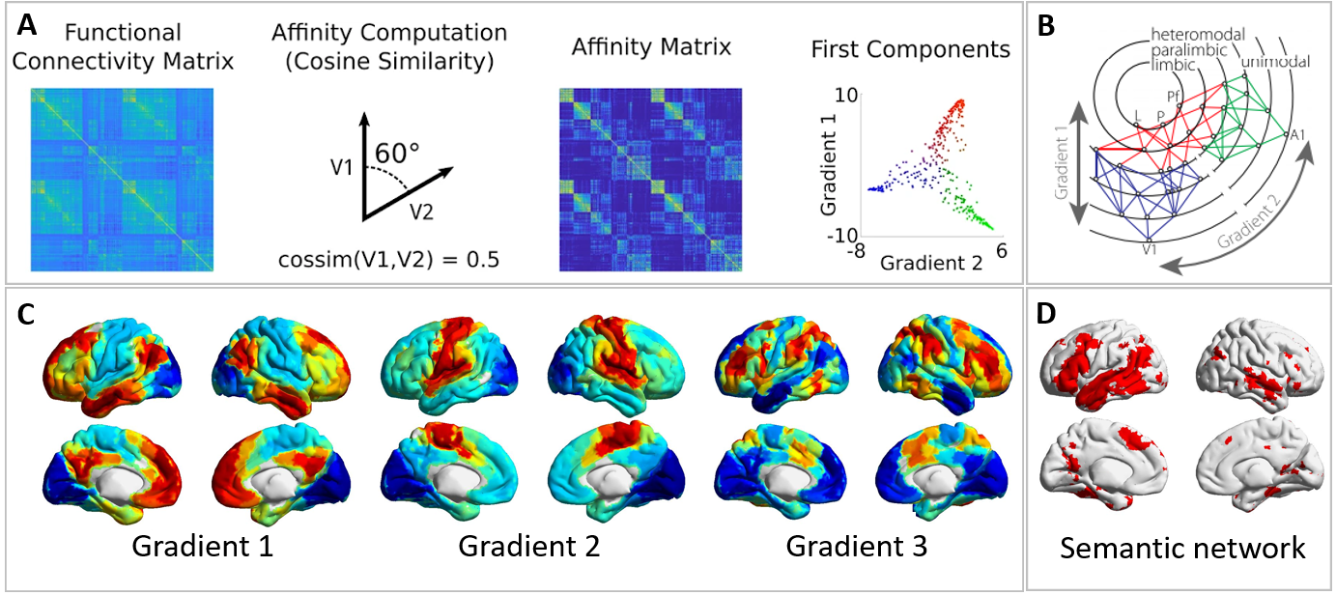
Figure 1. A: Illustration of the process to derive gradients from the connectivity matrix (figures taken from Vos de Wael et al., 2020); B: Modified illustration of Mesulam’s (1998; taken from Margulies et al., 2016) proposal of how the cortex is organized according to a functional hierarchy of processing from distinct unimodal regions to integrative heteromodal regions. Gradient 1 and 2 labels correspond to the results reported in Margulies et al., (2016). C: Whole-brain gradients one to three derived in our study; D: Semantic network map used in the present study (obtained from Neurosynth using the keyword ‘semantic’ and derived from 1031 studies (Yarkoni, Poldrack, Nichols, Van Essen, & Wager, 2011)

This study considered whether individual differences in whole-brain derived gradients relate to variation in key dimensions of semantic cognition (i.e. effects of input modality and the need for control over retrieval). Given that G1 captures the location of semantic control regions, which fall in between default mode and executive networks (Wang et al., 2020), we might expect that the magnitude of G1 will be associated with individual differences in controlled semantic cognition, particularly within semantically-relevant regions of cortex. In addition, effects of modality might be associated with individual differences in the strength of the second gradient, since this captures the separation of distinct “spoke” systems. To test these hypotheses, we calculated the similarity between individual gradient patterns with group-level gradients within semantically-relevant cortex (defined by a meta-analytic map for the term “semantic”). We then investigated whether individual differences in these gradient patterns correlate with performance on semantic tasks involving the retrieval of weak vs. strong associations (taxing semantic control) and the identification of semantic links for words vs. pictures (to examine the effect of modality).

2 Methods
This study includes analysis in a sample of participants who performed a resting-state scan and behavioural testing in separate sessions. We determined our sample size based on participant availability (i.e., tested as many of the participants with resting-state data as were willing), and report all data exclusions, all inclusion/exclusion criteria, whether inclusion/exclusion criteria were established prior to data analysis, all manipulations, and all measures in the study. No part of the study procedures or analyses was pre-registered in a time-stamped, institutional registry prior to the research being conducted.

2.1 Participants
We analysed data from a large cohort of 207 volunteers recruited from the University of York (137 females, mean age = 20.21, range = 18-31 years) who completed a MRI scanning session followed by cognitive and memory tests in subsequent behavioural sessions on different days. These data have been used in previous studies focussing on the lateralisation of semantic cognition (Gonzalez Alam et al., 2019), semantic summation (Evans et al., 2020), structural substrates of semantic control (Wang, X. et al., 2018), neurocognitive components of semantic performance (Vatansever et al., 2017), mind-wandering (Poerio et al., 2017; Sormaz et al., 2018; Turnbull et al., 2019; Wang, X. et al., 2018), and hippocampal connectivity (Karapanagiotidis, Bernhardt, Jefferies, & Smallwood, 2017; Sormaz et al., 2017). We excluded 31 participants: 25 with missing behavioural data, one with missing fMRI data, one due to incorrect TR during the fMRI acquisition, and four during preprocessing because they exceeded our motion cut-off of .3 mm, had more than 20% invalid scans and/or mean global signal change of z>2. Therefore, the final sub-sample in the current study consisted of 176 healthy participants (114 females, mean age = 20.57). All participants were right-handed, native English speakers, with normal or corrected-to-normal vision, and without any history of neurological impairment or psychiatric illness. All participants were provided with written informed consent prior to the experiment, and ethical approval was obtained from the York Neuroimaging Centre Ethics Committee.

2.2 Procedure
All participants first took part in a neuroimaging session, including a structural scan and a 9-minute resting-state fMRI scan. During the resting-state scan, participants were instructed to focus on a fixation cross with their eyes open, and not to think about anything in particular. Participants in this study were part of a larger cohort study: after the scanning session, participants completed a large battery of cognitive and memory tests across three days (the order of these sessions was counterbalanced across participants). Details of the task procedures for this cohort can be found in Wang, H. et al. (2018).

2.3 Behavioural tasks
We manipulated modality (word/picture), association strength (strong/weak) and decision type (semantic/non-semantic) in the tasks, and a three-alternative forced-choice design was employed in all three tasks.
In all tasks, each trial consisted of a centrally-presented probe, a target and two unrelated distractors, which were targets in other trials. Each trial started with a blank screen for 500ms. Then the response options were subsequently presented at the bottom of the screen for 900ms. Finally, the probe was presented at the top of the screen, triggering the onset of the decision-making period. The probe and choices remained visible until the participant responded, or for a maximum of 3s. Both response time (RT) and accuracy were recorded. Figure 3 illustrates the tasks and summarises the behavioural results. RT outliers (greater than 2.5 standard deviations around the mean) were replaced with the cut-off value (i.e., mean +/- 2.5 standard deviations), and the data were then mean-centred.

2.3.1 Modality Task
The modality task consisted of trials that required (i) picture-picture or (ii) word-word matching. In both conditions, participants were presented with a probe (either a written word or a colour picture), and asked to select the target (3 AFC task) most associated with the probe; all targets and distractors were presented in the same modality as the probe. There were 60 trials for each modality, split across four blocks of 30 trials each. The presentation of the blocks was interleaved with blocks of other semantic tasks. The probe-target concepts across conditions (i.e., picture vs word) did not differ significantly in mean strength of association, word length, familiarity, imageability and lexical frequency (SUBTLEX-UK (van Heuven, Mandera, Keuleers, & Brysbaert, 2014); Table 1).

2.3.2 Association Strength Task
Participants were asked to select the target word that was most strongly associated with the probe (a picture). The semantic association that linked probes and targets was either strong (e.g., dog-bone) or weak (e.g., dog-ball). There were 60 strong and 60 weak association trials, presented in four blocks of 30 trials each. The order of trials within each block was randomized across subjects. The strong and weak trials were selected from a large database used in previous experiments (Davey et al., 2015; Krieger-Redwood, 2012). The strength of association between probe-target pairs was assessed using a 7-point Likert scale, along with the familiarity and imageability for each member of the pair. The association rating between probes and targets differed significantly between conditions, but there were no differences between conditions in word length, familiarity, imageability or lexical frequency (Table 1).

2.3.3 Non-semantic figure matching task
We used a non-semantic perceptual control task, which had similar perceptual and decision-making demands to the semantic judgements. The stimuli consisted of sixty pixelated and scrambled black-and-white photographs of faces (taken from Krieger-Redwood, 2012). Participants were asked to select the target that was identical to the probe; the distracters were the same images rotated by 180° or 270°. The task was split in two blocks of thirty trials each.
All tasks were implemented in E-prime 2.0. The code and source materials of the tasks are publicly accessible on the following OSF repository: https://osf.io/2yjqg/.
Table 1. Psycholinguistic variables for target words manipulating association strength and modality. * indicates a significant difference in semantic association between the strong and weak words (p < .001), and no other significant difference is found between conditions.
 | Association Strength |  |  | Modality
 | Strong | Weak | t | Word | Picture | t
 | Mean (SE) |  |  | Mean (SE)
Word Length | 6.43 (.39) | 6.6 (.34) | -.16 | 6.08 (.31) | 6.4 (.32) | -.69
Lexical Frequency | 13565(1887) | 11234(1805) | .89 | 4620(823.1) | 6459(828) | -1.56
Familiarity | 6.02 (.09) | 6.12(.08) | -.88 | 6.04 (.1) | 5.98(.1) | .40
Imageability | 5.16 (.13) | 4.96 (.13) | 1.07 | 4.96 (.13) | 4.97 (.12) | -.07
Semantic Association | 6.02 (.07) | 3.32 (.10) | 21.74* | 4.80 (.14) | 4.95 (.15) | -.76

2.4 Neuroimaging data acquisition
Structural and functional MRI data were acquired on a 3T GE HDx Excite Magnetic Resonance Imaging scanner, equipped with an eight-channel phased array head coil at the York Neuroimaging Centre, University of York. For each participant, structural MRI was acquired based on a sagittal isotropic 3D fast spoiled gradient-recalled echo T1-weighted structural scan (TR = 7.8 ms, TE = minimum full, flip angle = 20°, matrix size = 256 × 256, 176 slices, voxel size = 1.13 mm × 1.13 mm × 1 mm). The 9-minute resting-state fMRI data were acquired using a gradient single-shot echo-planar imaging sequence (TE = minimum full, flip angle = 90°, matrix = 64 × 64, FOV = 192 mm × 192 mm, voxel size = 3 mm × 3 mm × 3 mm, TR = 3000 ms, 60 slices with no gap).

2.5 Neuroimaging data pre-processing
fMRI data was pre-processed using SPM12 (http://www.fil.ion.ucl.ac.uk/spm) and CONN (v.18b) (https://www.nitrc.org/projects/conn) (Whitfield-Gabrieli & Nieto-Castanon, 2012) implemented in Matlab (R2018a) (https://uk.mathworks.com/products/matlab). Pre-processing steps followed CONN’s default pipeline and included motion estimation and correction by volume realignment using a six-parameter rigid body transformation, slice-time correction, and simultaneous grey matter (GM), white matter (WM) and cerebrospinal fluid (CSF) segmentation and normalisation to MNI152 stereotactic space (2 mm isotropic) of both functional and structural data. Following pre-processing, the following potential confounds were statistically controlled for: 6 motion parameters calculated at the previous step and their 1st and 2nd order derivatives, volumes with excessive movement (motion greater than 0.5 mm and global signal changes larger than z = 3), linear drifts, and five principal components of the signal from WM and CSF (CompCor approach; (Behzadi, Restom, Liau, & Liu, 2007). Finally, data were band-pass filtered between 0.01 and 0.1 Hz. No global signal regression was performed (Vos de Wael, Hyder, & Thompson, 2017). The pre-processing steps reported here followed previous studies (Karapanagiotidis et al., 2020; McKeown et al., 2020).

2.6 Neuroimaging data analysis
The analysis steps below are identical to those described by McKeown et al. (2020), who related individual differences in gradients to mind-wandering behaviour.

2.6.1 Functional connectivity within semantic network: dimension reduction
After pre-processing, we extracted the functional time-series from 400 ROIs applying the 400 Schaefer parcellation (Schaefer et al., 2018) for each participant. A connectivity matrix for each participant was then calculated using Pearson correlation, resulting in a 400 × 400 connectivity matrix for each individual. Then these individual connectivity matrices were averaged to calculate a group-averaged connectivity matrix with a fisher-z transformation. The BrainSpace Toolbox (Vos de Wael et al., 2020) was then used to extract ten group-level gradients from the group-averaged connectivity matrix by making the input matrix sparse via row-wise thresholding at each vector of the matrix (to keep the strong and less noisy connections), computing affinity matrix via a kernel function, and applying manifold algorithms to derive the gradients, and then plotting the resulting gradients on the cortical surface (dimension reduction technique = diffusion embedding, kernel = normalized angle, sparsity = 0.9). These group-level gradient solutions were aligned using Procrustes rotation to a subsample of the HCP dataset ([n=217, 122 women, mean + sd age = 28.5 + 3.7 y]; for full details of subject selection see (Vos de Wael et al., 2018) openly available within the Brainspace toolbox (Vos de Wael et al., 2020). This alignment step was the same as described in McKeown et al. (2020), and it improves the stability of the group-level gradient templates by maximising the comparability of the solutions to those from the existing literature (i.e. Margulies et al., 2016). The group-level gradient maps for the first ten gradients are shown in Supplementary Figures S2 and S3.
Using identical parameters, gradients were then calculated for each individual using their 400 × 400 connectivity matrix. These individual-level gradient maps were aligned to the group-level gradient maps using Procrustes rotation to improve comparison between the group-level gradients and individual-level gradients (N iterations = 10). This step-ordered and rotated individual participants’ gradients such that they were comparable across the sample. This analysis resulted in ten group-level gradients and ten individual-level gradients for each participant explaining maximal whole-brain connectivity variance in descending order.
Ten gradients were extracted in order to maximize the degree of fit between the group-level and individual-level gradients, and only the first three gradients, G1, G2, and G3, were retained for further analysis based on the first elbow of the scree plot of the eigenvalues for each gradient shown in Figure S1, and in line with McKeown et al. (2020). G1 captures the separation between unimodal visual and motor regions and heteromodal cortex. G2 relates to the difference in connectivity between somato-motor and visual cortex. G3 describes the separation between DMN and executive networks. There can be variation in the order of the gradients across participants or across species, but the principal gradient - capturing the separation between heteromodal and unimodal cortex - is a major dimension of connectivity across all studies/species. These group-level and individual-level gradient maps were then masked by the binarized semantic network mask, obtained from Neurosynth using the keyword ‘semantic’ and derived from 1031 studies (Yarkoni, Poldrack, Nichols, Van Essen, & Wager, 2011). This semantic network mask was applied after the whole-brain gradients were derived, and consequently, the gradient solution was not influenced by applying the mask. Although the semantic network does not extend to the primary sensory/motor cortex, there is still variation along the principal gradient, from DMN apex regions to secondary visual and motor regions. G2 also still shows some separation within the semantic mask, suggesting that regions of the semantic mask have sensory-motor properties. Gradient maps one to ten from the group-averaged dimension-reduction analysis of the whole brain and within the semantic network are publicly available on NeuroVault in a collection with the title of this article (https://neurovault.org/collections/10931/). The conditions of our ethics approval do not permit public archiving of the raw data and code supporting this study. Readers seeking access to this data should contact the lead author, Ximing Shao, the PI Professor Beth Jefferies, or the local ethics committee at the Department of Psychology and York Neuroimaging Centre, University of York. Access will be granted to named individuals in accordance with ethical procedures governing the reuse of sensitive data. Specifically, the following conditions must be met to obtain access to the data: approval by the Department of Psychology and York Neuroimaging Research Ethics Committees and a suitable legal basis for the release of the data under GDPR.

2.6.2 Similarity analysis within semantic network: Spearman’s rank correlation
In order to investigate individual differences for each of the three connectivity gradients, a Spearman’s rank correlation was used to calculate the extent to which each individual-level gradient was related to each group-level gradient. In this way, the correlation coefficient for each participant for gradients 1 to 3 provided a second order statistic indicating the similarity between the group-level and individual-level gradients. Fisher’s r-to-z transformation was applied to these correlation coefficient scores. These z-transformed regression coefficients are referred to as 'gradient similarity scores' below. These similarity scores were then entered as dependent variables in subsequent multivariate regression analyses to investigate whether individual variation in semantic cognition could predict individual variation along the first three whole-brain connectivity gradients. A schematic for the analysis pipeline is shown in Figure 2 (similar to Mckeown et al., 2020).
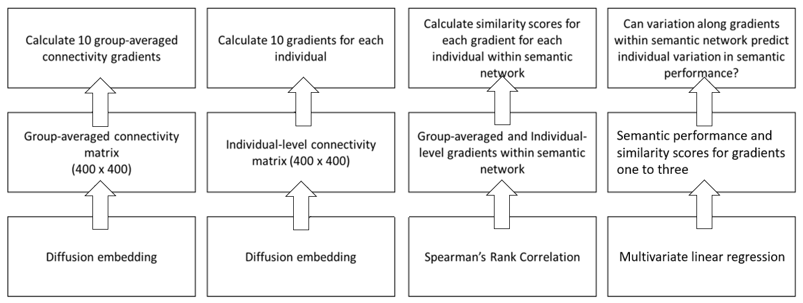
Figure 2. A schematic for the analysis pipeline
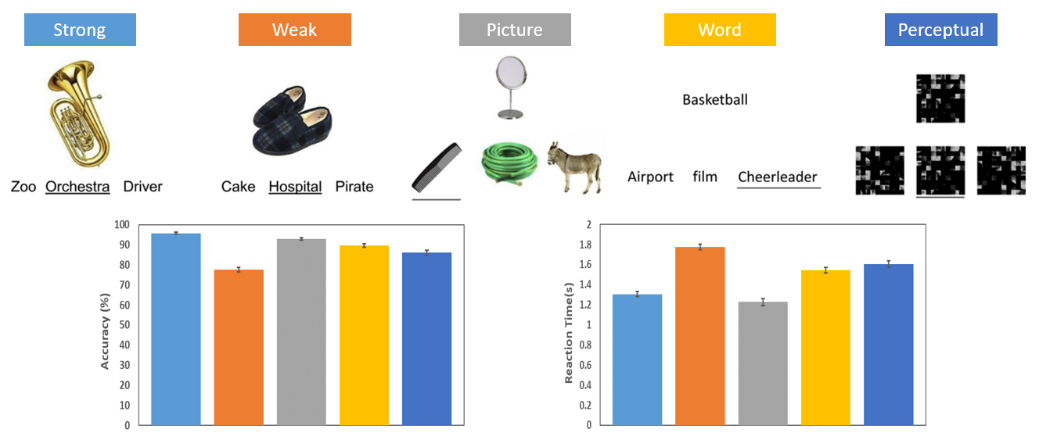
Figure 3. Top row: Illustration of the behavioural tasks; correct answers underlined. Bottom row: Mean accuracy and reaction time for each task. Error bar represents 95% confidence intervals.

3 Results

3.1 Behavioural data
Figure 3 shows mean accuracy and RT for each task. We used RT as the behavioural measure since accuracy for the strong association and modality tasks approached ceiling, suggesting this metric would be insensitive to individual differences in performance. Analyses conducted using accuracy are provided in the Supplementary Materials (See Table S1, S2).
Participants were slower to respond to weak than strong semantic associates (t = 57.606, p < .001), and slower at picture-picture than word-word matching (t = 18.818, p < .001). Participants were faster at non-semantic figure matching task compared with the slowest semantic decisions (figure matching vs. picture-picture matching: t = 18.18, p < .001; figure matching vs. weak associations: t = -10.479, p < .001). However, non-semantic figure matching was slower than the fastest semantic decisions (figure matching vs. word-word matching: t = -3.5, p = .001; figure matching vs. strong associates: t = 18.45, p < .001).

3.2 Relationship between semantic performance and gradient similarity scores within the semantic network
To examine the relationship between semantic performance and gradient similarity scores, we used a multivariate linear regression (SPSS; version 26). In the first stage of our analysis, we used semantically-relevant gradient similarity scores (for gradients 1-3) to predict performance on semantic association strength and modality tasks within the same model. The gradient similarity scores were based on correlation coefficients between individually-derived gradients and group-level gradients within semantically-relevant cortex (see Methods). In order to include both tasks in the same model, we used difference scores (i.e., weak minus strong RT and word minus picture RT), to capture the effects of semantic control demands and modality of presentation for each participant. Age, gender, and mean movement during the scan and RT for the non-semantic control task (figure matching) were entered as covariates of no interest.
This analysis revealed a significant multivariate effect for G1 [Pillai's Trace = .039, F (2,167) = 3.350, p = .037, Partial Eta Squared = 0.039] and a multivariate effect for G2 that approached significance [Pillai's Trace = .030, F (2,167) = 2.602, p = .077, Partial Eta Squared = 0.030]. No significant multivariate effect was found for G3 [Pillai's Trace = .008, F (2,167) = 0.648, p = .524, Partial Eta Squared = 0.008]. These results establish that the connectivity profile at rest was associated with individual differences in semantic cognition. The parameter estimates for G1 showed a significant relationship with the effect of strength of association in the word-picture matching task (b = -83.60, 95% CI = -162.62 to -4.58, p = .038, Partial Eta Squared = 0.025), but no association with the effect of modality (i.e. the difference between word-word and picture-picture matching; b= -121.69, 95% CI = -284.91 to 41.54, p = .143, Partial Eta Squared = 0.013). The parameter estimates for G2 showed the opposite pattern, namely no relationship with strength of association (b = 24.77, 95% CI = -47.39 to 96.93, p = .499, Partial Eta Squared = 0.003), and a significant association with the effect of presentation modality (b = 163.23, 95% CI = 14.17 to 312.28, p = .032, Partial Eta Squared = 0.027). The parameter estimates for Gradient 3 showed no significant association with strength of association (b= -12.65, 95% CI = -111.60 to 86.30, p = .801, Partial Eta Squared < 0.001) or the effect of presentation modality (b= 116.10, 95% CI = -88.30 to 320.48, p = .264, Partial Eta Squared = 0.007). In summary, G1 was related to the effects of association strength, and G2 with modality. There were no behavioural associations with G3.
To further characterise the multivariate effects, two repeated-measures ANOVA models examined RT for individual conditions. These analyses could therefore identify which condition(s) were giving rise to the effects identified above. The first model examined strong and weak association trials, and the interaction of strength of association with G1. The second model examined picture and word trials, and the interaction of modality with G2. Both models included the same covariates of no interest as the multivariate regression (i.e., gender, age, movement). There was a significant interaction between association strength and G1 (Pillai's Trace = .024, F (1,170) = 4.172, p = .043, Partial Eta Squared = 0.024); the parameter estimates confirmed that an association with this gradient was found for weak associations (b = -129.83, 95% CI = -251.58 to -8.08, p = .037, Partial Eta Squared = 0.025), but not strong associations (b = -51.69, 95% CI = -157.54, 54.16, p = .336, Partial Eta Squared = 0.005; Figure 4). There was also a significant interaction between modality and G2 (Pillai's Trace = .022, F (1,170) = 3.752, p = .054, Partial Eta Squared = 0.022); the parameter estimates showed a near-significant association with G2 for picture trials (b = -141.28, 95% CI = -290.02 to 7.45, p = .062, Partial Eta Squared = 0.020), and no association for word trials (b = 0.46, 95% CI = -108.83 to 109.75, p = .993, Partial Eta Squared < 0.001; Figure 5).
Next, we examined whether the effects seen here are specific to gradient scores within semantically-relevant areas of cortex, or whether similar effects are also linked to whole-brain gradient scores. We performed the same analysis using whole-brain correlations between individually-derived gradients and group-level gradients. No significant correlations were found between semantic performance and whole-brain gradient values, suggesting that gradient values within the semantic network were driving these brain-behaviour correlations. The results of the whole-brain analysis can be found in the supplementary materials (Table S3, S4).
To summarise, these analyses revealed that participants whose intrinsic connectivity showed a better fit with G2, capturing the separation between motor and visual cortices (as defined by Margulies et al., 2016), had better performance on picture semantic tasks. Also, a better fit with G1, capturing the separation between heteromodal and unimodal cortex (again, as defined by Margulies et al. 2016), was associated with stronger performance on weak associations. To visualise the relationship between semantic performance and gradient similarity to the group-level average gradients from Margulies et al. (2016) within semantically-relevant cortex, we calculated gradient scores for the top and bottom third of participants (ranked by gradient fit to the group average), and examined the differences between these groups. Figure 4, bottom row, shows participants whose intrinsic connectivity has a closer fit to the group-averaged G1, and who were faster to identify weak semantic associations, while Figure 5, bottom row, shows participants who fitted more closely with the group-averaged G2 and showed a performance benefit for picture semantic tasks (Figure 5, bottom row).
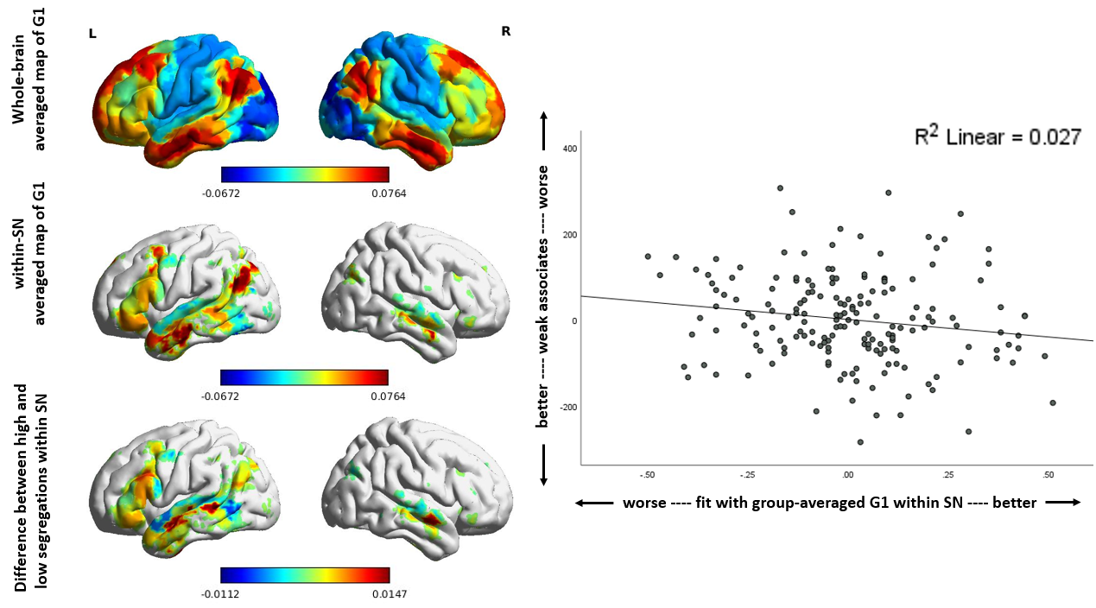

Figure 4. Left: Whole-brain group-averaged map for G1 (top row), group-averaged map for G1 within the semantic network (SN) used in the analysis (middle row), and the difference between participants with the closest fit to G1 (top third of the group) and the poorest fit to G1 (bottom third of the group) within the semantic network (bottom row). This demonstrates that there is more differentiation of heteromodal and sensory/motor regions in participants who have the greatest fit with G1; Right: Better fit with group-averaged G1 is partially correlated with faster retrieval of weak semantic associations, after controlling for strong semantic associates (response time; RT), non-semantic figure matching (RT) age, gender and mean movement.
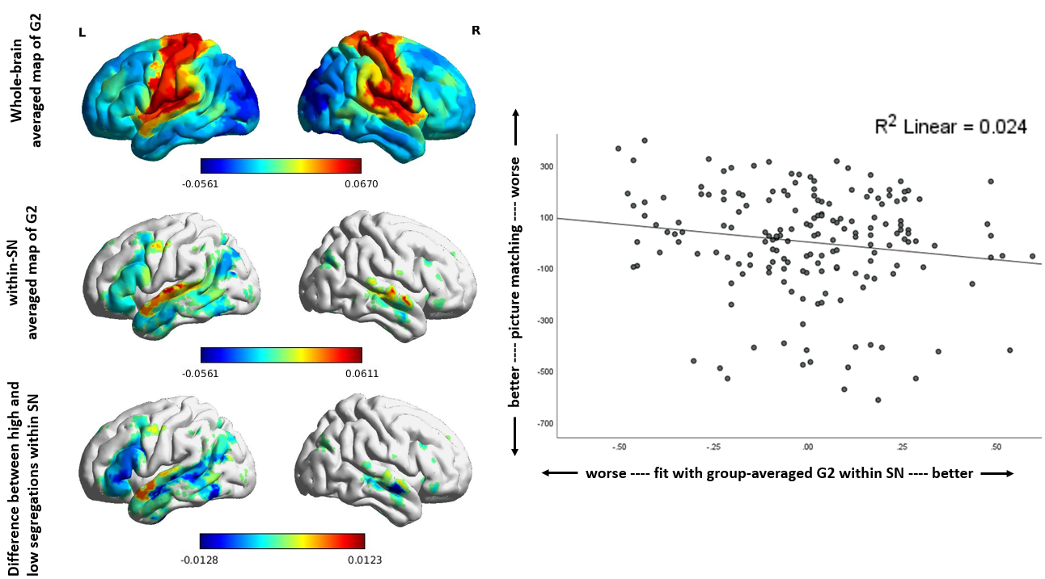
Figure 5. Left: Whole-brain group-averaged map for G2 (top row), group-averaged map for G2 within the semantic network (SN) used in the analysis (middle row), and the difference between participants with the closest fit to G2 (top third of the group) and the poorest fit to G2 (bottom third of the group) within the semantic network (bottom row). This demonstrates that there is more differentiation of visual and somatosensory/motor regions in participants who have the greatest fit with G2; Right: Better fit with group-averaged G2 is partially correlated with faster performance on semantic picture matching tasks, after controlling for verbal-semantic performance (reaction time; RT), non-semantic figure matching (RT), age, gender and mean movement.

3.3 Gradient Similarity Relationship with Key Semantic Regions
Our results suggest that a stronger fit with G1, which captures the separation between heteromodal and unimodal systems, is associated with better semantic control (given the relationship with performance on weak associations that are thought to require more controlled semantic retrieval). In order to further investigate this possibility, we extracted intrinsic connectivity between (i) key nodes within the semantic control network (i.e., left IFG and pMTG) and (ii) semantic regions not associated with control processes (left ATL and AG). The coordinates for the seeds were used in a recent study of intrinsic connectivity within the semantic network (Gonzalez Alam et al., 2021) and were derived from meta-analyses of (i) semantic control, for IFG (-48 22 20) and pMTG (-54 -42 4; Jackson, 2020), (ii) semantic processing within ATL (-41 -15 -31; averaged from peak coordinates of semantic>non-semantic contrasts listed in Table 1 of Rice, Hoffman, Binney, & Lambon Ralph, 2018) and (iii) AG (-48 -64 34; Humphreys & Lambon Ralph, 2015). Although left AG is functionally heterogeneous and its contribution to semantic cognition remains controversial, recent studies have suggested left mid-AG is associated with more automatic aspects of semantic retrieval, as well as episodic memory (e.g., Humphreys & Lambon Ralph, 2015; Humphreys, Lambon Ralph, & Simons, 2021).
Correlations between pairs of regions purportedly associated with control (IFG-pMTG) or not associated with control (ATL-AG) were then correlated with gradient similarity scores within the semantic network (see Table 2), as well as gradient fit across the whole brain (see Table S5). The results showed that individual differences in the fit of intrinsic connectivity patterns with G1 were positively correlated with intrinsic connectivity between semantic control regions in left IFG and pMTG: participants who fitted G1 more closely also showed stronger connectivity within the semantic control network. In contrast, no significant correlation was found between G1 and intrinsic connectivity between AG and ATL. G2 showed no correlation with either pattern of intrinsic connectivity.

Table 2. Pearson correlations between intrinsic connectivity and gradient values within the semantic network. To account for multiple correlations, the significance value for each Gradient was set to p < .025*.
 | Gradient Values within the Semantic Network
 | Correlation with G1 | Correlation with G2
IFG – pMTG | p=0.009, r=0.196 * | p=0.937, r=0.006
AG - ATL | p=0.336, r=0.073 | p=0.117, r=0.119

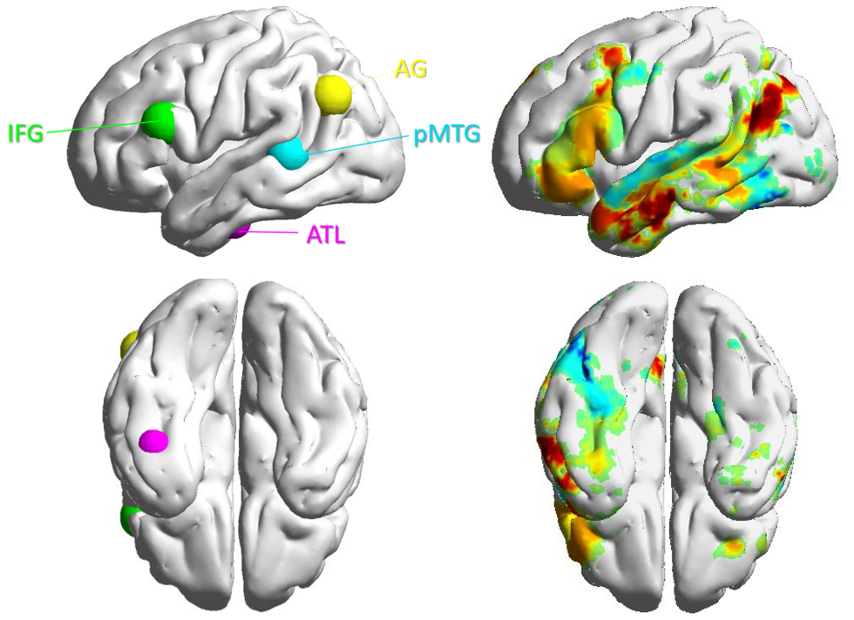
Figure 5. Left panel: four seeds derived from meta-analyses used in intrinsic connectivity analysis: two semantic control nodes including left IFG and pMTG (Jackson, 2020), and two semantic processing nodes including AG (Humphreys & Lambon Ralph, 2015) and ATL (Rice et al, 2018); Right panel: averaged map of Gradient 1 within the semantic network

3.4 Correlation between gradient similarity scores and the separation between ends of gradients
Given that G1 captures the separation between unimodal and heteromodal cortex, and G2 corresponds to the distinction between motor and visual cortex, a better global fit with these group gradient patterns might also be associated with greater separation at the ends of these gradients. To confirm this interpretation of the gradient similarity scores associated with behavioural performance, we extracted the gradient values within parcels at the ends of gradients (i.e., DMN, visual and sensorimotor networks, defined by Yeo et al. 2011), calculated the differences between the two ends for G1 and G2, respectively, and then calculated the correlation between gradient fit scores and these differences of gradient values between the two ends. For G1, we calculated the correlation between G1 fit scores and the differences in G1 scores within unimodal and heteromodal regions (i.e., ‘DMN – Visual’ and ‘DMN – Motor’). For G2, we calculated the correlation between G2 fit scores and the differences in G2 scores in visual and sensorimotor regions (i.e., ‘Motor – Visual’). These analyses were also performed within the semantic network, by extracting the gradient values within these regions that overlapped with the semantic network defined by Neurosynth.
The results are shown in Table S6. Fit scores with G1 were correlated with the difference in gradient values within heteromodal and unimodal cortex, both within the semantic network and across the whole brain. Consequently, participants who show a stronger fit with G1 might also have greater separation between the top and bottom ends of this gradient, and this appears to be associated with the emergence of a stronger semantic control network. Fit scores with G2 were correlated with the difference in gradient values between visual and motor cortex when the whole brain was considered, but not within the semantic network – perhaps because primary visual and motor cortex largely fall outside the semantic network.

4 Discussion
This study asked whether individual differences in functional connectivity patterns within the semantic network are related to individual performance on semantic tasks, employing a data-driven nonlinear dimensionality reduction technique to uncover components of connectivity known as gradients for each participant. Within the semantic network, individual differences in the strengths of Gradient 1 (G1, which describes sensory-heteromodal differentiation) and Gradient 2 (G2, which describes a differentiation of somato-motor and visual systems) were associated with different aspects of semantic cognition. Specifically, greater similarity to G1 was associated with better controlled semantic retrieval (quantified by differences in the retrieval of weak and strong associations, controlling for performance on a non-semantic matching task). In contrast, similarity to G2 was related to better performance on picture semantic judgements (compared with verbal semantic judgements). The current study therefore adds to emerging findings that individual differences in gradients are related to cognition (Mckeown et al., 2020) and shows how distinct large-scale gradients relate to different components of semantic cognition.
Our findings for G2 are broadly consistent with the ‘hub-and-spoke’ model of semantic representation. This account proposes that features such as shape, colour, size, movement and sound are represented within modality-specific ‘spoke’ regions, and drawn together in a hub within the anterior temporal lobes, allowing the computation of heteromodal concepts (Lambon Ralph et al., 2017; Patterson et al., 2007). G2 captures the separation of visual and motor ‘spokes’ (Huntenburg et al., 2018; Margulies et al., 2016), which should be relevant to individual differences in the effects of input modality in semantic tasks that primarily play out within the spokes. In addition, we found that a better fit with G2 was associated with better picture performance, while there was no relationship between G2 and verbal semantic performance, consistent with the view that picture tasks draw to a greater extent on unimodal or more concrete aspects of semantic representation. While both hub and spoke regions are thought to be critical for semantic processing (Lambon Ralph et al., 2017; Patterson et al., 2007), the relative importance of these systems is likely to differ across tasks. Pictures present concrete features, such as shape and colour, as part of the task; consequently, visual spokes might play a greater role in supporting semantic cognition elicited by pictures. Words do not provide any concrete features directly; instead these features must be retrieved from the meaning of the word (via the ATL and its top-down connections to the spoke systems). Consequently, in verbal tasks, semantic processing might be shifted towards the heteromodal hub. This task analysis can explain why similarity with G2 (capturing the separation of visual and motor spokes) is associated with performance on picture but not word associations.
An effect of strength of association was linked to individual differences in G1 in our study – specifically, participants who showed a better fit with G1 were faster to retrieve weak associations, which are thought to require greater control over semantic retrieval. The contrast of strong and weak associations has been used in many previous studies of semantic control (Badre, Poldrack, Paré-Blagoev, Insler, & Wagner, 2005; Davey et al., 2016; Gonzalez Alam et al., 2019; Wagner et al., 2001): strong associations are thought to be identified relatively automatically, since dominant information in the semantic store is sufficient to recover these links, while the retrieval of weak associations is thought to require control, allowing retrieval to be focussed on task-relevant yet weakly encoded aspects of knowledge (Badre et al., 2005; Davey et al., 2016; Gonzalez Alam et al., 2019; Wagner et al., 2001). Previous research has found that the principal gradient G1 captures the orderly transition of networks on the cortical surface, from DMN (which responds most strongly to highly coherent and more automatically retrieved knowledge), through control and attention networks, to sensory and motor systems (Hong et al., 2019; Margulies et al., 2016; Paquola et al., 2019; Wang et al., 2020). Within semantically relevant regions of cortex, the principal gradient also captures the location of the semantic control network in both connectivity space and on the cortical surface; this network lies between DMN sites implicated in heteromodal conceptual representation and more coherent or automatic patterns of semantic retrieval, and multiple-demand control regions that support executive control across domains (Davey et al., 2016; Wang et al., 2020). We therefore hypothesised that stronger G1 connectivity patterns within semantically-relevant regions of cortex might allow the semantic control network to emerge more strongly. This prediction was supported by the correlation between Gradient 1 similarity values and the strength of connectivity between key nodes of the semantic control network (LIFG-pMTG). A better fit with G1 might allow the stronger emergence of networks falling towards the middle of this connectivity space. These effects were only found when we considered gradient values within a semantic network mask.
We did not find behavioural associations with individual differences in the strength of Gradient 3 (G3), which captures the separation of the MDN from DMN. While we cannot draw strong conclusions from this null result, our study focussed on semantic cognition: consequently, we cannot exclude the possibility that G3 is related to functional brain organisation beyond the semantic domain. Moreover, G1 is the highest order gradient identified by diffusion embedding, and this component explains the most variance in patterns of intrinsic connectivity; for this reason, G1 may be more likely to show stronger behavioural associations than G3. Finally, while G1 and G3 show some important differences across the whole brain (with unimodal cortex positioned towards the centre of G3 and at the bottom of G1), within semantically-relevant cortex (which excludes primary sensory and motor cortex), G1 and G3 are largely overlapping. Both of these gradients capture the similarity between ATL and angular gyrus (two semantic sites that fall within DMN and are not implicated in control), plus the separation of these sites from semantic control and domain-general control regions, including pMTG and dorsal/posterior portions of IFG, bordering on inferior frontal sulcus and precentral sulcus. Since our analysis considered variance within all three gradient patterns simultaneously, G3 may have relatively little predictive value beyond the contribution of G1.
An additional limitation of our methods is that they do not identify whether particular parcels are driving each behavioural association; people with a lower fit with group-level gradients might have particular parcels that are highly discrepant in their gradient values, or might have less differentiation along the gradient more generally. For this reason, we plotted the parcels with significant differences in gradient values between the most and least gradient-aligned participants (see Figure S4): this confirmed that individuals who show a higher correlation with group-level gradients also show separation in the connectivity space captured by the group-level gradient to a larger extent. Given our metric is an overall fit score, this effect might be driven by different parcels in different participants - but even if this is the case, we observe some reliable general associations with overall gradient fit reductions. For example, we show that individual differences in G1 alignment can be related not only to behavioural outcomes but also to the strength of connectivity within the semantic control network, which lies in between heteromodal DMN and attention networks linked to sensory-motor processing, approximately half-way along G1 within the semantic network.
In conclusion, we found that individual differences in semantic cognition are linked to cortical gradients in semantically-relevant regions of cortex. Better controlled semantic retrieval of weak associations is related to patterns of intrinsic connectivity that better fit G1. This is potentially due to the emergence of stronger connectivity patterns linked to semantic control. Furthermore, participants showing a better fit with G2 had faster retrieval of semantic information from pictures, relative to semantic judgements involving words. These results demonstrate a link between specific components of semantic cognition (i.e. semantic control; the engagement of spoke systems) and individual differences in dimensions of the functional architecture of the brain derived from intrinsic connectivity.
Acknowledgments
This work was supported by the European Research Council (Project ID: 771863 – FLEXSEM to EJ).

References
Badre, D., & D'Esposito, M. (2007). Functional Magnetic Resonance Imaging Evidence for a Hierarchical Organization of the Prefrontal Cortex. Journal of Cognitive Neuroscience, 19(12), 2082-2099. https://doi.org/10.1162/jocn.2007.19.12.2082
Badre, D., & D'Esposito, M. (2009). Is the rostro-caudal axis of the frontal lobe hierarchical? Nature Reviews Neuroscience, 10(9), 659-669. https://doi.org/10.1038/nrn2667
Badre, D., & Nee, D. E. (2018). Frontal Cortex and the Hierarchical Control of Behavior. Trends in Cognitive Sciences, 22(2), 170-188. https://doi.org/10.1016/j.tics.2017.11.005
Badre, D., Hoffman, J., Cooney, J. W., & D'Esposito, M. (2009). Hierarchical cognitive control deficits following damage to the human frontal lobe. Nature Neuroscience, 12(4), 515-522. https://doi.org/10.1038/nn.2277
Badre, D., Poldrack, R. A., Paré-Blagoev, E. J., Insler, R. Z., & Wagner, A. D. (2005). Dissociable controlled retrieval and generalized selection mechanisms in ventrolateral prefrontal cortex. Neuron, 47(6), 907-918. https://doi.org/10.1016/j.neuron.2005.07.023
Behzadi, Y., Restom, K., Liau, J., & Liu, T. T. (2007). A component based noise correction method (CompCor) for BOLD and perfusion based fMRI. Neuroimage, 37(1), 90-101. https://doi.org/ 10.1016/j.neuroimage.2007.04.042
Bethlehem, R. A., Paquola, C., Seidlitz, J., Ronan, L., Bernhardt, B., Tsvetanov, K. A., & Cam-CAN Consortium. (2020). Dispersion of functional gradients across the adult lifespan. Neuroimage, 222, 117299. https://doi.org/10.1016/j.neuroimage.2020.117299
Chiou, R., Humphreys, G. F., Jung, J., & Lambon Ralph, M. A. (2018). Controlled semantic cognition relies upon dynamic and flexible interactions between the executive ‘semantic control’ and hub-and-spoke ‘semantic representation’ systems. Cortex, 103, 100-116. https://doi.org/10.1016/j.cortex.2018.02.018
Coifman, R. R., & Lafon, S. (2006). Diffusion maps. Applied and computational harmonic analysis, 21(1), 5-30. https://doi.org/10.1016/j.acha.2006.04.006
Connolly, A. C., Guntupalli, J. S., Gors, J., Hanke, M., Halchenko, Y. O., Wu, Y. C., ... & Haxby, J. V. (2012). The representation of biological classes in the human brain. Journal of Neuroscience, 32(8), 2608-2618. https://doi.org/10.1523/JNEUROSCI.5547-11.2012
Davey, J., Cornelissen, P. L., Thompson, H. E., Sonkusare, S., Hallam, G., Smallwood, J., & Jefferies, E. (2015). Automatic and Controlled Semantic Retrieval: TMS Reveals Distinct Contributions of Posterior Middle Temporal Gyrus and Angular Gyrus. The Journal of Neuroscience, 35(46), 15230. https://doi.org/10.1523/JNEUROSCI.4705-14.2015
Davey, J., Thompson, H. E., Hallam, G., Karapanagiotidis, T., Murphy, C., De Caso, I., . . . Jefferies, E. (2016). Exploring the role of the posterior middle temporal gyrus in semantic cognition: Integration of anterior temporal lobe with executive processes. Neuroimage, 137, 165-177. https://doi.org/10.1016/j.neuroimage.2016.05.051
Dong, H. M., Margulies, D. S., Zuo, X. N., & Holmes, A. J. (2021). Shifting gradients of macroscale cortical organization mark the transition from childhood to adolescence. Proceedings of the National Academy of Sciences, 118(28). https://doi.org/10.1073/pnas.2024448118
Evans, M., Krieger-Redwood, K., Gonzalez Alam, T. R., Smallwood, J., & Jefferies, E. (2020). Controlled semantic summation correlates with intrinsic connectivity between default mode and control networks. Cortex, 129, 356-375. https://doi.org/10.1016/j.cortex.2020.04.032
Faber, M., Przezdzik, I., Fernandez, G., Haak, K. V., & Beckmann, C. F. (2020). Overlapping connectivity gradients in the anterior temporal lobe underlie semantic cognition. BioRxiv. https://doi.org/10.1101/2020.05.28.121137
Gonzalez Alam, T., Karapanagiotidis, T., Smallwood, J., & Jefferies, E. (2019). Degrees of lateralisation in semantic cognition: Evidence from intrinsic connectivity. NeuroImage, 202, 116089. https://doi.org/10.1016/j.neuroimage.2019.116089
Gonzalez Alam, T., Krieger-Redwood, K., Evans, M., Rice, G. E., Smallwood, J., & Jefferies, E. (2021). Intrinsic connectivity of anterior temporal lobe relates to individual differences in semantic retrieval for landmarks. Cortex, 134, 76-91. https://doi.org/10.1016/j.cortex.2020.10.007
Gonzalez Alam, T., Mckeown, B. L., Gao, Z., Bernhardt, B., de Wael, R. V., Margulies, D. S., ... & Jefferies, E. (2021). A tale of two gradients: Differences between the left and right hemispheres predict semantic cognition and visual reasoning. bioRxiv. https://doi.org/10.1101/2021.02.23.432529
Hong, S. J., De Wael, R. V., Bethlehem, R. A., Lariviere, S., Paquola, C., Valk, S. L., ... & Bernhardt, B. C. (2019). Atypical functional connectome hierarchy in autism. Nature communications, 10(1), 1-13. https://doi.org/10.1038/s41467-019-08944-1
Hong, S. J., Xu, T., Nikolaidis, A., Smallwood, J., Margulies, D. S., Bernhardt, B., ... & Milham, M. P. (2020). Toward a connectivity gradient-based framework for reproducible biomarker discovery. Neuroimage, 223, 117322. https://doi.org/10.1016/j.neuroimage.2020.117322
Humphreys, G. F., & Lambon Ralph, M. A. (2015). Fusion and Fission of Cognitive Functions in the Human Parietal Cortex. Cerebral Cortex, 25(10), 3547-3560. https://doi.org/10.1093/cercor/bhu198
Huntenburg, J. M., Bazin, P.-L., & Margulies, D. S. (2018). Large-Scale Gradients in Human Cortical Organization. Trends in Cognitive Sciences, 22(1), 21-31. https://doi.org/10.1016/j.tics.2017.11.002
Jackson, R. L. (2020). The Neural Correlates of Semantic Control Revisited. bioRxiv, 2020.2007.2015.204990. https://doi.org/10.1101/2020.07.15.204990
Jefferies, E. (2013). The neural basis of semantic cognition: converging evidence from neuropsychology, neuroimaging and TMS. Cortex, 49(3), 611-625. https://doi.org/10.1016/j.cortex.2012.10.008
Karapanagiotidis, T., Bernhardt, B. C., Jefferies, E., & Smallwood, J. (2017). Tracking thoughts: Exploring the neural architecture of mental time travel during mind-wandering. Neuroimage, 147, 272-281. https://doi.org/ 10.1016/j.neuroimage.2016.12.031
Karapanagiotidis, T., Vidaurre, D., Quinn, A. J., Vatansever, D., Poerio, G. L., Turnbull, A., ... & Smallwood, J. (2020). The psychological correlates of distinct neural states occurring during wakeful rest. Scientific reports, 10(1), 1-11. https://doi.org/ 10.1038/s41598-020-77336-z
Krieger-Redwood, K., Teige, C., Davey, J., Hymers, M., & Jefferies, E. (2015). Conceptual control across modalities: graded specialisation for pictures and words in inferior frontal and posterior temporal cortex. Neuropsychologia, 76, 92-107. https://doi.org/10.1016/j.neuropsychologia.2015.02.030
Krieger-Redwood, K. M. (2012). An investigation of phonological and semantic control using TMS and fMRI (Doctoral dissertation, University of York).
Lambon Ralph, M. A., Jefferies, E., Patterson, K., & Rogers, T. T. (2017). The neural and computational bases of semantic cognition. Nature Reviews Neuroscience, 18(1), 42-55. https://doi.org/10.1038/nrn.2016.150
Lanzoni, L., Ravasio, D., Thompson, H., Vatansever, D., Margulies, D., Smallwood, J., & Jefferies, E. (2020). The role of default mode network in semantic cue integration. NeuroImage, 219, 117019. https://doi.org/10.1016/j.neuroimage.2020.117019
Margulies, D. S., Ghosh, S. S., Goulas, A., Falkiewicz, M., Huntenburg, J. M., Langs, G., . . . Smallwood, J. (2016). Situating the default-mode network along a principal gradient of macroscale cortical organization. Proceedings of the National Academy of Sciences of the United States of America, 113(44), 12574-12579. https://doi.org/10.1073/pnas.1608282113
McKeown, B., Strawson, W. H., Wang, H.-T., Karapanagiotidis, T., Vos de Wael, R., Benkarim, O., . . . Smallwood, J. (2020). The relationship between individual variation in macroscale functional gradients and distinct aspects of ongoing thought. Neuroimage, 220, 117072. https://doi.org/10.1016/j.neuroimage.2020.117072
Mesulam, M. M. (1998). From sensation to cognition. Brain, 121(6), 1013-1052. https://doi.org/10.1093/brain/121.6.1013
Mollo, G., Karapanagiotidis, T., Bernhardt, B. C., Murphy, C. E., Smallwood, J., & Jefferies, E. (2016). An individual differences analysis of the neurocognitive architecture of the semantic system at rest. Brain and Cognition, 109, 112-123. https://doi.org/10.1016/j.bandc.2016.07.003
Murphy, C., Wang, H. T., Konu, D., Lowndes, R., Margulies, D. S., Jefferies, E., & Smallwood, J. (2019). Modes of operation: A topographic neural gradient supporting stimulus dependent and independent cognition. NeuroImage, 186, 487-496. https://doi.org/10.1016/j.neuroimage.2018.11.009
Paquola, C., Vos De Wael, R., Wagstyl, K., Bethlehem, R. A., Hong, S. J., Seidlitz, J., ... & Bernhardt, B. C. (2019). Microstructural and functional gradients are increasingly dissociated in transmodal cortices. PLoS biology, 17(5), e3000284. https://doi.org/10.1371/journal.pbio.30002
Patterson, K., Nestor, P. J., & Rogers, T. T. (2007). Where do you know what you know? The representation of semantic knowledge in the human brain. Nature reviews neuroscience, 8(12), 976-987. https://doi.org/10.1038/nrn2277
Poerio, G. L., Sormaz, M., Wang, H. T., Margulies, D., Jefferies, E., & Smallwood, J. (2017). The role of the default mode network in component processes underlying the wandering mind. Social cognitive and affective neuroscience, 12(7), 1047-1062. https://doi.org/10.1093/scan/nsx041
Pulvermüller, F. (2013). How neurons make meaning: brain mechanisms for embodied and abstract-symbolic semantics. Trends in cognitive sciences, 17(9), 458-470. https://doi.org/10.1016/j.tics.2013.06.004
Reilly, J., Peelle, J. E., Garcia, A., & Crutch, S. J. (2016). Linking somatic and symbolic representation in semantic memory: the dynamic multilevel reactivation framework. Psychonomic bulletin & review, 23(4), 1002-1014. https://doi.org/10.3758/s13423-015-0824-5
Rice, G. E., Lambon Ralph, M. A., & Hoffman, P. (2015). The roles of left versus right anterior temporal lobes in conceptual knowledge: an ALE meta-analysis of 97 functional neuroimaging studies. Cerebral Cortex, 25(11), 4374-4391. https://doi.org/10.1093/cercor/bhv024
Rogers, T. T., Lambon Ralph, M. A., Garrard, P., Bozeat, S., McClelland, J. L., Hodges, J. R., & Patterson, K. (2004). Structure and Deterioration of Semantic Memory: A Neuropsychological and Computational Investigation. Psychological Review, 111(1), 205-235. https://doi.org/10.1037/0033-295X.111.1.205
Schaefer, A., Kong, R., Gordon, E. M., Laumann, T. O., Zuo, X. N., Holmes, A. J., . . . Yeo, B. T. T. (2018). Local-Global Parcellation of the Human Cerebral Cortex from Intrinsic Functional Connectivity MRI. (1460-2199 (Electronic)).
Sormaz, M., Murphy, C., Wang, H. T., Hymers, M., Karapanagiotidis, T., Poerio, G., ... & Smallwood, J. (2018). Default mode network can support the level of detail in experience during active task states. Proceedings of the National Academy of Sciences, 115(37), 9318-9323. https://doi.org/10.1073/pnas.1721259115
Sormaz, M., Jefferies, E., Bernhardt, B. C., Karapanagiotidis, T., Mollo, G., Bernasconi, N., ... & Smallwood, J. (2017). Knowing what from where: Hippocampal connectivity with temporoparietal cortex at rest is linked to individual differences in semantic and topographic memory. Neuroimage, 152, 400-410. https://doi.org/10.1016/j.neuroimage.2017.02.071
Thompson-Schill, S. L., D’Esposito, M., Aguirre, G. K., & Farah, M. J. (1997). Role of left inferior prefrontal cortex in retrieval of semantic knowledge: a reevaluation. Proceedings of the National Academy of Sciences, 94(26), 14792-14797. https://doi.org/10.1073/pnas.94.26.14792
Turnbull, A., Wang, H. T., Murphy, C., Ho, N. S. P., Wang, X., Sormaz, M., ... & Smallwood, J. (2019). Left dorsolateral prefrontal cortex supports context-dependent prioritisation of off-task thought. Nature communications, 10(1), 1-10. https://doi.org/10.1038/s41467-019-11764-y
Van Essen, D. C., & Maunsell, J. H. R. (1983). Hierarchical organization and functional streams in the visual cortex. Trends in Neurosciences, 6, 370-375. https://doi.org/10.1016/0166-2236(83)90167-4
Vatansever, D., Bzdok, D., Wang, H.-T., Mollo, G., Sormaz, M., Murphy, C., . . . Jefferies, E. (2017). Varieties of semantic cognition revealed through simultaneous decomposition of intrinsic brain connectivity and behaviour. Neuroimage, 158, 1-11. https://doi.org/10.1016/j.neuroimage.2017.06.067
Visser, M., Jefferies, E., Embleton, K. V., & Lambon Ralph, M. A. (2012). Both the middle temporal gyrus and the ventral anterior temporal area are crucial for multimodal semantic processing: distortion-corrected fMRI evidence for a double gradient of information convergence in the temporal lobes. Journal of Cognitive Neuroscience, 24(8), 1766-1778. https://doi.org/10.1162/jocn_a_00244
Vos de Wael, R., Benkarim, O., Paquola, C., Lariviere, S., Royer, J., Tavakol, S., . . . Bernhardt, B. C. (2020). BrainSpace: a toolbox for the analysis of macroscale gradients in neuroimaging and connectomics datasets. Communications Biology, 3(1), 103. https://doi.org/10.1038/s42003-020-0794-7
Vos de Wael, R., Hyder, F., & Thompson, G. J. (2017). Effects of tissue-specific functional magnetic resonance imaging signal regression on resting-state functional connectivity. Brain connectivity, 7(8), 482-490. https://doi.org/10.1089/brain.2016.0465
Vos de Wael, R., Larivière, S., Caldairou, B., Hong, S.-J., Margulies, D. S., Jefferies, E., . . . Bernhardt, B. C. (2018). Anatomical and microstructural determinants of hippocampal subfield functional connectome embedding. Proceedings of the National Academy of Sciences, 115(40), 10154. https://doi.org/10.1073/pnas.1803667115
Vos de Wael, R., Royer, J., Tavakol, S., Wang, Y., Paquola, C., Benkarim, O., ... & Bernhardt, B. (2020). Microstructural underpinnings and macroscale functional implications of temporal lobe connectivity gradients. bioRxiv. https://doi.org/10.1101/2020.11.26.400382
Wagner, A. D., Paré-Blagoev, E. J., Clark, J., & Poldrack, R. A. (2001). Recovering meaning: left prefrontal cortex guides controlled semantic retrieval. Neuron, 31(2), 329-338. https://doi.org/10.1016/S0896-6273(01)00359-2
Wang, H. T., Poerio, G., Murphy, C., Bzdok, D., Jefferies, E., & Smallwood, J. (2018). Dimensions of experience: exploring the heterogeneity of the wandering mind. Psychological Science, 29(1), 56-71. https://doi.org/10.1177/0956797617728727
Wang, X., Bernhardt, B. C., Karapanagiotidis, T., De Caso, I., Alam, T. R. D. J. G., Cotter, Z., ... & Jefferies, E. (2018). The structural basis of semantic control: Evidence from individual differences in cortical thickness. Neuroimage, 181, 480-489. https://doi.org/10.1016/j.neuroimage.2018.07.044
Wang, X., Gao, Z., Smallwood, J., & Jefferies, E. (2021). Both default and multiple-demand regions represent semantic goal information. Journal of Neuroscience. https://doi.org/10.1523/JNEUROSCI.1782-20.2021
Wang, X., Margulies, D. S., Smallwood, J., & Jefferies, E. (2020). A gradient from long-term memory to novel cognition: Transitions through default mode and executive cortex. NeuroImage, 220, 117074. https://doi.org/10.1016/j.neuroimage.2020.117074
Whitfield-Gabrieli, S., & Nieto-Castanon, A. (2012). Conn: a functional connectivity toolbox for correlated and anticorrelated brain networks. (2158-0022 (Electronic)).
Whitney, C., Kirk, M., O'Sullivan, J., Lambon Ralph, M. A., & Jefferies, E. (2011). The neural organization of semantic control: TMS evidence for a distributed network in left inferior frontal and posterior middle temporal gyrus. Cerebral cortex, 21(5), 1066-1075. https://doi.org/10.1093/cercor/bhq180
Yarkoni, T., Poldrack, R. A., Nichols, T. E., Van Essen, D. C., & Wager, T. D. (2011). Large-scale automated synthesis of human functional neuroimaging data. Nature Methods, 8(8), 665-670. https://doi.org/10.1038/nmeth.1635
Yeo, B. T., Krienen, F. M., Sepulcre, J., Sabuncu, M. R., Lashkari, D., Hollinshead, M., ... & Buckner, R. L. (2011). The organization of the human cerebral cortex estimated by intrinsic functional connectivity. Journal of neurophysiology. https://doi.org/10.1152/jn.00338.2011

Pillai’s Trace is used as a test statistic in MANOVA, ranging from 0 to 1, with increasing values meaning that effects are contributing more to the model.

